SUB: HISTORY OF ENGLISH LITRATURE-II SUB CODE: 16AACEN4

NEO CLASSICAL PERIOD
Neo classical writers modelled their works on classical texts and followed various esthetical values first established in Ancient Greece and Rome. Neo classical writers followed the Latin writers like Virgil and Horace. This period was divided into three.

The early to mid 18th century was a period during which satire flourished in England (and Ireland). The main authors are Joseph Addison, John Dryden, Alexander Pope (1688-1744), Sir Richard Steele and the Irish writer Jonathan Swift , the latter being particularly concerned with questions of language and entertaining generally conservative views on language change. The term Augustan is derived from the comparison of this age to that of the Roman Emperor Augustus under whose reign Horace, Ovid and Virgil flourished authors who the latter-day English writers also admired.

The middle of the 18th century sees the rise of the novel (initially in epistolary form) and the publication of the first major lexicographical work, the monolingual dictionary Dictionary of the English language (1755) by Samuel Johnson which was a model for all future lexicographers. (Johnson drew on the dictionaries of Nathaniel Bailey - such as the Universal etymological English dictionary (1721), with some 40,000 entries, and the Dictionarium Brittanicum (1730) - for the word list he used in his own).
POPULAR TYPES OF LITERATURE IN NEO CLASSICAL AGE
Satire
Essay
Parody
Fables
Melodrama

Wit and intellectual conceits shaped the tone of much Augustan writing (following on from the clever arguments of the metaphysical poets). Satire had already been a feature of Restoration literature, prior to the Augustan era, but at that time it was more circumscribed due to threat of prosecution for defamation.
In the eighteenth century, satire and parody were more widely used across the spectrum of prose, poetry and dramatic works. Poets also bantered and argued over what should be the proper modes of poetic expression, and which topics were worthy of the art form. One such debate was about the role of the pastoral, for example.

FAMOUS WRITERS IN CLASSICAL PERIOD:
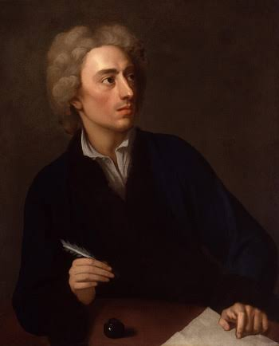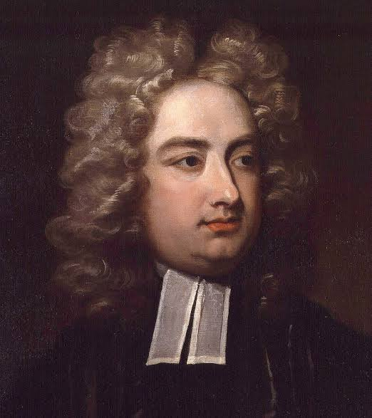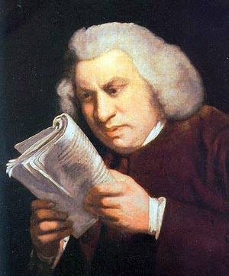
Alexander Pope Jonathan Swift Dr.Johnson

Representative works
Gulliver’s Travels by Jonathan Swift (1726, amended 1735), is an excellent example of parody and satire. In his work, Swift targets the empiricists who insist on individual, unyielding reason over morality and social values.
Alexander Pope was the most significant figure in poetry during the Augustan period. His witty couplets were often quoted and used as axioms. Pope took issue with other authors about what should be considered the proper subjects and nature of poetic expression. Often, he publicly attacked his contemporaries through his satiric verse, making enemies of many. Pope's work The Dunciad (1728), held contemporary ‘dunces' up to ridicule. He was roundly derided by similar methods in return.
Rape of the Lock
In Rape of the Lock (1712 and 1714), Pope created a mock-heroic narrative poem, which satirised classical literature, with its heroes and nymphs and gods. Pope used the trivial snipping of a lock of hair as the backdrop for a quarrel which rises to epic proportions. He used both parody and satire to show how the ‘gods' of human vanity and folly can be so promoted that triviality takes precedence over common sense and reason.

ROMANTIC AGE
The Romantic literary movement developed in the second half of the eighteenth century. It is characterized by a reaction against Augustan literary ideals, empiricism and the Enlightenment focus on ‘reasoning' as a way to make authoritative conclusions. The writers of the Romantic period were much affected and inspired by the ideas of the French Revolution. Poets such as Blake, Wordsworth and Coleridge considered the revolution was fair and necessary for the establishment of Liberty, Equality and Fraternity that it espoused.
Romantic Poets
The poets like Wordsworth, Coleridge, Blake and Shelly withdrew themselves into the inner world and were less concerned with the outer public world. They move towards nature and its elements. They preferred the beauties of the nature rather than the ugliness of the industrial world.
Older Poets
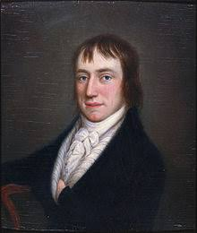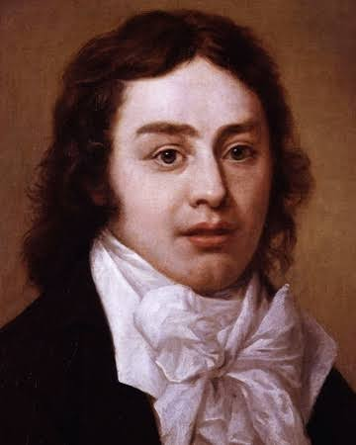
William Wordsworth S.T.Coleridge
The first generation romantics were inspired by the violence, battle and the revolution. They were writing at the time when the revolution was going on. We can say that they had seen the beginning of the revolution. Their themes were based on the revolution and on that condition.
Younger Poets
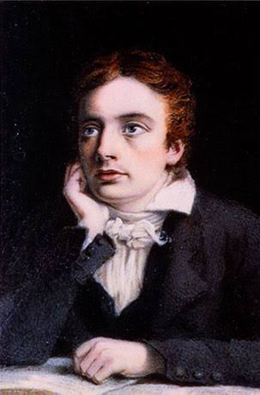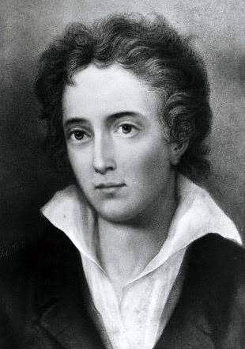
John Keats Percy Bysshe Shelley
Although the second generation romantics started writing when the war or revolution had already ended, the country was facing different social and political tensions.

Social and economic background of the Romantic Age:
At the end of the 18th century the country was changing swiftly. There were a lots of development changes. Machines were taking the place of men. Agriculture, manufacturing, mining and transport were changing. Steam power had become a practical reality. It radically improved Britain’s core industries, namely the production of textiles, metalwork and other manufactured goods and the mining of coal and other raw materials. The result was that there was violent conflict between employers and worker due to the use of machines. Later on it had taken the form of the French Revolution.

Literary background of the Romantic Age
The Romantic Age literature is considered as the literature of Imagination, Emotions, Feelings, Passions, Freedom and Expression. It was much related to the Nature. It seemed that all the writers and poets were much shocked with the Revolution and wanted to feel some peace in mind and in society. The wanted to sooth the mind of affected people. There was unrest and violent everywhere.

Characteristics of Romantic Poetry
1. Romantic poets believed in individual liberty and sympathized with those who rebelled against oppressors.
2. Romantic poets were much affected with the use of machinery and embraced imagination and naturalness.”
3. Romantic poets preferred personal experiences and emotions often in simple, unadorned language rather than the public, formal and witty works of the previous century.
4. They believed that feelings and emotions could create poetry.
5. According to Romantic poets (Wordsworth)-“Poetry is the spontaneous overflow of powerful feelings”.
6. Romantic poets loved the Nature. They thought that nature as transformative. They were fascinated by the ways of nature and the human mind mirrored the other’s creative properties.
7. The Romantic poets used lyric as their best to express their feeling, self-revelation and the imagination.

Facts about the Romantic Age
1. The key of Romanticism is-
a- Ability to produce his own original work
b- Creation from nothingness
2. Romanticism criticize the past and cults the sensibility.
3. Romantics were self-devoted, they think less about society.
4. They focused on individual liberty
5. According to romantic poets, truest experience was to be found in nature.
6. Romanticism focused on the primary importance of the free expression of the feeling of the artist.

VICTORIAN AGE
Here are some of the features of the Victorian period in English literature:
1) It was an age of extension and consolidation of Empire, England enjoying enormous authority at home and abroad;
2) Introduction of Railways, Industrialisation, and Urbanisation led to vertical mobility and material prosperity, and also social and moral evils as necessary fall-out;
3) Voices like Carlyle and Ruskin were loud against the evils of materialism, mechanisation, social and moral injustices;

4) The Pre-Raphaelite movement in art and poetry registered a strong reaction against Victorian realism and a journey back to the medieval past and Romantic sensuousness;
5) Problems of the urban middle-classes and the industrial poor figured in the novels of Dickens Mrs. Gaskell
6) Darwin's theory of evolution bred a strong element of doubt and despair as found in the novels of Hardy;
7) While the poetry of Tennyson represented the paradoxical duality of Work and Indolence, Arnold betrayed the spirit of moral-intellectual scepticism in his poetry of 'Victorian Unrest'.

The Beginning of Industrialization in Britain
The Industrial Revolution saw a rapid development of industry take place in Britain in the late 18th and early 19th centuries, soon spreading to Western Europe and North America. New and improved large-scale production methods and machinery marked the beginnings of Industrialization. Many different factors contributed to the rise of the Industrial Revolution in Britain. The new inventions, access to raw materials, trade routes and partners, social changes, and a stable government all paved the way for Britain to become an industry-driven country
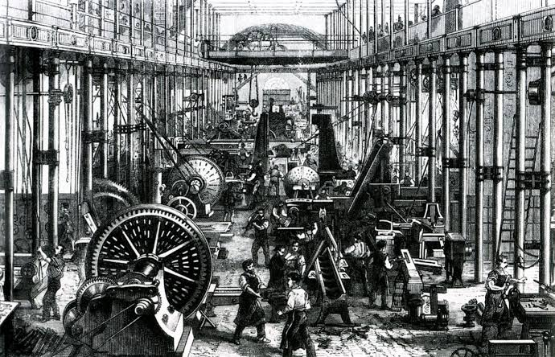
Industrialization in 19th century
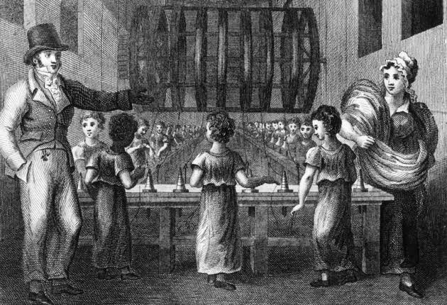
Child Labour

Famous Victorian novelists and poets
Significant Victorian novelists and poets include:
- Tennyson Matthew Arnold The Bronte sisters Christina Rossetti Joseph Conrad Robert Browning Elizabeth Barrett Browning Thomas Hardy Charles Dickens Benjamin Disraeli George Eliot Elizabeth Gaskell Rudyard Kipling Robert Louis Stevenson William Thackeray G.M. Hopkins Oscar Wilde Lewis Carroll.
Charles Dickens exemplifies the Victorian novelist better than any other writer. Extraordinarily popular in his day with his characters taking on a life of their own beyond the page, Dickens is still the most popular and read author of the time. The nineteenth century saw the rise of numerous literary journals that carried serial installments that were eagerly anticipated and widely read. His first real novel, The Pickwick Papers, written when he was only 25, was an overnight success, and all his subsequent works sold extremely well. He was in effect a self-made man who worked diligently and prolifically to produce exactly what the public wanted; often reacting to the public taste and changing the plot direction of his stories between monthly installments. The comedy of his first novel has a satirical edge which pervades his writings. These deal with the plight of the poor and oppressed and end with a ghost story cut short by his death. The slow trend in his fiction towards darker themes is mirrored in much of the writing of the century, and literature after his death in 1870 is notably different from that at the start of the era.

William Makepeace Thackeray was Dickens' great rival at the time. With a similar style but a slightly more detached, acerbic and barbed satirical view of his characters, he also tended to depict situations of a more middle class flavor than Dickens. He is best known for his novel Vanity Fair, subtitled A Novel without a Hero, which is also an example of a form popular in Victorian literature.

The Brontë sisters wrote fiction rather different from that common at the time.Away from the big cities and the literary society, Haworth in West Yorkshire was the site of some of the era's most important novel writing: the home of the Brontë family. Anne, Charlotte and Emily Brontë had time in their short lives to produce masterpieces of fiction although these were not immediately appreciated by Victorian critics. Wuthering Heights, Emily's only work, in particular has violence, passion, the supernatural, heightened emotion, and emotional distance, an unusual mix for any novel but particularly at this time. It is a prime example of Gothic Romanticism from a woman's point of view during this period of time, examining class, myth, and gender. Another important writer of the period was George Eliot, a pseudonym which concealed a woman, Mary Ann Evans, who wished to write novels which would be taken seriously rather than the silly romances which all women of the time were supposed to write.
The style of the Victorian novel
Virginia Woolf in her series of essays The Common Reader called George Eliot's Middlemarch "one of the few English novels written for grown-up people." This criticism, although rather broadly covering as it does all English literature, is rather a fair comment on much of the fiction of the Victorian Era.
Eliot in particular strove for realism in her fiction and tried to banish the picturesque and the burlesque from her work. Another woman writer Elizabeth Gaskell wrote even grimmer, grittier books about the poor in the north of England but even these usually had happy endings.
Poetry in a sense settled down from the upheavals of the romantic era and much of the work of the time is seen as a bridge between this earlier era and the modernist poetry of the next century. Alfred Lord Tennyson held the poet laureateship for over 40 years and his verse became rather stale by the end but his early work is rightly praised. Some of the poetry highly regarded at the time such as Invictus and If— are now seen as jingoistic and bombastic but Tennyson's Charge of the Light Brigade was a fierce criticism of a famous military blunder; a pillar of the establishment not failing to attack the establishment.

It seems wrong to classify Oscar Wilde as a Victorian writer as his plays and poems seem to belong to the later age of Edwardian literature, but as he died in 1900, he was most definitely Victorian. His plays stand apart from the many now forgotten plays of Victorian times and have a much closer relationship to those of George Bernard Shaw's, many of whose most important works were written in the twentieth century.

The husband and wife poetry team of Elizabeth Barrett Browning and Robert Browning conducted their love affair through verse and produced many tender and passionate poems. Both Matthew Arnold and Gerard Manley Hopkins wrote poems which sit somewhere in between the exultation of nature of the romantic Poetry and the Georgian Poetry of the early twentieth century. Arnold's works harks forward to some of the themes of these later poets while Hopkins drew for inspiration on verse forms from Old English poetry such as Beowulf.

Modern and Present Age
Introduction to modern period
Modern period in the English literature begins with the 20th century and remain till 1965. The period saw an abrupt break away from the old ways of interacting with the world. In all the previous periods experimentation and individualism were highly discouraged but with the onset of the modern period both these things became virtues.
There were many cultural shocks with the beginning of modernism. The blow of the modern age was the World War 1 and 2. These wars began in the year 1914 and last till 1919 and 1939 to 1945 respectively. Aftermath of the world wars was traumatic for everyone. The horror of the world war 1 was evident on the face of every citizen. Feeling of uncertainty was spread and no one knew where the world was heading into.
Transition from the Victorian period to the Modern Period
Changes in the literature
There were various changes took place in the field of literature also during the modern period. The imaginative writing, verses, structure of the verses of Victorian period became obsolete. Writers work started losing the magic they used to have in previous age. Victorian writers were becoming rancid and their works were failing to evoke the spirit of the readers. Art has to be renewed in order to revitalize the readers. But victorian art works were lacking the surprising elements and freshness in the content.

Declination of sentiments and values
Modern world people were more into independence, they don’t want to bind by the parental authority,whereas Victorians believed in maintaining the home life, they consider themselves a family person more. Moreover, the feeling of love was getting limited to sex in modern times, love had become less of a romance and more like a greed. Such things portray the decline in the values, emotions and feelings in the people of modern period. Literary work also portray the similar life style. If writers try to write on the themes of victorian age then it would be no longer a striking piece of literature. Therefore, you will find the literature of modern period having less zeal for love, natural beauty and the sentiments. Modern writers come up with fresh point of view suiting the conventional audience.
Literary trends
The trend of modernism emerged after the end of the First World War. They includes:

Modern English novels
They rein the literature in the initial three decades of the twentieth century, these years are known as the golden period of modernist novel.

The development of 20th century English drama
George Bernard Shaw and Oscar Wilde were the most known, praised and celebrated drama writers of the nineteenth century. They were highly popular in the last decade of the century. One can say that they marked the beginning of the modern drama. However, these two eminent writers never brought many variations or innovations in the writing techniques and types.
D. H. Lawrence
David Herber Lawrence was born in 1885 at a mining village which lies in Nottinghamshire. He was reared by parents who belonged to different classes and saw a silent conflict of views. His father was a man who acquired little education and led his life as a coal-miner. On the other hand, his mother was educated and had experience of working as a teacher. She used to think that she her marriage is beneath her and had a strong desire to provide education to her sons so they can stay away from the tough life of the coal miners.

James Joyce
James Joyce was born in Dublin in 1882. He belonged to a Catholic family and got his education from Catholic schools. During his studies he went through a phase of religious zest, however, he rejected the Catholic Church. He was influenced was Ibsen and inspired by his views, Joyce took literary mission as a career. He was sternly against the bigotry of Phillistines in Dublin.
His most remarkable works include:
- A Portrait of Artist as a Young Man
- Dubliners
- Theme in the works of Joyce
- Ulysses

Eliot’s Waste Land and James Joyce’s Ulysses were technically innovative and initially controversial (Ulysses was banned in the United States and Great Britain), but their eventual acceptance as literary landmarks helped to bring modernism into the canon of English literature. In the decades to come, the massive influence of Eliot as a critic would transform the image of modernism into what Eliot himself called classicism, a position deeply rooted in a sense of the literary past and emphasizing the impersonality of the work of art."

The four iconic authors of the British Modern period are Joyce, Woolf, Yeats, and Eliot. Three of the four weren't born in the country of England, but all four together represent the artistic, technical, and creative brilliance of this period, which fundamentally reshaped the tastes and trends of British literature as significantly as any period in British literary history. We tend to scant these figures a little in the survey because we offer a number of 300- and 500-level courses in modern British writing, and these are some of the most popular courses in the department.

