AIMAN COLLEGE OF ARTS AND SCIENCE FOR WOMEN DEPATMENT OF PHYSICS
I B.Sc PHYSICS

Subject Title: Mechanics
Subject Code: 16SCCPH2
Semester : 2

(NOTE: some concepts are added for understanding purpose that was mentioned in red colour)

Unit IV: DYNAMICS OF RIGID BODY & FRICTION
- Friction – laws of friction – resultant reaction – angle & cone of friction
Already explained these topic during class hours. For exam, refer properties of matter book. (pg. 205 & 206)
- Equilibrium of a body on a rough plane inclined to the horizontal
(For exam, refer properties of matter book)
A body resting on a plane inclined at at an angle α to the horizontal plane is in a state of equilibrium when the gravitational force tending to slide the body down the inclined plane is balanced by an equal and opposite frictional force acting up the inclined plane.
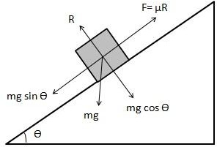

tñc7ñwt£ unAozononqfe f sgegxJarum

with the p.lan’e, Find the value of.p for.
ri . ,.

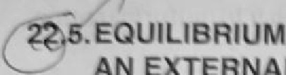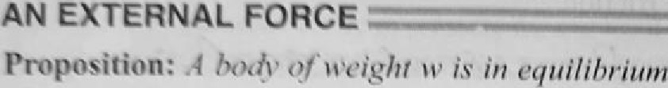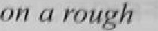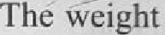Cmse 1: Let the body. be just on the ppint of sliding down the plane. Let P be the magnitude
0 ivi& die plane. The forces
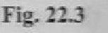of the body (w) acting vertically down, (ii) The normal reaction (2t) acting. i›eq›eñdicular to the plane (ifi) The forc.e of liniitlrig-fricfion.
) a %g up the plane (iv) The external force (gffort) P makihgran
angle 8 with the line of gratest slope of the inclined plane (Pig.,22.3). Resoivi9g &r
and perpendicular to the plane.
P cos 9 + — w sin ct
P sin 8 + R— w cos o Multiplying (2) by p and subracting from (1),
fcos O — p sin 8) — w (sin n — pt cos o)

or P =
(sin ii — p cos n)
(cox0- qxin’B)

But p = tan 1, where L is the angle. of friction.

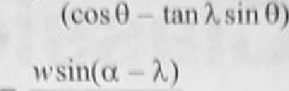Hence

Case 1: Let the bcdy bed j_{U}st on the point of sliding up the plane. Let P, be I&c M the extemal force. In this case. the force of limiting friction (tifi2 acts down the: pt.
Resolving the forcc•:s pamllcl and perpendicular to the plane,
P, cos 8 = u‘ sin n * qR P , rein 8 + fi = ir cos o
Simplitiâne. »’e poet. ' cos(0— X)
Corollary 1 : P is a minimum when cos (8— \) is maximum i.e:, wfien cos {£t.- k) -‘ I wiien 8 = 7.. Hence force required to move the body up the plane will be:left wben'it ix epp4 &k n direction making with the inclined plane an angle equal to the angle. of friction
Corollary 2: Let a body be at rest on a rough inclined plane wliose inclinati‹ñt to the
‹i * A. Let it be acted upon by an external force applied parallel to the plâne. ii e -

sn(;+%)

- Friction clutch
(Material for exam)
A clutch is actually a device consisting of two disks that allow power transmission from an input shaft to an output shaft.
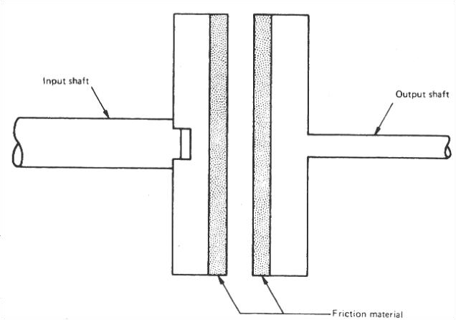
PRINCIPLE OF CLUTCH: It operates on the principle of friction. When two surfaces are brought in contact and are held against each other due
to friction between them, they can be used to transmit power.
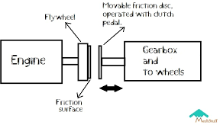
In friction clutches, the connection of the engine shaft to the gear box shaft is affected by friction between two or more rotating concentric surfaces. The surfaces can be pressed firmly against one another when engaged and the clutch tends to rotate as a single unit.
Clutching mechanism includes 3 components- Flywheel, Clutch plate & pressure plate.
Clutch plate is also known as friction plate. As it is a disc it has 2 surfaces & both are coated with materials of high co-efficient of friction. One side is connected to the flywheel & the other is connected to the pressure plate.

The aim of clutch plate is to transmit the torque from the flywheel to the gearbox. Here the frictional coating helps in gripping the flywheel firmly so that there will be no slippage.
Also the pressure plate helps the clutch plate by applying clamping force on the clutch plate to reduce slippage between flywheel & clutch plate.
***************************************************************
Unit V: CENTRE OF GRAVITY, CENTRE OF PRESSURE, FLOATING BODIES, ATMOSPHERIC PRESSURE
- CENTRE OF GRAVITY OF A BODY
- COG OF A TRAPEZOIDAL LAMINA
- COG OF A SOLID HEMISPHERE
- COG OF A SOLID TETRAHEDRON
- COG OF A SOLID CONE
- CENTRE OF PRESSURE
- COP IN A RECTANGULAR LAMINA
- COP IN A TRIANGULAR LAMINA
- COP IN A TRIANGULAR LAMINA IMMERSED IN A LIQUID
- CONDITIONS OF EQUILIBRIUM OF A FLOATING BODY
- STABILITY OF EQUILIBRIUM OF A FLOATING BODY
- META CENTRE
- EXPERIMENTAL DETERMINATION OF A METACENTRIC HEIGHT OF A SHIP
- THE BAROMETER
- FORTIN’S BAROMETER
- CORRECTION FOR A BAROMETER
- FAULTY BAROMETER
- VARIATION OF ATMOSPHERIC PRESURE WITH ALTITUDE

CENTRE OF GRAVITY

(For exam, refer properties of matter book)
COG: A point from which the weight of a body or system may be considered to act. In uniform gravity it is the same as the centre of mass.
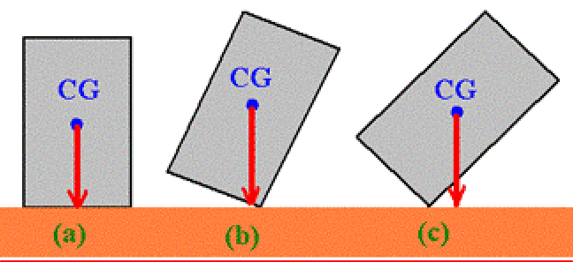
- CENTRE OF GRAVITY OF A BODY
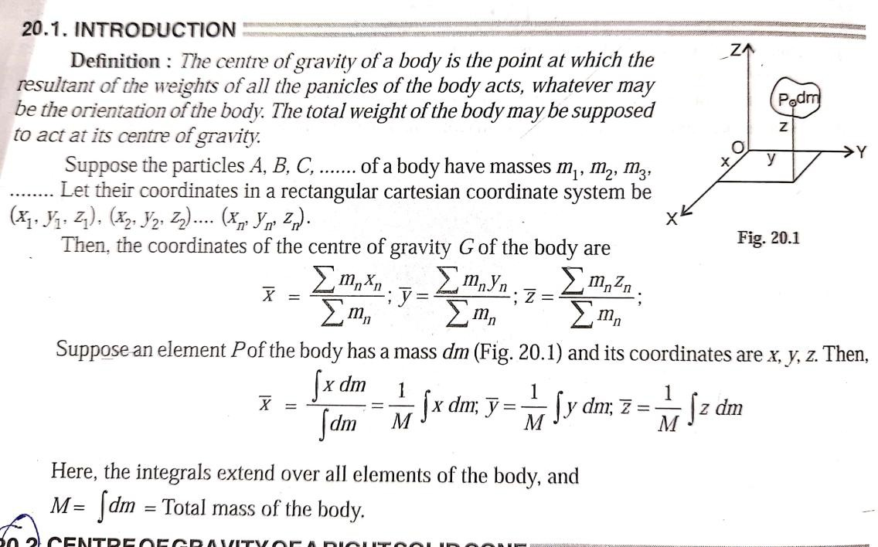
- COG OF A TRAPEZOIDAL LAMINA
(Material for exam)
The center of gravity of a trapezoid can be estimated by dividing the trapezoid in two triangles.
The center of gravity is the intersection between the middle line and the line between the triangles centers of gravity.

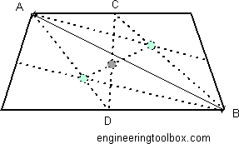

For any trapezoid with parallel sides a and b (Where b is the base) and height h,
The centroid is given by the following formula: Y = h (b+2a) / 3 (b + a)
Example
a = 4, b = 8, h = 2
Find the centroid of trapezium.
SOLUTION
Y = h (b+2a) / 3 (b + a)
= 2 (8 +2*4)/ 3 (8 + 4)
= 2 (16)/ 3 (12)
= 32 / 36 = 0.89

- COG OF A SOLID HEMISPHERE
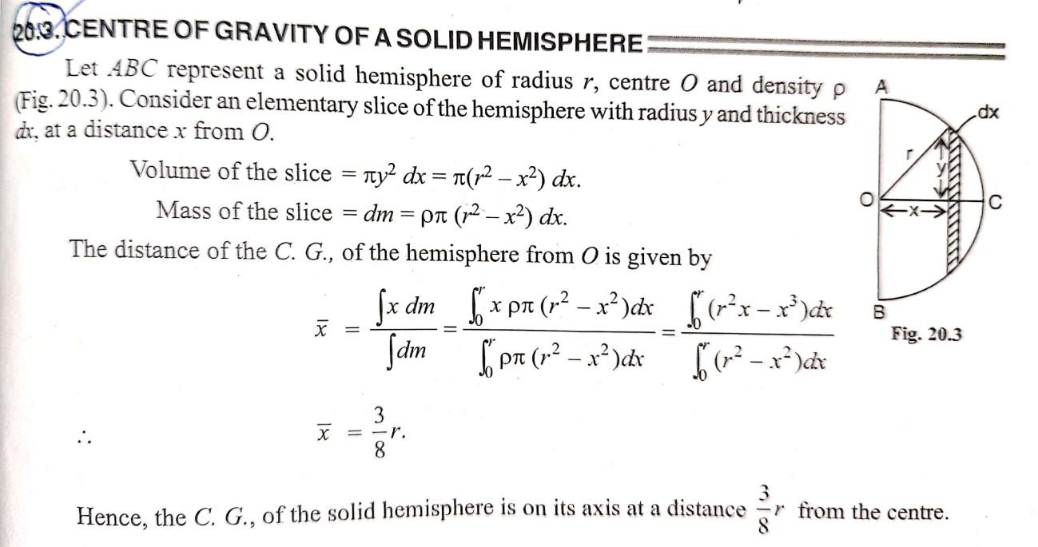

- COG OF A SOLID TETRAHEDRON
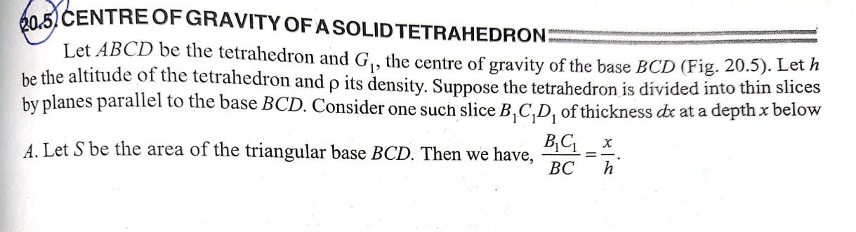

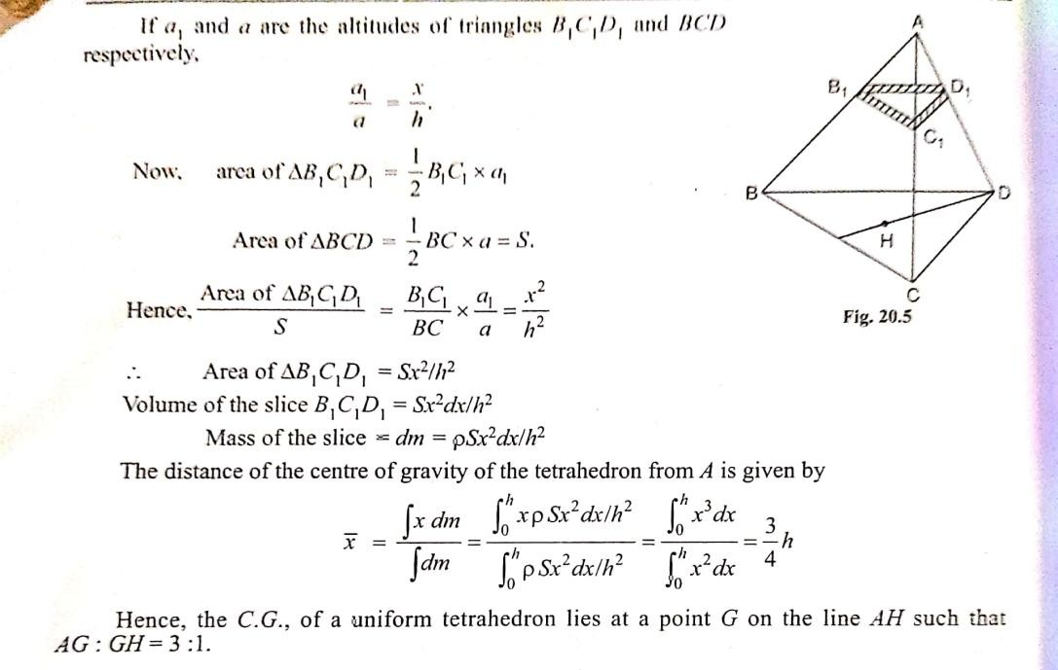
- COG OF A SOLID CONE

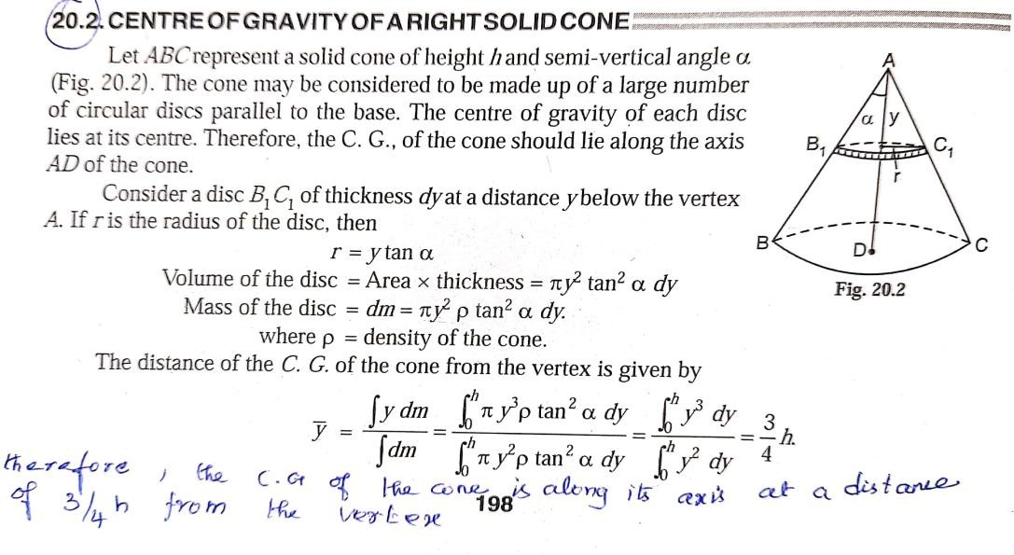

CENTRE OF PRESSURE
(For exam, refer properties of matter book)
The center of pressure is the point where the total sum of a pressure field acts on a body, causing a force to act through that point.
- CENTRE OF PRESSURE
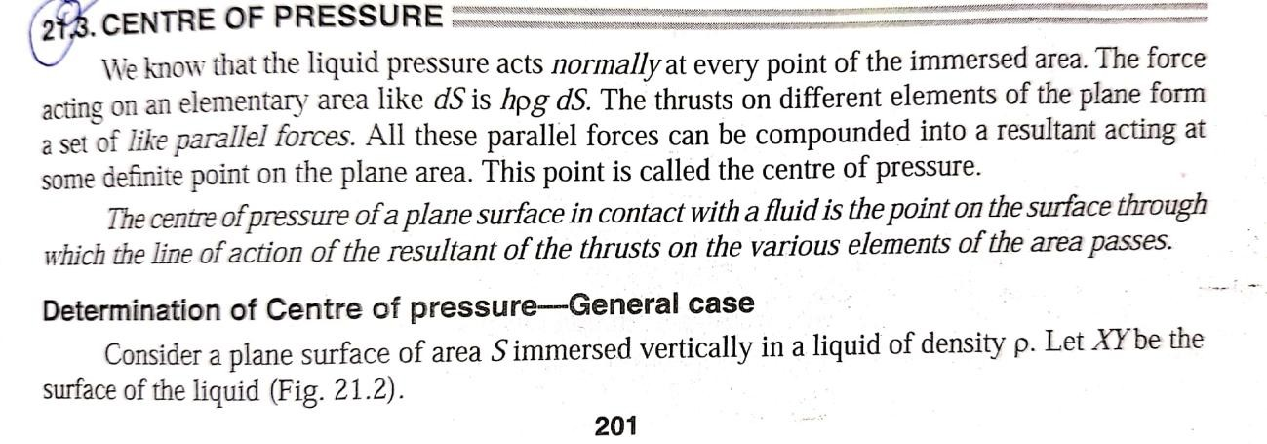

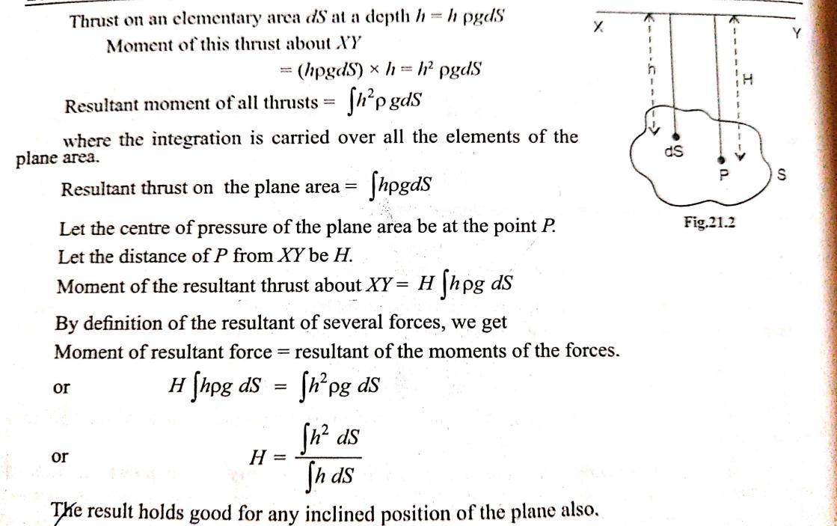

- COP IN A RECTANGULAR LAMINA
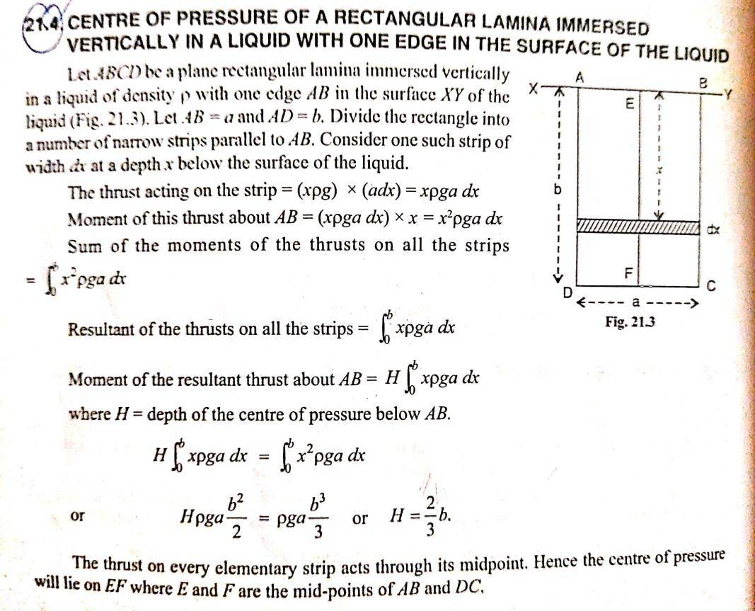

- COP IN A TRIANGULAR LAMINA
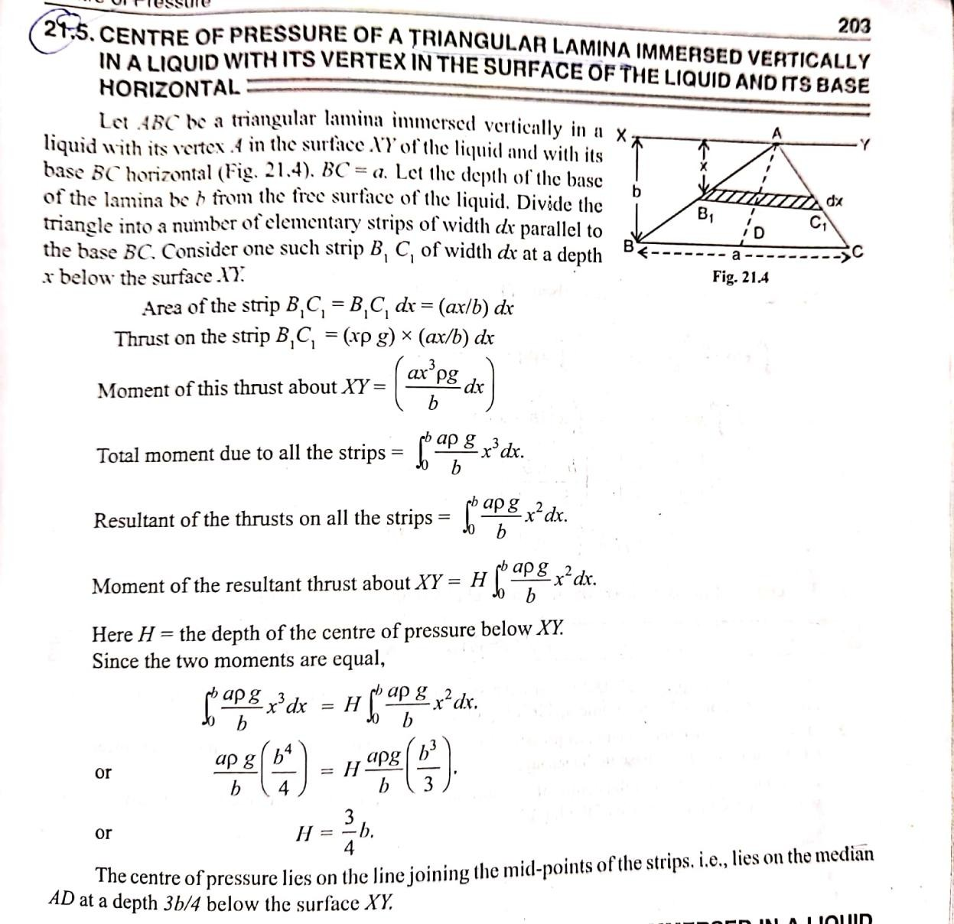

- COP IN A TRIANGULAR LAMINA IMMERSED IN A LIQUID

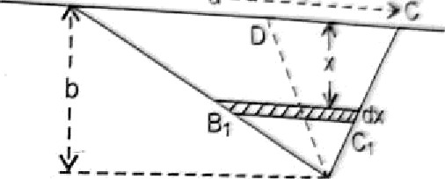21.6. CESITRE OF PRESSURE OF A TR IANG U LA R
WfTH ONE SIDE fN THE SURFACE, WHE N THE

l_{i} quid. Let .4N b2 fi 1@ediaii c›f the ti iangle. Let fi be the
depth c°â the i •u ex .1 below the surface Divide the B,
triangle into a number of elementary strips of width dx y ',
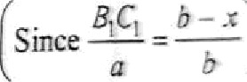
parallel ten the base BC. Consider one such strip B,C, at a depth .i- below BC.

.Sea of the strip B Cl — B, C W —
a(b — x) b

Thrust on the strip B C
— •°g b
a{b — x)

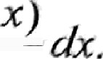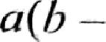Moment of this tllnist about — x² pg
b
Total moment due to all the strips — x2pg If (b — x

b
Resultant of the thrusts on all the strips = xpg '
Let N be the depth of the centre of presswe below
’dr.
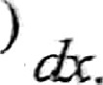b - x b

Moment of the resultant thrust about = H xg ‘(b
b ”‘•

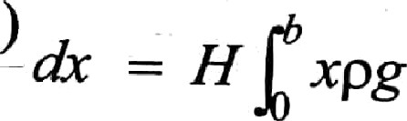
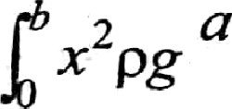
{b — x
b
a{b —
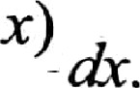
b

or H $x(b — x)dx (« 2 (b — x)<

or yy b3 b3
b4
4
b4
3 *
2 * 3
or H b

2
The e ll e > press ure is on the metli.en AD nt s depth hl? ho!$! -!’!’

FLOATING BODIES

  - The state of equilibrium of a solid body partially or fully immersed in a liquid or gas is called floating
  - In a body to float, the weight of the body should be supported by the buoyant force.
i.e., FB = ρg× Displaced volume of liquid = Weight of the floating body

  - Any floating object displaces its own weight of fluid When any boat
displaces a weight of water equal to its own weight, it floats. This is called the "principle of flotation": A floating object displaces a weight of fluid equal to its own weight.
  - Buoyancy is defined as the force applied to the object in an upward direction. Usually, most of the objects experience a force of buoyancy when they are immersed in a fluid and the object also appears to have lost its weight.
  - Archimedes’ principle states that when a body is immersed in a fluid it experiences an upward force of buoyancy equal to the weight of the fluid displaced by the immersed portion of the body.

- CONDITIONS OF EQUILIBRIUM OF A FLOATING BODY
(Material for exam)
The following are the conditions for equilibrium for a floating body
- The weight of the liquid displaced by the immersed part must be equal to the weight of the body.
- The centre of gravity and the centre of buoyancy of the body should be along the same vertical line.
- The centre of gravity lies vertically below the centre of buoyancy (stable equilibrium) and if centre of gravity lies above the centre of buoyancy (unstable equilibrium).

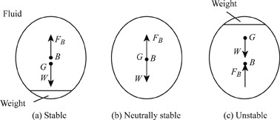

Stable Equilibrium for Floating Bodies: If a floating body is given a small angular displacement (disturbing moment) and after the removal of that Force or moment, body comes back to its original position. It is called as Stable Equilibrium.
Unstable Equilibrium for Floating Bodies: If a floating body is given a small angular displacement (disturbing moment) and after the removal of that Force or moment, body does not come back to its original position. It is called as UnStable Equilibrium.
Neutral Equilibrium for floating bodies: If a body in water or any liquid is given a slight angular displacement, it will neither rotates nor goes to the original position but attains a new position. This type of Equilibrium is known as Neutral Equilibrium.
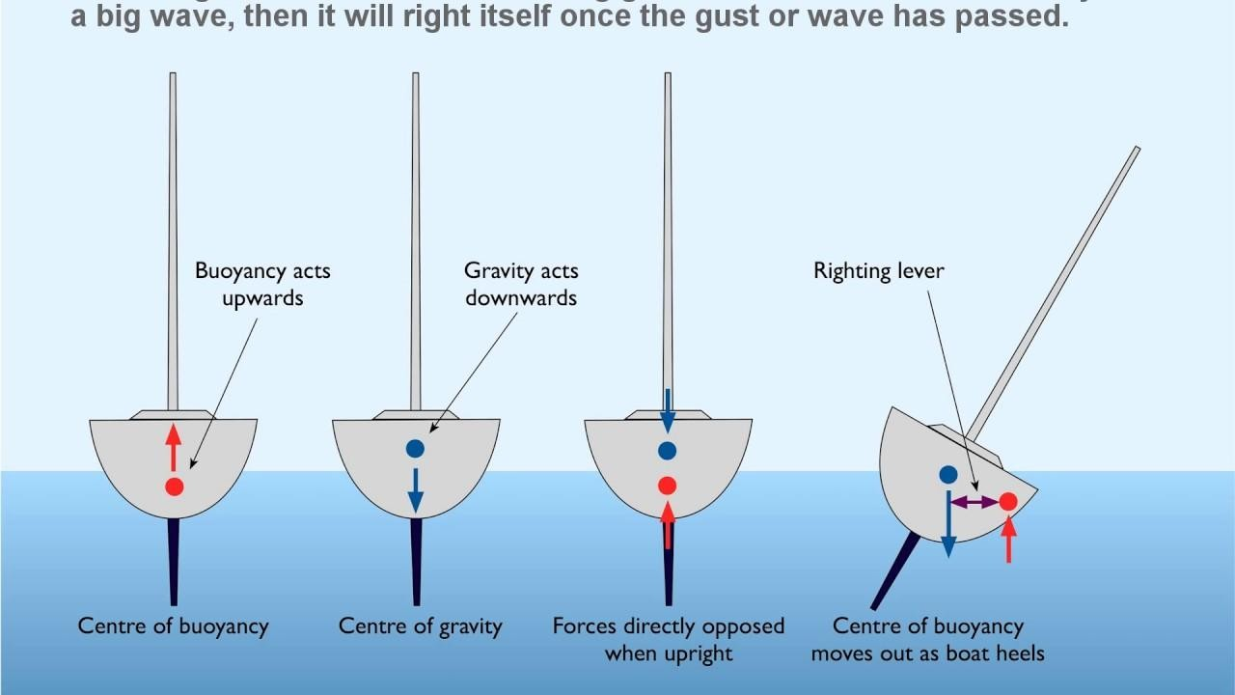

******************************************************************
- STABILITY OF EQUILIBRIUM OF A FLOATING BODY
(Material for exam)
Stability of Immersed and Floating Bodies
Stability becomes an important consideration when floating bodies such as a boat or ferry is designed. It is an obvious requirement that a floating body such as a boat does not topple when slightly disturbed.

We say that a body is in stable equilibrium if it is able to return to its position when slightly disturbed. Failure to do so denotes unstable equilibrium.

Consider the immersed body shown in Fig.1. if the center of gravity of the body lies below the center of buoyancy stable equilibrium prevails
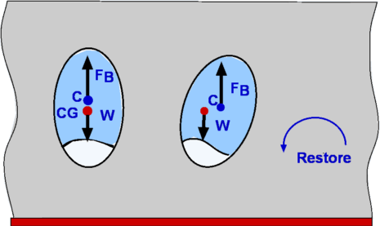
Figure 1: stability of immersed bodies

An overturning couple leading to unstable equilibrium results if the center of gravity is above the center of buoyancy (Fig.2).

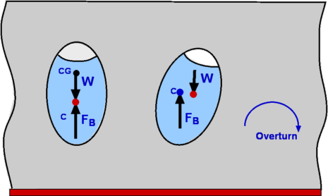

Figure 2: instability of immersed bodies

It becomes more complicated when floating bodies are considered. Now as the body rotates responding to any disturbance the center of buoyancy can shift. This could render the body stable even though the center of gravity is above the center of buoyancy.
This is particularly true of the bodies with a broader base such as a barge (Fig. 3). A slender body as shown in Fig. 4 is very susceptible for instability.
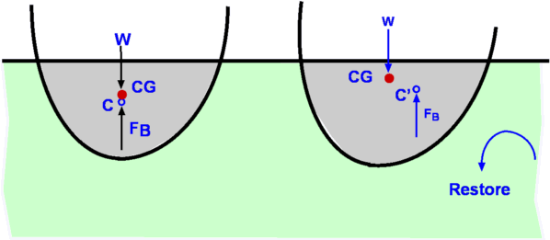
Figure 3: stability of floating bodies

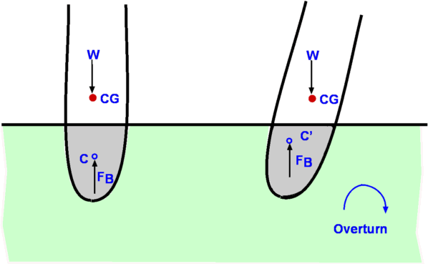

Figure 4: instability of floating bodies
***************************************************************************
- META CENTRE
(Material for exam)
When a small angular displacement is given to a body floating in a liquid, it starts oscillation about some point M. This point about which the body starts oscillating is called the metacentre

Metacentre (M) may be defined as the point of intersection of the axis of body passing through centre of gravity (G) and original centre of buoyancy (B) and a vertical line passing through the new centre of buoyancy (B¹) of the titled position of the body.

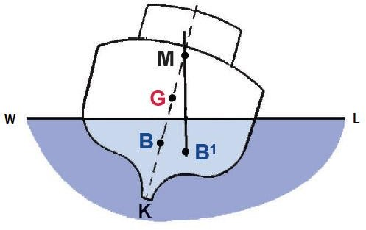

Metacentric height: The distance between the centre of gravity of a floating body and the metacentre, i.e. distance GM is called meta-centric height. Relation between centre of gravity and metacentre in different three types of equilibrium:
- Stable equilibrium: In this, position of metacentre (M) remains higher than centre of gravity of body.
- Unstable equilibrium: In this position of metacentre (M) remains lower than centre of gravity of body.
- Neutral equilibrium: The position of metacentre (M) coincides with centre of gravity of body.
*****************************************************************************
- EXPERIMENTAL DETERMINATION OF A METACENTRIC HEIGHT OF A SHIP
(Material for exam)

Inclining Experiment- Determining Metacentric height of the ship
The Metacentric height of the ship plays an important role in setting the loading capacity and stability of the ship. The Initial metacentric height of the ship is determined by an inclining experiment after the ship is completely built.
lets consider a ship which was in eqilibrium is now inclined by an angle θ.

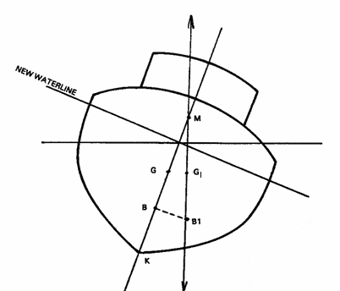

When a ship is heeled by an angle, the center of buoyancy is shifted from B to B1.When a vertical line is drawn from B and B1, they intersect at a point known as metacentre of the ship. The metacentric height is the distance between the centre of gravity and metacentre of the ship i.e. GM and it is used to calculate the stability of the ship.

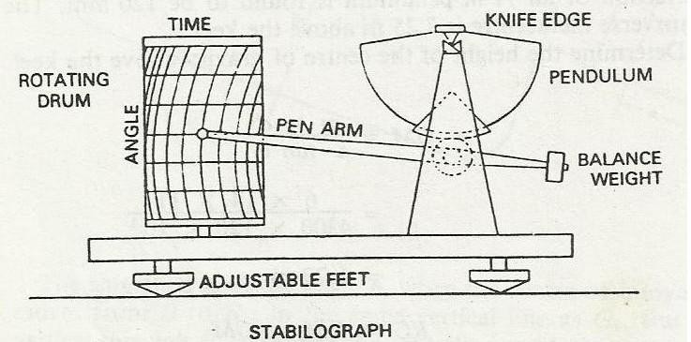

Inclining Experiment Requirements
- The experiment is carried out when the ship is built completely or when major structural changes have been done.

- The experiment is carried out with empty ship or as near to empty ship as possible.
- The ship must be in upright position.
- The ship should be sheltered and in calm waters.
- Mooring ropes should be slackened and gangway lifted.
- Draught and density of water are to be correctly noted.
- All tanks in the ship must be empty or pressed up tight to reduce free surface effect.
- Only those people responsible for conducting the experiment must go onboard.

The Experiment

To conduct this experiment, a special tool known as stabilograph is required. The tool consists of a heavy metal pendulum balanced on a knife edge and connected to a pointer to record the heel angle readings.
Normally minimum of two stabilographs are used and are placed at maximum distance from each other i.e. one in forward and one at aft.
Four masses are placed on the ships deck, two on each side of the mid ship, placed away from the centre line.
In the next step, the masses are moved one at a time until all four are on the same side, then all four on the other side, and lastly two on each side.
The deflection on both the stabilographs is recorded for all the movement of mass and an average of these readings are used to determine metacentric height.
Suppose θ is the angle of heel and G1 is the moved position of the centre of gravity after inclination. Then by trigonometry,
GG1= GM tanθ
Also GG1 is = m x d/Δ Where m= mass moved
d= distance by which the mass is moved Δ= displacement of ship in water
Hence GM = m x d /Δtanθ and GM is metacentric height
Where tanθ can be determined by the readings of stabilograph.
*****************************************************************

ATMOSPHERIC PRESSURE
Atmospheric pressure is a force in an area pushed against a surface by the weight of the atmosphere of Earth, a layer of air. This is because high places do not

have as much air above them, pushing down. Barometers can be used to measure atmospheric pressure.

- THE BAROMETER
(Material for exam)

Barometer, device used to measure atmospheric pressure. Because atmospheric pressure changes with distance above or below sea level, a barometer can also be used to measure altitude.

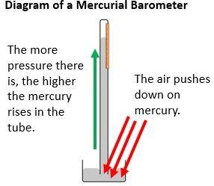
There are two main types of barometers: mercury and aneroid.
In the mercury barometer, Air pressure pushes down on the surface of the mercury, making some rise up the tube. The greater the air pressure, the higher the mercury rises. You can read the pressure off a scale marked onto the glass.
atmospheric pressure balances a column of mercury, the height of which can be precisely measured. To increase their accuracy, mercury barometers are often corrected for ambient temperature and the local value of gravity.

Pressure : SI unit called the Pascal
A nonliquid barometer called the aneroid barometer is used in portable instruments and in aircraft altimeters because of its smaller size and convenience.
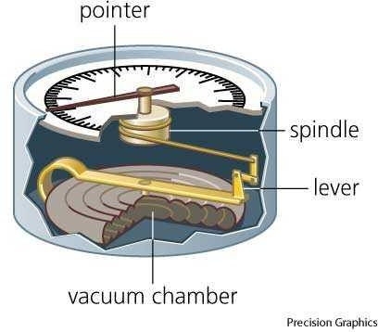Aneroid barometer

It contains a flexible-walled evacuated capsule, the wall of which deflects with changes in atmospheric pressure. This deflection is coupled to an indicating needle.
A barometer that mechanically records changes in barometric pressure over time is called a barograph.
*******************************************************
- FORTIN’S BAROMETER
(Material for exam)
The barometer is an instrument used to measure atmospheric pressure. Fortin’s barometer is a modified form of Torricelli’s simple barometer.

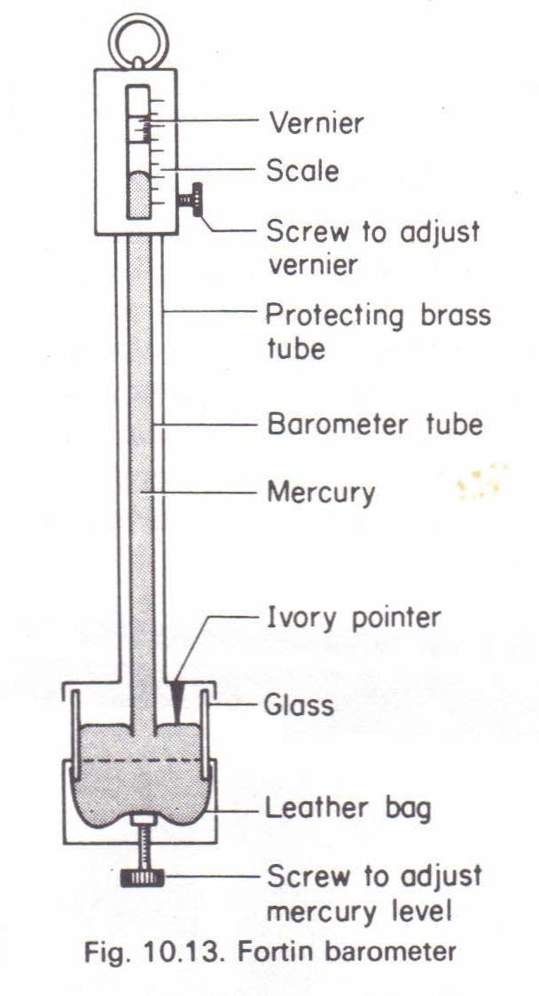

Construction

A Fortin’s barometer consists of a narrow glass tube of length about 90 cm. This tube is closed at one end. The tube is completely filled with mercury and kept inverted in a cistern filled with dry mercury. Usually, the glass tube is protected by enclosing it in a brass tube.
The upper part of the brass tube has a slit that enables the level of the mercury in the glass tube to be seen. A scale graduated in millimetres is attached to the brass tube. This functions as the main scale.
For accurate measurement, a vernier scale that can slide over the main scale is also fixed to the barometer. The vernier scale can be moved up and down using a screw.

The bottom of the cistern is like a bag made of flexible leather. The mercury level can be adjusted by means of a screw provided underneath. There is an ivory pointer in the cistern, placed at the top. The tip of this pointer coincides with the zero of the main scale.

The level of the mercury column in the cistern can be changed with the screw under it. It is so adjusted that the ivory point is exactly at the surface of the mercury in the cistern. The whole apparatus is fixed in a vertical position.

Working

Any change in the atmospheric pressure is accompanied by an immediate change in the level of the mercury in the glass tube. As the height of the mercury column in the barometer changes, mercury flows between the tube and cistern. As a result, the level of the mercury in the cistern also changes.
To determine the length of the mercury column in the barometer, it is necessary to know the position of the free surface in the cistern as well as in the tube.
The first step in measuring atmospheric pressure using Fortin’s barometer is to set the mercury level in the cistern. Using the adjustment screw, set the level of the mercury in the cistern such that the ivory pointer just touches the mercury.
The reading of the top of the mercury column is then measured using both the main scale and the vernier scale. Before the readings are noted, the vernier scale needs to be positioned properly.
The vernier scale is to be adjusted so that its edge and the corresponding reading in the main scale just set tangentially to the meniscus.
Now, the readings on the main scale and the vernier scale are noted, and the atmospheric pressure is calculated.

Advantages

The main advantages of Fortin’s barometer are:
- It is portable.
- It allows the mercury level in the cistern to be set to zero. This makes the reading more accurate.
***********************************************************
- CORRECTION FOR A BAROMETER
(Material for exam)

Correction of barometer readings:
The mercury barometer’s reading should be corrected to the one and the standard condition.
Standard condition is defined as a temperature of 0 °C, where the density of mercury is13.5951 g/cm3 and a gravity acceleration of 980.665 cm/s2.

During actual observation, the reading should be corrected for the index error, temperature correction, and gravity acceleration as follows:

- Corrections on index error
Individual mercury barometers include index errors (difference between the value indicated by an individual instrument and that of the standard). The index error is found by comparison with the standard, and the value is stated on a "comparison certificate".

- Corrections for temperature
The temperature correction means to correct a barometric reading, obtained at a certain temperature, to a value when mercury and graduation temperatures are 0 °C. The temperature of the attached thermometer is used for this purpose.
The height of the mercury column varies with temperature, even the atmospheric pressure is unchanged. The graduation of the barometer is engraved so that the correct pressure is indicated when temperature is 0
°C. In a case that when temperature is above 0 °C, the graduation expands and the measured value will be smaller than the true value.
This effect of temperature must be corrected from these two aspects collectively.
The correction value for temperature Ct is expressed as follows:
Ct = - H (μ – λ)t / 1 + μt
where:
H hPa is the barometric reading after the correction for index error.
t °C is the temperature indicated by the attached thermometer. μ is the volume expansion coefficient of mercury.
λ is the linear expansion coefficient of the tube.
There is a small difference in absolute values for correction between temperatures below and above 0 °C. The values for correction at temperatures above 0 °C are negative and those below 0 °C are positive.

- Corrections for gravity

Gravity affects the height of the mercury column. After the corrections for index error and temperature, the reading under the local acceleration of gravity has to be reduced to the one under the standard gravity acceleration. This is called corrections for gravity.
The gravity value for correction Cg is derived by:
C_{g} ₌ H₀ – H = H ( g – g₀ / g₀ )
where:
g₀ is the standard gravity acceleration.
g is the gravity acceleration at an observing point.
H is the barometric reading after the index error and temperature corrections
H₀ is the value already corrected for gravitation

When the gravity acceleration at the observing point is larger than the standard gravity acceleration, the gravity value for correction is positive. Otherwise, the value for correction is negative.
********************************************************
- FAULTY BAROMETER
(Material for exam)
A faulty barometer contains certains amount of air and saturated water vapour A barometer is faulty. When the true barometer reading are 73 and 75 cm of Hg, the
faulty barometer reads 69 cm and 70 cm respectively. What is the true .reading when the faulty barometer reads 69.5 cm?

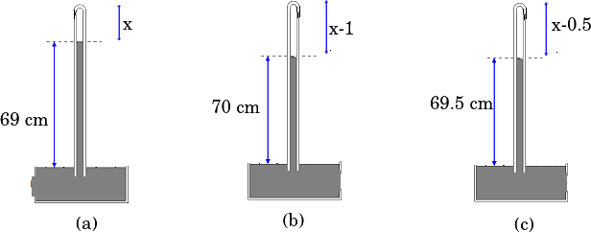

ANSWER
Let the density of mercury and cross section area of barometer be ρ and A respectively. For faulty barometer, Po=ρgh+Pair

Case (a): ρg(73)=ρg(69)+P1 ⟹P1=ρg(4) Case (b): ρg(75)=ρg(70)+P2 ⟹P2=ρg(5) Also P1V1=P2V2
∴ ρg(4)×Ax=ρg(5)×A(x−1) ⟹x=5cm

Case (c): Let the true pressure be shown by barometer reading h

Using P1V1=P3V3 where V3=A (x−0.5) = A (4.5)

∴ ρg(4)×A(5)=P3×A(4.5) ⟹P3=ρg(4.44)

∴ ρgh = ρg(69.5)+ρg(4.44) ⟹h=73.94cm

The true reading of the barometer will be 73.94 cm.
*****************************************************************
- VARIATION OF ATMOSPHERIC PRESURE WITH ALTITUDE
(Material for exam)
Atmospheric pressure, also known as barometric pressure is the pressure within the atmosphere of Earth.
The standard atmosphere (symbol: atm) is a unit of pressure defined as
101,325 Pa , which is equivalent to 760 mm Hg. The Earth's atmospheric pressure at sea level is approximately 1 atm.
The pressure at any level in the atmosphere may be interpreted as the total weight of the air above a unit area at any elevation. At higher elevations, there are
fewer air molecules above a given surface than a similar surface at lower levels. So that the pressure decreases with increasing altitude.

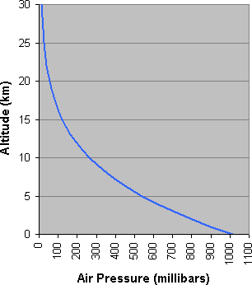

Pressure on Earth varies with the altitude of the surface. So air pressure on mountains is usually lower than air pressure at sea level.
Pressure varies smoothly from the Earth's surface to the top of the mesosphere. Although the pressure changes with the weather that is Temperature and humidity also affect the atmospheric pressure.

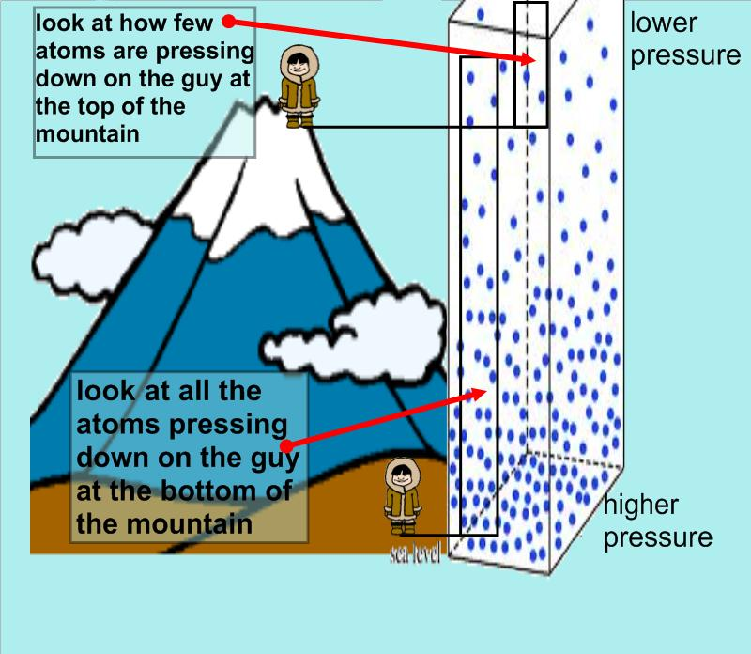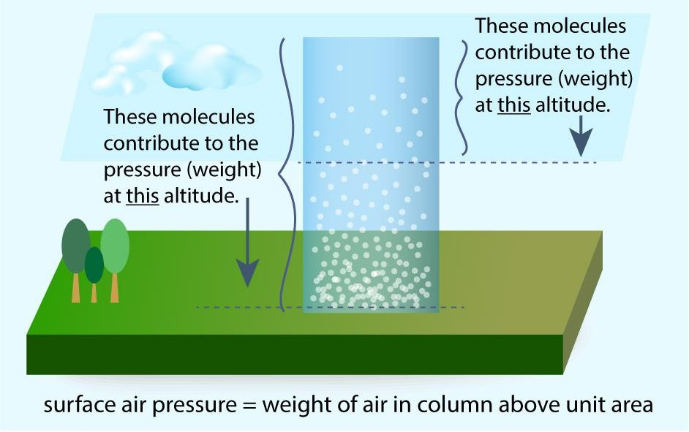

******************************************************************
******************************************************************
Prepare well All the best

