AIMAN COLLEGE OF ARTS &SCIENCE, TRICHY

Department of Physics

Subject Title: Mechanics
Subject Code: 16SCCPH2
Semester: 2

UNIT III-GRAVITATION

Topic-Orbital Velocity & Escape velocity
Definition
Orbital velocity is the velocity at which a body revolves around the other body. Objects that travel in uniform circular motion around the Earth are said to be in orbit. The velocity of this orbit depends on the distance between the object and the centre of the earth.
This velocity is usually given to the artificial satellites so that it revolves around any particular planet.
The orbital velocity formula is given by,
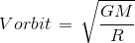
Where,
G = gravitational constant,
M = mass of the body at centre, R = radius of orbit.
Orbital Velocity Formula is applied to calculate the orbital velocity of the any planet if mass M and radius R are known.
Orbital Velocity is expressed in meter per second (m/s). Question 1:
Calculate the orbital velocity of earth so that the satellite revolves round the earth if radius of earth R = 6.5 × 10⁶ m, mass of earth M = 5.5 × 10²⁴ kg and Gravitational constant G =
6.67 × 10⁻¹¹ Nm²kg⁻²

Solution:
Given:
R = 6.5 × 10⁶ m
M = 5.5 × 10²⁴ kg
G = 6.6 × 10⁻¹¹ Nm²kg⁻²
The Orbital velocity formula is given by Vorbit = √GM / R
= √6.67 ×10⁻¹¹ × 5.5×10²⁴ / 6.5 ×10⁶
= √36.68 x 10¹³ / 6.5 x 10⁶
= 7.5 km/s

Example 2:
A satellite launch is made for the study of Jupiter. Determine its velocity so that it orbit round the Jupiter.
Given: Radius of Jupiter R = 70.5 × 10⁶ m, Mass of Jupiter M = 1.5 × 10²⁷ Kg,
Gravitational constant G = 6.67 × 10⁻¹¹ Nm²kg⁻²

Solution:
When the given parameters are substituted in the orbital velocity formula, we get
Vorbit = √GM / R
= √6.673×10⁻¹¹×1.5×10²⁷ / 70.5×10⁶
= √10.0095 x 10¹⁶ / 70.5 x 10⁶
= √0.141 x 10¹⁰
3.754 x 10⁹ m/s.
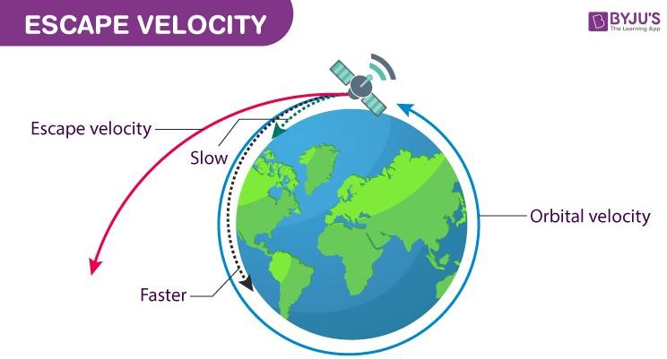

Escape velocity is the speed that an object needs to be travelling to break free of a planet and leave it without further propulsion. For example, a spacecraft leaving the surface of Earth needs to be going 7 miles per second to leave without falling back to the surface or falling into orbit.

Definition
Escape velocity of the earth is referred to as the minimum velocity needed by anybody or object to be projected to overcome the gravitational pull of the planet earth. In other words, the minimum velocity that one requires to escape the gravitational field is escape velocity.

Basically, it means escaping the land without any chance of falling back. Therefore, any object or body having escape velocity on the surface of the earth can totally escape the gravitational field of the earth in addition to avoiding the losses due to the atmosphere.

Escape Velocity Formula
Escape velocity refers to the minimum velocity which is needed to leave a planet or moon. For instance, for any rocket or some other object to leave a planet, it has to overcome the pull of gravity.

The formula for escape velocity comprises of a constant, G, which we refer to as the universal gravitational constant. The value of it is = 6.673 × 10⁻¹¹ N m² / kg². The unit for escape velocity is meters per second (m/s).

Escape velocity = v escape = √2GM/R
v escape refers to the escape velocity (m/s)
G is the universal gravitational constant (6.673 × 10⁻¹¹ N m² / kg²) M refers to the mass of the planet or moon (kg)
R is the radius of the planet or moon (m)

Solved Question
Question– Suppose the radius of Earth is 6.38 × 10⁶ m and the mass of the planet earth is 5.98 × 10²⁴ kg. Find out the escape velocity from planet earth.
Answer– We can find the escape velocity from earth using the escape velocity formula: vescape = √2GM/R
Thus, when we replace it with figures, we will get:
vescape =√ 2(6.673×10⁻¹¹)(5.98×10²⁴)/6.38×10⁶
vescape = 11184 m/s
Therefore, the escape velocity from Earth is 11 184 m/s, or approximately 11.2 km/s.

Question– In order to leave the moon, the Apollo astronauts had to take off in the lunar mobile and reach the escape velocity of the moon. The radius of the moon is 1.74 × 10⁶ m, and the mass of the moon is 7.35 × 10²² kg. Calculate the velocity which the Apollo astronauts have to reach in order to leave the moon?

Answer– We can find the escape velocity from the moon using the escape velocity formula: vescape =√ 2GM/R
vescape= √2(6.673×10−11)(7.35×1022) /1.74×106

vescape=2374 m/s

