AIMAN College of Arts and Science for Women
Department of Physics

Subject code: Electricity and Magnetism
Subject Title: 16SCCPH4
SEMSTER: 4

Faraday’s Laws of Electromagnetic Induction
Faraday’s Laws of Electromagnetic Induction consists of two laws. The first law describes the induction of emf in a conductor and the second law quantifies the emf produced in the conductor. In the next few sections, let us learn these laws in detail.

Faraday’s First Law of Electromagnetic Induction
The discovery and understanding of electromagnetic induction are based on a long series of experiments carried out by Faraday and Henry. From the experimental observations, Faraday arrived at a conclusion that an emf is induced in the coil when the magnetic flux across the coil changes with time. With this in mind, Faraday formulated his first law of electromagnetic induction as,
Whenever a conductor is placed in a varying magnetic field, an electromotive force is induced. If the conductor circuit is closed, a current is induced which is called induced current.

Changing the Magnetic Field Intensity in a Closed Loop
Mentioned here are a few ways to change the magnetic field intensity in a closed loop:
- By rotating the coil relative to the magnet.
- By moving the coil into or out of the magnetic field.
- By changing the area of a coil placed in the magnetic field.
- By moving a magnet towards or away from the coil.

Faraday’s Second Law of Electromagnetic Induction
Faraday’s second law of electromagnetic induction states that
The induced emf in a coil is equal to the rate of change of flux linkage.
The flux is the product of the number of turns in the coil and the flux associated with the coil. The formula of Faraday’s law is given below:
ε=−NΔϕ/Δt
Where,
- ε is the electromotive force
- Φ is the magnetic flux
- N is the number of turns
The negative sign indicates that the direction of the induced emf and change in direction of magnetic fields have opposite signs.

What do you mean by self inductance?
Self inductance is defined as the induction of a voltage in a current-carrying wire when the current in the wire itself is changing. In the case of self-inductance, the magnetic field created by a changing current in the circuit itself induces a voltage in the same circuit. Therefore, the voltage is self-induced.

What is Mutual Inductance?
Mutual Inductance between the two coils is defined as the property of the coil due to which it opposes the change of current in the other coil, or neighbouring coil. When the current in the neighbouring coil changes, the flux sets up in the coil and because of this, changing flux emf is induced in the coil called Mutually Induced emf and the phenomenon is known as Mutual Inductance.
What is Lenz law?
Lenz's law. Lenz's law is an important concept in electromagnetism. It states that when a voltage is created by a change in magnetic flux, the induced voltage must create a current whose magnetic field is in opposition to the change which produces it.

What is called resonance?
Resonance, An object free to vibrate tends to do so at a specific rate called the object's natural, or resonant, frequency. ... Such an object will vibrate strongly when it is subjected to vibrations or regular impulses at a frequency equal to or very close to its natural frequency. This phenomenon is called resonance.

What is co-efficient of coupling?

Coefficient Of Coupling
The fraction of magnetic flux produced by the current in one coil that links with the other coil is called the coefficient of coupling between the two coils. It is denoted by (k).
Two coils are taken coil A and coil B, when current flows through one coil it produces flux; the whole flux may not link with the other coil coupled, and this is because of leakage flux by a fraction (k) known as Coefficient Of Coupling.
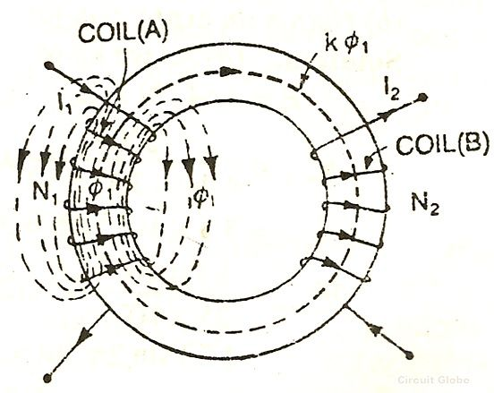
k=1, when the flux produced by one coil, completely links with the other coil and is called magnetically tightly coupled.
k=0, when the flux produced by one coil, does not link at all with the other coil and thus the coils are said to be magnetically isolated.
DERIVATION
Consider two magnetic coils A and B. When current I₁ flows through coil A.
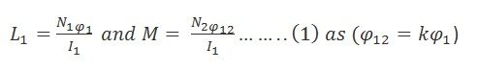
Considering coil B in which current I₂ flows
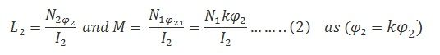
Multiplying equation (1) and (2)
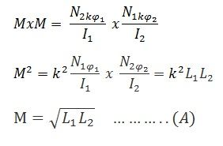
The above equation (A) shows the relationship between mutual inductance and self-inductance between the two coils
What is Amperes circulate law?
Amperes circulate law: The line integral of magnetic field of induction B around any closed path in free space is equal to absolute permeability of free space μ0​ times the total current flowing through area bounded by the path.
Mathematically, ϕB⋅dl=μ₀​I
where B-magnetic induction, I-Total current, dl-length element of path, μ₀​-Permeability of the space.

Define : Ballistic Galvanometer
Definition: The galvanometer which is used for estimating the quantity of charge flow through it is called the ballistic galvanometer. The working principle of the ballistic galvanometer is very simple. It depends on the deflection of the coil which is directly proportional to the charge passes through it. The galvanometer measures the majority of the charge passes through it in spite of current.

What are the uses of ballistic galvanometer?
A ballistic galvanometer is a type of sensitive galvanometer; commonly a mirror galvanometer. Unlike a current-measuring galvanometer, the moving part has a large moment of inertia, thus giving it a long oscillation period. It is really an integrator measuring the quantity of charge discharged through it.
What is meant by figure of merit of galvanometer?
Figure of merit is in general is the numerical value representing the degree of effectiveness or efficiency of an instrument approximated by different estimation techniques. The figure of merit of a galvanometer is the current required to produce a deflection of one division in the galvanometer scale.

What is the balancing condition of Wheatstone bridge?
The bridge is in balance condition when no current flows through the coil or the potential difference across the galvanometer is zero. This condition occurs when the potential difference across the a to b and a to d are equal, and the potential differences across the b to c and c to d remain same

What is specific resistance?
Specific resistance is defined as the resistance offered per unit length and unit cross-sectional area when the known amount of voltage is applied.

What do you mean by Curie temperature?
Curie point, also called Curie Temperature, temperature at which certain magnetic materials undergo a sharp change in their magnetic properties. In the case of rocks and minerals, remanent magnetism appears below the Curie point—about 570 °C (1,060 °F) for the common magnetic mineral magnetite.

Definition of coercive force
The opposing magnetic intensity that must be applied to a magnetized material to remove the residual magnetism
What is hysteresis loss?
Hysteresis loss is due to the reversal of magnetization of transformer core whenever it is subjected to alternating nature of magnetizing force . Whenever the core is subjected to an alternating magnetic field, the domain present in the material will change their orientation after every half cycle.

What is hysteresis loop?
A great deal of information can be learned about the magnetic properties of a material by studying its hysteresis loop. A hysteresis loop shows the relationship between the induced magnetic flux density (B) and the magnetizing force (H). It is often referred to as the B-H loop. An example hysteresis loop is shown below.
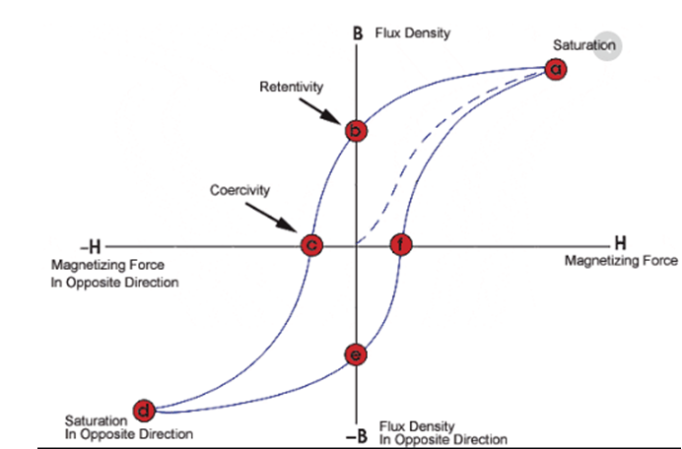

What is meant by magnetic susceptibility?
Magnetic susceptibility is a dimensionless proportionality constant that indicates the degree of magnetization of a material in response to an applied magnetic field. A related term is magnetizability, the proportion between magnetic moment and magnetic flux density.

