AIMAN COLLEGE OF ARTS & SCIENCE FOR WOMEN,TIRUCHIRAPPALLI

Class : I M.Sc Computer Science – II Semester

Subject Title : OOAD and UML

Subject Code : P16CS21

Staff Name : D. Lena Vino

Designation : Asst. Professor

UNIT 1
INRODUCTION
1.1 An Overview of Object Oriented System and Development
1.2 Object Oriented Systems Development Life Cycle
1.1 An Overview of Object Oriented System and Development
INTRODUCTION:
Software development is dynamic and always undergoing major change. Today a vast number of tools and methodologies are available for system development.
System development refers to all activities that go into producing information system solution. System development activities consist of system analysis, modelling, design, implementation, testing and maintenance. A software development methodology is series of processes that, if followed, can lead to the development of an application. The original goal based on the system requirements. Further we study about the unified approach, which is the methodology used for learning about object oriented system development. Object-Oriented (OO) systems development is a way to develop software by building self-contained modules that can be more easily:

- Replaced
- Modified and
- Reused.

Orthogonal View of the Software
A software system is a set of mechanism for performing certain action on certain data
“Algorithm + Data structure = Program”

Object Oriented System Development Methodology

- OO development offers a different model from the traditional software development approach. This is based on functions and procedures.

- To develop s/w by building self-contained modules or objects that can be easily replaced, modified and reused.

- In OO environment, s/w is a collection of discrete object that encapsulate their data as well as the functionality to model real world ―”objects”

- Each object has attributes (data) and method (function).

- Objects grouped in to classes and objects are responsible for itself

- A chart object is responsible for things like maintaining its data and labels and even for drawing itself.

Benefits of Object Orientation
- Faster development
- Reusability
- Increased quality
- Object technology emphasizes modeling the real world and provides us with the stronger equivalence of the real world‘s entities (objects) than other methodologies.
- Raising the level of abstraction to the point where application can be implemented in the same terms as they are described
Why object orientation?
To create sets of objects that work together concurrently to produce s/w that better, model their problem domain that similarly system produced by traditional techniques.
- It adapts to
- Changing requirements
- Easier to maintain
- More robust
- Promote greater design
- Code reuse
- Higher level of abstraction
- Seamless transition among different phases of software development
- Encouragement of good programming techniques
- Promotion of reusability
Overview of the Unified Approach
- The unified approach (UA) is a methodology for software development that is used in this book.
- The UA, based on methodologies by Booch, Rumbaugh, Jacobson, and others, tries to combine the best practices, processes, and guidelines.
- UA based on methodologies by Booch, Rumbaugh and Jacobson tries to combine the best practices, processes and guidelines along with the object management groups in unified modelling language.
- UML is a set of notations and conventions used to describe and model an application.
- UA utilizes the unified modeling language (UML) which is a set of notations and conventions used to describe and model an application.
1.2 Object-Oriented Systems Development activities
Goals
- The software development process
- Building high-quality software
- Object-oriented systems development
- Use-case driven systems development
- Prototyping
- Rapid application development
- Component-based development
- Continuous testing and reusability
Software Process
The essence of the software process is the transformation of
- Users‘ needs to
- The application domain into
- software solution.
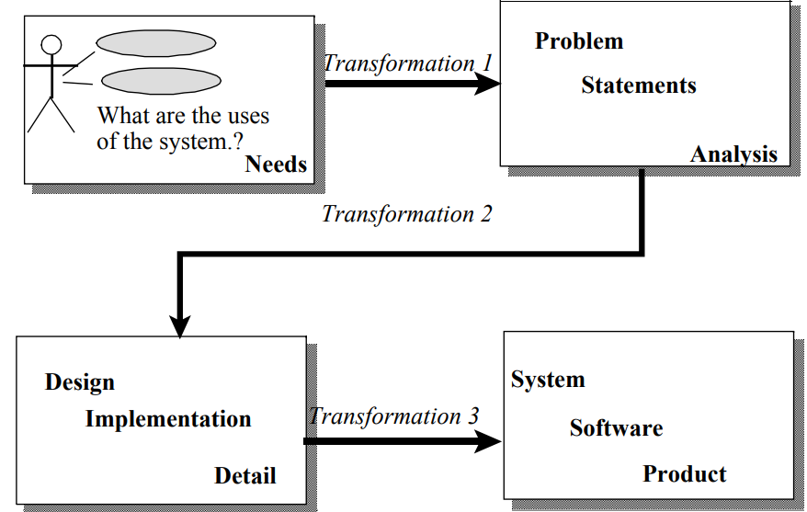
Traditional Waterfall Approach to Systems Development
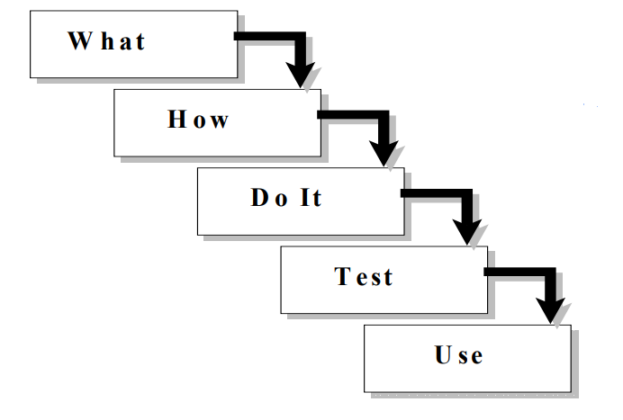
Software Quality
- There are two basic approaches to systems testing.
- We can test a system according to how it has been built.
- Alternatively, we can test the system with respect to what it should do.
Quality Measures
- Systems can be evaluated in terms of four quality measures:
  - Correspondence
  - Correctness
  - Verification
  - Validation
- Correspondence measures how well the delivered system corresponds to the needs of the operational environment.
It cannot be determined until the system is in place.
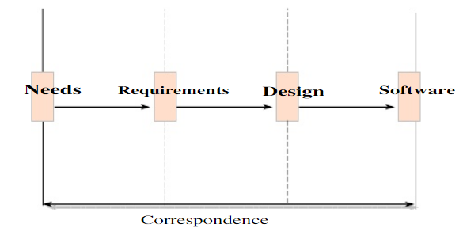
- Correctness measures the consistency of the product requirements with respect to the design specification.

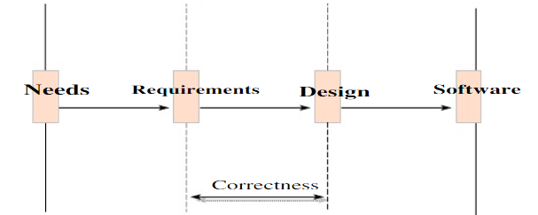

- Verification- "Am I building the product right?"
- Validation- "Am I building the right product?"
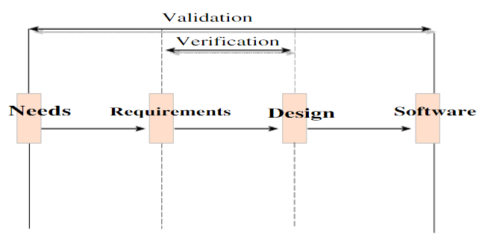
- Verification is to predict the correctness.
- Validation is to predict the correspondence.

Object-Oriented Systems Development Approach
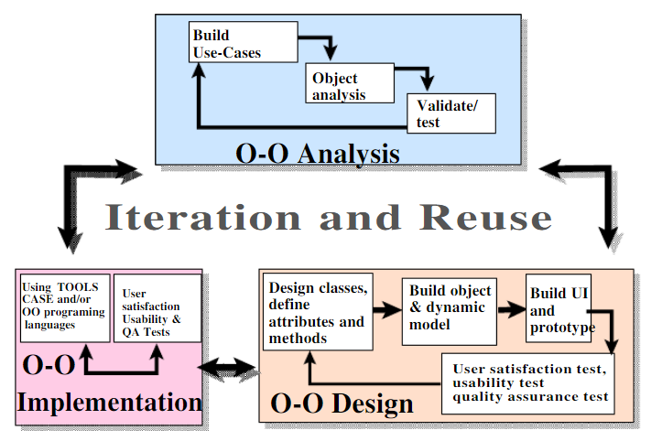
Object-Oriented Systems Development activities
- Object-oriented analysis.
- Object-oriented design.
- Prototyping.
- Component-based development.
- Incremental testing.
Use-case driven systems development
Use Case, is a name for a scenario to describe the user – computer system interaction
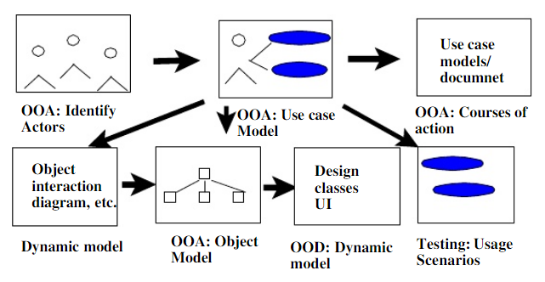
Object-Oriented Analysis
OO analysis concerns with determining the system requirements and identifying classes and their relationships that make up an application.
Object-Oriented Design
- The goal of object-oriented design (OOD) is to design
- The classes identified during the analysis phase,
- The user interface and
- Data access.
OOD activities include:
- Design and refine classes.
  - Design and refine attributes.
  - Design and refine methods.
  - Design and refine structures.
  - Design and refine associations.
- Design User Interface or View layer classes.
- Design data Access Layer classes.
Prototyping
- A Prototype enables you to fully understand how easy or difficult it will be to implement some of the features of the system.
- It can also give users a chance to comment on the usability and usefulness of the design.
Types of Prototypes
- A horizontal prototype is a simulation of the interface.
- A vertical prototype is a subset of the system features with complete functionality.
- An analysis prototype is an aid for exploring the problem domain.
- A domain prototype is an aid for the incremental development of the ultimatesoftware solution.
Component-based development (CBD)
- CBD is an industrialized approach to the software development process.
- Application development moves from custom development to assembly of pre-built, pre-tested, reusable software components that operate with each other.

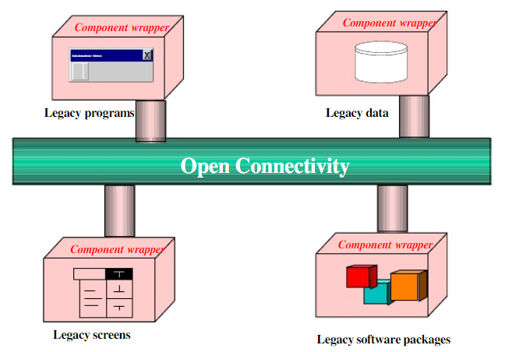

Rapid Application Development (RAD)
- RAD is a set of tools and techniques that can be used to build an application faster than typically possible with traditional methods.
- RAD does not replace SDLC but complements it, since it focuses more on process description and can be combined perfectly with the object-oriented approach.
Incremental Testing
- Software development and all of its activities including testing are an iterative process.
- If you wait until after development to test an application for bugs and performance, you could be wasting thousands of dollars and hours of time.
Reusability
A major benefit of object-oriented systems development is reusability, and this is the most difficult promise to deliver on.
Reuse strategy
- Information hiding (encapsulation).
- Conformance to naming standards.
- Creation and administration of an object repository.
- Encouragement by strategic management of reuse as opposed to constant redevelopment.
- Establishing targets for a percentage of the objects in the project to be reused (i.e.,50 percent reuse of objects).
The essence of the software process is the transformation of users‘ needs into a software solution. The O-O SDLC is an iterative process and is divided into analysis, design, prototyping/ implementation, and testing.

Unit II
OBJECT ORIENTED METHODOLOGIES

2.1 Rumbaugh Methodologies
2.2 Booch Methodology
2.3 Jacobson Methodology
2.4 Patterns
2.5 Frameworks
2.6 Unified Approach
2.7 Unified Modeling Language
2.8 Use case
2.9 Class Diagram
2.10 Interactive Diagram
2.11 Sequence Diagram
2.12 Collaboration Diagram
2.13 State Diagram
2.14 Activity Diagram
2.15 Package Diagram
Basic Definition
- A methodology is explained as the science of methods.
- A method is a set of procedures in which a specific goal is approached step by step.
- Many methodologies are available to choose from for system development.
- Here, we look at the methodologies developed by Rumbaugh et al., Booch, and Jacobson which are the origins of the Unified Modeling Language (UML) and the bases of the UA
Strength of the Methods
- Rumbaug : Describing Object Model or the static structure of the system
- Jacobson: good for producing user-driven analysis models
- Booch : Detailed object-oriented design models

2.1. Rumbaugh Methodologies
OMT (Object Modeling Technique) describes a method for the analysis, design, and implementation of a system using an object-oriented technique. Class attributes, method, inheritance, and association also can be expressed easily
Phases of OMT
- Analysis
- System Design
- Object Design
- Implementation
OMT consists of four phases, which can be performed iteratively:
- Analysis: The results are objects and dynamic and functional models.
- System design: The result is a structure of the basic architecture of the system.
- Object design: This phase produces a design document, consisting of detailed objects and dynamic and functional models.
- Implementation: This activity produces reusable, extendible, and robust code.
OMT Modeling
OMT separates modeling into three different parts:
- An object model, presented by the object model and the data dictionary.
- A dynamic model, presented by the state diagrams and event flow diagrams.
- A functional model, presented by data flow and constraints.
Object Model
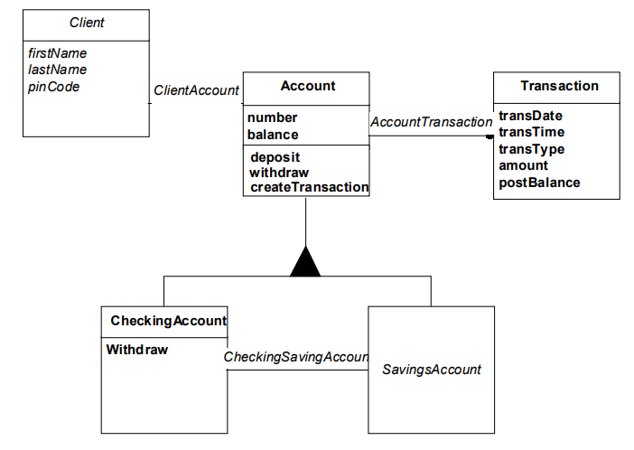
Dynamic Model
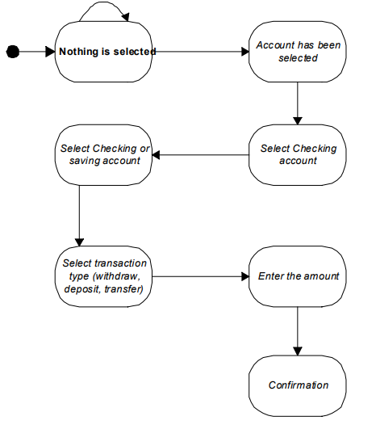
Functional Model
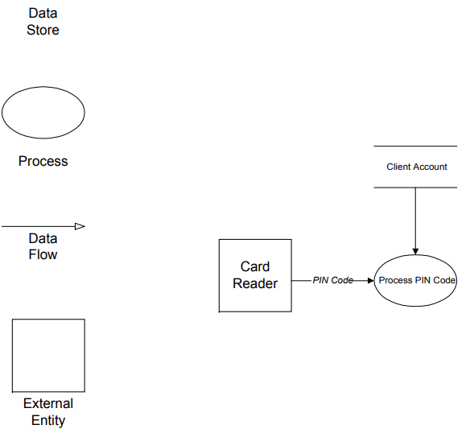
2. 2 Booch Methodology
- The Booch methodology covers the analysis and design phases of systems development.
- Booch sometimes is criticized for his large set of symbols.
- The Booch method consists of the following diagrams:
  - Class diagrams
  - Object diagrams
  - State transition diagrams
  - Module diagrams
  - Process diagrams
  - Interaction diagrams
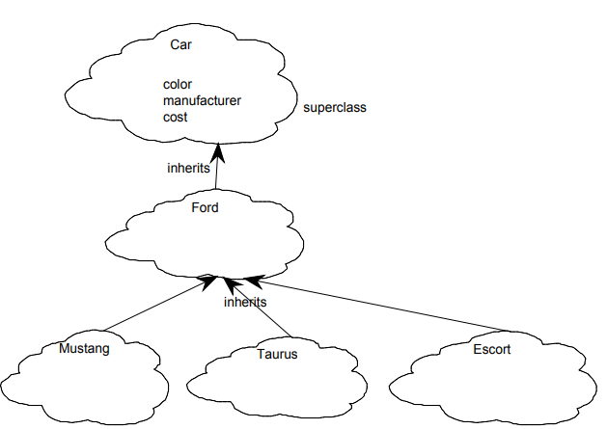
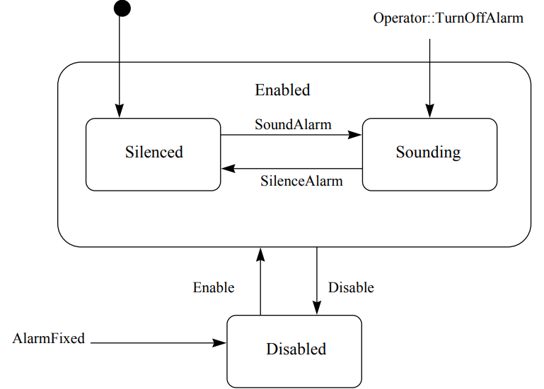
The Booch methodology prescribes
– A macro development process
– A micro development process.
The Macro Development Process
It servers as a controlling framework for the micro process. The primary concern is Technical Management of the System. The macro development process consists of the following steps:
- Conceptualization
- Analysis and development of the model.
- Design or create the system architecture.
- Evolution or implementation.
- Maintenance.
Conceptualization:
- Establish the core requirements of the system
- Establish a set of goals and develop prototype to prove the concept
Analysis and development of the model :
- Using the class diagram to describe the roles and responsibilities objects are to carry out in performing the desired behavior of the system
- Using the object diagram to describe the desired behavior of the system in terms of scenarios or, alternatively
- Using the interaction diagram to describe behavior of the system in terms of scenarios
Design or create the system architecture:
- Using the class diagram to decide what mechanisms are used to regulate how objects collaborate
- Using the module diagram to map out were each class and object should be declared
- Using the process diagram to determine to which processor to allocate a process. Also, determine the schedules for multiple processes on each relevant processor
Evolution or implementation
- Successively refine the system through many iterations
- Produce a stream of software implementations, each of which is refinement of the prior one
Maintenance
Make localized changes to the system to add new requirements and eliminate bugs

The Micro Development Process
The micro development process consists of the following steps:
- Identify classes and objects.
- Identify class and object semantics.
- Identify class and object relationships.
- Identify class and object interfaces and implementation.
2.3 Jacobson Methodologies
The Jacobson et al. methodologies (e.g., OOBE, OOSE, and Objectory) cover the entire lifecycle and stress traceability between the different phases.
Object-Oriented Software Engineering: Objectory
- Object-oriented software engineering (OOSE), also called Objectory, is a method of object-oriented development with the specific aim to fit the development of large,real-time systems.
- Objectory is built around several different models:
- Use case model.
- Domain object model.
- Analysis object model. Implementation model.
- Test model.
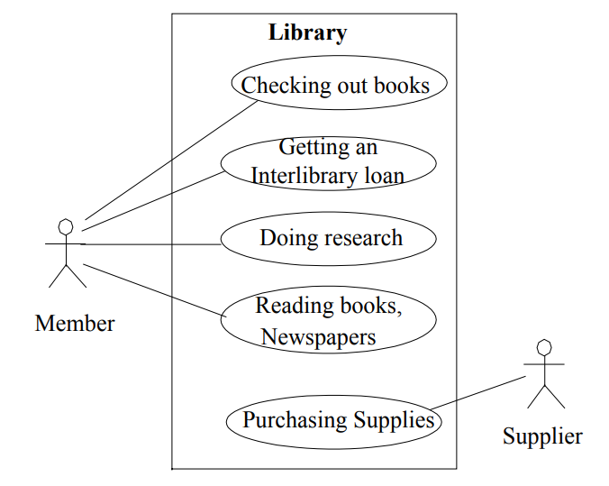

Object-Oriented Business Engineering (OOBE)
- Object-oriented business engineering (OOBE) is object modeling at the enterprise level.
- Use cases again are the central vehicle for modeling, providing traceability throughout the software engineering processes.
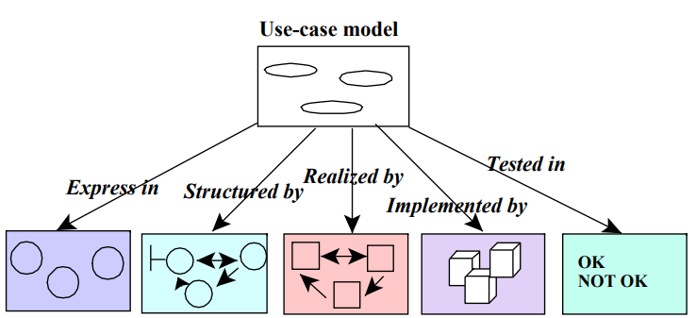

- OOBE consists of:
– Analysis phase
– Design
– Implementation phases and
– Testing phase.
2.4 Patterns
- A pattern is an instructive information that captures the essential structure and insight of a successful family of proven solutions to a recurring problem that arises within a certain context and system of forces.
- The main idea behind using patterns is to provide documentation to help categorize and communicate about solutions to recurring problems.
- The pattern has a name to facilitate discussion and the information it represents.
Good Patterns
A good pattern will do the following:
- It solves a problem. Patterns capture solutions, not just abstract principles or strategies.
- It is a proven concept. Patterns capture solutions with a track record, not theories or speculation.
- The solution is not obvious. The best patterns generate a solution to a problem indirectly — a necessary approach for the most difficult problems of design.
- It describes a relationship. Patterns do not just describe modules, but describe deeper system structures and mechanisms.
- The pattern has a significant human component. All software serves human comfort or quality of life; the best patterns explicitly appeal to aesthetics and utility.
Types of Patterns
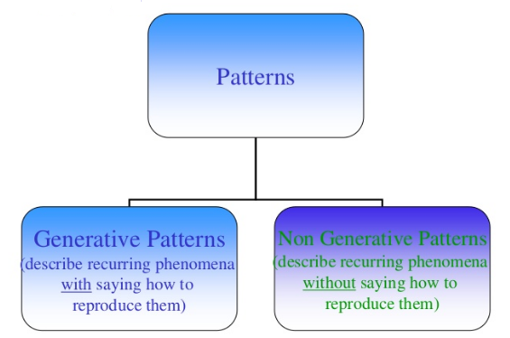
Patterns Template
Essential components should be clearly recognizable on reading a pattern:
- Name
- Problem
- Context
- Forces
- Solution
- Examples
- Resulting context
- Rationale
- Related Patterns
- Known uses

Guidelines for Capturing Patterns
- Focus on practicability
- Aggressive disregard of originality
- Non-anonymous review
- Writer’s workshops instead of presentations
- Careful editing
2.5 Frameworks
- A framework is a way of presenting a generic solution to a problem that can be applied to all levels in a development.
- A single framework typically encompasses several design patterns and can be viewed as the implementation of a system of design patterns.
Benefits of Frameworks
- Reusability
- Modularity
- Extensibility
- Inversion of Control
Differences Between Design Patterns and Frameworks
- Design patterns are more abstract than frameworks.
- Design patterns are smaller architectural elements than frameworks
- Design patterns are less specialized than frameworks
2.6 The Unified Approach
- The idea behind the UA is not to introduce yet another methodology.
- The main motivation here is to combine the best practices, processes, methodologies, and guidelines along with UML notations and diagrams
The Unified Approach (UA)
- The unified approach to software development revolves around (but is not limited to) the following processes and components.
- The UA processes are:
- Use-case driven development.
- Object-oriented analysis.
- Object-oriented design.
- Incremental development and prototyping.
- Continuous testing.
UA Methods and Technology
- Unified modeling language (UML) used for modeling.
- Layered approach.
- Repository for object-oriented system development patterns and frameworks.
- Promoting Component-based development.

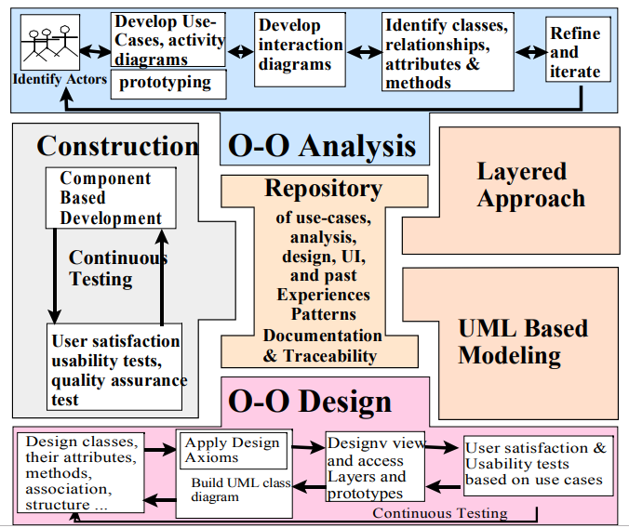
UA Object-Oriented Analysis: Use-Case Driven
- The use-case model captures the user requirements.
- The objects found during analysis lead us to model the classes.
- The interaction between objects provide a map for the design phase to model the relationships and designing classes.
UA Object-Oriented Design
- Booch provides the most comprehensive object-oriented design method.
- However, Booch methods can be somewhat imposing to learn and especially tricky to figure out where to start.
- UA realizes this by combining Jacobson et al.'s analysis with Booch's design concept to create a comprehensive design process.
Iterative Development and Continuous Testing
- The UA encourages the integration of testing plans from day 1 of the project.
- Usage scenarios or Use Cases can become test scenarios; therefore, use cases will drive the usability testing.
Modeling Based on the Unified Modeling Language
- The UA uses the unified modeling language (UML) to describe and model the analysis and design phases of system development.
The UA Proposed Repository
- The requirement, analysis, design, and implementation documents should be stored in the repository, so reports can be run on them for traceability.
- This allows us to produce designs that are traceable across requirements, analysis, design, implementation, and testing.
The Layered Approach to Software Development
Most systems developed with today's CASE tools or client-server application development environments tend to lean toward what is known as two-layered architecture: interface and data.
Two-Layer Architecture
In a two-layer system, user interface screens are tied directly to the data through routines that sit directly behind the screens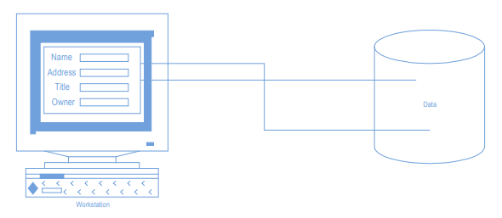Problem with the Two-Layer Architecture
This approach results in objects that are very specialized and cannot be reused easily in other projects.
Three-Layer Architecture
Your objects are completely independent of how:
    - they are represented to the user (through an interface) or
    - how they are physically stored.
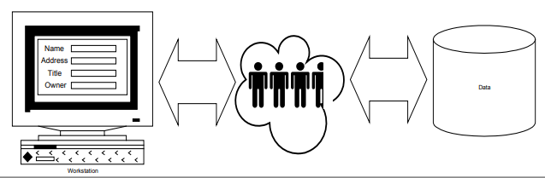
User Interface layer
This layer is typically responsible for two major aspects of the applications:
- Responding to user interaction
- Displaying business objects.
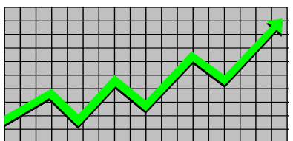
Business Layer
- The responsibilities of the business layer are very straight- forward.
- model the objects of the business and how they interact to accomplish the business processes.
Business Layer: Real Objects
These objects should not be responsible for:
- Displaying details
- Data access details
Access Layer
The access layer contains objects that know how to communicate with the place where the data actually resides, whether it is a relational database, mainframe, Internet, or file. The access layer has two major responsibilities:
- Translate request
- Translate result
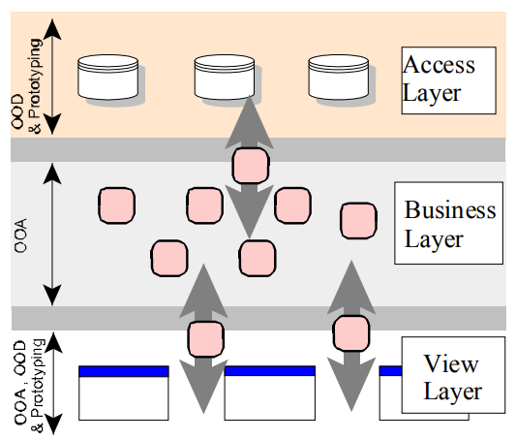
2.7 Unified Modeling Language
Modedling
A model is an abstract representation of a system, constructed to understand the system prior to building or modifying it. Most of the modeling techniques involve graphical languages.
Static or Dynamic Models
Static Model | Dynamic Model
- A static model can be viewed as "snapshot" of a system's parameters at rest or at a specific point in time. | - Is a collection of procedures or behaviors that, taken together, reflect the behavior of a system over time.
- The classes‘ structure and their relationships to each other frozen in time are examples of static models. | - For example, an order interacts with inventory to determine product availability.
Why Modeling?
- Turban cites the following advantages:
- Models make it easier to express complex ideas.
- For example, an architect builds a model to communicate ideas more easily to clients.
Advantages of Modeling
- Models reduce complexity by separating those aspects that are unimportant fromthose that are important.
- Models enhance learning.
- The cost of the modeling analysis is much lower than the cost of similar experimentation conducted with a real system.
- Manipulation of the model (changing variables) is much easier than manipulating areal system.
Modeling Key Ideas
- A model is rarely correct on the first try.
- Always seek the advice and criticism of others.
- Avoid excess model revisions, as they can distort the essence of your model. Let simplicity and elegance guide you through the process.
What Is the UML?
The Unified Modeling Language (UML) is a language for
- Specifying
- Visualizing
- Constructing
- Documenting the software system and its components.
What it is/isn’t?
Is NOT
- A process
- A formalism
Is
- A way to describe your software
- more precise than English
- less detailed than code

What is UML Used For?
- Trace external interactions with the software
- Plan the internal behavior of the application
- Study the software structure
- View the system architecture
- Trace behavior down to physical components
UML Diagrams
The UML defines nine graphical diagrams:
1. Class diagram (static)
2. Use-case diagram
3. Behavior diagrams (dynamic):
– 3.1. Interaction diagram:
3.1.1. Sequence diagram
3.1.2. Collaboration diagram
– 3.2. State chart diagram
– 3.3. Activity diagram
4. Implementation diagram:
4.1. Component diagram
4.2. Deployment diagram
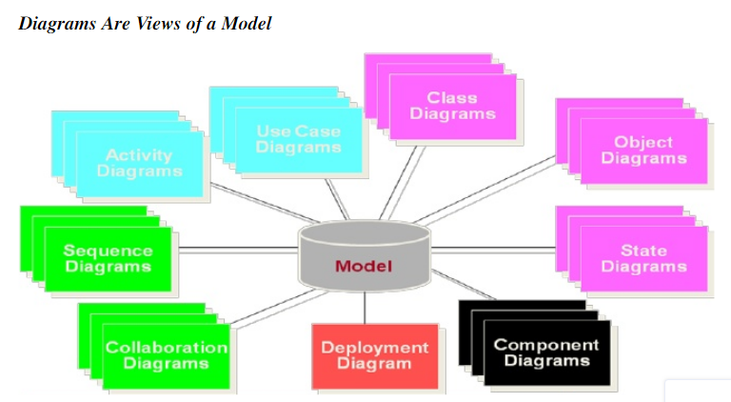
2.8 Use Case Diagram
- Use case diagrams are created to visualize the relationships between actors and use cases
- An actor is someone or something that must interact with the system under
development
- A use case is a pattern of behavior the system exhibits
- Use cases are written from an actor point of view
- Details what the system must provide to the actor when the use cases is executed
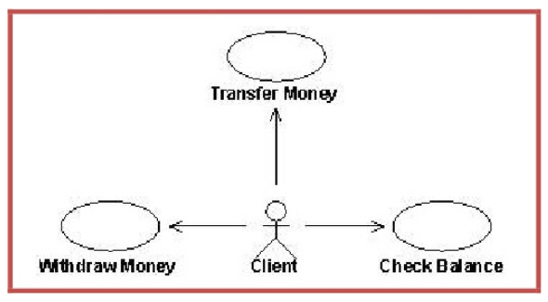
2.9 Class Diagrams
- A class diagram describes the types of objects in the system and the various kinds of static relationships that exist among them.
- A graphical representation of a static view on declarative static elements.
- A central modeling technique that runs through nearly all object-oriented methods.
- The richest notation in UML.
- A class diagram shows the existence of classes and their relationships in the logical view of a system

Essential Elements of a UML Class Diagram
– Class
– Attributes
– Operations
– Relationships
 Associations
 Aggregation
Generalization
– Dependency
Constraint Rules and Notes
A class is the description of a set of objects having similar attributes, operations,
relationships and behavior.
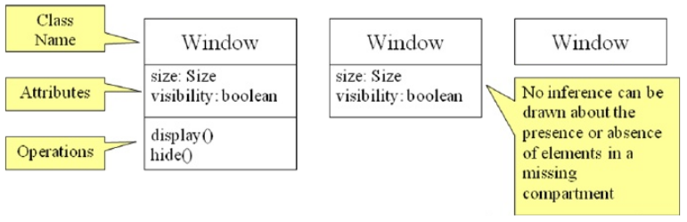
Attributes
– Classes have attributes that describe the characteristics of their objects.
– Attributes are atomic entities with no responsibilities.
– Attribute syntax (partial):
[visibility] name [ : type ] [ = defaultValue ]
– Class scope attributes are underlined
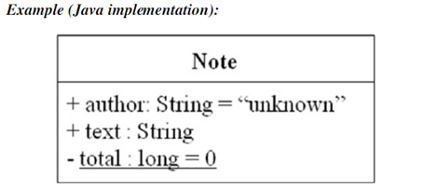
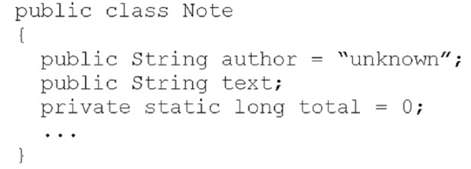
Visibility
- Visibility describes whether an attribute or operation is visible and can be referenced from classes other than the one in which they are defined.

- language dependent
Means different things in different languages
- UML provides four visibility abbreviations:
+ (public) – (private) # (protected) ~ (package)
UML modeling elements in class diagrams
- Classes and their structure, association, aggregation, dependency, and inheritance relationships
- Multiplicity and navigation indicators, etc.
Associations
- A semantic relationship between two or more classes that specifies connections among their instances.
- A structural relationship, specifying that objects of one class are connected to objects of a second (possibly the same) class.
- Example: ―”An Employee works for a Company”
- An association between two classes indicates that objects at one end of an
- association ―”recognize” objects at the other end and may send messages to them.
- This property will help us discover less trivial associations using interaction diagrams
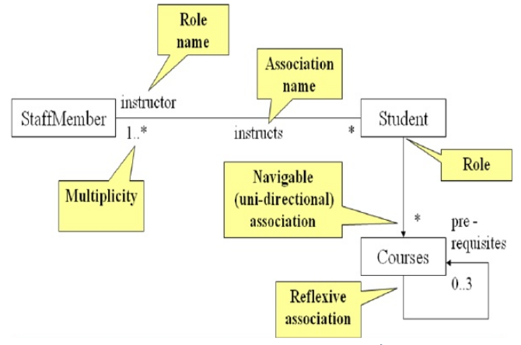
Aggregation
A special form of association that models a whole-part relationship between an aggregate (the whole) and its parts.
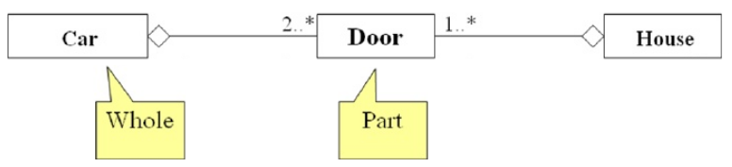
Generalization
A sub-class inherits from its super-class. A generalization relationship may not be used to model interface implementation.

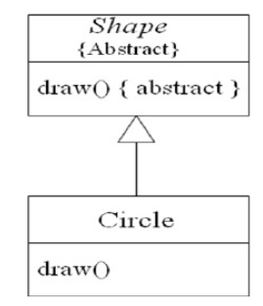
Dependency
A dependency is a relation between two classes in which a change in one may force changes in the other although there is no explicit association between them. A stereotype may be used to denote the type of the dependency.
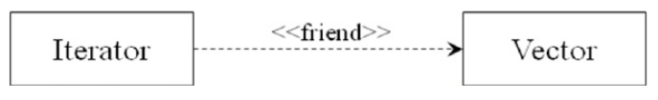
2.10 Interactive Diagrams
Interaction diagrams describe how groups of objects collaborate to get the job done. Interaction diagrams capture the behavior of a single use case, showing the pattern of interaction among objects. The purpose of Interaction diagrams is to:
Model interactions between objects
Assist in understanding how a system (a use case) actually works
Verify that a use case description can be supported by the existing classes
Identify responsibilities/operations and assign them to classes
Interaction diagrams:
Sequence diagrams
Collaboration diagrams

2.13 State Diagram
A statechart diagram (also called a state diagram) shows the sequence of states that an object goes through during its life in response to outside stimuli and messages. A statechart diagram is a view of a state machine that models the changing behavior of a state. Statechart diagrams show the various states that an object goes through, as well as the events that cause a transition from one state to another.
State chart diagram model elements
The common model elements that state chart diagrams contain are:
- States
- Start and end states
- Transitions
- Entry, do, and exit actions
A state represents a condition during the life of an object during which it satisfies some condition or waits for some event. Start and end states represent the beginning or ending of a process. A state transition is a relationship between two states that indicates when an object can move the focus of control on to another state once certain conditions are met.
Actions in a Statechart diagram
- Each state on a state chart diagram can contain multiple internal actions.
- An action is best described as a task that takes place within a state.
- There are four possible actions within a state:
- On entry
- On exit
- Do
- On event
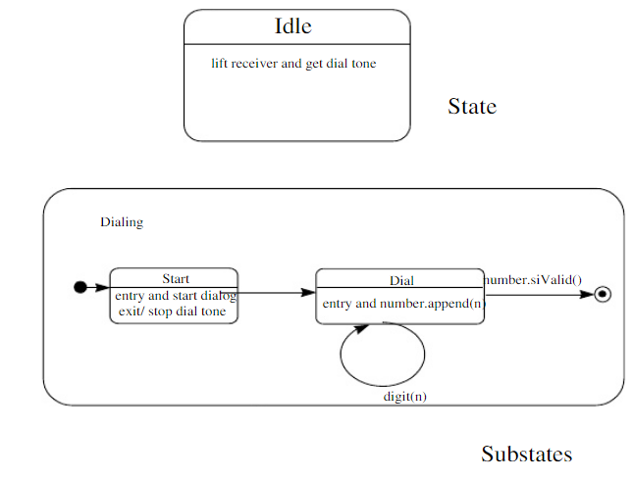
2.14 Activity Diagram
- Activity Diagram – a special kind of Statechart diagram, but showing the flow from activity to activity (not from state to state).
- Activity – an ongoing non-atomic execution within a state machine. Activities ultimately result in some action.
- A real world process or execution of a software routine
- Action – made up of executable atomic computations that results in a change in state of the system or the return of a value (i.e., calling another operation, sending a signal, creating or destroying an object, or some pure computation).
Activity diagrams commonly contain:
- Activity states and action states
- Transitions
- Objects
Action states - executable, atomic computations (states of the system, each representing the execution of an action) – cannot be decomposed. Activity states – non-atomic; can be further decomposed; can be represented by other activity diagrams – a composite whose flow of control is made up of other activity states and action states
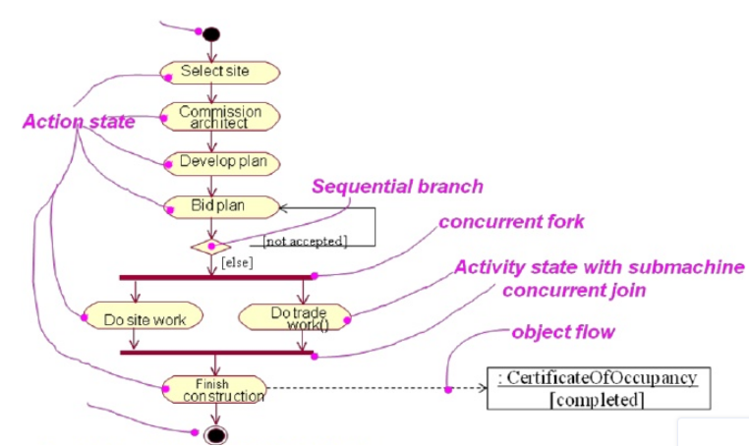
2.15 Packages
A package is a general purpose grouping mechanism. Can be used to group any UML element(e.g. use case, actors, classes, components and other packages. Commonly used for specifying the logical distribution of classes. A package does not necessarily translate into a physical sub-system.
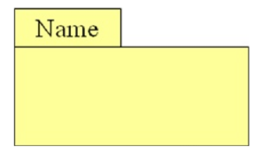

CS1402-Object Oriented Analysis and Design
© Einstein College of Engineering
2.10
Interactive Diagrams
Interaction diagrams describe how groups of objects collaborate to get the job done.Interaction diagrams capture the behavior of a single use case, showing the pattern of interaction among objectsThe purpose of Interaction diagrams is to:Model interactions between objectsAssist in understanding how a system (a use case) actually worksVerify that a use case description can be supported by the existing classesIdentify responsibilities/operations and assign them to classesInteraction diagrams:Sequence diagramsCollaboration diagrams
2.11 Packages
A package is a general purpose grouping mechanism. Can be used to group any UMLelement (e.g. use case, actors, classes, components and other packages. Commonly usedfor specifying the logical distribution of classes. A package does not necessarily translateinto a physical sub-system.
Packages and Class Diagrams
Emphasize the logical structure of the system (High level view)
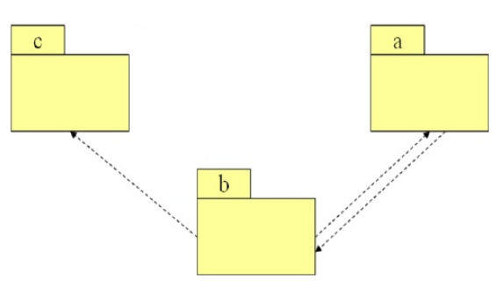

Emphasize the interface between packages by showing relations and dependencies between public classes, Add package information to class diagrams
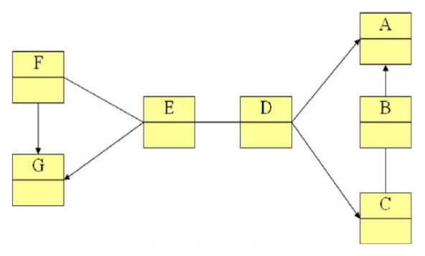

UNIT III
OBJECT ORIENTED ANALYSIS
3.1 Identifying Use cases
3.2 Object Analysis - Classification
3.3 Identifying Object Relationships, Attributes and Methods
3.1 Identifying Use Cases
The use-case approach to object-oriented analysis and the object-oriented analysis process.
- Identifying actors.
- Identifying use cases.
- Documentation.
What Is Analysis?
Analysis is the process of transforming a problem definition from a fuzzy set of facts and
myths into a coherent statement of a system‘s requirements.
The main objective of the analysis is to capture:
- a complete, unambiguous, and consistent picture of the requirements of the system and
- what the system must do to satisfy the users' requirements and needs.
Requirements Difficulties
Three most common sources of requirements difficulties are:
- Incomplete requirements.
- Fuzzy descriptions (such as fast response).
- Unneeded features.
The Object-Oriented Analysis (OOA) Process
The process consists of the following steps:
- Identify the actors:
- Who is using the system?
- Or, in the case of a new system, who will be using the system?

- Develop a simple business process model using UML activity diagram.
- Develop the use case
- What the users are doing with the system?
- Or, in the case of a new system, what users will be doing with the system?
- Use cases provide us with comprehensive documentation of the system under study.
- Prepare interaction diagrams:
- Determine the sequence.
- Develop collaboration diagrams
5. Classification - develop a static UML class diagram:
- Identify classes.
- Identify relationships.
- Identify attributes.
- Identify methods.

- Iterate and refine: If needed, repeat the preceding steps.
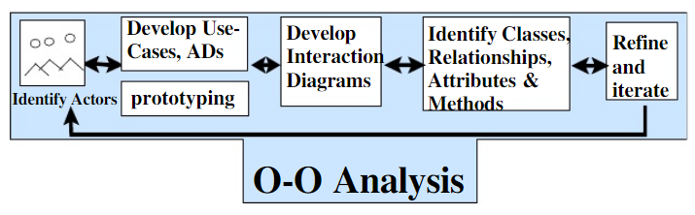
Developing Business Processes Modeling
Developing an activity diagram of the business processes can provide us with an overall view of the system.
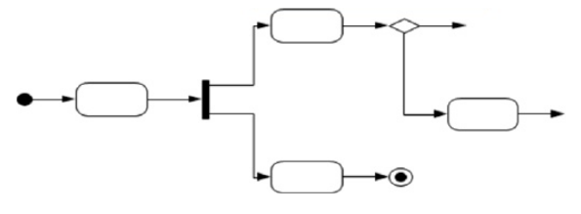

Use Case Model
Use cases are scenarios for understanding system requirements. The use-case model describes the uses of the system and shows the courses of events that can be performed. Use case defines what happens in the system when a use case is performed. The use-case model tries to systematically identify uses of the system and therefore the system's responsibilities.
Use Cases Under the Microscope:
"A Use Case is a sequence of transactions in a system whose task is to yield results of measurable value to an individual actor of the system."
Use Case Key Concepts
- Use case. Use case is a special flow of events through the system.
- Actors. An actor is a user playing a role with respect to the system.
- In a system. This simply means that the actors communicate with the system's use case.
- A measurable value. A use case must help the actor to perform a task that has some identifiable value.
- Transaction. A transaction is an atomic set of activities that are performed either fully ornot at all.
Use Associations
The use association occurs when you are describing your use cases and notice that some of them have common sub flows. The use association allows you to extract the common sub flow and make it a use case of its own.
Extends Associations
The extends association is used when you have one use case that is similar to another use case but does a bit more or Is more specialized; in essence, it is like a subclass.
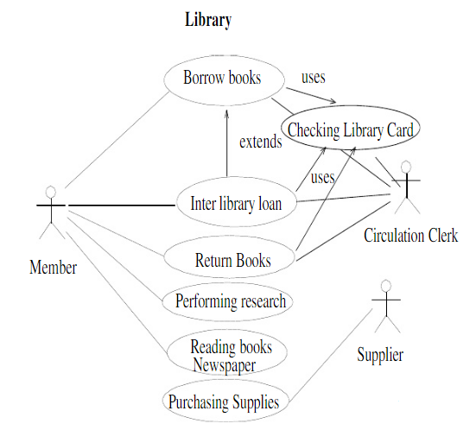
Types of Use Cases
- Use cases could be viewed as concrete or abstract.
- An abstract use case is not complete and has no initiation actors but is used by a concrete use case, which does interact with actors.
Identifying the Actors
- The term actor represents the role a user plays with respect to the system.
- When dealing with actors, it is important tothink about roles rather than people or job titles.
- Who affects the system? Or,
- Which user groups are needed by the system to perform its functions? These functions can be both main functions and secondary functions, such as administration.
- Which external hardware or other systems (if any)use the system to perform tasks?
- What problems does this application solve (that is,for whom)?
- And, finally, how do users use the system (use case)? What are they doing with the system?
Guidelines for Finding Use Cases
- For each actor, find the tasks and functions that the actor should be able to perform orthat the system needs the actor to perform.
- Name the use cases.
- Describe the use cases briefly by applying terms with which the user is familiar.
Separate Actors from Users
- Each use case should have only one main actor.
- Isolate users from actors.
- Isolate actors from other actors (separate the responsibilities of each actor).
- Isolate use cases that have different initiating actors and slightly different behavior.
Documentation
An effective document can serve as a communication vehicle among the project's team members, or it can serve as initial understanding of the requirements.
Effective Documentation: Common Cover
All documents should share a common cover sheet that identifies the document, the current version, and the individual responsible for the content
80 – 20 Rule
- 80 percent of the work can be done with 20 percent of the documentation.
- The trick is to make sure that the 20 percent is easily accessible and the rest (80percent) is available to those (few) who need to know.
Familiar Vocabulary
- Use a vocabulary that your readers understand and are comfortable with.
- The main objective here is to communicate with readers and not impress them with buzz words.
Make the Document as Short as Possible
- Eliminate all repetition;
- Present summaries, reviews, organization chapters in less than three pages.
- Make chapter headings task oriented so that the table of contents also could serve as an index.
Organize the Document
- Use the rules of good organization (such as the organization's standards, college handbooks, Strunk and White's Elements of Style, or the University of Chicago Manual of Style) within each section.
The main objective of the analysis is to capture a complete, unambiguous, and consistent picture of the requirements of the system. Construct several models and views of the system to describe what the system does rather than how. Capturing use cases is one of the first things to do in coming up with requirements. Every use case is a potential requirement. The key in developing effective documentation is to eliminate all repetition; present summaries, reviews, organization chapters in less than three pages. Use the 80 – 20 rule: 80 per cent of the work can be done with 20 per cent of the documentation.

3.2 Object Analysis: Classification
- The concept of classification
- How to identify classes
Intelligent classification is intellectually hard work and may seem rather arbitrary. Martin and Odell have observed in object-oriented analysis and design, that “In fact, an object can be categorized in more than one way.”
Approaches for Identifying Classes
- noun phrase approach
- common class patterns approach
- use-case driven approach
- classes, responsibilities, & collaborators (CRC)approach
Noun Phrase Approach
It examine Use cases, conduct interviews, and read requirements specification carefully, dividing noun phrases into three categories
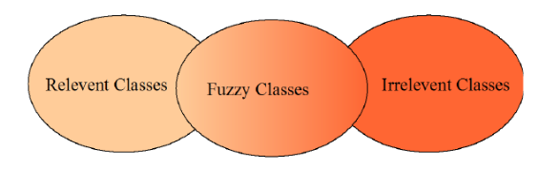
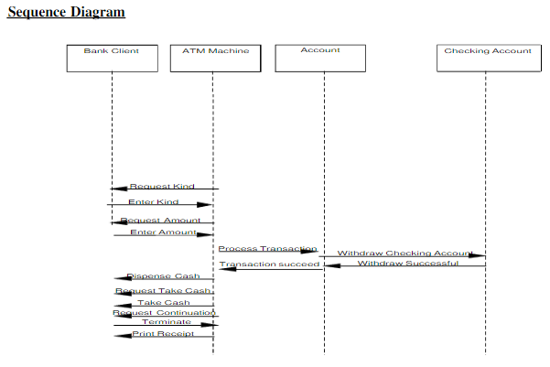
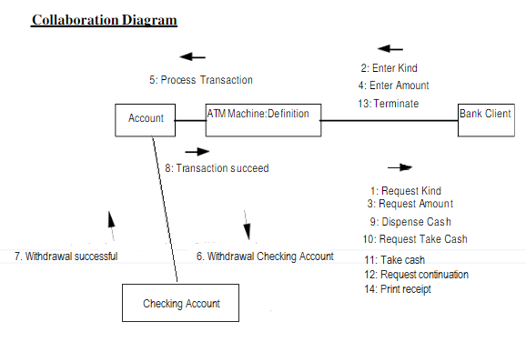

CRC Cards
CRC cards are 4" x 6" index cards. All the information for an object is written on a card.
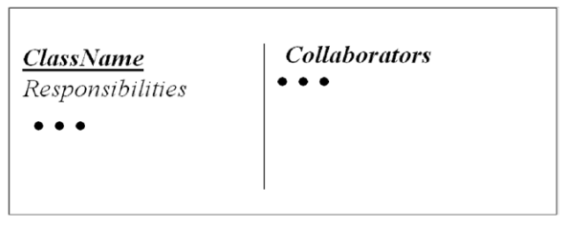
CRC starts with only one or two obvious cards. If the situation calls for a responsibility not already covered by one of the objects, add, or create a new object to address that responsibility.
– Finding classes is not easy.
– The more practice you have, the better you get at identifying classes.
– There is no such thing as the ”right set of classes”.
– Finding classes is an incremental and iterative process.
Guidelines for Naming Classes
- The class should describe a single object, so it should be the singular form of noun.
- Use names that the users are comfortable with.
- The name of a class should reflect its intrinsic nature.
- By the convention, the class name must begin with an upper case letter.
- For compound words, capitalize the first letter of each word - for example, Loan Window.
3.3 Identifying Object Relationships, Attributes, and Method
Goals:
- Analyzing relationships among classes
- Identifying association
- Association patterns
- Identifying super- & subclass hierarchies
Three Types of Objects Relationships
- Association
- Super-sub structure (also known as generalization hierarchy)
- Aggregation and a-part-of structure
Guidelines for Identifying Super-sub Relationships:
Top-down
- Look for noun phrases composed of various adjectives on class name.
- Example: Military Aircraft and Civilian Aircraft.
- Only specialize when the sub classes have significant behavior.
Bottom-up
- Look for classes with similar attributes or methods.
- Group them by moving the common attributes and methods to super class.
- Do not force classes to fit a preconceived generalization structure.
Reusability
- Move attributes and methods as high as possible in the hierarchy.
- At the same time do not create very specialized classes at the top of hierarchy.
- This balancing act can be achieved through several iterations.
Multiple inheritance
- Avoid excessive use of multiple inheritances.
- It is also more difficult to understand programs written in multiple inheritance system.
Class Responsibility: Identifying Attributes and Methods
- Identifying attributes and methods, like finding classes, is a difficult activity.
- The use cases and other UML diagrams will be our guide for identifying attributes, methods, and relationships among classes.

Identifying Class Responsibility by Analyzing Use Cases and Other UML Diagrams
- Attributes can be identified by analyzing the use cases, sequence/collaboration, activity, and state diagrams.
Guidelines for Identifying Attributes of Classes
- Do not carry discovery of attributes to excess.
- You can always add more attributes in the subsequent iterations.

UNIT IV
OBJECT ORIENTED DESIGN
Designing systems using self-contained objects and object classes
- To explain how a software design may be represented as a set of interacting objects that manage their own state and operations
- To describe the activities in the object-oriented design process
- To introduce various models that describe an object-oriented design
- To show how the UML may be used to represent these models
Characteristics of OOD
- Objects are abstractions of real-world or system entities and manage themselves
- Objects are independent and encapsulate state and representation information.
- System functionality is expressed in terms of object services
- Shared data areas are eliminated. Objects communicate by message passing
- Objects may be distributed and may execute sequentially or in parallel
4.1 Design axioms
- Main focus of the analysis phase of SW development “what needs to be done”
- Objects discovered during analysis serve as the framework for design
- Class‘s attributes, methods, and associations identified during analysis must be designed for implementation as a data type expressed in the implementation language
- During the design phase, we elevate the model into logical entities, some of which might relate more to the computer domain (such as user interface, or the access layer) than the real world or the physical domain (such as people or employees). Start thinking how to actually implement the problem in a program.
- The goal is to design the classes that we need to implement the system.
- Design is about producing a solution that meets the requirements that have been specified during analysis.
- Analysis Versus Design.
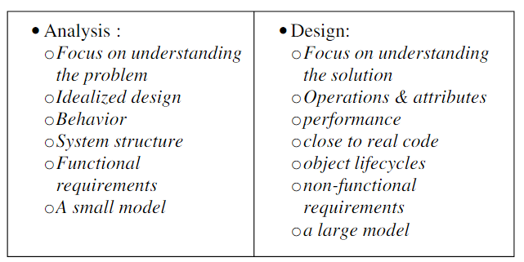
- OO design process in the unified approach are as below,
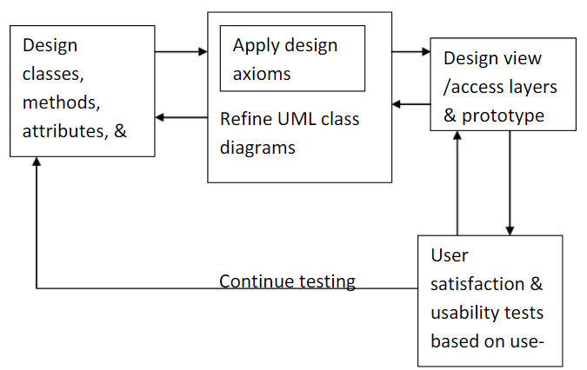

- OO Design Axioms

- An axiom = is a fundamental truth that always is observed to be valid and for which there is no counterexample or exception
- A theorem = is a proposition that may not be self-evident but can be proven from accepted axioms. Therefore, is equivalent to a law or principle.
- A theorem is valid if its referent axioms & deductive steps are valid.
- A corollary = is a proposition that follows from an axiom or another proposition that has been proven
- Suh‘s design axioms to OOD :
Axiom 1: The independence axiom. Maintain the independence of components.
Axiom 2: The information axiom. Minimize the information content of the design.
- Axiom 1 - states that, during the design process, as we go from requirement and use-case to a system component, each component must satisfy that requirement, without affecting other requirements
- Axiom 2 - concerned with simplicity. Rely on a general rule known as Occam’s razor.

Occam’s razor rule of simplicity in OO terms:
The best designs usually involve the least complex code but not necessarily the fewest number of classes or methods. Minimizing complexity should be the goal, because that produces the most easily maintained and enhanced application. In an object-oriented system, the best way to minimize complexity is to use inheritance and the system’s built-in classes and to add as little as possible to what already is there.
- Corollaries

- May be called Design rules, and all are derived from the two basic axioms :
- The origin of corollaries as shown in figure. Corollaries 1,2 and 3 are from both axioms, whereas corollary 4 is from axiom 1 and corollaries 5 & 6 are from axiom 2.
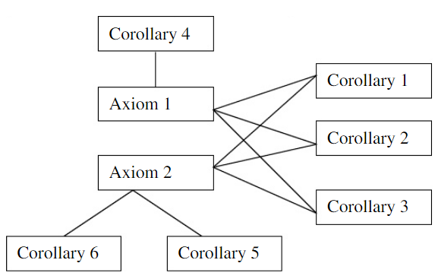
- Corollary 1 : Uncoupled design with less information content.
- Highly cohesive objects can improve coupling because only a minimal amount of essential information need be passed between objects
- Main goal is to maximize objects cohesiveness among objects & SW components to improve coupling
- Strong coupling among objects complicates a system, since the class is harder to understand or highly interrelated with other classes
- Degree or strength of coupling between two components is measured by the amount & complexity of information transmitted between them
- OO design has 2 types of coupling : Interaction coupling and Inheritance coupling
- Interaction coupling, the amount & complexity of messages between components.
- Desirable to have a little interaction.
- Minimize the number of messages sent & received by an object
- Types of coupling among objects or components is as follows

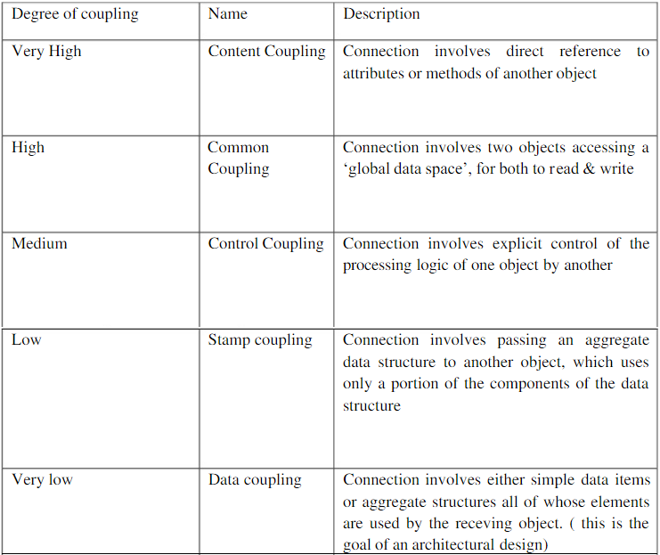
- Inheritance coupling, coupling between super-and subclasses
- A subclass is coupled to its superclass in terms of attributes &methods
- High inheritance coupling is desirable
- Each specialization class should not inherit lots of unrelated &unneeded methods & attributes
- Need to consider interaction within a single object or sw component - Cohesion
- Cohesion, reflects the single purposeness of an object (see corollaries 2 & 3)
- Method cohesion, a method should carry only one function.
- A method carries multiple functions is undesirable

- Corollary 2 : Single purpose
- Each class must have a purpose & clearly defined
- Each method must provide only one service
- Corollary 3 : Large number of simple classes
- Keeping the classes simple allows reusability
- A class that easily can be understood and reused (or inherited) contributes tothe overall system
- Complex & poorly designed class usually cannot be reused
- Guideline - The smaller are your classes, the better are your chances of reusing them in other projects. Large & complex classes are too specialized to be reused
- The emphasis OOD places on encapsulation, modularization, and polymorphism suggests reuse rather than building anew
- Primary benefit of sw reusability - Higher productivity
- Corollary 4 : Strong mapping
- There must be a strong association between the analysis’s object and design’s object
- OOA and OOD are based on the same model
- As the model progresses from analysis to implementation, more detailed is added
- Corollary 5 : Standardization
- Promote standardization by designing interchangeable components and reusing existing classes or components
- The concept of design patterns might provide a way to capture the design knowledge, document it, and store it in a repository that can be shared and reused in different applications
- Corollary 6 : Design with inheritance
- Common behavior (methods) must be moved to superclasses.
- The superclass-subclass structure must make logical sense

- Design Patterns

- Provides a scheme for refining the subsystems or components of a sw system or the relationships among them
- Are devices that allow systems to share knowledge about their design, by describing commonly recurring structures of communicating components that solve a general design problem within a particular context
- The main idea is to provide documentation to help categorize & communicate about solutions to recurring problems
- The pattern has a name to facilitate discussion and the information it represents
4.2 Designing classes:
Objectives: To explain how a software design may be represented as a set of interacting objects that manage their own state and operations To describe the activities in the object-oriented design process To introduce various models that describe an object-oriented design To show how the UML may be used to represent these models
Characteristics of OOD:
- Characteristics of OOD Objects are abstractions of real-world or system entities and manage themselves Objects are independent and encapsulate state and representation information.
- System functionality is expressed in terms of object services Shared data areas are eliminated.
- Objects communicate by message passing Objects may be distributed and may execute sequentially or in parallel
Advantages of OOD :
- Easier maintenance.
- Objects may be understood as stand-alone entities. Objects are appropriate reusable components. For some systems, there may be an obvious mapping from real world entities to system objects
Object-oriented development :
Object-oriented analysis, design and programming are related but distinct. OOA is concerned with developing an object model of the application domain. OOD is concerned with developing an object-oriented system model to implement requirements. OOP is concerned with realising an OOD using an OO programming language such as Java or C++
Objects and object classes :
Objects are entities in a software system which represents instances of real-world and system entities. Object classes are templates for objects. They may be used to create objects. Object classes may inherit attributes and services from other object classes
Objects :
An object is an entity which has a state and a defined set of operations which operate on that state. The state is represented as a set of object attributes. The operations associated with the object provide services to other objects (clients) which request these services when some computation is required. Objects are created according to some object class definition. An object class definition serves as a template for objects. It includes declarations of all the attributes and services which should be associated with an object of that class.
The Unified Modeling Language :
Several different notations for describing object-oriented designs were proposed in the 1980s and 1990s. The Unified Modeling Language is an integration of these notations. It describes notations for a number of different models that may be produced during OO analysis and design. It is now a de facto standard for OO modelling.
Object communication :
Conceptually, objects communicate by message passing. Messages - the name of the service requested by the calling object. Copies of the information required to execute the service and the name of a holder for the result of the service. In practice, messages are often implemented by procedure calls Name = procedure name. Information = parameter list.
Message examples :
// Call a method associated with a buffer
// object that returns the next value
// in the buffer
v = circularBuffer.Get () ;
// Call the method associated with a
// thermostat object that sets the
// temperature to be maintained
thermostat.setTemp (20) ;
Generalisation and inheritance :
Objects are members of classes which define attribute types and operations Classes may be arranged in a class hierarchy where one class (a super-class) is a generalisation of one or more other classes (sub-classes) A sub-class inherits the attributes and operations from its super class and may add new methods or attributes of its own Generalisation in the UML is implemented as inheritance in OO programming languages
Advantages of inheritance :
It is an abstraction mechanism which may be used to classify entities It is a reuse mechanism at both the design and the programming level The inheritance graph is a source of organizational knowledge about domains and systems
Problems with inheritance :
Object classes are not self-contained. They cannot be understood without reference to their super-classes Designers have a tendency to reuse the inheritance graph created during analysis. Can lead to significant inefficiency The inheritance graphs of analysis, design and implementation have different functions and should be separately maintained
Inheritance and OOD :
There are differing views as to whether inheritance is fundamental to OOD. View 1. Identifying the inheritance hierarchy or network is a fundamental part of object-oriented design. Obviously this can only be implemented using an OOPL. View 2. Inheritance is a useful implementation concept which allows reuse of attribute and operation definitions. Identifying an inheritance hierarchy at the design stage places unnecessary restrictions on the implementation Inheritance introduces complexity and this is undesirable, especially in critical systems
UML associations :
Objects and object classes participate in relationships with other objects and object classes In the UML, a generalised relationship is indicated by an association Associations may be annotated with information that describes the association Associations are general but may indicate that an attribute of an object is an associated object or that a method relies on an associated object
Concurrent objects :
Concurrent objects The nature of objects as self-contained entities make them suitable forconcurrent implementation The message-passing model of object communication can be implementeddirectly if objects are running on separate processors in a distributed system
Servers and active objects :
The object is implemented as a parallel process (server) with entry points corresponding to object operations. If no calls are made to it, the object suspends itself and waits for further requests for service.
Active objects - Objects are implemented as parallel processes and the internal object state may be changed by the object itself and not simply by external calls.
Active transponder object :
Active objects may have their attributes modified by operations but may also update them autonomously using internal operations. Transponder object broadcasts an aircraft‘s position. The position may be updated using a satellite positioning system. The object periodically updates the position by triangulation from satellites
Java threads :
Threads in Java are a simple construct for implementing concurrent objects. Threads must include a method called run() and this is started up by the Java run-time system. Active objects typically include an infinite loop so that they are always carrying out the computation
An object-oriented design process :
Define the context and modes of use of the system.
Design the system architecture.
Identify the principal system objects.
Develop design models.
Specify object interfaces.
Architectural design :
Once interactions between the system and its environment have been understood, you use this information for designing the system architecture Layered architecture is appropriate for the weather station Interface layer for handling communications Data collection layer for managing instruments Instruments layer for collecting data There should be no more than 7entities in an architectural model
Object identification :
Identifying objects (or object classes) is the most difficult part of object oriented design There is no 'magic formula' for object identification. It relies on the skill, experience and domain knowledge of system designers Object identification is an iterative process. You are unlikely to get it right first time
Approaches to identification :
Use a grammatical approach based on a natural language description of the system (used in Hood method) Base the identification on tangible things in the application domain Use a behavioural approach and identify objects based on what participates in what behaviour Use a scenario-based analysis. The objects, attributes and methods in each scenario are identified
Weather station object classes :
Weather station object classes - Ground thermometer, Anemometer, Barometer.
Application domain objects that are “hardware” objects related to the instruments in the system - weather station.
The basic interface of the weather station to its environment.
It therefore reflects the interactions identified in the use-case model. Weather data Encapsulates the summarised data from the instruments
Further objects and object refinement :
Further objects and object refinement Use domain knowledge to identify more objects and operations Weather stations should have a unique identifier Weather stations are remotely situated so instrument failures have to be reported automatically. Therefore attributes and operations for self-checking are required Active or passive objects In this case, objects are passive and collect data on request rather than autonomously. This introduces flexibility at the expense of controller processing time
Design models :
Design models Design models show the objects and object classes and relationships between these entities Static models describe the static structure of the system in terms of object classes and relationships Dynamic models describe the dynamic interactions between objects.
Examples of design models :
Examples of design models Sub-system models that show logical groupings of objects into coherent subsystems Sequence models that show the sequence of object interactions State machine models that show how individual objects change their state in response to events Other models include use-case models, aggregation models, generalisation models, etc.
Subsystem models :
Subsystem models Shows how the design is organised into logically related groups of objects In the UML, these are shown using packages - an encapsulation construct. This is a logical model. The actual organisation of objects in the system may be different.
Sequence models :
Sequence models Sequence models show the sequence of object interactions that take place Objects are arranged horizontally across the top Time is represented vertically so models are read top to bottom Interactions are represented by labelled arrows, Different styles of arrow represent different types of interaction A thin rectangle in an object lifeline represents the time when the object is the controlling object in the system
Statecharts :
Statecharts Show how objects respond to different service requests and the state transitions triggered by these requests If object state is Shutdown then it responds to a Startup() message In the waiting state the object is waiting for further messages If reportWeather () then system moves to summarising state If calibrate () the system moves to a calibrating state A collecting state is entered when a clock signal is received
Object interface specification :
Object interfaces have to be specified so that the objects and other components can be designed in parallel. Designers should avoid designing the interface representation but should hide this in the object itself. Objects may have several interfaces which are viewpoints on the methods provided. The UML uses class diagrams for interface specification but Java may also be used.
Design evolution :
Hiding information inside objects means that changes made to an object do not affect other objects in an unpredictable way. Assume pollution monitoring facilities are to be added to weather stations. These sample the air and compute the amount of different pollutants in the atmosphere. Pollution readings are transmitted with weather data.
4.3 Access Layer
The main idea behind creating an access layer is to create a set of classes that know how to communicate with the place(s) where the data actually reside. Regardless of where the data reside, whether it be a file, relational database, mainframe, Internet, DCOM or via ORB, the access classes must be able to translate any data-related requests from the business layer into the appropriate protocol for data access. These classes also must be able to translate the data retrieved back into the appropriate business objects.
The access layer‘s main responsibility is to provide a link between business or view objects and data storage. Three-layer architecture is similar to 3-tier architecture. The view layer corresponds to the client tier, the business layer to the application server tier and the access layer performs two major tasks: Translate the request: The access layer must be able to translate any data related requests from the business layer into the appropriate protocol for data access.
•Translate the results:
The access layer also must be able to translate the data retrieved back into the appropriate business objects and pass those objects back into the business layer.
•Here design is tied to any
base engine or distributed object technology such as CORBA or DCOM. Here we can switch easily from one database to another with no major changes to the user interface or business layer objects.
All we need to change are the access classes‘ methods.
A Date Base Management System (DBMS) is a set of programs that enables the creation and maintenance (access, manipulate, protect and manage) of a collection of related data.
The purpose of DBMS is to provide reliable, persistent data storage and mechanisms for efficient, convenient data access and retrieval.
Persistence refers to the ability of some objects to outlive the programs that created them.
Object lifetimes can be short for local objects (called transient objects) or long for objects stored indefinitely in a database (called persistent objects).Most object-oriented languages do not support serialization or object persistence, which is the processof writing or reading an object to and from a persistence storage medium, such as disk file.
Unlike object oriented DBMS systems, the persistent object stores do not support query or interactive user interface facilities.
Controlling concurrent access by users, providing ad-hoc query capability and allowing independent control over the physical location of data are not possible with persistent objects.
The access layer (AL), which is a key part of every n-tier system, is mainly consist of a simple set of code that does basic interactions with the database or any other storage device. These functionalities are often referred to as CRUD (Create, Retrieve, Update, and Delete).
The data access layer need to be generic, simple, quick and efficient as much as possible. It should not include complex application/ business logics.
I have seen systems with lengthy, complex store procedures (SP), which run through several cases before doing a simple retrieval. They contain not only most part of the business logic, but application logic and user interface logic as well. If SP is getting longer and complicated, then it is a good indication that you are burring your business logic inside the data access layer.
4.4 Object Storage & Object Interoperability
Atkinson describe 6 broad categories for the lifetime of a data.
•Transient results to the evaluation of
expressions Variables involved in procedure activation
•Global variables and variables that are dynamically allocated
•Data that exist between the execution of a program
•Data that exist between the versions of a program
•Data that outlive a program.
•The first 3 are transient data, data that cease to exist beyond the lifetime of the creating process. The other 3 are non transient, or persistent data.
•The programming languages provide excellent support for transient data. The non-transient data arewellsupported by DBMS or a file system. In traditional file processing, each application defines andimplements the files it requires.
•In DBMS, a single repository of data is maintained, which can be defined once and subsequentlyaccessedby various users.
•DBMS contains not only the data but a a complete definition of the data formats it manages, known asSchema or Meta-data, which contains a complete definition of the data formats, such as the datastructures, types and constraints.
•In file processing applications, such meta data are encapsulated in the application programsthemselves.But in DBMS, the format of the meta-data is independent of any particular application data structure.
Common Object Request Broker Architecture
It is used to integrate distributed, heterogeneous business applications and data. The CORBAinterface definition language (IDL) allows developers to specify language-neutral, object-oriented interfaces for application and system components. IDL definitions are stored in aninterface repository that offers object interfaces and services. For distributed enterprisecomputing, the interface repository is central to communication among objects located ondifferent systems.CORBA implements a communication channel through which applications canaccess object interfaces and request data and services. The CORBA common object environment(COE) provides system level services such as life cycle management for objects accessed throughCORBA, event notification between objects and transaction and concurrency control.

Unit V
UML – Modeling Types

5.1 Examples on: Structural models
5.2 Examples on: Behavioral models
5.3 Examples on: Architectural models

It is very important to distinguish between the UML model. Different diagrams are used for different types of UML modeling. There are three important types of UML modeling.
5.1 Structural modeling:
Structural modeling captures the static features of a system. They consist of the following −
- Classes diagrams
- Objects diagrams
- Use case diagrams
- Deployment diagrams
- Component diagram
Structural model represents the framework for the system and this framework is the place where all other components exist. Hence, the class diagram, component diagram and deployment diagrams are part of structural modeling. They all represent the elements and the mechanism to assemble them.
The structural model never describes the dynamic behavior of the system. Class diagram is the most widely used structural diagram.
5.2 Behavioral modeling:
Behavioral model describes the interaction in the system. It represents the interaction among the structural diagrams. Behavioral modeling shows the dynamic nature of the system. They consist of the following −
- Sequence diagram
- Collaboration diagram
- State transition diagram
- Activity diagrams
All the above show the dynamic sequence of flow in a system.
5.3 Architectural modeling:
Architectural model represents the overall framework of the system. It contains both structural and behavioral elements of the system. Architectural model can be defined as the blueprint of the entire system. Package diagram comes under architectural modeling.

DIAGRAMS:
1. Class Diagram - A set of classes, interfaces, and collaborations and their relationships. Most often found in modeling OO systems.
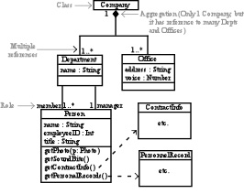
2. Object Diagram - A set of objects and their relationships. Represents static instances of things found in class diagrams.
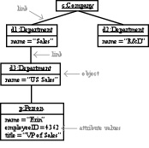
3. Use Case Diagram - A set of Use Cases and actors.
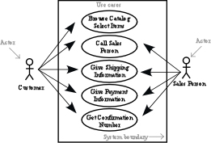
4. Component Diagram - Shows the organizations and dependencies among a set of components.
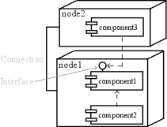
5. Deployment Diagram - Shows the configuration of run-time processing nodes and the components that are part of them.
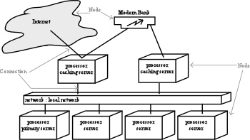
6. Sequence Diagram - An interactive diagram (set of objects, relationships, and messages that may be exchanged) emphasizing the time-ordering of messages.
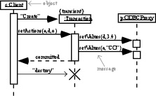
7. Collaboration Diagram - An interaction diagram emphasizes the structural organization of the objects that send and receive messages.
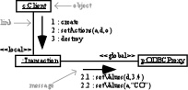
8. Statechart Diagram - Shows a state machine with states, transitions, events, and activities.
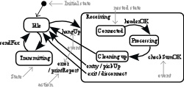
9. Activity Diagram - Special type of statechart diagram that shows the flow from activity to activity within a system.
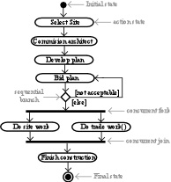
10. Package - A general purpose mechanism for organizing elements into groups.
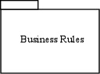

EXAMPLES: (set of diagrams refer the book)
- Library application
- Bank applination

