PATTERN MAKING AND GRADING
5x 5 = 25
ANSWER ANY FIVE QUESTIONS.
1.What are the Flat Pattern Methods?

Flat pattern method
The flat pattern method is the fastest and most efficient method for developing patterns, wherein the basic block is modified to develop new and varied styles. It helps in maintaining the consistency of size and fit of mass produced garments. Pattern can be manipulated and changed through the slash-spread method or pivot method. The slash-spread technique as the name implies refers to the technique of slashing a pattern, spreading it and manipulating to generate new patterns. In pivot method pattern is not slashed but points are pivoted for new designs. A traced copy of the original working pattern is used as the original and is never altered. After pattern is slashed and spread, it is placed on another piece of marking paper. It is retraced along the new lines. The lines are then blended, seam allowance added and grain line marked. All other pattern information is added to complete the pattern for the test fit.
Tools Required:
- Measuring tape.
- Brown sheet.
- Sharpened pencil.
- French curve.
- Ruler
- L scale
- Drafting table of suitable height and width
Merits
- Flat patterns are widely used for mass production of garments since the patterns are made as per standard sizes
- With the basic pattern at hand, it is possible to quickly make new designs as per fashion demands.
- The size of the developed design will be same as that of the original basic sloper
- Grading of the basic pattern to different sizes can be done very easily
- The basic pattern or sloper can be used again and again to develop several designs.
- From the basic pattern it is easy to alter patterns as per individual requirements.
- It is possible to restyle old and out of date pattern
Demerits
- Knowledge of basic principles of pattern making and pattern manipulation is necessary to make a basic sloper/pattern.
- Since it is a 2D method, it is difficult to imagine the final outcome of the completed garment.
- Flat pattern making requires professional training and one need to perfect the art.

2. Give the principles of Pattern Drafting?

PRINCIPLES FOR PATTERN DRAFTING:
Drafting can be done on ordinary brown paper which should not however be too thin.
To obtain an accurate draft, use a sharp pencil, and a ruler for, drawing straight lines. To get the corners at right angles, keep an 'L' scale or set squares ready. Before drafting, it is important to understand the procedures and instructions clearly, and to have practice in drawing a well balanced pattern with smooth curves and straight lines. You must understand the following principles before starting to attempt drafting.
Patterns must be made larger than body measurements to allow for freedom of movement, ease of action and comfort in wearing. Recommended ease allowance for various parts of the body are listed below. For bust 3' to 5' (3' for a tight fitting garment and 5' for loose fitting one); waist hip 3' to 5' ; upper arm 3' to 4'; arm hole depth 1'.
For all the garment the ease allowance must always be left before cutting out the pattern.
For symmetric designs where the right and left sides are alike, paper pattern for half front and half back only need to be made. For the bodice, start the drafting with the back part. For sleeves, full pattern must be drafted.
It is better to draft the primary or basic pattern blocks - plain bodice, plain sleeve, plain skirt without seam allowances. When this is done, be sure to leave seam allowances while laying out the pattern on the material at the time of cutting. If you do not have much experience in cutting, and want to avoid the risk of cutting without seam allowance you may add seam allowances to your paper pattern itself after completing the draft.
The following construction detailed information should be recorded and marked clearly.
Name of each piece of pattern (bodice front, bodice back, sleeve etc).
Number of pieces to be cut with each pattern piece. (For example, for a back
open dress, you have to cut 1 front, 2 backs and sleeves).
If seam allowances are not included in the draft, this should be mentioned. If seam allowances are included, seam lines and cutting lines should be clearly shown. Lengthwise or straight grain line should be drawn with a red pencil as shown on all pattern pieces. This line indicates that the pattern should be kept on the cloth in such a way that the line is parallel to the length of the cloth or the selvedges, it is usually drawn parallel to the centre front and centre back edges of the pattern.
3.Explain briefly about Human Proportions?
While there is significant variation in anatomical proportions between people, there are many references to body proportions that are intended to be canonical, either in art, measurement, or medicine.
In measurement, body proportions are often used to relate two or more measurements based on the body. A cubit, for instance, is supposed to be six palms. A span is taken to be 9 inches and was previously considered as half a cubit. While convenient, these ratios may not reflect the physiognomic variation of the individuals using them.
Similarly, in art, body proportions are the study of relation of human or animal body parts to each other and to the whole. These ratios are used in depictions of the figure (to varying degrees naturalistic, idealized or stylized), and may become part of an aesthetic canon within a culture.
It is important in figure drawing to draw the human figure in proportion. Though there are subtle differences between individuals, human proportions fit within a fairly standard range, though artists have historically tried to create idealised standards, which have varied considerably over different periods and regions. In modern figure drawing, the basic unit of measurement is the 'head', which is the distance from the top of the head to the chin. This unit of measurement is reasonably standard, and has long been used by artists to establish the proportions of the human figure. Ancient Egyptian art used a canon of proportion based on the "fist", measured across the knuckles, with 18 fists from the ground to the hairline on the forehead. This was already established by the Narmer Palette from about the 31st century BC, and remained in use until at least the conquest by Alexander the Great some 3,000 years later.^{[1]}
The proportions used in figure drawing are:
- An average person is generally 7-and-a-half heads tall (including the head).
- An ideal figure, used when aiming for an impression of nobility or grace, is drawn at 8 heads tall.
- A heroic figure, used in the heroic for the depiction of gods and superheroes, is eight-and-a-half heads tall. Most of the additional length comes from a bigger chest and longer legs.
4.Draw a Straight line Fashion Figure?

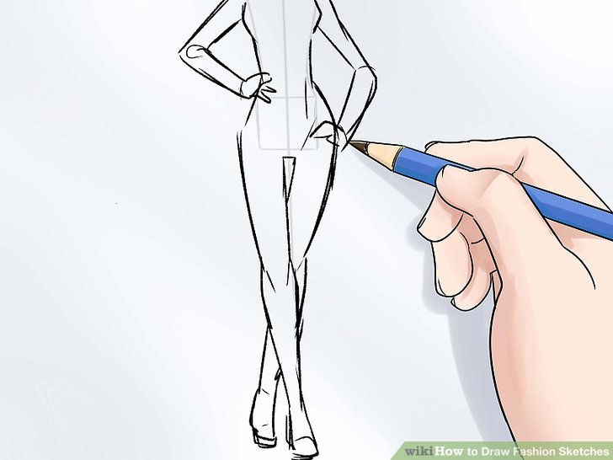

5.Explain the principles for taking body Measurement?

How to Take Body Measurements
Taking accurate body measurements is one of the keys to great fit. Whether you choose to make your pattern block from a commercial fitting pattern or draft it from measurements, having accuratemeasurements is critical to the success of your block. (And a well-fitting block is critical to the success of everything you make!)
All you need is a tape measure! While it's easiest to have someone else take your measurements, it can be done by yourself. Just stand in front of a mirror so that you can see that you have the tape in the right position.
Ideally, you should be measured wearing only your undergarments. However, a leotard or close-fitting clothing will be fine. Do NOT measure yourself wearing jeans, sweats, or other bulky clothing. It DOES make a difference!

6.Write a note on Measurements needed for the Construction of children?
This post examines childhood as a social construction looking at the work of Jane Pilcher and Philippe Aries among others.
There seems to be near universal agreement that there are some fundamental differences between adults and children. For example people in most societies seem to agree that
1. Children are physically and psychologically immature compared to adults
2. Children are dependent on adults for a range of biological and emotional needs – Children need a lengthy process of socialisation which takes several years.
3. In contrast to adults, children are not competent to run their own lives and cannot be held responsible for their actions
In contrast to the period of childhood, one of the defining characteristics of adulthood is that adults are biologically mature, are competent to run their own lives and are fully responsible for their actions.
However, despite broad agreement on the above, what people mean by childhood and the position children occupy is not fixed but differs across times, places and cultures. There is considerable variation in what people in different societies think about the place of children in society, about what children should and shouldn’t be doing at certain ages, about how children should be socialised, and about the age at which they should be regarded as adults.
For this reason, Sociologists say that childhood is socially constructed. This means that childhood is something created and defined by society:
7.Write in Detail about common Methods for Layout
A basic idea common to all standard design procedures is, as previously explained, the preparation of reusable, prefabricated and verified circuit components The design expenditure for the layout is saved. And the design engineer can work at a higher abstraction level. Transistors and the technological limitations — described in terms of process technology related design rules — no longer form the design basis; rather it is logic elements such as gates, flip flops and memories.
These elements are called cells. That is why standard-design procedures are also called celloriented design procedures.
Layout Design Methods A basic idea common to all standard design procedures is, as previously explained, the preparation of reusable, prefabricated and verified circuit components The design expenditure for the layout is saved. And the design engineer can work at a higher abstraction level. Transistors and the technological limitations - described in terms of process technology related design rules - no longer form the design basis; rather it is logic elements such as gates, flipflops and memories. These elements are called cells. That is why standard-design procedures are also called cell-oriented design procedures. There are also transistor-oriented design procedures. The most striking difference between transistor-oriented design and cell-oriented design is found in the design of the layout.
Transistor-oriented means that the layout of the individual transistors is generated and optimized manually-interactively, with the aid of appropriate CAD tools. Cell-oriented design methodologies offer considerable advantages in coping with the increasing complexity of VLSI circuits. They are, however, subject to restrictions. In Chap. 1.6, the characteristic restrictions in terms of cell geometries and wiring schemes are shown in a fundamental presentation.
8.Explain the Fabric to patterns?
If you’ve ever wondered what exactly ikat or houndstooth are, you’re not alone. There are dozens – maybe hundreds – of fabric patterns and types commonly used in the fashion and interior decorating world, and while some of them are very well known -- for example, stripes, -- others are more obscure, such as fleur-de-lis or ditzy.
As the name suggests, a basket weave pattern looks like the crisscross weave of a basket. The design can literally be woven with ribbon, or merely be printed on the fabric, but the overall effect is symmetrical and somewhat like a checkerboard. You can find this classic design in just about any color combination from neutral to bright. Basket weave is a great pattern for any contemporary style. Used quite a bit for upholstery and drapes, as well as bedding and fabric accessories, brocade is a heavy material woven on a Jacquard loom. A true brocade has a raised design that looks embroidered​ but is actually woven into the fabric. Brocade is often made of silk or satin, and frequently incorporates metallic threads or similar decorative touches. The colors are typically somewhat subdued. This is a fabric best used with traditional decorating styles.

PART –C (5× 10=50Marks)
ANSWER ANY FIVE QUESTIONS

9.Explain in detail the various Methods of Pattern Making?
Pattern making is a highly skilled technique which calls for technical ability, and a sensitivity to interpret a design with a practical understanding of garment construction. For successful dress designing pattern making forms the fundamental step. This function connects design to production by producing paper templates for all components such as cloth, hemming, fusible etc. which have to be cut for completing a specific garment.
Pattern making is an art. It is the art of manipulating and shaping a flat piece of fabric to conform to one or more curves of the human figure. Pattern making is a bridge function between design and production. A sketch can be turned into a garment via a pattern which interprets the design in the form of the garment components. A pattern is flat while the body is not. The body has height, width and depth. Within this roughly cylindrical framework there are a series of secondary curves and bulges, which are of concern to the pattern maker. Darts are the basis of all pattern making. They convert the flat piece of cloth into a three dimensional form, which fits the bulges of the body.
A pattern maker typically makes a pattern from a flat sketch with measurements or a two dimensionalfashion illustration. The basic pattern is the very foundation upon which pattern making, fit and design are based. The basic pattern is the starting point for flat pattern designing. It is a simple pattern that fits the body with just enough ease for movement and comfort.
Methods of Pattern Making
Pattern making involves three methods-
- Drafting
- Draping
- Flat paper pattern making
01. Drafting: It involves measurements derived from sizing systems or accurate measurements taken on a person, dress or body form. Measurements for chest, waist, hip and so on, and ease allowances are marked on paper and construction lines are drawn to complete the pattern. Drafting is used to create basic, foundation or design patterns.
MEASUREMENTS
Bust – measure just under the arms around the fullest part of chest.
Waist – measure around narrowest part of torso.
High Hip – measure 6 inches [15.5 cm] below waist around the hips.
Back-waist length – measure from nape of neck to waist level
Shoulder length – measure shoulder from ball socket to side of neck.
Armhole depth – measure from nape of neck to under arm level.
Back width – measure from armhole to armhole across shoulder blades.
Neck – measure around base of neck.
r than average. I also have a quilting square with diagonal lines for helping square up corners and creating angles.
J: Right Angle
This is also a huge help in creating perfect 90 degree angles on your pattern. These are also available in clear plastic, which most people prefer. I have had this black one since art school and still use it.
K: Curved Rulers
To shape arm holes, hip curves, hems and other lines that are not straight in patternmaking, it is essential that you have a few different curved rulers to get the proper slope in your pattern.
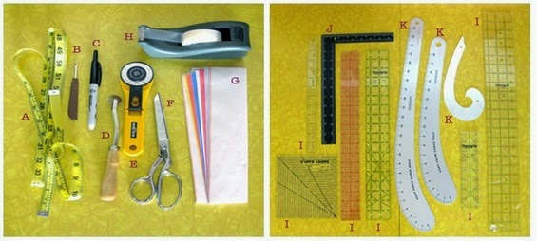
Tools use for Drafting
02. Draping: It involves the draping of a two dimensional piece of fabric around a form, conforming to its shape, creating a three-dimensional fabric pattern. Ease allowances for movement are added to make the garment comfortable to wear. Advantage of draping is that the designer can see the overall design effect of the finished garment on the body form before the garment piece is cut and sewn. However, it is more expensive and time consuming than flat pattern making. Draping can be made on a Human body or on a stand.
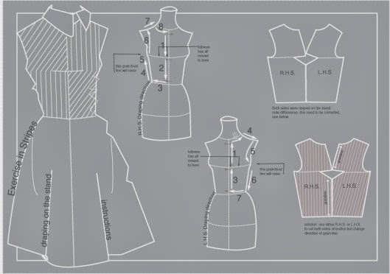
3. Flat Pattern Making: It involves the development of a fitted basic pattern with comfort ease to fit a person or body form. A sloper is the starting point for flat pattern designing. It is a simple pattern that fits the body with just enough ease for movement and comfort. Five basic pattern pieces are used for women’s clothing. They include a snug-fitting bodice front and bodice back with darts and a basic neckline, a sleeve and a fitted skirt front and back with darts. However, as fashion changes frequently women’s styles fluctuate frequently. These basic slopers are then manipulated to create fashions. Nowadays draping is also tested by Computer aid techniques. A basic sloper has no seam allowances, which facilitates its manipulations to various styles. It has no design interest, only construction lines are marked on it. It is necessary that the basic structure of a sloper should be such that adjustments can be introduced easily. For a good pattern making, accurate measurements are of utmost importance.
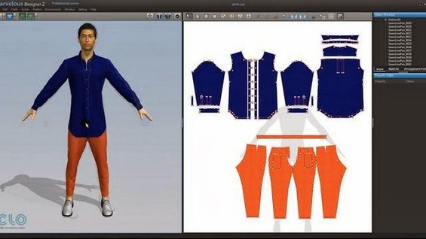
Pattern making by CAD system
The flat pattern making method is widely used in the ready-to-wear market because it is fast and accurate (Aldrich).

10. Draw the three Quarter view Lay figure Explain Briefly

Definition of three-quarter view
A representation of a head or figure posed about halfway between front and profile views
Three-quarter views of the torso show mood and subtle action in your fashion drawings. The partial side view brings your figure to life because you avoid that straight-on stiff soldier look. Plus, this view is a typical red carpet view that adds lots of movement to your fashion pose. Even better, this view works like a charm to make thin appear even thinner.
With female figures, you see a slight side view of one of the breasts. In both males and females, the center front line is still in the center front of the figure’s torso, but the angle from which you see the line changes.
Here’s how to draw a three-quarter view of your female figure:
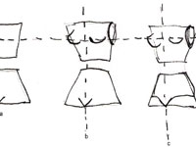

1Draw two stacked trapezoids. Draw the center front line off center, about a third of the way across the torso instead of halfway.
Add the apex line in its normal location on the upper torso.

2To show the slight side turn to the side, add a breast to the upper torso in slight profile; the breast extends slightly outward from the torso. Draw the other breast so that it extends almost but not quite to the center front line.The upper half of the breasts goes above the apex line, and the other half goes below the apex line.

3On the upper trapezoid, add an oval for the armhole on your figure’s left side.
Add a V shape for the crotch at the center front line on the lower trapezoid.

Add downward arcs on the lower trapezoid for the legs.
The arc on the left leg is wider than the one on the right because you see more of that leg. Finish your figure with a neck and head if you like.
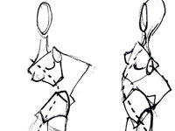

5(Optional) To add even more fashion attitude, try placing your trapezoids at different angles.
Notice that the center front line curves with the body, which helps define your placement of body parts such as the crotch and breasts. When you sketch arms and legs from the three-quarter view, you can draw them at extreme angles to further accentuate the attitude.
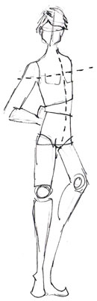

6(Optional) Modify your angles to create a male image.
When drawing a man in the three-quarter view, follow the same steps you use to draw a woman, but change the shapes for the chest and crotch.

11.Explain the method of taking important body measurements?
Body Measurement:
Accurate body measurements are of vital importance for obtaining best results in cloth construction. Besides good fitting, correct measurements can also contribute towards saving time in constructing a garment. Personal measurements are required not only for stitching the garment at home or getting it stitched, but also for buying ready made garments.
Taking body measurements is a responsible task, which should be undertaken with great care. For this purpose, it is important for a dress maker to have adequate knowledge about correct methods of taking and recording body measurements, equipment required for it and other important points to be considered in taking the measurements.
Points Considered While Taking Measurements:
1. A good quality measuring tape should be used for taking the body measurements. The long metal end of the tape is used for taking vertical measurements and the rounded metal end is used for taking horizontal measurements.
2. Person giving the measurements should stand straight, but in a natural pose and preferably in front of a mirror. A well fitted foundation garments should be worn while giving measurements.
3. Another person is needed to take measurements. Basic lines of the body are to be taken into consideration while measuring body parts.
4. Before body measurements are taken, a cord or tape is fastened around the waist and left until all measurements have been completed. The tape should be kept parallel to the ground while taking girth measurements like bust, waist, hip, etc.
5. The accuracy of several measurements depends on this exact waistline location. Add to these measurements the suggested amount of ease.
6. The amount of ease needed varies with the type of fabric used. More ease is needed for woven fabrics than knits.
7. A proper order and certain sequence should be followed in taking the measurements to make it more systematic.
12.Explain the method of pattern layout?
Principles of Pattern Layout
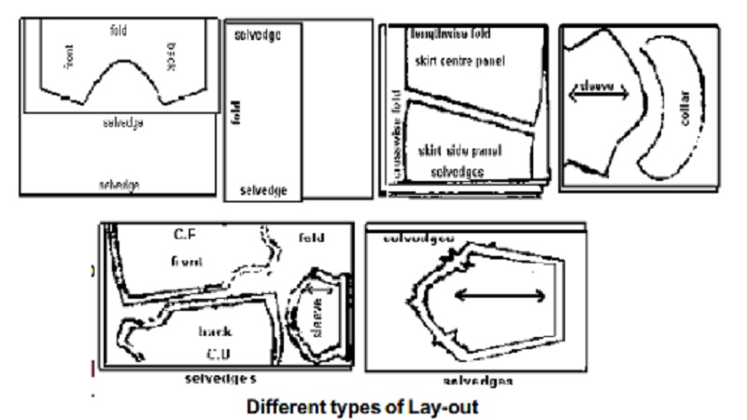
Laying Pattern Pieces over the fabric in an economical way is called as pattern layout. This prevents wastage of fabric.

PATTERN LAYOUT:

Laying Pattern Pieces over the fabric in an economical way is called as pattern layout. This prevents wastage of fabric.

Principles of Pattern Layout:

Some of the principles to be followed while laying patterns:
Press the fabric as well as the pattern pieces flat before laying the pattern on the fabric.
Use a large table or any hard flat surface for accommodating the work.
If an open layout is used, place the fabric right side up on the table. For all other layouts fold the fabric right sides facing and wrong sides out.
Decide on the best way to fold your cloth this will depend on the width of the cloth, width of your pattern pieces, the type of cloth and design of the garment (whether left and right haves are identical. Whether many pieces have to be cut on fold the garment
(whether left and right halves are identical, whether many pieces have to be cut on fold etc.) The common methods of folding the cloth for laying out pattern pieces are the following.
a. Lengthwise centre fold:
Here the fabric is folded down the middle parallel to the selvedge so that the selvedges come together. This is the most frequently used fold. The layout for a simple frock on this type of fold is illustrated in the figure.
b. Off centre lengthwise fold:

This is used when narrow pieces have to be cut on fold. To ensure that the fold is parallel to the selvedge, mark points measuring the required distance (width of the half pattern including seam allowance) from the selvedges at regular intervals and fold along the markings. The layout for a child's panty on this type of layout is illustrated in the figure.
c. Crosswise centre fold:
This is suitable for materials that are too narrow to accommodate the width of pattern pieces when folded lengthwise.

d. Off centre crosswise fold:
When only a part of the material is required to cut pattern pieces that are too wide for lengthwise fold layout, this type of fold is used.
e. Combination fold:
Here length wise fold and crosswise fold are combined.
f. Open layout:
In this type of layout, the fabric is not folded at all. This is used especially for designs which regain right and left halves to be cut separately.
Make a trial layout by keeping weights or two pins per pattern, to make sure that cloth will be sufficient. Rules 6 to 9 must be borne in mind while making the trial layout.
Straight grain lines on patterns must be kept parallel to the fabric selvedge. To ensure this, measure and adjust the pattern so that both ends of the straight grain line are the same distance from the selvedge and pin the pattern to the fabric along the grain line arrows.
Fold lines on the patterns must be kept on folded edges of fabric.
Leave enough space between patterns for cutting outward notches and marking seam allowance (if the patterns do not include seam allowances). Also make sure that there is enough material left for cutting out belts, facings, etc. for which you may not have made paper patterns.
The patterns must be placed on the fabric in the most economical way.
Pin patterns to the fabric firmly, after placement of the pattern has been decided, pin the corners and the long outside edges of the patterns, placing pins close to and approximately perpendicular to the cutting line. Use just enough pins to keep the pattern in position. Too many pins will distort the edges. You should start cutting the fabric only after pinning all the pattern pieces.
13 Discuss different principles for pattern alterations?
A comfortable, attractive garment fits properly. It is neither too large nor too small and conforms to the contours of the body without binding, pulling, sagging, straining, or wrinkling.
Pattern adjustments and alterations are often necessary to achieve a good fit, especially in a form-fitting garment. Making adjustments or alterations before the garment is cut from fabric will eliminate many problems later. Use this collection of alteration guidelines to solve women’s most common fitting problems.
A pattern can be altered and adjusted three ways:
1. By folding out excess fullness to make an area smaller.
2. By slashing and spreading or overlapping along pattern lines to increase or decrease dimensions.
3. By redrawing darts or seamlines.
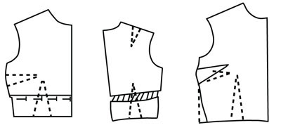
Fitting problems usually involve one or more of these basic body areas: neckline, bustline, hipline, arms, shoulder line, back waistline, or abdomen.
As time passes, you may find that the problems of fitting your figure may change. Because of this, you will want to compare your current body measurements (Table 1) plus ease² to the particular pattern you are using. The amount of ease in a pattern is determined by how close- or loose-fitting the pattern design is.
Make appropriate adjustments or alterations when you find differences between your measurements plus ease and the pattern. After adjusting or altering the pattern, do a careful pin-fitting to further ensure that your garment will fit well
ALTERING BODICE PATTERNS
Full Bust (large cup size)
Slash across the pattern along bust dart foldline to center front. Slash across the pattern from waist to shoulder along waist dart foldline. Spread the desired amount at center front and bust area. Do not spread at shoulder seam. Redraw seamlines and darts. (New darts will be larger than the original darts.)
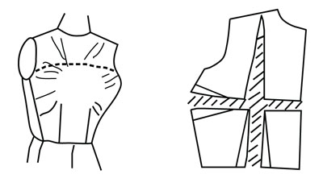

Small Bust (small cup size)
Slash across the pattern along bust dart foldline to center front. Slash across pattern from waist to shoulder along waist dart foldline. Overlap darts the desired amount to decrease the bust area. Do not overlap at shoulder seam. (New darts will be smaller than the original darts.)
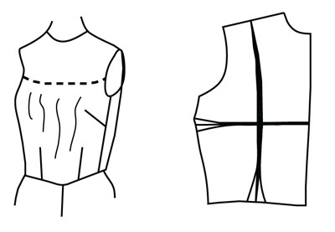
High Bust
Slash below dart and up to armscye (or armhole) level. Fold out desired amount above the dart. Lengthen the waistline dart as needed. Redraw seamline below dart.
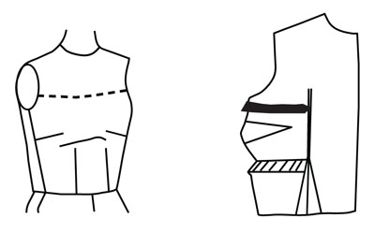

Low Bust
Slash above dart and down to waist. Fold out desired amount below dart. Shorten the waistline dart as needed. Redraw seamline above dart.
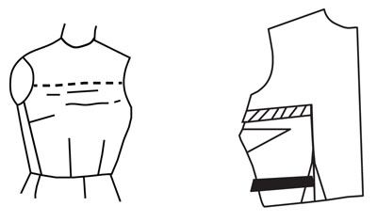

Small Neck
Redraw neckline to raise it the desired amount. Add the same amounts to the facing and collar patterns.
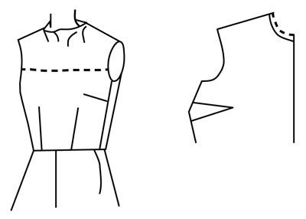

Large Neck
Redraw neckline to lower it the desired amount. Alter the facing and collar patterns to match the new neckline.
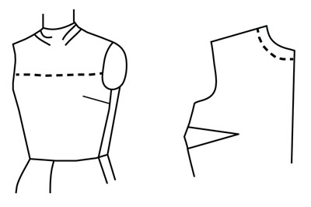

Gaping Neckline
Slash from neckline down through bust area to waist. Overlap the desired amount on neck edge; the waistline dart will become larger. Remember to alter the neckline facing and collar patterns to fit the altered neckline.
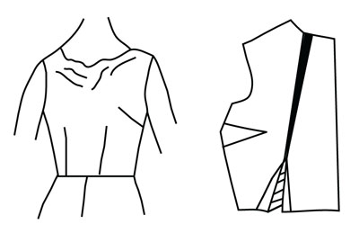

Sloping Shoulders
Redraw shoulder seam and armscye seams, sloping and lowering them the desired amount. Be sure to redraw seams on both front and back pattern pieces.
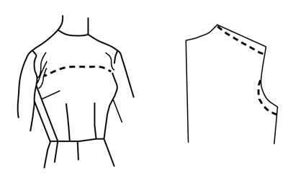

Round Shoulders
Slash across the back from center back to armscye. Slash down from middle of neckline curve. Spread the desired amounts, making the addition at the neckline a new dart.
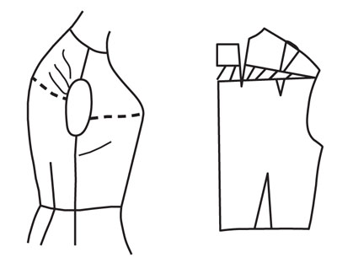

Narrow Shoulders
Slash from midpoint of shoulder down and across to middle of armscye. Overlap pattern the desired amount, and redraw. Be sure to complete alterations for both bodice front and back.
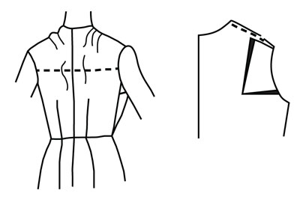

Broad Shoulders
Slash from midpoint of shoulder down and across to the middle of armscye. Spread pattern the desired amount. Redraw seam from neckline to armscye. Be sure to complete alterations for both bodice front and back.
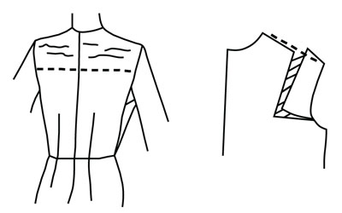

Square Shoulders
Redraw shoulder seam and armscye seams, raising them the desired amount. Be sure to redraw seams on both front and back pattern pieces.
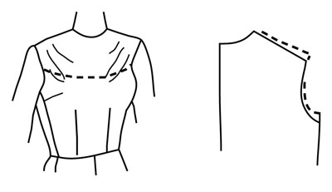

Narrow Back
Slash from shoulder to waist. Slash from underarm side seam to first slash. Overlap pattern sections the desired amount, but do not overlap at shoulder or waistline.
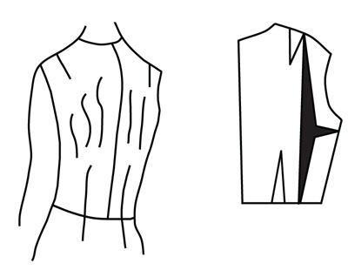

Broad Back
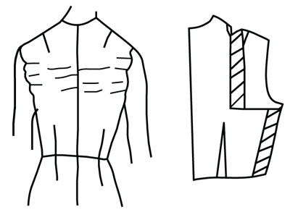
Slash down from midpoint of shoulder to bottom of armscye and across. Spread pattern the desired amount. Redraw side seam and shoulder dart. (The new dart will be larger than the original one.)

Sleeve Cap Too Narrow
Slash from top of sleeve to elbow, then across to side seam. Spread the desired amount at the top. Redraw cap. Add 1/2 the amount added to the shoulder cap to the shoulder seam on both the bodice front and back.
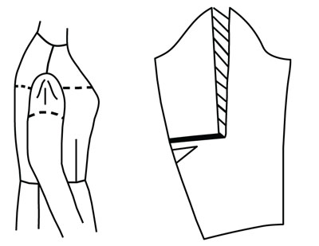

Large Upper Arm
Measure the length of the original seam at the top of the sleeve and record the measurement. Slash sleeve down the center from top to bottom. Slash across cap. As you pull the sleeve open to make it wider, the cap will become shorter; redraw the cap to its original height. Measure the length of the new seam at the top of the sleeve. Figure the difference from the original seam. Add 1/2 of the difference to the underarm seams of both the bodice front and back.
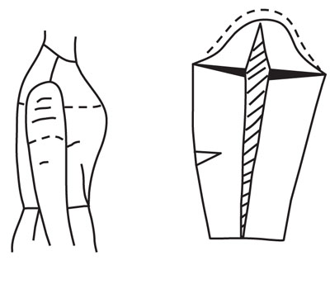

Small Arm
Measure the length of the original seam at the top of the sleeve and record the measurement. On the pattern, fold out the desired amount along a line from top to bottom of sleeve. Redraw lines at hem of sleeve and cap to make a smooth seamline. Measure the length of the new seam at the top of the sleeve; figure the difference from the original seam. Remove 1/2 the difference from the underarm seams of both the bodice front and back.
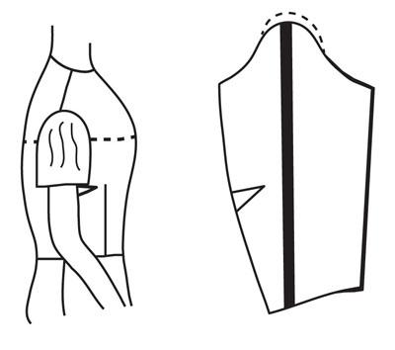

Large Arm
Slash sleeve down the center from top to bottom and spread the desired amount. Add 1/2 the amount added to the sleeve to the bodice front and back side seam.
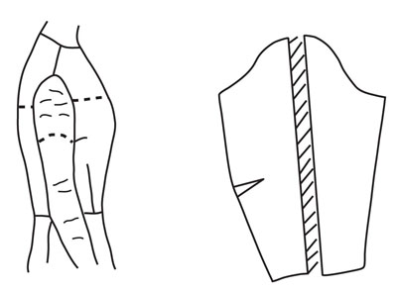

Altering Skirt Patterns

Protruding Derriere
Slash from waistline to hemline parallel to center back through waistline dart. In hip area, slash across pattern from center back to side seam. Spread the pattern the width and length desired. Redraw dart and seamlines. (The new dart will be larger than the original dart.)
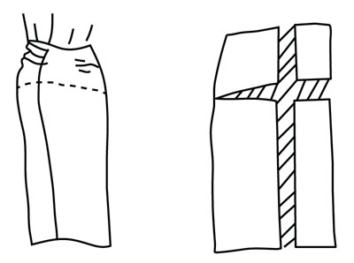
14.What are the solving fitting problems in various Garments?
Fitting Defects in Garments
Fitting of garment is that tightly follows the contours of the part of the body being covered. The success of your garment depends a great deal on its fit. A well garments fitting has optimum amount of ease (neither too tight nor too loose) and its seam lines follow the general silhouette of the body. Fitting defects in garments are one of the most important problem because the wearer don’t feel comfortable by wearing unfitted garments.
Garments fitting
Improper fit:
Fitting is one of the important criteria for consumers in their buying decision. Variation in dimensions and improper fitting are the normal complaints in ready-made garments. The solutions include collecting data on age, body structure and ethnicity. Data can be colleted by sample survey method that can represent the population as a whole. Appropriate statistical tools can help in getting range and variation of sizes found in people. Adopting technologies such as automated measurement and 3D body scanning facilitate more effective and affordable data collection for garment manufacturingcompanies. The effectiveness of sizing system is highly dependent on skills of pattern makers and graders in identifying, defining and manufacturing the type of fit appropriate for the target market. Someof the tools and strategies to facilitate this are target body scanner, market surveys, wear testing, and virtual fit assessment. Materials with stretching characteristics can fit a wider range of body.
Improper fitted garment
Improper size labels:
Many times it is seen that consumers get confused with the sizes. They are not able correlate the numbers with body measurement, so they prefer taking trials of various sizes of same item. The reason behind this is non standardization of label sizes among manufacturers. To get rid of this problem, manufacturers are using terms such as slim, classic, relaxed fit. Use of Internationals Standards for dress size and educating the users on the Standards adopted could solve the problem to a certain extent.
Cutting inaccuracies:
Factors that cause cutting inaccuracies are wide or vague lines on the marker, imprecise following of lines on the marker, variation in the cutting patch, shifting of the spread or block, allowing fabric to bunch up or push ahead of the knife, using improper equipment and using improper cutting sequence as parts are cut.

15.Principles for pattern alterations and its Applications?
Fit is an important ingredient that makes a garment Pattern Alteration Pattern Alteration E- a wardrobe plus or minus. Standards of good fit are influenced by many things such as the current fashion look, the hang and stretch of the fabric, the amount of ease preferred and figure size and type. For any seamstress, whether beginning or experienced, the art of fitting requires skill and patience.
When this art has been mastered, garments will look better and feel more comfortable. Once the fabric is cut, however, fitting adjustments are limited to existing darts and seam allowances. Therefore, fitting problems should be solved before the garment is cut by making needed changes in the pattern. Preserve the altered pattern for later use by fusing nonwoven stabilizer on the pattern’s wrong side or redraw the pattern and new markings onto pattern paper. Use dry heat for fusing because steam wrinkles the tissue paper and smears the ink. Know your
Know your measurements Accurate measurements are the key to good fit. Measurements should be taken at least every 6 months and/or when weight or the figure has varied significantly. Take all measurements snugly, but not tightly, over undergarments usually worn. Also, wear shoes similar to those usually worn. A string tied around the waist and the base of the neck helps establish reference points for measuring.
Work in front of a mirror or with a partner to make sure that the tape is straight, parallel to the floor and positioned on the body in the correct locations. Five measurements are needed to determine pattern size and type. See Extension publication E-373, Personal Measurement Chart, for measuring instructions and illustrations. For best results, top and dress pattern sizes are usually selected according the best fit between the high bust and full bust measurement. Select the smaller size pattern if the full bust measurement is 2 or more inches larger than the high bust measurement. Fit across the upper chest is a wiser choice because of the difficulty of altering the Patterns that have a range of sizes in one category (8-10- 12) are made to fit the largest size. When measurements fall between sizes, it is usually best to select the smaller sized pattern. The 17 measurements listed on the Personal Measurement Chart are commonly used in altering garments. These measurements, plus a careful observation of body proportions, shapes and posture, are needed to determine necessary alterations. Prior experience in home sewing or buying ready-to-wear is helpful in pinpointing areas usually needin
To measure the pattern pieces
Measure each pattern piece at points that correspond with body measurements. For example, if your full hip measurement was taken 10 inches below the waist, measure the pattern’s circumference at the same point—10 inches below the waist seamline. First, smooth the pattern pieces flat. Pin in darts, pleats or gathers as though sewn. Measure from seamline to seamline. Carefully follow the shape of the pattern piece in the area measured. For example, waist and side seamlines often curve, so the tape measure also should curve along the seamline. For a sharp curve such as the crotch, turn the tape measure on its side for ease in following the curve. The numbered measurements in Figure 1 correspond to the body measurements on the Personal Measurement Chart. Use these illustrations as a guide when measuring pattern pieces. Record totals in column IV of the Personal Measurement Chart. Be sure that totals reflect how the pattern will be cut. For example, the bust pattern measurement (number 2) will be taken on all back and front pattern pieces that will be sewn together to make the garment’s bustline. For each pattern piece cut double or on the fold, multiply by 2
To alter the pattern
After measuring the body and adding needed ease, compare this measurement to the pattern’s measurement. The difference is the amount of alteration needed, column V of the Personal Measurement Chart. The following guidelines are basic to the success of all alterations. Consider each carefully before beginning. These markings are used throughout this publication series to indicate specific alterations. Using a ruler, extend grainline markings the entire length of pattern pieces so that they can be seen dearly throughout altering and cutting. To extend the grainline, lay a ruler along the marked line. Extend the grainline to each seamline or outside edge, keeping the line straight. When pattern pieces are cut apart and then put back together, the original lengthwise grainline should be maintained whenever possible
16.Explain about grading?
Grading in education is the process of applying standardized measurements of varying levels of achievement in a course. Grades can be assigned as letters (for example A through F), as a range (for example 1 to 6), as a percentage of a total number of questions answered correctly, or as a number out of a possible total .

In some countries, all grades from all current classes are averaged to create a grade point average (GPA) for the marking period. The GPA is calculated by taking the number of grade points a student earned in a given period of time of middle school through high school. GPAs are also calculated for undergraduate and graduate students in most universities.
The GPA can be used by potential employers or educational institutions to assess and compare applicants. A cumulative grade point average (CGPA) is a calculation of the average of all of a student's total earned points divided by the possible number of points. This grading system calculates for all of his or her complete education career. Grade point averages can be unweighted (where all classes with the same number of credits have equal influence on the GPA) or weighted .
Yale traces its beginnings to "An Act for Liberty to Erect a Collegiate School", passed by the General Court of the Colony of Connecticut on October 9, 1701, while meeting in New Haven.
The Act was an effort to create an institution to train ministers and lay leadership for Connecticut. Soon thereafter, a group of ten Congregational ministers, Samuel Andrew, Thomas Buckingham, Israel Chauncy, Samuel Mather (brother of Increase Mather), Rev. James Noyes II (son of James Noyes), James Pierpont, Abraham Pierson, Noadiah Russell, Joseph Webb, and Timothy Woodbridge, all alumni of Harvard, met in the study of Reverend Samuel Russell in Branford, Connecticut, to pool their books to form the school's library.^{[15]} The group, led by James Pierpont, is now known as "The Founders".
Originally known as the "Collegiate School", the institution opened in the home of its first rector, Abraham Pierson, today considered the first president of Yale. Pierson lived in Killingworth (now Clinton). The school moved to Saybrook and then Wethersfield. In 1716, it moved to New Haven, Connecticut.
Meanwhile, there was a rift forming at Harvard between its sixth president, Increase Mather, and the rest of the Harvard clergy, whom Mather viewed as increasingly liberal, ecclesiastically lax, and overly broad in Church polity. The feud caused the Mathers to champion the success of the Collegiate School in the hope that it would maintain the Puritan religious orthodoxy in a way that Harvard had not.^{[17]}

Naming and development
In 1718, at the behest of either Rector Samuel Andrew or the colony's Governor Gurdon Saltonstall, Cotton Mather contacted the successful Boston born businessman Elihu Yale to ask him for financial help in constructing a new building for the college. Through the persuasion of Jeremiah Dummer, Yale, who had made a fortune through trade while living in Madras as a representative of the East India Company, donated nine bales of goods, which were sold for more than £560, a substantial sum at the time. Cotton Mather suggested that the school change its name to "Yale College". (The name Yale is the Anglicised spelling of the Welshtoponym, Iâl. from the family estate at Plas yn Iâl near the village of Llandegla, Denbighshire, Wales).
Meanwhile, a Harvard graduate working in England convinced some 180 prominent intellectuals that they should donate books to Yale. The 1714 shipment of 500 books represented the best of modern English literature, science, philosophy and theology.
It had a profound effect on intellectuals at Yale. Undergraduate Jonathan Edwards discovered John Locke's works and developed his original theology known as the "new divinity". In 1722 the Rector and six of his friends, who had a study group to discuss the new ideas, announced that they had given up Calvinism, become Arminians and joined the Church of England.
They were ordained in England and returned to the colonies as missionaries for the Anglican faith. Thomas Clapp became president in 1745 and struggled to return the college to Calvinist orthodoxy, but he did not close the library. Other students found Deist books in the library.

Curriculum
Yale was swept up by the great intellectual movements of the period—the Great Awakening and the Enlightenment—due to the religious and scientific interests of presidents Thomas Clap and Ezra Stiles. They were both instrumental in developing the scientific curriculum at Yale, while dealing with wars, student tumults, graffiti, "irrelevance" of curricula, desperate need for endowment and fights with the Connecticut legislature.
Serious American students of theology and divinity, particularly in New England, regarded Hebrew as a classical language, along with Greek and Latin, and essential for study of the Old Testament in the original words.
The Reverend Ezra Stiles, president of the College from 1778 to 1795, brought with him his interest in the Hebrew language as a vehicle for studying ancient Biblical texts in their original language (as was common in other schools), requiring all freshmen to study Hebrew (in contrast to Harvard, where only upperclassmen were required to study the language) and is responsible for the Hebrew phrase on the Yale seal.

