ORACLE AND RDBMS
UNIT-I I-M.COM (CA)
- What is RDBMS?

RDBMS stands for Relational Database Management Systems..
All modern database management systems like SQL, MS SQL Server, IBM DB2, ORACLE, My-SQL and Microsoft Access are based on RDBMS.
It is called Relational Data Base Management System (RDBMS) because it is based on relational model introduced by E.F. Codd.

2. What is table?
The RDBMS database uses tables to store data. A table is a collection of related data entries and contains rows and columns to store data.
A table is the simplest example of data storage in RDBMS.
Let's see the example of student table.

ID | Name | AGE | COURSE
1 | Banu | 21 | B.com(ca)
2 | Thiru | 21 | M.com(CA)
3 | Chitra | 21 | M.com(CA)

3. What is row or record?
A row of a table is also called record. It contains the specific information of each individual entry in the table. It is a horizontal entity in the table.
Let's see one record/row in the table.
1 | Ajeet | 24 | B.Tech

4.What is column?
A column is a vertical entity in the table which contains all information associated with a specific field in a table. For example: "name" is a column in table which contains all information about student's name.
Banu
Aryan
Mahesh

5. Normalization of Database
Database Normalization is a technique of organizing the data in the database. Normalization is a systematic approach of decomposing tables to eliminate data redundancy(repetition) and undesirable characteristics like Insertion, Update and Deletion Anomalies. It is a multi-step process that puts data into tabular form, removing duplicated data from the relation tables.
Normalization is used for mainly two purposes,
- Eliminating redundant(useless) data.
- Ensuring data dependencies make sense i.e data is logically stored.
6.What are Normal Forms?
- First Normal Form
- Second Normal Form
- Third Normal Form
- BCNF
- Fourth Normal Form

7.What is Boyce - Codd Normal Form (BCNF)?
Boyce - Codd Normal Form is a higher version of the Third Normal form. This form deals with certain type of anomaly that is not handled by 3NF. A 3NF table which does not have multiple overlapping candidate keys is said to be in BCNF. For a table to be in BCNF, following conditions must be satisfied:
- R must be in 3rd Normal Form
- and, for each functional dependency ( X → Y ), X should be a super Key.
8. List categories of data integrity .
There are the following categories of data integrity exist with each RDBMS:
- Entity integrity: It specifies that there should be no duplicate rows in a table.
- Domain integrity: It enforces valid entries for a given column by restricting the type, the format, or the range of values.
- Referential integrity: It specifies that rows cannot be deleted, which are used by other records.
- User-defined integrity: It enforces some specific business rules that are defined by users. These rules are different from entity, domain or referential integrity.

9. What is field?
Field is a smaller entity of the table which contains specific information about every record in the table.
example the field in the table consist of id, name, age, course.etc.,

10. What is Multi-valued Dependency?
A table is said to have multi-valued dependency, if the following conditions are true,
- For a dependency A → B, if for a single value of A, multiple value of B exists, then the table may have multi-valued dependency.
- Also, a table should have at-least 3 columns for it to have a multi-valued dependency.
- And, for a relation R(A,B,C), if there is a multi-valued dependency between, A and B, then B and C should be independent of each other.
If all these conditions are true for any relation(table), it is said to have multi-valued dependency.

ORACLE AND RDBMS
UNIT-II I-M.COM (CA)
1.What is oracle?
Oracle database is a relational database management system (RDBMS) from the Oracle Corporation. Oracle is a fully scalable relational database architecture and is often used by global enterprises, which manage and process data across wide and local area networks. The Oracle database has its own network component to allow communications across networks.
2. Define personal database
Personal databases are typically small database management systems designed to be used by only one person to organize information.
Example : Microsoft Access, Microsoft Excel, Visual Fox Pro
3. What is table locking?
The table is locked totally or partly by the DBMS indicates that the transaction holding the lock has updated table rows.
The LOCK TABLE statement allows you to lock on the specified table. The table lock lasts until the end of the current transaction. To lock a table you must either be the database owner or the table owner.

4. List the data types used in Oracle table.
Oracle supplies the following built-in data types:
- character data types. CHAR. NCHAR. VARCHAR2 and VARCHAR. NVARCHAR2. CLOB. NCLOB. LONG.
- NUMBER data type.
- DATE data type.
- binary data types. BLOB. BFILE. RAW. LONG RAW.

5. What is Constraints?
  - Constraints enforce a rule that restricts the values in a database.
  - The Constraints help you to make your database one with integrity. This ensures the accuracy and reliability of the data in the database.
  - Constraints implement data integrity at the individual column level .
  - Whenever a row or record is inserted , updated or deleted from the table a constraint must be satisfied for the operation to succeed.

6. What is called Primary Key?
In Oracle a primary key is a single field or combination of fields that uniquely defines a record. None of the fields that are part of the primary key can contain a null value. A table can have only one primary key.
Syntax for creating Primary key:
CONSTRAINT constraint_name PRIMARY KEY (column1,... column_n);

7. Define the term Foreign key.
A foreign key is a way to enforce referential integrity within your Oracle database. A foreign key means that values in one table must also appear in another table.
The referenced table is called the parent table while the table with the foreign key is called the child table. The foreign key in the child table will generally reference a primary key in the parent table.

Syntax for creating Foreign key:
CONSTRAINT fk_column FOREIGN KEY (column1, column 2, ... column_n)
REFERENCES parent_table (column1, column 2, ... column_n);

8. Write the syntax of the command to create a table in oracle
To create a table you have to name that table and define its columns and data type for each column.
Syntax:
CREATE TABLE table_name.(column1 datatype ,
column2 datatype , ...column_n datatype);

9. what is super key?
A super key is a combination of columns that uniquely identifies any row within a relational database management system (RDBMS) table. A candidate key is a closely related concept where the super key is reduced to the minimum number of columns required to uniquely identify each row.

10. What is optimistic locking?
In Optimistic locking you are read data and only update it if it did not change since the initial fetch. That no two transactions will happen at the same time on one table which is known as Optimistic locking.
11.Illustrate the use of group by clause
The GROUP BY clause is used in a SELECT statement to group rows into a set of summary rows by values of columns or expressions. The GROUP BY clause returns one row per group.
The GROUP BY clause is also used with aggregate functions such as AVG(), COUNT(), MAX(), MIN() and SUM(). In this case, the aggregate function returns the summary information per group.
syntax of the Oracle GROUP BY clause:

SELECT column_list FROM T GROUP BY c1,c2,c3;

ORACLE AND RDBMS
UNIT-III I-M.COM (CA)
1.What is the use of JOIN operation?
Oracle JOINS are used to retrieve data from multiple tables. An Oracle JOIN is performed whenever two or more tables are joined in a SQL statement.
There are 4 different types of Oracle joins:
- Oracle INNER JOIN (or sometimes called simple join)
- Oracle LEFT OUTER JOIN (or sometimes called LEFT JOIN)
- Oracle RIGHT OUTER JOIN (or sometimes called RIGHT JOIN)
- Oracle FULL OUTER JOIN (or sometimes called FULL JOIN)

2.How will you create Synonym?
To create a synonym so that users do not have to prefix the table name with the schema name when using the table in a query.
The syntax to create a synonym in Oracle is:
CREATE [OR REPLACE] [PUBLIC] SYNONYM [schema .] synonym_name
FOR [schema .] object_name [@ dblink];

3.Define Synonym.
A synonym is an alternative name for objects such as tables, views, sequences, stored procedures, and other database objects.
4.What is view in oracle?
A view is a virtual table because you can use it like a table in your SQL queries. Every view has columns with data types so you can execute a query against views or manage their contents (with some restrictions) using the INSERT, UPDATE, DELETE, and MERGE statements.
Unlike a table, a view does not store any data. To be precise, a view only behaves like a table

5. When to use the Oracle view
You can use views in many cases for different purposes. The most common uses of views are as follows:
- Simplifying data retrieval.
- Maintaining logical data independence.
- Implementing data security.
6. Define object-level privileges?
An object-level privilege is a permission granted to an Oracle database user account or role to perform some action on a database object. These object privileges include SELECT, INSERT, UPDATE, DELETE, ALTER, INDEX on tables and views and EXECUTE on procedures, functions, and packages.
They can be granted through Oracle AS Portal or using Oracle database commands. You typically grant object-level privileges to give access to objects needed to build a provider. The privileges are granted to the schema that maps to the provider, not to the provider itself.

7.What are Object-level access privileges?
PRIVILEGE | ENABLES USER TO
ALTER | Change the definition of an object.
DELETE | Remove rows from a table or view's base table.
EXECUTE | Execute a procedure, function, or Java source.
INDEX | Create an index on a specified table or view.
INSERT | Insert rows into a table or a view's base table.
REFERENCES | Create a constraint on a table or view.
SELECT | Retrieve data from one or more tables or views.
UPDATE | Change existing values in a table or view's base table.

8.Define INNER JOIN (simple join)
It is the most common type of join. Oracle INNER JOINS return all rows from multiple tables where the join condition is met.
The syntax for the INNER JOIN in Oracle/PLSQL is:
SELECT columns
FROM table1
INNER JOIN table2
ON table1.column = table2.column;
In this visual diagram, the Oracle INNER JOIN returns the shaded area:
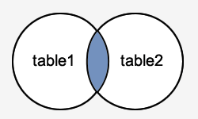

9.Define FULL OUTER JOIN.
Another type of join is called an Oracle FULL OUTER JOIN. This type of join returns all rows from the LEFT-hand table and RIGHT-hand table with nulls in place where the join condition is not met.
The syntax for the Oracle FULL OUTER JOIN is:
SELECT columnsFROM table1
FULL [OUTER] JOIN table2ON table1.column = table2.column;
In some databases, the FULL OUTER JOIN keywords are replaced with FULL JOIN.
In this visual diagram, the Oracle FULL OUTER JOIN returns the shaded area:
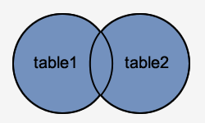
The Oracle FULL OUTER JOIN would return the all records from both table1 and table2.

ORACLE AND RDBMS
UNIT-IV I-M.COM (CA)
1.What is PL/SQL?
PL/SQL stands for “Procedural Language extensions to the Structured Query Language”. SQL is a popular language for both querying and updating data in the relational database management systems (RDBMS). PL/SQL adds many procedural constructs to SQL language to overcome some limitations of SQL.
PL/SQL is a highly structured and readable language. Its constructs express the intent of the code clearly. Also, PL/SQL is a straightforward language to learn.

2.How will you Declare variable in PL/SQL.
In PL/SQL, a variable is named storage location that stores a value of a particular data type. The value of the variable changes through the program. Before using a variable, you must declare it in the declaration section of a block.
The syntax for a variable declaration is as follows:
variable_name datatype [NOT NULL] [:= initial_value];
In this syntax:
- First, specify the name of the variable. e.g., l_total_sales, l_credit_limit, and l_sales_revenue.
- Second, choose an appropriate data type for the variable. for example, number, character, Boolean and date time.

3.Define Data Types.
Each value in PL/SQL such as a constant, variable and parameter has a data type that determines the storage format, valid values and allowed operations.
PL/SQL has two kinds of data types: scalar and composite. The scalar types are types that store single values such as number, Boolean, character, and date time whereas the composite types are types that store multiple values, for example, record and collection.

4.PL/SQL’s Scalar data types
PL/SQL divides the scalar data types into four families:
- Number
- Boolean
- Character
- Date time
A scalar data type may have subtypes. A subtype is a data type that is a subset of another data type, which is its base type. A subtype further defines a base type by restricting the value or size of the base data type.
Note that PL/SQL scalar data types include SQL data types and its own data type such as Boolean.

5.Define Character data type.
The character data types represent alphanumeric text. PL/SQL uses the SQL character data types such as CHAR, VARCHAR2, LONG, RAW, LONG RAW, ROWID, and UROWID.
- CHAR(n) is a fixed-length character type whose length is from 1 to 32,767 bytes.
- VARCHAR2(n) is varying length character data from 1 to 32,767 bytes.
6.What is the use of Default values in variable Declaration
PL/SQL allows you to set a default value for a variable at the declaration time.
To assign a default value to a variable, you use the assignment operator (:=) or the DEFAULT keyword.
Example:
l_product_name VARCHAR2( 100 ) DEFAULT 'Laptop';
BEGIN
NULL;
END;
7.PL/SQL architecture
The following picture illustrates the PL/SQL architecture:
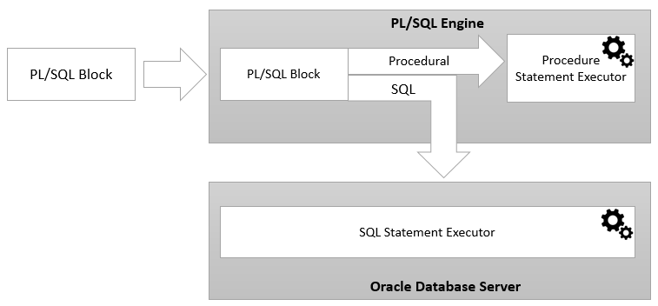

ORACLE AND RDBMS
UNIT-V I-M.COM (CA)
1.How will you define a cursor in PL/SQL
A cursor is a pointer that points to a result of a query.PL/SQL has two types of cursors:
- implicit cursors and
- explicit cursors.

PL/SQL cursor example
We will use the orders and order_items tables from the sample database for the demonstration.
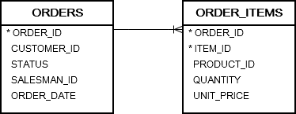
2.Declaring a cursor

Before using an explicit cursor, you must declare it in the declaration section of a block or package as shown below:
1 | CURSOR cursor_name IS query;
In this syntax:
- First, specify the name of the cursor after the CURSOR keyword.
- Second, define a query to fetch data after the IS keyword.

3.What is Package?
In PL/SQL, a package is a schema object that contains definitions for a group of related functionalities. A package includes variables, constants, cursors, exceptions, procedures, functions, and subprograms. It is compiled and stored in the Oracle Database.
Typically, a package has a specification and a body. A package specification is mandatory while the package body can be required or optional, depending on the package specification.
The following picture illustrates PL/SQL packages:
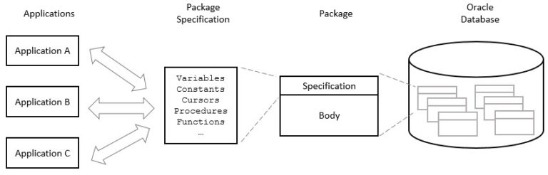

4.Define Package body.
A package body contains the implementation of the cursors or subprograms declared in the package specification. In the package body, you can declare or define private variables, cursors, etc., used only by package body itself.
A package body can have an initialization part whose statements initialize variables or perform other one-time setups for the whole package.
A package body can also have an exception-handling part used to handle exceptions.

5.Advantages of using PL/SQL packages

Make code more modular
Packages allow you to encapsulate logically related types, variables, constants, subprograms, cursors, and exceptions in named PL/SQL modules. By doing this, you make each package more reusable, manageable, readable and reliable.

Hide implementation details
Packages allow you to expose the functionality via their specifications and hide the detailed implementation in the package body.

Improve application performance
Oracle loads the package into memory at the first time you invoke a package subprogram. The subsequent calls of other subprograms in the same package do not require disk I/O. This mechanism helps improve performance.

Minimize unnecessary recompiling code
Packages help avoid the unnecessary recompiling process.

Manage authorization easily
By encapsulate objects in a package, you grant role on the package, instead of granting roles on each object in the package.

6.Define Exception
PL/SQL treats all errors that occur in an anonymous block, procedure, or function as exceptions. The exceptions can have different causes such as coding mistakes, bugs, even hardware failures.
It is not possible to anticipate all potential exceptions, however, you can write code to handle exceptions to enable the program to continue running as normal.
The code that you write to handle exceptions is called an exception handler.
basic syntax of the exception-handling section:
BEGIN
-- executable section
...
-- exception-handling section
EXCEPTION
WHEN e1 THEN
-- exception_handler1
WHEN e2 THEN
-- exception_handler1
WHEN OTHERS THEN
-- other_exception_handler
END;
In this syntax, e1, e2 are exceptions.

7. Define PL/SQL procedures
A PL/SQL procedure is a reusable unit that encapsulates specific business logic of the application. Technically speaking, a PL/SQL procedure is a named block stored as a schema object in the Oracle Database.
The following illustrates the basic syntax of creating a procedure in PL/SQL:
CREATE [OR REPLACE ] PROCEDURE procedure_name (parameter_list)
IS
[declaration statements]
BEGIN
[execution statements]
EXCEPTION
[exception handler]
END [procedure_name ];

8. Define PL/SQL procedure body
The procedure body has three parts. The executable part is mandatory whereas the declarative and exception-handling parts are optional. The executable part must contain at least one executable statement.
1) Declarative part
In this part, you can declare variables, constants, cursors, etc. Unlike an anonymous block, a declaration part of a procedure does not start with the DECLARE keyword.
2) Executable part
This part contains one or more statements that implement specific business logic. It might contain only a NULL statement.
3) Exception-handling part
This part contains the code that handles exceptions.

