I B.COM
ALLIED COURSE –II
BUSINESS ECONOMICS- SUBJECT CODE: 16CACCM1B

OBJECTIVE: To understand the concepts and application of economic tools in business.(Theory only)
UNIT- I
Business Economics – definition - Scope and Nature Art or Science –Concepts – relationship with other disciplines - Micro and Macro Economics relating to business.

UNIT-II
Demand Analysis- Demand Schedule - Law of Demand- Demand curves- Elasticity of Demand- Demand forecasting - Indifference curve analysis- Marginal rate of substitution – Consumer’s equilibrium.

UNIT-III
Production function-Factors of production - Isoquant analysis -scale of production- economies of large scale production and limitations.

UNIT-IV
Supply-supply schedule-Law of supply-Supply curve-Elasticity of supply. Market structure- Equilibrium of firm and industry- Optimum firm. Meaning and characteristics of perfect, monopoly, duopoly oligopoly and monopolistic markets. Pricing under Perfect & Monopolistic competition

Unit V:
National Income- concept – Measurement – inequalities of income – Fiscal policy method. Public Finance – Definition – Scope - importance.

Text and Reference Books (Latest revised edition only)
- S.Sankaran, .”Business Economics” Margam Publications, Chennai.
- Misra and Puri, .”Business Economics” Himalaya Publications, Mumbai
- MithaniD.M. .”Business Economics”, Himalaya Publications, Mumbai
- K.P.M.Sundharam and sundharam,”Business Economics” sultanchand& co., New Delhi.
- P.Ravilochanan, .”Business Economics”Ess Pee Kay Publishing House
- P.N.Reddy and Appannaiah, .”Business Economics”S.Chand & Co., Chennai.
7.T.Aryamala, .”Business Economics”Vijay Nicole Imprints Limited,
ALLIED COURSE-II
BUSINESS ECONOMICS
SUBJECT CODE: 16CACCM1B
UNIT-I

INTRODUCTION
Economics was formerly called political economy. The term Political economy means the management of the wealth of the state. “Adam Smith, the father of modem Economics, in his book entitled 'An Enquiry into the Nature and Causes of the Wealth of Nations’ (Published in 1776) defined Economics as a study of wealth. Smith considered the acquisition of wealth as the main objective of human activity. According to him the subject matter of Economics is the study of how wealth is produced and consumed.
Smith's definition is known as wealth definition.
This definition was too materialistic. It gave more importance to wealth than to man for whose use wealth is produced. The emphasis on wealth was severely criticised by many others. Cailyle, Ruskin and other philosophers called it the Gospel of Mammon. They even called it a dismal science as it was supposed to teach selfishness.
Later economists held that apart from man they said study of wealth has no meaning Economics is concerned not only with the production and use of wealth but also with man. It deals with wealth as serving the purpose of man. Wealth is only a means to the end of human welfare. We cannot consider the desire to acquire wealth as the inspiring factor behind every human endeavor. Nor can it be expected to be the sole cause of human happiness. The emphasis has now shifted from wealth to man. Man occupies the primary place and wealth only a secondary place.

DEFINITIONS OF ECONOMICS
Several definitions of Economics have been given. For the sake of convenience let us classify the various definitions into four groups:
- Science of wealth
- Science of material well-being
- Science of choice making and
- Science of dynamic growth and development We shall examine each one of these briefly.
- Science of wealth. Some earlier economists defined Economics as follows:
“An inquiry into the nature and causes of the wealth of the nations’’ by Adam Smith. “Science which deals with wealth" by J.B. Say.
In the above definition wealth becomes the main focus of the study of Economics. The definition of Economics, as science of wealth, had some merits. The important ones are:
  - It highlighted an important problem faced by each and every nation of the world, namely creation of wealth.
  - Since the problems of poverty, unemployment etc. can be solved to a greater extent when wealth is produced and is distributed equitably; it goes to the credit of Adam Smith and his followers to have addressed to the problems of economic growth and increase in the production of wealth.
The study of Economics as a 'Science of Wealth' has been criticized on several grounds. The main criticisms leveled against this definition are;
  - Adam Smith and other classical economists concentrated only on material wealth. They totally ignored creation of immaterial wealth like services of doctors, chartered accountants etc.
  - The advocates of Economics as 'science of wealth' concentrated too much on the production of wealth and ignored social welfare. This makes their definition incomplete and inadequate.
- Science of material well-being. Under this group of definitions the emphasis is on welfare as compared with wealth in the earlier group. Two important definitions are as follows:
"Economics is a study of mankind in the ordinary business of life. It examines that part of individual and social action which is most closely connected with the attainment and with the use of the material requisites of well-being. Thus, it is on the one side a study of wealth and on the other and more important side a part of the study of the man", Alfred Marshall
"The range of our inquiry becomes restricted to that part of social welfare that can be brought directly or indirectly into relation with the measuring rod of money" A.C. Pigou.
Professor Marshall has clearly pointed that Economics is the study of wealth but more important is the study of man. Thus, man gets precedence over wealth. There is also emphasis on material requisites of well-being. Obviously, the material things like food, clothing and shelter, are very important economic objectives.
The second definition by Pigou emphasizes social welfare but only that part of it which can be related with the measuring rod of money. Money is general measure of purchasing power by the use of which the science of Economics can be rendered more
precise.
Marshall's and Pigou's definitions of Economics are wider and more
comprehensive as they take into account the aspect of social welfare. But their definitions have their share of criticism. Their definitions are criticised on the following grounds. (i) Economics is concerned with not only material things but also with immaterial things like services of singers, teachers, actors etc. Marshall and Pigou chose to ignore them.
(ii) Robbins criticised the welfare definition on the ground that it is very difficult to state which things would lead to welfare and which will not. He is of the view that we would study in Economics all those goods and services which carry a price whether they promote welfare or not.
3. Science of choice making. Robbins gave a more scientific definition of Economics. His definition is as follows:
"Economics is the science which studies human behavior as a relationship between ends and scarce means which have alternative uses".
Definition of Business Economics
In simple words, business economics is the discipline which helps a business manager in decision making for acheiving the desired results. In other words, it deals with the application of economic theory to business management.
According to Spencer and Siegelman, Business economics is "the integration of economic theory with business practise for the purpose of facilitating decision-making and forward planning by management".
According to Mc Nair and Meriam, "Business economics deals with the use of economic modes of thought to analyse business situation".
From the above said definitions, we can safely say that business economics makes in depth study of the following objectives:
ii) Explanation of nature and form of economic analysis
(ii) Identification of the business areas where economic analysis can be applied (Hi) Spell out the relationship between Managerial Economics and other disciplines outline the methodology of managerial economics.
CHARACTERISTICS OF BUSINESS ECONOMICS
The following characteristics of business economics will indicate its nature:
- Micro economics: Managerial economics :s micro economic in character. This is so because it studies the problems of an individual business unit. It does not study the problems of the entire economy.
- Normative science: Managerial economics is a normative science. It is concerned with what management should do under particular circumstances. It determines the goals of the enterprise. Then it develops the ways to achieve these goals.
- Pragmatic: Managerial economics is pragmatic. It concentrates on making economic theory more application oriented. It tries to solve the managerial problems in their day-today functioning.
- Prescriptive: Managerial economics is prescriptive rather than descriptive. It prescribes solutions to various business problems.
- Uses macro economics: Marco economics is also useful to business economics. Macro-economics provides an intelligent understanding of the environment in which the business operates. Managerial economics takes the help of macro-economics to understand the external conditions such as business cycle, national income, economic policies of Government etc.
- Uses theory of firm: Managerial economics largely uses the body of economic concepts and principles towards solving the business problems. Managerial economics is a special branch of economics to bridge the gap between economic theory and managerial practice.
- Management oriented: The main aim of managerial economics is to help the management in taking correct decisions and preparing plans and policies for future. Managerial economics analyses the problems and give solutions just as doctor tries to give relief to the patient.
- Multi disciplinary: Managerial economics makes use of most modern tools of mathematics, statistics and operation research. In decision making and planning principles such accounting, finance, marketing, production and personnel etc.
- Art and science.-Managerial economics is both a science and an art. As a science, it establishes relationship between cause and effect by collecting, classifying and analyzing the facts on the basis of certain principles. It points out to the objectives and also shows the way to attain the said objectives.
OBJECTIVES OF BUSINESS ECONOMICS
Business economics provides such tools necessary for business decisions. business economics answers the five fundamental problems of decision making. These problem are : (a) what should be the product mix (b) which is the least cost production technique and input mix (c) what should be the level of output and price of the product (d) how to take investment decisions (e) how much should be the selling cost. In order to solve the problems of decision- making, data are to be collected and analysed in the light of business objectives. Business economics supplies such data to the business economist. As pointed out by Joel Dean "The purpose of business economics is to show how economic analysis can be used in formulating business policies"
The basic objective of business economics is to analyse economic problems of business and suggest solutions and help the managers in decision-making. The objectives of business economics are outlined as below:
    - To integrate economic theory with business practice.
    - To apply economic concepts: and principles to solve business problems.
    - To employ the most modern instruments and tools to solve business problems.
    - To allocate the scarce resources in the optimal manner.
    - To make overall development of a firm.
    - To help achieve other objectives of a firm like attaining industry leadership, expansion of the market share etc.
    - To minimise risk and uncertainty
    - To help in demand and sales forecasting.
    - To help in operation of firm by helping in planning, organising, controlling etc.
    - To help in formulating business policies.
    - To help in profit maximisation.
Business economics is useful because: (i) It provides tools and techniques for managerial decisions, (ii) It gives answers to the basic problems of business management, (iii) It supplies data for analysis and forecasting, (iv) It provides tools for demand forecasting and profit planning, (v) It guides the managerial economist. -
Thus, Business economics offers a number of benefits to business managers. It is also useful to individuals, society and government.
SCOPE OF BUSINESS ECONOMICS
Managerial economics is a developing science which generates the countless problems to determine its scope in a clear-cut way. From the following fields, we can examine the scope of business economics.
- Demand analysis and forecasting. The foremost aspect regarding scope is demand analysis and forecasting. A business firm is an economic unit which transforms productive resources into saleable goods. Since all output is meant to be sold, accurate estimates of demand help a firm in minimising its costs of production and storage. A firm must decide its total output before preparing its production schedule and deciding on the resources to be employed. Demand forecasts serves as a guide to the management for maintaining its market share in competition with its rivals, thereby securing its profit.
- Cost and production analysis. A firm's profitability depends much on its costs of production. A wise manager would prepare cost estimates of a range of output, identify the factors causing variations in costs and choose the cost-minimising output level, taking also into consideration the degree of uncertainty in production and cost calculations. Production process are under the charge of engineers but the business manager works to carry out the production function analysis in order to avoid wastages of materials and time. Sound pricing policies depend much on cost control.
- Pricing decisions, policies and practices. Another task before a business manager is the pricing of a product. Since a firm's income and profit depend mainly on the price decision, the pricing policies and all such decisions are to be taken after careful analysis of the nature of the market in which the firm operates. The important topics covered in this field of study are : Market Structure Analysis, Pricing Practices and Price Forecasting.
4. Profit management. Each and every business firms are tended for earning profit, it is profit which provides the chief measure of success of a firm in the long period. Economists tells us that profits are the reward for uncertainity bearing and risk taking. A successful business manager is one who can form more or less correct estimates of costs and revenues at different levels of output.
- Capital management. Still another most challenging problem for a modern business manager is of planning capital investment. Investments are made in the plant and machinery and buildings which are very high. Therefore, capital management requires top- level decisions. It means capital management i.e., planning and control of capital expenditure. It deals with Cost of capital, Rate of Return and Selection of projects.
- Inventory management: A firm should always keep an ideal quantity of stock. If the stock is too much, the capital is unnecessarily locked up in inventories At the same time if the level of inventory is low, production will be interrupted due to non-availability of materials. Hence, a firm always prefers to have an optimum quantity of stock. Therefore, managerial economics will use some methods such as ABC analysis, inventory models with a view to minimising the inventory cost.
- Linear programming and theory of games : Linear programming and theory of games have came to be regarded as part of managerial economics recently.
- Environmental issues: There are certain issues of macroeconomics which also form a part of managerial economics. These issues relate to general business, social and political environment in which a business enterprise operates.
- Business cycles: Business cycles affect business decisions. They refer to regular fluctuations in economic activities in the country. The different phases of business cycle are depression, recovery, prosperity, boom and recession.
FUNDAMENTAL CONCEPTS OF APPLIED BUSINESS ECONOMICS
- Principle of opportunity cost: The opportunity cost of using a machine to produce one product is the income forgone which would have been earned from the production of other products. If the machine has only one use, it has no opportunity cost. Similarly, the opportunity costs of funds invested in one's own business is the amount of interest earned if the amount had been used in other projects. If an old building is proposed to be used for a business, likely rent of the building is the opportunity cost. These are called opportunity costs because they represent the opportunities which are foregone.
- Principle of incremental cost and revenue: Two important incremental concepts used in Managerial Economics are fundamental concepts of Managerial Economics are incremental cost and incremental revenue. Incremental cost is a change in total cost resulting from a decision. Incremental revenue means the change in total revenue resulting from a decision. A decision is profitable only if
- It increases revenue more than costs,
- It decreases some costs more than it increases others, (iii) It increases some revenue more than it decreases others, and (iv) It reduces costs more than revenue.
Incremental principle can be used in the theories of consumption, production, pricing and distribution. Incremental concept is closely related to marginal cost and marginal revenue in the theory of pricing.
- Principle of Time Perspective. Another principle is the principle of time perspective which is useful in decision-making in output, prices, advertising and expansion of business. Economists distinguish between the short run and the long run in discussing the determination of price in a given market form because in the long run a firm must cover its full cost.
- Discounting Principle. Generally people consider a rupee tomorrow to be worth less than a rupee today. This is also implied by the common saying that a bird in hand is worth than two in the bush. Anybody will prefer Rs. 1000 today to Rs. 1000 next year. There are two main reasons for this : (1) the future is uncertain and it is preferable to get Rs. 1000 today rather than a year after ; (2) even if one is sure to receive the Rs. 1000 next year, one would do well to receive Rs. 1000 now and invest it for a year and earn a rate of interest on Rs. 100 for one year.
What is the present worth (PW) of Rs. 1000 obtainable after one year ? The relevant formula for finding this out is
Rs.100
PW = where i is the rate of interest.
1+i
We find that PW of Rs. 100 = 100 ÷ (1 + 8%)
= 100 ÷ 108 = Rs. 92.59.
The same reasoning applies to longer periods. A sum of Rs. 100 two years after will have

a present worth :
Rs.100
PW = =
(1+i)²
Rs.100 Rs.100
= = Rs. 85.73
(1.08)² 1.1664

The principle of economics used in the calculations given above is called the discounting principle. It can be explained as "If a decision affects costs and revenues at future dates, it is necessary to discount those costs and revenues to obtain the present values of both before a valid comparison of alternatives can be made"present values of both before a comparison of alternatives can be made’’
- Equi-marginal principle : This is one of the widely used concepts in managerial economics. This principle is also known the principle of maximum satisfaction. According to this principle, an input should be allocated in such a manner that the value added by the last unit of input is same in all uses. In this way, this principle provides a base for maximum exploitation of all the inputs of a firm so as to maximise the profitability.
.
- Optimisation: This is another important concept used managerial economics. Managerial economics often aims at optimising a given objective. The objective may be maximisation of profit or minimisation of time or minimisation of cost. The important techniques for optimisation include marginal analysis, calculus, linear programming etc.

RELATIONSHIP WITH OTHER DISCIPLINES:
BUSINESS ECONOMICS AND STATISTICS
Statistics provides several tools to Business Economics; Statistical techniques are used in collecting, marshalling and analysing business data that makes possible an empirical testing of the economic generalisations before they are applied for decision making. Economic generalisations cannot be fully accepted until they are verified and found Valid against the real data. The theory of probability and forecasting techniques help the manager in decision-making process. When the manager is to meet with the reality of uncertainty in decision making the theory of probability provides the logic for dealing with such uncertainty.
BUSINESS ECONOMICS AND MATHEMATICS
Mathematics is especially of to the manager when several economic relationships are to logic in the analysis of economic events provides clarity of the concepts and also helps to establish a quantitative relationship. Managers deal primarily with concepts that are quantitative in nature eg., demand, price, cost, capital, wages, inventories etc.
Mathematics is the manager's most useful logical tool.
BUSINESS ECONOMICS AND OPERATIONS RESEARCH
Operation research and business economics are related to a certain extent. Operation research is the application of mathematical and statistical techniques in solving business problems. It deals with construction of mathematical models that helps the decision making process. Operation research is helpful in business firms in studying the inter-relationship and relative efficiencies of various business aspects like sales, production etc. Linear programming, techniques of inventory control, game theory etc. is used in business economics. These are used to find out the optimum combination of various factors to achieve the objects of maximization of profit, minimizations of cost and time etc.

BUSINESS ECONOMICS AND ACCOUNTING
Accounting is closely related with business economics. Accounting is the main source of data regarding the operation and functioning of the firm. Accounting data and statements represent the language of the business. A business manager needs market information, production information and accounting information for decision-making.
The profit and loss statement reflects the operational efficiency of the firm.
The balance sheet tells the financial position of the firm. The accounting information provides a basis for the manager in decision making and forward planning. In short, accounting provides right information to take right decisions.
MICRO-ECONOMICS
The subject matter of economics consists of two parts, namely Micro economics and Macro economics. Ragnar Frisch. Who is among the first Nobel laureates in Economics coined these term. Which are now universally used. "Micro" is derived from the Greek word “Mikros" meaning small and "Macro" from "Makros" meaning large.
In Micro–Economics we study the economic behaviour of an individual, firm or industry in the national economy. It is thus a study of a particular unit rather than all the units combined. We mainly study the following in Micro-Economics:
(i) Product pricing; (ii) Consumer behaviour iii) Factor pricing;
iv) Economic conditions of a section of the people;
    - Study of firms; and
    - Location of a industry.
According to K.E. Boulding, "Micro economics is the study of particular firms, particular households, individual prices, wages, incomes, individual industries, particular commodities". Thus, it deals with the analysis of small individual units of the economy such as individual consumers, firms and small groups of individual units such as various industries and markets; it is a microscopic study of the economy. Herein it should be emphasized that it does not study the economy in its totality. It looks at the economy through a microscope, to analyse how the millions of units in the economy (analogous to cells in any organism) play their part in the functioning of the entire economic organisation. To quote Prof.Mc.Connel, "Micro Economics is concerned with specific economic units and a detailed consideration of the behavior of these individual units. In Micro Economics, we examine the trees, not the forest. Micro Economics is useful in achieving a worm's-eye view of some very specific component of our economic system’’
MACRO ECONOMICS
Macroeconomics is the study of aggregates; hence called Aggregative Economics. It is the analysis of the entire economic system, the overall conditions of an economy like total investment and total production. In the words of K.E.Boulding, "Macroeconomics deals not with individual quantities as such but with aggregates of these quantities; not with individual incomes, but with the national income; not with individual prices but with the price levels; not with individual outputs but with the national output." It analyses the entire economy and its large aggregates like total national income and output, aggregate consumption, saving and investment and total employment.
In Macro-Economics, we study the economic behaviour of the large aggregates such as the overall conditions of the economy such as total production, total consumption, total saving and total investment in it. It is the study of overall economic phenomena as a whole rather than its individual parts. It includes:
- National income and output;
- General price level;
- Balance of trade and payments;
- External value of money;
- Saving and investment; and
- Employment and economic growth.
Thus, when we study why we continue to have balance of payments deficits, or why the value of rupee vis-a-vis dollar is falling or why saving rates are high or low in a particular country we are studying Macro-Economics.
In the view of Prof. Mc. Connel, " The level of Macroeconomics is concerned either with the economy as a whole or with the basic sub-divisions or aggregates such as governments, households and businesses which make up the economy In short, macroeconomics examines the forest, not the trees. It gives us a bird's-eye view of the economy". It deals with the great averages and aggregates of the system rather than with particular units composing it.

UNIT-II
MEANING OF DEMAND
In economic science, the term "demand" refers to the desire, backed by the necessary ability to pay. The demand for a good at a given price is the quantity of it that can be bought per unit of time at the price. There are three important things about the demand: 1. It is the quantity desired at a given price. 2. It is the demand at a price during a given time. 3. It is the quantity demanded per unit of time.
DETERMINANTS OF DEMAND
The factors that determine the size and amount of demand are manifold. The term "function" is employed to show such "determined" and "determinant" relationship. For instance, we say that the quantity of a good demanded is a function of its price
i.e., Q = f(p)
Where Q represents quantity demanded f means function, and p represents price of the good.
There are many important determinants of the demand for a commodity:
- Price of the goods: The first and foremost determinant of the demand for good is price. Usually, higher the price of goods, lesser will be the quantity demanded of them.
- Income of the buyer: The size of income of the buyers also influences the demand for a commodity. Mostly it is true that "larger the income, more will be the quantity demanded".
- Prices of Related Goods: The prices of related goods also affect the demand for a good. In some cases, the demand for a good will go up as the price of related good rises. The goods so inter-related arc known as substitutes, e.g. radio and gramophone. In some other cases, demand for a good will comes down as the price of related good rises. The goods so inter-related are complements, e.g. car and petrol, pen and ink, cart and horse, etc.
- Tastes of the buyer: This is a subjective factor. A commodity may not be purchased by the consumer even though it is very cheap and useful, if the commodity is not up to his taste or liking. Contrarily, a good may be purchased by the buyer, even though it is very costly, if it is very much liked by him.
- Seasons prevailing at the time of purchase; In winter, the demand for woollen clothes will rise; in summer, the demand for cool drinks rises substantially; in the rainy season, the demand for umbrellas goes up.
- Fashion: When a new film becomes a success, the type of garments worn by the hero or the heroine or both becomes an article of fashion and the demand goes up for such garments.
- Advertisement and Sales promotion: Advertisement in newspapers and magazines, on outdoor hoardings on buses and trains and in radio and television broadcasts, etc. have a substantial effect on the demand for the good and thereby improves sales.
The need to have clarity in demand analysis makes us adopt a 'ceteris paribus' assumption, i.e. all other things remain the same except one. This enables us to consider the relation between demand and each of the variable factors considered in isolation.
LAW OF DEMAND
Among the many causal factors affecting demand, price is the most significant and the price- quantity relationship called as the Law of Demand is stated as follows: "The greater the amount to be sold, the smaller must be the price at which it is offered in order that it may find purchasers, or in other words, the amount demanded increases with a fall in price and diminishes with a rise in price" (Alfred Marshall). In simple words other things being equal, quantity demanded will be more at a lower price than at higher price.
Demand Schedule
It is a list of alternative hypothetical prices and the quantities demanded of a good corresponding to these prices. It refers to the series of quantities an individual is ready to buy at different prices. An imaginary demand schedule of an individual for apples is given below:
Table 1. Demand of a Consumer for apples
Price of apple

per unit (in rupees)

Quantity demanded of apples

(
in dozens
)

5

4

3

2

1

2

3

4

Assuming the individual to be rational in his purchasing behaviour, the above schedule illustrates the law of demand. At Rs.5/- per apple, the consumer demands 1 dozen of apples; at Rs.4/- per unit 2 dozens, at Rs.3/- per unit 3 dozens and at Rs.2/~ per unit 4 dozens. Thus the inverse relationship between price and demand is shown in the demand schedule.
Demand Curve
When the data presented in the demand schedule can be plotted on a graph with quantities demanded on the horizontal or X- axis and hypothetical prices on the vertical or Y- axis, and a smooth curve is hypothetical prices on the vertical or Y- axis, and a smooth curve is drawn Joining all the points so plotted, it gives a demand curve. Thus, the demand schedule is translated into a diagram known as the demand curve.
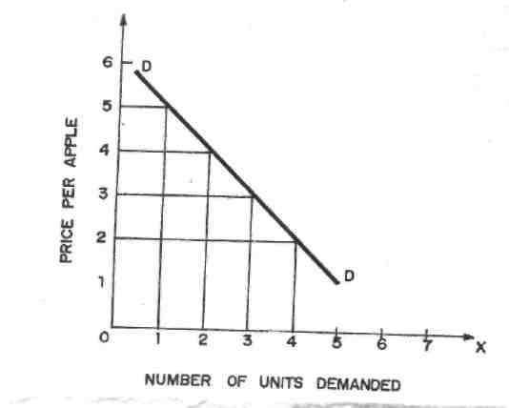
Fig -1

The demand curve slopes downwards from left to right, showing the inverse relationship between price and quantity as in Figure 1.
Market Demand
The market demand reflects the total quantity purchased by all consumers at alternative hypothetical prices. It is the sum-total of all individual demands. It is derived by adding the quantities demanded by each consumer for the product in the market at a particular price. The table presenting the series of quantities demanded of all consumers for a product in the market at alternative hypothetical prices is known as the Market Demand Schedule. If the data are represented on a two dimensional graph, the resulting curve will be the Market Demand Curve. From the point of view of the seller of the product, the market demand curve shows the various quantities that he can sell at different prices. Since the demand curve of an individual is downward sloping, the lateral addition of such curves to get market demand curve will also result in downward sloping curve.
Shifts in Demand Curve
The price-quantity relationship represented by the law of demand is important but it is more important for the manager of the firm to know about the shifts in the demand function (or curve). For many products, change in price has little effect in the quantity demanded in relevant price ranges. Many other determinants like incomes, tastes, fashion, and business activity have larger effect on demand for such product. Thus, changes or shifts in demand curve rather than movement along the demand curve is of greater significance to the decision-maker in the firm.
Let us clearly know the difference between movement along one and the same demand curve and shift in demand curve due to changes
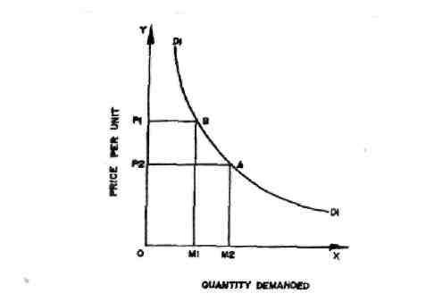
Fig- 2a
in demand. When price of a good alone varies, ceteris paribus, the quantity demanded of the good changes. These changes due to price variations alone are called as extension or contraction of demand represented by movement along the same demand curve. Such movement along the same demand curve is shown in Figure 2(a). Price declines from OP1 to OP2 and demand goes up from OM1 to OM2. Here the demand for the good is said to have extended or expanded. This is represented by movement from point A to point B along the demand curve. On the contrary, if price rises from OP2 to OP1 demand falls from OM2 to OM1. Here the demand for the good is said to have contracted. This is represented by movement from point B to point A along the demand curve D1D1.

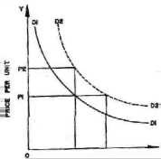

Quantity Demanded
Fig. 2b
Shifts in demand curve take place on account of determinants other than price such as changes in income, fashion, tastes, etc. The ceteris paribus assumption is relaxed; other factors than price influence demand and the impact of these factors on demand is described as changes in demand or shifts in demand, showing increase or decrease in demand. This kind of change is shown in Figure 2(b). The quantity demanded at OP1 is OM1. If, as a result of increase in income, more of the product is demanded, say OM2 at the same price OP1. Note that OM2 is due to the new demand curve D2D2. This is a case of shift in demand. Due to fall in income, less of the good may be demanded at the same price and this will be a case of decrease in demand. Thus increase or decrease in demand with shifts in demand curves upward or downward are different from extension or contraction of demand.

Causes of changes in demand may be due to:
- Changes in the consumer's income.
- Changes in the tastes of the consumer.
- Changes in the prices of related goods (substitutes and complements).
- Changes in exogenous factors like fashion, social structure, etc.

THE LAW OF DEMAND
Truly, the demand curve slopes left downward to right, throughout its length although the slope may be much steeper in some parts. It means, demand increases with the fall in price and contracts with an increase in price. There are several reasons responsible for the inverse price demand relationship which has been explained as under:
- Law of Diminishing Marginal Utility. The law of demand is based on the law of diminishing marginal utility which states that as the consumer purchases more and more units of a commodity, the utility derived from each successive unit goes on decreasing. It means as the price of the commodity falls, consumer purchases more of the commodity so that his marginal utility from the commodity falls to be equal to the reduced price and vice-versa.
- Substitution Effect. Substitution effect also leads the demand curve to slope from left downward to right. As the price of a commodity falls, prices of its substitute goods remain the same, the consumer will buy more of that commodity. For instance, tea and coffee are the substitute goods. If the price of tea goes down, the consumers may substitute tea for coffee, although price of coffee remains the same. Therefore, with a fall in price, the demand will increase due to favourable substitution effect. On the other hand with the rise in price, the demand falls due to unfavourable substitution effect. This is nothing but the application of Law of Demand.
- Income Effect. Another reason for the downward slope of demand curve is the income effect. As the price of the commodity falls, the real income of the consumer goes up. Real income is that income which is measured in terms of goods and services. For example, a consumer has Rs.20, he wants to buy oranges whose price is Rs.20 per dozen. It means the consumer can buy one dozen of oranges with his fixed income. Now, suppose, the price of the oranges falls to Rs.15 per dozen which leads to an increase in his real income by Rs.5. In this case, either the consumer will buy more quantity of oranges than before or he will buy some other commodity with his increased income.
- New Consumers. When the price of commodity falls, many other consumers who were not consuming that commodity previously will start consuming the commodity. As a result, total market demand goes up. For example, if the price of radio set falls, even the poor man can buy the radio set. Consequently, the total demand for radios goes up.
- Several Uses. Some commodities can be put to several uses which lead to downward slope of the demand curve. When the price of such commodities goes up they will be used for important purposes, so their demand will be limited. On the other hand, when the price falls, the commodity in question will extend its demand. For instance, when the price of coal increases, it will be used for important purposes but as the price falls its demand will increase and it will be used for many other uses.
- Psychological Effects. When the price of a commodity falls, people favour to buy more which is natural and psychological. Therefore, the demand increases with the fall in prices. For example, when the price of silk falls, it is purchased for all the members of the family.
TYPES OF DEMAND
There are three types of demand. They are
- Price Demand
- Income Demand and
- Cross Demand which are explained below:
1. Price Demand
It refers to the various quantities of the good which consumers will purchase at a given time and at certain hypothetical prices assuming that other conditions remain the same. We are generally concerned with price demand only. In the explanation of the law of demand given above, we dealt in detail with price demand only.
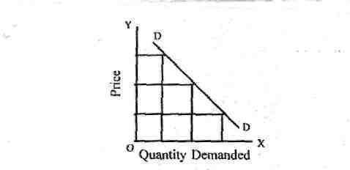
Fig - 3
Income demand: Income demand refers to the various quantities of a commodity that a consumer would buy at a given time at various levels of income. Generally, when the income increases, demand increases and vice versa.

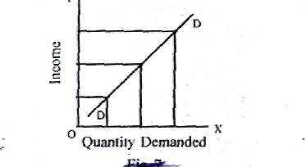
Fig - 4
Cross Demand: When the demand of one commodity is related with the price of other commodity is called cross demand. The commodity may be substitute or complementary.
Substitute goods are those goods which can be used in case of each other. For example, tea and coffee, Coca-cola and Pepsi. In such case demand and price are positively related. This means if the price of one increased then the demand for other also increases and vise versa. Complementary goods are those goods which are jointly used to satisfy a want. In other words, complementary goods are those which are incomplete without each other.
These are things that go together, often used simultaneously. For example, pen and ink.

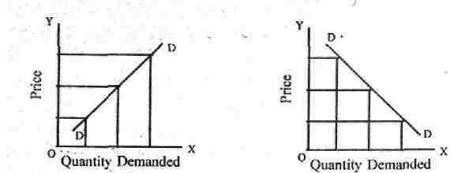

Fig – 5a Fig – 5b

Tennis rackets and tennis balls, cameras and film, etc. In such goods the price and demand are negatively related. This means when the price of one commodity increases the demand for the other falls.
Importance of the Law of Demand
The law of demand plays a crucial role in decision-making and forward planning of a business unit. The production planning in a firm mainly rests on accurate demand analysis. The law of demand has theoretical as well as practical advantages. These are as follows:
- Price determination: With the help of law of demand a monopolist fixes the price of his product. He is able to decide the most profitable quantity of output for him.
- Useful to government: The finance minister takes the help of this law to know the effects of his tax reforms and policies. Only those commodities which have relatively inelastic demand should be taxed.
- Useful to farmers: From the law of demand, the farmer knows how far a good or bad crop will affect the economic condition of the fanner. If there is a good crop and demand for it remains the same, price will definitely go down. The farmer will not have much benefit from a good crop, but the rest of the society will be benefited.
- In the field of planning: The demand schedule has great importance in planning for individual commodities and industries. In such cases it is necessary to know whether a given change in the price of the commodity will have the desired effect on the demand for commodity within the country or abroad. This is known from a study of the nature of demand schedule for the commodity.
INDIFFERENCE CURVE ANALYSIS
In the last section we discussed marginal utility analysis of demand. A very popular alternative and more realistic method of explaining consumer's demand is the Indifference Curve Analysis. This approach to consumer behaviour is based on consumer preferences.
Indifference Curves Ordinal analysis of demand (here we will discuss the one given by Hicks and Allen) is based on indifference curves. An indifference curve is a curve which represents all those combinations of goods which give same satisfaction to the consumer. Since all the combinations on an indifference curve give equal satisfaction to the consumer, the consumer is indifferent among them. In other words, since all the combinations provide same level of satisfaction the consumer prefers them equally and does not mind which combination he gets.
To understand indifference curves let us consider the example of a consumer who has one unit of food and 12 units of clothing. Now we ask the consumer how many units of clothing he is prepared to give up to get an additional unit of food, so that his level of satisfaction does not change. Suppose the consumer says that he is ready to give up 6 units of clothing to get an additional unit of food. We will have then two combinations of food and clothing giving equal satisfaction to consumer: Combination A has 1 unit of food and 12 units of clothing, combination B has 2 units of food and 6 units of clothing. Similarly, by asking the consumer further how much of clothing he will be prepared to forgo for successive increments in his stock of food so that his level of satisfaction remains unaltered, we get various combinations as given below:
Table Indifference Schedule
Table 2

Combination

Food

Clothing

MRS

A

1

12

B

2

6

6

C

3

4

2

D

4

3

1

Now if we draw the above schedule we will get the following figure.
In Figure 8, an indifference curve IC is drawn by plotting the various combinations of the indifference schedule. The quantity of food is measured on the X axis and the quantity of clothing on the Y axis. As in indifference schedule, combinations lying on an indifference curve will give the consumer same level of satisfaction.
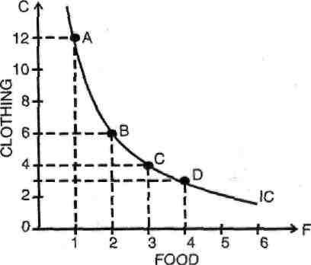

Fig. 8 : A Consumer's Indifference Curve
Indifference Map: A set of indifference curves is called indifference map.
An indifference map depicts complete picture of consumer's tastes and preferences. In Figure 9, an indifference map of a consumer is shown which consists of three indifference curves.
We have taken good X on X-axis and good Y on Y-axis. It should be noted that while the consumer is indifferent among the combinations lying on the same indifference curve, he certainly prefers the combinations on the higher indifference curve to the combinations lying on a lower indifference curve because a higher indifference curve signifies a higher level of .satisfaction. Thus while all combinations of IC, give same satisfaction, all combinations lying on IC2 give greater satisfaction than those lying on IC1

Properties of Indifference Curves: The following are the main characteristics or properties of indifference curves :
- Indifference curves slope downward to the right: This property implies that when the amount of one good in combination is increased, the amount of the other good is reduced. This is essential if the level of satisfaction is to remain the same on an indifference curve.
- Indifference curves are always convex to the origin: It has been observed that as more and more of one commodity (X) is substituted for another (Y), the consumer is willing to part with less and less of the commodity being substituted (i.e. Y). This is called diminishing marginal rate of substitution. Thus in our example of food and clothing, as a consumer has more and more units of food, he is prepared to forego less and less units of clothing. This happens mainly because want for a particular good is satiable and as a person has more and more of a good, his intensity of want for that good goes on diminishing. This diminishing marginal rate of substitution gives convex shape to the indifference curves. However, there are two extreme situations. When two goods are perfect substitutes of each other, the indifference curve is a straight line on which MRS is constant. And when two goods are perfect complementary goods (e.g. gasoline and water in a car), the indifference curve will consist of two straight line with a right angle bent which is convex to the origin or in other words, it will be L shaped.
- Indifference curves can never intersect each other: No two indifference curves will intersect each other although it is not necessary that they are parallel to each other. In case of intersection the relationship becomes logically absurd because it would show that higher and lower levels are equal which is not possible. This property will be clear from the following Figure 10.
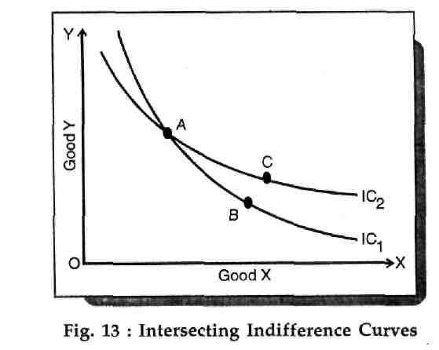
Fig. 10
In figure 10 IC₁, and IC₂ intersect at A. Since A and B lie on IC₁, they give same satisfaction to the consumer. Similarly since A and C lie on IC₂, they give same satisfaction to the consumer. This implies that combination B and C are equal in terms of satisfaction. But a glance will show that this is an absurd conclusion because certainly combination C is better than combination B because it contains more units of commodities X and Y. Thus we see that no two indifference curves can touch or cut each other.
- A higher indifference curve represents a higher level of satisfaction than the lower indifference curve: This is because combinations lying on a higher indifference curve contain mere of either one or both goods and more goods are preferred to less of them.
.
ELASTICITY OF DEMAND
Elasticity of Demand
The concept of price-elasticity of demand was first of all introduced in economics by Dr. Marshall. In simple words, price elasticity of demand is the ratio of percentage change in quantity demanded to the percentage change in price. In other words, price elasticity of demand is a measure of the relative change in quantity purchased of a good in response to a relative change in its price. It is, thus a rate at which the demand changes to the given change in prices. So, it means the rate or the degree of response in demand to the change in price. Thus, the co-efficient of price-elasticity of demand can be expressed as under:
Pr oportionate change in Quantity Demanded
E_{d} =
Pr oportionate change in price
Definitions of Price Elasticity of Demand
The concept of price elasticity of demand has been defined by different economists as under :
According to Alfred Marshall: "Elasticity of demand may be defined as the percentage change in quantity demanded to the percentage change in price."
According to A.K. Cairncross : "The elasticity of demand for a commodity is the rate at which quantity bought changes as the price changes."
According to J.M. Keynes : "The elasticity of demand is a measure of the relative change in quantity to a relative change in price."
According to Kenneth Boulding : "Elasticity of demand measures the
responsiveness of demand to changes in price."
DEGREES OF PRICE ELASTICITY
Different commodities have different price elasticities. Some commodities have more elastic demand while others have relative elastic demand. Basically, the price elasticity of demand ranges from zero to infinity. It can be equal to zero, less than one, greater than one and equal to unity.
According to Dr. Marshall : "The elasticity or reponsiveness of demand in a market is great or small according as the amount demanded increases much or little for a given fall in price and diminishes much or little for a given rise in price."
However, some particular values of elasticity of demand have been explained as under ;
Perfectly Elastic Demand.
Perfectly elastic demand is said to h appen when a little change in price leads to an infinite change in quantity demanded. A small rise in price on the part of the seller reduces the demand to zero. In such a case the shape of the demand curve will be horizontal straight line as shown in figure 13

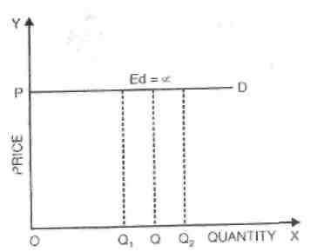

Fig - 13
The figure 13 shows that at the ruling price OP, the demand is infinite. A slight rise in price will contract the demand to zero. A slight fall in price will attract more consumers but the elasticiy of demand will remain infinite. But in real world, the cases of perfectly elastic demand are exceedingly rare and are not of any practical interest.
- Perfectly inelastic Demand
Perfectly inelastic demand is opposite to perfectly elastic demand. Under the perfectly inelastic demand, irrespective of any rise or fall in price of a commodity, the quantity demanded remains the same. The elasticity of demand in this case will be equal to zero.In diagram 14, DD shows the perfectly inelastic demand. At price OP, the quantity demanded is OQ. Now, the price falls to OP, from OP₁, demand remains the same. Similarly, if the price rises to OP₂ the demand still remains the same. But just as we do not see the example of perfectly elastic demand in the real world, in the same fashion it is diffcult to come across the cases of perfectly inelastic demand because even the demand for bare essentials of life does show some degree of responsiveness to change
in price.

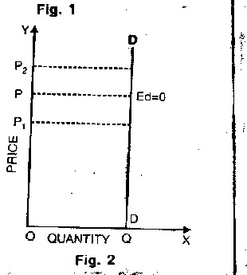
Fig. 14
- Unitary Elastic Demand. The demand is said to be unitary elastic when a given proportionate change in the price level brings about an equal proportionate change in quantity demanded, The numerical value of unitary elastic demand is exactly one i.e., ed = 1. Marshall calls it unit elastic.
In figure 15, DD demand curve represents unitary elastic demand. This demand curve is called rectangular hyperbola. When price is OP, the quantity demanded is OQ₁. Now price falls to OP₁, the quantity demanded increases to OQ₁. The shaded area in the fig. equal in terms of price and quantity demanded denotes that in all cases price elasticity of demand is equal to one.
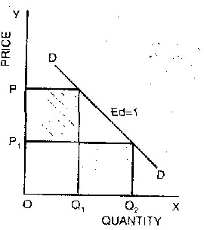

Fig - 15
- Relatively Elastic Demand.
Relatively elastic demand refers to a situation in which a small change in price leads to a big change in quantity demanded. In such a case elasticity of demand is said to be more than one. This has been shown in figure 16.
In fig.16, DD is the demand curve which indicates that when price is OP the quantity demanded is OQ₁, Now the price falls from OP to OP₁, the quantity demanded increases from OQ₁ to OQ₂ i.e. quantity demanded changes more than the change in price.
- Relatively Inelastic Demand.
Under the relatively inelastic demand a given percentage change in price produces a relatively less percentage change in quantity demanded. In such a case elasticity of demand is said to be less than one as shown in figure 17.
All the five degrees of elasticity of demand have been shown in figure 18. On OX axis, quantity demanded and on OY axis price is given. It shows:
- AB — Perfectly Inelastic Demand
- CD — Perfectly Elastic Demand
- EQ — Less Than Unitary Elastic Demand 4. EF — Greater Than Unitary Elastic Demand
5. MN — Unitary Elastic Demand.

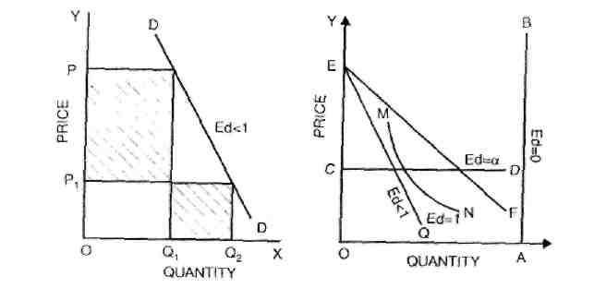
Fig. 17 Fig. 18

MEASUREMENT OF PRICE ELASTICITY OF DEMAND
There are five methods to measure the price elasticity of demand.
    - Total Expenditure Method.
    - Proportionate Method.
    - Point Elasticity of Demand.
    - Arc Elasticity of Demand.
    - Revenue Method.
Total Expenditure Method
Dr. Marshall has evolved the total expenditure method to measure the price elasticity of demand. According to this method, elasticity of demand can be measured by considering the change in price and the subsequent change in the total quantity of goods purchased and the total amount of money spend on it.
Total Outlay = Price x Quantity Demanded.
There are three possibilities:
- If with a fall in price (demand increases) the total expenditure increases or with a rise in price (demand falls) the total expenditure falls, in that case the elasticity of demand is greater than one i.e. (Ed >1.)
- If with a rise or fall in the price (demand falls or rises respectively), the total expenditure remains the same, the demand will be unitary elastic i.e. (Ed = 1).
- with a fall in price (Demand rises), the total expenditure also falls, and with a rise in price (Demand falls) the total expenditure also rises, the demand is said to be less elastic or elasticity of demand is less than one i.e. (Ed <1).
Table Representation: The method of total expenditure has been explained with the help of Table 3.
Table
3

Price (P)

Quantity Demanded
)
Q
(

Total Outlay

Elastic
ity of demand
)
Ed
(

10

9

8

7

1

2

3

4

.10

18

24

28

Ed > 1

6

5

5

6

.30

30

Ed = 1

4

3

2

1

7

8

9

10

.28

24

18

10

Ed
< 1

In the above Table 3, we find three possibilities:
1. More Elastic Demand. When price is Rs. 10 the quantity demanded is 1 unit and total expenditure is 10. Now price falls from Rs. 10 to Rs. 6, the quantity demanded increases from 1 to 5 units and correspondingly the total expenditure increases from Rs. 10 to Rs. 30. Thus it is clear that with the fall in price, the total expenditure increases and viceversa. So elasticity of demand is greater than one or Ed > 1.
2.Unitary Elastic Demand. If price is Rs. 6, demand is 5 units so the total outlay is Rs. 30. Now price falls to Rs. 5, the demand increases to 6 units but the total expenditure remains the same i.e., Rs. 30. Thus it is clear that with the rise or fall in price, the total expenditure remains the same. The elasticity of demand in this case is equal to one or Ed = 1.
3.Less Elastic Demand. If price is Rs. 5, demand is 6 and total outlay is Rs. 30. Now price falls from Rs. 5 to Re. 1. The demand increases from 6 units to 10 units and hence
the total expenditure falls from Rs. 30 to Rs. 10. Thus it is clear that with the fall in price, the total expenditure also falls and vice-versa. In this case, the elasticity of demand is less
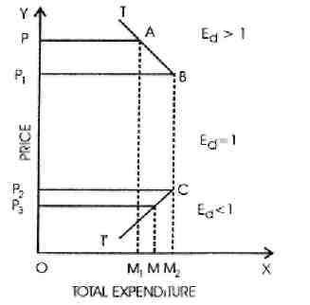
than one or Ed<l.
Fig. 19
Diagrammatic Representation:
Measurement of price elasticity through total expenditure method can be shown with the help of fig. 19
In the figure 19 total expenditure has been shown on X-axis and price on Y-axis. Line TT' is the total expenditure line. When price of the commodity falls from OP to OP1 total expenditure increases from OM1 to OM2. The elasticity of demand is greater than one as is shown in TB portion of the figure. Now, suppose that the price of the commodity decreases from OP¹ to OP³ the total expenditure falls from OM2 to OM. This is shown in T'C part of the figure which represents the less than unity elasticity of demand. In the same way, BC part of the figure represents the unit elasticity of demand. Thus it is clear that the changes in total expenditure due to changes in price also affect the elasticity of demand.

INCOME ELASTICITY OF DEMAND
According to Stonier and Hague: "Income elasticity of demand shows the way in which a consumer's purchase of any good changes as a result of change in his income."
It shows the responsiveness of a consumer's purchase of a particular commodity to a change in his income. Income elasticity of demand means the ratio of percentage change in the quantity demanded to the percentage change in income. In brief income elasticity.
proportionate change in quantity purchased

Degrees of Income Elasticity of Demand
Positive income elasticity of Demand : Positive income elasticity of demand is said to occur when with the increase in the income of the consumer, his demand for goods and services also increases and vice-versa. Income elasticity of demand is positive in case of normal goods.
In fig. 22, quantity of commodity T has been measured on X-axis and income of the consumer on Y-axis. DD is the positive income elasticity of demand curve. It slopes upward from left to right indicating that increase in income is accompanied by increase in demand of goods and services and vice-versa.

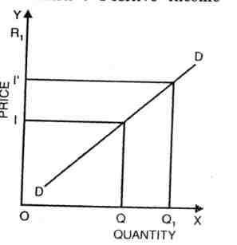
Fig. 22

1.Income Elasticity is Unity. The change in demand is proportionate to the change in income. For example

25% change in demand
Income Elasticity = 1 when
25% change in income
- Income Elasticity Greater than One. When the change in demand is more than proportionate change in income, income elasticity of demand is greater than one or unity. For example,

15% change in demand

Income Elasticity >1 when 10% change in income ^{=1.5}
- Income Elasticity Less than One. If change in demand is less than proportionate change in income, income elasticity of demand is less than one or unity. For example.

20% change in demand
= 0.5 Income Elasticity <1 when 40% change in income
- Negative Income Elasticity of Demand: Negative income elasticity of demand is said to occur when increase in the income of the consumers is accompanied by fall in demand of goods and services and vice-versa. It is the case of giffen goods.
In fig. 23 when income of the consumer is 01, demand for goods and services is
OX. Now as the income I1 increases to I1 quantity demanded falls o to OX1. Again as the income increases to I2, quantity demanded falls to OX2. DD is the negative income elasticity of demand curve.
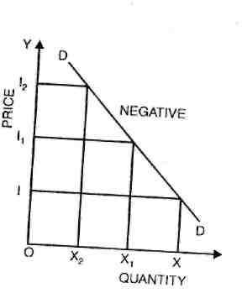

Fig. 23
- Zero Income Elasticity of Demand: Zero income elasticity of demand is said to exist when increase or decrease in income has no impact on the demand of goods and services.
In fig. 24 initially when income is OI, quantity demanded is OD. Now, income increases to OI2 demand Remains constant i.e. OD. Even when income reduces to 01 , quantity demanded remains OD
Generally, as income increases demand for goods increases. But in some cases, demand may not change to change in income or demand may diminish for an increase in income. The former case represents zero income elasticity. Income elasticity is zero if a change in income fails to produce any change in demand. Income elasticity is negative, if an increase in income leads to a reduction of demand. This happens only in the case of inferior goods. But in all other cases it is positive.
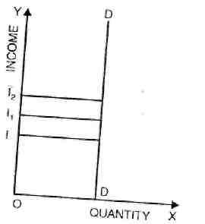

In short income elasticity is greater than one for luxuries but less than one for necessaries.
CROSS ELASTICITY OF DEMAND
It is the ratio of proportionate change in the quantity demanded of Y to a given proportionate change in the price of the related commodity X. It is a measure of relative change in the quantity demanded of a commodity due to a change in the price of its substitute complement.
It can be expressed as
proportionate change in the quantity demanded of Y
C_{e} =
proportionate change in the price of X
Cross elasticity may be infinite or zero. It is infinite if the slightest change in the
Fig - 24
price of X causes a substantial change in the quantity demanded of Y. It is always the case with goods which have perfect substitutes for one another.
Cross elasticity is zero, if a change in the price of one commodity will not affect the quantity demanded of the other. In the case of goods which are not related to each other, cross elasticity of demand is zero.

Types of Cross Elasticity of Demand
1.Positive : When goods are substitute of each other than cross elasticity of demanded is positive. In other words, when an increase in the price of Y leads to an increase in the demand of X. For instance with the increase in price of a tea, demand of coffee will increase. In fig 25 Quantity has been measured on OX axis and price on OY axis. At price OP of Y commodity, demand of X – commodity is OM. Now as price Of Y commodity increase to OP1 demand of X-commodity increases to OM1. Thus, cross,
elasticity of demand is positive.
- Negative: In case of complementary goods, cross elasticity of demand is negative. A proportionate increase in price of one commodity leads to a proportionate fall in the demand, of .another commodity because both are demanded jointly
In fig. 26 quantity has been measured on OX-axis while price has been measured on OY-axis. When the price of commodity increases from OP to OP₁ quantity demanded falls from OM to OM₁ Thus, cross elasticity of demand is negative.
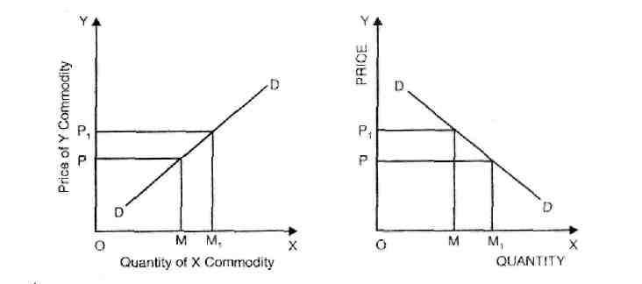
Fig. 25 Fig. 26

- Zero: Cross elasticity of demand is zero when two goods are related to each other. For instance, increase in price of car does not affect the demand of cloth. Thus, cross elasticity of demand is zero. It has been shown in fig. 27
Therefore, it can be concluded that cross elasticity depends uponSubstitutability is perfect, cross elasticity is infinite; if on the other hand, substitutability does not exist, cross elasticity is zero. In the case of complementary goods like jointly demanded goods cross elasticity is negative. A rise in the price of one commodity X will mean not only decrease in the quantity of X but also decrease in the quantity demanded of Y because both are demanded together. 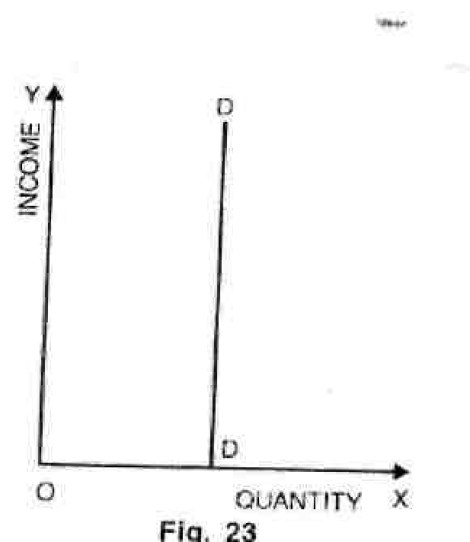

Limitations of Cross Elasticity of Demand
The cross elasticity of demand is a useful measure of price-demand relationships between commodities. But this concept has following two limitations.
  - Negative Cross Elasticity does not always mean complementarily.
  - Cross Elasticity of Demand is only a one-way Relationship.
DEMAND FORECASTING
Meaning of Demand Forecasting
Future is uncertain. There is great deal of uncertainty with regard to demand. Since the demand is uncertain, production, cost, revenue, profit etc. are also uncertain.
Through forecasting it is possible to minimise the uncertainties.
Forecasting simply refers to estimating or anticipating future events. It is an attempt to foresee the future by examining the past. Thus demand forecasting means estimating or anticipating future demand on the basis of past data.

Objectives of Demand Forecasting
- Short Term Objectives
    - To help in preparing suitable sales and production policies.
    - To help in ensuring a regular supply of raw materials.
    - To reduce the cost of purchase and avoid unnecessary purchase.
    - To ensure best utilization of machines.
    - To make arrangements for skilled and unskilled workers so that suitable labour force may be maintained.
    - To help in the determination of a suitable price policy.
    - To determine financial requirements.
    - To determine separate sales targets for all the sales territories.
    - To eliminate the problem of under or over production.
- Long term Objectives
    - To plan long term production.
    - To plan plant capacity.
    - To estimate the requirements of workers for long period and make arrangements.
    - To determine an appropriate dividend policy.
    - To help the proper capital budgeting.
    - To plan long term financial requirements.
    - To forecast the future problems of material supplies and energy crisis.
Methods of Demand Forecasting for New Products
Demand forecasting of new product is more difficult than forecasting for existing product. The reason is that the product is not available. Hence, no historical data are available. In these conditions the forecasting is to be done by taking into consideration the inclination and wishes of the customers to purchase. For this a research is to be conducted. But there is one problem that it is difficult for a customer to say anything without seeing and using the product before. Thus it is very difficult to forecast the demand for new products. Any way Prof. Joel Dean has suggested the following methods for forecasting demand of new products:
- Evolutionary approach: This method is based on the assumption that the new product is the improvement and evolution of the old product. The demand is forecasted on the basis of the demand of the old product. For example, the demand for black and white TV should be taken in to consideration while forecasting the demand for colour TV sets because the latter is an improvement of the former.
- Substitute approach: Here the new product is treated as a substitute of an existing product, e.g. polythene bags for cloth bags. Thus the demand for a new product is analysed as a substitute for some existing goods or service.
- Growth curve approach: Under this method the growth rate of demand of a new product is estimated on the basis of the growth rate of demand of an existing product. Suppose Pears soap is in use and a new cosmetic is to be introduced in the market. In this case the average sale of Pears soap will give an idea as to how the new cosmetic will be accepted by the consumers.
- Opinion poll approach: Under this method the demand for a new product is estimated on the basis of information collected from the direct interviews (survey) with consumers.
- Sales Experience approach: Under this method, the new product is offered for sale in a sample market, i.e. by direct mail or through multiple shop or departmental shop. From this the total demand is estimated for the whole market.
- Vicarious approach: This method consists of surveying consumers' reactions through the specialised dealers who are in touch with consumers.

UNIT - III
PRODUCTION FUNCTION
Production is an important economic activity. It directly or indirectly satisfies the wants and needs of the people. Satisfaction of human wants is the objective of production. In this lesson a general discussion of the concept of production and its functions are carried out.
Meaning of Production
Production is the conversion of input into output. The factors of production and all other things which the producer buys to carry out production are called input. The goods and services produced are known as output. Thus production is the activity that creates or adds utility and value. In the words of Fraser, "If consuming means extracting utility from matter, producing means creating utility into matter". According to Edwood Buffa, “Production is a process by which goods and services are created"

Factors of Production
As already stated, production is a process of transformation of factors of production (input) into goods and services (output). The factors of production may be defined as resources which help the firms to produce goods or services. In other words, the resources required to produce a given product are called factors of production. Production is done by combining the various factors of production. Land, labour, capital and organisation (or entrepreneurship) are the factors of production (according to Marshall). We can use the word CELL to help us remember the four factors of production: C. capital; Entrepreneurship; L land: and L labour.

Characteristics of Factors of Production
- The ownership of the factors of production is vested in the households.
- There is a basic distinction between factors of production and factor services. It is these factor services, which are combined in the process of production.
- The different units of a factor of production are not homogeneous. For example, different plots of land have different level of fertility. Similarly labourers differ in efficiency.
- Factors of production are complementary. This means their co-operation or combination is necessary for production.
- There is some degree of substitutability between factors of production. For example, labour can be substituted for capital to a certain extent.

Production Function
Production is the process by which inputs are transformed in to outputs. Thus there is relation between input and output. The functional relationship between input and output is known as production function. The production function states the maximum quantity of output which can be produced from any selected combination of inputs. In other words, it states the minimum quantities of input that are necessary to produce a given quantity of output.
The production function is largely determined by the level of technology. The production function varies with the changes in technology. Whenever technology improves, a new production function comes into existence. Therefore, in the modern times the output depends not only on traditional factors of production but also on the level of technology.
The production function can be expressed in an equation in which the output is the dependent variable and inputs are the independent variables. The equation is expressed as follows:
Q= f (L, K, T……………n)
Where, Q = output L = labour
K = capital
T = level of technology n = other inputs employed in production.
There are two types of production function - short run production function and long run production function. In the short run production function the quantity of only one input varies while all other inputs remain constant. In the long run production function all inputs are variable.
Assumptions of Production Function
The production function is based on the following assumptions.
- The level of technology remains constant.
- The firm uses its inputs at maximum level of efficiency.
- It relates to a particular unit of time.
- A change in any of the variable factors produces a corresponding change in the output.
- The inputs are divisible into most viable units.

Business Use of Production Function
The production function is of great help to a manager or business economist. The BUSINESS uses of production function are outlined as below:
- It helps to determine least cost factor combination: The production function is a guide to the entrepreneur to determine the least cost factor combination. Profit can be maximized only by minimizing the cost of production. In order to minimize the cost of production, inputs are to be substituted. The production function helps in substituting the inputs.
- It helps to determine optimum level of output: The production function helps to determine the optimum level of output from a given quantity of input. In other words, it helps to arrive at the producer's equilibrium.
- It enables to plan the production: The production function helps the entrepreneur (or management) to plan the production.
- It helps in decision-making :Production function is very useful to the management to take decisions regarding cost and output. It also helps in cost control and cost reduction. In short, production function helps both in the short run and long run decision-making process.
Cobb Douglas Production Function
Paul H. Douglas and C.W Cobb of the U.S.A have studied the production of the American manufacturing industries and they formulated a statistical production function.
It is popularly known as Cobb-Douglas Production Function. It is stated as follows.
Q = KLaC,,a) where, Q = output
L = quantity of labour
C = quantity of capital
K and a = positive constants
In this production function the output (Q) is a function of two inputs L and C.
According to Cobb Douglas production function, about 3/4 of the increase in
output is due to labour and the remaining 1/4 is due to capital. On this basis,

Cobb Douglas production function can be expressed as under:
Q = KL^{3/4} C^{1/4}
L+C=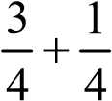=1
An important point in Cobb Douglas production function is that it indicates constant returns to scale. This means that if each input factor is increased by one percent, output will exactly increase by one percent. In other words, there will be no economies or diseconomies of scale.
Although the Cobb Douglas production function is nonlinear, it can be
transformed into a linear function by converting all variables into logarithms. That is why this function is known as a log linear function.
In 1937, David Duerentt suggested that it will be better to present Cobb-Douglas production function in the form of following equation :
Q = KLªC ^{j}
In the above equation, 'a' and 'j' stand for elasticity of production of labour and capital respectively.
Importance of Cobb-Douglas Production Function
Cobb-Douglas production function is most commonly used function in the field of economics. It graduates data on output and input well. Many economists used it independently. Hence, there are a number of varieties of the Cobb-Douglas form which yield variable elasticity’s of production and substitution. It is useful in international or inter- industry comparisons.
Cobb-Dougla's research has been a test of the marginal productivity theory of wages (or theory of distribution) as well as descriptions of production technology.
LAWS OF PRODUCTION
Law of Diminishing Returns or Law of Variable Proportion
The law of variable proportion is the modern approach to the 'Law of Diminishing
Returns (or The Laws of Returns). This law was first explained by Sir. Edward West (French economist). Adam Smith, Ricardo and Malthus (Classical economists) associated this law with agriculture. This law was the foundation of Recardian Theory of Rent and Malthusian theory of population.
The law of variable proportion shows the production function with one input factor variable while keeping the other input factors constant.
The law of variable proportion states that, if one factor is used more and more (variable), keeping the other factors constant, the total output will increase at an increasing rate in the beginning and then at a diminishing rate and eventually decreases absolutely.
According to K. E. Boulding, "As we increase the quantity of any one input which is combined with a fixed quantity of the other inputs, the marginal physical productivity of the variable input must eventually decline".
In this law we study the effect of variations in factor proportion on output. When one factor varies, the others fixed, the proportion between the fixed factor and the variable factor will vary, (e.g., land and capital will be fixed in the short run, while labour will be variable).That is why the law is called the law of variable proportion. The law of
variable proportion is also known as the law of proportionality, the law of diminishing returns, law of non-proportional outputs etc.
The following table illustrates the operations of Law of Variable Proportion. Table - 2
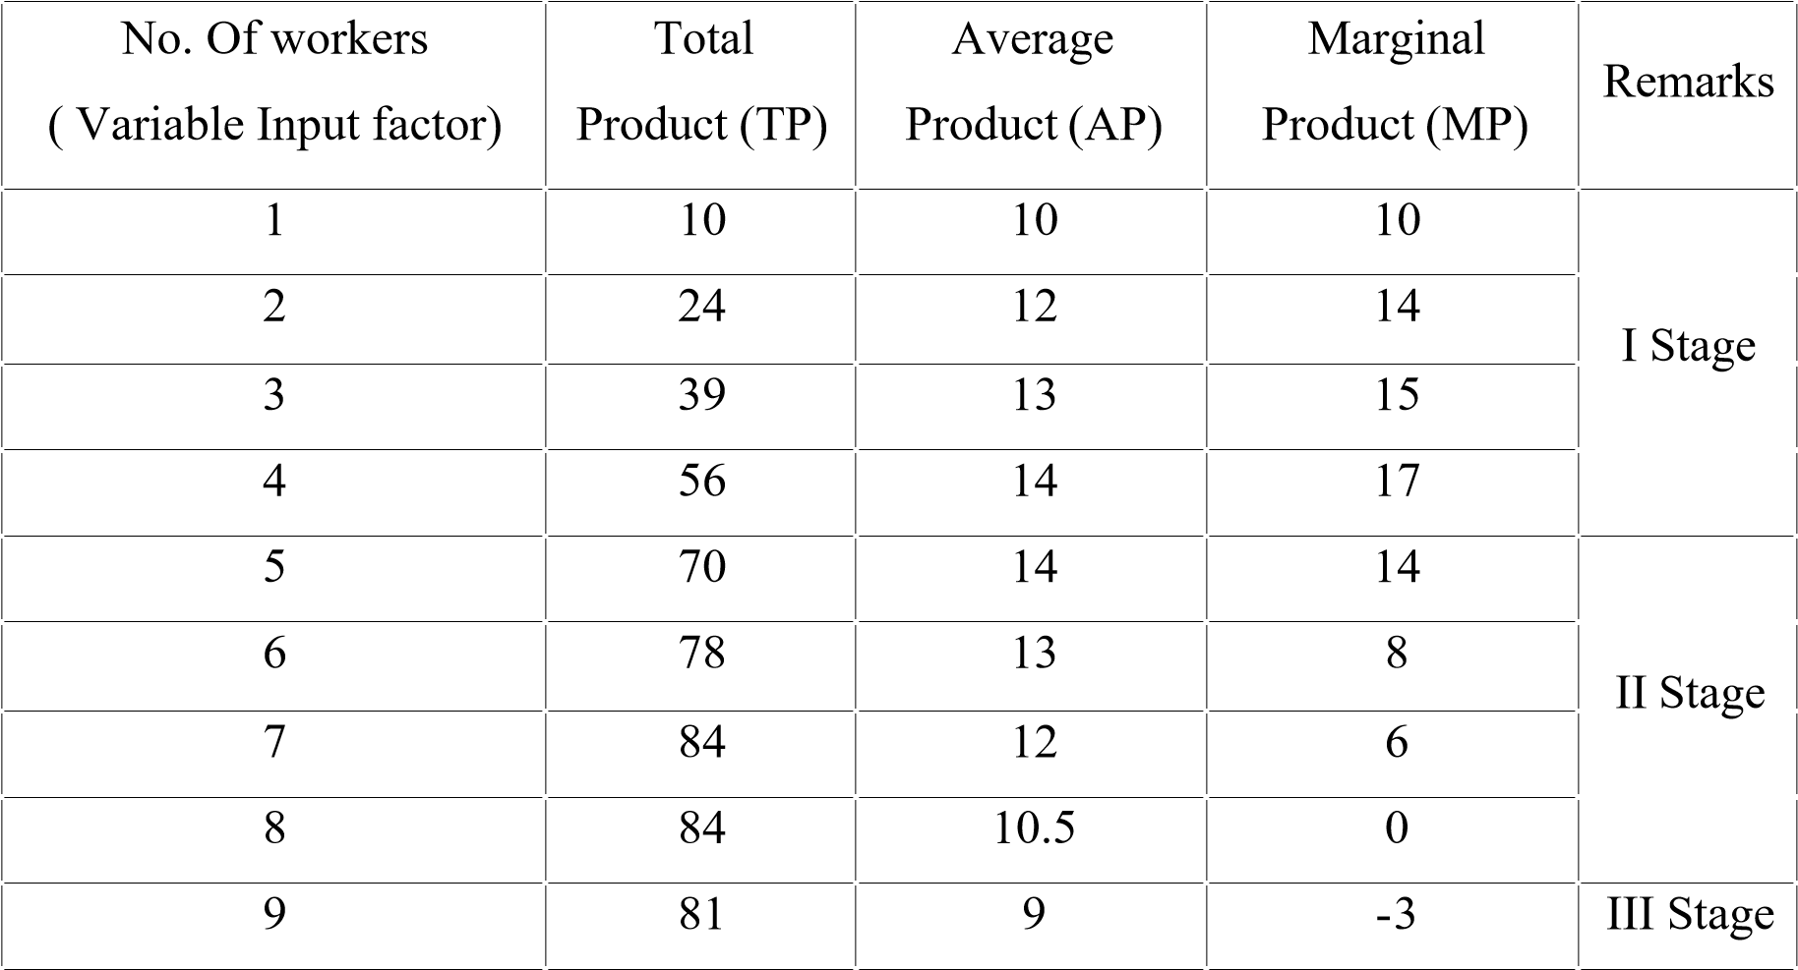

In the above table we can see that both the average and marginal products increase at first and then decline. Average product is the product for one unit of labour. It is calculated by dividing the total product by the number of workers. Marginal product is the additional product resulting from additional labour. The total product increases at an increasing rate till the employment of the 4th worker. Beyond the 4th worker, the marginal product is diminishing. The marginal product declines faster than the average product. When 7 workers are employed, the total product is maximum. For 8 workers marginal product is zero and the marginal product of 9 workers is negative. Thus when more and more units labour are combined with other fixed factors, the total product increases first at an increasing rate, then at a diminishing rate and finally it becomes negative.
The above idea can be more clearly illustrated with the help of a diagram (Fig.5).

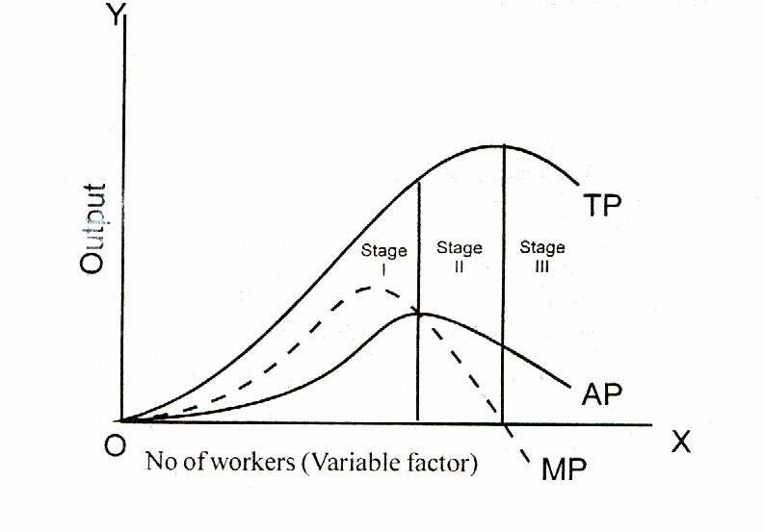
Fig. 5
When one input is variable and others are held constant, the relations between the input and the output are divided into three stages. The law of variable proportion may be explained under the following three stages as shown in the graph:
Stage 1: Total product increases at an increasing rate and this continues till the end of this stage. Average product also increases and reaches its highest point at the end of this stage.
Marginal product increases at an increasing rate. Thus TP, AP and MP - all are increasing. Hence this stage is known as stage of increasing return.
Stage II: Total product continues to increase at a diminishing rate until it reaches its maximum point at the end of this stage. Both AP and MP diminish, but are positive. At the end of the second stage, MP becomes zero. MP is zero when the TP is at the maximum. AP shows a steady decline throughout this stage. As both AP and MP decline, this stage is known as stage of diminishing return.
Stage III: In this stage the TP declines. AP shows a steady decline, but never becomes zero. MP becomes negative. It goes below the X axis. Hence the 3rd stage is known as stage of negative return.
According to classical economists there were three laws of returns: (i) Law of increasing returns, (ii) Law of constant returns, and (iii) Law of diminishing returns. But the modern economists do not accept this. According to them there are not three laws of production but there is only one law of production i.e. law of variable proportion. It has three stages.
It is necessary to understand the following terms:
Total Product or Total Physical Product (TPP): This is the quantity of output a firm obtains in total from a given quantity of input.
Average Product or Average Physical Product (APP): This is the total physical product (TPP) divided by the quantity of input.
Marginal Product or Marginal Physical Product (MPP): It is the increase in total output that results from a one unit increase in the input, keeping all other inputs constant.

Assumptions of the Law
The law of variable proportion is valid when the following conditions are fulfilled:
- The technology remains constant. If there is an improvement in the technology, due to inventions, the average and marginal product will increase instead of decreasing.
- Only one input factor is variable and other factor are kept constant.
- All the units of the variable factors are identical. They are of the same size and quality.
- A particular product can be produced under varying proportions of the input combinations.
- The law operates in the short run.

Importance of the Law of Variable Proportion
The law of variable proportion is one of the most fundamental laws of Economics. The law of variable proportion is applicable not only to agriculture but also to other constructive industries like mining, fishing etc. It is applied to secondary or tertiary sectors too. This law helps the management in the process of decision making.
The law is a law of life and can be applicable anywhere and everywhere. The applications of this law are as follows:

Isoquant Map or Equal Product Map
An isoquant map consists of a number of isoquants. An isoquant map gives a set of equal product curves which show different production levels. Each isoquant in the map indicates different levels of output. A higher isoquant represents a higher level of output. The distance of an isoquant from the origin shows the relative levels of output. The farther the isoquant from the origin the greater will be the level of output along it. But it should be noted that the distance between two equal product curves does not measure the absolute difference in the volume of output. Isoquant map is shown in the following diagram.
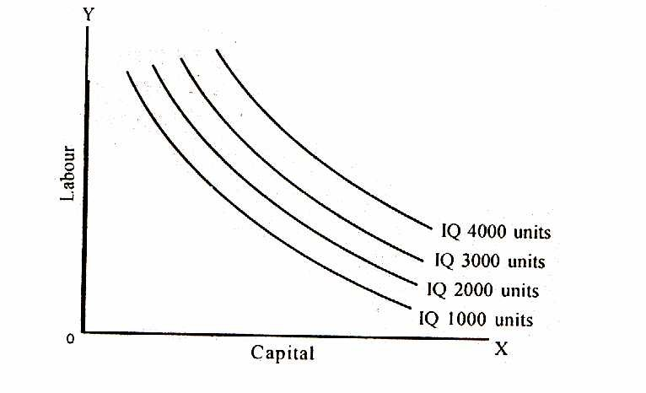
Fig. 7
Properties or Features of Isoquant
The following are the important properties of isoquants:
- Isoquant is downward sloping to the right. This means that if more of one factor is used less of the other is needed for producing the same output.
- A higher isoquant represents larger output.
- No isoquants intersect or touch each other. If so it will mean that there will be a common point on the two curves. This further means that same amount of labour and capital can produce the two levels of output which is meaningless. The isoquant as shown in Fig.8 will never exist.
- Isoquants need not be parallel to each other. It so happens because the rate of substitution in different isoquant schedules need not necessarily be equal. Usually they are found different and therefore, isoquants may not be parallel.
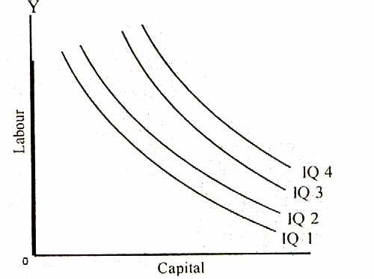

Fig. 9
- Isoquant is convex to the origin. This implies that the slope of the isoquant diminishes from left to right along the curve. This is because of the operation of the principle of diminishing marginal rate of technical substitution.

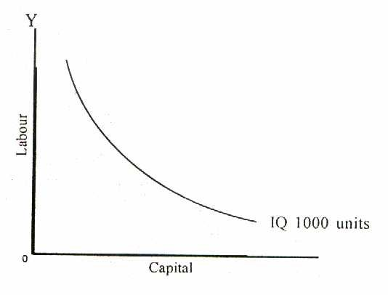
Fig.10
- No isoquant can touch either axis. If an isoquant touches X axis then it would mean that without using any labour the firm can produce output with the help of capital alone. But this is wrong because the firm can produce nothing with OK units of capital alone. If an isoquant touches Y axis, it would mean that without using any capital the firm can produce output with the help of labour alone. This is impossible.
7.Isoquants have negative slope. This is so because when the quantity of one factor (labour) is increased the quantity of other factor (capital) must be reduced, so that total output remains the same. If the marginal productivity of the factor becomes zero the isoquant will bend back and it will have positive slope as shown below.
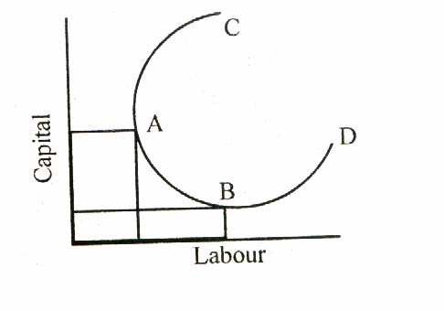

Fig.11
The portions AC and BD of the isoquant have positive slope.

If the inputs are perfect substitutes, each isoquant will be a straight line (case a). If the inputs cannot be substituted at all, the isoquants will be right angles (case b). Typical isoquants lie between the extreme cases of straight lines and right angles (case c). Along a curved isoquant, the ability to substitute one input for another varies.

UNIT-IV

SUPPLY:
Supply is a fundamental economic concept that describes the total amount of specific good or service that is available to consumers.
SUPPLY CURVE:
Supply curve is a graphic representation of the correlation between the cost of good or service and quantity supplied for a given period
MARKET STRUCTURE
Market On the basis of area
Markets may be classified on the basis of area into local, national and international markets. If the buyers and sellers are located in a particular locality, it is called as a local market, e.g. fruits, vegetables etc. These goods are perishable; they cannot be stored for a long time; they cannot be taken to distant places. When a commodity is demanded and supplied all over the country, national market is said to exist. When a commodity commands international market or buyers and sellers all over the world, it is called international market.
Whether a market will be local, national or international in character will depend upon the following factors: (a) nature of commodity; (b) taste and preference of the people; (c) availability of storage; (d) method of business; (e) political stability at home and abroad; if) portability of the commodity.
On the basis of time
Time element has been used by Marshall for classifying the market. On the basis of time, market has been classified into very short period, short period, long period and very long period. Very short period market refers to the market in which commodities that are fixed in supply or are perishable are transacted. Since supply is fixed, only the changes in demand influence the price. The short period markets are those where supply can be increased but only to a limited extent. Long period market refers to a market where adequate time is available for changing the supply by changing the fixed factors of production. The supply of commodities may be increased by installing a new plant or machinery and the output can be changed accordingly. Very long period or secular period is one in which changes take place in factors like population, supply of capital and raw material etc.

On the basis of nature of transactions
Markets are classified on the basis of nature of transactions into two broad categories viz., Spot market and future market. When goods are physically transacted on the spot, the market is called as spot market. In case the transactions involve the agreements of future exchange of goods, such markets are known as future markets.

On the basis of volume of business
Based on the volume of business, markets are broadly classified into wholesale and retail markets. In the wholesale markets, goods are transacted in large quantities. Wholesale markets are in fact, a link between the producer and the retailer while the retailer is a link between the wholesaler and the consumer.
On the basis of status of sellers
During the process of marketing, a commodity passes through a chain of sellers and middlemen. Markets can be classified into primary, secondary and terminal markets.
The primary market consists of manufacturers who produce and sell the product to the wholesalers. The wholesalers who are an international link between the manufacturers and retailers constitute secondary markets while the retailers who sell it to the ultimate consumer constitute the terminal market.
On the basis of regulation
On this basis, market is classified into regulated and unregulated markets. For some goods and services, the government stipulates certain conditions and regulations for their transactions. Market of goods and services is called regulated market. On the other hand, goods and services whose transactions are left to the market forces belong to unregulated market. Regulations of market by the government become essential for those goods whose supply or price can be manipulated against the interests of the general public.
On the basis of competition
Markets are classified on the basis of nature of competition into perfect competition and imperfect competition.
PERFECT COMPETITION
Perfect competition in economic theory has a meaning diametrically opposite to the everyday use of the term. In practice, businessmen use the word competition as synonymous to rivalry. In theory, perfect competition implies no rivarly among firms. Perfect competition, therefore, can be defined as a market structure characterised by a complete absence of rivalry among the individual firms.
FEATURES
- Large number of buyers and sellers
There must be a large number of firms in the industry. Each individual firm supplies only a small part of the total quantity offered in the market. As a result, no individual firm can influence the price. Similarly, the buyers are also numerous. Hence, no individual buyer has any influence on the market price. The price of the product is determined by the collective forces of industry demand and industry supply. The firm is only a 'price taker'.
Each firm has to adjust its output or sale according to the prevailing market price.
- Homogeneity of products
In a perfectly competitive industry, the product of any one firm is identical to the products of all other firms. The technical characteristics of the product as well as the services associated with its sale and delivery are identical.
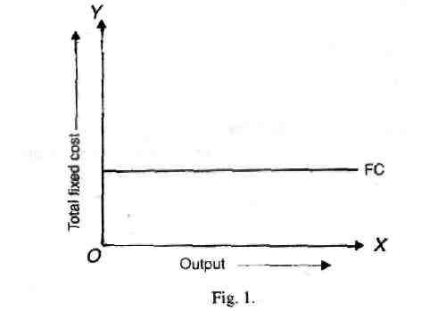

The demand curve of the individual firm is also its average revenue and its marginal revenue curve.
The assumptions of large numbers of sellers and product homogeneity imply that the individual firm in pure competition is a price taker. Its demand curve is infinitely elastic indicating that the firm can sell any amount of output at the prevailing market price.
- Free entry exit
There is no barrier to entry or exit from the industry. Entry or exit may take time but firms have freedom of movement in and out of the industry. If the industry earns abnormal profits, new firms will enter the industry and compete away the excess profits. Similarly, if the firms in the industry are incurring losses some of them will leave the industry which will reduce the supply of the industry and will thus raise the price and wipe away the losses.
- Absence of government regulation
There is no government intervention in the form of tariffs, subsidies, relationship of production or demand.
If these assumptions are fulfilled, it is called pure competition which requires the fulfillment of some more condition.
- Perfect mobility of factors of production The factors of production are free to move from one firm to another throughout the economy. It is also assumed that workers can move between different jobs. Raw materials and other factors are not monopolised and labour is not unionised. In short, there is perfect competition in the factor market.
- Perfect knowledge
It is assumed that all sellers and buyers have complete knowledge of the conditions of the market. This knowledge refers not only to the prevailing conditions in the current period but in all future periods as well.
Information is free and costless. Under these conditions uncertainty about future developments in the market is ruled out.
- Absence of transport costs
In a perfectly competitive market, it is assumed that there are no transport costs.

MONOPOLY COMPETITION
Monopoly is that market form in which a single producer controls the entire supply of a single commodity which has no close substitutes. There must be only one seller or producer. The commodity produced by the producer must have no close substitutes. Monopoly can exist only when there are strong barriers to entry. The barriers which prevent the entry may be economic, institutional or artificial in nature.
Features
- There is a single producer or seller of the product.
- There are no close substitutes for the product. If there is a substitute, then the monopoly power is lost.
- No freedom to enter as there exists strong barriers to entry.
- The monopolist may use his monopolistic power in any manner to get maximum revenue. He may also adopt price discrimination.

PRICE-OUTPUT DETERMINATION UNDER MONOPOLY
The aim of the monopolist is to maximise profits. Therefore, he will produce that level of output and charge a price which gives him the maximum profits. He will be in equilibrium at that price and output at which his profits are maximum. In order words, he will be in equilibrium position at that level of output at which marginal revenue equals marginal cost. The monopolist, to be in equilibrium should satisfy two conditions :
- Marginal cost should be equal to marginal revenue and
- The marginal cost curve should cut marginal revenue curve from below.
The short run equilibrium of the monopolist is shown in figure 12.
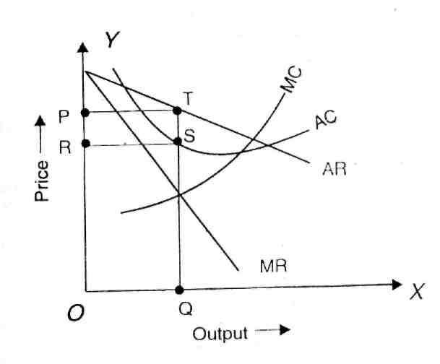
Fig. 12
AR is the average revenue curve, MR is the marginal revenue curve, AC is the average cost curve and MC is the marginal cost curve. Upto OQ level of output marginal revenue is greater than marginal cost but beyond OQ the marginal revenue is less than marginal cost. Therefore, the monopolist will be in equilibrium where MC = MR. Thus a monopolist is in equilibrium at OQ level of output and at OP price. He earns abnormal profit equal to PRST.
But it is not always possible for a monopolist to earn super- normal profits. If the demand and cost situations are not favourable, the monopolist may realise short run
losses.

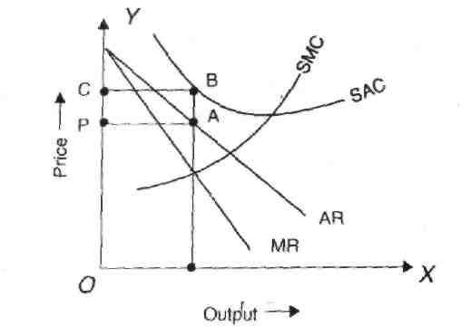
Fig. 13
Though the monopolist is a price maker, due to weak demand and high costs, he suffers a loss equal to PABC.
Long run equilibrium
In the long run the firm has the time to adjust his plant size or to use the existing plant so as to maximise profits. The long run equilibrium of the monopolist is shown in figure 14.

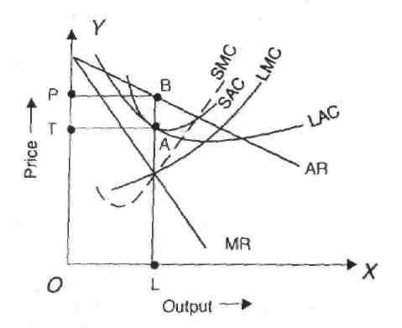
Fig. 14

The monopolist is in equilibrium at OL output where LMC cuts MR curve. He will charge OP price and earn an abnormal profit equal to TPQH.
In order to show the difference between the short run equilibrium and long run equilibrium under monopoly, both can be shown in a single figure.
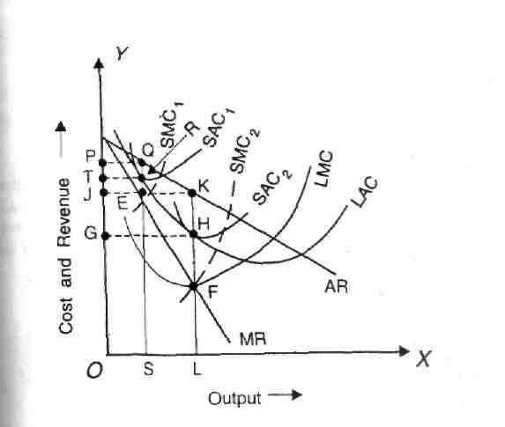

The monopolist
is in the s h o r t r u n
equilibrium
at E producing OS level of output. In the long run he can change the plant and will be in equilibrium at F where MR curve cuts LMC curve. The monopolist has increased his output from OS to OL and price has fallen from OP to OJ. Profits have also increased in the long run from TPQR to GHKJ.

PRICE DISCRIMINATION OR DISCRIMINATING MONOPOLY

Price discrimination refers to the practice of selling the same product at different prices to different buyers. Mrs. Robinson defines it as "charging different price for the same product or same price for differentiated product". Prof. Stigler defines price discrimination as "the scale of technically similar products at prices which are not proportional to Marginal costs".
Price discrimination may be divided into three types-personal, local and according to use. Price discrimination is personal when a seller charges different prices for different persons. For example, hair cut for children and adult. Price discrimination is local when the seller charges different prices for people of different localities. For instance, a seller may charge one price at domestic market and another price in international market. Discrimination is according to use when the same commodity is put to different uses. For example, electricity is usually sold at a cheaper rate for industrial uses than for domestic purposes.
Degrees of price discrimination
Prof. A.C. Pigou has distinguished between three degrees of price discrimination.
- Price discrimination of the first degree.
- Price discrimination -of the second degree.
- Price discrimination of the third degree.
Price discrimination of the first degree
It is also known as perfect price discrimination. Price discrimination of the first degree is said to occur when the monopolist is able to sell each separate unit of the output at a different price. In other words, it involves maximum possible exploitation of each buyer.
Price discrimination of the second degree
In price discrimination of the second degree buyers are divided into different groups and from each group a different price is charged which is the lowest demand price of that group. This is shown in figure. 17.
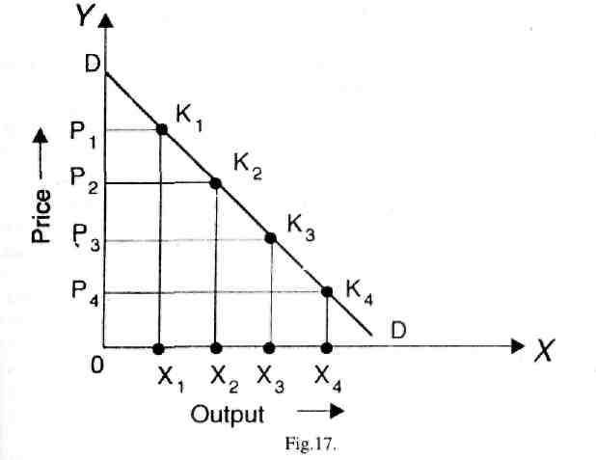
Market is divided into four groups. DD is the market demand curve. In the first group X units of output will be sold at a price of OP1. All the buyers in this group pay OP1 price and the group gets DK₁ P₁ as consumer’s surplus. Similarly for other groups, consumers pay OP2, OP3, OP4 and get the consumer's surplus equal to DK2 P2, DK3 P3 and DK4 P4 respectively.

Price discrimination of the third degree
It occurs when the seller divides his buyers into two or more than two submarkets or groups and charges a different price in each sub-market. The price charged in the sub-market need not be the lowest demand price of that sub-market..
Possibility of price discrimination
Price discrimination is possible in the following cases:
1The nature of the commodity should be such as to enable the monopolist to charge different prices. This is possible only when there is no possibility of transference of the commodity from one market to the other. For example, doctors charge different fees for the rich and for the poor for same service.
- When the markets are separated by long distance or tariff, then price discrimination is possible. If the transportation cost is higher than the price difference between the two markets, one monopolist can charge different prices. For example, a commodity may be sold at Rs. 10 in Delhi and Rs. 20 in Madras. If the transportation cost between Delhi and Madras is greater than Rs. 10 it is not profitable for the consumers to transport the commodity from Delhi to Madras on their own. Similarly when domestic market is protected by tariff, the monopolist can sell the product at a lower price in the foreign market and at a higher price in the domestic market.
- In certain cases, the firms have a legal sanction for price discrimination. For example, electricity board charges a lower price for industrial purposes and a higher price for domestic purposes. Similarly, transportation companies charge different fares for different classes of passengers.
- Price discrimination is possible due to preferences or prejudices of the consumers. Different prices are charged for different varieties although they differ only in label or name. Upper class people may prefer to buy in fashionable quarters to buy in a congested, ugly and cheaper locality.
- Price discrimination may become possible due to ignorance and laziness of buyers. If a seller is discriminating between two markets but the buyers are ignorant that the seller is selling the product at a lower price in another market, price discrimination is possible. Price discrimination is also possible if the buyers are aware that the seller is selling the product at lower price in another market but due to laziness may not go for shopping, in the cheaper market.
- When a monopolist is able to meet different needs for his customers it is possible for him to follow price discrimination. For example, railways charge different rates for carrying coal, cotton, silk and fruit even though the service rendered is the same for
all.
- A monopolist can easily charge discriminating prices when goods are being supplied to special orders. In such a case, there is no question of comparing prices by the buyers.
.
Same elasticity of demand in two markets
If the elasticity of demand is same in two markets, the marginal revenues in two markets at every price of the product will also be the same and it will not be profitable for the monopolist to discriminate between the two markets. This is illustrated in figure 18.
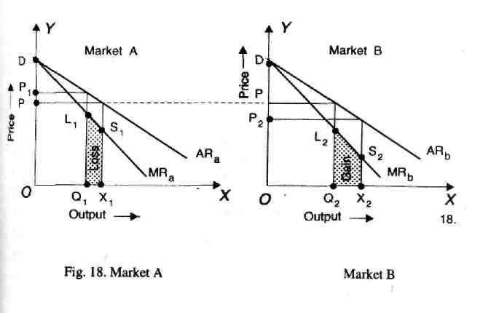

ARa and ARb are the iso-elastic demand curves of the markets A and B. At price OP marginal revenue in the two markets is the same. If the monopolist transfers a given amount from one market te another and thereby charge different prices, it would not be profitable for the monopolist. Suppose, he reduces his sales in market A from OX to OQ₁ and transfer it to market B, where the sales go up from OQ2 to OX2. As a result of reduced sales in market A, the monopolist loses Q1 X1 S1 L1 while he gains Q2 X2 L2 S2 in market B by increasing his sales. Since the loss is greater than the gain, it is not profitable for the monopolist to discriminate prices between the two markets having the same elasticity of demand.

Elasticity of demand differs in two markets
If the monopolist wants to maximum profits, he must discriminate prices if the elasticities of demand in the two markets at the given monopoly prices are different. This is shown in Figure 19.
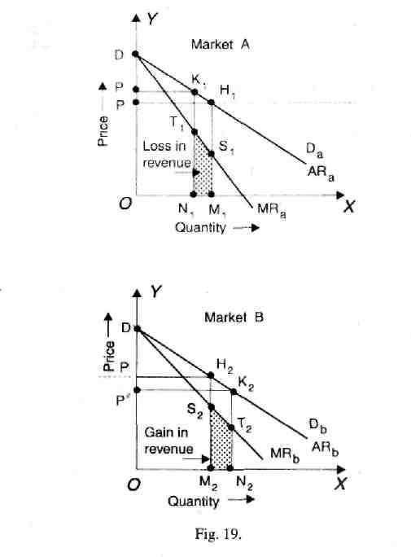
The monopolist reduces the output in market B and transfers it to market A. When he increases his sales in market A from OX to OQi, he gains Xi Qj L\ S\ and when he reduces it in market B his sales go down from OQ2 to OX2, he loses X2 Q2 L2 S2. Since the gain is more than the loss it is profitable for the monopolist to follow price discrimination.
Price-output determination under discriminating monopoly
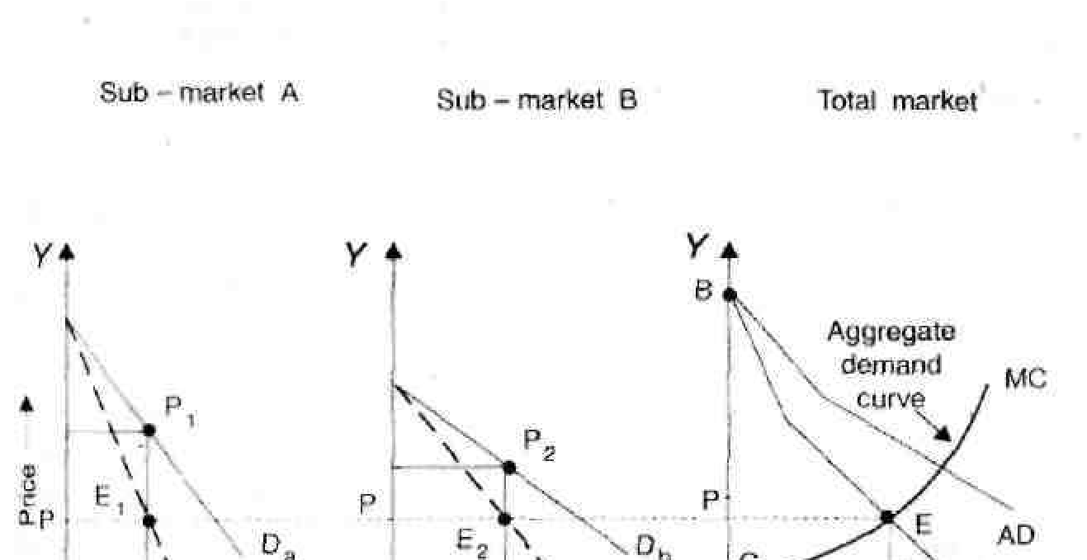
The graphical representation of price-output determination under conditions of discriminating monopoly can be shown with the help of a figure.
There are two markets A and B with different price elasticities. The price elasticity in market B is lower than that in market A.

The total marginal revenue arising from the two markets is arrived at by horizontal summation of the marginal revenue curves for the two sub-markets. Da is the demand curve and MRa is the marginal revenue curve in market A. Similarly, MRb is the marginal revenue curve in market B corresponding to the demand curve D. AMR is the aggregate marginal revenue curve, which has been derived by adding MRa and MR5 . MC is the marginal cost curve of the monopolist.
The discriminating monopolist will maximise his profits by producing that level of output at which MC intersects AMR. Thus he will be producing OM level of output. This total output will be distributed in such a way that marginal revenues in two markets are equal and at the same time it should be equal to the marginal cost. Since marginal cost is ME, the total output OM has to be distributed in such a way that the marginal revenue in two markets should be equal to the marginal cost. Hence OM amount can be sold in market A and OM2 in market B. Further, OM amount can be sold in market A at M₁ P₁ price and OM2 can be sold in market B at M2 P2 Price. Price is higher in market A where the demand is less elastic than in market B where the demand is more elastic. Thus a profit maximising monopolist charges different prices and supplies different quantities in the sub- markets having different price elasticities.

Monopoly equilibrium Vs Competitive equilibrium
The only similarity between the two is that a firm is in equilibrium at the level of output at which marginal revenue is equal to marginal cost. But there are many
differences:
- Under perfect competition, the average revenue curve is horizontal straight line parallel to the X axis. Therefore, MR is equal to AR at all levels of output and MR curve coincides with AR curve. But under monopoly, AR is sloping downwards. Hence, MR is less than AR at all levels of output and MR curve lies below the AR curve. In equilibrium the marginal revenue will be smaller than the average revenue.

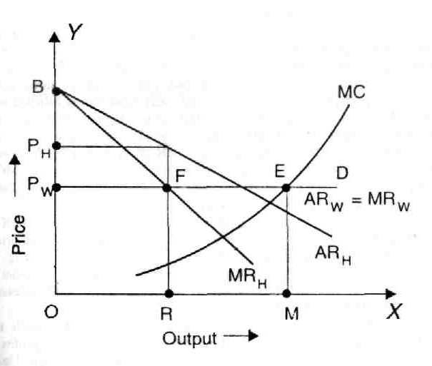
Fig. 22

- Both under perfect competition and monopoly, the firm is in equilibrium where MC is equal to MR. But in perfect competition, when MC is equal to MR, it is also equal to price or AR. This is not so in case of monopoly. Under monopoly, MR is less than AR or price; in equilibrium MC will be equal to MR but it will be less than price. Therefore, in perfect competition, price is equal to MC and in monopoly price is higher than the marginal cost.
- Another significant difference between the two is that whereas a perfectly competitive firm is in long-run equilibrium at the minimum point of the long-run average cost curve, monopolistic firm is in equilibrium at the level of output where average cost is still declining and has not yet reached its minimum point. Under perfect competition, it pays the firm to expand production so long as the average cost is falling since AR and MR remain constant. But it does not pay a monopolist firm to expand production to the minimum of AC curve.
- Another important difference between the two is that while under perfect competition equilibrium is possible only when MC is rising at the point of equilibrium, but monopoly equilibrium can be reached whether marginal cost is rising, remaining constant or falling at the equilibrium output. This is so because the second order condition of equilibrium namely MC curve should cut MR curve from below at the equilibrium point, can be satisfied in monopoly in all the three cases, whereas in perfect competition the second order condition is fulfilled only when MC curve is rising. Since in perfect competition the MR curve is a horizontal straight line, MC curve can cut the MR curve from below only when MC is rising. But under monopoly MR curve is sloping downward and therefore, MC curve can cut the MR curve from below whether MC is rising, remaining constant or falling. The equilibrium of the monopolist in these three cases is shown in Figure 22. Fig. A illustrates the equilibrium of the monopolist when MC is rising at the equilibrium output. Fig. B shows the monopoly equilibrium when MC is constant at and near the equilibrium output. In Fig. C, monopolist is in equilibrium when MC is falling at and near the point of equilibrium. In all these three cases, OP represents price, OM represents output and RNQP represents profit.
- Still another difference between the two is that while the perfectly competitive firm in the long run, earns only normal profits, a monopolist can make supernormal profits even in the long run. Under perfect competition, if firms in the short run are making supernormal profits, the new firms will enter the industry to compete away the profits. But under monopoly, the firm continues to earn supernormal profits even in the long run since there are strong barriers to the entry of new firms in monopoly. It does not mean that the monopoly always guarantees supernormal profits. If the demand and cost conditions are not favourable, the monopolist may suffer short run losses, as shown in the figure. 23.

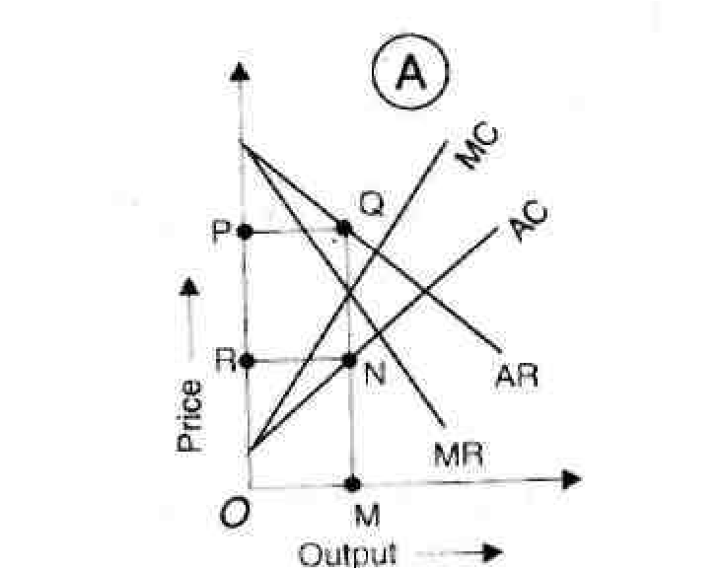

MONOPOLISTIC COMPETITION
Perfect competition and monopoly are rarely found in the real world. Therefore, professor Edward. H. Chamberlin of Harvard University brought about a synthesis of the two theories and put forth, "Theory of Monopolistic Competition" in 1933. Monopolistic competition is more realistic than either pure competition or monopoly. It is a blending of competition and monopoly. "There is competition which is keen though not perfect, between many firms making very similar products". Thus monopolistic competition refers to competition among a large number of sellers producing close but not perfect substitutes.
FEATURES
- Large number of sellers
In monopolistic competition the number of sellers is large. No one controls a major portion of the total output. Hence each firm has a very limited control over the price of the product. Each firm decides its own price-output policy without considering the reactions of rival firms. Thus there is no interdependence between firms and each seller pursues an independent course of action.

- Product differentiation
One of the most important features of monopolistic competition is product differentiation. Product differentiation implies that products are different in some ways from each other. They are heterogeneous rather than homogeneous. There is slight difference between one product and others in the same category. Products are close substitutes but not perfect substitutes. Product differentiation may be due to differences in the quality of the product. Product may be differentiated in order to suit the tastes and preferences of the consumers. The products are differentiated on the basis of materials used, workmanship, durability, size, shape, design, colour, fragrance, packing etc. Products are differentiated in order to promote sales by influencing the demand for the products. This can be achieved through propaganda and advertisement. Advertisement brings a psychological reaction in the minds of the buyers and thus influences the demand. In addition, location of the shop, its general appearance, counter service, credit and other facilities increase sales.
Patent rights and trade marks also promote product differentiation. Kodak and Coca Cola are the examples of patent rights. Trade marks like Hamam, Rexona, Lux etc.
help the consumers to differentiate one product over others.
- Free entry and exit of firms
Another feature of monopolistic competition is the freedom of entry and exit of firms. Firms under monopolistic competition are small in size and they are capable of producing close substitutes. Hence they are free to enter or leave the industry in the long run. Product differentiation increases entry of new firms in the group because each firm produces a different product from the others.
- Selling cost
It is an important feature of monopolistic competition. As there is keen competition among the firms, they advertise their products in order to attract the customers and sell more. Thus selling cost has a bearing on price determination under monopolistic competition.
- Group equilibrium
Chamberlin introduced the concept of group in the place of industry. Industry refers to a number of firms producing homogeneous products. But, firms under monopolistic competition produce similar but not identical products. Therefore, chamberlin uses, the concept of group to include firms producing goods which are close substitutes.
- Nature of demand curve
Under monopolistic competition, a single firm can control only a small portion of the total output. Though there is product differentiation, as products are close substitutes, a reduction in price leads to increase in sales and vice-versa. But it will have little effect on the price-output conditions of other firms. Hence each will loose only few customers, due to an increase in price. Similarly a reduction in price will increase sales. Therefore the demand curve of a firm under monopolistic competition slopes downwards to the right. It is highly elastic but not perfectly elastic. In other words, under monopolistic competition, the demand curve faced by the firm is highly elastic. It means that it has some control over price due to product differentiation and there are price differentials between the firms.

Price-Output Determination under Monopolistic Competition
Since, under monopolistic competition, different firms produce different varieties of products, prices will be determined on the basis of demand and cost conditions. The firms aim at profit maximisation by making adjustments in price and output, product adjustment and adjustment of selling costs.
Equilibrium of a firm under monopolistic competition is based upon the following assumptions:
- The number of sellers is large and they act independently of each other.
- The product is differentiated.
- The firm has a demand curve which is elastic.
- The supply of factor services is perfectly elastic.
- The short run cost curves of each firm differ from each other.
- No new firms enter the industry.
PRODUCT DIFFERENTIATION
While analysing the equilibrium of a firm with regard to the variation of the product we assume the price of product to be constant. The firm has to select among the various possible qualities and attributes of the product. An important characteristic of product variation is that it changes the cost curve and demand for the product. Therefore, the entrepreneur has to choose the product whose cost and demand are such as to yield maximum profit. Yet another feature of product variation is that product variation is qualitative and therefore, quantitative measurement is not possible.
INDIVIDUAL EQUILIBRIUM AND PRODUCT VARIATION
The equilibrium of the firm under condition of product variation is shown in figure 28.
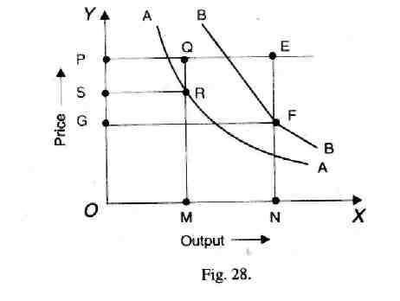
AA is the average cost curve of the product A and BB is the average cost curve of the product B. The price of the product is OP. If OM quantity of the product A is demanded at the price of OP, the total costs are OMRS. The entrepreneur earns an abnormal profit equal to PQRS. If the Quantity demanded of the product B is ON, then the total costs are ONFG and the total profits made by the entrepreneur are GFEP. Since the product B yields greater profits than A, the entrepreneur will select the product B.
Group Equilibrium and Product Variation
It is assumed that the demand is uniform and the possibility of product variation is also uniform. The equilibrium adjustment of the product is shown in figure 29.
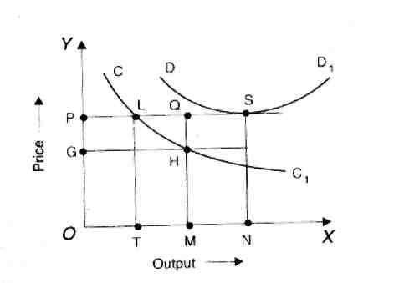
Fig. 29
CC1 is the average cost curve. If the quantity demanded is OM then the total cost- is OMHG. The firm earns supernormal profits equal to GHQP. This supernormal profits should be wiped away to achieve group equilibrium. Attracted by the supernormal profits, new competitor may enter the group. The quantity demanded will come down to OT.
Price will cover only cost of production. Besides, the adjustment in the number of firms, product improvement may also take place. When all entrepreneurs improve their product, cost will increase as shown by DD₁ and become equal to the price at the point S.
Group equilibrium must satisfy the following conditions:
- The average cost must be equal to price.
- It is not possible for any one to increase his profits by making further adjustment or improvement in his product.

Selling Cost and Price Determination
Selling cost is another important factor which influences pricing under monopolistic competition. Selling costs are costs incurred on advertising, publicity, salesmanship, free sampling, free service, door to door canvassing and so on. Selling costs are "the costs necessary to persuade a buyer to buy one product rather than another or to buy from one seller rather than another".
Under perfect competition, there is no need for advertising as the product is homogeneous. Similarly, under monopoly also, selling costs are not needed as there are no rivals. But under conditions of monopolistic competition, as the products are differentiated, selling costs are essential to increase sales. Chamberlin defines selling cost,"as costs incurred in order to alter the portion or shape of the demand curve for a product".
DUOPOLY AND OLIGOPOLY

Duopoly
When there are two monopolists who share the monopoly power then it is called duopoly. It may be of two types-duopoly without product differentiation and duopoly with product differentiation.
Under duopoly without product differentiation, there are two monopolists selling an identical commodity. There is no product differentiation. There is also a possibility for collusion. They may agree on price or divide the market for goods. Suppose, if there is no agreement between the two, a constant price war will emerge. In this case they will earn only normal profits. If their costs are different, the one with lower costs will squeeze out the other and a simple monopoly would result. The best course for the duopolists will be to fix the monopoly price and share the market and profits. In the. short run, duopoly price may be lower than the competitive price. In the long run, the price may.be somewhere between the monopoly price and the competitive price. When there is product differentiation, each producer will have his own customers. There is no danger of price war. There is no agreement. Since products are differentiated the firm with better product will earn supernormal profits.
OLIGOPOLY
Oligopoly is a situation in which few large firms compete against each other and there is an element of interdependence in the decision making of these firms. A policy change on the part of one firm will have immediate effects on competitors, who react with their counter policies.
Features
Following are the features of oligopoly which distinguish it from .other market structures :
- Small number of large sellers.
The number of sellers dealing in a homogeneous or differentiated product is small. The policy of one seller will have a noticeable impact on market, mainly on price and output.
- Interdependence.
Unlike perfect competition and monopoly, the oligopolist is not independent to take decisions. The oligopolist has to take into account the actions and reactions of his rivals while deciding his price and output policies. As the products of the oligopolist are close substitutes, the cross elasticity of demand is very high.
- Price rigidity.
Any change in price by one oligopolist invites retaliation and counter- action from others, the oligopolist normally sticks to one price. If an oligopolist reduces his price, his rivals will also do so and therefore, it is not advantageous for the oligopolist to reduce the price. On the other hand, if an oligopolist tries to raise the price, others will not do so. As a result they capture the customers of this firm. Hence the oligopolist would never try to either reduce or raise the price. This results in price rigidity.
- Monopoly element.
As products are differentiated the firms enjoy some monopoly power. Further, when firms collude with each other, they can work together to raise the price and earn some monopoly income.
- Advertising.
The only way open to the oligopolists to raise his sales is either by advertising or improving the quality of the product. Advertisement expenditure is used as an effective tool to shift the demand in favour of the product. Quality improvement will also shift the demand favorably. Usually, both advertisements as well as variations in designs and quality are used simultaneously to maintain and increase the market share of an
oligopolist.
- Group behaviour.
The firms under oligopoly recognise their interdependence and realise the importance of mutual cooperation. Therefore, there is a tendency among them for collusion. Collusion as well as competition prevail in the oligopolistic market leading to uncertainty and indeterminateness.
- Indeterminate demand curve.
It is not possible for an oligopolist to forecast the nature and position of the demand curve with certainty. The firm cannot estimate the sales when it decides to reduce the price. Hence the demand curve under oligopoly is indeterminate.
TYPES OF OLIGOPOLY.
Oligopoly may be classified in the following ways:
- Perfect and imperfect oligopoly.
On the basis of the nature of product, oligopoly may be classified into perfect
(pure) and imperfect (differentiated) oligopoly. If the products are homogeneous, then oligopoly is called as perfect or pure oligopoly. If the products are differentiated and are close substitutes, then it is called as imperfect or differentiated oligopoly.
- Open or closed oligopoly.
On the basis of possibility of entry of new firms, oligopoly may be classified into open or closed oligopoly. When new firms are free to enter, it is open oligopoly. When few firms dominate the market and new firms do not have a free entry into the industry, it is called closed oligopoly.
- Partial and full oligopoly.
Partial oligopoly refers to a situation where one firm acts as the leader and others follow it. On the other hand, full oligopoly exists where no firm is dominating as the price leader.
- Collusive and non- collusive oligopoly.
Instead of competition with each other, if the firms follow a common price policy, it is called collusive oligopoly. If the collusion is in the form of an agreement, it is called open collusion. If it is an understanding between the firms, then it is a secret collusion. On the other hand, if there is no agreement or understanding between oligopoly firms, it is known as non-collusive oligopoly.

- Syndicated and organised oligopoly.
Syndicated oligopoly is one in which the firms sell their products through a centralised syndicate. Organised oligopoly refers to the situation where the firms organise themselves into a central association for fixing prices, output, quota etc.

IMPORTANCE OF PRICE POLICY
- To Maintain Appropriate Living Standard. Price rise lets living standard of people fall and economic development of the country is obstructed. To maintain the proper living standard, price control is essential.
- To Maintain Planning. As price rises, the work of planning increases which results in obstruction in the prescribed aims and objectives of the planning. To maintain the planning process in a fine manner, prices should be controlled at all costs.
- Protection from Monetary Fluctuations. When price increase is more than investment and national income increases, monetary fluctuation defects are created. To remove them appropriate price control is required.
- Establishment of Balance in Demand and Supply. In a developing economy, due to changing circumstances, balance of demand and supply disrupts by which consumer, producer and investor have to take hardships. This shows that there is need to balance the demand and supply in a proper way.
- For Well Adjusted Distribution Management. With the view point of consumers for quick supply of goods on less prices distribution management should be well adjusted. For this, it is necessary to control the consumer price.
- Multifaced Development of National Resources. The major objective of economic planning is multifaced development of national resources. Thus, price policy should be quite independent as price regulation can adjust this motto.
21.4 FACTORS AFFECTING PRICING POLICY
Price policy is government by external factors and internal factors. External factors are-elasticity of demand and supply competition goodwill of firm, trend of the market, and management policy.
Keeping in view above facts, certain general considerations which must be kept in view while formulating a suitable price policy are listed below:
(A) Internal Factors
- Organisational Factors
Pricing decisions occur on two levels in the organisation. Over-all price strategy is dealt with by top executives. They determine the basic ranges that the product falls into in terms of market segments. The actual mechanics of pricing are dealt with at lower levels in the firm and focus on individual product strategies. Usually, some combination of production and marketing specialists are involved in choosing the price.
- Marketing Mix
Marketing experts view price as only one of the many important elements of the marketing mix. A shift in any one of the elements has an immediate effect on the other three-Production, Promotion and Distribution. In some industries, a firm may use price reduction as a marketing technique. Other firms may raise prices as a deliberate strategy to build a high-prestige product line. In either case, the effort will not succeed unless the price change is combined with a total marketing strategy that supports it.
Product Differentiation
The price of the product also depends upon the characteristics of the product. In order to attract the customers, different characteristics are added to the product, such as quality, size, colour, attractive package, alternative uses etc. Generally, customers pay more price for the product which is of the new style, fashion, better package etc.
- Cost of the Product
Cost and price of a product are closely related. The most important factor is the cost of production. In deciding to market a product, a firm may try to decide what prices are realistic, considering current demand and competition in the market. The product ultimately goes to the public and their capacity to pay will fix the cost; otherwise product would be flapped in the market.
- Objectives of the Firm
A firm may have various objectives and pricing contributes its share in achieving such goals. Firms may pursue a variety of value-oriented objectives, such as maximising sales revenue, maximising market share, maximising customer volume, minimising customer volume, maintaining an image, maintaining stable price etc. Pricing policy should be established only after proper considerations of the objectives of the firm.
(B) External Factors
3. External Factors
External factors are those factors which are beyond the control of an organisation. The following external factors would effect the pricing decisions :
- Demand: The nature and condition of demand should be considered when fixing the price. Composition of the market, the nature of buyers, their psychology, their purchasing power, standard of living, taste, preferences and customs have large influence on the demand.
- Competition: Inmodern marketing, a manufacturer cannot fix his own price without considering the competition. A number of substitutes enter the market these days. Hence the influence of substitutes has also to be considered when fixing a price. Distribution channels: Distribution channels also sometimes affect the price. The consumer knows only the retail price. But there is amiddleman working in the channel of distribution. He charges his profit. Thus when the articles reach the hands of consumers, the price becomes higher. It sometimes happens that the consumers reject it.
- General Economic conditions: Price is affected by the general economic conditions such as inflation, deflation, trade cycle etc. In the inflationary period the management is forced to fix higher price. In recession period, the prices are reduced to maintain the level of turnover. In boom period, prices are increased to cover the increasing cost of production and distribution.
- Govt. Policy: Pricing also depends on price control by the Govt, through enactment of legislation. While fixing the price, a firmhas to take into consideration the taxation and trade policies of govt.
- Reactions of consumers: An important factor affecting pricing decisions is the attitude of consumers. If a firm fixes the price of its product unreasonably high, the consumers may boycott the product.

UNIT-V
NATIONAL INCOME:
The term National Income is used to refer the money value of the total income of the economy in a year. In common parlance national income means the total value of goods and services produced annually in a country. In other words the total amount of income accruing to a country from economics activities in a year's time is known as national income. Firstly it measures the market value of annual product. Secondly National income is a monetary measure. Thirdly national income includes the market value of all final goods the value of intermediate products are not included. A final product is one which is available for immediate consumption.

DEFINITIONS OF NATIONAL INCOME
The definitions of National income can be grouped into two classes as the traditional definition advanced by Marshall, Pigou and Fisher and the modern definitions.
Marshallion Definition:- According to Marshall, the labour and capital of a country acting on its natural resources produce annually a certain net aggregate of commodities, material and immaterial, including services of all kinds. This is the true net annual income or revenue of the country or national dividend.
Pigovian Definition:- According to Pigou "National income is that part of objective income of the community, including of course income derived from abroad which can be measured in money”
Fisher's Definition:- Fisher adopted consumption as the criterion of national certain whereas Marshall and Pigou regarded it to be production.
According to Fisher ‘The national income consists solely of services as received by ultimate consumers whether from their material or from their human environment'.
From the modern point of view national income is defined as the net output of commodities and services flowing during the year from country's productive system in the hands of ultimate consumer.
CIRCULAR FLOW OF INCOME
The total income obtained as wages, rent, interest and profits are the national income of the country. Various households get their income from the firms for the production of goods and services. The value of all the goods produced is the national product. Thus the total national product produced by firms in a year is distributed to all factors in the form of wages, interest rent and profits. The sum of all these factors income will be equal to the national income. Thus the national product is equal to the national income.
National Income = Wages + Rent + Interest + profit
National income = Domestic income + Net income from abroad.
Personal Income = Domestic income + Net income from abroad + Transfer Payments + Net interest on borrowings + Unearned income - Taxes on profit - Undistributed profit - Contribution to social security measures.
METHODS OF MEASUREMENT OF NATIONAL INCOME
There are three methods to calculate the national income of a country. They are:
- Product or inventory method: Under this method national income is computed by adding the net value of all commodities and services produced during a given period. Thus national income is equal to the total of final products. We first estimate the gross value of domestic output in the various sectors of production (Agriculture, manufacturing industry, and services including government). The value of gross output is obtained by multiplying the output of each sector by their respective market prices and adding them together. Then we deduct value of depreciation from gross value of domestic output. The figure so obtained has to be adjusted with net income from abroad. This is the national income at factor cost. This method is also known as output method or value added method.
This method is very complicated because of non-availability of adequate and requisite data. It is also difficult to calculate depreciation.
- Income Method: Under this method the national income of a country is obtained by adding the incomes accrue to factors of production within the national territory. Basic factors of production used producing the national products are land, labour, capital and organisation. The national income is equal to total rent plus total wages and salaries of all employees including income of self employed persons plus total interest on capital including dividends of the shareholders plus total profit of all firms including undistributed corporate profits and earnings of public enterprises. In short, the national income represents the total of rent, wages, interest and profit.
It is difficult to make distinction between the earnings from ordinary labour and organisational efforts. It is also difficult to make distinction between earnings from land and capital. Therefore factors of production are grouped as labour and capital for purposes of estimating national income.
Under this method, the income earned by all individuals of the country during a year is taken. Individuals earn income in the form of Rent, profit, wages, and salaries and interest. This method is called income method.
- Expenditure method: This method is based on the assumption that income is equal to expenditure plus savings. Under this method the personal consumption expenditure, government purchase of goods and services, gross private domestic investment and net foreign investment are added together to get the national income of a country. This method is also known as consumption- saving method.
The expenditure method is not generally used because the necessary data regarding consumption expenditure are not easily available.
This method includes the total expenditure of a country during a given year. The income is spent on consumer goods or on producer goods. The consumption expenditure and investment expenditure of all the individuals in a government during a year is added. Thus
National Income = Consumption Expenditure + Investment Expenditure + government expenditure + exports - imports.
Y = C + I + G + X-M

- Value Added Method
Another method of measuring national income is the value added by industries. The difference between the value of material output and input at each stage of production is the value added. If all such differences are added up for all industries in the economy we arrive at the gross domestic product.
CONCEPTS OF NATIONAL INCOME
There are various concepts of national income
- Gross National Product (GNP)
Gross national product is defined as the total market value of all final goods and services produced in a year. GNP includes four types of final goods and services, (i) Consumer goods and services to satisfy the immediate wants of the people (ii) gross private domestic investment on capital goods consisting of fixed capital formation, residential constructions and inventories of finished and unfinished goods, (iii) goods and services produced by government and (ir) net export of goods and services'
GNP = government production + private output
- Net National Product (NNP)
The second concept is Net National Product. The capital goods like machinery wear out as a result of continuous use. This is called depreciation. This is also called National income at market prices. Hence NNP = GNP - depreciation.
- National Income at factor cost
National income at factor cost denotes the sum of all incomes earner by the factors. GNP at factor cost is the sum of the money value of the income produced by and accruing to the various factors of production in one year in a country. It includes all items of GNP less indirect tax. GNP at market price is always more than GNP at factor cost as GNP at factor cost is the income which the factors of production receive in return for their service alone.
National income at factor cost = net national product - indirect taxes + subsidies.
- Personal Income (PI)
Personal income is the sum of all incomes received by all individuals during a given year. Some incomes such as Social security contribution are not received by individuals, similarly some incomes such as transfer payments are not currently earned, for example
Old Age Pension. Therefore,
Personal income = national income - social security contribution
- Corporate income taxes - undistributed corporate profit + transfer payment.

5. Disposable Income (DI)
Disposable income = personal income - personal taxes
After a part of the income is paid to the Government in the form of taxes, the remaining income is called disposable income.
DIFFICULTIES IN THE MEASUREMENT OF NATIONAL INCOME
There are certain difficulties in the measurement of National Income. They are given below:,
  - The National Income must be calculated in monetary terms. There are certain nonmonetary transactions which are not included in the value of product. For example the unpaid personal services of a housewife cannot be included in the national product.
  - The Government services such as justice .administration and defence should he treated as equivalent to any other capital formation.
3.The treatment of profits of foreign firms as income of the parent country is another difficulty in measurement, because the foreign firms production is taking place in India while the profits of the firm is not considered in the income calculation of the country.
  - In underdeveloped countries like India, the major part of the output does not come to the market due to non monitised transaction. This results in the underestimation of the National Income.
  - Due to illiteracy regular accounts are not kept by the producers. This also makes the national income calculation more difficult.
  - The agriculture and industrial sectors are unorganized and scattered in India.
  - Finally the lack of statistical data and unreliability of statistics is the major difficulties in measuring the National Income.
  - A Greatest difficulty in calculating the national income is of double counting which arises from the failure, to distinguish properly, between a final and intermediate product.
  - Income earned through illegal activities such as gambling or illicit extraction of wine etc is not included in national income. Such goods and services do have value and meet the needs of consumers. But by leaving them out, national income works out to less than actual.
  - There arises difficulty of including transfer payments in the national income. Individuals get pension, unemployment allowance and interest on public loan's but whether these should be included on the national income in a difficult problem.
  - Another difficulty in calculating national income is that of price changes which fail to keep stable the measuring rod of money for national income. When the price level in the country rises the national income also shows an increase even though production might have fallen.
Thus the above difficulties involved in National Income analysis are both statistical and conceptual. Therefore the National Income cannot be calculated accurately.
SIGNIFICANCE OR IMPORTANCE OF NATIONAL INCOME
ESTIMATES
The following are the main uses of national income analysis:
1 The national income estimate reveals the overall production performance of the economy. It records the level of production in each year. This enables to compare the real growth of the economy over the years.
- The percapita income measures the average standard of living of the people. It is used to compare standards of living in different countries.
- National income data are used to measure economic welfare of the community. Other things being equal, economic welfare is greater if rational income is higher and vice versa.
- The study of national income statistics is useful in diagnosing the economic ills of a country and suggesting remedies.
- The national income figures are useful in assessing the pace of economic development of a country.
- The national income figures are used to assess the savings and investment potential of the community. The rate of saving and investment depend on national income.
- The comparison of rational income over the years enables to know the nature of the economy. This is important when the government of a country launches planning for economic development. In factor planning is possible without national income estimates.
- National income estimates show the contribution made by different sectors of f he economy such as agriculture, industry, trade and commerce, service etc. On the basis of national income figures.
- National income estimates will tell us how far different categories of income such as rent, wages, interest, and profits are contributing to national income.
- The formulation of panning for different sectors of the economy is based on the national income figures. National income estimates are very useful in formulating plans for the development of agriculture, industry, infrastructure etc.
- We can evaluate the achievements of the development targets laid down in the plus from the changes in national income and various components.
- National income data are useful for forecasting future economic events.
- National income statistics can be used to determine how an international financial burden should be apportioned between different countries.
- In war time the study of the components of national income is of great importance because they show the maximum production possibilities of the country.

LIMITATIONS OF NATIONAL INCOME ESTIMATES
Undoubtedly, the national income data are highly useful for several purposes. But we should take much care while using the national income figures. They cannot be taken as absolutely reliable. They suffer from the following limitations.
- Comparisons of income are valid only for short period, say, four or five years. But over longer periods they may be misleading. Over a longer period, a number of new products may appear in the economy and a number of old products may disappear from the consumption. Hence the real in come will change and the comparison will not have much meaning.
- It is difficult to compare the incomes of two countries of different economic systems.
- In underdeveloped countries, most production takes place in the hones of the people. But national income estimates are limited to goods and services sold in the market. Thus, statistics would omit the largest part of the real incomes of underdeveloped countries.
- The rational income figures measure money incomes rather than real incomes. There are some difficulties in the ascertainment of real income.
- They are only rough approximations. On their basis we cannot say that a certain policy will produce the desired result.

