SRINIVASAN COLLEGE OF ARTS AND SCIENCE PERAMBALUR
III. B.Com CA
MANAGEMENT ACCOUNTING- 16CCCCA13

UNIT – I

Meaning of management accounting:
Management accounting is not a specific system of accounting. It could be any form of accounting which enables a business to be conducted more effectively and efficiently. It is largely concerned with providing economic information to mangers for achieving organizational goals. It is an extension of the horizon of cost accounting towards newer areas of management. Much management accounting information is financial in nature but has been organized in a manner relating directly to the decision on hand.
Management Accounting is comprised of two words „Management‟ and „Accounting‟. It means the study of managerial aspect of accounting. The emphasis of management accounting is to redesign accounting in such a way that it is helpful to the management in formation of policy, control of execution and appreciation of effectiveness.
Management accounting is of recent origin. This was first used in 1950 by a team of accountants visiting U. S. A under the auspices of Anglo-American Council on Productivity
Definition:
Anglo-American Council on Productivity defines Management Accounting as, “the presentation of accounting information in such a way as to assist management to the creation of policy and the day to day operation of an undertaking” .
The American Accounting Association defines Management Accounting as “the methods and concepts necessary for effective planning for choosing among alternative business actions and for control through the evaluation and interpretation of performances”.

OBJECTIVES OF MANAGEMENT ACCOUNTING:
The fundamental objective of management accounting is to enable the management to maximize profits or minimize losses. The evolution of management accounting has given a new approach to the function of accounting. The main objectives of management accounting are as follows:
1. Planning and policy formulation:
Planning involves forecasting on the basis of available information, setting goals; framing polices determining the alternative courses of action and deciding on the programme of activities. Management accounting can help greatly in this direction. It facilitates the preparation of statements in the light of past results and gives estimation for the future.
2. Interpretation process:
Management accounting is to present financial information to the management. Financial information is technical in nature. Therefore, it must be presented in such a way that it is easily understood. It presents accounting information with the help of statistical devices like charts, diagrams, graphs, etc.
3. Assists in Decision-making process:
With the help of various modern techniques management accounting makes decision-making process more scientific. Data relating to cost, price, profit and savings for each of the available alternatives are collected and analyzed and provides a base for taking sound decisions.
4. Controlling:
Management accounting is a useful for managerial control. Management accounting tools like standard costing and budgetary control are helpful in controlling performance. Cost control is effected through the use of standard costing and departmental control is made possible through the use of budgets. Performance of each and every individual is controlled with the help of management accounting.
5. Reporting:
Management accounting keeps the management fully informed about the latest position of the concern through reporting. It helps management to take proper and quick decisions. The performance of various departments is regularly reported to the top management.
6. Facilitates Organizing:
“Return on Capital Employed” is one of the tools of management accounting. Since management accounting stresses more on Responsibility Centres with a view to control costs and responsibilities, it also facilitates decentralization to a greater extent. Thus, it is helpful in setting up effective and efficiently organization framework.
7. Facilitates Coordination of Operations:
Management accounting provides tools for overall control and coordination of business operations. Budgets are important means of coordination.

NATURE AND SCOPE OF MANAGEMENT ACCOUNTING:
Management accounting involves furnishing of accounting data to the management for basing its decisions. It helps in improving efficiency and achieving the organizational goals. The following paragraphs discuss about the nature of management accounting.
1. Provides accounting information:
Management accounting is based on accounting information. Management accounting is a service function and it provides necessary information to different levels of management. Management accounting involves the presentation of information in a way it suits managerial needs. The accounting data collected by accounting department is used for reviewing various policy decisions.
2. Cause and effect analysis.
The role of financial accounting is limited to find out the ultimate result, i.e., profit and loss; management accounting goes a step further. Management accounting discusses the cause and effect relationship. The reasons for the loss are probed and the factors directly influencing the profitability are also studied. Profits are compared to sales, different expenditures, current assets, interest payables, share capital, etc.
3. Use of special techniques and concepts.
Management accounting uses special techniques and concepts according to necessity to make accounting data more useful. The techniques usually used include financial planning and analyses, standard costing, budgetary control, marginal costing, project appraisal, control accounting, etc.
4. Taking important decisions.
It supplies necessary information to the management which may be useful for its decisions. The historical data is studied to see its possible impact on future decisions. The implications of various decisions are also taken into account.
5. Achieving of objectives.
Management accounting uses the accounting information in such a way that it helps in formatting plans and setting up objectives. Comparing actual performance with targeted figures will give an idea to the management about the performance of various departments. When there are deviations, corrective measures can be taken at once with the help of budgetary control and standard costing.
6. No fixed norms.
No specific rules are followed in management accounting as that of financial accounting. Though the tools are the same, their use differs from concern to concern. The deriving of conclusions also depends upon the intelligence of the management accountant. The presentation will be in the way which suits the concern most.
7. Increase in efficiency.
The purpose of using accounting information is to increase efficiency of the concern. The performance appraisal will enable the management to pin-point efficient and inefficient spots. Effort is made to take corrective measures so that efficiency is improved. The constant review will make the staff cost – conscious.
8. Supplies information and not decision.
Management accountant is only to guide and not to supply decisions. The data is to be used by the management for taking various decisions. „How is the data to be utilized‟ will depend upon the caliber and efficiency of the management.
9. Concerned with forecasting.
The management accounting is concerned with the future. It helps the management in planning and forecasting. The historical information is used to plan future course of action. The information is supplied with the object to guide management for taking future decisions.

ADVANTAGES OF MANAGEMENT ACCOUNTING:

♦ Management accounting brings regularity in the business by improving cash flow of the business through good budgetary control. It determines unnecessary expenditures and presents a road map for future business expenditure.
♦ It ensures maximum returns on capital employed. It provides both qualitative and quantitative information in form of reports to the management for good decision making.
♦ It leads to optimization of resources and improves efficiency by removing unwanted elements.
♦ Management accounting tools and techniques helps the management to analyse various costs associated with the operations of the company with the aim to lower their operational expenses

LIMITATIONS OF MANAGEMENT ACCOUNTING:
Management Accounting is in the process of development. Hence, it suffers form all the limitations of a new discipline. Some of these limitations are:
1. Limitations of Accounting Records:
Management accounting derives its information from financial accounting, cost accounting and other records. It is concerned with the rearrangement or modification of data. The correctness or otherwise of the management accounting depends upon the correctness of these basic records. The limitations of these records are also the limitations of management accounting.
2. It is only a Tool:
Management accounting is not an alternate or substitute for management. It is a mere tool for management. Ultimate decisions are being taken by management and not by management accounting.
3. Heavy Cost of Installation:
The installation of management accounting system needs a very elaborate organization. This results in heavy investment which can be afforded only by big concerns.
4. Personal Bias:
The interpretation of financial information depends upon the capacity of interpreter as one has to make a personal judgment. Personal prejudices and bias affect the objectivity of decisions.
5. Psychological Resistance:
The installation of management accounting involves basic change in organization set up. New rules and regulations are also required to be framed which affect a number of personnel and hence there is a possibility of resistance form some or the other.
6. Evolutionary stage:
Management accounting is only in a developmental stage. Its concepts and conventions are not as exact and established as that of other branches of accounting. Therefore, its results depend to a very great extent upon the intelligent interpretation of the data of managerial use.
7. Provides only Data:
Management accounting provides data and not decisions. It only informs, not prescribes. This limitation should also be kept in mind while using the techniques of management accounting.
8. Broad-based Scope:
The scope of management accounting is wide and this creates many difficulties in the implementations process. Management requires information from both accounting as well as non-accounting sources. It leads to inexactness and subjectivity in the conclusion obtained through it.

Meaning of Analysis of Financial Statements
The process of critical evaluation of the financial information contained in the financial statements in order to understand and make decisions regarding the operations of the firm is called ‘Financial Statement Analysis’. It is basically a study of relationship among various financial facts and figures as given in a set of financial statements, and the interpretation thereof to gain an insight into the profitability and operational efficiency of the firm to assess its financial health and future prospects. The term ‘financial analysis’ includes both
Objectives of Analysis of Financial Statements
• To assess the current profitability and operational efficiency of the firm as a whole as well as its different departments so as to judge the financial health of the firm.
• To ascertain the relative importance of different components of the financial position of the firm.
• To identify the reasons for change in the profitability/financial position of the firm.
• To judge the ability of the firm to repay its debt and assessing the short-term as well as the long-term liquidity position of the firm.

Tools of Analysis of Financial Statements
- Comparative Statements
- Common Size Statements:
- Trend Analysis:
- Ratio Analysis:
- fund Flow analysis
- Cash Flow Analysis:

1. Comparative Statements: These are the statements showing the profitability and financial position of a firm for different periods of time in a comparative form to give an idea about the position of two or more periods. It usually applies to the two important financial statements, namely,balance sheet and statement of profit and loss prepared in a comparative form.
2. Common Size Statements: These are the statements which indicate the
relationship of different items of a financial statement with a common item
by expressing each item as a percentage of that common item. The percentage thus calculated can be easily compared with the results of corresponding percentages of the previous year or of some other firms, as the numbers are brought to common base.
3. Trend Analysis: It is a technique of studying the operational results and financial position over a series of years. Using the previous years’ data of a business enterprise, trend analysis can be done to observe the percentage changes over time in the selected data. The trend percentage is the percentage relationship, in which each item of different years bear to the same item in the base year.
4. Ratio Analysis: It describes the significant relationship which exists between various items of a balance sheet and a statement of profit and loss of a firm. As a technique of financial analysis, accounting ratios measure the comparative significance of the individual items of the income and position statements. It is possible to assess the profitability, solvency and efficiency of an enterprise through the technique of ratio analysis.
5. Fund flow statements
It is a statement which discloses the sources and applications of funds or working capital. It explains reasons for changes in working capital during an accounting year. It is also known as statement showing changes in financial position prepared on working capital basis.
6.Cash flow statement:A cash flow statement discloses the movement in liquid cash between two balance sheet dates. The term cash includes cash in hand, cash at bank and cash equivalents like Government Securities, Treasury Bills etc.

I. Comparative Statements.

- Comparative income statement
- Comparative Balance Sheet

- Comparative income statement.
Comparative income statement is the part of financial statement analysis. This statement is made for analysis of company's revenue position. For making this statement, we take two years income statement. We compare it’s all figures. By comparing its all figures, we find increase or decrease in its all items. After this, we calculate % of increase or decrease by taking previous year as base year.

Example:
From the following information, prepare a comparative income statement of
ABC Limited
2007 2008
Sales 120% of cost of goods sold 150% of Cost of goods sold
Cost of goods sold 20,00,000 25,00,000
Indirect Expenses 10 percentage of Gross Profit
Rate of income tax 50 percentage of Net Profit before tax.
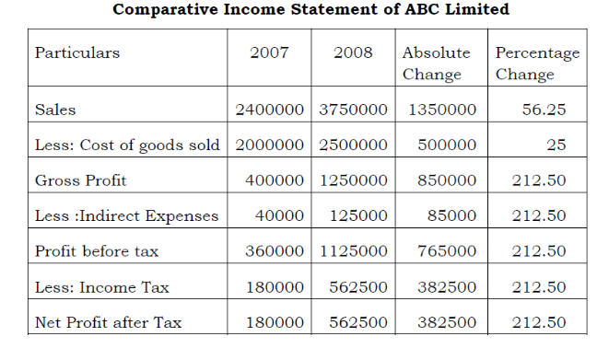

- Comparative Balance Sheet
A comparative balance sheet presents side-by-side information about an entity's assets, liabilities, and shareholders' equity as of multiple points in time. For illustration, a comparative balance sheet could present the balance sheet as of the end of each year for the past three years. The changes in periodic balance sheet items reflect the conduct of a business.
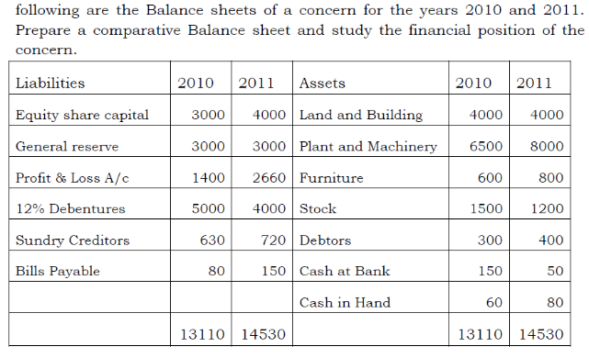

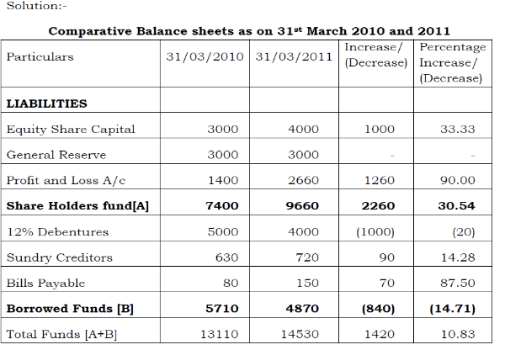
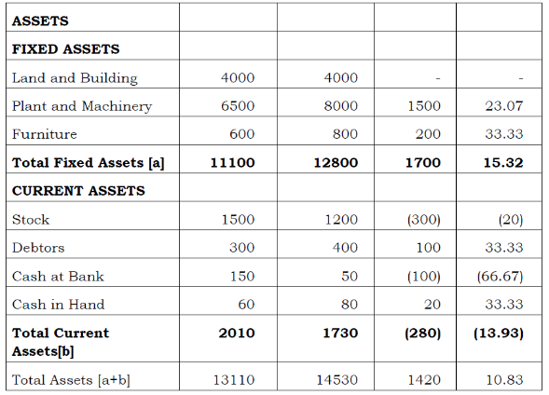
Comments:
Fixed Assets have increased moderately by 15.32% during 2011. Current Assets have also increased similarly except Cash at Bank which actually decreased by 66.67%.Total borrowed funds decreased during the year while shareholders funds increased by over 30% mainly due to issue of new shares and accumulation of profits. Overall financial position has improved satisfactorily during 2012.
II. Common Size Statements
Common size statements examine the proportion of a single line item to the total statement. For balance sheets, all assets are expressed as a percentage of total assets, while liabilities and equity are expressed as a percentage of total liabilities and shareholders’ equity. Income statement items are expressed as a percentage of revenues, i.e, sales.
1. Common size Balance sheet
2. Common size Income statement
1. Common Size Balance sheet
A statement in which balance sheet items are expressed as the ratio of each asset to total assets and the ratio of each liability is expressed as a ratio of total liabilities is called common-size balance sheet. The common size balance sheet can be used to compare companies of differing size
Example
Prepare a Common size Balance sheet of XYZ from the following data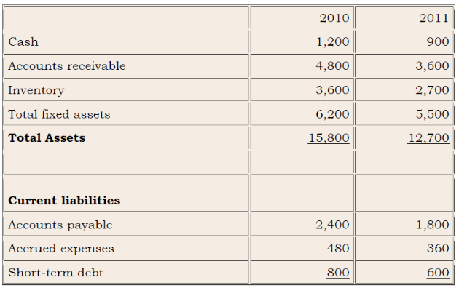
Solution:
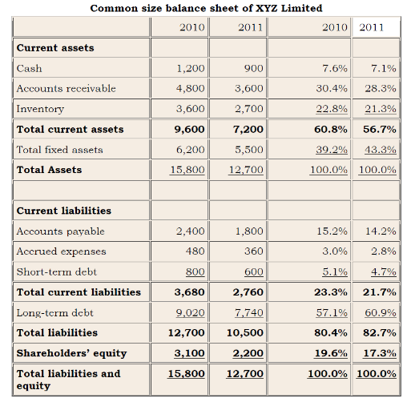

2.Common-size income statement
Common-size income statement is the type of income statements in which each item is reported as a reference to the revenue of the company. This method is executed by converting all the items of the income statements as a reference to percentage of the revenue. This is a method used for the analysis purpose.

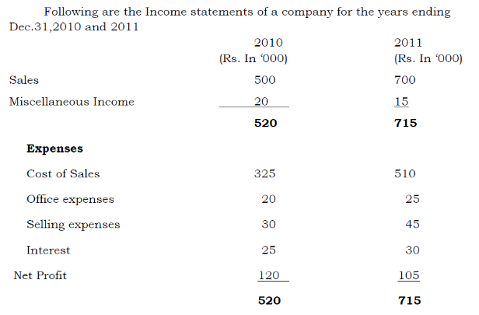
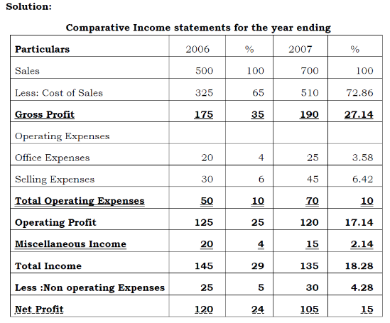
III. Trend analysis

Trend means a tendency. It discloses the changes in financial and operating data between specific periods and makes it possible for the analysis to form opinion as to whether favorable or unfavorable tendencies are reflected by the accounting data. In the analysis of financial information, trend analysis is the presentation of amounts as a percentage of a base year.
Example.
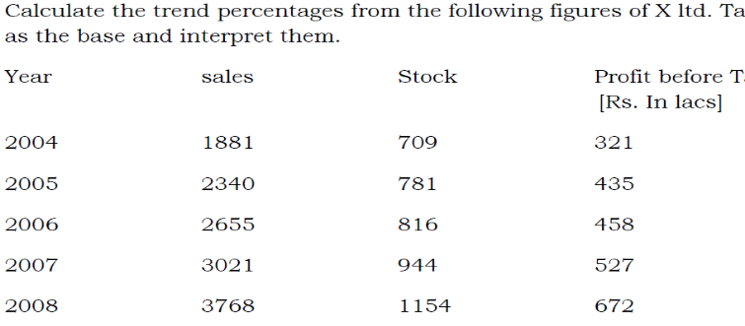
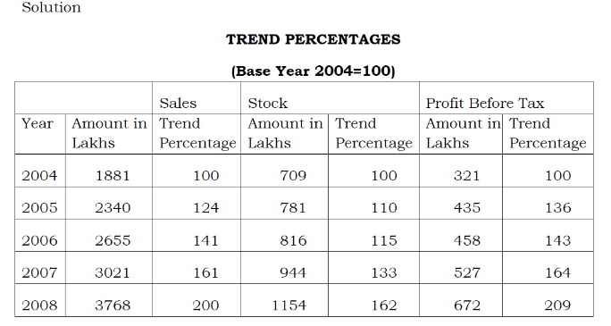
IV.RATIO ANALYSIS
The ratio analysis is one of the powerful tools of financial analysis. It is the process of establishing and interpreting various ratios. It is with the help of ratios that the financial statements can be analyzed more clearly ad decisions made from such analysis.
Definition of ratio:
According to Accountant’s Handbook by Wixon , Kell and Bedford, a ratio is an expression of the quantitative relationship between two numbers.

Use and Significance of Ratio analysis
{a} Managerial uses of Ratio analysis
1. Helps in decision making
2. Helps in financial forecasting and planning
3. Helps in communicating
4. Helps in co-ordination
5. Helps in control
{b}Utility to Share holders/ Investors
An investor is particularly interested to know about the Long term financial position and profitability position. Ratio analysis will be useful to the investor in making up his mind whether present financial position of the concern warrants further investment or not.
{c}Utility to Creditors
The creditors or suppliers extend short term credit to the concern. They are interested to know whether financial position of the concern warrants their payments at a specified time or not.
{d}utility to the Employees
The employees are also interested in the financial position of the concern especially profitability because their wage increases and amount of fringe benefits are related to the volume of profits earned by the concern.
{e}Utility to government
Government is interested to know the overall strength of the industry. Various financial statements published by industrial units are used to calculate ratios for determining short term, long term and overall financial position of the concerns. Ratio analysis also serves this purpose.
{f}Tax audit requirements
Clause 32 of the Income tax Act requires that the business should calculate Gross Profit/turnover, Net Profit/turnover , stock in trade/ turnover and Material consumed/finished goods produced ratios.

LIMITATIONS OF RATIO ANALYSIS
The ratio analysis is one of the most powerful tools of financial management. Though ratios are simple to calculate and easy to understand, they suffer from some serious limitations.
1. Limited use of a single ratio. A single ratio usually does not convey much of a sense. To make a better interpretation a number of ratios have to be calculated which is likely to confuse the analyst than help him in making any meaningful conclusion.
2. Lack of adequate standards. There are no well accepted standards or rules of thumb for all ratios which can be accepted as norms. It renders interpretation of the ratios difficult.
3. Inherent limitations of accounting. Like financial statements, ratios also suffer from the inherent weakness of accounting records such as their historical nature. Ratios of the past are not necessarily true indicators of the future.
4. Change of accounting procedure. Change in accounting procedure by a firm often makes ratio analysis misleading.
5. Window dressing. Financial statements can easily be window dressed to present a better picture of its financial and profitability position to outsiders
6. Personal bias Ratio are only means of financial analysis and not an end in itself. Ratios have to be interpreted and different people may interpret the same ratio in different ways.
7. Incomparable. Not only industries differ in their nature but also the firms of the similar business widely differ in their size and accounting procedures etc
8. Absolute Figures Distortive. Ratios devoid of absolute figures may prove distortive as ratio analysis is primarily a quantitative analysis and not a qualitative analysis
9. Price level changes. While making ratio analysis, no consideration is made to the changes in price levels and this makes the interpretation of ratios invalid.
10. Ratios no substitutes. Ratio analysis is merely a tool of financial statements. Hence, ratios become useless if separated from the statements from which they are computed.

CLASSIFICATION OF RATIOS
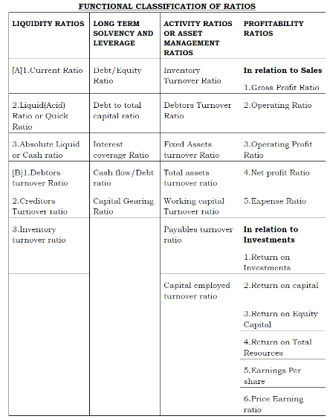

I.ANALYSIS OF SHORT-TERM FINANCIAL POSITION OR TEST OF LIQUIDITY
The short term creditors of a company like suppliers of goods of credit and commercial banks providing short-term loans are primarily interested in knowing the company’s ability to meet its current or short term obligations as and when these become due. The short term obligations of a firm can be met only when there are sufficient liquid assets.
A. Liquidity Ratios
B. Current assets movement or Efficiency Ratios
A. Liquidity Ratios
Liquidity refers to the ability of a concern to meet its current obligations as and when these become due. The short term obligations are met by realizing amounts from current, floating or circulating assets.
1. Current ratio
Current ratio may be defined as the relationship between current assets and current liabilities. This ratio, also known as working capital ratio, is a measure of general liquidity and is most widely used to make the analysis of a short term financial position or liquidity of the firm. It is calculated by dividingthe total of current assets by total of the current liabilities.
Current ratio= Current Assets/Current Liabilites

2.Quick Ratio
Quick ratio may be defined as the relationship between quick/liquid assets and current or liquid liabilities. An asset is said to be liquid if it can be converted into cash within a short period without loss of value.
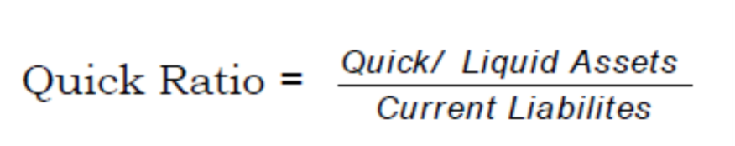
3.Absolute Liquid Ratio or Cash Ratio
Absolute Liquid Ratio is calculated by dividing Absolute Liquid assets by current Liabilities. Absolute Liquid Assets include cash in hand and at bank and marketable securities or temporary investments. The acceptable norm for this ratio is 50% or 0.5 :1 or 1 :2.
Example:
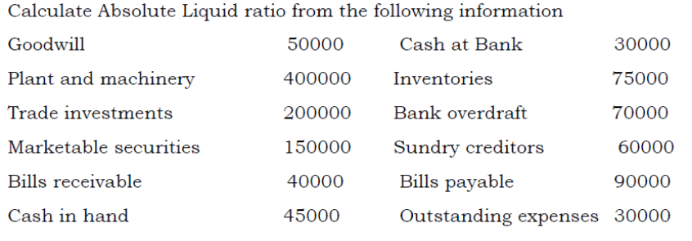
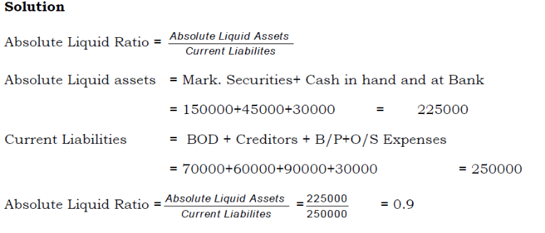
II. SOLVENCY – SOLVENCY RATIOS
1. Debt-Equity Ratio
A firm uses both equity and debt for financing its assets. The ratio of these two sources of funds is turned as Debt Equity Ratio.
Debt Equity Ratio = Total borrowed funds/ Owned funds

2.Capital Gearing Ratio
This ratio indicates the relationship between fixed interest bearing securities and equity shareholders funds.
Capital Gearing Ratio = Fixed Income bearing securities/Equity Shareholders funds

3.Propreitory ratio/ Equity Ratio
It is the ratio of shareholders funds to Total Assets of the firm. It indicates the relative contribution of owners or shareholders in financing total assets. This ratio is also called net worth to Total Assets Ratio. This ratio establishes the relationship between shareholder’s funds to total assets of the firm.
Proprietary ratio/ Equity Ratio = Shareholders funds/ Total Assets
Where shareholders funds = Equity share capital+ preference share capital+ undistributed profits+ reserves and surpluses
Total assets = Total resources of the concern

4.Solvency Ratio
It is the ratio of total borrowed funds to total assets (also equal to total liabilities). It indicates the relative contribution of outsiders in financing the assets of the firm. It is calculated as :-
Solvency ratio = Total Borrow ed funds/Total Assets

5.Ratio of Fixed assets to Net worth.
The ratio shows the relationship between net fixed assets and Net worth
Ratio of Fixed assets to Net worth = Net Fixed Assets/Net Worth

6.Funded Debt to capitalization
This ratio indicates the contribution of owners in financing fixed assets. If the ratio is less than one, it is considered as ideal. It means that the whole of fixed assets and a part of working capital are financed from shareholders funds. If the ratio is more than one, it means that a part of the fixed assets is financed using borrowed funds.
Funded Debt to capitalization = Long term debt/Total Assets or Total Liabilites

III.Activity Ratios
1.Inventory turnover ratio
2. Debtors turnover ratio
3. Creditors turnover ratio
4. Total assets turnover ratio
5. fixed assets turnover ratio
6. Working capital turnover ratio

1.Inventory turnover ratio
Inventory turnover ratio = cost of goods sold/ average inventory
Cost of goods sold = net sales – gross profit
Cost of goods sold = opening stock +net purchases + direct expenses – closing stock
Average inventory = opening inventory +closing inventory/2

2.DEBTORS TURNOVER RATIO
Debtors Turnover Ratio = Net Credit Sales / Average Trade Debtors
Debtors Turnover Ratio = Total Sales / Debtors
Average Collection Period Ratio:
(Trade Debtors × No. of Working Days) / Net Credit Sales

3. Creditors / Accounts Payable Turnover Ratio:
Creditors Turnover Ratio = Credit Purchase / Average Trade Creditors
Average payment period ratio gives the average credit period enjoyed from the creditors.
It can be calculated using the following formula:
Average Payment Period = Trade Creditors / Average Daily Credit Purchase
Average Daily Credit Purchase= Credit Purchase / No. of working days in a year
Or
Average Payment Period = (Trade Creditors × No. of Working Days) / Net Credit Purchase

4.Fixed Assets Turnover: The fixed (or capital) assets turnover ratio measures how intensively a firm's fixed assets such as land, buildings, and equipment are used to generate sales.
Fixed Assets Turnover Ratio = Cost of Sales / Net Fixed Asset

5.Total Assets Turnover
Total Assets Turnover=Sales/Total Assets

6.Working Capital Turnover Ratio
Working Capital Turnover Ratio = Cost of Sales / Net Working Capital

IV.PROFITABILITY RATIOS
1. Gross profit ratio
2. Operating profit ratio
3. Operating ratio
4. Net profit ratio

1.Gross Profit Ratio (GP Ratio)::
Gross profit ratio (GP ratio) is the ratio of gross profit to net sales expressed as a percentage. It expresses the relationship between gross profit and sales.
Gross Profit Ratio = (Gross profit / Net sales) × 100

2.Net Profit Ratio (NP Ratio):
Net profit ratio is the ratio of net profit (after taxes) to net sales. It is expressed as percentage.
Net Profit Ratio = (Net profit / Net sales) × 100

3.Operating Ratio:
Operating ratio is the ratio of cost of goods sold plus operating expenses to net sales. It is generally expressed in percentage.
Operating Ratio = [(Cost of goods sold + Operating expenses) / Net sales] × 100

4.Expense Ratio:
Expense ratios indicate the relationship of various expenses to net sales. The operating ratio reveals the average total variations in expenses.

Particular Expense = (Particular expense / Net sales) × 100

V.OVERALL PROFITABILITY RATIOS
1.Return on total assets
2. Return on capital employed
3. Return on shareholder’s equity
4. Return on equity capital

1.Return on Shareholders’ Investment or Net Worth Ratio:
Return on share holder's investment = {Net profit (after interest and tax) / Share holder's fund} × 100

2.Return on Equity Capital (ROEC) Ratio
Return on Equity Capital = [(Net profit after tax − Preference dividend) / Equity share capital] × 100

3.Return on Capital Employed Ratio (ROCE Ratio)
Gross capital employed = Fixed assets + Investments + Current assets
Net capital employed = Fixed assets + Investments + Working capital .
Working capital = current assets − current liabilities.
4.Return on Total Assets
Return on total Assets is also called Return on Investment or ROI. It is calculated by dividing operating profit by total tangible assets.
Return on total Assets = Operating Profit/ Total Tangible Assets x100

VI.MARKET TEST RATIOS
1.Dividend Yield Ratio
2.Dividend Payout Ratio
3.Earnings Per Share (EPS) Ratio
4.Price Earnings Ratio (PE Ratio)
5.Coverage Ratios
1.Dividend Yield Ratio:
Dividend yield ratio is the relationship between dividends per share and the market value of the shares.
Dividend Yield Ratio = Dividend Per Share / Market Value Per Share

2.Dividend Payout Ratio:
Dividend payout ratio is calculated to find the extent to which earnings per share have been used for paying dividend and to know what portion of earnings has been retained in the business.
Dividend Payout Ratio = Dividend per Equity Share / Earnings per Share
Retained Earning Ratio = Retained Earning Per Equity Share / Earning Per Equity Share

3.Earnings per Share (EPS) Ratio
Earnings per share ratio (EPS Ratio) is a small variation of return on equity capital ratio and is calculated by dividing the net profit after taxes and preference dividend by the total number of equity shares.
The formula of earnings per share is:
Earnings per share (EPS) Ratio = (Net profit after tax − Preference dividend)
/ No. of equity shares (common shares)

4.Price Earnings Ratio (PE Ratio)
Price earnings ratio (P/E ratio) is the ratio between market price per equity share and earning per share
Price Earnings Ratio = Market price per equity share / Earnings per share

5.Coverage Ratios
Interest Coverage Ratio = Net Profit before Interest and Tax / Fixed Interest Charges
Preference share dividend cover = Profit after tax / Preference share dividend
Equity dividend cover = profit after tax – preference share dividend / equity share dividend

6. Capital Gearing Ratio
Capital Gearing Ratio = Equity Share Capital / Fixed Interest Bearing Funds

Unit - II
FUNDS FLOW STATEMENT
Meaning of the term ‘Fund’
In a narrow sense it means cash and in a broader sense it is capital or all financial resources of a business. But the fund is commonly used in its popular sense as working capital or net current assets. Thus for accounting purpose and for preparing funds flow statements , the term fund means working capital of the excess of current assets over current liabilities.
MEANING AND CONCEPT OF FLOW OF FUNDS
The term flow means movement and includes both inflow and outflow of fund. the term flow of funds means the transfer of economic values from one asset of equity to another. Flow of funds is said to have taken place when any transaction makes changes in the amount of funds available before happening of the transaction.
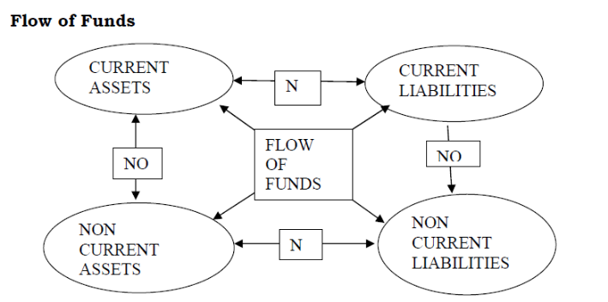
Definition of Flow of funds.
Funds flow statement may be defined as “ a statement of sources and applications of funds is a technical devise designed to analyze the changes in financial conditions of business enterprise between two dates.

SIGNIFICANCE AND IMPORTANCE OF FUND FLOW STATEMENT
1. It helps in the analysis of financial operations
2. It gives answers to many questions like happening of net profit, proceeds of sale of shares etc.
3. It helps in the formation of a realistic dividend policy
4. It helps in the proper allocation of resources
5. It acts as a guide for future to the management.
6. It helps in appraising the use of working capital
7. It helps in knowing the overall credit worthiness of the firm
8. It states how much funds has been generated from operations during the year
9. It helps the management in framing financial policies like dividend policies, issue of shares etc.
10. Creditors and financial institutions who have lend money to the firm can assess the financial strengths and repayment capacity based on funds flow analysis.

LIMITATIONS OF FUNDS FLOW STATEMENT
1. The funds flow statement cannot substitute the income statement or balance sheet.
2. The interpretation of fund as working capital distorts the real change in financial position of a business.
3. Preparation of funds flow statement requires a lot of workings and preparation of non current accounts.
4. Certain items like provision for tax and proposed dividend can be treated differently as current liability or noncurrent liability which gives misleading results regarding funds from operations
5. A statement of changes in financial position on cash basis(cash flow Statement) is more informative and useful than the funds flow statement which is prepared on working capital basis.
PROCEDURE FOR PREPARING A FUNDS FLOW STATEMENT
Broadly speaking the preparation of FFS consists of two parts
1. Statement or schedule of changes in working capital
2. Statement of sources and application of funds
Statement or schedule of changes in working capital
Working capital means the excess of current assets over current liabilities. Statement of changes in working capital is prepared to show the changes in the working capital between the two balance sheet dates. This statement is prepared with the help of current assets and current liabilities derived from the two balance sheets as

Working capital = Current assets - Current liabilities

So
- An increase in current assets increases the working capital
- The decrease in current assets decreases the working capital
- An increase in current liabilities decreases the working capital
- A decrease in current liabilities increases working capital
- The total increase and the total decrease are compared and the difference shows the net increase or net decrease in working capital.
Illustration 1
Prepare a statement of changes in working capital from the following balance sheet. Of Manjit and co. Ltd. 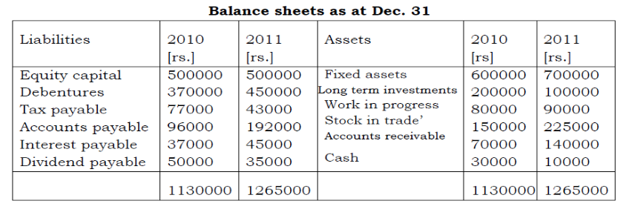
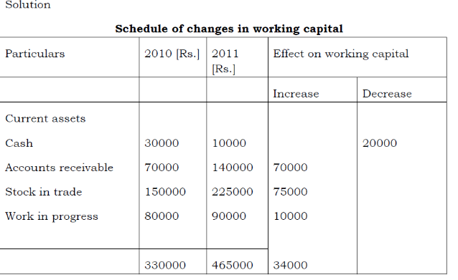
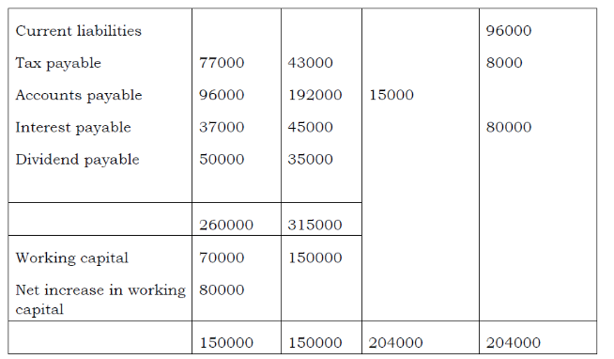
Preparing Non Current Accounts
This is to ascertain the inflows or outflows of funds from non current accounts. In the preparation of non current accounts the general principle is that a decrease in non current assets or increase in non current liabilities results in an inflow of funds. Similarly, an increase in non current assets or decrease in non current liabilities results in an out flow of fund. This principle is subject to exceptions when additional information is given in the problem. It may relate to depreciation written off on assets, old assets discarded, intangible or fictitious assets written off , transfer to general reserve, bonus share issued etc.

Funds from operations
It means regular source of funds received from operations of the business. It is the cash operating profit of the business or the income from operations net of cash operating expense. It is an important item coming under the head ‘source of funds ‘
[a]Adjusting net profit for the year [Statement method]
Funds from operations are not equal to net profit. It is the net profit before charging non fund and non operating expenses and losses and excluding non operating incomes. It is calculated as follows
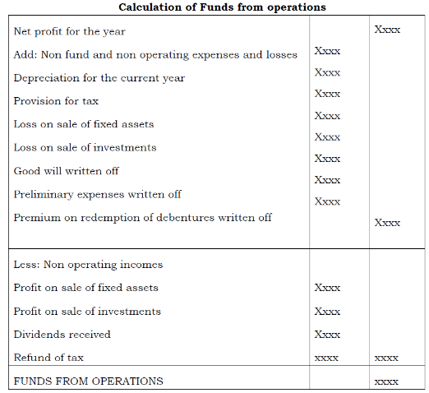
[b] Preparing an adjusted Profit and Loss Account [Account Method]
An adjusted profit and loss account is prepared under this method and funds from operations can be ascertained as the balancing figure. When adjusted P/L A/c is prepared all appropriations of profits made during current year like transfer to general reserve, interim dividend paid , proposed dividend for current year etc. are also debited in addition to non fund and non operating expenses and losses. An adjusted Retained Earnings account or adjusted reserve and surplus account can be prepared to find our funds from operations, where separate profit and loss account balances are not given in the problem.
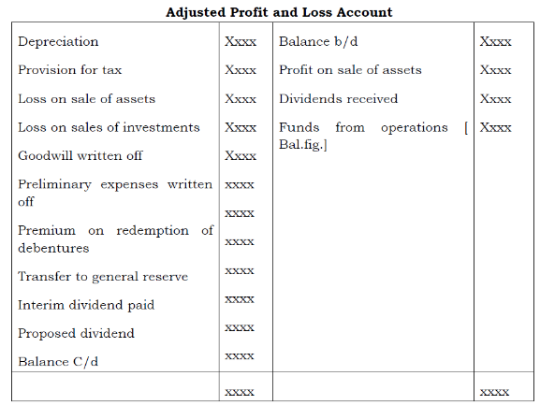
Illustration 2
Calculate funds from operations from the information given below as on 31st March 2008
1. Net profit for the year ended 31st march 2008 650000
2. Gain on sale of building Rs 35500
3. Good will appears in the books at Rs 180000.out of that 10% has been written off during the year
4. Old machinery worth Rs. 8000 has been sold for 6500 during the year
5. Rs. 125000 has been transferred to the general reserve fund
6. Depreciation has been provided during the year on machinery and furniture at 20% whose total cost is 650000
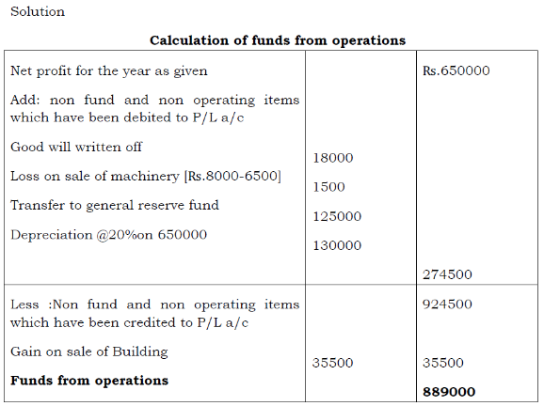
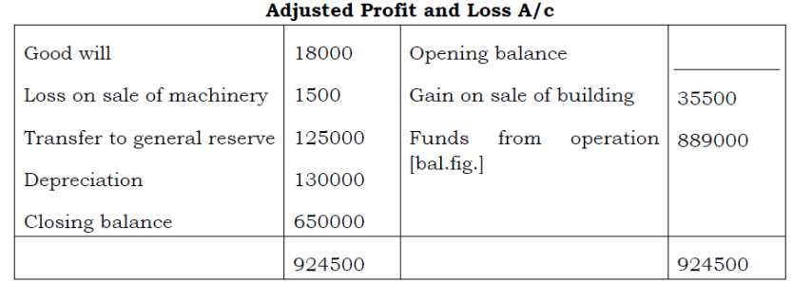

CASH FLOW STATEMENT
Meaning of the term cash
The term ‘cash’ includes cash and cash equivalents. These include cash in hand, cash at bank and short term investments or marketable securities. Short term investments are highly liquid and can be converted into cash on demand or on short notice. These are not held for a real return but to meet the liquidity requirements of the business.
Meaning of cash flow statement
Cash flow statement is a statement which describes the inflows and outflows of cash and cash equivalents in an enterprise during a specified period of time. It explains the reasons for changes in a firm’s cash position during an accounting year.
The Institute of Cost and Works Accountant of India defines cash flow statement as “ a statement setting out the flow of cash under distinct heads of sources of funds and their utilization to determine the requirements of cash during the given period and to prepare for its adequate provision.”
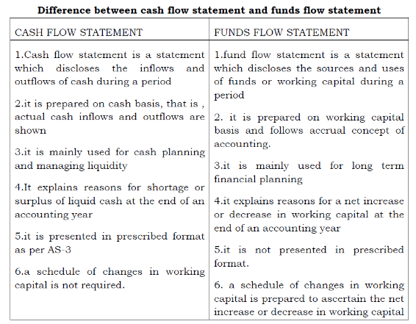
USES OF CASH FLOW STATEMENT
1. A Cash flow statement discloses changes in financial position on cash basis. It facilitates management of cash flows of a business.
2. It facilitates management in the evaluation of cash position and appropriate measures may be taken to arrange loans or make investments of surplus cash
3. It helps management in formulating financial policies such as dividend policy, credit policy etc.
4. A projected cash flow statement can guide the management regarding the need for arranging cash on long term basis by issuing shares, raising loans etc.
5. A cash flow statement can explain how much cash is generated within the business from operations for meeting various demands for cash such as payment of dividend, tax, financing expansion and investment son new projects etc.
6. It also explains reasons for paying very low dividend in spite of earning sufficient net profit by the business.
Limitations of cash flow statement
1. A cash flow statement discloses changes in financial position on cash basis only. Therefore, non cash transactions affecting changes in financial position are ignored
2. It is not a substitute to financial statements like Profit and Loss Account and Balance sheet. It can only substantiate these statements.
3. It is easy to manipulate cash position by delaying payment or quick collection of cash by management decisions. Therefore, the real cash position may not be disclosed.
4. The real liquidity position can be evaluated only by analyzing other current assets also. But in cash flow analysis only cash is evaluated.

CLASSIFICATION OF CASH FLOWS
The revised Accounting Standard [ AS-3] has made the following classification in respect of cash flows.
1. Cash flows from operating activities
2. Cash flows from investing activities
3. Cash flows from financing activities
1. Cash flow from operating activities
These are cash flows from regular course of operations. The operations of a firm include manufacturing, trading, rendering of services etc. Examples of cash flows from operating activities are;-
a. Cash sales
b. Cash received from debtors on account of credit sales
c. Cash purchase of goods
d. Cash paid to suppliers on account of credit purchases
e. Wages paid to employees and staff
f. Cash operating expenses
g. Income from investing activities

2. Cash from investing activities
The investing activities of a business include purchase and sale of fixed assets like land buildings, equipments, machinery etc. Acquisition or disposal of companies also comes under investing activities. These are separately discloses in cash flow statement Eg.
a. Cash payments to acquire fixed assets
b. Cash receipts from disposal of fixed assets
c. Cash payments to acquire shares, debt instruments or warrants
d. Cash receipts from disposal of shares
e. Cash advances and loans made to third parties

3. Cash flows from financing activities
The financing activities of a firm include issuing or redemption of share capital, issue and redemption of debentures , raising and repayment of long term loans etc. these are items changing the owners equity and debt capital during an accounting year. Dividends paid to shareholders also come under financing activities Eg.
a. Cash proceeds from issuing shares or other similar instruments
b. Cash proceeds from issuing debentures, loans, notes , bonds and other short or long term borrowings and
c. Cash repayments of amounts borrowed such as redemption of debentures, bonds, preference shares.

PREPARATION OF CASH FLOW STATEMENT
It requires comparative balance sheet at the beginning of the year and at the end f the year. In addition income statement for current year and/ or additional information regarding sale of asset, depreciation provided, tax paid etc. are also given. Thus the information given is the same as that is required for the preparation of funds flow statement.
The following steps are involved in the preparation of cash flow statement.
1. Prepare all non current accounts and ascertain inflow or outflow of cash
2. Calculate cash from operations for current year
3. Prepare cash flow statement in the prescribed format as per AS-3
Cash from operations
Cash from operations is an important source of inflow of cash into the business. It can be calculated by the following methods;-
a. Direct method
b. The indirect method
a. The Direct method
Under this method, all cash receipts on accounts of normal course of operations of business are added and from these total all cash payments on account of operations are deducted. The net amount is the cash received from operations as outlined below;-
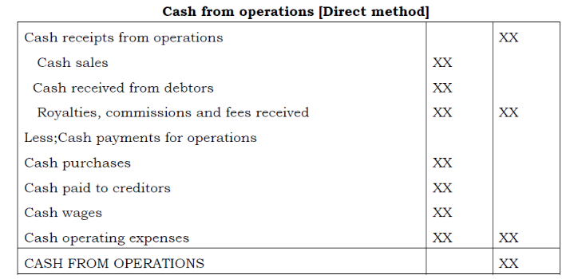
Illustration 1.
From the following Profit and Loss account, calculate cash from operations under direct method
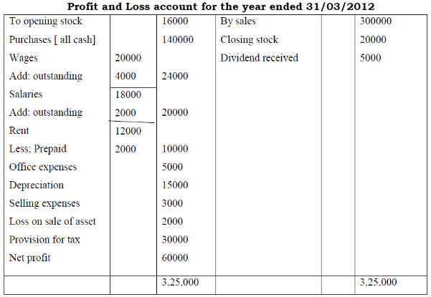
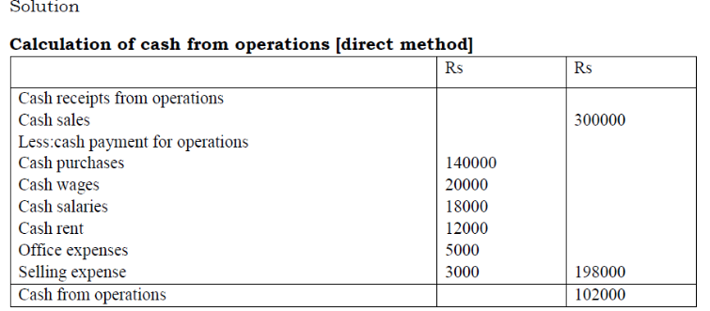
The indirect method
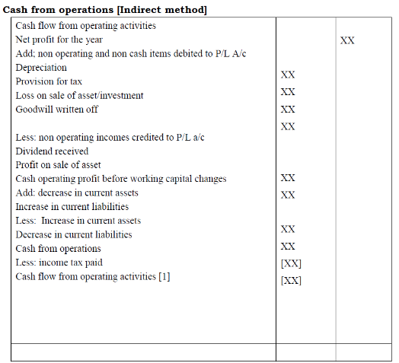
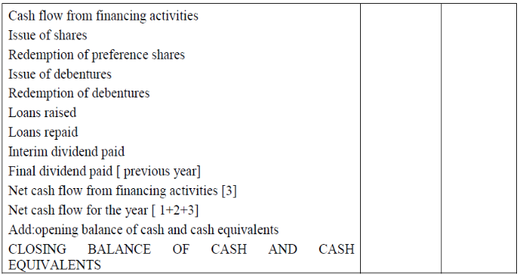

Illustration 2
From the following comparative balance sheets and additional information, calculate cash from operations for the year ending 31/03/2012
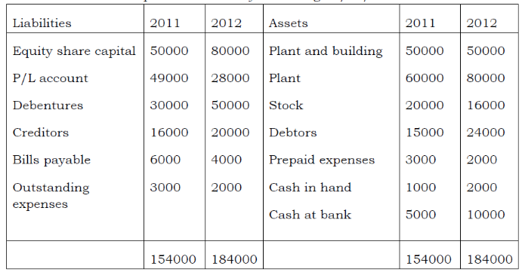Additional information;
1. Net profit after tax for the year was Rs. 25000
2. Depreciation on plant Rs.12000
3. Loss on sale of plant debited to P/L a/c Rs.2000
4. Net profit includes Rs.1000 received as other income
5. During the year provision for tax was made for Rs.10000
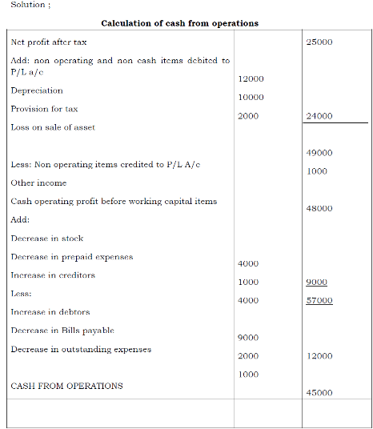

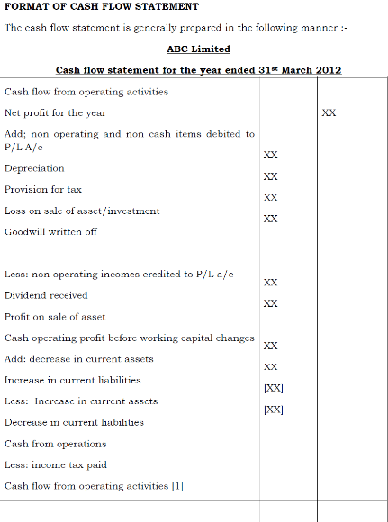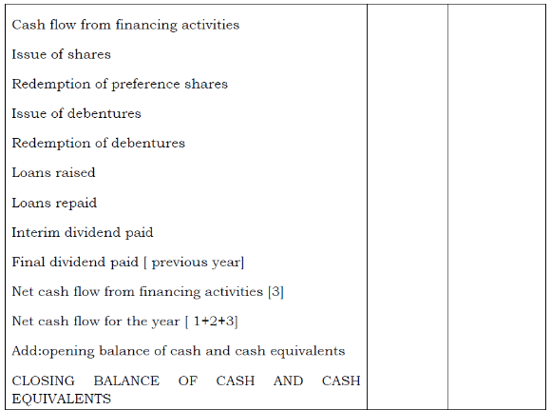
Illustration 3
Balance sheets of P& Q as on 01-01-2011 and 31-12-2011 were as follows :
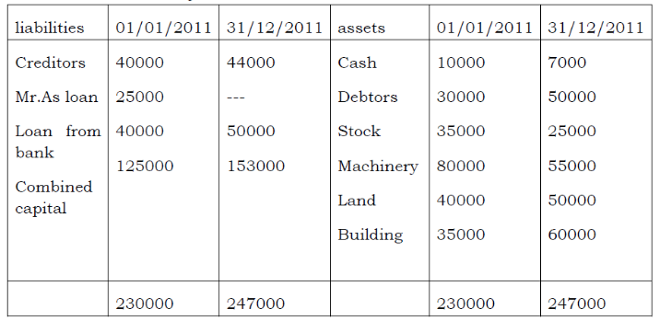
During the year, a machine costing ₨.10000 [accumulated depreciation Rs.3000] was sold for Rs.5000. the provision for depreciation against machinery on 01/01/2011 was Rs.25000 and on 31/12/2011 it was ₨.40000. Net profit for the year 2011 amounted to₨.45000.you are required to prepare a cash flow statement
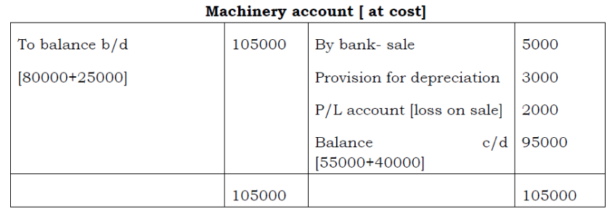
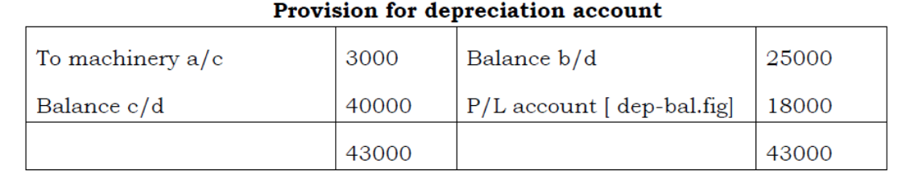
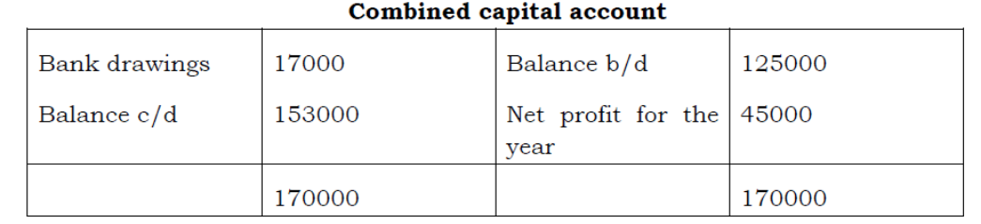
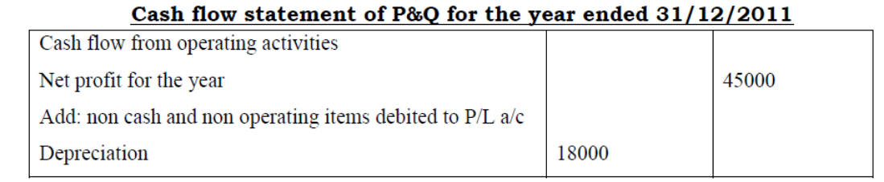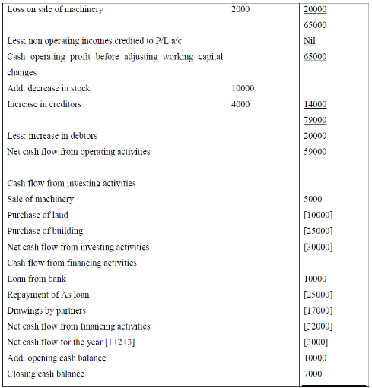

Unit - III

MARGINAL COSTING

Marginal Cost
The term Marginal cost means the additional cost incurred for producing an additional unit of output. It is the addition made to total cost when the output is increased by one unit.
Marginal cost of nth unit = Total cost of nth unit- total cost of n-1 unit

MARGINAL COSTING
According to CIMA, marginal costing is “the ascertainment, by differentiating between fixed and variable costs, of marginal costs and of the effect on profit of changes in volume or type of output.

FEATURES OF MARGINAL COSTING:
- All costs can be classified into fixed and variable elements. Semi variable costs are also segregated into fixed and variable elements.
- The total variable costs change in direct proportion with units of output. It follows a linear relation with volume of output and sales.
- The total fixed costs remain constant at all levels of output. These are incurred for a period and have no relation with output.
- Only variable costs are treated as product costs and are charged to output, product, process or operation
- Fixed costs are treated as ‘Period costs’ and are directly transferred to Costing Profit and Loss Account.
- The closing stock is also valued at marginal cost and not at total cost.
- The relative profitability of product or department is based on the contribution it gives and not based on the profit
- It is also assumed that the selling price per unit remains the same i.e, any number of units can be sold at the current market price.
- The product or sales mix remains constant over a period of time.

CONCEPT OF CONTRIBUTION
Contribution is the excess of sales over marginal cost. It is not purely profit. It is the profit before recovery of fixed assets. Fixed costs are first met out of contribution and only the remaining amount is regarded as profit. Contribution is an index of profitability. It has a fixed relationship with sales. Larger the sales more will be the contribution and vice versa.
Contribution = Sales – Marginal cost

Marginal cost equation
Sales-Marginal cost = Contribution
Contribution = Fixed costs + Profit
Therefore, Fixed cost = Contribution – Profit’

PROFIT VOLUME RATIO [P/V RATIO].
Contribution is an absolute measure of profitability but it cannot be used for comparison of two products or departments. Therefore, the contribution is related to volume of sales. It is called Contribution / Sales Ratio or Profit/Volume Ratio [P/V Ratio]
P/V Ratio = Contribution x100
Sales
When the P/V Ratio is higher, profitability of the product will also be higher. It is an index of relative profitability of products or departments.
Sales = Contribution
P/V Ratio

Contribution = Sales x P/V Ratio
P/V Ratio can also be find out by the following formula :-
P/V Ratio = Change in Profit x100
Change in Sales

Or P/V Ratio = Fixed Cost x 100
Break even sales
Marginal cost statement:
The Marginal cost statement is a profitability statement prepared according to marginal costing principles. It is prepared in the following format.

Sales  Less: Variable/Marginal cost Direct Labour  Direct Expenses  Variable Factory overheads Variable Administration overheads  Variable Selling and distribution overheads Contribution  Less Fixed Costs Profit |  | Xx
Illustration 1.

You are given the following information relating to a company for the year 2012 Output 20000 units
Selling price per unit Rs.12
Direct materials per unit Rs.5
Direct Labour per unit Rs.2
Variable overhears per unit Rs.1
Fixed cost per year Rs.60000

Calculate a) Total Marginal cost b) Contribution c) Profit d) P/V Ratio

MARGINAL COST STATEMENT
Output 20000 Units Sales Less: Marginal Cost  Direct Materials Direct Labour Direct Expenses  Total Marginal Cost  Contribution  Less: Fixed Costs  Profit | 12 | 240000
 | 5 | 100000
 | 2 | 40000
 | 1 | 20000
 | 8 | 160000
 | 4 | 80000
 |  | 60000
 |  | 20000

P/V Ratio = Contribution x 100 = 80000 x 100 = 33.33% Sales 240000

Advantages of Marginal Costing
Following are the advantages of Marginal costing
- It is simple to understand and easy to apply to any firm
- There is no arbitrary apportionment of fixed cost in this system. Fixed costs are transferred to costing profit and Loss account.
- It also prevents the illegal carry forward in stock valuation of some proportion of current years fixed cost.
- The effect of different sales mix on profit can be ascertained and management can adopt the optimum sales mix
- It is used in control of cost by concentrating on variable cost of production.
- It helps in profit planning by break even and cost volume profit analysis
- It helps management to take a number of short term decisions like pricing, output, closing down of department, sales mix, make or buy etc..

Disadvantages
Important disadvantages of marginal costing are ;
- All Assumptions of marginal costing are not appropriate. The assumption fixed cost remains constant for all levels may not hold good in the long run.
- The assumption that changes in direct proportion with the volume of also do not hold good under all circumstances.
- It is difficult to segregate all costs into fixed and variable elements.
- The exclusion of fixed costs in ascertaining cost of production may give misleading results and lead to non recovery of total costs.
- The exclusion of fixed costs from inventories affect profit and financial statements may not reflect true and fair view of financial affairs.

Marginal costing and Absorption costing
Marginal costing is the practice of charging only variable costs to cost of production, leaving fixed costs to be charged to the costing profit and loss account.
In Absorption costing or Total costing all types of costs are charged to output or process. While variable costs are wholly allocated to output or production, fixed costs are apportioned and a portion is charged to output or production.

DIFFERENCE BETWEEN MARGINAL COSTING AND ABSORPTION COSTING
- Marginal costing is the practice of charging only variable costs to products, outputs or processes and absorption costing variable and fixed cost to products, outputs or processes
- There is no apportionment of fixed costs and they are charged to profit and loss account under marginal costing. But fixed costs are apportioned and charged to outputs or processes under absorption costing.
- Under marginal costing, inventories or stocks are valued at marginal costs and under absorption costing they are valued at total costs.
- Under marginal costing, the profitability of a product or department is judged on the basis of the contribution that it gives but under absorption costing it is judged on the basis of the ultimate profit that it gives.
- Under marginal costing, profit is ascertained by deducting fixed costs from contribution and under absorption costing it is ascertained by deducting total costs from sales.

BREAK EVEN ANALYSIS
Every business is interested in ascertaining the breakeven point. It is the level of operation where total revenue or sales are equal to total cost. It is the point of no profit or no loss. The contribution received at Breakeven point is just sufficient to meet the fixed costs, leaving nothing as profit. The firm ceases to incur losses at this point or it starts to earn a profit from this point. Breakeven point can be expressed in algebraic method or graphical method.

Algebraic Method
Breakeven point may be expressed in terms of number of units to be produced, or in terms of volume of sales or in terms of the capacity of operation. It can be calculated by the following formula.
- Break even point in units = Total Fixed costs
Contribution per unit

2. Break even point in value = Total Fixed costs or Total Fixed cost x sales
P/V Ratio Contribution
3.Break even point (in % of capacity utilization)  Illustration 2  From the following information calculate | = | Total Fixed Costs x 100 Contribution
1. P/V Ratio
2. Breakeven point in Units
3. Breakeven point in Value
Given :
Selling price per unit Rs.20
Variable cost per unit Rs.12
Fixed costs Rs.32000
- P/V Ratio = Contribution/Sales x 100 = 20-12/20x100 = 40 %

- Breakeven point in units = Fixed costs/ Contribution per unit = 32000/8= 4000 units
- Breakeven point in value = Fixed costs = 32000/40 x100 = Rs.80000
P/V Ratio

Target Profit
The Break even analysis can guide an organization to determine the volume of sales required to earn a desired level of profit. The firm can decide upon the target return or profit in advance. To achieve this profit, efforts would be taken to increase the volume of sales. The volume of sales required to achieve the desired level of profit may be computed as follows :-
Number of units to be sold = Fixed costs + desired Profit
Contribution per unit

Sales volume required = Fixed costs+ Desired Profits
P/V Ratio

Break Even Chart [Graphic Method]
It is the graphical presentation of breakeven point. It shows the relationship between sales volume, variable and fixed costs. It also shows the profit or loss at different levels of output or volume of sales.

Construction of Break even Chart
A Break even chart shows the total sales line, total cost line and the point of intersection called the breakeven point. It is constructed using a database of variable costs, fixed costs, total costs and sales at different levels of output.
The units of output or sales revenue are plotted along the X axis, using suitable scale of measurement. The costs and sales are plotted along the Y axis. The fixed costs line is plotted first. It forms a parallel line to the X axis indicating that the fixed cost remain constant at all levels of output. The variable cost line is plotted next, starting from zero it progresses continuously indicating that the variable cost increase with the volume fixed cost line of sales. The total cost line is plotted above the variable cost line. It starts from the fixed cost line on the Y axis and follows the same pattern of variable cost line. The sales line is plotted finally. It starts from the zero and progresses continuously, indicating that the sales increase with larger units of output. The point of intersection of sales line and total cost line indicates the Break even point. A vertical line drawn to the X axis from this point shows the volume of output required to Break even.
Illustration 4

Draw a Break even chart using the following data
Selling price per unit Rs.12
Variable cost per unit Rs.7
Fixed costs Rs. 2000
Budgeted output800 units
Solution

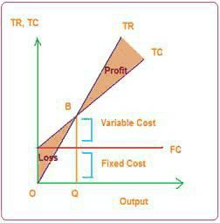

ANGLE OF INCIDENCE
It is the angle caused by the intersection of the total sales line and total cost line at the Break even point. The width of the angle represents the rate of profitability i.e, the larger the angle the greater will be the profit the business is making on additional sales

MARGIN OF SAFETY
Margin of safety represents the strength of the business to face an adverse market condition. It is the excess of actual sales over break even sales. Higher the Margin of safety, better the position of the firm.
Margin of safety = Actual sales- Break even sales Margin of safety = Profit / P/V Ratio
Or
Profit = margin of safety x P/V Ratio
Illustration
The following data have been obtained from the records of a manufacturing firm.

 | Period I | Period II
Sales | 300000 | 320000
Total cost | 260000 | 272000
Calculate

- Break even sales
- Profit when sales are Rs.360000.
- Sales required to earn a profit of Rs.50000 Solution:
P/V Ratio = Change in Profit x 100
Change in Sales
Change in profit = 48000-40000= 8000
Change in Sales = 320000-300000 = Rs.20000

P/V Ratio = 8000/20000x 100 = 40%
Contribution = Sales x P/V Ratio

Period I = 300000 x 40/100 = Rs.120000
Fixed cost = Contribution – Profit = 120000- 40000 = Rs.80000
1. BEP = Fixed cost /P/V Ratio = 8000/40 x 100 = 200000
- Profit when sales are Rs.360000 Contribution = 360000x40/100 = 144000
Profit = Contribution – Fixed cost = 144000-80000=Rs.64000
3.Sales required to earn a profit of Rs.50000
Contribution required = Fixed cost + Profit required = 80000+50000 = 130000
Sales = Contribution requires/ P/V ratio
= 130000/40x100 = Rs.325000

CASH BREAK EVEN POINT
Total fixed costs include depreciation. Depreciation is a non cash expense. Therefore, cash break even point is the number of units to be produced to give a contribution equal to cash fixed costs.
Cash Break even point = Fixed cost – Depreciation
Contribution per unit

Illustration

Calculate cash Break even point for the following Selling price per unit Rs.40
Variable cost per unit Rs.32
Fixed cost [including depreciation of Rs.20000] Rs.60000 per annum Solution
Contribution per unit = S- VC = 40-32 = 8

Cash break even point = Fixed cost – depreciation
Contribution per unit

= 60000-20000/8
= 5000 units

COMPOSITE BREAK EVEN POINT
In the case of companies producing more than one product an over all or composite break even point is calculated.
Composite Break even point = Total Fixed Costs
Composite P/V Ratio

Composite P/V Ratio = Total contribution x 100
Total Sales of all products

Cost-Volume Profit Analysis [ CVP Analysis]
It is the study of the impact of a change in cost , price and volume on profit. Break even analysis is a narrow interpretation of cost volume profit analysis. But it is mainly confined to finding out the Break even point. In CVP analysis the relationship between cost, volume and profit is studied in detail. It helps management in profit planning, decision making and cost control.

Assumptions in CVP analysis
The assumptions in CVP analysis are the same as that under marginal costing.
  - Cost can be classified into fixed and variable components.
  - Total fixed cost remain constant at all levels of output
  - The variable cost change in direct proportion with the volume of output
  - The product mix remains constant
  - The selling price per unit remains the same at all the levels of sales
  - There is synchronization of output and sales, i.e, what ever output is produced , the same is sold during that period.

PROFIT VOLUME CHART OR [P/V CHART]
It shows the amount of profit or loss at different levels of output. When the output is zero, total loss will be equal to fixed costs. The fixed costs are recovered gradually when the volume of output is increased. When the output reaches the Break even point, the whole fixed costs are recovered. The firm incurs no loss or earns no profit. Thereafter, the firm makes a profit and the amount of profit increases with the increase in sales volume.

CONSTRUCTION OF P/V CHART
The same data used for drawing a Break even chart may be used for constructing a P/V chart. The following steps may be followed for constructing a P/V chart.
- Sales or units of output are plotted along the X axis
- The Y axis is used for marking fixed costs losses and profits
- Points of Profits or losses are marked at different levels of sales and these points are joined to get the profit or loss line.
- The point where the profit or loss line intersects the X axis is marked as the Break even point.
- The angle at the BEP measures the angle of incidence
- The distance between BEP and actual sales on the X axis measures the margin of safety
Illustration
Draw a Profit/ Volume graph from the following data and find out the BEP?
Sales for the year [ 20000units] Rs.2000000 Variable Costs Rs.1600000
Fixed costs for the year Rs.200000
What would be the profits when the output is 22000 units?
Cost-volume-profit graph:

MANAGERIAL USES OF MARGINAL COSTING AND BREAK EVEN ANALYSIS
Marginal costing and Beak even analysis are very useful to management. The important uses of marginal costing and Break Even analysis are the following

Profit Planning
The first step in profit planning is the ascertainment of Break even point. It is the level of operation when there is no profit no loss. Once BEP is found out the management can decide upon the required level of sales to earn a particular amount of profit.
- Cost control
Cost control is an important function of management. In marginal costing all costs are classified into fixed and variable elements. Fixed costs are generally non controllable in nature. But variable costs can be controlled by managerial actions.Therefore, managerial attention is drawn towards the control of variable costs in marginal costing.

Decision making
Marginal costing helps to take important managerial decisions like ;-

  - Fixation of selling price under different market conditions
  - Whether to accept a special order or not
  - Whether to accept an export order or not

  - Selection of suitable product or sales mix
  - Make or buy decisions
  - Whether to discontinue a product or not

  - Closing down of a department
  - Merger of plant capacities
  - Key factor or limiting factor
  - Shut down or continue

Fixation of selling price
Selling price is actually the profit plus cost. But under severe competition or in a depressed market, it may not be possible to earn a uniform profit on sales. Some times the price may be fixed even below the cost. In marginal costing any product which gives the positive contribution is profitable and recommended in the long run.
Illustration
ABC Ltd is working below the normal capacity due to adverse market conditions. The present sales and costs of the firm are:
Normal capacity 5000 units
Actual output 3000 units Direct Materials Rs.30000
Direct Labour Rs.12000
Variable overheads Rs.3000
Fixed overheads Rs.25000 Selling price per unit Rs.20

Calculation of Marginal cost
Direct Materials Rs.30000 Direct Labour Rs.12000
Variable overheads Rs.3000

Marginal Cost Rs.45000
Marginal cost per unit = 45000/3000 = Rs.15
Therefore, the minimum price to be charged is Rs.15.Any price above the marginal cost will reduce the present loss by recovery of fixed costs.
Accepting Special Offer / Export Offer

UNIT – IV
Budget and budgetary control
Meaning of budget:
A budget is a financial and quantitative statement of an operational plan related to a specific time period, which is to be followed during the budgeted period in order to achieve specific financial objectives of an organization.
Definition of budget:
According to I.C.W.A, “A budget is a financial and/or quantitative statement prepared prior to a defined period of time, of the policy to be pursued during that period for the purpose of attaining a given objective.”
Features of a Budget
- It is a financial and quantitative statement of a plan of action.
- It is always expressed in terms of money and/or quantity.
- It is prepared prior to the implementation of the operational plan.
- It is based on pre-determined management policy.
- It is prepared to achieve specific financial objectives.
- It indicates the costs and revenues, capital to be employed, incremental effects on former budgets etc.
Meaning of Budgeting:
Budgeting refers to the process of preparation, implementation and operation of budgets. It involves formulation of operational plans for a given future period and expressing it in monetary terms.
Types of Budgeting
Budget can be classified into three categories from different points of view. They are:
- According to Function
- According to Flexibility
- According to Time

According to Function

Sales Budget
The budget which estimates total sales in terms of items, quantity, value, periods, areas, etc is called Sales Budget.

Production Budget
It estimates quantity of production in terms of items, periods, areas, etc. It is prepared on the basis of Sales Budget.

Cost of Production Budget
This budget forecasts the cost of production. Separate budgets may also be prepared for each element of costs such as direct materials budgets, direct labour budget, factory materials budgets, office overheads budget, selling and distribution overheads budget, etc.

Purchase Budget
This budget forecasts the quantity and value of purchase required for production. It gives quantity wise, money wise and period wise particulars about the materials to be purchased.

Personnel Budget
The budget that anticipates the quantity of personnel required during a period for production activity is known as Personnel Budget.

Research Budget
This budget relates to the research work to be done for improvement in quality of the products or research for new products.

Capital Expenditure Budget
This budget provides a guidance regarding the amount of capital that may be required for procurement of capital assets during the budget period.

Cash Budget
This budget is a forecast of the cash position by time period for a specific duration of time. It states the estimated amount of cash receipts and estimation of cash payments and the likely balance of cash in hand at the end of different periods.

Master Budget
It is a summary budget incorporating all functional budgets in a capsule form. It interprets different functional budgets and covers within its range the preparation of projected income statement and projected balance sheet.

According to Flexibility
On the basis of flexibility, budgets can be divided into two categories. They are:

  - Fixed Budget
  - Flexible Budget

Fixed Budget
Fixed Budget is one which is prepared on the basis of a standard or a fixed level of activity. It does not change with the change in the level of activity.
- Flexible Budget

A budget prepared to give the budgeted cost of any level of activity is termed as a flexible budget. According to CIMA, London, a Flexible Budget is, ‘a budget designed to change in accordance with level of activity attained’. It is prepared by taking into account the fixed and variable elements of cost.

According to Time

On the basis of time, the budget can be classified as follows:

  - Long term budget
  - Short term budget
  - Current budget
  - Rolling budget

Long-Term Budget
A budget prepared for considerably long period of time, viz., 5 to 10 years is called Long-term Budget. It is concerned with the planning of operations of the firm. It is generally prepared in terms of physical quantities.

Short-Term Budget
A budget prepared generally for a period not exceeding 5 years is called Short-term Budget. It is generally prepared in terms of physical quantities and in monetary units.

Current Budget
It is a budget for a very short period, say, a month or a quarter. It is adjusted to current conditions. Therefore, it is called current budget.

Rolling Budget
It is also known as Progressive Budget. Under this method, a budget for a year in advance is prepared. A new budget is prepared after the end of each month/quarter for a full year ahead. The figures for the month/quarter which has rolled down are dropped and the figures for the next month/quarter are added. This practice continues whenever a month/quarter ends and a new month/quarter begins.
Budgetary Control
Budgetary Control is the process of determining various budgeted figures for an organization for the future period and then comparing the budgeted figures with actual figures for calculating deviations and taking remedial measures to minimize deviations. It is a continuous process that helps in planning and controlling costs.
Definition of budgetary control:
According to Howard and Brown, “Budgetary control is a system of controlling costs which includes preparation of budgets, coordination of departments, comparison of actual performance with budgeted performance and acting upon the results to achieve maximum profitability.”
Requirements of a Good Budgetary System
- Budgeting process must be backed by the Chief Executive of an organization
- Organizational goals must be clearly stated and quantified and further divided into functional goals.
- People responsible for execution of budget must be involved in its preparation.
- Budgets must be realistic, continuous and must cover all relevant aspects.
- Budgeting system must be based on information, communication and participation.
- Clear responsibilities for effective budget implementation must be Established.
Essentials of Budgetary Control
(1)Organization Structure
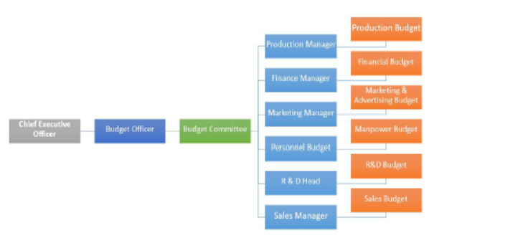

(2) Budget Centers – It may be a department or a group of people in a department, who are responsible for preparation of a budget.
(3) Budget Manual – It is a written document containing rules, regulation, policies and guidelines for preparing budgets.
(4) Budget Officer (Coordinator) – The person responsible for scrutinizing, evaluating and finalizing the budgets prepared by different functional heads.
(5) Budget period – Time period for which budget is prepared.
(6) Budget Committee – Group of people responsible for preparation and execution of budgets
(7) Determining Key Factor – Principle factor that influences all budgets
Steps in Budgetary Control System
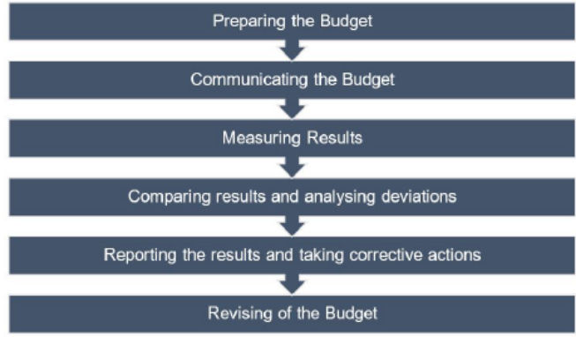
Advantages of Budgetary control
- Effective budgetary control leads to maximization of profit.
- It facilitates coordination between different functional departments.
- It acts as a tool for measuring (financial and operational) performance.
- It helps in eliminating wastages and taking corrective actions.
- It helps in reducing costs.
- It helps to take decisions regarding performance appraisal of employees.
Preparation of Budgets

- Preparation of Sales Budget

Sales budget is the basis for the preparation of other budgets. It is the forecast of sales to be achieved in a budget period. The sales manager is directly responsible for the preparation of this budget. The following factors are taken into consideration:

  - Past sales figures and trend
  - Salesmen’s estimates
  - Plant capacity
  - General trade position
  - Orders in hand
  - Proposed expansion
  - Seasonal fluctuations
  - Market demand
  - Availability of raw materials and other supplies
  - Financial position
  - Nature of competition
  - Cost of distribution
  - Government controls and regulations
  - Political situation.

Example

- The Royal Industries has prepared its annual sales orecast, expecting to achieve sales of ` 30, 00,000 next year. The Controller is uncertain about the pattern of sales to be expected by month and asks you to prepare a monthly budget of sales. The following is the sales data pertained to the year, which is considered to be representative of a normal year:
Month | Sales (`) | Month | Sales (`)
January | 1,10,000 | July | 2,60,000
February | 1,15,000 | August | 3,30,000
March | 1,00,000 | September | 3,40,000
April | 1,40,000 | October | 3,50,000
May | 1,80,000 | November | 2,00,000
June | 2,25,000 | December | 1,50,000
Prepare a monthly sales budget for the coming year on the basis of the above data.
Solution:
Sales Budget
Month | Sales (given) | Sales estimation based on cash sales ratio given
January | 1,10,000 | (1,10,000/25,00,000) x 30,00,000 = 1,32,000
February | 1,15,000 | (1,15,000/25,00,000) x 30,00,000 = 1,38,000
March | 1,00,000 | (1,00,000/25,00,000) x 30,00,000 = 1,20,000
April | 1,40,000 | (1,40,000/25,00,000) x 30,00,000 = 1,68,000
May | 1,80,000 | (1,80,000/25,00,000) x 30,00,000 = 2,16,000
June | 2,25,000 | (2,25,000/25,00,000) x 30,00,000 = 2,70,000
July | 2,60,000 | (2,60,000/25,00,000) x 30,00,000 = 3,12,000
August | 3,30,000 | (3,30,000/25,00,000) x 30,00,000 = 3,96,000
September | 3,40,000 | (3,40,000/25,00,000) x 30,00,000 = 4,08,000
October | 3,50,000 | (3,50,000/25,00,000) x 30,00,000 = 4,20,000
November | 2,00,000 | (2,00,000/25,00,000) x 30,00,000 = 2,40,000
December | 1,50,000 | (1,50,000/25,00,000) x 30,00,000 = 1,80,000
Total | 25,00,000 | 30,00,000

- M/s. Alpha Manufacturing Company produces two types of products, viz., Raja and Rani and sells them in Chennai and Mumbai markets. The following information is made available for the current year:
Market | Product | Budgeted Sales | Actual Sales
Chennai | Raja | 400 units @ ` 9 each | 500 units @ ` 9 each
,, | Rani | 300 units @ ` 21 each | 200 units @ ` 21 each
Mumbai | Raja | 600 units @ ` 9 each | 700 units @ ` 9 each
 | Rani | 500 units @ ` 21 each | 400 units @ ` 21 each
Market studies reveal that Raja is popular as it is under priced. It is observed that if its price is increased by ` 1 it will find a readymade market. On the other hand, Rani is overpriced and market could absorb more sales if its price is reduced to ` 20. The management has agreed to give effect to the above price changes.

On the above basis, the following estimates have been prepared by Sales Manager:
Product | % increase in sales over current budget
 | Chennai | Mumbai
Raja | +10% | + 5%
Rani | + 20% | + 10%
With the help of an intensive advertisement campaign, the following additional sales above the estimated sales of sales manager are possible:
Product | Chennai | Mumbai
Raja | 60 units | 70 units
Rani | 40 units | 50 units
You are required to prepare a budget for sales incorporating the above estimates.
Answer
Sales Budget
Area | Product | Budget for current year |  |  | Actual sales |  |  | Budget for  future period
 |  | Units | Price  ` | Value  ` | Units | Price  ` | Value  ` | Units | Price  ` | Value  `
Chennai | Raja | 400 | 9 | 3600 | 500 | 9 | 4500 | 500 | 10 | 5000
 | Rani | 300 | 21 | 6300 | 200 | 21 | 4200 | 400 | 20 | 8000
 | Total | 700 |  | 9900 | 700 |  | 8700 | 900 |  | 13000
Mumbai | Raja | 600 | 9 | 5400 | 700 | 9 | 6300 | 700 | 10 | 7000
 | Rani | 500 | 21 | 10500 | 400 | 21 | 8400 | 600 | 20 | 12000
 | Total | 1100 |  | 15900 | 1100 |  | 14700 | 1300 |  | 19000
Total | Raja | 1000 | 9 | 9000 | 1200 | 9 | 10800 | 1200 | 10 | 12000
 | Rani | 800 | 21 | 16800 | 600 | 21 | 12600 | 1000 | 20 | 20000
Total Sales |  | 1800 |  | 25800 | 1800 |  | 23400 | 2200 |  | 32000

- Preparation of Production Budget
Production = Sales + Closing Stock – Opening Stock
Example
3 The sales of a concern for the next year is estimated at 50,000 units. Each unit of the product requires 2 units of Material ‘A’ and 3 units of Material ‘B’. The estimated opening balances at the commencement of the next year are:

Finished Product : 10,000 units
Raw Material ‘A’ : 12,000 units
Raw Material ‘B’ : 15,000 units
The desirable closing balances at the end of the next year are:
Finished Product : 14,000 units
Raw Material ‘A’ : 13,000 units
Raw Material ‘B’ : 16,000 units
Prepare the materials purchase budget for the next year.

Answer
Production Budget
Estimated Sales | 50,000  14,000 | units  ,,
Add: Estimated Closing Finished Goods
 | 64,000 | ,,
Less: Estimated Opening Finished Goods | 10,000 | ,,
Production | 54,000 | ,,
Materials Purchase Budget
 | Material ‘A’ | Material ‘B’
Material Consumption | 1,08,000 units | 1,62,000 units
Add: Closing stock of materials | 13,000 ,, | 16,000 ,,
 | 1,21,000 ,, | 1,78,000 ,,
Less: Opening stock of materials | 12,000 ,, | 15,000 ,,
Materials to be purchased | 1,09,000 ,, | 1,63,000 ,,
Workings

Materials consumption: | Material ‘A’ | Material ‘B’
Material required per unit of production | 2 units | 3 units
For production of 54,000 units | 1,08,000 | 1,62,000

- Preparation of Cash Budget
It is an estimate of cash receipts and disbursements during a future period of time. “The Cash Budget is an analysis of flow of cash in a business over a future, short or long period of time. It is a forecast of expected cash intake and outlay” (Soleman, Ezra – Handbook of Business administration).
Procedure for Preparation of Cash Budget
- First take into account the opening cash balance, if any, for the beginning of the period for which the cash budget is to be prepared.
- Then Cash receipts from various sources are estimated. It may be from cash sales, cash collections from debtors/bills receivables, dividends, interest on investments, sale of assets, etc.
- The Cash payments for various disbursements are also estimated. It may be for cash purchases, payment to creditors/bills payables, payment to revenue and capital expenditure, creditors for expenses, etc.
- The estimated cash receipts are added to the opening cash balance, if any.
- The estimated cash payments are deducted from the above proceeds.
- The balance, if any, is the closing cash balance of the month concerned.
- The closing cash balance is taken as the opening cash balance of the following month.
- Then the process is repeatedly performed.
- If the closing balance of any month is negative i.e the estimated cash payments exceed estimated cash receipts, then overdraft facility may also be arranged suitably.
Example

- From the following budgeted figures prepare a Cash Budget in respect of three months to June 30, 2006.
Month | Sales | Materials  ` | Wages | Overheads
January | 60,000 | 40,000 | 11,000 | 6,200
February | 56,000 | 48,000 | 11,600 | 6,600
March | 64,000 | 50,000 | 12,000 | 6,800
April | 80,000 | 56,000 | 12,400 | 7,200
May | 84,000 | 62,000 | 13,000 | 8,600
June | 76,000 | 50,000 | 14,000 | 8,000
Additional Information
  - Expected Cash balance on 1st April, 2006 – ` 20,000
  - Materials and overheads are to be paid during the month following the month of supply.
  - Wages are to be paid during the month in which they are incurred.
  - All sales are on credit basis.
  - The terms of credits are payment by the end of the month following the month of sales: Half of credit sales are paid when due the other half to be paid within the month following actual sales.
  - 5% sales commission is to be paid within in the month following sales
  - Preference Dividends for ` 30,000 is to be paid on 1st May.
  - Share call money of ` 25,000 is due on 1st April and 1st June.
  - Plant and machinery worth ` 10,000 is to be installed in the month of January and the payment is to be made in the month of June.
Answer
Cash Budget for three months from April to June, 2006
Particulars | April  ` | May  ` | June  `
Opening Cash Balance | 20,000 | 32,000 | (-) 5,600
Add: Estimated Cash Receipts: Sales Collection from debtors Share call money  Less: Estimated Cash Payments: Materials  Wages Overheads  Sales Commission Preference Dividend Plant and Machinery | 60,000  25,000 | 72,000 | 82,000  25,000
 | 1,05,000 | 1,04,600 | 1,01,400
 | 50,000  12,400  6,800  3,200  ---  --- | 56,000  13,000  7,200  4,000  30,000  --- | 62,000  14,000  8,600  4,200  --- 10,000
 | 72,400 | 1,10,200 | 98,800
Closing Cash Balance | 32,600 | (-) 5,600 | 2,600

- Preparation of Flexible Budget
A flexible budget consists of a series of budgets for different level of activity. Therefore, it varies with the level of activity attained. According to CIMA, London, A Flexible Budget is, ‘a budget designed to change in accordance with level of activity attained’. It is prepared by taking into account the fixed and variable elements of cost. This budget is more suitable when the forecasting of demand is uncertain.

Points to be remembered while preparing a flexible budget

      - Cost has to be classified into fixed and variable cost.
      - Total fixed cost remains constant at any level of activity.
      - Total Variable cost varies in the same proportion at which the level of activity varies.
      - Fixed and variable portion of Semi-variable cost is to be segregated.

Example
      - The following information at 50% capacity is given. Prepare a flexible budget and forecast the profit or loss at 60%, 70% and 90% capacity.
Fixed expenses: | Expenses at 50%  capacity (`)
Salaries | 5,000
Rent and taxes | 4,000
Depreciation | 6,000
Administrative expenses | 7,000
Variable expenses:
Materials | 20,000
Labour | 25,000
Others | 4,000
Semi-variable expenses:
Repairs | 10,000
Indirect Labour | 15,000
Others | 9,000
It is estimated that fixed expenses will remain constant at all capacities. Semi-variable expenses will not change between 45% and 60% capacity, will rise by 10% between 60% and 75% capacity, a further increase of 5% when capacity crosses 75%.

Estimated sales at various levels of capacity are:

 | Capacity | Sales (`)
 | 60% | 1,10,000
 | 70% | 1,30,000
Answer | 90% | 1,50,000

Flexible Budget
(Showing Profit & Loss at various capacities)
Particulars | Capacities
 | 50% | 60% | 70% | 90%
 | ` | ` | ` | `
Fixed Expenses:
Salaries | 5,000 | 5,000 | 5,000 | 5,000
Rent and taxes | 4,000 | 4,000 | 4,000 | 4,000
Depreciation | 6,000 | 6,000 | 6,000 | 6,000
Administrative expenses | 7,000 | 7,000 | 7,000 | 7,000
Variable expenses:
Materials | 20,000 | 24,000 | 28,000 | 36,000
Labour | 25,000 | 30,000 | 35,000 | 45,000
Others | 4,000 | 4,800 | 5,600 | 7,200
Semi-variable expenses:
Repairs | 10,000 | 10,000 | 11,000 | 11,500
Indirect Labour | 15,000 | 15,000 | 16,500 | 17,250
Others | 9,000 | 9,000 | 9,900 | 10,350
Total Cost | 1,05,000 | 1,14,800 | 1,28,000 | 1,49,300
Profit (+) or Loss (-) |  | (-) 4,800 | (+) 2,000 | (+) 700
Estimated Sales |  | 1,10,000 | 1,30,000 | 1,50,000

V.Zero Base Budgeting (ZBB)

It is a management technique aimed at cost reduction. It was introduced by the U. S. Department of Agriculture in 1961. Peter A. Phyrr popularized it. In 1979, president Jimmy Carte issued a mandate asking for the use of ZBB by the Government.

ZBB - Definition

“It is a planning and budgeting process which requires each manager to justify his entire budget request in detail from scratch (Zero Base) and shifts the burden of proof to each manager to justify why he should spend money at all.

The approach requires that all activities be analyzed in decision packages, which are evaluated by systematic analysis and ranked in the order of importance”. – Peter A. Phyrr.

It implies that-

- Every budget starts with a zero base
- No previous figure is to be taken as a base for adjustments
- Every activity is to be carefully examined afresh
- Each budget allocation is to be justified on the basis of anticipated circumstances
- Alternatives are to be given due consideration
Advantages of ZBB

          - Effective cost control can be achieved
          - Facilitates careful planning
          - Management by Objectives becomes a reality
          - Identifies uneconomical activities
          - Controls inefficiencies
          - Scarce resources are used judiciously
          - Examines each activity thoroughly
          - Controls wasteful expenditure
          - Integrates the management functions of planning and control
          - Reviews activities before allowing funds for them.

UNIT – V
WORKING CAPITAL
Meaning of working capital:
According to Weston & Brigham - “Working capital refers to a firm’s investment in short term assets, such as cash amounts receivables, inventories etc.
Working capital can be understood as a measure of both a company’s efficiency and its shortterm financial health. For a layman, it simply means the difference between the current assets and current liabilities. It is the firm’s holdings of current, or short-term, assets
Importance of Working Capital:
1. Solvency of the business: Adequate working capital helps in maintaining solvency of the business by providing uninterrupted flow of production.
2. Goodwill: Sufficient working capital enables a business concern to make prompt payments and hence helps in creating and maintaining goodwill.
3. Easy Loans: A concern having adequate working capital, high solvency and good credit standing can arrange loans from banks and other on easy and favourable terms.
4. Cash discounts: Adequate working capital also enables a concern to avail cash discounts on the purchases and hence it reduces costs.
5. Regular supply of raw materials: Sufficient working capital ensures regular supply of raw materials and continuous production.
6. Regular payment of salaries, wages and other day-to-day commitments: A company which has ample working capital can make regular payment of salaries, wages and other day-to-day commitments which raises the morale of its employees, increases their efficiency, reduces wastages and costs and enhances production and profits.
7. Exploitation of favourable market condition: Only concern with adequate working capital can exploit favourable market conditions such as purchasing its requirements in bulk when the prices are lower and by holding its inventories for higher prices.
8. Ability to face crisis: Adequate working capital enables a concern to face business crisis in emergencies such as depression because during such periods, generally, there is much pressure on working capital.
9. Quick and regular return on investments: Every investor wants a quick and regular return on his investments. Sufficiency of working capital enables a concern to pay quick and regular dividends to its investors as there may not be much pressure to plough back profits.
10. High morale: Adequacy of working capital creates an environment of security, confidence, and high morale and creates overall efficiency in a business
STRUCTURE OF WORKING CAPITAL:
The different elements or components of current assets and current liabilities constitute the structure of working capital which can be illustrated in the shape of a chart as follows:
STRUCTURE OF CURRENT ASSETS AND CURRENT LIABILITIES
Current Liabilities | Current Assets
Bank Overdraft | Cash and Bank Balance
Creditors | Inventories: Raw-Materials Work-in-progress Finished Goods
Outstanding Expenses | Spare Parts
Bills Payable | Accounts Receivables
Short-term Loans | Bills Receivables
Proposed Dividends | Accrued Income
Provision for Taxation, etc | Prepaid Expenses  Short-term Investments

Classification or Kinds of Working Capital:
a) Concept based working capital
b) Time based working capital
c) Classification on the basis of financial reports.
a) CONCEPT BASED WORKING CAPITAL
1. Gross Working Capital
2. Net Working Capital
3. Negative Working Capital
1. Gross Working Capital: It refers to the firm’s investment in total current or circulating assets.
2. Net Working Capital: The term “Net Working Capital” has been defined in two different ways:
3. Negative Working Capital: This situation occurs when the current liabilities exceed the current assets. It is an indication of crisis to the firm.
b) TIME BASED WORKING CAPITAL
1. Permanent or Fixed Working Capital
(a) Regular Working Capital
(b) Reserve Working Capital
2. Temporary or Variable Working Capital
(a) Seasonal Working Capital
(b) Special Working Capital
1. Permanent Working Capital: This refers to that minimum amount of investment in all current assets which is required at all times to carry out minimum level of business activities.
2. Temporary Working Capital: The amount of such working capital keeps on fluctuating from time to time on the basis of business activities. In other words, it represents additional current assets required at different times during the operating year.
Classification on the basis of financial reports – The information of working capital can be collected from Balance Sheet or Profit and Loss Account; as such the working capital may be classified as follows:
- Cash Working Capital – This is calculated from the information contained in profit and loss account. This concept of working capital has assumed a great significance in recent years as it shows the adequacy of cash flow in business. It is based on ‘Operating Cycle Concept’.
- Balance Sheet Working Capital – The data for Balance Sheet Working Capital is collected from the balance sheet. On this basis the Working Capital can also be divided in three more types, viz., gross Working Capital, net Working Capital and Working Capital deficit.

FACTORS DETERMINANTS OF WORKING CAPITAL :
Internal Factors | External Factors
- Nature and size of the business | - Business fluctuations
- Firm’s production policy | - Changes in the technology
- Firm’s credit policy | - Import policy
- Availability of credit | - Infrastructural facilities
- Growth and expansion of business | - Taxation policy
- Profit margin and dividend policy
- Operating efficiency of the firm
- Co-coordinating activities in firm

I. INTERNAL FACTORS
1. Nature and size of the business:
The working capital requirements of a firm are basically influenced by the nature and size of the business. Size may be measured in terms of the scale of operations. A firm with larger scale of operations will need more working capital than a small firm.
2. Firm’s production policy :
The firm’s production policy (manufacturing cycle) is an important factor to decide the working capital requirement of a firm. The production cycle starts with the purchase and use of raw material and completes with the production of finished goods.
3. Firm’s credit policy:
The credit policy of a firm influences credit policy of working capital. A firm following liberal credit policy to all customers requires funds. On the other hand, the firm adopting strict credit policy and grant credit facilities to few potential customers will require less amount of working capital.
4. Availability of credit:
The working capital requirements of a firm are also affected by credit terms granted by its suppliers – i.e. creditors. A firm will need less working capital if liberal credit terms are available to it.
5. Growth and expansion of business:
Working capital requirement of a business firm tend to increase in correspondence with growth in sales volume and fixed assets. A growing firm may need funds to invest in fixed assets in order to sustain its growing production and sales. This will, in turn, increase investment in current assets to support increased scale of operations. Thus, a growing firm needs additional funds continuously.
6. Profit margin and dividend policy:
The magnitude of working capital in a firm is dependent upon its profit margin and dividend policy. A high net profit margin contributes towards the working capital pool. To the extent the net profit has been earned in cash, it becomes a source of working capital. This depends upon the dividend policy of the firm.
7. Operating efficiency of the firm:
Operating efficiency means the optimum utilisation of a firm’s resources at minimum cost. If a firm successfully controls operating cost, it will be able to improve net profit margin which, will, in turn, release greater funds for working capital purposes.
8. Co-ordinating activities in firm:
The working capital requirements of a firm are depend upon the co-ordination between production and distribution activities. The greater and effective the co-ordinations, the pressure on the working capital will be minimized. In the absence of co-ordination, demand for working capital is reduced.
II. External Factors
- Business fluctuations;
Most firms experience fluctuations in demand for their products and services. These business variations affect the working capital requirements. When there is an upward swing in the economy, sales will increase, correspondingly, the firm’s investment in inventories and book debts will also increase. On the other hand when, there is a decline in economy, sales will come down and consequently the conditions, the firm try to reduce their short-term borrowings. Similarly the seasonal fluctuations may also affect the requirement of working capital of a firm.
- Changes in the technology:
The technological changes and developments in the area of production can have immediate effects on the need for working capital. If the firm wish to install a new machine in the place of old system, the new system can utilise less expensive raw materials, the inventory needs may be reduced there by working capital needs.
- Import policy:
Import policy of the Government may also effect the levels of working capital of a firm since they have to arrange funds for importing goods at specified times.
- Infrastructural facilities:
The firms may require additional funds to maintain the levels of inventory and other current assets, when there is a good infrastructural facility in the company like transportation and communications.
- Taxation policy:
The tax policies of the Government will influence the working capital decisions. If the Government follows regressive taxation policy, i.e. imposing heavy tax burdens on business firms, they are left with very little profits for distribution and retention purpose. Consequently the firm has to borrow additional funds to meet their increased working capital needs. When there is a liberalized tax policy, the pressure on working capital requirement is minimized. Thus the working capital requirements of a firm are influenced by the internal and external factors.
MEASUREMENT OF WORKING CAPITAL:
There are 3 methods for assessing the working capital requirement as explained below:
- Percent of Sales Method
Based on the past experience, some percentage of sale may be taken for determining the quantum of working capital
- Regression Analysis Method
The relationship between sales and working capital and its various components may be plotted on Scatter diagram and the average percentage of past 5 years may be ascertained. This average percentage of sales may be taken as working capital.
- Operating Cycle Method
As a first step, we have to compute the operating cycle as follows:
i) Inventory period: Number of days consumption in stock = I ÷ M/36
Where, I – Average inventory during the year
M = Materials consumed during the year
ii) Work-in-process: Number of days of work-in-process = W ÷ K/365
Where, W = Average work-in-process during the year
K = Cost of work-in-process i.e., Material + Labour + Factory overheads.
iii) Finished products inventory period = G ÷F/365
Where G = Average finished products inventory during the year
F= Cost of finished goods sold during the year
iv) Average collection period of Debtors = D ÷S/365
Where, D = Average Debtors balances during the year
S = Credit sales during the year
v) Credit period allowed by Suppliers = C ÷P/365
Where, C = Average creditors’ balances during the year
P = credit purchases during the year
vi) Minimum cash balance to be kept daily. Formula: O.C. = M + W + F + D – C
Note : It is also known as working capital cycle. Operating cycle is the total time gap between the purchase of raw material and the receipt from Debtors.
The calculation of net working capital may also be shown as follows ;
Working Capital = Current Assets – Current Liabilities
= (Raw Materials Stock + Work-in-progress Stock + Finished Goods Stock + Debtors + Cash Balance) – (Creditors +Outstanding Wages + Outstanding Overheads).
Where,
Raw Materials = Cost (Average) of Materials in Stock
Work-in-progress Stock = Cost of Materials + Wages +Overhead of Work-in-progress.
Finished Goods Stock = Cost of Materials + Wages +Overhead of Finished Goods.
Creditors for Material = Cost of Average Outstanding Creditors.
Creditors for Wages = Averages Wages Outstanding.
Creditors for Overhead = Average Overheads Outstanding.
Thus,
Working Capital = Cost of Materials in Stores, in Work-in-progress, in Finished Goods and in Debtors.
Less : Creditors for Materials
Plus : Wages in Work-in-progress, in Finished Goods and in Debtors.
Less :Creditors for Wages
Plus : Overheads in Work-in-progress, in Finished Goods and in Debtors.
Less : Creditors for Overheads.

ESTIMATION OF WORKING CAPITAL REQUIREMENTS
The following points are also worth noting while estimating the working capital requirement:
1. Depreciation: An important point worth noting while estimating the working capital requirement is the depreciation on fixed assets. The depreciation on the fixed assets, which are used in the production process or other activities, is not considered in working capital estimation. The depreciation is a non-cash expense and there is no funds locked up in depreciation as such and therefore, it is ignored. Depreciation is neither included in valuation of work-in-progress nor in finished goods. The working capital calculated by ignoring depreciation is known as cash basis working capital. In case, depreciation is included in working capital calculations, such estimate is known as total basis woking capital.
2. Safety Margin: Sometimes, a firm may also like to have a safety margin of working capital in order to meet any contingency. The safety margin may be expressed as a % of total current assets or total current liabilities or net working capital. The safety margin, if required, is incorporated in the working capital estimates to find out the net working capital required for the firm. There is no hard and fast rule about the quantum of safety margin and depends upon the nature and characteristics of the firm as well as of its current assets and current liabilities

STANDARD COSTING

Standard cost:
Standard cost is a figure which represents an amount that can be taken as a typical of the cost of an article or other cost factor. It is established on the basis of planed operations, planed cost efficiency levels, and expected capacity utilization.
Standard Costing:
A standard costing system is a method of cost accounting in which standard costs are used in recording certain transaction and the actual costs are compared with the standard cost to learn the amount and reason for variations from the standard. ‐ W.B. Lawrence
Advantages of Standard Costing:
1. Proper Planning: It helps to apply the principle of “Management by exception”. That is, the management need not worry over those activities which proceed in tandem plans. It is only on the issues of exceptions that they have to concentrate.
2. Efficient Cost Control: Standard Costing is a tool for the management to gain reduction in the cost and control over it. Under this technique, differences are analyzed and responsibilities are determined.
3. Motivational Factor: Labour efficiency is promoted and they are destined to be cost conscious. Standards provide incentives and motivation to work with greater effort. This increases efficiency and productivity.
4. Comparison of Forecasting and Outcome: A target of efficiency is set for the employees and the cost consciousness is stimulated. Since the process of standard costing allow an appraisal to be made of personnel, machines and method of working, current inefficiencies come to the notice and get eliminated.
5. Inventory Control: Standard costing facilitates inventory control and simplifies inventory valuations. This ensures uniform pricing of stocks in the form of raw materials, work‐in‐progress and finished goods.
6. Economical System: Standard costing system is economical system from the viewpoint that it does not require detailed records. It also des not require a big staff. It results in the reduction in paper work in accounting and needs very few records. Thus, there is saving of time as well as money.
7. Helpful in Budgeting: Budgets are prepared on the basis of standard costing. Standards which are set up in respect of materials, labour and overheads, are helpful in preparing various budgets. For example, flexible budget, sales budget, etc.
8. Helps Formulate Policies: This technique is a valuable aid to the management in determining prices and formulating production policies. Standard costing equips cost estimates while planning the production of new products.
9. Helps Distinguish Activities: Standard costing helps in distinguishing between skilled and unskilled activities. So the skilled worker only gives pays attention to improving the activities of the unskilled workers.
10. Eliminates Wastage: Through fixing standard, certain waste such as material wastage, idle time, lost machine hours, etc. are reduced.
Limitations of Standard Costing:
1. Costly System: Because the Standard Costing requires highly skillful and competent personnel, it becomes a costly system too. For the same experts are paid high remuneration.
2. Difficulties in Fixation of Standard: It is always difficult to determine precise standard costs in a given situation which will coincide with actual cost when operations are over. Standard cost are determined partly by the past experience and partly by the cost projections based on advanced statistical techniques. Thus, uncertainties revolve around standards.
3. Constraint for Service Industry: Standard costing is applied for planning and controlling manufacturing costs. Thus, it cannot be applied in a service industry.
4. Consistency of Standard: because the standards of marginal costing fluctuate and vary time to time, it is difficult to always sustain and continue the same standards.
5. Unsuitable for Non‐standardised Products: Standard costing is expensive and unsuitable for job manufacturing industries as they manufacture non standardized products such as catering, tailoring, printing, etc.
6. Relatively Fixed Standards: A business may not be able to keep standards up‐to‐date. In other words, a business may not revise standards to keep pace with the frequent changes in manufacturing conditions. Firms may avoid revising standards as it is a costly affair.
7. Difficulties for Small Industries: Establishment of standards and their implementation involve initial high costs. Standards have to be revised and new standards be fixed involving larger costs.

STEPS IN STANDARD COSTING
Set the standard cost
- A standard quantity is predetermined and standard price per unit is estimated.
- Budgeted cost is calculated by using standard cost.
Record the actual cost
- Calculate actual quantity and cost incurred giving full details.
Variance Analysis
- Comparison of the actual cost with the budgeted cost.
- The cost variance is used in controlling cost.
- Take suitable corrective action.
- Fix responsibilities to ensure compliance
- Create effective control system.
- Resetting the budget, if required.

TYPES OF STANDARDS
- Ideal Standards : These represents the level of performance attainable when prices for material and labour are most favorable, when the highest output is achieved with the best equipment and layout and when maximum efficiency in utilization of resources results in maximum output with minimum cost.
- Normal Standards : These are the standards that may be achieved under normal operating conditions. The normal activity has been defined as number of standard hours which will produce normal efficiency sufficient goods to meet the average sales demand over a term of years.
- Basic or Bogey standards : These standards are use only when they are likely to remain constant or unaltered over long period. According to this standard, a base year is chosen for comparison purposes in the same way as statistician use price indices. When basic standards are in use, variances are not calculated as the difference between standard and actual cost. Instead, the actual cost is expressed as a percentage of basic cost.
- Current Standard : These standards reflect the management’s anticipation of what actual cost will be for the current period. These are the costs which the business will incur if the anticipated prices are paid for goods and services and the usage corresponds to that believed to be necessary to produce the planned output.

VARIANCE
Meaning of Variance
Variance means the deviation of the actual cost or actual sales from the standard cost or profit or sales. Calculation of variances is the main object of standard costing. This calculation shows that whether costs are under controlled or not. A variance may be favorable or adverse.
The process of computing the amount of variance and isolate the causes of variances between actual and standard.
- The difference between standard cost and actual cost of the actual output is defined as Variance. A variance may be favourable or unfavourable.
- If the actual cost is less than the standard cost, the variance is favourable and if the actual cost is more than the standard cost, the variance will be unfavourable.
- It is not enough to know the figures of these variances in fact it is required to trace their origin and causes of occurrence for taking necessary remedial steps to reduce / eliminate them.
Types of Variance
The purpose of standard costing reports is to investigate the reasons for significant variances so as to identify the problems and take corrective action. Variances are broadly of two types, namely, controllable and uncontrollable.
- Controllable Variance : Controllable variances are those which can be controlled by the departmental heads whereas uncontrollable variances are those which are beyond their control. If uncontrollable variances are of significant nature and are persistent, the standards may need revision.
- Variance Analysis : Variance analysis is the dividing of the cost variance into its components to know their causes, so that one can approach for corrective measures.
- Variances of Efficiency : Variance arising due to the effectiveness in use of material quantities, labour hours. Here actual quantities are compared with predetermined standards.
- Variances of Price Rates : Variances arising due to change in unit material prices, standard labour hour rates and standard allowances for indirect costs. Here actual prices are compared with predetermined ones.
- Variances of Due to Volume : Variance due to effect of difference between actual activity and the level of activity estimated when the standard was set.
Reasons of Material Variance
- Change in Basic price.
- Fail to purchase anticipated standard quantities at appropriate price.
- Use of sub-standard material.
- Ineffective use of materials. Pilferage.
Material Variance :
- Material Cost Variance = (Standard Quantity X Standard Price) – (Actual Qty X Act Price)
- Material Price Variance = Actual Quantity (Standard Price - Actual Price)
- Material Usage Variance = Standard Price (Standard Quantity - Actual Quantity)
- Material Mix Variances = Standard Price (Std. Mix ‐ Actual Mix)
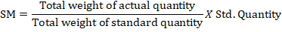
- Material Yield Variances = Standard Yield Price (Std. Yield ‐ Actual Yield)
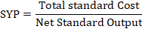
Reasons of Labour Variance
Time Related Issues.
- Change in design and quality standard.
- Low Motivation.
- Poor working conditions.
- Improper scheduling/placement of labour.
- Inadequate Training.
Rate Related Issues.
- Increments / high labour wages.
- Overtime.
- Labour shortage leading to higher rates.
- Union agreement.
LABOUR VARIANCE
    - Labour Cost Variance = (Standard Hrs X Standard Rate Per Hour) –(Actual Hrs X Actual Rate Per Hour)
    - Labour Rate Variance = Actual Hrs (Standard Rate - Actual Rate)
    - Labour efficiency Variance = Standard Rate (Std Hrs - Actual Hrs worked)
    - Idle Time Variance = Idle Hours X Std Rate

