SRINIVASAN COLLEGE OF ARTS AND SCIENCE PERAMBALUR
III. B.Com CA
COMPUTERISED ACCOUNTING - 16CCCCA15

TALLY
Basic Principles of Accounting : -
Guidelines on Basic Accounting Principles and Concepts GAAP (Generally Accepted Accounting Principles) is the framework, rules and guidelines of the financial accounting profession with a purpose of standardizing the accounting concepts, principles and procedures. Here are the basic accounting principles and concepts under this framework :
1. Business Entity A business is considered a separate entity from the owner(s) and should be treated separately. Any personal transactions of its owner should not be recorded in the business accounting book, vice versa. Unless the owner’s personal transaction involves adding and/or withdrawing resources from the business.
2. Going Concern It assumes that an entity will continue to operate indefinitely. In this basis, assets are recorded based on their original cost and not on market value. Assets are assumed to be used for an indefinite period of time and not intended to be sold immediately.
3. Monetary Unit The business financial transactions recorded and reported should be in monetary unit, such as INR,US Dollar, Canadian Dollar, Euro, etc. Thus, any non-financial or non-monetary information that cannot be measured in a monetary unit are not recorded in the accounting books, but instead, a memorandum will be used.
4. Historical Cost All business resources acquired should be valued and recorded based on the actual cash equivalent or original cost of acquisition, not the prevailing market value or future value. Exception to the rule is when the business is in the process of closure and liquidation.
5. Matching Concept This principle requires that revenue recorded, in a given accounting period, should have an equivalent expense recorded, in order to show the true profit of the business.
6. Accounting Period This principle entails a business to complete the whole accounting process of a business over a specific operating time period. It may be monthly, quarterly or annually. For annual accounting period, it may follow a Calendar or Fiscal Year.
7. Conservatism This principle states that given two options in the valuation of business transactions, the amount recorded should be the lower rather than the higher value.
8. Consistency This principle ensures consistency in the accounting procedures used by the business entity from one accounting period to the next. It allows fair comparison of financial information between two accounting periods.
9. Materiality Ideally, business transactions that may affect the decision of a user of financial information are considered important or material, thus, must be reported properly. This principle allows errors or violations of accounting valuation involving immaterial and small amount of recorded business transaction.
10. Objectivity This principle requires recorded business transactions should have some form of impartial supporting evidence or documentation. Also, it entails that bookkeeping and financial recording should be performed with independence, that’s free of bias and prejudice.

Golden Rules of Accounting :-
A] Real Accounts:-
Debit what comes in.
Credit what goes out.
B] Personal Accounts :-
Debit the reciver.
Credit the giver.
C] Nominal Accounts :-
Debit all expenses & Losses.
Credit all Incomes & Revenue.

Salient Features of Tally.
A leading accounting package: The first version of Tally was released in 1988 and, through continuous development, is now recognised as one of the leading accounting packages across the world, with over a quarter million customers. Tally’s market share is more than 90%.
No accounting codes: Unlike other computerised accounting packages which require numeric codes, Tally.ERP 9 pioneered the ‘no accounting codes’ concept. Tally.ERP 9 users have the freedom to allocate meaningful names in plain English to their data items in the system.
Complete business solution: Tally.ERP 9 provides a comprehensive solution to the accounting and inventory needs of a business. The package comprises financial accounting, book-keeping and inventory accounting. It also has various tools to extract, interpret and present data.
Integrated/ Non-integrated accounting and inventory: With Tally.ERP 9, the user is able to choose between accounting and accounting with inventory. If accounting with inventory is opted for, the user can choose whether it should be integrated or not. ‡ Flexible and easy to use: Tally.ERP 9 is very flexible. It mimics the human thought process, which means that Tally.ERP 9 can adapt to any business need. Tally.ERP 9 users need not change the way their business is run to adapt to the package.
Speed : Tally.ERP 9 provides the capability to generate instant and accurate reports, which assists the management to take timely and correct decisions for the overall productivity and growth of the company.
Power : Tally.ERP 9 allows the user to maintain multiple companies and with unlimited levels of classification & grouping capabilities. It also allows drill down facility from report level to transaction level.
Flexibility : Tally.ERP 9 provides flexiblity to generate instant reports for any given period (month/year) or at any point of time besides providing the facility to toggle between Accounting & Inventory reports of the same company or between companies.
Concurrent multi-lingual capability : Tally.ERP 9 offers you the exclusive capability of maintaining your accounts in any Indian language, viewing them in another language and printing them in yet another Indian language.
Real time processing : Immediate posting & updation of books of accounts as soon as the transactions are entered, thereby facilitating instant statements & Reports. It also faciliaties real-time multi-user environment.
Versatility: Tally.ERP 9 is suitable for a range of organisations, from small grocery stores to large corporations with international locations and operations.
Multi-platform availability: Tally.ERP 9 is available on Windows 95, 98, ME, 2000 and NT. It runs on a single PC or on a network. On a network, it supports access via any combination of platforms.
Online Help : The Tally.ERP 9 Online Help (Alt+H) provides instant assistance on basic and advanced features or any other relevant topics of Tally.ERP 9.
Tally.NET : is an enabling framework which establishes a connection through which the remote user can access the Client's data without copying / transferring the data. ‡
Remote Access : Tally.ERP 9 provides remote capabilities to access the data from anywhere and anytime.
Control Centre : works as an interface between the user and Tally.ERP 9 installed at different sites and enables the user to centrally configure and administer Site/User belonging to an account.
Support Centre : allows a user to directly post his support queries on the functional and technical aspects of the Product

Getting Functional with Tally.
Tally.ERP 9 Start-up Tally.ERP 9 can be started in any of the following ways : Click on Start > Programs > Tally.ERP 9 > Tally.ERP 9 or double click on the Tally.ERP 9 icon on your desktop
The welcome screen Tally.ERP 9 – Power of Simplicity appears while the software loads. You will be ready to explore Tally.ERP 9, the moment the Tally.ERP 9 start up screen appears. The Tally.ERP 9 Start-up Screen appears as shown below:

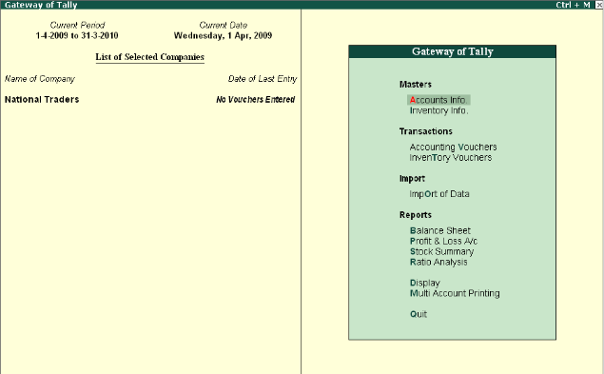
To Select a Company
1. Go to the Gateway of Tally > Alt + F3 > Company Info. > Select Company OR Press F1.
Tally.ERP 9 displays the List of Companies screen. All the companies created are displayed
in an alphabetical order. Select the company name from the list given.
2. In case two or more companies are loaded (like National Traders and Indus Enterprises), click on the company which you need to work on so that the selected company will be highlighted and will appear on top of the list.

To Shut a Company
Go to the Gateway of Tally > Alt + F3 > Company Info. > Shut Company. Select the Company which you need to shut from the List of Companies. You can also use Alt + F1 to shut a Company from the Gateway of Tally screen.

To Alter Company Details
Go to the Gateway of Tally > Alt + F3 > Company Info. > Alter. Select the company which you need to alter from the List of Companies and press Enter to view the Company Alteration screen. Alter the company details as required and accept the screen.

F1: Accounting Features
The Accounting Features consists of configurations/ functionalities, which generally affects
Accounting transactions and reports. The Accounting features is further sub-divided into six
sections, namely :
- General
- Oustandings Management
- Cost/ Profit Centres Management
- Invoicing
- Budgets/ Scenario Management
- Other Features

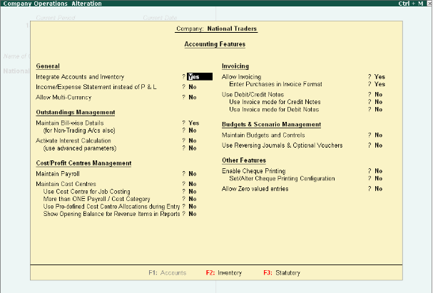

Enable the required features
- Press Enter to accept

Inventory Features
The Inventory features comprises of configurations/ functionalities pertaining to Inventory transactions and reports. The Inventory features is further sub-divided into seven sections, namely :
- General
- Storage & Classification
- Order Processing
- Invoicing
- Purchase Management
- Sales Management
- Additional Inventory Vouchers

Go to Gateway of Tally > F11: Features > Inventory Features or click on F2 : Inventory
The Inventory Feature screen is displayed as shown.
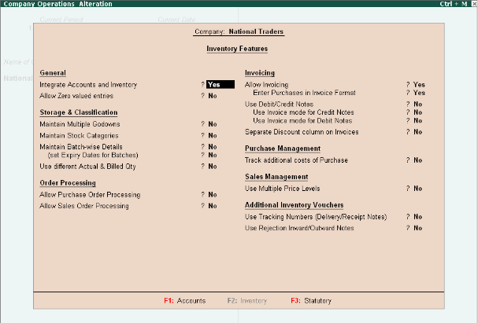

Enable the required features
􀂇 Press Enter to accept
SELECT THE PROPER KEY AS PER REQUIREMENT :-
- F4 – Contra : For any Deposit/Withdrawal of Cash from Bank. (Only Cash/Bank A/c are Debited / Credited in Contra entries.)
- F5 – Payment: For any Payment made weather cash /Cheque entry should be passed through Payment entry. (Only Cash/Bank A/c are Credited in Payment entry.)
- F6 – Receipt: For any Receipt weather in cash /Cheque entry should be passed through Receipt entry. (Only Cash/Bank A/c are Debited in receipt entry.)
- F7 – Journal : Other than Cash/Bank any entry can be passed through Journal entry. (Transactions where No Cash/Bank A/c are affected should be passed through Journal e.g. Year end Provisions entries).
- F8 & F9 – Sales & Purchase Entries: For Trading Activities i.e Purchase & Sales of Goods, Entries should be passed through this keys.

Pre-defined Groups of Accounts
There are 28 predefined groups in Tally.ERP 9, which are widely used in the Chart of Accounts of
many trading organizations. Out of these, 15 groups are Primary Groups and the remaining 13 are Sub-Groupsare Profit & Loss A/c items. However, you may also alter the nomenclature of these predefined 28 Groups.

The List of Accounts screen is displayed as shown
1. Capital Account
Reserves & Surplus [Retained Earnings]
2. Current Assets
Bank Accounts
Cash-in-hand
Deposits (Asset)
Loans & Advances (Asset)
Stock-in-hand
Sundry Debtors
3. Current Liabilities
Duties & Taxes
Provisions
Sundry Creditors
4. Fixed Assets
5. Investments
6. Loans (Liability)
Bank OD A/c [Bank OCC A/c]
Secured Loans
Unsecured Loans
7. Suspense A/c
8. Misc. Expenses (Asset)
9. Branch/Divisions

Out of the 15 pre-defined primary groups, the following are the six pre-defined groups that
appear in the Profit & Loss Account.

1. Sales Accounts
2. Purchase Accounts
3. Direct Incomes [Income (Direct)]
4. Indirect Incomes [Income (Indirect)]
5. Direct Expenses [Expenses (Direct)]
6. Indirect Expenses [Expenses (Indirect)]
Accounting Vouchers
Tally.ERP 9 is pre-programmed with a variety of accounting vouchers, each designed to perform a
different job. The standard Accounting Vouchers are:
- Contra Voucher (F4)
- Payment Voucher (F5)
- Receipt Voucher (F6)
- Journal Voucher (F7)
- Sales Voucher /Invoice (F8)
- Credit Note Voucher (CTRL+ F8)
- Purchase Voucher (F9)
- Debit Note Voucher (CTRL+ F9)

Contra Voucher (F4)
For example: withdrawing money from the bank for petty cash.
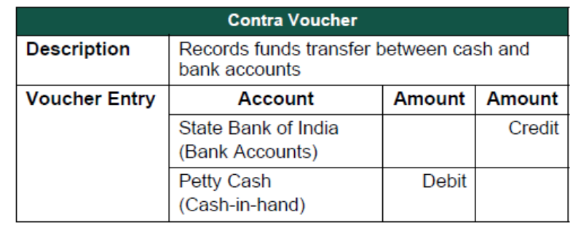
Use a Contra Voucher to record the entry.
Setup :
In Voucher entry mode, press F12: Contra Configuration and set the following to Yes:
- Skip the Date field in Create Mode (faster entry!)
- Use Cr/Dr instead of To/By during entry
- Warn on Negative Cash Balance
- Show Ledger Current Balances
- Show Balances as on Voucher Date
Go to the Gateway of Tally > Accounting Vouchers > F4: Contra
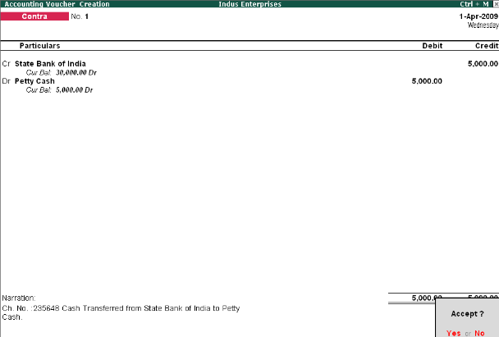
Payment Voucher (F5)
For example, a company settles a creditor's bill by cheque.
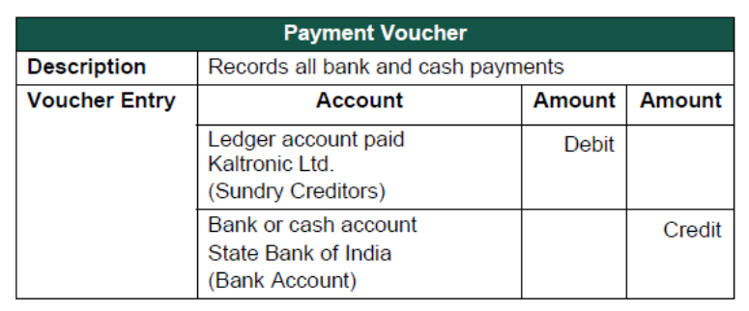
Use a Payment Voucher to record the entry.
Go to the Gateway of Tally > Accounting Vouchers > F5: Payment.
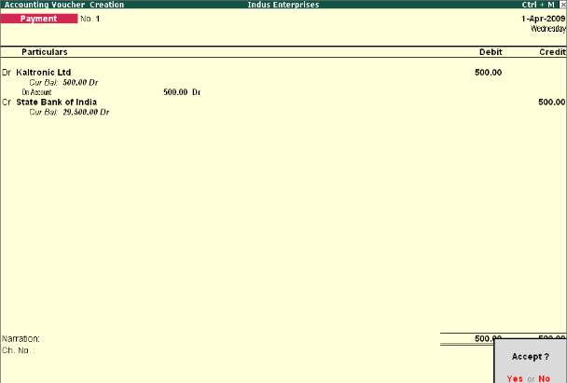
- Press Y or Enter to accept the screen.
Receipt Voucher (F6)
For example, the company receives a bank advice that the interest has been credited to its
deposit account.
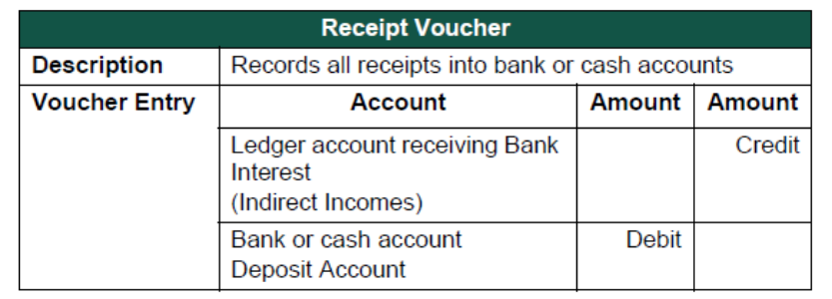
Use a Receipt Voucher to record the entry.
Ensure in F12: Payment Configuration, Use Single Entry mode for Pymt/Rcpt/Contra is set to No.
Go to the Gateway of Tally > Accounting Vouchers > F6: Receipt.
The entry made appears as shown below:
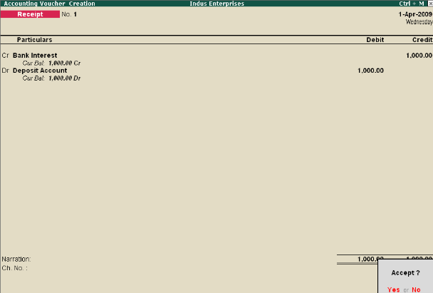
- Press Y or Enter to accept the screen
Journal Voucher (F7)
For example, the company has entered some expenditure on advertising as general office costs, rather than recording the transaction in the separate ledger for advertising.
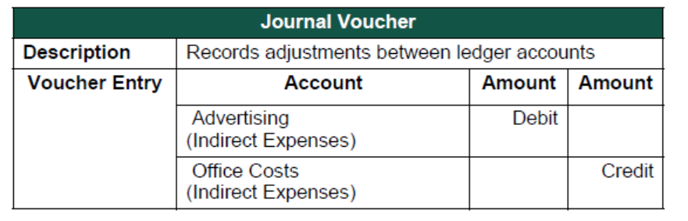
Use the Journal Voucher to adjust the two accounts.
Go to the Gateway of Tally > Accounting Vouchers > F7: Journal.
The entry made appears as shown below:
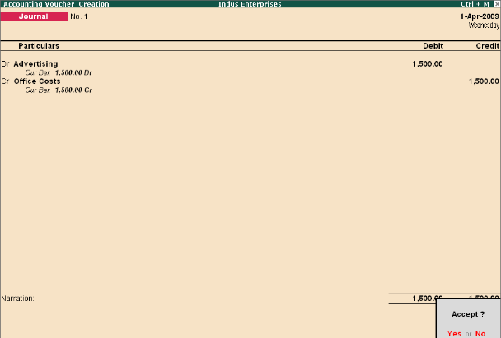
Press Y or Enter to accept the screen
Sales Voucher (F8)
For example, a company sells software on credit.
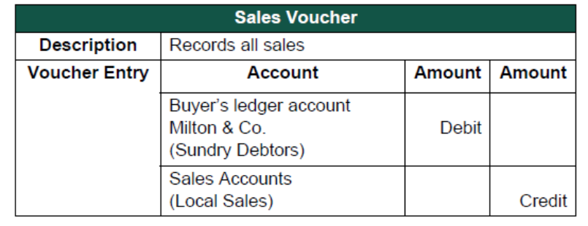
Use a Sales Voucher for making this entry.
Go to the Gateway of Tally > Accounting Vouchers > F8: Sales.
The entry made appears as shown below:
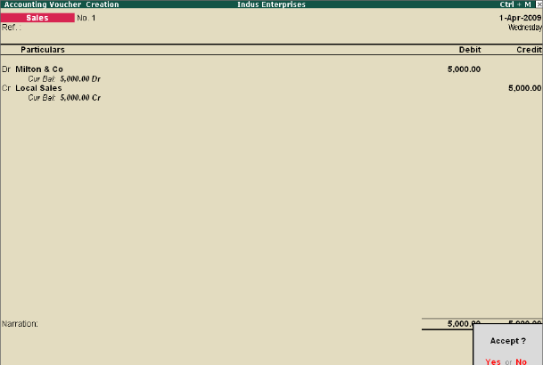
Press Y or Enter to accept the screen.
Credit Note Voucher (Ctrl + F8)
This voucher type is made available when the option Use Debit/Credit Note to is set to Yes in the
F11: Features (F1: Accounting features).
For example: A customer returns stock that was incorrectly supplied.
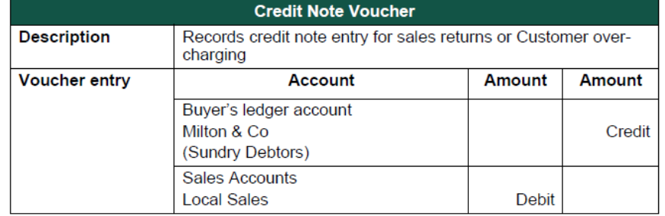

Use a Credit note to record this entry.
Go to the Gateway of Tally > Accounting Vouchers > F8: Credit Note.
The entry made appears as shown below:
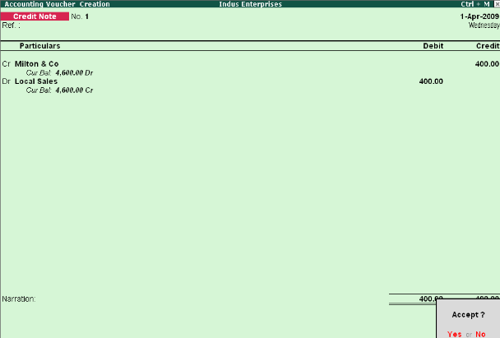
Press Y or Enter to accept the screen.
Purchase Voucher (F9)
A company buys computer parts on credit.
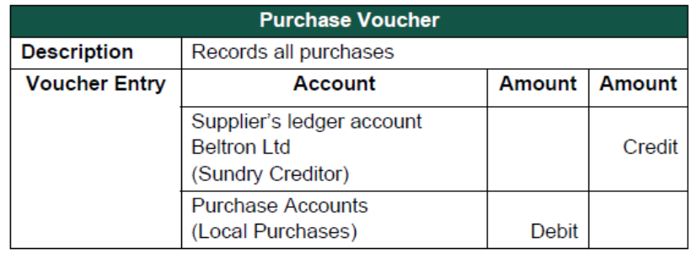
Use a Purchase Voucher to record this entry.
Go to the Gateway of Tally > Accounting Vouchers > F9: Purchase.
The entry made appears as shown below:
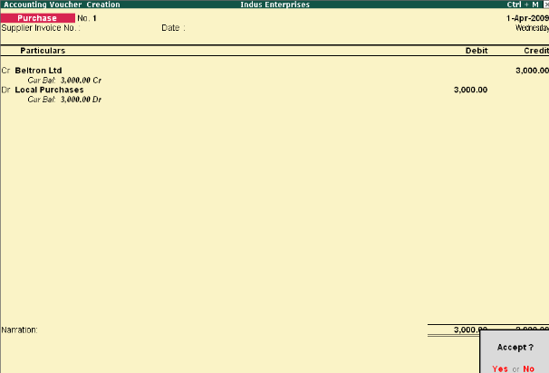
Press Y or Enter to accept the screen
Debit Note Voucher (Ctrl + F9)
This voucher type is made available when the option Use Debit/Credit Notes is set to Yes in the
F11: Features (F1: Accounting Features).
For example, a company returns damaged goods to a supplier.
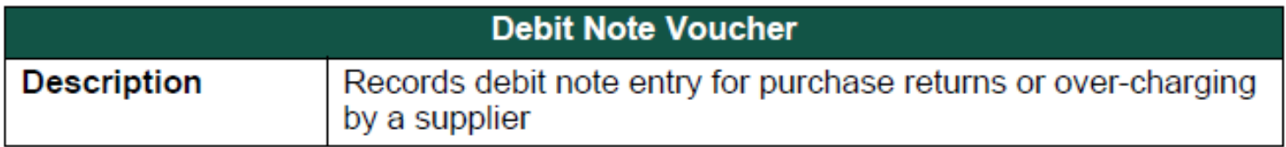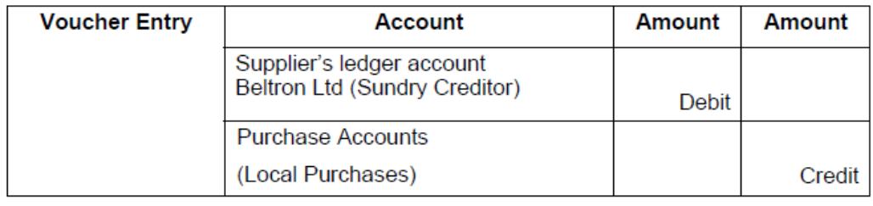
Use a Debit Note to record this entry.
Go to the Gateway of Tally > Accounting Vouchers > F9: Debit Note.
The entry made appears as shown below:
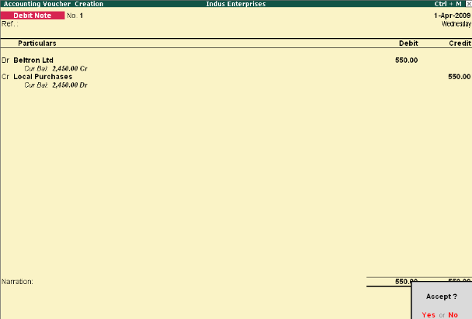
Press Y or Enter to accept the screen

UNIT-V

Inventory Entry in Tally

To insert stock details in tally, we have to follow these steps.
1. Open an already existing company or create a new company.
2. Click on “Inventory info.”
3. Create stock item’s group and measurement units and insert stock details.
Brief Details About Inventory Info. Options
1. Stock group: this option is used to create stock brand and company names such (LG, Samsung, Godrej, etc.)
2. Units of measure: this option is used to create measurement units such (Litre, kilogram, Piece, etc.)
3. Stock items: this option is used to insert real stock item’s details with help of "Stock group" and "Unis of measure".
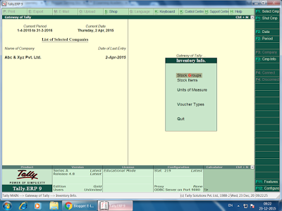
Inventory Info. Screen
Excise 1: Create a company with name “Rakesh journal store” and insert the following stock item details.
Stock items | Company/Brand | Quantity | Price
Rice | Basmati | 250 | 75
Oil (M) | Mustard | 150 | 120
Oil (C) | Coconut | 170 | 450
Red chili | MDH (PKT) | 200 | 80
Desi ghee | Nova | 60 | 420

Multiple Godown In Tally
In tally we can create multiple godowns and to perform this task, we have to follow these steps.
1. Create a new company or open an already existing company
2. Press “F11” key.
3. Click on “Inventory features”
4. Make “Yes” to “Maintain Multiple Godowns”
5. Save the settings and exit
6. Now select “Inventory info” from “Gateway of Tally”
7. Select “GoDown” from “Inventory info”
8. Now Create your desired “Godown”
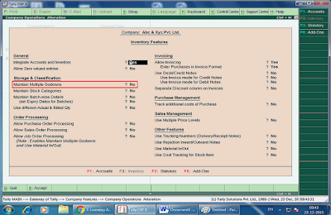

Excise 2: Company name: Rakesh Hardware & Electronics
Delhi Godown
Stock item | Brand/Company | Quantity | Price
Motherboard | Gigabyte | 400 | 4000
LED | LG | 250 | 6500
Processor | Intel | 200 | 3500

Mumbai Godown
Stock item | Brand/Company | Quantity | Price
Washing machine | Godrej | 100 | 17000
FM Radio | Phillips | 200 | 2000
DVD Player | Phillips | 350 | 2500

Haryana Godown
Stock item | Brand/Company | Quantity | Price
Television | Samsung | 150 | 12000
Refrigerator | GodRej | 120 | 18000
DVDs | WriteX | 400 | 45
Pen drive | HP | 250 | 450
How Show Godown Details
1. Open an already existing company
2. Click on "Display"
3. Click on "Statements of Invetory"
4. Click on "Godown"
5. Now Select Godown name, which information you want to show.

Stock Transfer Entries
Create a company with name “Hari& Sons Journal Store”

Create the following Godowns.
Delhi
Stock items | Brand company | Quantity | Price
Oil (M) | Mustard | 700 | 80
Ghee | Nova | 250 | 450
Oil (C) | Coconut | 150 | 850

Mumbai
Stock items | Brand company | Quantity | Price
Rice (S) | Shri-Lal-Mahal | 400 (Pkt) | 165
Wheat | Shakti-Bhog | 1000 | 55
Sugar | Mavana | 300 | 85

Punjab
Stock items | Brand company | Quantity | Price
Red chili | MDH | 700 | 75
Black pepper | MDH | 140 | 100
Rice (D) | Dawat | 500 (Pkt) | 140

Inventory Voucher Entries
1. Transfer goods from Delhi to Mumbai (250 Lt.) Mustard Oil.
2. Transfer goods from Mumbai to Delhi (350kg wheat) & (200 kg sugar)
3. Punjab to Delhi (200 pkt. Rice (D))& Punjab to Mumbai (Red chili 250 Kg. & Black pepper 100)
4. Punjab to Delhi (250 Pkt. Red chili) and (150 Pkt. Dawat Rice) from Punjab to Mumbai.
5. Punjab to Mumbai (50 pkt. Rice) & Mumbai to Punjab (Wheat 100, Rice 100 pkt.)
6. Transfer goods 50 Ltr. Mustard Oil from Delhi to Mumbai and 200 Ltr. Mustard oil from Delhi Punjab.

Multiple Stock Items
Multiple stock items feature is used to insert those types of stock’s items which are related with same brand or company.
For Examples
a) Monitor
b) Television
c) Cell phone
The above stock items related with one company “Samsung” therefore it’s beneficial to insert these stock items by using “multiple stock items” than compare of single stock item entry (which is used to insert more than stock items one by one)

How To Insert Multiple Stock Details
1. Open an already existing company or create a new company.
2. Click on “Inventory info.”
3. Click on “Stock groups”
4. Create group name under “Multiple stock groups”
5. Create measurement unit under “Units of Measure”
6. Insert number of stock items under “Multiple stock items”
7. Save the transaction.
Note: the “single stock item” and “multiple stock items” share the common measurement unit.
Insert the following stock items by using “Multiple stock items”

Company name: Shyam Journal store
Stock Item Group: Stationery
Items name | Quantity | Price
Pen | 400 | 10
Pencil | 500 | 5
Notebook | 300 | 25
Eraser | 450 | 03
Sharpener | 500 | 04
Ink | 200 | 15
Stock Item Group: Crockery
Items name | Quantity | Price
Spoon | 540 | 10
Cup | 450 | 12
Platte | 300 | 40
Mug | 350 | 35

Stock Item Group: Intel
Items name | Quantity | Price
Processor | 150 | 4000
Motherboard | 200 | 3500
Tablet | 140 | 7000

Stock Item Group: Samsung
Items name | Quantity | Price
Monitor | 100 | 5000
Television | 85 | 10000
Refrigerator | 60 | 20000
AC | 50 | 25000
Cell Phone | 150 | 6500

