SRINIVASAN COLLEGE OF ARTS AND SCIENCE PERAMBALUR
III. B.Com CA
MANAGEMENT INFORMATION SYSTEM - 16MBECA2

UNIT - I
Management : Management is art of getting things done through and with the people in formally organized groups. The basic functions performed by a manager in an organization are: Planning, controlling, staffing, organizing, and directing.
Information : Information is considered as valuable component of an organization. Information is data that is processed and is presented in a form which assists decision maker.
System : A system is defined as a set of elements which are joined together to achieve a common objective. The elements are interrelated and interdependent. Thus every system is said to be composed of subsystems. A system has one or multiple inputs, these inputs are processed through a transformation process to convert these input( s) to output.
MIS DEFINITION:
The MIS is defined as an integrated system of man and machine for providing the information to support the operations, the management and the decision making function in the organization.
The MIS is defined as a system based on the database of the organization evolved for the purpose of providing information to the people in the organization.
Objectives of MIS :
1. Data Capturing : MIS capture data from various internal and external sources of organization. Data capturing may be manual or through computer terminals.
2. Processing of Data : The captured data is processed to convert into required information. Processing of data is done by such activities as calculating, sorting, classifying, and summarizing.
3. Storage of Information : MIS stores the processed or unprocessed data for future use. If any information is not immediately required, it is saved as an organization record, for later use.
4. Retrieval of Information : MIS retrieves information from its stores as and when
required by various users.
5. Dissemination of Information : Information, which is a finished product of MIS, is disseminated to the users in the organization. It is periodic or online through computer terminal.
Characteristics of MIS :

1. Systems Approach : The information system follows a systems approach. Systems approach means taking a comprehensive view or a complete look at the interlocking sub-systems that operate within an organization.
2. Management Oriented : Management oriented characteristic of MIS implies that the management actively directs the system development efforts. For planning of MIS, top-down approach should be followed. Top down approach suggests that the system development starts from the determination of management’s needs and overall business objective. To ensure that the implementation of system’s polices meet the specification of the system, continued review and participation of the manager is necessary.
3. Need Based : MIS design should be as per the information needs of managers at different levels.
4. Exception Based : MIS should be developed on the exception based also, which means that in an abnormal situation, there should be immediate reporting about the exceptional situation to the decision –makers at the required level.
5. Future Oriented : MIS should not merely provide past of historical information; rather it should provide information, on the basis of future projections on the actions to be initiated.
6. Integrated : Integration is significant because of its ability to produce more meaningful information. Integration means taking a comprehensive view or looking at the complete picture of the interlocking subsystems that operate within the company.
7. Common Data Flow : Common data flow includes avoiding duplication, combining similar functions and simplifying operations wherever possible. The development of common data flow is an economically sound and logical concept, but it must be viewed from a practical angle.
8. Long Term Planning : MIS is developed over relatively long periods. A heavy element of planning should be involved.
9. Sub System Concept : The MIS should be viewed as a single entity, but it must be broken down into digestible sub-systems which are more meaningful.
10. Central database : In the MIS there should be common data base for whole system

Features of a Management Information System
Flexible: An MIS should allow you to analyze and evaluate data from multiple sources as needed and in multiple ways depending on your needs.
Easy to use: Managers shouldn't need advanced knowledge in information systems in order to get what they need. Using the MIS should not be time intensive, and the reports it generates should not overload a manager with too much information.
Versatile: An MIS should be able to support different skills and knowledge.
Collaborative: An MIS should facilitate communication between managers and staff throughout a company.

Nature and Scope of MIS
The following diagram shows the nature and scope of MIS −
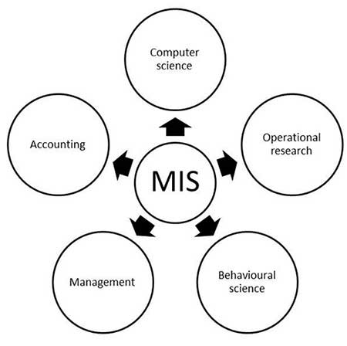
MIS for a Business Organization :
1. Support the Business Process : Treats inputs as a request from the customer and outputs as services to customer. Supports current operations and use the system to influence further way of working.
2. Support Operation of a Business Organization : MIS supports operations of a business organization by giving timely information, maintenance and enhancement which provides flexibility in the operation of an organizations.
3. To Support Decision Making : MIS supports the decision making by employee in their daily operations. MIS also supports managers in decision making to meet the goals and objectives of the organization. Different mathematical models and IT tools are used for the purpose evolving strategies to meet competitive needs.
4. Strategies for an Organization : Today each business is running in a competitive market. MIS supports the organization to evolve appropriate strategies for the business to assented in a competitive environment.

Prerequisites of an Effective MIS
(i) Qualified System and Management Staff : The prerequisite of an effective MIS is that it should be managed by qualified officers. These officers should have a mutual understanding about the roles and responsibilities of each other. be understand clearly the view of their fellow officers. For this, each organization should have two categories of officers :
(a) System and Computer Experts who in addition to their expertise in their subject area , they should also be capable of understanding management concepts to facilitate the understanding of problems asked by concern. They should also be clear about the process of decision making and information requirements for planning.
(b) Management experts who should also understand quite-clearly the concepts and operations of a computer. This basic knowledge of computer will be useful will place them in a comfortable position, while working with systems, technicians in designing or other wise, of the information system.
(ii) Futuristic Perspective : An effective MIS should be capable of meeting the future requirements of its executives as well. This capability can be achieved by regular monitoring and updating the MIS.
(iii) Support of Top Management : For a management information system to be effective, it must receive the full support of top management. The Reasons for this are :
(a) Subordinate managers are usually lethargic about activities which do not receive the support of their superiors.
(b) The resources involved in computer based information system are larger and are growing larger and larger in view of importance gained by management information system.
(iv) Common Database : It is an integrated collection of data and information which is utilized by several information subsystems of an organization. A common database may be defined as a super file which consolidates and integrates data records formerly stored in a separate data file. Such a database can be organized as an integrated collection of data records into a single super file or it can be organized as an integrated collection of several data file.
(v) Control and maintenance of MIS : Control of the MIS means the operation of the system as it was designed to operate. Some times, users develop their own procedures or short cut methods to use the system which reduces its effectiveness.
Management Information System (MIS) Models
A model is an abstraction of something it represents (some phenomenon), called an entity. For example, if a model represents a firm, then the firm is an entity.
Types of Models:
- Physical Models:
It is a model that exists in three-dimensional form. For example, clay model of a new automobile developed by designers.
- Narrative Models:
It is created by verbal or written description. Also, these can be created anywhere without much resources hence they are most popular.
- Graphs:
It is usually a two-dimensional diagram. For example, graphs and charts.
- Mathematical Models:
It uses symbolic notations and mathematical equations to represent a system. It can be represented by 3-D also. Following are the types of mathematical models:
  - (a). Influence of Time:
Static Model does not include time as a variable whereas, Dynamic Model allows the changes of system attributes to be derived as a function of time.
  - (b). Degree of Certainty:
A probability is a chance of occurring something will happen.Probabilities ranges from 0 to 1. A model that includes probabilities is called Probabilistic model, otherwise it is called a Deterministic model.
  - (c). Ability to Achieve Optimization:
Optimizing Model selects the best solution among the alternatives.A SUB-OPTIMIZING MODEL permits the manager to enter a set of decisions, once this step is completed the model will project an outcome. It leaves the decision task on the manager.
Steps of Model Construction:
- Define the problem and the factor that influence it.
- Select criteria to guide the decision and establish objectives.
- Formulate a model that helps management to understand the relationships between the influence factors and the objectives the firm is trying to achieve.
- Collect the relevant data while trying to avoid the incorporation of superfluous information into the model.
- Identify and evaluate the alternatives.
- Select the best alternative.
- Implement the alternative.
The below shown figure is an model of Management Information System (MIS).
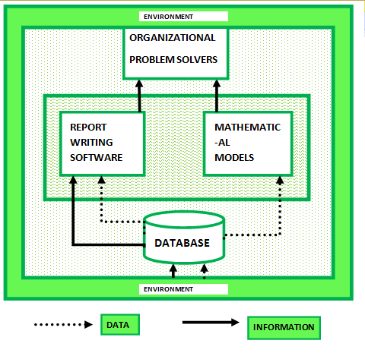

Components of MIS
A management information system is made up of five major components namely people, business processes, data, hardware, and software. All of these components must work together to achieve business objects.
People – these are the users who use the information system to record the day to day business transactions. The users are usually qualified professionals such as accountants, human resource managers, etc. The ICT department usually has the support staff who ensure that the system is running properly.
Business Procedures – these are agreed upon best practices that guide the users and all other components on how to work efficiently. Business procedures are developed by the people i.e. users, consultants, etc.
Data – the recorded day to day business transactions. For a bank, data is collected from activities such as deposits, withdrawals, etc.
Hardware – hardware is made up of the computers, printers, networking devices, etc. The hardware provides the computing power for processing data. It also provides networking and printing capabilities. The hardware speeds up the processing of data into information.
Software – these are programs that run on the hardware. The software is broken down into two major categories namely system software and applications software. System software refers to the operating system i.e. Windows, Mac OS, and Ubuntu, etc. Applications software refers to specialized software for accomplishing business tasks such as a Payroll program, banking system, point of sale system, etc.
Type of Information.
A business has several information systems :
(A) Formal Information System
(B) Informal Information System
(C) Computer Based Information System
(a) Formal Information System : It is based on organizational chart represented by the organization.
(b) Informal Information System : It is an employee based system designed to meet personal and vocational needs and to help in the solution of work-related problems. It also funnels information upward through indirect channels. It works within the framework of the business and its stated policies.
(c) Computer Based Information System (CBIS) : This category of information system depends mainly on the computer for handling business application. System analysis develops different types of information system to meet variety of business needs. There is class of system known as collectively as computer based information system. They are categorized in the following 6 classes:
i) Transaction Processing System (TPS)
ii) Management Information System (MIS)
iii)Decision Support System (DSS)
iv)Executive Support System (ESS)
v)Office Automation Systems (OASs), and
vi)Business Expert Systems (BESs)
1. Transaction Processing System:
TPS processes transaction and produces reports. It represents the automation of the fundamental, routine processing used to support business operations.It does not provide any information to the user to his/her decision-making. TPS uses data and produces data as shown in the following diagram.
Previously, TPS was known as Management Information System. Prior to computers, data processing was performed manually or with simple machines. The domain of TPS is at the lowest level of the management hierarchy of an organization.
2. Management Information System (MIS)
MIS is an information system, which processes data and converts it into information.A management information system uses TPS for its data inputs. The information generated by the information system may be used for control of operations, strategic and long-range planning. Short-range planning, management control, and other managerial problem solving. It encompasses processing in support of a wide range of organizational functions & management processes. MIS is capable of providing analysis, planning & decision making support. The functional areas of a business may be marketing, production, human resource, finance and accounting.
3. Decision Support System (DSS)
A decision support system (DSS) is an information system application that assists decision-making. DSS tends to be used in planning, analyzing alternatives, and trial and error search for solution. The elements of the decision support system include a database, model base & software. The main application areas of DSS are Production, finance and marketing.
DSS can be differentiated from MIS on the basis of processing the information. MIS processes data to convert it into information. DSS processes information to support the decision making process of a manager.
4. Executive Support System (ESS)
Executive Support System (ESS) is an extension of the management information system, which is a special kind of DSS; An ESS is specially tailored for the use of chief executive of an organization to support his decision-making. It includes various types of decision-making but it is more specific and person oriented.
5. Office Automation Systems (OAS)
Office automation refers to the application of computes and communication technology to office functions. Office automation systems are meant to improve the productivity of managers at various levels of management of providing secretarial assistance and better communication facilities.
Office activities may be grouped under two classes, namely
i)Activities performed by clerical personnel (clerks, secretaries, typist, etc.,) and
ii)Activities performed by the executives (managers, engineers or other professionals like economist, researches etc.)
In the first category, the following is a list of activities.
a) Typing
b)Mailing
c) Scheduling of meetings and conferences,
d) Calendar keeping, and
e)Retrieving documents
The following is a list of activities in the second category (managerial category)
a)Conferencing.
b)Production of information (messages, memos, reports, etc.) and controlling performance.
6. Business Expert Systems:These systems are one of the main types of knowledge-based information systems. These systems are based on artificial intelligence, and are advanced information systems. A business expert system is a knowledge based information system that uses its knowledge about a specific, complex application area to act as an expert. The main components of an expert system are:
a. Knowledge Base
b. Interface Engine
c. User Interface

Subsystems of an Information System

Data Repository
This is a subsystem which is at the core of any information system. Mostly this is a relational database management system that has pre-formatted and structured tables for storage of data. These structures are arranged in a way that helps in faster storage and retrieval of such data with adequate security.

User Interface
This subsystem handles the interaction of the system with the user (human) and hence it has to take care of issues related to the display of data on an output medium. This can be either graphical or character-based depending on the level of ease offered to the user.

Network
This subsystem ensures communication between the different entities of an information system. It is crucial for functioning of an information system.

Computer Hardware
One needs IT infrastructure to use information systems in an effective manner. Almost all the components of an information system are housed in some kind of computer hardware enabling it to perform the tasks better. For example, an algorithm to find the lowest of three numbers can also be calculated manually but under a computerized system, it will be much faster and efficient.

System Software
Some basic software is required just like computer hardware for efficient functioning of information systems. The system software does not directly aid in the functionality of information systems but work as enablers. Examples would include operating systems.

Input/Output
Sometimes this is clubbed with the user interface to suggest that I/O functions are handled by UI alone. However, in some systems I/O may be user independent like when an alert is activated, the input for the alert comes from some other system input rather than a user.

Business Rule (Process)
This is a set of rules that governs how a system should function to mimic the real business process.

Algorithm/Program/ Application Software
This is the actual invisible component that integrates all the components. The logic (business rule), is defined in the program (embedded in it) which enables the functioning of the information system for some specific purpose.

Role of MIS
- The MIS satisfies the diverse needs through variety of systems such as query system, analysis system, modeling system and decision support system.
- The MIS helps in strategic planning, management control, operational control and transaction processing. The MIS helps in the clerical personal in the transaction processing and answers the queries on the data pertaining to the transaction, the status of a particular record and reference on a variety of documents.
- The MIS helps the junior management personnel by providing the operational data for planning, scheduling and control , and helps them further in decision-making at the operation level to correct an out of control situation.
- The MIS helps the middle management in short term planning, target setting and controlling the business functions. It is supported by the use of the management tools of planning and control.
- The MIS helps the top level management in goal setting, strategic planning and evolving the business plans and their implementation.
- The MIS plays the role of information generation, communication, problem identification and helps in the process of decision-making. The MIS, therefore, plays a vital role in the management, administration and operation of an organization.

IMPORTANCE OF MIS

To control the creation and growth of records
Despite decades of using various non-paper storage media, the amount of paper in our offices continues to escalate. An effective records information system addresses both creation control (limits the generation of records or copies not required to operate the business) and records retention (a system for destroying useless records or retiring inactive records), thus stabilizing the growth of records in all formats.

To reduce operating costs
Recordkeeping requires administrative dollars for filing equipment, space in offices, and staffing to maintain an organized filing system (or to search for lost records when there is no organized system).
To improve efficiency and productivity
Time spent searching for missing or misfiled record is non-productive. A good records management program (e.g. a document system) can help any organization upgrade its recordkeeping systems so that information retrieval is enhanced, with corresponding improvements in office efficiency and productivity. A well designed and operated filing system with an effective index can facilitate retrieval and deliver information to users as quickly as they need it.
To assimilate new records management technologies
A good records management program provides an organization with the capability to assimilate new technologies and take advantage of their many benefits. Investments in new computer systems whether this is financial, business or otherwise, don't solve filing problems unless current manual recordkeeping or bookkeeping systems are analyzed (and occasionally, overhauled) before automation is applied.
To ensure regulatory compliance
In terms of recordkeeping requirements, China is a heavily regulated country. These laws can create major compliance problems for businesses and government agencies since they can be difficult to locate, interpret and apply. The only way an organization can be reasonably sure that it is in full compliance with laws and regulations is by operating a good management information system which takes responsibility for regulatory compliance, while working closely with the local authorities. Failure to comply with laws and regulations could result in severe fines, penalties or other legal consequences.
To minimize litigation risks
Business organizations implement management information systems and programs in order to reduce the risks associated with litigation and potential penalties. This can be equally true in Government agencies. For example, a consistently applied records management program can reduce the liabilities associated with document disposal by providing for their systematic, routine disposal in the normal course of business.
To safeguard vital information
Every organization, public or private, needs a comprehensive program for protecting its vital records and information from catastrophe or disaster, because every organization is vulnerable to loss. Operated as part of a good management information system, vital records programs preserve the integrity and confidentiality of the most important records and safeguard the vital
information assets according to a "Plan" to protect the records. This is especially the case for financial information whereby ERP (Enterprise Resource Planning) systems are being deployed in large companies.
To support better management decision making
In today's business environment, the manager that has the relevant data first often wins, either by making the decision ahead of the competition, or by making a better, more informed decision. A good management information system can help ensure that managers and executives have the information they need when they need it.
To preserve the corporate memory
An organization's files, records and financial data contain its institutional memory, an irreplaceable asset that is often overlooked. Every business day, you create the records, which could become background data for future management decisions and planning.
To foster professionalism in running the business
A business office with files, documents and financial data askew, stacked on top of file cabinets and in boxes everywhere, creates a poor working environment. The perceptions of customers and the public, and "image" and "morale" of the staff, though hard to quantify in cost-benefit terms, may be among the best reasons to establish a good management information system.

Delegation vs Decentralization
Points | Delegation | Decentralization
Nature | It usually involves two people – a manager and his subordinate. | It involves the entire organization – from the top management to individual departments.
Control | The manager or the delegator controls it. | The control lies with the concerned departments or sections.
Need | All organizations need delegation to get things done. Delegating authority is essential to assign responsibility. | This is an optional mode of working. Organizations can also work in a centralized manner.
Responsibility | The delegator can delegate authority but the responsibility remains with him. The delegator is accountable for the task. | The head of the department is responsible for the activities performed under him. Therefore, responsibility is fixed at the department-level.
Relationship | Creates better superior-subordinate relationships. | Helps in the creation of semi-autonomous units.

UNIT – II
Meaning of System:
A system is a group of interrelated components working together toward a common goal by accepting inputs and producing outputs in an organized transformation process. System will have the following basic interacting components or functions:
1. Input
2. Processing
3. Output
4. Feedback and
5. Control
Example of A business as a System:
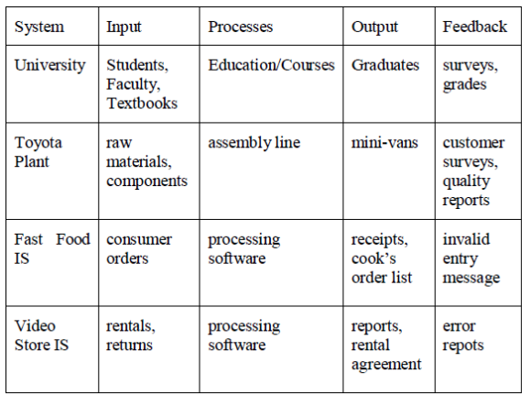
Components of a System
System Boundaries
Every system has a boundary that defines its scope of activities. For example, the activities in your class include lectures, discussion, continuous evaluation, grading, and preparation of assigned course work. These activities may represent the boundary of the system for which a teacher is responsible. Within the system of the classroom, the teacher is responsible for organizing class time, assigning homework to students, and evaluating student progress. The boundary, then, delineates an area of responsibility. When defining a system, you must establish a boundary.
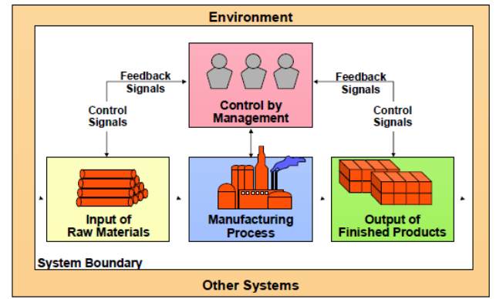
Systems and Sub Systems
Systems may consist of numerous subsystems, each of which has elements, interactions, and objectives. Subsystems perform specialized tasks related to the overall objectives of the total system.
Outputs and Inputs
The inner workings of a system or subsystem are organized to produce outputs from inputs. In this conversion process, some value or utility should be added to the inputs. For example, a training program should produce trained employees with certain skills, knowledge, or behaviour
from its inputs-untrained employees. The outputs of one subsystem usually become inputs into the next. The outputs of a course in introductory data processing concepts, for instance, become inputs into the next course in Java programming.
Subsystem Interface
An interface is a connection at system or subsystem boundaries. An interface serves as a medium to convey the output from one system to the input of another system. An example will help clarify this concept. Two typical business systems that interface with each other are inventory
control and purchasing. If inventory levels drop below a certain level, then additional stock of these items should be purchased. Purchasing will need to know what quantity of a particular item to obtain to replenish the stock and information on sales and inventory turnover to learn which
items are in greatest demand so these items can be replenished on a timely basis.
Interface Problems
In the previous section we mentioned that adhering to standards can alleviate some interface problems. However, you might encounter other types of interface problems. Sometimes the output of one subsystem is not sufficient to accommodate the needs of the next subsystem.
System and its Environment
The system’s environment consists of people, organizations, and other systems that supply data to or that receive data from the system. Not surprisingly, different man-agers perceive the environment differently
System Feedback
A system needs feedback to do its job. Feedback is an indicator of current performance rates when compared to a set of standards. With effective feedback, continuing adjustments in the activities of a system can be made to assure that the system achieves its goals. Measuring performance against a standard is an effective control mechanism.
System Entropy
Systems can run down if they are not maintained. Systems entropy corresponds roughly to chaos or disorder - a state that occurs without maintenance. If employees do not have opportunities to learn new concepts and techniques, the skills they apply to performing job tasks will become out of date. The process of maintaining a system is a process of decreasing entropy or increasing orderliness. Sending auto-mobile mechanics to training classes to learn new diagnostic techniques is an example of decreasing entropy. Orderliness can be achieved through preventive maintenance checks, such as a yearly physical examination for an employee or a routine tune up for an automobile, and then taking action as a result of these regular checks. These checks provide valuable feedback to help detect faults or problems when none have been anticipated. Diagnostic tools for equipment and machinery help prevent downtime, which may cause delays in production and cost thousands of dollars in lost business.
System Stress and Change
Systems change over time. Some of these changes occur because of identified problems, new business opportunities, and new management directives. Systems may also change as a result of stresses. The achievement levels needed to meet existing goals may change.

Definition of Computers:
A computer is a fast electronic device that processes the input data according to the instructions given by the programmer/user and provides the desired information as an output.
IMPORTANCE OF COMPUTERS
Fast: A computer is so fast that it can perform the given task (arithmetical or logical) in few seconds as compared to man who can spend many months for doing the same task. A computer can process millions of instructions per second.
Accurate: While doing calculations, a computer is more accurate than man can make mistakes in calculations but a computer does not make mistakes, if it is provided accurate instructions.
Diligence: A computer does not suffer from the human traits of tiredness and boredom. Man will be tired and bored while doing millions of calculations but a computer, being a machine, does this job very efficiently and without any tiredness and boredom.
High Memory: A computer has much more memory or storage capacity than human being. It can store millions of data and instructions, which can be retrieved and recalled even after a number of years. This is not possible in case of human brain.
No Intelligence: A computer is a machine and obviously has no intelligence of its own. Each and every instruction must be given to the computer for doing a task. Man has an intelligence and it is the man who invented computer and gives it all the instructions and logic to work. A computer cannot take decisions on its own and it is the main drawback of computer
CLASSIFICATION OF COMPUTERS
The classification of computers is based on the following three criteria:
(a) According to Purpose
(b) According to Technology used
(c) According to size and Capacity
According to Purpose
According to the utilization of computer for different uses, computers are of following two types:
1. General Purpose Computers: Computers that follow instructions for general requirements such as sales analysis, financial accounting, invoicing, inventory, management information etc. are called General Purpose Computers. Almost all computers used in offices for commercial, educational and other applications are general purpose computers.
2. Special Purpose Computers: Computers designed from scratch to perform special tasks like scientific applications and research, weather forecasting, space applications, medical diagnostics etc. are called Special Purpose Computers.
According to Technology Used
According to the technology used, computers are of following three types:
1. Analog Computers: Analog computers are special purpose computers that represent and store data in continuously varying physical quantities such as current, voltage or frequency. These computers are programmed for measuring physical quantities like pressure, temperature, speed etc. and to perform computations on these measurements.
Analog computers are mainly used for scientific and engineering applications. Some of the examples of analog computers are given below:
(i) Thermometer: It is a simple analog computer used to measure temperature. In thermometer, the mercury moves up or down as the temperature varies.
(ii) Speedometer: Car's speedometer is another example of analog computer where the position of the needle on the dial represents the speed of the car.
2. Digital Computers: Digital computers are mainly general purpose computers that represent and store data in discrete quantities or numbers. In these computers, all processing is done in terms of numeric representation (Binary Digits) of data and information. Although the user enter data in decimal or character form, it is converted into binary digits (0's and l's). Almost all the computers used nowadays are digital computers and we will discuss the detailed working and components of these computers in subsequent sections of this unit.
3. Hybrid Computers: Hybrid computers incorporate the technology of both analog and digital computers. These computers store and process analog signals which have been converted into discrete numbers using analog-to-digital converters. They can also convert the digital numbers into analog signals or physical properties using digital-to-analog converters. Hybrid computers are mainly used in artificial intelligence (robotics) and computer aided manufacturing (e.g. process control).
According to Size and Capacity
According to the size and memory/storage capacity, computers are of following four types:
1. Supercomputer: Supercomputer is the biggest and fastest computer, which is mainly designed for complex scientific applications. It has many CPUs (Central Processing Units - main part of computer) which operate in parallel to make it as a fastest computer. It is typically used for the following applications:
- Weather Forecasting
- Petroleum Exploration and Production
- Energy Management
- Defense
- Nuclear Energy Research
- Structural Analysis
- Electronic Design
- Real-time Animation
- Medicine
Some of the examples of supercomputers are CRAY3, CRAY-XMP-14, NEC500, P ARAM
9000 and P ARAM 10000.
2. Mainframe Computer: Mainframe computers are very large and fast computers but smaller and slower than supercomputers. These are used in a centralized location where many terminals (input/output devices) are connected with one CPU and thus, allow different users to share the single CPU. They have a very high memory (several hundred Megabytes) and can support thousands of users. They are mainly used for following applications:
- Railway and Airline Reservations
- Banking Applications
- Commercial Applications of Large Industries/Companies
Some of the examples of mainframe computers are IBM 3090, IBM 4381, IBM 4300 and IBM
ES-9000.
3. Minicomputer: Minicomputers are medium-scale, smaller and generally slower than mainframe computers. Like mainframes, they have many terminals which are connected with one CPU and can support many users. The cost of minicomputer is very less as compared to mainframe. Therefore, it is mainly used in applications where processing can be distributed among several minicomputers rather than using a mainframe computer.
Some of the examples of minicomputers are PDP-1, IBM AS/400 and DEC Micro VAX.
IBM AS/400, which is actually a midicomputer (computer with performance between a
mainframe and minicomputer) is becoming very popular among minicomputers.
4. Microcomputer: A microcomputer is the smallest digital computer, which uses a microprocessor as its CPU. Microprocessor is a single chip (Integrated Circuit) CPU. Microcomputer is popularly called as Personal Computer (PC). It can be used both as a stand-alone machine and a terminal in a multi-user environment. Microcomputers are becoming very popular nowadays due to very high processing power and memory. Today, a powerful microcomputer may be used as a substitute for mini or mainframe computer.
COMPONENTS OF COMPUTER:
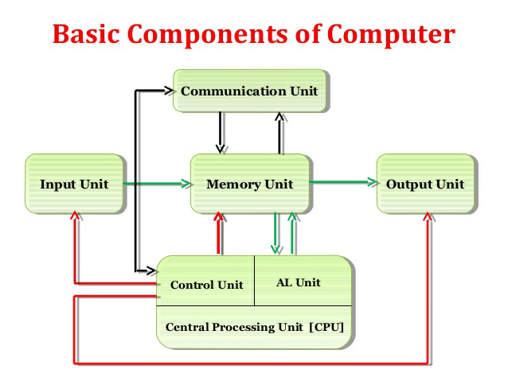
A computer system has following three main components
(a) Input/Output Unit
(b) Central Processing Unit
(c) Memory Unit
a) Input/Output Unit:
We know that the computer is a machine that processes the input data according to given
set of instructions and gives the output. Before a computer does processing, it must be given data and instructions. After processing, the output must be displayed or printed by the computer. The unit used for getting the data and instructions into the computer and displaying or printing output is known as an Input/Output Unit (I/O Unit).
b) Central Processing Unit
Central Processing Unit (CPU) is the main component or "brain" of a computer, which performs all the processing of input data. Its function is to fetch, examine and then execute the instructions stored in main memory of computer.
Arithmetic Logic Unit (ALU): The arithmetic and logic unit of CPU is responsible for all arithmetic operations like addition, subtraction, multiplication and division as well as logical operations such as less than, equal to and greater than. Actually, all calculations and comparisons are performed in the arithmetic logic unit.
Control Unit (CU): The control unit is responsible for controlling the transfer of data and instructions among other units of computer. It is considered as a "Central Nervous System" of computer, as it manages and coordinates all the units of computer. It obtains the instructions from the memory, interprets them and directs the operation of the computer. It also performs the physical data transfer between memory and the peripheral device.
Registers: Registers are the small high speed circuits (memory locations) which are used to store data, instructions and memory addresses (memory location numbers), when ALU performs arithmetic and logical operations. Registers can store one word of data (1 word = 2 bytes & 1 byte = 8 bit; details of BITS and BYTES are discussed in later part of this unit) until it is overwritten by another word.
Buses: Data is stored as a unit of eight bits (BIT stands for Binary Digit i.e. (0 or 1) in a register. Each bit is transferred from one register to another by means of a separate wire. This group of eight wires, which is used as a common way to transfer data between registers is known as a bus..
Clock: Clock is another important component of CPU, which measures and allocates a fixed time slot for processing each and every micro-operation (smallest functional operation). In simple terms, CPU is allocated one or more clock cycles to complete a micro-operation. CPU executes the instructions in synchronization with the clock pulse.
c) Memory Unit
Memory Unit is that component of a computer system, which is used to store the data, instructions and information before, during and after the processing by ALU. It is actually a work area (physically a collection of integrated circuits) within the computer, where the CPU stores the data and instructions. It is also known as a Main/Primary/Internal Memory.
It is of following three types:
(a) Read Only Memory (ROM pronounced as “Ra-om”)
(b) Random Access Memory (RAM pronounced as "R-aem")
(c) Complementary Metal Oxide Semiconductor Memory (CMOS)
Read Only Memory (ROM). This memory is permanent and is not erased when system is switched off. As appears with its name, it is read type of memory i.e. it can be read only and not be written by user/programmer. The memory capacity of ROM varies from 64 KB to 256 KB (1 Kilobyte = 1024 bytes)depending on the model of computer.
Random Access Memory: Random Access Memory (RAM) is another important component of Memory Unit. It is used to store the data and instructions during the execution of programme. Contrary to ROM, RAM is temporary and is erased when Computer – An Introduction computer is switched off. RAM is a read/write type of memory and, thus can be read and written by user/programmer.

Types of RAM:
Dynamic RAM (DRAM): The information stored in Dynamic RAM has to be refreshed after every few milliseconds, otherwise it is erased. DRAM has higher storage capacity and is cheaper than Static RAM.
Static RAM (SRAM): The information stored in Static RAM need not be refreshed, but it remains stable as long as power supply is provided. SRAM is costlier but has higher speed than DRAM.
Complementary Metal Oxide Semiconductor Memory: Complementary Metal Oxide Semiconductor (CMOS) memory is used to store the system configuration, date, time and other important data. When computer is switched on, BIOS matches the information of CMOS with the peripheral devices and displays error in case of mismatching.

INPUT AND OUTPUT DEVICES:
The devices which are used to input the data and the programs in the computer are known as "Input Devices". or Input device can read data and convert them to a form that a computer can use. Output Device can produce the final product of machine processing into a form usable by humans. It provides man to machine communication

INPUT DEVICES:
(1) Keyboard : Keyboard is used in the input phase of a computer-based information system. Keyboard is most common input device is used today. The data and instructions are input by typing on the keyboard. The message typed on the keyboard reaches the memory unit of a computer. It’s connected to a computer via a cable. Apart from alphabet and numeral keys, it has other function keys for performing different functions.
(2) Mouse : It’s a pointing device. The mouse is rolled over the mouse pad, which in turn controls the movement of the cursor in the screen. We can click, double click or drag the mouse. Most of the mouse’s have a ball beneath them, which rotates when the mouse in moved. The ball has 2 wheels of the sides, which in turn mousse with the movement of the ball. The sensor notifies the speed of its movements to the computer, which in turn moves the cursor/pointer on the screen.
(3) Scanner : Scanners are used to enter information directly in to the computers memory. This device works like a Xerox machine. The scanner converts any type of printed or written information including photographs into digital pulses, which can be manipulated by the computer.
(4) Track Ball : Track ball is similar to the upside- down design of the mouse. The user moves the ball directly, while the device itself remains stationary. The user spins the ball in various directions to effect the screen movements.
(5) Light Pen : This is an input device which is used to draw lines or figures on a computer screen. It’s touched to the CRT screen where it can detect raster on the screen as it passes.
(6) Optical Character Rader : It’s a device which detects alpha numeric characters printed or written on a paper. The text which is to be scanned is illuminated by a low frequency light source. The light is absorbed by the dark areas but reflected from the bright areas. The reflected light is received by the photocells.
(7) Bar Code Reader : This device reads bar codes and coverts them into electric pulses to be processed by a computer. A bar code is nothing but data coded in form of light and dark bars.
(8) Voice Input Systems : This devices converts spoken words to M/C language form. A micro phone is used to convert human speech into electric signals. The signal pattern is then transmitted to a computer when it’s compared to a dictionary of patterns that have been previously placed in a storage unit of computer. When a close match is found, the word is recognized.
(9) Plotter : Plotter is an O/P device that is used to produce graphical O/P on papers. It uses single color or multi color pens to draw pictures as blue print etc.
(10) Digital Camera : It converts graphics directly into digital form. It looks like an ordinary camera, but no film is used therein, instead a CCD (changed coupled Divide) Electronic chip in used. When light falls, on the chip though the lens, it converts light waves into electrical waves.

OUTPUT DEVICES
Following are some of the important output devices used in a computer.
- Monitors
- Graphic Plotter
- Printer
Monitors
Monitors, commonly called as Visual Display Unit (VDU), are the main output device of a computer. It forms images from tiny dots, called pixels that are arranged in a rectangular form. The sharpness of the image depends upon the number of pixels.
There are two kinds of viewing screen used for monitors.
- Cathode-Ray Tube (CRT)
- Flat-Panel Display
Cathode-Ray Tube (CRT) Monitor
The CRT display is made up of small picture elements called pixels. The smaller the pixels, the better the image clarity or resolution. It takes more than one illuminated pixel to form a whole character, such as the letter ‘e’ in the word help.
A finite number of characters can be displayed on a screen at once. The screen can be divided into a series of character boxes - fixed location on the screen where a standard character can be placed. Most screens are capable of displaying 80 characters of data horizontally and 25 lines vertically.
There are some disadvantages of CRT −
- Large in Size
- High power consumption
Flat-Panel Display Monitor
The flat-panel display refers to a class of video devices that have reduced volume, weight and power requirement in comparison to the CRT. You can hang them on walls or wear them on your wrists. Current uses of flat-panel displays include calculators, video games, monitors, laptop computer, and graphics display.

The flat-panel display is divided into two categories −
- Emissive Displays − Emissive displays are devices that convert electrical energy into light. For example, plasma panel and LED (Light-Emitting Diodes).
- Non-Emissive Displays − Non-emissive displays use optical effects to convert sunlight or light from some other source into graphics patterns. For example, LCD (Liquid-Crystal Device).
Printers
Printer is an output device, which is used to print information on paper.
There are two types of printers −
- Impact Printers
- Non-Impact Printers
mpact Printers
Impact printers print the characters by striking them on the ribbon, which is then pressed on the paper.
Characteristics of Impact Printers are the following −
- Very low consumable costs
- Very noisy
- Useful for bulk printing due to low cost
- There is physical contact with the paper to produce an image
These printers are of two types −
- Character printers
- Line printers
Character Printers
Character printers are the printers which print one character at a time.
These are further divided into two types:
- Dot Matrix Printer(DMP)
- Daisy Wheel
Dot Matrix Printer
In the market, one of the most popular printers is Dot Matrix Printer. These printers are popular because of their ease of printing and economical price. Each character printed is in the form of pattern of dots and head consists of a Matrix of Pins of size (5*7, 7*9, 9*7 or 9*9) which come out to form a character which is why it is called Dot Matrix Printer.
Daisy Wheel
Head is lying on a wheel and pins corresponding to characters are like petals of Daisy (flower) which is why it is called Daisy Wheel Printer. These printers are generally used for word-processing in offices that require a few letters to be sent here and there with very nice quality.
Line Printers
Line printers are the printers which print one line at a time.
Drum Printer
This printer is like a drum in shape hence it is called drum printer. The surface of the drum is divided into a number of tracks. Total tracks are equal to the size of the paper, i.e. for a paper width of 132 characters, drum will have 132 tracks. A character set is embossed on the track. Different character sets available in the market are 48 character set, 64 and 96 characters set. One rotation of drum prints one line. Drum printers are fast in speed and can print 300 to 2000 lines per minute.
chain Printer
In this printer, a chain of character sets is used, hence it is called Chain Printer. A standard character set may have 48, 64, or 96 characters.
Non-impact Printers
Non-impact printers print the characters without using the ribbon. These printers print a complete page at a time, thus they are also called as Page Printers.
These printers are of two types −
- Laser Printers
- Inkjet Printers
Characteristics of Non-impact Printers
- Faster than impact printers
- They are not noisy
- High quality
- Supports many fonts and different character size
Laser Printers
These are non-impact page printers. They use laser lights to produce the dots needed to form the characters to be printed on a page.
Inkjet Printers
Inkjet printers are non-impact character printers based on a relatively new technology. They print characters by spraying small drops of ink onto paper. Inkjet printers produce high quality output with presentable features.
Types of Information System:
A typical organization is divided into operational, middle, and upper level. The information requirements for users at each level differ. Towards that end, there are number of information systems that support each level in an organization.
This tutorial will explore the different types of information systems, the organizational level that uses them and the characteristics of the particular information system.
In this tutorial, you will learn the different Classification of Information.
- Pyramid Diagram of Organizational levels and information requirements
- Transaction Processing System (TPS)
- Management Information System (MIS)
- Decision Support System (DSS)
- Artificial intelligence techniques in business
- Online Analytical Processing (OLAP)

Pyramid Diagram of Organizational levels and information requirements
Understanding the various levels of an organization is essential to understand the information required by the users who operate at their respective levels.
The following diagram illustrates the various levels of a typical organization.
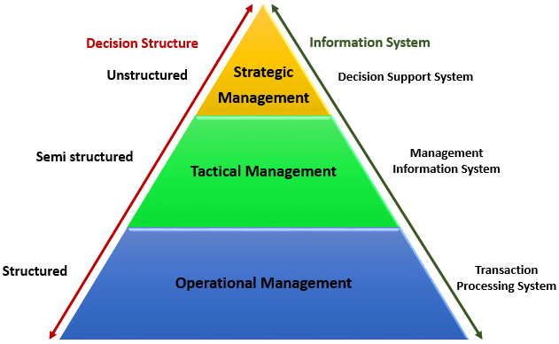
Operational management level
The operational level is concerned with performing day to day business transactions of the organization.
Tactical Management Level
This organization level is dominated by middle-level managers, heads of departments, supervisors, etc. The users at this level usually oversee the activities of the users at the operational management level.
Tactical users make semi-structured decisions. The decisions are partly based on set guidelines and judgmental calls. As an example, a tactical manager can check the credit limit and payments history of a customer and decide to make an exception to raise the credit limit for a particular customer. The decision is partly structured in the sense that the tactical manager has to use existing information to identify a payments history that benefits the organization and an allowed increase percentage.
Strategic Management Level
This is the most senior level in an organization. The users at this level make unstructured decisions. Senior level managers are concerned with the long-term planning of the organization. They use information from tactical managers and external data to guide them when making unstructured decisions.

Transaction Processing System (TPS)
Transaction processing systems are used to record day to day business transactions of the organization. They are used by users at the operational management level. The main objective of a transaction processing system is to answer routine questions such as;
- How printers were sold today?
- How much inventory do we have at hand?
- What is the outstanding due for John Doe?
By recording the day to day business transactions, TPS system provides answers to the above questions in a timely manner.
- The decisions made by operational managers are routine and highly structured.
- The information produced from the transaction processing system is very detailed.
For example, banks that give out loans require that the company that a person works for should have a memorandum of understanding (MoU) with the bank. If a person whose employer has a MoU with the bank applies for a loan, all that the operational staff has to do is verify the submitted documents. If they meet the requirements, then the loan application documents are processed. If they do not meet the requirements, then the client is advised to see tactical management staff to see the possibility of signing a MoU.
Examples of transaction processing systems include;
- Point of Sale Systems – records daily sales
- Payroll systems – processing employees salary, loans management, etc.
- Stock Control systems – keeping track of inventory levels
- Airline booking systems – flights booking management

Management Information System (MIS)
Management Information Systems (MIS) are used by tactical managers to monitor the organization's current performance status. The output from a transaction processing system is used as input to a management information system.
The MIS system analyzes the input with routine algorithms i.e. aggregate, compare and summarizes the results to produced reports that tactical managers use to monitor, control and predict future performance.
For example, input from a point of sale system can be used to analyze trends of products that are performing well and those that are not performing well. This information can be used to make future inventory orders i.e. increasing orders for well-performing products and reduce the orders of products that are not performing well.
Examples of management information systems include;
- Sales management systems – they get input from the point of sale system
- Budgeting systems – gives an overview of how much money is spent within the organization for the short and long terms.
- Human resource management system – overall welfare of the employees, staff turnover, etc.
Tactical managers are responsible for the semi-structured decision. MIS systems provide the information needed to make the structured decision and based on the experience of the tactical managers, they make judgement calls i.e. predict how much of goods or inventory should be ordered for the second quarter based on the sales of the first quarter.

Decision Support System (DSS)
Decision support systems are used by senior management to make non-routine decisions. Decision support systems use input from internal systems (transaction processing systems and management information systems) and external systems.
The main objective of decision support systems is to provide solutions to problems that are unique and change frequently. Decision support systems answer questions such as;
- What would be the impact of employees' performance if we double the production lot at the factory?
- What would happen to our sales if a new competitor entered the market?
Decision support systems use sophisticated mathematical models, and statistical techniques (probability, predictive modeling, etc.) to provide solutions, and they are very interactive.
Examples of decision support systems include;
- Financial planning systems – it enables managers to evaluate alternative ways of achieving goals. The objective is to find the optimal way of achieving the goal. For example, the net profit for a business is calculated using the formula Total Sales less (Cost of Goods + Expenses). A financial planning system will enable senior executives to ask what if questions and adjust the values for total sales, the cost of goods, etc. to see the effect of the decision and on the net profit and find the most optimal way.
- Bank loan management systems – it is used to verify the credit of the loan applicant and predict the likelihood of the loan being recovered.

Artificial intelligence techniques in business
Artificial intelligence systems mimic human expertise to identify patterns in large data sets. Companies such as Amazon, Facebook, and Google, etc. use artificial intelligence techniques to identify data that is most relevant to you.
Let's use Facebook as an example, Facebook usually makes very accurate predictions of people that you might know or went with to school. They use the data that you provide to them, the data that your friends provide and based on this information make predictions of people that you might know.
Amazon uses artificial intelligence techniques too to suggest products that you should buy also based on what you are currently getting.
Google also uses artificial intelligence to give you the most relevant search results based on your interactions with Google and your location.These techniques have greatly contributed in making these companies very successful because they are able to provide value to their customers.

Online Analytical Processing (OLAP)
Online analytical processing (OLAP) is used to query and analyze multi-dimensional data and produce information that can be viewed in different ways using multiple dimensions.
Let's say a company sells laptops, desktops, and Mobile device. They have four (4) branches A, B, C and D. OLAP can be used to view the total sales of each product in all regions and compare the actual sales with the projected sales.Each piece of information such as product, number of sales, sales value represents a different dimension. The main objective of OLAP systems is to provide answers to ad hoc queries within the shortest possible time regardless of the size of the datasets being used.

System Development Life Cycle
Like any other product development, system development requires careful analysis and design before implementation. System development generally has the following phases −
Planning and Requirement Analysis
The project planning part involves the following steps −
- Reviewing various project requests
- Prioritizing the project requests
- Allocating the resources
- Identifying the project development team
The techniques used in information system planning are −
- Critical Success Factor
- Business System Planning
- End/Mean Analysis
The requirement analysis part involves understanding the goals, processes and the constraints of the system for which the information system is being designed.
It is basically an iterative process involving systematic investigation of the processes and requirements. The analyst creates a blueprint of the entire system in minute details, using various diagramming techniques like −
- Data flow diagrams
- Context diagrams
Requirement analysis has the following sub-processes −
- Conducting preliminary investigation
- Performing detailed analysis activities
- Studying current system
- Determining user requirements
- Recommending a solution
Defining Requirements
The requirement analysis stage generally completes by creation of a 'Feasibility Report'. This report contains −
- A preamble
- A goal statement
- A brief description of the present system
- Proposed alternatives in details
The feasibility report and the proposed alternatives help in preparing the costs and benefits study.
Based on the costs and benefits, and considering all problems that may be encountered due to human, organizational or technological bottlenecks, the best alternative is chosen by the end-users of the system.
Designing System Architecture
System design specifies how the system will accomplish this objective. System design consists of both logical design and physical design activity, which produces 'system specification' satisfying system requirements developed in the system analysis stage.
In this stage, the following documents are prepared −
- Detailed specification
- Hardware/software plan
Building or Developing the System
The most creative and challenging phase of the system life cycle is system design, which refers to the technical specifications that will be applied in implementing the candidate system. It also includes the construction of programmers and program testing.
It has the following stages −
- Acquiring hardware and software, if necessary
- Database design
- Developing system processes
- Coding and testing each module
The final report prior to implementation phase includes procedural flowcharts, record layout, report layout and plan for implementing the candidate system. Information on personnel, money, hardware, facility and their estimated cost must also be available. At this point projected cost must be close to actual cost of implementation.
Testing the System
System testing requires a test plan that consists of several key activities and steps for programs, strings, system, and user acceptance testing. The system performance criteria deals with turnaround time,backup,file protection and the human factors.
Testing process focuses on both −
- The internal logic of the system/software, ensuring that all statements have been tested;
- The external functions, by conducting tests to find errors and ensuring that the defined input will actually produce the required results.
In some cases, a 'parallel run' of the new system is performed, where both the current and the proposed system are run in parallel for a specified time period and the current system is used to validate the proposed system.
Deployment of the System
At this stage, system is put into production to be used by the end users. Sometime, we put system into a Beta stage where users' feedback is received and based on the feedback, the system is corrected or improved before a final release or official release of the system.
System Evaluation and Maintenance
Maintenance is necessary to eliminate the errors in the working system during its working life and to tune the system to any variation in its working environment. Often small system deficiencies are found, as system is brought into operation and changes are made to remove them. System planner must always plan for resources availability to carry on these maintenance functions.
SYSTEM DEVELOPMENT LIFE CYCLE:
System life cycle is an organizational process of developing and maintaining systems. It helps in stablishing a system project plan, because it gives overall list of processes and sub-processes required for developing a system.
System development life cycle means combination of various activities. In other words we can say that various activities put together are referred as system development life cycle. In the System Analysis and Design terminology, the system development life cycle also means software development life cycle.
Following are the different phases of system development life cycle:
1. Preliminary study
2. Feasibility study
3. Detailed system study
4. System analysis
5. System design
6. Coding
7. Testing
8. Implementation
9. Maintenance

PHASES OF SYSTEM DEVELOPMENT LIFE CYCLE
- Preliminary System Study:
The initial system study involves the preparation of a „System Proposal‟ which lists the Problem Definition, Objectives of the Study, Terms of reference for Study, Constraints, Expected benefits of the new system, etc. in the light of the user requirements. The system proposal is prepared by the System Analyst (who studies the system) and places it before the user management.
that system study phase passes through the following steps:
• problem identification and project initiation
• background analysis
• inference or findings (system proposal)

- Feasibility Study:
In the process of feasibility study, the cost and benefits are estimated with greater accuracy to find the Return on Investment(ROI). This also defines the resources needed to complete the detailed investigation. The result is a feasibility report submitted to the management. This may be accepted or accepted with modifications or rejected. The system cycle proceeds only if the management accepts it.
- Detailed System Study:
The detailed investigation of the system is carried out in accordance with the objectives of the proposed system. This involves detailed study of various operations performed by a system and their relationships within and outside the system. During this process, data are collected on the available files, decision points and transactions handled by the present system. Interviews, on-site observation and questionnaire are the tools used for detailed system study
- System Analysis:
Systems analysis is a process of collecting factual data, understand the processes involved, identifying problems and recommending feasible suggestions for improving the system functioning. This involves studying the business processes, gathering operational data, understand
the information flow, finding out bottlenecks and evolving solutions for overcoming the weaknesses of the system so as to achieve the organizational goals.
- System Design:
Based on the user requirements and the detailed analysis of the existing system, the new system must be designed. This is the phase of system designing. It is the most crucial phase in the developments of a system. The logical system design arrived at as a result of systems analysis is converted into physical system design. Normally, the design proceeds in two stages:
• Preliminary or General Design
• Structured or Detailed Design

Preliminary or General Design: In the preliminary or general design, the features of the new system are specified. The costs of implementing these features and the benefits to be derived are estimated. If the project is still considered to be feasible, we move to the detailed design stage.
Structured or Detailed Design: In the detailed design stage, computer oriented work begins in earnest. At this stage, the design of the system becomes more structured. Structure design is a blue
print of a computer system solution to a given problem having the same components and inter-relationships among the same components as the original problem. Input, output, databases, forms, codification schemes and processing specifications are drawn up in detail.

- Coding:
It is an important stage where the defined procedures are transformed into control specifications by the help of a computer language. The programs coordinate the data movements and control the entire process in a system. It is generally felt that the programs must be modular in nature. This helps in fast development, maintenance and future changes, if required.
- Testing:
Before actually implementing the new system into operation, a test run of the system is done for removing the bugs, if any. It is an important phase of a successful system. After codifying the whole programs of the system, a test plan should be developed and run on a given set of test data. The output of the test run should match the expected results. Sometimes, system testing is considered a part of implementation process. Using the test data following test run are carried out:
• Program test
• System test

Program test: When the programs have been coded, compiled and brought to working conditions, they must be individually tested with the prepared test data. Any undesirable happening must be noted and debugged (error corrections)
System Test: After carrying out the program test for each of the programs of the system and errors removed, then system test is done. At this stage the test is done on actual data. The complete system is executed on the actual data. At each stage of the execution, the results or output of the system is analysed.

- Implementation:
After having the user acceptance of the new system developed, the implementation phase begins. Implementation is the stage of a project during which theory is turned into practice. The major steps involved in this phase are:
• Acquisition and Installation of Hardware and Software
• Conversion
• User Training
• Documentation

- Maintenance:
Maintenance is necessary to eliminate errors in the system during its working life and to tune the system to any variations in its working environments. It has been seen that there are always some errors found in the systems that must be noted and corrected. It also means the review of the system from time to time

UNIT-III
Meaning of Transaction Processing Systems
Transaction processing systems were among the earliest computerized systems. Their primary purpose is to record, process, validate, and store transactions that take place in the various functional areas/of a business for future retrieval and use. A transaction processing system (TPS) is an information system that records company transactions (a transaction is defined as an exchange between two or more business entities).
Types of Transactions
Note that the transactions can be internal or external. When a department orders office supplies from the purchasing department, an internal transaction occurs, when a customer places an order for a product, an external transaction occurs.
1. Internal Transactions: Those transactions, which are internal to the company and are related with the internal working of any organization. For example Recruitment Policy, Promotion Policy, Production policy etc.
2. External Transactions: Those transactions, which are external to the organization and are related with the external sources, are regarded as External Transaction. For examples sales, purchase etc.

Characteristics of Transaction Processing Systems
1. A TPS records internal and external transactions for a company. It is a repository of data that is frequently accessed by other system
2. A TPS performs routine, repetitive tasks. It is mostly used by lower-level managers to make operational decisions
3. Transactions can be recorded in batch mode or online. In batch mode, the files are updated periodically; in online mode, each transaction is recorded as it occurs.
4. There are six steps in processing a transaction. They are data entry, data validation, data processing and revalidation, storage, - output generation, and query support.

Features of TPS
1. A TPS supports different tasks by imposing a set of rules and guidelines that specify how to record, process, and store a given transaction. There are many uses of transaction processing systems in our everyday lives, such as when we make a purchase at retail store, deposit or withdraw money at a bank, or register for classes at a university. Almost all organizations, regardless of the industry in which they operate, have a manual or automated TPS
2. A TPS is the data life-line for a company because it is the source of data for other information systems, such as MIS and DSS (Decision Support Systems). Hence, if the TPSshuts down, the consequences can be serious for the organization
3. A TPS is also the main link between the organization and external entities, such as customers suppliers, distributors, and regulatory agencies
4. TPS exist for the various functional areas in an organization, such as finance, accounting, manufacturing, production, human resources, marketing quality control, engineering, research and development. Until a few years ago, many companies viewed the TPS for each business function as separate entity with little or no connection to other systems in the company

Process of Transaction Processing System
The seven steps in processing a transaction are:
1. Data entry
2. Data Capture
3. Data validation
4. Processing and revalidation
5. Storage
6. Output generation
7. Query support
1. Data Entry
To be processed, transaction data must first be entered into the system. There are a number of input devices for entering data, including the keyboard and the mouse. Documents generated at the point where a transaction occurs are called source documents and become input data for
the system.
Methods for Data Entry
1. Keyboard/video display terminals
2. Optical character recognition (OCR) devices, such as optical scanning wands and grocery check--out scanners.
3. Magnetic ink character recognition (MICR) devices, such as MICR reader/sorters used in banking for check
4. Other technologies, including electronic mice, light pens, magnetic stripe cards, voice input, and tactile. Input also be used as input device depending upon the application requirement
2. Data Capture
We could capture transaction data as close as possible to the source that generates the data. Salespersons capture data that rarely changes by prerecording it on machine-readable media, or by storing it on the computer system.
Tips for Data Capturing
1. Capture data by using machine-readable media initially (barcoded and magnetic stripe credit cards), instead of preparing written source documents
2. Captures data directly without the use of data media by optical scanning of bar codes printed on product packaging. It ensures the accuracy and reliability of data by comparing
3. Data Validation
There are two steps in validation: error detection and error correction, Error detection is per-formed by one set of control mechanisms, error correction is performed by another.
Invalid data is data that is outside the range For example, if the number of hours worked by a part-time employee is 72 hours per week instead of the 1120 hours, then we have invalid data
Inconsistent data means that the same data item assumes different values in different places with-out a valid reason.
4. Processing and Revalidation
Once the accuracy and reliability of the data are validated, the data are ready for processing. There are two ways to process the transactions: online and bath mode Following methods are available for Data Processing:
1. Online transaction processing (OLTP) is the almost instantaneous processing of data. The term online means that the input device is directly linked to the TPS and therefore the data
are processed as soon as it is entered into the system. Input device may be at a remote location and be linked to the system by networks or by telecommunications systems.
2. Batch Processing, in which transactions are accumulated over time and processed identically. Batch processing may be done on a daily, weekly, or monthly basis or any other time period
appropriate to the application.
5. Data Storage
Processed data must be carefully and properly stored for future use. Data storage is a critical consideration-for many organizations because the value and usefulness of data diminish if data are not properly stored. The kind of processing and the type of storage medium are, to some extent, related issues.
6. Output Generation
Once data has been input, validated, processed, revalidated and stored, the output can be communicated to decision makers in two ways:
1. Documents and reports
2. Forms: screens or panels.
7. Query Support
The last step in processing a transaction is querying (asking questions of) the system. Query facilities allow users to process data and information that may otherwise not be readily available
1. Checking on the status of a sales order
2. Checking on the balance in an account
3. Checking on the amount of stock in inventory

Executive information system (EIS):
An Executive information system (EIS), also known as an Executive support system (ESS),^{[1]} is a type of management support system that facilitates and supports senior executive information and decision-making needs. It provides easy access to internal and external information relevant to organizational goals. It is commonly considered a specialized form of decision support system (DSS).^{[2]}
EIS emphasizes graphical displays and easy-to-use user interfaces. They offer strong reporting and drill-down capabilities. In general, EIS are enterprise-wide DSS that help top-level executives analyze, compare, and highlight trends in important variables so that they can monitor performance and identify opportunities and problems. EIS and data warehousing technologies are converging in the marketplace.

COMPONENTS OF EIS
EIS components can typically be classified as:

- Hardware
- Software
- User interface
- Telecommunications
Hardware
When talking about computer hardware for an EIS environment, we should focus on the hardware that meets the executive's need. The executive must be put first and the executive's needs must be defined before the hardware can be selected. The basic hardware needed for a typical EIS includes four components:

Input data-entry devices. These devices allow the executive to enter, verify, and update data immediately
The central processing unit (CPU), which is the most important because it controls the other computer system components
Data storage files. The executive can use this part to save useful business information, and this part also helps the executive to search historical business information easily
Output devices, which provide a visual or permanent record for the executive to save or read. This device refers to the visual output device such as monitor or printer
In addition, with the advent of local area networks (LAN), several EIS products for networked workstations became available. These systems require less support and less expensive computer hardware. They also increase EIS information access to more company users.

Software
Choosing the appropriate software is vital to an effective EIS.[citation needed] Therefore, the software components and how they integrate the data into one system are important. A typical EIS includes four software components:

Text-handling software—documents are typically text-based
Database—heterogeneous databases on a range of vendor-specific and open computer platforms help executives access both internal and external data
Graphic base—graphics can turn volumes of text and statistics into visual information for executives. Typical graphic types are: time series charts, scatter diagrams, maps, motion graphics, sequence charts, and comparison-oriented graphs (i.e., bar charts)
Model base—EIS models contain routine and special statistical, financial, and other quantitative analysis
User interface
An EIS must be efficient to retrieve relevant data for decision makers, so the user interface is very important. Several types of interfaces can be available to the EIS structure, such as scheduled reports, questions/answers, menu driven, command language, natural language, and input/output.

Telecommunication
As decentralizing is becoming the current trend in companies, telecommunications will play a pivotal role in networked information systems. Transmitting data from one place to another has become crucial for establishing a reliable network. In addition, telecommunications within an EIS can accelerate the need for access to distributed data. It can be both by scientific and business means.

Applications
EIS helps executives find data according to user-defined criteria and promote information-based insight and understanding. Unlike a traditional management information system presentation, EIS can distinguish between vital and seldom-used data, and track different key critical activities for executives, both which are helpful in evaluating if the company is meeting its corporate objectives. After realizing its advantages, people have applied EIS in many areas, especially, in manufacturing, marketing, and finance areas.

Manufacturing
Manufacturing is the transformation of raw materials into finished goods for sale, or intermediate processes involving the production or finishing of semi-manufactures. It is a large branch of industry and of secondary production. Manufacturing operational control focuses on day-to-day operations, and the central idea of this process is effectiveness.

Marketing
In an organization, marketing executives' duty is managing available marketing resources to create a more effective future. For this, they need make judgments about risk and uncertainty of a project and its impact on the company in short term and long term. To assist marketing executives in making effective marketing decisions, an EIS can be applied. EIS provides sales forecasting, which can allow the market executive to compare sales forecast with past sales. EIS also offers an approach to product price, which is found in venture analysis. The market executive can evaluate pricing as related to competition along with the relationship of product quality with price charged. In summary, EIS software package enables marketing executives to manipulate the data by looking for trends, performing audits of the sales data, and calculating totals, averages, changes, variances, or ratios.

Financial
Financial analysis is one of the most important steps to companies today. Executives needs to use financial ratios and cash flow analysis to estimate the trends and make capital investment decisions. An EIS integrates planning or budgeting with control of performance reporting, and it can be extremely helpful to finance executives. EIS focuses on financial performance accountability, and recognizes the importance of cost standards and flexible budgeting in developing the quality of information provided for all executive levels.
Advantages of EIS
- Easy for upper-level executives to use, extensive computer experience is not required in operations
- Provides strong drill-down capabilities to better analyze the given information.
- Information that is provided is better understood
- EIS provides timely delivery of information. Management can make decisions promptly.
- Improves tracking information
- Offers efficiency to decision makers
Disadvantages of EIS
- System dependent
- Limited functionality, by design
- Information overload for some managers
- Benefits hard to quantify
- High implementation costs
- System may become slow, large, and hard to manage
- Need good internal processes for data management
- May lead to less reliable and less secure data
- Excessive cost for small company

ENTERPRISE RESOURCE PLANNING
ERP is an integrated, real-time, cross-functional enterprise application, an enterprise-wide transaction framework that supports all the internal business processes of a company.
It supports all core business processes such as sales order processing, inventory management and control, production and distribution planning, and finance.
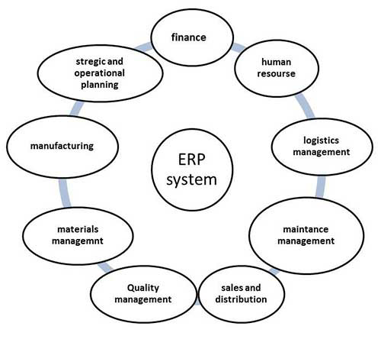
ERP is very helpful in the follwoing areas −
- Business integration and automated data update
- Linkage between all core business processes and easy flow of integration
- Flexibility in business operations and more agility to the company
- Better analysis and planning capabilities
- Critical decision-making
- Competitive advantage
- Use of latest technologies
Scope of ERP
- Finance − Financial accounting, Managerial accounting, treasury management, asset management, budget control, costing, and enterprise control.
- Logistics − Production planning, material management, plant maintenance, project management, events management, etc.
- Human resource − Personnel management, training and development, etc.
- Supply Chain − Inventory control, purchase and order control, supplier scheduling, planning, etc.
- Work flow − Integrate the entire organization with the flexible assignment of tasks and responsibility to locations, position, jobs, etc.

Features of ERP
The following diagram illustrates the features of ERP −
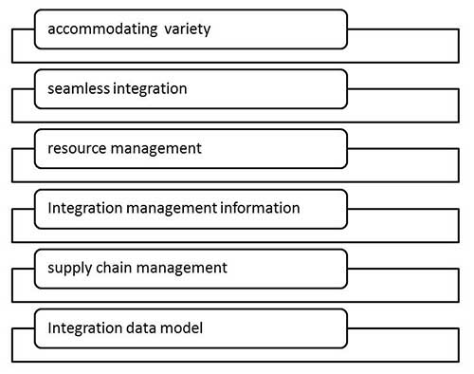
Advantages of ERP
- Reduction of lead time
- Reduction of cycle time
- Better customer satisfaction
- Increased flexibility, quality, and efficiency
- Improved information accuracy and decision making capability
- Onetime shipment
- Improved resource utilization
- Improve supplier performance
- Reduced quality costs
- Quick decision-making
- Forecasting and optimization
- Better transparency
Disadvantage of ERP
- Expense and time in implementation
- Difficulty in integration with other system
- Risk of implementation failure
- Difficulty in implementation change
- Risk in using one vendor

UNIT –IV
DATABASE MANAGEMENT SYSTEMS
A Database Management System (DBMS) is basically another software program like Word or Excel or Email. This type of software is more complicated: it permits an organization to centralize data, manage them efficiently, and provide access to the stored data by application programs. A DBMS has 3 components, all of them are important for the long-term success of the system.

Components of DBMS
1. Data Definition Language (DDL). Marketing looks at customer addresses differently from Shipping. So you must make sure that all users of the database are speaking the same language. Think of it this way:
2. Data Manipulation Language (DML). This is a formal language used by programmers to manipulate the data in the database and make sure they are formulated into useful information. The goal of this language should be to make it easy for users. The basic idea is to establish a single data element that can serve multiple users in different departments depending on the situation
3. Data Dictionary. Each data element or field should be carefully analysed to determine what it will be used for, who will be the primary user, and how it fits into the overall scheme of things. Then write it all down and make it easily available to all users. This is one of the most important steps in creating a good database.

Logical and Physical Views of Data
Physical views of items are often different from the logical views of the same items when they are actually being used. Database Management Systems have three critical components: the data definition language, the data manipulation language, and the data dictionary. Managers should ensure that all three receive attention. Managers should also make sure that end users are involved in developing these three components.

Designing Databases
Every tool has its job. You wouldn’t use a screwdriver to pound a nail in the wall (or maybe you would), nor would you use a hammer to turn a bolt. Each type of database that we discuss in this section has its own advantages and disadvantages, so you should choose the right type of database for the job you want to do.

Types of Designing Databases

- Hierarchical Databases
- Network Database
- Relational Data Model

Hierarchical Databases
The hierarchical data model presents data to users in a treelike structure. Think of a mother and her children. A child only has one mother and inherits some of her characteristics, such as eye color or hair color. A mother might have one or more children to which she passes some of her characteristics but usually not exact ones. The child then goes on to
develop its own characteristics separate from the mother.
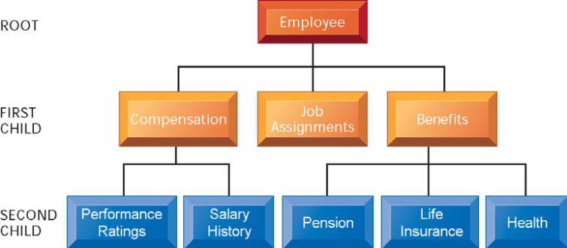
A hierarchical database for a human resources system.
Network Database
A network data model is a variation of the hierarchical model. Take the same scenario with one parent and many children and add a father and perhaps a couple of stepparents.
Relational Data Model
A relational data model uses tables in which data are stored to extract and combine data in different combinations. The tables are sometimes called files. In a relational database, each table contains a primary key, a unique identifier for each record.
three basic operations to develop relational databases:
1. Select: create a subset of records meeting the stated criteria
2. Join: combine related tables to provide more information than individual tables
3. Project: create a new table from subsets of previous tables

Comparing of Database Alternatives
The above table compares these alternatives on several dimensions to show you the advantages and disadvantages of each. What you should remember is that none of these databases is very good if you don’t keep the end user in mind. If you’re not careful, you’ll wind up with lots of information that no one can use.

Creating a Database
First, you should think long and hard about how you use the available information in your current situation. Think of the good and the bad of how it is organized, stored, and used. Now imagine how this information could be organized better and used more easily throughout the
organization.

DATABASE TRENDS
Recent database trends include the growth of distributed databases and the emergence of object-oriented and hypermedia databases.
Distributed Databases
These are usually found in very large corporations that require multiple sites to have immediate, fast access to data. As the book points out, there are lots of disadvantages, so you should be careful in determining if this is the right way for you to run your business.

Object-Oriented and Hypermedia Databases
Many companies are steering away from strictly text-based database systems. Data as objects can be pictures, groups of text, voice, audio, etc. Object-oriented databases bring the various objects from many different sources and get them all working together.

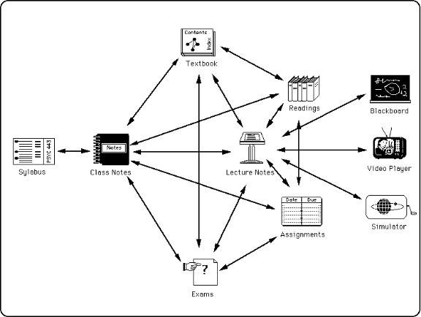

Multidimensional Data Analysis
As technology improves, so does our ability to manipulate information maintained in databases. Have you ever played with a Rubik Cube – one of those cute little multicolour puzzle boxes you can twist around and around to come up with various colour combinations. That’s a close analogy to how multidimensional data analysis or on-line analytical processing (OLAP) works. In theory, it’s easy to change data around to fit your needs.
Data Warehouses
As organizations want and need more information about the company, the products, and the customers, the concept of data warehousing has become very popular.
Linking Databases to the Web
Even though Web browsers have been around for only a few years, they are far easier to use than most of the query languages associated with the other programs on mainframe computer systems. That’s why many companies are starting to link their databases to a Web-like browser. They are finding out that it’s easier to provide their “road warriors” with Web-like browsers attached to the computer at the main office.

MANAGEMENT REQUIREMENTS
Key organizational elements in the database environment. Nothing is ever as easy as it sounds. There is a lot more to a viable, useful database than just its structure as shown
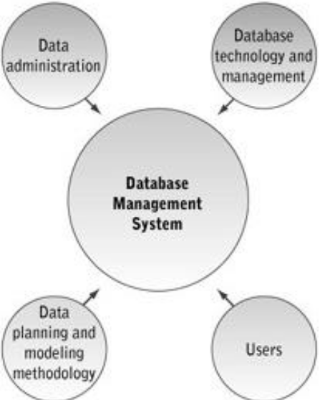
Data Administration
Ask any manager what his resources are and he’s likely to list people, equipment, buildings, and money. Very few managers will include information on the list, yet it can be more valuable than some of the others. A data administration function, reporting to senior management, can help emphasize the importance of this resource. This function can help define and structure the information requirements for the entire organization to ensure it receives the attention it deserves.
Data Administration is responsible for:
1. Developing information policies
2. Planning for data
3. Overseeing logical database design
4. Data dictionary development
5. Monitoring the usage of data by techies and non-techies
Data Planning
At the beginning we said that as many users as possible should be brought together to plan the database. We believed it so much then that we’ll say it again here. By excluding groups of users in the planning stages, no matter how insignificant that group may seem a company courts trouble.
Database Technology, Management and Users
Change isn’t just something you experience by chance; in all likelihood, it will be required throughout the corporate structure. You need to get the non-techies talking and working with the techies. Users will take on more responsibility for accessing data on their own through query languages if they understand the structure of the database. Users need to understand
the role they play in treating information as an important corporate resource. Not only will they require a user friendly structure for the database, but they will also need lots of training and hand holding up front. It will pay off in the long run.
Database administration functions can:
1. Define and organize database structure and content.
2. Develop security procedures to safeguard the database.
3. Develop database documentation.
4. Maintain the database management software.

The Range of Database Applications
A database Application is a set of programs that were developed to support the needs of the database users. The application is used to perform the basic function of adding new data, modifying or deleting data, or reading data to create meaningful information, such as the invoice shown above. Database applications are divided into five categories; from a single user on a personal databases, to workgroup, departmental, enterprise, and Internet/Intranet/Extranet databases.
Personal databases: Designed to support one user and are used for simple applications, typically developed by the end user
Workgroup Database : Small team of professionals who collaborate on the same project. e.g., a team of systems analysts developing an information system will share a common database to create their schema, programs and documents. The workgroup members use PCs that are linked by the way of a local area network (LAN). The database is managed by a computer, called database server, which is part of the network.
Department Databases : A department is a function within the organization such as accounting, and marketing. The databases are designed to support the function of the organization. For a marketing department the database would tracks data concerning customer, orders, and salespersons
Enterprise Database: An enterprise database supports the entire enterprise (all the departments). At times a single enterprise database isn’t practical, so multiple databases are maintained. This is due to performance issues, diverse needs of users, and complexity of systems.
Enterprise databases include:
(1) Enterprise resource planning (ERP)
(2) Data warehousing.
ERP systems have evolved from the material requirement (MRP) and manufacturing resource planning (MRP II) systems of the 1970s and 1980s. The ERP systems include additional functionality such as customer resource management, and personnel. Because of the complexity of ERP systems, a database is a must work with current operational data of the enterprise, data in the data warehouse are derived by extracting and basis. Users work with the historical data of the warehouse to identify patterns and trends and answer strategic business questions. Data warehousing is discussed later in the course.
Internet, Intranet, and Extranet Databases: The internet is the most recent change that had a tremendous effect on businesses and their information systems and databases. The internet is a worldwide network that easily enables users with multiple platforms to.

Conceptual Structure of MIS
This structure of MIS defined as federation of functional sub-system. In this approach, each sub-system has been divided into four information system components, such as, transaction processing, operational control, management control, and strategic control information system. All the federations of functional sub-systems are well connected to perform their functions with assistance of MIS.
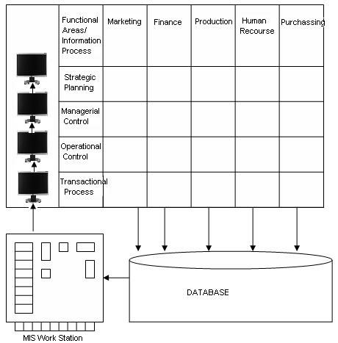

CLIENT SERVER ARCHITECTURES NETWORKS

Computer Networks and Client/Server :
Client/Server - Probably the most common LAN types used by companies today, they are called “client/server” because they consist of the server (which stores the files or runs applications) and the client machines, which are the computers used by workers. Using a client/server setup can be helpful in many ways. It can free up disk space by providing a central location for all the files to be stored. It also ensures the most recent copy of that file is available to all. A server can also act as a mail server (which collects and sends all the e-mail) or a print server (which takes all the print jobs and sends them to the printer, thus
freeing computing power on the client machine to continue working).
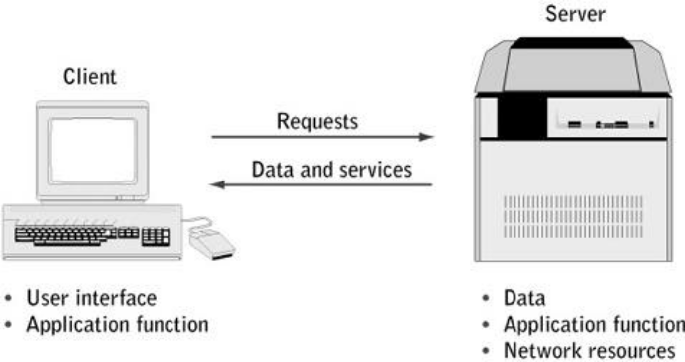

Server:
A server is simply a computer that is running software that enables it to serve specific requests from other computers, called “clients.”
A server provides many benefits including:
• Optimization: server hardware is designed to serve requests from clients quickly
• Centralization: files are in one location for easy administration
• Security: multiple levels of permissions can prevent users from doing damage to files
• Redundancy and Back-up: data can be stored in redundant ways making for quick restore in case of problems

Client/server computing
With the increasing popularity of networks, you need to understand the server/client structure. Think of an octopus, with the body representing the server and the tentacles representing the clients. At the heart of every network is a server. It can be a mainframe, mini-computer, workstation, or a soaped up personal computer. It’s where some of the data, applications software, and other instructions that network users need in order to communicate with and process transactions on the network are stored.
The client computer is the node on the network that users need in order to access and process transactions and data through the network. The following figure shows some different types of client/server computing.
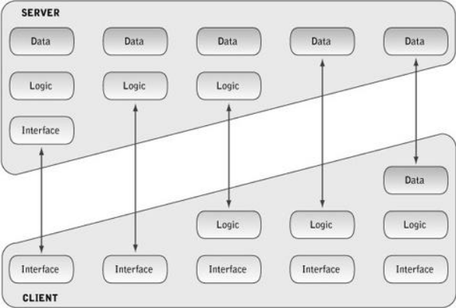
Depending on the configuration of the network, a company can save or lose many dollars. What’s most important to remember is that the Total Cost of Ownership (TCO) should extend past the hard dollars spent on hardware and software. The cost should incorporate such as items as employee training, their ability to perform necessary functions given the network configuration, and lost productivity when the network is down. The TCO should also include the amount of money spent on communications wiring (telephone wires, fiber optic cable, etc) and security and access issues.

ARCHITECTURES NETWORKS

Wireless Networking
Wireless networking refers to hardware and software combinations that enable two or more appliances to share data with each other without direct cable connections. Thus, in its widest sense, wireless networking includes cell and satellite phones, pagers, two-way radios, wireless LANs and modems, and Global Positioning Systems (GPS).

- Wireless LANs
- Wide Area Networks (WANs)
- Controller Area Network (CANs)
- Campus Area Networks (CANs)
- Metropolitan Area Networks (MANs)
- Virtual Private Network (VPNs)
- Home Area Network (HANs)

- Wireless LANs
Wireless LANs enable client computers and the server to communicate with one another without direct cable connections. Generally, a wireless LAN is connected to an existing
wired LAN, although they can exist without a wired LAN (in this case, users will only be able to communicate with other users on the same subnet).
Benefits of Wireless LANs
Cost: Wireless LANs can cost less to implement than wired LANs, especially in situations where implementing a wired LAN requires extensive labor and materials to install the wiring
and drops. For environments that are difficult to wire (such as schools or temporary spaces) a wireless network can be more cost-effective in the long run than a wired one.
Simple/flexible to Install: Wireless LANs eliminate the time needed with wired LANs for laying and pulling wires, and can reach places that cannot be reached by wires.
Portability: Wireless LAN systems can move physical locations much easier than wired LANs, reducing total cost of ownership for organizations that are on the move.
Mobility: Wireless LAN systems can provide LAN users with access to network information anywhere in their organization.
Scalability: Wireless LAN systems can be configured for small offices and large, with peer-to-peer systems or large established LANs, specific to the localized need of a workgroup or across the whole enterprise. Wireless LAN systems grow easily with the need by adding more access points, client LAN adaptors and extension points. Wireless can be a good solution if you need to connect several buildings without installing a wired connection. Wireless LAN bridges can extend LANs that are typically one to five miles apart. These wireless bridges span multiple building LANs without incurring the monthly costs of a T1 or
higher speed lines.
Drawbacks of Wireless LANs
Cost: In environments with installed wiring or less demanding wiring needs, the up front costs of adopting a wireless LAN system can be more expensive than with wired LANs.
Interoperability: There are several competing technologies used by wireless LAN vendors to communicate data between hardware, with no ability for communication directly between
systems using these different standards.
Interference: Most of the wireless devices today operate on 2.4-GHz radio bands, which are also used by cordless phones and most microwave ovens. The potential for interference when
used near other devices sharing the same frequency band.
Speed: Most commonly used wireless LAN products are rated for a maximum 11Mbps throughput, and in practice see speeds about 80% less than this - some wireless LAN products are rated for speeds much less than this (Home RF systems for example). Still quite speedy for most network needs and for broadband Internet sharing, but for larger offices with high network traffic and demands for speed, this should be taken into consideration.
- Wide Area Networks (WANs)
Wide Area Networks or WANs are very large networks of computers. These networks span large geographical areas, generally covering a couple miles, sometimes connecting
computers thousands of miles apart. A WAN can also be a collection of LANs, bringing together many smaller networks into one large network. A WAN can constitute a very large
corporate or government network, spanning the country or even the world.
- Controller Area Network (CANs)
Last modified Abbreviated CAN, a serial bus network of microcontrollers that connects devices, sensors and actuators in a system or sub-system for real-time control applications. There is no addressing scheme used in controller area networks, as in the sense of conventional addressing in networks (such as Ethernet).
- Campus Area Networks (CANs)
An interconnection of local-area networks within a limited geographical space, such as a school campus or a military base
- Metropolitan Area Networks (MANs)
A data network designed for a town or city. In terms of geographic breadth, MANs are larger than local-area networks (LANs), but smaller than wide-area networks (WANs). MANs are usually characterized by very high-speed connections using fiber optical cable or other digital media.
- Virtual Private Network (VPNs)
A virtual private network (VPN) is a private data network that makes use of the public telecommunication infrastructure, maintaining privacy through the use of a tunneling protocol and security procedures. A virtual private network can be contrasted with a system of owned or leased lines that can only be used by one company. The idea of the VPN is to give the company the same capabilities at much lower cost by using the shared public infrastructure rather than a private one.
- Home Area Network (HANs)
A HAN is a network contained within a user’s home that connects a person’s digital devices, from multiple computers and their peripheral devices to telephones, VCRs, televisions, video games, home security systems, “smart” appliances, fax machines and other digital devices that are wired into the network.

UNIT - V
Functional management information systems

Functional information system:
The information systems that perform or support the completion of these tasks are often referred to as Functional management information systems, or transaction processing systems. In fact financial transactions typically come to mind when you think of Functional management information systems because many Functional management information systems focus on the routine, repetitive financial transactions that are an important part of the basic activities of most business enterprises.

However, Functional management information systems include more than the financial transactions of an organization. Functional management information systems record, process, and report all routine and repetitive activities or organizations. These activities occur not only in accounting and finance but also in human resources, production, and marketing. Just go through the following table.

Functional information system
- Accounting and Financial Information Systems
- Marketing Information Systems
- Production information systems
- Human resource management information systems

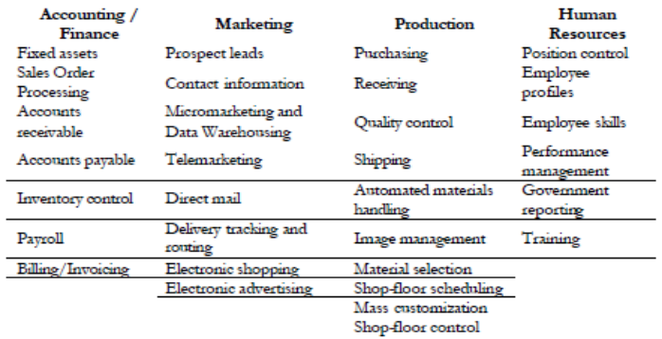

The Nature of Functional management Information Systems:

Functional management information systems primarily produce routine, repetitive, descriptive, expected, and objective data that describe past activities. The information they produce is usually detailed, highly structured, accurate, derived from internal sources, and
produced regularly. To some, these systems may appear to represent pure drudgery for employees who must complete them.
However, the application of information sys-tem technology to Functional management information systems has reduced this drudgery to a great extent and provided managers with a number of major advantages
Management Advantages
Automating Functional management information systems usually increases the efficiency of these systems; they typically run faster and require fewer personnel and other business re-sources than manual systems. Organizations that automate Functional management information systems usually receive several benefits for their efforts
· Reduced Cost
· Increased Speed
· Increased Accuracy
· Increased Customer Service
· Increased Data for Decision Making

- Accounting and Financial Information Systems:

Typically, the first applications that organizations computerize are Functional management-level financial accounting systems. Functional management financial accounting information systems are typically task oriented. They focus on processing financial transactions to produce the routine, repetitive information outputs that every organization finds necessary. These outputs include paychecks, checks to vendors, customer invoices, purchase orders, stock reports, and other regular forms and reports.
Financial Accounting Systems
The heart of an organization’s Functional management financial information system is its financial accounting system. A computerized financial accounting system is composed of a series of software modules or subsystems that may be used separately or in an integrated fashion. The system modules typically include
· General ledger
· Fixed assets
· Sales order processing
· Accounts receivable
· Accounts payable
· Inventory control
· Purchase order processing
· Pay roll
When these computerized financial accounting systems are integrated, each sys-tem receives data as input from some systems and provides information as output to other systems.

Components of Finance and Accounting Systems

General Ledger System provides managers with periodic accounting reports and statements such as the income statement and balance sheet.
Fixed Assets System maintains records of equipment, property, and other long--term assets that an organization owns. The records include the original cost of the as-sets, their depreciation rates, the accumulated depreciation to date, and the book value of the assets, or the original cost less accumulated depreciation.
Sales Order Processing System or order-entry system, routinely records sales orders and also provides data to other systems that fill those orders, maintain inventory levels, and bill
the customer. This system provides sales tax data to the general ledger system for posting to taxing agency accounts, stock data to the inventory sys-tem for updating inventory balances, and sales data to the accounts receivable system for posting to customer accounts.
Accounts Receivables System allows you to enter, update, and delete customer information such as sales made on account, credit terms, cash payments received, credit memorandums, and account balances. Inputs to the accounts receivab1e system include sales invoices, credit memorandums, and cash received from customers. Typical outputs of this system are monthly customer statements of account and a schedule of accounts receivable listing each ac-count and its balance.
Accounts Payable System processes much the same routine, repetitive information as the accounts receivable system, except that in this case the information is about the organization’s creditors rather than about its customers.
Inventory Control System provides input to the general ledger system and receives input from the purchase order and the sales order systems. The basic purpose of the system is to
keep track of inventory levels and inventory costs. The system maintains information about each stock item, such as stock numbers and stock descriptions, receipts and issues of stock,
stock damage, and stock balances.
Purchase Order Processing System processes purchase orders and tracks which purchase orders have been filled, which stock items ordered are on backorder, which stock items have been damaged or do not meet the specifications of the original order, and which orders are still on order and when those orders are expected to arrive. The purchase order system provides information to the accounts payable and inventory systems. The system produces a variety of reports, including a list of all stock on backorder and an open-order report that lists
all purchase orders not yet received and their expected arrival dates.
Payroll System processes wage and salary information such as payments to employees; deductions from employee paychecks; and payments to federal, state, and other taxing agencies for taxes used. The payroll system produces such repoft4 as the weekly payroll summary report, overtime reports, forms for taxing agencies such as wage and tax statements (Forms W-2), payroll checks, and checks for payroll taxes owed to taxing agencies.

- Marketing Information Systems:

The marketing function occurs in all organizations, including profit and not-for-profit, manufacturing, agricultural, financial, educational, and service organizations. The basic goal of the marketing function in any organization is to satisfy the needs and wants of its customers. To achieve that goal, marketing personnel engage in activities such as planning and developing new products; advertising, promoting, selling, storing, and distributing goods and services; providing financing and credit to customers’ and conducting market research.
Functional marketing information systems include systems such as sales systems, advertising systems, sales promotion systems, warehousing systems, and pricing systems. The systems collect data that describe marketing operations, process those data, and make marketing information available to marketing managers to help them make decisions
Computer information systems have been widely applied to Functional management-level marketing tasks. Information technology has increased the productivity of sales people; helped firms manage customers better, locate prospective customers, customize marketing efforts to specific groups and individuals, and reduce costs; and vastly widened the reach of many organizations in terms of the geographic territory they serve. Computer technology applied to Functional management-level marketing systems also captures data useful for tactical and strategic decisions.

Components of marketing information Systems

Sales Force Automation Systems are designed to increase the productivity of sales-people. Bread-and-butter sales activities usually include identifying potential or prospective customers, contacting customers, calling on customers, making sales pitches, closing the sale, and following up on sales. Typically, automating a sales force involves equipping salespeople with notebook computers and software to support their activities
Prospect information systems: Locating potential customers
are often a time- consuming and frustrating part of the salesperson’s work. The sources of information used to obtain sales leads are diverse and may include other customers, other
vendors who sell supporting or ancillary products, newspaper notices, telephone directories, and customer inquiries. Searching directories and other customer lists may take a lot of time and yield few actual customers
Contact management systems: Provide information to the sales force pertaining to customers, their product or service preferences, sales history data, and a historical record of sales calls and/or visits. One output of these systems may be a call report showing the number of sales calls made by a salesperson categorized by size of organization, previous sales, or some other characteristic, and the number or amount of sales made per customer, per visit, and/or per category.
Other sales force automation systems: May also provide support for many other routine, repetitive salesperson activities, for example, travel expense reports, appointment calendars,
telephone and address rolodexes, sales letter creation and distribution, e-mail, and fax. Internet access may also be provided so that salespeople can keep current on business news
at any hour, especially news about the industry, competitors, and customers.
Micromarketing and Data Warehouse Systems: Pitching sales or advertising campaigns to very narrowly defined customer targets is called micromarketing. Computer systems have made micromarketing possible. They can be used to identify and target specific customers or prospects from large databases
Telemarketing systems: Usually include support for the automatic dialing of parties and/or delivering voice messages to the answering party under the control of a computer system.
Some systems allow you to make notes about the calls, to generate follow-up letters, and to view a customer file while a call to that customer is in progress.
Direct Mail Advertising Systems: Many organizations generate sales by mailing sales brochures and catalogs directly to customers using direct mail advertising systems. To distribute sales documents rapidly to large numbers of potential customers, most marketing departments maintain customer mailing lists that are used for mass mailings. The ‘lists may be drawn from customer files; accounts receivable records; prospect files; commercial databases of households, businesses, and organizations; or they can be purchased from other firms.
Point of Sale System: Systems provide immediate updates to sales and inventory systems and allow firms to monitor sales trends minute by minute. They also allow firms to capture customer data and preferences and add the information to their data warehouses.
Delivery Tracking and Routine Systems: Customers like to receive their merchandise on time. In a manual system, customers called in to a customer representative to check on the delivery of their merchandise. The customer rep would then have to call the delivery vehicle driver who uses a cell phone to tell the rep where he or she is and how soon the merchandise might be delivered. That process took time, frequently frustrated the customer, and cost the firm money to support.
Electronic Shopping and Advertising: Firms have been able to advertise and customers to shop via TV; radio, and the telephone for many years. The computer age, however, has made
other avenues for shop-ping and advertising available, the most dramatic of which is clearly the Internet
Virtual shopping: When people view, select, and purchase products and services from a tore in another location using electronic means, they are virtually shopping at that store.
Virtual shopping, or electronic shopping, allows organizations to present information about goods and services to potential customers who are connected to their electronic “store.” Selecting and buying goods using an electronic kiosk (de-scribed in the next section), from an organization’s Internet site, and from a “virtual mall” of Internet Web “stores” are all examples of virtual or electronic shopping.

- Production Information Systems:

Production information systems are diverse; they include continuous flow production, mass production, job order production, and project production. In addition, Functional management production systems include the production of services as well as hard goods. The purpose of the production system is to acquire the raw materials and purchased parts; test the materials for quality; acquire the appropriate human resources, work space, and equipment; schedule the materials, human resources, space, and equipment; fabricate the products or services; test the product or service outputs; and monitor and control the use
and costs of the resources involved.
Numerous Functional management information systems support the production function. Some are part of the financial accounting system of an organization

Components of Production information Systems

Purchasing Systems: To produce goods and services, you must have the right quantity of raw materials and production supplies on hand. Furthermore, you will want to procure these
materials and supplies at the lowest cost and have them delivered at the right time. To assist in this function, the purchasing system has to maintain data on all phases of the acquisition
of raw materials and purchased parts used in production.
Receiving Systems: When shipments of purchased goods and supplies are received, they must usually be opened, inspected, and verified against purchase orders, and the information about their status passed to the accounts payable, inventory, and production departments Delivery dates should also be noted for several reasons, including collecting data on the delivery-time reliability of suppliers. This type of information is supplied by receiving systems
Quality Control Systems provide information about the status of production goods as they move from the raw materials state, through goods in process, to finished goods. Quality control systems ensure that raw materials or parts purchased for use in the production processes meet the standards set for those materials. The systems also monitor quality during the production cycle.
Shipping Systems: At the other end of the production process, finished goods are placed in inventory and/or shipped to customers. Many records and documents are used to assist
and monitor in the inventorying and shipping processes-for example, shipping reports and packing slips. The information from the shipping system affects the inventory and accounts
receivable systems.
Cost Accounting Systems: Many Functional management-level financial accounting systems collect and report information about the resources that are used in the production processes so that managers can obtain accurate costs of production on products and services. Cost accounting systems monitor the three major resources used in production: human resources, materials, and equipment and facilities.
Materials management systems provide information on current inventory levels of production materials, use of these materials in the production processes and their locations, and specifications of how these materials are employed in products. The lat-ter system is usually called a bill-of-materials (BOM) system. A bill-of-materials system produces a list of the raw materials, subassemblies, and component parts needed to complete each product. It provides, in essence, a list of ingredients for the end product
Inventory Control System: Maintaining inventories at their proper levels eliminates production shutdowns from lack of raw materials and lost sales from lack of finished goods.
However, maintaining inventories also represents a number of costs to the organization, including the costs of procuring and carrying the inventory, and stock out costs, or those costs that result when the right amount of the right item is not on hand at the right time.
Automated Material Handling Systems track, control, and otherwise support the movement of raw materials, work in process and finished goods from the receiving docks to the shipping docks.
Computer Aided Design and Manufacturing Systems are aiding product engineers design new products and improve old products.
Image Management Systems are designed to manage the storage and retrieval of engineering and architectural drawings using optical disk storage media.
Material Selection Systems aid in choosing the materials for the product under design.
Shop-Floor Scheduling Systems help in scheduling production jobs. The tasks include scheduling the time, building and rooms, tools and equipment, inventory, and personnel to
complete factory orders.

- Human Resource Information Systems

Human resource departments are responsible for many facets to human resource management, including recruiting, assessment, selection, placement, training, performance appraisal, compensation and benefit management, promotion, termination, occupational health and safety, employee services, complaints with legal constraints, helping managers with human resource problems, and providing top management with information
for strategic planning.
Human Resource Information Systems provide managers with data to support the routine, repetitive human resource decisions that occur regularly in the management of organisation’s human resources. There are many Functional management level human resource information systems including systems that help managers keep track of the organisation’s positions and employees, conduct performance evaluation, provide alternative or flexible scheduling, recruit new employees, place employees, train employees, relocate employees, terminate employees, provide employment benefits and provide reports
to governmental agencies.

Components of human resource information

Position Control Systems is to identify each position in the organisation, the job title in which the position is classified, and the employee currently assigned to the position. Reference to the position control systems allows a human resource manager to identify the details about unfilled positions.
Employee Information Systems is a set of employee profile records, or employee inventory. An employee profile usually contains personal and organisation-related information, such as
name, address, sex, minority status, marital status, citizenship, years of service or seniority data, education and training, previous experience, employment history within the organisation, salary rate, salary or wage grade, and recruitment and health plan choices. Employee Skills Inventory contains information about every employee’s work experience, work preferences, test scores, interests, and special skills or proficiencies.
Performance Management Systems: Many organizations review the work of employees on a regular basis to make decisions regarding merit pay, pay increases, transfer or promotion.
Typically, a new employee is evaluated at the end of the first six months of employment, and other employees are evaluated annually. These reviews are often called performance appraisals. The data for performance appraisals are frequently collected by asking each employee’s immediate superior to complete an employee appraisal form. The form may be also given to peers, the employees themselves, and even customers
or clients.
Government Reporting Systems: Data Secures from the payroll, position control, employee profiles, performance management, and other human resource information systems can be used to produce reports required by myriad governmental laws and regulations, including affirmative action and equal employment opportunity laws and regulations.
Applicant Selection and Placement Systems After jobs and the employee requirements for those jobs have been identified and after a pool of suitable job candidates has been recruited,
candidates must be screened, evaluated, selected, and placed in the positions that are open. The primary purpose of the application selection and placement system is to assist the
human resources staff in these tasks.
Training Systems: A great deal of software available today providing on-line training for employees, including management training software, sale training software, microcomputer
training software, and word processing software.

