SRINIVASAN COLLEGE OF ARTS AND SCIENCE, PERAMBALUR- 621212

HUMAN RESOURCE MANAGEMENT - 16MBECA5

Human Resource Management
You have just been hired to work in the human resource department of a small company. You heard about the job through a conference you attended, put on by the Society for Human Resource Management (SHRM). Previously, the owner of the company, Jennifer, had been doing everything related to human resource management (HRM). You can tell she is a bit critical about paying a good salary for something she was able to juggle all on her own. On your first day, you meet the ten employees and spend several hours with the company owner, hoping to get a handle on which human resource processes are already set up.
Shortly after the meeting begins, you see she has a completely different perspective of what HRM is, and you realize it will be your job to educate her on the value of a human resource manager. You look at it as a personal challenge—both to educate her and also to show her the value of this role in the organization.
First, you tell her that HRM is a strategic process having to do with the staffing, compensation, retention, training, and employment law and policies side of the business. In other words, your job as human resources (HR) manager will be not only to write policy and procedures and to hire people (the administrative role) but also to use strategic plans to ensure the right people are hired and trained for the right job at the right time. For example, you ask her if she knows what the revenue will be in six months, and Jennifer answers, “Of course. We expect it to increase by 20 percent.” You ask, “Have you thought about how many people you will need due to this increase?” Jennifer looks a bit sheepish and says, “No, I guess I haven’t gotten that far.” Then you ask her about the training programs the company offers, the software used to allow employees to access pay information online, and the compensation policies. She responds, “It looks like we have some work to do. I didn’t know that human resources involved all of that.” You smile at her and start discussing some of the specifics of the business, so you can get started right away writing the strategic human resource management plan.

What Is Human Resources?
Every organization, large or small, uses a variety of capital to make the business work. Capital includes cash, valuables, or goods used to generate income for a business. For example, a retail store uses registers and inventory, while a consulting firm may have proprietary software or buildings. No matter the industry, all companies have one thing in common: they must have people to make their capital work for them. This will be our focus throughout the text: generation of revenue through the use of people’s skills and abilities.

What Is HRM?
Human resource management (HRM) is the process of employing people, training them, compensating them, developing policies relating to them, and developing strategies to retain them. As a field, HRM has undergone many changes over the last twenty years, giving it an even more important role in today’s organizations. In the past, HRM meant processing payroll, sending birthday gifts to employees, arranging company outings, and making sure forms were filled out correctly—in other words, more of an administrative role rather than a strategic role crucial to the success of the organization. Jack Welch, former CEO of General Electric and management guru, sums
up the new role of HRM: “Get out of the parties and birthdays and enrollment forms.… Remember, HR is important in good times, HR is defined in hard times.” ¹
It’s necessary to point out here, at the very beginning of this text, that every manager has some role relating to human resource management. Just because we do not have the title of HR manager doesn’t mean we won’t perform all or at least some of the HRM tasks. For example, most managers deal with compensation, motivation, and retention of employees—making these aspects not only part of HRM but also part of management. As a result, this book is equally important to someone who wants to be an HR manager and to someone who will manage a business.

The Role of HRM
Keep in mind that many functions of HRM are also tasks other department managers perform, which is what makes this information important, despite the career path taken. Most experts agree on seven main roles that HRM plays in organizations. These are described in the following sections.

Staffing
You need people to perform tasks and get work done in the organization. Even with the most sophisticated machines, humans are still needed. Because of this, one of the major tasks in HRM is staffing. Staffing involves the entire hiring process from posting a job to negotiating a salary package. Within the staffing function, there are four main steps:
      - Development of a staffing plan. This plan allows HRM to see how many people they should hire based on revenue expectations.
      - Development of policies to encourage multiculturalism at work.Multiculturalism in the workplace is becoming more and more important, as we have many more people from a variety of backgrounds in the workforce.
      - Recruitment. This involves finding people to fill the open positions.
      - Selection. In this stage, people will be interviewed and selected, and a proper compensation package will be negotiated. This step is followed by training, retention, and motivation.

Development of Workplace Policies
Every organization has policies to ensure fairness and continuity within the organization. One of the jobs of HRM is to develop the verbiage surrounding these policies. In the development of policies, HRM, management, and executives are involved in the process. For example, the HRM professional will likely recognize the need for a policy or a change of policy, seek opinions on the policy, write the policy,
and then communicate that policy to employees. It is key to note here that HR departments do not and cannot work alone. Everything they do needs to involve all other departments in the organization. Some examples of workplace policies might be the following:
- Discipline process policy
- Vacation time policy
- Dress code
- Ethics policy
- Internet usage policy

Compensation and Benefits Administration
HRM professionals need to determine that compensation is fair, meets industry standards, and is high enough to entice people to work for the organization.
Compensation includes anything the employee receives for his or her work. In addition, HRM professionals need to make sure the pay is comparable to what other people performing similar jobs are being paid. This involves setting up pay systems that take into consideration the number of years with the organization, years of experience, education, and similar aspects. Examples of employee compensation include the following:
Health Benefits
Pay 401(k) (retirement plans) Stock purchase plans Vacation time
Sick leave Bonuses
Tuition reimbursement

Retention
Human resource people must be aware of all the laws that affect the workplace. An HRM professional might work with some of thHRM Retention involves keeping and

motivating employees to stay with the organization. Compensation is a major factor in employee retention, but there are other factors as well. Ninety percent of employees leave a company for the following reasons:
- The job they are performing
- Challenges with their manager
- Poor fit with organizational culture
- Poor workplace environment

Training and Development
Once we have spent the time to hire new employees, we want to make sure they not only are trained to do the job but also continue to grow and develop new skills in their job. This results in higher productivity for the organization. Training is also a key component in employee motivation. Employees who feel they are developing their skills tend to be happier in their jobs, which results in increased employee retention. Examples of training programs might include the following:
        - Job skils training, such as how to run a particular computer program
        - Training on communication
        - Team-building activities
        - Policy and legal training, such as sexual harassment training and ethics training

Dealing with Laws Affecting Employment
Human resource people must be aware of all the laws that affect the workplace. An HRM professional might work with some of these laws:
        - Discrimination laws
  - Health-care requirements
  - Compensation requirements such as the minimum wage
  - Worker safety laws
  - Labor laws
The legal environment of HRM is always changing, so HRM must always be aware of changes taking place and then communicate those changes to the entire management organization. Rather than presenting a chapter focused on HRM laws, we will address these laws in each relevant chapter.

Worker Protection
Safety is a major consideration in all organizations. Oftentimes new laws are created with the goal of setting federal or state standards to ensure worker safety. Unions and union contracts can also impact the requirements for worker safety in a workplace. It is up to the human resource manager to be aware of worker protection requirements and ensure the workplace is meeting both federal and union standards. Worker protection issues might include the following:
- Chemical hazards
- Heating and ventilation requirements
- Use of “no fragrance” zones
- Protection of private employee information

Communication
Besides these major roles, good communication skills and excellent management skills are key to successful human resource management as well as general management.

Awareness of External Factors
In addition to managing internal factors, the HR manager needs to consider the outside forces at play that may affect the organization. Outside forces,
orexternal factors, are those things the company has no direct control over; however, they may be things that could positively or negatively impact human resources.
External factors might include the following:
      - Globalization and offshoring
      - Changes to employment law
      - Health-care costs
      - Employee expectations
      - Diversity of the workforce
      - Changing demographics of the workforce
      - A more highly educated workforce
      - Layoffs and downsizing
      - Technology used, such as HR databases
      - Increased use of social networking to distribute information to employees
For example, the recent trend in flexible work schedules (allowing employees to set their own schedules) and telecommuting (allowing employees to work from home or a remote location for a specified period of time, such as one day per week) are external factors that have affected HR. HRM has to be aware of these outside issues, so they can develop policies that meet not only the needs of the company but also the needs of the individuals. Another example is the Patient Protection and Affordable Care Act, signed into law in 2010. Compliance with this bill has huge implications for HR. For example, a company with more than fifty employees must provide health-care coverage or pay a penalty. Currently, it is estimated that 60 percent of employers offer health-care insurance to their employees. ³ Because health-care insurance will be mandatory, cost concerns as well as using health benefits as a recruitment strategy are big external challenges. Any manager operating without considering outside forces will likely alienate employees, resulting in unmotivated, unhappy workers. Not understanding the external factors can also mean breaking the law, which has a concerning set of implications as well.

Developing and Implementing Strategic HRM Plans

The Value of Planning
James stumbled into his position as the human resource manager. He had been working for Techno, Inc. for three years, and when the company grew, James moved from a management position into a human resource management position. Techno, Inc. is a technology and software consulting company for the music industry.
James didn’t have a good handle on how to effectively run a human resources (HR) department, so for much of the time he tried to figure it out as he went. When Techno started seeing rapid growth, he hired thirty people within a one-month period to meet the demand. Proud of his ability to accomplish his task of meeting the business’s current needs, James was rather pleased with himself. He had spent numerous hours mulling over recruitment strategies, putting together excellent compensation plans, and then eventually sifting through résumés as a small part of the hiring process. Now the organization had the right number of people needed to carry out its projects.
Fast forward five months, however, and it turned out the rapid growth was only temporary. James met with the executives of the business who told him the contracts they had acquired were finished, and there wasn’t enough new work coming in to make payroll next month if they didn’t let some people go. James felt frustrated because he had gone through so much effort to hire people, and now they would be laid off. Never mind the costs of hiring and training his department had taken on to make this happen. As James sat with the executives to determine who should be laid off, he felt sad for the people who had given up other jobs just five months before, only to be laid off.
After the meeting, James reflected on this situation and realized that if he had spoken with the executives of the company sooner, they would have shared information on the duration of the contracts, and he likely would have hired people differently, perhaps on a contract basis rather than on a full-time basis. He also considered the fact that the organization could have hired an outsourcing company to recruit workers for him. As Jason mulled this over, he realized that he needed a strategic plan to make sure his department was meeting the needs of the organization. He vowed to work with the company executives to find out more about the company’s strategic plan and then develop a human resource management (HRM) strategic plan to make sure Techno, Inc. has the right number of workers with the right skills, at the right time in the future.

Strategic Planning

In the past, human resource management (HRM) was called the personnel department. In the past, the personnel department hired people and dealt with the hiring paperwork and processes. It is believed the first human resource department was created in 1901 by the National Cash Register Company (NCR). The company faced a major strike but eventually defeated the union after a lockout. (We address unions in "Working with Labor Unions (Page 362)".) After this difficult battle, the company president decided to improve worker relations by organizing a personnel department to handle grievances, discharges, safety concerns, and other employee issues. The department also kept track of new legislation surrounding laws impacting the organization. Many other companies were coming to the same realization that a department was necessary to create employee satisfaction, which resulted in more productivity. In 1913, Henry Ford saw employee turnover at 380 percent and tried to ease the turnover by increasing wages from $2.50 to $5.00, even though $2.50 was fair during this time period. ¹ Of course, this approach didn’t work for long, and these large companies began to understand they had to do more than hire and fire if they were going to meet customer demand.
More recently, however, the personnel department has divided into human resource management and human resource development, as these functions have evolved over the century. HRM is not only crucial to an organization’s success, but it should be part of the overall company’s strategic plan, because so many businesses today depend on people to earn profits. Strategic planning plays an important role in how productive the organization is.

Personnel Management Focus | HRM Focus
Administering of policies | Helping to achieve strategic goals through people

Table 2.1: Examples of Differences between Personnel Management and HRM

Personnel Management Focus | HRM Focus
Stand-alone programs, such as training | HRM training programs that are integrated with company’s mission and values
Personnel department responsible for managing people | Line managers share joint responsibility in all areas of people hiring and management
Creates a cost within an organization | Contributes to the profit objectives of the organization

Table 2.1: Examples of Differences between Personnel Management and HRM

Most people agree that the following duties normally fall under HRM. Each of these aspects has its own part within the overall strategic plan of the organization:
- Staffing. Staffing includes the development of a strategic plan to determine how many people you might need to hire. Based on the strategic plan, HRM then performs the hiring process to recruit and select the right people for the right jobs. We discuss staffing in greater detail in "Recruitment (Page 78)", "Selection (Page 112)", and "Compensation and Benefits (Page 146)".
- Basic workplace policies. Development of policies to help reach the strategic plan’s goals is the job of HRM. After the policies have been developed, communication of these policies on safety, security, scheduling, vacation times, and flextime schedules should be developed by the HR department. Of course, the HR managers work closely with supervisors in organizations to develop these policies. Workplace policies will be addressed throughout the book.
- Compensation and benefits. In addition to paychecks, 401(k) plans, health benefits, and other perks are usually the responsibility of an HR manager. Compensation and benefits are discussed in "Compensation and Benefits (Page 146)" and "Retention and Motivation (Page 189)".

- Retention. Assessment of employees and strategizing on how to retain the best employees is a task that HR managers oversee, but other managers in the organization will also provide input. "Successful Employee Communication (Page 263)", "Managing Employee Performance (Page 288)", and "Employee Assessment (Page 321)" cover different types of retention strategies, from training to assessment.

- Training and development. Helping new employees develop skills needed for their jobs and helping current employees grow their skills are also tasks for which the HRM department is responsible. Determination of training needs and development and implementation of training programs are important tasks in any organization. Training is discussed in great detail in "Successful Employee Communication (Page 263)"including succession planning. Succession planning includes handling the departure of managers and making current employees ready to take on managerial roles when a manager does leave.
- Regulatory issues and worker safety. Keeping up to date on new regulations relating to employment, health care, and other issues is generally a responsibility that falls on the HRM department. While various laws are discussed throughout the book, unions and safety and health laws in the workplace are covered in "Working with Labor Unions (Page 362)" and "Safety and Health at Work (Page 390)".
In smaller organizations, the manager or owner is likely performing the HRM functions. ² They hire people, train them, and determine how much they should be paid. Larger companies ultimately perform the same tasks, but because they have more employees, they can afford to employ specialists, or human resource managers, to handle these areas of the business. As a result, it is highly likely that you, as a manager or entrepreneur, will be performing HRM tasks, hence the value in understanding the strategic components of HRM.

HRM vs. Personnel Management
Human resource strategy is an elaborate and systematic plan of action developed by a human resource department. This definition tells us that an HR strategy includes detailed pathways to implement HRM strategic plans and HR plans. Think of the
HRM strategic plan as the major objectives the organization wants to achieve, and the HR plan as the specific activities carried out to achieve the strategic plan. In other words, the strategic plan may include long-term goals, while the HR plan may include short-term objectives that are tied to the overall strategic plan. As mentioned at the beginning of this chapter, human resource departments in the past were called
personnel departments. This term implies that the department provided “support” for the rest of the organization. Companies now understand that the human side of the business is the most important asset in any business (especially in this global economy), and therefore HR has much more importance than it did twenty years ago. While personnel management mostly involved activities surrounding the hiring process and legal compliance, human resources involves much more, including strategic planning, which is the focus of this chapter. The Ulrich HR model, a common way to look at HRM strategic planning, provides an overall view of the role of HRM in the organization. is model is said to have started the movement that changed the view of HR; no longer merely a functional area, HR became more of a partnership within the organization. While his model has changed over the years, the current model looks at alignment of HR activities with the overall global business strategy to form a strategic partnership. ³ His newly revised model looks at five main areas of HR:
- Strategic partner. Partnership with the entire organization to ensure alignment of the HR function with the needs of the organization.
- Change agent. The skill to anticipate and respond to change within the HR function, but as a company as a whole.
- Administrative expert and functional expert. The ability to understand and implement policies, procedures, and processes that relate to the HR strategic plan.
- Human capital developer. Means to develop talent that is projected to be needed in the future.
- Employee advocate. Works for employees currently within the organization.
According to Ulrich, ⁴ implementation of this model must happen with an understanding of the overall company objectives, problems, challenges, and opportunities. For example, the HR professional must understand the dynamic nature of the HRM environment, such as changes in labor markets, company culture and values, customers, shareholders, and the economy. Once this occurs, HR can determine how best to meet the needs of the organization within these five main areas.

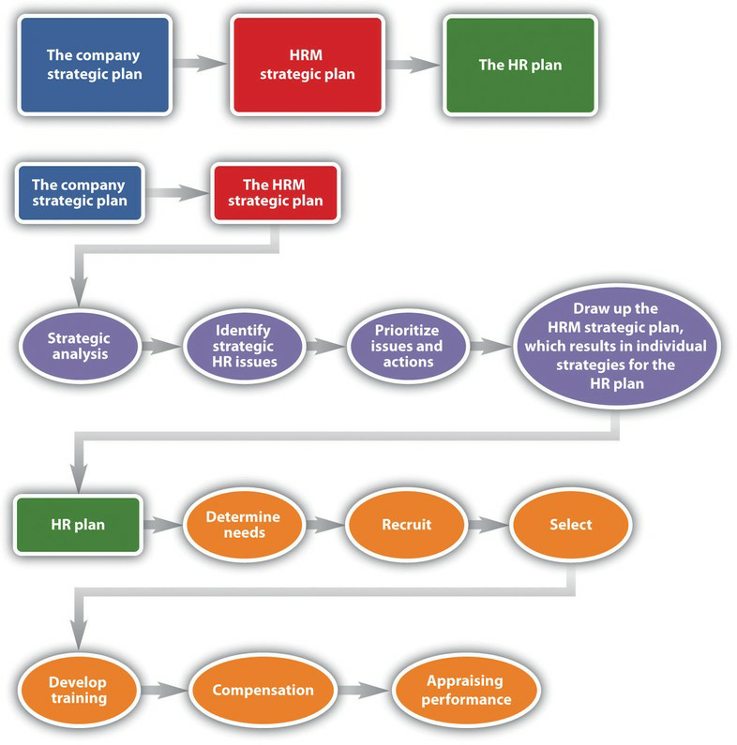
Fig. 2.2: As you can see from this figure, the company strategic plan ties into the HRM strategic plan, and from the HRM strategic plan, the HR plan can be developed.

The six parts of the HRM plan include the following:
      - Determine human resource needs. This part is heavily involved with the strategic plan. What growth or decline is expected in the organization? How will this impact your workforce? What is the economic situation? What are your forecasted sales for next year?
      - Determine recruiting strategy. Once you have a plan in place, it’s necessary to write down a strategy addressing how you will recruit the right people at the right time.

      - Select employees. The selection process consists of the interviewing and hiring process.
      - Develop training. Based on the strategic plan, what training needs are arising? Is there new software that everyone must learn? Are there problems in handling conflict? Whatever the training topics are, the HR manager should address plans to offer training in the HRM plan.
      - Determine compensation. In this aspect of the HRM plan, the manager must determine pay scales and other compensation such as health care, bonuses, and other perks.
      - Appraise performance. Sets of standards need to be developed so you know how to rate the performance of your employees and continue with their development.
Each chapter of this text addresses one area of the HR plan, but the next sections provide some basic knowledge of planning for each area.

Determine Human Resource Needs
The first part of an HR plan will consist of determining how many people are needed. This step involves looking at company operations over the last year and asking a lot of questions:
      - Were enough people hired?
      - Did you have to scramble to hire people at the last minute?
      - What are the skills your current employees possess?
      - What skills do your employees need to gain to keep up with technology?
      - Who is retiring soon? Do you have someone to replace them?
      - What are the sales forecasts? How might this affect your hiring?
These are the questions to answer in this first step of the HR plan process. As you can imagine, this cannot be done alone. Involvement of other departments, managers, and executives should take place to obtain an accurate estimate of staffing needs for now and in the future. We discuss staffing in greater detail in "Recruitment (Page 78)".
Many HR managers will prepare an inventory of all current employees, which includes their educational level and abilities. This gives the HR manager the big picture on what current employees can do. It can serve as a tool to develop employees’ skills and abilities, if you know where they are currently in their development. For example, by taking an inventory, you may find out that Richard is going to retire next year, but no one in his department has been identified or trained to take over his role. Keeping the inventory helps you know where gaps might exist and allows you to plan for these gaps. This topic is

HR managers will also look closely at all job components and will analyze each job. By doing this analysis, they can get a better picture of what kinds of skills are needed to perform a job successfully. Once the HR manager has performed the needs assessment and knows exactly how many people, and in what positions and time frame they need to be hired, he or she can get to work on recruiting, which is also called a staffing plan.

Recruit
Recruitment is an important job of the HR manager. More detail is provided in Knowing how many people to hire, what skills they should possess, and hiring them when the time is right are major challenges in the area of recruiting. Hiring individuals who have not only the skills to do the job but also the attitude, personality, and fit can be the biggest challenge in recruiting. Depending on the type of job you are hiring for, you might place traditional advertisements on the web or use social networking sites as an avenue. Some companies offer bonuses to employees who refer friends. No matter where you decide to recruit, it is important to keep in mind that the recruiting process should be fair and equitable and diversity should be considered. We discuss diversity in greater detail in
Depending on availability and time, some companies may choose to outsource their recruiting processes. For some types of high-level positions, a head hunter will be used to recruit people nationally and internationally. A head hunter is a person who specializes in matching jobs with people, and they usually work only with high-level positions. Another option is to use an agency that specializes in hiring people for a variety of positions, including temporary and permanent positions. Some companies decide to hire temporary employees because they anticipate only a short-term need, and it can be less expensive to hire someone for only a specified period of time.
No matter how it is done, recruitment is the process of obtaining résumés of people interested in the job. In our next step, we review those résumés, interview, and select the best person for the job.

Select
After you have reviewed résumés for a position, now is the time to work toward selecting the right person for the job. Although we discuss selection in great detail in Chapter 6 "Compensation and Benefits", it is worth a discussion here as well.
Numerous studies have been done, and while they have various results, the majority of studies say it costs an average of $45,000 to hire a new manager. ⁶ While this may seem exaggerated, consider the following items that contribute to the cost:

  - Time to review résumés
  - Time to interview candidates
  - Interview expenses for candidates
  - Possible travel expenses for new hire or recruiter
  - Possible relocation expenses for new hire
  - Additional bookkeeping, payroll, 401(k), and so forth
  - Additional record keeping for government agencies
  - Increased unemployment insurance costs
  - Costs related to lack of productivity while new employee gets up to speed
Because it is so expensive to hire, it is important to do it right. First, résumés are reviewed and people who closely match the right skills are selected for interviews. Many organizations perform phone interviews first so they can further narrow the field. The HR manager is generally responsible for setting up the interviews and determining the interview schedule for a particular candidate. Usually, the more senior the position is, the longer the interview process takes, even up to eight weeks. ⁷ After the interviews are conducted, there may be reference checks, background checks, or testing that will need to be performed before an offer is made to the new employee. HR managers are generally responsible for this aspect. Once the applicant has met all criteria, the HR manager will offer the selected person the position. At this point, salary, benefits, and vacation time may be negotiated. Compensation is the next step in HR management.

Determine Compensation

What you decide to pay people is much more difficult than it seems. This issue is covered in greater detail in Pay systems must be developed that motivate employees and embody fairness to everyone working at the organization. However, organizations cannot offer every benefit and perk because budgets always have constraints. Even governmental agencies need to be concerned with compensation as part of their HR plan. For example, in 2011, Illinois State University gave salary increases of 3 percent to all faculty, despite state budget cuts in other areas. They reasoned that the pay increase was needed because of the competitive nature of hiring and retaining faculty and staff. The university president said, “Our employees have had a very good year and hopefully this is a good shot in the arm that will keep our morale high. ⁸
The process in determining the right pay for the right job can have many variables, in addition to keeping morale high. First, as we have already discussed, the organization life cycle can determine the pay strategy for the organization. The supply and demand of those skills in the market, economy, region, or area in which the business is located is a determining factor in compensation strategy. For example, a company operating in Seattle may pay higher for the same job than their division in Missoula, Montana, because the cost of living is higher in Seattle. The HR manager is always researching to ensure the pay is fair and at market value. In, we get into greater detail about the variety of pay systems, perks, and bonuses that can be offered. For many organizations, training is a perk. Employees can develop their skills while getting paid for it. Training is the next step in the HR planning process.

Develop Training

Once we have planned our staffing, recruited people, selected employees, and then compensated them, we want to make sure our new employees are successful.
Training is covered in more detail in Chapter 8. One way we can ensure success is by training our employees in three main areas:
      - Company culture. A company culture is the organization’s way of doing things. Every company does things a bit differently, and by understanding the corporate culture, the employee will be set up for success. Usually this type of training is performed at an orientation, when an employee is first hired. Topics might include how to request time off, dress codes, and processes.
      - Skills needed for the job. If you work for a retail store, your employees need to know how to use the register. If you have sales staff, they need to have product knowledge to do the job. If your company uses particular software, training is needed in this area.
      - Human relations skills. These are non-job-specific skills your employees need not only to do their jobs but also to make them all-around successful employees. Skills needed include communication skills and interviewing potential employees.

Perform a Performance Appraisal
The last thing an HR manager should plan is the performance appraisal. While we discuss performance appraisals in greater detail in it is definitely worth a mention here, since it is part of the strategic plan. A performance appraisal is a method by which job performance is measured. The performance appraisal can be called many different things, such as the following:

      - Employee appraisal

      - Performance review
      - 360 review
      - Career development review
No matter what the name, these appraisals can be very beneficial in motivating and rewarding employees. The performance evaluation includes metrics on which the employee is measured. These metrics should be based on the job description, both of which the HR manager develops. Various types of rating systems can be used, and it’s usually up to the HR manager to develop these as well as employee evaluation forms. The HR manager also usually ensures that every manager in the organization is trained on how to fill out the evaluation forms, but more importantly, how to discuss job performance with the employee. Then the HR manager tracks the due dates of performance appraisals and sends out e-mails to those managers letting them know it is almost time to write an evaluation.

Recruitment and Selection
As you saw in the opening of sometimes organizations do not mean to be exclusive or discriminatory, but their practices are discriminatory and illegal. For example, the Equal Employment Opportunity Commission (EEOC) says it is illegal to publish a job advertisement that shows a preference for a particular type of person or discourages someone from applying for a job. For example, a Facebook post that says “recent college graduates wanted” might be inclusive to a younger group and discouraging to a diverse (older) workforce, not making the post multicultural. Another example might be the reliance on word-of- mouth advertisement for job openings. Suppose you have a mostly Hispanic workforce and use word of mouth for recruitment. It is likely that most new hires will also be Hispanic. This is also illegal, but perhaps a consideration is the lack of diversity you will have in your workplace with these recruitment methods.
Make sure that job announcements aren’t posted only for your Facebook friends to see; post them in a variety of places to gain the largest and most diverse response.
We address discrimination in the selection process in. However, a mention of the four-fifths rule here is important to determine how we can quantitatively evaluate discrimination in our selection practices. One way to calculate possible discrimination is by using the four-fifths rule, or 80 percent rule. The rule states that a selection rate for any race, sex, or ethnic group that is less than four- fifths of the rate for the group with the highest rate could be regarded as adverse impact. Adverse impact refers to employment practices that may appear to be neutral but have a discriminatory effect on a protected group. For example, let’s assume 100 women and 500 men applied to be firefighters. Let’s say 20 of those women were hired and 250 men were hired. To determine adverse impact based on the four-fifths rule, calculate the following:

- Selection rate for women: 20 percent
- Selection rate for men: 50 percent
- Then divide the highest selection rate: .20/.50 = .4
Because .4, or 40 percent, is less than four-fifths, there may be adverse impact in the selection process for firefighters.

Recruitment

Keeping Up with Growth
Over the last two years, the company where Melinda works as HR manager, Dragon Enterprises, has seen plenty of growth. Much of this growth has created a need for a strategic, specific recruiting processes. In the past, Dragon Enterprises recruited simply on the basis of the applications they received, rather than actively searching for the right person for the job. The first thing Melinda did when arriving at the company was to develop a job analysis questionnaire, which she had all employees fill out using the website Survey Monkey. The goal was to create a job analysis for each position that existed at the company. This happened to be the point where the organization started seeing rapid growth, as a result of increased demand for the types of parts the company sells. Luckily, since Melinda followed the industry closely and worked closely with management, part of her strategic outline planned for the hiring of several new positions, so she was mostly ready for it. Keeping in mind the Equal Employment Opportunity Commission (EEOC) laws and the company’s position on a diverse workforce, Melinda set out to write new job descriptions for the job analysis she had performed. She knew the job analysis should be tied to the job description, and both of these should be tied to the job qualifications. Obviously, to recruit for these positions, she needed to develop a recruitment plan. Over the next year, the organization needed to hire three more floor management positions, three office positions, and fifteen factory floor positions. Next, she needed to determine a time line to recruit candidates and a method by which to accept the applications she would receive. After sharing this time line with her colleague, the chief operating officer, she went to work recruiting. She sent an e-mail to all employees asking them to refer a friend and receive a $500 bonus. Next, part of her strategy was to try to find very specialized talent in management to fill those positions. For this, she thought working with a recruiting company might be the best way to go. She also used her Twitter and Facebook accounts to broadcast the job openings. After a three-week period, Melinda had 54 applications for the management positions, 78 for the office positions, and 110 for the factory floor positions. Pleased with the way recruiting had gone, she started reviewing the résumés to continue with the selection process.

The Recruitment Process
The recruitment process is an important part of human resource management (HRM). It isn’t done without proper strategic planning. Recruitment is defined as a process that provides the organization with a pool of qualified job candidates from which to choose. Before companies recruit, they must implement proper staffing plans and forecasting to determine how many people they will need. The basis of the forecast will be the annual budget of the organization and the short- to long-term plans of the organization—for example, the possibility of expansion. In addition to this, the organizational life cycle will be a factor. Organization life cycle is discussed in. Forecasting is based on both internal and external factors. Internal factors include the following:
    - Budget constraints
    - Expected or trend of employee separations
    - Production levels
    - Sales increases or decreases
    - Global expansion plans

Recruitment Strategy
Although it might seem easy, recruitment of the right talent, at the right place and at the right time, takes skill and practice, but more importantly, it takes strategic planning. In development of staffing plans is discussed. An understanding of the labor market and the factors determining the relevant aspects of the labor market is key to being strategic about your recruiting processes.
Based on this information, when a job opening occurs, the HRM professional should be ready to fill that position. Here are the aspects of developing a recruitment strategy:
      - Confirm the job analysis is correct through questionnaires.
      - Write the job description and job specifications.
      - Have a bidding system to recruit and review internal candidate qualifications for possible promotions.
      - Determine the best recruitment strategies for the position.
      - Implement a recruiting strategy.
The first step in the recruitment process is acknowledgment of a job opening. At this time, the manager and/or the HRM look at the job description for the job opening (assuming it isn’t a new job). We discuss how to write a job analysis and job description.
Assuming the job analysis and job description are ready, an organization may decide to look at internal candidates’ qualifications first. Internal candidates are people who are already working for the company. If an internal candidate meets the qualifications, this person might be encouraged to apply for the job, and the job opening may not be published. Many organizations have formal job posting procedures and bidding systems in place for internal candidates. For example, job postings may be sent to a listserv or other avenue so all employees have access to them. However, the advantage of publishing open positions to everyone in and outside the company is to ensure the organization is diverse. Diversity is discussed in We discuss more about internal and external candidates and bidding systems.
Then the best recruiting strategies for the type of position are determined. For example, for a high-level executive position, it may be decided to hire an outside head- hunting firm. For an entry-level position, advertising on social networking websites
might be the best strategy. Most organizations will use a variety of methods to obtain the best results. We discuss specific strategies.
Another consideration is how the recruiting process will be managed under constraining circumstances such as a short deadline or a low number of applications. In addition, establishing a protocol for how applications and résumés will be processed will save time later. For example, some HRM professionals may use software such as Microsoft Excel to communicate the time line of the hiring process to key managers.
Once these tasks are accomplished, the hope is that you will have a diverse group of people to interview (called the selection process). Before this is done, though, it is important to have information to ensure the right people are recruited. This is where the job analysis and job description come in.
Job Analysis and Job Descriptions
The job analysis is a formal system developed to determine what tasks people actually perform in their jobs. The purpose of a job analysis is to ensure creation of the right fit between the job and the employee and to determine how employee performance will be assessed. A major part of the job analysis includes research, which may mean reviewing job responsibilities of current employees, researching job descriptions for similar jobs with competitors, and analyzing any new responsibilities that need to be accomplished by the person with the position. According to research by Hackman and Oldham, ¹ a job diagnostic survey should be used to diagnose job characteristics prior to any redesign of a job.
To start writing a job analysis, data need to be gathered and analyzed, keeping in mind Hackman and Oldham’s model. Figure 4.1 "Process for Writing the Job Analysis"shows the process of writing a job analysis. Please note, though, that a job analysis is different from a job design. Job design refers to how a job can be modified or changed to be more effective—for example, changing tasks as new technology becomes available. .

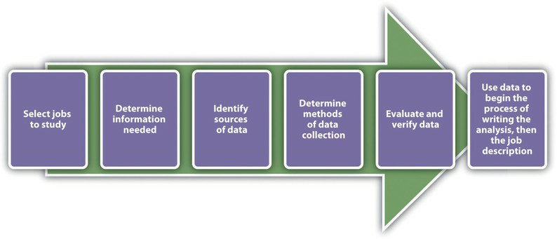
Campus Recruiting

Colleges and universities can be excellent sources of new candidates, usually at entry- level positions. Consider technical colleges that teach cooking, automotive technology, or cosmetology. These can be great sources of people with specialized training in a specific area. Universities can provide people that may lack actual experience but have formal training in a specific field. Many organizations use their campus recruiting programs to develop new talent, who will eventually develop into managers.
For this type of program to work, it requires the establishment of relationships with campus communities, such as campus career services departments. It can also require time to attend campus events, such as job fairs. IBM, for example, has an excellent campus recruiting program. For IBM, recruiting out of college ensures a large number of people to grow with the organization. ⁶
Setting up a formal internship program might also be a way to utilize college and university contacts. Walgreens, for example, partners with Apollo College to recruit interns; this can result in full-time employment for the motivated intern and money saved for Walgreens by having a constant flow of talent.

The Interview
Many of us have or will sit in a waiting room with our best clothes on awaiting a job (or school) interview. You can feel your palms sweat and thoughts race as you wait for your name to be called. You look around at the office environment and imagine yourself walking through those doors everyday. People walk by and smile, and overall, you have a really good first impression of the organization. You hope they like you.
You tell yourself to remember to smile, while recalling all your experience that makes you the perfect person for this job. A moment of self-doubt may occur, as you wonder about the abilities of the other people being interviewed and hope you have more experience and make a better impression than they do. You hear your name, stand up, and give a firm handshake to the HR manager. The interview has begun.
As she walks you back to a conference room, you think you see encouraging smiles as you pass by people. She asks you to take a chair and then tells you what the interview process will be like. She then asks the first question, “Tell me about yourself.” As you start discussing your experience, you feel yourself relax, just a little bit. After the interview finishes, she asks you to take a quick cognitive test, which you feel good about. She tells you she will be doing reference checks and will let you know by early next week.
To get to this point, the hiring manager may have reviewed hundreds of résumés and developed criteria she would use for selection of the right person for the job. She has probably planned a time line for hiring, developed hiring criteria, determined a compensation package for the job, and enlisted help of other managers to interview candidates. She may have even performed a number of phone interviews before bringing only a few of the best candidates in for interviews. It is likely she has certain qualities in mind that she is hoping you or another candidate will possess. Much work goes into the process of hiring someone, with selection being an important step in that process. A hiring process done correctly is time-consuming and precise. The interviewer should already have questions determined and should be ready to sell the organization to the candidate as well. This chapter will discuss the main components to the selection process.

Compensation and Benefits

Matching Compensation with Core Values
As you sit down to review the compensation package your company offers, one thing that stands out is that your compensation package no longer matches the core values of your organization. When your organization merged five years ago with a similar firm that specializes in online shoe retailing, your company had to hire hundreds of people to keep up with growth. As a result—and what happens with many companies—the compensation plans are not revised and revisited as they should be. The core values your company adopted from the merging company focused on customer service, freedom to work where employees felt they could be most productive, and continuing education of employees, whether or not the education was related to the organization. The compensation package, providing the basic salary, health benefits, and 401(k) plans, seems a bit old-fashioned for the type of company yours has become.
After reviewing your company’s strategic plan and your human resource management (HRM) strategic plan, you begin to develop a compensation plan that includes salary, health benefits, and 401(k) plans, but you feel it might be smart to better meet the needs of your employees by making some changes to these existing plans. For example, you are considering implementing a team bonus program for high customer service ratings and coverage for alternative forms of medicine, such as acupuncture and massage. Instead of guessing what employees would like to see in their compensation packages, you decide to develop a compensation survey to assess what benefits are most important to your employees. As you begin this task, you know it will be a lot of work, but it’s important to the continued recruitment, retention, and motivation of your current employees.

large companies, this may work fine, but smaller, more agile organizations may use other methods to determine pay structure. For example, some organizations have moved to adelayering and banding process, which cuts down the number of pay levels within the organization. General Electric delayered pay grades in the mid-1990s because it found that employees were less likely to take a reassignment that was at a lower pay grade, even though the assignment might have been a good development opportunity. ¹⁰ So, delayering enables a broader range of pay and more flexibility within each level. Sometimes this type of process also occurs when a company downsizes. Let’s assume a company with five hundred employees has traditionally used a pay grade model but decided to move to a more flexible model. Rather than have, say, thirty pay levels, it may reduce this to five or six levels, with greater salary differentials within the grades themselves. This allows organizations to better reward performance, while still having a basic model for hiring managers to follow.
Rather than use a pay grade scale, some organizations use a going rate model. In this model, analysis of the going rate for a particular job at a particular time is considered when creating the compensation package. This model can work well if market pressures or labor supply-and-demand pressures greatly impact your particular business. For example, if you need to attract the best project managers, but more are already employed (lack of supply)—and most companies are paying $75,000 for this position—you will likely need to pay the same or more, because of labor supply and demand. Many tools are available, such as salarywizard.com, to provide going rate information on particular jobs in every region of the United States.
Another pay model is the management fit model. In this model, each manager makes a decision about who should be paid what when that person is hired. The downside to this model may be potential discrimination, halo effects, and resentment within the organization. Of course, these factors can create morale issues, the exact thing we want to avoid when compensating employees.
In addition to the pay level models we just looked at, other considerations might include the following:
      - Skill-based pay. With a skill-based pay system, salary levels are based on an employee’s skills, as opposed to job title. This method is implemented similarly to the pay grade model, but rather than job title, a set of skills is assigned a particular pay grade.
      - Competency-based pay. Rather than looking at specific skills, the competency- based approach looks at the employee’s traits or characteristics as opposed to a specific skills set. This model focuses more on what the employee can become as opposed to the skills he or she already has.
      - Broadbanding. Broadbanding is similar to a pay grade system, except all jobs in a particular category are assigned a specific pay category. For example, everyone working in customer service, or all administrative assistants (regardless of department), are paid within the same general band. McDonald’s uses this

- Gerald Ferris, Handbook of Human Resource Management (Cambridge, MA: Blackwell, 1995).

compensation philosophy in their corporate offices, stating that it allows for flexibility in terms of pay, movement, and growth of employees. ¹¹
      - Variable pay system. This type of system provides employees with a pay basis but then links the attainment of certain goals or achievements directly to their pay. For example, a salesperson may receive a certain base pay but earn more if he or she meets the sales quota.
How Would You Handle This?
You have been working for your organization for five years. After lots of hard work, you are promoted to sales manager. One of your first tasks is to develop goals for your sales team, then create a budget based on these goals. First, you look at the salaries of all the sales staff to find major pay discrepancies. Some salespeople, who perform equally well, are paid much lower than some sales staff whom you consider to be nonperformers. As you dig deeper, you see this is a problem throughout the sales team. You are worried this might affect motivation for your team if they find out what others are making. How would you handle this?

Chapter 7 Retention and Motivation

Dissatisfaction Isn’t Always about Pay
Available under Creative Commons-ShareAlike 4.0 International License (http:// creativecommons.org/licenses/by-sa/4.0/).
As an HR consultant, your job normally involves reviewing HR strategic plans and systems of small to medium size companies, then making recommendations on how to improve. Most of the companies you work with do not have large HR departments, and they find it less expensive to hire you than to hire a full-time person.
Your current client, Pacific Books, is a small online retailer with forty-seven employees. Pacific Books has had some challenges, and as the economy has improved, several employees have quit. They want you to look into this issue and provide a plan to improve retention.
Pacific Books currently has just one person managing payroll and benefits. The individual managers in the organization are the ones who handle other HR aspects, such as recruiting and developing compensation plans. As you speak with the managers and the payroll and benefits manager, it is clear employees are not happy working for this organization. You are concerned that if the company does not improve its employee retention, they will spend an excessive amount of time trying to recruit and train new people, so retention of the current employees is important.
As with most HR issues, rather than just guessing what employees want, you develop a survey to send to all employees, including management. You developed the survey on Survey Monkey and asked employee satisfaction questions surrounding pay and benefits. However, you know that there are many other things that can cause someone to be unhappy at work, so to take this survey a step further, you decide to ask questions about the type of work employees are doing, management style, and work-life balance. Then you send out a link to all employees, giving them one week to take the survey.
When the results come in, they are astounding. Out of the forty-seven employees, forty-three selected “dissatisfied” on at least four or more areas of the five-question survey. While some employees are not happy with pay and benefits, the results say that other areas of the organization are actually what are causing the dissatisfaction. Employees are feeling micromanaged and do not have freedom over their time. There are also questions of favoritism by some managers for some employees, who always seem to get the “best” projects. When you sit down with the CEO to discuss the survey results, at first she defends the organization by saying the company offers the highest salaries and best benefits in the industry, and she doesn’t understand how someone can be dissatisfied. You explain to her that employee retention and motivation is partly about pay and benefits, but it includes other aspects of the employee’s job, too. She listens intently and then asks you to develop a retention and motivation plan that can improve the organization.

The Costs of Turnover
Available under Creative Commons-ShareAlike 4.0 International License (http:// creativecommons.org/licenses/by-sa/4.0/).
Learning Objectives

- Be able identify the difference between direct and indirect turnover costs.
- Describe some of the reasons why employees leave.

- Explain the components of a retention plan.

According to the book Keeping the People Who Keep You in Business by Leigh Branham, ¹ the cost of losing an employee can range from 25 percent to 200 percent of that employee’s salary. Some of the costs cited revolve around customer service disruption and loss of morale among other employees, burnout of other employees, and the costs of hiring someone new. Losing an employee is called turnover.
There are two types of turnover, voluntary turnover and involuntary turnover. Voluntary turnover is the type of turnover that is initiated by the employee for many different reasons. Voluntary turnover can be somewhat predicted and addressed in HR, the focus of this chapter. Involuntary turnover is where the employee has no choice in their termination—for example, employer-initiated due to nonperformance. This is discussed further in "Successful Employee Communication (Page 263)".
It has been suggested that replacement of an employee who is paid $8 per hour can range upwards of $4,000. ² Turnover can be calculated by separations during the time period (month)/total number of employees midmonth × 100 = the percentage of turnover. For example, let’s assume there were three separations during the month of August and 115 employees midmonth. We can calculate turnover in this scenario by 3/ 115 × 100 = 2.6% turnover rate.
This gives us the overall turnover rate for our organization. We may want to calculate turnover rates based on region or department to gather more specific data. For example, let’s say of the three separations, two were in the accounting department.
We have ten people in the accounting department. We can calculate that by accounting: 2/10 × 100 = 20% turnover rate.

- Leigh Branham, Keeping the People Who Keep You in Business (New York: American Management Association, 2000), 6.
- Noel Paiement “It Will Cost You $4,000 to Replace Just One $8 per Hour Employee,” Charity Village, July 13, 2009, accessed August 30, 2011,http://www.charityvillage.com/cv/research/rhr50.html.

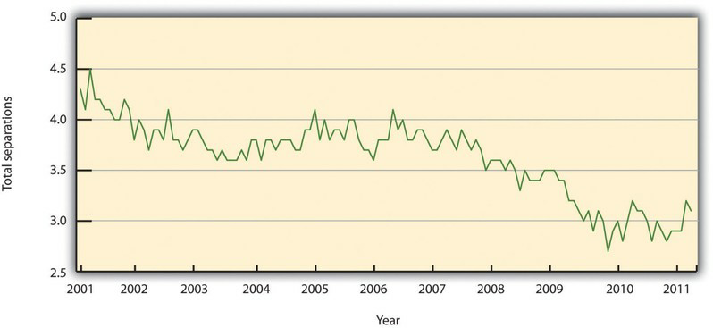
Fig. 7.1: United States Yearly Turnover Statistics, 2001–11 Source: Data from Bureau of Labor Statistics, “Job Openings and Labor Turnover Survey,” accessed August 11, 2011, http://www.bls.gov/

The turnover rate in accounting is alarmingly high compared to our company turnover rate. There may be something happening in this department to cause unusual turnover. Some of the possible reasons are discussed in "Reasons for Voluntary Turnover (Page 192)".
In HR, we can separate the costs associated with turnover into indirect costs and direct costs. Direct turnover costs include the cost of leaving, replacement costs, and transition costs, while indirect turnover costs include the loss of production and reduced performance. The following are some examples of turnover costs: ³
- Recruitment of replacements
- Administrative hiring costs
- Lost productivity associated with the time between the loss of the employee and hiring of replacement
- Lost productivity due to a new employee learning the job
- Lost productivity associated with coworkers helping the new employee
- Costs of training
- Costs associated with the employee’s lack of motivation prior to leaving
- Sometimes, the costs of trade secrets and proprietary information shared by the employee who leaves
- Public relations costs
•

- Carl. P. Maertz, Jr. and M. A. Campion, “25 Years of Voluntary Turnover Research: A Review and Critique,” in International Review of Industrial and Organizational Psychology, vol. 13, ed. Cary L. Cooper and Ivan T. Robertson (London: John Wiley, 1998), 49–86.

To avoid these costs, development of retention plans is an important function of the HR strategic plan. Retention plans outline the strategies the organization will use to reduce turnover and address employee motivation.

Direct | Indirect
Recruitment costs | Lost knowledge
Advertising costs for new position | Loss of productivity while new employee is brought up to speed
Orientation and training of new employee | Cost associated with lack of motivation prior to leaving
Severance costs | Cost associated with loss of trade secrets
Testing costs
Time to interview new replacements
Time to recruit and train new hires

Table 7.1: Turnover Costs

    - Reasons for Voluntary Turnover
Available under Creative Commons-ShareAlike 4.0 International License (http:// creativecommons.org/licenses/by-sa/4.0/).
Before we discuss specific details on retention planning, it is important to address the reasons why people choose to leave an organization to begin with. One mistake HR professionals and managers make is to assume people leave solely on the basis of their unhappiness with their compensation packages. Many factors can cause demotivated employees, which we discuss in "Theories on Job Dissatisfaction (Page 196)".
Once we find out what can cause voluntary turnover, we can develop retention strategies to reduce turnover. Some of the common reasons employees leave organizations can include the following:

- A poor match between the job and the skills of the employee. This issue is directly related to the recruitment process. When a poor match occurs, it can cause frustration for the employee and for the manager. Ensuring the recruitment phase is viable and sound is a first step to making sure the right match between job and skills occurs.
- Lack of growth. Some employees feel “stuck” in their job and don’t see a way to have upward mobility in the organization. Implementing a training plan and developing a clearly defined path to job growth is a way to combat this reason for leaving.
- Internal pay equity. Some employees, while they may not feel dissatisfied with their own pay initially, may feel dissatisfaction when comparing their pay with others. Remember the pay equity theory discussed in "Compensation and Benefits (Page 146)"? This theory relates to one reason why people leave.
- Management. Many employees cite management as their reason for leaving. This can be attributed to overmanaging (micromanaging) people, managers not being fair or playing favorites, lack of or poor communication by managers, and unrealistic expectations of managers.
- Workload. Some employees feel their workloads are too heavy, resulting in employees being spread thin and lacking satisfaction from their jobs, and possibly, lack of work-life balance as a result. We know that some people will move or perhaps their family situation changes. This type of turnover is normal and expected. Figure 7.2 "Common Reasons for Employee Turnover" shows other examples of why people leave organizations.

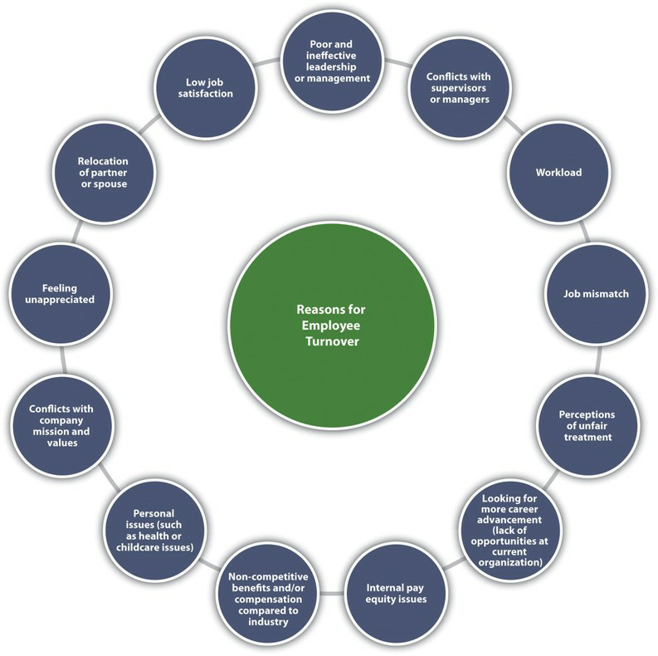
Fig. 7.2: Common Reasons for Employee Turnover

As HR professionals and managers, we want to be sure we have plans in place to keep our best people. One such plan is the retention plan, which we will discuss in "Retention Plans (Page 195)".
Key Takeaways
Human Resource Recall

Do you feel your current or past organization did a good job of reducing turnover? Why or why not?

- Retaining employees is an important component to a healthy organization. Losing an employee is called turnover. Turnover can be very expensive to an organization, which is why it is important to develop retention plans to manage turnover.
- Voluntary turnover is turnover that is initiated by the employee, whileinvoluntary turnover is initiated by the organization for various reasons such as nonperformance.

- Direct turnover costs and indirect turnover costs can include the costs associated with employee replacement, declining employee morale, or lost customers.
- Some of the reasons why employees leave can include a poor match between job and skills, no growth potential, pay inequity among employees, the fairness and communication style of management, and heavy workloads.
1. Perform an Internet search of average employee turnover cost and report findings from at least three different industries or companies.

Retention Plans
Exercises
Available under Creative Commons-ShareAlike 4.0 International License (http:// creativecommons.org/licenses/by-sa/4.0/).
Learning Objectives

- Be able to discuss some of the theories on job satisfaction and dissatisfaction.
- Explain the components of a retention plan.

Effective high-performance work systems (HPWS) is the name given to a set of systematic HR practices that create an environment where the employee has greater involvement and responsibility for the success of the organization. A high- performance work system is a strategic approach to many of the things we do in HR, including retention. Generally speaking, a HPWS gets employees involved in conceiving, designing, and implementing processes that are better for the company and better for the employee, which increases retention. Figure 7.4 "HR Components of a HPWS"gives an example of HR’s part in creating these systems.

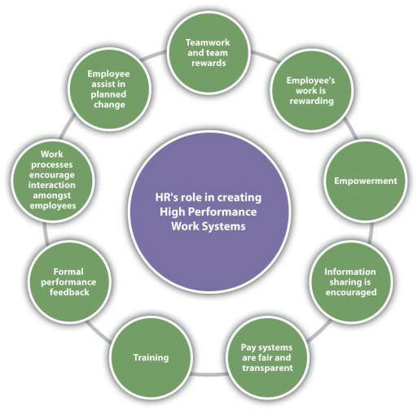
Fig. 7.3: HR Components of a HPWS

Keeping HPWS in mind, we can begin to develop retention plans. The first step in this process is to understand some of the theories on job satisfaction and dissatisfaction. Next, we can gather data as to the satisfaction level of our current employees. Then we can begin to implement specific strategies for employee retention.

Theories on Job Dissatisfaction
Available under Creative Commons-ShareAlike 4.0 International License (http:// creativecommons.org/licenses/by-sa/4.0/).
There are a number of theories that attempt to describe what makes a satisfied employee versus an unsatisfied employee. While you may have learned about these theories in another class, such as organizational behavior, they are worth a review here to help us better understand employee satisfaction from an HR perspective.

Progression of Job Withdrawal
Available under Creative Commons-ShareAlike 4.0 International License (http:// creativecommons.org/licenses/by-sa/4.0/).
The first step to developing a retention plan is understanding some of the theories surrounding job satisfaction. One of the basic theories is the progression of job

withdrawal theory, developed by Dan Farrell and James Petersen. ⁴ It says that people develop a set of behaviors in succession to avoid their work situation. These behaviors include behavior change, physical withdrawal, and psychological withdrawal.
Within the behavior change area, an employee will first try to change the situation that is causing the dissatisfaction. For example, if the employee is unhappy with the management style, he or she might consider asking for a department move. In the physical withdrawal phase, the employee does one of the following:
- Leaves the job
- Takes an internal transfer
- Starts to become absent or tardy
If an employee is unable to leave the job situation, he or she will experience psychological withdrawal. They will become disengaged and may show less job involvement and commitment to the organization, which can create large costs to the organization, such as dissatisfied customers.
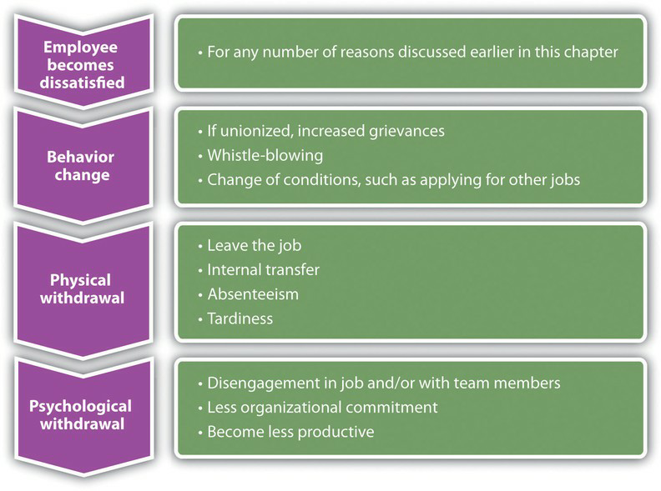
Fig. 7.4: Process of Job Withdrawal

- Dan Farrell and James C. Petersen, “Commitment, Absenteeism and Turnover of New Employees: A Longitudinal Study,” Human Relations 37, no. 8 (August 1984): 681–692, accessed August 26, 2011,http://libres.uncg.edu/ir/uncg/f/ J_Petersen_Commitment_1984.pdf.

Hawthorne Studies
Available under Creative Commons-ShareAlike 4.0 International License (http:// creativecommons.org/licenses/by-sa/4.0/).
Between 1927 and 1932, a series of experiments were conducted by Elton Mayo in the Western Electric Hawthorne Works company in Illinois. ⁵ Mayo developed these experiments to see how the physical and environmental factors of the workplace, such as lighting and break times, would affect employee motivation.
This was some of the first research performed that looked at human motivation at work. His results were surprising, as he found that no matter which experiments were performed, worker output improved. His conclusion and explanation for this was the simple fact the workers were happy to receive attention from researchers who expressed interest in them. As a result, these experiments, scheduled to last one year, extended to five years to increase the knowledge base about human motivation.
The implication of this research applies to HR and managers even today. It tells us that our retention plans must include training and other activities that make the employee feel valued.

Maslow’s Hierarchy of Needs
Available under Creative Commons-ShareAlike 4.0 International License (http:// creativecommons.org/licenses/by-sa/4.0/).
In 1943, Abraham Maslow developed what was known as the theory of human motivation. ⁶ His theory was developed in an attempt to explain human motivation. According to Maslow, there is a hierarchy of five needs, and as one level of need is satisfied, it will no longer be a motivator. In other words, people start at the bottom of the hierarchy and work their way up. Maslow’s hierarchy consists of the following:
      - Self-actualization needs
      - Esteem needs
      - Social needs
      - Safety needs
      - Physiological needs
Physiological needs are our most basic needs, including food, water, and shelter. Safety needs at work might include feeling safe in the actual physical environment, or job security. As humans, we have the basic need to spend time with others. Esteem needs refer to the need we have to feel good about ourselves. Finally, self- actualization needs are the needs we have to better ourselves.
The implications of his research tell us, for example, that as long as an employee’s physiological needs are met, increased pay may not be a motivator. Likewise,
- Elton Mayo, The Social Problems of an Industrial Civilization (1949; repr., New York: Arno Press, 2007).
- Abraham Maslow, Toward a Psychology of Being, 3rd ed. (New York: Wiley, 1999).

employees should be motivated at work by having all needs met. Needs might include, for example, fair pay, safety standards at work, opportunities to socialize, compliments to help raise our esteem, and training opportunities to further develop ourselves.

Herzberg Two-Factor Theory
Available under Creative Commons-ShareAlike 4.0 International License (http:// creativecommons.org/licenses/by-sa/4.0/).
In 1959, Frederick Herzberg published The Motivation to Work, ⁷ which described his studies to determine which aspects in a work environment caused satisfaction or dissatisfaction. He performed interviews in which employees were asked what pleased and displeased them about their work. From his research, he developed the motivation-hygiene theory to explain these results.
The things that satisfied the employees were motivators, while the dissatisfiers were the hygiene factors. He further said the hygiene factors were not necessarily motivators, but if not present in the work environment, they would actually cause demotivation. In other words, the hygiene factors are expected and assumed, while they may not necessarily motivate.
His research showed the following as the top six motivation factors:
- Achievement
- Recognition
- The work itself
- Responsibility
- Advancement
- Growth
The following were the top six hygiene factors:
- Company policies
- Supervision
- Relationship with manager
- Work conditions
- Salary
- Relationship with peers
The implication of this research is clear. Salary, for example, is on the hygiene factor list. Fair pay is expected, but it doesn’t actually motivate someone to do a better job.
- Frederick Herzberg, Bernard Mausner, and Barbara Bloch Snyderman, The Motivation to Work (New Brunswick, NJ: Transaction Publishers, 1993).

On the other hand, programs to further develop employees, such as management training programs, would be considered a motivator. Therefore, our retention plans should be focused on the area of fair salary of course, but if they take the direction of Herzberg’s motivational factors, the actual motivators tend to be the work and recognition surrounding the work performed.

McGregor
Available under Creative Commons-ShareAlike 4.0 International License (http:// creativecommons.org/licenses/by-sa/4.0/).
Douglas McGregor proposed the X-Y theory in his 1960 book called The Human Side of Enterprise. ⁸ McGregor’s theory gives us a starting point to understanding how management style can impact the retention of employees. His theory suggests two fundamental approaches to managing people. Theory X managers, who have an authoritarian management style, have the following fundamental management beliefs:
      - The average person dislikes work and will avoid it.
      - Most people need to be threatened with punishment to work toward company goals.
      - The average person needs to be directed.
      - Most workers will avoid responsibility.
Theory Y managers, on the other hand, have the following beliefs: Most people want to make an effort at work.
      - People will apply self-control and self-direction in pursuit of company objectives.
      - Commitment to objectives is a function of expected rewards received.
      - People usually accept and actually welcome responsibility.
      - Most workers will use imagination and ingenuity in solving company problems.
As you can see, these two belief systems have a large variance, and managers who manage under the X theory may have a more difficult time retaining workers and may see higher turnover rates. As a result, it is our job in HR to provide training opportunities in the area of management, so our managers can help motivate the employees. Training is a large part of the retention plan. This will be addressed in more detail in "Implementing Retention Strategies (Page 207)".
Human Resources Recall

Carrot and Stick
Available under Creative Commons-ShareAlike 4.0 International License (http:// creativecommons.org/licenses/by-sa/4.0/).
It is unknown for sure where this term was first used, although some believe it was coined in the 1700s during the Seven Years’ War. In business today, the stick approach refers to “poking and prodding” to get employees to do something. The carrot approach refers to the offering of some reward or incentive to motivate employees.
Many companies use the stick approach, as in the following examples:
- If you don’t increase your sales by 10 percent, you will be fired.
- Everyone will have to take a pay cut if we don’t produce 15 percent more than we are currently producing.
As you can see, the stick approach takes a punitive look at retention, and we know this may motivate for a short period of time, but not in the long term.
The carrot approach might include the following:
- If you increase sales by 10 percent, you will receive a bonus.
- If production increases by 15 percent, the entire team will receive an extra day off next month.
The carrot approach takes a much more positive approach to employee motivation but still may not be effective. For example, this approach can actually demotivate employees if they do not feel the goal is achievable. Also, if organizations use this as the only motivational technique, ignoring physiological rewards such as career growth, this could be a detriment as well. This approach is used as a retention method, usually as part of a compensation plan.
All the employee satisfaction theories we have discussed have implications for the development of our retention plans and reduction of turnover. These theories can be intertwined into the specific retention strategies we will implement. This is discussed in Section 7.3.1 "Salaries and Benefits".

Sources of Employee Satisfaction Data
Available under Creative Commons-ShareAlike 4.0 International License (http:// creativecommons.org/licenses/by-sa/4.0/).
After we have an understanding of why employees leave and employee satisfaction theories, research is our next step in developing a retention plan that will work for your organization. There isn’t a “one size fits all” approach to retention planning, so the research component is essential to formulate a plan that will make a difference in turnover rates.
Research can be performed in two ways. First, exit interviews of employees who are leaving the organization can provide important retention information.

Anexit interview is an interview performed by HR or a manager that seeks information as to what the employee liked at the organization and what they see should be improved. Exit interviews can be a valuable way to gather information about employee satisfaction and can serve as a starting point for determining any retention issues that may exist in the organization. However, the exit survey data should be reviewed over longer periods of time with several employees, so we can be sure we are not making retention plans based on the feedback of only a few people.
Sample Exit Interview Questions

- What is your primary reason for leaving?

- What did you like most about your job?

- What did you like least about your job?

- Did you feel there was room for growth in your job?

- What incentives did you utilize while at our company?

- Which incentives would you change and why?

- Did you have enough training to do your job effectively?

The second way to perform research is through employee satisfaction surveys. A standardized and widely used measure of job satisfaction is
thejob descriptive index (JDI) survey. While JDI was initially developed in 1969 at Bowling Green State University, it has gone through extensive revisions, the most recent one in 2009. JDI looks at five aspects of job satisfaction, including present job, present pay, opportunities for promotion, supervision, and coworkers. ⁹ Each of the five facets contains nine or eighteen questions; the survey can be given in whole or measure only one facet. The value of the scale is that an HR manager can measure job satisfaction over a period of time and compare current results to past results and even compare job satisfaction at their company versus their industry. This allows the HR manager to consider changes in the organization, such as a change in compensation structure, and see how job satisfaction is impacted by the change.
Any type of survey can provide information on the employee’s satisfaction with their manager, workload, and other satisfaction and motivational issues. An example of a general employee satisfaction survey is shown in Figure 7.7 "A Sample Employee Satisfaction Survey". However, a few things should be considered when developing an employee satisfaction survey:
- Communicate the purpose and goal of the survey.
- Once the survey is complete, communicate what changes have been made as a result of the survey.
- Assure employees their responses will be anonymous and private.

9. “Job Descriptive Index,” JDI Research Group, Bowling Green State University, accessed July 29, 2011, http://www.bgsu.edu/departments/psych/io/jdi/page54706.html.

- Involve management and leadership in the survey development.
- Ask clear, concise questions that get at the root of morale issues.
Once data have been gathered and analyzed, we can formulate our retention plans. Our plan should always be tied to the strategic goals of the organization and the HPWS previously developed, and awareness of motivational theories should be coupled with the plans. Here are the components of a retention plan:
- JDI survey results, other survey results, and exit interview findings
- Current retention plans, strengths, and weaknesses
- Goals of a retention plan (e.g., reduce turnover by 10 percent)
- Individual strategies to meet retention and turnover reduction goals.
- Budgeting. An understanding of how your retention plans will impact the payroll budget is important. See Video 7.2 for an example on how to calculate turnover costs and compare those to costs saved with an effective retention strategy.
In "Implementing Retention Strategies (Page 207)", we will discuss the implementation of specific retention strategies.

Team Activity

- Following is a list of some possible retention strategies. Rank each one in order of importance to you as an employee (1 being the most important), then share your rankings with classmates:

  - Salary

  - Opportunity for bonuses, profit sharing

  - Benefits

  - Opportunity to grow professionally with the organization

  - Team bonuses

  - More paid time off

  - Option to telecommute

  - Flextime scheduling

  - Sense of empowerment

  - Tuition reimbursement

  - Job satisfaction

Chapter 8 Training and Development

Training: Not Like It Used to Be
Available under Creative Commons-ShareAlike 4.0 International License (http:// creativecommons.org/licenses/by-sa/4.0/).
Imagine this: You have a pile of work on your desk and as you get started, your Outlook calendar reminds you about a sexual harassment training in ten minutes. You groan to yourself, not looking forward to sitting in a conference room and seeing PowerPoint slide after PowerPoint slide. As you walk to the conference room, you run into a colleague who is taking the same training that day and commiserate on how boring this training is probably going to be. When you step into the conference room, however, you see something very different.
Computers are set up at every chair with a video ready to start on the computer. The HR manager greets you and asks you to take a seat. When the training starts, you are introduced (via video) on each of the computers to a series of sexual harassment example scenarios. The videos stop, and there is a recorded discussion about what the videos portrayed. Your colleagues in the Washington, DC, office are able to see the same training and, via video conferencing, are able to participate in the discussions. It is highly interactive and interesting. Once the training is finished, there are assignments to be completed via specific channels that have been set up for this training. You communicate about the material and complete the assignments in teams with members of your Washington, DC, office. If you want to review the material, you simply click on a review and the entire session or parts of the training can be reviewed. In fact, on your bus ride home from work, you access the channels on your iPhone, chatting with a colleague in your other office about the sexual harassment training assignment you have due next week. You receive an e-mail from your HR manager asking you to complete a training assessment located in a specific channel in the software, and you happily comply because you have an entirely new perspective on what training can be.
This is the training of today. No longer do people sit in hot, stuffy rooms to get training on boring content. Training has become highly interactive, technical, and interesting owing to the amount of multimedia we can use. Sun Microsystems, for example, has developed just the kind of software mentioned above, called Social Learning eXchange (SLX). This type of training allows people across the country to connect with each other, saving both money and time. In fact, Sun Microsystems received a Best Practices Award from Training Magazine for this innovative software in 2010. ¹ The SLX software allows training to be delivered in an interactive manner in multiple locations. The implications of this type of software are numerous. For example, SLX is used at Sun Professional Services division by delivering instructional videos on tools and software, which employees can view at their own pace. ² There is also a channel in the
- 2010 Top 25 Winners,” Training Magazine, accessed July 25, 2010,http://www.trainingmag.com/article/ 2010-top-125-winners.
- “Video Community for the Enterprise,” Social Learning eXchange, accessed July 25, 2010,http://www.slideshare.net/ sociallearningexchange/social-learning-exchange-slx?from=share_email.

software that allows the vice president to communicate with employees on a regular basis to improve employee communications. In another example, this software can be used to quickly communicate product changes to the sales team, who then begin the process of positioning their products to consumers. Training videos, including breakout sessions, can save companies money by not requiring travel to a session.
These can even be accessed using application technology on cell phones. Employees can obtain the training they need in the comfort of their own city, office, or home.
Someone is sick the day the training is delivered? No problem; they can review the recorded training sessions.
An estimated $1,400 per employee is spent on training annually, with training costs consuming 2.72 percent of the total payroll budget ³ for the average company. With such a large amount of funds at stake, HR managers must develop the right training programs to meet the needs; otherwise, these funds are virtually wasted. This chapter is all about how to assess, develop, implement, and measure an effective training program.

Steps to Take in Training an Employee
Available under Creative Commons-ShareAlike 4.0 International License (http:// creativecommons.org/licenses/by-sa/4.0/).
Learning Objective

1. Explain the four steps involved when training an employee.

Any effective company has training in place to make sure employees can perform his or her job. During the recruitment and selection process, the right person should be hired to begin with. But even the right person may need training in how your company does things. Lack of training can result in lost productivity, lost customers, and poor relationships between employees and managers. It can also result in dissatisfaction, which means retention problems and high turnover. All these end up being direct costs to the organization. In fact, a study performed by the American Society for Training and Development (ASTD) found that 41 percent of employees at companies with poor training planned to leave within the year, but in companies with excellent training, only 12 percent planned to leave. ⁴ To reduce some costs associated with not
training or undertraining, development of training programs can help with some of the risk. This is what this chapter will address.
For effective employee training, there are four steps that generally occur. First, the new employee goes through an orientation, and then he or she will receive in-house training on job-specific areas. Next, the employee should be assigned a mentor, and then, as comfort with the job duties grows, he or she may engage in external training. Employee training and development is the process of helping employees develop their personal and organization skills, knowledge, and abilities.

- See the American Society for Training and Development Trend Review, ASTD Website, accessed July 25, 2010, http://www.astd.org/.
- Leigh Branham, The 7 Hidden Reasons Why Employees Leave (New York: American Management Association,2005), 112–5.

Employee Orientation
Available under Creative Commons-ShareAlike 4.0 International License (http:// creativecommons.org/licenses/by-sa/4.0/).
The first step in training is an employee orientation. Employee orientation is the process used for welcoming a new employee into the organization. The importance of employee orientation is two-fold. First, the goal is for employees to gain an understanding of the company policies and learn how their specific job fits into the big picture. Employee orientation usually involves filling out employee paperwork such as I-9 and 401(k) program forms.
The goals of an orientation are as follows:
      - To reduce start-up costs. If an orientation is done right, it can help get the employee up to speed on various policies and procedures, so the employee can start working right away. It can also be a way to ensure all hiring paperwork is filled out correctly, so the employee is paid on time.
      - To reduce anxiety. Starting a new job can be stressful. One goal of an orientation is to reduce the stress and anxiety people feel when going into an unknown situation.
      - To reduce employee turnover. Employee turnover tends to be higher when employees don’t feel valued or are not given the tools to perform. An employee orientation can show that the organization values the employee and provides tools necessary for a successful entry.
      - To save time for the supervisor and coworkers. A well-done orientation makes for a better prepared employee, which means less time having to teach the employee.
      - To set expectations and attitudes. If employees know from the start what the expectations are, they tend to perform better. Likewise, if employees learn the values and attitudes of the organization from the beginning, there is a higher chance of a successful tenure at the company.
Some companies use employee orientation as a way to introduce employees not only to the company policies and procedures but also to the staff. For an example of an orientation schedule for the day, see Figure 8.1.

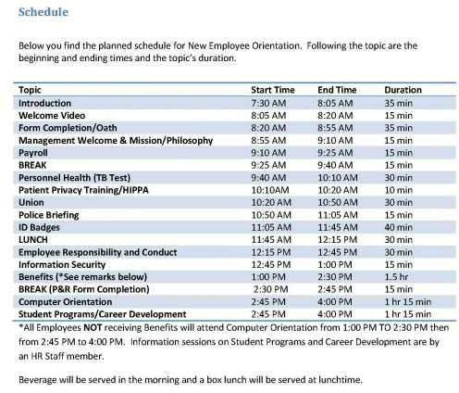

Fig. 8.1:

Some companies have very specific orientations, with a variety of people providing information to the new hires. This can create a welcoming environment, besides giving the employee the information they need. This is an example of one such orientation.
Source: Sample schedule courtesy of Louis Stokes Cleveland VA Medical Center,http:// www.cleveland.va.gov/docs/NEOSchedule.pdf (accessed September 2, 2011).
Human Resource Recall

Have you ever participated in an orientation? What was it like? What components did it have?

In-House Training
Available under Creative Commons-ShareAlike 4.0 International License (http:// creativecommons.org/licenses/by-sa/4.0/).
In-house training programs are learning opportunities developed by the organization in which they are used. This is usually the second step in the training process and often is ongoing. In-house training programs can be training related to a specific job, such as how to use a particular kind of software. In a manufacturing setting, in-house training might include an employee learning how to use a particular kind of machinery.

Many companies provide in-house training on various HR topics as well, meaning it doesn’t always have to relate to a specific job. Some examples of in-house training include the following:
- Ethics training
- Sexual harassment training
- Multicultural training
- Communication training
- Management training
- Customer service training
- Operation of special equipment
- Training to do the job itself
- Basic skills training
As you can tell by the list of topics, HR might sometimes create and deliver this training, but often a supervisor or manager delivers the training.

Mentoring
Available under Creative Commons-ShareAlike 4.0 International License (http:// creativecommons.org/licenses/by-sa/4.0/).
After the employee has completed orientation and in-house training, companies see the value in offering mentoring opportunities as the next step in training. Sometimes a mentor may be assigned during in-house training. A mentor is a trusted, experienced advisor who has direct investment in the development of an employee. A mentor may be a supervisor, but often a mentor is a colleague who has the experience and personality to help guide someone through processes. While mentoring may occur informally, a mentorship program can help ensure the new employee not only feels welcomed but is paired up with someone who already knows the ropes and can help guide the new employee through any on-the-job challenges.
To work effectively, a mentoring program should become part of the company culture; in other words, new mentors should receive in-house training to be a mentor.
Mentors are selected based on experience, willingness, and personality. IBM’s Integrated Supply Chain Division, for example, has successfully implemented a mentorship program. The company’s division boasts 19,000 employees and half of IBM’s revenues, making management of a mentorship program challenging. However, potential mentors are trained and put into a database where new employees can search attributes and strengths of mentors and choose the person who closely meets their needs. Then the mentor and mentee work together in development of the new employee. “We view this as a best practice,” says Patricia Lewis-Burton, vice president of human resources, Integrated Supply Chain Division. “We view it as something that is not left to human resources alone. In fact, the program is imbedded in the way our group does business.” ⁵
Some companies use short-term mentorship programs because they find employees training other employees to be valuable for all involved. Starbucks, for example,

- Blyde Witt, “Serious Leadership: IBM Builds a Successful Mentoring Program,” Material Handling Management,December 1, 2005, accessed July 25, 2010,http://mhmonline.com/workforce-solutions/mhm_imp_4483/.

utilizes this approach. When it opens a new store in a new market, a team of experienced store managers and baristas are sent from existing stores to the new stores to lead the store-opening efforts, including training of new employees. ⁶

External Training
Available under Creative Commons-ShareAlike 4.0 International License (http:// creativecommons.org/licenses/by-sa/4.0/).
External training includes any type of training that is not performed in-house. This is usually the last step in training, and it can be ongoing. It can include sending an employee to a seminar to help further develop leadership skills or helping pay tuition for an employee who wants to take a marketing class. To be a Ford automotive technician, for example, you must attend the Ford ASSET Program, which is a partnership between Ford Motor Company, Ford dealers, and select technical schools.
7

How Would You Handle This?
To Train or Not to Train
Towanda Michaels is the human resource manager at a medium-size pet supply wholesaler. Casey Cleps is a salesperson at the organization and an invaluable member of the team. Last year, his sales brought in about 20 percent of the company revenue alone.
Everybody likes Casey: he is friendly, competent, and professional.
Training is an important part of the company, and an e-mail was sent last month that said if employees do not complete the required safety training by July 1, they would be let go.
It is July 15, and it has just come to Towanda’s attention that Casey has not completed the online safety training that is required for his job. When she approaches him about it, he says, “I am the best salesperson here; I can’t waste time doing training. I already know all the safety rules anyway.”
Would you let Casey go, as stated in the e-mail? How would you handle this?
How Would You Handle This? https://api.wistia.com/v1/medias/1348781/embed
The author discusses the How Would You Handle This situation in this chapter at: https://api.wistia.com/v1/medias/1348781/embed.

- Arthur Thompson, “Starbucks Corporation,” July 24, 2011, accessed July 29, 2011,http://www.mhhe.com/business/ management/thompson/11e/case/starbucks-2.html.
- “Automotive Technology/Ford ASSET Course,” Sheridan Technical Center, accessed July 29, 2011, http://www.sheridantechnical.com/Default.aspx?tabid=692.

Key Takeaways
  - Employee training and development is the framework for helping employees develop their personal and organizational skills, knowledge, and abilities. Training is important to employee retention.
  - There are four steps in training that should occur. Employee orientation has the purpose of welcoming new employees into the organization. An effective employee orientation can help reduce start-up costs, reduce anxiety for the employee, reduce turnover, save time for the supervisor and colleagues, and set expectations and attitudes.
  - An in-house training program is any type of program in which the training is delivered by someone who works for the company. This could include management or HR. Examples might include sexual harassment training or ethics training. In-house training can also include components specific to a job, such as how to use a specific kind of software. In-house training is normally done as a second and ongoing step in employee development.
  - A mentor form of training pairs a new employee with a seasoned employee. This is usually the third step in employee training. A mentor program for training should include a formalized program and process.
  - External training is any type of training not performed in-house; part of the last training step, external training can also be ongoing. It can include sending employees to conferences or seminars for leadership development or even paying tuition for a class they want to take.
Exercises

- Why do you think some companies do not follow the four training steps? What are the advantages of doing so?
- What qualities do you think a mentor should have? List at least five.

- Have you ever worked with a mentor in a job, at school, or in extracurricular activities? Describe your experience.

Types of Training
Available under Creative Commons-ShareAlike 4.0 International License (http:// creativecommons.org/licenses/by-sa/4.0/).
Learning Objective

1. Be able to explain and give examples of the types of training that can be offered within an organization.

There are a number of different types of training we can use to engage an employee. These types are usually used in all steps in a training process (orientation, in-house, mentorship, and external training). The training utilized depends on the amount of resources available for training, the type of company, and the priority the company places on training. Companies such as The Cheesecake Factory, a family restaurant, make training a high priority. The company spends an average of $2,000 per hourly employee. This includes everyone from the dishwasher and managers to the servers. For The Cheesecake Factory, this expenditure has paid off. They measure the effectiveness of its training by looking at turnover, which is 15 percent below the industry average. ⁸ Servers make up 40 percent of the workforce and spend two weeks training to obtain certification. Thirty days later, they receive follow-up classes, and when the menu changes, they receive additional training. ⁹ Let’s take a look at some of the training we can offer our employees.
As you will see from the types of training below, no one type would be enough for the jobs we do. Most HR managers use a variety of these types of training to develop a holistic employee.

Technical or Technology Training
Available under Creative Commons-ShareAlike 4.0 International License (http:// creativecommons.org/licenses/by-sa/4.0/).
Depending on the type of job, technical training will be required. Technical training is a type of training meant to teach the new employee the technological aspects of the job. In a retail environment, technical training might include teaching someone how to use the computer system to ring up customers. In a sales position, it might include showing someone how to use the customer relationship management (CRM) system to find new prospects. In a consulting business, technical training might be used so the consultant knows how to use the system to input the number of hours that should be charged to a client. In a restaurant, the server needs to be trained on how to use the system to process orders. Let’s assume your company has decided to switch to the newest version of Microsoft Office. This might require some technical training of the entire company to ensure everyone uses the technology effectively. Technical training is often performed in-house, but it can also be administrered externally.

- Gina Ruiz, “Cheesecake Factory Cooks Up a Rigorous Employee Training Program,”Workforce Management, April 24, 2006, accessed July 25, 2010,http://www.workforce.com/section/11/feature/24/35/18/.
- Gina Ruiz, “Cheesecake Factory Cooks Up a Rigorous Employee Training Program,”Workforce Management, April 24, 2006, accessed July 25, 2010,http://www.workforce.com/section/11/feature/24/35/18/.

Quality Training
Available under Creative Commons-ShareAlike 4.0 International License (http:// creativecommons.org/licenses/by-sa/4.0/).
In a production-focused business, quality training is extremely important. Quality training refers to familiarizing employees with the means of preventing,
detecting, and eliminating nonquality items, usually in an organization that produces a product. In a world where quality can set your business apart from competitors, this type of training provides employees with the knowledge to recognize products that are not up to quality standards and teaches them what to do in this scenario.
Numerous organizations, such as the International Organization for Standardization (ISO), measure quality based on a number of metrics. This organization provides the stamp of quality approval for companies producing tangible products. ISO has developed quality standards for almost every field imaginable, not only considering product quality but also certifying companies in environmental management
quality. ISO9000 is the set of standards for quality management, while ISO14000 is the set of standards for environmental management. ISO has developed 18,000 standards over the last 60 years. ¹⁰ With the increase in globalization, these international quality standards are more important than ever for business development. Some companies, like 3M, ¹¹choose to offer ISO training as external online training, employing companies such as QAI to deliver the training both online and in classrooms to employees.
Training employees on quality standards, including ISO standards, can give them a competitive advantage. It can result in cost savings in production as well as provide an edge in marketing of the quality-controlled products. Some quality training can happen in-house, but organizations such as ISO also perform external training.

Skills Training
Available under Creative Commons-ShareAlike 4.0 International License (http:// creativecommons.org/licenses/by-sa/4.0/).
Skills training, the third type of training, includes proficiencies needed to actually perform the job. For example, an administrative assistant might be trained in how to answer the phone, while a salesperson at Best Buy might be trained in assessment of customer needs and on how to offer the customer information to make a buying decision. Think of skills training as the things you actually need to know to perform your job. A cashier needs to know not only the technology to ring someone up but what to do if something is priced wrong. Most of the time, skills training is given in- house and can include the use of a mentor. An example of a type of skills training is from AT&T and Apple, ¹² who in summer 2011 asked their managers to accelerate retail
employee training on the iPhone 5, which was released to market in the fall.

- “The ISO Story,” International Organization for Standards, accessed July 26, 2010,http://www.iso.org/iso/about/ the_iso_story/iso_story_early_years.htm.
- QAI website, accessed July 30, 2011, http://www.trainingforquality.com/Content.aspx?id=26.
- Lance Whitney, “Apple, AT&T Reportedly Prepping Staff for iPhone 5 Launch,” CNET, July 26, 2011, accessed July 29, 2011, http://news.cnet.com/8301-13579_3-20083435-37/apple-at-t-reportedly-prepping-staff-for-iphone-5-launch/.

Soft Skills Training
Available under Creative Commons-ShareAlike 4.0 International License (http:// creativecommons.org/licenses/by-sa/4.0/).
Our fourth type of training is called soft skills training. Soft skills refer to personality traits, social graces, communication, and personal habits that are used to characterize relationships with other people. Soft skills might include how to answer the phone or how to be friendly and welcoming to customers. It could include sexual harassment training and ethics training. In some jobs, necessary soft skills might include how to motivate others, maintain small talk, and establish rapport.
In a retail or restaurant environment, soft skills are used in every interaction with customers and are a key component of the customer experience. In fact, according to a Computer world magazine survey, executives say there is an increasing need for people who have not only the skills and technical skills to do a job but also the necessary soft skills, such as strong listening and communication abilities. ¹³ Many problems in organizations are due to a lack of soft skills, or interpersonal skills, not by problems with the business itself. As a result, HR and managers should work together to strengthen these employee skills. Soft skills training can be administered either in- house or externally.

Professional Training and Legal Training
Available under Creative Commons-ShareAlike 4.0 International License (http:// creativecommons.org/licenses/by-sa/4.0/).
In some jobs, professional training must be done on an ongoing basis.
Professional training is a type of training required to be up to date in one’s own professional field. For example, tax laws change often, and as a result, an accountant for H&R Block must receive yearly professional training on new tax codes. ¹⁴ Lawyers need professional training as laws change. A personal fitness trainer will undergo yearly certifications to stay up to date in new fitness and nutrition information.
Some organizations have paid a high cost for not properly training their employees on the laws relating to their industry. In 2011, Massachusetts General Hospital paid over
$1 million in fines related to privacy policies that were not followed. ¹⁵ As a result, the organization has agreed to develop training for workers on medical privacy. The fines could have been prevented if the organization had provided the proper training to begin with.
Other types of legal training might include sexual harassment law training and discrimination law training.

- Thomas Hoffman, “Nine Nontechie Skills That Hiring Managers Wish You Had,”Computerworld, November 12, 2007, accessed July 26, 2010,http://www.computerworld.com/s/article/305966/Are_You_the_Complete_Package_.
- Jeannine Silkey, “Tax Preparer Certifications,” Suite 101, January 28, 2010, accessed July 26, 2010, http://personal-tax- planning.suite101.com/article.cfm/tax-preparer-certifications.
- Julie Donnelly, “Mass. General to Pay $1M to Settle Privacy Claims,” Boston Business Journal, February 24, 1011, accessed February 26, 2011,http://www.bizjournals.com/boston/news/2011/02/24/mass-general-to-pay-1m-to-settle.html.

Team Training
Available under Creative Commons-ShareAlike 4.0 International License (http:// creativecommons.org/licenses/by-sa/4.0/).
Do you know the exercise in which a person is asked to close his or her eyes and fall back, and then supposedly the team members will catch that person? As a team- building exercise (and a scary one at that), this is an example of team training. The goal of team training is to develop cohesiveness among team members, allowing them to get to know each other and facilitate relationship building. We can
define team training as a process that empowers teams to improve decision making, problem solving, and team-development skills to achieve business results. Often this type of training can occur after an organization has been restructured and new people are working together or perhaps after a merger or acquisition. Some reasons for team training include the following:
- Improving communication
- Making the workplace more enjoyable
- Motivating a team
- Getting to know each other
- Getting everyone “onto the same page,” including goal setting
- Teaching the team self-regulation strategies
- Helping participants to learn more about themselves (strengths and weaknesses)
- Identifying and utilizing the strengths of team members
- Improving team productivity
- Practicing effective collaboration with team members
Team training can be administered either in-house or externally. Ironically, through the use of technology, team training no longer requires people to even be in the same room.
Human Resource Recall

What kind of team training have you participated in? What was it like? Do you think it accomplished what it was supposed to accomplish?

Managerial Training
Available under Creative Commons-ShareAlike 4.0 International License (http:// creativecommons.org/licenses/by-sa/4.0/).
After someone has spent time with an organization, they might be identified as a candidate for promotion. When this occurs, managerial training would occur. Topics might include those from our soft skills section, such as how to motivate and delegate, while others may be technical in nature. For example, if management uses a particular computer system for scheduling, the manager candidate might be technically trained. Some managerial training might be performed in-house while other training, such as leadership skills, might be performed externally.

Key Takeaways
For example, Mastek, a global IT solutions and services provider, provides a program called “One Skill a Month,” which enables managers to learn skills such as delegation, coaching, and giving feedback. The average number of total training days at Mastek is
7.8 per employee ¹⁶ and includes managerial topics and soft skills topics such as e-mail etiquette. The goal of its training programs is to increase productivity, one of the organization’s core values.

Safety Training
Available under Creative Commons-ShareAlike 4.0 International License (http:// creativecommons.org/licenses/by-sa/4.0/).
Safety training is a type of training that occurs to ensure employees are protected from injuries caused by work-related accidents. Safety training is especially important for organizations that use chemicals or other types of hazardous materials in their production. Safety training can also include evacuation plans, fire drills, and workplace violence procedures. Safety training can also include the following:
- Eye safety
- First aid
- Food service safety
- Hearing protection
- Asbestos
- Construction safety
- Hazmat safety
The Occupational Safety and Health Administration, or OSHA, is the main federal agency charged with enforcement of safety and health regulation in the United States. OSHA provides external training to companies on OSHA standards. Sometimes in- house training will also cover safety training.
Starbucks Training Video

This is a short video Starbucks uses to train new employees on customer service.
Please view this video at http://www.youtube.com/ watch?v=OAmftgYEWqU.

- There are several types of training we can provide for employees. In all situations, a variety of training types will be used, depending on the type of job.
- Technical training addresses software or other programs that employees use while working for the organization.

- Mastek website, accessed July 30, 2011, http://www.mastek.com/careers/learning-development.html.

  - Quality training is a type of training that familiarizes all employees with the means to produce a good-quality product. The ISO sets the standard on quality for most production and environmental situations. ISO training can be done in-house or externally.
  - Skills training focuses on the skills that the employee actually needs to know to perform their job. A mentor can help with this kind of training.
  - Soft skills are those that do not relate directly to our job but are important. Soft skills training may train someone on how to better communicate and negotiate or provide good customer service.
  - Professional training is normally given externally and might be obtaining certification or specific information needed about a profession to perform a job. For example, tax accountants need to be up to date on tax laws; this type of training is often external.
  - Team training is a process that empowers teams to improve decision making, problem solving, and team-development skills. Team training can help improve communication and result in more productive businesses.
  - To get someone ready to take on a management role, managerial training might be given.
  - Safety training is important to make sure an organization is meeting OSHAstandards. Safety training can also include disaster planning.
Exercises

- Which type of training do you think is most important for an administrative assistant? What about for a restaurant server? Explain your answer.
- Research OSHA. What are some of the new standards and laws it has recently developed? Outline a training plan for the new standards.

Training Delivery Methods
Available under Creative Commons-ShareAlike 4.0 International License (http:// creativecommons.org/licenses/by-sa/4.0/).
Learning Objective

1. Explain the types of training delivery methods.

Depending on the type of training occurring, you may choose one delivery method over another. This section discusses the types of delivery methods we can use to

execute the types of training. Keep in mind, however, that most good training programs will use a variety of delivery methods.

On-the-Job Coaching Training Delivery
Available under Creative Commons-ShareAlike 4.0 International License (http:// creativecommons.org/licenses/by-sa/4.0/).
On-the-job coaching is one way to facilitate employee skills training. On-the- job coaching refers to an approved person training an employee on the skills
necessary to complete tasks. A manager or someone with experience shows the employee how to perform the actual job. The selection of an on-the-job coach can be done in a variety of ways, but usually the coach is selected based on personality, skills, and knowledge. This type of skills training is normally facilitated in-house. The disadvantage of this training revolves around the person delivering the training. If he or she is not a good communicator, the training may not work. Likewise, if this person has “other things to do,” he or she may not spend as much time required to train the person and provide guidance. In this situation, training can frustrate the new employee and may result in turnover.

Mentoring and Coaching Training Delivery
Available under Creative Commons-ShareAlike 4.0 International License (http:// creativecommons.org/licenses/by-sa/4.0/).
Mentoring is also a type of training delivery. A mentor is a trusted, experienced advisor who has direct investment in the development of an employee. Mentoring is a process by which an employee can be trained and developed by an experienced person. Normally, mentoring is used as a continuing method to train and develop an employee. One disadvantage of this type of training is possible communication style and personality conflict. It can also create overdependence in the mentee or micromanagement by the mentor. This is more different than on-the-job coaching, which tends to be short term and focuses on the skills needed to perform a particular job.

Brown Bag Lunch Training Delivery
Available under Creative Commons-ShareAlike 4.0 International License (http:// creativecommons.org/licenses/by-sa/4.0/).
Brown bag lunches are a training delivery method meant to create an informal atmosphere. As the name suggests,brown bag lunch training is one in which the training occurs during lunchtime, employees bring their food, and someone presents training information to them. The trainer could be HR or management or even another employee showing a new technical skill. Brown bag lunches can also be an effective way to perform team training, as it brings people together in a more relaxed atmosphere. Some companies offer brown bag lunch training for personal development as well. For example, HR might want to bring in a specialist on 401(k) plans, or perhaps an employee provides a slide presentation on a trip he or she has

taken, discussing the things learned on the trip. One disadvantage to this type of training can be low attendance and garnering enough interest from employees who may not want to “work” during lunch breaks. There can also be inconsistency in messages if training is delivered and not everyone is present to hear the message.
Human Resource Recall

What types of brown bag lunch training would employees be most willing to attend? Do you think this type of training should be required?

Web-Based Training Delivery
Available under Creative Commons-ShareAlike 4.0 International License (http:// creativecommons.org/licenses/by-sa/4.0/).
Web-based training delivery has a number of names. It could be called e-learning or Internet-based, computer-based, or technology-based learning. No matter what it is called, any web-based training involves the use of technology to facilitate training. There are two types of web-based learning. First, synchronous learning uses instructor-led facilitation. Asynchronous learning is self-directed, and there is no instructor facilitating the course. There are several advantages to web-based training. First, it is available on demand, does not require travel, and can be cost efficient.
However, disadvantages might include an impersonal aspect to the training and limited bandwidth or technology capabilities. ¹⁷
Web-based training delivery lends itself well to certain training topics. For example, this might be an appropriate delivery method for safety training, technical training, quality training, and professional training. However, for some training, such as soft- skills training, job skills training, managerial training, and team training, another more personalized method may be better for delivery. However, there are many different platforms that lend themselves to an interactive approach to training, such as Sun Microsystems’ Social Learning eXchange (SLX) training system, which has real-time video and recording capabilities. Hundreds of platforms are available to facilitate web- based training. DigitalChalk, for example, allows for both synchronous and asynchronous training and allows the instructor or human relations manager to track training progress and completion. ¹⁸ Some companies use SharePoint, an intranet platform, to store training videos and materials. ¹⁹ Blackboard and Angel (used primarily by higher education institutions) allows human resource managers to create training modules, which can be moderated by a facilitator or managed in a self-paced format. In any of the platforms available, media such as video and podcasts can be included within the training.
Considerations for selecting a web-based platform include the following:
      - Is there a one-time fee or a per-user fee?

- “Advantages and Disadvantages,” Web Based Training Information Center, accessed July 27, 2010, http://www.webbasedtraining.com/primer_advdis.aspx.
- DigitalChalk website, accessed August 12, 2010, http://www.digitalchalk.com/.
- Microsoft’s SharePoint website, accessed August 12, 2010,http://sharepoint.microsoft.com/enus/Pages/default.aspx.

- Do the majority of your employees use a Mac or a PC, and how does the platform work with both systems?
- Is there enough bandwidth in your organization to support this type of platform?
- Is the platform flexible enough to meet your training needs?
- Does the software allow for collaboration and multimedia?
- Is there training for the trainer in adoption of this system? Is technical support offered?

Job Shadowing Training Delivery
Available under Creative Commons-ShareAlike 4.0 International License (http:// creativecommons.org/licenses/by-sa/4.0/).
Job shadowing is a training delivery method that places an employee who already has the skills with another employee who wants to develop those skills. Apprenticeships use job shadowing as one type of training method. For example, an apprentice electrician would shadow and watch the journeyman electrician perform the skills and tasks and learn by watching. Eventually, the apprentice would be able to learn the skills to do the job alone. The downside to this type of training is the possibility that the person job shadowing may learn “bad habits” or shortcuts to performing tasks that may not be beneficial to the organization.

It takes a lot of training for the Walt Disney Company to produce the best Mickey Mouse, Snow White, Aladdin, or Peter Pan. In Orlando at Disneyworld, most of this training takes place at Disney University. Disney University provides training to its 42,000 cast members (this is what Disney calls employees) in areas such as culinary arts, computer applications, and specific job components. Once hired, all cast members go through a two-day Disney training program called Traditions, where they learn the basics of being a good cast member and the history of the company. For all practical purposes, Traditions is a new employee orientation.
Training doesn’t stop at orientation, though. While all positions receive extensive training, one of the most extensive trainings are especially for Disney characters, since their presence at the theme parks is a major part of the customer experience. To become a character cast member, a character performer audition is required. The auditions require dancing and acting, and once hired, the individual is given the job of several characters to play. After a two- week intensive training process on character history, personalities, and ability to sign the names of the characters (for the autograph books sold at the parks for kids), an exam is given. The exam tests competency in character understanding, and passing the exam is required to become hired. 20

- Jim Hill, “Blood, Sweat, and Fur,” Jim Hill Media, May 2005, accessed July 30, 2011,http://jimhillmedia.com/ guest_writers1/b/rob_bloom/archive/2005/05/03/1703.aspx.

While Disney University trains people for specific positions, it also offers an array of continuing development courses called Disney Development Connection. Disney says in 2010, more than 3,254,596 hours were spent training a variety of employees, 21 from characters to management. The training doesn’t stop at in-house training, either. Disney offers tuition reimbursement up to $700 per credit and pays for 100 percent of books and $100 per course for cost of other materials. In 2010, Disney paid over $8 million in tuition expenses for cast members. 22
Disney consistently ranks in “America’s Most Admired Companies” by Fortune Magazine, and its excellent training could be one of the many reasons.

Job Swapping Training Delivery
Available under Creative Commons-ShareAlike 4.0 International License (http:// creativecommons.org/licenses/by-sa/4.0/).
Job swapping is a method for training in which two employees agree to change jobs for a period of time. Of course, with this training delivery method, other training would be necessary to ensure the employee learns the skills needed to perform the skills of the new job. Job swap options can be motivational to employees by providing a change of scenery. It can be great for the organization as well to cross-train employees in different types of jobs. However, the time spent learning can result in unproductive time and lost revenue.

Vestibule Training Delivery
Available under Creative Commons-ShareAlike 4.0 International License (http:// creativecommons.org/licenses/by-sa/4.0/).
In vestibule training, training is performed near the worksite in conference rooms, lecture rooms, and classrooms. This might be an appropriate method to deliver orientations and some skills-based training. For example, to become a journeyman electrician, an apprentice performs job shadowing, on-the-job training, and vestibule training to learn the law and codes related to electricity installation. During the busy holiday season, Macy’s uses vestibule training to teach new hires how to use the cash register system and provides skills training on how to provide great customer service.
23

Many organizations use vestibule training for technical training, safety training, professional training, and quality training. It can also be appropriate for managerial training, soft skills training, and team training. As you can tell, this delivery method, like web-based training delivery, is quite versatile. For some jobs or training topics, this

- “Training and Development,” Disney, accessed July 30, 2011,http://corporate.disney.go.com/citizenship2010/ disneyworkplaces/overview/traininganddevelopment/.
- “Training and Development,” Disney, accessed July 30, 2011,http://corporate.disney.go.com/citizenship2010/ disneyworkplaces/overview/traininganddevelopment/.
- Macy’s website, accessed July 27, 2010, http://www.macysjobs.com/about/.

may take too much time away from performing the actual “job,” which can result in lost productivity.

International Assignment Training
Available under Creative Commons-ShareAlike 4.0 International License (http:// creativecommons.org/licenses/by-sa/4.0/).
Since we are working within a global economy, it might be necessary to provide training to employees who are moving overseas or working overseas. Up to 40 percent of international assignments are terminated early because of a lack of international training. ²⁴ Ensuring success overseas is reliant upon the local employee’s learning how to navigate in the new country. The following topics might be included in this type of training:
- Cultural differences and similarities
- Insight and daily living in the country
- Social norms and etiquette
- Communication training, such as language skills
This training is best delivered by a professional in the region or area in which the employee will be working. We discuss this topic in more detail in International HRM (Page 421).
Key Takeaways

- Training delivery methods are important to consider, depending on the type of training that needs to be performed.
- Most organizations do not use only one type of training delivery method; a combination of many methods will be used.
- On-the-job coaching delivery method is a training delivery method in which an employee is assigned to a more experienced employee or manager to learn the skills needed for the job. This is similar to the mentor training delivery method, except a mentor training method is less about skills training and more about ongoing employee development.
- Brown bag lunch training delivery is normally informal and can involve personal development as well as specific job-related skills.
- Web-based training is any type of training that is delivered using technology.
- There are numerous platforms that can be used for web-based training and considerations, such as cost, when selecting a platform for use.

- Sherry E. Sullivan and Howard Tu, “Preparing Yourself for an International Assignment,” Bnet, accessed September 15, 2011,http://findarticles.com/p/articles/mi_m1038/is_n1_v37/ai_14922926/.

Exercises
- A synchronous training method is used for web-based training and refers to delivery that is led by a facilitator.
An asynchronous training method is one that is self-directed.

- Job shadowing is a delivery method consisting of on-the-job training and the employee’s learning skills by watching someone more experienced.
- To motivate employees and allow them to develop new skills, job swapping training delivery may be used. This occurs when two people change jobs for a set period of time to learn new skills. With this method, it is likely that other methods will also be used, too.
- Vestibule training delivery is also known as “near site” training. It normally happens in a classroom, conference room, or lecture room and works well to deliver orientations and some skills-based training. Many organizations also use vestibule training for technical training, safety training, professional training, and quality training.
- Since many companies operate overseas, providing training to those employees with international assignments can better prepare them for living and working abroad.
- Do an Internet search on web-based training. Discuss two of the platforms you found. What are the features and benefits?
- Which training delivery method do you think you personally would prefer in a job and why?
- What do you see as advantages and disadvantages to each type of training method?

Designing a Training Program
Available under Creative Commons-ShareAlike 4.0 International License (http:// creativecommons.org/licenses/by-sa/4.0/).
Learning Objectives

- Be able to design a training program framework.

- Understand the uses and applications of a career development program.

The next step in the training process is to create a training framework that will help guide you as you set up a training program. Information on how to use the framework is included in this section.

Training Program Framework Development
Available under Creative Commons-ShareAlike 4.0 International License (http:// creativecommons.org/licenses/by-sa/4.0/).
When developing your training plan, there are a number of considerations. Training is something that should be planned and developed in advance.
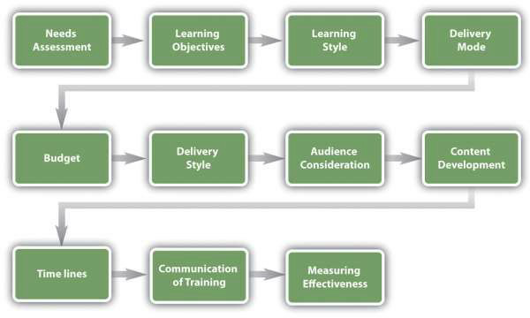
Fig. 8.2: Training Program Development Model

The considerations for developing a training program are as follows:
      - Needs assessment and learning objectives. This part of the framework development asks you to consider what kind of training is needed in your organization. Once you have determined the training needed, you can set learning objectives to measure at the end of the training.
      - Consideration of learning styles. Making sure to teach to a variety of learning styles is important to development of training programs.
      - Delivery mode. What is the best way to get your message across? Is web-based training more appropriate, or should mentoring be used? Can vestibule training be used for a portion of the training while job shadowing be used for some of the training, too? Most training programs will include a variety of delivery methods.
      - Budget. How much money do you have to spend on this training?
      - Delivery style. Will the training be self-paced or instructor led? What kinds of discussions and interactivity can be developed in conjunction with this training?
      - Audience. Who will be part of this training? Do you have a mix of roles, such as accounting people and marketing people? What are the job responsibilities of these individuals, and how can you make the training relevant to their individual jobs?
      - Content. What needs to be taught? How will you sequence the information?
      - Timelines. How long will it take to develop the training? Is there a deadline for training to be completed?
      - Communication. How will employees know the training is available to them?

      - Measuring effectiveness of training. How will you know if your training worked? What ways will you use to measure this?
Human Resource Recall

Can you think of a time where you received training, but the facilitator did not connect with the audience? Does that ever happen in any of your classes (of course not this one, though)?

Needs Assessment
Available under Creative Commons-ShareAlike 4.0 International License (http:// creativecommons.org/licenses/by-sa/4.0/).
The first step in developing a training program is to determine what the organization needs in terms of training. There are three levels of training needs assessment: organizational assessment, occupational (task) assessment, and
individual assessment:
      - Organizational assessment. In this type of needs assessment, we can determine the skills, knowledge, and abilities a company needs to meet its strategic objectives. This type of assessment considers things such as changing demographics and technological trends. Overall, this type of assessment looks at how the organization as a whole can handle its weaknesses while promoting strengths.
      - Occupational (task) assessment. This type of assessment looks at the specific tasks, skills knowledge, and abilities required to do jobs within the organization.
      - Individual assessment. An individual assessment looks at the performance of an individual employee and determines what training should be accomplished for that individual.
We can apply each of these to our training plan. First, to perform an organizational assessment, we can look at future trends and our overall company’s strategic plan to determine training needs. We can also see how jobs and industries are changing, and knowing this, we can better determine the occupational and individual assessments.
Researching training needs can be done through a variety of ways. One option is to use an online tool such as Survey Monkey to poll employees on what types of training they would like to see offered.
As you review performance evaluations turned in by your managers, you may see a pattern developing showing that employees are not meeting expectations. As a result, this may provide data as to where your training is lacking.
There are also types of training that will likely be required for a job, such as technical training, safety training, quality training, and professional training. Each of these should be viewed as separate training programs, requiring an individual framework for each type of training. For example, an employee orientation framework will look entirely different from an in-house technical training framework.

Training must be tied to job expectations. Any and all training developed should transfer directly to the skills of that particular employee. Reviewing the HR strategic plan and various job analyses may help you see what kind of training should be developed for specific job titles in your organization.

Learning Objectives
Available under Creative Commons-ShareAlike 4.0 International License (http:// creativecommons.org/licenses/by-sa/4.0/).
After you have determined what type of training should occur, learning objectives for the training should be set. A learning objective is what you want the learner to be able to do, explain, or demonstrate at the end of the training period. Good learning objectives are performance based and clear, and the end result of the learning objective can be observable or measured in some way. Examples of learning objectives might include the following:
      - Be able to explain the company policy on sexual harassment and give examples of sexual harassment.
      - Be able to show the proper way to take a customer’s order.
      - Perform a variety of customer needs analyses using company software.
      - Understand and utilize the new expense-tracking software.
      - Explain the safety procedure in handling chemicals.
      - Be able to explain the types of communication styles and strategies to effectively deal with each style.
      - Demonstrate ethics when handling customer complaints.
      - Be able to effectively delegate to employees.
Once we have set our learning objectives, we can utilize information on learning styles to then determine the best delivery mode for our training.

Learning Styles
Available under Creative Commons-ShareAlike 4.0 International License (http:// creativecommons.org/licenses/by-sa/4.0/).
Understanding learning styles is an important component to any training program. For our purposes, we will utilize a widely accepted learning style model. Recent research has shown that classifying people into learning styles may not be the best way to determine a style, and most people have a different style depending on the information being taught. In a study by Pashler et al., ²⁵ the authors look at aptitude and personality as key traits when learning, as opposed to classifying people into categories of learning styles. Bearing this in mind, we will address a common approach to learning styles next.

- Harold Pashler, Mark McDaniel, Doug Rohrer, and Robert Bjork, “Learning Styles: Concepts and Evidence,” Psychological Science in the Public Interest 9, no. 3 (2008): 109–19, accessed February 26, 2011, http://www.psychologicalscience.org/ journals/pspi/PSPI_9_3.pdf.

An effective trainer tries to develop training to meet the three different learning styles:
26

- Visual learner. A visual learner usually has a clear “picture” of an experience. A visual learner often says things such as “I can see what you are saying” or “This looks good.” A visual learner is best reached using graphics, pictures, and figures.
- Auditory learner. An auditory learner learns by sound. An auditory learner might say, “If I hear you right” or “What do you hear about this situation?” The auditory learner will learn by listening to a lecture or to someone explaining how to do something.
- Kinesthetic learner. A kinesthetic learner learns by developing feelings toward an experience. These types of learners tend to learn by doing rather than listening or seeing someone else do it. This type of learner will often say things such as “This feels right.”
Most individuals use more than one type of learning style, depending on what kinds of information they are processing. For example, in class you might be a visual learner, but when learning how to change a tire, you might be a kinesthetic learner.

Delivery Mode
Available under Creative Commons-ShareAlike 4.0 International License (http:// creativecommons.org/licenses/by-sa/4.0/).
Depending on the type of training that needs to be delivered, you will likely choose a different mode to deliver the training. An orientation might lend itself best to vestibule training, while sexual harassment training may be better for web-based training.
When choosing a delivery mode, it is important to consider the audience and budget constrictions. For example, Oakwood Worldwide, a provider of temporary housing, recently won the Top 125 Training Award for its training and development programs. ²⁷ It offers in-class and online classes for all associates and constantly add to its course catalog. This is a major recruitment as well as retention tool for its employees. In fact, the company credits this program for retaining 25 percent of its workforce for ten years or more. Table 8.1 looks at each of the types of training and suggests appropriate options for delivery modes.

Delivery Method | Type of Training Suggested
On-the-job coaching | Technical training
 | Skills training
 | Managerial training
 | Safety training
Mentor | Technical training

Table 8.1: Types of Training and Delivery
- “What’s YOUR Learning Style?” adapted from Instructor Magazine, University of South Dakota, August 1989, accessed July 28, 2010, http://people.usd.edu/~bwjames/tut/learning-style/.
- “Oakwood Worldwide Honored by Training Magazine for Fifth Consecutive Year Training also Presents Oakwood with Best Practice Award,” press release, February 25, 2011,Marketwire, accessed February 26, 2011, http://www.live-pr.com/ en/oakwood-worldwide-honored-by-training-magazine-r1048761409.htm.

 | Skills training
 | Managerial training
 | Safety training
Brown bag lunch | Quality training
 | Soft skills training
 | Professional training
 | Safety training
Web-based | Technical training
 | Quality training
 | Skills training
 | Soft skills training
 | Professional training
 | Team training
 | Managerial training
 | Safety training
Job shadowing | Technical training
 | Quality training
 | Skills training
 | Safety training
Job swapping | Technical training
 | Quality training
 | Skills training
 | Professional training
 | Team training
 | Managerial training
 | Safety training
Vestibule training | Technical training
 | Quality training
 | Skills training
 | Soft skills training
 | Professional training

Table 8.1: Types of Training and Delivery

Team training
Managerial training
Safety training
Table 8.1: Types of Training and Delivery

    - Budget
Available under Creative Commons-ShareAlike 4.0 International License (http:// creativecommons.org/licenses/by-sa/4.0/).
How much money do you think the training will cost? The type of training performed will depend greatly on the budget. If you decide that web-based training is the right delivery mode, but you don’t have the budget to pay the user fee for the platform, this wouldn’t be the best option. Besides the actual cost of training, another cost consideration is people’s time. If employees are in training for two hours, what is the cost to the organization while they are not able to perform their job? A spreadsheet should be developed that lists the actual cost for materials, snacks, and other direct costs, but also the indirect costs, such as people’s time.

Delivery Style
Available under Creative Commons-ShareAlike 4.0 International License (http:// creativecommons.org/licenses/by-sa/4.0/).
Taking into consideration the delivery method, what is the best style to deliver this training? It’s also important to keep in mind that most people don’t learn through “death by PowerPoint”; they learn in a variety of ways, such as auditory, kinesthetic, or visual. Considering this, what kinds of ice breakers, breakout discussions, and activities can you incorporate to make the training as interactive as possible? Role plays and other games can make the training fun for employees. Many trainers implement online videos, podcasts, and other interactive media in their training sessions. This ensures different learning styles are met and also makes the training more interesting.

Audience
Available under Creative Commons-ShareAlike 4.0 International License (http:// creativecommons.org/licenses/by-sa/4.0/).
Considering your audience is an important aspect to training. How long have they been with the organization, or are they new employees? What departments do they work in? Knowing the answers to these questions can help you develop a relevant delivery style that makes for better training. For example, if you know that all the people attending the training are from the accounting department, examples you provide in the training can be focused on this type of job. If you have a mixed group, examples and discussions can touch on a variety of disciplines.

Content Development
Available under Creative Commons-ShareAlike 4.0 International License (http:// creativecommons.org/licenses/by-sa/4.0/).
The content you want to deliver is perhaps one of the most important parts in training and one of the most time-consuming to develop. Development of learning objectives or those things you want your learners to know after the training makes for a more focused training. Think of learning objectives as goals—what should someone know after completing this training? Here are some sample learning objectives:
      - Be able to define and explain the handling of hazardous materials in the workplace.
      - Be able to utilize the team decision process model.
      - Understand the definition of sexual harassment and be able to recognize sexual harassment in the workplace.
      - Understand and be able to explain the company policies and structure.
After you have developed the objectives and goals, you can begin to develop the content of the training. Consideration of the learning methods you will use, such as discussion and role playing, will be outlined in your content area.
Development of content usually requires a development of learning objectives and then a brief outline of the major topics you wish to cover. With that outline, you can “fill in” the major topics with information. Based on this information, you can develop modules or PowerPoint slides, activities, discussion questions, and other learning techniques.

Timelines
Available under Creative Commons-ShareAlike 4.0 International License (http:// creativecommons.org/licenses/by-sa/4.0/).
For some types of training, time lines may be required to ensure the training has been done. This is often the case for safety training; usually the training should be done before the employee starts. In other words, in what time frame should an employee complete the training?
Another consideration regarding time lines is how much time you think you need to give the training. Perhaps one hour will be enough, but sometimes, training may take a day or even a week. After you have developed your training content, you will likely have a good idea as to how long it will take to deliver it. Consider the fact that most people do not have a lot of time for training and keep the training time realistic and concise.
From a long-term approach, it may not be cost effective to offer an orientation each time someone new is hired. One consideration might be to offer orientation training once per month so that all employees hired within that month are trained at the same time.

Development of a dependable schedule for training might be ideal, as in the following example:
- Orientation is offered on the first Thursday of every month.
- The second and third Tuesday will consist of vestibule training on management skills and communication.
- Twice yearly, in August and March, safety and sexual harassment training will be given to meet the legal company requirements.
Developing a dependable training schedule allows for better communication to your staff, results in fewer communication issues surrounding training, and allows all employees to plan ahead to attend training.

Communication
Available under Creative Commons-ShareAlike 4.0 International License (http:// creativecommons.org/licenses/by-sa/4.0/).
Once you have developed your training, your next consideration is how you will communicate the available training to employees. In a situation such as an orientation, you will need to communicate to managers, staff, and anyone involved in the training the timing and confirm that it fits within their schedule. If it is an informal training, such as a brown bag lunch on 401(k) plans, this might involve determining the days and times that most people are in the office and might be able to participate. Because employees use Mondays and Fridays, respectively, to catch up and finish up work for the week, these days tend to be the worst for training.
Consider utilizing your company’s intranet, e-mail, and even old-fashioned posters to communicate the training. Many companies have Listservs that can relay the message to only certain groups, if need be.
Human Resource Recall

What can happen if training is not communicated to employees appropriately?

Measuring Effectiveness
Available under Creative Commons-ShareAlike 4.0 International License (http:// creativecommons.org/licenses/by-sa/4.0/).
After we have completed the training, we want to make sure our training objectives were met. One model to measure effectiveness of training is the Kirkpatrick model, ²⁸developed in the 1950s. His model has four levels:
      - Reaction: How did the participants react to the training program?
      - Learning: To what extent did participants improve knowledge and skills?
      - Behavior: Did behavior change as a result of the training?
      - Results: What benefits to the organization resulted from the training?

- Donald Kirkpatrick, Evaluating Training Programs, 3rd ed. (San Francisco: Berrett-Koehler, 2006).

Each of Kirkpatrick’s levels can be assessed using a variety of methods. We will discuss those next.
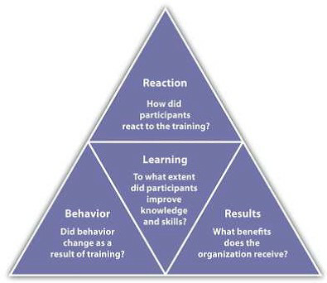
Fig. 8.3: Kirkpatrick’s Four Levels of Training Evaluation

Review the performance of the employees who received the training, and if possible review the performance of those who did not receive the training. For example, in your orientation training, if one of the learning objectives was to be able to request time off using the company intranet, and several employees who attended the training come back and ask for clarification on how to perform this task, it may mean the training didn’t work as well as you might have thought. In this case, it is important to go back and review the learning objectives and content of your training to ensure it can be more effective in the future.
Many trainers also ask people to take informal, anonymous surveys after the training to gauge the training. These types of surveys can be developed quickly and easily through websites such as Survey Monkey. Another option is to require a quiz at the end of the training to see how well the employees understand what you were trying to teach them. The quiz should be developed based on the learning objective you set for the training. For example, if a learning objective was to be able to follow OSHA standards, then a quiz might be developed specifically related to those standards.
There are a number of online tools, some free, to develop quizzes and send them to people attending your training. For example, Wondershare Quiz Creator ²⁹ offers a free trial and enables the manager to track who took the quiz and how well they did. Once developed by the trainer, the quiz can be e-mailed to each participant and the manager can see how each trainee did on the final quiz. After you see how participants do on the quiz, you can modify the training for next time to highlight areas where participants needed improvement.
- WonderShare QuizCreator, accessed July 29, 2010, http://www.sameshow.com/quiz-creator.html#172.

It can be easy to forget about this step in the training process because usually we are so involved with the next task: we forget to ask questions about how something went and then take steps to improve it.
One way to improve effectiveness of a training program is to offer rewards when employees meet training goals. For example, if budget allows, a person might receive a pay increase or other reward for each level of training completed.
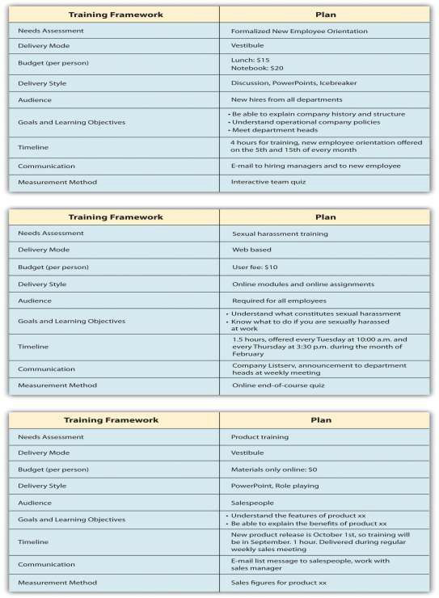
Fig. 8.4:

Once the training framework has been developed, the training content can be developed. The training plan serves as a starting point for training development.

Career Development Programs and Succession Planning
Available under Creative Commons-ShareAlike 4.0 International License (http:// creativecommons.org/licenses/by-sa/4.0/).
Another important aspect to training is career development programs. A
career development program is a process developed to help people manage their career, learn new things, and take steps to improve personally and professionally. Think of it as a training program of sorts, but for individuals. Sometimes career development programs are called professional development plans.
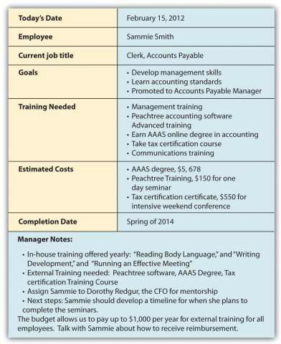
Fig. 8.5: Sample Career Development Plan Developed by an Employee and Commented on by Her Manager

As you can see, the employee developed goals and made suggestions on the types of training that could help her meet her goals. Based on this data, the manager suggested in-house training and external training for her to reach her goals within the organization.
Career development programs are necessary in today’s organizations for a variety of reasons. First, with a maturing baby-boom population, newer employees must be trained to take those jobs once baby boomers retire. Second, if an employee knows a particular path to career development is in place, this can increase motivation. A career development plan usually includes a list of short- and long-term goals that employees have pertaining to their current and future jobs and a planned sequence of

formal and informal training and experiences needed to help them reach the goals. As this chapter has discussed, the organization can and should be instrumental in defining what types of training, both in-house and external, can be used to help develop employees.
To help develop this type of program, managers can consider a few components: ^{30]}
      - Talk to employees. Although this may seem obvious, it doesn’t always happen. Talking with employees about their goals and what they hope to achieve can be a good first step in developing a formal career development program.
      - Create specific requirements for career development. Allow employees to see that if they do A, B, and C, they will be eligible for promotion. For example, to become a supervisor, maybe three years of experience, management training, and communication training are required. Perhaps an employee might be required to prove themselves in certain areas, such as “maintain and exceed sales quota for eight quarters” to be a sales manager. In other words, in career development there should be a clear process for the employees to develop themselves within the organization.
      - Use cross-training and job rotation. Cross-training is a method by which employees can gain management experience, even if for short periods of time. For example, when a manager is out of the office, putting an employee “in charge” can help the employee learn skills and abilities needed to perform that function appropriately. Through the use of job rotation, which involves a systematic movement of employees from job to job within an organization, employees can gain a variety of experiences to prepare them for upward movement in the organization.
      - Utilize mentors. Mentorship can be a great way for employees to understand what it takes to develop one’s career to the next level. A formal mentorship program in place with willing mentees can add value to your career development program.

- Martha Heller, “Six Tips for Effective Employee Development Programs,” CIO Magazine, June 15, 2005, accessed July 28, 2010,http://www.cio.com/article/29169/Six_Tips_for_Effective_Career_Development_Programs.

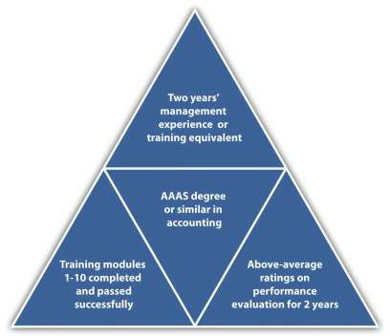
Fig. 8.6: Career Development Sample Process to Become an Accounts Payable Manager

There are many tools on the web, including templates to help employees develop their own career development plans. Many organizations, in fact, ask employees to develop their own plans and use those as a starting point for understanding long-term career goals. Then hopefully the organization can provide them with the opportunities to meet these career goals. In the late 1980s, many employees felt that career opportunities at their current organizations dwindled after seeing the downsizing that occurred. It gave employees the feeling that companies were not going to help develop them, unless they took the initiative to do so themselves. Unfortunately, this attitude means that workers will not wait for career opportunities within the company, unless a clear plan and guide is put into place by the company. ³¹ Here is an example of a process that can be used to put a career development program in place: ³²
- Meet individually with employees to identify their long-term career interests (this may be done by human resources or the direct manager).
- Identify resources within the organization that can help employees achieve their goals. Create new opportunities for training if you see a gap in needs versus what is currently offered.
- Prepare a plan for each employee, or ask them to prepare the plan.
- Meet with the employee to discuss the plan.
- During performance evaluations, revisit the plan and make changes as necessary.

- Peter Capelli, “A Balanced Plan for Career Development,” n.d., Microsoft, accessed July 29, 2010, http://office.microsoft.com/en-us/word-help/a-balanced-plan-for-career-development-HA001126815.aspx.
- Jose Trueba Adolfo, “The Career Development Plan: A Quick Guide for Managers and Supervisors,” n.d., National Career Development Association, accessed July 29, 2010,http://associationdatabase.com/aws/NCDA/pt/sd/news_article/ 6420/_PARENT/layout_details/false.

Key Takeaways
Identifying and developing a planning process not only helps the employee but also can assist the managers in supporting employees in gaining new skills, adding value, and motivating employees.
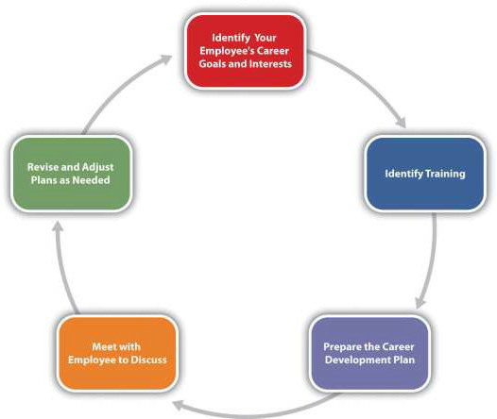
Fig. 8.7: Career Development Planning Process

- There are a number of key considerations in developing a training program. Training should not be handled casually but instead developed specifically to meet the needs of the organization. This can be done by a needs assessment consisting of three
levels: organizational, occupational, and individual assessments.

- The first consideration is the delivery mode; depending on the type of training and other factors, some modes might be better than others.
- Budget is a consideration in developing training. The cost of materials, but also the cost of time, should be considered.
- The delivery style must take into account people’s individual learning styles. The amount of lecture, discussion, role plays, and activities are considered part of delivery style.
- The audience for the training is an important aspect when developing training. This can allow the training to be better

Exercises
developed to meet the needs and the skills of a particular group of people.
- The content obviously is an important consideration. Learning objectives and goals for the training should be developed before content is developed.
- After content is developed, understanding the time constraints is an important aspect. Will the training take one hour or a day to deliver? What is the time line consideration in terms of when people should take the training?
- Letting people know when and where the training will take place is part of communication.
- The final aspect of developing a training framework is to consider how it will be measured. At the end, how will you know if the trainees learned what they needed to learn?
- A career development process can help retain good employees. It involves creating a specific program in which employee goals are identified and new training and opportunities are identified and created to help the employee in the career development process.

- Develop a rough draft of a training framework using for a job you find on Monster.com.
- Write three learning objectives you think would be necessary when developing orientation training for a receptionist in an advertising firm.
- Why is a career development plan important to develop personally, even if your company doesn’t have a formal plan in place? List at least three reasons and describe.

Cases and Problems
Available under Creative Commons-ShareAlike 4.0 International License (http:// creativecommons.org/licenses/by-sa/4.0/).

Chapter Summary
    - Employee training and development is a necessity in today’s work environment. Training and development can lead to lower turnover and increased motivation.
    - There are four basic steps to employee training: employee orientation, in-house training, mentoring, and external training.
    - Different types of training can be delivered, each falling into the steps of employee training. These include technical or technology training, quality training, skills training, soft skills training, professional training, team training, managerial training, and safety training.
    - Within the types of training, we need to determine which method is best for the actual delivery of training. Options include on-the-job training, mentor training, brown bag lunches, web-based training, job shadowing, job swapping, and vestibule training.
    - Development of a training development framework is the first step in solidifying the training.
    - Considerations and steps to developing the training framework include determining the training needs, delivery modes, budget, delivery style, audience, content, time lines, communication of the training, and measurement of the training.
    - Career development programs can be an essential piece to the training puzzle. A comprehensive program or plan, either developed by employees or administered by HR, can help with motivation and fill the gap when people in the organization leave or retire. It can also be used as a motivational tool.

Chapter Case

New on the Job
JoAnn Michaels just started her job as human resources manager at In the Dog House, a retail chain specializing in dog apparel and accessories. She is a good friend of yours you met in college.
The organization has 35 stores with 250 employees in Washington, Idaho, and Oregon. As the chain has grown, the training programs have been conducted somewhat piecemeal. Upon visiting some of the stores in a three-week tour, JoAnn has realized that all the stores seem to have different ways of training their in-store employees.
When she digs further, she realizes even the corporate offices, which employ seventy-five people, have no formal training program. In the past, they have done informal and optional brown bag lunch training to keep employees up to date. As a result, JoAnn develops a survey using SurveyMonkey and sends it to all seventy-five corporate employees. She created a rating system, with 1 meaning strongly disagree and 5 meaning strongly agree. Employees were not required to answer all questions, hence the variation in the number of responses column. After this task, JoAnn creates a slightly different survey and sends it to all store managers, asking them to encourage their retail employees to take the survey. The results are shown here.

In the Dog House Corporate Employee Survey Results
Question | Number of Responses | Average Rating
I am paid fairly. | 73 | 3.9
I feel my group works well as a team. | 69 | 2.63
I appreciate the amount of soft skills training offered at In the Dog House. | 74 | 2.1
I can see myself growing professionally here. | 69 | 1.95
I feel I am paid fairly. | 74 | 3.8
I have all the tools and equipment I need to do my job. | 67 | 4.2
I feel confident if there were an emergency at the office, I would know what to do and could help others. | 73 | 2.67
I think my direct supervisor is an excellent manager. | 55 | 2.41
The orientation training I received was helpful in understanding the expectations of the job. | 75 | 3.1
I would take training related to my job knowing there would be a reward offered for doing so. 71 4.24 In | 71 | 4.24
In the Dog House Retail Employee Survey Results
Question | Number of Responses | Average Rating
I am content with the benefits I am receiving. | 143 | 1.2
I feel my store works well as a team. | 190 | 4.1
I appreciate the amount of product training and information offered at In the Dog House. | 182 | 2.34

I can see myself growing professionally here. | 158 | 1.99
I feel I am paid fairly. | 182 | 3.2
My supervisor works with my schedule, so I work at times that are convenient for me. | 172 | 3.67
I feel confident if I had to evacuate the store, I would know what to do and could help customers. | 179 | 2.88
I think my store manager is a great manager. | 139 | 3.34
The orientation training I received was helpful in understanding the expectations of the job. | 183 | 4.3
I am interested in developing my career at In the Dog House. | 174 | 1.69

Based on the information JoAnn received from her survey, she decided some changes need to be made. JoAnn asks you to meet for coffee and take a look at the results. After you review them, JoAnn asks you the following questions. How would you respond to each?
“Obviously, I need to start working on some training programs. Which topics do you think I should start with?”
“How do I go about developing a training program that will be really useful and make people excited? What are the steps I need to take?”
“How should I communicate the training program to the corporate and retail employees? Should the new training I develop be communicated in the same way?”
“Do you think that we should look at changing pay and benefits? Why or why not?”
“Can you please help me draft a training program framework for what we have discussed? Do you think I should design one for both the corporate offices and one for the retail stores?” (Hint: Look at Figure 8.4for guidelines.)

Team Activity

- In teams of three to four, outline a two-hour training program for managers to better understand motivation for their employees. Motivation is discussed in Retention and Motivation (Page 189). Use the training development model discussed in this chapter. Your training should address learning objectives, delivery modes, budget, delivery style, time line, communication, and measurement. Prepare a five-minute presentation to present in class.
- Using the same plan above, plan and deliver the content to the rest of the class.

