Allied Paper II

COMPUTER APPLICATION IN BUSINESS

Objective:

To enable the students to know the importance of computer application in
business.

Unit I

Computer – Meaning – Characteristics – Areas of application – Components – Memory control unit – Input and output devices – Ms Word – Creating word documents – creating business letters using wizards – editing word documents – inserting objects – formatting documents – spelling and grammar check – word count – thesaurus, auto correct working with tables – opening, savings
and closing documents – mail merge.

Unit II

Spread sheet – Spread sheet programmes and applications – Ms Excel and features – Building work sheets – entering data in work sheets, editing and formating work sheets – creating and formating different types of charts - application of financial and statistical function – creating, analyzing and organizing data – opening and closing work books – Introduction to Pivot
tables.

Unit III

Fundamentals of Computerized accounting – Computerized accounting Vs manual accounting - Architecture and customization of Tally – Features of Tally – latest version – Configuration of Tally – Tally screens and menus – Creation of company – Creation of groups – Editing and deleting groups – Creation of ledgers – Editing and deleting ledgers – Introduction to vouchers –
Vouchers entry – Payment vouchers – Receipt vouchers – Sales vouchers – Purchase vouchers – Contra vouchers – Journal vouchers – Editing and
deleting vouchers.

Unit IV

Introduction to Inventories – Creation of stock categories – Creation of Stock groups – Creation of Stock items- Configuration and features of stock item– Editing and deleting stocks – Usage of stocks in Vouchers entry. Purchase orders – Stock vouchers – Sales orders – Stock vouchers – Introduction to cost – creation of cost category – Creation cost centres – Editing and deleting cost centres & categories – Usage of cost category and cost – centres in vouchers entry – Budget and controls – Creation of budgets – Editing and deleting
budgets – Generating and printing reports in detailed and condensed format.

Unit V

Day books– Trial balance – Profit and Loss account – – Balance sheet . Ratio analysis, Cash flow statement – Fund flow statement – Cost centre report –
Inventory report - Bank Reconciliation Statement | .

Theory: 60 Marks Practical: 40 Marks

LIST OF PRACTICAL

MS (Unit I)

- Creating business letters
- Creating an application for the job with the bio-data
- Creating Circular letter with mail-merge options
- Creating a Table by using the split and merge options

MS-Excel (Unit II)

- Creating a work sheet like mark sheet, Pay Slip, PF Contribution list etc.
- Creating Charts
- Creating a list for the enclosures4. Filtering the date using Auto filter custom filters using comparison operations
5. Creating Pivot tables

Accounting Package (Unit III,IV and V)

- Preparing voucher entries for the given transactions.
- Preparing final accounts from the trial balance given with any ten adjustments
- Inventory report
- Bank Reconciliation Statement

Text and Reference Books (Latest revised edition only)

- Computer Applications in Business – S.V. SrinivsasaVallabhan – Sultan Chand Publication.
- Microsoft office – Jones Derek – Comdex Computer Publication.
- Implementing Tally – K.K. Nandhani Publication, BPB Publication.
- Computer Application in Business – R. Paramasivam – S.Chand& Co.,
- Computer Application in Business: Dr.JosephAnbarasu, Learntech Press

Theory & Practical Examination

Internal Assessment : Theory -15 Marks, | Practical -10 Marks
University Examination : Theory -45 Marks, | Practical -30 Marks

UNIT - 1
INTRODUCTION TO COMPUTERS
A computer is an electronic device that receives input, stores or processes the input asper user instructions and provides output in desired format. Computers have become an integral part of our lives because they can accomplish easy tasks repeatedly without getting bored and complex ones repeatedly without committing errors. In this tutorial we will discuss in detail about the different parts of computer that enable it to carry out tasks efficiently and correctly. We will also discuss about microprocessors, the brain of computers, which actually do all the assigned tasks.

Input-Process-Output Model
Computer input is called data and the output obtained after processing it, based on user’s instructions is called information. Raw facts and figures which can be processed using arithmetic and logical operations to obtain information are called data.
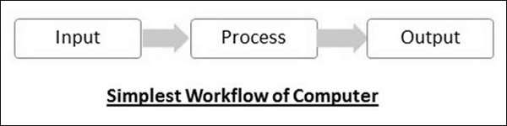
The processes that can be applied to data are of two types −
- Arithmetic operations − Examples include calculations like addition, subtraction, differentials, square root, etc.
- Logical operations − Examples include comparison operations like greater than, less than equal to , opposite etc…
The corresponding figure for an actual computer looks something like this −
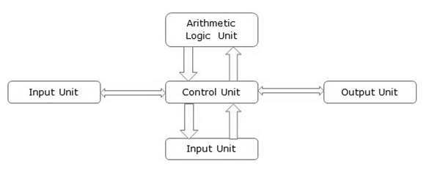
The basic parts of a computer are as follows −
- Input Unit − Devices like keyboard and mouse that are used to input data and instructions to the computer are called input unit.
- Output Unit − Devices like printer and visual display unit that are used to provide information to the user in desired format are called output unit.
- Control Unit − As the name suggests, this unit controls all the functions of the computer. All devices or parts of computer interact through the control unit.
- Arithmetic Logic Unit − This is the brain of the computer where all arithmetic operations and logical operations take place.
- Memory − All input data, instructions and data interim to the processes are stored in the memory. Memory is of two types – primary memory and secondary memory. Primary memory resides within the CPU whereas secondary memory is external to it.
Control unit, arithmetic logic unit and memory are together called the central processing unit or CPU. Computer devices like keyboard, mouse, printer, etc. that we can see and touch are the hardware components of a computer. The set of instructions or programs that make the computer function using these hardware parts are called software. We cannot see or touch software. Both hardware and software are necessary for working of a computer.
CLASSIFICATION OF COMPUTERS
All modern computers and computing devices use microprocessors whose speeds and storage capacities are skyrocketing day by day. The developmental benchmark for computers is now their size. Computers are now classified on the basis of their use or size −
- Desktop
- Laptop
- Tablet
- Server
- Mainframe
- Supercomputer
Let us look at all these types of computers in detail.

Desktop
Desktop computers are personal computers (PCs) designed for use by an individual at a fixed location. IBM was the first computer to introduce and popularize use of desktops. A desktop unit typically has a CPU (Central Processing Unit), monitor, keyboard and mouse. Introduction of desktops popularized use of computers among common people as it was compact and affordable.
Riding on the wave of desktop’s popularity many software and hardware devices were developed specially for the home or office user. The foremost design consideration here was user friendliness.

Laptop
Despite its huge popularity, desktops gave way to a more compact and portable personal computer called laptop in 2000s. Laptops are also called notebook computers or simply notebooks. Laptops run using batteries and connect to networks using Wi-Fi (Wireless Fidelity) chips. They also have chips for energy efficiency so that they can conserve power whenever possible and have a longer life.
Modern laptops have enough processing power and storage capacity to be used for all office work, website designing, software development and even audio/video editing.

Tablet
After laptops computers were further miniaturized to develop machines that have processing power of a desktop but are small enough to be held in one’s palm. Tablets have touch sensitive screen of typically 5 to 10 inches where one finger is used to touch icons and invoke applications.
Keyboard is also displayed virtually whenever required and used with touch strokes. Applications that run on tablets are called apps. They use operating systems by Microsoft (Windows 8 and later versions) or Google (Android). Apple computers have developed their own tablet called iPad which uses a proprietary OS called iOS.

Server
Servers are computers with high processing speeds that provide one or more services to other systems on the network. They may or may not have screens attached to them. A group of computers or digital devices connected together to share resources is called a networ Servers have high processing powers and can handle multiple requests simultaneously. Most commonly found servers on networks include −
- File or storage server
- Game server
- Application server
- Database server
- Mail server
- Print server

Mainframe
Mainframes are computers used by organizations like banks, airlines and railways to handle millions and trillions of online transactions per second. Important features of mainframes are −
- Big in size
- Hundreds times Faster than servers, typically hundred megabytes per second
- Very expensive
- Use proprietary OS provided by the manufacturers
- In-built hardware, software and firmware security features

Supercomputer
Supercomputers are the fastest computers on Earth. They are used for carrying out complex, fast and time intensive calculations for scientific and engineering applications. Supercomputer speed or performance is measured in teraflops, i.e. 1012 floating point operations per second.
Chinese supercomputer Sunway TaihuLigh is the world’s fastest supercomputer with a rating of 93 petaflops per second, i.e. 93 quadrillion floating point operations per second.
Most common uses of supercomputers include −
- Molecular mapping and research
- Weather forecasting
- Environmental research
- Oil and gas exploration
GENERATIONS OF COMPUTER
Introduction:
A computer is an electronic device that manipulates information or data. It has the ability to store, retrieve, and process data.
Nowadays, a computer can be used to type documents, send email, play games, and browse the Web. It can also be used to edit or create spreadsheets, presentations, and even videos. But the evolution of this complex system started around 1940 with the first Generation of Computer and evolving ever since.
There are five generations of computers.
- FIRST GENERATION

  - Introduction:
    - 1946-1959 is the period of first generation computer.
    - J.P.Eckert and J.W.Mauchy invented the first successful electronic computer called ENIAC, ENIAC stands for “Electronic Numeric Integrated And Calculator”.
  - Few Examples are:
    - ENIAC
    - EDVAC
    - UNIVAC
    - IBM-701
    - IBM-650
…
  - Advantages:
    - It made use of vacuum tubes which are the only electronic component available during those days.
    - These computers could calculate in milliseconds.
  - Disadvantages:
    - These were very big in size, weight was about 30 tones.
    - These computers were based on vacuum tubes.
    - These computers were very costly.
    - It could store only a small amount of information due to the presence of magnetic drums.
    - As the invention of first generation computers involves vacuum tubes, so another disadvantage of these computers was, vacuum tubes require a large cooling system.
    - Very less work efficiency.
    - Limited programming capabilities and punch cards were used to take inputs.
    - Large amount of energy consumption.
    - Not reliable and constant maintenance is required.

2.SECOND GENERATION

  - Introduction:
    - 1959-1965 is the period of second-generation computer.
    - 3.Second generation computers were based on Transistor instead of vacuum tubes.
  - Few Examples are:
    - Honeywell 400
    - IBM 7094
    - CDC 1604
    - CDC 3600
    - UNIVAC 1108
… many more
  - Advantages:
    - Due to the presence of transistors instead of vacuum tubes, the size of electron component decreased. This resulted in reducing the size of a computer as compared to first generation computers.
    - Less energy and not produce as much heat as the first genration.
    - Assembly language and punch cards were used for input.
    - Low cost than first generation computers.
    - Better speed, calculate data in microseconds.
    - Better portability as compared to first generation
  - Disadvantages:
    - A cooling system was required.
    - Constant maintenance was required.
    - Only used for specific purposes.

3.THIRD GENERATION
  - Introduction:
    - 1965-1971 is the period of third generation computer.
    - These computers were based on Integrated circuits.
    - IC was invented by Robert Noyce and Jack Kilby In 1958-1959.
    - IC was a single component containing number of transistors.
  - Few Examples are:
    - PDP-8
    - PDP-11
    - ICL 2900
    - IBM 360
    - IBM 370
… and many more
  - Advantages:
    - These computers were cheaper as compared to second-generation computers.
    - They were fast and reliable.
    - Use of IC in the computer provides the small size of the computer.
    - IC not only reduce the size of the computer but it also improves the performance of the computer as compared to previous computers.
    - This generation of computers has big storage capacity.
    - Instead of punch cards, mouse and keyboard are used for input.
    - They used an operating system for better resource management and used the concept of time-sharing and multiple programming.
    - These computers reduce the computational time from microseconds to nanoseconds.
  - Disadvantages:
    - IC chips are difficult to maintain.
    - The highly sophisticated technology required for the manufacturing of IC chips.
    - Air conditioning is required.

4.FOURTH GENERATION

  - Introduction:
    - 1971-1980 is the period of fourth generation computer.
    - This technology is based on Microprocessor.
    - A microprocessor is used in a computer for any logical and arithmetic function to be performed in any program.
    - Graphics User Interface (GUI) technology was exploited to offer more comfort to users.
  - Few Examples are:
    - IBM 4341
    - DEC 10
    - STAR 1000
    - PUP 11
… and many more
  - Advantages:
    - Fastest in computation and size get reduced as compared to the previous generation of computer.
    - Heat generated is negligible.
    - Small in size as compared to previous generation computers.
    - Less maintenance is required.
    - All types of high-level language can be used in this type of computers.
  - Disadvantages:
    - The Microprocessor design and fabrication are very complex.
    - Air conditioning is required in many cases due to the presence of ICs.
    - Advance technology is required to make the ICs.

5.FIFTH GENERATION

  - Introduction:
    - The period of the fifth generation in 1980-onwards.
    - This generation is based on artificial intelligence.
    - The aim of the fifth generation is to make a device which could respond to natural language input and are capable of learning and self-organization.
    - This generation is based on ULSI(Ultra Large Scale Integration) technology resulting in the production of microprocessor chips having ten million electronic component.
  - Few Examples are:
    - Desktop
    - Laptop
    - NoteBook
    - UltraBook
    - Chromebook
… and many more
  - Advantages:
    - It is more reliable and works faster.
    - It is available in different sizes and unique features.
    - It provides computers with more user-friendly interfaces with multimedia features.
  - Disadvantages:
    - They need very low-level languages.
    - They may make the human brains dull and doomed.
MEMORY UNIT
Memory unit is the amount of data that can be stored in the storage unit. This storage capacity is expressed in terms of Bytes.
The following table explains the main memory storage units −
S.No. | Unit & Description
1 | Bit (Binary Digit)  A binary digit is logical 0 and 1 representing a passive or an active state of a component in an electric circuit.
2 | Nibble  A group of 4 bits is called nibble.
3 | Byte  A group of 8 bits is called byte. A byte is the smallest unit, which can represent a data item or a character.
4 | Word  A computer word, like a byte, is a group of fixed number of bits processed as a unit, which varies from computer to computer but is fixed for each computer.  The length of a computer word is called word-size or word length. It may be as small as 8 bits or may be as long as 96 bits. A computer stores the information in the form of computer words.
The following table lists some higher storage units −
S.No. | Unit & Description
1 | Kilobyte (KB)  1 KB = 1024 Bytes
2 | Megabyte (MB)  1 MB = 1024 KB
3 | GigaByte (GB)  1 GB = 1024 MB
4 | TeraByte (TB)  1 TB = 1024 GB
5 | PetaByte (PB)  1 PB = 1024 TB
AUXILIARY STORAGE DEVICES
Auxiliary memory (also referred to as secondary storage) is the non-volatile memory lowest-cost, highest-capacity, and slowest-access storage in a computer system. It is where programs and data kept for long-term storage or when not in immediate use
Such memories tend to occur in two types-sequential access (data must access in a linear sequence) and direct access (data may access in any sequence). The most common sequential storage device is the hard disk drives, whereas direct-access devices include rotating drums, disks, CD-ROMs, and DVD-ROMs.It used as permanent storage of data in mainframes and supercomputers.
Auxiliary memory may also refer to as auxiliary storage, secondary storage, secondary memory, external storage or external memory. Auxiliary memory is not directly accessible by the CPU; instead, it stores noncritical system data like large data files, documents, programs and other back up information that supplied to primary memory from auxiliary memory over a high-bandwidth channel, which will use whenever necessary. Auxiliary memory holds data for future use, and that retains information even the power fails.
INPUT AND OUTPUT DEVICES

Input and output devices allow the computer system to interact with the outside world by moving data into and out of the system. An input device is used to bring data into the system. Some input devices are:
Keyboard
Mouse
Microphone
Bar code reader
Graphics tablet
An output device is used to send data out of the system. Some output devices are:
Monitor
Printer
Speaker
Input/output devices are usually called I/O devices. They are directly connected to an electronic module inside the systems unit called a device controller. For example, the speakers of a multimedia computer system are directly connected to a device controller called an audio card (such as a Soundblaster), which in turn is connected to the rest of the system.
Sometimes secondary memory devices like the hard disk are called I/O devices (because they move data in and out of main memory.) What counts as an I/O device depends on context. To a user, an I/O device is something outside of the system box. To a programmer, everything outside of the processor and main memory looks like an I/O devices. To an engineer working on the design of a processor, everything outside of the processor is an I/O device
COMPUTER SOFTWARE
Software is a set of programs, which is designed to perform a well-defined function. A program is a sequence of instructions written to solve a particular problem.
There are two types of software −
- System Software
- Application Software

System Software
The system software is a collection of programs designed to operate, control, and extend the processing capabilities of the computer itself. System software is generally prepared by the computer manufacturers. These software products comprise of programs written in low-level languages, which interact with the hardware at a very basic level. System software serves as the interface between the hardware and the end users.
Some examples of system software are Operating System, Compilers, Interpreter, Assemblers, etc.
Here is a list of some of the most prominent features of a system software −
- Close to the system
- Fast in speed
- Difficult to design
- Difficult to understand
- Less interactive
- Smaller in size
- Difficult to manipulate
- Generally written in low-level language

Application Software
Application software products are designed to satisfy a particular need of a particular environment. All software applications prepared in the computer lab can come under the category of Application software.
Application software may consist of a single program, such as Microsoft's notepad for writing and editing a simple text. It may also consist of a collection of programs, often called a software package, which work together to accomplish a task, such as a spreadsheet package.
Examples of Application software are the following −
- Payroll Software
- Student Record Software
- Inventory Management Software
- Income Tax Software
- Railways Reservation Software
- Microsoft Office Suite Software
- Microsoft Word
- Microsoft Excel
- Microsoft PowerPoint
Features of application software are as follows −
- Close to the user
- Easy to design
- More interactive
- Slow in speed
- Generally written in high-level language
- Easy to understand
- Easy to manipulate and use
- Bigger in size and requires large storage space
OPERATING SYSTEM
An operating system (OS) is a collection of software that manages computer hardware resources and provides common services for computer programs. The operating system is a vital component of the system software in a computer system. This tutorial will take you through step by step approach while learning Operating System concepts.

Why to Learn Operating System?
An Operating System (OS) is an interface between a computer user and computer hardware. An operating system is a software which performs all the basic tasks like file management, memory management, process management, handling input and output, and controlling peripheral devices such as disk drives and printers.
Some popular Operating Systems include Linux Operating System, Windows Operating System, VMS, OS/400, AIX, z/OS, etc.
Following are some of important functions of an operating System.
- Memory Management
- Processor Management
- Device Management
- File Management
- Security
- Control over system performance
- Job accounting
- Error detecting aids
- Coordination between other software and users

Applications of Operating System
Following are some of the important activities that an Operating System performs −
- Security − By means of password and similar other techniques, it prevents unauthorized access to programs and data.
- Control over system performance − Recording delays between request for a service and response from the system.
- Job accounting − Keeping track of time and resources used by various jobs and users.
- Error detecting aids − Production of dumps, traces, error messages, and other debugging and error detecting aids.
- Coordination between other softwares and users − Coordination and assignment of compilers, interpreters, assemblers and other software to the various users of the computer systems.

Audience
This tutorial has been prepared for the computer science graduates to help them understand the basic to advanced concepts related to Operating System.

Prerequisitess
Before you start proceeding with this tutorial, we are making an assumption that you are already aware of basic computer concepts like what is keyboard, mouse, monitor, input, output, primary memory and secondary memory etc. If you are not well aware of these concepts, then we will suggest to go through our short tutorial on Computer Fundamentals.
PROGRAMMING LANGUAGE
Computer programming language, any of various languages for expressing a set of detailed instructions for a digital computer. Such instructions can be executed directly when they are in the computer manufacturer-specific numerical form known as machine language, after a simple substitution process when expressed in a corresponding assembly language, or after translation from some “higher-level” language. Although there are many computer languages, relatively few are widely used.
Machine and assembly languages are “low-level,” requiring a programmer to manage explicitly all of a computer’s idiosyncratic features of data storage and operation. In contrast, high-level languages shield a programmer from worrying about such considerations and provide a notation that is more easily written and read by programmers.

Language Types

Machine and assembly languages
A machine language consists of the numeric codes for the operations that a particular computer can execute directly. The codes are strings of 0s and 1s, or binary digits (“bits”), which are frequently converted both from and to hexadecimal (base 16) for human viewing and modification. Machine language instructions typically use some bits to represent operations, such as addition, and some to represent operands, or perhaps the location of the next instruction. Machine language is difficult to read and write, since it does not resemble conventional mathematical notation or human language, and its codes vary from computer to computer.
Assembly language is one level above machine language. It uses short mnemonic codes for instructions and allows the programmer to introduce names for blocks of memory that hold data. One might thus write “add pay, total” instead of “0110101100101000” for an instruction that adds two numbers.
Assembly language is designed to be easily translated into machine language. Although blocks of data may be referred to by name instead of by their machine addresses, assembly language does not provide more sophisticated means of organizing complex information. Like machine language, assembly language requires detailed knowledge of internal computer architecture. It is useful when such details are important, as in programming a computer to interact with input/output devices (printers, scanners, storage devices, and so forth)

Algorithmic languages
Algorithmic languages are designed to express mathematical or symbolic computations. They can express algebraic operations in notation similar to mathematics and allow the use of subprograms that package commonly used operations for reuse. They were the first high-level languages.

UNIT - II

FUNDAMENTALS OF COMPUTERIZED ACCOUNTING

What Is a Computerized Accounting System?
How is your company doing? Being able to answer that question requires you to know how much money you're making, which in turn requires accurate bookkeeping. Keeping accurate financial records is crucial to the success of any business, so it's important to know your options.
While some firms still do their bookkeeping by hand, most firms generally have too many transactions to sustain a manual accounting system. The more complicated the financial activities of your business are, the more likely it is that you'll need a computerized accounting system to ensure effective financial reporting. Computerized accounting systems are software programs that are stored on a company's computer, network server, or remotely accessed via the Internet.
Computerized accounting systems allow you to set up income and expense accounts, such as rental or sales income, salaries, advertising expenses, and material costs. They also can be used to manage bank accounts, pay bills, and prepare budgets. Depending upon the program, some accounting systems also allow you to prepare tax documents, handle payroll, and manage project costing.
You can generally customize the software to meet the needs of your business. It's important to make sure that your staff are trained and understand how to use the system correctly so that your company can successfully use your accounting program.
In accounting, the financial transactions are recorded, processed and presented to generate financial statements, that is useful to the readers, in making decisions. Traditionally, accounting is done manually, by a trained accountant, with the use of registers, account books, vouchers etc. But with the emerging technology, nowadays, computerized accounting is in vogue, due to its accuracy, convenience and speed.
Both manual and computerized system is based on the same principles, conventions and concept of accounting. However, they differ only in their mechanism, in the sense that manual accounting uses pen and paper, to record transactions, whereas computerized accounting makes use of computers and internet, to enter transactions electronically.
In this article, you can find the substantial differences between manual and computerized accounting.

Content: Manual Accounting Vs Computerized Accounting
- Comparison Chart
- Definition
- Key Differences
- Conclusion

Comparison Chart
BASIS FOR COMPARISON | MANUAL ACCOUNTING | COMPUTERIZED ACCOUNTING
Meaning | Manual Accounting is a system of accounting that uses physical registers and account books, for keeping financial records. | Computerized Accounting is an accounting system that uses an accounting software, for recording financial transactions electronically.
Recording | Recording is possible through book of original entry. | Data content is recorded in customized database.
Calculation | All the calculation is performed manually. | Only data input is required, the calculations are performed by computer system.
Speed | Slow | Comparatively faster.
Adjusting entries | It is made for rectification of errors. | It cannot be made for rectification of errors.
Backup | Not possible | Entries of transactions can be saved and backed up
Trial Balance | Prepared when necessary. | Instant trial balance is provided on daily basis.
Financial Statement | It is prepared at the end of the period, or quarter. | It is provided at the click of button.

Definition of Manual Accounting
Manual Accounting, as the name signifies, is the paper-based accounting system, in which journal and ledger registers, vouchers, account books are used to store, classify and analyse financial transactions of an organization. It is often used by small businessmen, such as sole proprietors, shopkeepers, etc. to maintain the record of the business transactions, due to lower cost.
One of the advantages of the manual accounting system is its easy accessibility. It is also characterised by confidentiality, which makes the sensitive information hacking free. Nevertheless, manual accounts can only be prepared correctly if the accountant possesses good knowledge of bookkeeping and accounting.
Moreover, human error, such as incorrect recording of the transaction, the omission of the transaction, figure transposition and so forth, is likely to occur while the preparation of manual accounts which cannot be ignored.

PROCEDURES FOR CREATING A NEW COMPANY

Section I: Getting Started

1. Click File, New Company
2. Click Next
3. Choose a Sage 50 product; this will determine which features are available in the company (if not using Sage 50—U.S. Edition Accountant Edition, skip to Step 5)
4. Click Next
5. Enter your company information

Note: All of the information on this screen can be changed after the company is created, if necessary
6. Click Next
7. Select a method to create your company:
Use a sample business type that closely matches your company will provide a list of business types with predefined charts of accounts to select from after click Next
Copy settings from an existing Sage 50 Accounting company; if this option is selected, a list of companies that can be copied will be provided after clicking Next
Convert a company from another accounting program creates a blank chart of accounts that will later be built via import or manually
Build your own chart of accounts creates a blank chart of accounts that will later be built manually
Consolidate Existing Sage 50 Accounting companies (Premium and Quantum only) creates a parent company that pulls account balances from subsidiaries for financial statement purposes
8.Click Next
If Use a sample business was selected, Select a business type and click Next
If Copy settings was selected:
Choose a company from the list
Click Next
Select which parts of the company to copy

Note: If you will be importing maintenance records from the copied company, check all options; if wanting to use a different fiscal year structure, uncheck Accounting Periods
Click Next
If Build your own chart of accounts was selected, Define Account Segments if desired (this can be done later; see Related Resources), then click Next
If Consolidate was selected:
Select the company or companies to be consolidated, and click Add, then click next

Note: Subsidiary companies must use the same general ledger account structure, have the same retained earnings account number, and have the same fiscal year structure
If a selected company has security enabled, you will be prompted to enter a User Name and Password for it; after doing so, click next
10. Choose an accounting method:
Accrual: income and expense are recorded when the invoice is created, regardless of when payment occurs
Cash: income and expense are recorded when invoices are paid

Note: if unsure which accounting method is correct for the company, consult an accountant before continuing; the accounting method cannot be changed once the company is created
10.Choose a posting method:
Real Time: transactions post as soon as they are printed or saved (recommended)
Batch: transactions are added to a posting queue when saved or printed, and will not effect the general ledger until manually posted
Smart Posting: transactions are added to a posting queue, which will automatically post when there is a lull in system activity (Quantum only); this is only recommended for companies that will have 10 or more simultaneous users

Note: Posting method can be changed at any time; see Related Resources
11. Choose an accounting period structure, then click next; if copying accounting periods from another company, skip to Step 14
12. Set the fiscal year structure (this cannot be changed once the company is created):
If 12 monthly accounting periods was selected, set the month and year for period 1; periods 2-12 will follow from the selected month (for example, if January 2014 is period 1, February 2014 is period 2, and so on)
If accounting periods that do not match the calendar months was selected:
Set the number of periods per fiscal year (1); there is a minimum of 1 and a maximum of 13
Set the start date of period 1 (2)
Set the date range of each period
13 .Click Next
14 .Click Finish
15 .When the creation process completes, the new company will open

GROUPS CREATION
How to create Group in Tally
Maintain the following Sundry Debtors Ledgers Accounts in Tally.ERP 9
- Main Groups: South India Debtors Group and North India Debtors Group under Sundry Debtors
- Sub-Groups: Bangalore debtors, Vijayawada debtors and Hyderabad Debtors under South India Debtors
- ABC limited & Tech solutions grouped under North India Debtors.
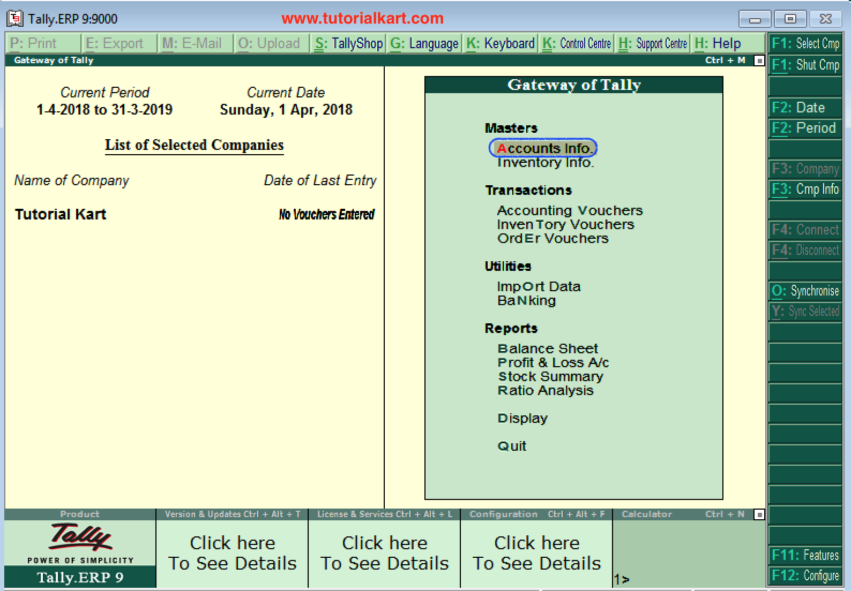

Step 1: Go to Gateway of Tally and click on accounts Info

Step 2: Under Accounts info, choose the option Groups.
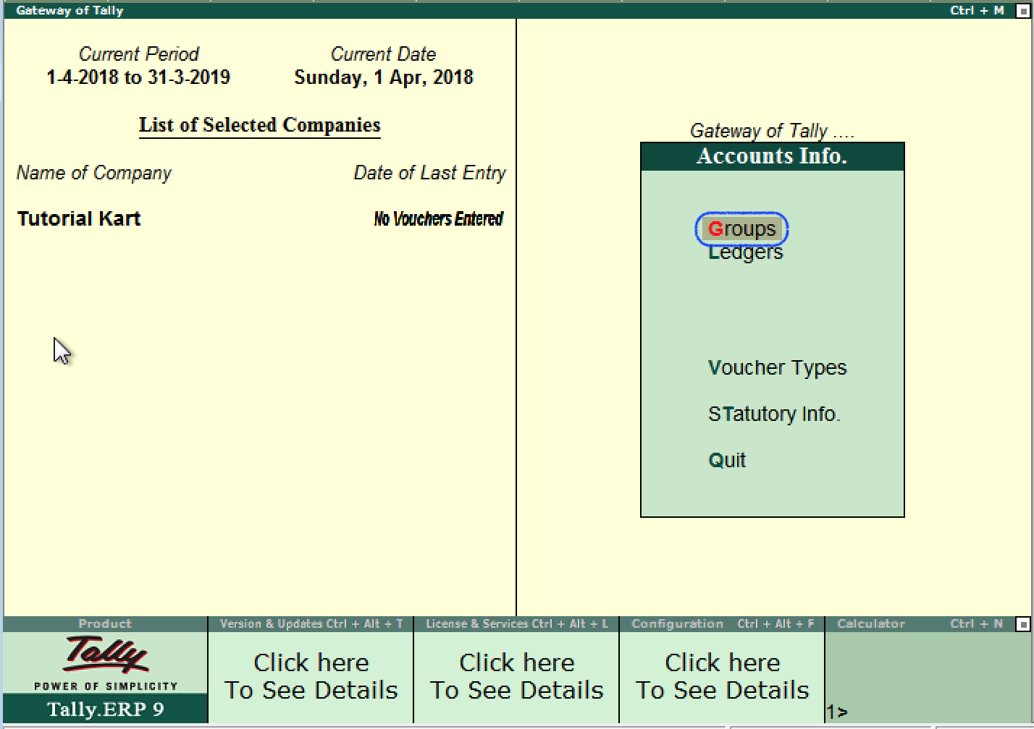
LEDGER CREATION
In this Tally tutorial, we shall learn how to create single ledger in Tally step by step.
Note: In this lesson, we are going to create ledger Axis Bank Account under Bank Account.
The date that required for ledger depends upon the features opted by us. If the settings of accounting features (F11) of company were “NO” for all options, than the ledger screen provides with minimal information.
Tally.ERP 9 automatically creates two ledger accounts i.e. Cash in Hand and Profit & Loss Account. We can create the ledger accounts as per requirements of an organization. We cannot create another profit & loss account in tally, and we can create any number of cash accounts with different names (Petty Cash).
How to create ledger account in Tally ERP 9
Path: Gateway of Tally –> Accounts Info –> Ledgers –> Single Ledger –> Choose Create
Step 1: From Gateway of Tally Screen, click on accounts info
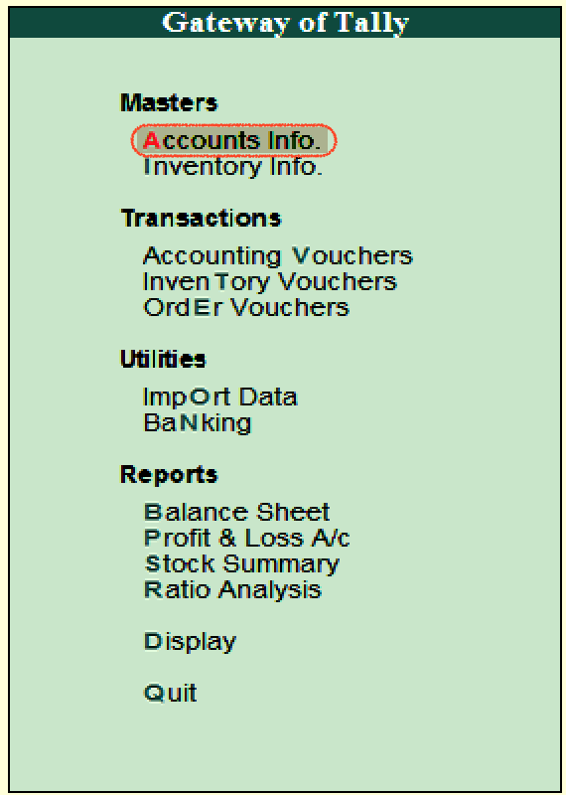

Step 2: In the next screen, choose “Ledger”
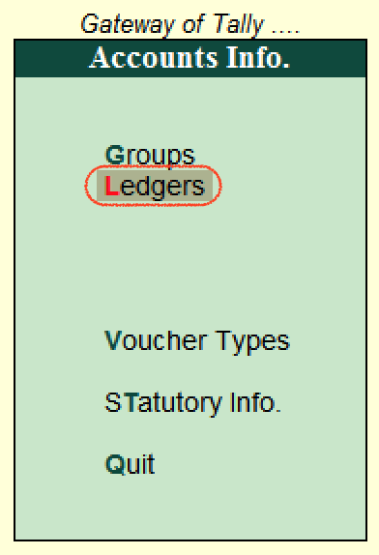
Step 3: In the next ledger screen, choose the option create under single ledger
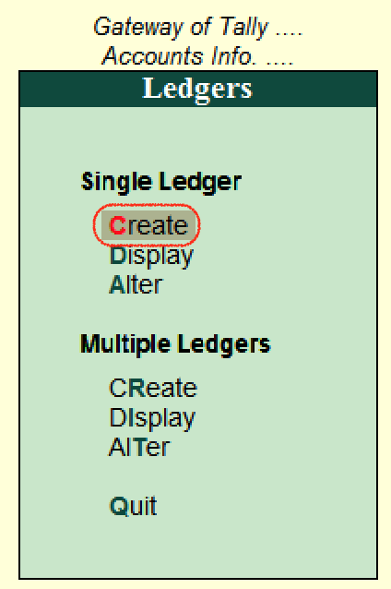
Step 4: On ledger creation screen, update the following details
- Name: Enter the name of ledger account, and the name should be unique.
- Under: Choose the group name from list of group that pertains to ledger account.
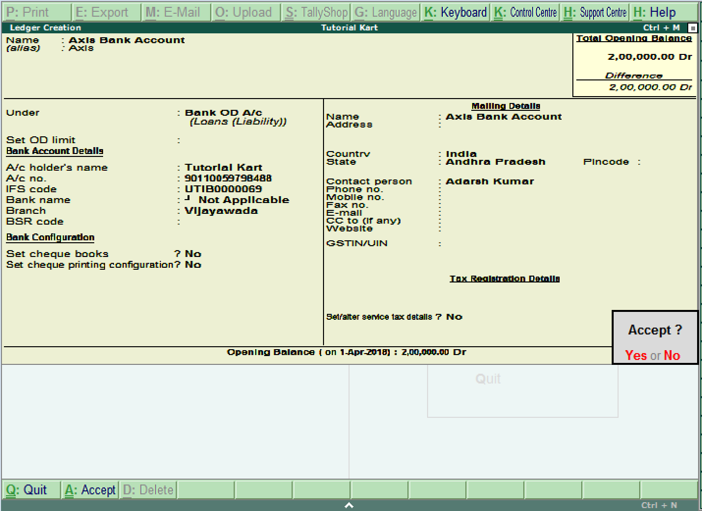
After maintaining all the required details, choose Yes option under Accept to save the configured details in Tally.ERP 9.

How to display single ledger in Tally
After creation of single ledger account in Tally, you view the details of ledger by choosing the option display. Refer below steps how to display single ledger
Path: Gateway of Tally –> Accounts Info –> Ledgers –> Single Ledger –> Choose Display
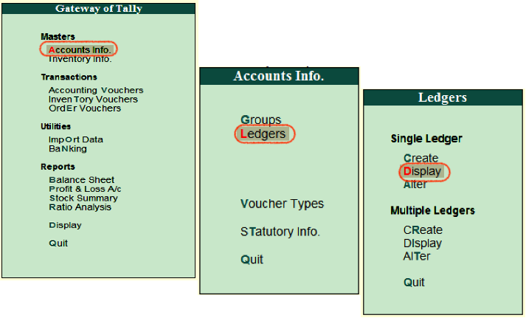
Choose the ledger account from list of ledgers
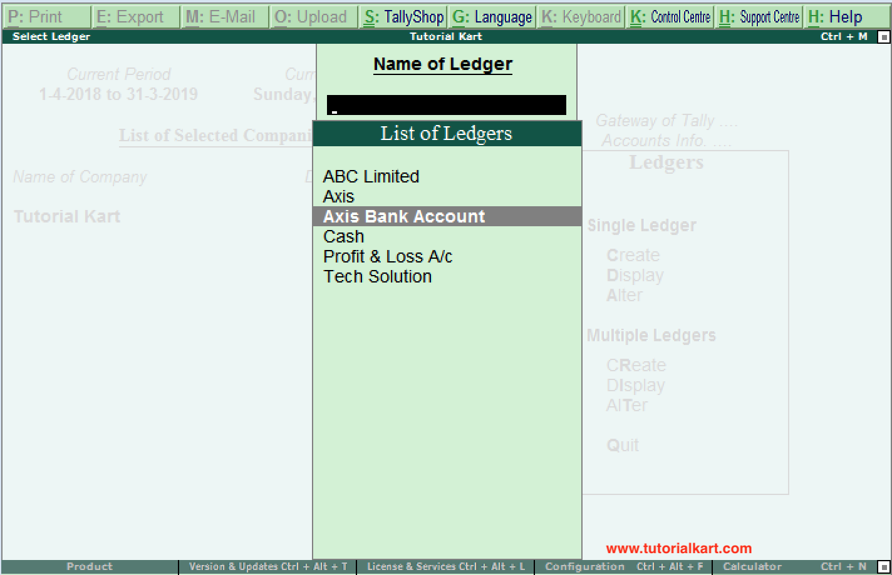
Now the complete details of ledger account display in the screen as shown below image.
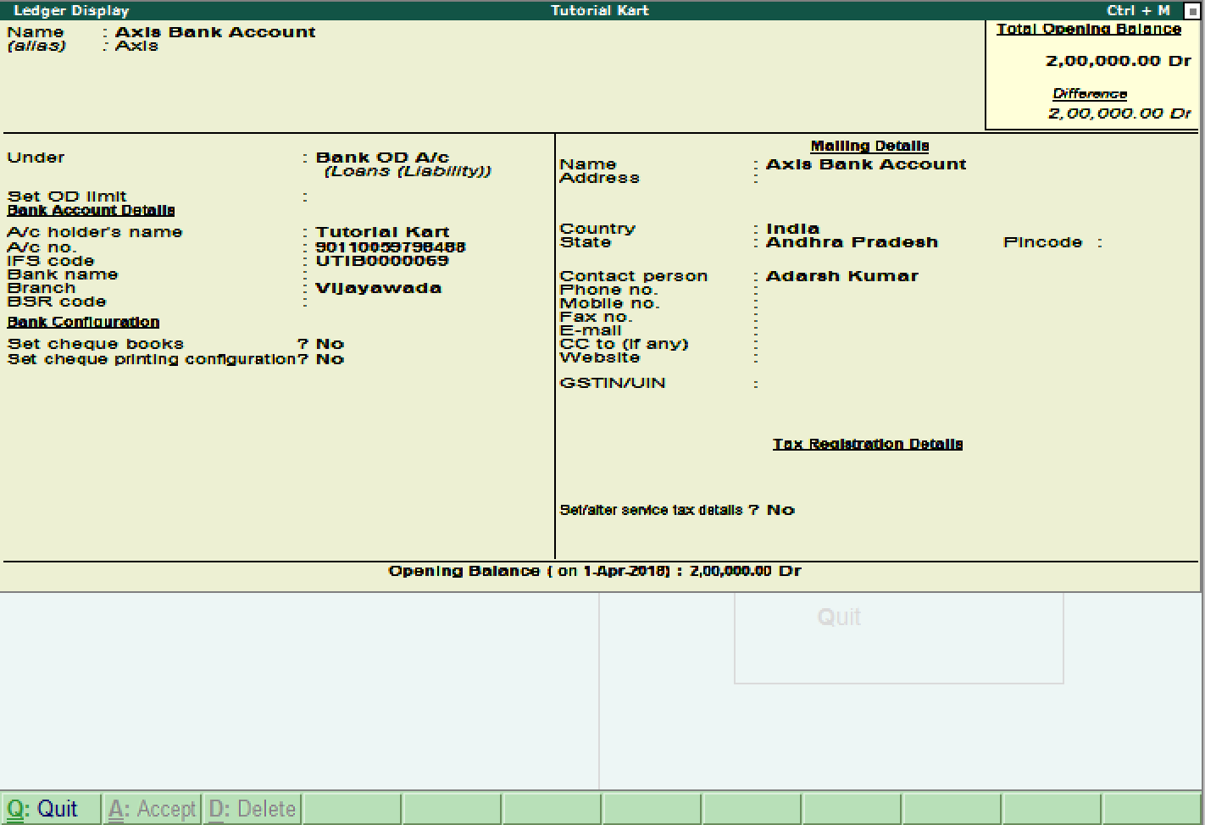

How to Alter Single ledger in Tally
Path: Gateway of Tally –> Accounts Info –> Ledgers –> Single Ledger –> Choose Alter
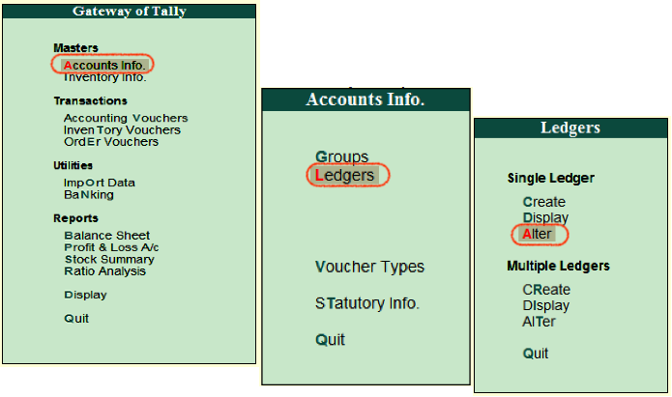
On select ledger screen, choose the ledger account from the list of ledgers
Now modify/ alter the required details for ledger account and click on A:Accept to save the changed details in Tally ERP 9.
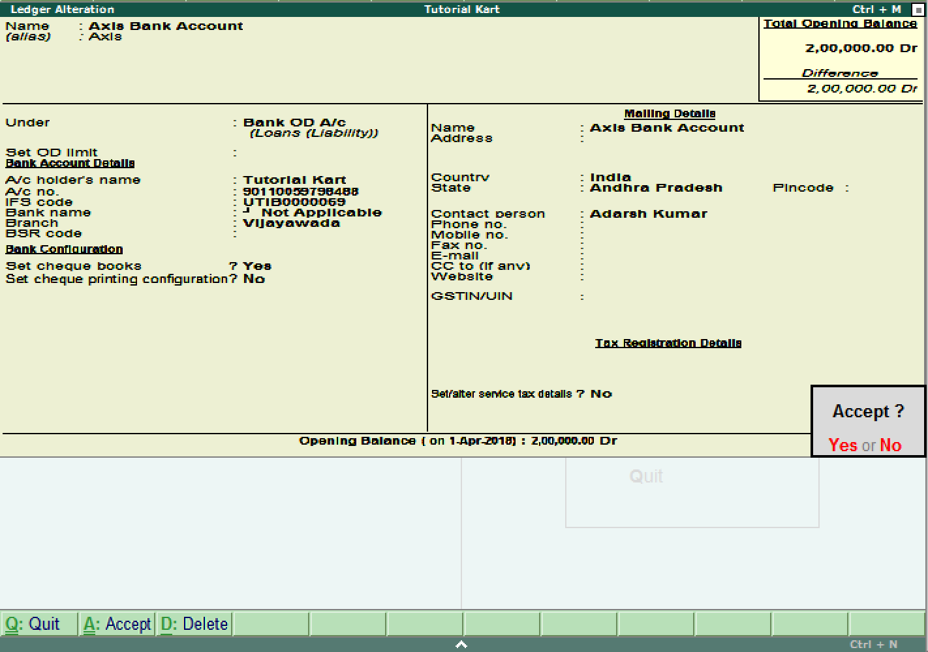
Continue to read: How to create multiple ledgers in Tally.
❮ PreviousNext ❯
UNIT III

VOUCHER CREATION
Voucher type is the transaction data posting screen in Tally. ERP9, where you can post different types of transactions such as sales, purchases, contra, payment and receipt etc. ... Example: Based on your requirement you can create new voucher types easily in Tally like, sales percentage wise sales@18%, 5% and 12%

What is a voucher in accounting?
Voucher means a written statement that serves to confirm or witness for some facts like a Transaction. Primarily, it is a document that shows goods purchased or services rendered, authorizing the payment and indicating in the ledger account in which these transactions have to be recorded.

Benefits of Voucher
- Vouchers are useful for maintaining a higher level of control over the payables process.
- Several invoices can be paid at once (reducing the number of checks).
- It can be pre-numbered, which simplifies the audit trail for payables.
- Invoice approval is separated from invoice payment, it makes easier to schedule both to maximize efficiency.
- Payment of the invoices is done by the cashier, who reports to the treasurer.

Types of Vouchers in Accounting
There are four different types of Vouchers in Accounting. They are:
- Debit or Payment voucher
- Credit or Receipt voucher
- Non-cash or Transfer Voucher
- Supporting Voucher

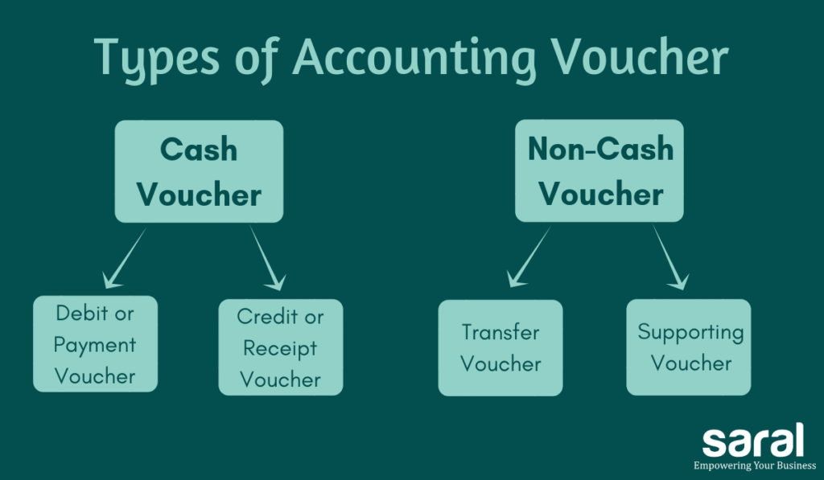

Debit or Payment Voucher
A Payment voucher is used to record a payment of cash or cheque. In this case, the cash/bank will be credited and there will be an outflow of funds.

Credit or Receipt Voucher
A Receipt voucher is used to record cash or bank receipt. Here there is an inflow of funds. Receipt Vouchers are of two types:
- Cash receipt voucher – It represents receipt of cash in hand
- Bank receipt voucher – It indicates receipt of a cheque or demand draft i.e., money is not received in the form of cash in hand. Instead, the money is credited to the bank account of the assess
NON – CASH VOUCHER
Non-cash vouchers are used for non-cash transactions. They are basically used as documentary evidence. e.g., Goods sold on a credit basis. In these cases, the cash / bank account of the assessee is not affected.
Supporting voucher
Supporting voucher serves as documentary evidence of the transactions happened in the past. For example, you can attach the bill of an expense along with the original voucher just to further support the primary voucher. Petrol Bills attached to the conveyance vouchers is a good example of Supporting Voucher.
This ends the post on different types of vouchers in accounting
A voucher is a document that is used by the accounting department on an organisation or a
business. Vouchers are used for the systematic compilation and collation of data in the
form of invoices, purchase order, certificates, along with other information required to
process the payment.
Different Types of Voucher in Tally with Examples
Vouchers can be majorly divided in two categories, inventory vouchers, and accounting vouchers in Tally ERP 9. Under each category, there are numerous different types vouchers in Tally ERP 9 that the accounting professionals use. Here is an extensive list of some of the accounting voucher in Tally examples:

Accounting Vouchers in Tally Examples
- Sales Voucher
- Purchase Voucher
- Payment Voucher
- Receipt Voucher
- Contra Voucher
- Journal Voucher
- Credit Note Voucher
- Debit Note Voucher

There are numerous types of accounting voucher in Tally ERP 9 which help in executing various important accounting tasks. Here, we have listed the accounting voucher in Tally examples:
- Sales Voucher in Tally
Sales voucher is one of the most used accounting vouchers in Tally. Users can create this voucher in two different formats; as an invoice, or as a voucher. The invoice format enables users to print a copy of invoices for customers. The voucher format can be used to store transactional records electronically and it doesn’t need a paper copy for the customer.
- Purchase Voucher in Tally
Like sales vouchers, purchase voucher belongs to the accounting category and is available in both invoice and voucher formats. Editing and modifying receipt entries in Tally are easy, as its voucher format helps accountants to do so quickly. Moreover, Tally also helps in converting a purchase voucher in the invoice format to the voucher format.
- Payment Voucher in Tally
The payment voucher is another accounting voucher in Tally that helps create and print cheques against the order. Once the payment voucher gets passed, the corresponding cheque can be printed by clicking on ‘banking’ and then on ‘cheque printing’.
- Receipt Voucher in Tally
When accountants make a receipt voucher in Tally, all the invoices which have pending payments pop up as a reminder. As soon as the client makes the payment through any mode, the receipt can be updated with the payment method details. In addition, all the details of this receipt can be sent to the customer. Thus, receipt vouchers make payment monitoring easy.
- Contra Voucher in Tally
Contra vouchers are used to withdraw or deposit money in banks with the help of instruments such as cheques/ATM/DD or e-transfer to another account through NEFT/IMPS. With the help of contra vouchers in Tally, accountants can also generate deposit slips for recordkeeping.
Tally also provides exact currency denominations to monitor and print the deposit slip while also depositing the amount.
- Journal Voucher in Tally
Unlike other vouchers, a journal voucher in Tally can come under the roof of both accounting and inventory vouchers. There are multiple uses of a journal voucher in Tally depending on the type of business it is being used for.
It can be found as an optional voucher in Tally to make sales and purchase by accountants. Professionals can also use it for the adjustment or transferring of stock from one warehouse to the other.
- Credit Note Voucher in Tally
Credit note voucher in Tally has to be enabled manually. It is usually enabled by pressing F11 and they manually configuring its features. Credit note can also be passed by checking the original invoice. When a client is selected, Tally shows the transaction invoice history that have been raised.
- Debit Note Voucher in Tally
Debit note voucher is one of the most-used types of voucher in Tally ERP 9, that is used for managing purchase returns. With the help of this, accountants can generate a debit note for invoicing as well as a voucher. Like credit note voucher in Tally, debit note too can easily be configured by pressing F11 and configuring it manually.
UNIT-IV

inventory Management
In any business or organization, all functions are interlinked and connected to each other and are often overlapping. Some key aspects like supply chain management, logistics and inventory form the backbone of the business delivery function. Therefore these functions are extremely important to marketing managers as well as finance controllers.
Inventory management is a very important function that determines the health of the supply chain as well as the impacts the financial health of the balance sheet. Every organization constantly strives to maintain optimum inventory to be able to meet its requirements and avoid over or under inventory that can impact the financial figures.
Inventory is always dynamic. Inventory management requires constant and careful evaluation of external and internal factors and control through planning and review. Most of the organizations have a separate department or job function called inventory planners who continuously monitor, control and review inventory and interface with production, procurement and finance departments.

Defining Inventory
Inventory is an idle stock of physical goods that contain economic value, and are held in various forms by an organization in its custody awaiting packing, processing, transformation, use or sale in a future point of time.
Any organization which is into production, trading, sale and service of a product will necessarily hold stock of various physical resources to aid in future consumption and sale. While inventory is a necessary evil of any such business, it may be noted that the organizations hold inventories for various reasons, which include speculative purposes, functional purposes, physical necessities etc.
From the above definition the following points stand out with reference to inventory:
- All organizations engaged in production or sale of products hold inventory in one form or other.
- Inventory can be in complete state or incomplete state.
- Inventory is held to facilitate future consumption, sale or further processing/value addition.
- All inventoried resources have economic value and can be considered as assets of the organization.

Different Types of Inventory
Inventory of materials occurs at various stages and departments of an organization. A manufacturing organization holds inventory of raw materials and consumables required for production. It also holds inventory of semi-finished goods at various stages in the plant with various departments. Finished goods inventory is held at plant, FG Stores, distribution centers etc. Further both raw materials and finished goods those that are in transit at various locations also form a part of inventory depending upon who owns the inventory at the particular juncture. Finished goods inventory is held by the organization at various stocking points or with dealers and stockiest until it reaches the market and end customers.
Besides Raw materials and finished goods, organizations also hold inventories of spare parts to service the products. Defective products, defective parts and scrap also forms a part of inventory as long as these items are inventoried in the books of the company and have economic value.

Types of Inventory by Function

INPUT | PROCESS | OUTPUT
Raw Materials | Work In Process | Finished Goods
Consumables required for processing. Eg : Fuel, Stationary, Bolts & Nuts etc. required in manufacturing | Semi Finished Production in various stages, lying with various departments like Production, WIP Stores, QC, Final Assembly, Paint Shop, Packing, Outbound Store etc. | Finished Goods at Distribution Centers through out Supply Chain
Maintenance Items/Consumables | Production Waste and Scrap | Finished Goods in transit
Packing Materials | Rejections and Defectives | Finished Goods with Stockiest and Dealers
Local purchased Items required for production |  | Spare Parts Stocks & Bought Out items
 |  | Defectives, Rejects and Sales Returns
 |  | Repaired Stock and Parts
 |  | Sales Promotion & Sample Stocks

How to Create Stock Items In Tally
Stock Items in Tally
In Tally, stock items are referred to goods or services that a company manufactures or trade.
Stock items in Tally can be created by two methods, i.e.
- Single stock item
- Multiple stock items
Groups | Name of Items | Unit | Opening Qty | Rate | Amount
Music System | Sony Blue Ray Player | Nos | 10 | 25,000 | 250,000
 | Philips DVD player | Nos | 5 | 15,000 | 75,000
 | Sony 5.1 Music System | Nos | 2 | 20,000 | 40,000
Television | Sony 32 Inch Tv | Nos | 3 | 25,000 | 75,000
 | LG 32 Inch Tv | Nos | 4 | 20,000 | 80,000
 | MI 32 Inch Tv | Nos | 2 | 15000 | 30,000
 | MI 42 Inch TV | Nos | 2 | 20000 | 40,000
How to create single stock item in Tally
Path: Gateway of Tally.ERP 9 > Inventory Info > Stock Items > Single stock item > Create
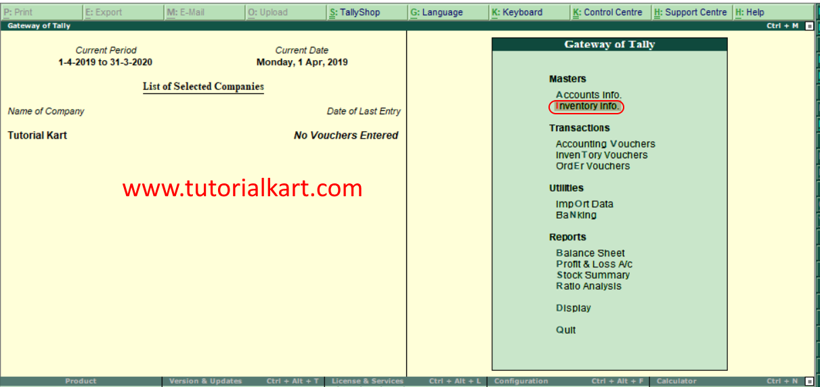
Step 2: Next screen, choose “Stock items”
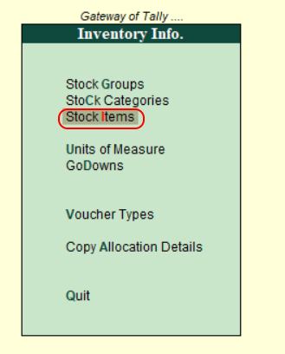
BUDGET AND CONTROLS
Budgeting and Control
Budgeting

Budgets have multiple functions, namely:

Planning – Management produce detailed plans for implementation.
Coordination – Actions of different parts of organisation are brought together.
Communication – Everyone is informed of the plans and policies; top management communicates to lower level management.
Motivation – This influences managerial behaviour, individuals motivated to perform in line with objectives. This can encourage inefficiency and conflict between managers.
Control – Assists managers in controlling activities with management’s attention concentrated on deviations from a pre-set plan.
Performance Evaluation – Measuring success of achieving the budget rewards like bonuses are given in some companies and is meant to influence human behaviour.
Incremental budgeting

Indirect cost and support activities are prepared incrementally.

Zero based budgeting

Activities are justified & prioritised before decisions are taken. The approach is that ‘budgeted’ expenditure starts from base zero and description of each activity is included in a decision package, they are evaluated, ranked and resources allocated.

The benefits are that the deficiencies of traditional budgeting are avoided, resources are allocated by need or benefit; a questioning attitude is created and the focus is on attention on outputs in relation to value for money.

Anthony (1965) categorised control into three main types:

Strategic Control

The setting of corporate strategy and long term objectives for the organisation.
Operational Control

Operational control is ensuring that specific tasks are carried out. This is primarily concerned with the processing of inputs and raw materials to get outputs.
Management Control

Management control is the coordination of the day to day activities in an organisation to ensure that inputs and raw materials are used efficiently and effectively towards achieving long term goals. Management control, therefore, links strategic control and operational control.
Management control utilises regular feedback reporting systems so that corrective action can taken where variances from plan are identified. The budget plays an important role here in providing controls to aid management control.

The systematic comparison of planned inputs to actual results made using the budget, followed by corrective action where deviations from plan exist, is known as a ‘control system’. The system providing the reports for this control system is known as ‘responsibility accounting’. This will be discussed in more detail later in the session.

Feedback and Feed-forward Controls

Feedback control – occurs where actual outputs are monitored against desired outputs and corrective action is taken where there is a variance between the two.
Feed-forward control – predictions are made about future outputs and compared to desired outputs and action is taken where there is a difference between the two.
So, with feed-forward controls any likely errors can be foreseen and actions taken to avoid them, whereas, with feedback control actual errors against the plan are identified and corrective actions taken to achieve the remainder of the plan.

The budgeting process is an example of both a feed-forward and feedback control system.

Budgets as feed-forward control

In putting budgets together, and submitting them to the budget committee, they are compared against the future expectations of the organisation as outlined in the long term plan. If the budget falls short of these expectations then it may be adjusted and alternatives considered. This process may continue until a budget is agreed that will meet long term expectations.

Budgets as feedback control

During the budget period actual results are compared to the budget and any deviations from budget identified. Corrective actions are then taken to ensure that future results are in line with the budget.

UNIT-V
DAY BOOK
Viewing Day Book
The Day Book lists all transactions made in a particular day and by default displays the last voucher entry date of a regular voucher. It could also be set up to list all the transactions made over a certain period. Transactions include all financial vouchers, reversing and memorandum journals as well as inventory vouchers. You can view this report in browser .

In Tally.ERP 9, the Day Book is by default displayed for the current date (as on the last date of voucher entry). However, you may specify the required period, as per your requirements.

To view the Day Book

1. Go to Gateway of Tally > Display > Daybook . The Day Book will appear as shown below:
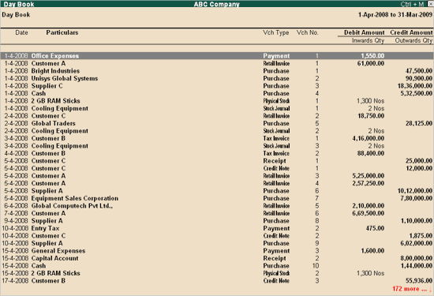
2. Click F2: Period to change the period for which the Day Book is displayed.
3. Click F4: Change Vouch to view Day Book for a particular voucher type.
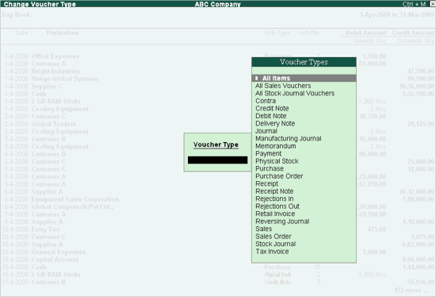
4.Select the required Voucher Type to display. The screen appears as shown below:
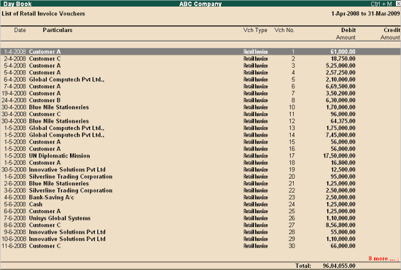
What is an inventory report?
An inventory report is a summary of the amount of inventory a business has on hand at a given time. The inventory report is a physical or electronic document with numbers representing product you’re able to sell now, inventory you are ordering, or inventory you need for internal business use.
Good inventory reports contain up-to-date information with a high level of detail and use visuals to make it clear how many of a given item you have in stock. Inventory reports help you avoid over-ordering inventory or running out of inventory when customers buy your products online.
Inventory reports are helpful — and necessary — in a wide variety of ways.
What are inventory reports used for?
Inventory reports help you run your business without interruption or breaking the bank. They can help you cut costs and reduce the risk of running out of stock. Inventory reporting may just seem like extra time or paperwork, but it can save you a ton of money and unnecessary effort.
Inventory management
One of the biggest uses of inventory reporting is managing inventory. You need to know what you have to ensure you don’t run out before customers’ orders are fulfilled. Ordering too late results in out-of-stock items and lost sales. Ordering too much too soon ties up your cash, increases your risk of damaged inventory, and requires more space for warehousing. Accurate inventory reporting tells you exactly when your stock levels reach the reorder point so you can restock.
Inventory tracking (within warehouses)
If you have a large amount of inventory and high sales volume, you need to track the locations of your inventory within the warehouse(s) you use for order fulfillment. Tracking SKUs by inventory storage location and keeping everything organized can make your job easier by preventing unnecessary movement, double-handling of products, and even lost inventory.
It can also help you:
Keep track of items ordered within a certain date range
If you order from more than one supplier
Identify affected products in the case of a recall
If you need to return damaged merchandise
If your inventory is perishable, or regularly changes in cost, you may need to track the location for the sake of FIFO (first in first out) or LIFO (last in first out) inventory rules.
Inventory categorization
Depending on your industry, there could be a number of ways to categorize your inventory. Looking at a mountain of cardboard boxes, it can be very unclear to see what’s what.
A list of items in each category that’s updated in real-time allows you to track inventory as it moves throughout the supply chain. For instance, manufacturers often need to track inventory as raw materials, goods in process, or inventory ready to sell. The inventory valuation of each category or step is a necessary part of tracking the cost of goods sold for tax purposes and inventory accounting.
Once it’s in your fulfillment center, you’ll want to track each product as inventory received, stowed, picked for an order, packed in a box, and shipped to a customer.
How to write an inventory report
You can create a basic inventory report in Excel or Google Sheets to track inventory; However, this does not allow for automated updates and only represents a snapshot at one point in time. A best practice for inventory reporting is to connect the systems that utilize your supply chain and customer order data (more on that below).
Here are the steps to create a basic inventory report that requires manual updating.
Create a column for inventory items
Create a list of items in your inventory using a vertical column. This should be done at the SKU level (i.e., if you have a red shirt in four sizes, you would list out each size for a total of four entries, not one) and can be recorded as the SKU name. The more SKUs you have, the more difficult and time-consuming it will be.
Create a column for descriptions
Describe the items in another column. If you have a variety of colors, sizes, etc., you can provide more context or detail here to validate what makes it a unique product for inventory reporting and tracking purposes.
Assign a price to each item
List the price of each item so you can quickly pull out the total value of your inventory and the value of each item, based on price and quantity. Depending on your business, you may need to track the purchase or manufacturing cost separately from the selling price. Inventory valuation can also help you calculate inventory carrying costs.
Create a column for remaining stock
Next, add a column to track the number of units currently in stock. This column will be updated with new purchase orders and sales orders to make sure the number is current.
Select a time frame
How frequently you choose to update your inventory report will depend on your needs. The higher your sales volume, the more often you’ll update it since your numbers can change rapidly.
Frequency would also depend on how much safety stock you carry. If you have a cushion of inventory between your reorder point and zero, you can get away with less frequent updates. Just remember that excessive safety stock adds to your expenses.
Inventory reporting for ecommerce
A retail shop with a stockroom requires inventory tracking, but their needs are very different from an ecommerce business owner when it comes to inventory management.
Unlike a physical business, ecommerce purchases are made outside of regular hours and from all corners of the world. This can put ecommerce businesses that are gaining traction at a higher risk of running out of an item when a customer is ready to order.
Ecommerce business owners need to reduce the chance of this happening. Inventory levels should be updated as often as possible to ensure accurate and complete numbers. The only way to truly keep accurate inventory is to use an automated system that syncs with your point of sale software and updates your inventory with each and every sale. That way, you always know exactly what you have and can reorder merchandise or supplies right on time.
Automate your reporting with ShipBob
ShipBob simplifies the process for ecommerce sellers through accurate inventory reporting. ShipBob connects to your ecommerce store and handles ecommerce fulfillment for you. All of your inventory is stored at any combination of ShipBob’s warehouses throughout the United States, and they handle inventory reporting on-site and online.

By syncing with your ecommerce platform, inventory reports are updated in real-time to reflect exactly what you have in stock, minute by minute. You can access detailed reports, complete with charts and graphs, to help you see your stock at a glance. Check out ShipBob’s advanced reporting features to learn more and see what your inventory reports could look like for your business.
Bank Reconciliation Statement
By JULIA KAGAN
Updated Jul 6, 2019
What Is a Bank Reconciliation Statement?
A bank reconciliation statement is a summary of banking and business activity that reconciles an entity’s bank account with its financial records. The statement outlines the deposits, withdrawals and other activities affecting a bank account for a specific period. A bank reconciliation statement is a useful financial internal control tool used to thwart fraud.

Bank Reconciliation Statement

Understanding the Bank Reconciliation Statement
Bank reconciliation statements ensure payments have been processed and cash collections have been deposited into the bank. The reconciliation statement helps identify differences between the bank balance and book balance, in order to process necessary adjustments or corrections. An accountant typically processes reconciliation statements once a month.

KEY TAKEAWAYS
A bank reconciliation statement summarizes banking and business activity, reconciling an entity’s bank account with its financial records.
Bank reconciliation statements confirm that payments have been processed and cash collections have been deposited into a bank account.
All fees charged on an account by a bank must be accounted for on a reconciliation statement.
After all adjustments, the balance on a bank reconciliation statement should equal the ending balance of the bank account.
Required Information to Create Bank Reconciliation Statement
Completing a bank reconciliation statement requires using both the current and the previous month's statements, including the closing balance of the account. The accountant typically prepares the bank reconciliation statement using all transactions through the previous day, as transactions may still be occurring on the actual statement date.

All deposits and withdrawals posted to an account must be used to prepare a reconciliation statement.
Bank Reconciling Statement: Adjusting Balance per Bank
The accountant adjusts the ending balance of the bank statement to reflect outstanding checks or withdrawals. These are transactions in which payment is en route but the cash has not yet been accepted by the recipient. An example is a check mailed on Oct. 30. When preparing the Oct. 31 bank reconciliation statement, the check mailed the previous day is unlikely to have been cashed, so the accountant deducts the amount from the bank balance. There may also be collected payments that have not yet been processed by the bank, which requires a positive adjustment.

Bank Reconciling Statement: Adjusting Balance per Books
The balance of the cash account in an entity's financial records may require adjusting as well. For instance, a bank may charge a fee for having the account open. The bank typically withdraws and processes the fees automatically from the bank account. Therefore, when preparing a bank reconciliation statement, any fees taken from the account must be accounted for by preparing a journal entry.

Another item that requires an adjustment is interest earned. Interest is automatically deposited into a bank account after a certain period of time. Thus, the accountant may need to prepare an entry that increases the cash currently shown in the financial records. After all, adjustments are made to the books, the balance should equal the ending balance of the bank account. If the figures are equal, a successful bank reconciliation statement has been prepared.

- …………..

