BBA AVIATION MANAGEMENT

ECONMICS FOR EXECUTIVES

(UNITS – I) objectives of Business firms

The main objectives of firms are:
- Profit maximisation
- Sales maximisation
- Increased market share/market dominance
- Social/environmental concerns
- Profit satisficing
- Co-operatives
Sometimes there is an overlap of objectives. For example, seeking to increase market share, may lead to lower profits in the short-term, but enable profit maximisation in the long run.
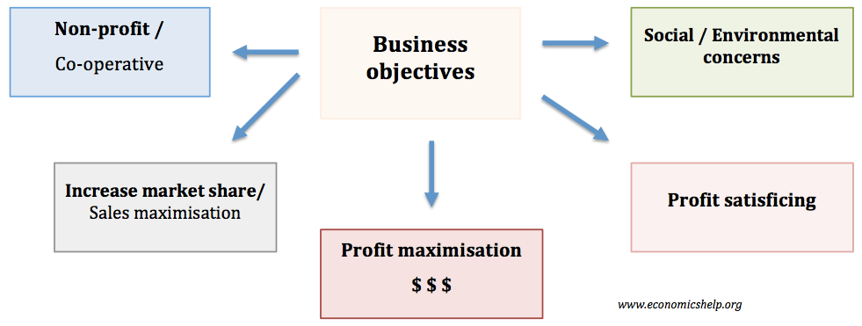

Profit maximisation
Usually, in economics, we assume firms are concerned with maximising profit. Higher profit means:
- Higher dividends for shareholders.
- More profit can be used to finance research and development.
- Higher profit makes the firm less vulnerable to takeover.
- Higher profit enables higher salaries for workers

Alternative aims of firms
However, in the real world, firms may pursue other objectives apart from profit maximisation.

1. Profit Satisficing
- In many firms, there is a separation of ownership and control. Those who own the company (shareholders) often do not get involved in the day to day running of the company.
- This is a problem because although the owners may want to maximise profits, the managers have much less incentive to maximise profits because they do not get the same rewards, (share dividends)
- Therefore managers may create a minimum level of profit to keep the shareholders happy, but then maximise other objectives, such as enjoying work, getting on with other workers. (e.g. not sacking them) This is the problem of separation between owners and managers.
- This ‘principal-agent‘ problem can be overcome, to some extent, by giving managers share options and performance related pay although in some industries it is difficult to measure performance.
- More on profit-satisficing.

2. Sales maximisation
Firms often seek to increase their market share – even if it means less profit. This could occur for various reasons:
- Increased market share increases monopoly power and may enable the firm to put up prices and make more profit in the long run.
- Managers prefer to work for bigger companies as it leads to greater prestige and higher salaries.
- Increasing market share may force rivals out of business. E.g. the growth of supermarkets have lead to the demise of many local shops. Some firms may actually engage in predatory pricing which involves making a loss to force a rival out of business.

3. Growth maximisation
This is similar to sales maximisation and may involve mergers and takeovers. With this objective, the firm may be willing to make lower levels of profit in order to increase in size and gain more market share. More market share increases its monopoly power and ability to be a price setter.

4. Long run profit maximisation
In some cases, firms may sacrifice profits in the short term to increase profits in the long run. For example, by investing heavily in new capacity, firms may make a loss in the short run but enable higher profits in the future.

5. Social/environmental concerns
A firm may incur extra expense to choose products which don’t harm the environment or products not tested on animals. Alternatively, firms may be concerned about local community / charitable concerns.
- Some firms may adopt social/environmental concerns as part of their branding. This can ultimately help profitability as the brand becomes more attractive to consumers.
- Some firms may adopt social/environmental concerns on principal alone – even if it does little to improve sales/brand image.

6. Co-operatives
Co-operatives may have completely different objectives to a typical PLC. A co-operative is run to maximise the welfare of all stakeholders – especially workers. Any profit the co-operative makes will be shared amongst all members.

Diagram showing different objectives of firms

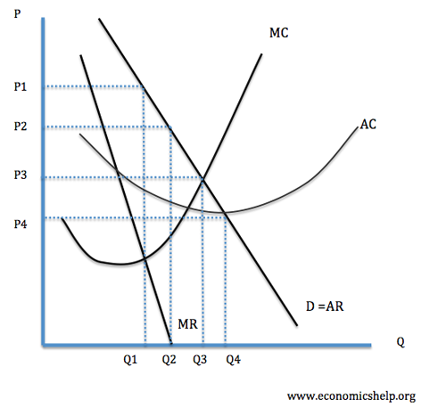
- Q1 = Profit maximisation (MR=MC)
- Q2 = Revenue Maximisation (MR=0)
- Q3 = Marginal cost pricing (P=MC) – allocative efficiency
- Q4 = Sales maximisation – maximum sales while still making normal profit (AR=ATC)

A business has a variety of potential objectives from profit maximisation to cultivating good relationships with various business stakeholders. Economic theory often assumes that firms are rational profit maximisers. However, in the real world, there are many other objectives that a firm can pursue.

Profit Maximisation.
The most basic model of a firm assumes firms wish to maximise their profit. They will do this by increasing revenue (price * quantity sold) and reducing costs. Higher profits enable a firm to pay higher wages, more dividends to shareholders and survive an economic downturn. Many other objectives such as corporate image an increasing market share can be a way to maximise long-term profit.
Growth Maximisation.
An alternative to profit maximisation is for a firm to try and increase market share and increase the size of the firm. They can do this by cutting price and increasing sales. Growth maximisation may come at the expense of lower profits. For example, starting a price war can lead to lower profits but enable higher sales. However, increasing market share can be a way to increase profits in the long-term. A firm like Walmart and Amazon have often pursued this goal of maximising market share. It gives a strong position to dominate the market in the future.
Social / Ethical concerns.
A firm may not be motivated by money but may seek to offer a service to the local community. They may voluntarily take decisions which help the environment / local community. Many big firms now place a key role in promoting their ethical policies; arguably there may also be some marketing benefits to promoting ethical and social concerns. It could have a tie-up with profit maximisation.
Corporate Image.
Related to social/ethical concerns is the image/brand of a firm. It may wish to cultivate a certain image and brand. Google – ‘do no evil. BP – “Beyond Petroleum”. Body Shop ‘leader in human and animal rights.’ This corporate image may be part of a business strategy to maximise profits, but it could also be a genuine desire to promote altruistic goals.
Stakeholders Well Being.
A firm may also be concerned about the welfare of its stakeholders – suppliers, workers and customers. For example, giving training and long-term job security to its workers. Co-operative businesses are founded on the goal of sharing proceeds of business with whole community – customers and workers.
Survival.
For many businesses, it seems a matter of surviving – breaking even. In desperate times, firms may be forced to sell off assets to keep their creditors at bay. For many small local businesses struggling in a highly competitive market, survival may be the best they can hope for. In a way survival strategies is a form of profit maximization as survival will still involve trying to increase revenue and reduce costs.
Another issue for firms is:
Profit Satisficing. This is a situation where there is a separation of ownership and control in a firm. The owners (shareholders) wish to maximise profit, but the managers and workers don’t feel the same incentive. Therefore, they do enough to keep the owners happy but then pursue other objectives such as having a good time at work.

Behavioural theories and objectives of firms

In recent years, behavioural economics has looked at psychological influences which can explain consumer behaviour. Behavioural economics suggests economics has been too narrow in reducing owners to rational profit maximisers. In the real world, profit is only one motivating factor. Business owners and workers may value enjoying work, the prestige of a good company and make irrational decisions based on emotion, e.g. keeping the family business going in one direction because of tradition.

Functional Objectives of Firms
A functional objective of a firm is achievable goals or targets of different parts of a business structure as it tries to achieve wider business objectives.
Examples of Functional Objectives
- Minimise costs. This may involve better management of raw materials and supplies, e.g. implementing just in time management and stock control.
- Raise profile of business. A successful marketing strategy to raise brand awareness and increase sales.
- Improving Staff Loyalty and Motivation. Human resource department might find ways to promote a greater feeling of worker loyalty and willingness to work for company. For example, giving workers targets and rewards for achieving them. This can help the objectives of worker satisfaction and in the long run, contribute to the improved performance of the firm.
- Development of Products. No market is static, therefore a firm will need to find ways to improve the quality and uniqueness of its market.
- Increase Market Share. An objective may be to increase sales and take market share from other firms, e.g. it may try and do this through a selective price war.

Functional Objectives and Business Strategies
To achieve functional objectives, a firm may use different business strategies. For example, if the firm has an objective to reduce staff turnover, it may pursue a new strategy of employer feedback where the firm gives staff the opportunity to have a say in the running of the business.
- An objective to increase sales could be achieved by a marketing strategy to raise brand awareness.

Functional Objectives and Corporate Objectives.
A corporate objective is something like profit maximisation or diversification of business. These objectives are quite general. Functional objectives help these to become a reality. e.g. to achieve the maximum rate of return for shareholders, firms may need practical functional objectives such as increasing sales.
PROFIT MAXIMAISATION
In economics, profit maximization is the short run or long run process by which a firm may determine the price, input, and output levels that lead to the highest profit. Neoclassical economics, currently the mainstream approach to microeconomics, usually models the firm as maximizing profit.
There are several perspectives one can take on this problem. First, since profit equals revenue minus cost, one can plot graphically each of the variables revenue and cost as functions of the level of output and find the output level that maximizes the difference (or this can be done with a table of values instead of a graph). Second, if specific functional forms are known for revenue and cost in terms of output, one can use calculus to maximize profit with respect to the output level. Third, since the first order condition for the optimization equates marginal revenue and marginal cost, if marginal revenue (mr) and marginal cost(mc) functions in terms of output are directly available one can equate these, using either equations or a graph.
Fourth, rather than a function giving the cost of producing each potential output level, the firm may have input cost functions giving the cost of acquiring any amount of each input, along with a production function showing how much output results from using any combination of input quantities. In this case one can use calculus to maximize profit with respect to input usage levels, subject to the input cost functions and the production function. The first order condition for each input equates the marginal revenue product of the input (the increment to revenue from selling the product caused by an increment to the amount of the input used) to the marginal cost of the input.
For a firm in a perfectly competitive market for its output, the revenue function will simply equal the market price times the quantity produced and sold, whereas for a monopolist, which chooses its level of output simultaneously with its selling price, the revenue function takes into account the fact that higher levels of output require a lower price in order to be sold. An analogous feature holds for the input markets: in a perfectly competitive input market the firm's cost of the input is simply the amount purchased for use in production times the market-determined unit input cost, whereas a monopsonist’s input price per unit is higher for higher amounts of the input purchased.
The principal difference between short-run and long-run profit maximization is that in the long run the quantities of all inputs, including physical capital, are choice variables, while in the short run the amount of capital is predetermined by past investment decisions. In either case there are inputs of labor and raw materials.

Basic definitions

Any costs incurred by a firm may be classed into two groups: fixed costs and variable costs. Fixed costs, which occur only in the short run, are incurred by the business at any level of output, including zero output. These may include equipment maintenance, rent, wages of employees whose numbers cannot be increased or decreased in the short run, and general upkeep. Variable costs change with the level of output, increasing as more product is generated. Materials consumed during production often have the largest impact on this category, which also includes the wages of employees who can be hired and laid off in the short-run span of time under consideration. Fixed cost and variable cost, combined, equal total cost.
Revenue is the amount of money that a company receives from its normal business activities, usually from the sale of goods and services (as opposed to monies from security sales such as equity shares or debt issuances).
Marginal cost and marginal revenue, depending on whether the calculus approach is taken or not, are defined as either the change in cost or revenue as each additional unit is produced, or the derivative of cost or revenue with respect to the quantity of output. For instance, taking the first definition, if it costs a firm $400 to produce 5 units and $480 to produce 6, the marginal cost of the sixth unit is 80 dollars.
Total revenue–total cost perspective
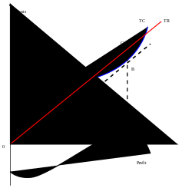
Profit maximization using the total revenue and total cost curves of a perfect competitor
To obtain the profit maximizing output quantity, we start by recognizing that profit is equal to total revenue (TR) minus total cost (TC). Given a table of costs and revenues at each quantity, we can either compute equations or plot the data directly on a graph. The profit-maximizing output is the one at which this difference reaches its maximum.
In the accompanying diagram, the linear total revenue curve represents the case in which the firm is a perfect competitor in the goods market, and thus cannot set its own selling price. The profit-maximizing output level is represented as the one at which total revenue is the height of C and total cost is the height of B; the maximal profit is measured as the length of the segment CB. This output level is also the one at which the total profit curve is at its maximum.
If, contrary to what is assumed in the graph, the firm is not a perfect competitor in the output market, the price to sell the product at can be read off the demand curve at the firm's optimal quantity of output. This optimal quantity of output is the quantity at which marginal revenue equals maginal cost.
Marginal revenue–marginal cost perspective
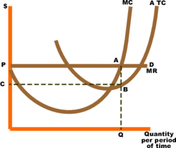
Profit maximization using the marginal revenue and marginal cost curves of a perfect competitor
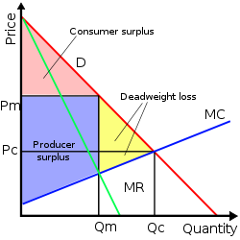
Price setting by a monopolist
An equivalent perspective relies on the relationship that, for each unit sold, marginal profit (Mπ) equals marginal revenue (MR) minus marginal cost (MC). Then, if marginal revenue is greater than marginal cost at some level of output, marginal profit is positive and thus a greater quantity should be produced, and if marginal revenue is less than marginal cost, marginal profit is negative and a lesser quantity should be produced. At the output level at which marginal revenue equals marginal cost, marginal profit is zero and this quantity is the one that maximizes profit.^{[1]} Since total profit increases when marginal profit is positive and total profit decreases when marginal profit is negative, it must reach a maximum where marginal profit is zero—where marginal cost equals marginal revenue—and where lower or higher output levels give lower profit levels.^{[1]} In calculus terms, the requirement that the optimal output have higher profit than adjacent output levels is that:^{[1]}

The intersection of MR and MC is shown in the next diagram as point A. If the industry is perfectly competitive (as is assumed in the diagram), the firm faces a demand curve (D) that is identical to its marginal revenue curve (MR), and this is a horizontal line at a price determined by industry supply and demand. Average total costs are represented by curve ATC. Total economic profit is represented by the area of the rectangle PABC. The optimum quantity (Q) is the same as the optimum quantity in the first diagram.
If the firm is a monopolist, the marginal revenue curve would have a negative slope as shown in the next graph, because it would be based on the downward-sloping market demand curve. The optimal output, shown in the graph as Q_{m}, is the level of output at which marginal cost equals marginal revenue. The price that induces that quantity of output is the height of the demand curve at that quantity (denoted P_{m}).
In an environment that is competitive but not perfectly so, more complicated profit maximization solutions involve the use of game theory.

Case in which maximizing revenue is equivalent
In some cases a firm's demand and cost conditions are such that marginal profits are greater than zero for all levels of production up to a certain maximum.^{[2]} In this case marginal profit plunges to zero immediately after that maximum is reached; hence the Mπ = 0 rule implies that output should be produced at the maximum level, which also happens to be the level that maximizes revenue.^{[2]} In other words, the profit maximizing quantity and price can be determined by setting marginal revenue equal to zero, which occurs at the maximal level of output. Marginal revenue equals zero when the total revenue curve has reached its maximum value. An example would be a scheduled airline flight. The marginal costs of flying one more passenger on the flight are negligible until all the seats are filled. The airline would maximize profit by filling all the seats.

Changes in total costs and profit maximization
A firm maximizes profit by operating where marginal revenue equals marginal cost. In the short run, a change in fixed costs has no effect on the profit maximizing output or price.^{[3]} The firm merely treats short term fixed costs as sunk costs and continues to operate as before.^{[4]} This can be confirmed graphically. Using the diagram illustrating the total cost–total revenue perspective, the firm maximizes profit at the point where the slopes of the total cost line and total revenue line are equal.^{[2]} An increase in fixed cost would cause the total cost curve to shift up rigidly by the amount of the change.^{[2]} There would be no effect on the total revenue curve or the shape of the total cost curve. Consequently, the profit maximizing output would remain the same. This point can also be illustrated using the diagram for the marginal revenue–marginal cost perspective. A change in fixed cost would have no effect on the position or shape of these curves.^{[2]}

Markup pricing
In addition to using methods to determine a firm's optimal level of output, a firm that is not perfectly competitive can equivalently set price to maximize profit (since setting price along a given demand curve involves picking a preferred point on that curve, which is equivalent to picking a preferred quantity to produce and sell). The profit maximization conditions can be expressed in a "more easily applicable" form or rule of thumb than the above perspectives use.^{[5]} The first step is to rewrite the expression for marginal revenue as MR = ∆TR/∆Q =(P∆Q+Q∆P)/∆Q=P+Q∆P/∆Q, where P and Q refer to the midpoints between the old and new values of price and quantity respectively.^{[5]} The marginal revenue from an incremental unit of output has two parts: first, the revenue the firm gains from selling the additional units or, giving the term P∆Q. The additional units are called the marginal units.^{[6]} Producing one extra unit and selling it at price P brings in revenue of P. Moreover, one must consider "the revenue the firm loses on the units it could have sold at the higher price"^{[6]}—that is, if the price of all units had not been pulled down by the effort to sell more units. These units that have lost revenue are called the infra-marginal units.^{[6]} That is, selling the extra unit results in a small drop in price which reduces the revenue for all units sold by the amount Q(∆P/∆Q). Thus MR = P + Q(∆P/∆Q) = P +P (Q/P)(∆P/∆Q) = P + P/(PED), where PED is the price elasticity of demand characterizing the demand curve of the firms' customers, which is negative. Then setting MC = MR gives MC = P + P/PED so (P − MC)/P = −1/PED and P = MC/[1 + (1/PED)]. Thus the optimal markup rule is:
(P − MC)/P = 1/ (−PED)
or equivalently
P = [PED/(1 + PED)] × MC.^{[7][8]}
In words, the rule is that the size of the markup of price over the marginal cost is inversely related to the absolute value of the price elasticity of demand for the good.^{[7]}
The optimal markup rule also implies that a non-competitive firm will produce on the elastic region of its market demand curve. Marginal cost is positive. The term PED/(1+PED) would be positive so P>0 only if PED is between −1 and −∞ (that is, if demand is elastic at that level of output).^{[9]} The intuition behind this result is that, if demand is inelastic at some value Q₁ then a decrease in Q would increase P more than proportionately, thereby increasing revenue PQ; since lower Q would also lead to lower total cost, profit would go up due to the combination of increased revenue and decreased cost. Thus Q₁ does not give the highest possible profit.

Marginal product of labor, marginal revenue product of labor, and profit maximization
The general rule is that the firm maximizes profit by producing that quantity of output where marginal revenue equals marginal cost. The profit maximization issue can also be approached from the input side. That is, what is the profit maximizing usage of the variable input? ^{[10]} To maximize profit the firm should increase usage of the input "up to the point where the input's marginal revenue product equals its marginal costs".^{[11]} So mathematically the profit maximizing rule is MRP_{L} = MC_{L}, where the subscript L refers to the commonly assumed variable input, labor. The marginal revenue product is the change in total revenue per unit change in the variable input. That is MRP_{L} = ∆TR/∆L. MRP_{L} is the product of marginal revenue and the marginal product of labor or MRP_{L} = MR x MP_{L}.

Sub-optimal Profit maximization
Oftentimes, businesses will attempt to maximize their profits even though their optimization strategy typically leads to a sub-optimal quantity of goods produced for the consumers. When deciding a given quantity to produce, a firm will often try to maximize its own producer surplus, at the expense of decreasing the overall social surplus. As a result of this decrease in social surplus, consumer surplus is also minimized, as compared to if the firm did not elect to maximize their own producer surplus.

Government Regulation
In an attempt to prevent businesses from abusing their power to maximize their own profits, governments often intervene to stop them in their tracks. A major example of this is through anti-trust regulation which effectively outlaws most industry monopolies. Through this regulation, consumers enjoy a better relationship with the companies that serve them, even though the company itself may suffer, financially speaking.

Profit Maximisation

- An assumption in classical economics is that firms seek to maximise profits.
- Profit = Total Revenue (TR) – Total Costs (TC).
- Therefore, profit maximisation occurs at the biggest gap between total revenue and total costs.
- A firm can maximise profits if it produces at an output where marginal revenue (MR) = marginal cost (MC)

Diagram of Profit Maximisation

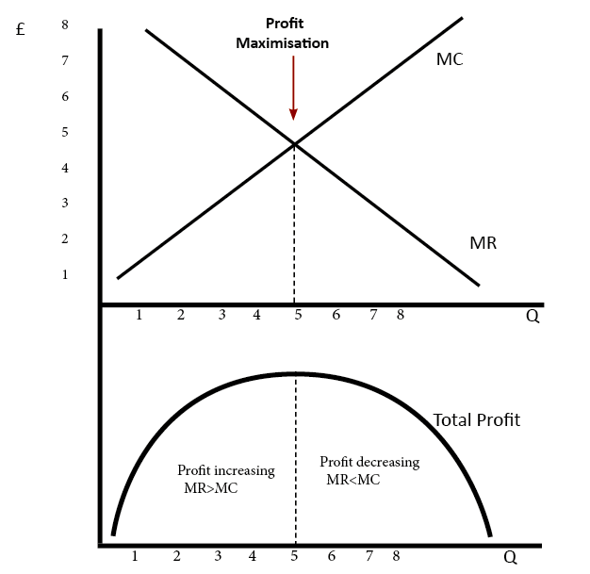
To understand this principle look at the above diagram.
- If the firm produces less than Output of 5, MR is greater than MC. Therefore, for this extra output, the firm is gaining more revenue than it is paying in costs, and total profit will increase.
- At an output of 4, MR is only just greater than MC; therefore, there is only a small increase in profit, but profit is still rising.
- However, after the output of 5, the marginal cost of the output is greater than the marginal revenue. This means the firm will see a fall in its profit level because the cost of these extra units is greater than revenue.

Profit maximisation for a monopoly
- In this diagram, the monopoly maximises profit where MR=MC – at Qm. This enables the firm to make supernormal profits (green area). Note, the firm could produce more and still make normal profit. But, to maximise profit, it involves setting a higher price and

lower quantity than a competitive market.
- Note, the firm could produce more and still make a normal profit. But, to maximise profit, it involves setting a higher price and lower quantity than a competitive market.
- Therefore, in a monopoly profit maximisation involves selling a lower quantity and at a higher price. see also:

- Diagram of monopoly

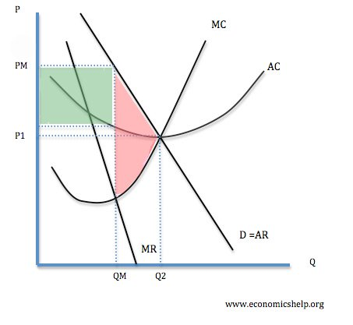

Profit Maximisation in Perfect Competition

In perfect competition, the same rule for profit maximisation still applies. The firm maximises profit where MR=MC (at Q1).
For a firm in perfect competition, demand is perfectly elastic, therefore MR=AR=D.
This gives a firm normal profit because at Q1, AR=AC.

Profit Maximisation in the Real World

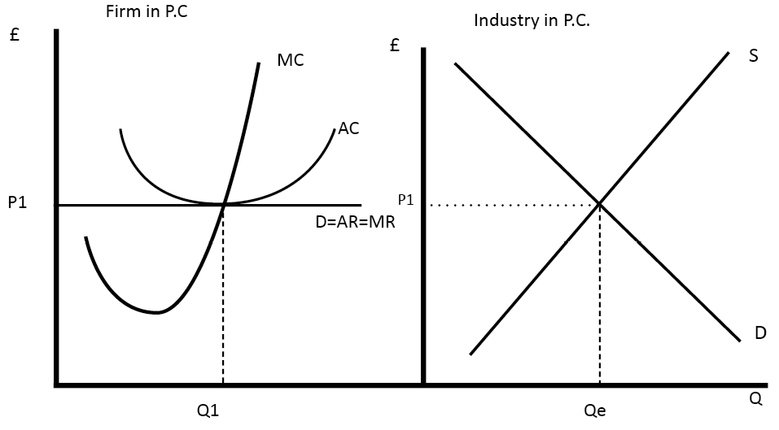

Limitations of Profit Maximisation

- In the real world, it is not so easy to know exactly your marginal revenue and the marginal cost of last goods sold. For example, it is difficult for firms to know the price elasticity of demand for their good – which determines the MR.
- It also depends on how other firms react. If they increase the price, and other firms follow, demand may be inelastic. But, if they are the only firm to increase the price, demand will be elastic (see: kinked demand curve and game theory.
- However, firms can make a best estimation. Many firms may have to seek profit maximisation through trial and error. e.g. if they see increasing price leads to a smaller % fall in demand they will try to increase price as much as they can before demand becomes elastic
- It is difficult to isolate the effect of changing the price on demand. Demand may change due to many other factors apart from price.
- Firms may also have other objectives and considerations. For example, increasing the price to maximize profits in the short run could encourage more firms to enter the market; therefore firms may decide to make less than maximum profits and pursue a higher market share.
- Firms may also have other social objectives such as running the firm like a cooperative – to maximize the welfare of stakeholders (consumers, workers, suppliers) and not just the profit of owners.
- Profit satisficing. This occurs when there is a separation of ownership and control and where managers do enough to keep owners happy but then maximize other objectives such as enjoying work.

Unit 2

UNIT-2

Definition and Explanation:

Human wants are unlimited and they are of different intensity. The means at the disposal of a man are not only scarce but they have alternative uses. As a result of scarcity of recourses, the consumer cannot satisfy all his wants. He has to choose as to which want is to be satisfied first and which afterward if the recourses permit. The consumer is confronted in making a choice.

For example, a man is thirsty. He goes to the market and satisfy his thirst by purchasing coca cola instead of tea. We are here to examine the economic forces which make him purchase a particular commodity. The answer is simple. The consumer buys a commodity because it gives him satisfaction. In technical term, a consumer purchases a commodity because it has utility for him. We now examine the tools which are used in the analyzes of consumer behavior.

Concept of Utility:

Jevon (1835 -1882) was the first economist who introduces the concept of utility in economics. According to him:
"Utility is the basis on which the demand of a individual for a commodity depends upon".
Utility is defined as:
"The power of a commodity or service to satisfy human want".
Utility is thus the satisfaction which is derived by the consumer by consuming the goods.
For example, cloth has a utility for us because we can wear it. Pen has a utility who can write with it. The utility is subjective in nature. It differs from person to person. The utility of a bottle of wine is zero for a person who is non drinker while it has a very high utility for a drinker.
Here it may be noted that the term ‘utility’ may not be confused with pleasure or unfulness which a commodity gives to an individual. Utility is a subjective satisfaction which consumer gets from consuming any good or service.
For example, poison is injurious to health but it gives subjective satisfaction to a person who wishes to die. We can say that utility is value neutral.

Law of Diminishing Marginal Utility:

Definition and Statement of the Law:

The law of diminishing marginal utility describes a familiar and fundamental tendency of human behavior. The law of diminishing marginal utility states that:

“As a consumer consumes more and more units of a specific commodity, the utility from the successive units goes on diminishing”.

Mr. H. Gossen, a German economist, was first to explain this law in 1854. Alfred Marshal later on restated this law in the following words:

“The additional benefit which a person derives from an increase of his stock of a thing diminishes with every increase in the stock that already has”.

Law is Based Upon Three Facts:

The law of diminishing marginal utility is based upon three facts. First, total wants of a man are unlimited but each single want can be satisfied. As a man gets more and more units of a commodity, the desire of his for that good goes on falling. A point is reached when the consumer no longer wants any more units of that good. Secondly, different goods are not perfect substitutes for each other in the satisfaction of various particular wants. As such the marginal utility will decline as the consumer gets additional units of a specific good. Thirdly, the marginal utility of money is constant given the consumer’s wealth.

The basis of this law is a fundamental feature of wants. It states that when people go to the market for the purchase of commodities, they do not attach equal importance to all the commodities which they buy. In case of some of commodities, they are willing to pay more and in some less. There are two main reasons for this difference in demand. (1) the linking of the consumer for the commodity and (2) the quantity of the commodity which the consumer has with himself. The more one has of a thing, the less he wants the additional units of it. In other words, the marginal utility of a commodity diminishing as the consumer gets larger quantities of it. This, in brief, is the axiom of law of diminishing marginal utility.

Explanation and Example of Law of Diminishing Marginal Utility:

This law can be explained by taking a very simple example. Suppose, a man is very thirsty. He goes to the market and buys one glass of sweet water. The glass of water gives him immense pleasure or we say the first glass of water has great utility for him. If he takes second glass of water after that, the utility will be less than that of the first one. It is because the edge of his thirst has been blunted to a great extent. If he drinks third glass of water, the utility of the third glass will be less than that of second and so on.

The utility goes on diminishing with the consumption of every successive glass water till it drops down to zero. This is the point of satiety. It is the position of consumer’s equilibrium or maximum satisfaction. If the consumer is forced further to take a glass of water, it leads to disutility causing total utility to decline. The marginal utility will become negative. A rational consumer will stop taking water at the point at which marginal utility becomes negative even if the good is free. In short, the more we have of a thing, ceteris paribus, the less we want still more of that, or to be more precise.

“In given span of time, the more of a specific product a consumer obtains, the less anxious he is to get more units of that product” or we can say that as more units of a good are consumed, additional units will provide less additional satisfaction than previous units. The following table and graph will make the law of diminishing marginal utility more clear.

Schedule of Law of Diminishing Marginal Utility:

Units | Total Utility | Marginal Utility
1st glass | 20 | 20
2nd glass | 32 | 12
3rd glass | 40 | 8
4th glass | 42 | 2
5th glass | 42 | 0
6th glass | 39 | -3

From the above table, it is clear that in a given span of time, the first glass of water to a thirsty man gives 20 units of utility. When he takes second glass of water, the marginal utility goes on down to 12 units; When he consumes fifth glass of water, the marginal utility drops down to zero and if the consumption of water is forced further from this point, the utility changes into disutility (-3).

Here it may be noted that the utility of then successive units consumed diminishes not because they are not of inferior in quality than that of others. We assume that all the units of a commodity consumed are exactly alike. The utility of the successive units falls simply because they happen to be consumed afterwards.

Curve/Diagram of Law of Diminishing Marginal Utility:

The law of diminishing marginal utility can also be represented by a diagram.

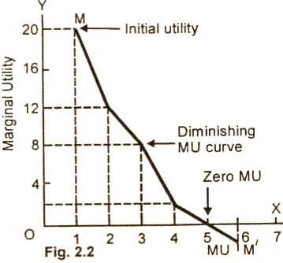

In the figure (2.2), along OX we measure units of a commodity consumed and along OY is shown the marginal utility derived from them. The marginal utility of the first glass of water is called initial utility. It is equal to 20 units. The MU of the 5th glass of water is zero. It is called satiety point. The MU of the 6th glass of water is negative (-3). The MU curve here lies below the OX axis. The utility curve MM/ falls left from left down to the right showing that the marginal utility of the success units of glasses of water is falling.

Assumptions of Law of Diminishing Marginal Utility:

The law of diminishing marginal utility is true under certain assumptions. These assumptions are as under:

(i) Rationality: In the cardinal utility analysis, it is assumed that the consumer is rational. He aims at maximization of utility subject to availability of his income.

(ii) Constant marginal utility of money: It is assumed in the theory that the marginal utility of money based for purchasing goods remains constant. If the marginal utility of money changes with the increase or decrease in income, it then cannot yield correct measurement of the marginal utility of the good.

(iii) Diminishing marginal utility: Another important assumption of utility analysis is that the utility gained from the successive units of a commodity diminishes in a given time period.

(iv) Utility is additive: In the early versions of the theory of consumer behavior, it was assumed that the utilities of different commodities are independent. The total utility of each commodity is additive.
U = U¹ (X¹) + U² (X²) + U³ (X³)………. U^{n} (X^{n})
(v) Consumption to be continuous: It is assumed in this law that the consumption of a commodity should be continuous. If there is interval between the consumption of the same units of the commodity, the law may not hold good. For instance, if you take one glass of water in the morning and the 2nd at noon, the marginal utility of the 2nd glass of water may increase.

(vi) Suitable quantity: It is also assumed that the commodity consumed is taken in suitable and reasonable units. If the units are too small, then the marginal utility instead of falling may increase up to a few units.

(vii) Character of the consumer does not change: The law holds true if there is no change in the character of the consumer. For example, if a consumer develops a taste for wine, the additional units of wine may increase the marginal utility to a drunkard.

(viii) No change to fashion: Customs and tastes: If there is a sudden change in fashion or customs or taste of a consumer, it can than make the law inoperative.

(ix) No change in the price of the commodity: there should be any change in the price of that commodity as more units are consumed.

Limitations/Exceptions of Law of Diminishing Marginal Utility:

There are some exceptions or limitations to the law of diminishing utility.

(i) Case of intoxicants: Consumption of liquor defies the low for a short period. The more a person drinks, the more likes it. However, this is truer only initially. A stage comes when a drunkard too starts taking less and less liquor and eventually stops it.

(ii) Rare collection: If there are only two diamonds in the world, the possession of 2nd diamond will push up the marginal utility.

(iii) Application to money: The law equally holds good for money. It is true that more money the man has, the greedier he is to get additional units of it. However, the truth is that the marginal utility of money declines with richness but never falls to zero.

Summing up, we can say that the law of diminishing utility, like other laws of Economics, is simply a statement of tendency. It holds good provided other factors remain constant.

Practical Importance of Law of Diminishing Marginal Utility:

The law of diminishing utility has great practical importance in economics. The law of demand, the theory of consumer’s surplus, and the equilibrium in the distribution of expenditure are derived from the law of diminishing marginal utility.

(i) Basis of the law of demand: The law of marginal diminishing utility and the law of demand are very closely related to each other. In fact they law of diminishing marginal utility, the more we have of a thing, and the less we want additional increment of it. In other words, we can say that as a person gets more and more of a particular commodity, the marginal utility of the successive units begins to diminish. So every consumer while buying a particular commodity compares the marginal utility of the commodity and the price of the commodity which he has to pay.

If the marginal utility of the commodity is higher than that of price, he purchases that commodity. As he buys more and more, the marginal utility of the successive units begins to diminish. Then he pays fewer amounts for the successive units. He tries to equate at every step the marginal utility and the price of the commodity, he must lower its price so that the consumers are induced to buy large quantities and this is what is explained in the law of demand. From this, we conclude that the law of demand and the law of diminishing are very closely inter-related.

(ii) Consumer’s surplus concept: The theory of consumer’s surplus is also based on the law of diminishing marginal utility. A consumer while purchasing the commodity compares the utility of the commodity with that of the price which he has to pay. In most of the cases, he is willing to pay more than what he actually pays. The excess of the price which he would be willing to pay rather than to go without the thing over that which he actually does pay is the economic measure of this surplus satisfaction. It is in fact difference between the total utility and the actually money spent.

(iii) Importance to the consumer: A consumer in order to get the maximum satisfaction from his relatively scare resources distributes his income on commodities and services in such a way that the marginal utility from all the uses are the same. Here again the concept of marginal utility helps the consumer in arranging his scale of preference for the commodities and services.

(iv) Importance to finance minister: Some times it is pointed out that the law of diminishing marginal utility does not apply on money. As a person collects money, the desires to accumulate more money increases. This view is superficial. It is true that wealth is acquired for the procurement of goods and services and man is always anxious in getting more and more of money. But what about the utility of money to him? Is it not a fact that as a person gets more and more wealth, its utility progressively decreases, though it does not reach to zero?

For example, a person who earns $90,000 per month attaches less importance to $10. But a man who gets $1000 per month, the value of $10 to him is very high. A finance minister knowing this fact that the utility of money to a rich man is high and to poor man low bases the system of taxation in such a way that the rich persons are taxed at a progressive rate. The system of modern taxation is therefore, based on the law of diminishing marginal utility.

Consumer's Surplus:

Definition and Explanation:

The concept of consumer’s surplus was introduced by Alfred Marshall. According to him:

"A consumer is generally willing to pay more for a given quantity of good than what he actually pays at the price prevailing in the market".

For example, you go to the market for the purchase of a pen. You are mentally prepared to pay $25 for the pen which the seller has shown to you. He offers the pen for $10 only. You immediately purchase the pen and say ‘thank you’.

You were willing to pay $25 for the pen but you are delighted to get it for $10 only. Consumer’s surplus is the difference between the maximum amount a consumer is willing to pay for the good and the price he actually pays for the good. In our example given above, the consumer’s surplus is $15 ($25 – $10).

Demand Curve and Consumer’s Surplus:

The consumer surplus can be easily found out by consumer’s demand curve for the commodity and the current market price which we assume a purchaser cannot change. In the words of Alfred Marshall:

“The excess of the price which he (consumer) would be willing to pay rather than go without the thing over that which he actually does pay is the economic measure of this surplus satisfaction”.

In the words of A. Koutsoyannis:

“Consumer’s surplus is equal to the difference between the amount of money that consumer actually pays to buy a certain quantity rather than go without it”.

The concept of consumer’s surplus is the result of two important phenomena:

(i) Characteristic of consumer’s behavior.

(ii) Characteristic of market.

The characteristic of consumer’s behavior is that as he buys more and more of a particular commodity, the marginal utility of the successive units begins to decrease. A rational buyer continuous purchasing the commodity up to the unit which equates his marginal utility of the good to the price he pays for it.

The second phenomenon is that there is perfect competition among sellers and a single price prevails in the market for a particular commodity at a particular time. The buyer is able to get the first unit of the commodity at the same price as the second or pay any other unit thereafter.
Schedule:
The concept of consumer’s surplus is now explained with the help of a schedule and a demand curve.

Quantity | Willing to Pay ($) | Price ($) | Consumer’s Surplus ($)
1 | 25 | 10 | 15 = (25 – 10)
2 | 20 | 10 | 10 = (20 – 10)
3 | 15 | 10 | 5 = (15 – 10)
4 | 10 | 10 | 0
Total | 75 | 10 x 4 = 40 | 30

Diagram/Figure:

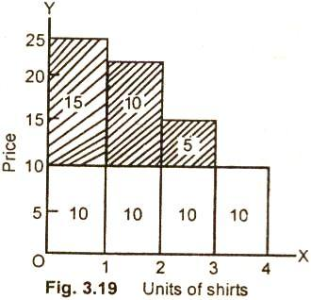

In this figure 3.20, the individual demand curve DD/ shows the maximum amount a consumer is willing to pay for each unit of the good. An individual is not willing to purchase any pen at a price of $30 per month. He will, however, is willing to purchase one pen at a price of $20 per pen, he is willing to purchase 2 pens. The surplus diminishes with the decline in the marginal utility of pens.

In case the price comes down to $15 per pen, the consumer purchases 3 pens. By using this demand curve, we measure the surplus which a consumer gets from the purchase of pens. The current market price of a pen $10, which we have assumed the purchaser cannot change. The consumer was willing to pay $25 per pen but he actually pay $10 only, the consumer’s surplus for the first pen is $15 = (25 – 10).
For the second pen, it is $10 = (20 – 10) and for the third consumer’s surplus is $5 = (15 – 10).

There is no surplus on the fourth unit as the market price for the pen is the same what he would have paid for the pen. The total consumer’s surplus from the purchase of four pens is $15 + $10 + $5 = $30. It is the sum of surpluses received from each pen. The shaded area in the graph shows the total consumer’s surplus.

Criticism:

The Marshallian concept of consumer’s surplus has been severally criticized by modern economists Allen and Hicks. According to them, the concept is based on assumptions which are unwarranted. Utility, according to them, is a psychological feeling. It cannot be exactly measured in term of money.

In Marshallian analysis, the marginal utility of money is assumed to remain constant. The fact is that when a consumer spends money on goods, his income decreases and the marginal utility of money to him rises. Analysis ignores this basic fact.
Consumer’s surplus is said to be imaginary as it assumes that utilities derived from various goods are independent. In real life, this is not true. The fact is that utilities derived from various goods are independent.

Measurement of Consumer’s Surplus with the Help of Indifference Curves (Hicksian Method):

Professor J.R. Hicks, has explained the concept of consumer surplus with the help of indifference curve technique . According to Hicks when there is fall in the price of a commodity, it has two main effects:

First, the consumer can purchase more of the good whose price has fallen.

Secondly, he can purchase the same quantity of the good as he was buying before but with a lesser amount of money. He spares some money in the bargain. This is a form of rise in the real income of the consumer.

Diagram/Figure:

The Hicksian method of measuring consumer’s surplus is now explained with the help of diagram below.

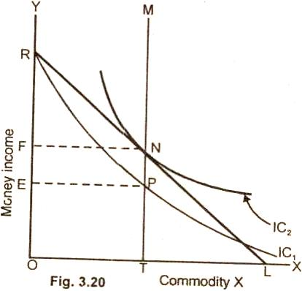

In figure 3.20 commodity X is measured on OX axis and money income of an individual on OY axis. We assume here that a consumer does not know the price of the commodity X and has OR quantity of money. The indifference curve IC¹ represents various combinations of income and X of commodity X which yield the same level of satisfaction to the consumer.

The indifference curve IC¹ originates from point R. It shows the stage when the consumer retains all of his income and zero units of commodity for a given level of the utility. The consumer moves down along the curve IC¹. The consumer at point P buys OT amount of commodity X and has OE amount of money income. In other words, the consumer is ready to sacrifice RE amount of money for getting OT units of commodity X.

We now assume that the consumer is informed of the price of commodity X. The RL is the budget line. The budget line touches the indifference curve IC² at point N which is the point of equilibrium. The consumer now has the OT commodity of X and OF amount of income. He gives up RF amount of money to buy OT units of commodity X. Previously he was ready to pay RE amount of income which is higher than the amount he pays now. We infer from this that RE – RF i.e., FE is the consumer surplus.

FE is the difference between the amount of income the consumer was willing to pay and what he actually pays. The surplus has also shifted the consumer on the higher level of satisfaction from IC¹ to IC².

Importance of Consumer’s Surplus:

The concept of consumer’s surplus has both theoretical as well as practical importance.

(i) Theoretical importance: The idea of consumer’s surplus reveals the benefits which we derive from our purchase of the commodity in the market.

For example, when we purchase salt, or a match box, we are willing to pay the amount much higher than their market value. For example, a consumer would be willing to pay $10 for a match box rather than go without it but he actually pay Re one only on the purchase of a match box. Consumer’s surplus on the purchase of match box thus is $ 9.0.

(ii) Practical importance: A monopolist can charge higher price for his product if the consumers are enjoying large consumers surplus on the use of his product.

(iii) The inhabitants of a country derive consumer's surplus when they import commodities from abroad. They are usually prepared to pay more for than what they actually pay.

(iv) A finance minister imposes taxes of the commodities yielding consumer's surplus.

(v) An entrepreneur before investing capital in a project evaluates the consumer's surplus to be derived from it. If the benefits to the obtained are greater than the costs, the investment is undertaken.
ELASCITY OF DEMAND

Degrees of Elasticity of Demand:

We have stated demand for a product is sensitive or responsive to price change. The variation in demand is, however, not uniform with a change in price. In case of some products, a small change in price leads to a relatively larger change in quantity demanded.

Elastic and Inelastic Demand:

For example, a decline of 1% in price leads to 8% increase in the quantity demanded of a commodity. In such a case, the demand is said to elastic. There are other products where the quantity demanded is relatively unresponsive to price changes. A decline of 8% in price, for example, gives rise to 1% increase in quantity demanded. Demand here is said to be inelastic.

The terms elastic and inelastic demand do not indicate the degree of responsiveness and unresponsiveness of the quantity demanded to a change in price.

The economists therefore, group various degrees of elasticity of demand into five categories.

(1) Perfectly Elastic Demand:

A demand is perfectly elastic when a small increase in the price of a good its quantity to zero. Perfect elasticity implies that individual producers can sell all they want at a ruling price but cannot charge a higher price. If any producer tries to charge even one penny more, no one would buy his product.

People would prefer to buy from another producer who sells the good at the prevailing market price of $4 per unit. A perfect elastic demand curve is illustrated in fig. 6.1.

Diagram:

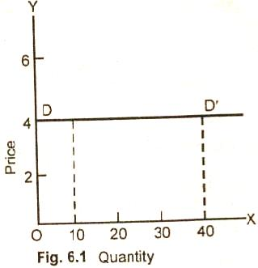

It shows that the demand curve DD/ is a horizontal line which indicates that the quantity demanded is extremely (infinitely) response to price. Even a slight rise in price (say $4.02), drops the quantity demanded of a good to zero. The curve DD/ is infinitely elastic. This elasticity of demand as such is equal to infinity.

(2) Perfectly Inelastic Demand:

When the quantity demanded of a good dose not change at all to whatever change in price, the demand is said to be perfectly inelastic or the elasticity of demand is zero.

For example, a 30% rise or fall in price leads to no change in the quantity demanded of a good.

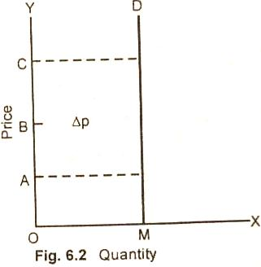

In figure 6.2 a rise in price from OA to OC or fall in price from OC to OA causes no change (zero responsiveness) in the amount demanded.

(3) Unitary Elasticity of Demand:

When the quantity demanded of a good changes by exactly the same percentage as price, the demand is said to has a unitary elasticity.

For example, a 30% change in price leads to 30% change quantity demand = 30% / 30% = 1.

One or a one percent change in price causes a response of exactly a one percent change in the quantity demand.

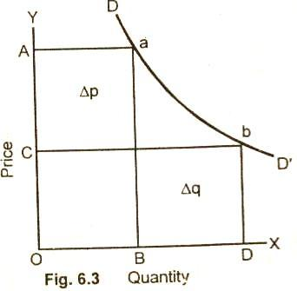

In this figure (6.3) DD/ demand curve with unitary elasticity shows that as the price falls from OA to OC, the quantity demanded increases from OB to OD. On DD/ demand curve, the percentage change in price brings about an exactly equal percentage in quantity at all points a, b. The demand curve of elasticity is, therefore, a rectangular hyperbola.

(4) Elastic Demand:

If a one percent change in price causes greater than a one percent change in quantity demanded of a good, the demand is said to be elastic.

Alternatively, we can say that the elasticity of demand is greater than. For example, if price of a good change by 10% and it brings a 20% change in demand, the price elasticity is greater than one.

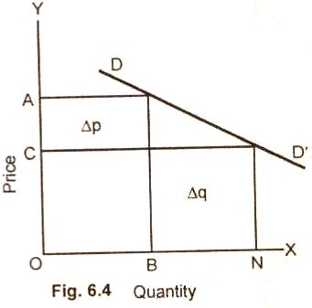

In figure (6.4) DD/ curve is relatively elastic along its entire length. As the price falls from OA to OC, the demand of the good extends from OB to ON i.e., the increase in quantity demanded is more than proportionate to the fall in price.

(5) Inelastic Demand:

When a change in price causes a less than a proportionate change in quantity demand, demand is said to be inelastic.
The elasticity of a good is here less than I or less than unity. For example, a 30% change in price leads to 10% change in quantity demanded of a good, then:

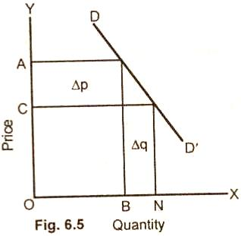

In figure (6.5) DD/ demand curve is relatively inelastic. As the price fall from OA to OC, the quantity demanded of the good increases from OB to ON units. The increase in the quantity demanded is here less than proportionate to the fall in price.

Note: It may here note that the slope of a demand curve is not a reliable indicator of elasticity. A flat slope of a demand curve must not mean elastic demand. Similarly, a steep slope on demand curve must not necessarily mean inelastic demand.

The reason is that the slope is expressed in terms of units of the problem. If we change the units of problem, we can get a different slope of the demand curve. The elasticity, on the other hand, is the percentage change in quantity demanded to the corresponding percentage change in price.

Types of Elasticity of Demand:

The quantity of a commodity demanded per unit of time depends upon various factors such as the price of a commodity, the money income of the prices of related goods, the tastes of the people, etc., etc.

Whenever there is a change in any of the variables stated above, it brings about a change in the quantity of the commodity purchased over a specified period of time. The elasticity of demand measures the responsiveness of quantity demanded to a change in any one of the above factors by keeping other factors constant. When the relative responsiveness or sensitiveness of the quantity demanded is measured to changes, in its price, the elasticity is said be price elasticity of demand.

When the change in demand is the result of the given change in income, it is named as income elasticity of demand. Sometimes, a change in the price of one good causes a change in the demand for the other. The elasticity here is called cross electricity of demand. The three main types of elasticity of demand are now discussed in brief.

(1) Price Elasticity of Demand:

Definition and Explanation:

The concept of price elasticity of demand is commonly used in economic literature. Price elasticity of demand is the degree of responsiveness of quantity demanded of a good to a change in its price. Precisely, it is defined as:

"The ratio of proportionate change in the quantity demanded of a good caused by a given proportionate change in price".

Formula:

The formula for measuring price elasticity of demand is:

Price Elasticity of Demand = Percentage in Quantity Demand

Example:

Let us suppose that price of a good falls from $10 per unit to $9 per unit in a day. The decline in price causes the quantity of the good demanded to increase from 125 units to 150 units per day. The price elasticity using the simplified formula will be:

E_{d} = Δq X P

Δq = 150 - 125 = 25

Δp = 10 - 9 = 1

Original Quantity = 125

Original Price = 10

E_{d} = 25 / 1 x 10 / 125 = 2

The elasticity coefficient is greater than one. Therefore the demand for the good is elastic.

Types:

The concept of price elasticity of demand can be used to divide the goods in to three groups.

(i) Elastic. When the percent change in quantity of a good is greater than the percent change in its price, the demand is said to be elastic. When elasticity of demand is greater than one, a fall in price increases the total revenue (expenditure) and a rise in price lowers the total revenue (expenditure).

(ii) Unitary Elasticity. When the percentage change in the quantity of a good demanded equals percentage in its price, the price elasticity of demand is said to have unitary elasticity. When elasticity of demand is equal to one or unitary, a rise or fall in price leaves total revenue unchanged.

(iii) Inelastic. When the percent change in quantity of a good demanded is less than the percentage change in its price, the demand is called inelastic. When elasticity of demand is inelastic or less than one, a fall in price decreases total revenue and a rise in its price increases total revenue.

(2) Income Elasticity of Demand:

Definition and Explanation:

Income is an important variable affecting the demand for a good. When there is a change in the level of income of a consumer, there is a change in the quantity demanded of a good, other factors remaining the same. The degree of change or responsiveness of quantity demanded of a good to a change in the income of a consumer is called income elasticity of demand. Income elasticity of demand can be defined as:

"The ratio of percentage change in the quantity of a good purchased, per unit of time to a percentage change in the income of a consumer".

A simple example will show how income elasticity of demand can be calculated. Let us assume that the income of a person is $4000 per month and he purchases six CD's per month. Let us assume that the monthly income of the consumer increase to $6000 and the quantity demanded of CD's per month rises to eight. The elasticity of demand for CD's will be calculated as under:

Δq = 8 - 6 = 2

Δp = $6000 - $4000 = $2000

Original quantity demanded = 6

Original income = $4000

E_{y} = Δq / Δp x P / Q = 2 / 200 x 4000 / 6 = 0.66

The income elasticity is 0.66 which is less than one.

Types:

When the income of a person increases, his demand for goods also changes depending upon whether the good is a normal good or an inferior good. For normal goods, the value of elasticity is greater than zero but less than one. Goods with an income elasticity of less than 1 are called inferior goods. For example, people buy more food as their income rises but the % increase in its demand is less than the % increase in income.

(3) Cross Elasticity of Demand:

Definition and Explanation:

The concept of cross elasticity of demand is used for measuring the responsiveness of quantity demanded of a good to changes in the price of related goods. Cross elasticity of demand is defined as:

"The percentage change in the demand of one good as a result of the percentage change in the price of another good".

Formula:

The formula for measuring, cross, elasticity of demand is:

E_{xy} = % Change in Quantity Demanded of Good X
% Change in Price of Good Y

The numerical value of cross elasticity depends on whether the two goods in question are substitutes, complements or unrelated.

Types and Example:

(i) Substitute Goods. When two goods are substitute of each other, such as coke and Pepsi, an increase in the price of one good will lead to an increase in demand for the other good. The numerical value of goods is positive.

For example there are two goods. Coke and Pepsi which are close substitutes. If there is increase in the price of Pepsi called good y by 10% and it increases the demand for Coke called good X by 5%, the cross elasticity of demand would be:

E_{xy} = %Δq_{x} / %Δp_{y} = 0.2

Since E_{xy} is positive (E > 0), therefore, Coke and Pepsi are close substitutes.

(ii) Complementary Goods. However, in case of complementary goods such as car and petrol, cricket bat and ball, a rise in the price of one good say cricket bat by 7% will bring a fall in the demand for the balls (say by 6%). The cross elasticity of demand which are complementary to each other is, therefore, 6% / 7% = 0.85 (negative).

(iii) Unrelated Goods. The two goods which a re unrelated to each other, say apples and pens, if the price of apple rises in the market, it is unlikely to result in a change in quantity demanded of pens. The elasticity is zero of unrelated goods.

UNIT-3
FACTORS OF PRODUCTION

What Are Factors of Production?
Factors of production is an economic term that describes the inputs used in the production of goods or services in order to make an economic profit. These include any resource needed for the creation of a good or service. The factors of production include land, labor, capital, and entrepreneurship.
These production factors are also construed by organizations as management, machines, materials and labor, technology, and knowledge. Each of these has recently been contemplated by scholars as being potential new factors of production.

Factors Of Production

The Basics of Factors of Production
The modern definition of factors of production is primarily derived from a neoclassical view of economics. It amalgamates past approaches to economic theory, such as the concept of labor as a factor of production from socialism, into a single definition.
Land, labor, and capital as factors of production were originally identified by the early political economists such as Adam Smith, David Ricardo, and Karl Marx. Today, capital and labor remain the two primary inputs for the productive processes and the generation of profits by a business.

Land as a Factor
Land has a broad definition as a factor of production and can take on various forms, from agricultural land to commercial real estate to the resources available from a particular piece of land. Natural resources, such as oil and gold, can be extracted and refined for human consumption from the land. Cultivation of crops on land by farmers increases its value and utility. For a group of early French economists called the physiocrats who pre-dated the classical political economists, the land was responsible for generating economic value.
While the land is an essential component of most ventures, its importance can diminish or increase based on industry. For example, a technology company can easily begin operations with zero investment in land. On the other hand, the land is the most significant investment for a real estate venture.

Labor as a Factor
Labor refers to the effort expended by an individual to bring a product or service to the market. Again, it can take on various forms. For example, the construction worker at a hotel site is part of labor as is the waiter who serves guests or the receptionist who enrolls them into the hotel.
Within the software industry, labor refers to the work done by project managers and developers in building the final product. Even an artist involved in making art, whether it is a painting or a symphony, is considered labor.
For the early political economists, labor was the primary driver of economic value. Production workers are paid for their time and effort in wages that depend on their skill and training. Labor by an uneducated and untrained worker is typically paid at low prices. Skilled and trained workers are referred to as human capital and are paid higher wages because they bring more than their physical capacity to the task. For example, an accountant’s job requires synthesis and analysis of financial data for a company. Countries that are rich in human capital experience increased productivity and efficiency.
The difference in skill levels and terminology also helps companies and entrepreneurs arbitrage corresponding disparities in pay scales. This can result in a transformation of factors of production for entire industries. An example of this is the change in production processes in the Information Technology (IT) industry after jobs were outsourced to countries with a trained workforce and significantly lower salaries.

Capital as a Factor
In economics, capital typically refers to money. But money is not a factor of production because it is not directly involved in producing a good or service. Instead, it facilitates the processes used in production by enabling entrepreneurs and company owners to purchase capital goods or land or pay wages. For modern mainstream (neoclassical) economists, capital is the primary driver of value.
As a factor of production, capital refers to the purchase of goods made with money in production. For example, a tractor purchased for farming is capital. Along the same lines, desks and chairs used in an office are also capital.
It is important to distinguish personal and private capital in factors of production. A personal vehicle used to transport family is not considered a capital good. But a commercial vehicle that is expressly used for official purposes is considered a capital good. During an economic contraction or when they suffer losses, companies cut back on capital expenditure to ensure profits. During periods of economic expansion, however, they invest in new machinery and equipment to bring new products to market.
An illustration of the above is the difference in markets for robots in China versus the United States after the financial crisis. China experienced a multiyear growth cycle after the crisis and its manufacturers invested in robots to improve productivity at their facilities and meet growing market demands. As a result, the country became the biggest market for robots. Manufacturers within the United States, which had been in the throes of an economic recession after the financial crisis, cut back on their investments related to production due to tepid demand.

Entrepreneurship as a Factor
Entrepreneurship is the secret sauce that combines all the other factors of production into a product or service for the consumer market. An example of entrepreneurship is the evolution of social media behemoth Facebook Inc. (FB). Mark ZuckerbergMark Zuckerberg assumed the risk for the success or failure of his social media network when he began allocating time from his daily schedule towards that activity. At the time that he coded the minimum viable product himself, Zuckerberg’s labor was the only factor of production.
After Facebook became popular and spread across campuses, Zuckerberg realized that he needed help to build the product and, along with co-founder Eduardo Saverin, recruited additional employees. He hired two people, an engineer (Dustin Moskovitz) and a spokesperson (Chris Hughes), who both allocated hours to the project, meaning that their invested time became a factor of production. The continued popularity of the product meant that Zuckerberg also had to scale technology and operations. He raised venture capital money to rent office space, hire more employees, and purchase additional server space for development.
At first, there was no need for land. However, as business continued to grow, Facebook built its own office space and data centers. Each of these requires significant real estate and capital investments.
Another example of entrepreneurship is Starbucks Corporation. The retail coffee chain needs all four factors of production: land (prime real estate in big cities for its coffee chain), capital (large machinery to produce and dispense coffee), and labor (employees at its retail outposts for service). The company’s founder Howard Schulz was the first person to realize that a market for such a chain existed and figured out the connections between the other three factors of production.
While large companies make for excellent examples, a majority of companies within the United States are small businesses started by entrepreneurs. Because entrepreneurs are vital for economic growth, countries are creating the necessary framework and policies in order to make it easier for them to start companies.

KEY TAKEAWAYS
- Factors of production is an economic term that describes the inputs used in the production of goods or services in order to make an economic profit.
- These include any resource needed for the creation of a good or service.
- The factors of production typically include land, labor, capital, entrepreneurship, and the state of technological progress.

Ownership of Factors of Production
The definition of factors of production in economic systems presumes that ownership lies with households, who lend or lease them to entrepreneurs and organizations. But that is a theoretical construct and is rarely the case in practice. With the exception of labor, ownership for factors of production varies based on industry and economic system.
For example, a firm operating in the real estate industry typically owns significant parcels of land. But retail corporations or shops lease land for extended periods of time. Capital also follows a similar model in that it can be owned or leased from another party. Under no circumstances, however, is labor owned by firms. Labor’s transaction with firms is based on wages.
Ownership of the factors of production also differs based on the economic system. For example, private enterprise and individuals own most of the factors of production in capitalism. However, collective good is the predominating principle in socialism. As such, factors of production, such as land and capital, is owned by workers.

Special Considerations: Technology's Role in Production
While it is not directly listed as a factor, technology plays an important role in influencing production. In this context, technology has a fairly broad definition and can be used to refer to software, hardware, or a combination of both used to streamline organizational or manufacturing processes.
Increasingly, technology is responsible for the difference in efficiency between firms. To that end, technology, like money, is a facilitator of the factors of production. The introduction of technology into a labor or capital process makes it more efficient. For example, the use of robots in manufacturing has the potential to improve productivity and output. Similarly, the use of kiosks in self-serve restaurants can help firms cut back on their labor costs.
Typically, Solow Residual or Total Factor Productivity (TFP), which measures the residual output that remains unaccounted for from the four factors of production, increases when technological processes or equipment are applied to production. Economists consider TFP to be the main factor driving economic growth for a country. The more a firm or country’s total factor productivity, the more its growth.
LAW OF RETURNS

Production Function:

Definition:

A given output can be produced with many different combinations of factors of production (land, labor, capita! and organization) or inputs. The output, thus, is a function of inputs. The functional relationship that exists between physical inputs and physical output of a firm is called production function.

Formula:

In abstract term, it is written in the form of formula:

Q = f (x¹, x², ......., x^{n})

Q is the maximum quantity of output and x¹, x², x^{n} are quantities of various inputs. The functional relationship between inputs and output is governed by the laws of returns.

The laws of returns are categorized into two types.

(i) The law of variable proportion seeking to analyze production in the short period.

(ii) The law of returns to scale seeking to analyze production in the long period.

Law of Variable Proportions

Definition:

There were three laws of returns mentioned in the history of economic thought up till Alfred Marshall's time. These laws were the laws of increasing returns, diminishing returns and constant returns. Dr. Marshall was of the view that the law of diminishing returns applies to agriculture and the law of increasing returns to industry. Much time was wasted in discussion of this issue. However, it was later on recognized that there are not three laws of production. It is only one law of production which has three phases, increasing, diminishing and negative production. This general law of production was named as the Law of Variable Proportions or the Law of Non-Proportional Returns.

The Law of Variable Proportions which is the new name of the famous law of Diminishing Returns has been defined by Stigler in the following words:

"As equal increments of one input are added, the inputs of other productive services being held constant, beyond a certain point, the resulting increments of produce will decrease i.e., the marginal product will diminish".

According to Samuelson:

"An increase in some inputs relative to other fixed inputs will in a given state of technology cause output to increase, but after a point, the extra output resulting from the same addition of extra inputs will become less".

Assumptions:

The law of variable proportions also called the law of diminishing returns holds good under the following assumptions:

(i) Short run. The law assumes short run situation. The time is too short for a firm to change the quantity of fixed factors. All the, resources apart from this one variable, are held unchanged in quantity and quality.

(ii) Constant technology. The law assumes that the technique of production remains unchanged during production.

(iii) Homogeneous factors. Each factor unit in assumed to he identical in amount and quality.

Explanation and Example:

The law of variable proportions is, now explained with the help of table and graph.

Schedule:

Fixed Inputs (Land Capital) | Variable Resource (labor) | Total Produce (TP Quintals) | Marginal Product (MP Quintals) |  | Average Product (AP Quintals)
30  30 | 1  2 | 10  25 | 10  15 | Increasing marginal return | 10  12.5
30  30  30  30  30 | 3  4  5  6  7 | 37  47  55  60  63 | 12  10  8  5  3 | Diminishing marginal returns | 12.3  11.8  11.0  10.0  9.0
30  30 | 8  9 | 63  62 | 0  -1 | Negative marginal returns | 7.9  6.8

In the table above, it is assumed that a farmer has only 30 acres of land for cultivation. The investment on it in the form of tubewells, machinery etc., (capital) is also fixed. Thus land and capital with the farmer is fixed and labor is the variable resource.

As the farmer increases units of labor from one to two to the amount of other fixed resources (land and capital), the marginal as well as average product increases. The total product also increase at an increasing rate from 10 to 25 quintals. It is the stage of increasing returns.

The stage of increasing returns with the employment of more labor does not last long. It is shown in the table that with the employment of 3rd labor at the farm, the marginal product and the average product (AP) both fall but marginal product (MP) falls more speedily than the average product AP). The fall in MP and AP continues as more men are put on the farm.

The decrease, however, remains positive up to the 7th labor employed. On the employment of 7th worker, the total production remains constant at 63 quintals. The marginal product is zero. if more men are employed the marginal product becomes negative. It is the stage of negative returns. We here find the behavior of marginal product (MP). it shows three stages. In the first stage, it increases, in the 2nd it continues to fall and in the 3rd stage it becomes negative.

Three Stages of the Law:

There are three phases or stages of production, as determined by the law of variable proportions:

(i) Increasing returns.

(ii) Diminishing returns.

(iii) Negative returns.

Diagram/Graph:

These stages can be explained with the help of graph below:

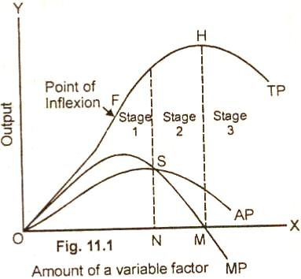

(i) Stage of Increasing Returns. The first stage of the law of variable proportions is generally called the stage of increasing returns. In this stage as a variable resource (labor) is added to fixed inputs of other resources, the total product increases up to a point at an increasing rate as is shown in figure 11.1.

The total product from the origin to the point K on the slope of the total product curve increases at an increasing rate. From point K onward, during the stage II, the total product no doubt goes on rising but its slope is declining. This means that from point K onward, the total product increases at a diminishing rate. In the first stage, marginal product curve of a variable factor rises in a part and then falls. The average product curve rises throughout .and remains below the MP curve.

Causes of Initial Increasing Returns:

The phase of increasing returns starts when the quantity of a fixed factor is abundant relative to the quantity of the variable factor. As more and more units of the variable factor are added to the constant quantity of the fixed factor, it is more intensively and effectively used. This causes the production to increase at a rapid rate. Another reason of increasing returns is that the fixed factor initially taken is indivisible. As more units of the variable factor are employed to work on it, output increases greatly due to fuller and effective utilization of the variable factor.

(ii) Stage of Diminishing Returns. This is the most important stage in the production function. In stage 2, the total production continues to increase at a diminishing rate until it reaches its maximum point (H) where the 2nd stage ends. In this stage both the
marginal product (MP) and average product of the variable factor are diminishing but are positive.

Causes of Diminishing Returns:

The 2nd phase of the law occurs when the fixed factor becomes inadequate relative to the quantity of the variable factor. As more and more units of a variable factor are employed, the marginal and average product decline. Another reason of diminishing returns in the production function is that the fixed indivisible factor is being worked too hard. It is being used in non-optima! proportion with the variable factor, Mrs. J. Robinson still goes deeper and says that the diminishing returns occur because the factors of production are imperfect substitutes of one another.

(iii) Stage of Negative Returns. In the 3rd stage, the total production declines. The TP, curve slopes downward (From point H onward). The MP curve falls to zero at point L² and then is negative. It goes below the X axis with the increase in the use of variable factor (labor).

Causes of Negative Returns:

The 3rd phases of the law starts when the number of a variable, factor becomes, too excessive relative, to the fixed factors, A producer cannot operate in this stage because total production declines with the employment of additional labor.

a rational producer will always seek to produce in stage 2 where MP and AP of the variable factor are diminishing. At which particular point, the producer will decide to produce depends upon the price of the factor he has to pay. The producer will employ the variable factor (say labor) up to the point where the marginal product of the labor equals the given wage rate in the labor market.

Importance:

The law of variable proportions has vast general applicability. Briefly:

(i) It is helpful in understanding clearly the process of production. It explains the input output relations. We can find out by-how much the total product will increase as a result of an increase in the inputs.

(ii) The law tells us that the tendency of diminishing returns is found in all sectors of the economy which may be agriculture or industry.

(iii) The law tells us that any increase in the units of variable factor will lead to increase in the total product at a diminishing rate. The elasticity of the substitution of the variable factor for the fixed factor is not infinite.

From the law of variable proportions, it may not be understood that there is no hope for raising the standard of living of mankind. The fact, however, is that we can suspend the operation of diminishing returns by continually improving the technique of production through the progress in science and technology.

Law of Returns to Scale:

Definition and Explanation:

The law of returns are often confused with the law of returns to scale. The law of returns operates in the short period. It explains the production behavior of the firm with one factor variable while other factors are kept constant. Whereas the law of returns to scale operates in the long period. It explains the production behavior of the firm with all variable factors.

There is no fixed factor of production in the long run. The law of returns to scale describes the relationship between variable inputs and output when all the inputs, or factors are increased in the same proportion. The law of returns to scale analysis the effects of scale on the level of output. Here we find out in what proportions the output changes when there is proportionate change in the quantities of all inputs. The answer to this question helps a firm to determine its scale or size in the long run.

It has been observed that when there is a proportionate change in the amounts of inputs, the behavior of output varies. The output may increase by a great proportion, by in the same proportion or in a smaller proportion to its inputs. This behavior of output with the increase in scale of operation is termed as increasing returns to scale, constant returns to scale and diminishing returns to scale. These three laws of returns to scale are now explained, in brief, under separate heads.

(1) Increasing Returns to Scale:

If the output of a firm increases more than in proportion to an equal percentage increase in all inputs, the production is said to exhibit increasing returns to scale.

For example, if the amount of inputs are doubled and the output increases by more than double, it is said to be an increasing returns returns to scale. When there is an increase in the scale of production, it leads to lower average cost per unit produced as the firm enjoys economies of scale.

(2) Constant Returns to Scale:

When all inputs are increased by a certain percentage, the output increases by the same percentage, the production function is said to exhibit constant returns to scale.

For example, if a firm doubles inputs, it doubles output. In case, it triples output. The constant scale of production has no effect on average cost per unit produced.

(3) Diminishing Returns to Scale:

The term 'diminishing' returns to scale refers to scale where output increases in a smaller proportion than the increase in all inputs.

For example, if a firm increases inputs by 100% but the output decreases by less than 100%, the firm is said to exhibit decreasing returns to scale. In case of decreasing returns to scale, the firm faces diseconomies of scale. The firm's scale of production leads to higher average cost per unit produced.

Graph/Diagram:

The three laws of returns to scale are now explained with the help of a graph below:

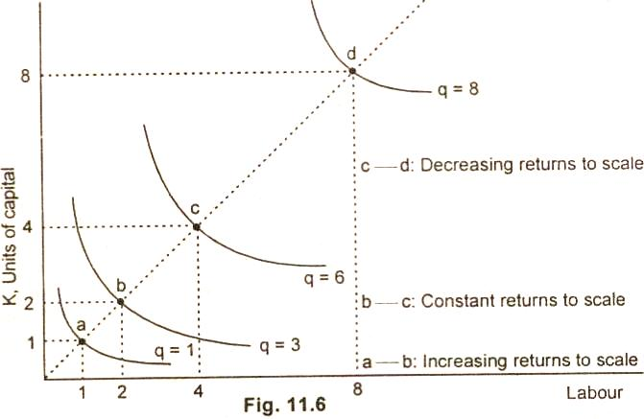

The figure 11.6 shows that when a firm uses one unit of labor and one unit of capital, point a, it produces 1 unit of quantity as is shown on the q = 1 isoquant. When the firm doubles its outputs by using 2 units of labor and 2 units of capital, it produces more than double from q = 1 to q = 3.

So the production function has increasing returns to scale in this range. Another output from quantity 3 to quantity 6. At the last doubling point c to point d, the production function has decreasing returns to scale. The doubling of output from 4 units of input, causes output to increase from 6 to 8 units increases of two units only.

Economics of Large Scale Production:

Classifications/Types and Explanation:

The economies of large scale production are classified by Marshall into:

(1) Internal Economies and (2) External Economies.

(1) Internal Economies of Scale:

Definition and Types:

Internal economies of scale are those economies which are internal to the firm. These arise within the firm as a result of increasing the scale of output of the firm. A firm secures these economies from the growth of the firm independently. The main internal economies are grouped under the following heads:

(i) Technical Economies: When production is carried on a large scale, a firm can afford to install up to date and costly machinery and can have its own repairing arrangements. As the cost of machinery will be spread over a very large volume of output, the cost of production per unit will therefore, be low.

A large establishment can utilize its by products. This will further enable the firm to lower the price per unit of the main product. A large firm can also secure the services of experienced entrepreneurs and workers which a small firm cannot afford. In a large establishment there is much scope for specialization of work, so the division of labor can be easily secured.

(ii) Managerial Economies: When production is carried on a large scale, the task of manager can be split up into different departments and each department can be placed under the supervision of a specialist of that branch. The difficult task can be taken up by the entrepreneur himself. Due to these functional specialization, the total return can be increased at a lower cost.

(iii) Marketing Economies: Marketing economies refer to those economies which a firm can secure from the purchase or sale of the commodities. A large establishment is in a better position to buy the raw material at a cheaper rate because it can buy that commodities on a large scale. At the time of selling the produced goods, the firm can secure better rates by effectively advertising in the newspapers, journals and radio, etc.

(iv) Financial Economies: Financial economies arise from the fact that a big establishment can raise loans at a lower rate of interest than a small establishment which enjoys little reputation in the capital market.

(v) Risk Bearing Economies: A big firm can undertake risk bearing economies by spreading the risk. In certain cases the risk is eliminated altogether. A big establishment produces a variety of goods in order to cater the needs of different tastes of people. If the demand for a certain type of commodities slackens, it is counter balanced by the increase in demand of the other type of commodities produced by the firm.

(vi) Economies of Scale: As a firm grows in size, it is-possible for it to reduce its cost. The reduction in costs, as a result of increasing production is called economies of scale. The economies of scale are obtained by the firm up to the lowest point on the firms long run average cost curve. The main sources of economies of scale are in brief as under.:

Diseconomies of Scale:

Definition:

The extensive use of machinery, division of labor, increased specialization and larger plant size etc., no doubt entail lower cost per unit of output but the fall in cost per unit is up to a certain limit. As the firm goes beyond the optimum size, the efficiency of the firm begins to decline. The average cost of production begins to rise.

Factors of Diseconomies:

The main factors causing diseconomies of scale and eventually leading to higher per units cost are as follows:

(i) Lack of co-ordination. As a firm becomes large scale producer, it faces difficulty in coordinating the various departments of production. The lack of co-ordination in the production, planning, marketing personnel, account, etc., lowers efficiency of the factors of production. The average cost of production begins to rise.

(ii) Loose control. As the size of plant increases, the management loses control over the productive activities. The misuse of delegation of authority, the redtapisim bring diseconomies and lead to higher average cost of production.

(iii) Lack of proper communication. The lack of proper communication between top management and the supervisory staff and little feed back from subordinate staff causes diseconomies of scale and results in the average cost to go up.

(iv) Lack of identification. In a large organizational structure, there is no close liaison between the top management and the thousands of workers employed in the firm. The lack of identification of interest with the firm results in the per unit cost to go up.

(2) External Economies of Scale:

Definition and Types:

External economies of scale are those economies which are not specially availed of by .any firm. Rather these accrue to all the firms in an industry as the industry expands. The main external economies are as under:

(i) Economies of localization. When an industry is concentrated in a particular area, all the firms situated in that locality avail of some common economies such as (a) skilled labor, (b) transportation facilities, (c) post and telegraph facilities, (d) banking and insurance facilities etc.

(ii) Economies of vertical disintegration. The vertical disintegration implies the splitting up the production process in such a manner that some Job are assigned to specialized firms. For example, when an industry expands, the repair work of the various parts of the machinery is taken up by the various firms specialists in repairs.

(iii) Economies of information. As the industry expands it can set up research institutes. The research institutes provide market information, technical information etc for the benefit of alt the firms in the industry.

(iv) Economies of by products. All the firms can lower the costs of production by making use of waste materials.

External Diseconomies:

Definition:

A firm or an industry cannot avail of economies for an indefinite period of time. With the expansion and growth of an industry, certain disadvantage also begin to arise. The diseconomies of large scale production are:

(i) Diseconomies of pollution, (ii) Excessive pressure on transport facilities, (iii) Rise in the prices of the factors of production, (iv) Scarcity of funds, (v) Marketing problems of the products, (iv) Increase in risks.

UNIT -4

Market Structure:

Definition of Market:

A market is a set of conditions in which buyers and sellers meet each other for the purpose of exchange of goods and services for money.

Elements of Market:

The essentials of a market are:

(i) Presence of goods and services to be exchanged.

(ii) Existence of one or more buyers and sellers.

(iii) A place or a region where buyers and sellers of a good get in close touch with each other.

Types of Market/Market Model:

Markets are classified according to the number of firms in the market and by the commodity to be exchanged. The economists on the basis of variation in the features of market describe four market models:

(i) Perfect Competition.

(ii) Pure Monopoly.

(iii) Monopolistic Competition.

(iv) Oligopoly.

In the analysis of each market model, it is examined as to what determines the equilibrium price, output and profit levels for the individual firm and for the industry, in this chapter, we discuss the most important of the various market models that is perfect competition.

Perfect Competition:

Definition:

The concept of perfect competition was first introduced by Adam Smith in his book "Wealth of Nations". Later on, it was improved by Edgeworth. However, it received its complete formation in Frank Kight's book "Risk, Uncertainty and Profit" (1921).

Leftwitch has defined market competition in the following words:

"Prefect competition is a market in which there are many firms selling identical products with no firm large enough, relative to the entire market, to be able to influence market price".

According to Bllas:

"The perfect competition is characterized by the presence of many firms. They sell identically the same product. The seller is a price taker".

The main conditions or features of perfect competition are as under:

Features/Characteristics or Conditions:

(1) Large number of firms. The basic condition of perfect competition is that there are large number of firms in an industry. Each firm in the industry is so small and its output so negligible that it exercises little influence over price of the commodity in the market. A single firm cannot influence the price of the product either by reducing or increasing its output. An individual firm takes the market price as given and adjusts its output accordingly. In a competitive market, supply and demand determine market price. The firm is price taker and output adjuster.

(2) Large number of buyers. In a perfect competitive market, there are very large number of buyers of the product. If any consumer purchases more or purchases less, he is not in a position to affect the market price of the commodity. His purchase in the total output is just like a drop in the ocean. He, therefore, too like the firm, is a price taker.

In the figure (15.1) PK is the market price determined by the market forces of demand and supply. The price taker firm has to adjust and sell its output at Price PK or OE.

Diagram/Figure:

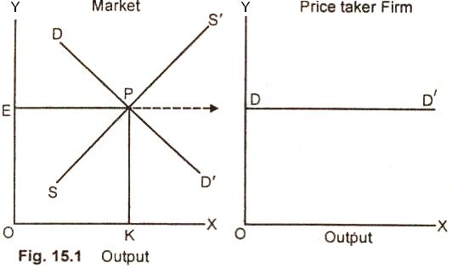

(3) The product is homogeneous. Another provision of perfect competition is that the good produced by all the firms in the industry is identical. In the eyes, of the consumer, the product of one firm (seller) is identical to that of another seller. The buyers are indifferent as to the firms from which they purchase. In other words, the cross elasticity between the products of the firm is infinite.

(4) No barriers to entry. The firms in a competitive market have complete freedom of entering into the market or leaving the industry as and when they desire. There are no legal, social or technological! barriers for the new firms (or new capital) to enter or leave the industry. Any new firm is free to start production if it so desires and stop production and leave the industry if it so wishes. The industry, thus, is characterized by freedom of entry and exit of firms.

(5) Complete information. Another condition for perfect competition is that the consumers and producers possess perfect information about the prevailing price of the product in the market. The consumers know the ruling price, the producers know costs, the workers know about wage rates and so on. In brief, the consumers, the resource owners have perfect knowledge about the current price of the product in the market. A firm, therefore, cannot charge higher price than that ruling in the market. If it does so, its goods will remain unsold as buyers will shift to some other seller.

(6) Profit maximization. For perfect competition to exist, the sole objective of the firm must be to get maximum profit.

Importance:

Perfect competition model is hotly debated in economic literature. It is argued that the model is based on unrealistic assumptions. It is rare in practice. The defenders of the model argue that the theory of perfect competition has positive aspect and leads us to correct conclusions. The concept is useful in the analysis of international trade and in the allocation of resources. It also makes us understand as to how a firm adjusts its output in a competitive world.

Distinction Between Pure Competition and Perfect Competitions:

For a pure competition to exist, there are three main requisites, i.e., (1) homogeneity of product (2) large number of firms and (3) ease of entry and exist of firms.

A perfect competition, on the other hand, is made up of all the six postulates stated earlier.

Equilibrium of the Firm Under Perfect Competition or Marginal Revenue = Marginal Cost (MR = MC) Rule:

Definition and Explanation:

A firm under perfect competition faces an infinitely elastic demand curve or we can say for an individual firm, the price of the commodity is given in the market. The firm while making changes in the amounts of variable factor evaluates the extra cost incurred on producing extra unit MC (Marginal Cost).

It also examines the change in total receipts which results from the sale of extra unit of production MR (Marginal Revenue). So long as the additional revenue from the sale of an extra unit of product (MR) is greater than the additional cost (MC) which a firm has to incur on its production, it will be in the interest of the firm to increase production.

In economic terminology, we can say, a firm will go on expanding its output so long as the marginal revenue of any unit is greater than its marginal cost. As production increases, marginal cost begins to increase after a certain point. When both marginal revenue and marginal cost are equal, the firm is in equilibrium. The firm at this equilibrium point is cither ensuring maximum profit or minimizing losses. This is shown with the help of a diagram below:

Diagram/Figure:

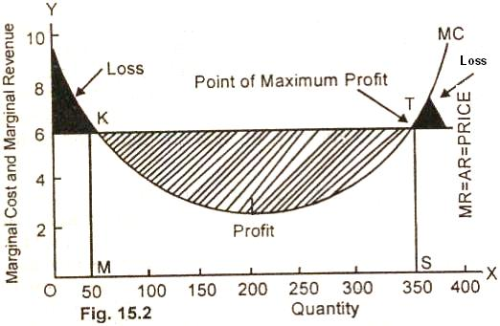

In the figure (15.2) quantity of output is measured along OX axis and marginal cost and marginal revenue on OY axis. The marginal cost curve cuts the marginal revenue curve at two points K and T.

The competitive firm is in equilibrium, at both these points as marginal cost equals marginal revenue. The firm will not produce OM quantity of good because for OM output, the marginal cost is higher than marginal revenue. Marginal cost curve cuts the marginal revenue curve from above. The firm incurs loss equal to the black shaded area for producing 50 units (OM) of output.

As production is increased from 50 units to 350 units (from OM to OS) marginal cost decreases at early levels of output and then increases thereafter. The marginal cost curve cuts the marginal revenue curve from below at point T. The shaded portion between M to S level of output shows profit on production. When a firm produces OS quantity of output; it earns maximum profit. The point T where MR = MC is the point of maximum profit.

In case, the firm increases the level of output from OS, the additional output adds less to Its revenue than to its cost. The firm undergoes losses as is shown in the shaded area.

Summing up, profit maximization normally occurs at the rate of output at which marginal revenue equals marginal cost. This golden rule holds good for all market structures. As regards the absolute profits and losses of the firm, they depend upon the relation between average cost and average revenue of the firm.

Short Run Equilibrium of the Price Taker Firm Under Perfect Competition:

Definition and Explanation:

By short run is meant a length of time which is not enough to change the level of fixed inputs or the number of firms in the industry but long enough to change the level of output by changing variable inputs.

In short period, a distinction is made of two types of costs (i) fixed cost and (ii) variable cost.

The fixed cost in the form of fixed factors i.e., plant, machinery, building, etc. does not vary with the change in the output of the firm. If the firm is to increase or decrease its output, the change only takes place in the quantity of variable resources such as labor, raw material, etc.

Further, in the short run, the demand curve facing the firm is horizontal. No new firms enter or leave the industry. The number of firms in the industry, therefore, remain the same. Under perfect competition, the firm takes the price of the product as determined in the market. The firm sells all its output at the prevailing market price. The firm, in other words, is a price taker.

Equilibrium of a Competitive Firm:

The short-run equilibrium of a firm can be easily explained with the help of marginal revenue = marginal cost approach or (MR = MC) rule.

Marginal revenue is the change in total revenue that occurs in response to a one unit change in the quantity sold. Marginal cost is the addition to total cost resulting from the additional of marginal unit. Since price is given for the competitive firm, the average revenue curve of a price taker firm is identical to the marginal curve. Average revenue (AR) thus is equal to marginal revenue (MR) is equal to price (MR = AR = Price).

According to the marginal revenue and marginal cost approach or (MR = MC) rule , a price taker firm is in equilibrium at a point where marginal revenue (MR) or price is equal to marginal cost The point where MR = MC = Price, the firm produces the best level of output. From this it may not be concluded that the perfectly competitive firm at the equilibrium level of output (MR = MC = Price) necessarily ensures maximum profit. The fact is that in the short period, a firm at the equilibrium level of output is faced with four types of product prices in the market which give rise to following results:

(i) A firm earns supernormal profits.

(ii) A firm earns normal profits.

(iii) A firm incurs losses but does not close down.

(iv) A firm minimizes losses by shutting down. All these short run cases of profits or losses are explained with the help of diagrams.

Determining Profit from a Graph:

(1) Profit Maximizing Position:

A firm in the short run earns abnormal profits when at the best level of output, the market price exceeds the short run average total cost (SATC). The short run profit maximizing position of a purely competitive firm is explained with the help of a diagram.

Diagram/Graph:

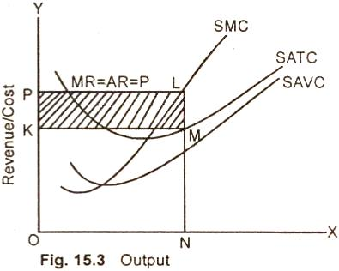

In the figure (15.3), output is measured along OX axis and revenue / cost on OY axis. We assume here that the market price is equal to OP. A price taker firm has to sell its entire output at this prevailing market price i.e. OP. The firm is in equilibrium at point L. Where MC = MR. The inter section of MC and MR determine the quantity of the good the firm will produce.

After having determined the quantity, drop a vertical line down to the horizontal axis and see what the average total cost (ATC) is at that output level (point N). The competitive firm will produce ON quantity of output and sell at market price OP. The total revenue of the firm at the best level of output ON is equal to OPLN. Whereas the total cost of producing ON quantity of output is equal to OKMN. The firm is earning supernormal profits equal to the shaded rectangle KPLM. The per unit profit is indicated by the distance LM or PK.

It may here be noted that a firm would not produce more than ON units because producing another unit adds more to the cost than the firm would receive from the sale of the unit (MC > MR). The firm would not stop short of ON output because producing another unit adds more to the revenue than to cost (MR > MC). Hence, ON is the best level of output where profit of the firm is maximum.

(2) Zero Profit of a Firm:

A firm, in the short run, may be making zero economic profit or normal economic profit. It may here be remembered that although economic profit is zero, all the resources including entrepreneurs are being paid their opportunity. So they are getting a normal profit the case of normal profits of a firms at break even price is explained with the help of the diagram 15.4.

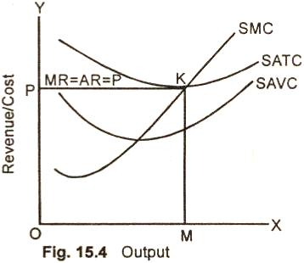

We assume in the figure (15.4) that OP is the prevailing market price and PK is the average revenue, marginal revenue curve. At point K, which is the break even price for a Competitive firm, the MR, MC and ATC are all equal. The firm produces OM output-and sells at market price OP. The total revenue of the firm to equal is the area OPKM. The total cost of producing OM output also equals the area OPKM. The firm is earning only normal profits. It is a situation in which the resources employed by the firm are earning just what they could-earn in some other alternative occupations.

(3) Loss Minimizing Case:

The firm in the short rue is minimizing tosses if the market price is smaller than average total cost but larger than average variable cost. The loss minimizing position of a price taker firm is explained with the help of a diagram.

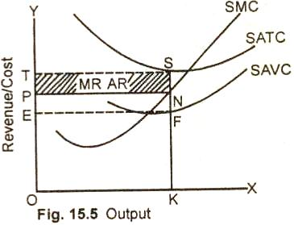

We assume in the figure (15.5) that the market price is QP. The firm is in equilibrium at point N where MR = MC. The firm's best level of output is OK which is sold at unit cost OP. The total revenue of the firm is equal to the area OPNK. The total cost of producing OK quantity of output is equal to OTSK. The firm is suffering a net loss equal to the shaded area PTSN.

The firm at price OP in the market is covering its full variable cost and a part of the fixed cost. The loss of part of fixed cost equal to the shaded area PTSN is less than, the firm would incur by closing down. In case of shut down, the firm has to bear the total fixed cost ETSF. The firm thus by producing OK output and selling at OP price is minimizing losses. Summing up, in the short run the firm will not go out of business for as long as the loss m staying the business is less than the loss from closing down.

(4) Short Run Shut Down:

The price taker firm in the short-run minimizes losses by closing it down if the market price is less than average variable cost. The shut down position of a Competitive firm is explained with the help of a diagram.

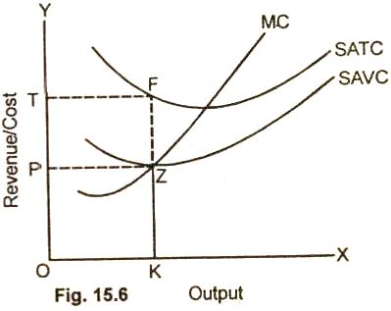

In this figure (15.6) we assume that the market price is OP. The firm, is in equilibrium at point Z where MR = MC. The firm produces OK output and sells at OP unit cost. The total revenue of the firm is equal to the area OPZK. Whereas .the total cost producing OK output is OTFR. The firm is suffering a net loss of total fixed cost equal to the area PTFZ. The firm at point Z is just covering average variable costs.

If the price falls below Z, the competitive firm will minimize its losses by closing down. There is no level of output which the firm can produce and realize a loss smaller than its fixed costs. It is therefore a shut down point for the firm. Operate When Price is > average variable cost.

MONOPOLY

Definition and Meaning:

Monopoly is from the Greek word meaning one seller. It is the polar opposite of perfect competition. Monopoly is a market structure in which one firm makes up the entire market. Monopoly and competition are at the two extremes. It is define as:

"Monopoly refers to a market where there is a single seller for a product and there is no close substitute of the commodity that is offered by the sole supplier to the buyers. The firm constitutes the entire industry".

Explanation:

Monopoly, therefore, indicates a case where:

(i) There is only a single seller of a product or service in the market.

(ii) The goods produced by a sole seller has not close substitutes.

(iii) The entry of new firms into the industry is effectively barred by legal or natural barriers.

(iv) The firm being the sole supplier of a product constitutes industry. Firm and industry thus have single identity. Or we can say monopoly is a single firm identity.

(v) The single seller affects no other seller by its own action in the market. The other sellers too cannot affect the price and output of the monopolist.

(vi) The demand curve facing the monopolist is negatively sloped. The monopolist being the only seller of the commodity in the market can increase the total sale by lowering the price and if, he raises the price, he would not lose all his sale. The demand curve facing a monopolist is less than perfectly elastic, i.e., . it slopes downward from left to right.

For the monopoly to exist, it is not necessary that the size of a firm should .be large. Even a small firm may have a monopoly. For instance, a local water company or a local electricity company, supplying water and electricity in the city possesses all the characteristics of a monopoly.

Monopolist:

Spencer has defined monopolist market in the following words:

"A monopolist market can be defined as one m which there is no perfect substitute for the product of an individual seller so that there is a separate demand curve for the product of each seller in the market".

Pure monopoly in its actual form does not exist in the real world. It is near monopolies which are very common. For example, railways face competition from road transport, electricity companies from oil and gas, telephone company from postal service, internet etc.

Monopolistic Competition
Definition: Monopolistic competition is a market structure which combines elements of monopoly and competitive markets. Essentially a monopolistic competitive market is one with freedom of entry and exit, but firms can differentiate their products. Therefore, they have an inelastic demand curve and so they can set prices. However, because there is freedom of entry, supernormal profits will encourage more firms to enter the market leading to normal profits in the long term.
A monopolistic competitive industry has the following features:
- Many firms.
- Freedom of entry and exit.
- Firms produce differentiated products.
- Firms have price inelastic demand; they are price makers because the good is highly differentiated
- Firms make normal profits in the long run but could make supernormal profits in the short term
- Firms are allocatively and productively inefficient.

Diagram monopolistic competition short run
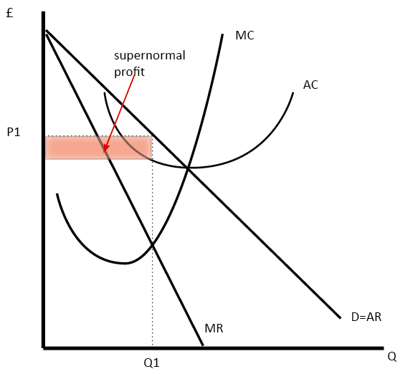
In the short run, the diagram for monopolistic competition is the same as for a monopoly.
The firm maximizes profit where MR=MC. This is at output Q1 and price P1, leading to supernormal profit

Monopolistic competition long run
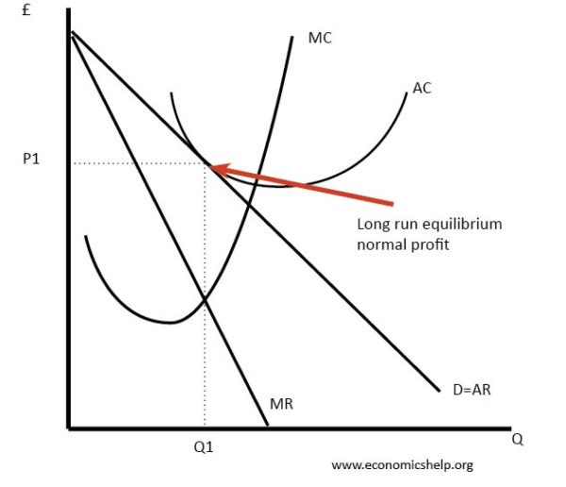
Demand curve shifts to the left due to new firms entering the market.
In the long-run, supernormal profit encourages new firms to enter. This reduces demand for existing firms and leads to normal profit. I
Efficiency of firms in monopolistic competition
- Allocative inefficient. The above diagrams show a price set above marginal cost
- Productive inefficiency. The above diagram shows a firm not producing on the lowest point of AC curve
- Dynamic efficiency. This is possible as firms have profit to invest in research and development.
- X-efficiency. This is possible as the firm does face competitive pressures to cut cost and provide better products.

Examples of monopolistic competition
- Restaurants – restaurants compete on quality of food as much as price. Product differentiation is a key element of the business. There are relatively low barriers to entry in setting up a new restaurant.
- Hairdressers. A service which will give firms a reputation for the quality of their hair-cutting.
- Clothing. Designer label clothes are about the brand and product differentiation
- TV programmes – globalization has increased the diversity of tv programmes from networks around the world. Consumers can choose between domestic channels but also imports from other countries and new services, such as Netflix.

Limitations of the model of monopolistic competition
- Some firms will be better at brand differentiation and therefore, in the real world, they will be able to make supernormal profit.
- New firms will not be seen as a close substitute.
- There is considerable overlap with oligopoly – except the model of monopolistic competition assumes no barriers to entry. In the real world, there are likely to be at least some barriers to entry
- If a firm has strong brand loyalty and product differentiation – this itself becomes a barrier to entry. A new firm can’t easily capture the brand loyalty.
- Many industries, we may describe as monopolistically competitive are very profitable, so the assumption of normal profits is too simplistic.
Key difference with monopoly
In monopolistic competition there are no barriers to entry. Therefore in long run, the market will be competitive, with firms making normal profit.
Key difference with perfect competition
In Monopolistic competition, firms do produce differentiated products, therefore, they are not price takers (perfectly elastic demand). They have inelastic demand.

New trade theory and monopolistic competition
New trade theory places importance on the model of monopolistic competition for explaining trends in trade patterns. New trade theory suggests that a key element of product development is the drive for product differentiation – creating strong brands and new features for products. Therefore, specialisation doesn’t need to be based on traditional theories of comparative advantage, but we can have countries both importing and exporting the same good. For example, we import Italian fashion labels and export British fashion labels. To consumers, the importance is the choice of goods.

Readers Question: if all firms in a monopolistic competitive industry were to merge would that firm produce as many different brands or just one brand?
Interesting question. I think it is an open-ended question with many different possibilities. One approach is to think how firms in different industries may behave if they did merge. Bearing in mind the model of monopolistic competition doesn’t always stand up to scrutiny too well in the real world.
If the firms merged together, there is no certainty how they would behave.
In some industries, it makes sense to have many differentiated brands creating an illusion of competition and providing a barrier to entry.
How many soap powders are there? About 35. But, most of these brands are owned by two companies, Unilever and Proctor and Gamble. Having brand proliferation means it is harder for a new firm to enter the market. This is because a new firm would have to compete against 30 established brands as opposed to 2. There is less chance of getting a good market share with so many brands. Therefore the new firm would have an incentive to keep different brands to deter competitors.
However, if you have merge different brands there may be economies of scale. You can devote more resources and investment to improving that particular product and maximising its efficiency. This might be appropriate for an industry like computer software or computers. There used to be many different brands of computers until the pc came to dominate.
Are the different brands catering to different sectors of the market. If you take the restaurant business, there is a big difference between Chinese and Indian. If 2 restaurants merge, they would be better off retaining distinct business. It would make no sense to have a restaurant which offered a mixture of Chinese/Indian – consumers would trust it less.
If you fear the arrival of a powerful company, it might be good to consolidate your brands. For example, there are many small search engines, but they would be better off combining forces to compete against the mighty Google.

Oligopoly
Definition of oligopoly
An oligopoly is an industry dominated by a few large firms. For example, an industry with a five-firm concentration ratio of greater than 50% is considered a monopoly.
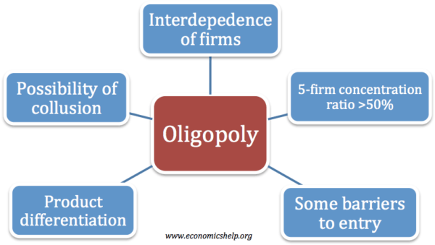

Examples of oligopolies
Car industry – economies of scale have cause mergers so big multinationals dominate the market. The biggest car firms include Toyota, Hyundai, Ford, General Motors, VW.
- Petrol retail – see below.
- Pharmaceutical industry
- Coffee shop retail – Starbucks, Costa Coffee, Cafe Nero
- Newspapers – In UK market share dominated by tabloids Daily Mail, The Sun, The Mirror, The Star, Daily Express.
- Book retail – In UK market share dominated by Water stones, Amazon.

The main features of oligopoly:
- An industry which is dominated by a few firms.
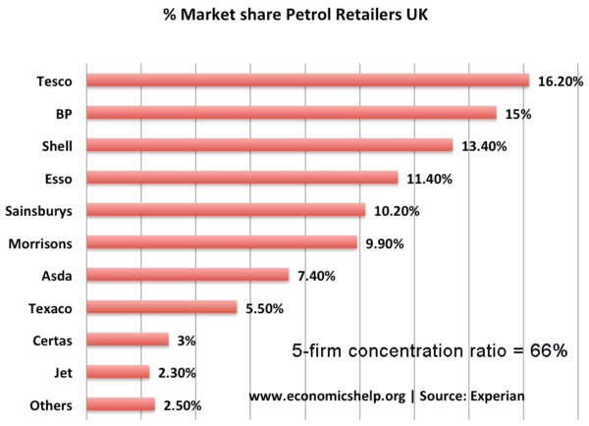
The UK definition of an oligopoly is a five-firm concentration ratio of more than 50% (this means the five biggest firms have more than 50% of the total market share) The above industry (UK petrol) is an example of an oligopoly. See also: Concentration ratios
- Interdependence of firms – companies will be affected by how other firms set price and output.
- Barriers to entry. In an oligopoly, there must be some barriers to entry to enable firms to gain a significant market share. These barriers to entry may include brand loyalty or economies of scale. However, barriers to entry are less than monopoly.
- Differentiated products. In an oligopoly, firms often compete on non-price competition. This makes advertising and the quality of the product are often important.
- Oligopoly is the most common market structure

How firms compete in oligopoly
There are different possible ways that firms in oligopoly will compete and behave this will depend upon:
- The objectives of the firms; e.g. profit maximisation or sales maximisation?
- The degree of contestability; i.e. barriers to entry.
- Government regulation.
There are different possible outcomes for oligopoly:
- Stable prices (e.g. through kinked demand curve) – firms concentrate on non-price competition.
- Price wars (competitive oligopoly)
- Collusion- leading to higher prices.

The kinked demand curve model
This model suggests that prices will be fairly stable and there is little incentive for firms to change prices. Therefore, firms compete using non-price competition methods.
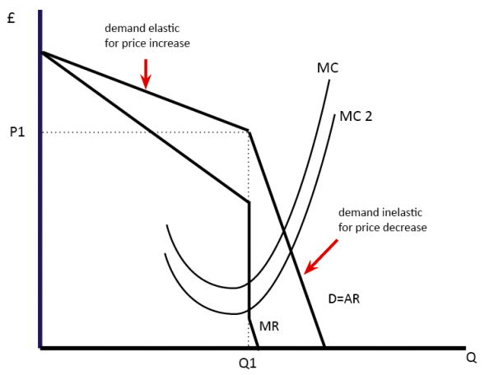
- This assumes that firms seek to maximise profits.
- If they increase the price, then they will lose a large share of the market because they become uncompetitive compared to other firms. Therefore demand is elastic for price increases.
- If firms cut price then they would gain a big increase in market share. However, it is unlikely that firms will allow this. Therefore other firms follow suit and cut-price as well. Therefore demand will only increase by a small amount. Therefore demand is inelastic for a price cut.
- Therefore this suggests that prices will be rigid in oligopoly
The diagram above suggests that a change in marginal cost still leads to the same price, because of the kinked demand curve. Profit maximisation occurs where MR = MC at Q1.

Evaluation of kinked demand curve
- In the real world, prices do change.
- Firms may not seek to maximise profits, but prefer to increase market share and so be willing to cut prices, even with inelastic demand.
- Some firms may have very strong brand loyalty and be able to increase the price without demand being very price elastic.
- The model doesn’t suggest how prices were arrived at in the first place.

Price wars
Firms in oligopoly may still be very competitive on price, especially if they are seeking to increase market share. In some circumstances, we can see oligopolies where firms are seeking to cut prices and increase competitiveness.
A feature of many oligopolies is selective price wars. For example, supermarkets often compete on the price of some goods (bread/special offers) but set high prices for other goods, such as luxury cake.

Collusion
- Another possibility for firms in oligopoly is for them to collude on price and set profit maximising levels of output. This maximises profit for the industry.
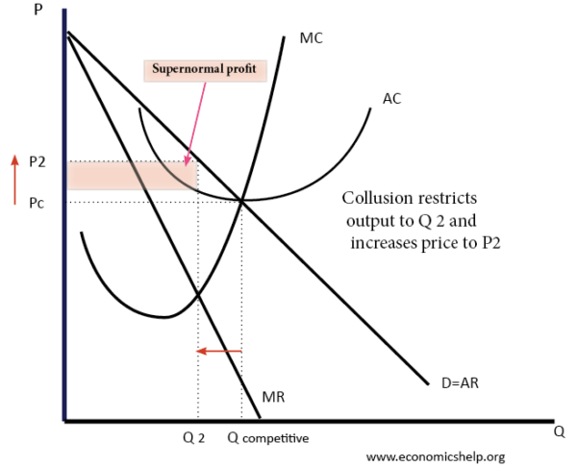
In the above example, the industry was initially competitive (Qc and Pc). However, if firms collude, they can agree to restrict industry supply to Q2, and increase the price to P2. This enables the industry to become more profitable. At Qc, firms made normal profit. But, if they can stick to their quotas and keep the price at P2, they make supernormal profit.
- Collusion is illegal, but tacit collusion may be hard to spot.
- For collusion to be effective, there need to be barriers to entry.
- A cartel is a formal collusive agreement. For example, OPEC is a cartel seeking to control the price of oil.
See: Collusion

Collusion and game theory
Game theory is looking at the decisions of firms based on the uncertainty of how other firms will react. It illustrates the concept of interdependence. For example, if a firm agrees to collude and set low output – it relies on the other firm sticking to the collusive agreement. If the firm restricts output (sets the High price), and then the other firm betrays its agreement (setting low price). The firm will be worse off.
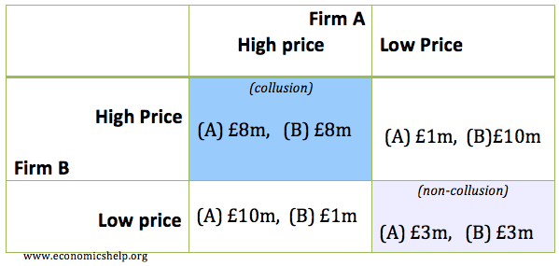
This shows different options. If the market is non-collusive, firms make £3m each. If they collude, they make £8m. But, there is an incentive for firms to exceed quota and increase output.
Collusion and game theory is more complex if we add in the possibility of firms being fined by a government regulator.
Collusion is illegal and firms can be fined. Usually, the first firm who confesses to the regulator is protected from prosecution, so there is always an incentive to be the first to confess.

UNIT-5
National Income: Definition, Concepts and Methods of Measuring National Income

Introduction:
National income is an uncertain term which is used interchangeably with national dividend, national output and national expenditure. On this basis, national income has been defined in a number of ways. In common parlance, national income means the total value of goods and services produced annually in a country.
In other words, the total amount of income accruing to a country from economic activities in a year’s time is known as national income. It includes payments made to all resources in the form of wages, interest, rent and profits.
Contents:
- Definitions of National Income
- Concepts of National Income
- Methods of Measuring National Income
- Difficulties or Limitations in Measuring National Income
- Importance of National Income Analysis
- Inter-Relationship among different concept of National Income

1. Definitions of National Income:

The definitions of national income can be grouped into two classes: One, the traditional definitions advanced by Marshall, Pigou and Fisher; and two, modern definitions.

The Marshallian Definition:
According to Marshall: “The labour and capital of a country acting on its natural resources produce annually a certain net aggregate of commodities, material and immaterial including services of all kinds. This is the true net annual income or revenue of the country or national dividend.” In this definition, the word ‘net’ refers to deductions from the gross national income in respect of depreciation and wearing out of machines. And to this, must be added income from abroad.
It’s Defects:
Though the definition advanced by Marshall is simple and comprehensive, yet it suffers from a number of limitations. First, in the present day world, so varied and numerous are the goods and services produced that it is very difficult to have a correct estimation of them.
Consequently, the national income cannot be calculated correctly. Second, there always exists the fear of the mistake of double counting, and hence the national income cannot be correctly estimated. Double counting means that a particular commodity or service like raw material or labour, etc. might get included in the national income twice or more than twice.
For example, a peasant sells wheat worth Rs.2000 to a flour mill which sells wheat flour to the wholesaler and the wholesaler sells it to the retailer who, in turn, sells it to the customers. If each time, this wheat or its flour is taken into consideration, it will work out to Rs.8000, whereas, in actuality, there is only an increase of Rs.2000 in the national income.
ADVERTISEMENTS:
Third, it is again not possible to have a correct estimation of national income because many of the commodities produced are not marketed and the producer either keeps the produce for self-consumption or exchanges it for other commodities. It generally happens in an agriculture- oriented country like India. Thus the volume of national income is underestimated.

The Pigouvian Definition:
A.C. Pigou has in his definition of national income included that income which can be measured in terms of money. In the words of Pigou, “National income is that part of objective income of the community, including of course income derived from abroad which can be measured in money.”
This definition is better than the Marshallian definition. It has proved to be more practical also. While calculating the national income now-a- days, estimates are prepared in accordance with the two criteria laid down in this definition.
First, avoiding double counting, the goods and services which can be measured in money are included in national income. Second, income received on account of investment in foreign countries is included in national income.
ADVERTISEMENTS:
It’s Defects:
The Pigouvian definition is precise, simple and practical but it is not free from criticism. First, in the light of the definition put forth by Pigou, we have to unnecessarily differentiate between commodities which can and which cannot be exchanged for money.
But, in actuality, there is no difference in the fundamental forms of such commodities, no matter they can be exchanged for money. Second, according to this definition when only such commodities as can be exchanged for money are included in estimation of national income, the national income cannot be correctly measured.
According to Pigou, a woman’s services as a nurse would be included in national income but excluded when she worked in the home to look after her children because she did not receive any salary for it. Similarly, Pigou is of the view that if a man marries his lady secretary, the national income diminishes as he has no longer to pay for her services.
Thus the Pigovian definition gives rise to a number of paradoxes. Third, the Pigovian definition is applicable only to the developed countries where goods and services are exchanged for money in the market.
According to this definition, in the backward and underdeveloped countries of the world, where a major portion of the produce is simply bartered, correct estimate of national income will not be possible, because it will always work out less than the real level of income. Thus the definition advanced by Pigou has a limited scope.

Fisher’s Definition:
Fisher adopted ‘consumption’ as the criterion of national income whereas Marshall and Pigou regarded it to be production. According to Fisher, “The National dividend or income consists solely of services as received by ultimate consumers, whether from their material or from the human environments. Thus, a piano, or an overcoat made for me this year is not a part of this year’s income, but an addition to the capital. Only the services rendered to me during this year by these things are income.”
Fisher’s definition is considered to be better than that of Marshall or Pigou, because Fisher’s definition provides an adequate concept of economic welfare which is dependent on consumption and consumption represents our standard of living.
It’s Defects:
But from the practical point of view, this definition is less useful, because there are certain difficulties in measuring the goods and services in terms of money. First, it is more difficult to estimate the money value of net consumption than that of net production.
In one country there are several individuals who consume a particular good and that too at different places and, therefore, it is very difficult to estimate their total consumption in terms of money. Second, certain consumption goods are durable and last for many years.
If we consider the example of piano or overcoat, as given by Fisher, only the services rendered for use during one year by them will be included in income. If an overcoat costs Rs. 100 and lasts for ten years, Fisher will take into account only Rs. 100 as national income during one year, whereas Marshall and Pigou will include Rs. 100 in the national income for the year, when it is made.
Besides, it cannot be said with certainty that the overcoat will last only for ten years. It may last longer or for a shorter period. Third, the durable goods generally keep changing hands leading to a change in their ownership and value too.
It, therefore, becomes difficult to measure in money the service-value of these goods from the point of view of consumption. For instance, the owner of a Maruti car sells it at a price higher than its real price and the purchaser after using it for a number of years further sells it at its actual price.
Now the question is as to which of its price, whether actual or black market one, should we take into account, and afterwards when it is transferred from one person to another, which of its value according to its average age should be included in national income?
But the definitions advanced by Marshall, Pigou and Fisher are not altogether flawless. However, the Marshallian and Pigovian definitions tell us of the reasons influencing economic welfare, whereas Fisher’s definition helps us compare economic welfare in different years.

Modern Definitions:
From the modern point of view, Simon Kuznets has defined national income as “the net output of commodities and services flowing during the year from the country’s productive system in the hands of the ultimate consumers.”
On the other hand, in one of the reports of United Nations, national income has been defined on the basis of the systems of estimating national income, as net national product, as addition to the shares of different factors, and as net national expenditure in a country in a year’s time. In practice, while estimating national income, any of these three definitions may be adopted, because the same national income would be derived, if different items were correctly included in the estimate.

2. Concepts of National Income:

ADVERTISEMENTS:
There are a number of concepts pertaining to national income and methods of measurement relating to them.

(A) Gross Domestic Product (GDP):
GDP is the total value of goods and services produced within the country during a year. This is calculated at market prices and is known as GDP at market prices. Dernberg defines GDP at market price as “the market value of the output of final goods and services produced in the domestic territory of a country during an accounting year.”
There are three different ways to measure GDP:
Product Method, Income Method and Expenditure Method.
ADVERTISEMENTS:
These three methods of calculating GDP yield the same result because National Product = National Income = National Expenditure.
1. The Product Method:
In this method, the value of all goods and services produced in different industries during the year is added up. This is also known as the value added method to GDP or GDP at factor cost by industry of origin. The following items are included in India in this: agriculture and allied services; mining; manufacturing, construction, electricity, gas and water supply; transport, communication and trade; banking and insurance, real estates and ownership of dwellings and business services; and public administration and defense and other services (or government services). In other words, it is the sum of gross value added.
2. The Income Method:
The people of a country who produce GDP during a year receive incomes from their work. Thus GDP by income method is the sum of all factor incomes: Wages and Salaries (compensation of employees) + Rent + Interest + Profit.
3. Expenditure Method:
This method focuses on goods and services produced within the country during one year.
GDP by expenditure method includes:
(1) Consumer expenditure on services and durable and non-durable goods (C),
(2) Investment in fixed capital such as residential and non-residential building, machinery, and inventories (I),
(3) Government expenditure on final goods and services (G),
(4) Export of goods and services produced by the people of country (X),
(5) Less imports (M). That part of consumption, investment and government expenditure which is spent on imports is subtracted from GDP. Similarly, any imported component, such as raw materials, which is used in the manufacture of export goods, is also excluded.
Thus GDP by expenditure method at market prices = C+ I + G + (X – M), where (X-M) is net export which can be positive or negative.

(B) GDP at Factor Cost:
GDP at factor cost is the sum of net value added by all producers within the country. Since the net value added gets distributed as income to the owners of factors of production, GDP is the sum of domestic factor incomes and fixed capital consumption (or depreciation).
Thus GDP at Factor Cost = Net value added + Depreciation.
GDP at factor cost includes:
(i) Compensation of employees i.e., wages, salaries, etc.
(ii) Operating surplus which is the business profit of both incorporated and unincorporated firms. [Operating Surplus = Gross Value Added at Factor Cost—Compensation of Employees—Depreciation]
(iii) Mixed Income of Self- employed.
Conceptually, GDP at factor cost and GDP at market price must be identical/This is because the factor cost (payments to factors) of producing goods must equal the final value of goods and services at market prices. However, the market value of goods and services is different from the earnings of the factors of production.
In GDP at market price are included indirect taxes and are excluded subsidies by the government. Therefore, in order to arrive at GDP at factor cost, indirect taxes are subtracted and subsidies are added to GDP at market price.
Thus, GDP at Factor Cost = GDP at Market Price – Indirect Taxes + Subsidies.

(C) Net Domestic Product (NDP):
NDP is the value of net output of the economy during the year. Some of the country’s capital equipment wears out or becomes obsolete each year during the production process. The value of this capital consumption is some percentage of gross investment which is deducted from GDP. Thus Net Domestic Product = GDP at Factor Cost – Depreciation.

(D) Nominal and Real GDP:
When GDP is measured on the basis of current price, it is called GDP at current prices or nominal GDP. On the other hand, when GDP is calculated on the basis of fixed prices in some year, it is called GDP at constant prices or real GDP.
Nominal GDP is the value of goods and services produced in a year and measured in terms of rupees (money) at current (market) prices. In comparing one year with another, we are faced with the problem that the rupee is not a stable measure of purchasing power. GDP may rise a great deal in a year, not because the economy has been growing rapidly but because of rise in prices (or inflation).
On the contrary, GDP may increase as a result of fall in prices in a year but actually it may be less as compared to the last year. In both 5 cases, GDP does not show the real state of the economy. To rectify the underestimation and overestimation of GDP, we need a measure that adjusts for rising and falling prices.
This can be done by measuring GDP at constant prices which is called real GDP. To find out the real GDP, a base year is chosen when the general price level is normal, i.e., it is neither too high nor too low. The prices are set to 100 (or 1) in the base year.
Now the general price level of the year for which real GDP is to be calculated is related to the base year on the basis of the following formula which is called the deflator index:
Suppose 1990-91 is the base year and GDP for 1999-2000 is Rs. 6, 00,000 crores and the price index for this year is 300.
Thus, Real GDP for 1999-2000 = Rs. 6, 00,000 x 100/300 = Rs. 2, 00,000 crores

(E) GDP Deflator:
GDP deflator is an index of price changes of goods and services included in GDP. It is a price index which is calculated by dividing the nominal GDP in a given year by the real GDP for the same year and multiplying it by 100. Thus,
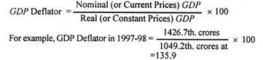
It shows that at constant prices (1993-94), GDP in 1997-98 increased by 135.9% due to inflation (or rise in prices) from Rs. 1049.2 thousand crores in 1993-94 to Rs. 1426.7 thousand crores in 1997-98.

(F) Gross National Product (GNP):
GNP is the total measure of the flow of goods and services at market value resulting from current production during a year in a country, including net income from abroad.
GNP includes four types of final goods and services:
(1) Consumers’ goods and services to satisfy the immediate wants of the people;
(2) Gross private domestic investment in capital goods consisting of fixed capital formation, residential construction and inventories of finished and unfinished goods;
(3) Goods and services produced by the government; and
(4) Net exports of goods and services, i.e., the difference between value of exports and imports of goods and services, known as net income from abroad.
In this concept of GNP, there are certain factors that have to be taken into consideration: First, GNP is the measure of money, in which all kinds of goods and services produced in a country during one year are measured in terms of money at current prices and then added together.
But in this manner, due to an increase or decrease in the prices, the GNP shows a rise or decline, which may not be real. To guard against erring on this account, a particular year (say for instance 1990-91) when prices be normal, is taken as the base year and the GNP is adjusted in accordance with the index number for that year. This will be known as GNP at 1990-91 prices or at constant prices.
Second, in estimating GNP of the economy, the market price of only the final products should be taken into account. Many of the products pass through a number of stages before they are ultimately purchased by consumers.
If those products were counted at every stage, they would be included many a time in the national product. Consequently, the GNP would increase too much. To avoid double counting, therefore, only the final products and not the intermediary goods should be taken into account.
Third, goods and services rendered free of charge are not included in the GNP, because it is not possible to have a correct estimate of their market price. For example, the bringing up of a child by the mother, imparting instructions to his son by a teacher, recitals to his friends by a musician, etc.
Fourth, the transactions which do not arise from the produce of current year or which do not contribute in any way to production are not included in the GNP. The sale and purchase of old goods, and of shares, bonds and assets of existing companies are not included in GNP because these do not make any addition to the national product, and the goods are simply transferred.
Fifth, the payments received under social security, e.g., unemployment insurance allowance, old age pension, and interest on public loans are also not included in GNP, because the recipients do not provide any service in lieu of them. But the depreciation of machines, plants and other capital goods is not deducted from GNP.
Sixth, the profits earned or losses incurred on account of changes in capital assets as a result of fluctuations in market prices are not included in the GNP if they are not responsible for current production or economic activity.
For example, if the price of a house or a piece of land increases due to inflation, the profit earned by selling it will not be a part of GNP. But if, during the current year, a portion of a house is constructed anew, the increase in the value of the house (after subtracting the cost of the newly constructed portion) will be included in the GNP. Similarly, variations in the value of assets, that can be ascertained beforehand and are insured against flood or fire, are not included in the GNP.
Last, the income earned through illegal activities is not included in the GNP. Although the goods sold in the black market are priced and fulfill the needs of the people, but as they are not useful from the social point of view, the income received from their sale and purchase is always excluded from the GNP.
There are two main reasons for this. One, it is not known whether these things were produced during the current year or the preceding years. Two, many of these goods are foreign made and smuggled and hence not included in the GNP.
Three Approaches to GNP:
After having studied the fundamental constituents of GNP, it is essential to know how it is estimated. Three approaches are employed for this purpose. One, the income method to GNP; two, the expenditure method to GNP and three, the value added method to GNP. Since gross income equals gross expenditure, GNP estimated by all these methods would be the same with appropriate adjustments.
1. Income Method to GNP:
The income method to GNP consists of the remuneration paid in terms of money to the factors of production annually in a country.
Thus GNP is the sum total of the following items:
(i) Wages and salaries:
Under this head are included all forms of wages and salaries earned through productive activities by workers and entrepreneurs. It includes all sums received or deposited during a year by way of all types of contributions like overtime, commission, provident fund, insurance, etc.
(ii) Rents:
Total rent includes the rents of land, shop, house, factory, etc. and the estimated rents of all such assets as are used by the owners themselves.
(iii) Interest:
Under interest comes the income by way of interest received by the individual of a country from different sources. To this is added, the estimated interest on that private capital which is invested and not borrowed by the businessman in his personal business. But the interest received on governmental loans has to be excluded, because it is a mere transfer of national income.
(iv) Dividends:
Dividends earned by the shareholders from companies are included in the GNP.
(v) Undistributed corporate profits:
Profits which are not distributed by companies and are retained by them are included in the GNP.
(vi) Mixed incomes:
These include profits of unincorporated business, self-employed persons and partnerships. They form part of GNP.
(vii) Direct taxes:
Taxes levied on individuals, corporations and other businesses are included in the GNP.
(viii) Indirect taxes:
The government levies a number of indirect taxes, like excise duties and sales tax.
These taxes are included in the price of commodities. But revenue from these goes to the government treasury and not to the factors of production. Therefore, the income due to such taxes is added to the GNP.
(ix) Depreciation:
Every corporation makes allowance for expenditure on wearing out and depreciation of machines, plants and other capital equipment. Since this sum also is not a part of the income received by the factors of production, it is, therefore, also included in the GNP.
(x) Net income earned from abroad:
This is the difference between the value of exports of goods and services and the value of imports of goods and services. If this difference is positive, it is added to the GNP and if it is negative, it is deducted from the GNP.
Thus GNP according to the Income Method = Wages and Salaries + Rents + Interest + Dividends + Undistributed Corporate Profits + Mixed Income + Direct Taxes + Indirect Taxes + Depreciation + Net Income from abroad.
2. Expenditure Method to GNP:
From the expenditure view point, GNP is the sum total of expenditure incurred on goods and services during one year in a country.
It includes the following items:
(i) Private consumption expenditure:
It includes all types of expenditure on personal consumption by the individuals of a country. It comprises expenses on durable goods like watch, bicycle, radio, etc., expenditure on single-used consumers’ goods like milk, bread, ghee, clothes, etc., as also the expenditure incurred on services of all kinds like fees for school, doctor, lawyer and transport. All these are taken as final goods.
(ii) Gross domestic private investment:
Under this comes the expenditure incurred by private enterprise on new investment and on replacement of old capital. It includes expenditure on house construction, factory- buildings, and all types of machinery, plants and capital equipment.
In particular, the increase or decrease in inventory is added to or subtracted from it. The inventory includes produced but unsold manufactured and semi-manufactured goods during the year and the stocks of raw materials, which have to be accounted for in GNP. It does not take into account the financial exchange of shares and stocks because their sale and purchase is not real investment. But depreciation is added.
(iii) Net foreign investment:
It means the difference between exports and imports or export surplus. Every country exports to or imports from certain foreign countries. The imported goods are not produced within the country and hence cannot be included in national income, but the exported goods are manufactured within the country. Therefore, the difference of value between exports (X) and imports (M), whether positive or negative, is included in the GNP.
(iv) Government expenditure on goods and services:
The expenditure incurred by the government on goods and services is a part of the GNP. Central, state or local governments spend a lot on their employees, police and army. To run the offices, the governments have also to spend on contingencies which include paper, pen, pencil and various types of stationery, cloth, furniture, cars, etc.
It also includes the expenditure on government enterprises. But expenditure on transfer payments is not added, because these payments are not made in exchange for goods and services produced during the current year.
Thus GNP according to the Expenditure Method=Private Consumption Expenditure (C) + Gross Domestic Private Investment (I) + Net Foreign Investment (X-M) + Government Expenditure on Goods and Services (G) = C+ I + (X-M) + G.
As already pointed out above, GNP estimated by either the income or the expenditure method would work out to be the same, if all the items are correctly calculated.
3. Value Added Method to GNP:
Another method of measuring GNP is by value added. In calculating GNP, the money value of final goods and services produced at current prices during a year is taken into account. This is one of the ways to avoid double counting. But it is difficult to distinguish properly between a final product and an intermediate product.
For instance, raw materials, semi-finished products, fuels and services, etc. are sold as inputs by one industry to the other. They may be final goods for one industry and intermediate for others. So, to avoid duplication, the value of intermediate products used in manufacturing final products must be subtracted from the value of total output of each industry in the economy.
Thus, the difference between the value of material outputs and inputs at each stage of production is called the value added. If all such differences are added up for all industries in the economy, we arrive at the GNP by value added. GNP by value added = Gross value added + net income from abroad. Its calculation is shown in Tables 1, 2 and 3.
Table 1 is constructed on the supposition that the entire economy for purposes of total production consists of three sectors. They are agriculture, manufacturing, and others, consisting of the tertiary sector.
Out of the value of total output of each sector is deducted the value of its intermediate purchases (or primary inputs) to arrive at the value added for the entire economy. Thus the value of total output of the entire economy as per Table 1, is Rs. 155 crores and the value of its primary inputs comes to Rs. 80 crores. Thus the GDP by value added is Rs. 75 crores (Rs. 155 minus Rs. 80 crores).
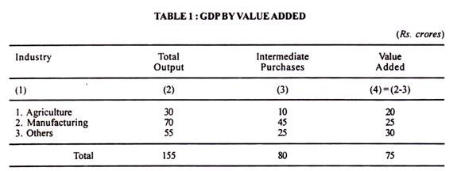
The total value added equals the value of gross domestic product of the economy. Out of this value added, the major portion goes in the form wages and salaries, rent, interest and profits, a small portion goes to the government as indirect taxes and the remaining amount is meant for depreciation. This is shown in Table 3.
Thus we find that the total gross value added of an economy equals the value of its gross domestic product. If depreciation is deducted from the gross value added, we have net value added which comes to Rs. 67 crores (Rs. 75 minus Rs. 8 crores).
This is nothing but net domestic product at market prices. Again, if indirect taxes (Rs. 7 crores) are deducted from the net domestic product of Rs. 67 crores, we get Rs. 60 crores as the net value added at factor cost which is equivalent to net domestic product at factor cost. This is illustrated in Table 2.
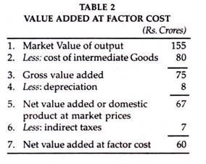
Net value added at factor cost is equal to the net domestic product at factor cost, as given by the total of items 1 to 4 of Table 2 (Rs. 45+3+4+8 crores=Rs. 60 crores). By adding indirect taxes (Rs 7 crores) and depreciation (Rs 8 crores), we get gross value added or GDP which comes to Rs 75 crores.
If we add net income received from abroad to the gross value added, this gives -us, gross national income. Suppose net income from abroad is Rs. 5 crores. Then the gross national income is Rs. 80 crores (Rs. 75 crores + Rs. 5 crores) as shown in Table 3.
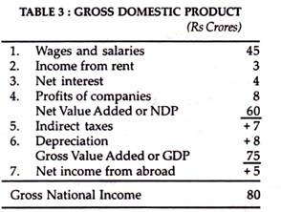
It’s Importance:
The value added method for measuring national income is more realistic than the product and income methods because it avoids the problem of double counting by excluding the value of intermediate products. Thus this method establishes the importance of intermediate products in the national economy. Second, by studying the national income accounts relating to value added, the contribution of each production sector to the value of the GNP can be found out.
For instance, it can tell us whether agriculture is contributing more or the share of manufacturing is falling, or of the tertiary sector is increasing in the current year as compared to some previous years. Third, this method is highly useful because “it provides a means of checking the GNP estimates obtained by summing the various types of commodity purchases.”
It’s Difficulties:
However, difficulties arise in the calculation of value added in the case of certain public services like police, military, health, education, etc. which cannot be estimated accurately in money terms. Similarly, it is difficult to estimate the contribution made to value added by profits earned on irrigation and power projects.

(G) GNP at Market Prices:
When we multiply the total output produced in one year by their market prices prevalent during that year in a country, we get the Gross National Product at market prices. Thus GNP at market prices means the gross value of final goods and services produced annually in a country plus net income from abroad. It includes the gross value of output of all items from (1) to (4) mentioned under GNP. GNP at Market Prices = GDP at Market Prices + Net Income from Abroad.

(H) GNP at Factor Cost:
GNP at factor cost is the sum of the money value of the income produced by and accruing to the various factors of production in one year in a country. It includes all items mentioned above under income method to GNP less indirect taxes.
GNP at market prices always includes indirect taxes levied by the government on goods which raise their prices. But GNP at factor cost is the income which the factors of production receive in return for their services alone. It is the cost of production.
Thus GNP at market prices is always higher than GNP at factor cost. Therefore, in order to arrive at GNP at factor cost, we deduct indirect taxes from GNP at market prices. Again, it often happens that the cost of production of a commodity to the producer is higher than a price of a similar commodity in the market.
In order to protect such producers, the government helps them by granting monetary help in the form of a subsidy equal to the difference between the market price and the cost of production of the commodity. As a result, the price of the commodity to the producer is reduced and equals the market price of similar commodity.
For example if the market price of rice is Rs. 3 per kg but it costs the producers in certain areas Rs. 3.50. The government gives a subsidy of 50 paisa per kg to them in order to meet their cost of production. Thus in order to arrive at GNP at factor cost, subsidies are added to GNP at market prices.
GNP at Factor Cost = GNP at Market Prices – Indirect Taxes + Subsidies.

(I) Net National Product (NNP):
NNP includes the value of total output of consumption goods and investment goods. But the process of production uses up a certain amount of fixed capital. Some fixed equipment wears out, its other components are damaged or destroyed, and still others are rendered obsolete through technological changes.
All this process is termed depreciation or capital consumption allowance. In order to arrive at NNP, we deduct depreciation from GNP. The word ‘net’ refers to the exclusion of that part of total output which represents depreciation. So NNP = GNP—Depreciation.

(J) NNP at Market Prices:
Net National Product at market prices is the net value of final goods and services evaluated at market prices in the course of one year in a country. If we deduct depreciation from GNP at market prices, we get NNP at market prices. So NNP at Market Prices = GNP at Market Prices—Depreciation.

(K) NNP at Factor Cost:
Net National Product at factor cost is the net output evaluated at factor prices. It includes income earned by factors of production through participation in the production process such as wages and salaries, rents, profits, etc. It is also called National Income. This measure differs from NNP at market prices in that indirect taxes are deducted and subsidies are added to NNP at market prices in order to arrive at NNP at factor cost. Thus
NNP at Factor Cost = NNP at Market Prices – Indirect taxes+ Subsidies
= GNP at Market Prices – Depreciation – Indirect taxes + Subsidies.
= National Income.
Normally, NNP at market prices is higher than NNP at factor cost because indirect taxes exceed government subsidies. However, NNP at market prices can be less than NNP at factor cost when government subsidies exceed indirect taxes.

(L) Domestic Income:
Income generated (or earned) by factors of production within the country from its own resources is called domestic income or domestic product.
Domestic income includes:
(i) Wages and salaries, (ii) rents, including imputed house rents, (iii) interest, (iv) dividends, (v) undistributed corporate profits, including surpluses of public undertakings, (vi) mixed incomes consisting of profits of unincorporated firms, self- employed persons, partnerships, etc., and (vii) direct taxes.
Since domestic income does not include income earned from abroad, it can also be shown as: Domestic Income = National Income-Net income earned from abroad. Thus the difference between domestic income f and national income is the net income earned from abroad. If we add net income from abroad to domestic income, we get national income, i.e., National Income = Domestic Income + Net income earned from abroad.
But the net national income earned from abroad may be positive or negative. If exports exceed import, net income earned from abroad is positive. In this case, national income is greater than domestic income. On the other hand, when imports exceed exports, net income earned from abroad is negative and domestic income is greater than national income.

(M) Private Income:
Private income is income obtained by private individuals from any source, productive or otherwise, and the retained income of corporations. It can be arrived at from NNP at Factor Cost by making certain additions and deductions.
The additions include transfer payments such as pensions, unemployment allowances, sickness and other social security benefits, gifts and remittances from abroad, windfall gains from lotteries or from horse racing, and interest on public debt. The deductions include income from government departments as well as surpluses from public undertakings, and employees’ contribution to social security schemes like provident funds, life insurance, etc.
Thus Private Income = National Income (or NNP at Factor Cost) + Transfer Payments + Interest on Public Debt — Social Security — Profits and Surpluses of Public Undertakings.

(N) Personal Income:
Personal income is the total income received by the individuals of a country from all sources before payment of direct taxes in one year. Personal income is never equal to the national income, because the former includes the transfer payments whereas they are not included in national income.
Personal income is derived from national income by deducting undistributed corporate profits, profit taxes, and employees’ contributions to social security schemes. These three components are excluded from national income because they do reach individuals.
But business and government transfer payments, and transfer payments from abroad in the form of gifts and remittances, windfall gains, and interest on public debt which are a source of income for individuals are added to national income. Thus Personal Income = National Income – Undistributed Corporate Profits – Profit Taxes – Social Security Contribution + Transfer Payments + Interest on Public Debt.
Personal income differs from private income in that it is less than the latter because it excludes undistributed corporate profits.
Thus Personal Income = Private Income – Undistributed Corporate Profits – Profit Taxes.

(O) Disposable Income:
Disposable income or personal disposable income means the actual income which can be spent on consumption by individuals and families. The whole of the personal income cannot be spent on consumption, because it is the income that accrues before direct taxes have actually been paid. Therefore, in order to obtain disposable income, direct taxes are deducted from personal income. Thus Disposable Income=Personal Income – Direct Taxes.
But the whole of disposable income is not spent on consumption and a part of it is saved. Therefore, disposable income is divided into consumption expenditure and savings. Thus Disposable Income = Consumption Expenditure + Savings.
If disposable income is to be deduced from national income, we deduct indirect taxes plus subsidies, direct taxes on personal and on business, social security payments, undistributed corporate profits or business savings from it and add transfer payments and net income from abroad to it.
Thus Disposable Income = National Income – Business Savings – Indirect Taxes + Subsidies – Direct Taxes on Persons – Direct Taxes on Business – Social Security Payments + Transfer Payments + Net Income from abroad.

(P) Real Income:
Real income is national income expressed in terms of a general level of prices of a particular year taken as base. National income is the value of goods and services produced as expressed in terms of money at current prices. But it does not indicate the real state of the economy.
It is possible that the net national product of goods and services this year might have been less than that of the last year, but owing to an increase in prices, NNP might be higher this year. On the contrary, it is also possible that NNP might have increased but the price level might have fallen, as a result national income would appear to be less than that of the last year. In both the situations, the national income does not depict the real state of the country. To rectify such a mistake, the concept of real income has been evolved.
In order to find out the real income of a country, a particular year is taken as the base year when the general price level is neither too high nor too low and the price level for that year is assumed to be 100. Now the general level of prices of the given year for which the national income (real) is to be determined is assessed in accordance with the prices of the base year. For this purpose the following formula is employed.
Real NNP = NNP for the Current Year x Base Year Index (=100) / Current Year Index
Suppose 1990-91 is the base year and the national income for 1999-2000 is Rs. 20,000 crores and the index number for this year is 250. Hence, Real National Income for 1999-2000 will be = 20000 x 100/250 = Rs. 8000 crores. This is also known as national income at constant prices.

(Q) Per Capita Income:
The average income of the people of a country in a particular year is called Per Capita Income for that year. This concept also refers to the measurement of income at current prices and at constant prices. For instance, in order to find out the per capita income for 2001, at current prices, the national income of a country is divided by the population of the country in that year.
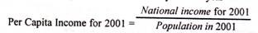
Similarly, for the purpose of arriving at the Real Per Capita Income, this very formula is used.
This concept enables us to know the average income and the standard of living of the people. But it is not very reliable, because in every country due to unequal distribution of national income, a major portion of it goes to the richer sections of the society and thus income received by the common man is lower than the per capita income.

3. Methods of Measuring National Income:

There are four methods of measuring national income. Which method is to be used depends on the availability of data in a country and the purpose in hand.

(1) Product Method:
According to this method, the total value of final goods and services produced in a country during a year is calculated at market prices. To find out the GNP, the data of all productive activities, such as agricultural products, wood received from forests, minerals received from mines, commodities produced by industries, the contributions to production made by transport, communications, insurance companies, lawyers, doctors, teachers, etc. are collected and assessed at market prices. Only the final goods and services are included and the intermediary goods and services are left out.

(2) Income Method:
According to this method, the net income payments received by all citizens of a country in a particular year are added up, i.e., net incomes that accrue to all factors of production by way of net rents, net wages, net interest and net profits are all added together but incomes received in the form of transfer payments are not included in it. The data pertaining to income are obtained from different sources, for instance, from income tax department in respect of high income groups and in case of workers from their wage bills.

(3) Expenditure Method:
According to this method, the total expenditure incurred by the society in a particular year is added together and includes personal consumption expenditure, net domestic investment, government expenditure on goods and services, and net foreign investment. This concept is based on the assumption that national income equals national expenditure.

(4) Value Added Method:
Another method of measuring national income is the value added by industries. The difference between the value of material outputs and inputs at each stage of production is the value added. If all such differences are added up for all industries in the economy, we arrive at the gross domestic product.

4. Difficulties or Limitations in Measuring National Income:

There are many conceptual and statistical problems involved in measuring national income by the income method, product method, and expenditure method.
We discuss them separately in the light of the three methods:

(A) Problems in Income Method:
The following problems arise in the computation of National Income by income method:
1. Owner-occupied Houses:
A person who rents a house to another earns rental income, but if he occupies the house himself, will the services of the house-owner be included in national income. The services of the owner-occupied house are included in national income as if the owner sells to himself as a tenant its services.
For the purpose of national income accounts, the amount of imputed rent is estimated as the sum for which the owner-occupied house could have been rented. The imputed net rent is calculated as that portion of the amount that would have accrued to the house-owner after deducting all expenses.
2. Self-employed Persons:
Another problem arises with regard to the income of self-employed persons. In their case, it is very difficult to find out the different inputs provided by the owner himself. He might be contributing his capital, land, labour and his abilities in the business. But it is not possible to estimate the value of each factor input to production. So he gets a mixed income consisting of interest, rent, wage and profits for his factor services. This is included in national income.
3. Goods meant for Self-consumption:
In under-developed countries like India, farmers keep a large portion of food and other goods produced on the farm for self-consumption. The problem is whether that part of the produce which is not sold in the market can be included in national income or not. If the farmer were to sell his entire produce in the market, he will have to buy what he needs for self-consumption out of his money income. If, instead he keeps some produce for his self-consumption, it has money value which must be included in national income.
4. Wages and Salaries paid in Kind:
Another problem arises with regard to wages and salaries paid in kind to the employees in the form of free food, lodging, dress and other amenities. Payments in kind by employers are included in national income. This is because the employees would have received money income equal to the value of free food, lodging, etc. from the employer and spent the same in paying for food, lodging, etc.

(B) Problems in Product Method:
The following problems arise in the computation of national income by product method:
1. Services of Housewives:
The estimation of the unpaid services of the housewife in the national income presents a serious difficulty. A housewife renders a number of useful services like preparation of meals, serving, tailoring, mending, washing, cleaning, bringing up children, etc.
She is not paid for them and her services are not including in national income. Such services performed by paid servants are included in national income. The national income is, therefore, underestimated by excluding the services of a housewife.
The reason for the exclusion of her services from national income is that the love and affection of a housewife in performing her domestic work cannot be measured in monetary terms. That is why when the owner of a firm marries his lady secretary, her services are not included in national income when she stops working as a secretary and becomes a housewife.
When a teacher teaches his own children, his work is also not included in national income. Similarly, there are a number of goods and services which are difficult to be assessed in money terms for the reason stated above, such as painting, singing, dancing, etc. as hobbies.
2. Intermediate and Final Goods:
The greatest difficulty in estimating national income by product method is the failure to distinguish properly between intermediate and final goods. There is always the possibility of including a good or service more than once, whereas only final goods are included in national income estimates. This leads to the problem of double counting which leads to the overestimation of national income.
3. Second-hand Goods and Assets:
Another problem arises with regard to the sale and purchase of second-hand goods and assets. We find that old scooters, cars, houses, machinery, etc. are transacted daily in the country. But they are not included in national income because they were counted in the national product in the year they were manufactured.
If they are included every time they are bought and sold, national income would increase many times. Similarly, the sale and purchase of old stocks, shares, and bonds of companies are not included in national income because they were included in national income when the companies were started for the first time. Now they are simply financial transactions and represent claims.
But the commission or fees charged by the brokers in the repurchase and resale of old shares, bonds, houses, cars or scooters, etc. are included in national income. For these are the payments they receive for their productive services during the year.
4. Illegal Activities:
Income earned through illegal activities like gambling, smuggling, illicit extraction of wine, etc. is not included in national income. Such activities have value and satisfy the wants of the people but they are not considered productive from the point of view of society. But in countries like Nepal and Monaco where gambling is legalised, it is included in national income. Similarly, horse-racing is a legal activity in England and is included in national income.
5. Consumers’ Service:
There are a number of persons in society who render services to consumers but they do not produce anything tangible. They are the actors, dancers, doctors, singers, teachers, musicians, lawyers, barbers, etc. The problem arises about the inclusion of their services in national income since they do not produce tangible commodities. But as they satisfy human wants and receive payments for their services, their services are included as final goods in estimating national income.
6. Capital Gains:
The problem also arises with regard to capital gains. Capital gains arise when a capital asset such as a house, some other property, stocks or shares, etc. is sold at higher price than was paid for it at the time of purchase. Capital gains are excluded from national income because these do not arise from current economic activities. Similarly, capital losses are not taken into account while estimating national income.
7. Inventory Changes:
All inventory changes (or changes in stocks) whether positive or negative are included in national income. The procedure is to take changes in physical units of inventories for the year valued at average current prices paid for them.
The value of changes in inventories may be positive or negative which is added or subtracted from the current production of the firm. Remember, it is the change in inventories and not total inventories for the year that are taken into account in national income estimates.
8. Depreciation:
Depreciation is deducted from GNP in order to arrive at NNP. Thus depreciation lowers the national income. But the problem is of estimating the current depreciated value of, say, a machine, whose expected life is supposed to be thirty years. Firms calculate the depreciation value on the original cost of machines for their expected life. This does not solve the problem because the prices of machines change almost every year.
9. Price Changes:
National income by product method is measured by the value of final goods and services at current market prices. But prices do not remain stable. They rise or fall. When the price level rises, the national income also rises, though the national production might have fallen.
On the contrary, with the fall in the price level, the national income also falls, though the national production might have increased. So price changes do not adequately measure national income. To solve this problem, economists calculate the real national income at a constant price level by the consumer price index.

(C) Problems in Expenditure Method:
The following problems arise in the calculation of national income by expenditure method:
(1) Government Services:
In calculating national income by, expenditure method, the problem of estimating government services arises. Government provides a number of services, such as police and military services, administrative and legal services. Should expenditure on government services be included in national income?
If they are final goods, then only they would be included in national income. On the other hand, if they are used as intermediate goods, meant for further production, they would not be included in national income. There are many divergent views on this issue.
One view is that if police, military, legal and administrative services protect the lives, property and liberty of the people, they are treated as final goods and hence form part of national income. If they help in the smooth functioning of the production process by maintaining peace and security, then they are like intermediate goods that do not enter into national income.
In reality, it is not possible to make a clear demarcation as to which service protects the people and which protects the productive process. Therefore, all such services are regarded as final goods and are included in national income.
(2) Transfer Payments:
There arises the problem of including transfer payments in national income. Government makes payments in the form of pensions, unemployment allowance, subsidies, interest on national debt, etc. These are government expenditures but they are not included in national income because they are paid without adding anything to the production process during the current year.
For instance, pensions and unemployment allowances are paid to individuals by the government without doing any productive work during the year. Subsidies tend to lower the market price of the commodities. Interest on national or public debt is also considered a transfer payment because it is paid by the government to individuals and firms on their past savings without any productive work.
(3) Durable-use Consumers’ Goods:
Durable-use consumers’ goods also pose a problem. Such durable-use consumers’ goods as scooters, cars, fans, TVs, furniture’s, etc. are bought in one year but they are used for a number of years. Should they be included under investment expenditure or consumption expenditure in national income estimates? The expenditure on them is regarded as final consumption expenditure because it is not possible to measure their used up value for the subsequent years.
But there is one exception. The expenditure on a new house is regarded as investment expenditure and not consumption expenditure. This is because the rental income or the imputed rent which the house-owner gets is for making investment on the new house. However, expenditure on a car by a household is consumption expenditure. But if he spends the amount for using it as a taxi, it is investment expenditure.
(4) Public Expenditure:
Government spends on police, military, administrative and legal services, parks, street lighting, irrigation, museums, education, public health, roads, canals, buildings, etc. The problem is to find out which expenditure is consumption expenditure and which investment expenditure is.
Expenses on education, museums, public health, police, parks, street lighting, civil and judicial administration are consumption expenditure. Expenses on roads, canals, buildings, etc. are investment expenditure. But expenses on defence equipment are treated as consumption expenditure because they are consumed during a war as they are destroyed or become obsolete. However, all such expenses including the salaries of armed personnel are included in national income.

5. Importance of National Income Analysis:

The national income data have the following importance:
1. For the Economy:
National income data are of great importance for the economy of a country. These days the national income data are regarded as accounts of the economy, which are known as social accounts. These refer to net national income and net national expenditure, which ultimately equal each other.
Social accounts tell us how the aggregates of a nation’s income, output and product result from the income of different individuals, products of industries and transactions of international trade. Their main constituents are inter-related and each particular account can be used to verify the correctness of any other account.
2. National Policies:
National income data form the basis of national policies such as employment policy, because these figures enable us to know the direction in which the industrial output, investment and savings, etc. change, and proper measures can be adopted to bring the economy to the right path.
3. Economic Planning:
In the present age of planning, the national data are of great importance. For economic planning, it is essential that the data pertaining to a country’s gross income, output, saving and consumption from different sources should be available. Without these, planning is not possible.
4. Economic Models:
The economists propound short-run as well as long-run economic models or long-run investment models in which the national income data are very widely used.
5. Research:
The national income data are also made use of by the research scholars of economics. They make use of the various data of the country’s input, output, income, saving, consumption, investment, employment, etc., which are obtained from social accounts.
6. Per Capita Income:
National income data are significant for a country’s per capita income which reflects the economic welfare of the country. The higher the per capita income, the higher the economic welfare of the country.
7. Distribution of Income:
National income statistics enable us to know about the distribution of income in the country. From the data pertaining to wages, rent, interest and profits, we learn of the disparities in the incomes of different sections of the society. Similarly, the regional distribution of income is revealed.
It is only on the basis of these that the government can adopt measures to remove the inequalities in income distribution and to restore regional equilibrium. With a view to removing these personal and regional disequibria, the decisions to levy more taxes and increase public expenditure also rest on national income statistics.

6. Inter-Relationship among different concept of National Income

The inter-relationship among the various concept of national income can be shown in the form of equations as under:
******************************************************************

