Introduction to Project Management

Introduction
Realization of these objectives requires systematic planning and careful implementation. To this effect, application of knowledge, skill, tools and techniques in the project environment, refers to project management. Project management in recent years has proliferated, reaching new heights of sophistication. It has emerged as a distinct area of management practices to meet the challenges of new economic environment, globalization process, rapid technological advancement, and quality concerns of the stakeholders.

Project Definition
Project in general refers to a new endeavor with specific objective and varies so widely that it is very difficult to precisely define it. Some of the commonly quoted definitions are as follows.
Project is a temporary endeavor undertaken to create a unique product or service or result. (AMERICAN National Standard ANSI/PMI99-001-2004)

Project is a unique process, consist of a set of coordinated and controlled activities with start and finish dates, undertaken to achieve an objective confirming to specific requirements, including the constraints of time cost and resource.
(ISO10006)

Examples of project include Developing a watershed, Creating irrigation facility, Developing new variety of a crop, Developing new breed of an animal, Developing agroprocessing centre, Construction of farm building, sting of a concentrated feed plant etc. It may be noted that each of these projects differ in composition, type, scope, size and time.

Project Characteristics
Despite above diversities, projects share the following common characteristics.
Unique in nature.
Have definite objectives (goals) to achieve.
Requires set of resources.
Have a specific time frame for completion with a definite start and finish.
Involves risk and uncertainty.
Requires cross-functional teams and interdisciplinary approach.

Project Performance Dimensions
Three major dimensions that define the project performance are scope, time, and resource. These parameters are interrelated and interactive. The relationship generally represented as an equilateral triangle. The relationship is shown in figure 1.
Scope
Cost
Time
Figure 1. Project performance dimensions

It is evident that any change in any one of dimensions would affect the other. For example, if the scope is enlarged, project would require more time for completion and the cost would also go up. If time is reduced the scope and cost would also be required to be reduced. Similarly any change in cost would be reflected in scope and time. Successful completion of the project would require accomplishment of specified goals within scheduled time and budget. In recent years a forth dimension, stakeholder satisfaction, is added to the project. However, the other school of management argues that this dimension is an inherent part of the scope of the project that defines the specifications to which the project is required to be implemented. Thus the performance of a project is measured by the degree to which these three parameters (scope, time and cost) are achieved.

Mathematically
Performance = f(Scope, Cost, Time)

In management literature, this equilateral triangle is also referred as the “Quality triangle” of the project.

Project Life Cycle
Every project, from conception to completion, passes through various phases of a life cycle synonym to life cycle of living beings. There is no universal consensus on the number of phases in a project cycle. An understanding of the life cycle is important to successful completion of the project as it facilitates to understand the logical sequence of events in the continuum of progress from start to finish. Typical project consists of four phases- Conceptualization, Planning, Execution and Termination. Each phase is marked by one or more deliverables such as Concept note, Feasibility report, Implementation Plan, HRD plan, Resource allocation plan, Evaluation report etc.

Conceptualization Phase
Conception phase, starting with the seed of an idea, it covers identification of the product / service, Pre-feasibility, Feasibility studies and Appraisal and Approval. The project idea is conceptualized with initial considerations of all possible alternatives for achieving the project objectives. As the idea becomes established a proposal is developed setting out rationale, method, estimated costs, benefits and other details for appraisal of the stakeholders. After reaching a broad consensus on the proposal the feasibility dimensions are analyzed in detail.

Planning Phase
In this phase the project structure is planned based on project appraisal and approvals. Detailed plans for activity, finance, and resources are developed and integrated to the quality parameters. In the process major tasks need to be performed in this phase are
- Identification of activities and their sequencing
- Time frame for execution
- Estimation and budgeting
- Staffing
A Detailed Project Report (DPR) specifying various aspects of the project is finalized to facilitate execution in this phase.

Execution Phase
This phase of the project witnesses the concentrated activity where the plans are put into operation. Each activity is monitored, controlled and coordinated to achieve project objectives. Important activities in this phase are
- Communicating with stakeholders
- Reviewing progress
- Monitoring cost and time
- Controlling quality
- Managing changes

Termination Phase
This phase marks the completion of the project wherein the agreed deliverables are installed and project is put in to operation with arrangements for follow-up and evaluation.

Life Cycle path
The life cycle of a project from start to completion follows either a “S” shaped path or a “J “ shaped path (Figure 2 and 3). In “S” shape path the progress is slow at the starting and terminal phase and is fast in the implementation phase. For example, implementation of watershed project. At the beginning detailed sectoral planning and coordination among various implementing agencies etc. makes progress slow and similarly towards termination, creating institutional arrangement for transfer and maintenance of assets to the stakeholders progresses slowly.
Error!

Percentage completion
100

Slow start
Quick
Momentum
Slow finish
Time
Figure 2. Project life path –“S” shape

In “J” type cycle path the progress in beginning is slow and as the time moves on the progress of the project improves at fast rate. Example, in a developing an energy plantation. In this the land preparation progresses slowly and as soon as the land and seedling are transplantation is under taken. This is shown in figure 3.

Error!

Time
% Completion

100

Figure 3. Project life cycle path - “J” Shape

Project Classification
There is no standard classification of the projects. However considering project goals, these can be classified into two broad groups, industrial and developmental. Each of these groups can be further classified considering nature of work (repetitive, non-repetitive), completion time (long term, shot term etc), cost (large, small, etc.), level of risk (high, low, no-risk), mode of operation ( build, build-operate-transfer etc).

Industrial projects also referred as commercial projects, which are undertaken to provide goods or services for meeting the growing needs of the customers and providing attractive returns to the investors/stake holders. Following the background, these projects are further grouped into two categories i.e., demand based and resource / supply based. The demand based projects are designed to satisfy the customers’ felt as well the latent needs such as complex fertilizers, agro-processing infrastructure etc. The resource/ supply based projects are those which take advantage of the available resources like land, water, agricultural produce, raw material, minerals and even human resource. Projects triggered by successful R&D are also considered as supply based. Examples of resource based projects include food product units, metallurgical industries, oil refineries etc. Examples of projects based on human resource (skilled) availability include projects in IT sector, Clinical Research projects in bio services and others.

Development projects are undertaken to facilitate the promotion and acceleration of overall economic development. These projects act as catalysts for economic development providing a cascading effect. Development projects cover sectors like irrigation, agriculture, infrastructure health and education.

The essential differences between Industrial projects and Developmental project aresumerised in the following table 1.

Table 1. Difference between Industrial and Developmental Projects
Dimension | Industrial Project | Developmental Project
Scale of Project | Limited | Large
Promoters | Entrepreneurs or corporates | Government, Public Sectors,  NGOs
Investment | --- | High
Gestation Period | --- | High
Profitabilty | High, Considered on IRR (  Internal Rate of Return) | Modest, Considered on ERR  (Economic Rate of Return)
Finance | Stringent debt equity norms | Operates on higher debtequity norms
Source of fund | National stock markets and from domestic financial  institutions | International organizations like World Bank,  IMF,ADB,DFID and others mostly as loan ,yet times providing for some grants.
Interest rates and repayment period: | Market rate and the repayment period is generally  7 to 10 years | Very low for borrowed funds and the repayment period extends up to 25 years and even beyond.

Project management
Project management is a distinct area of management that helps in handling projects. It has three key features to distinguish it from other forms of management and they include: a project manager, the project team and the project management system. The project management system comprises organization structure, information processing and decisionmaking and the procedures that facilitate integration of horizontal and vertical elements of the project organization. The project management system focuses on integrated planning and control.

Benefits of Project Management Approach
The rationale for following project management approach is as follows.
- Project management approach will help in handling complex, costly and risky assignments by providing interdisciplinary approach in handling the assignments.
Example: R&D organizations.
- Project management approaches help in handling assignments in a specified time frame with definite start and completion points .Example handling customer orders by Industries involved in production of capital goods.
- Project management approaches provide task orientation to personnel in an Organization in handling assignments. Example: Organizations in IT sector handling software development assignments for clients.
2. Project Identification and Formulation

Introduction

A project in the economic sense directly or indirectly adds to the economy of the Nation. However an introspection of the project performance clearly indicates that the situation is far from satisfactory. Most of the major and critical projects in public sector that too in crucial sectors like irrigation, agriculture, and infrastructure are plagued by tremendous time and cost overruns. Even in the private sector the performance is not all that satisfactory as is evident from the growing sickness in industry and rapid increase in non-performing assets (NPAS) of Banks and Financial Institutions. The reasons for time and cost over runs are several and they can be broadly classified under-technical, financial, procedural and managerial. Most of these problems mainly stem from inadequate project formulation and haphazard implementation.

Project Identification
Project identification is an important step in project formulation. These are conceived with the objective of meeting the market demand, exploiting natural resources or creating wealth. The project ideas for developmental projects come mainly from the national planning process, where as industrial projects usually stem from identification of commercial prospects and profit potential.
As projects are a means to achieving certain objectives, there may be several alternative projects that will meat these objectives. It is important to indicate all the other alternatives considered with justification in favour of the specific project proposed for consideration.
Sectoral studies, opportunity studies, support studies, project identification essentially focuses on screening the number of project ideas that come up based on information and data available and based on expert opinions and to come up with a limited number of project options which are promising.

Project Formulation
Project Formulation Concept
“Project Formulation” is the processes of presenting a project idea in a form in which it can be subjected to comparative appraisals for the purpose of determining in definitive terms the priority that should be attached to a project under sever resource constraints. Project Formulation involves the following steps (Figure 1).

PROJECT FORMULATION
↓
OPPORTUNITY STUDIES/Support Studies
↓
IDENTIFICATION OF PRODUCT/SERVICE
↓
PREFEASIBILITY STUDY
↓
FEASIBILITY STUDY
(TECHNO ECONOMIC FEASIBILITY)
↓
PROJECT APPRAISAL
↓
DETAILED PROJECT REPORT

Figure 1. Project Formulation –Schematic view

Opportunity Studies
An opportunity study identifies investment opportunities and is normally undertaken at macro level by agencies involved in economic planning and development. In general opportunity studies there are three types of study – Area Study, sectoral and Sub-sectoral Studies and Resource Based Studies. Opportunity Studies and Support studies provide sound basis for project identification.

Pre feasibility Studies / Opportunity Studies
A pre-feasibility study should be viewed as an intermediate stage between a project opportunity study and a detailed feasibility study, the difference being primarily the extent of details of the information obtained. It is the process of gathering facts and opinions pertaining to the project. This information is then vetted for the purpose of tentatively determining whether the project idea is worth pursuing furthering. Pre feasibility study lays stress on assessing market potential, magnitude of investment, , technical feasibility, financial analysis, risk analysis etc. The breadth and depth of pre feasibility depend upon the time available and the confidence of the decision maker. Pre feasibility studies help in preparing a project profile for presentation to various stakeholders including funding agencies to solicit their support to the project. It also throws light on aspects of the project that are critical in nature and necessitate further investigation through functional support studies.

Support studies are carried out before commissioning pre feasibility or a feasibility study of projects requiring large-scale investments. These studies also form an integral part of the feasibility studies. They cover one or more critical aspects of project in detail. The contents of the Support Study vary depending on the nature of the study and the project contemplated. Since it relates to a vital aspect of the project the conclusions should be clear enough to give a direction to the subsequent stage of project preparation.

Feasibility Study
Feasibility Study forms the backbone of Project Formulation and presents a balanced picture incorporating all aspects of possible concern. The study investigates practicalities, ways of achieving objectives, strategy options, methodology, and predict likely outcome, risk and the consequences of each course of action. It becomes the foundation on which project definition and rationale will be based so that the quality is reflected in subsequent project activity. A well conducted study provides a sound base for decisions, clarifications of objectives, logical planning, minimal risk, and a successful cost effective project. Assessing feasibility of a proposal requires understanding of the STEEP factors. These are as under Social, Technological, Ecological, Economic, and Political.

A feasibility study is not an end in itself but only a means to arrive at an investment decision. The preparation of a feasibility study report is often made difficulty by the number of alternatives (regarding the choice of technology, plant capacity, location, financing etc.) and assumptions on which the decisions are made. The project feasibility studies focus on
- Economic and Market Analysis
- Technical Analysis
- Market Analysis
- Financial Analysis
- Economic Benefits
- Project Risk and Uncertainty
- Management Aspects

Economic and Market Analysis
In the recent years the market analysis has undergone a paradigm shift. The demand forecast and projection of demand supply gap for products / services can no longer be based on extrapolation of past trends using statistical tools and techniques. One has to look at multiple parameters that influence the market. Demand projections are to be made keeping in view all possible developments. Review of the projects executed over the years suggests that many projects have failed not because of technological and financial problems but mainly because of the fact that the projects ignored customer requirements and market forces.

In market analysis a number of factors need to be considered covering – product specifications, pricing, channels of distribution, trade practices, threat of substitutes, domestic and international competition, opportunities for exports etc. It should aim at providing analysis of future market scenario so that the decision on project investment can be taken in an objective manner keeping in view the market risk and uncertainty.

Technical Analysis
Technical analysis is based on the description of the product and specifications and also the requirements of quality standards. The analysis encompasses available alternative technologies, selection of the most appropriate technology in terms of optimum combination of project components, implications of the acquisition of technology, and contractual aspects of licensing. Special attention is given to technical dimensions such as in project selection. The technology chosen should also keep in view the requirements of raw materials and other inputs in terms of quality and should ensure that the cost of production would be competitive. In brief the technical analysis included the following aspects.
Technology - Availability
 | - Alternatives
 | - Latest / state-of-art
 | - Other implications
Plant capacity | - Market demand
 | - Technological parameters
Inputs | - Raw materials
 | - Components
 | - Power
 | - Water
 | - Fuel
 | - Others
Availability skilled man power
\Location
Logistics
Environmental consideration – pollution, etc.,
Requirement buildings/ foundation
Other relevant details

Environmental Impact Studies:
All most all projects have some impact on environment. Current concern of environmental quality requires the environmental clearance for all projects. Therefore environ impact analysis needs to be undertaken before commencement of feasibility study.

Objectives of Environmental Impact Studies:
- To identify and describe the environmental resources/values (ER/Vs) or the environmental attributes (EA) which will be affected by the project (in a quantified manner as far as possible).
- To describe, measure and assess the environmental effects that the proposed project will have on the ER/Vs.
- To describe the alternatives to the proposed project which could accomplish the same results but with a different set of environmental effects
The environmental impact studies would facilitate providing necessary remedial measures in terms of the equipments and facilities to be provided in the project to comply with the environmental regulation specifications.

Financial Analysis

The Financial Analysis, examines the viability of the project from financial or commercial considerations and indicates the return on the investments. Some of the commonly used techniques for financial analysis are as follows.

- Pay-back period.
- Return on Investment (ROI)
- Net Present Value (NPV)
- Profitability Index(PI)/Benefit Cost Ratio
- Internal Rate of Return (IRR)

Pay-back Period

This is the simplest of all methods and calculates the time required to recover the initial project investment out of the subsequent cash flow. It is computed by dividing the investment amount by the sum of the annual returns (income – expenditure) until it is equal to the capital cost.
Example1. (Uniform annual return)
A farmer has invested about Rs. 20000/- in constructing a fish pond and gets annual net return of Rs.5000/- (difference between annual income and expenditure). The pay back period for the project is 4 years (20000/ 5000).
Example 2.(Varying annual return)
In a project Rs.1,00,000/- an initial investment of establishing a horticultural orchard. The annual cash flow is as under.

Time | Annual  Income | Annual  Expenditure | Annual return | Cumulative return
1st Year | 60,000 | 30,000 | 30,000 | 30,000
2nd Year | 70,000 | 30,000 | 40,000 | 70,000
3rd Year | 85,000 | 25,000 | 60,000 | 1,30,000
Pay-back period = Two and half years

The drawback in this method is that it ignores any return received after the payback period and assumes equal value for the income and expenditure irrespective of the time.

It is also possible that projects with high return on investments beyond the pay-back period may not get the deserved importance i.e., two projects having same pay-back period – one giving no return and the other providing large return after pay-back period will be treated equally, which is logically not correct.
Return on Investment (ROI);
The ROI is the annual return as percentage of the initial investment and is computed by dividing the annual return with investment. It is calculation is simple when the return is uniform. For example the ROI of the fish ponds is (5000/ 10000) X 100 = 50%. When the return is not uniform the average of annual returns over a period is used. For horticultural orchard average return is (1,30,000/3) = 43333. ROI = (43333/100000) X 100 = 43.3 %.

Computation of ROI also suffers from similar limitation as of pay-back period. It does not differentiate between two projects one yielding immediate return (lift irrigation project) and another project where return is received after some gestation period say about 2-3 years (developing new variety of crop).

Both the pay-back period and ROI are simple ones and more suited for quick analysis of the projects and sometimes provide inadequate measures of project viability. It is desirable to use these methods in conjunction with other discounted cash flow methods such as Net Present Value (NPV), Internal Rate of Return (IRR) and Benefit-Cost ratio.

Discounted Cash Flow Analysis:

The principle of discounting is the reverse of compounding and takes the value of money over time. To understand his let us take an example of compounding first. Assuming return of 10 %, Rs 100 would grow to Rs110/- in the first year and Rs 121 in the second year. In a reverse statement, at a discount rate of 10% the return of Rs.110 in the next year is equivalent to Rs100 at present. In other words the present worth of next years return at a discount rate 10 % is only Rs.90.91 i.e., (100/110) Similarly Rs121 in the second year worth Rs 100/- at present or the present value of a return after two years is Rs. 82.64 (100/121). These values Rs.90.91 and rs.82.64 are known as present value of of future annual return of Rs.100 in first and second year respectively. Mathematically, the formula for computing present value (PV) of a cash flow “C_{n}” in “nth” year at a discount rate of “d” is as follows;
PV= C_{n} / (1+d)^{n}
The computed discount factor tables are also available for ready reference. In the financial analysis the present value is computed for both investment and returns. The results are presented in three different measures ie. NPV, B-C Ratio, and IRR.

Net Present Value (NPV)

Net Present Value is considered as one of the important measure for deciding the financial viability of a project. The sum of discounted values of the stream of investments in different years of project implementation gives present value of the cost (say C). Similarly sum of discounted returns yields the present value of benefits (say B). The net present value (NPV) of the project is the difference between these two values (B- C). Higher the value of NPV is always desirable for a project.

Benefit-Cost Ratio (B-C Ratio) or Profitability Index (PI);

The B-C Ratio also referred as Profitability Index (PI), reflect the profitability of a project and computed as the ratio of total present value of the returns to the total present value of the investments (B/C). Higher the ratio better is the return.

Internal Rate of Return (IRR):

Internal Rate of Return (IRR) indicates the limit or the rate of discount at which the project total present value of return (B) equals to total present value of investments ( C ) i.e. B-C = Zero. In other words it is the discount rate at which the NPV of the project is zero. The IRR is computed by iteration i.e. Computing NPV at different discount rate till the value is nearly zero.
It is desirable to have projects with higher IRR.

Risk and Uncertainty

Risk and Uncertainty are associated with every project. Risk is related to occurrence of adverse consequences and is quantifiable. It is analysed through probability of occurrences. Where as uncertainty refers to inherently unpredictable dimensions and is assessed through sensitivity analysis. It is therefore necessary to analyse these dimensions during formulation and appraisal phase of the programme. Factors attributing to risk and uncertainties of a project are grouped under the following;
- Technical –relates to project scope, change in technology, quality and quantity of inputs, activity times, estimation errors etc.
- Economical- pertains to market, cost, competitive environment, change in policy, exchange rate etc.
- Socio-political- includes dimensions such as labour, stakeholders etc.
- Environmental – factors could be level of pollution, environmental degradation etc.

Economic Benefits:

Apart from the financial benefits (in terms of Return on Investment) the economic benefits of the project are also analyzed in the feasibility study. The economic benefits include employment generation, economic development of the area where the project is located, foreign exchange savings in case of import substitutes or earning of foreign exchange in case of export oriented projects and others.

Management Aspects:

Management aspects are becoming very important in project feasibility studies. The management aspects cover the background of promoters, management philosophy, the organization set up and staffing for project implementation phase as well as operational phase, the aspects of decentralization and delegation, systems and procedures, the method of execution and finally the accountability.

Time Frame for Project Implementation:

The feasibility study also presents a broad time frame for project implementation. The time frame influences preoperative expenses and cost escalations which will impact the profitability and viability of the project.

Feasibility Report:

Based on the feasibility studies the Techno economic feasibility report or the project report is prepared to facilitate project evaluation and appraisal and investment decisions.

Project Appraisal

The project appraisal is the process of critical examination and analysis of the proposal in totality. The appraisal goes beyond the analysis presented in the feasibility report. At this stage, if required compilation of additional information and further analysis of project dimensions are undertaken. At the end of the process an appraisal note is prepared for facilitating decision on the project implementation.
The appraisal process generally concentrates on the following aspects.
- Market Appraisal: Focusing on demand projections, adequacy of marketing infrastructure and competence of the key marketing personnel.
- Technical Appraisal: Covering product mix, Capacity, Process of manufacture engineering know-how and technical collaboration, Raw materials and consumables, Location and site, Building, Plant and equipments, Manpower requirements and Breakeven point.
- Environmental Appraisal: Impact on land use and micro-environment, commitment of natural resources, and Government policy.
- Financial Appraisal: Capital, rate of return, specifications, contingencies, cost projection, capacity utilization, and financing pattern.
- Economic Appraisal: Considered as a supportive appraisal it reviews economic rate of return, effective rate of protection and domestic resource cost.
- Managerial Appraisal: Focuses on promoters, organization structure, managerial personnel, and HR management.
- Social Cost Benefit Analysis (SCBA): Social Cost Benefit Analysis is a methodology for evaluating projects from the social point of view and focuses on social cost and benefits of a project. There often tend to differ from the costs incurred in monetary terms and benefits earned in monetary terms by the project SCBA may be based on UNIDO method or the Little-Mirriles (L-M) approach. Under UNIDO method the net benefits of the project are considered in terms of economic (efficiency) prices also referred to as shadow prices. As per the L-M approach the outputs and inputs of a project are classified into (1) traded goods and services (2) Non traded goods and services; and (3) Labor. All over the world including India currently the focus is on Economic Rate of Return (ERR) based on SCBA assume importance in project formulation and investment decisions.

Detailed Project Report (DPR)
Once the projects are appraised and the investment decisions are made a Detailed Project Report (DPR) is prepared. It provides all the relevant details including design drawings, specifications, detailed cost estimates etc. and this would act as a blue print for project implementation.

Project Management Techniques
Introduction

Project management involves decision making for the planning, organizing, coordination, monitoring and control of a number of interrelated time bound activities. Project Manager therefore, often depends on tools and techniques that are effective enough not only for drawingup the best possible initial plan but also capable of projecting instantaneously the impact of deviations so as to initiate necessary corrective measures. The search for an effective tool has resulted in development of a variety of techniques. These project management techniques can be classified under two broad categories i.e., Bar Charts and Networks.

Bar Charts

Bar charts are the pictorial representation of various tasks required to be performed for accomplishment of the project objectives. These charts have formed the basis of development of many other project management techniques.

Gantt Chart

Henry L Gantt (1861 – 1919) around 1917 developed a system of bar charts for scheduling and reporting progress of a project. These charts latter were known as Gantt Charts. It is a pictorial representation specifying the start and finish time for various tasks to be performed in a project on a horizontal time-scale. Each project is broken down to physically identifiable and controllable units, called the Tasks. These tasks are indicated by means of a bar, preferably at equi-distance in the vertical axis and time is plotted in the horizontal axis (Figure 1). In this figure “Task A” is land preparation, “Task B” is procurement of inputs etc. Land preparation (Task A) takes five days starting from day one. However in practice the time scale is superimposed on a calendar i.e., if land preparation starts on 1st June it would be completed by 5th June.
Length of the bar indicates required time for the task whereas the width has no significance. Though the bar chart is comprehensive, convenient, and very effective, it has the following limitations:

- Like many other graphical techniques are often difficult to handle large number of tasks in other words a complex project.

- Does not indicate the inter relationship between the tasks i.e., if one activity overruns time what would be the impact on project completion.

Task A

Task B

Task C

Task D

(
Land preparation)
(
Procurement of inputs
)

' ' ' ' ' ' ' ' ' '
1 2 3 4 5 6 7 8 9 10

Time (Days)

Figure 1: Bar Chart

Milestone Chart

Milestone chart is an improvement over the bar chart (Gantt chart) by introducing the concept of milestone. The milestone, represented by a circle over a task in the bar chart indicates completion of a specific phase of the task (Figure 2). For example land preparation (Task A) includes ploughing and leveling. From the simple bar chart it is difficult to monitor progress of the ploughing. Introduction of a milestone on day 3 would specify that the ploughing would be completed by day 3 of the project i.e. 3rd June. In a milestone chart a task is broken down in to specific phases (activities) and after accomplishment of each of the specific activity a milestone is reached or in other words an event occurs. The chart also shows the sequential relationship among the milestones or events within the same task but not the relationship among milestones contained in different tasks. For example in figure 2, the milestone 2 of task A cannot be reached until the milestone 1 is crossed and the activity between milestone 1 and 2 is over. Similarly, in task B the milestone 4 can begin only after completion of milestone 3. But the relationship between the milestone of task A and task B is not indicated in the milestone chart. Other weaknesses of this chart are as follows:

- Does not show interdependence between tasks.

- Does not indicate critical activities.

- Does not consider the concept of uncertainty in accomplishing the task.

- Very cumbersome to draw the chart for large projects.

Task A

(
Ploughing
)

(
Land preparation)
(
Land Leveling
)

_{Task B}

Task C

. ' '' ' ' ' ' ' ' ' ' ' '
1 2 3 4 5 6 7 8 9 10
Time (Days)

Figure 2: Milestone Chart

Networks

The network is a logical extension of Gantt’s milestone chart incorporating the modifications so as to illustrate interrelationship between and among all the milestones in an entire project. The two best-known techniques for network analysis are Programme Evaluation and review Technique (PERT) and Critical Path Method (CPM). These two techniques were developed almost simultaneously during 1956-1958. PERT was developed for US navy for scheduling the research and development activities for Polaris missiles programme. CPM was developed by E.I. du Pont de Nemours & Company as an application to construction project. Though these two methods were developed simultaneously they have striking similarity and the significant difference is that the time estimates for activities is assumed deterministic in CPM and probabilistic in PERT. There is also little distinction in terms of application of these concepts. PERT is used where emphasis is on scheduling and monitoring the project and CPM is used where emphasis is on optimizing resource allocation. However, now-a-days the two techniques are used synonymously in network analysis and the differences are considered to be historical.
Both CPM and PERT describe the work plan of project where arrows and circles respectively indicate the activities and events in the project. This arrow or network diagram includes all the activities and events that should be completed to reach the project objectives. The activities and events are laid in a planned sequence of their accomplishments. However, there are two types of notations used in the network diagram. They are as under, 1. Activity-on-Arrow (AOA), and
2. 2. Activity-on-Node (AON).
In AOA notation, the arrow represents the work to be done and the circle represents an event – either the beginning 0f another activity or completion of previous one. This is shown in figure 3.
Land Preparation Procurement of input

Figure 3. Activity on Arrow
For AON notation, a box (or node) is used to show the task itself and the arrow simply show the sequence in which work is done. This is shown in figure 4.

LandPreparation

Procurementofinput
Figure 4. AON Diagram

Most project management software usually uses AON diagram. AOA network diagram are usually associated with the PERT diagram. This would be used in the following sections.

1.3.1 Programme Evaluation and Review Technique (PERT)

The PERT technique is a method of minimizing trouble spots, programme bottlenecks, delays and interruptions by determining critical activities before they occur so that various activities in the project can be coordinated.

PERT terminology
Some of the terms frequently used in PERT are as follows.

Activity : A recognizable work item of a project requiring time and resource for its completion.

Dummy Activity: An activity that indicates precedence relationship and requires no time nor resource.

Critical Activity: Activities on the critical path having zero slack / float time.

Critical Path: The longest time path connecting the critical activities in the project network. The total time on this path is the shortest duration of the project.

Event: An instantaneous point in time signifying completion or beginning of an activity.

Burst Event: An event which gives rise to more than one activity.

Merge Event: The event which occurs only when more than one activity are accomplished.

Expected Time: The weighted average of the estimated optimistic, most likely and pessimistic time duration of a project activity:

T_{o} + 4 T_{M} + T
Expected Time (T_{E} ) = ------------------------
6

where T_{o} is the Optimistic time, T_{M} is the Most likely time
T is the Pessimistic time

Earliest Start Time (EST): The earliest possible time at which the event can occur. The EST also denotes the Earliest Start Time (EST) of an activity as activities emanate from events. The EST of an activity is the time before which it can not commence without affecting the immediate preceding activity.

Latest Start Time (LST): The latest time at which the event can take place. Also referred as the Latest Start Time (LST) indicating the latest time at which an activity can begin without delaying the project completion time.
Slack: The amount of spare time available between completion of an activity and beginning of next activity.

Steps For Network Analysis
The six steps of network analysis are as follows.

- Prepare the list of activities
- Define the inter relationship among the activities.
- Estimate the activity duration
- Assemble the activities in the form of a flow diagram
- Draw the network
- Analyze the network i.e. compute EST and LST; identify critical events, critical path and critical activities.

Step1: Prepare the list of activities
An activity in a project is the lowest level of resource consuming, time-bound work having a specified beginning and endpoint. It should be quantifiable, measurable, costable, and discrete. The total project is subdivided into activities and each activity is given an alphabetical symbol / code. When the number of activities is more than 26, alphanumeric or multi -alphabet codes can be used. This involves a detailed delineation of the activities to be performed to complete the project. There is no limit to the number of activities to which the project should be splitted. However, it is advisable to limit the number to the minimum required from managerial consideration for avoiding unnecessary complexity. In a simple project it may be easier to identify the activity. In complex projects project activities are identified by splitting it into different hierarchical levels (sub-projects). For example in the activities of a watershed project could be broken down in to sub-projects such as agricultural sub-projects, Soil & water conservation sub-projects, Aforestation sub-project etc. For each of these subprojects the activities could be identified. Depending on the size and nature of the project sub-projects could be further divided into sub-sub project.
For illustration of the process, a simple example of creating facility for lift irrigation in a farm would be used in the following text. Some of the assumptions are as under.
  - It is assumed that the competent authority has approved the project and the project scheduling starts with the activity of “Site selection”.
  - Irrigation would be provided from a newly dug well.
  - Field channels from the well would be laid after its digging.
  - Suitable pump would be procured and installed for lifting water.
  - Specification for the pump is finalized based on the groundwater prospecting data before digging.
  - Pump and other inputs would not be procured until the site is selected.
  - Pump would be installed after digging the well.

With above assumptions, the activities of the project are listed in Table 1. It may be noted the list is not exhaustive. The list would be different with different set of assumption or the perception of the project manager. More activities could be added to the list or some of the activities could be further subdivided. The number of activities in this example has been delineated and limited to only six numbers with objective of simplicity and to demonstrate the process of networking.

Table 1. List of activity
Sr. No | Activity | Symbol / Code
1. | Site selection | A
2. | Digging well | B
3. | Laying field channels | C
4. | Procurement of Pump | D
5. | Installation of pump | E
6. | Test run | F

Step 2: Define the inter relationship among the activities
The relationship among the activities could be defined by specifying the preceding and succeeding activity. Preceding activity for an activity is its immediate predecessor, i.e. the activity that needs to be completed before the start of the new activity. In the given example, selection of the site precedes digging of well. In other words the site needs to be selected before digging of the well. Thus the activity “Selection of site” becomes proceeding activity to the activity of “Digging the well” Succeeding activity is the one that immediately starts after completion of the activity. “Digging well” is the succeeding activity to “Selection of site”.
In PERT the interrelationship is generally defined using the preceding activity. Only the terminating activities will not have any preceding activity. And all other activities must appear at least once as a preceding activity in the table. The inter relationship among the activities listed in the example is as in Table 2.

Table 2. Interrelationship of activities
Sr. No | Activity | Symbol | Preceding activity
1. | Site selection | A | ----
2. | Digging well | B | A
3. | Laying field channels | C | B
4. | Procurement of Pump | D | A
5. | Installation of pump | E | B, D
6. | Test run | F | C, E

Step 3: Estimation of activity time
The activity time is the time, which is actually expected to be expended in carrying out the activity. In deterministic cases as in CPM one time estimate is used. In probabilistic cases as in PERT, the activity time has some kind of probabilistic distribution and is the weighted average of three time estimates ( Optimistic time, Pessimistic time and Most likely time) for each activity. The expected time for each activity is computed as following:

T_{o} + 4 T_{M} + T
Expected Time (T_{E} ) = ------------------------
6

where T_{o} is the Optimistic time,(minimum time assuming every thing goes well) T_{M} is the Most likely time, (modal time required under normal circumstances)
T is the Pessimistic time, (maximum time assuming every thing goes wrong)

Example: Estimation of estimated time for the activity “Site selection”
For this activity the tree time estimates i.e., Optimistic, Most likely and Pessimistic times are 4, 6 and 14 days respectively.

i.e. T_{O} = 4, T_{M} = 6, and T_{P} = 14.

T_{E} = 4 + 4*6 + 14 = 4+24+14 = 42 = 7 days
6 6 6

Three time estimates, optimistic, pessimistic and most likely, could the decided on past experiences in execution of similar activities or from the feedback from individuals with relevance experience. The three time estimates and computed estimated time for the project activities are given in Table 3.

Table 3. Activity time estimates
Sr.  No | Activity | Symb  ol | Precedin g activity | Time (Days)
 |  |  |  | Optimis  tic  Time  T_{O} | Most  likely time T_{M} | Pessimis tic time  T_{P} | Estimate d time  T_{E}
1. | Site selection | A | ---- | 4 | 6 | 14 | 7
2. | Digging well | B | A | 2 | 3 | 4 | 3
3. | Laying field channels | C | B | 7 | 16 | 19 | 15
4. | Procurement of Pump | D | A | 4 | 7 | 10 | 7
5. | Installation of pump | E | D, B | 3 | 4 | 11 | 3
6. | Test run | F | C, E | 1 | 2 | 3 | 2

Network Diagram
Having decided on activities, their relationship and duration (estimated time of the activity), next step is to draw the network diagram of the project. PERT network is a schematic model that depicts the sequential relationship among the activities that must be completed to accomplish the project.

Step 4: Assemble the activities in the form of a flow chart.
In a flow chart the activity and its duration is shown in a box. The boxes are connected with lines according to the preceding and succeeding activity relationship. The flow charts do not give details like start and completion time of each activity until unless it is super imposed on a calendar. It also does not facilitate computation of various slacks. However, the critical path for the project can be identified by comparing the various path lengths (sum of activity time, from start to finish, on any path). The longest path in the chart is the critical path. The flow diagram for the project considered for illustration is as in Figure 5 .

START

B
E 3
D

A 7
F
C

FINISH

Figure 5. The flow diagram
Path I A-B-E-F 7+3+3+2 = 15
Path II A-B-C-F 7+3+15+2 = 27
Path III A-D-E-F 7+7+3+2 = 19
Path II i.e., A-B-C-F being the longest path (27 days) is the Critical path .
Step 5: Draw the network
This graphical representation of the project shows the precedence relationship among the activities. An arrow generally represents activities in the diagram while a circle represents event. Each activity starts with an event and end in an event. Activities in a project are performed either sequentially i.e. one after another or they are undertaken concurrently i.e. simultaneously. To draw the network it requires the knowledge of specifying which activities must be completed before other activities can be started, which activities can be performed in parallel, and which activities immediately succeed other activities. Some of the common combination of activity in a project is as follows,

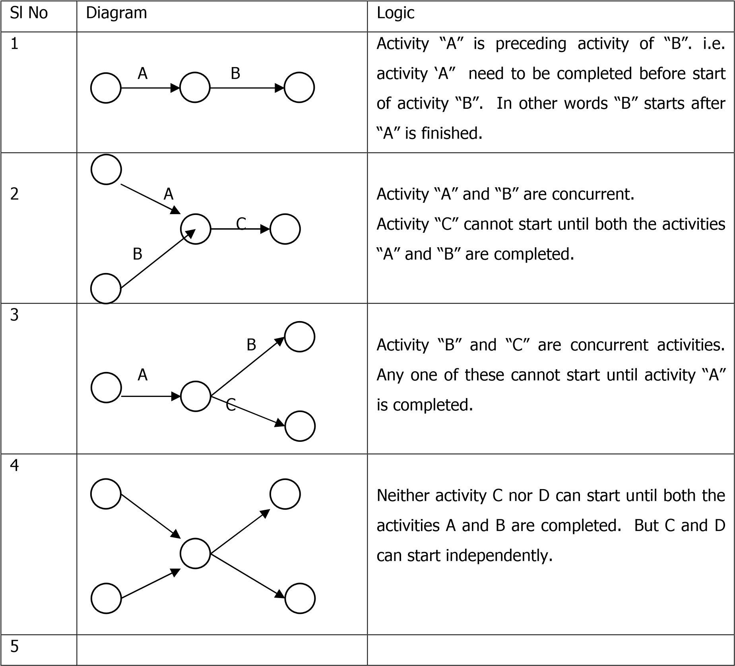
 | A B  Z  C D | Activity D cannot begin until both A & C are completed. But B can start after A is complete. The activity Z, represented by dashed arrow, is a dummy activity (Explained bellow). It specifies the inter relation ship.

Dummy Activity:
For example in a project Crop 2 is to be raised in same plot of land after harvesting of Crop 1. The activities and there inter relation could be as under

Sl No | Activity | Code | Preceding activity
1 | Harvesting of Crop-1 | A | -
2 | Sale of Crop – 1 | B | A
3 | Raising nursery of Crop-2 | C | -
4 | Transplanting Crop-2 | D | A, C

The network diagram of the above project would be as follows

Z
D
C

B
A
The activity “Z”, represented by dashed arrow in the diagram, is a dummy activity. This does not consume any resource i.e. have zero time and zero cost. This only represents the logical relation among the activities.

Rules for Drawing the Network:
- Each activity is represented by one and only one arrow in the network
- All the arrows must run from left to right.
- Dotted line arrows represent dummy activities.
- A circle represents an event.
- Every activity starts and ends with an event.
- No two activities can be identified by the same head and tail event.
- Do not use dummy activity unless required to reflect the logic.
- Avoid Looping and crossing of activity arrows by repositioning.
- Every Activity, except the first and the last, must have at least one preceding and one succeeding activity.
- Danglers, isolated activities must be avoided.
- For coding use alphabets for all activities including the dummy activity and numbers for events.

Event
Code
EST
LST

- Standard representation of the event :

The network diagram for the project detailed in Table 4 is as follows (Figure 6)..

B

F

AZ
D
E
C

Figure 6. Activity inter-relationship
Network Analysis

Introduction
Network analysis helps the manager to calculate the duration and identify critical activities in a project. Critical activities are those activities, which determine the overall duration of the project. The duration of the project is not necessarily the simple arithmetical sum of the individual activity durations because several activities occur concurrently in the project. Project duration would be equal to the sum of all individual activity durations only when all the activities in the project are sequential. The starting and finishing time for each individual activity is calculated through the network analysis. These computations provide a strong base for determining the work schedule. The network analysis includes the following.
- Event numbering
- Computation of the Earliest Start Time (EST)
- Computation of the Latest Start Time (LST)
- Computation of Earliest Finish Time (EFT)
- Computation of the Latest Finish Time (LFT)
- Identification of Critical Path
- Computation of Slack or Float

Event Numbering
It is common practice to number every event in the network so that they are not duplicated, every event is identified with a reference number in the network and every activity is identified by its preceding and succeeding event numbers. There are two systems in vogue for numbering events:

- Random numbering system
- Sequential numbering system

Random numbering system; In this system, events of a network are numbered randomly, thereby avoiding the difficulty in numbering extra events due to insertion of new jobs.
Sequential numbering system: In this system the events are numbered successively from the beginning to the end of the network. For any individual job, the head (succeeding) event must bear a higher number than the tail (preceding) event.
Fulkerson has reduced this sequential numbering to the following routine;
- Find the initial event and number it ‘1’ (An initial event is one which has arrows emerging from it but none entering it).
- Now delete all the arrows emerging from the already numbered event(s). This will create at least one new initial event.
- Number all the new initial events ‘2’, ‘3’ and so on till the final event is reached (the final event is one which has no arrows emerging from it).

The complete sequential numbering system described above is inconvenient when extra jobs have to be inserted. Extra jobs often mean extra events; when these events are numbered, all the events following them must be renumbered. One way to overcome this difficulty is to use tens only like 10 for the first event, 20 for the second event and so on. The event numbering of the network diagram for the project below (Table 1) is shown in figure 1.

Table 1. Lift Irrigation in the farm.
Sr. No | Activity | Symbol | Preceding activity | Time (Days)
1. | Site selection | A | ---- | 7
2. | Digging well | B | A | 3
3. | Laying field channels | C | B | 15
4. | Procurement of Pump | D | A | 7
5. | Installation of pump | E | D, B | 3
6. | Test run | F | C, E | 2

1

2

3

4

5

6

A

B

C

D

E

F

Z

Step 6: Computing Earliest Start Time (EST) and Latest Start Time (LST)

The EST represents the time before which the activity cannot begin and LST refers to the latest time by which the activity must begin. The EST and LST are computed in two phases. The EST is calculated first in the forward pass beginning from the start event. For the start event the EST is always set to zero so that it can be scaled to any convenient calendar date at a later stage. The EST at the last event is generally considered to be the project duration i.e. the minimum time required for project completion. Therefore, EST and LST are equal at the end event. LST for other events is then calculated through backward pass starting from the end event. Steps involved in computation are listed below.

EST | LST
Through forward pass | Through backward pass
Calculation begins from start event | Calculation stars from end event
Proceeds from left to right | Proceeds from right to left
At start event EST is Zero | At end event LST equals to EST
Adding the activity time to EST | Subtracting the activity time from LST
At a merge event take maximum value | At a burst event take minimum value

Example: Computation of EST
EST of an activity = EST of preceding activity + Activity duration
EST at start event 1 (for activity A) is Zero. To compute EST at event number 2, add 7 i.e. the duration of activity A to zero. This is also the EST for both activities B and D starting from event 2. Continuing, EST at event 3 is 10 i.e. (7+3). At event 4, being a merge event, will have two estimates of EST (considering Dummy activity Z and activity D). It is 10 (10+0) and 14 (7+7). In cases where there is more than one estimate the maximum the estimates is considered. In this exercise maximum of 10 and 14 i.e. 14 is the EST at event 4. It is also EST of activity E. EST for the network is computed figure 2 and table2 .

EST
3

4

5

6

B

C

D

E

F

Z

3

7

1

3

2

10

14

2
2
0

1

2

A

7

0

7

Figure 2. Computation of EST

Example: Computation of LST
LST of an activity = LST of succeeding activity – Activity duration
Computation of LST starts from the end event of the project and proceeds backward. At the end event the LST is equal to the EST In this example at the event 6, the LST is equal to the EST and it is 27. At event 5, the LST is 27-2=25. Similarly at event 4 it is 25-3=22. Event 3 being a burst event (i.e. more than one activity emanating from this event) will have two estimates of LST and in such cases only the minimum value of the LST is considered. Accordingly at event 3, the two estimates are 22-0=22 and 25-15=10. Minimum of these two values 10 is the LST at event 3. Similarly at event 2 it is the minimum of 10-3=7 and 22-7=15 i.e. 7. Accordingly at event 1, LST is 7-7=0 which is equal to the EST at the start event. Both the EST and LST values for the project activities are presented in figure 3 . and table 2 .
Table 2. The EST and LST of activities
Event No. | EST |  | Event No. | LST
1 | 0 |  | 6 | 27
2 | 0+7 = 7 |  | 5 | 27-2 = 25
3 | 7+3 = 10 |  | 4 | 25-3= 22
4 | Max. (7+7=14, 10+0=10) = 10 |  | 3 | Min.(25-15=10,25-0=25) =10
5 | Max. (10+15=25, 14+3=17) = 25 |  | 2 | Min. (10-3=7, 22-7=15) = 15
6 | 25+2 = 27 |  | 1 | 7-7=0

1

2

3

4

5

6

A

B

C

D

E

F

z

7

3

7

1

3

2

0

0

10

7

14

2
2
2
2
2
1
0

7

Figure 3. The EST and LST of activities
Computation of the Earliest Finish Time (EFT) and the Latest Finish Time (LFT)
The EFT for each activity is calculated starting from the first activity, which commences after the start event. It is given by

EFT of an activity + EST of preceding activity + activity duration.

The calculation of LFT starts from the last activity of the network or from the computed LST and is given by,
LFT = Latest Starting Time (LST) of succeeding event

The various computed for the project is given in table 3.

Table 3. Computed times for the activities

Sl No | Activity | Duration | EST | LST | EFT | LFT
1 | A | 7 | 0 | 0 | 7 | 7
2 | B | 3 | 7 | 7 | 10 | 10
3 | C | 15 | 10 | 10 | 25 | 25
4 | D | 7 | 7 | 15 | 14 | 22
5 | E | 3 | 14 | 22 | 17 | 25
6 | F | 2 | 25 | 25 | 27 | 27

Calculation Of Slacks / Floats
Slack or float is used to indicate the spare time available with in a non-critical activity. However, in general slack relates to an event and floats to an activity. These are important for smoothening the resource utilization in a project. The various floats and slacks are computed as follows
- Event Slack = LST-EST
- Total Flot is the time available for an activity over and above the requirement for its completion.
Total Float = LST of end event – EST of Starting event- Duration of reference activity
- Free Float is the time available for an activity to expand without influencing the later activities.
Free Float = EST of end event – EST of starting event – Duration of reference activity.
- Independent Float is the time with which an activity can expand without influencing the preceding or succeeding activities. Seldom the independent float could be negative. In such cases it would be considered to be equal to zero.
Independent float = EST of end event – LST of starting event – Duration of reference activity.

Floats and their relation ship
Various floats and their relationship is shown in Figure 3 . It may be observed that
Total Float is more than or equal to free float. And free float is more than or equal to independent float. I.e. TF>= FF >= IF

Beginning

End Slack
Slack
Activity
Duration

Total Float

Free Float

Independent Float

Activity
Duration

Activity
Duration

Figure 4. Relationship between the floats

Identification of Critical Events
The critical events of the project are identified by the event slack i.e. the difference between LST and EST. For critical events this slack is zero i.e. the value of LST and EST are equal. The event slack computed for all the events of the project are as follows Table 4:
Table 4. Event Slacks

Event No | LST | EST | Event slack | Critical / NC
1 | 0 | 0 | 0 | Critical
2 | 7 | 7 | 0 | Critical
3 | 10 | 10 | 0 | Critical
4 | 14 | 22 | 8 | Not Critical
5 | 25 | 25 | 0 | Critical
6 | 27 | 27 | 0 | Critical

With above values of EST, LST and event slack the Critical Events are 1,23,5, and 6.
Identification of Critical Activity
An activity can be called as critical activity if the following conditions are satisfied.
i. LST and EST are equal at the head event ii. LST and EST are equal at tail event
iii. Difference between EST at head and tail event of the activity equals to the activity time. iv. Difference between LST at head and tail event of the activity equals to the activity time.

Review of computation results suggests that the critical activities in the project are A, B, C, and F.

Identification of Critical Path
The critical path is the chain of critical activity spanning the network from start to end i.e. the path joining all the critical events. It is also the longest path from start to end of the project network. Alternatively therefore comparing all the possible path lengths can identify the critical path (see flow diagram). The critical path time is the shortest duration of the project. The critical path is denoted preferably by denoting the critical events on the path.

Critical path for the project is, A – B –C – F.

The critical path of the project can also be denoted in terms of the event numbers. In the present project it is 1- 2–3 – 5-6. To distinguish the critical path from other paths in the project, it is preferable to use a thicker line to demarcate the critical path. It is quite possible that a project can have multiple critical paths. In such case the length of all the critical paths will be equal.

Critical Path and Project Management:
The critical path time being the shortest project time any delay in completion of any of the activity on the critical path would delay the entire project. Therefore it is the critical activity that needs to be monitored for timely completion of the project. However, the activities with positive event slack could be rescheduled within the available time frame for efficient utilization i.e. smoothing of the demand on the available resources. If the duration of the project requires to be reduced, activities on the critical path will be the ones to be considered for completion at an early date with allocation of additional resources.

Network Revision
So far the steps involved in developing the initial network provided two basic pieces of information an estimate of the project duration and the critical path.
The initial network constructed is examined to convert it into a valid, practical network which satisfies the project requirements and provides the basis for effective implementation and control. This process is called network revision.
The purpose of revision is two-fold. Firstly, it is concerned with improving the quality of the information in the network; information about the relationships and durations of activities. Secondly, it is concerned with ensuring that the final network satisfied the project objectives.
These relate to four factors; time, cost, resources and performance.

Reviewing the relationships: The first task is to review the activities and their relationships. Some relationships may not have been shown properly in the initial network. A sequence of activities which at first sight appear to need serial representation, can sometimes be arranged to take place in parallel with one another. Often it is s only a part of an activity which really conditions the start of the following activity, and in these cases, the activity can be subdivided and part of it depicted on the network as occurring in parallel with other activities. If the activity thus treated is on the critical path, a useful shortening of the project duration can be achieved.

Reviewing the duration of activities: At the revision stage, the activity durations must be reexamined in the light of information about the project duration and critical path. Work may have to be analyzed in greater detail, suppliers may have to be contacted for confirmation of current delivery periods and so on. Less accurate estimates can usually be tolerated for activities with plenty of float.
For some activities, the duration is variable. The time required to carry out the work depends almost entirely upon the quality or accuracy of performance specified. Estimates for research and development work and producing advertising copy or design work may be of this type. One approach for reviewing the duration of the activities when they are not critical is the use of the concept of available time.
One useful little check, which can be applied to the activity durations, is to calculate the parentage of even number durations in the network. Because of a fairly general bias towards even numbers, the percentage is rarely as low as the theoretical 50%.

Project objectives while in theory, the objectives of every project should be clearly defined at the outset, in practice this is not always done. On the other hand, the initial network assists and forces the clear definition of project objectives. Statement about objectives is usually expressed in term of time, cost, resources and performance. It will be realized that the objectives stated in terms of one factor may conflict with others. For example, it may not be possible to complete a project in the shortest time and at minimum cost. If a network is to be checked to see whether it satisfies the project objectives, then these objectives must have been stated in such a way as to recognize and assign priority to their relationships.

Meeting time objectives; It is likely that the project duration calculated from the initial network may not be acceptable to the management. This means that at the revision stage, the network must be modified to satisfy any time limits set for the project. If the project duration is to be reduced, the critical activities must be subjected first to careful examination. Changes in the relationships in turn affect the time along the concerned path as discussed earlier.
But once the possibilities for changes in relationships have been exhausted, the scope for reduction in the duration of critical activities must be examined. In some cases, this may mean diverting resources from non critical activities to critical, ones. In others, this may mean the use of more labour, more machines; overtime work or extra shifts.

Meeting cost objectives: The cost of a project is usually given in terms of an estimate which may be required for such purposes as establishing feasibility, finding out return on investment, obtaining approval or getting out a price for a job, etc. The time involved will be important and a realistic cost target cannot be set without a careful study of the plan embodied in the network. The plan will determine in broad terms the pattern of expenditure over the period of the project. The network can be used to investigate this pattern of expenditure and the results can be compared with the availability of money. The network may indicate a pattern of expenditure in excess of what is possible, in which case the plan will have to be modified.
Certain activities can be speeded up or slowed down depending upon the amount of money spent on them. The network can be used to examine the relationship between total time and total cost, and the project duration established for which the total cost is minimum. These aspects will be discussed in more detail later.
Meeting resource objectives: The initial network is drawn without considering the resources as this does not affect the relationships between activities. However, if the resources are limited, the plan must be examined to see to what extent it will have to be modified in the light of resource availability. Activities which are independent may have to be made dependent upon one another because they will be done by the same machine or by the same man. For example, a number of fitting jobs may be unrelated in the network, but if there is only one fitter to whom this work can be allocated then the jobs will have to be done one after the other. If the jobs have sufficient float to allow this, the project completion date will remain unaffected; but if the float is inadequate, an additional fitter has to be employed or a later completion date accepted. The plan. should be modified accordingly.
Another aspect which should be considered at this stage is the relationship between to duration of an activity and the resources allotted to it. The original duration assumes normal resources but for some activities, this time may be varied by altering resources put on the job. Thus certain critical activities may be speeded up by putting on additional resources, while activities with plenty of float may be allowed to take longer time with less resources, thus releasing men for more critical activities.
Examination of the network can throw some light on the resource implications of the plan in a general way. Often a detailed analysis of the network is necessary, if the information is going to lead to management action. The analysis of network with respect to resources will be discussed in detail later.

Meeting the performance objectives: There are two ways in which the plan influences the specification of the project. Firstly, it will embody methods of working and procedures which influence performance and these may have to be revised in order to effect a reduction in the project duration. It may be necessary to find alternative ways of doing things which are less satisfactory and the implications of these decisions must be carefully evaluated in relation to the project as a whole and the possible effect on the specification.
The second aspect, already mentioned, is the relationship between performance and time for certain activities. Any reduction in the time allowed for development work and testing may affect ultimate performance and the plan must be checked to establish whether the original specification can still be met. In this way the network can give some indication of the relationship between time and performance, allowing the decisions to be made which are consistent with overall project objectives.

The final network: There are usually a number of ways in which the plan can be revised to meet project objectives and each will have different implications. The use of network to simulate these alternatives can help in finding the right balance between the objectives. Many changes will be made to the initial network before a final plan can be agreed upon and on the basis of the final plan detailed work schedules are worked out.

Activity Scheduling
Once the final network is drawn the next step is to convert this into a programme of work. This step is known as Scheduling.
Critical activities, by definition have only one possible starting time if the project completion date is to be met. All other activities in the network have a range of possible start times from the earliest to the latest start time. The actual starting times of activities are decided based upon any one of the following approaches;
All activities started
- at earliest start times
- at latest start at times
- by distributing float
- at arbitrary start times
- by considering resource availability

All activities started at earliest start time
In order to minimize the effect of delays on the project completion date due to unforeseen delays in some activities, it is desirable to preserve the float for later use. One way of ensuring this is to start all activities at their earliest start times.
The schedule start time can be read straight from the network without further computation. This approach, though simple has its disadvantages. Using the network as a rigid schedule to start activities as early as possible may result in unnecessary increase in costs. Expensive plant and equipment delivered at the earliest possible time may be lying idle awaiting installation, or staff may be recruited well before there is any work for them. From the angle of finance, money should be spent as late as possible; this means carrying out activities as late as possible.

All activities started at latest start times
From the financial point of view this approach is far better and might result in significant saving of money. But the disadvantages are so obvious, schedulers dare not use this approach. Starting all activities at their latest start times will mean deliberately discarding available float with the result that all activities, in the project become critical. The project becomes extremely sensitive to delays and its chance of being completed on time is very remote.

All activities started by distributing float
As a compromise between the two above mentioned extremes, viz, starting all activities at earliest start times and starting all activities at latest start times, it is possib1e to distribute the total float which exists in a chain of activities in such a way that, each individual activity is allocated a portion of it. This approach is based on the assumption that since most activity times will vary, from the original estimate, it is advisable to allow for some variation in as many activities as possible.
The main objection to this method is that it allows float to be given up and used as a contingency allowance, and that if a major delay occurs one may find that the float given away earlier is now desperately needed. There is always a danger that once float is allocated to an activity, it will be used up, whether it is really required or not in accordance with the famous Parkinson’s law which states that ‘work expands to fill the time available for its completion’.
All activities started at arbitrary start times
One way out of this dilemma is to leave the decision about the actual start time to the person responsible for the execution of the activity, pointing out that it must be started between earliest start time and latest start time. This approach is usually unsatisfactory and leads to lot of confusion as the project proceeds, as no one can be really sure when activities carried out by others are going to finish, and hence they cannot easily plan their own work. This approach also has the disadvantage of distributed float method as for one reason or the other the float would have been gradually used up leaving all the remaining activities critical.
All activities started by considering resource availability
Resource availability is one factor which may have an important influence on when activities can actually be started. The initial network ignores this factor, and it is at the scheduling stage that the resources have to be taken into account. Activities which could logically be carried out in parallel may have to be done in series and this phasing of activities to meet resource limitations will involve the use of float. The planning of work to balance such requirement against availability may be an overriding factor in deriving schedules and these aspects are discussed in detail later.
In practice no approach other than that of resource considerations, can be used to determine the start times of all activities in the project.

Resource Analysis and schedu1ing
In some projects, time is all-important and considerations of cost and resources are secondary. Examples of this type are research and development projects. But for most projects, resources are always limited and hence the success of the projects depends on the ability to use the available resources effectively. This calls for a careful analysis of the network to see how far the requirements can be met, what changes may be needed to the plan and how efficiently the resources can be used. A network is primarily designed to give information about time, but can be used to study resources as well, as discussed below:

Resource analysis: By associating with each activity in the network, the units of resources that would normally be used to carry it out, it is possible to analyse the total resources requirement against time over the duration of the project. From a schedule where all activities start at their earliest start times, a resource histogram can be constructed, showing the total units of resources required for each unit of time through the project. This procedure is called resource analysis. If the units of available resources are known, the histogam can be used to investigate whether the schedule creates less/same/more demands on resources. The procedure is illustrated in the following example.
Project: Establishment of a Mango orchard

Activity | Symbol | Preceding | Duration (Day) | Manpower/day
Land preparation | A | - | 3 | 4
Digging pits | B | A | 5 | 4
Purchse saplings | C | A | 3 | 2
Application of FYM | D | B | 3 | 3
Transplant saplings | E | C,D | 4 | 4

The network diagram for the project is given in figure 4.

4.The
heproject
moft
Networkdiagra
Figure
3

A

B

D

C

E

5

3

3

4

1

2

3

4

5

In the above diagram the critical path is A-B-D-E and the project duration is 15 days. The Total float of the activity C is 5 days. Assuming the activities are scheduled on the Earliest Start Time (EST) the manpower requirement for the project is shown in figure 5.

C

Total Float

Days
Manpower

D

E

B

A

3

6

8

11

15

Manpower
7

4

3

Figure 5: Pattern of manpower requirement

From the above figure it is evident that the manpower requirement is to the maximum of 7 numbers during 3rd to 6th day of project commencement and the minimum requirement is 3 persons during 8th and 11th day. The difference is 4 persons.

Considering the float of the activity C , this activity can be scheduled for any three days between 3rd to 11th day. If it is scheduled during 9th to 11th day the manpower requirement pattern would be as in figure . The demand is almost uniform, the difference between the maximum and the minimum is only one person. The manpower demand for the project duration after rescheduling the activity C is shown in figure 6.

Days
Manpower

C

D

E

B

A

3

6

8

11

15

Total Float

5

4

Manpower

Figure 6. Revised schedule of activities.

The resource smoothing is a technique applied to distribute the resources load evenly through out the project period. In agricultural projects where the field operations are highly dependent on weather, cropping pattern, crop characteristics, application of this technique would be limited to the use of implements or to the operation those are not bound by natural phenomena.

Project Crashing and Project Control

Time-Cost Relationship Of An Activity
The time required for the performance of an activity is estimated according to the quantity of resources. Except for fixed duration activities such as crop duration, gestation period etc it is possible to mange the duration of an activity by varying the quantity of resource. If cost is not a constraint, putting more resources to the activity duration could reduce be reduced. This in other word means time and cost of a project are inversely related. The relationship between cost of an activity and its duration may take the form of the curve as depicted in figure 1.

Figure1.Time-Costrelationship

T
C
T
N
C
C

C
N

Crash time

Normal Time

Normal Cost

Crash
Activity Cost

The time for the activity at minimum cost is called Activity Duration Normal time and the minimum time for the activity is called crash time. The costs associated with these times are called respectively the normal cost and the crash cost. Although it is possible to estimate the time and cost associated with the normal and crash conditions for each activity it is difficult to estimate the time and cost at any intermediate stage between these two points. To overcome this difficulty, it is assumed that the relationship between the time and cost as linear in the range between normal and crash situations.

Project Crashing
Project crashing is an exercise carried out to reduce the time of a project by investing more money. This becomes necessary when the dead line has to be met. For crashing only the critical are considered since duration of the project could be reduced by crashing these activities only. It is possible that when a project is crashed another non-critical activity may become critical and in the next cycle this has to be considered for further crashing. The steps involved in crashing are as under.
- Identify critical path and critical activity
- Compute crash cost slope i.e. (Crash cost – Normal cost) / (Normal Time – Crash
Time)
- Select the activity with the least cost slope i.e. minimum crash cost per time.
- Check for the critical path.
As the project shortening (crashing) continues, a point is reached at which no further crashing is possible. At this point, some activities might not have reached their crash points. If these activities are crashed further, costs are increased with no saving in project duration.

Project Crashing Example
The principles of project crashing are illustrated with the help of the example. Activity table of the project and the network diagram are shown in Table1 and Figure 1 respectively. Table 2 presents the normal and crash parameters.

Project: Development of Agro-Technology Demonstration Blocks
Table 1. Activity Table
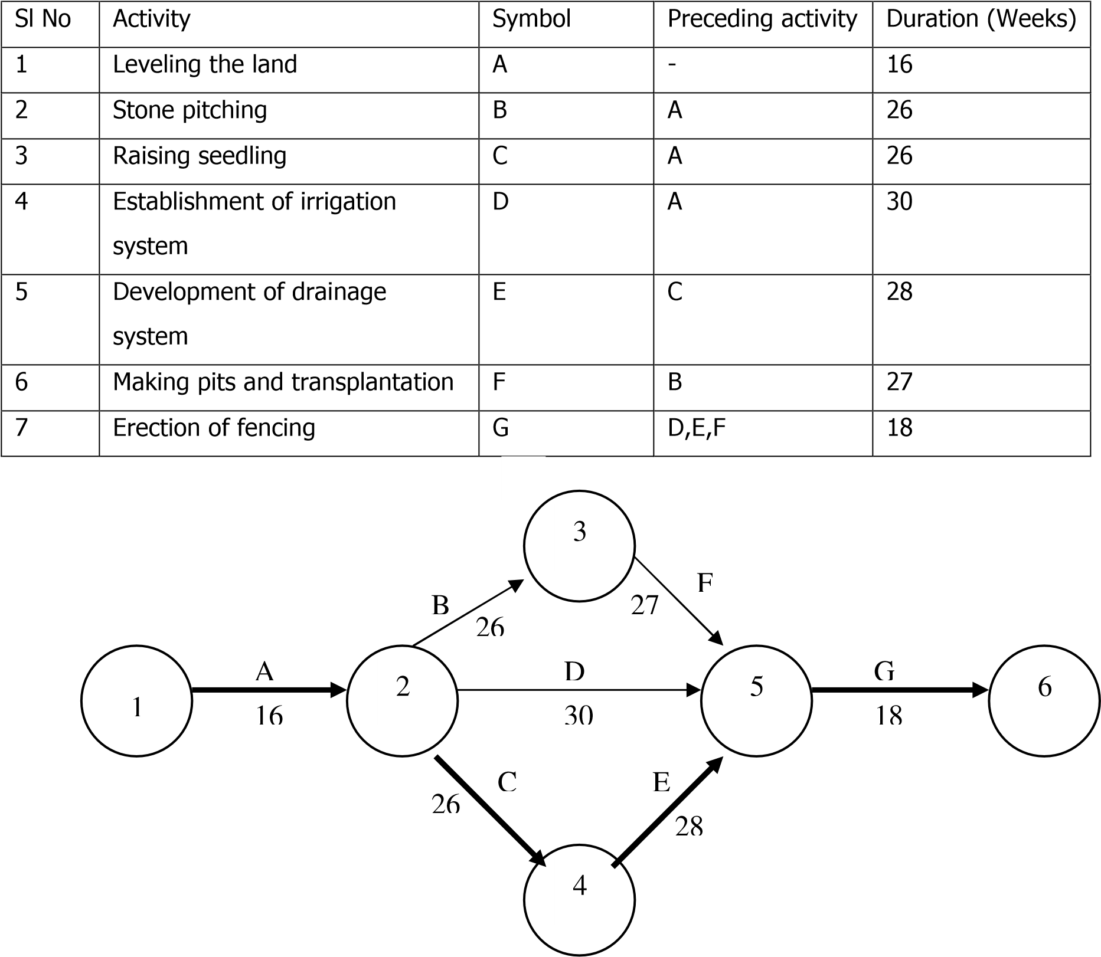

Table 2. Normal and Crash parameters
Activity | Time in weeks |  | Cost in Rs. |  | Reduction in time | Increase in cost | Cost slope  (Rs./week)
 | Normal | Crash | Normal | Cost
A | 16 | 11 | 36000 | 38000 | 5 | 2000 | 400
B | 26 | 18 | 27000 | 33000 | 8 | 6000 | 750
C | 26 | 21 | 8000 | 8900 | 5 | 900 | 180
D | 30 | 23 | 135000 | 138570 | 7 | 3570 | 510
E | 28 | 20 | 20000 | 22400 | 8 | 2400 | 300
F | 27 | 23 | 12000 | 13700 | 4 | 1700 | 425
G | 18 | 12 | 35000 | 36500 | 6 | 1500 | 2500
Total |  |  | 273000 | 291070 | 43 | 18070

The above project has a duration (Critical path length) of 88 weeks, normal cost Rs273000 and crash cost of Rs. 291070. For crashing, the critical activities in the project A,C,E and G are to be considered first. Activity C has the least cost slope i.e. Rs180/ week and can be crashed first from 26 to 21 weeks. After this crashing the project duration is reduced to 83 weeks (Activity C from 26 to 21 weeks) and the cost has increased from Rs.2,73,000 to Rs.2,73,900.
The revised PERT network of the project after crashing is as in figure 2 .

G

21

28

F

27

18

30

C

26

16

E

A

B

D

1

2

3

4

5

6

Figure 2. The network diagram after crashing activity C

In the redrawn network the new critical path is A,B,F and G. These activities are to e considered for further crashing. Among these activity G having least cost can be crashed from 18 weeks to 12. The project cost would be increased from 2,73900 to Rs 275000. After crashing the network diagram is to be drawn and the procedures could continue till a stage is reached when no further crashing is possible. The crashing result for the project is summarized in Table 3.

Table 3. Summery of crashing exercise
Crashe d activit y | Crashe d  Time  (Weeks  ) | Crashe d  Time (Week  s) | Project duration in weeks |  |  | Project cost in Rs.
 |  |  | Before crashin g | After crashin g | Cumulati ve Reduction | Before crashin g | After crashin g | Cumulati ve increase
Normal |  |  | 88 | - | - | 273000 | - | -
C | 5 | 5 | 88 | 87 | 1 | 273000 | 273900 | 900
G | 6 | 6 | 87 | 81 | 7 | 273900 | 275400 | 2400
A | 5 | 5 | 81 | 76 | 12 | 275400 | 277400 | 4400
F | 4 | 4 | 76 | 72 | 16 | 277400 | 279100 | 6100
E | 8 | 8 | 72 | 72 | 16 | 279100 | 281500 | 8500
B | 8 | 8 | 72 | 64 | 24 | 281500 | 287500 | 14500

It may be noted from the above table that even though the activity C is crashed by 5 weeks i.e. from 26 to 21 weeks, the critical path length has not reduced to the same extent. It has reduced by only one week i.e. from 88 to 87 weeks. This in other words the crashing of 5 weeks in the activity C has resulted only one week reduction in the project time. This happen only when the difference between the critical path and the other paths are less than the crashed period ( In the example Critical path was 88 weeks and the next path length was 87. This difference of one week which is less than the crashed period of 5 weeks). Cases where the network has two or more critical paths crashing one activity may not result in any reduction of project duration as in case of crashing activity. For example after crashing activity F the project will have two critical paths i.e. A-B-F-G and A-C-E-G. Further crashing of activity E would not result in reduction of project duration. Because the path A-B-F-G would still remain as critical path. The project in example could be crashed to the maximum of 24 weeks by incurring additional expenditure of Rs.14500.

Crashing of project indicates the time-cost trade-off implication. The decision on the extent to which the project is to be crashed depends on the managerial decision based on paucity / availability of fund.

Project Control
Steps in Project Control
Fixing up the Review Period
Obtaining Progress Information
Comparing Actual Progress with the Schedule
Taking Appropriate Corrective Correction
Reporting to Higher Management
Updating
Conventions for Updating
Frequency of Updating

Redrawing Network

So far the discussions were on the use of PERT/CPM in planning and scheduling a project. This unit considers the third aspect, viz. the use of this method during project execution.
No management technique, however elegant and sophisticated, can take away the responsibility of management to exercise control through making decisions. Management techniques will, however, by providing the relevant information, enable management to take better-informed decisions and thereby exercise a finer degree of control than would be possible otherwise.
A project being a dynamic entity must respond to changing conditions if it is to be completed successfully. Further projects are always executed in an environment of endless change, and there is therefore the need for continuous reassessment and reappraisal of the project. The original plan and schedule cannot therefore be executed to the last detail because of a host of influencing factors, of which the following are a few.
- Changes in the date for completion
- Changes in activity durations
- Changes in resource availability
- Changes in activity relationship
- Failure of suppliers to deliver on time
- Unexpected environmental conditions (strikes, weather, etc.)
It is, therefore, necessary to have some procedure whereby the progress of work is checked at regular intervals against the plan, discrepancies highlighted and the necessary corrective active action taken to ensure that objectives are achieved. This is the function of project control.
Measurement of the actual achievement and comparison with the original plan is therefore an essential feature of an effective control system. The sequence of instruction, execution, measurement, feedback and. correction is fundamental to control theory.
The management of the project is therefore a continuous process involving both planning and control. While the planning can be done at leisure, the control phase is carried out under continuous pressure.
The continuous recycling of information helps comparing with the original. Plan and in cases of deviation (in majority of the cases deviations do, occur as it is very rare that plan targets are fulfilled exactly) it becomes necessary to reschedule the plan. This involves considerable work even in smaller projects. In the case of large projects involving several activities, a computer becomes an invaluable tool.
Project control in action: The steps involved in project control are:
- Fixing up the review period
- Obtaining progress information
- Comparing actual progress with the schedule
- Taking appropriate corrective action when required.

Fixing up the review period : How often the project is to be reviewed depends upon a large number of factors and there can be no standard rule or practice about this. The frequency of reviewing however will depend upon the type of project, its overall duration and the degree of uncertainty involved.
For the average project, a fortnightly review should be sufficient in the normal course but in the case of rapidly changing projects, higher frequency of reviewing is necessary to have close control. Projects of the same overall duration using 3 time estimates (PERT system) for activities require greater frequency of reviewing than those using single time estimates (CPM system) for activities. The interval between reviews may change depending on the management needs.

Obtaining progress information: For obtaining progress, a form shown below is normally used. The basic information required refers to activities just started, activities completed, and progress on current activities. While the information regarding first two can be given precisely, the last may best be quantified by estimating the comp1etion date.

Progress Report
 |  | Project |  |  |  | For delayed activity
Activity | Duration | Scheduled date |  | Actual date |  | Expected date |  | Remarks
 |  | Start | Finish | Start | Finish | Start | Finish

Comparing actual progress with the schedule: The actual progress is transferred either on to the network or to the scheduling table so that it can be compared with the schedule to identify deviations.
Taking appropriate corrective action when required: Obtaining progress information and identification of deviations alone are of little value without effective follow up. If a delay occurs in a non-critical activity, corrective action will usually be limited to rescheduling the following activities. If a delay occurs in one of the critical activities, corrective action would include adding additional resources from non-critical to critical jobs, rescheduling of series operations in parallel etc. If the time cannot be made up by any of these methods, completion of the project will be delayed.
Based on the corrective action taken, fresh schedules are prepared for the following week/fortnight and the control cycle consisting of execution, measurement, feedback correction and instruction repeats itself.
Frequency of updating: There is no standard practice regarding the frequency of updating. Updating may be undertaken at regular intervals or whenever the situation warrants it. Updating should be done whenever major changes occur that will affect project completion date or cause a shift in the critical path, or when the impact of changes on the schedule cannot be readily noticed by inspecting the network.

Overview of Microsoft Project

Start MS Project
- Double-click on the MS Project icon.
Or
- Click the Start button, select Programs, select the Project icon.

Using Help
- Click on the Help menu and select Microsoft Project Help or press [F1].
- The Project Help task pane will open on the right of the screen enabling you to search for assistance on a specific topic.

The Office Assistant
The office assistant offers tips on what you are doing, can answer questions you have, and enables you to ask questions in a non-jargon way. The office assistant usually appears as an animated paper clip.

To Use the Office Assistant

- Click on the Help menu and select Show the Office Assistant
- Type in the topic required.
- Click on Search

Note: When performing certain actions (especially for the first time) the Office Assistant will appear automatically with a list of help options relative to what you are doing.

As well as offering help, the Office Assistant also offers tips on quick or short cuts for the features you are using. If the Office Assistant is visible a light bulb appears next to the paper clip. Otherwise a light bulb appears on the tool on the toolbar.

MS Project - The Screen

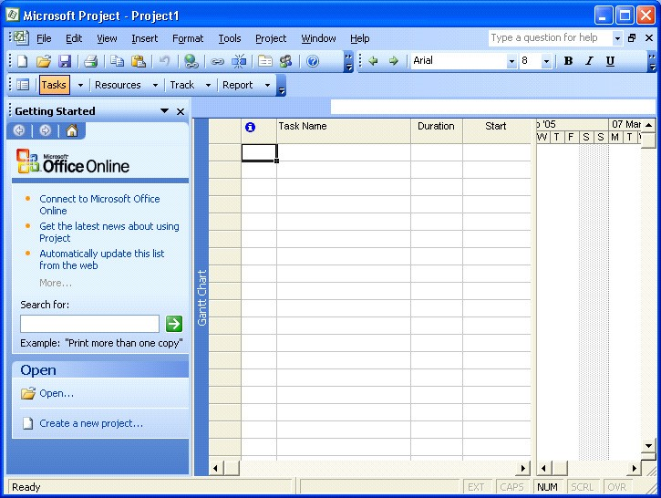

The Menus: | Always displayed, some options depend on the selected view.
Tool Bars: | Buttons provide quick access to the most common commands, The bars can be customised
Task Pane | With options to help when ‘Getting Started’. Other task panes are available.
Entry Bar: | The entry point for text with outlining buttons.
Status Bar: | At the bottom of the screen showing the current status.
Scroll Bars: | When using a mouse to scroll the views and to move the boundary between two views.
Working Area: | The area for 1 or 2 views, the size of each can be adjusted.

Elements of the Default View

The default Project view is the Gantt Chart view, as displayed below. This view is used extensively in Microsoft Project. The Gantt Chart consists of a Gantt table and a Gantt bar chart. The divider bar separates the two and can be repositioned to display more of the table or more of the chart. The Gantt table consists of rows and columns. Just like on a spreadsheet, the intersection of a row and a column is called a cell. The Gantt bar chart graphically displays your schedule on a time line.

The status bar displays the current mode of operation and warning messages and indicates when special key control modes, such as Num Lock mode, are on. The entry bar contains an Entry box where all information is input. The default toolbars are the Standard toolbar, Formatting toolbar and the Project Guide. Other toolbars can be displayed by choosing Toolbars from the View menu.

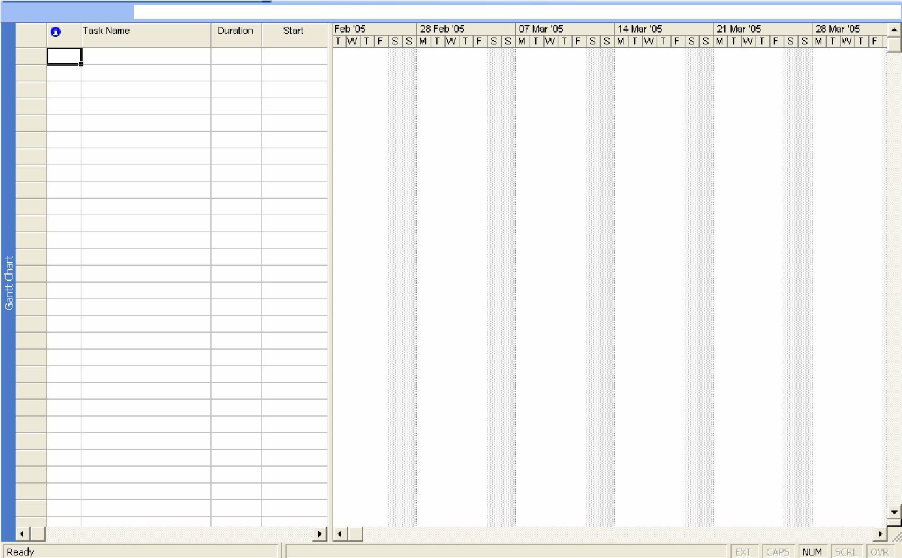

Views and Tables

A view is the format of the way that project data is displayed on the screen and there are a considerable number of different permutations that can be used.

The View Menu is the first place where the view that is required is selected. The basic selection is between a Chart, a Form, or a Sheet. Some of the options in this menu can provide a split view to show two different displays for the same Task or Resource.

You can also use the View bar, located vertically on the left of the default view (if it is active). To activate/deactivate the View Bar, select View, View Bar.

As well as the standard views achieved with the View menu or View bar, you can select More Views to see more detailed and complex views and forms.

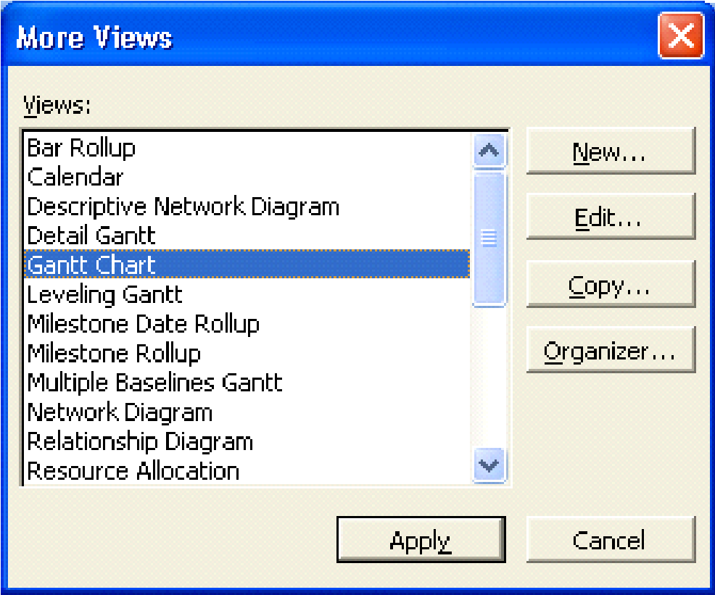

The table below describes some of the main views in Project.

Calendar: | Shows the view in the form of a calendar.
Gantt Chart: | A diagrammatic view of the Tasks and their time scale. This chart can also show the relationship between Tasks and the Critical Path. It usually shows the task entry form alongside the Gantt chart.
Network Diagram Chart: | Network Diagram is an acronym for Programme Evaluation Review Technique. This view represents each Task as a box with relevant information within it. The layout of the boxes on the chart and the lines that link the boxes represent the structure of the project.
Task Usage: | The Task Usage view displays project tasks with their assigned resources grouped underneath them.
Tracking Gantt: | The Tracking Gantt view displays two task bars, one on top of the other, for each task. The lower bar shows baseline start and finish dates, and the upper bar shows scheduled start and finish dates (or if the task has already started, meaning that the percentage complete is greater than zero, the upper bar shows the actual start and finish dates).
Resource Graph: | A graphical representation of a single resource and its utilisation.
Resource Sheet: | A list of all the resources for the project.
Resource Usage: | This is a view that shows the use in hours per day for each resource.
More Views: | Allows the showing of combination views as well as details of a single Task
Table:(Entry): | Changes the form alongside the Gantt chart.
Reports: | Takes you into Report Wizard.
Toolbars: | Allows you to change the Toolbar display.
View Bar: | Activates the View bar, located vertically on the left of the screen.
Zoom: | Changes the amount of information you can see on screen, from days to years.

The Tracking Gantt View
When you initially set up your project with tasks and dates, and then save the project with a baseline, the Tracking Gantt view displays those tasks as shown in the following example.

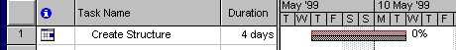

The baseline bars and the scheduled or actual bars are synchronized. However, if the start date of task slips by, say, 2 days, the red scheduled bar will extend 2 days beyond the lower baseline bar.

Because the tasks are linked, the slipping of task 2 will cause a ripple effect, making its successor tasks slip by 2 days as well.

You can use the Tracking Gantt view to:

- See how tasks progress across time and evaluate the slippage of tasks. You can track progress by comparing baseline and scheduled or actual start and finish dates and by checking the completion percentage of each task.
- View tasks graphically while still having access to detailed information about the tasks.
- Create a project by entering tasks and the amount of time each task will take.
- Establish sequential dependencies between tasks by linking them. When you link tasks, you can see how a change in the duration of one task affects the start and finish dates of other tasks and the project finish date.
- Assign personnel and other resources to tasks.

MS Project - Menus

The File Menu
The File menu is typical of the windows environment. The command which pertains to MS Project is:

Properties: Provides basic information on the Project.

The Edit Menu
The Edit menu is also typical of the windows environment. Commands which pertain to MS Project include:

Link Tasks: | Create links between tasks.
Unlink Tasks: | Break an existing link.
Go To: | Go to a task or resource. (Depends on view.)

The Insert Menu
Among other things allows you to insert new rows for tasks or columns for information. You can also go to the Task information dialog box to add more detailed information to the current task.

The Format Menu
This changes dramatically when different views are selected. The following are the principal selections.

For a Network Diagram the choices are:
Text Styles: | Modifies the size, and type of the selected text.
Box Styles: | Changes the appearance of the Network Diagram boxes.
Layout: | Allows you to customise the way links are shown.
Layout Now: | Redraws to show changes made to links etc.
For the GANTT chart the choices are:
Font: Used to change the font.
Bar: Change the selected Gantt Bar style
Timescale: Allows you to set the displayed time at anything from years to minutes.
Gridlines: Allows you to display or hide Gridlines and change their appearance.
Gantt Chart Wizard: Takes you through the programs method of setting up your Gantt chart. Text Styles: Change the font, size and colours Bar Styles: Change all Gantt bars.
Details: Details of the Gantt chart
Layout: Change the way the bars are displayed including
links.

The Tools Menu
The main choices here are Change Working Time, Tracking and Multiple Projects.
Assign Resources: Apply various filters to the tasks. Level Resources: Shows resource levelling
information
Change Working Time: Format a new Calendar.
Tracking: Check the progress.
Links Between Projects: Set up sub projects and links.

The Project Menu
This menu is for retrieving information on the project and its components. Some of the options launch sub menus. The commands are fairly self-explanatory and will become clearer later in this course.
There are also the usual Window and Help options.

You will find that the menu choices may change depending on the view selected. If this happens it simply means that the option you wanted is not available for that view.

MS Project - The Tool Bars
The Buttons provide quick access to some of the commands available from the pull down menus. The default arrangement of the toolbars is the Standard and Formatting bars active.

The formatting bar is virtually identical to the same thing in other Office applications, except it has the Outline tools attached to it. These tools are for promoting and demoting tasks, Collapsing and expanding sub tasks plus the usual Text format and alignment buttons.

The Standard toolbar contains the following buttons:

- Create a New blank file.
- Open an existing File.
- Save the current file
- Perform a File Search
- Print the active View
- Print Preview the active view
- Spell check the selection.
- Cut the highlighted section to the Clipboard
- Copy the highlighted section to the Clipboard
- Paste from the Clipboard.
- Format Painter.
- Undo the previous action.
- Insert a hyperlink Launch the Web toolbar.
- Link the selected tasks with a Finish-to-Start relationship

- Unlink the selected tasks.
- Split the selected tasks
- Open the Task Information dialog box.
- Attach a note to the current task.
- Add Resources.
- Publish Information.
- Group Information.
- Zoom in.
- Zoom out.
- Goto selected task.
- Copy a static Picture so it can be used in another application.
- Display the Office Assistant

Loading and Viewing a Project
- Select File, Open to open any project file.
- Press [Ctrl-Home] and [Alt-Home] to go to the start of the project.
- Use the scroll tools to see the project progress.
- Use the mouse to change the size of the various windows.
- Alter the time scale with View, Zoom.

Change the View
- Click on the View menu.
- Choose each of the top five and note the different screens.
- Select View, Gantt Chart to return to the original view.
- Move the mouse to the central vertical bar on the screen when it will change to a double line with a double-headed arrow
- Click and hold the left button and drag left to see more of the Gantt Chart.
- Repeat but drag right to see more of the Entry Table.

Change the Project Start Date
- Select Project, Project Information from the menus.
- Change the project Start Date.
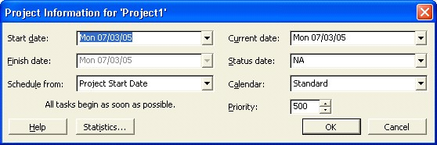
- Click Add and click OK and examine the views again.
- Select Tools, Tracking, Update Project to see project progress so far.
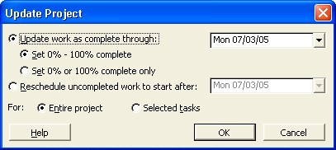

Exit Project
• Select File, Close to close the existing project file.
Task Entry and Linking
Entering Tasks

This is the main activity in setting up a new project. The tasks which have been identified at the Design Stage must be entered.

The system will hold task information in a task database, which we cannot access directly but is used by the system whenever we view task data. This is one of two databases the system uses the other being the resource database.

It is important to understand that the system checks the data that it holds and where the data does not cross check then the system will generally update the database to make it right. It is important to keep an eye on this process; this will be discussed in a later section.

As each entry is made the system will update the appropriate data and views to reflect the entries.

The order of entry should be in the logical progression but this is not essential as it can be changed.

Normal Task entry will be by using the standard Task Sheet. The Gantt View shows the Gantt Chart in the right part of the window with the Task Sheet in the left part.

The Task Information box/Task Sheet
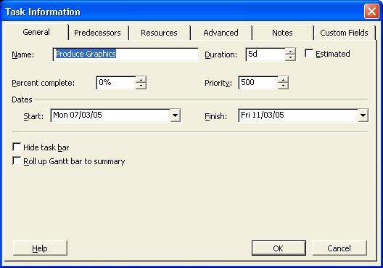

The Task sheet is a view of the selected task with information shown in the columns as follows: -

ID: | The Task Identification number.
Name: | The Name of the Task.
Duration: | The time the Task will take including the time units.
Start Date: | This is the current Scheduled Start date for the Task. Not the Planned or Actual Start.
Finish Date: | The Scheduled Finish date.
Predecessors: | The ID numbers for the preceding Tasks that are linked to this Task.
Resources: | The names of the resources performing or used in the Task.

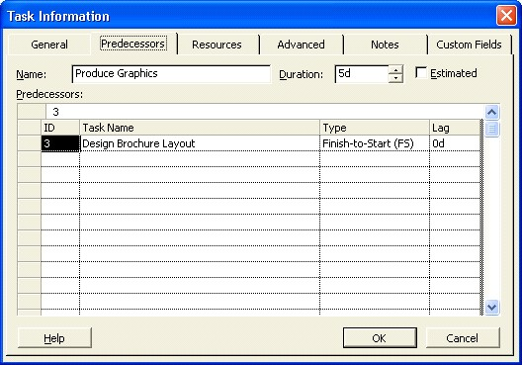

The Task Entry Form
It is possible to select the Task Entry view to see the Gantt Chart in the upper pane and the Task Form in the lower pane. To do this choose View, More Views, Task Entry. From the Task Sheet the following entries can be made.

ID: The Task Identification number.

Task Name: The Name of the Task.

Duration: The time the Task will take including the time units.

As the entries are made, the Gantt Chart will automatically be updated to display the tasks.

If using the Task Form it will be possible to enter and/or view the following.
Name: | The name of the task
Duration: | The length of time the task will take and the units of time.
Fixed: | A check box to specify the start date to be fixed.
Start: | The scheduled start date, if this is not entered the system will calculate it from the data entered and the relationships defined.
Finish: | The scheduled finish date, entered or calculated as above.
% Complete: A measure of the completion of the Task if it has been started.

Tables and descriptions

Resource Table

ID: The identification number of the Resource Resource Name: The name of the resource.
Units The number of units available for the resource.
Work The amount of work currently assigned to the resource.

Predecessor Table
ID The identification number of the Predecessor.
Predecessor Name: The name of the Predecessor. If this is not entered the system will look it up using the ID number.
Type: The relationship with the current Task which will be FS, or SS, or FF.
Lag The time delay between the end of the Predecessor the start of the Successor.
It is not necessary to complete all the fields at entry time, as more information is added so the system will update the boxes. It is only necessary to enter the data that has been determined in the design stage.

To enter task descriptions and durations one cell at a time:

- In the Task Name column, select the first available cell and type the name of the task.
- Press TAB
- In the Duration column, type the value of the duration. If the duration is anything other than days, type m for minutes, h for hours, or w for weeks.
- Press ENTER
- Press LEFT ARROW to return to the Task Name column and repeat steps 1 through 4 as required.
To enter task descriptions and durations by selecting a range:

- Select the first cell (the numbered cell) of the desired range.
- Drag the mouse through the range of cells you want to include.
- In the first cell, type the desired information.
- Press TAB
- In the Duration column, type the appropriate information.
- Repeat steps 4 and 5 as required.

Note: Pressing SHIFT+TAB moves to the previous cell without deselecting the range. Clicking your mouse inside or outside the range will deselect the range.

Other Methods of Adding Tasks
As a general rule Tasks can be added in any view where the tasks are displayed. The most obvious methods in addition to using the normal Task Entry view are as follows: -

In the Gantt Chart or the Task Sheet
An additional task can be added at the end of the list using the Insert, New Task command.

Where additional information is required to be entered then this can be done by using the Task Information form which is opened by simply double-clicking a task in the task list.

Using the Task Information Form
It is possible to enter additional tasks using this form but it does not have all the possible entry points. The details of this form are included in the description of the Task Entry View above.

Using The Network Diagram Chart
Additional tasks can be placed within the chart by drawing a box and then entering the information within the fields. The relationship can be also be entered graphically by pointing to the Predecessor and dragging a line to the Successor.

Where a relationship needs to be removed, a double click on it will display a box which has a delete button in it.

Further time will be spent on this view later.

Note: When you try to make a link that is not logical or possible, Project will warn you about this (see illustration below).

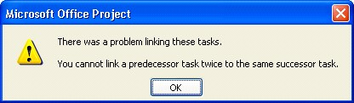

Add Tasks
The following tasks can be used as a practical in MS Project.

[This column is for your info only] | Task | Duration
Milestone task | Course Development | 0d
Summary task | Preparation | 1d
Sub tasks | Install Software | 2h
″ ″ | Studies and Specifications | 1d
Summary task | Section Development
Sub tasks | Section 1
″ ″ | Section 2
″ ″ | Section 3
″ ″ | Section 4
″ ″ | Section 5
″ ″ | Section 6
″ ″ | Section 7
″ ″ | Section 8

• Enter the tasks as above. As you enter them Project will enter 1d as the default duration. Change this for Install Software.
Note: By simply setting the Course Development task to zero days. It is given Milestone status.

Linking Tasks
In order that the system is able to display the overall time aspects of the project, each
Task must be defined in terms of the Tasks on which it is dependent and in turn those Tasks that are dependent on it. It is also possible to define in what way these dependencies exist.

Most associated Tasks will have a straightforward linear relationship. That is, the preceding task must finish before the next task can start. This is the Finish to Start relationship.

This is not true for all situations, for example if bricks are being made to build a house, the building cannot start until some bricks are available but it is not necessary for all the bricks to be made before the building can start. The relationship between making the bricks and building the house can be described as Start to Start but with a time lag to allow for the first batch of bricks to be ready.

An alternative relationship can be Finish to Finish which is true where two tasks must be ready at the same time. For example in the preparation of a banquet, the elements of each course must be completed at the same time in order that they are at their best. To summarise the main three relationships that can happen are as follows: -

- Finish to Start (FS)
- Start to Start (SS)
- Finish to Finish (FF)
We can also fine tune these relationships by specifying Lag or Lead times as required.

Linking of Tasks can be achieved by making the appropriate entry in any of the task views or highlighting the tasks and using the link button on the Tool Bar, or by using the Edit, Link Tasks command

Note: You need to highlight the tasks you want to link before trying to link them. Use the mouse while holding down the [Ctrl] and/or [Shift] button(s) to do this
Links are most clearly shown in the Network

Diagram
- Enter some of the links by completing the Predecessor ID in the lower pane.
- Add some of the links by selecting them and using the linking button.

Defining the Summary Tasks
Microsoft Project provides the ability to structure the tasks by setting different levels of tasks and grouping tasks under a summary task. This can be useful where the project has a considerable number of tasks; management can be made easier by only viewing and reporting on the summary tasks.

There are five buttons on the far left of the Formatting Toolbar which can be used on a single task or group of highlighted tasks.

- Promote the selection to the next higher level
- Demote the selection to the next lower level
- Expands a summary task to show its subordinate tasks
- Collapse a summary task to hide the subordinate tasks
- Hide assignments
- Show all subtasks, or those of a particular outline level.

Create Summary Tasks and Link Tasks
- Select the sub tasks Install Software and Studies and Specification.
- Indent the tasks to make them sub tasks.
- While they are still selected link them (chain button or Edit menu).
- Make Sections 1 to 8 sub tasks and link them.
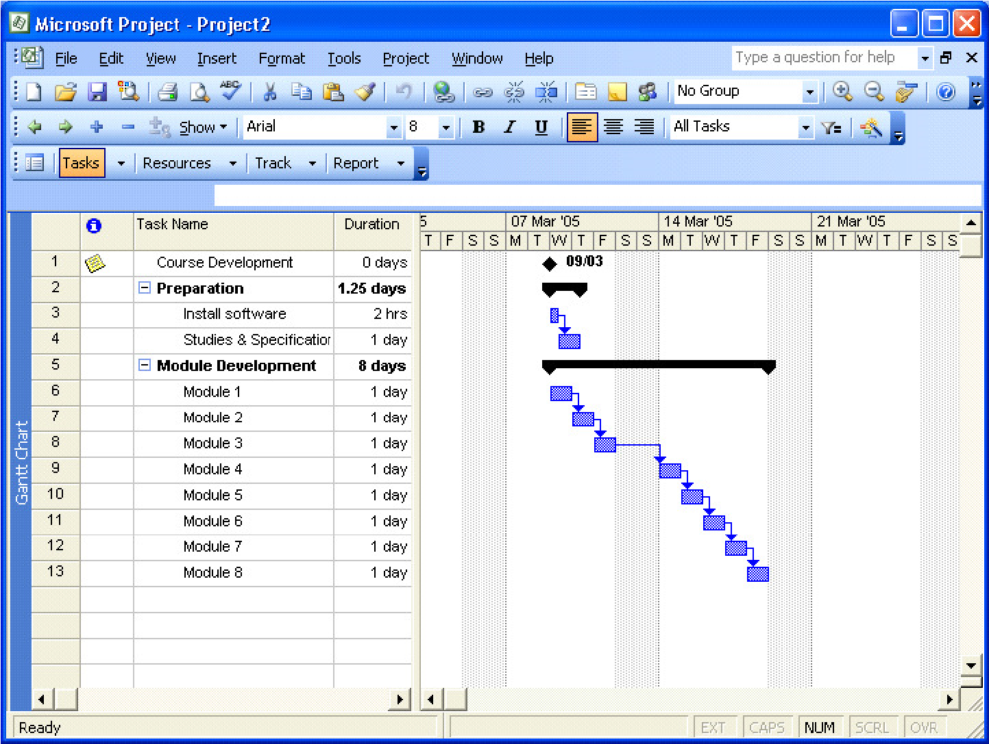

Insert Tasks
If you miss a task from your list you can insert a blank line and type the information.

- Click on Studies and Specifications.
- Right-click and choose New Task to insert a blank row.
- Type Backup Installation as the task and set the time to 1h.

Add New Tasks
Having added tasks you can continue adding tasks at the end of your project.

- Move to the line below Section 8 and type Slide Development.
- Set the Duration to 5d.
- Outdent the task by clicking on the Outdent button.
- Link it to Section 8.
- Save your project as Training Course.
- Save with a baseline.

Change Duration
The default duration is 1day. To change this you can simply overtype with the new value.

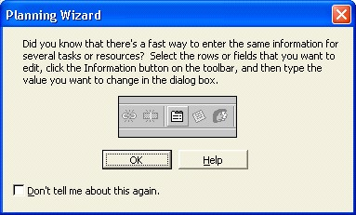
- Change the durations for each Module to 2d.
- When the Wizard appears READ THE
INFORMATION then click on the OK button.
- Select all the remaining tasks.
- Open the Task information box.
- Set the duration to 1.5d

Multiple Links
Tasks can be linked to more than one predecessor.

- Select the task Slide Development, hold down the Ctrl key and select the task Module 1.
- Click on the Link Tasks button.
- When you get a warning, try to figure out why the link is illogical.
Look at the Gantt chart if it makes it easier to think.

Save a Baseline
- Select Tools, Tracking, Save Baseline from the menus.
- Click on the Save baseline radio button.
- Click on the OK button.
