Unit-V
5. Shakespearean Soliloquies

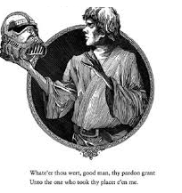
Soliloquy:
A Soliloquy means speaking with oneself or a dialogue with one’s own self. Soliloquy is very useful in drama. Sometimes when an actor is not supposed to speak on the stage, but the dramatist wants to convey his feelings or thoughts to the spectators, that actor is made to step aside and speak softly as if to himself, and thus let the audience know what he is thinking or talking about.
Soliloquies in Shakespeare’s Plays:
The real function of a soliloquy is self-analysis and self-revelation specifically to bring out the inner springs of any of the leading characters, particularly, the hero of a play. It is mostly the heroes and the villains who generally indulge in soliloquies in the plays of Shakespeare and mostly in the tragedies because tragedies are deep with the deeper emotions and the more secret springs of human head and the human heart. Shakespeare’s soliloquies are intended chiefly to explain, to idealize, to inform, and also to reveal things which otherwise cannot be revealed either through incident or through dialogue.
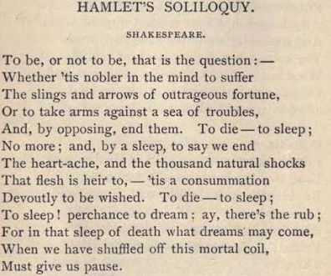
Shakespeare frequently uses soliloquies in his plays. Some of his plays, like Hamlet, Macbeth and Richard II, contain a number of soliloquies, and so do some of his comedies. Among the tragedies, the largest number of soliloquies is found in Hamlet and Macbeth. There are about nine Soliloquies each in Othello and Hamlet, several in Macbeth, and only one in Richard II. These soliloquies convey to the reader or the spectator the innermost thoughts of the character that speaks to them, or communicates some information which cannot be conveyed through action or dialogues.
Soliloquies in Shakespeare’s plays serve three purposes (i) to illuminate and explain the character of the more important figures in the play; (ii) to supply details to show the connection between various links of the plot; and (iii) to help in maintaining necessary unity by tracing the true sequence of cause and effect.
For illustration of Shakespearean soliloquies we shall take up and analyze the dramatic significance of some of well-known soliloquies in Macbeth.
Soliloquies in Macbeth:
Macbeth contains several soliloquies by Macbeth, a few by Lady Macbeth, and one or two by Banquo and Lady Macduff. Macbeth’s soliloquies are in the form of ‘asides’, that is speeches made so as not to be heard by anybody on the stage. Banquo also uses an aside to enquire about Ross’s information about Macbeth having been made the thane of Cawdor (‘what, can the devil speak true?’). Macbeth speaks his first aside after having been informed about his elevation in rank so as to become the thane of Cawdor. He thinks that if the witches’ prophecy about his being the thane of Cawdor has proved to be true, then that regarding his becoming the king may prove to be so too. He says: “Glamis, and thane of Cawdor. The greatest is behind”. This shows the height of his ambition. Another aside by him occurs when he learns that Malcolm, the son of the king, has been made the Prince of Cumberland in preparation for becoming the heir to the throne Macbeth soliloquizes: “The Prince of Cumberland that is a step / on which I must fall down, or else O’erleap,/ For in my way it lies”. This soliloquy reveals his determination to get rid of all obstacles coming in the way to his becoming the king. The growth of evil in Macbeth’s mind is evident here.
In the beginning of Act I, Scene 7, in the soliloquy beginning with the words, “If it were done when it’s done, then ‘t were well / It were done quickly”, we get a glimpse into Macbeth’s mind considering the pros and cons of the proposed act of the murder of Duncan. His hesitation, his want of moral stability, his fear of the opinion of others, and his sense of inadequacy of his motive, are seen here. Macbeth’s soliloquy in the dagger-scene (Act II, scene) “Is this a dagger which I see before me / The handle toward my hand” – points out to his fearful imaginings before committing the murder. In the soliloquy appearing just before the banquet scene, Macbeth seems to repent his act of murder and give vent to his fears about the possibility of his being dethroned or killed like the king.
In Act II, scene 2, there is a soliloquy of Lady Macbeth, i.e. “He is about it; the doors are open – I have drugged their posses / I laid their daggers ready, he could not miss them”, which throws light on the progress of the action of the play and helps the audience to imagine the events that are occurring off the stage. In the opening scene of Act III, we have Banquo’s Soliloquy which affords a glimpse into some of his characteristics. He is seen to be aware of Macbeth’s crime and guilt, but is not morally strong enough to expose it.

Thus, it is found that soliloquies play an important part in Macbeth. They reveal the character of various persons, point at the inner workings of their mind, and help the spectators in understanding the meaning of various actions, and witnessing the progress of the plot.
******

