ARITIFICIAL INTELLIGENCE

UNIT-5 GAME PLAYING
Game playing is an important domain of artificial intelligence. Games don’t require much knowledge the only knoeledge we need to provide is the rule,legal moves and the condition of winning or losing the game. Both players try to win the game , so both of them try to make the best move possible at each term.
Searching teachnique like BFS are not accurate for this as the branching factor is very high so searching will take a lot of time so we need another search procedure that improve.
- Generate procedure so that only good moves are generated .
- Test procedure so that the best move can be explored first .

The most common search technique is game playing is minimax search procedure .It is depth-first ,depth_limited search procedure.It is used for games like chess and tic-tac-toe.

MINIMAX ALGORITHM:

* Mini-max algorithm is a recursive or backtracking algorithm which is used in decision-making and game theory. It provides an optimal move for the player assuming that opponent is also playing optimally.
* Mini-Max algorithm uses recursion to search through the game-tree.
* Min-Max algorithm is mostly used for game playing in AI. Such as Chess, Checkers, tic-tac-toe, go, and various tow-players game. This Algorithm computes the minimax decision for the current state.
* In this algorithm two players play the game, one is called MAX and other is called MIN.
* Both the players fight it as the opponent player gets the minimum benefit while they get the maximum benefit.
* Both Players of the game are opponent of each other, where MAX will select the maximized value and MIN will select the minimized value.
* The minimax algorithm performs a depth-first search algorithm for the exploration of the complete game tree.
* The minimax algorithm proceeds all the way down to the terminal node of the tree, then backtrack the tree as the recursion.
MINIMAX ALGORITHM USES TWO FUNCTIONS:

MOVEGEN: It generates all the possible moves that can be generates from the current position.
STATIC VALUATION: It require a value depending upon the goodness from the view point of two players.

Properties of Mini-Max algorithm:

* Complete- Min-Max algorithm is Complete. It will definitely find a solution (if exist), in the finite search tree.
* Optimal- Min-Max algorithm is optimal if both opponents are playing optimally.
* Time complexity- As it performs DFS for the game-tree, so the time complexity of Min-Max algorithm is O(bm), where b is branching factor of the game-tree, and m is the maximum depth of the tree.
*Space Complexity- Space complexity of Mini-max algorithm is also similar to DFS which is O(bm).

MINIMAX ALGORITHM:

function minimax(node, depth, maximizingPlayer) is
if depth ==0 or node is a terminal node then
return static evaluation of node

if MaximizingPlayer then // for Maximizer Player
maxEva= -infinity
for each child of node do
eva= minimax(child, depth-1, false)
maxEva= max(maxEva,eva) //gives Maximum of the values
return maxEva

else // for Minimizer player
minEva= +infinity
for each child of node do
eva= minimax(child, depth-1, true)
minEva= min(minEva, eva) //gives minimum of the values
return minEva

Example:

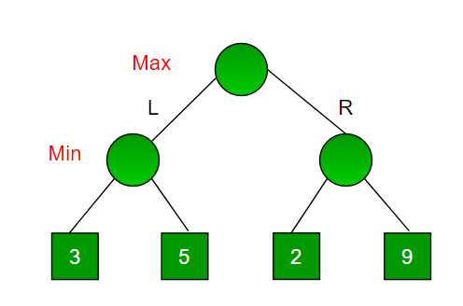
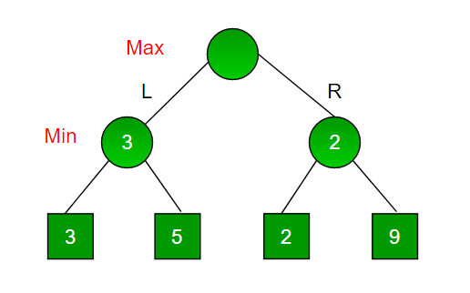
EXPERT SYSTEM:
Expert system are the computer application developed to solve complex problems in a particular domain at the level of extra ordinary human intelligence and expertise.

CHARACTERISTICS OF EXPERT SYSTEM:
*High performance
*Understandable
*Reliable
*Highly responsive

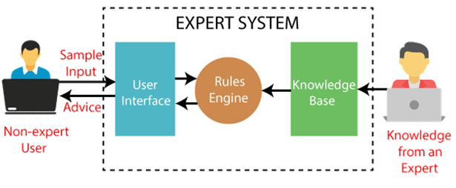
COMPONENTS OF EXPERTS SYSTEM:
An expert system mainly consists of three components:

* User Interface
* Inference Engine
* Knowledge Base

Expert Systems in AI:
1. User Interface

With the help of a user interface, the expert system interacts with the user, takes queries as an input in a readable format, and passes it to the inference engine. After getting the response from the inference engine, it displays the output to the user. In other words, it is an interface that helps a non-expert user to communicate with the expert system to find a solution.
2. Inference Engine(Rules of Engine)

The inference engine is known as the brain of the expert system as it is the main processing unit of the system. It applies inference rules to the knowledge base to derive a conclusion or deduce new information. It helps in deriving an error-free solution of queries asked by the user.
With the help of an inference engine, the system extracts the knowledge from the knowledge base.
There are two types of inference engine:
Deterministic Inference engine: The conclusions drawn from this type of inference engine are assumed to be true. It is based on facts and rules.
Probabilistic Inference engine: This type of inference engine contains uncertainty in conclusions, and based on the probability.

Inference engine uses the below modes to derive the solutions:

Forward Chaining: It starts from the known facts and rules, and applies the inference rules to add their conclusion to the known facts.
Backward Chaining: It is a backward reasoning method that starts from the goal and works backward to prove the known facts.

3. Knowledge Base

The knowledgebase is a type of storage that stores knowledge acquired from the different experts of the particular domain. It is considered as big storage of knowledge. The more the knowledge base, the more precise will be the Expert System.
It is similar to a database that contains information and rules of a particular domain or subject.
One can also view the knowledge base as collections of objects and their attributes. Such as a Lion is an object and its attributes are it is a mammal, it is not a domestic animal, etc.
Capabilities of the Expert System

Below are some capabilities of an Expert System:

* Advising: It is capable of advising the human being for the query of any domain from the particular ES.
* Provide decision-making capabilities: It provides the capability of decision making in any domain, such as for making any financial decision, decisions in medical science, etc.
* Demonstrate a device: It is capable of demonstrating any new products such as its features, specifications, how to use that product, etc.
* Problem-solving: It has problem-solving capabilities.
* Explaining a problem: It is also capable of providing a detailed description of an input problem.
* Interpreting the input: It is capable of interpreting the input given by the user.
* Predicting results: It can be used for the prediction of a result.
* Diagnosis: An ES designed for the medical field is capable of diagnosing a disease without using multiple components as it already contains various inbuilt medical tools.

Advantages of Expert System:

* These systems are highly reproducible.
*They can be used for risky places where the human presence is not safe.
* Error possibilities are less if the KB contains correct knowledge.
* The performance of these systems remains steady as it is not affected by emotions, tension, or fatigue.
* They provide a very high speed to respond to a particular query.

Limitations of Expert System:

* The response of the expert system may get wrong if the knowledge base contains the wrong information.
* Like a human being, it cannot produce a creative output for different scenarios.
*Its maintenance and development costs are very high.
* Knowledge acquisition for designing is much difficult.
* For each domain, we require a specific ES, which is one of the big limitations.
* It cannot learn from itself and hence requires manual updates.

