UNIT-III PHOTOSHOP

Photoshop:
Adobe Photoshop is a raster graphics editor developed and published by Adobe Inc. for macOS and Windows. It was originally created in 1988 by Thomas and John Knoll. Since then, it has become the de facto industry standard in raster graphics editing, to the point that it has also become a generic trademark leading to its use as a verb such as "to photoshop an image",
Advantages & Disadvantages of photoshop:
- Easily Make Small Edits: The advantages of Adobe Photoshop are fairly easy to identify, and there are quite a few of them. One of the biggest advantages is the fact that a person can easily make small edits on photos that would otherwise be difficult. Changing skin tone, creating a high resolution copy of the photo, adjusting brightness or removing a blurry area can be done in just a few clicks when using Adobe Photoshop. Removing errors in a photo, changing the background or removing a background entirely are all tasks that can be performed with ease when using Photoshop.
- Strengthen Your Skills: Additional advantages of using Photoshop include the fact that those who use it can utilize it to expand and strengthen his or her editing skills. This is a great program to use for anyone who is looking to teach themselves how to do advanced editing. Adobe also offers tutorials and guides for people wanting to further expand his or her skill set.
- Professionalism: Photoshop is often used to take substandard photos to a professional level, which is one of the main advantages of the software.
Disadvantages of Adobe Photoshop
- Not Great for Beginners: While Adobe Photoshop can be a good learning resource, the program isn't well suited for beginners. Very basic functions within the program are usually the extent of what an absolute beginner can figure out on his or her own.
- High Price Tag: When looking at the advantages and disadvantages of Adobe Photoshop, the price is a major factor. The software is proprietary software that's extremely expensive. Someone doing minor photo editing could likely find the functions he or she needs in a cheaper and more basic program.
- Full Functionality may be out of Reach: Unless a person is well-versed in photo editing or using this type of software, he or she will likely not even know how to find the more advanced functions available, let alone use them. This poses a problem when the price of Photoshop is taken into consideration.

The Photoshop screen:
The Screen Blend Mode in Photoshop. Screen is actually the exact opposite of multiply, and while the Multiply blend mode gets its name from the math that goes on behind the scenes when we set a layer to the Multiply mode, Screen gets its name from its real world analogy.
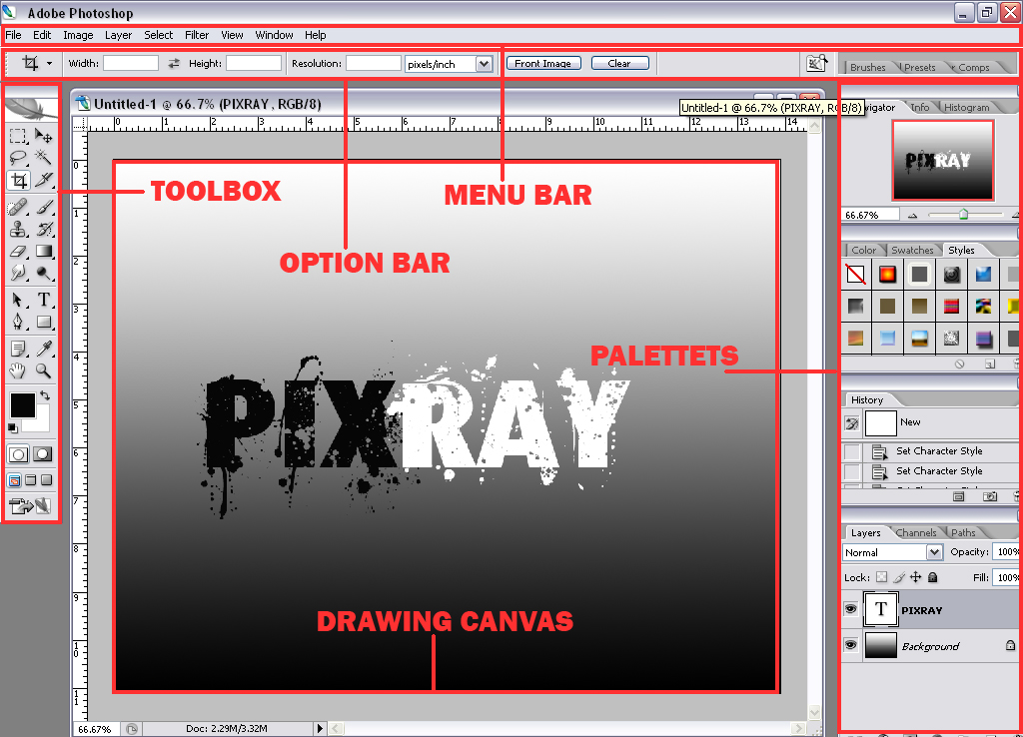

Screen Presets:
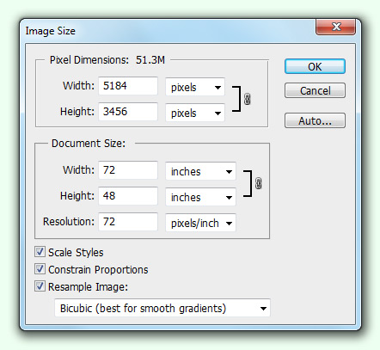
We can preset the image size by describing before its opening.
Loading custom settings:
Save and load presets
- Open Photoshop.
- Choose Edit > Presets > Presets Manager.
- Choose the desired option from the Preset Type drop-down menu. For example, choose Brushes.
- Select the desired presets. For example, select the brushes that you want to migrate.
- Click Save Set and then, click Save.
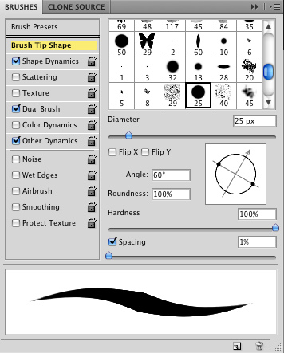
Saving files in photoshop:
Adobe Photoshop allows you to save your files in a variety of file formats, which makes it possible to use your images in many different ways. You can save images to allow for additional editing of things such as layers and effects you have applied in Photoshop, or save images for sharing with users who need only the finished file for use on the Web or for printing. In all, Photoshop allows you to save your file in more than a dozen unique file formats.
As you work on images, it is best to save them using the default Photoshop format, which uses the .PSD extension at the end of the filename. This is the native Photoshop file format, and retains the most usable data without a loss in image quality. Because the Photoshop format was developed by Adobe, many non-Adobe software applications do not recognize the PSD format.
Additionally, the PSD format may contain more information than you need, and may be a larger file size than is appropriate for sharing through e-mail or posting on a web site. While you may create copies of images for sharing, it is a good idea to keep an original version in the PSD format as a master file that you can access if necessary. This is especially important because some file formats are considered to be lossy formats, which means that they remove image data in order to reduce the size of the file.
Channel masks are a great way to select some of the more impossible selections. Like grass & hair.
- File > Open > Photoshop Exercise Files > Masking Advanced > Channel Mask 1.jpg.
- File > Open > Photoshop Exercise Files > Masking Advanced > Background 1.jpg.
- Have the Channel Mask 1.jpg visible.
- Make sure you can see your channels panel (Window > Channels).
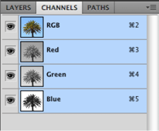

- Decide on which channel has the most contrast between the background and foreground. Do this by click on the words ‘Red’, ‘Green’ & ‘Blue.
Note: In this case it’s the blue channel.
- Duplicate the Blue channel by right clicking it (PC) or Ctrl clicking (Mac).
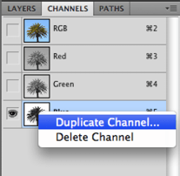

- Name it ‘My Temporary Mask’.
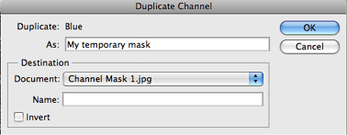

- Click OK.
- Turn off the eyes on all the layers except the new mask layer ‘My Temporary Mask’.
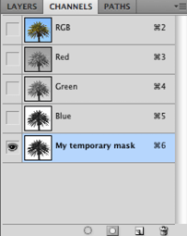

Note: The goal now is to get a good contrast between black & white around the edges of your object. To do this we can use a couple of options. Levels, the Paint Brush and the Quick selection tool can be handy.

- Image > Adjustments > Levels.
Play with the levels until you get a good contrast. You will have to experiment as every image will be different.
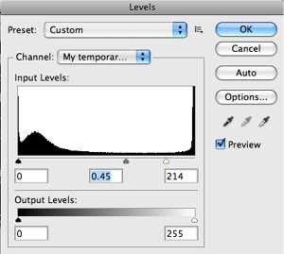

- Click OK.
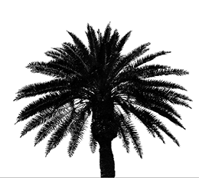

Note: Now we can use the Brush Tool to paint in some of the white parts of the tree that aren’t meant to be white.

- Choose the Brush Tool .
- Make sure your foreground colour is black.

- Choose a suitable brush size and hardness.
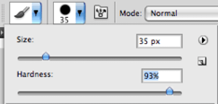

- Zoom in and paint out the white parts in the middle of the tree.
Note: If you leave these white areas in the middle of the tree trunk they will become holes in the mask. Make sure the trunk is completely black as per the screen shot below.
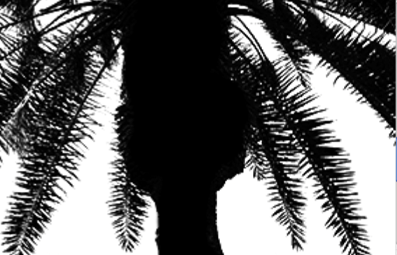

- Choose the Load Channel as Selection button at the bottom of the Channels Panel
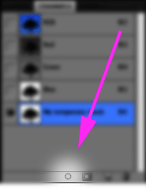

Your background is now selected.

- Invert your selection. Selection > Inverse.
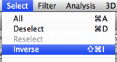

- Choose the RGB option at the top of the Channel list.
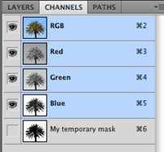

Note: That’s it for our ‘My Temporary Mask’ channel. It’s of no more use.

- Switch back to your layers panel (Window > Layers).
You can’t add a mask to a layer named ‘Background’ because they are locked by default (a photoshop’ism!)

- Double click the words Background in the layers panel and rename it ‘Palm’.
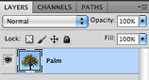

- Choose the Add Layer Mask button from the bottom of the Layers Panel.
Note: This will give you your mask.

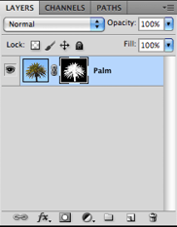

- Choose your Move tool.
- Click and drag your tree from the middle of the screen up into the Background 1.jpg tab.

- The image will change to the Background 1.jpg image. Keep holding your mouse down and move the tree to the centre of the Background.
- Finished.
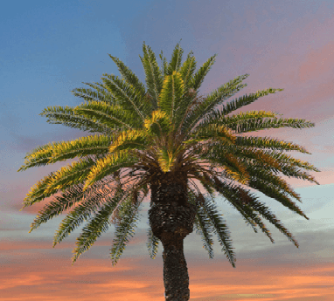

Note: When working with your mask in Photoshop ensure you have the mask selected in your layers panel and not the image itself. The mask will have a small white frame around it.

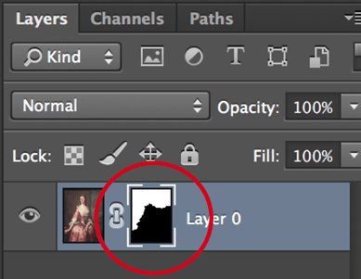

Refine mask

Once you have applied a mask to a layer you can adjust the edges.
- Double click on the mask in the Layers Panel.
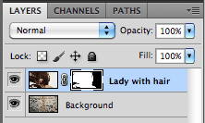
- Up will pop the properties panel for refining your mask.
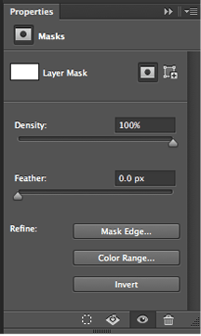
- Click Mask Edge.
- You can change the view mode to see the edges more clearly.
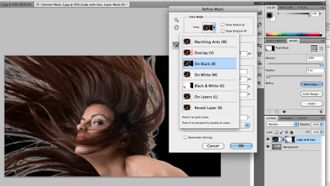
- Play with the options in the Refine Mask Panel to achieve the best result. Choose Output To: New Layer with Layer Mask.
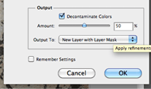
- Before / After
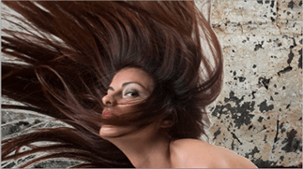 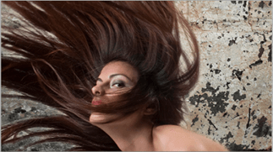
Animation:
In Photoshop, you use the Timeline panel to create animation frames. Each frame represents a configuration of layers. The unicycle image is on its own layer; the position of the layer changes in each frame of the animation. To create frame-based animations in Photoshop

