ENTREPRENEURIAL DEVELOPMENT

MR. M.GANESHKUMAR-MBA.,M.Phil.,(Ph.D),

Asst.Professor

Department of Management Studies
ANNAI VAILAKANNI ARTS AND SCIENCE COLLEGE
THANJAVUR-05
UNIT-I
ENTREPRENEUR
An entrepreneur is an individual who, rather than working as an employee, founds and runs a small business, assuming all the risks and rewards of the venture. The entrepreneur is commonly seen as an innovator, a source of new ideas, goods, services and business.
DEFINITION
According to Merriam-Webster's definition that explains entrepreneur as "one who organizes, manages, and assumes the risks of a business or enterprise."
ENTREPRENEURSHIP
Entrepreneurship is the process of designing, launching and running a new business, which is often initially a small business. The people who create these businesses are called entrepreneurs.
DEFINITION
Entrepreneurship is both the study of how new businesses are created as well as the actual process of starting a new business – the term is used interchangeably. An entrepreneur is someone who has an idea and who works to create a product or service that people will buy, by building an organization to support those sales.
IMPORTANCE OF ENTREPRENEURSHIP
The importances of entrepreneurship are;
- Growth of Entrepreneurship.
- Creation of job opportunities
- Innovation.
- Impact on community development.
- The consequence of business failure.
- Promotes research and development.
- Growth of Entrepreneurship
- Entrepreneurship the advent of new venture particularly small ventures in order to materialize the innovative ideas of the entrepreneurs.
- Thus, the growth or establishment of small enterprises ii the specific contribution of entrepreneurship in every economy of the world.
- Creation of job opportunities
- Entrepreneurship firms contributed a large share of new jobs. It provides entry-level jobs so necessary fur training or gaining experience for unskilled workers.
- The small enterprises are the only sector that generates a large portion of total employment every year.
- Innovation
- Entrepreneurship is the incubator of the innovation. Innovation creates disequilibria in the present state of order.
- It goes beyond discovery and does implementation and commercialization, of innovations.
- Impact on community development
- A community is better off if its employment base is diversified among many small entrepreneurial firms.
- It promotes abundant retail facilities, a higher level of home ownership, fewer slums, better, sanitation standards and higher expenditure on education, recreation, and religious activities.
- The consequence of business failure
- The collapse of large industry almost has irresistible damage to the development of state and to the state of the economy and to the financial condition of the relevant persons.
- The incumbents lost their jobs: suppliers and financial institutions face a crisis of recovery.

- Promotes research and development
- Entrepreneurship is innovation and hence the innovated ideas of goods and services have to be tested by experimentation.
- Therefore, entrepreneurship provides funds for research and development with universities and research institutions. This promotes the general development, research, and development in the economy.
- Entrepreneurship is the pioneering zeal that provides events in our civilization.
QUALITIES OF AN ENTREPRENEUR
- Disciplined
- Confidence
- Open Minded
- Self Starter
- Competitive
- Creativity
- Determination
- Strong people skills
- Strong work ethic
- Passion
1. Disciplined
These individuals are focused on making their businesses work, and eliminate any hindrances or distractions to their goals. They have overarching strategies and outline the tactics to accomplish them. Successful entrepreneurs are disciplined enough to take steps every day toward the achievement of their objectives.
2. Confidence
The entrepreneur does not ask questions about whether they can succeed or whether they are worthy of success. They are confident with the knowledge that they will make their businesses succeed. They exude that confidence in everything they do.
3. Open Minded
Entrepreneurs realize that every event and situation is a business opportunity. Ideas are constantly being generated about workflows and efficiency, people skills and potential new businesses. They have the ability to look at everything around them and focus it toward their goals.
4. Self Starter
Entrepreneurs know that if something needs to be done, they should start it themselves. They set the parameters and make sure that projects follow that path. They are proactive, not waiting for someone to give them permission.
5. Competitive
Many companies are formed because an entrepreneur knows that they can do a job better than another. They need to win at the sports they play and need to win at the businesses that they create. An entrepreneur will highlight their own company’s track record of success.
TYPES/CLASSIFICATION OF ENTREPRENEUR
Entrepreneurs are found in every system and in every form of economic activity. They are found amongst artisans, traders, importers, engineers, exporters, bankers, industrialists, farmers, forest workers, tribal’s, professionals and so on. They are also found among politicians, theologizes, bureaucrats etc. The nature of entrepreneurs differs according to their functions.
The various types of entrepreneurs are classified on certain bases. Some important classifications are discussed below:
I. On the Basis of Stages of Economic Development
Clarence Danh of classifies entrepreneur into four type :

- Innovative: An Innovating entrepreneur is one who introduces new products, new methods of production and new technology.
- Imitative or Adoptive: Imitative entrepreneur is characterized by readiness to adopt successful innovation initiated by innovating entrepreneurs.
- Fabian: Fabian entrepreneurs are lazy and shy. They lack the will to adopt new methods of production.
- Drone: Drone entrepreneur is one who follows the traditional methods of production.
II. On the Basis of Attitude and Knowledge
Author H. Cole classified entrepreneurs as :
- Empirical : He hardly introduces anything revolutionary.
- Rational : He introduces changes which look more revolutionary.
- Cognitive : He draws upon the advice and services of experts. He introduces changes that reflect complete break from the present situations.
- On the Basis of type of Business Occupations We may broadly classify then as follows :
- Business Entrepreneur : They conceive an idea for a new product of services and then create a business to materialize their idea into reality. They exploit new business opportunity. They set up and promote business units.
- Trading Entrepreneurs: They undertake buying and selling activities. They are not concerned with the manufacturing work.
- Industrial Entrepreneur: He is product-oriented man. He makes long-run plans in terms of new products, tomorrow’s markets and future growth. He converts resources into economic utilities and values.
- Corporate Entrepreneur: Such an entrepreneur has vision and imaginative skill to organize and manage a corporate undertaking. He plans, develops and crates a corporate legal entity.
- Agricultural Entrepreneur: Such entrepreneurs undertake agricultural activities. They raise and market crops, fertilizers and other inputs of agriculture.
IV. On the Basis of Use of Technology
- Technical: Such entrepreneur possesses technical expertise and know-how.
      - Non-Technical: He simply deals with developing alternative marketing and distribution strategies to promote his business.
- Professional: Such entrepreneur is interested in establishing a business. He takes no interest in managing or operating it once it is established.
V. On the Basis of Ownership
- Private: Private entrepreneur is motivated by profit. He never enters those sectors of economy in which prospects of earning profit are discouraging.
- Public: In the underdeveloped countries the government acts as entrepreneur and undertakes economic activities with the object of public welfare and prosperity. The government runs the enterprises to promote development of the country.
- Joint: Joint enterprises is a partnership is an association of persons who have voluntarily joined together to achieve common economic ends. Its main object is rendering services to its members. Members make equitable contributions to the capital required.
- Co-operative: Co-operative entrepreneurship is an association of persons who have voluntarily joined together to achieve common economic ends. Its main object is rendering services to its members. Members make equitable contribution to the capital required.
VI. On the Basis of Stage development
- First generation entrepreneur
- Second generation
- Classical/ Third Entrepreneur

VII. On the Basis of gender
- Man entrepreneur
- Young entrepreneur
- Old entrepreneur
- Women entrepreneur
- Middle aged entrepreneur
VIII. On the Basic of Area
- Runal entrepreneur
- Urban entrepreneur
IX. On the Basis of the Scale of Entrepreneurs
- Small Scale Resources: this entrepreneur is found in the underdeveloped countries. He does not possess the necessary abilities and resources to initiate large scale production. He is not able to introduce revolutionary technological changes.
- Large Scale : Large scale enterprises are established in the developed countries. Big entrepreneurs possess huge capital resources, necessary technical and skill to introduce new production changes.
X. Other Types of Entrepreneurs
- Pure Entrepreneur : He is motivated by psychological and economic rewards. He starts activities for his personal satisfaction is work, ago or status.
- Induced Entrepreneur : Such entrepreneur is induced to take up an entrepreneurial task due to the policy measures of the government.
- Motivated Entrepreneur : Such an entrepreneur is motivated by the desire for self-fulfilment. He is also motivated by the desire for innovations and profit.
- Growth Entrepreneur : These entrepreneurs choose an industry which has high growth prospects.
- Super-Growth Entrepreneur : He is an individual who has shown enormous growth performance in has venture.
- First-Growth Entrepreneur : He is one who starts an industrial unit by means of an innovative skill.
- Modern Entrepreneur : He is one who undertakes those ventures which go well along with the changing demand in the market. He cares for the current marketing needs.
CHARACTERISTICS OF SUCCESSFUL ENTREPRENEURS
1. Facilitating Character
An entrepreneur must build a team, keep it motivated, and provide an environment for individual growth and career development.
2. Self-Confidence
Entrepreneurs must have belief in themselves and the ability to achieve their goals.
3. Work with Vision and Mission
An entrepreneur must be committed to the project with a time horizon of five to seven years. No ninety-day wonders are allowed.
4. High Degree of Endurance
Success of an entrepreneur demands the ability to work long hours for sustained period of time.
5. Trouble Shooting Nature
An entrepreneur must have an intense desire to complete task or solve a problem. Creativity is an essential ingredient.
6. Initiative and Enterprising Personality
An entrepreneur must have initiative, accepting personal responsibility for actions, and above all make good use of resources.
7. Goal Setter
An entrepreneur must be able to set challenging but realistic goals.
8. Calculated Risk-Taking Ability
An entrepreneur must be a moderate risk-taker and learn from any failures.
ROLE OF ENTREPRENEURSHIP IN ECONOMIC DEVELOPMENT

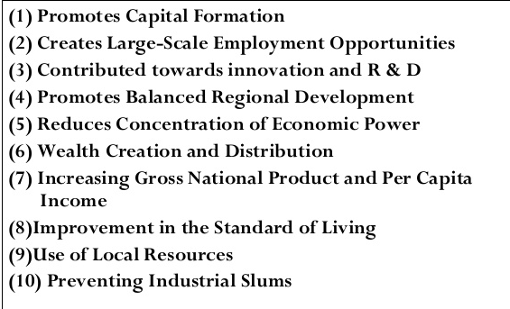
DIFFERENCE BETWEEN ENTREPRENEUR AND INTRAPRENEUR

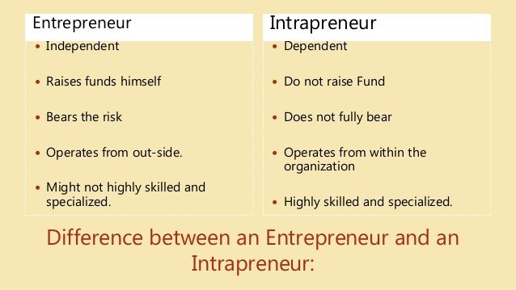

ENTREPRENEUR VS ENTREPRENEURSHIP
The major differences between these two terms are as follows.
Entrepreneurship is the function of seeking investment and production opportunity organising an enterprise to undertake a new production process, raising capital, arranging labour and raw materials, finding a site introducing a new technique and commodities, discounting new sources for the enterprise. Entrepreneur is one who combines capital and labour for the purpose of production.

UNIT-II

Entrepreneurial Environment
DEFINITION
“Suitable Environment and intuition in grasping the essential facts promotes entrepreneurship” –Schumpter.
MEANING
Environment refers to the totality of all factors which are external and beyond the control of the business enterprise.
CLASSIFICATION OF ENVIRONMENT
Environment may be grouped in to two, viz, Eco- nomic and Non-Economic environment. Environment formed by the economic fac- tors like fiscal policy, indus- trial policy, physical control of price-income, the eco- nomic system that operates, the stage of economic devel- opment refers to economic environment.
Environmental Factors
It is true that the entrepreneurs must have come from diverse economic, social and geographical backgrounds which interlace influence entrepreneurial spirits. This will enhance the entrepreneurial performance. The various factors which influences the entrepreneurship may be categorized into two, viz, Internal and External environment factors
Internal Factors
The internal environmental factors are mainly the environment in which entrepreneurs are born and brought up and work. Internal factors are those which will stimulate the entrepreneurs from within to take up entrepreneurial venture. Some of them are:
1. Strong desire of entrepreneurs to do something independently in life.
2. Technical know-how or manufacturing experiences acquired by them.
3. Business experience in the same or related line.
4. Family background including size, type and economic status of family.
5. Occupational origins of the entrepreneurs
External Environment
The success of entrepreneurship in a region at any point of time depends on the very many external environmental factors. These factors influence the entrepreneurial operations and ultimately determine the effectiveness of entrepreneurial performance also. These environmental factors can be grouped into:
Economic Environment
The different economic environmental factors which influence/ inhibit the entrepreneurship are: Structure of the economy, Industrial Policy, Agricultural” Policy, Growth pattern of National income, G.D.P., Savings and capital formation in the country. Besides that, Balance of trade and balance of payments, trade and tariff policy etc.
Legal Environment
Entrepreneur should know what the prevailing legal environment is by knowing the latest position in legal enactments relating to various aspects of entrepreneurial venture. Such as formation of the unit, collaboration, foreign exchange, industrial dispute, labour management, social security benefits, consumer protection etc.
Political Environment
The working political system in a country influences the entrepreneurial growth by designing and implementing various policy matters pertaining to promotion of entrepreneurship. Hence entrepreneurs and industrialists should have representatives on various government bodies at all levels of policy formulation and planning.
Socio-Cultural Environment
In the modem days a suitable entrepreneurial culture must be created by developing healthy work environment and modem attitudes towards work giving social recognition etc. These factors will give psychological stimulus which in turn promotes innovation, inspiration, ethics and values which are very essential for a successful entrepreneurs.
FACTORS AFFECTING ENTREPRENEURIAL GROWTH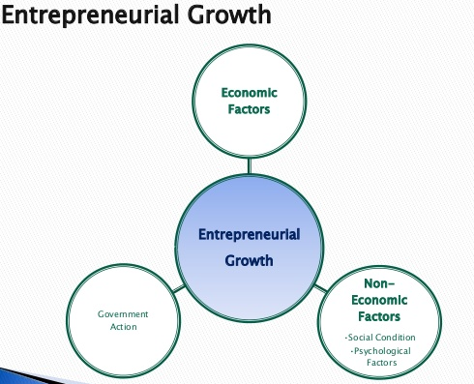

I. Economic Factors
1. Capital
Capital is one of the most important factors of production for the establishment of an enterprise. Increase in capital investment in viable projects results in increase in profits which help in accelerating the process of capital formation. Entrepreneurship activity too gets a boost with the easy availability of funds for investment.
2. Labor
Easy availability of right type of workers also effect entrepreneurship. The quality rather than quantity of labor influences the emergence and growth of entrepreneurship. The problem of labor immobility can be solved by providing infrastructural facilities including efficient transportation.
3. Raw Materials
The necessity of raw materials hardly needs any emphasis for establishing any industrial activity and its influence in the emergence of entrepreneurship. In the absence of raw materials, neither any enterprise can be established nor can an entrepreneur be emerged.
4. Market
The role and importance of market and marketing is very important for the growth of entrepreneurship. In modern competitive world no entrepreneur can think of surviving in the absence of latest knowledge about market and various marketing techniques.
5. Infrastructure
Expansion of entrepreneurship presupposes properly developed communication and transportation facilities. It not only helps to enlarge the market, but expand the horizons of business too. Take for instance, the establishment of post and telegraph system and construction of roads and highways in India.

II. Non-Economic Factors
1. Education
Education enables one to understand the outside world and equips him with the basic knowledge and skills to deal with day-to-day problems. In any society, the system of education has a significant role to play in inculcating entrepreneurial values.
2. Attitude of the Society
A related aspect to these is the attitude of the society towards entrepreneurship. Certain societies encourage innovations and novelties, and thus approve entrepreneurs’ actions and rewards like profits.
3. Cultural Value
Motives impel men to action. Entrepreneurial growth requires proper motives like profit-making, acquisition of prestige and attainment of social status. Ambitious and talented men would take risks and innovate if these motives are strong.
Entrepreneurial Motivation
Enrepreneurial behaviour is the result of entrepreneurial motivation Motivation refers to the inner urge that ignites and sustain behaviour to satisfy need.Motivation has been derived from the word motive which implies the inner state of mind that activates provokes and direcs our behaviour towards the goal.
MOTIVATION
The term motivation derives from the Latin Word mover, which means "to move". Motivation is the process by which behaviour is mobilized and sustained in it particular direction. It is in fact impossible to determine a person's motivation until the behaves or acts.
- Maslow's Need Hierarchy theory
According to Abraham H. Maslow, the behaviour of a person or an entrepreneur is motivated by various needs which are as follows:
  - Physiological needs
  - Safety and Security needs
  - Social needs
  - Self-actualization needs
  - Ego noels
- McClelland's Acquired needs 'theory
According to David C. McClelland of Harvard University, USA, a person acquires three types of needs any time. In other words the needs are the result of life-experience. These needs are:
  - Need for affiliations which imply the desire to establish and maintain friendly and warm relations with others.
  - Need for power which means the desire to dominate and influence others by controlling their actions and the se of physical objects.
  - Need for achievement (N-Ach) which refers to the desire to accomplish something with one's own efforts. It is the urge to excel or the will to do well.
McClelland suggested that entrepreneurs have high need for achievement. People with high achievement motivation are characterized by the following:
- They set moderate, realistic and attainable goals or targets.
- They lake calculated risks.
- They prefer situations wherein they can take personal responsibility for solving problems.
- They want concrete feedback on how well they are doing.
- Their need for achievement exists not merely for the sake of economic reward for social recognition rather personal accomplishment is intrinsically satisfying to them.
Motivation to achieve targets
The motivations which motivate an entrepreneur to achieve the targets are as follows:
- Urgent needs
- Desire to Compete others
- Desire to being busy in target achievement
- Ambition to become prosperous
- Ambition for advancement nation
TYPES OF MOTIVATION
- Negative and Positive Motivation
- Extrinsic and Intrinsic Motivation
- Financial and Non-financial motivation
Motivation to Achievement Targets
A person may have tremendous capacity to work, but his capacity would be of no use unless he is willing to work. To stimulate a person's willingness work, can be called motivation. Motivation includes all those activities which can successfully invoke a person's willingness to work more efficiently and effectively. For development of an organization it is essential that the people working in the organization are motivated to contribute their best. Motivation plays a significant role in getting Work done from the people.
The importance of motivation can be given as follows:
- Attainment of Organizational goals
- Development of Cordial Human Relations
- Maintain Competent Persons in the organization
- Boosting Morale, of the Employees
- Increase in the Productivity of Workers
- Reduction in the Cost of Production.
BARRIERS TO ENTREPRENEURIAL DEVELOPMENT

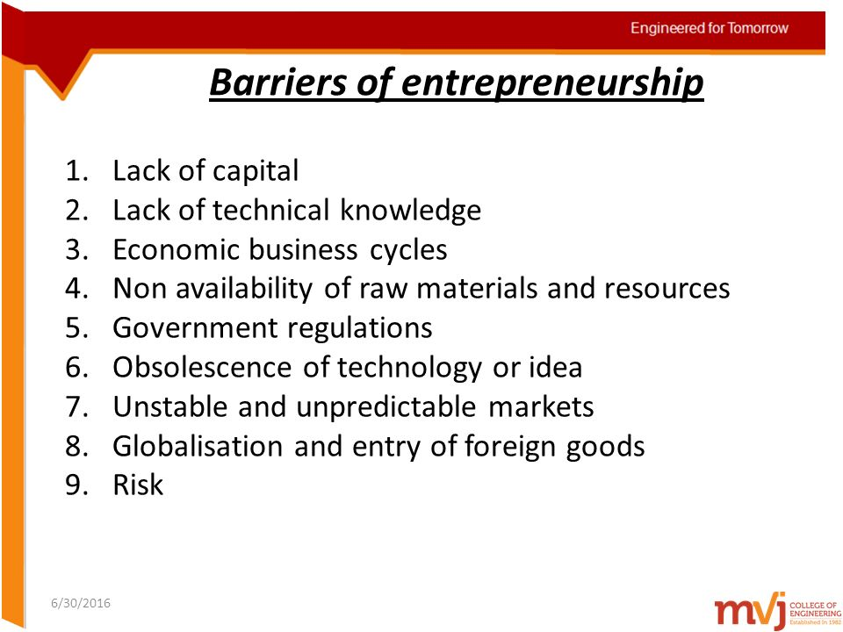

UNIT-III

ENTREPRENEURSHIP DEVELOPMENT PROGRAMMES
Meaning:
As the term itself denotes, EDP is a programme meant to develop entrepreneurial abilities among the people. In other words, it refers to inculcation, development, and polishing of entrepreneurial skills into a person needed to establish and successfully run his / her enterprise. Thus, the concept of entrepreneurship development programme involves equipping a person with the required skills and knowledge needed for starting and running the enterprise.
Objectives of EDP:
The major objectives of the Entrepreneurship Development Programmes (EDPs) are to:
a. Develop and strengthen the entrepreneurial quality, i.e. motivation or need for achievement.
b. Analyze environmental set up relating to small industry and small business.
c. Select the product.
d. Formulate proposal for the product.
e. Understand the process and procedure involved in setting up a small enterprise.
f. Know the sources of help and support available for starting a small scale industry.
g. Acquire the necessary managerial skills required to run a small-scale industry.
6 Inputs of Course Contents and Curriculum of EDPs
1. General Introduction to Entrepreneurship:
First of all, the participants are exposed to a general knowledge of entrepreneurship such as factors affecting small-scale industries, the role of entrepreneurs in economic development, entrepreneurial behaviour, and the facilities available for establishing small-scale enterprises.
2. Motivation Training:
The training inputs under this aim at inducing and developing the need for achievement among the participants. This is, in fact, a crucial input of entrepreneurship training. Efforts are made to inject confidence and positive attitude and behaviour among the participants towards business.
3. Management Skills:
Running a business, whether large or small requires the managerial skills. Since a small entrepreneur cannot employ a management professionals /experts to manage his/her business, he/she needs to be imparted basic and essential managerial skills in the different functional areas of management like finance, marketing, human resource, and production.
4. Support System and Procedure:
The participants also need to be exposed to the support available from different institutions and agencies for setting up and running small-scale enterprises. This is followed by acquainting them with procedure for approaching them, applying and obtaining support from them.
IMPORTANCE OF ENTREPRENEURSHIP DEVELOPMENT
The need for entrepreneurship development was not felt by the classical economists like Adam Smith and David Ricardo. They thought that capital formation led to economic development.
The entrepreneurship development is needed on the following grounds
1. Optimum Utilization of Resources
Natural resources are getting depleted over a period of time. Some of the resources are almost scarce and it is the responsibility of the entrepreneurs to identify the alternative sources of supply of resources and also to make use of the existing resources without doing much harm to the environment.
2. Improved Standard of Living
The living conditions of the people could be improved through planned entrepreneurship development programme. Entrepreneurs use the latest technology and manufacture those products which are essential to all people at the lowest cost and thereby try to improve the living standar4 of the people.
3. Ensure Industrialization
A country is said to be advanced if there is an existence of adequate industrial units of big and small in size. The existing entrepreneurship development programmes create a congenial atmosphere for the aspiring and young entrepreneurs to come forward to set up industrial units especially in the industrially backward regions.
4. Innovation is the gateway
Innovation takes place in all fields activities. The application of computers enable businessmen and Government to expedite their business activities. Marked improvement has been taken place in the filed of communication due to the application of innovative technology.
5. Allow Global Market Entry
Entrepreneurship’ development enables the manufactures to manufacture products of international quality and thereby try to enter into the global market and compete with the products of other nations.
PROBLEMS OF WOMEN ENTREPRENEURS

INSTITUTIONAL SUPPORT TO ENTREPRENEURS
Defining MSME in India

In accordance with the provision of Micro, Small & Medium Enterprises Development (MSMED) Act, 2006 the Micro, Small and Medium Enterprises (MSME) are classified in two Classes:

a. Manufacturing Enterprises- The enterprises engaged in manufacture or production of goods pertaining to any industry specified in the first schedule to the industries (Development and regulation) Act, 1951). The manufacturing enterprise is defined in terms of investment in Plant & Machinery.

b.Service Enterprises- The enterprises engaged in providing or rendering of services and are defined in terms of investment in equipment.

OBJECTIVES OF DISTRICT INDUSTRIES CENTERS (DICS)

The following are the main objectives of DICs:

- To identify the new entrepreneurs and providing assistance to them regarding their own startup’s.

- To provide financial and other facilities to smaller blocks.

- To rise the complete efforts for industrialization at district level.

- To enhance the rural industrialization and also the development of handicrafts.

- To reach economic equality in multiple areas of the district.

- To allow various government schemes to the new entrepreneurs.

- To desize the regional imbalance of development.

- To make all the necessary facilities to come under one roof.

FUNCTIONS OF DISTRICT INDUSTRIES CENTERS (DICS)

The DIC’s programme is funded jointly by the concerned state and central government. It took part in various promotional measures In order to bring out the development of small unit sectors in the district level. The DIC’s performs the following functions mainly:

1. To spot the entrepreneurs:
DICs conducting various motivational programmes so that they can find new entrepreneurs throughout the districts. It is done particularly under some schemes and with the association of SIS’s and TCO’s for conducting Entrepreneurial programmes.
2. Purchase of fixed assets:
Topurchase fixed assets, the DICs suggest loan applications of the prospective entrepreneur to some of the concerned financial and development institutions like NSIC, SISI etc., DCI’s also recommend commercial banks so that to meet the working capital requirement of SSI to run operations daily.
3. Offers subsidies and other incentives:
DCIs help the rural people to subsidies offered by the government on various schemes. It leads to the betterment in boosting financial capacity of the units and may undergo for further development activities.
4. Guidance of import and export:
Government provides various types of incentives for import and export on particular goods and services. The license to the importer and exporter is issued on the basis of recommendation of DIC.

5. Entrepreneurial training programmes:

DCIs allow a lot of training programmes for the rural entrepreneurs who are new to the business world and also recommend other institutions to take part in such training programs.These are intended to give better assistance to the new entrepreneurs 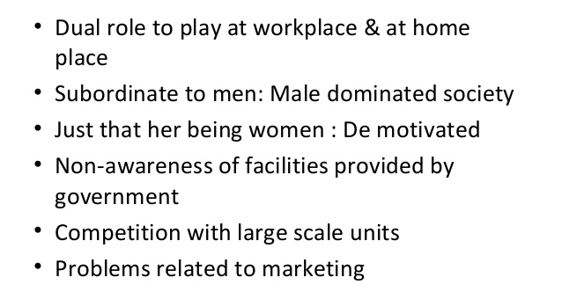
ACTIVITIES OF DISTRICT INDUSTRIES CENTRE (DICs)
The DIC’s performs the following activities primarily:

- Economic Investigation.

- Plant and Machinery

- Research, education and training

- Raw materials

- Credit facilities

- Marketing assistance

- Cottage industries

SIDO
Small Industries Development Organization (SIDO) is a subordinate office of the Department of SSI & Auxiliary and Rural Industry (ARI). It is an apex body and nodal agency for formulating, coordinating and monitoring the policies and programmes for promotion and development of small-scale industries.
The main functions of the SIDO are classified into:
- Co-ordination,
- Industrial development, and
- Extension.

SMALL INDUSTRIES SERVICE INSTITUTES (SISI)

The small industries service institutes have been set up in state capitals and other places all over the country to provide consultancy and training to small entrepreneurs both existing and prospective.

FUNCTIONS

- To assist existing and prospective entrepreneurs through technical and managerial counseling such as help in selecting the appropriate machinery and equipment, adoption of recognized standards of testing, quality performance etc;

- Conducting EDPs all over the country;

- To advise the Central and State governments on policy matters relating to small industry development;

- To assist in testing of raw materials and products of SSIs, their inspection and quality control;

- To provide market information to the SISI’s;

- To recommend SSI’s for financial assistance from financial institutions;

- To enlist entrepreneurs for partition in Government stores purchase programme;

- Conduct economic and technical surveys and prepare techno-economic feasible reports for selected areas and industries.

EDII
Entrepreneurship Development Institute of India (EDII), an autonomous and not-for-profit institute, set up in 1983, is sponsored by apex financial institutions - the IDBI Bank Ltd., IFCI Ltd., ICICI Bank Ltd. and the State Bank of India (SBI). The Government of Gujarat pledged 23 acres of land on which stands the majestic and sprawling EDII campus.
Functions of EDII
•Creating a multiplier effect on opportunities for self-employment, •Augmenting the supply of competent entrepreneurs through training, •Augmenting the supply of entrepreneur trainer-motivators, •Participating in institution building efforts,
•Inculcating the spirit of 'Entrepreneurship' in youth,
•Promoting micro enterprises at rural level,
•Developing new knowledge and insights in entrepreneurial theory and practice through research,
•Facilitating corporate excellence through creating intrapreneurs,
•Improving managerial capabilities of small scale industries,
INSTITUTIONAL FINANCE TO ENTREPRENEURS
IDBI Bank is an Indian government-owned financial service company, formerly known as Industrial Development Bank of India, headquartered in Mumbai, India. It was established in 1964 by an Act of Parliament to provide credit and other financial facilities for the development of the fledgling Indian industry. IDBI Bank is on a par with nationalized banks and the SBI Group as far as government ownership is concerned. It is one among the 27 commercial
banks owned by the Government of India. IDBI bank is considered as government of India owned bank. It is currently 10th largest development bank in the world in terms of reach. It has an authorised capital of 3000 cr.

UNIT-IV

MEANING OF PROJECT.

An entrepreneur takes numerous decisions to convert his business idea into a running concern. His/Her decision making process starts with project/product selection. The project selection is the first corner stone to be laid down in setting up an enterprise.

DEFINITION

Planned set of interrelated tasks to be executed over a fixed period and within certain cost and other limitations.

Project identification

The purpose of project identification is to develop a preliminary proposal for the most appropriate set of interventions and course of action, within specific time and budget frames, to address a specific development goal in a particular region or setting. Investment ideas can arise from many sources and contexts. They can originate from a country’s sector plan, programme or strategy, as follow-up of an existing project or from priorities identified in a multi-stakeholder sector or local development dialogue. Identification involves:

- a review of alternative approaches or options for addressing a set of development problems and opportunities;

- the definition of project objectives and scope of work at the degree of detail necessary to justify commitment of the resources for detailed formulation and respective preparatory studies; and

- the identification of the major issues that must be tackled and the questions to be addressed before a project based on the concept can be implemented.

Sufficient information on project options must be gathered to enable the government and financing agencies to select a priority project and reach agreements among stakeholders on arrangements for preparation work, including setting up steering committees or national preparation teams. The results of identification work should be summarized in a report, project brief or concept document, the format of which will depend upon the government’s and/or financing agencies’ requirements.

PROJECT FORMULATION.-

A process is a collection of interrelated actions and activities that take place in order to achieve a set of previously specified products, results or services. The project team is in charge of executing the formulation, evaluation and project management processes.

Project formulation

1.Taking a first look carefully and critically at the project idea

2.Carefully weighing its various components

3.Analyzing with the assistance of specialists or consultants

4.Assessment of the various aspects of an investment proposition

5.It is an important stage in the pre-investment phase

Stages of project formulation

- Feasibility analysis

- Techno-Economic Analysis

- Project Design and network analysis

- Input analysis

- Financial analysis

- Cost-benefit analysis

  - Pre-investment analysis

Feasibility Analysis

- First stage in project formulation

- Examination to see whether to go in for a detailed investment proposal or not

- Screening for internal and external constraints

- The project idea seems to be feasible

- The project idea is not a feasible one

- Unable to arrive at a conclusion for want of adequate data

Techno-Economic Analysis

Screens the idea to estimate of potential of the demand of goods/services choice of optimal technology This analysis gives the project a platform for preparation of detailed project design

Project Design and Network Analysis

- It is the heart of the project entity

- It defines the sequences of events of the project

- Time is allocated for each activity

- It is presented in a form of a network drawing

- It helps to identify project inputs, finance needed and cost benefit profile of the project

Input Analysis

- It’s assesses the input requirement during the construction and operation of the project

- It defines the inputs required for each activity

- Inputs include materials, human resources

- It evaluates the feasibility of the project from the point of view the availability of necessaryresources

- This aids in assessing the project cost

Financial Analysis:

- It involves estimating the project costs, operating cost and fund requirements

- It helps in comparing various project proposals on a common scale

- Analytical tools used are discounted cash flow, cost-volume-profit relationship and ratio analysis

- Investment decision involve commitment of resources in future, with a long horizon

- It needs caution and foresight in developing financial forecasts

Cost –Benefit analysis

- The overall worth of a project is considered

- The project design forms the basis of evaluation

- It considers costs that all entities have to bear and the benefit connected to it.

Pre-investment Analysis

- The results obtained in previous stages are consolidated to arrive at clear conclusions

- Helps the project-sponsoring body, the project implementing body and the external consultingagencies to accept/reject the proposal

Meaning of Project Report

A Project Report is a document which provides details on the overall picture of the proposed business. The project report gives an account of the project proposal to ascertain the prospects of the proposed plan/activity.

Project Report is a written document relating to any investment. It contains data on the basis of which the project has been appraised and found feasible. It consists of information on economic, technical, financial, managerial and production aspects. It enables the entrepreneur to know the inputs and helps him to obtain loans from banks or financial Institutions.

The project report contains detailed information about Land and buildings required, Manufacturing Capacity per annum, Manufacturing Process, Machinery & equipment along with their prices and specifications, Requirements of raw materials, Requirements of Power & Water, Manpower needs, Marketing Cost of the project, production, financial analyses and economic viability of the project.

Contents of a Project Report

Following are the contents of a project report.

1. General Information

A project report must provide information about the details of the industry to which the project belongs to. It must give information about the past experience, present status, problems and future prospects of the industry. It must give information about the product to be manufactured and the reasons for selecting the product if the proposed business is a manufacturing unit. It must spell out the demand for the product in the local, national and the global market. It should clearly identify the alternatives of business and should clarify the reasons for starting the business.

2. Executive Summary

A project report must state the objectives of the business and the methods through which the business can attain success. The overall picture of the business with regard to capital, operations, methods of functioning and execution of the business must be stated in the project report. It must mention the assumptions and the risks generally involved in the business.

3. Organization Summary

The project report should indicate the organization structure and pattern proposed for the unit. It must state whether the ownership is based on sole proprietorship, partnership or Joint Stock Company. It must provide information about the bio data of the promoters including financial soundness. The name, address, age qualification and experience of the proprietors or promoters of the proposed business must be stated in the project report.

4. Project Description

A brief description of the project must be stated and must give details about the following:

- Location of the site,

- Raw material requirements,

- Target of production,

- Area required for the workshed,

- Power requirements,

- Fuel requirements,

- Water requirements,

- Employment requirements of skilled and unskilled labour,

- Technology selected for the project,

- Production process,

- Projected production volumes, unit prices,

- Pollution treatment plants required.

If the business is service oriented, then it must state the type of services rendered to customers. It should state the method of providing service to customers in detail.

5. Marketing Plan

The project report must clearly state the total expected demand for the product. It must state the price at which the product can be sold in the market. It must also mention the strategies to be employed to capture the market. If any, after sale service is provided that must also be stated in the project. It must describe the mode of distribution of the product from the production unit to the market. Project report must state the following:

  - Type of customers,

  - Target markets,

  - Nature of market,

  - Market segmentation,

  - Future prospects of the market,

  - Sales objectives,

  - Marketing Cost of the project,

  - Market share of proposed venture,

  - Demand for the product in the local, national and the global market,

  - It must indicate potential users of products and distribution channels to be used for distributing the product.

- Capital Structure and operating cost

The project report must describe the total capital requirements of the project. It must state the source of finance, it must also indicate the extent of owners funds and borrowed funds. Working capital requirements must be stated and the source of supply should also be indicated in the project. Estimate of total project cost, must be broken down into land, construction of buildings and civil works, plant and machinery, miscellaneous fixed assets, preliminary and preoperative expenses and working capital.

Proposed financial structure of venture must indicate the expected sources and terms of equity and debt financing. This section must also spell out the operating cost

7. Management Plan

The project report should state the following.

- Business experience of the promoters of the business,

- Details about the management team,

- Duties and responsibilities of team members,

- Current personnel needs of the organization,

- Methods of managing the business,

- Plans for hiring and training personnel,

- Programmes and policies of the management.

8. Financial Aspects

In order to judge the profitability of the business a projected profit and loss account and balance sheet must be presented in the project report. It must show the estimated sales revenue, cost of production, gross profit and net profit likely to be earned by the proposed unit. In addition to the above, a projected balance sheet, cash flow statement and funds flow statement must be prepared every year and at least for a period of 3 to 5 years.

The income statement and cash flow projections should include a three-year summary, detail by month for the first year, and detail by quarter for the second and third years. Break even point and rate of return on investment must be stated in the project report. The accounting system and the inventory control system will be used is generally addressed in this section of the project report. The project report must state whether the business is financially and economically viable.

9. Technical Aspects

Project report provides information about the technology and technical aspects of a project. It covers information on Technology selected for the project, Production process, capacity of machinery, pollution control plants etc.

10. Project Implementation

Every proposed business unit must draw a time table for the project. It must indicate the time within the activities involved in establishing the enterprise can be completed. Implementation schemes show the timetable envisaged for project preparation and completion.

11. Social responsibility

The proposed units draws inputs from the society. Hence its contribution to the society in the form of employment, income, exports and infrastructure. The output of the business must be indicated in the project report.

Guidelines for Preparing a Detailed Project Report

Your company seeking financial assistance for implementation of its business idea is required to prepare a Project Report covering certain important aspects of the project as detailed below:

- Promoters background/experience

- Product with capacity to be built up and processes involved

- Project location

- Cost of the Project and Means of financing thereof

- Availability of utilities

- Technical arrangements

- Market Prospects and Selling arrangements

- Environmental aspects

- Profitability projections and Cash flows for the entire repayment period of financial assistance

Spreadsheets formats attached with this document will help you prepare a Detailed Project Report for your Bank. You may omit the manufacturing related information in case you are applying for a non-manufacturing project.

Since the appraisal of the Project involves evaluation of the Project in the following areas, your company/you would be required to submit certain documents/information in the matter.

Management Evaluation

- Memorandum and Articles of Association : Object, authorised and paid-up share capital,promoter's contribution, borrowing powers, list of directors on the Board, terms of appointment of directors

- Your company as the Promoter : Corporate plan of the Company, projects promoted/implemented/under implementation, Bankers' report on dealings and repayment of past loan assistance, details of group companies, operations, balance sheet and profit & loss account of the promoter company

- New Promoters : Educational background, any industrial experience, family background, sources of income, details of personal properties, banker's reference, income tax/ wealth tax returns

- Management and Organisation set up : Broad composition of the Board, details of full time directors and their responsibilities, details of Chief executive and functional executives including qualification, experience, organisation set-up for existing company and during project implementation for new company.

Technical Feasibility

- Technology and manufacturing process : Proven/new technology, basis of selection of technology, competing technologies, performance data of plants based on the technology, details of licensor of technology, process flow chart and description

- Location of the Project : Locational advantage, availability of raw material and other utilities, infrastructure facilities, availability of labour, environmental aspects

- Plant and Machinery : List of machinery & equipment, details of suppliers, competitive quotations, technical & commercial evaluation of major equipment

- Raw material, Utilities and Manpower: Details of raw materials and suppliers, electricity and water supply, basis of manpower estimates, details of manpower eg. managerial, supervisory, skilled/unskilled, training needs

- Contracts : Agreement with contractors detailing on know-how, engineering, procurement, construction, financial soundness and experience of contractors

- Project monitoring and implementation : Mode of implementation, details of monitoring team, detailed schedule of implementation.

Environmental Aspects:

Air, Water and Soil Pollution, list of pollutants / Hazardous substances, their safety, handling and disposal arrangements, compliance with national and International Standards, Clearances and No objection certificates required and obtained etc.

Commercial Viability

- Existing and potential market demand and supply for the proposed product in respect of volume and pattern

- Share of the proposed product of the company in the total market through marketing strategy

- Selling price of the product and export potential, if any.

- Buy-back arrangements, if any.

Financial Appraisal

- Cost of the Project: This includes the cost of land & site development, building, plant & machinery, technical know-how & engineering fees, miscellaneous fixed assets, preliminary & preoperative expenses, contingencies, margin money for working capital. Your company is expected to submit realistic estimates and reasonableness of the cost of the project will be examined with reference to various factors such as implementation period, inflation, various agreements, quotations etc.

- Means of Financing: Means of financing shall have to conform to proper mix of share capital and debt. This includes share capital, unsecured loans from Promoters/associates, internal accruals, term loans, Government subsidy/grant. Reasonableness of Promoters' contribution in the form of equity and interest-free unsecured loans, if any, is ascertained in view of commitment to the Project.

- Profitability Projections: Past records of financial performance of Your company will be examined. Your company needs to submit profitability estimates, cash flow and projected balance sheet for the project and for the Company as a whole. Based on the projections, various financial ratios such as Debt -Equity ratio, Current ratio, Fixed asset coverage ratio, Gross profit, Operating profit, Net profit ratios, Internal rate of return(over the economic life of the project), Debt Service Coverage ratio, Earning per share, Dividend payable etc. would be worked out to ascertain financial soundness of your Project.

Economic Viability

- Your company will have to take real value of input as against the value accounted in financial analysis for the purpose of economic evaluation of the project.

- Your company should carry out social cost benefit analysis as a measure of the costs and benefits of the project to Society and the Economy.

- Economic analysis is therefore aimed at inherent strength of the Project to withstand international competition on its own.

UNIT-V

PROJECT APPRAISSAL

Project appraisal is the process of assessing, in a structured way, the case for proceeding with a project or proposal, or the project's viability. It often involves comparing various options, using economic appraisal or some other decision analysis technique. The entire project should be objectively appraised for the same feasibility study should be taken in its principal dimensions, technical, economic, financial, social and so far to establish the justification of the project or The project appraisal is the process of judging whether the project is profitable or not to client.

1. Economic Analysis:

Under economic analysis, the project aspects highlighted include requirements for raw material, level of capacity utilization, anticipated sales, anticipated expenses and the probable profits. It is said that a business should have always a volume of profit clearly in view which will govern other economic variables like sales, purchases, expenses and alike.

It will have to be calculated how much sales would be necessary to earn the targeted profit. Undoubtedly, demand for the product will be estimated for anticipating sales volume. Therefore, demand for the product needs to be carefully spelled out as it is, to a great extent, deciding factor of feasibility of the project concern.

2. Financial Analysis:

Finance is one of the most important pre-requisites to establish an enterprise. It is finance only that facilitates an entrepreneur to bring together the labour of one, machine of another and raw material of yet another to combine them to produce goods.

1. Assessment of the financial requirements both – fixed capital and working capital need to be properly made. You might be knowing that fixed capital normally called ‘fixed assets’ are those tangible and material facilities which purchased once are used again and again. Land and buildings, plants and machinery, and equipment’s are the familiar examples of fixed assets/fixed capital. The requirement for fixed assets/capital will vary from enterprise to enterprise depending upon the type of operation, scale of operation and time when the investment is made. But, while assessing the fixed capital requirements, all items relating to the asset like the cost of the asset, architect and engineer’s fees, electrification and installation charges (which normally come to 10 per cent of the value of machinery), depreciation, pre-operation expenses of trial runs, etc., should be duly taken into consideration. Similarly, if any expense is to be incurred in remodeling, repair and additions of buildings should also be highlighted in the project report.

- In accounting, working capital means excess of current assets over current liabilities. Generally, 2: 1 is considered as the optimum current ratio. Current assets refer to those assets which can be converted into cash within a period of one week. Current liabilities refer to those obligations which can be payable within a period of one week. In short, working capital is that

amount of funds which is needed in day today’s business operations. In other words, it is like circulating money changing from cash to inventories and from inventories to receivables and again converted into cash.

This circle goes on and on. Thus, working capital serves as a lubricant for any enterprise, be it large or small. Therefore, the requirements of working capital should be clearly provided for. Inadequacy of working capital may not only adversely affect the operation of the enterprise but also bring the enterprise to a grinding halt.

The activity level of an enterprise expressed as capacity utilization, needs to be well spelt out in the business plan or project report. However, the enterprise sometimes fails to achieve the targeted level of capacity due to various business vicissitudes like unforeseen shortage of raw material, unexpected disruption in power supply, inability to penetrate the market mechanism, etc.

Then, a question arises to what extent and enterprise should continue its production to meet all its obligations/liabilities. ‘Break-even analysis’ (BEP) gives an answer to it. In brief, break-even analysis indicates the level of production at which there is neither profit nor loss in the enterprise. This level of production is, accordingly, called ‘break-even level’.

3. Market Analysis:

Before the production actually starts, the entrepreneur needs to anticipate the possible market for the product. He/she has to anticipate who will be the possible customers for his product and where and when his product will be sold. There is a trite saying in this regard: “The manufacturer

Based on above, the product life cycle has been divided into the following five stages:

  - Introduction

  - Growth

  - Maturity

  - Saturation

  - Decline

- Technical Feasibility:

While making project appraisal, the technical feasibility of the project also needs to be taken into consideration. In the simplest sense, technical feasibility implies to mean the adequacy of the proposed plant and equipment to produce the product within the prescribed norms. As regards know-how, it denotes the availability or otherwise of a fund of knowledge to run the proposed plants and machinery.

- Availability of land and site.

- Availability of other inputs like water, power, transport, communication facilities.

  - Availability of servicing facilities like machine shops, electric repair shop, etc.

  - Coping-with anti-pollution law.

- Availability of work force as per required skill and arrangements proposed for training-in-plant and outside.

- Availability of required raw material as per quantity and quality.

5. Management Competence:

Management ability or competence plays an important role in making an enterprise a success or otherwise. Strictly speaking, in the absence of managerial competence, the projects which are otherwise feasible may fail.

On the contrary, even a poor project may become a successful one with good managerial ability. Hence, while doing project appraisal, the managerial competence or talent of the promoter should be taken into consideration.

Research studies report that most of the enterprises fall sick because of lack of managerial competence or mismanagement. This is more so in case of small-scale enterprises where the proprietor is all in all, i.e., owner as well as manager. Due to his one-man show, he may be jack of all but master of none.

