**Principles of Information Technology**

**Unit 1**

**Introduction of Computers**

**What is computer?**

* The word “computer” is comes from the word “TO COMPUTE” means to calculate.
* A computer is normally considered to be a calculation device which can perform the arithmetic operations very speedily.
* A computer may be defined as a device which operates upon the data.
* Data can be in the form of numbers, letters, symbols, size etc. And it comes in various shapes & sizes depending upon the type of computer application.
* A computer can store, process & retrieve data as and when we desired.
* The fact that computer process data is so fundamental that many people have started calling as “Data Processor”.
* A computer first it gets the Data, does Process on it and then produces Information.

**Definition of computer**

A computer is an electronic device which takes input from the user, processes it and gives the output as per user’s requirement. So the main tasks of performed by the computer are:

* Input
* Process
* Output

**Characteristics of computer**

The characteristics of the computer system are as follows

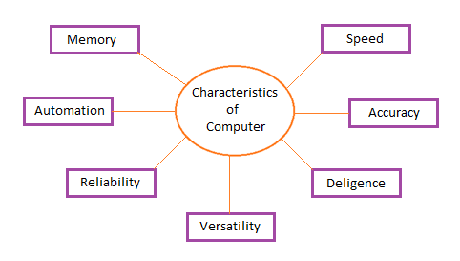

**Speed**

A computer works with much higher speed and accuracy compared to humans while performing mathematical calculations. Computers can process millions (1,000,000) of instructions per second. The time taken by computers for their operations is microseconds and nanoseconds.

**Accuracy**

Computers perform calculations with 100% accuracy. Errors may occur due to data inconsistency or inaccuracy.

**Diligence**

A computer can perform millions of tasks or calculations with the same consistency and accuracy. It doesn’t feel any fatigue or lack of concentration. Its memory also makes it superior to that of human beings.

**Versatility**

Versatility refers to the capability of a computer to perform different kinds of works with same accuracy and efficiency.

**Reliability**

A computer is reliable as it gives consistent result for similar set of data i.e., if we give same set of input any number of times, we will get the same result.

Automation

Computer performs all the tasks automatically i.e. it performs tasks without manual intervention.

**Memory**

A computer has built-in memory called primary memory where it stores data. Secondary storage are removable devices such as CDs, pen drives, etc., which are also used to store data.

**GENERATION OF THE COMPUTERS**

There are totally Five Computer Generations till today. Discussed as following.

**First Generation (1942-1955)**

**Technology: vacuum tube**

* Used as a calculating device.
* Performed calculations in milliseconds.
* To bulky in size & complex design.
* Required large room to place it.
* Generates too much heat & burnt.
* Required continuously hardware maintenance.
* Generates much heat so must air-conditioner rooms are required.
* Commercial production is difficult & costly.
* Difficult to configure.
* Limited commercial use.
* ENIAC, EDVAC, EDSAC are example of 1st generation computer.

**Second Generation (1955-1964)**

**Technology: transistor**

* 10 times Smaller in size than 1st generation system.
* Less heat than 1st generation computers.
* Consumed less power than 1st generation system.
* Computers were done calculations in microseconds.
* Air-conditioner is also required.
* Easy to configure than 1st generation compuMore reliable in information.
* Wider commercial use.
* Large & fast primary/secondary storage than 1st generation computers.

**Third Generation (1965-1975)**

**Technology: IC chip**

* Smaller in size than 1st & 2nd generation computers.
* Perform more fast calculations than 2nd generation systems.
* Large & fast primary/secondary storage than 2nd generation computers.
* Air –conditioner is required.
* Widely used for commercial applications.
* General purpose computers.
* High level languages like COBOL & FORTAN are allowed to write programs.
* Generate less heat & consumed less power than 2nd generation computer.

**Fourth Generation (1975-1989)**

**Technology: Microprocessor chip**

* Based on LSI & VLSI microprocessor chip.
* Smaller in size.
* Much faster than previous generations.
* Minimum hardware maintenance is required.
* Very reliable as computer to previous generation computers.
* Totally general purpose computer.
* Easy to configure.
* Possible to use network concept to connect the computer together.
* NO requirement of air-conditioners.

**Fifth Generation (1989 to Present)**

**Technology: ULSI microprocessor chip**

* Much smaller & handy.
* Based on the ULSI chip which contains 100 million electronic components.
* The speed of the operations is increased.
* Consumed less power.
* Air-conditioner is not required.
* More user friendly interface with multi-media features.
* High level languages are allowed to write programs.
* Larger & faster primary/secondary storage than previous generations.
* Notebook computers are the example of 5th generation computers.

**Classification of Digital Computer**

**What is a Digital Computer?**

* Digital Computer is a machine or a device that helps to process any kind of information.
* These are the devices through which we provide some input and get the output within a fraction of seconds.
* The operations that are conducted internally in the device happens using the binary number system since the computer understands only digits ie 0’s and 1’s.

**There are mainly three parts in a digital computer and it consists of –**

* **Input:** User normally provides the data to the device that is known as input.
* **Processing:** The input that is provided by the user is processed internally using some defined sequence**.**
* **Output:** Once the processing is completed, based on the input, the output is displayed to the user

**Different types of Digital Computer**

Digital computers are a device that needs to be programmed in order to receive the desired output.

It uses electronic technology to generate, store and process different types of data. Digital computers are classified into four categories.

* Microcomputer
* Minicomputer
* Mainframe computer
* Supercomputer

**Microcomputer**

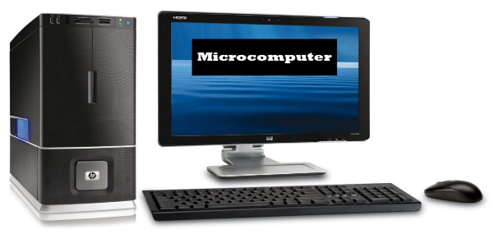

* A Microcomputer is not really expensive and it comes with a microprocessor as its Central processing unit and input/output devices.
* These computers are generally called personal computers and few of the examples are IBM pc, Apple, Dell.

**Minicomputers**

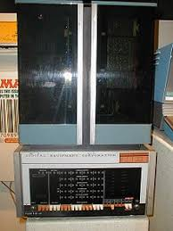

* Minicomputers are known as mid-range computers that contain one or more processors.
* They support multiprocessing which means these multiple processors share the same computer memory and other required peripheral devices to perform the given task.
* Minicomputers are generally used for processing transactions, file handling, managing database.

**Mainframe computers**

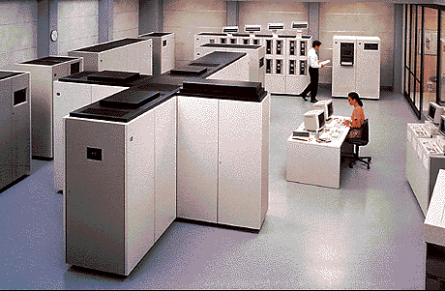

* Mainframe computers are generally large size computers mainly used for storing large amounts of data and processing. It is known for a high level of reliability.
* These machines are used by an organization which requires crucial application such as census, customer statistics for large calculation which requires a high volume of data processing.

**Super Computers**

* Supercomputers are very expensive and the world’s fastest computers available.
* These computers have thousands of processors that perform trillions of calculations per second and hence the fastest known ever.
* Supercomputers are used extensively in enterprises and organizations that require massive calculations.

**Personal Computers**

* Used at home
* Used in Educations Institutions and Organizations as nodes
* Can perform typical activities like documentation, playing games, surfing web to more complex activities as programming, design, DTP etc.

**Network Computers**

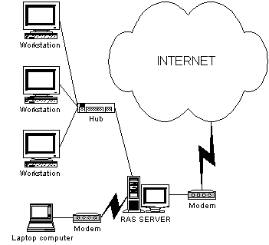

* Collection of PCs
* Additional Network Interface Card
* Can share the information, work from anywhere environment
* LAN – WAN – MAN – Internet
* Uniting the World

**Laptops**

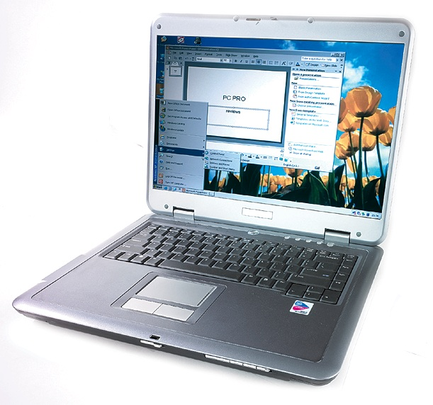

* Same as PCs in functionality
* More Compact, Portable
* Less Power requirement, operated on battery/s
* Less capacity compared to PCs
* Maintenance and actually are costlier compared to PCs
* Theft prone

## Analog Computer

* Analog computers are mainly based on voltages and current with continuous electrical signals and display the output continuously.
* These computers store the data and perform calculations quite differently than digital computers which make use of symbolic representation.
* These are generally slower in speed compared to digital computers. Some of the examples are thermometer.

**Hybrid Computers**

* Hybrid computers are a special purpose computer that has a combination of both Analog and digital computers.
* They are digital computer which accepts Analog signals and converts them to digital form.
* These are generally used for scientific applications, airplanes, and hospitals.
* Some of the examples include electrocardiogram machine, ultrasound machine, monitoring machine

**Anatomy of Digital Computer**

All computers, regardless of their implementing technology, have five basic parts or subsystems:



* 1. Memory,
  2. Control unit,
  3. Arithmetic/logic unit (ALU),
  4. Input unit, and
  5. Output unit

**Memory**

* Memory stores both the program while it is running and the data on which the program operates
* **Properties of memory:**
  + Discrete locations
    - Memory is organized as a sequence of discrete locations
    - In modern memory, each location is composed of 1 byte (8 bits)
* **Addresses**
  + Every memory location has an address, whole numbers starting at 0
* **Values**
  + Memory locations record or store values
* **Finite capacity**
  + Memory locations have a finite capacity (limited size),
  + Data may not “fit” in the memory location

**Random Access Memory**

* Computer memory is called random access memory (RAM)
  + “Random access” is out-of-date and simply means that the computer can refer to the memory locations in any order
* RAM is measured in megabytes (MB) or gigabytes (GB)
* Lots of memory is need to handle the space required of programs and data

**Control Processing Unit**

* It transforms raw data into useful information is called “Processing”.
* components are needed to transform the data.
  + - Memory
    - Processor
* Processor is brain of computer, it organizes and caries out the information.
* Processor consists of one or more microprocessors.
* The microprocessor is plugged into a circuit board.
* The circuit board to which the microprocessor is connected is called “motherboard”.
* The Term CPU refers to a computer processing hardware, whether it consist of a single chip or several circuit boards.

**Input and Output Units**

* These two components are the wires and circuits through which information moves into and out of a computer
* A computer without input or output is useless

**Input Devices:**

The devices which are used to entered data in the computer systems are known as input devices.

* *Keyboard, mouse, scanner, mike, light pen etc are example of input devices.*

***Function of input devices***

* Accept the data from the outside worlds.
* Convert that data into computer coded information.
* Supply this data to CPU for further processing.

**Output Devices**

* The devices which display the result generated by the computer are known as output devices.
* *Monitor, printer, plotter, speaker etc are the example of output devices.*

***Functions of output devices***

* Accept the result form the CPU.
* Convert that result into human readable form.
* Display the result on the output device.