Principles of Information of Technology
Unit 2
CPU AND MEMORY
Central Processing Unit (CPU)
- CPU is considered as the brain of the computer.
- CPU performs all types of data processing operations.
- It stores data, intermediate results, and instructions (program).
- It controls the operation of all parts of the computer.
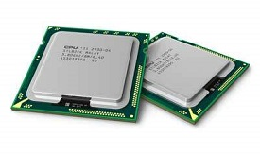
CPU has three components.
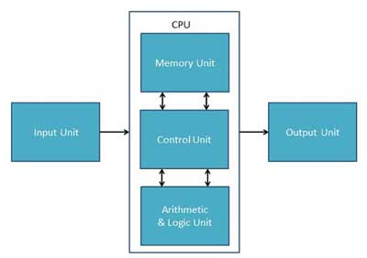
- Memory or Storage Unit
- Control Unit
- ALU(Arithmetic Logic Unit
Memory or Storage Unit
Memory unit can store instructions, data, and intermediate results. This unit supplies information to other units of the computer when needed. It is also known as internal storage unit or the main memory or the primary storage or Random Access Memory (RAM).

Its size affects speed, power, and capability. Primary memory and secondary memory are two types of memories in the computer. Functions of the memory unit are −
- It stores all the data and the instructions required for processing.
- It stores intermediate results of processing.
- It stores the final results of processing before these results are released to an output device.
- All inputs and outputs are transmitted through the main memory.
Control Unit
Control unit controls the operations of all parts of the computer but does not carry out any actual data processing operations.
Functions of this unit are
- It is responsible for controlling the transfer of data and instructions among other units of a computer.
- It manages and coordinates all the units of the computer.
- It obtains the instructions from the memory, interprets them, and directs the operation of the computer.
- It communicates with Input/Output devices for transfer of data or results from storage.
- It does not process or store data.
ALU (Arithmetic Logic Unit)
This unit consists of two subsections namely,
- Arithmetic Section
- Logic Section
Arithmetic Section
Function of arithmetic section is to perform arithmetic operations like addition, subtraction, multiplication, and division. All complex operations are done by making repetitive use of the above operations.
MEMORY
Memory in a computer system is required for storage on subsequent retrieval of the instructions and data. Memory measured in bytes.
- 8 bits - 1 Byte (BIT stands for Binary Digit. That means 0 and 1)
- 1024 Bytes - 1 KB (Kilo Byte)
- 1024 K Bytes - 1 MB (Mega Byte)
- 1024 M Bytes - 1 GB (Giga Byte)
- 1024 G Bytes - 1 TB (Tera Byte)
In computers there are two types of memories.
1). PRIMARY MEMORY (OR) MAIN MEMORY:
- Primary memory consists of semiconductor memory chips and is used to store the data and programs currently in used.
- Each storage element of memory is directly (Randomly) accessible and can be examined and modified without effecting other cells and hence primary memory is also called RAM (Random Access Memory).
- Main memory stores a variety of critical information required for processing the CPU.
- The memory unit stores all the information in memory cells also called memory locations in binary digits. Each memory location has a UNIQUE address. T
- The RAM is a volatile memory.
2). SECONDARY MEMORY (OR) AUXILIARY MEMORY:
- Secondary memory is used to store the information permanently.
- is non-volatile memory. This is also called auxiliary or permanent memory.
- The devices which are used for permanent memory are called as secondary storage medias. Which is external to a computer.
- The following are some of the commonly available categories of secondary storage devices.
SECONDARY STORAGE DEVICES
MAGNETIC TAPES
There are used as external storage devices apart from being used as high speed input and output devices. These devices use a tape which is about 12.5mm to 25mm wide and about 500 meters to 1200 meters long. This tape is usually made of a plastic known as mylar. This tape is quite similar to the audio cassette tape. The tape is coated with very thin layer of iron oxide, a magnetic material.

MAGNETIC DISKS
Magnetic disks are very popular means of secondary storage. A magnetic disk is usually made up of plastic like material called mylar coated with ferromagnetic materials. These disks come in various sizes. These magnetic disks can be divided into two major categories. They are:
a). floppy disks
b). fixed or hard disks
All these disk surfaces are composed on concentric circles called tracks. Data is stored on these tracks. The tracks are further divided into sectors.
FLOPPY DISKS:
A floppy disk is small, flexible, faster and cheap alternative to storage using magnetic film. This was developed in early 1970's, is one of the popular media for data storage. This disk is made up of flexible plastic material, coated with magnetic materials like ferrous oxide. The floppy disk is packed in protective paper or plastic envelope. All the disks have two sides. Floppy diskette comes in two basic sizes at present as follows:
a). 5 1/4 inch floppy disk (mini floppy)
b). 3 1/2 inch floppy disk (micro floppy)

HARD DISK
- Hard disk also called as fixed disk. These fixed disk is usually made from aluminum or other materials instead of mylar or other plastic like material.
- These are non-removable disks,which typically holds 10 MB to 160 GB of data. These are provide substantially fasterdata access compared to floppy disk and provide very large data storage for on-line retrieval.
- These disks have multiple platters, which are stacked vertically, normally at a distance of an inch. This is known as a disk pack.
- A disk pack can contain multiple heads mounted with the same arm. This entire pack is called as Hard Disk Drive.

OPTICAL DISKS
Optical disks are alternate mass storage devices with huge capacity. In optical storage devices the information is written using laser beam. These devices which are memories can store large amount of data. Ex: CD (Compact Disc), DVD (Digital Versatile Disc)

COMPACT DISC
The compact disc is creating revolution in the secondary storage media. In CD's the information is stored evenly across the disk in segments of the same size. As discussed earlier, the data is stored sequentially along a spiral track.
In this disc random access becomes more difficult because locating a desired address involves first moving the head to the specific area then adjusting the rotation speed and then reading the address, and then to find and access the specific sector.

Input Devices
What is input devices?
- The Input devices are the devices which are used to enter the data in the computer system.
- Keyboard, mouse, scanner, microphone are the example of input devices.
Functions of input devices:
- Accept the data from the outside worlds.
- Convert that data into computer coded information.
- Supply this data to Central Processing Unit for further processing.
Classification of input devices:
Input Devices
MOUSE
TRACK BALL
JOYSTICK
LIGHT PEN
TOUCH SCREEN
MICROPHONE
SCANNER
CAMERA
KEYBOARD
SPECIAL INPUT
DEVICES
POINTING
DEVICES
STANDARD
INPUT DEVICE

STANDARD INPUT DEVICE
KEYBOARD
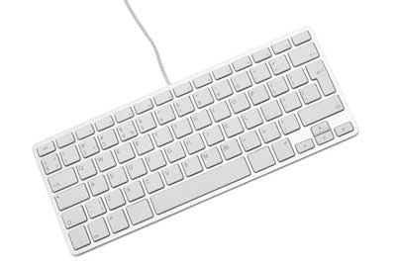
- Keyboard is most commonly used input device.
- It is similar like a type writer which is used to enter data in the computer.
- It contains sets of keys such as alphabets, number & special signs.

POINTING DEVICES
MOUSE
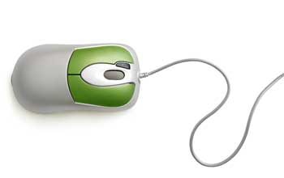
- Mouse is Small hand-hold device Input device which is generally used for drawing purpose.
- It’s a Pointing device.
- It contains two or three buttons
- Left button is used to point out or select any item by clicking.
- Right to generate context menu.
- When user moves mouse across flat surface, the graphic cursor moves on screen.
- Graphic cursor contains verity of symbols such as arrow, wrist, pointing finger etc.
- Depending on application text & graphic cursors are changed.
TRACK BALL
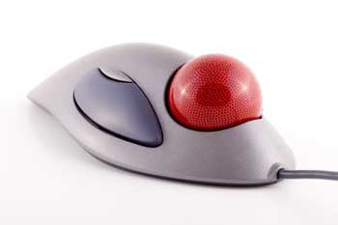
- Trackball is a pointing device which is similar to a mouse.
- A ball is placed on the track ball device which is used to move the graphic cursor on the screen.
- It also contains buttons which are used to select a particular item on the screen.
- To move the graphic cursor on screen, the ball is rolled with the fingers or thumb.
- It needs not to move the whole device to move the cursor so it is often attached with some keyboards.
- Track balls come in various shapes with same functionality.
- Commonly three shapes are used: ABALL, A SQUARE, and A SQUARE.
- In case of ball we need to move it with the help of finger.
- In case of button pushed with finger in desired direction of the cursor movement.
- In case of button press finger to up or down & left or right to move cursor.

Advantages of track ball
- Takes less desk space.
- Takes less arm movements than mouse.
- Doesn’t require any mouse pad & large area to move the mouse.
- Less strain on the wrist.
- Finger trip control which may offer more accuracy than mouse.
JOYSTICK
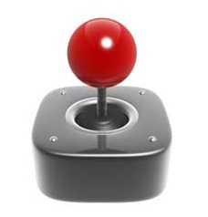

- Joystick is a pointing device which is works on the same principle of track ball.
- It contains a stick which is placed on the spherical ball.
- The stick is used to move the cursor at desired position left or right or backward or forward.
- It also contain button that is clicked to make selection of currently pointed item.
- A joystick is similar to a mouse, except that with a mouse the cursor stops moving as soon as you stop moving the mouse.
- With a joystick, the pointer continues moving in the direction the joystick is pointing.
- To stop the pointer, you must return the joystick to its upright position.
- Some of the systems using joysticks are Aircrafts, UAVs for flight control Motorized Wheelchairs as input device Microscopes, Submarines, Security Systems, Video Games
- Joysticks are widely used for video games
Advantages of joystick
- It is very easy to learn to use.
- Very simple design so they can be inexpensive.
- It has a big analogue stick in the middle so it’s easier to control.

LIGHT PEN
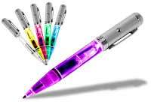
- Light pen is a pointing device which is used to draw directly draw on the screen.
- It is called light pen because it is similar to a pen & senses light.
- It’s an input device in the form of light-sensitive stick used in conjunction with a CRT display.
- The light pen allows the user to point out or draw any object on the screen.
- The user brings the pen to the desired point on screen and presses the pen button to make contact.
- It has a switch on its top which allows the user to make contact with screen.
- It is useful for drawing or graphics in the program such as CAD(computer aid design).
- An engineer, architect or fashion designer can draw directly on screen.
- Used in application such as gaming, graphic arts, healthcare applications etc.
- Light pen cannot scratch or damage a screen.
Advantages of light pen
- Less expensive than touch screen.
- give the user the full range of mouse capabilities, without the use of a pad
- or any horizontal surface
- Cannot scratch or damage screen.
- Works on any size screen.
TOUCH SCREEN
- Touch screen is a pointing device.
- It is most simple & easiest to learn of all input devices
- It allows the user to choose from available options by simply touching with their figure to the desired icon or menu item displayed on the computer screen.
- A touch screen is an electronic visual display that can detect the presence and location of a touch within the display area.
- The term generally refers to touching the display of the device with a finger or hand.
- Touch screens are common in devices such as computers, tablet computers & Smartphone.

DIGITIZER
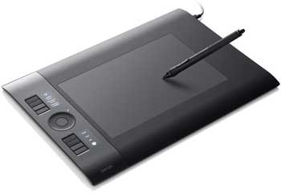
- An input device Used for converting pictures, map & drawing into digital form.
- Allows one to hand-draw images and graphics, similar to the way one draws images with a pencil and paper.
- Also be used to capture data or handwritten signatures.
- The device consists of a flat surface upon which the user may "draw" an image using an attached stylus, a pen-like drawing tool.
- These devices are usually connected via a Serial port.
- Placed on the desk n connected with the computer.
- Digitizer consists of graphic tablets which are associated with a stylus.
- The stylus is like a pen with a button.
- Stylus connected with a tablet and can press down at a point on the tablet to input (x, y) co-ordinates of point.
- It contains hundreds of copper wires forming a grid that receives electric pulsed.
- When stylus moves on tables the cursor on screen moves simultaneously.
- Allows the user to draw sketches directly.
- Commonly used in CAD by architects & engineers.

SPECIAL INPUT DEVICES
MICROPHONE
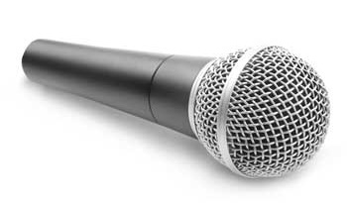
- It’s an input device.
- Used to stores the voice data into the computer system.
- Microphones are a type of transducer - a device which converts energy from one form to another.
- Microphones convert sound waves into electrical energy.
- Different types of microphone have different ways of converting energy.
- All the microphones share one common thing: The diaphragm.
- Thin piece of material (such as paper, plastic or aluminium) which vibrates when it is struck by sound waves.
- When the diaphragm vibrates, it causes other components in the microphone to vibrate.
- These vibrations are converted into an electrical current which becomes the audio signal.
- The microphones are divided in mainly two types
- The type of conversion technology they use
- This refers to the technical method the mike uses to convert sound into electricity.
- The most common technologies are dynamic, condenser, ribbon and crystal.
- The type of application they are designed for some mikes are designed for general use and others are much specialised purpose.
WEB CAMERA
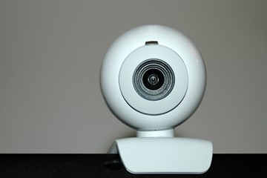
- It’s an input device.
- Used to feeds the image to a computer or computer network often via USB or Wi-Fi.
- A webcam is a video camera that feeds its image in real time to a computer or computer network.

OUTPUT DEVICES
WHAT IS OUTPUT DEVICE?
- The output devices are the devices which are used to display the result generated by the computer system.
- Monitor, printer, plotter, speaker are the example of output devices.
FUNCTIONS OF OUTPUT DEVICES
- Accept the result from the CPU.
- Convert that result into human readable form.
- Supply this result to output device.
Monitor
Monitor is the most common computer output device. It creates a visual display by the use of which users can view processed data. Monitors come in various sizes and resolutions.
Common Types of Monitors
- Cathode Ray Tube – this uses phosphorescent dots to generate the pixels that constitute displayed images.
- Flat Panel Screen – this makes use of liquid crystals or plasma to produce output. Light is passed through the liquid crystals in order to generate pixels.
All monitors depend on a video card, which is positioned either on the computer motherboard or in a special expansion slot. The video card sorts out the computer data into image details that the monitors can then show.
Printer
Printer is the device generates a hard copy version of processed data, like documents and photographs. The computer transmits the image data to the printer, which then physically recreates the image, typically on paper.
Types of Printers
- Ink Jet – this kind of printer sprays tiny dots of ink onto a surface to form an image.
- Laser – this type utilises toner drums that roll through magnetized pigment, and then transfers the pigment onto a surface.
- Dot Matrix – dot matrix printers utilise a print head to set images on a surface, using an ink ribbon.
Speakers
Speakers are attached to computers to facilitate the output of sound; sound cards are required in the computer for speakers to function.
The different kinds of speakers range from simple, two-speaker output devices right the way up to surround-sound multi-channel units.
Headset
Headset is a combination of speakers and microphone. It is mostly used by gamers, and is also a great tool for communicating with family and friends over the internet using some VOIP program or other.
Projector
Projector is a display device that projects a computer-created image onto another surface: usually some sort of whiteboard or wall. The computer transmits the image data to its video card, which then sends the video image to the projector. It is most often used for presentations, or for viewing videos.
Plotter
Plotter generates a hard copy of a digitally depicted design. The design is sent to the plotter through a graphics card, and the design is formed by using a pen. It is generally used with engineering applications, and essentially draws a given image using a series of straight lines.

