BHARATHIDASAN UNIVERSITY TIRUCHIRAPPALLI- 620 024

ENVIRONMENTAL STUDIES 19UGCES

(Applicable to the candidates admitted from the Academic year 2019-20 onwards)

By

Dr. N. PRAKASH, M.Sc., M.Phil., B.Ed., Ph.D.,
HOD & Assistant Professor
Department of Chemistry
Annai Vailankanni Arts and Science College
Thanjavur-07

Unit: 3
Ecosystems
Ecosystem
The interaction of all the living and non- living factors interact themselves of any particular environment exchanging energy and matter.
Ecology
The study of interactions among organism or group of organism with their environment. The environment consists of both biotic and abiotic components.
Biome
There are many set of ecosystems which are exposed to same climatic conditions and having dominant species with similar life cycle, climatic adoptions and physical structure. This set of ecosystem is called Biome.
Biome is a small ecosystem with in an ecosystem.

Types of Ecosystem

Ecosystem

Artificial (or) Manmade
Eg: Croplands, dams.

Natural

Aquatic
Terrestrial

Fresh water
Marine

Lentic (Standing)
Eg: Lake, pond
Lotic (running)
Eg: Stream, rivers

Structure (or) Components of an Ecosystem
Structure of an ecosystem explains the relationship between biotic and abiotic components.
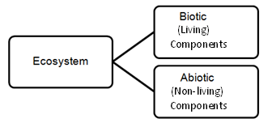
1. Biotic components
The living organisms of an ecosystem are known as biotic components which include plants, animals and micro organisms like bacteria, fungi etc.

i) Producers(Autotrophs)
Producers are Organisms that produce their own food from energy source, such as the sun, and inorganic compounds.
  - Photosynthesis- Photo autotrophs Eg : Plant
  - Chemosynthetic-Chemo autotrophs Eg: Sulphur bacteria
ii) Consumers(Heterotrophs)
Consumers are Organisms that consume other organisms as a food source.
a) Herbivores (Primary consumers) - Plant eaters
Eg.– Cows, Elephants, Giraffes
b) Carnivores (Secondary & Tertiary consumers) - Meat eaters
Eg.- Secondary- Frog, Tertiary- Lion , Tiger, Shark
c) Omnivores – Eat both plants and animals
Eg. – Bears, Humans, rats and fox
d) Detritivores -Feed on the part of dead organisms, wastes of living organisms(both plants &animals)
Eg. – Vultures, Crows, earthworms, ants
iii) Decomposers:
- Feed on dead organisms.
- Breaking down the complex organic molecules to simpler organic compounds and return the nutrients to the soil.
Eg. – Bacteria, fungi and Mushrooms

- Abiotic components:
The non-living components of an ecosystem are called Abiotic components.
- Organic substances-protein, fats, amino acids, carbohydrates.
- Inorganic substances-water, oxygen, hydrogen, nitrogen etc.,
- Physical factors-light, temperature, wind, and humidity.

The Functions of an Ecosystem
The major functional attributes of an ecosystem includes
  - Food chain, food web and Tropic structure
  - Energy flow
  - Cycling of matters (chemicals)
  - Primary and Secondary production
  - Ecosystem development and regulation
Primary Function (or) Production:
Primary function of all ecosystem is Manufacture of Starch.
Secondary Function (or) Production:
Secondary function of all ecosystem is distributing energy in the form of food.
Tertiary Function:
Tertiary function of all ecosystem is Cycling.
Food Chain
The sequence of eating and being eaten in an ecosystem is known as food chain.
Food Web
The interlocking pattern of various food chain in an ecosystem is called food web.
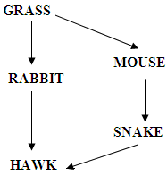

Ecological Pyramids
- Ecological pyramid is defined as graphical representation of tropic structure and function of an ecosystem.
- It starts from producers at the base and successive tropic level forming the apex is known as an ecological pyramid.
Ecological pyramids are of three types,
    - Pyramid of Numbers
    - Pyramid of Biomass
    - Pyramid of Energy

i. Pyramid of Numbers
It represents the number of individual organisms at each tropic level. It may be upright or inverted pyramid
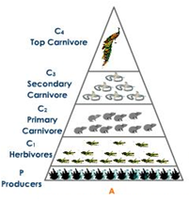
ii. Pyramid of Biomass
It is based on the total biomass (in grams per square meter of area) at each tropic level in a food chain

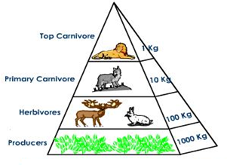
iii. Pyramid of Energy
At every successive tropic level, there is a heavy loss of energy (about 90%) in the form of heat only 10% of the energy is transferred.
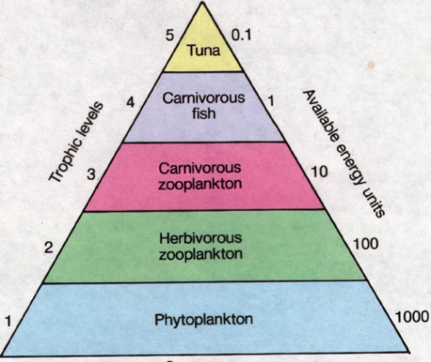

Energy flow in an ecosystem
- Energy is the most essential requirement for all living organisms.
- Solar energy is the only source of our earth.
- Solar energy is transformed into chemical energy in photosynthesis by the plants.
- This is the most essential step to provide energy for all living organisms in the ecosystem.
- Some amount of energy is used by the plants for their growth and the remaining is transferred to consumers.
The conversion of solar energy is governed by law of thermodynamics.
First Law:
Energy can neither be created nor be destroyed, but it can be converted from one form to another.
Here, solar energy is converted into Chemical energy.
Second Law:
Whenever the energy is transformed, there is a loss of energy through the release of heat.
- Glucose is stored as starch in plants.
- Autotrophs take the energy of the sun and pass some of this energy onto consumers through food chains.
- The energy contained within producers and consumers is ultimately passed to the decomposers that are responsible for the constant recycling of nutrients.
- Energy flow cannot occur in reverse direction, there is a one-way flow of energy through the biotic community.
- The amount of energy decreases with successive tropic levels.
- At every successive tropic level, there is a heavy loss of energy (about 90%) in the form of heat, therefore only 10% of the energy is transferred.
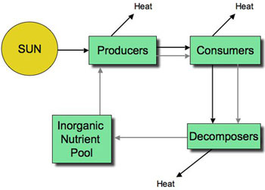
Tropic level
The various steps through which food energy passes in an ecosystem are called as tropic levels.
The tropic levels are arranged in the following way as
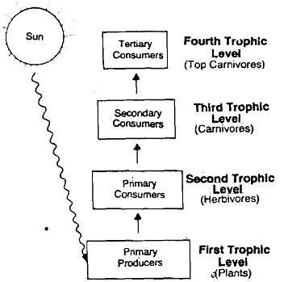

Nutrient cycles
Nutrient like carbon, nitrogen, sulphur, oxygen, hydrogen, phosphorus etc. move in circular paths through biotic and abiotic components and are called as Bio-geochemical cycles )or) Nutrient cycle.

Hydrological Cycle
Movement of water in a cyclic manner is known as hydrological cycle.
Nitrogen cycle
- Nitrogen is present in all biotic components in different forms of food like Proteins, Vitamins and Amino acids etc.
- Nitrogen is present in Atmosphere as 78 %.
- Nitrogen from the atmosphere is taken by the green plants as a raw material for the biosynthesis of different food and used in metabolism.
- These food moves through the food chain.
- After the death of plants and animals the organic nitrogen in dead tissues is decomposed by micro organisms into ammonia, nitrites and nitrates which is again used by the plants.
- Some bacteria convert nitrates into molecular nitrogen released back into atmosphere and the cycle goes on.
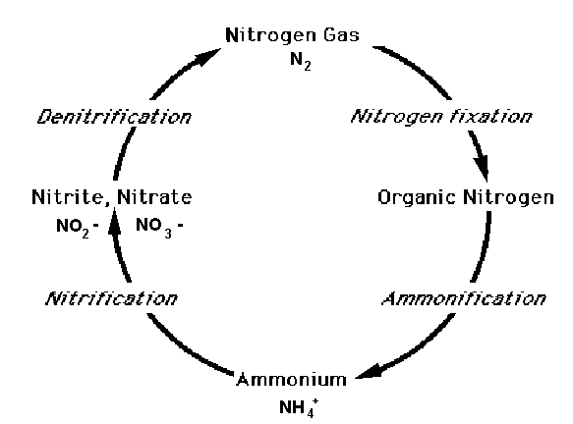
Nitrogen Fixation
Conversion of N₂ → NH₃
Combustion, volcanic action, Lightning, Industrial processes (making fertilizer).Bacteria (Azotobactor, Clostridium, Nostoc etc.)
Nitrification
Conversion of NH₃ → NO₃ by using nitrifying bacteria.
Ex : Nitrobacter.
Ammonification
Amino acids and nucleotides are broken down into waste products NH₃ or NH₄
Denitrification
The conversion of NO₃ into N₂ by denitrifying bacteria.
Ex: Pseudomonas
The Oxygen Cycle
- Oxygen cycle is a cycle that helps the movement of oxygen through three main regions of the earth.
- Almost all living things need oxygen. They use this oxygen during the process of creating energy in living cells.
- Oxygen cycle play an important role in helping to project and maintain life on the earth.
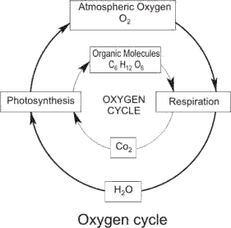
The Atmosphere:
- Region of gases that lies above the earth’s surface is called atmosphere.
- Plants mark the beginning of the oxygen cycle.
- Plants use the energy of sunlight to convert carbon dioxide and water into carbohydrates and oxygen in a process called photosynthesis.
6CO₂+ 6H₂O+ hν ------- >(C₆H₁₂O₆) Carbohydrates +6O₂

- This means that plants "breathe" in carbon dioxide and "breathe" out oxygen.
The Biosphere:
- Biosphere is the sum of all the earth’s ecosystem.
Animals form the other half of the oxygen cycle.
- We breathe in oxygen which we use to break down carbohydrates into energy in a process called respiration.
- Carbon dioxide produced during respiration is breathed out by animals into the air.
- So oxygen is created in plants and used up by animals.
The Lithosphere:
- Soil and rock components of earth are called lithosphere.
- The largest reservoir of oxygen is lithosphere.
- Here oxygen is present as silicates and oxides.
- When oxygen bearing mineral is exposed to the elements, a chemical reaction occurs and produces free oxygen.

ECOLOGICAL SUCCESSION
` “The Progressive replacement of one community by another till the development of stable community in a particular area is called Ecological Succession”.
Stages of Ecological Succession:
Pioneer Community:
First group of organism which establish their community in an area.
Seres (or) Seral Stage:
Various developmental stages of a community is called seres.
Types of Ecological Succession:
Primary Succession:
Involves the gradual establishment of biotic communities on a lifeless ground.
- Hydrach –Establishment starting in water area like pond, lake etc.
- Xerarch- Establishment starting in a dry area like desert, rock etc.
Secondary Succession:
Involves the establishment of biotic communities in an area, where some type of biotic community is already present.
Process of Ecological Succession
1. Nudation
- This is the development of bare area without any life form.
- The bare area may because due to volcanic eruptions, floods, landslides .
2.Invasion
Establishment of one or more species on bare area through migration followed by establishment.
- Migration:
Migration of seeds is brought about by wind, water or birds
- Establishment:
The seeds then germinate and grow on the land and establishes their pioneer communities
3. Competition
As the number of individuals grows there is a competition for space, water and nutrition etc,
4. Reaction
The living organisms, take water, nutrients and grow and modify the environment is known as reaction
5. Stabilization
The succession ends with stable community called “Climax”, which is in equilibrium with environment.
TYPES OF ECOSYSTEM
- Forest ecosystem
- Grassland ecosystem
- Desert ecosystem
- Aquatic ecosystems (Lake , Pond and Ocean)
Forest Ecosystem
- Forests are found in undisturbed areas receiving moderate to high rainfall.
- Forest occupies 40% of world’s land area. In India only 19%
Types of forest ecosystem:
Depending upon the climatic conditions forests can be classified in to various types.
- Tropical rain forests
- Tropical deciduous forest
- Tropical scrub forests
- Temperate rain forests
- Temperate deciduous forests
Tropical rain forests:
- They are found near the equator
- They are characterized by high temperature high humidity and high rain fall.
- Throughout the year climate is uniform they have broad leaf trees like and sandal
Animals: Lion, tiger, monkey and very large flowers are present .
Eg: Silent valley in Kerala.
Tropical deciduous forest:
- They are found a little away from the equator
- Characterized by warm climate and rain is only during monsoon.
- A large part of the year remains dry and therefore difference types of deciduous tress like maple, oak, and hickory who lose their leaves during dry season.
Animals: Deer, fox, rabbit, and rat are present.
Tropical scrub forests:
- They are characterised by dry season for longer time.
- Here small deciduous trees and shrubs are present.
Animals: Deer, fox .
Temperate rain forests:
- They are found in temperate areas with adequate rainfall.
- They are dominated by coniferous trees like, pines firs, redwoods
Animals: Squirrels fox, cats, bear etc.
Temperate deciduous forests:
- They are found in areas with moderate temperatures
- There is a marked seasonality with long summer, cold but severe winter and abundant rainfall throughout the year
- The major trees include broad leaf deciduas trees like oak, hickory.
Animals: Deer, fox, bear.
Characteristics of Forest Ecosystem:
- Forests are characterised by warm temperature and adequate rainfall.
- It maintains climate and rainfall.
- It supports many wild animals and protects biodiversity.
- Soil is rich in organic matter and nutrients. So is support for growth of trees.
- Penetration of light is so poor so, the conversion of organic matter into nutrients is very fast.
Structure and function of Forest Ecosystem
I. Biotic components: Living components of an ecosystem.
1.Producer –They synthesis their own food.
Ex: Trees, shrubs.
2. Consumers
a) Primary Consumers-These are Herbivores which feed directly on producers.
Eg:Ants, Beetles,
b)Secondary Consumers-These are carnivores and feed on primary consumers.
Eg: Birds, frog
c)Tertiary Consumers-These are secondary carnivores and feed on secondary consumers.
Eg: Lion.
3.Decomposers -They attract the dead or decayed bodies of organisms & decomposition takes place.
Eg: Bacteria, fungi etc
II. Abiotic components : Non living components of an ecosystem.
These include basic inorganic & organic compounds present in the soil & atmosphere.

Grassland Ecosystem
- Grassland occupies 20% of earth’s surface.
- In addition to grasses some trees and shrubs also present here.
- Limited grazing improve the net primary production of starch.
- Overgrazing leads to degradation of grasslands resulting in desertification.
Types of grassland ecosystem:
Depending upon the climatic conditions grassland can be classified into
1.Tropical grasslands
2. Temperate grasslands
3. Polar grasslands
Tropical grasslands :
- They found near the borders of tropical rain forests
- They are characterized by high temperature and moderate rainfall (40-100cm)
- They have tall grasses with scattered shrubs, stunted trees
Animals: Zebras, giraffes, antelopes
Temperate grasslands:
- They are usually found in the centers of continents on flat, sloped hills.
- Characterised by very cold winters and hot summers.
- Evaporation rate is high
- Intense grazing and summer fires do not allow shrubs or trees to grow.
Polar grasslands:
They are found in arctic Polar Regions, have severe cold, strong winds with ice and snow.
Animals: Arctic wolf, weasel, arctic fox etc
Charactersistics of Grassland Ecosystem:
- Grassland ecosystem is a plain land occupied by grasses.
- Soil is rich in nutrients and organic matter.
- It is an ideal place for grazing animals.
- It is characterized by low or uneven rainfall.

Structure and function of Grassland Ecosystems
I. Biotic components: Living components of an ecosystem.
1. Producer -In grassland, producers are mainly grasses;
Eg: herbs & shrubs.
2.Consumers -In grassland, consumers are of three main types;

a.Primary Consumers-The primary consumers are herbivores feeding directly on grasses.
Eg : Cows.
b.Secondary Consumers-These are carnivores that feed on primary consumers
Eg: Fox.
c.Tertiary Consumers–These are feed on secondary consumers.
Eg: Eagles.
3.Decomposers -They attract the dead or decayed bodies of organisms & decomposition takes place.
Eg: Fungi, bacteria
II. Abiotic components: Non living components of an ecosystem.
- These include basic inorganic & organic compounds present in the soil & aerial environment.
- The essential elements like C, H, N, O, P, S etc. are supplied by water, nitrogen, nitrates, sulphates, phosphates present in soil & atmosphere.

Desert Ecosystem
- Desert occupies 35% of world’s land area.
- It is characterized by less than 25cm rainfall.
- Atmosphere is dry hence it is a poor insulator.
Types of desert ecosystem:
Based on climatic conditions deserts are classified in to 3 types.
1.Tropical deserts
2. Temperate deserts
3. Cold deserts.
Tropical deserts:
Characterised by only few species, windblown sand dunes are very common.
Eg:Africa – Sahara.
India – Thar desert in Rajasthan
Temperate deserts :
Day time temperature is very hot in summer but very cool in winters
Eg: South California – Majave.
Cold deserts :
Cold winter warm summer
Eg: china – Gobi desert
Characteristics of Desert Ecosystems:
- Desert air is dry and the climate is hot.
- Annual rainfall is less than 25cm.
- Soil is very poor in nutrients and organic matter.
- Vegetation is poor.
Structure and Functions of Desert Ecosystems
I. Biotic components: Living components of an ecosystem.
1. Producer -In a desert, producers are mainly shrubs and bushes; some grasses & a few trees.
2. Consumer -These include animals such as insects, reptiles, etc.
These animals make dig holes in the ground to live in.
3. Decomposers - Due to poor vegetation with very low amount of dead organic matter, decomposers are poor in desert ecosystem.
II. Abiotic components
Due to high temperature & very low rainfall, the organic substances are poorly present in the soil.
Aquatic Ecosystems
- Aquatic ecosystems deal with biotic community present in water bodies.
- In terrestrial ecosystem, carbon dioxide & oxygen are present in gaseous form whereas in aquatic ecosystem, these are available in dissolved state.
- Depending upon the quality and nature of water, the aquatic ecosystem are categorized into:
    - Freshwater Ecosystem
    - Marine Ecosystem.
Freshwater Ecosystems
- Freshwater ecosystems cover 0.8% of the Earth's surface and contain 0.009% of its total water.
- Freshwater ecosystems contain 41% of the world's known fish species.
- Aquatic ecosystems perform many important environmental functions.
Eg: They recycle nutrients, purify water, attenuate floods, recharge ground water.
There are three basic types of freshwater ecosystems:
i.Lentic: standing water bodies including Pools, Ponds, and Lakes.
ii.Lotic: Running water bodies including Streams and Rivers.
iii.Wetlands: Areas where the soil is saturated with water

Lakes & pond Ecosystem
- A pond is a place where living organisms not only live but interact with biotic & abiotic components.
- Ponds are temporary, only seasonal.
- They are polluted easily due to limited amount of water.
- Lakes are usually big standing freshwater bodies.
- They have a shallow water zone called Littoral zone; an open water zone where effective penetration of solar light takes place, called limnetic zone and a deep water zone where light penetration is negligible, called profoundal zone.

Structure and function of lake & pond ecosystem
I. Biotic components: Living components of an ecosystem.
1. Producer -It includes submerged, free floating and
amphibious plants(like Hydrilla)
2.Consumers:
Primary consumers: These are zooplanktons and benthos.
Ex: protozoa, flagellates
Secondary consumers: These are carnivores like insects and fishes and feeding on herbivores.
Ex: Insects, small fishes.
Tertiary consumers: These are the large fishes feeding on small fishes.
3.Decomposers: They decompose the dead plants and animals.
Ex: Micro – organisms like bacteria, fungi and actinomyctes.
II. Abiotic component: Non living components of an ecosystem.
These are the inorganic as well as organic substances present in the bottom soil or dissolved in water.
River (or) Stream Ecosystem
- The running water of a stream or river is well oxygenated because it absorbs oxygen from the air.
- The number of animals are low in river or stream\
Characteristics of River or Stream:
- It is fresh and free flowing water systems.
- Due to mixing of water, dissolved oxygen content is more.
- River deposits large amount of nutrients.
Structure and function of stream (or) River ecosystem
Abiotic component: Non living components of an ecosystem.
Ex: Temperature, light, pH, nutrients, organic and inorganic nutrients.
Biotic components: Living components of an ecosystem.
- Producer -It includes phytoplankton, algae, water grasses and amphibious plants.
2.Consumers:
Primary consumers: They feed on phytoplankton.
Ex: Water insects, snails, fishes.
Secondary consumers: They feed on primary consumers.
Ex: Birds and mammals.
Tertiary consumers: These are the large fishes feeding on small fishes.
3. Decomposers: They decompose the dead plants and animals.
Ex: Micro – organisms like bacteria, fungi.
Marine or Ocean Ecosystem
- Marine ecosystems are largest one among the Earth's aquatic ecosystems.
- They include: Oceans, Estuaries and Lagoons, Mangroves and Coral reefs,
- These ecosystems are different from freshwater ecosystem mainly because of its salty water.
- The salt concentration in an open sea is usually 3.5%
- Average temperature of Marine ecosystem is 2-3 degree centigrade, devoid of light.
Structure and function of Marine or Ocean ecosystem
I. Biotic components: Living components of an ecosystem.
1. Producers -It includes phytoplankton’s and mangrove vegetation
Ex: Marine plants, Sea weeds etc.
2. Consumers
a)Primary consumers: These are herbivores and feed directly on producers
Ex: Crustaceans, fish
b) Secondary consumers: These are carnivorous fishes. They feed on herbivores.
Ex: Herring, Sahd
c)Tertiary consumers: These are top carnivorous fishes. They feed on small fishes.
Ex: Cod, Haddock
3.Decomposers: They decompose the dead organic matter.
Ex: Micro – organisms like bacteria, fungi
II. Abiotic components: Non living components of an ecosystem.
High Na, Ca, Mg and K salt concentration, variable dissolved oxygen content, light & temperature.
Estuarine Ecosystem
An estuary is a partially enclosed coastal area at the mouth of a river, where river joints the sea.
Characteristics of Estuarine Ecosystem:
- Estuaries are transition zones and are strongly affected by tides of the sea.
- Characteristics of water are periodically changed.
- Living organisms are wide tolerance.
- Salinity remains highest during the summer and lowest during the winter.
Structure and function of Estuarine Ecosystem:
I. Biotic components: Living components of an ecosystem.
1. Producers –Marsh grasses, sea weeds, sea grasses and phytoplankton.
2. Consumers – Oysters, crabs, sea birds, small fishes.
3.Decomposers: They decompose the dead organic matter.
Ex: Micro – organisms like bacteria, fungi
II. Abiotic components: Non living components of an ecosystem.
Ex: Temperature, pH, sodium and potassium salts, various nutrients etc.
Keystone Species
Within a habitat each species connects to and depends on other species. But, while each species contribute to habitat functioning, some species do more than others in the overall scheme of thing. Without the work of these key species, the habitat changes significantly. These species are called keystone species.
Ex: Elephants as keystone species in Grasslands.
……………………………

