Unit 5
Dividend
Meaning / definition:
- A sum of money paid regularly (may be annually) by a company to its shareholders out of its profits (or reserves). – Prof.Edward
- A dividend is the distribution of reward from a portion of the company's earnings and is paid to a class of its shareholders.
- Dividend refers to a reward, cash or otherwise, that a company gives to its shareholders. Dividends can be issued in various forms, such as cash payment, stocks or any other form.
Forms of Dividend Policy Or Classification Or Types
Four Most common types of dividend policy are –
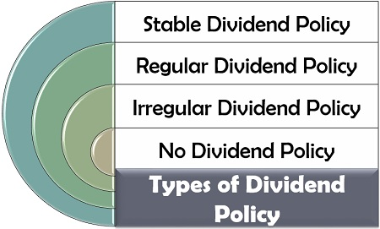

1.Regular dividend policy
- Under this type of dividend policy, the company follows the procedure to pay out a dividend to its shareholders every year.
- When the gain is high, the shareholders’ earnings will also hike and vice-versa. It is one of the most appropriate policy to be adopted for creating goodwill.
- This will be given to retired employees, widows and inability people.

A regular dividend policy offers the following advantages:
- It establishes a profitable record of the company.
- It creates confidence amongst the shareholders.
- It aids in long-term financing and renders financing easier.
- It stabilizes the market value of shares.
- The ordinary shareholders view dividends as a source of funds to meet their day-to-day living expenses.
- If profits are not distributed regularly and are retained, the shareholders may have to pay a higher rate of tax in the year when accumulated profits are distributed.

2. Stable Dividend Policy:

- Under this type of dividend policy, the company follows the procedure to pay out a defined fixed percentage of profits as dividends every year.
- The term ‘stability of dividends’ means consistency in the stream of dividend payments. In more precise terms, it means payment of certain minimum amount of dividend regularly.
IMPLICATION OR ADVANTAGES:
- It stabilises the market value of shares.
- It creates confidence among the investors.
- It provides a source of livelihood to those investors who expecting dividends as a source of funds to meet day-to-day expenses.
- It meets the requirements of institutional investors who prefer companies with stable dividends.
- It improves the credit standing and makes financing easier.
- It results in a continuous flow to the national income stream and thus helps in the stabilisation of national economy.
3. Irregular dividend:
as the name suggests here the company does not pay regular dividend to the shareholders. The company uses this practice due to following reasons:
- Due to uncertain earning of the company.
- Due to lack of liquid resources.
- The company sometime afraid of giving regular dividend.
- Due to not so much successful business.
4) No dividend:
The company may use this type of dividend policy due to requirement of funds for the growth of the company or for the working capital requirement.

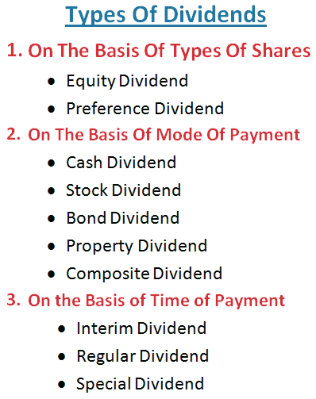

On the basis of types of Shares
1. Equity Dividend: Dividend paid on equity shares called as equity dividend. Generally dividend on equity shares is recommended by the board of directors depending upon profit of the company. Rate of dividend is not fixed. It depends upon the recommendation of directors which in depends upon the profit and future requirement of funds of the company.
2. Preference Dividend: Preference dividend is the dividend paid to preference shareholders. The preference dividend is paid at pre-determined rate and like equity shares,dividend on preference shares is also recommended by the board of directors.

On the basis of Modes of Payment
1. Cash Dividend: The board of directors vote and propose on the declaration of dividends. It is not paid immediately because transfer of stock from one holder to another require a current list of stockholders be prepared. For this reason, there is a date of declaration of dividend on meeting of the board of directors.
2. Bond Dividend: Sometimes companies pay dividend in the form of debentures or bonds or notes for along term period learning interest at fixed rate. The effect of bond dividends and dividend in scrips is the same.
3. Composite Dividend: When dividend is paid partly in the form of cash and partly in other form, it is called as composite dividend.

4. Property Dividend: A property dividend is a nonreciprocal transfer of non monetary assets between an enterprise and its owner. It is payable in form of assets other than cash. They may be in the form of merchandise, real estate, or investments.

On the basis of Time of Payment
1. Interim Dividend: Generally dividend is declared at the end of financial year, but sometime company pays dividend before it declares divide in its annual general meeting. In other words, we can say that it is dividend paid between two annual general meetings.

2. Regular Dividend: Dividend declared in annual general meeting is called as regular dividend. Every year company declares dividend in its annual general meeting.

3. Special Dividend: Wherever there is any huge/abnormal/extra profit, company should declare it as special dividend. So that the shareholders do not expect for the same in each year, the basis purpose of this special dividend is to convey the shareholders that this is a special dividend and will not be paid every year.

Determinants or Factors influencing or affecting dividend policy decision
Existence of Earned Surplus:
A company cannot pay divi­dends out of capital. Dividend is payable out of current profits or accumulated profits of a company. It can be paid after pro­viding for depreciations as per Companies Act.
Government Taxation Policy:
In these days corporate taxation is a very important factor to take into consideration. State and central governmentfixing huge amount of taxes on companies in terms of CGST and SGCT . This means the management is put into difficul­ty in maintaining stable or high rate of dividend. So, this has to be considered while formulating dividend policy.
Legal Restrictions:
As per companies act 1956 income tax sections 93 to 203 the following restriction given to company
- Dividend pain out of profit
- Profit must be retained in current year.
- Dividend payable only in cash.
- If the profit is not exceeding 10per cent age.
Need for Growth and Expansion:
A company, quite likely, is brought into being not to remain static. It is to grow and ex­pand. For this, cash flow must exist. Every available amount cannot be spent for payment as dividend to shareholders. That will restrict the scope for its growth and expansion.
Many com­panies follow orthodox dividend policy and provide for liberal ploughing back of profits into the business and these retained earnings are utilized for expansion and growth as a source of internal finance.
Dividend Restrictions by Creditors:
A firm which has incurred heavy indebtedness, is not in a position to pay higher dividends to shareholders. Earning retention is very important for such concerns which are following a programme of substantial debt reduction. On the other hand, if the company has no debt obligations, it can afford to pay higher rate of dividend.

Liquidity position:
Cash position is a big criterion to pay dividend. For a company, cash is needed for various con­tingencies. They cannot be ignored for the survival of a com­pany. So, dividend policy has to be made after a serious consid­eration of the cash position of the company.

CAPM
What Is the Capital Asset Pricing Model?
The Capital Asset Pricing Model (CAPM) describes the relationship between systematic risk and expected return for assets, particularly stocks. CAPM is widely used throughout finance for pricing risky securities and generating expected returns for assets given the risk of those assets and cost of capital.

Systematic Risk vs. Unsystematic Risk
The capital asset pricing model was developed by the financial economist (and later, Nobel laureate in economics) William Sharpe, set out in his 1970 book Portfolio Theory and Capital Markets. His model starts with the idea that individual investment contains two types of risk:
Systematic Risk – These are market risks—that is, general perils of investing—that cannot be diversified away. Interest rates, recessions, and wars are examples of systematic risks.
Unsystematic Risk – Also known as "specific risk," this risk relates to individual stocks. In more technical terms, it represents the component of a stock's return that is not correlated with general market moves.

Internal financing
internal financing using its profits as a source of capital for new investment, rather than a) distributing them to firm's owners or other investors and b) obtaining capital elsewhere. It is to be contrasted with external financing which consists of new money from outside of the firm brought in for investment. Internal financing is generally thought to be less expensive for the firm than external financing because the firm does not have to incur transaction costs to obtain it, nor does it have to pay the taxes associated with paying dividends.
Advantage:
- Capital is immediately available
- No interest payments
- No control procedures regarding creditworthiness
- Spares credit line
- No influence of third parties
- More flexible
- More freedom given to the owners
Disadvantages
- Expensive because internal financing is not tax-deductible
- No increase of capital
- Losses (shrinking of capital) are not tax-deductible
- Limited in volume (volume of external financing as well is limited but there is more capital available outside - in the markets - than inside of a company)

Financial Modeling Definition
Financial modeling is the process of creating a summary of a company's expenses and earnings in the form of a spreadsheet that can be used to calculate the impact of a future event or decision.

10 most common types of financial models:
- Merger Model (M&A)
- Initial Public Offering (IPO) Model
- Leveraged Buyout (LBO) Model
- Sum of the Parts Model
- Consolidation Model
- Budget Model
- Forecasting Model
- Option Pricing Model

Approaches to Dividend Policy
APPROACH 1 Walter’s model:
- Professor James E. Walterargues that the choice of dividend policies almost always affects the value of the enterprise.
- His model shows clearly the importance of the relationship between the firm’s internal rate of return (r) and its cost of capital (k) in determining the dividend policy that will maximize the wealth of shareholders.
- When the company is giving higher dividend, company will get increased. When the company is giving lower dividend, the value of the company gets decreased.
Growth firms
- Growth firms are characterized by an internal rate of return r > cost of the capital k.
- These firms will have surplus profitable opportunities to invest.
- Because of this, the firms in growth phase can earn more return for their shareholders in comparison to what the shareholders can earn if they reinvested the dividends.
Normal firms
- have an internal rate of return = cost of the capital i.e. r = k.
- The firms in normal phase will make returns equal to that of a shareholder.
- Hence, the dividend policy is of no relevance in such a scenario.
- It will have no influence on the market price of the share. • So, there is no optimum payout ratio for firms in the normal phase.
Declining firms:
- Declining firms have an internal rate of return < cost of the capital i.e. r < k.
- Declining firms make returns that are less than what shareholders can make on their investments.
- So, it is illogical to retain the company’s earnings.
- The optimum dividend payout ratio, in such situations, is 100%.
Walter’s model is based on the following assumptions:
1. The firm finances all investment through retained earnings; that is debt or new equity is not issued;
2. The firm’s internal rate of return (r), and its cost of capital (k) are constant;
3. All earnings are either distributed as dividend or reinvested internally immediately.
4. Beginning earnings and dividends never change.
5. The firm has a very long or infinite life.

The criticisms on the model are as follows:
- Only retained earning methodology will be followed in investment and there is no possibility for external financing and debt.
- Walter’s model is based on the assumption that r is constant. In fact decreases as more investment occurs. This reflects the assumption that the most profitable investments are made first and then the poorer investments are made.

APPROACH 2 Gordon’s Model:
- Gordon’s theory on dividend policy is one of the theories believing in the ‘relevance of dividends’ concept.
- It is also called as ‘Bird-in-the-hand’ theory that states that the current dividends are important in determining the value of the firm.
- Gordon’s model is one of the most popular mathematical models to calculate the market value of the company using its dividend policy.

Assumptions:
Gordon’s model is based on the following assumptions.
1. The firm is an all Equity firm
2. No external financing is available
3. The internal rate of return (r) of the firm is constant.
4. The appropriate discount rate (K) of the firm remains constant.
5. The firm and its stream of earnings are perpetual.

Modigliani and miller approach:
- According to this approach dividend policy has no effect on the market price of the shares and the value of the firm is determined by the earning capacity of the firm or its investment policy.
- According to Modigliani and Miller (M-M), dividend policy of a firm is irrelevant as it does not affect the wealth of the shareholders.
- They argue that the value of the firm depends on the firm’s earnings which result from its investment policy.

Following assumptions:
- The firm operates in perfect capital market
- Taxes do not exist
- The firm has a fixed investment policy

UNIT 4
WCM
What is working capital management?
- A company’s working capital essentially consists of current assets and current liabilities.
- Working capital management involves the relationship between a firm’s short-term assets and its short-term liabilities.
- Working Capital = Current Assets – Current Liabilities
- Current assets refer to those assets that can be converted into cash within one year, like debtors, and stock and prepaid expenses- expenses that have already been paid for.
- Current liabilities are the day-to-day debts incurred by a business in its operation. These could be credit purchases made from vendors (creditors) and outstanding expenses (expenses that are yet to be paid).
CONCEPT OF WORKING CAPITAL MANAGEMENT:
There are two concepts or senses used for working capital.

These are:

1. Gross Working Capital
2. Net working Capital

Let us explain what these two concepts mean.

1. Gross Working Capital:
The concept of gross working capital refers to the total value of current assets. In other words, gross working capital is the total amount available OR invested for financing of current assets. A borrowing will increase current assets and, thus, will increase gross working capital but, at the same time, it will increase current liabilities also.

Gross working capital = Stock + Debtors + Receivables + Cash + prepaid expenses+short term investment

In this sense, the working capital is a financial concept. As per this concept:

Gross Working Capital = Total Current Assets

2. Net Working Capital:
- The net working capital is an accounting concept which represents the excess of current assets over current liabilities. Current assets consist of items such as cash, bank balance, stock, debtors, bills receivables, etc. and current liabilities include items such as bills payables, creditors, outstanding expenses, provision for taxation, bank overdraft etc. Excess of current assets over current liabilities, thus, indicates the liquid position of an enterprise.
- The ratio of 2:1 between current assets and current liabilities is considered as optimum or sound.

Thus, in the form of a simple formula:

- Net Working Capital = Current Assets-Current Liabilities

- After subtracting current liabilities from current assets what is left over is net working capital.

Types of Working Capital

Working capital are of various types. They are explained as follows.

Types of working capital

1. Permanent Working Capital
- It is otherwise called as Fixed Working Capital.
- There is always minimum level of current assets always required to carry out its normal business.
- Permanent working capital implies the base investment amount in all types of current resources which is respected at all times to carry on business activities.
- For example every company has to maintain a minimum level of raw material and cash balance etc…..

Features of Permanent Working Capital

a) The gross value of permanent working capital remain constant but the value of components of current assets is differing from each other.

b) There is a positive correlation between the size of business and the amount of permanent working capital.

c) Only long term sources of funds are used for permanent working capital.

2. Temporary Working Capital
- It is otherwise called as Fluctuating or Variable Working Capital.
- There is a close relationship prevailing between temporary working capital and the level of production and sales.
- There is no uniform production and sales throughout the year.
- If heavy order is received for production and there is a large amount of credit sales, there is a need of more amount of temporary working capital.

OBJECTIVES OF WORKING CAPITAL MANAGEMENT:
- It means raw material should be present on the requirement and it should not be a cause to stoppages of production.
- All other requirements of production should be in place before time.
- The finished goods should be sold as early as possible once they are produced and inventoried.
- The accounts receivable should be collected on time.
- Accounts payable should be paid when due without any delay.
- Cash should be available as and when required along with some cushion.

What Are core current assets Assets?
- The assets which required for smooth operation of business such us stock, machine & production tools.

Factors determining OR Factors Affecting Working Capital Management:
(1) Nature of Business:
- The requirement of working capital depends on the nature of business.
- The nature of business is usually of two types: Manufacturing Business and Trading Business. In the case of manufacturing business it takes a lot of time in converting raw material into finished goods. Therefore, capital remains invested for a long time in raw material, semi-finished goods and the stocking of the finished goods.
- In case of trading business the goods are sold immediately after purchasing or sometimes the sale is affected even before the purchase itself. Therefore, very little working capital is required.

(2) Scale of Operations:
There is a direct link between the working capital and the scale of operations. In other words, more working capital is required in case of big organisations while less working capital is needed in case of small organisations.
(3) Business Cycle:
The need for the working capital is affected by various stages of the business cycle. During the boom period, the demand of a product increases and sales also increase. Therefore, more working capital is needed. On the contrary, during the period of depression, the demand declines and it affects both the production and sales of goods. Therefore, in such a situation less working capital is required.
4) Production Cycle:
- Production cycle means the time involved in converting raw material into finished product. The longer this period, the more will be the time for which the capital remains blocked in raw material and semi-manufactured products.
- Thus, more working capital will be needed. On the contrary, where period of production cycle is little, less working capital will be needed.
(5) Credit Allowed:
Those enterprises which sell goods on cash payment basis need little working capital but those who provide credit facilities to the customers need more working capital.
(6) Operating Efficiency:
- Operating efficiency means efficiently completing the various business operations. Operating efficiency of every organisation happens to be different.
- Some such examples are:
(i) Converting raw material into finished goods at the earliest,
(ii) Selling the finished goods quickly, and
(iii) Quickly getting payments from the debtors. A company which has a better operating efficiency has to invest less in stock and the debtors.
(7) Growth Prospects:
Growth means the development of the scale of business operations (production, sales, etc.). The organisations which have sufficient possibilities of growth require more working capital, while the case is different in respect of companies with less growth prospects.

(8) Level of Competition:
High level of competition increases the need for more working capital. In order to face competition, more stock is required for quick delivery and credit facility for a long period has to be made available.

Working Capital Investment Policies (Explained With Diagram)
1. Hedging Policy:
One of the policies by which a firm finances its working capital needs is the hedging policy, also known as matching policy. This policy works in an arrangement where the current assets of the business are used perfectly to match the current liabilities.

2. Conservative Policy:
As the name suggests, this policy tries to avoid the risk involved in financing of current assets. Here, relatively high proportions of long-term sources are to be used for financing current assets. The firm not only matches the current assets with current liabilities but also keeps some excess amount to meet any uncertainty.

3. Aggressive Policy:
Aggressive working capital financing policy is a risky policy that requires maximum amount of invest­ment in current assets. Fluctuating as well as permanent current assets under this policy will be financed through short-term debt. In this policy debt is collected on time and payments to the creditors are made as late as possible.

Advantages of working capital management
- Quick and Regular Return on Investments
- Ability to Face Crisis
- regular Payment of Salaries, Wages and Other Day-to-day Commitments
- Regular Supply of Raw Materials
- It helps the business concern in maintaining the goodwill.
- It can arrange loans from banks and others on easy and favorable terms.
- It creates an environment of security, confidence, and over all efficiency in a business.
Disadvantages of working capital
- Rate of return on investments also fall with the shortage of working capital.
- Excess working capital may result into over all inefficiency in organization.
- Excess working capital means idle funds which earn no profits.
- Inadequate working capital can not pay its short term liabilities in time.

Sources of short term finance or sources of working capital management
Commercial Paper:
- Commercial paper, also called CP, is a short-term debt instrument issued by companies to raise funds generally for a time period up to one year.
- was introduced in India for the first time in 1990.
- CPs have a minimum maturity of seven days and a maximum of up to one year from the date of issue.
- They are typically issued by large banks or corporations to cover short-term receivables and meet short-term financial obligations, such as funding for a new project.
Trade Credit:
- A trade credit is a business-to-business (B2B) agreement in which a customer can purchase goods on account without paying cash up front, paying the supplier at a later scheduled date.
- Usually businesses that operate with trade credits will give buyers 30, 60, or 90 days to pay, with the transaction recorded through an invoice.
- Trade credit can be thought of as a type of 0% financing& requiring no interest to be paid in relation to the repayment period.
Letters Of Credit:
- A letter of credit, or "credit letter"
- A letter of credit is a document that guarantees the buyer’s payment to the sellers.
- It is Issued by a bank and ensures the timely and full payment to the seller.
- If the buyer is unable to make such a payment, the bank covers the full or the remaining amount on behalf of the buyer.
- A letter of credit is issued against a pledge of securities or cash. Banks typically collect a fee, ie, a percentage of the size/amount of the letter of credit.
Commercial Banks:
- Commercial banks are the major source of working capital finance to industries and commerce. Granting loan to business is one of their primary functions.
- Getting bank loan is not an easy task since the lending bank may ask a number of questions about the prospective borrower’s financial position and its plans for the future.
- At the same time the bank will want to monitor borrower’s business progress. But there is a good side to this, that is borrower’s share price tends to rise, because investor knows that convincing banks is very difficult.
Public Deposits:
- Many companies invite and accept deposits for short periods from their directors, shareholders and the general public.
- This method of raising short term finance is becoming popular due to increasing cost of bank credit Deposits are generally invited for a period ranging from 6 months to five years.
- Government has prescribed rules and regulations which must be followed by companies inviting public deposits.
Accrual Accounts:
- There is a time lag between receipt of income and making payment for the expenditure incurred in earning that income.
- During this time lag, the outstanding expenses help an enterprise in meeting some of its working capital needs.
- For example, wages and taxes become due but are not paid immediately.

FACTORING:
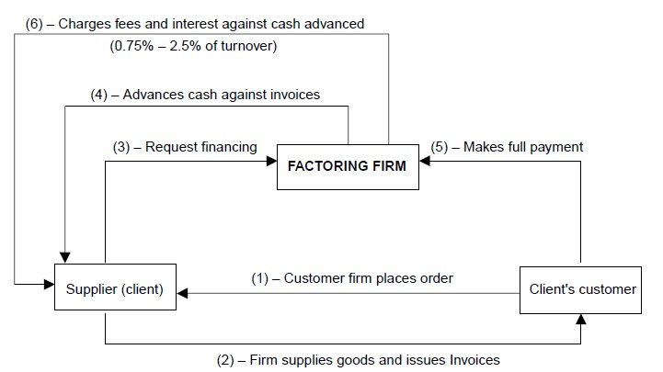

BILL DISCOUNTING:
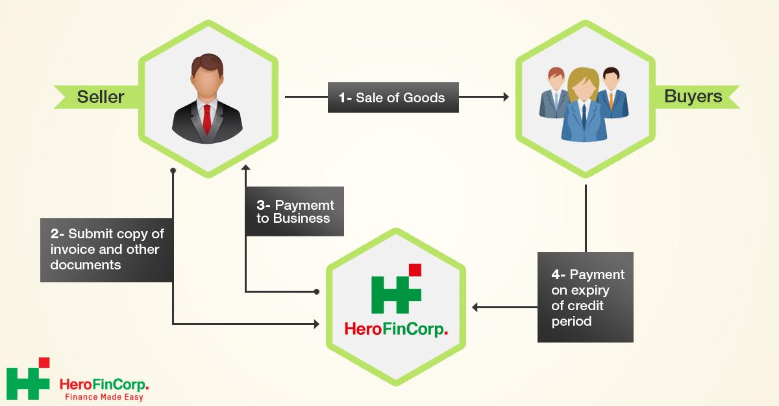

Cash management
Cash management:
What Is Cash Management?
- Cash management is the process of collecting and managing cash flows. Cash management can be important for both individuals and companies.
- Cash management refers to management of cash balance and the bank balance.
- Cash management refers to a broad area of finance involving the collection, handling, and usage of cash.

CASH CYCLE:
- The cash cycle definition is the time it takes a company to turn raw materials into cash. It is also a common concept in any business which processes materials. Also known as the cash conversion cycle, it refers to the time between purchasing the raw materials used to make a product and collecting the money from selling the product. It also functions well as a measure of liquidity: how easily can unfinished product be turned into cash.
Objectives of cash management:
- To ensure enough and sufficient fund.
- To ensure able to manage expenditure.
- To meet payment schedule.
- To meet working capital requirements
- It is necessary to calculate cash inflows and cash outflows during a period and forecast the cash balance at the end of it.
Dimensions or aspects or Techniques of Cash Management
- Cash planning
- Management of cash inflows
- Management of cash outflows

Cash planning:
- Cash planning is a technique to plan and control the use of cash.
- Amount needed for the firm.
- Expected cash receipts and payments
- Cash planning may be prepared on the daily, weekly, monthly or quarterly basis.
Management of cash inflows:
Cash inflow is the money going into a business. That could be from sales, investments or financing. Managing those amounts for business operations.

Management of cash outflows:
Cash outflow is the amount of cash that a business disburses. The reasons for these cash payments fall into one of the following classifications: ... Examples are payments to employees and suppliers. Investing activities. Examples are loans to other entities or expenditures made to acquire fixed assets.

Objectives of cash management
- To raise the amount.
- To control the costs and expenditure.
- To manage the cash inflow and cash outflow.
- To avoid loss.
- To utilize the amount effectively.

Receivable Management
MEANING:
- “Receivables are sales made on credit basis”
- ‘Credit is the soul of business.’
- Receivable management is the process of making decisions relating to investment in trade debtors. Certain investment in receivables is necessary to increase the sales and the profits of the firm.

Objectives of Receivables Management:
- To Achieving the growth in the volume of sales
- To Increasing the volume of profits
- To Meeting the competition

Factors influencing size of receivable management or investment in receivable
Size of credit sales
- The volume of credit sale is the first factor that influences receivables.
- Higher the credit allowed more will be the receivables and vice a versa

Credit Policies
- Firm with conservative credit policies will have low receivables when compared with firms following liberal credit policies.
- Firm with conservative credit policies will have more receivables when compared with firms following vague credit policies.

Expansion plans
- Concerns that want to expand has to enter new markets. To attract customers it becomes necessary for the enterprise to provide incentives in terms of credit.
- Once the concern gets the permanent customers it may start reducing the period for which credit was allowed to permanent customer.

Habits of customers:

- The paying habits of customers also have a bearing on the size of receivables.
- When the customer making delay to pay credit amount even though customers are financially sound, it will affects the company.
Stability of sales:
- The total sales of the company should be stable in all the seasons.
- When the company has higher sales they may provide higher credit sales.
- When the company has lower sales they cannot give more credit sales to their customer.

INVENTORY MANAGEMENT
What Is Inventory Management?
Inventory management refers to the process of ordering, storing, and using a company's inventory. These include the management of raw materials, components, and finished products, as well as warehousing and processing such items.

Methods /Techniques of Inventory Management
EOQ:
- Economic order quantity (EOQ) is the ideal order quantity a company should purchase to minimize inventory costs such as holding costs, shortage costs, and order costs.
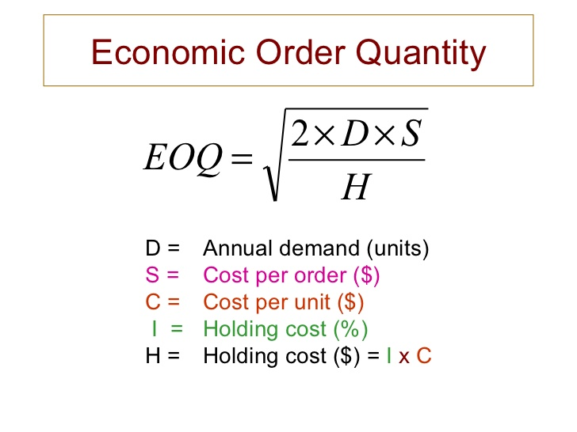
ABC:
- ALWAYS BETTER CONTROL
- ABC analysis is a type of inventory categorization method in which inventory is divided into three categories, A, B, and C, in descending value. A has the highest value items, B is lower value than A, and C has the lowest value.
- Otherwise known as 80:20 rules.
- Which states that 80% of overall consumption value comes from only 20% of items. Plainly, it means that 20% of your products will bring in 80% of your revenues.
JIT:
- Just in Time
- ust in time is a common inventory management technique and type of lean methodology designed to increase efficiency, cut costs and decrease waste by receiving goods only as they are needed.

VED Analysis:-
- Namely Vital, Essential, and Desirable.
- Vital: Vital category items are those items without which the production activities or any other activity of the company, would come to a halt, or at least be drastically affected.
- Essential: Essential items are those items whose stock – out cost is very high for the company.
- Desirable: Desirable items are those items whose stock-out or shortage causes only a minor disruption for a short duration in the production schedule.

IMPORTANT QUESTIONS:
- What is working capital management?
- What is cash management?
- What is receivable management?
- What is inventory management?
- What is cash management cycle?
- What is meant by current assets?
- What is EOQ?
- What are the objectives of cash management? 5 marks
- What are the factors influencing size of receivables? 5 marks

Unit 3
Investment and Capital Structure Decisions - Net Income Approach - Net OperatingmIncome Approach - MM Approach; Valuation and Rates of Return; Method of Capital Budgeting.
What Is Capital Structure?
- The capital structure is the combination of debt and equity used by a company to finance its overall operations and growth.
- Debt comes in the form of bond issues or loans.
- equity may come in the form of common stock.
- Capital Structure refers to the amount of debt and/or equity employed by a firm to fund its operations and finance its assets.

What is optimum capital structure?
The optimal capital structure of a firm is the best mix of debt and equity financing that maximizes a company’s market value while minimizing its cost of capital.

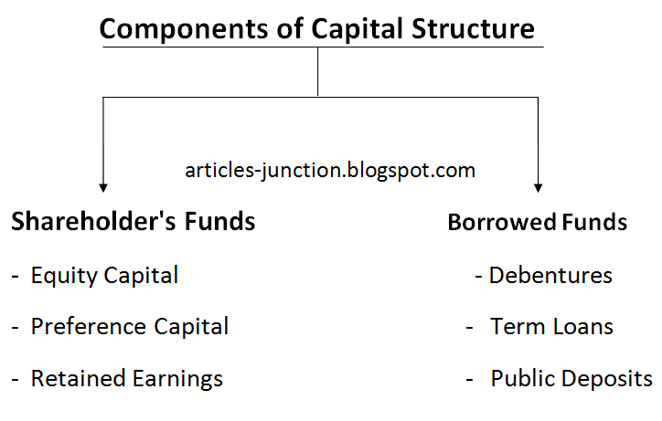
PATTERNS OF CAPITAL STRCUTURE:
- Equity Share Only.
- Both Equity and Preference Share.
- Equity Share and Debenture.
- Equity Share, Preference Share and Debenture.
Factors determining or Affecting Capital Structure
1] Cash Flow Position
A firm’s ability to pay expenses and loans determines debt capacity. Some firms operate in volatile financial environments affecting their ability to meet financial obligations. The company may raise funds by issuing debts if it has a fluent cash flow position, as they are to be paid back after some time.
2. Return on Investment
It will be beneficial for a firm to raise finance through borrowed funds if the return on investment is higher than the rate of interest on the debt. But if the return is uncertain and the company is not sure if it can cover the fixed cost of interest, they should opt for equity.
3.Stability of sales:
- An established business which has a growing market and high sales turnover, the company is in position to meet fixed commitments. Interest on debentures has to be paid regardless of profit.
- When the sales are low it will affects the capital structure.
4. Sizes of a company-
- Small size business firms capital structure generally consists of loans from banks and retained profits.
- While on the other hand, big companies having goodwill, stability and an established profit can easily go for issuance of shares and debentures as well as loans and borrowings from financial institutions.
5. Return on Investment-ROI:
- The greater return on investment of a company increases its image.
- The lesser return on investment of a company decrease its capacity to utilise more debt capital.
6. Tax Rate:
The rate of tax affects the cost of debt. If the rate of tax is high, the cost of debt decreases. The reason is the deduction of interest on the debt capital from the profits considering it a part of expenses and a saving in taxes.
7.Regular Earnings: In the case of irregular earnings, the company avoids debts, since paying off fixed interest becomes difficult in such a situation.

Point of indifference
Point of indifference refers to the level of earnings per share or return on share capital is equal for different combinations of debt and equity.
Formula:
- PLAN 1 =(X-I₁ ) (1-T) – P.D/S1
- PLAN 2 =(X-I₂) (1-T) – P.D/S2

WHERE,
- X-EBIT
- I₁- INTEREST UNDER PLAN 1
- I₂- INTEREST UNDER PLAN 2
- T- TAX RATE
- P.D – PREFERENCE DIVIDENT
- S1 – NO OF SHARES

Importance of Capital Structure( 5 MARKS)
- Return Maximization
- Increases Firm’s Value
- Optimum Utilization of Funds
- Reduce financial risk
- Easy to generate the amount
- East to finance on assets.

Theories or approaches of capital structure (important Question)
THEORY 1: Net income approach:
- This theory is suggested by “David Durand”
- This theory proposed to measure the valuation of the firm.
- According to this theory company may minimize the cost of capital and maximize the use of debt in capital structure.
- Value of the firm measured by adding both equity and debts
Where,
V=S+D
V denote value of the firm
S denote equity of the firm
D denote debt of the firm
For calculation of NET INCOME company have to use the following formula
= NET INCOME / COST OF EQUITY
THEORY 2: Net Operating income approach:
- This theory is suggested by “David Durand”
- This theory also proposed to measure the valuation of the firm
- This is just opposite to net income approach.
- The market value of the firm is not at all affected by the company capitalization.
- The value of the firm in determined by net operating income and overall cost of capital constant.
Assumptions:
- The overall cost of capital is constant and unchanged.
- There is no corporate tax.
- Use of debt in investment having low cost increases.
- Interest rate is low.
Formula
Value of the firm = EBIT/Ko
Where,
EBIT – earnings before interest and tax
Ko - overall cost of capital
THEORY 3: Modigliani and Miller Theories
- Modigliani and Miller theories of capital structure (also called MM or M&M theories).
- The MM approach favors the Net operating income approach and agrees with the fact that the cost of capital is independent of the degree of leverage and at any mix of debt-equity proportions.
- At any degree of leverage, the company's overall cost of capital (ko) and the Value of the firm (V) remains constant. This means that it is independent of the capital structure.
Assumptions of MM approach:
- Capital markets are perfect.
- All investors have the same expectation of the company's net operating income for the purpose of evaluating the value of the firm.
- Within similar operating environments, the business risk is equal among all firms.
- 100% dividend payout ratio.
- An assumption of "no taxes" was there earlier, which has been removed.

CAPITAL BUDGETING
What Is capital budgeting?
- It is a process of making plan and development of available fund to raise amount for business activities.
- Capital budgeting is the process of taking investment decisions regarding capital expenditure ( like purchasing of fixed assets, cost of replacement of fixed assets)

Significance, Importance, features and advantages of capital budgeting

- Long term planning for high profit.
- Reduce and monitoring expenses
- Increase the assets.
- Replacement of existing assets
- Helps to generating profit within short period.

Financial Management-An important Concepts

Unit I
1.Finance:
Finance is the art and science of managing money.

2.Financial Management:
Financial Management is the managerial activity which is concerned with the planning and controlling of the firm’s financial resources.

3.Bond /Debenture:
A bond or a debenture is a certificate acknowledging the amount of money lent by a bondholder to the company. It states the amount, the rate of interest and the maturity of the bond or debenture.

4.Finance Functions:
-Investment decisions(Long-term asset-mix)
-Financing decisions(Capital-mix )
-Dividend decisions(Profit-allocation)
-Liquidity decisions(Short-term asset-mix)

5.Financial Goal:
i).Profit maximization
ii)Wealth maximization.

6.Time value of money:

Time value of money means that the value of a unit of money is different in different time periods. The value of a sum of money received today is more than its value received after some time.

7.Annuity:
Annuity is a stream of equal annual cash flows.

8.Perpetuity:
Perpetuity is an annuity with an indefinite life, making continuous annual payments.

9.Sinking fund:
Sinking fund is a fund, which is created out of fixed payments each period to accumulate to a future sum after a specified period. For example, companies generally create sinking funds to retire bonds (debentures) on maturity.

10.Net present value:
Net present value of a financial decision is the difference between the present value of cash inflows and the present value of cash outflows.

11.Zero-interest bond:
A bond that pays some specified amount in future(without periodic interest)in exchange for the current price today is called a zero-interest bond or zero-coupon bond.

12.Risk:
Risk is the possibility of loss or injury; the degree or probability of such loss.
It consists of two components
- Systematic risk
- Unsystematic risk

13.Return:
Return is the actual income received plus any change in market price of an asset/investment.

14.Portfolio:
A portfolio means a combination of two or more securities(assets).

15.Par value:
Par value is the value on the face of the bond.

16.Coupon rate:
Coupon rate is the specified interest rate available on a security.

17.Maturity Period:
Maturity period refers to the number of years after which the par value is payable to the bondholder.

18.Discount:
Discount is the amount by which a bond sells below its face value.

19.Premium:
Premium is the amount by which a bond sells at a value higher than its face value.

20.Yield to maturity(YTM):
Yield to maturity is the rate of return an investor earns on a bond held till maturity.

21.Option:
An option is a claim without any liability. It is a claim contingent upon the occurrence of certain conditions.

22.Call option:
A Call option on a share(or any asset) is a right to buy the share at an agreed exercise price.

23.Put option:
A put option is a contract that gives the holder a right to sell a specified share(or any other asset) at an agreed exercise price on or before a given maturity period.

24.Strike price:
The price at which option can be exercised is called an exercise price or a strike price.

25.Underlying asset:
The asset on which the put or call option is created is referred to as the underlying asset.

26.European option:
When an option is allowed to be exercised only on the maturity date, it is called a European option.

27.American option:
When the option can be exercised any time before its maturity, it is called an American option.

Unit II
1.Capital Budgeting:
“A long term planning for making and financing proposed capital outlays”
-Charles T.Horngreen.
2. Capital expenditure:
It is an outlay of funds that is expected to produce benefits over a period of time exceeding one year.

3. Capital rationing:
It is the financial situation in which a firm has only fixed amount to allocate among competing capital expenditures.

4.Internal Rate of Return:
IRR is the discount rate that equates the present values of cash inflows with the initial investment.

5.Accounting Rate of Return:
The Accounting Rate of Return also known as the Return On Investment(ROI) ,uses accounting information, as revealed by financial statements to measure the profitability of an investment.

6.Cost of Capital:
Cost of capital is the minimum rate of return a firm must earn on its investment.

Unit III
1.Leverage:
Leverage is the employment of an asset for which firm pays fixed return.

2.Operating leverage:
It is defined as the firm’s ability to use fixed operating costs to magnify the effects of changes in sales on its earnings before interest and taxes.
It is caused due to fixed operating expenses in a firm.

3.Financial Leverage:
It is defined as the ability of a firm to use fixed financial charges to magnify the effects of changes in EBIT on the earnings per share.
It is caused due to fixed financial costs (interest) in firm.

4.EBIT-EPS analysis:
It involves comparison of alternative methods of financing at various levels of EBIT.

5.Capital Structure:
It is the proportion of debt and preference and equity shares on a firm’s balance sheet.

6.Optimum capital structure:
It is defined as the capital structure or combination of debt and equity that leads to the maximum value of the firm.

7.Theories of capital structure:
1.Net Income Approach
2.Net Operating Income Approach.
3.Modigliani-Miller Approach.
4.Traditional Approach.

8.Dividend:
It refers to that portion of a firm’s net earnings which are paid out to the shareholders.

9.Bonus shares:
Bonus shares are shares issued to the existing shareholders without any charge.

10.Dividend irrelevance:
It implies that the value of a firm is unaffected by the distribution of dividends and is determined solely by the earning power and risk of its assets.

11.Dividend relevance:It implies that shareholders prefer current dividends and there is no direct relationship between dividend policy and market value of a firm.

12.Dividend policy:
It involves decision to pay out earnings or to retain them for re-investment.

13.Dividend payout ratio:
It indicates the % earnings distributed to shareholders in cash, calculated dividing the cash dividend per share by its EPS.

14.Forms of Dividends:
i)Cash dividend
ii)Scrip or Bond dividend.
iii)Property dividend.
iv)Stock dividend
(Now a days Cash dividend and
Bonus shares(Stock dividend in USA) are given)

15.Share split:
It is a method to increase the number of outstanding shares through a proportional reduction in the par value of the share.

16.Reasons for share split:
-to make trading in shares attractive.
-to signal the possibility of higher profits in the future.
-to give higher dividends to shareholders.

17.Buyback of shares:
It is the repurchase of its own shares by a company.

18.Theory of Irrelevance:
1.Residual Approach
2.Modigliani and Miller Approach (MM Model)

19.The Theory of Relevance:
1.Walter’s Approach.
2.Gordon’s Approach.

20.Types of Dividend Policy:
i)Regular Dividend Policy.
ii)Stable Dividend Policy
iii)Irregular Dividend Policy.
iv) No dividend Policy.

Unit iv

1.Concept of working capital:
i)Gross working capital-it means total current assets only.
ii) Net working capital-it i.e. the difference between current assets and current liabilities.

2.Permanent(fixed) working capital:
It is a certain minimum level of working capital on a continuous and uninterrupted basis.

3.Temporary(fluctuating/variable)working capital:
It is the working capital needed to meet seasonal as well as unforeseen requirements.

4.cash:
It is the ready currency to which all liquid assets can be reduced

5.Near cash:
It implies marketable securities viewed the same way; as cash because of their high liquidity.

6.Primary motives for maintaining cash balances:
i)Transaction motive.
ii)Precautionary motive
iii)Speculative motive and
IV)Compensating motive.

7.Cash cycle:
The cash cycle refers to the process by which cash is used to purchase materials from which are produced goods which are then sold to customers who later pay the bills. The firm receives cash from customers and the cycle repeats itself.

8.Cash turnover:
It means the number of times cash is used during each year.

9.Lock-Box system:
It is a collection procedure in which payers send their payments/cheque to a nearby post box that is emptied by the firm’s bank several times and the bank deposits the cheque in the firm’s account. It reduces floats.

10.Cash management:
It is concerned with the managing of
i)Cash flows into and out of the firm
ii)cash flows within the firm and
iii)cash balances held by the firm at a point of time by financing deficit or investing surplus cash.

11.Short-term forecasting Methods:
i)The receipt and disbursements method.
ii)The adjusted net income method.

12.Types of floats:
i) Postal float
ii) Processing/Lethargy floats
iii) Bank/clearing float
iv) Deposit float

13.Delinquency cost:
It is cost arising out of failure of customers to pay on due date.

14.Trade credit:
It refers to the credit that a customer gets from suppliers of goods in the normal course of business.

15.Factoring:
It involves the outright sale of receivables at a discount to a factor to obtain funds.

16.Factor:
It is a financial institution that specializes in purchasing accounts receivables from business firms.

17.Commercial Paper:
It is an important money market instrument in advanced countries like USA to raise short-term funds. In India RBI introduced the commercial paper scheme in the Indian money market in 1989.

Unit V

1.Capital market/Securities market:
It isa financial relationship created by a number of institutions and arrangements that allows supplier and demanders of long-term funds(i.e. funds with maturities exceeding one year) to make transactions.

2.Money market:
It is created by a financial relationship between suppliers and demanders of short-term funds having maturities of one year or less.

3.New securities:
New securities are offered to the investing public for the first time.

4.Old securities:
Old securities are securities which have been issued already and listed on a stock exchange.

5.Underwriting:
It is a form of guarantee that the new issues would be sold by eliminating the risk arising from uncertainty of public response.

6.Public Issue:
Public issue are securities that are offered to the general public directly at a stated price.

7. Book building:
It is a price discovery and investors response mechanism.

8. Right issue:
It is the sale of securities to the existing shareholders.
9. Authorised share capital:
It is the number of ordinary shares capital that a firm can raise without further shareholder approval.

10. Subcribed share capital:
Subscribed share capital is that part of the issued capital which has been accepted/subscribed by the investors.

11. Initial Public Offerings (IPO):
It is the first issue of equity shares to the public by an unlisted company.

12. Term loan:
It is a loan made by a bank/financial institution to a business having an initial maturity of more than 1 year.

13. Leasing:
It is the process by which a firm can obtain the use of a certain fixed asset for which it just make a series of contractual,periodic,tax-deductible payments(lease rentals).

14.Leasing types:
i) Financial leases-Long-term, non-cancellable lease contracts .
ii) Operating leases-Short term,cancellable lease agreements.
iii)Sale-and-lease-back-Sometimes,a user may sell an(existing) asset owned by him to the lessor(leasing company) and lease it back from him.

15.Venture capital:
It is a way in which investors support entrepreneurial talent with finance and business skills to exploit market opportunities and thus, to obtain long/term capital gains.

16.Project financing:
In project financing , the project its assets,contracts,inherent economics and cash flows are separated from their promoters or sponsors in order to permit credit appraisal and loan to the project, independent of the sponsors.

17.Financial services: It is concerned with the design and delivery of advice and financial products to individuals, businesses and governments.

