UNIT-V
APPLICATION LAYER:
- DNS-Domain Name System
- Electronic mail
- World wide web(www)

DNS:
Domain Name System, the essence of DNS is the invention of a hierarchical domain based naming scheme and a distributed database system for implementing this scheme.
- DNS name space socket
- Resource records
- Name servers
DNS Namespace socket:

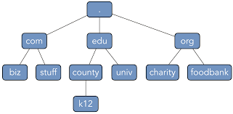

- DNS following the postal hierarchical addressing system, using the postal addressing system there is no confusing.
- The internet is divided into over 200 top level domain where each domain covers many hosts.
- Each domain is partitioned into sub domains and these are further partitioned.
- All these domains can be represented by a tree, they leafs of the tree represented domains that have no sub domains but it contain machine.
- They top level domain divided into two categories.
- General
- Countries

The original Generic domains
Com-[commercial]
Edu-[educational institutions]
Gov-[us federal government]
Int-[international organization]
mil-[us military]
net-[network provider]
org-[non profit organization]

The country domain include one entry for country.
- In nov2000 added four new General purposed domain namely,

.Biz[business]
.INFO[information]
.name[people name]
.pro[professional such as doctors & layers]
In addition 3 more specialized top level domains where introduced.
Aero-[aerospace]
Coop-[cooperative]
Museum-[museum]
Getting second level domain such as name of the company. Com is easy, it requires going to register for the corresponding top level domain.
Ex:
- cs.bdu.com
- They components are separated by period(.), domain names are case insensitive so edu,Edu,EDU,eDU all are same.
- Component name can be upto 63 characters long and full path name must not exceed 255 character.
Ex:
Cs.yale.edu
Cs.yale.ct.us
Resource record:
- Every domain whether it is a single host or a top level domain, can have a set of resource record associated with it.
- In single host they most common resource record is just it internet port address.
- The resource record is 5 tuples resource records are presented as ASCII text, one line per resource record.
Format:
Domain name Time -to –live class type value.
Ex:

Cs.mail.edu | 86400 | In | CName | Cs.mil.edu

- The domain name tells the domain to which this record Applies.
- The time-to-live fields gives on indication of how stable is record.
- The third field of every resource record is the class for internet information it is always IN.
- The type field tells what kinds of record or files.
- Value –this field can be a number, a domain name or ASCII string.

Type | meaning | Value
SOA | Start of authority | Parameter for this zone.
A | IP address of a host | 32 bit integer.
MX | Mail exchange | Domain willing to accept email.
CNAME | Canonical name | Domain name
PTR | Pointer | Alias for an IP address.

Name server:
- A single name server contain the entire DNS database and response to all request about it.
- A DNS namespace is divided into non over lapping zones.
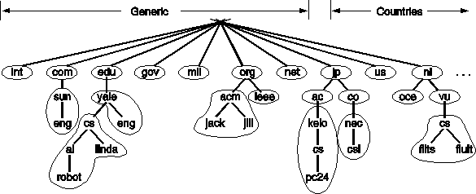

Electronic mail:
- Email, like most other forms of communicative has it’s own convention & style.
- It’s very informal and has a layer threshold of use.
Architecture & service:
Email system consists of two sub system.
- User agent(UA)
- Message transfer agent(MTA)
User Agent:
- It allows people to read & send emails.
MTA:
- It moves the message from the source to the destination.
Basic function:
- Composition
- Transfer
- Reporting
- Displaying
- Disposition
Composition:
- It refer to the process of creating message and answer.
- Any text editor can be used for the body of the message.
Transfer:
- It refers to moving message from the originator to the recipient.
- The email system should to this automatically.
Reporting:
- It has to deal with telling the originator what happen to the message.
Ex:
Was it delivered?
Was it rejected?
Was it last loss?

Displaying:
Displaying incoming message is needed, so people can read the email.
Disposition:
- This is the final step the recipient does with to the message after receiving it.
Extra function:
- Mail box
- Mailing list
Mail box:
- To store incoming emails.
Mailing list:
- It contain a list of email address.
User Agent:
- The user agent is normally a program that accept a variety of commands for composing, receiving and replaying to message as well as manipulation mail boxes.
- Sending email
- Reading email
Sending email:
- To send on email messages, a user must provide the message, the destination address and some other possible parameters.
- The message can be produced with text editor, a word processing program build into the user agent.
- The destination address must be in a format that the user agent can deal with it.
- \c=US\ST=NEW YORK\<=cambridge/PA=36,south st/CN=Trichy/.
- They address specifies a country, states location, personal address and a common name.
- Most email system have aliases that allow users to enter or select a persons name and get a correct email address.
- Most e – mail system supporting mailing list, so that a user send a message to a list of People.
Reading email:
- The user mailbox for incoming email before displaying anything on the screen, then it may announce they number of message is the mailbox.

# | Flag | bytes | sender | Subject
1  2  3  4 | K  KA  KF  K | 1.30  1500  350  850 | Anitha  Mercy  Santhi  punitha | Hai  Hello  Resume  welcome
- First field is the message number, second field flag, k means that the message is not new but was read previously and kept in the mail box.
- Flag A means that the message has been already answered.
- The third field tells the how long the message.
- The fourth field tells who send the message, this field simplify extracted from the message this field may contain first name, last name initial.
- Finally the subject field give a brief summary of what the message is about.
- After the header has been displayed the user can perform any of several actions .

Message format:
- RFC-822: consist of some primitive envelope.
- To-email address of primary recipient multiple recipient is also allowed.
- cc-email address of secondary recipient.
- Bcc-email address of blind carbon copy.
- From-person to create a message.
- Sender-email address of the actual sender.
- Receiver-line address of the transfer agent along the root.
- Return path-can be used to identify a path back to the sender
- Date-the date & time they message was send.
- Replay to-email address to which reply as should be send
- Message ID-unique number for referencing this message later.
- References-other relevant msgid.
- Keyword – user chose the keywords.
- Subject-sort summary of the message.
MIMF(Multipurpose internet mail extension):
- In the early days of email consisted exclusively of text message written in English and expressed in ASCII string.
- It specify the headers only, now a days this approach is no longer, problem include sending and receiving.
- A solution was proposed in RFC 1341 and updated in RFC 2045-2049, this solution is called MIME.
- Now it is widely used, the basic idea of MIME is to use the RFC-822 format, but add structure to the message body and define encoding rules for non ASCII message.
- MIME defines 5 new message heads

Header | Meaning
MIME version | Identities the MIME version
Content description | Human readable string telling what is in the message
Content-ID | Unique identifier
Content transfer encoding | How the message body is wrapped for transmission.
Content type | Type and format of the content.

- MIME VERSION is used identify the MIME version and any message not contain a MIME version header is assumed by English blind text message.
- Content description header is on ASCII string what is in the message.
- Content id header identify the content, it uses the same format as the standard message id header.
- Content transfer encoding tells how the message be is wrapped for transmission through a network.
- Content type header specify the nature of the message body, each have one or more sub type separated by slash.

Ex:
Content type=video\MPEG
Type | Subtype
Text  Image  Audio  Video | Main enriced  JPEG.,GIF  Basic  MPEG

MTA:
- Message Transfer Agent
- The system is concerned with relaying message from originator to the recipient.
- The simplest way to also this to establish a transport connection form source machine to the destination machine and then just transfer message.

SMTP: [SIMPLE MAIL TRANSFER PROTOCOL]

- Within the internet email is delivered by having the source machine establish a TCP connection to port 25 of the destination machine, this port accept Incoming connection and copy message from them into the appropriate mail boxes.
- If a message cannot be delivered on failure report is return to the sender.
- SMTP is a simple ASCII protocol a sending machine operating as the client, wait for the receiving machine operating as the server to talk.
- All the emails has been exchanged in both direction.

Ex:
MAIL from:<elinor@abcd.com>
Sender of
RCPT TO:carlyn@xyz.com
RECEIVER ok
Data end with”.”
From:elinor@abcd.com
TO: carolya@xyz.com
MIME VERSION:1.0
Message id:<0704AA014>
Content type:Text/plain
Subject: Hai friend
Content transfer encoding: base 64 quit.

WWW Architectural overview:

- Client side
- Server side

Client side:
URL Has three Parts.
- Determine URL by browser.
- Browser asks DNS to want IP Address.
- DNS replay.
- The browser make TCP Connection of port 80.
- If then send request.
- Server send the file.
- Connection released.
- Display all text.

Server side:
- Accept TCP Connection.
- Get the name of the file.
- Get the file from the disk.
- Return to the client.
- Release.

World wide web:
- World wide collection of documents is called web pages each page may contain link to other pages any where in the world.
- The idea of having one page point to another page is called hypertext.
- Pages are viewed with a program called browsers, internet explorer, Netscape navigator are one of the popular browsers.
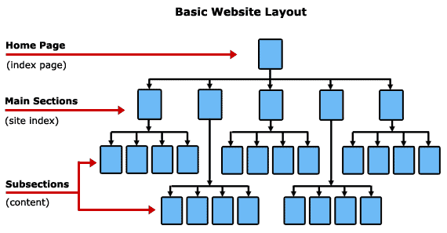

- They browser display in a web page on the line text. That is linked to a page on the abcd.com.
- They browser follow the hyperlink by sending a message to the abcd.com server asking a page when page arrives it is displayed.
- It this page contains the hyper link to a page on the xyz.com.
- That is clicked on the browser then send a request to that machine for the page.
Client side:
- Client side on a page is selected, they browser follow the hyperlink and fetch the page selected.
- The embedded hyperlink way to name any other page on the web.
- Pages are named using uniform resource locator (URL).
A difficult URL is
- http://www.abcd.com\fibo.html
It have three parts:
- Name of the protocol(http)
- DNS name of the machine where the page is located (www.abcd.com)
- Name of file containing thepage(fibo.html)
A browser click on the a hyperlink, the browser carry out a series of steps in order to fetch the page.
- They browser determines the URL.
- The browser ask to DNS for the IP address
- DNS replays with 156.106.192.32
- The browser makes a TCP connection to port 80 on 156.106.192.32.
- If then send over a request asking for file.
- The www.idu.org server send the file
- The TCP connection is released
- The browser display all the text
- The browser fetch and display all images in this file.

Server side:
- Accept a TCP connection from a client
- Get the name of the file requested.
- Get the file from disk.
- Return the file to the client.
- Release the TCP connection.

