Physiology of Circulation

Dr. P. Murugan, M.Sc., M.Phil., Ph.D.,

Assistant Professor and Principal i/c

Department of Biochemistry,

Bharathidasan University Model College,

Vedharanyam - 614 810.

Blood vessels
- Arteries: Blood vessels that carry blood away from the heart to the lungs and tissues. Arterioles are small arteries that deliver blood to the capillaries, and because of their small diameter, they play a key role in vasoconstriction and vasodilatation. Most arteries and arterioles carry oxygenated blood, except the pulmonary arteries where they transport deoxygenated blood from RV to the lungs.
- Capillaries: Microscopic blood vessels that allow the exchange of nutrients and wastes between blood and tissues. This exchange is a filtration process enforced by hydrostatic pressure (created by water molecules in blood plasma) and osmotic pressure (created by plasma proteins, particularly albumin).
- Veins: blood vessels that carry blood to the heart, from the lungs and tissues. Blood pressure in veins is extremely low, as a result valves formed by the tunica internal layer are necessary to prevent backflow. Most veins carry deoxygenated blood, except the pulmonary veins where they transport oxygenated blood from the lungs to the left atrium. Venules are small veins that are formed by the union of several capillaries.
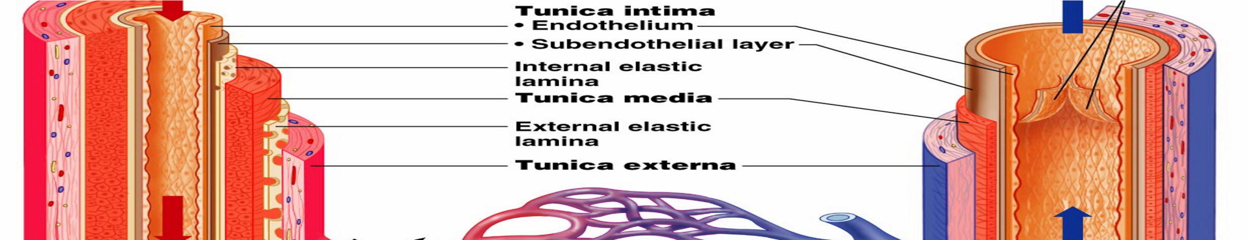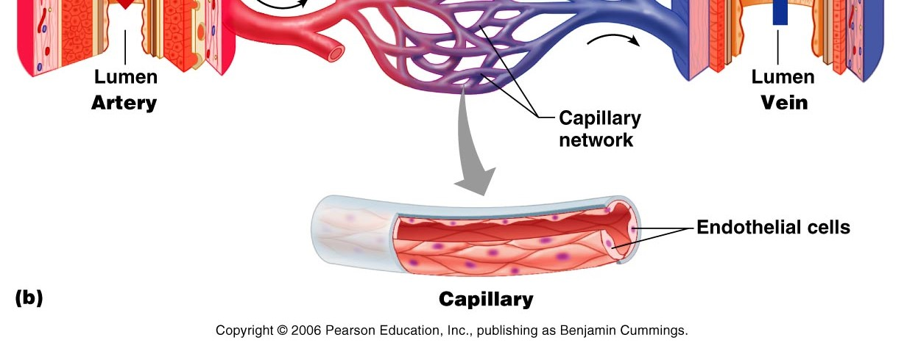

Blood vessels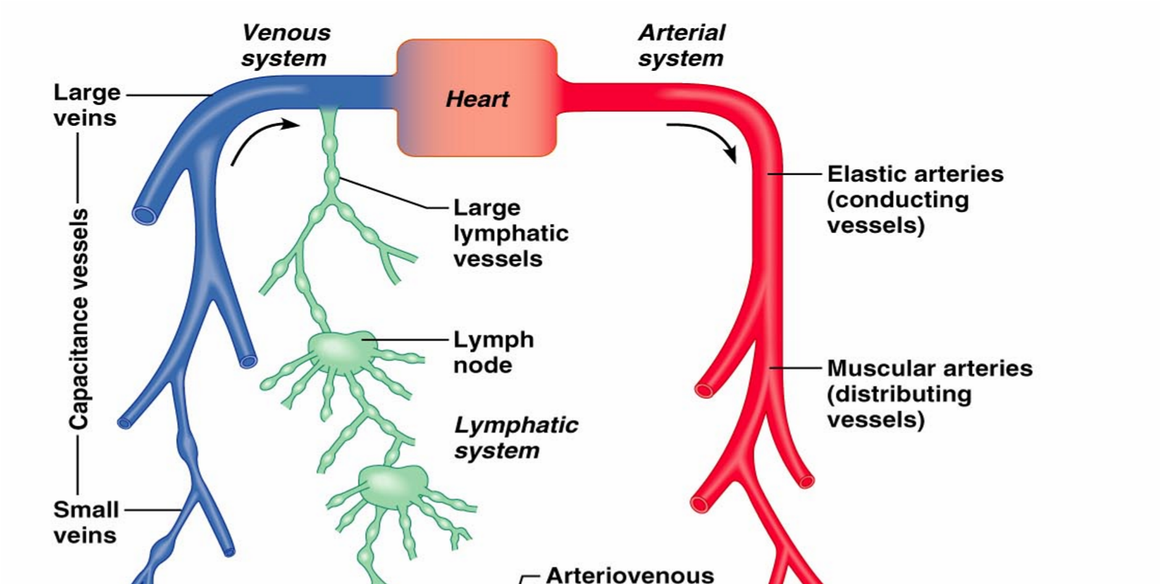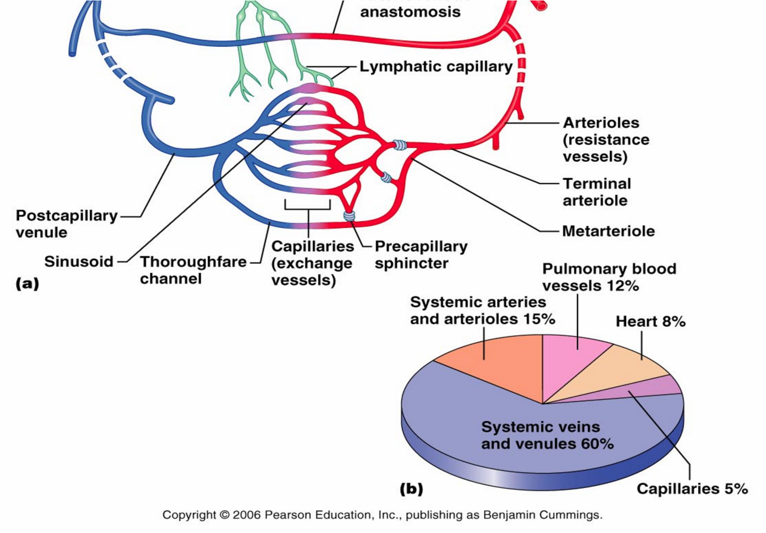

Blood vessels
Arteries & arterioles:
- The arteries are adapted to carry relatively high blood pressure away from the heart.
- Arterioles are branches of arteries.
- The walls of arteries and arterioles consist of layers of endothelium, smooth muscle, and connective tissue.
- Autonomic fibers that can stimulate vasoconstriction or vasodilatation innervate smooth muscles in vessel walls.
Capillaries: connects arterioles and venules. The capillary wall is a single layer of cells that from a semi-permeable membrane.
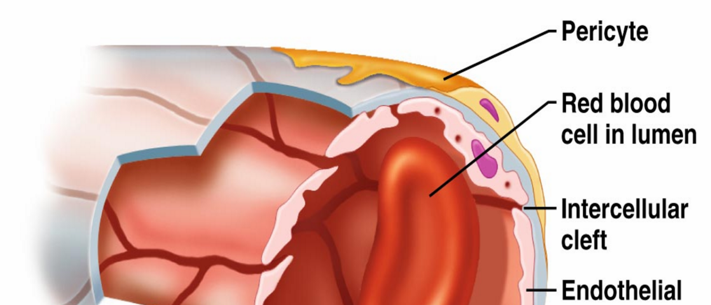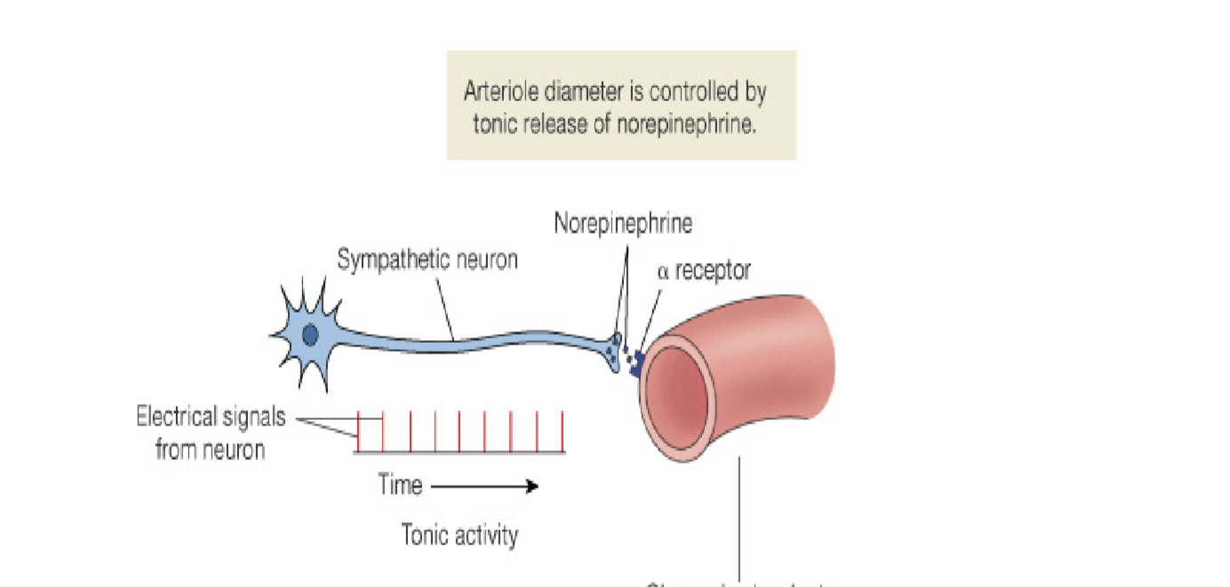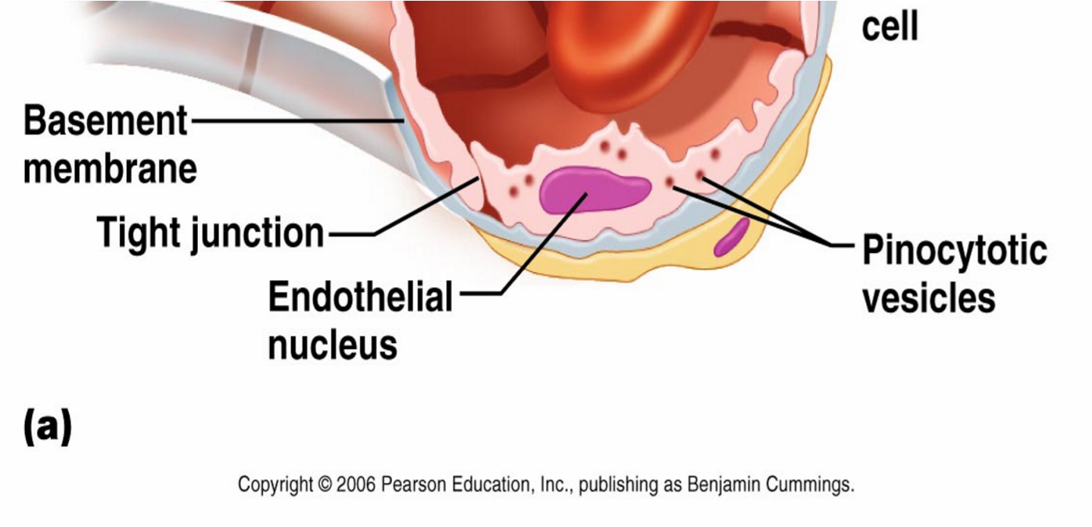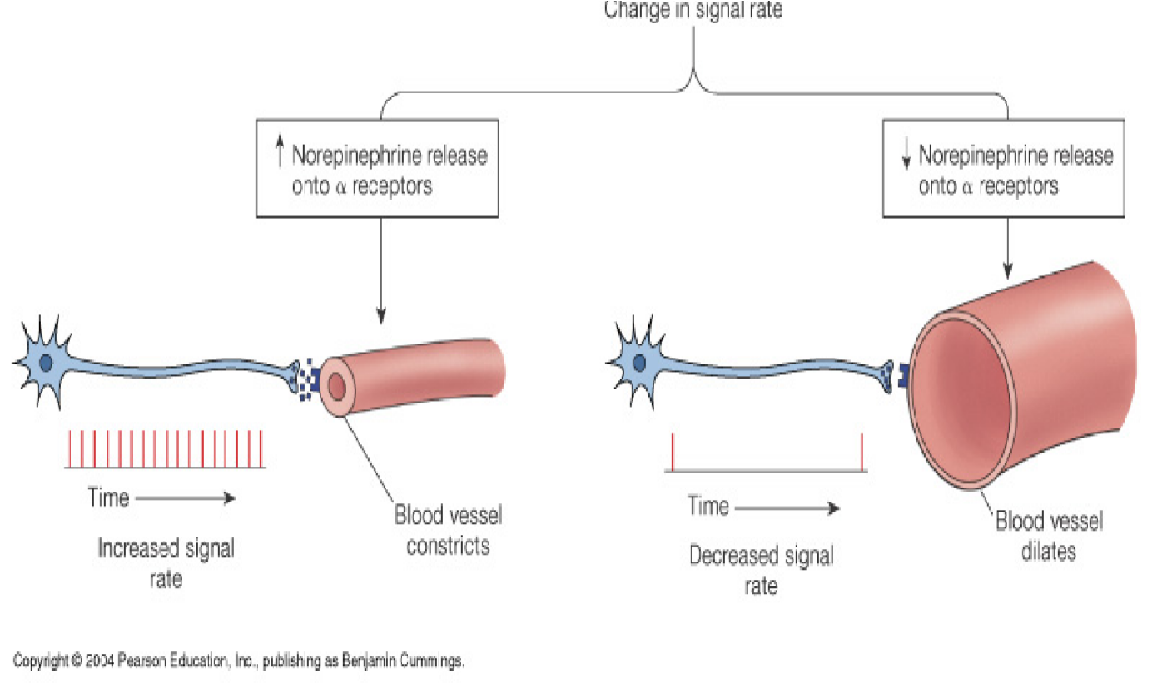
Capillary
  - Capillary permeability:
- (a) opening in the capillary walls are thin slits between endothelial cells.
- (b) the size of openings vary from tissue to tissue.
- (c) endothelial cells of brain capillaries are tightly fused, forming a blood – brain barrier through which substances move by facilitated diffusion.
  - Capillary arrangement: capillary density varies directly with tissue metabolic rates.
  - Regulation of capillary blood flow:
- (a) precapillary sphincters regulate capillary blood flow.
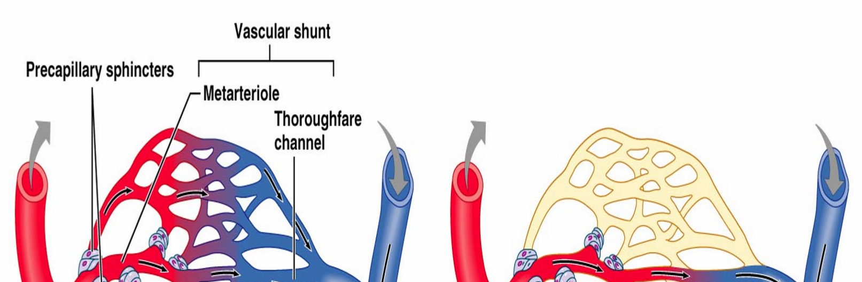
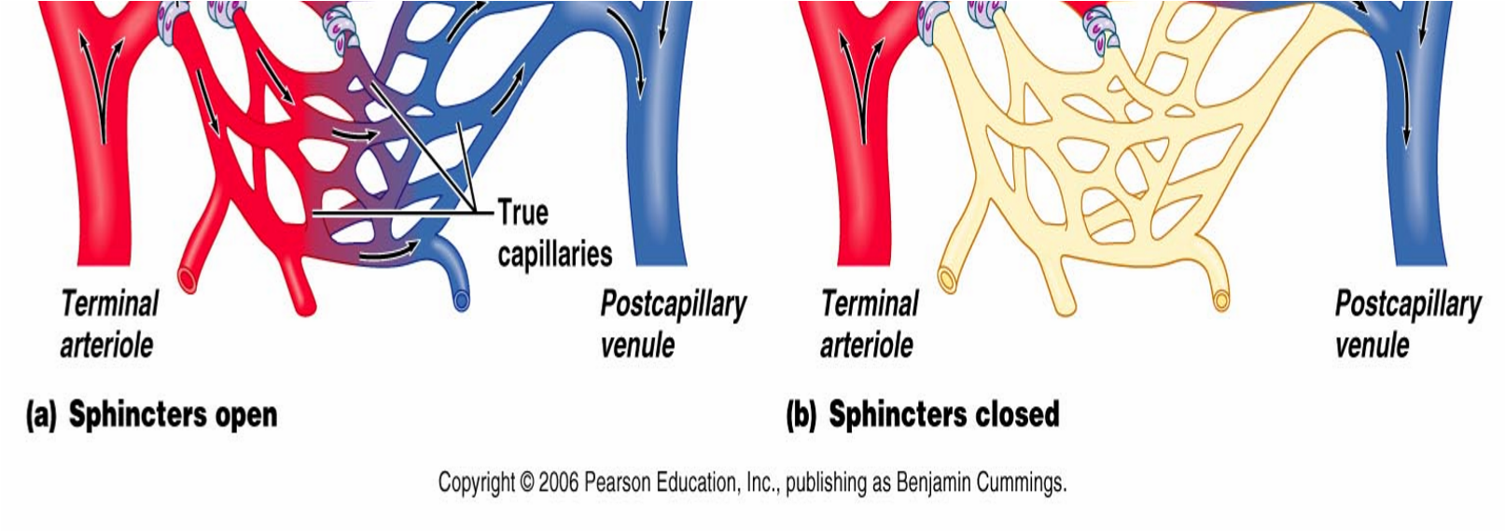
- (2) precapillary sphincters open when cells are low in O₂ and nutrients, and close when cellular needs are met. IV. Exchange of capillaries
- a. gases, nutrients, and metabolic by – products are exchanged between the capillary blood and tissue fluid.
- b. diffusion provide the most important means of transport.
- c. diffusion pathways depend on lipid solubilities. ▪ d. plasma proteins generally remains in the blood.
- e. filtration, which is due to the hydrostatic pressure of blood, causes a net outward movement of fluid at the arteriolar end of a capillary. The hydrostatic pressure of the blood forces fluid the arteriolar ends of capillaries into the interstitial spaces of the tissues.
- f. osmosis causes a net inward movement of fluid at the venular end of a capillary. Since the colloid osmotic pressure of plasma is greater than that of tissue fluid, water returns by osmosis to the venular end of capillaries.
- g. excess tissue fluid is returned to the venous system by lymphatic vessels. Edema occurs when excess tissue fluid accumulates.
Venules and veins: venules continue from capillaries and merge to from veins.

Hemoynamics
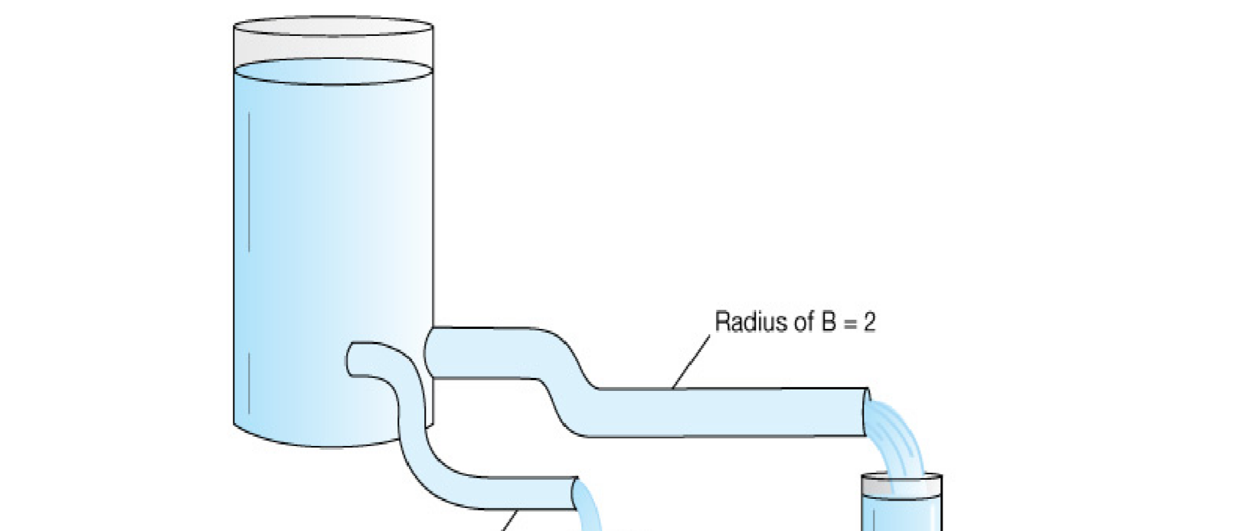
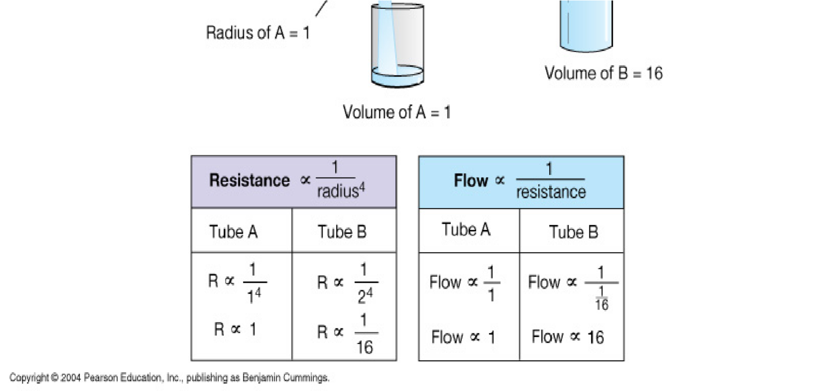
- The velocity (speed) of blood flow is inversely related to the total cross – sectional area of blood vessels, where the larger the total area, the slower the velocity. [capillaries, as a group, make up the largest total cross – sectional area in the cardiovascular system, as a result allow the slowest velocity of blood flow].
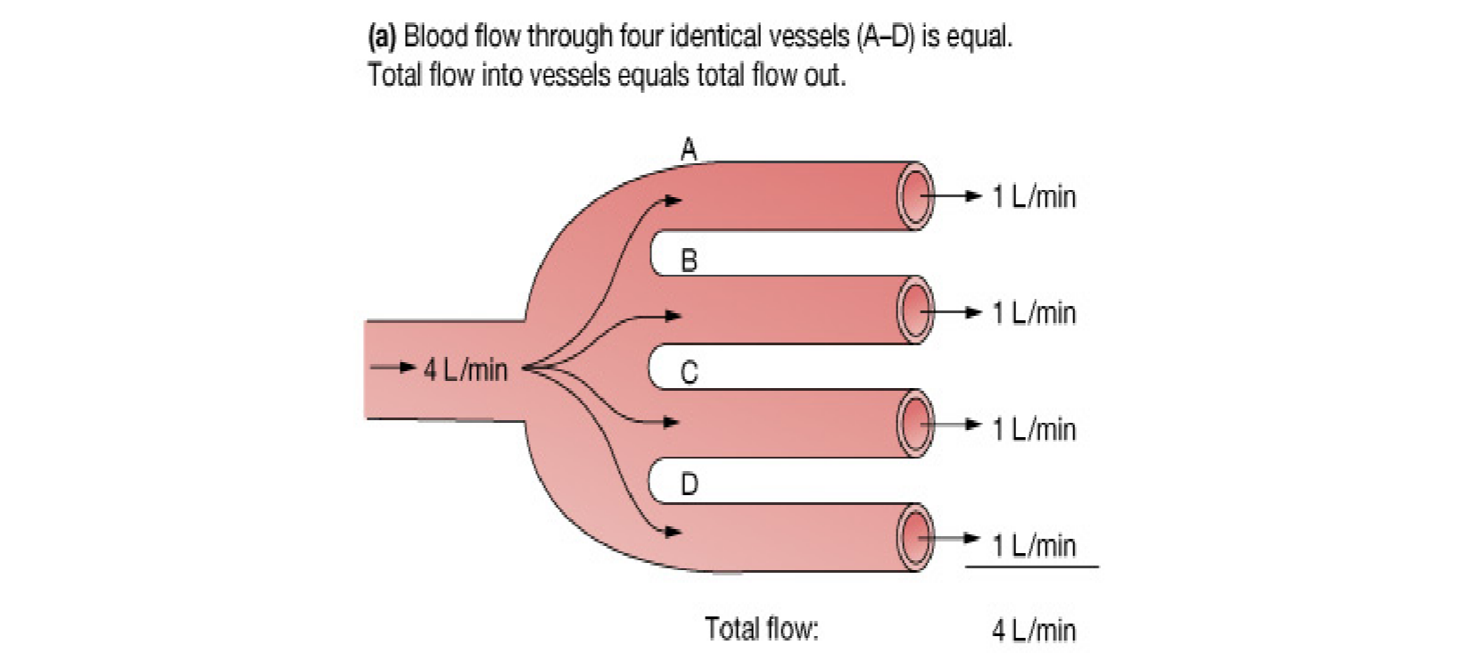
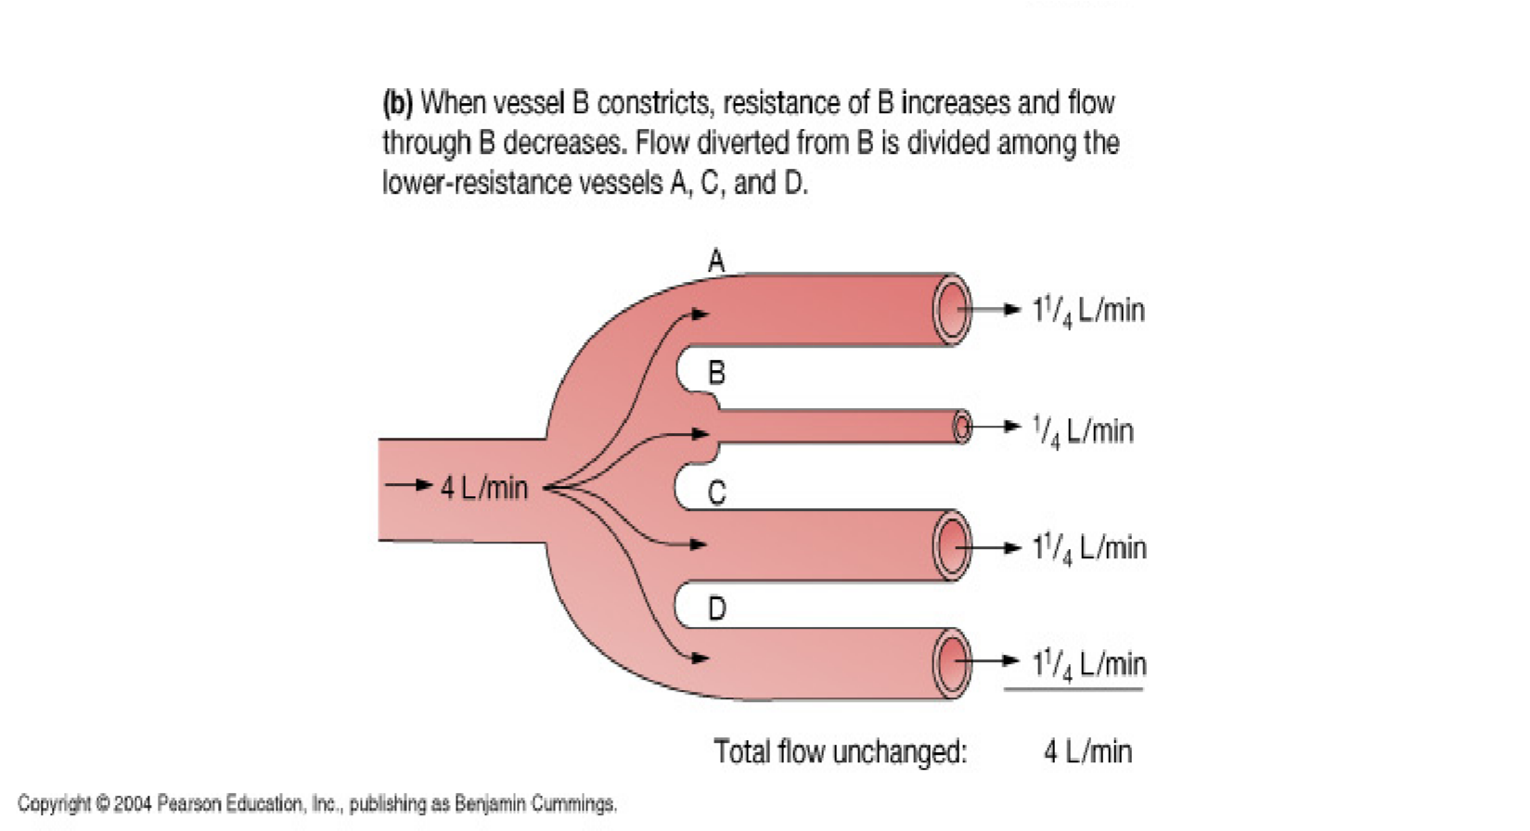
- Blood flow is affected by blood pressure (BP) and resistance (R). R refers to the opposition to blood flow due to friction between blood and blood vessel walls, blood clots, and other resisting factors, it is calculated based on the fourth power of the radius of blood vessel: R=1/r⁴. This equation indicates that the smaller the radius, the larger the resistance to blood flow. [A blood vessel with a 1 mm radius offers 16 folds more resistance than a blood vessel with a 2 mm radius!].
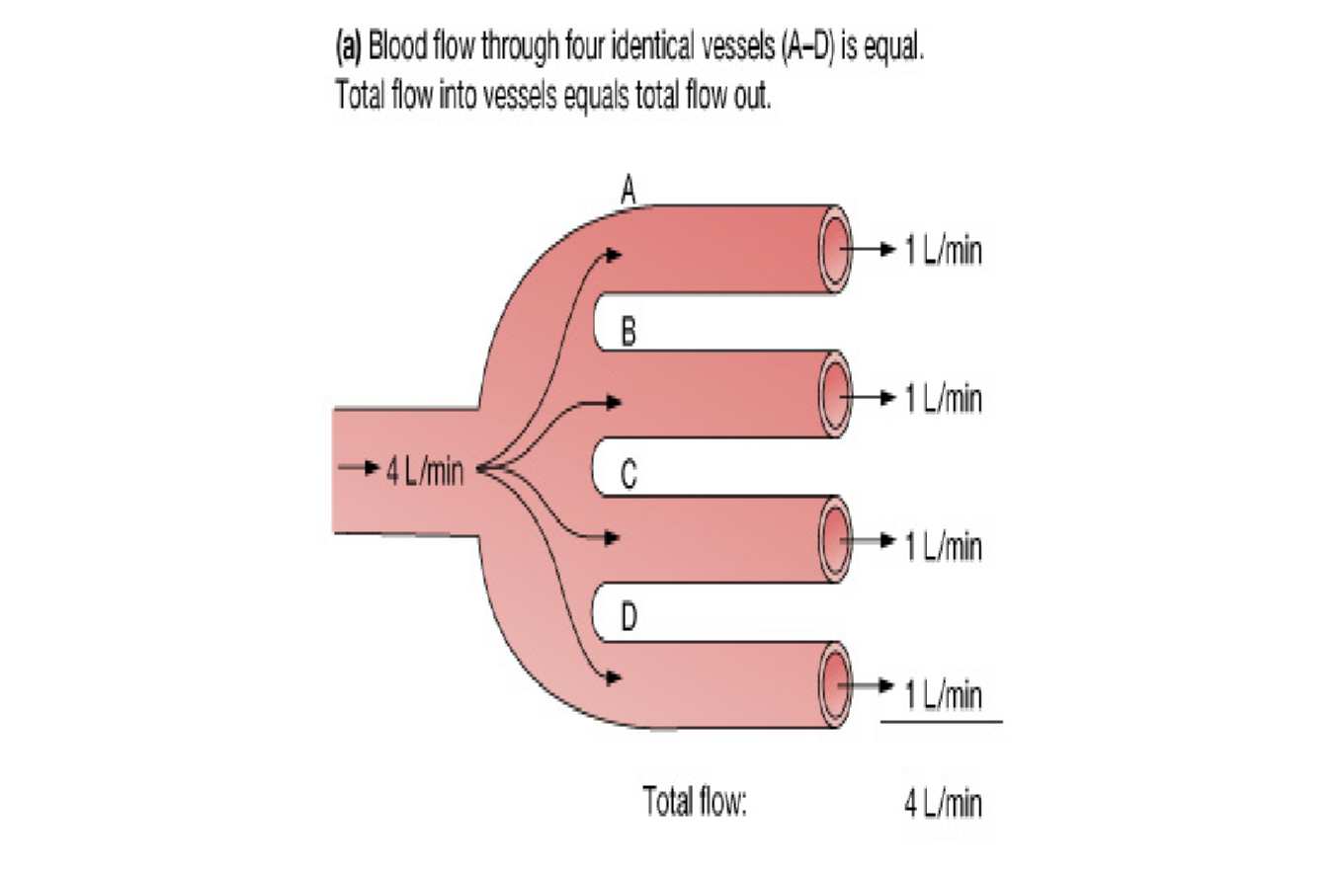
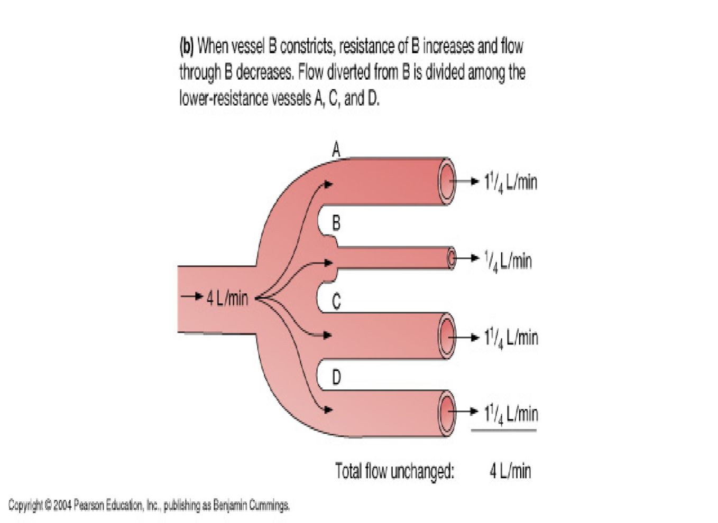
- Blood volume: The sum of all blood cells and blood plasma volume. About 5 liters in an average person.
- Peripheral resistance: Friction between blood flow and blood vessel walls produces resistance that affect blood flow and blood pressure.
- Viscosity: Higher viscosity of blood (thicker blood) causes more friction in blood flow, resulting in more resistance.

Blood pressure
Blood pressure is the force blood exerts against the insides of blood vessels.
- 1. Arterial blood pressure:
  - The arterial blood pressure is produced primarily by heartaction and rises and falls with phases of the cardiac cycle. b. systolic pressure occurs when the ventricle contracts; diastolic pressure occurs when the ventricle relaxes.
- 2. Factors that influence arterial blood pressure.
  - Heart action, blood volume, resistance to flow, and blood viscosity influence arterial blood pressure.
  - Arterial blood pressure , as cardiac output, blood volume,peripheral resistance, or blood viscosity increases.
- 3. Control of blood pressure:
  - Blood pressure is controlled in part by mechanisms thatregulate cardiac output and peripheral resistance.
  - Cardiac output depends on the volume of blood dischargedfrom the ventricle with each beat and on the heart rate.
  - The more blood that enters the heart, the stronger the ventricular contraction, the greater the stroke volume and the greater the cardiac output.
  - The cardiac center of the medulla oblongata regulates heart rate.
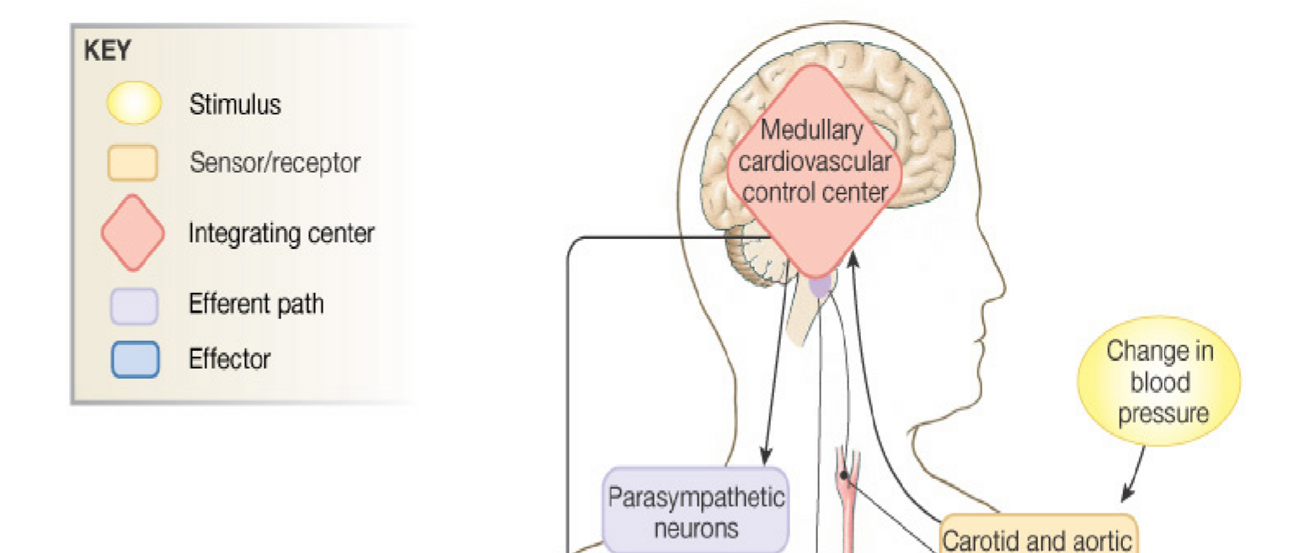
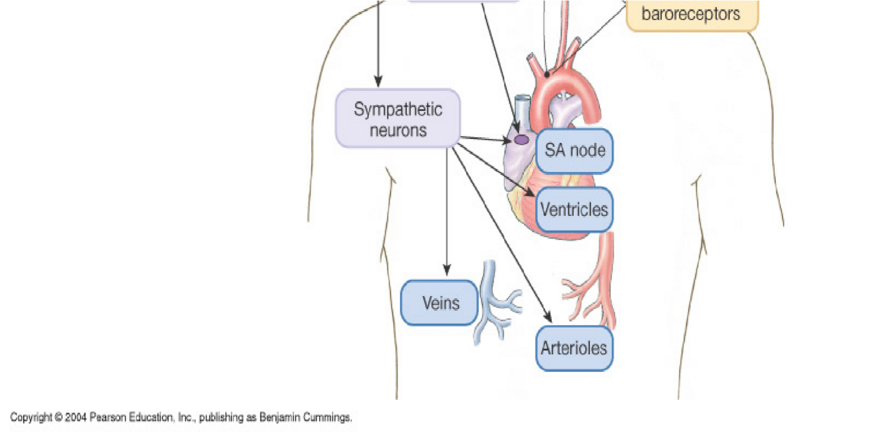
c. Changes in the diameter
of arterioles, controlled by the vasomotor center of the medulla oblongata, regulate peripheral resistance.

Venous Blood Flow
- a. venous blood flow is not a direct result of heart action; it depends on skeletal muscle contraction, breathing movement and venoconstriction.
  - pressure changes during breathing due to abdominal pressure creates a respiratory pump that sucks blood up ward toward the heart.
  - skeletal muscle contraction pump blood to ward the heart.
- b. veins contain flap like values that prevent blood from backing up.
- c. venous constriction can increase venous pressure and blood flow.

The muscular pump
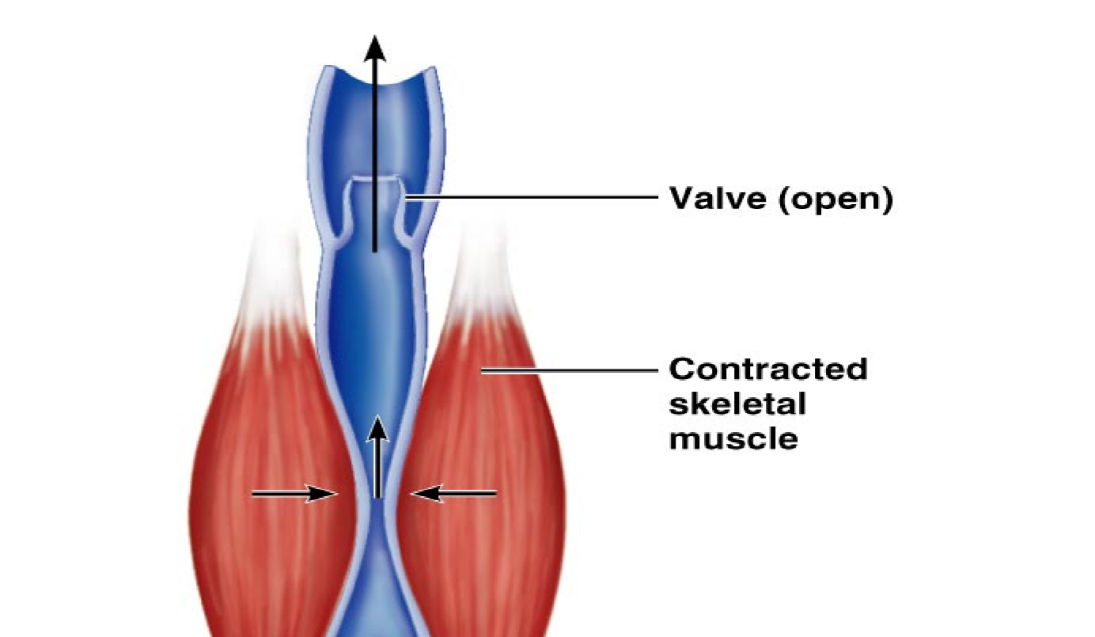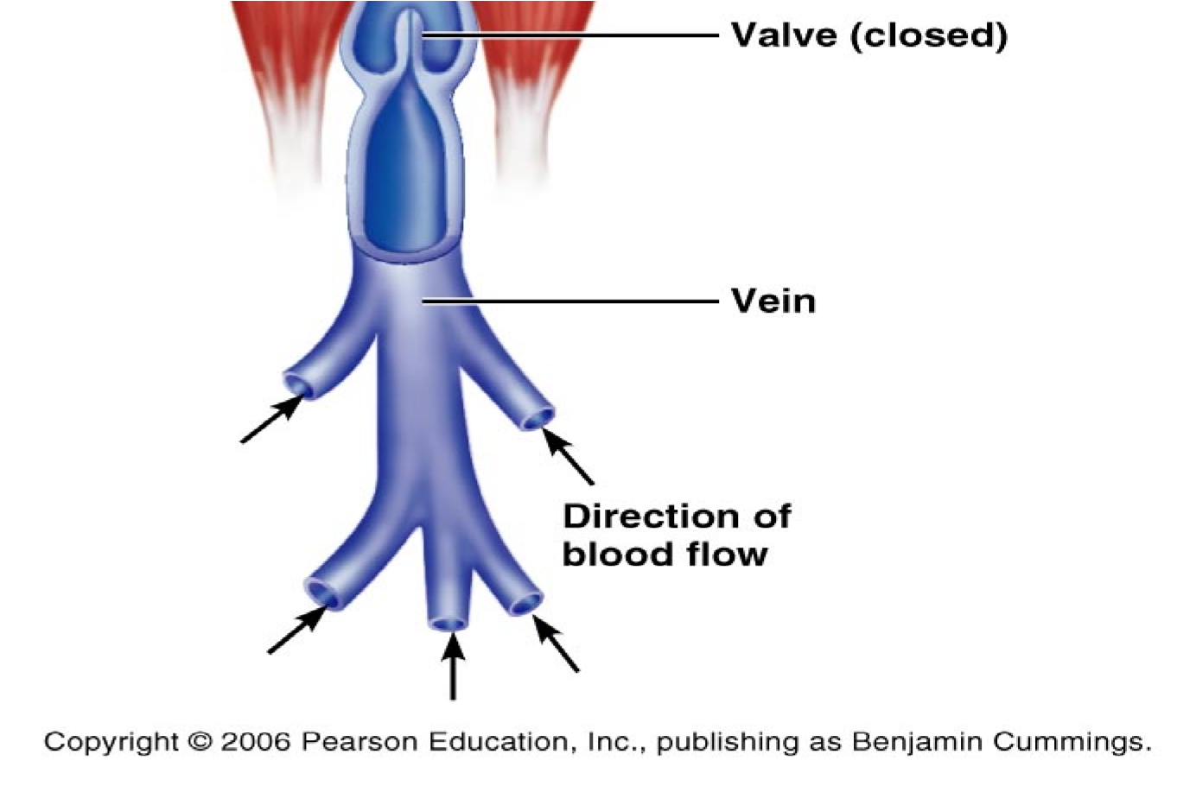
Transcapillary Exchange System
- 1. Diffusion (permeability):
  - Degree to which capillary permits the passage of molecules.
  - Major determinants are lipid solubility and molecular sizeand shape.
  - Ions do pass perhaps through gaps in or between cells.
  - Another large determinant is concentration gradients andsurface area.
  - Large lipid – insoluble molecule (albumin) enter through pores.
  - Capillary permeability is not uniform throughout the body.Note: capillaries of liver and intestine have higher permeability, muscle and skin have lower permeability.
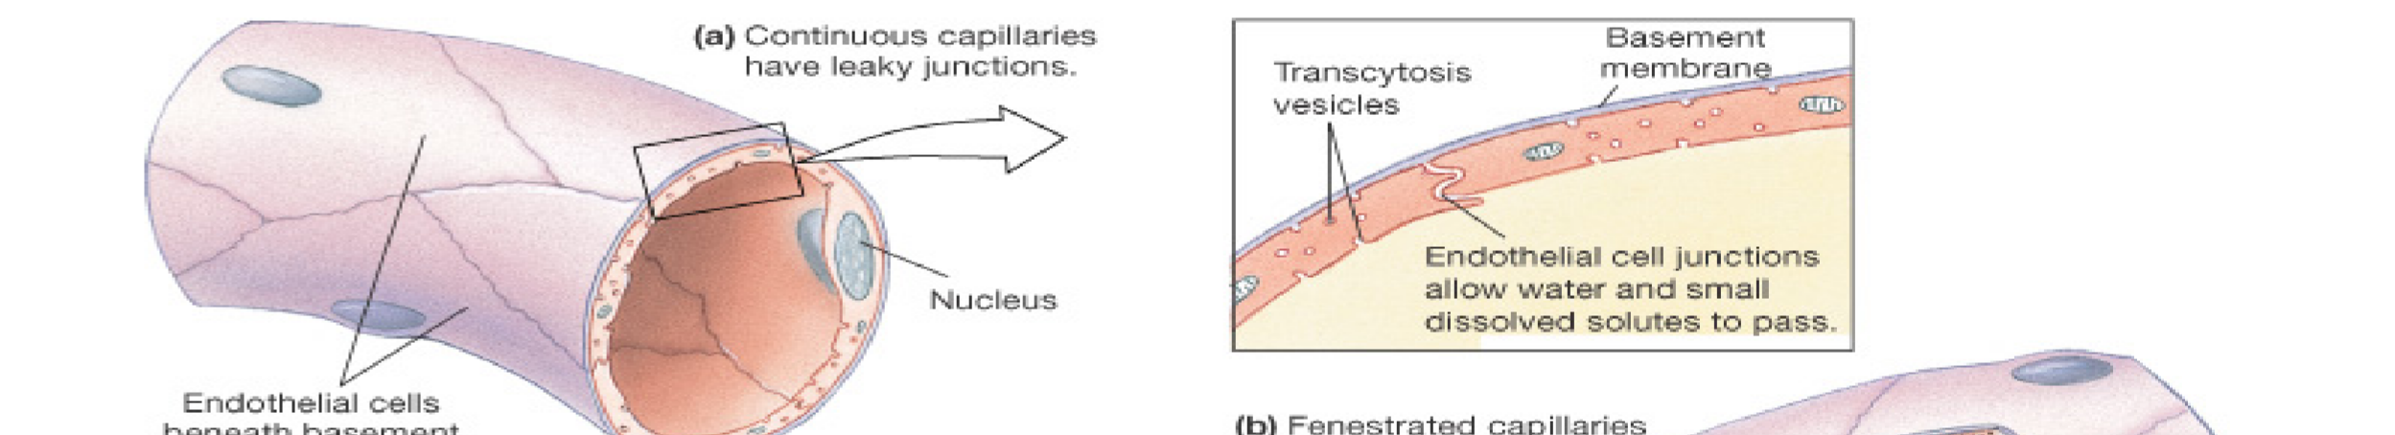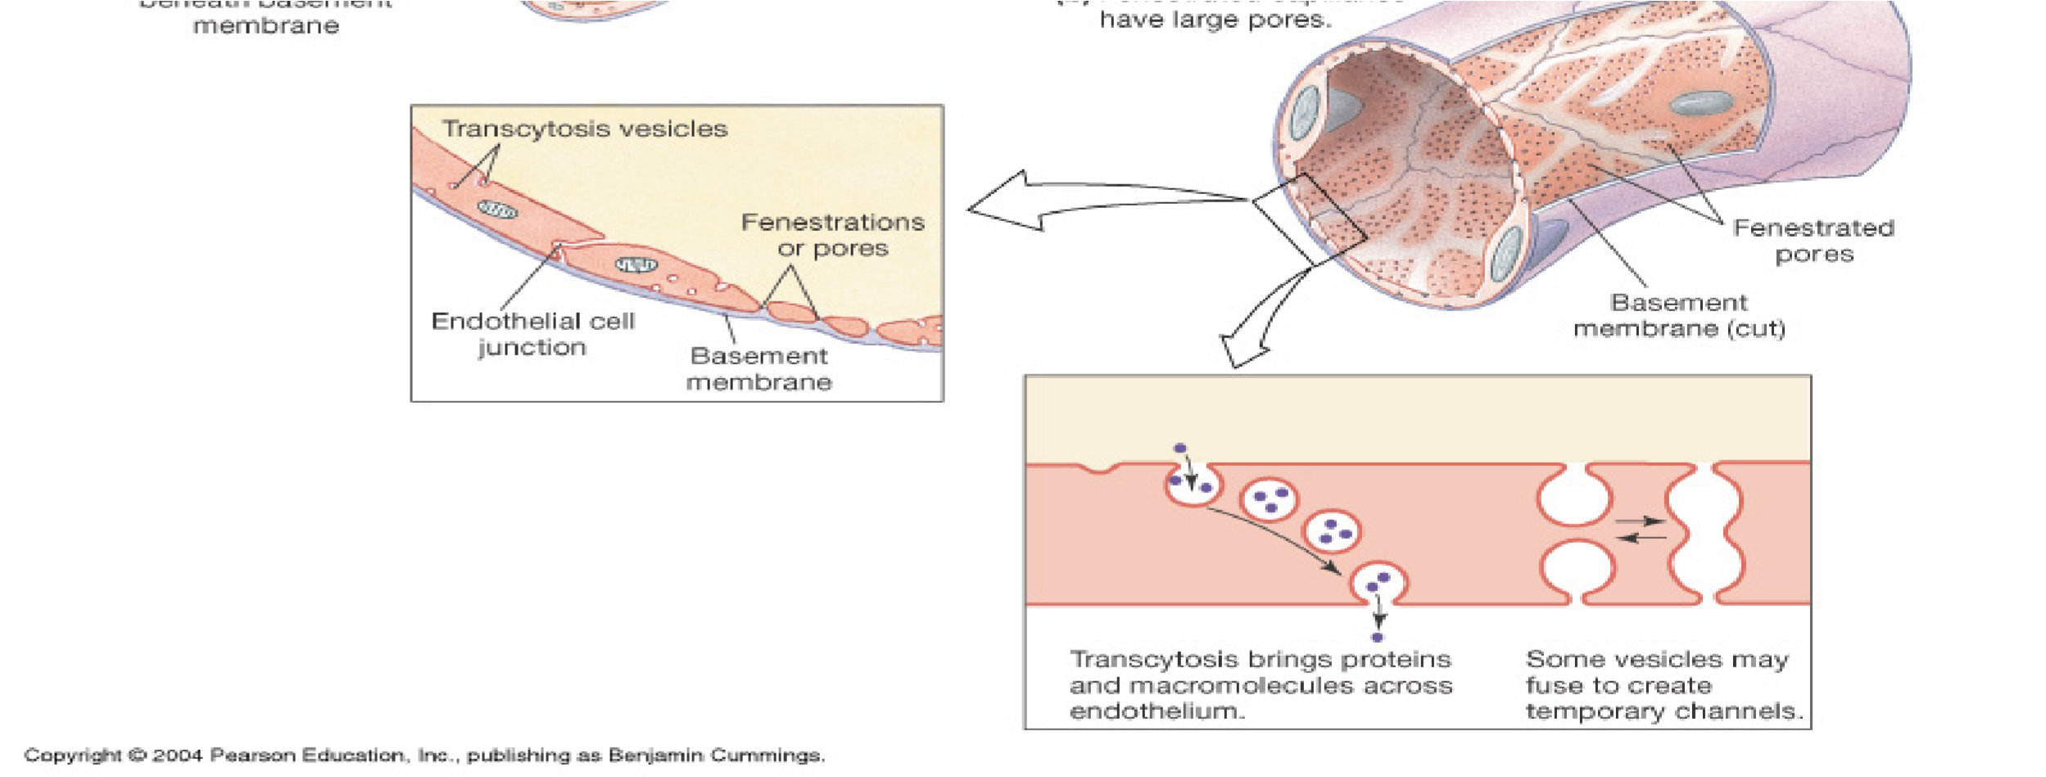
- 2. Capillary filtration rate:
- a. movement of fluid and solutes through wall in response to a hydrostatic pressure gradient.
- b. size of molecule plays a role.
- c. water filtrates through capillary wall between cell margins and through fenestrations (cell overlap) and gaps.
- d. Transport of solutes via filtration is slight and much less than via diffusion.
- 3. Net transcapillary exchange of water depends on balance between filtration (force fluid out of circulation) and diffusion (absorbs fluid into circulation).
4. Transcapillary exchange of fluids depends on:
- a. capillary hydrostatic force (CHP) and tissue spaces (THP).
- b. The collidal osmotic (diffusional) force of the plasma (POP) and the interstitial fluid (TOP).
- CHP: depends on arterial pressure, venous pressure and the ratio of post to precapillary pressure.
- THP: represents pressure developed in interstitial compartment outside capillary wall. THP is determined by volume of fluid in the interstitial space and by distensibility of space.

Fluid Exchange at the Capillary
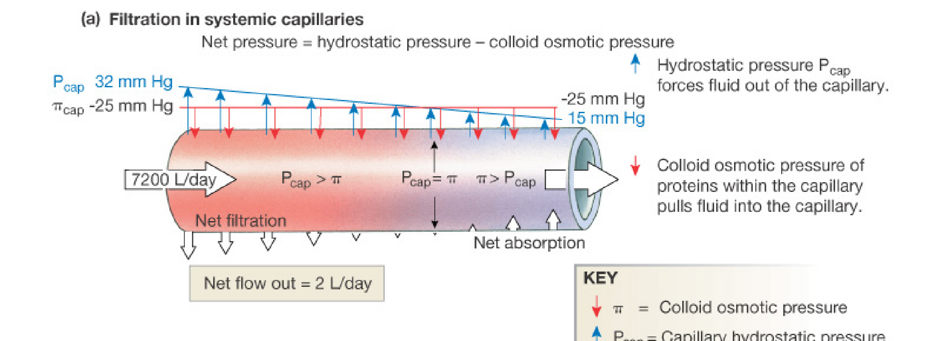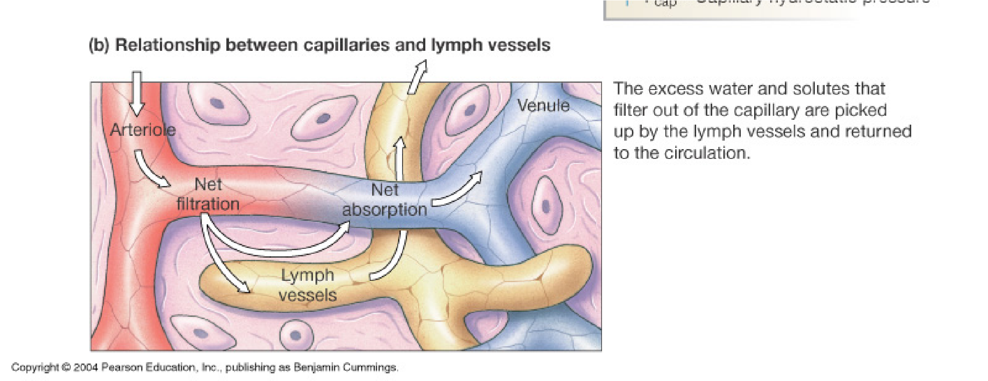

Plasma Colloid Osmotic (Oncotic) Pressure
Plasma colloid osmotic pressure:
- a. In osmosis the concentration of particles is the major determinant of osmotic gradient across a semi-permeable, rather selectively permeable membrane.
- b. Thus, plasma proteins are effective osmotic particles in the transcapillary system.
- c. Any condition leading to: decrease plasma proteins, increase capillary pressure, increase capillary permeability will result in accumulation of fluid in extra vascular tissue causing edema.
- d. Oncotic pressure also contributed by unequal distribution of diffusible ions.

Tissue Colloid Osmotic (Oncotic) Pressure
- Provided by plasma proteins which have passed through capillary wall into interstitial fluid compartment.
- Thus, it varies according to changes in capillary wall permeability.
- Low in muscle, higher in intestine and liver.
- Note: CHP may be controlled by arterial and venous resistance.
  - Increase capillary pressure is due to pre – vasoconstriction and decrease surface area.
  - post – vasodilation: increase diameter and decrease pressure.

Pressure gradient
Blood plasma and interstitial fluid are almost identical in composition except for the presence of considerable amounts of protein in plasma and very little in the interstitial fluid.
With plasma on one side and interstitial fluid on the other side of a membrane made up of a capillary wall, we find fluid flowing from interstitial fluid to plasma as a result of inequality of plasma protein in the two fluids.
To prevent flow, pressure equal to 23 mmHg must be applied to the plasma. This is the osmotic gradient caused by unequal amount of proteins (the oncotic gradient). In the body, This pressure is applied by the heart; it is the capillary blood pressure.

Filtration & reabsorption in the capillary
• Capillary blood pressure is not the same in all parts of a capillary; it is higher at the arterial end and falls continuously through the capillary until reaching the lowest value at the venous end.
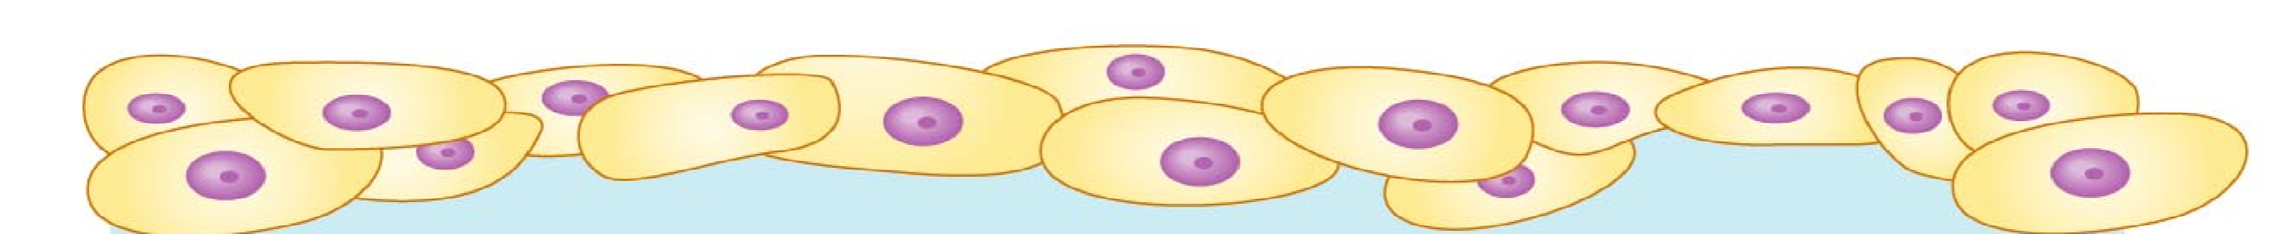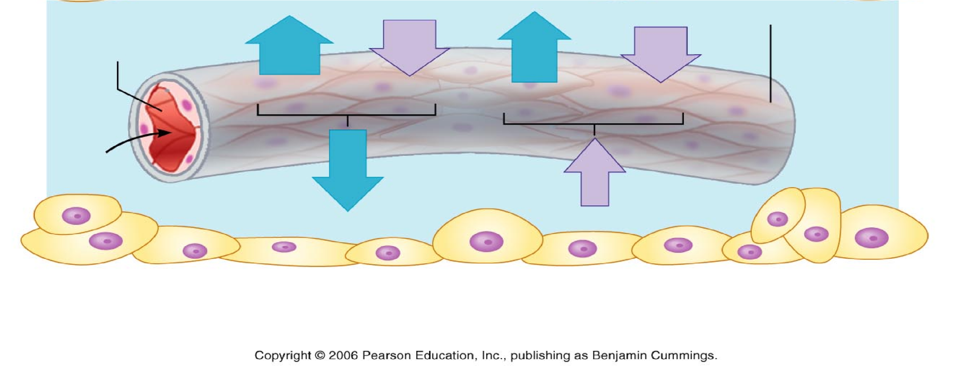
- keeping track of fluid balance in an average capillary shows that at the arterial end, hydrostatic pressure gradient = blood pressure - tissue pressure = 35 - 2=33 mmHg pushing fluid out (filtration).
- oncotic pressure gradient = plasma oncotic pressure - tissue oncotic pressure = 25 - 2=23 mmHg pulling fluid in (reabsorption). The net result at the arterial end is 33 - 23=10 mmHg pushing fluid out.
- At the venous end the blood pressure is lower about 15 mmHg. Now we have only the hydrostatic pressure gradient = 15 - 2=13 mmHg pushing fluid out while the same oncotic pressure gradient of 23 mmHg pulls fluid in. In other words, at the venous end of the capillary, we have 23 - 13=10 mmHg pulling fluid in.
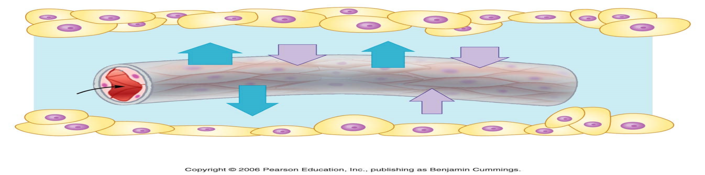

Causes of Edema
- 1. High arterial blood pressure, which increases capillary pressure.
- 2. Venous obstruction.
- 3. Decreased plasma protein concentration, leakage of plasma protein into interstitial fluid.
- 4. myxedema – excessive production of glycoproteins (mucin) in the extracellular matrix caused by hypothyroidism.
- 5. Decreased drainage – obstruction of lymphatic vessels.
Variables that affect venous return & end-diastolic volume increase end diastolic volume

increasevenousreturn
increasenegative
intrathoracic
volume
increasebloodvolume
increasevenouspressure
breathing
decreaseurine
decreasetissuefluid
vasoconstriction
skeletal
volume
volume
muscle
pump
sympatheticnervestimulation

Regulation by Antidiuretic Hormone (ADH)
- Release of ADH from posterior pituitary occurs when neurons in hypothalamus called osmoreceptors detect an increase in plasma osmolality (osmotic pressure) [produced by dehydration or excessive salt intake]. ADH stimulates reabsorption of H₂O from kidney filtrate and act to maintain blood volume.
- A decrease in blood flow to the kidneys activate the renin – angiotensin system.
- Angiotensin II stimulates vasoconstriction and the secretion of aldosterone by the adrenal cortex.
- Aldosterone acts on the kidneys to promote the retention of salt and water.
Negative feedback control of blood volume & osmolarity
- Stimuli : dehydration or salt ingestion
(decrease blood volume) increase blood osmolality
osmoreceptors in hypothalamus

posterior pituitary thirst

increase ADH
increase water retention by kidneys drinking
Negative
Feed back response: increase blood volume & decrease blood osmolality
Control of B.P. by the baroreceptor reflex:
- Going from lying to standing position decrease venous return decrease end diastolic volume decrease stroke volume
decreasecardiacoutput
decreasebloodpressure
baroreceptors(sensoryneurons)
medullaoblongata
increasesympathetic
&decreaseparasympathetic
vasoconstrictionofarterioles
increasecardiacrate
increasetotalperipheralresistance
increasecardiacoutput
increasebloodpressure

Measurement of pressure
- With each heart beat, the arterial pressure in a young adult varies between 120 (systolic) and 80 (systolic) mmHg. Pulse pressure = systolic – diastolic = 120 – 80 = 40 mmHg.
- To measure blood pressure, wrap a pressure cuff around an arm and inflate until arteries collapse and blood flow stops. The pressure at which sounds first occur corresponds to the pressure when the artery is just barely able to open for a moment, which equals to systolic pressure (the 1st korotkoff sound). Continue releasing pressure until the sound muffle; this equals to diastolic pressure (the 2nd korotkoff sound). The sounds arise from the turbulent blood flow through the narrowed (partially collapsed) artery under the cuff.

