Digestionand Absorption Of
Lipids
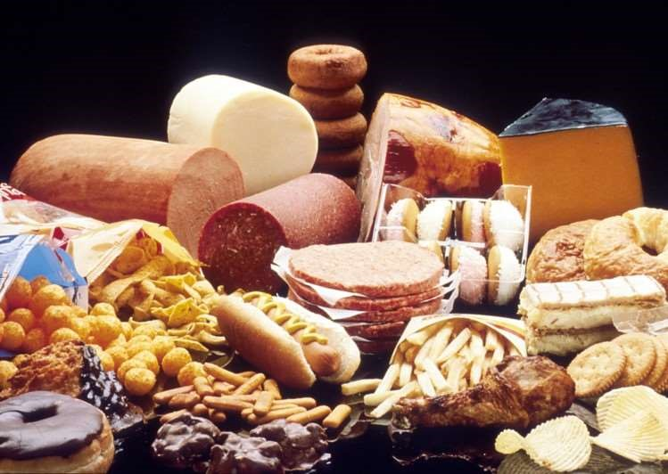
Dr. P. Murugan, M.Sc., M.Phil., Ph.D.,
Assistant Professor and Principal i/c,
Department of Biochemistry,
Bharathidasan University Model College,
Vedharanyam - 614 810.

Definition
They have the common property of being

(1)relatively insoluble in water
(2) soluble in nonpolar solvents such as alcohol, ether and chloroform.

Functions
- Storage form of energy
    - Concentrated storage
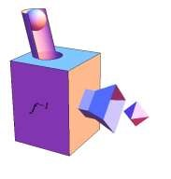
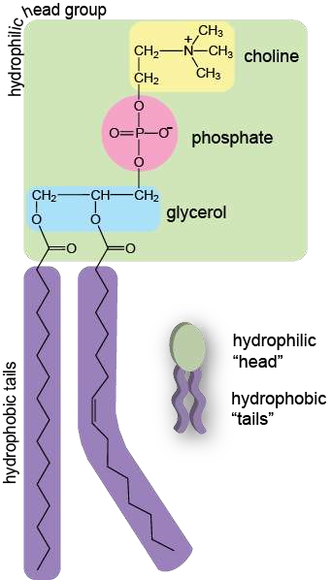
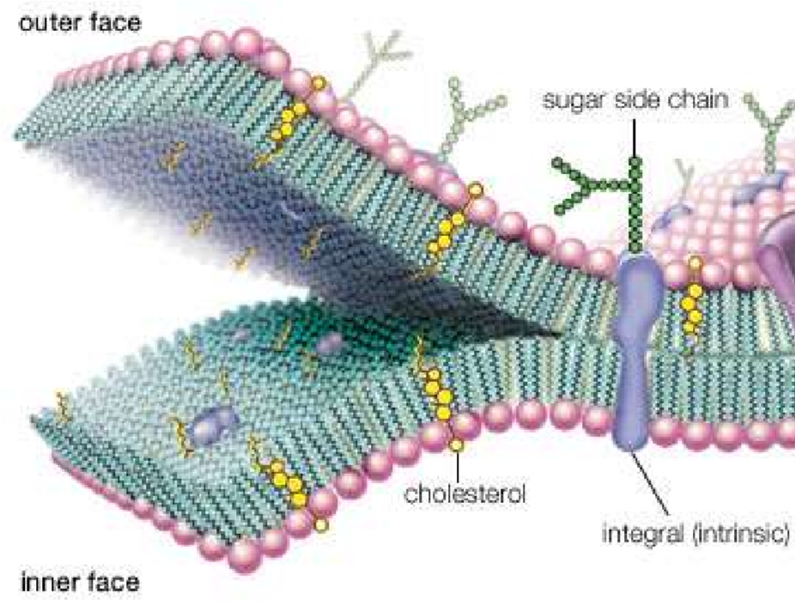
    - 9.24kcal/g
- Bio membrane
    - Structural components
    - Phospholipids
    - Glycolipids
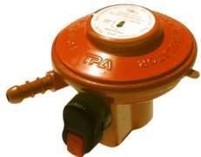
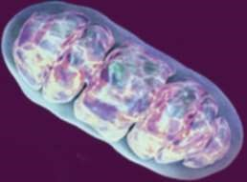
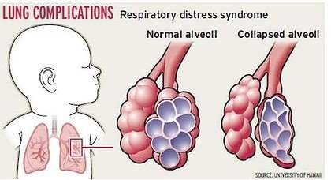
- Metabolic regulator
  - Steroid hormones
  - Prostaglandins
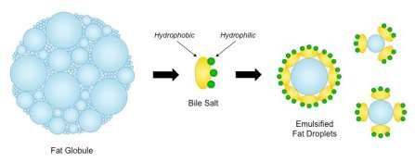
- Surfactant
  - Diphosphatidylcholine
(Lecithine)
- Detergent,emulsifier
- Electric insulator of neuron
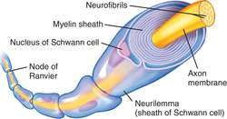
- Insulator from external temperature
- Shape and contour to the body
- Cushioning to internal organs
- Fat soluble vitamins
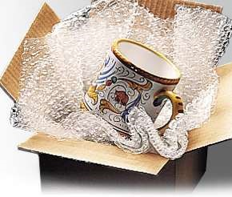
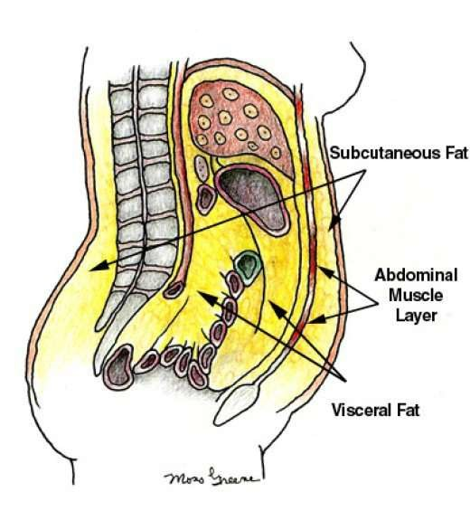
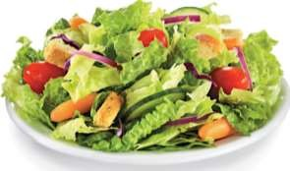
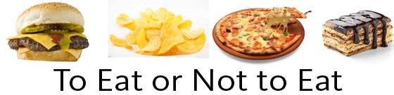
- Taste and palatability
Vs

Dietary fatComposition
>More than 95% : TG
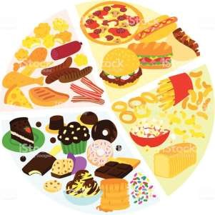
Cholesterol,
Cholesteryl esters,
Phospholipids, and
Unesterified fatty acids.

Dietary sources ofLipids
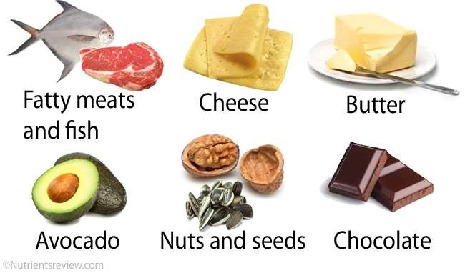
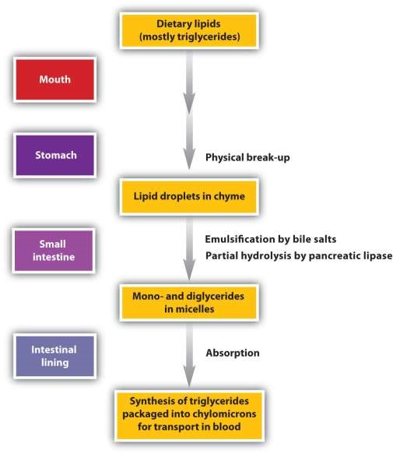
Overview

Digestion in Mouth
TG ^{Lingual lipase} 1,2 DAG +FFA
Lingual lipase:
Secreted by dorsal surface of tongue
Active at low pH (pH 2.0 – 7-5)
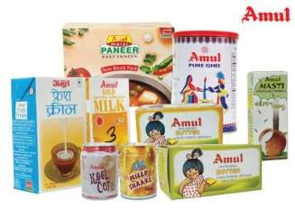
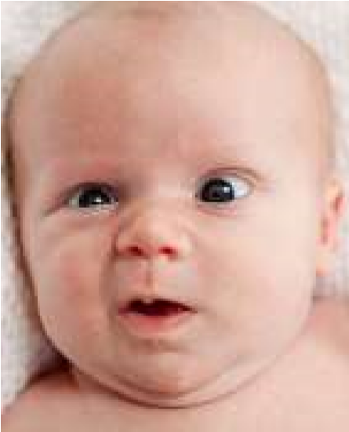
optimum pH 4.0-4.5
Ideal substrate-Short chain TGS
Enzymatic action continues in stomach
Short chain fatty acids: absorbed directly from the stomach wall
Enter the portal vein.

Triglyceridedegradation
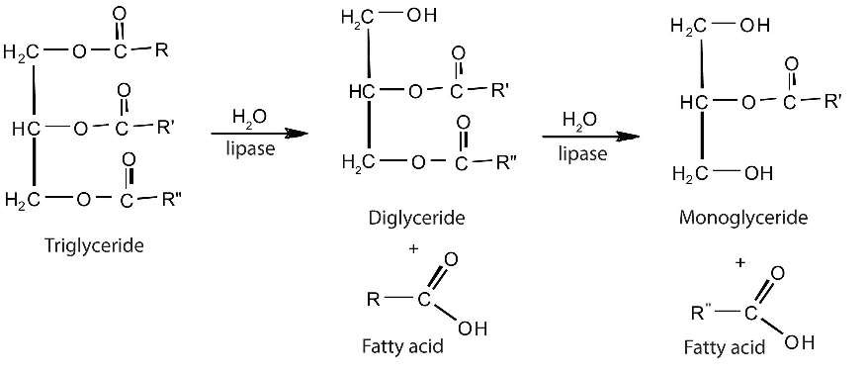

Digestion inStomach

Gastric Lipase
- Optimum p H 5.4 (4-7)
- Acid stable
- Gastrin→ Chief cells
- Requires the presence of Ca⁺⁺
- Short and medium chain fatty acid (30%)

Fats ingastric emptying : Satiety
Fats → Enterogastrone
↓
inhibits gastric motility
↓
↓ rate of emptying of stomach
↓
high satiety value.

Significance of Lingual & GastricLipases
- Neonates
- Pancreatic insufficiency
- Cystic fibrosis
- other pancreatic disorders
- short and medium chain fatty
Emulsification anddigestion
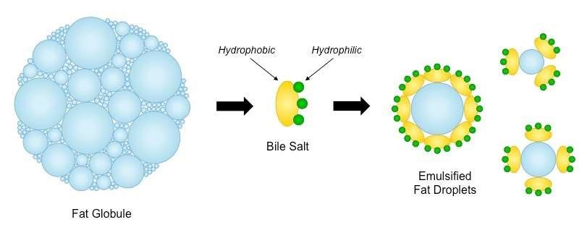
- Lipids
  - hydrophobic
  - poorly soluble in the aqueous environment
  - Lipase, : water soluble
  - can only work at the surface of fat globules.
- Digestion is greatly aided by
Emulsification : breaking up of fat globules into much smaller emulsion droplets.

Emulsification anddigestion
TG digestion :
- occurs at lipid-water interfaces
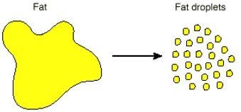
- Rate α surface area
- increased by
- churning peristaltic movements of the intestine
- emulsifying action of bile salts
- Emulsification takes place in the duodenum.

Digestion in smallintestine
- Major site of fat digestion
- Effective → Pancreatic lipase and bile salts.
- Bile salts → effective emulsifying agents
- Secretion of pancreatic juice is stimulated by?
- acid gastric /Protein rich content in duodenum
- Secretin/ Cholecystokinin Pancreozymin

GI hormones
Secretin- ↑ secretion of electrolytes and HCO3rich fluid components of pancreatic juice Pancreozymin of CCK – stimulates the secretion of the pancreatic enzymes
Cholecystokinin of CCK-PZ-
Contraction of the gall bladder
Dilatation of spincture of Oddi
Hepatocrinin-
Released by intestinal mucosa
stimulates more bile formation (poor in bile acid)

Contents of PancreaticJuice
Pancreatic Lipase- triglycerides
Phospholipase A2- Phospholipids
Cholesterol esterase- Cholesteryl esters

BileSalts
- Required for the proper functioning of the pancreatic lipase enzyme
- Combines lipase + 2 X Colipase.
- Enhances the lipase activity
- Emulsification of fats
Coli
pase
lipase
TG
particle

BileSalts
- Synthesized in the liver
- Stored in the gall bladder
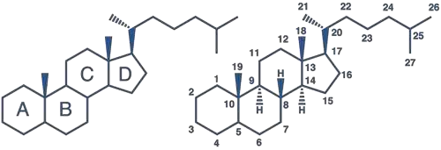
- Derivatives of cholesterol
- sterol ring + side chain + glycine / Taurine
- Na & K salts of Glycocholic & Taurocholic acid
- Entero-hepatic circulation

Emulsification by bilesalts
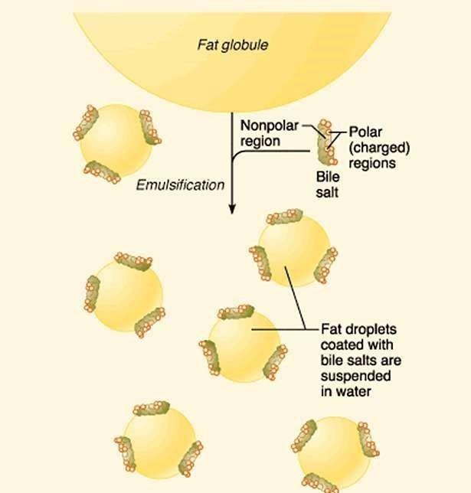
interact with the dietary lipid particles and the aqueous duodenal contents stabilizing the lipid particles as smaller preventing them from coalescing
TG degradation by pancreaticlipase
- specific for I⁰ ester linkages
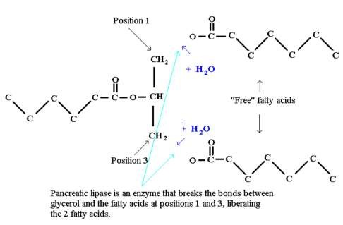
- Cant act on ‘2
- Acts on FA present at position 1 and 3
↓
α,β diglyceride
↓
β mono glyceride

TG degradation by pancreaticlipase
Isomerase
- β- Mono acyl glycerol ---------------→ α- Mono acyl glycerol Pancreatic lipase
- α- Mono acyl glycerol ---------------→ Glycerol + FA
- Primary product
- β- Mono acyl glycerol (78%)
- α- Mono acyl glycerol (6%)
- free fatty acids
- glycerol (14%)
Emulsification andDigestion of TG
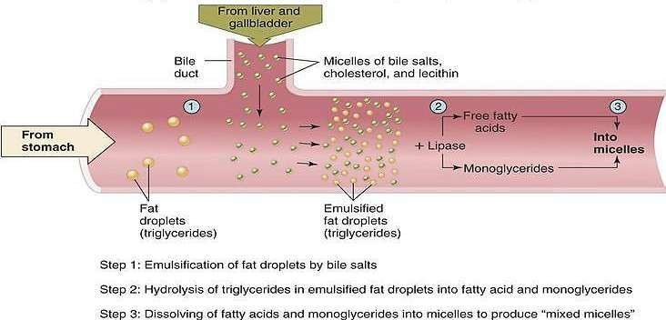

Significance ofPancreatic lipase
- High concentration in pancreas.
- severe pancreatic deficiency such
- cystic fibrosis
- malabsorption of fats
- Orlistat
- antiobesity drug
- inhibits gastric and pancreatic lipases • decreasing fat digestion and absorption • weight loss.
Cholesteryl esterdegradation
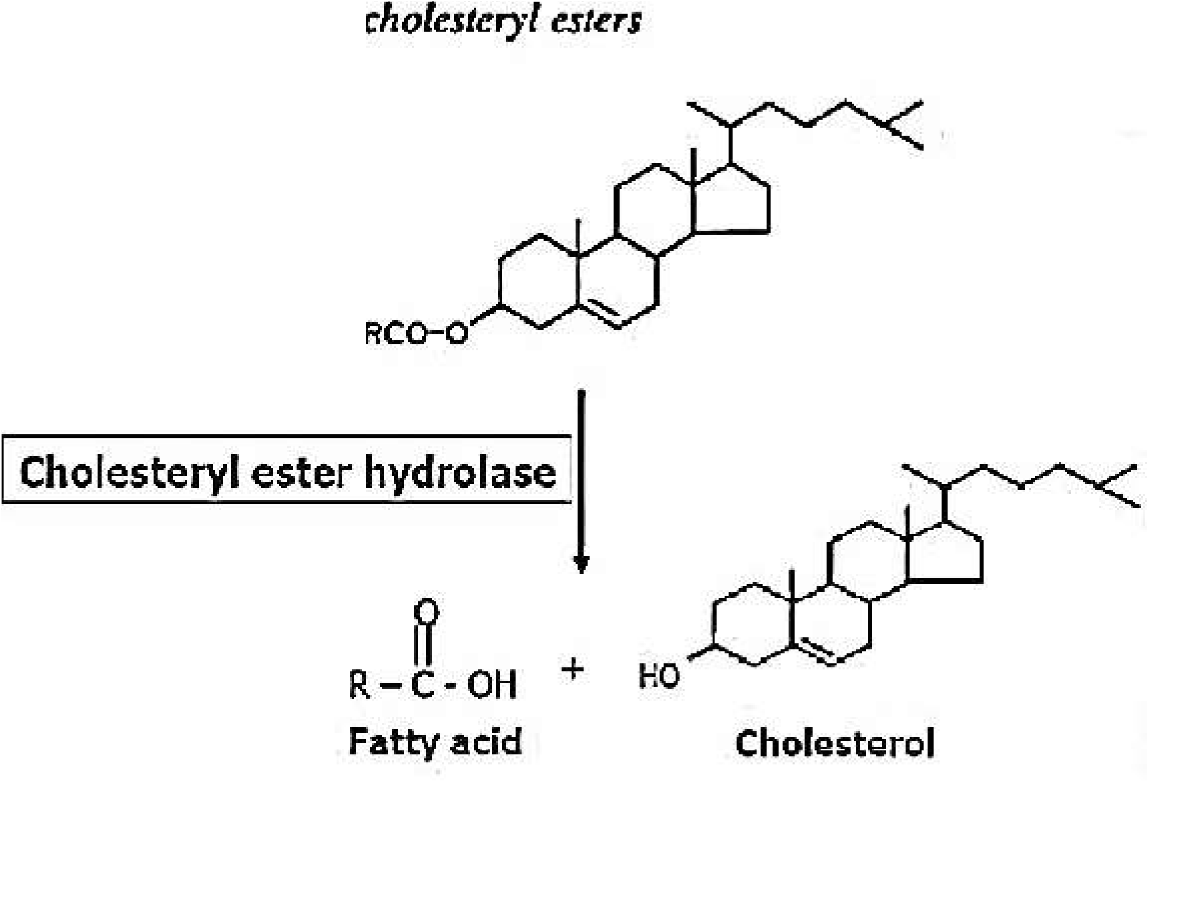
- Dietary cholesterol
- mainly free (Non esterified) form
- 10-15% is in esterified form
- Hydrolase : activity ↑ by bile salts
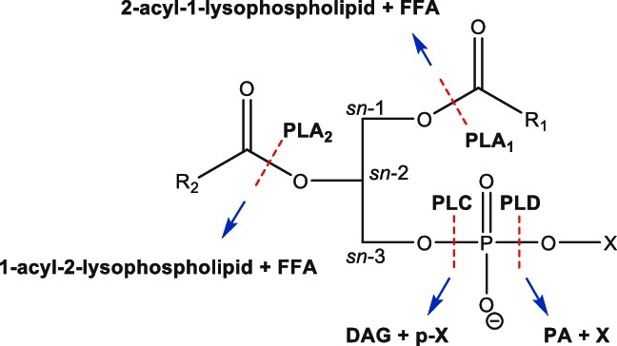
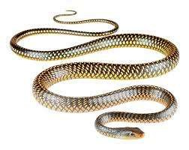
Phospholipid
degradation

Absorption ofLipids
Glycerol, short chain FA & medium chain FA directly absorbed from the intestinal lumen → portal vein → liver
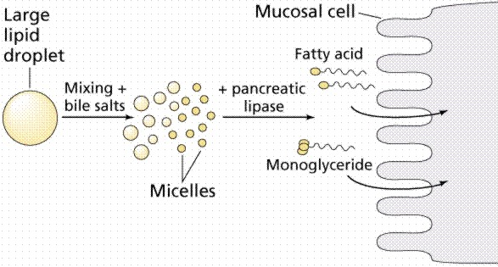
Long chain fatty acids, free cholesterol and β- acyl glycerol
With bile salts form mixed micelles

Micelles
- Spherical
- Clusters of amphipathiclipids
- hydrophobic groups on the inside
- hydrophilic groups on the outside of clusters
- Mixed micelles : soluble in the aqueous environment of the intestinal lumen
- Approach the brush border membrane of the enterocytes
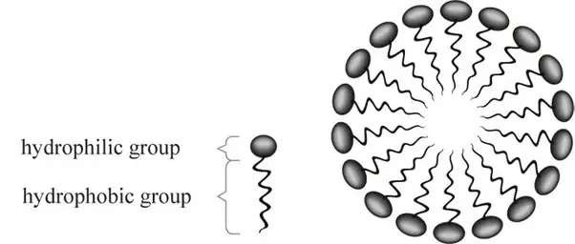

Micelles
- Micelles constantly break down and re-form,
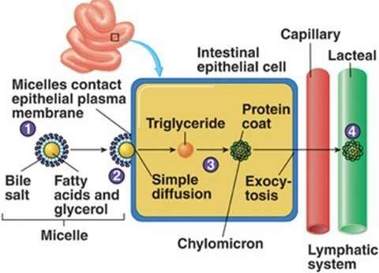
- MAG & FA :
- nonpolar
- diffuse across the plasma membrane of the enterocyte.
- Some : specific transport proteins

Clinical Significance of Cholesterol
Absorption
Ezetimibe
- Blocks a protein mediating cholesterol transport across enterocytes
- Effective at reducing levels of LDL cholesterol
- Clinical trials are in progress

Resynthesis of TAG and CHE
Within the intestinal epithelium
- 1- monoacyglycerols → FA + glycerol
- 2-monoacylglycerols → TAC
(monoacylglycerolpathway)
- Lysophospholipids → phospholipids.
- Cholesterol → Cholesteryl esters
- LCFA → TGs, PL, CHE.
- SCFA & MCFA → portal circulation
- carried by serum albumin to liver.

Formation and Transportationof Chylomicrons
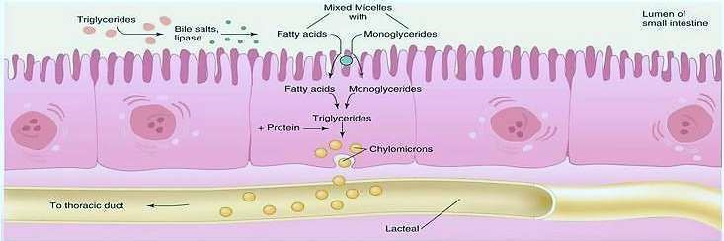

Lipid Malabsorption (Steatorrhea)
- lipids loss (including fat soluble vitamins A,D E and K) in the feces.
- Cause
- pancreatic insufficiency
- cystic fibrosis
- chronic diseases of pancreas
- surgical removal of pancreas
- Shortened bowel, Celiac diseases, sprue or crohn’s disease
- Bile duct obstruction
- Milk and coconut oil are used therapeutically since they contain medium chain fatty acids.

Secretion of lipidsfrom enterocytes
- Once inside the enterocyte
- monoglycerides and fatty acids → TAG.
- TAG + CH & Fat soluble vitamins → chylomicrons.
- Chylomicrons are lipoproteins, special particles that are designed for the transport of lipids in the circulation.
- Chylomicrons are released by exocytosis at the basolateral surface of the enterocytes.
- too large to enter typical capillaries.
- enter lacteals
- Chylomicrons then flow into the circulation via lymphatic vessels.

Structure ofChylomicron
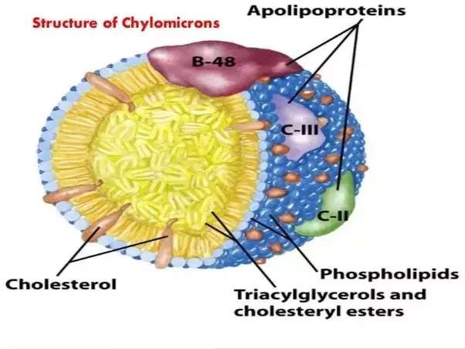
- Size: 0.1–1 µm
- Average composition
o TG (84%) o Cholesterol(2%) o Ester Cholesterol
(4%) o Phospholipid (8%) o Apo lipoproteins (2%)

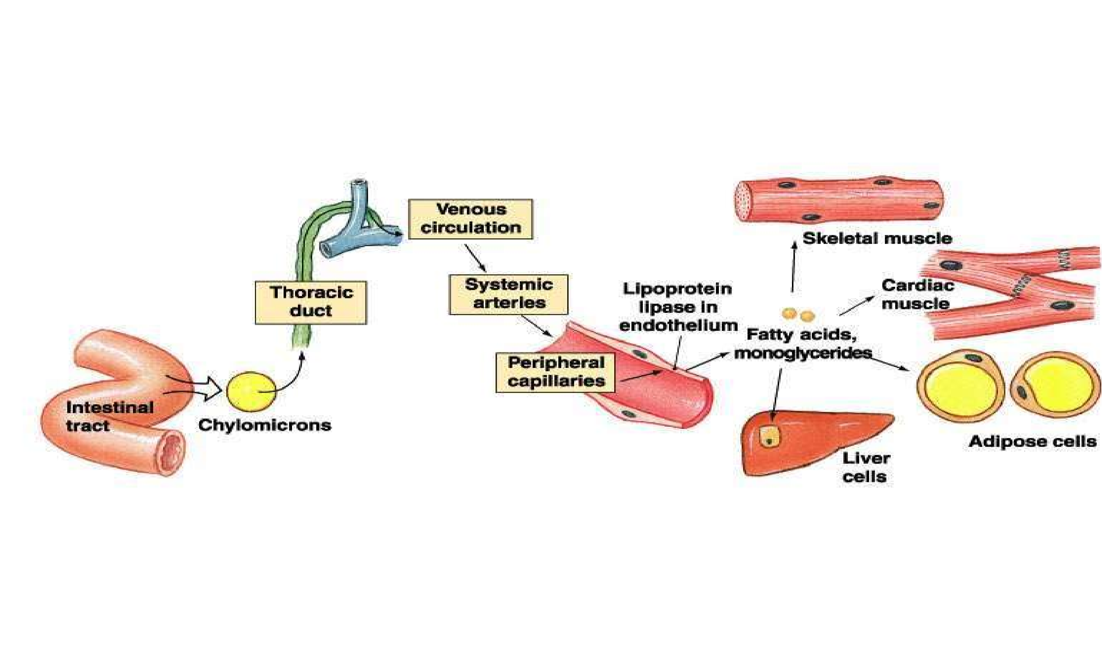
Transport and Utilizationof chylomicrons
Clinical significance ofChylomicron synthesis andutilization
- Defective synthesis- Deficiency of apo-B 48 protein.
- The triglyceride may accumulate in intestinal cells.
- Chyluria- abnormal connection between urinary tract and lymphatic drainage system of the intestines • forming Chylous fistula
- passage of Milky urine.
- Chylothorax- Small intestine resulting in accumulation of lymph in pleural cavity giving Milky pleural effusion

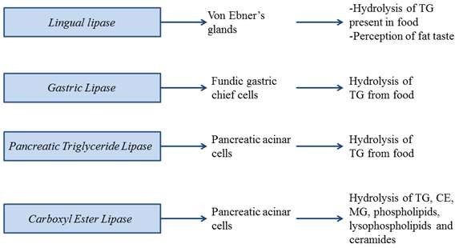

Physiologically importantlipases
Lingual /acid stablelipase | Mouth ,stomach | TAGS with medium chain FAS | FFA+DAG
Pancreatic lipase + co-lipase | Small intestine | TAGS with long chain FAS | FFA+2MAG
Intestinal lipase with bileacids | Small intestine | TAGS with mediumchain FAS | 2FFA+glycerol
PhospholipaseA2 + bileacids | Small intestine | PLs with unsat. FA at position2 | Unsat FFA lysolecithin
Lipoprotein lipase insulin(+) | Capillarywalls | TAGs in chylomicronor  VLDL | FFA+glycerol
Hormone  sensitivelipase | Adiposecell | TAG stored in adiposecells | FFA+glycerol
Summary oflipid digestion and
Absorption
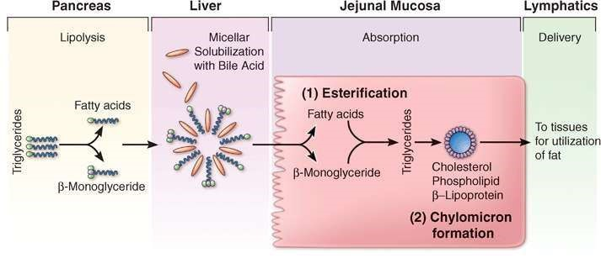
Chylomicrons deliver absorbed TAG to the body's cells. TAG in chylomicrons and other lipoproteins are hydrolyzed by lipoprotein lipase, an enzyme that is found in capillary endothelial cells. Monoglycerides and fatty acids released from digestion of TAG then diffuse into cells.

