SHRIMATI INDIRA GANDHI COLLEGE
(Nationally Accredited at ‘A’ Grade(3rd cycle) by NACC)
(Affiliated to Bharathidasan University)
Tiruchirappalli-620002


DEPARTMENT OF
FASHION TECHNOLOGY & COSTUME DESIGNING

“Sewing techniques”

Prepared By

D.JEYAPRADHA, M.tech
Asst.Professor.

Sewing Techniques

PART - A

- Write use of pinking shears.

These are useful for finishing the edges of seams and other raw edges of fabric. They produce a notched cutting line which prevents raveling of firmly woven fabrics. Pinking gives a neat appearance to the inside of garments.

- Write use of orange stick.

This is a long tool whose point can be inserted into the corners of collars, seams etc., so as to give a neat pointed appearance.

- What is the need for stitch regulator in sewing machine?

This controls the length of the stitch. Some regulators can be set to stitch in reverse.

- Write the uses of hemmer foot.

This is used for turning up and stitching a narrow seam. Ex: Bottom Hem of a Garment, Hemline of the sleeve and Bottom hem of a Pant etc.

- Give any two types of Basting Stitches?

- Even Basting
- Uneven Basting
- Diagonal Basting
- Slip Basting

- Define Seam?

A seam is a method of joining two or more pieces of material together by a row of stitching. The purpose of most of these seams is purely functional and called as constructional seams. Ex: Shoulder seam, Side seam.

- Define Placket?

Plackets are finished openings constructed in order to make it easy to put on or take off a garment.

- What is true bias?

True bias falls on a diagonal line at 45 degree to the lengthwise and crosswise grains. It has the maximum elasticity or in other words it stretches more than any other direction on cloth. True Bias is used to finish raw edges.

- Define Bead Work?

A bead work is usually done on the children garments, saree, Choli and Blouses etc.,
It is used mainly for decorative purposes. Interesting effects can be achieved through careful and artistic placement of beads, Cut beads and tube beads etc.

- Write the use of belt in a garment?

  - Belts are used for functional and decorative purposes.
  - In children garments fabric belts are most commonly used.
  - Belts can be made out of contrasting material or the garment material itself.

PART B

11. a) Explain about any 5 cutting tools.

Scissors: These have found handles and blades are usually less than 6 inches. They are designed mainly for snipping threads and trimming seems. However, scissors with 5 inch blade can be used by beginners for cutting fabrics as well. For embroidery and for cutting button holes sharp pointed scissors with blades ½ inch to one inch long are very useful. The best types of scissors have blades of uneven width. They should be held so that the wider blade is above the narrower blade.
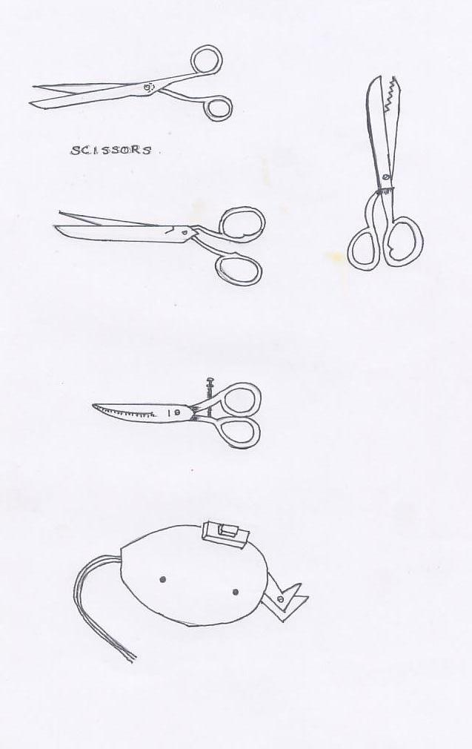

Dress maker’s shears: For cutting fabric, shears are more satisfactory than scissors. Shears differ from scissors in that they have one small ring handle for the thumb and a large ring handle for the second, third and fourth fingers. They also have longer blades (6 to 12 inches). It is better to select bent-handled shears made of high quality steel and having blades joined with a blot or screw rather than a rivet. Take good care of your shears and use them only for cutting fabric. Do not drop them or leave them out to rust.

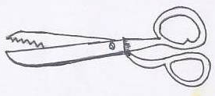
Pinking Shears: These are useful for finishing the edges of seams and other raw edges of fabric. They produce a notched (zigzag) cutting line which prevents raveling of filmy woven fabrics. Pinking gives a neat appearance to the inside of garments.

Buttonhole scissors: These can be adjusted so as to cut buttonholes in any size you require. They are useful if you are expert in tailoring and need to make many buttonholes.

Electric Scissors: In some foreign countries electric scissors which are very light and easy to operate are available.

b) Write about any special attachments for sewing machines.

Most of the attachments must be fixed to the presser bar in the place of the presser foot. The attachments that are to be fastened to the presser bar will have a prong similar to the pressure shape. Some attachments also have a hook that rests on the needle clamp. The attachments most commonly used on straight stitch machines are listed below:
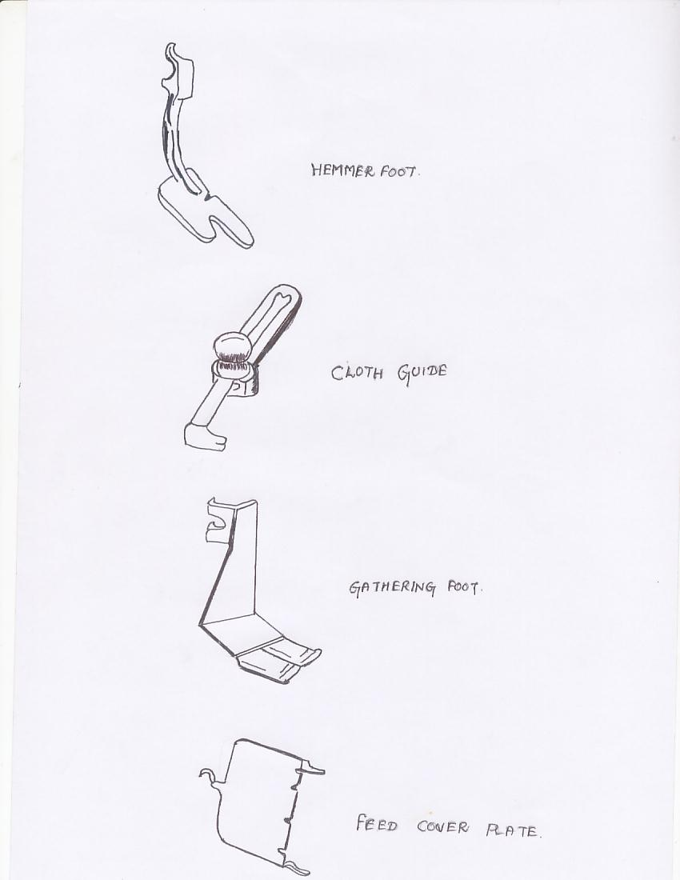
Hemmer foot: This is used for turning up and stitching a narrow hem.

Ruffler: This attachment is capable of taking uniform gathered or pleated frills and will take and apply frills to another section at the same time. It is useful in making children’s clothes and curtains.

Cloth guide: This is a device which is useful in guiding fabric for uniform stitching.

Cording foot or zipper foot: This is designed for stitching close to a raised edge. It is used for applying cording into seams and for application of zipper.
Binder: This is used for applying ready made or self made bias binding to a straight or curve edge and is a very useful attachment for trimming dresses etc.
Tucker: This is used for making uniform tucks from 1/8inch to 1 inch in width.
Gathering foot: This attachment gathers fabric as it is stitched, with the fullness, locked in every stitch.

Feed cover plate: This is used to cover the feed dog while doing machine embroidery and darning.

12 a) Describe about bobbin winding & bobbin case fixing.

Winding the Bobbin
Bobbins wind differently on the various machines, but generally the thread is first placed on a spool pin located below the flywheel and then drawn through the thread guide near the spool pin. Now with your hand wind the end of the thread on the bobbin in clockwise direction and place it on the winder. Turn the bobbin on the winder until learning to treadle, run the machine with the pressure foot up and the clutch on flywheel loosened so that the needle does not go up and down. Sit at a comfortable height in front of the machine and place one foot forward and the other foot slightly back on the treadle. Start the machine by turning the flywheel towards you. As the treadle begin to move start pedaling slowly in such a way as to move, start motion. Continue evenly, and gradually increase the flywheel and stop the motion of the feet. Practice to run the machine smoothly at low and high speeds.
If you have a hand machine, you need practice to turn the wheel smoothly with your right hand and guide the fabric with the left hand.
An electric sewing machine is operated by knee or foot control of an electric motor. A little practice is required to control the pressure needed to operate the machine at any desired speed with an even, regular rhythm.
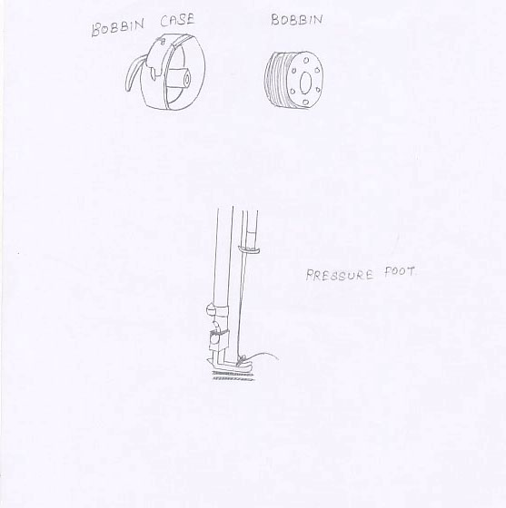

Bobbin case Fixing
Under threading: In each bobbin case there is a slanting slot and a spring. Insert the bobbin into the bobbin case so that the thread comes around the bobbin and turns back to lie in the slot. Now guide the thread through the slot and below the sprig and pull out a length of thread test the tension on the bobbin thread by pulling the thread end gently. There should be slightly, but noticeable tension and bobbin should stay firmly in place. Leave a thread end 3 or 4 inches long extending from the bobbin case. Now open the slide plate, lift the latch on the bobbin with your thumb and forefinger and insert the bobbin case into the machine close the slide plate.

Top threading: Raise the take-up lever to its highest point before you start threading. The spool of thread is first placed on the spool pin on top of the machine head and the thread end is passed through a thread guide to the tension mechanism. After drawing the thread between the tension discs and through the take-up spring, pass the end of the thread through the hole in the take-up lever from the side through the tension disc. Now thread the remaining guide which leads to the needle and insert the thread into the needle from the side on which the last guide appear. Fig shows the machine already threaded.

b) How will you adjust the stitch length and pressure of pressure foot in a sewing machine.
Adjusting the stitch length:
The chart on page 5 gives the correct stitch length for various fabrics. In general, fine fabrics require a short stitch (16 to an inch), medium weight fabrics a medium stitch (12 stitches per inch) and heavy fabrics a long stitch (8 to 10 to the inch). For machine basting and machine gathering a still longer stitch (6to 8 per inch) is needed. To adjust the stitch length, loosen the stitch regulator knob by partly unscrewing it, move it to the desired number on the marked plate and tighten the knob. On our local models of machines, the higher numbers denote longer stitches. In recent models of numbers denote longer also has a setting for reverse stitching.
Adjusting the pressure of the presser foot:
Ordinarily this adjustment need not be done for sewing on fabrics of medium texture. In general, coarse fabrics require a heavier pressure while sheer pressure feed a double thickness of fabrics through the machine and adjust the presser thumb screw until the fabric moves under the presser foot with ease leaving no feed marks. Usually the presser bar screw is turned to the right to increase pressure and to the left to decrease pressure.
13. a) Give any 5 types of pleat with Illustration.
Pleats:
Pleats are introduced usually at the waist line of skirts and dresses, to provide fullness evenly all around. One usually employs knit pleats, box pleats or inverted pleats, alone or in combination (for example a wide box pleat in the centre front of skirt with knife pleats on either side). Other types of pleats are kicking pleats, cartridge pleats and pinch pleats. The preparation of pleats is similar to that of tucks, the main difference being that pleats are seldom stitched all the way down. Sometimes they are stitched part way down the garment for flatness. A point to remember is that to make each pleat you require extra material of twice the width of finished pleat. So if you want pleats touching each other all round the garment, the amount of material needed is three times the finished width.
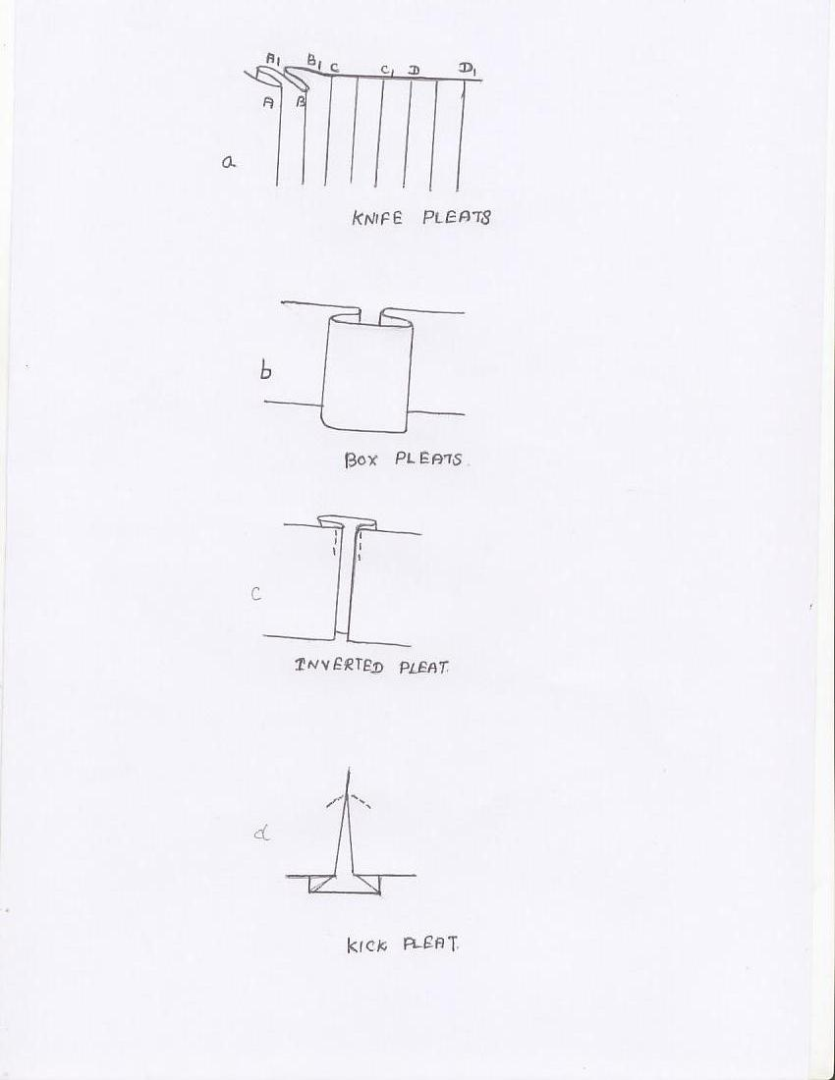
Knife pleats: They are usually about 1\2 inch to 1 inch wide and are funned towards the same direction. The direction may be reversed at centre back or centre front of the garment. The figure shows two knife pleats tacked in position and markings for two more pleats. To from the third pleat, make a fold along line C and bring this fold to the right so as to lie over line C₁. Similarly the fourth pleat will bring D over D₁. The distance CC₁ (or DD₁) is twice the width of the finished pleat.

Box pleats: Two knife pleats turned away from each other (one to the left and one to the right) from a box pleat.

Inverted pleat: It is the opposite of a box pleat. It is made up of two knife pleats turned towards each other so that the folds meet in the middle on the right side of the garment.

Kick pleats: This is actually a knife or inverted pleat which has the fullness released in the lower 6 to 8 inches of the skirt.

Fan pleats: These consist of narrow pleats which are wider at the bottom than at the top because they are made on circular skirts.
Cartridge pleats: These are round pleats used as trimming for skirts and dresses and are suitable only in firm fabrics. Take a strip of material 1.5 to 2 times as long as the section of the garment which is to be trimmed with pleats. Make markings dividing the garment section into a number of equal spaces and make an equal number of evenly spaced markings on the long strip.

13. b) Write about any 5 permanent hand stitches with neat sketch.
Running stitch: This is the simplest form of hand stitch which is used for permanent sewing. Hand made seams, tucks, gathering, shirring, quilting and mending can be done with this stitch. It is similar to even basting, but the stitches are much smaller. The
Stitches should be straight, fine and evenly spaced and about 1/16 to 1/8 inch in length. Pass the needle through the fabric several times before pilling it through.
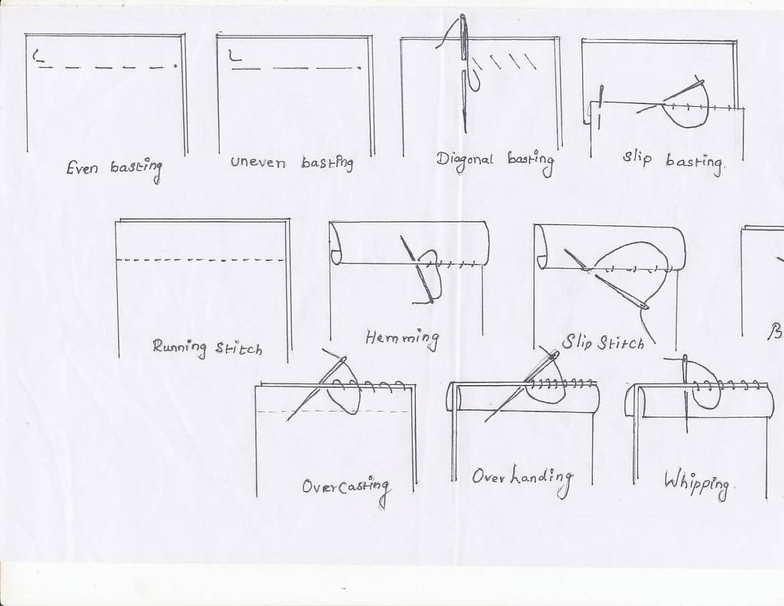

Hemming: This is used to secure down a folded edge of material. Its most common use is for hems. Hemming appears as small slanting stitches on the wrong side and right side. The stitches should be fine and spaced close enough to hold the hem securely in place, yet far enough apart to be inconspicuous from the right side of the garments. Before staring the hem, fasten the thread with several tiny stitches on top of each other. Finish off the hemming also with several stitches to fasten it securely.

Slip stitching: This is used for hems, facing or folds where invisibility is more important than strength. Fasten the thread beneath the hem, bringing the needle out the edge of the fold. Take a tiny stitch in the garments directly beneath the point where the thread leaves the fold. Now insert the needle in the hem, slip it along inside the fold and bring it out again about ½ inch away. Repeat the stitch.

Back stitch: The back stitch is strong and is sometimes substituted for machine stitching should be about 1/16 to 1/8 which long on the top side. To make the back stitch, push needle up through the material at a point on the stitching line about 1/8 inches from its right end. Take a stitch inserting the needs 1/8 inch back of the thread at the beginning of the stitching line and bringing it out an, equal distance in front of the thread. Repeat this way. Keeping stitches uniform in size and fairly firm.
Run and back stitch or combination stitch: In this a back stitch and three four running stitches are combined and can be used for working plain seams done by hand. This stitch is faster than the back stitch and stronger than the running stitch.
14. a) Explain about construction of continuous bound placket with its sketch.
Continuous Bound Placket
This is also called one-piece placket and may be made in a seam or slash. It is suitable for children’s dresses, undergarments like sere petticoat, and for sleeve openings where a cuff or band is used. Do not use this placket on curved seams and on bulky fabrics.
To make a placket in a slash, cut a strip of fabric on the lengthwise grain, 1 1\4 inch to 1 1\2 inch wide and one inch longer than twice the length of the opening. Keep the centre of a long edge of the strip to the end of the slash, with right sides of garment and strip facing each other. Pull back the tip of the slash about 1\4 inch from the edge of the placket strip and pin. Spread the placket edges apart almost into a straight line and attach to the strip by a line of tacking worked 1\4 inch from the edge of the strip. From the garment side, machine over the tacking line from one end up to its midpoint. Stop the machine at this point with the needle in the fabric, raise the presser foot and move the fullness backward out of the way to prevent catching a pleat. Make sure that the garment edge is caught in the seam. Lower the presser foot and stitch to opposite end of the opening.
Press the seam edges towards the placket strip and fold under the free edge of the strip 1\4 inch and crease. Then fold the strip over the seam edge and hem it along the stitching line. Fold the strip under on the overlap section as illustrated in and tack it at the seam. Tacking can be removed after the fasteners are fixed.
To make the placket in a seam, reinforce the end of the seam below the opening with back stitching. Clip into the seam allowances at the end of the opening then trim the seam allowances to 1\4 inch from this point to the end of the opening. After this the steps in completing this placket are the same as for the placket in a slash.
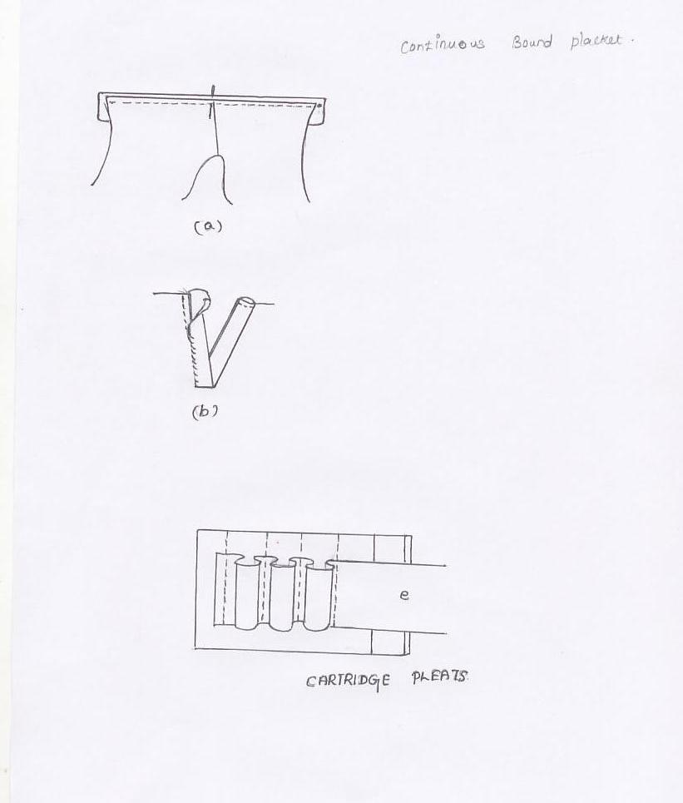

14 b) Write about the construction detail of Peter Pan collar with sketch.
Collars
Various collar designs and the method of drafting them are described in the second part of this book with illustrations. Since Peter Pan collar is the most widely used type for girls dresses the method of applying this is explained in this chapter.
Construction Detail of Peter Pan collar: Peter Pan collar is a round flat collar and can be of one or two pieces. If the dress has a back opening you have to apply a two piece collar on to the neck edge with a bias facing are illustrated.
- The first step is to cut out collar pieces, using the collar pattern. Since collars are of double thickness, you need four sections for the two-piece collar. Cut them out in pairs from the fabric folded with right sides facing. (2) After cutting out the collar, keep upper and under collars together right sides facing and stitch on the seam line leaving the neck edge free. Trim the under seam bias strip fully to the wrong side of the garment, make a ¼ inch turning on its free edge and hem it to the garment without catching the collar. Finished appearance of the collar can be seen in figure.
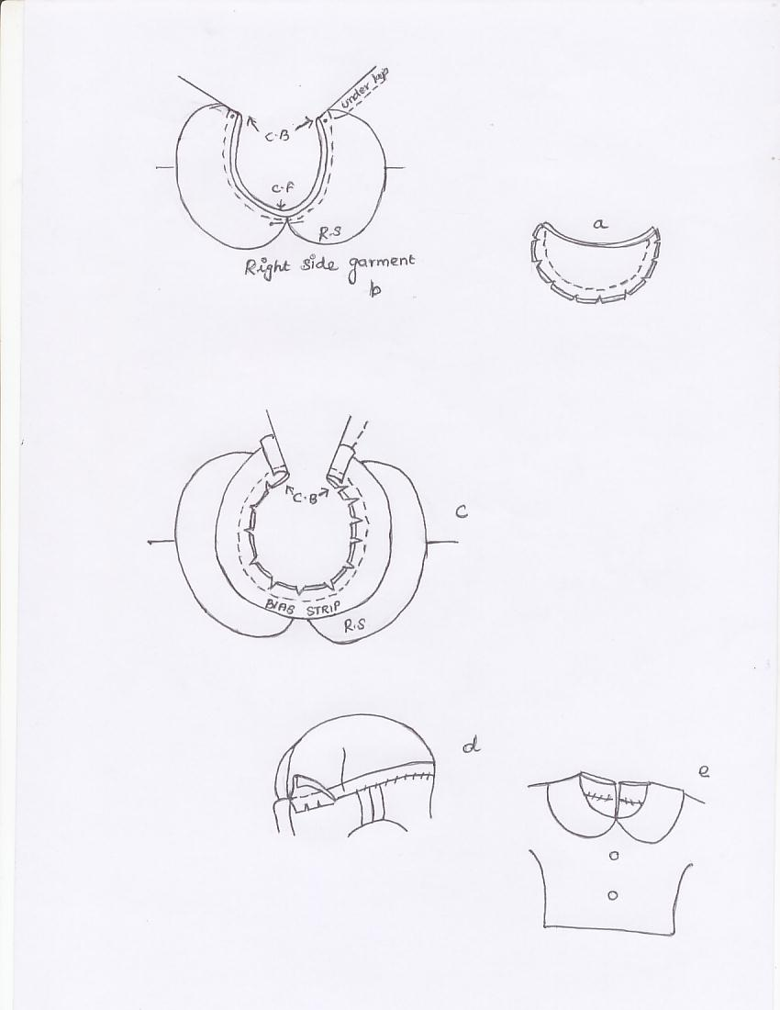
Flats collars of any shape and size can be applied in the same way as above.

15 a) Write the relative length & girth measurements for ladies.
Ladies Measurement:
Table1 presents sample measurement for ladies garments. The various position on the body where measurement are to be taken are shown in fig are labeled by the same numbers as in the text.

Bodice Measurements
- Bust: Measure around the fullest part of the bust raising the measuring tape slightly to a level just below the shoulder blades at the back.
- Waist: Measure snugly around the waist keeping the tape parallel to the floor.
- Neck: Measure around the neck, passing the tape just above the collar bone in front and along the base of the neck at the back.
- Shoulder: Measure from the neck joint to the arm joint along the base of the neck at the back.
- Front waist length: Measure down from neck at highest point of shoulder to waist line through the fullest part of shoulder.
- Shoulder to bust: Measure down from highest point of shoulder to tip of bust.
- Distance between bust points: Measure in the horizontal direction, the distance between the two bust points.
- Back width of across back measurement: Measure across the back from armhole to armhole about 3 inches below base of neck.
- Back wise length: Measure from the base of neck at the centre back to waist line.
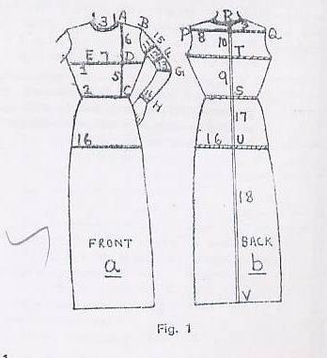

- Armscye depth: Measure from base of neck at centre back to a point directly below it and in level with the bottom of the arm where it joins the body.
Sleeve measurements
- Upper arm circumference: Measure around the fullest part of the arm.
- Lower arm: Measure around the arm at desired level corresponding to lower edge of sleeve.
- Elbow circumference: Measure around the arm at elbow.
- Wrist: Measure around the wrist.
15. Sleeve length: for short sleeve length, measure down from tip of shoulder at top of arm to desire length of sleeve. For elbow sleeve measure from top of arm to elbow point. For full length, bend the elbow slightly and measure down from top of arm to back of wrist passing the tape over the elbow point.

b) Describe about yoke types with sketch.
Preparing Pattern for Different Types of Yokes:
Partial Yoke: A yoke which does not extend across the entire garment is referred to as a “partial yoke”.
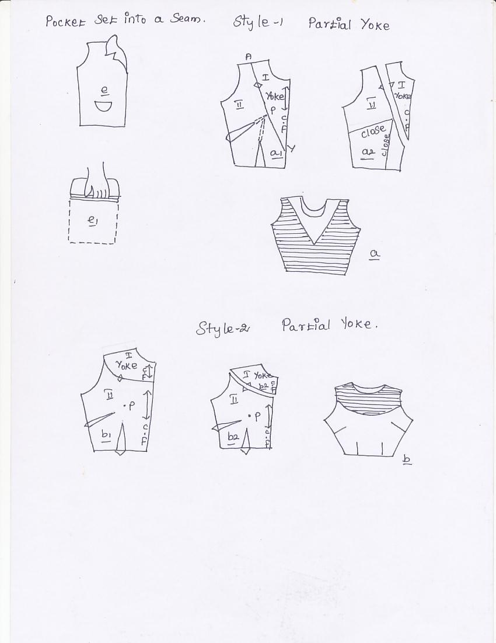
(a)Style 1: fig shows a triangular yoke design without fullness. To make the pattern, trace the basic bodice pattern and extend the basic darts till the bust point P. Draw the yoke line XY through bust point p as illustrated. Mark matching notches and cut apart along the yoke line. Label the yoke as section I and the lower part of the bodice as section II. In section II close the darts as shown.

(b)Style2: Fig shows a blouse design with a round yoke since this design has the bodice darts in their normal position, there is no need to manipulate them. You need only to draw the yoke line, mark matching notches and cut along the yoke line. Label both the section as shown in Fig. Here the yoke has only a decorative function. For easy stitching, you can cut the full blouse front and yoke separately and then simply attach the cut out yoke on top of the blouse as in Fig .
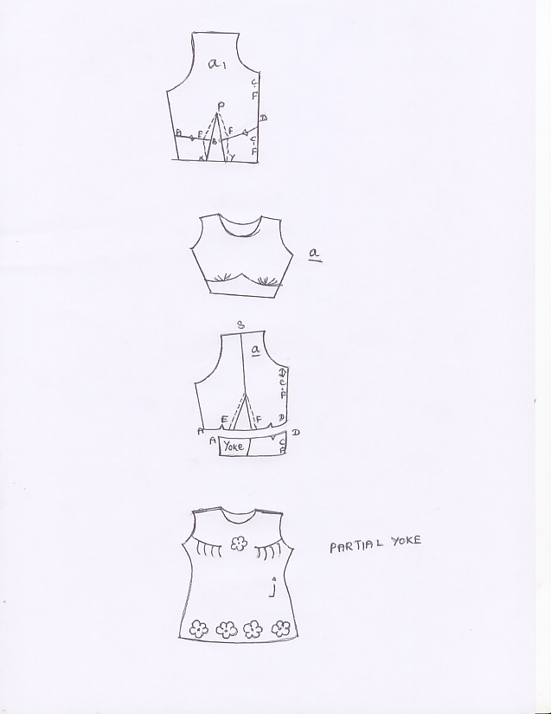

Yoke with fullness within the yoke:
The shoulder yoke shown in fig has fullness in the form of tucks within it. Instead of tucks you can design the yoke with pleats, shirring or smocking.
Midriff yoke: Midriff yoke is also referred to as torso or waist yoke and is a good device for securing fullness over the bust and smooth and trim fitting around the waistline.

