UNIT –III RADAR COMMUNICATION
Basic Radar Systems – Radar Range – Antenna Scanning – Pulsed Radar System – A- Scope Plan position Indicator – Doppler Effect – MTI principle – CW Doppler Radar – Frequency Modulator CW Radar.
Introduction
RADAR stands for Radio Detection and Ranging System. It is basically an electromagnetic system used to detect the location and distance of an object from the point where the RADAR is placed.
It works by radiating energy into space and monitoring the echo or reflected signal from the objects. It operates in the UHF and microwave range.
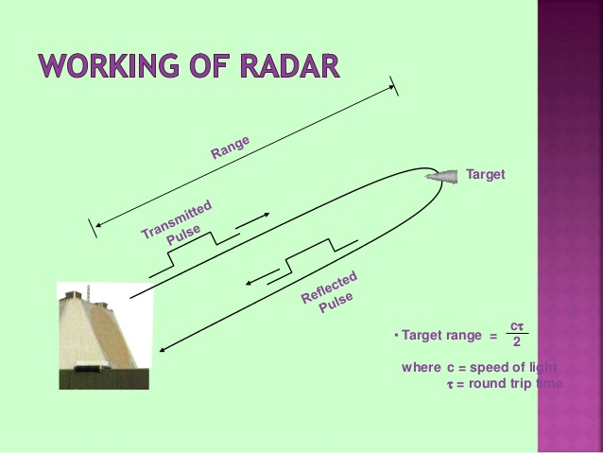

A Basic RADAR
The RADAR system generally consists of a transmitter which produces an electromagnetic signal which is radiated into space by an antenna. When this signal strikes any object, it gets reflected or reradiated in many directions. This reflected or echo signal is received by the radar antenna which delivers it to the receiver, where it is processed to determine the geographical statistics of the object. The range is determined by the calculating the time taken by the signal to travel from the RADAR to the target and back. The target’s location is measured in angle, from the direction of maximum amplitude echo signal, the antenna points to. To measure range and location of moving objects, Doppler Effect is used.

A Basic RADAR System --- 6 major parts of a RADAR System:
- A Transmitter:
It can be a power amplifier like a Klystron, Travelling Wave Tube or a power Oscillator like a Magnetron. The signal is first generated using a waveform generator and then amplified in the power amplifier.
- Waveguides:
The waveguides are transmission lines for transmission of the RADAR signals.
- Antenna:
The antenna used can be a parabolic reflector, planar arrays or electronically steered phased arrays.
- Duplexer:
A duplexer allows the antenna to be used as a transmitter or a receiver. It can be a gaseous device that would produce a short circuit at the input to the receiver when transmitter is working.
- Receiver:
It can be super heterodyne receiver or any other receiver which consists of a processor to process the signal and detect it.
- Threshold Decision:
The output of the receiver is compared with a threshold to detect the presence of any object. If the output is below any threshold, the presence of noise is assumed.
Radar Range
Radar Max Range is determined, ideally speaking, on the properties of the antenna only. A signal at a certain frequency is transmitted, reflected, then hopefully, detected. Due to the three-dimensional propagation of radar waves, frequency hold the highest weight in determining range.Often, power consumption and range must be balanced for maximum usability.
**Note: All of our calculators allow SI prefix input. For example, if you wish to input "25000000", just type "25M" instead. See the quick-reference table below for all compatible SI prefixes.
Prefix Symbol Value  Tera 'T' 10¹²  Giga 'G' 10⁹  Mega 'M' 10⁶  kilo 'k' 10³ | Prefix Symbol Value  pico 'p' 10⁻¹²  nano 'n' 10⁻⁹  micro 'u' 10⁻⁶  milli 'm' 10⁻³

Antenna
- The antenna takes the radar pulse from the transmitter and puts it into the air.
- The antenna must focus the energy into a well-defined beam which increases the power and permits a determination of the direction of the target.
- The antenna must keep track of its own orientation which can be accomplished by a synchro-transmitter.
- There are also antenna systems which do not physically move but are steered electronically

Antenna Scanning
Scanning movements are added to a tracking antenna's trajectory to estimate the true spacecraft position. The scanning movements are composed of the harmonic axial movements of an antenna. This motion produces power variations of the received signal, which are used to estimate the spacecraft's position
Directional antenna are always used in radar systems to increase range and better angular resolution. The types of antenna used in radar work depend upon the frequency and upon the application. Radar antenna are often made to scan a given area of the surrounding space .But the actual scanning pattern depend upon the application .

Scanning patterns of radar :-
Nodding scanning pattern which is extension of horizontal scanning and scanning of both plane used to scan limited sector.
Spiral scanning pattern of a limited area or more or less circular shape is to be curved and spiral antenna may be used.
Duplexer
Generally the transmission and reception the same antenna is used for all radars.This is accomplished with the help of a " Duplexer "
i. Switch the radar antenna for transmitter or the receiver .
ii. Save to protect he receiver from burnout of damage during transmission .
Duplexer is made by using the fast switches called as TR ( Transmitter Receiver Boxes ) and "ATR box ( Antenna transmit receiver) . The duplexes usually use the gas filled transmitter /receiver tube ( AT & ATR ) which are basically section of transmission line filled with a low breakdown voltage of Gas.
These gas get fired due to presence of high power to direct the transmitter output of antenna. After the transmission signal is radiate these tubes de ionizes or recover quickly to direct any receiver, and receiver signal to the signal input
Types of Radar or Indicator :-
Various types of display used in radar systems: The output pulse from the radar receiver is fed to CRT, to present visual indications ,Indicator given the information about presence and position of target . Some are given below.
Type A indicators: This type of indicators given the range of the target and does not give any information about angular position of target .In this horizontal co ordinate represents the range and the vertical co-ordinate represents the echo amplitude .
Type B indicators: In this indicator horizontal and vertical axes represents azimuth angle and range .The entire lower age of display the radar location.
Type C indicator :This type of indicator represents the angular position ( Azimuth and elevation ) of the target in rectangular Co-ordinate .It does not provide the range measurements and should therefore can be used with type A and B indicators are to furnish target information in three coordinate systems .
Plane Position indicator ( PPI) :-

PPI gives the map like representation through 360 degree or any particular sector desired without distortion .It gives the target location in polar coordinator the radar location is at the center of display . The target range is represented by radical distance from center and the target azimuth angle is given from the Output of display usually north clockwise.

Blind Speed in Radar:-

Blind Doppler or blind speed in a very seriouse problems in MTI radar systems when the Doppler shift equals an integer multiple of PRF the moving target echo signal spectral lines coincide with spectral lines of the stationary target echoes .Another way of saying the same thing would be that when the radical velocity components is such that it travels distance of nλ/2 along the radar axis during the time between successive pulses , then the phase difference between the corresponding echoes pulses would be 2nr radians which is equivalent to no phase change or a stationary target .Though use of Doppler filters effectively attenuate echoes at zero .Doppler shift and an integer multiple of PRF for clutter rejection a moving target producing these Doppler shift can not be detected .Such Doppler shift and the associated radical velocity components are called blinds Doppler's or blind speed .The blind Doppler shifts and blind speeds can be computed from

F n = nPRF V n = nc PRF/2f n = +-1 +-2 +-3 +-4 --------------

Horizontal:
The simplest but has the disadvantage of scanning in the horizontal plane only. Eg. In ship to ship radar

Nodding:
The nodding scan antenna is rocked rapidly in elevation while it rotates more slowly in azimuth, and scanning in both planes is obtained for a limited sector
Helical :
Helical scanning system capable of searching over the complete hemisphere. The elevation of the antenna is raised slowly and rotates more rapidly in azimuth.
Spiral :
Returned to its starting point at the completion of the scanning cycle.
Speeds ---rotation of 6 rpm by a rise rate of 20°/minute.
Use:
Limited area of more or less circular shape is to be covered, spiral scan may be used
Pulsed Radar Systems
Pulsed RADAR sends high power and high frequency pulses towards the target object. It then waits for the echo signal from the object before another pulse is send. The range and resolution of the RADAR depends on the pulse repetition frequency. It uses the Doppler shift method.
The principle of RADAR detecting moving objects using the Doppler shift works on the fact that echo signals from stationary objects are in same phase and hence get cancelled while echo signals from moving object will have some changes in phase.

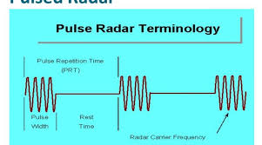

Two types of Pulsed RADAR are:

Pulse Doppler RADAR

Moving Target Indicator Radar
Pulse Doppler RADAR:
It transmits high pulse repetition frequency to avoid Doppler ambiguities. The transmitted signal and the received echo signal are mixed in a detector to get the Doppler shift and the difference signal is filtered using a Doppler filter where the unwanted noise signals are rejected.
Block Diagram of Pulsed Doppler RADAR

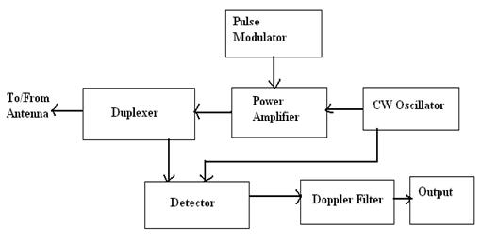
Moving Target Indicator RADAR:
It transmits low pulse repetition frequency to avoid range ambiguities. In a MTI RADAR system, the received echo signals from the object are directed towards the mixer, where they are mixed with the signal from a stable local oscillator (STALO) to produce the IF signal. This IF signal is amplified and then given to the phase detector where its phase is compared with the phase of the signal from the Coherent Oscillator (COHO) and the difference signal is produced. The Coherent signal has the same phase as the transmitter signal. The coherent signal and the STALO signal are mixed and given to the power amplifier which is switched on and off using the pulse modulator.

Continuous Wave RADAR
The continuous wave RADAR doesn’t measures the range of the target but rather the rate of change of range by measuring the Doppler shift of the return signal. In a CW RADAR electromagnetic radiation is emitted instead of pulses. It is basically used for speed measurement.
The RF signal and the IF signal are mixed in the mixer stage to generate the local oscillator frequency. The RF signal is the transmitted signal and the received signal by the RADAR antenna consists of the RF frequency plus the Doppler shift frequency.
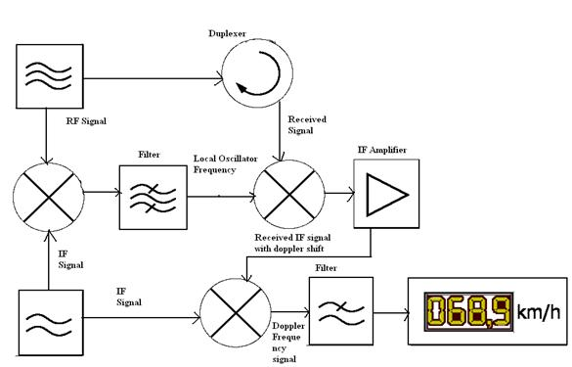

The received signal is mixed with the local oscillator frequency in the second mixture stage to generate the IF frequency signal. This signal is amplified and given to the third mixture stage where it is mixed with the IF signal to get the signal with Doppler frequency. This Doppler frequency or Doppler shift gives the rate of change of range of the target and thus the velocity of the target is measured.

A-Scope

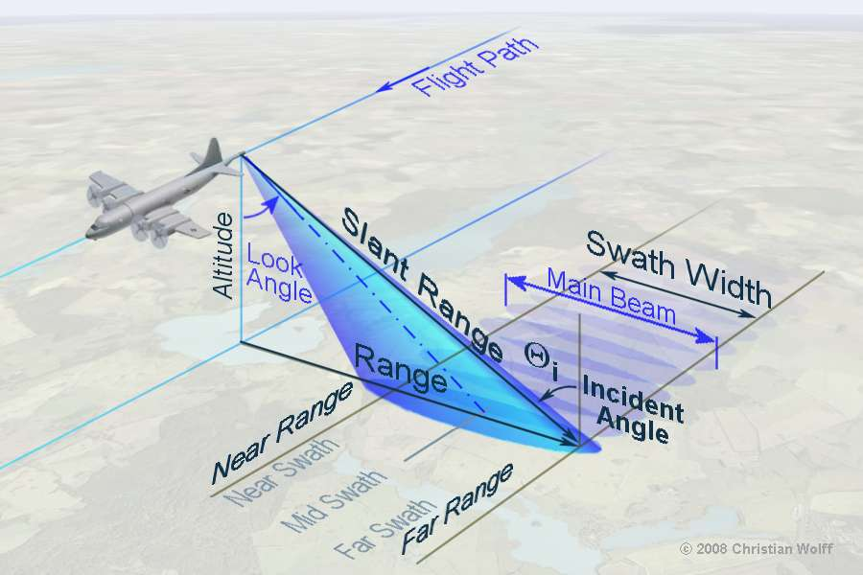

The A-scope display, shown in the figure, presents only the range to the target and the relative strength of the echo. Such a display is normally used in weapons control radar systems. The bearing and elevation angles are presented as dial or digital readouts that correspond to the actual physical position of the antenna. The A-scope normally uses an electrostatic-deflection crt. The sweep is produced by applying a sawtooth voltage to the horizontal deflection plates. The electrical length (time duration) of the sawtooth voltage determines the total amount of range displayed on the crt face.

The A- scope display is using in older radar sets only as monitoring oscilloscope. In modern digital radar sets don't exist a similar video signal of the backscatter. The target messages are transmitted to the displays as a digital word. There isn't any possibility to get a synchronizing signal for these asynchronous serial digital signals. Well, the oscilloscope can get an internal trigger only. Therefore it is impossible to analyze the bit sequence with a simple oscilloscope. The one and only statement is possible seeing this picture: a digital word exists on this line, which means, obviously the driver module for this line work
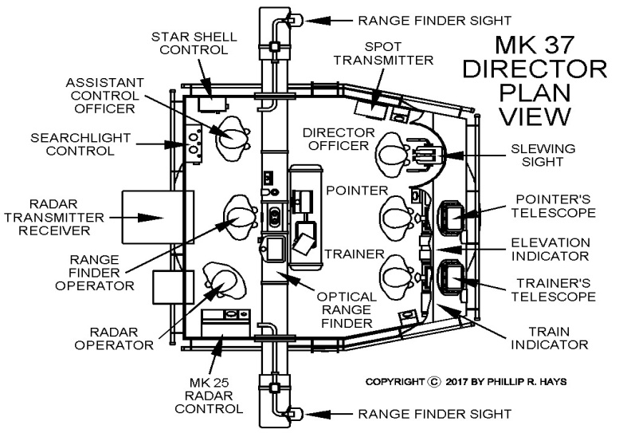

Plan Position Indicator

A plan position indicator (PPI) is a type of radar display that represents the radar antenna in the center of the display, with the distance from it and height above ground drawn as concentric circles.

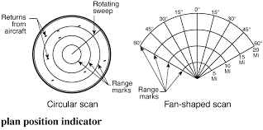
Doppler Effect -- Definition
An increase (or decrease) in the frequency of sound, light, or other waves as the source and observer move towards (or away from) each other. The effect causes the sudden change in pitch noticeable in a passing siren, as well as the red shift seen by astronomers.

If the target is not stationary, then there will be a change in the frequency of the signal that is transmitted from the Radar and that is received by the Radar. This effect is known as the Doppler effect.

MTI Principle
When it is desired to remove the clutter due to stationary targets an MTI radar is employed. The basic principle of MTI radar is to compare a set of received echoes with those received during the previous sweep.

Moving targets will give change of phase and are not cancelled. Thus clutter due to stationary targets both manmade and natural is removed from the display and this allows easier detection of moving targets.
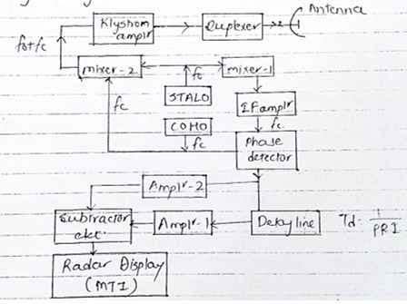
- Mixer-2 in block diagram generates the transmitter frequency (f₀+f_{c}) which is obtain by the sum of frequency produced by two oscillators the STALO and COHO (coherent oscillator producing f_{c} ).

- Echo pulse from the target is received by the MTI radar antenna. If the echo is due to moving target, the echo pulse undergoes Doppler frequency shift.
- The received echo pulse is then passed through mixer-1 which mix (f₀+f_{c}) with f₀ and produce a difference frequency f_{c} at its output.
- The detector output is proportional to phase difference between two signals.
- Phase difference is constant for all stationary targets but varies for moving targets. Thus Doppler frequency shift is there as per phase difference.
- This delay line acts as high pass filter to separate Doppler shifted echo signal of moving target from stationary clutter.

Limitations for MTI radar:-
- Doppler shift may results in blind speed.
- For MTI radar, Reduction in Doppler shift may results in loss of information.

Applications of RADAR
Military Applications:
- In air defense it is used for target detection, target recognition and weapon control (directing the weapon to the tracked targets).
- In missile system to guide the weapon.
- Identifying enemy locations in map.
Air Traffic Control:
- To control air traffic near airports. The Air Surveillance RADAR is used to detect and display the aircraft’s position in the airport terminals.
- To guide the aircraft to land in bad weather using Precision Approach RADAR.
- To scan the airport surface for aircraft and ground vehicle positions
Remote Sensing:
RADAR can be used for observing weather or observing planetary positions and monitoring sea ice to ensure smooth route for ships.
Ground Traffic Control:
RADAR can also be used by traffic police to determine speed of the vehicle, controlling the movement of vehicles by giving warnings about presence of other vehicles or any other obstacles behind them.
Space:
- To guide the space vehicle for safe landing on moon
- To observe the planetary systems
- To detect and track satellites
- To monitor the meteors

Frequency Modulator CW Radar:

Ordinary pulsed radar detects the range to a target by emitting a short pulse and observing the time of flight of the target echo. This requires the radar to have high instantaneous transmit power and often results in a radar with a large, expensive physical apparatus. Frequency-modulated continuous-wave (FMCW) radars achieve similar results using much smaller instantaneous transmit powers and physical size by continuously emitting periodic pulses whose frequency content varies with time. A very important type of FMCW radar pulse is the linear FM sweep. In this case, the range to the target is found by detecting the frequency difference between the received and emitted radar signals. The range to the target is proportional to this frequency difference, which is also referred to as the beat frequency.
