Unit –II CARBON NANO TUBES-Synthesis

Techniques have been developed to produce carbon nanotubes in sizable quantities, including arc discharge, laser ablation, high-pressure carbon monoxide disproportionation, and chemical vapour deposition (CVD). Most of these processes take place in a vacuum or with process gases. CVD growth of CNTs can occur in vacuum or at atmospheric pressure. Large quantities of nanotubes can be synthesized by these methods; advances in catalysis and continuous growth are making

Synthesis –Methods

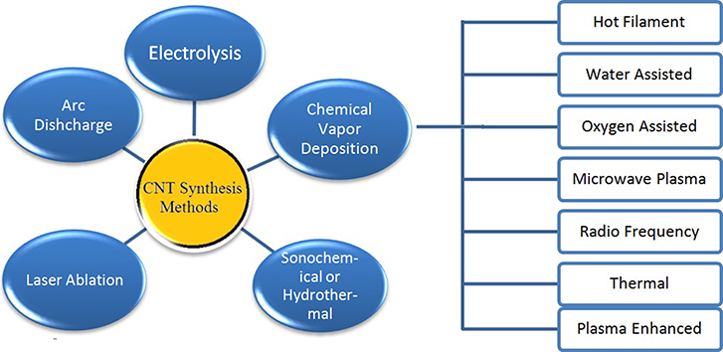

(i)Arc discharge
Nanotubes were observed in 1991 in the carbon soot of graphite electrodes during an arc discharge, by using a current of 100 amps, that was intended to produce fullerenes However the first macroscopic production of carbon nanotubes was made in 1992 by two researchers at NEC's Fundamental Research Laboratory. The method used was the same as in 1991. During this process, the carbon contained in the negative electrode sublimates because of the high-discharge temperatures.
The yield for this method is up to 30% by weight and it produces both single- and multi-walled nanotubes with lengths of up to 50 micrometers with few structural defects. Arc-discharge technique uses higher temperatures (above 1,700 °C) for CNT synthesis which typically causes the expansion of CNTs with fewer structural defects in comparison with other methods.

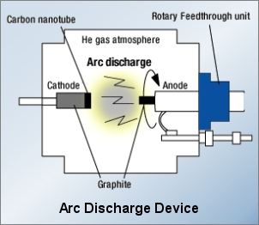

(ii)Laser ablation
In laser ablation, a pulsed laser vaporizes a graphite target in a high-temperature reactor while an inert gas is bled into the chamber. Nanotubes develop on the cooler surfaces of the reactor as the vaporized carbon condenses. A water-cooled surface may be included in the system to collect the nanotubes. This is the process by which layers are removed from solid metals and industrial compounds using a laser beam for ultimate precision.

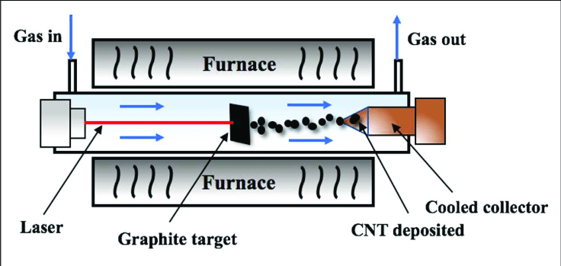
The beam will irradiate the surface, meaning that it has been exposed to radiation. With a low level of laser flux, the material being focused upon is absorbed by the laser’s energy and then changes to a gaseous state. With a higher level of laser flux, the material that is being focused upon will usually be converted to plasma. It is possible to undergo the process with both a pulsed fiber laser and a continuous wave laser, although the former is the more common method due to the high level of laser intensity.
Laser ablation has many benefits over more traditional methods of processes, such as with thin film removal, whereby alternative solutions have to undergo a multi-step process which is costly, time-consuming and inflexible, as well as having risks for the environment.

The process is a much more efficient, reliable and cost-effective method. It can also be used to determine the presence and concentration levels of a particular chemical or material on a surface. This is achieved by generating bright plasma on the surface, and then analysing this plasma to see what is present there. This is a much more environmentally-friendly process for determining chemical analysis, as opposed to more traditional methods such as using toxic acid solutions.
This process was developed by Dr. Richard Smalley and co-workers at Rice University, who at the time of the discovery of carbon nanotubes, were blasting metals with a laser to produce various metal molecules. When they heard of the existence of nanotubes they replaced the metals with graphite to create multi-walled carbon nanotubes.
Later that year the team used a composite of graphite and metal catalyst particles (the best yield was from a cobalt and nickel mixture) to synthesize single-walled carbon nanotubes.The laser ablation method yields around 70% and produces primarily single-walled carbon nanotubes with a controllable diameter determined by the reaction temperature. However, it is more expensive than either arc discharge or chemical vapour deposition.
The effective equation for few cycle optical pulse dynamics was obtained by virtue of the Boltzmann collision-less equation solution for conduction band electrons of semiconductor carbon nanotubes in the case when medium with carbon nanotubes has spatially-modulated refractive index.

(iii) Plasma torch

In this method, metallic nanoparticles are synthesized by evaporating and condensing metals using arc plasma as a heat source under atmospheric pressure. By mixing H₂ for the inert gas (Ar) under atmospheric pressure, the particle synthesis rate is significantly promoted.

The plasma jet reactor for synthesis carbon nanotubes used high current divergent anode-channel plasma torch has been developed. The carbon and catalysts (Ni, Co) in solid state are introduced with argon into plasma torch. Their evaporation in plasma jet with the further rapid cooling forms carbon and catalysts vapour with synthesis of carbon samples both in gas volume, on a surface of a graphite reactor and metallic target.

In comparison with method where the evaporation of graphite electrodes is used, the method has advantages allowing potentially increase yield of nanotubes. Evaporation of carbon, Ni and Co occurs not only in plasma jet, but also in the field of the arc.

The consumption of powder, work gas, and power of plasma torch are controlled independent from each other. The pressure of gas is changed from 10 to 760 Tor. Changing geometry of a reactor, pressure and velocity of a plasma jet it is possible to vary over a wide range the rate of cooling carbon vapour. Time of continuous work is limited by a life time of cathode. The rate evaporation of graphite and soot (1 g/min) already achieved. The first carbon samples have been obtained.

Single-walled carbon nanotubes can also be synthesized by a thermal plasma method, first invented in 2000 at INRS (Institut national de la recherche scientifique) in Varennes, Canada, by Olivier Smiljanic. In this method, the aim is to reproduce the conditions prevailing in the arc discharge and laser ablation approaches, but a carbon-containing gas is used instead of graphite vapours to supply the necessary carbon.
Doing so, the growth of SWNT is more efficient (decomposing the gas can be 10 times less energy-consuming than graphite vaporization). The process is also continuous and low cost. A gaseous mixture of argon, ethylene and ferrocene is introduced into a microwave plasma torch, where it is atomized by the atmospheric pressure plasma, which has the form of an intense 'flame'. The fumes created by the flame contain SWNT, metallic and carbon nanoparticles and amorphous carbon.
Another way to produce single-walled carbon nanotubes with a plasma torch is to use the induction thermal plasma method, implemented in 2005 by groups from the University of Sherbrooke and the National Research Council of Canada.
The method is similar to arc discharge in that both use ionized gas to reach the high temperature necessary to vaporize carbon-containing substances and the metal catalysts necessary for the ensuing nanotube growth. The thermal plasma is induced by high-frequency oscillating currents in a coil, and is maintained in flowing inert gas.
Typically, a feedstock of carbon black and metal catalyst particles is fed into the plasma, and then cooled down to form single-walled carbon nanotubes.

Different single-wall carbon nanotube diameter distributions can be synthesized. The induction thermal plasma method can produce up to 2 grams of nanotube material per minute, which is higher than the arc discharge or the laser ablation methods.

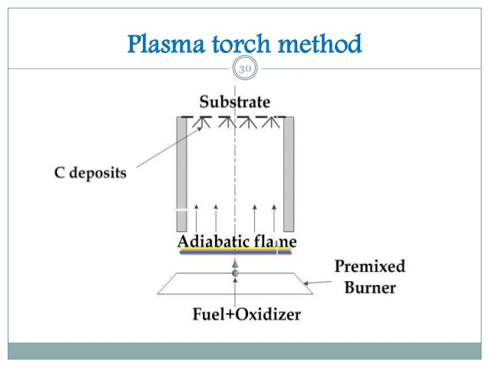

(iv) Chemical vapour deposition (CVD) This technique allows CNTs to expand on different of materials and involves the chemical breakdown of a hydrocarbon on a substrate.
The main process of growing carbon nanotubes in this method as same as arc-discharge method also is exciting carbon atoms that are in contact with metallic catalyst particles.

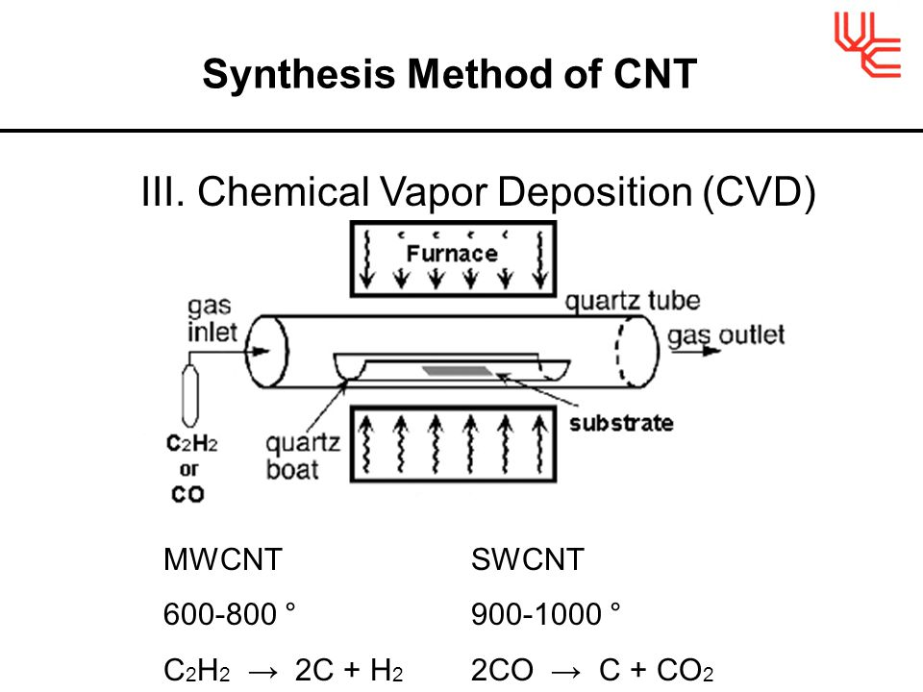
As compared with laser ablation, CCVD is an economically practical method for large-scale and quite pure CNT production and so the important advantage of CVD are high purity obtained material and easy control of the reaction course. Chemical vapour deposition (CVD) is the most popular method of producing CNTs nowadays. In this process, thermal decomposition of a hydrocarbon vapour is achieved in the presence of a metal catalyst. Hence, it is also known as thermal CVD or catalytic CVD (to distinguish it from many other kinds of CVD used for various purpose).
The catalytic vapour phase deposition of carbon was reported in 1952 and 1959, but it was not until 1993 that carbon nanotubes were formed by this process. In 2007, researchers at the University of Cincinnati (UC) developed a process to grow aligned carbon nanotube arrays of length 18 mm on a First Nano ET3000 carbon nanotube growth system.During CVD, a substrate is prepared with a layer of metal catalyst particles, most commonly nickel, cobalt, iron, or a combination.

The metal nanoparticles can also be produced by other ways, including reduction of oxides or oxides solid solutions. The diameters of the nanotubes that are to be grown are related to the size of the metal particles. This can be controlled by patterned (or masked) deposition of the metal, annealing, or by plasma etching of a metal layer. The substrate is heated to approximately 700 °C.
To initiate the growth of nanotubes, two gases are bled into the reactor: a process gas (such as ammonia, nitrogen or hydrogen) and a carbon-containing gas (such as acetylene, ethylene, ethanol or methane). Nanotubes grow at the sites of the metal catalyst; the carbon-containing gas is broken apart at the surface of the catalyst particle, and the carbon is transported to the edges of the particle, where it forms the nanotubes.
This mechanism is still being studied. The catalyst particles can stay at the tips of the growing nanotube during growth, or remain at the nanotube base, depending on the adhesion between the catalyst particle and the substrate. Thermal catalytic decomposition of hydrocarbon has become an active area of research and can be a promising route for the bulk production of CNTs. Fluidised bed reactor is the most widely used reactor for CNT preparation. Scale-up of the reactor is the major challenge.
CVD is the most widely used method for the production of carbon nanotubes. For this purpose, the metal nanoparticles are mixed with a catalyst support such as MgO or Al₂O₃ to increase the surface area for higher yield of the catalytic reaction of the carbon feedstock with the metal particles. One issue in this synthesis route is the removal of the catalyst support via an acid treatment, which sometimes could destroy the original structure of the carbon nanotubes. However, alternative catalyst supports that are soluble in water have proven effective for nanotube growth.

If a plasma is generated by the application of a strong electric field during growth (plasma-enhanced chemical vapour deposition), then the nanotube growth will follow the direction of the electric field. By adjusting the geometry of the reactor it is possible to synthesize vertically aligned carbon nanotubes (i.e., perpendicular to the substrate), a morphology that has been of interest to researchers interested in electron emission from nanotubes. Without the plasma, the resulting nanotubes are often randomly oriented.
Under certain reaction conditions, even in the absence of a plasma, closely spaced nanotubes will maintain a vertical growth direction resulting in a dense array of tubes resembling a carpet or forest. CVD shows the most promise for industrial-scale deposition, because of its price/unit ratio, and because CVD is capable of growing nanotubes directly on a desired substrate, whereas the nanotubes must be collected in the other growth techniques.
The growth sites are controllable by careful deposition of the catalyst.In 2007, a team from Meijo University demonstrated a high-efficiency CVD technique for growing carbon nanotubes from camphor. Researchers at Rice University, until recently led by the late Richard Smalley, have concentrated upon finding methods to produce large, pure amounts of particular types of nanotubes. Their approach grows long fibers from many small seeds cut from a single nanotube; all of the resulting fibers were found to be of the same diameter as the original nanotube and are expected to be of the same type as the original nanotube.

Applications
Many electronic applications of carbon nanotubes crucially rely on techniques of selectively producing either semiconducting or metallic CNTs, preferably of a certain chirality. Several methods of separating semiconducting and metallic CNTs are known, but most of them are not yet suitable for large-scale technological processes. The most efficient method relies on density-gradient ultracentrifugation, which separates surfactant-wrapped nanotubes by the minute difference in their density. This density difference often translates into difference in the nanotube diameter and (semi)conducting properties.
Another method of separation uses a sequence of freezing, thawing, and compression of SWNTs embedded in agarose gel. This process results in a solution containing 70% metallic SWNTs and leaves a gel containing 95% semiconducting SWNTs. The diluted solutions separated by this method show various colours.
The separated carbon nanotubes using this method have been applied to electrodes, e.g. electric double-layer capacitor. Moreover, SWNTs can be separated by the column chromatography method. Yield is 95% in semiconductor type SWNT and 90% in metallic type SWNT.
In addition to separation of semiconducting and metallic SWNTs, it is possible to sort SWNTs by length, diameter, and chirality. The highest resolution length sorting, with length variation of <10%, has thus far been achieved by size exclusion chromatography (SEC) of DNA-dispersed carbon nanotubes (DNA-SWNT).

SWNT diameter separation has been achieved by density-gradient ultracentrifugation (DGU) using surfactant-dispersed SWNTs and by ion-exchange chromatography (IEC) for DNA-SWNT. Purification of individual chiralities has also been demonstrated with IEC of DNA-SWNT: specific short DNA oligomers can be used to isolate individual SWNT chiralities. Alternatively, carbon nanotubes have been successfully sorted by chirality using the aqueous two phase extraction method.
There have been successful efforts to integrate these purified nanotubes into devices, e. g. FETs. An alternative to separation is development of a selective growth of semiconducting or metallic CNTs. Recently, a new CVD recipe that involves a combination of ethanol and methanol gases and quartz substrates resulting in horizontally aligned arrays of 95–98% semiconducting nanotubes was announced.
Nanotubes are usually grown on nanoparticles of magnetic metal (Fe, Co), which facilitates production of electronic (spintronic) devices. In particular, control of current through a field-effect transistor by magnetic field has been demonstrated in such a single-tube nanostructure.

