Unit 1
FASHION ACCESSORIES
Fashion Accessories:
Accessory means something which is used as secondary manner. Fashion accessories means something which are use as secondary manner besides the wearer outfit. Even after wearing nice dress without proper accessories everything can be ruined. It is used often to complete an outfit properly. So, always be careful about proper accessories selecting & having.
Types of Fashion Accessories
Fashion accessory is mainly divided into two categories
Worn accessories
Carried accessories
1. Worn accessories
As name indicates worn accessory is used by wearing. There various types of worn accessory. i.e.
a) Watches
In the case of watch selecting you give preference of taking such watch which nicely adjust with your wrist. It’s not so important how nice the watch is, but which one is looking more beautiful after worn by you it is the important point.
b) Shoes
There somebody tells that your worn shoes expresses out personality or taste level. So, be careful about shoes selecting. Don’t always use high heel shoes. It may be harmful for your health.
c) Socks
A sock is an item which is worn on the feet. It helps to absorb the sweat and draw it to areas where air can evaporate the perspiration. In cold environment, socks decrease the risk of frostbite. So socks are very important accessory to wear.
d) Gloves
Gloves protect and comfort hand against cold or heat or damage by friction, abrasion or chemicals and disease also. For fashion concerning person gloves is very important.
e) Ties
With nice shirt try a nice tie which will help to express your nice personality.
f) Hats
When you are going out you keep a hat on your head. It can be a great unique style for you.
g) Jewelry
Jewelry can be of different types. I.e. Earrings, Nose pin, Chain, Necklace, Bracelet etc. Be smart about selecting jewelry with your outfit. If you are wearing larger earrings than wear thin chain, and if you are wearing big necklace than just wear small tops or don’t wear any earrings.
h) Sunglasses
Sunglasses are very important for giving you a dashing look. And for more information you can follow my previous article about sunglasses.
i) Belts
Try simple designed lather or any other belts for getting unique look.
2. Carried accessories
a) Purses and Handbags
Without purse fashion look is just out of thinking. Select the purse which is going on present time. Try different purse or bags for different purposes. Never try only one. Because it expresses your taste level.
b) Umbrella
Going out? Just keep an umbrella with you. It will protect you from UV rays and will give extra fashion concerned look and it may help you when it is raining suddenly.

SHOES
D’Orsay: A style of pump featuring one or both sides cut-out.
Sling back: Shoe that is backless with a rear strap that goes around the upper heel, usually with a buckle or elastic panel.
Stiletto: A high, tapered, narrow heel, also called a 'spike' heel, named for a type of slim knife
Pumps: Women's dress shoe, usually slip on, often with enclosed toe and sides
Mary Jane: A type of women's shoe characterized by a strap across the instep
Peek-a-boo Toe: A type of closed toe with a small open panel allowing a glimpse of toe
T-Strap: A type of shoe with a single vertical strap linking the toe and ankle/heel areas
Mule: A closed toe shoe with no back
Heel: "Heel" can refer to both the rear, padded area of the underside of the foot, as well as the solid part of a shoe that supports the heel cup. The standard measure for heel heights is as follows: an 8/8 (low heel) is 1" high; a 16/8 (medium heel) is 2" high; and a 24/8 (high heel) is 3" high. Types of shoe heels include:
Louis or French - Features a curved back; ranges in height from 16/8 to 24/8.
Baby Louis - The same shape as a Louis heel, but a 12/8 or shorter. Built Heel - Created from layers of leather or fiber with contrasting tones. Continental - A higher heel with a slightly curved back and flat front.
Cuban - A thick, stacked heel with little or no curvature and tapered at the bottom; usually medium in height.
Stacked - Similar to the built heel, but typically can be created from synthetic and leather materials. Often found on spectator shoes.
Wedge - A heel that is as wide as the shoe itself and follows the shoes contour from toe to heel. May be of any height.
Chelsea Boot: A type of boot, usually ankle height, in a pull on style with elastic side panels. Popularized in England.
Saddle Shoes: Shoes with a contrast colored instep overlay or 'saddle,' usually found on golf shoes, oxfords or retro styles
Penny-Loafer: A slip-on style shoe with a slit over the instep where a penny traditionally was placed for good luck
Oxford: A low shoe, laced or tied over the instep
Boat Shoe: A type of shoe originally meant to be worn aboard a boat, usually with a non-slip outsole, often with side lacing details, almost always a casual shoe you can wear with or without socks.
Flip-Flop: A type of sandal, usually a thong, with a lightweight foam outsole that makes a 'flip-flop' sound when you walk.
Moccasin: Possibly the earliest type of shoe, a slip on style with visible stitching, often with a soft leather bottom
Espadrille: Any shoe that has woven rope or rope-look trim, usually in the sole area
Clog: A type of shoe, usually casual and comfortable, with an open or closed heel and a slip on style. Collar: A strip of material stitched to the opening of a shoe or the topline. The collar can be padded for extra comfort
Slip-On: Footwear that slips on the foot with no other adjustments.
Sneaker: An athletic shoe, typically made of canvas with a rubber sole.
HANDBAGS
Backpack (N.) [bak-pak] Bags that are carried over the shoulders with the help of two thick straps are called backpacks. Traditionally, backpacks have been large-sized, especially used by students to carry books, or travellers and hikers to carry food, camera or water bottles. However, 2017 brought about the fashion trend of smaller backpacks, that were anywhere from the size of a laptop to palm-sized. Also rucksack.
Book bag, kitbag, knapsack, pack, sack pack or back sack as alternate names for this bag ; it is a sturdy bag carried on the back of the body with two straps. There are large backpacks used for traveling and they are called rucksacks.
Hobo bag (N.) [Hoh-boh bag] Handbags made in soft, flexible material like leather that slouch or bend in the middle when set down are called hobo bags. These type of bags are named after the shape of bindle on a stick that hobos carry over their shoulder. Also see bindle.
This is a large bag made of soft materials with a slouchy shape. It is characterized by a crescent shape under the handle because of the way it slumps down when put down or carried. This bag has a distinct silhouette which marks it as a casual carry all.

Baguette bags
This is a small compact bag with a short strap, made famous by the brand Fendi. Baguette is a type of long and narrow bread; this bag is named after this bread because of its shape
Messenger (N.) [mes–uhn-jer] Usually used by men, messenger bags are medium-sized rectangular bags with a long and thick strap. These types of bags are cross-body and made out of soft material, like leather, often with a flap and buckle closure, sometimes used to carry books. Also known as satchel. Also see cross-body bag.
These are medium sized bags which have a flap on the front. It usually has a long strap and is worn cross body. Another name for this bags is courier bag.

Barrel Bag
A large cylindrical bag ; also known as a gym bag. This bag comes in many sizes and can carry a lot
Minaudière (N.) [Mee-noh-dyair] A small evening bag, or clutch, made from hard material and used for carrying small articles, such as keys or lipstick, is known as a minaudière bag. Minaudières are also sometimes without any handles or straps. These types of bags are ornamental or decorative, and often considered a women’s jewelry piece. Most brands use the term minaudière synonymously with ‘clutch’, although some refer to them just as decorative clutches. Also see clutch, evening bag.
It is not strictly a bag ; this is a jeweled case which acts as a bag. They have a hinged frame and top closure. Usually, they are encrusted with beads, crystals and sometimes has a shoulder strap
Bucket bag (N.) [buhk-it bag] Elongated bags that have top handles, resembling a bucket, or drawstring on the top as a closure are called bucket bags. These types of bags may also have a zip or snap stud (tich) button closure on the inside, and often have an oval or round base. Also known as a drawstring bag, when the top closure is a drawstring.
This is a bag which has a flat bottom, a drawstring closure and long handles, This medium-sized bag is casual in its appearance and is a fashion trend which has a carry-all cool appeal.
Clutch (N.) [kluhch] Small, hand-held evening bags that have either detachable or no straps with minimalistic or concealed hardware are called clutch bags. Also see minaudière, evening bag.
Clutch is a slim, flat handbag meant to be held in the hand, without handles or a strap
Saddle bag (N.) [sad-uh l bag] A handbag with a flat top and a rounded bottom, with a front flap in the shape of a horse saddle is called a saddle bag.

Satchel
This is a rectangular bag with a flap that fastens in the front with a single or double buckle. Usually, they have a long strap and are hung low on the body
Duffel (N.) [duhf–uh l] Also known as gym bags, duffel bags are long, cylindrical and have both handles and a long strap
This is a bag with flat sides and rounded sides and a top zip closure. It is a large roomy bag
Shopping bag (N.) [shop-ing bag] A large handbag with top handles used for shopping, sometimes without a closure, is called a shopping bag. Shopping bags are often made of paper, jute or plastic, and may be used by shops to hold purchased items to give to customers. Shopping bags are often reusable, which may be carried by shoppers for groceries, etc. for environment-friendliness. Some fashion brands also use the term ‘shopping bag’ to describe the type of bag that is large and may have strap or top handles, designed to be carried while shopping.
The big shopping bag needs no introduction. They are usually made of cloth or plastic and can accommodate just about anything that you shop for
Flap bag (N.) [flap bag] A type of handbag that has a flap in the front to cover the zip closure is called a flap bag. The flap often has a snap stud (tich) button closure on its under-side. Flap bags are often types of sling bags, but may also be clutches or cross-body.
Tote (N.) [toht] A large rectangular shaped bag, sometimes without any closure, is called tote bag. Tote bags may have a buckle and strap closure or zip in some cases. Due to their large size, they are often made in washable fabric, used for beach trips, to carry a change of clothes or beach sheet. Leather tote bags are also popular for office use by women to carry laptops or files.
This is a rectangular shaped bags made of stronger materials like canvas or leather ; It is ‘the-shopping-must-have’ for most girls. This bag has somewhat short-medium handles and is roomy enough for most all shopping that women does.
Wristlet (N.) [rist-lit] Small bags that have a loop on one end, which is wrapped around the wrists, are called wristlets. Wristlets are different from wallets in that wallets are used just to carry money and credit cards, and so are very compact and structured, whereas wristlets may have a larger open compartment for keys, phone, and a small pouch for money/credit card.
Wristlet is a small handbag with a short carrying strap resembling a bracelet.

Drawstring bag
These bags have a drawstring closure on the top; it could be a back pack or a pouch.
JEWELLERY

Types of Indian Jewelry
Tradition of adoring oneself with jewelry is 5000 years old in India. Indian women and jewelry have always formed a great combination. The tradition is still alive and time has made it only more vigorous than earlier. The art of making beautiful ornaments, with delicacy and acumen, has been developed throughout the historical times. Rulers and feudal gave patronage to art and artists, to develop the same to optimum. There is jewelry for almost all the body parts, including neck, ear, nose, arms, ankles, fingers, waist, hair parting, etc.
In India, jewelry is designed to match with the attire. The theme of its design as well as the color of the jewelry is taken into consideration while adoring. To make jewelry more attractive, it is topped by diamonds and various types of gems. Traditionally, Indian jewelry has been made of heavy and voluminous gold pieces, but recently jewelry made of silver, platinum and other metals has become quite popular among people. The popularity of jewelry made of stone, encrusted on metal, has grown more recently. In the following lines, we will tell you about the different kinds of jewelry in India.
Antique Jewelry
The jewelry which is not in mainstream production and of which the mode of production is no longer popular is known by the name of 'Antique Jewelry.' This kind of jewelry has dull and rough look, combined with an old world-world charm, and this serves as the major USP of such jewelry.
Bead Jewelry
Bead art in India is five thousand year old and dates back to the time of Indus Valley Civilization. People of that civilization used to make beads out of gold, silver, copper, clay, ivory and even wood. The excavated carried out there came out with finished and unfinished beads from the site.
Bridal Jewelry
India has great tradition of wedding jewelry. Made of superior metals and excellent quality, jewelry accentuates the beauty of bride in multiples. Though these days silver and platinum jewelry is gaining popularity, gold jewelry still holds the most popularity among Indians.
Custom Jewelry
Custom jewelry is personalized jewelry, which a customer gets her made on her interest and fancy. This happens particularly in cases where readymade jewelry does not match the taste of person. Custom jewelry gives total freedom to customer about the specifics.
Fashion Jewelry
Fashion jewelry is also called costume jewelry, mainly for the reason that it is not made of precious metals and stones, rather lighter and cheaper material are used. Fashion jewelry is trend-conscious and keeps on changing as per changing needs.
Filigree Jewellery
Filigree work is done on silver and involves lots of precision and technicality, added with great amount of patience and an eye for minute details. Historically, filigree work was quite popular in countries like Egypt, Italy, and Spain. India's history of filigree work goes back to early centuries.
Gold Jewellery
Gold is a metal that lures many. It gives the security against any financial crisis, because of its easy liquidity, and is also used by women for adorning themselves. Traditionally, gold has been considered auspicious among Hindus and is regarded to be symbolic of Lakshmi, the Goddess of Wealth.
Handmade jewellery
Talking about jewelry manufacturing in India is as good as talking about handmade jewelry in India. A major chunk of jewelry in the country is made by independent craftsmen. Traditionally also, a significant part of jewelry manufacturing has been handmade jewelry.
Ivory Jewellery
Jewelry that is made from the tusk of an elephant is called ivory jewelry. Importance of ivory jewelry can be guessed from the fact that in Gujarat, the bride receives an ivory bangle from her family just before marriage as jewelry. During marriage ceremony wearing of ivory bangles is must for bride.
Jadau Jewellery
Jadau Jewelry forms one of the major examples of high skilled craftsmanship that was brought into India by Mughals. Historically speaking, the tradition of Jadau work has been in practice in the states of Rajasthan and Gujarat since the Mughal era. Jadau jewellery is also called engraved jewelry.
Kundan Jewellery
During Mughal period, the art of kundan work reached Rajasthan from Delhi. Later on, craftsmen from the different part of the country migrated to the place and made Rajasthan a hub of Kundankari. Rulers and feudal lords gave patronage to the art and it developed into perfection.
Lac Jewelry
Lac jewelry, also known as lacquer jewelry, originated in Rajasthan and has gained considerable popularity in India today. Lac jewelry is available in versatile designs, which add to its beauty. Among the various items in lac jewelry, the bangles need a special mention.
Meenakari Jewelry
In Meenakari jewelry, precious stones are set and then enameled with gold. Historically speaking, the art was introduced to Rajasthan artisans by Raja Mansingh of Amer. He invited Lahore-based skilled artisans to his kingdom, and their intermingling with the locals craftsmen resulted in an amalgam.
Navratna Jewelry
In Navratna jewelry, nine auspicious stones are used in a single ornament. The belief behind this is that the nine stones together ensure well being of the person who wears it. In India, Navratna jewelry has been given major importance, because of its astrological significance as well as its innate charm.
Pachchikam Jewelry
In the world of fashion and design, old trends tend to come over again and again, though with slight changes. Pachchikam jewelry making craft is one of the examples of jewelry that has come back once again. Originated in Gujarat and Kutch, centuries ago, Pachchikam jewelry has again become popular.
Silver Jewelry
Silver Jewelry, along with gold jewelry, is quite popular amongst Indian women. Ornaments made of silver, such as rings, bracelets, chains, necklaces, nose rings, earrings, toe rings, heavy kadas, and armlets, form integral part of Indian jewelry.
Stone Jewelry
Jewelry studded with different gems is quite popular among Indians. For reasons ranging from spiritual to aesthetic to health, gemstone jewelry has become the part of life of Indian women and men both. These stone jewelries are worn according to the individual's astrological chart and ruling of planet.
Temple Jewelry
Indian jewelry art is at times divided into three kinds - temple jewelry, spiritual jewelry and bridal jewelry. Temple jewelry of India initially used to be described as the jewelry used to adorn the idols of Gods and Goddesses. The statues In India were ornamented with chunky necklaces.
Tribal Jewelry
Tribal jewelry in India is quite rich. Each tribe has kept its unique style of jewelry intact even now. The original format of jewelry design has been preserved by ethnic tribal. Jewelry that is made of bone, wood, clay, shells and crude metal, by tribals, is not only attractive, but also holds a distinct rustic charm.

Types of Jewellery
Jewellery can be the best way to glam up your whole look in an instant. It attenuates your signature styles and comes in all shapes, patterns, materials, and looks. You can buy it at all kinds of jewellery stores as well.
Due to the ease of online shopping, women and men have expanded their jewelry preference, which can be seen in the phenomenal 10.7% growth from previous years that the industry has incurred.
There are several different types of accessories that you can choose from, which ensure that everyone’s needs are satisfied. With the right addition and combination of jewelry styles, you can really call attention to your whole look.

Rings
A ring is usually made out of metal and is worn as an ornamental jewelry piece. The term ‘ring’ is usually used for finger rings, but they can also be worn in other different ways as well. Rings have become a huge part of a lot of rituals such as engagements and weddings throughout the world. They can be made from any hard material like glass, gemstone, plastic, wood, stone, or bone. Rings have always been used as a display of wealth and are still considered to have supernatural or spiritual significance in different segments of the world.

Toe Rings
A toe ring is worn on any of the toes and is usually made from hard materials. They are most commonly worn on the second toe since it usually is the longest toe. In most Western cultures they have no symbolic meaning and are considered as a recent fashion trend. However, they have been part of the eastern, primarily the Indian culture for decades. Toe rings have been mentioned in the Ramayana in the narration of Sita’s tale and continue to be a symbol for married women.

Earrings
Earrings are the most popular piece of jewelry across the globe. They are mostly attached to the earlobe via a piercing but are also attached to other parts of the ear such as the helix, industrial, rook, daith, conch, snug, and many others. They have been used in different civilizations throughout history and were most famously worn by the Minoan Civilization. They come in all sorts of designs like studs, drop, hoop, dangle, barbell, ear threads, ear spikes, and huggy earrings.
The most expensive pair of earrings is known as Apollo and Artemis after the Greek twin gods. They include a 14.54-carat blue diamond and a 16-carat pink diamond. They have been polished perfectly into a pear shape and were sold for $57.4 million. They are hailed as one of the most ‘chemically pure’ diamonds in the world.

Necklaces
A necklace is an ornamental jewelry piece worn around the neck. The oldest forms of necklaces have been found being used, starting from the Prehistoric times when they were made of bone, shells, feathers, and plant materials. They have traditionally served as funerary, magical, religious, and ceremonial purposes throughout time and were often used as a symbol of status and wealth. They come with amulets, crosses, lockets, pendants, precious stones, and many other attachments.

Bracelets
The term ‘bracelet’ is derived from the Greek work known as ‘brachile’ which means of the arm. Bracelets are worn around the wrist and may serve different uses. Many types of bracelets are used as ornaments, identification, decoration, religious or cultural significance, and many more, depending on the different cultures around the world. They can contain charms, crystals, metal, plastic hoops, pearls, rocks, jewels, wood, and many other materials.

Brooches
Brooches are usually decorative jewelry items that are attached to clothing and even hold garments together. This makes brooches both functional and visually stunning piece of jewelry. They are usually made of silver or gold but can be made from bronze and other materials as well. Brooches are regularly decorated with gemstones and enamel. The earliest record of brooches was in the Bronze Age where they became tools to identify the chronological order of history. In the Victorian Era, they became a symbol of mourning and became keepsakes of the loved ones left behind by a departed soul. Alongside rings, brooches have become the most common form of family heir looms that are passed down generations.

Anklets
Anklets have been worn by women for decades in India, where they are known as ‘payals’. They hold strong importance in the culture which is why they are used during Indian weddings and are paired with saris. They have also been documented in the Egyptian Civilization where women wore them in pre-dynastic times. In the Western popular culture, they are usually made from leather and even come in formal designs. They also come with small bells, which make a pleasant sound when the person is walking.
Foot harness jewelry pieces are a combination of anklets and toe rings. They begin at the ankle, adorn the foot, and end in a toe ring. They are commonly used by Indian brides to enhance the look of the henna.

Hair Pins
Hairpins were considered luxury objects during the Egyptian, Greek, and Roman civilizations. They can be made of carved wood, bronze, metal, and many other materials. They became really popular after 1901 after Ernest Godward invented the spiral hair pin. They are used to hold complex hairstyles together and can be entrusted with ornaments and jewels. Modern versions are usually made with different lengths of wires so that they can hold the hair properly.

Cufflinks
Cufflinks are used to secure the cuffs of dress shirts and are often used in formal settings. They can be made from leather, wood, glass, metal, glass, and many other materials. The first cufflinks were made in the 1600s, close to when men’s shirts started to gain popularity. There are many different types of cufflinks that you can buy, like a bullet back, whaleback, fixed backing, chain link, ball return, knotted, stud/button, and locking.

Tie Clips
A tie clip is a clothing accessory that is, as the name suggests, traditionally used by men to clip the tie to the shirt front. This prevents it from swinging and ensures that the tie hangs straight. They are usually made of metal and can have embellishments and decorative patterns. They are also used to signify membership to exclusive groups and are also used as commemorative tokens. They began to gain popularity during the 1920s when ties started getting made with more delicate materials like silk.

Nose Rings
Nose piercings have become really common since nose jewels are really beautiful jewelry pieces. They are most commonly associated with the Indian culture. They have been worn in the region, since over 5000 years and are worn by their gods and goddesses like Goddess Parvati. Nose-jewels are usually worn on the side of the nose. They were often used as a symbol of wealth and status since they came with delicate pearls and gemstones, but over time they have become a norm amongst the general public.
Bengali and Nepali women also wear septum nose jewels as a symbol of marriage. They are also popular among Native American communities and were worn by leaders of the Shawnee tribe. Septum piercings have recently gained a lot of popularity among the general public. They are worn between the nostrils on the dividing wall. Septum rings are now making a comeback in fashion and have been seen being carried by popular celebrities like Rihanna, Zendaya, Zoe Kravitz, Madonna, and many others.

Belly Chains
Belly chains, also known as waist chains, are typically worn around the abdomen area. They were traditionally called the ‘Kamarband/Udiyanam’. They can also be attached to navel piercings and are usually made of gold or silver. They are really popular decorative jewelry among belly dancers. Belly chains have been used for over 4000 years in India but are currently used all over the world in these modern times. Their traditional use saw them being worn during religious ceremonies by men and women, and was seen as a symbol for wealth and power. They were worn by the most powerful deities in Hindu religion like Lord Krishna.

Armlets
Armlets, or armbands, are a band made of metal which adorns the biceps of the upper arm. They are similar to bracelets but are worn on the upper arm. They were traditionally worn by men and have been documented in the literature written in the Bronze Age. They are really popular in the Indonesian culture, where they are worn by men and women both. They are Kelat Bahu in the region and are worn as traditional jewelry in ceremonies and dances. They were also worn by brides in Sri Lanka to ward of ill luck.

Tiaras
A tiara is traditionally worn by women as ornamental jewelry. They are worn only on formal occasion where the dress code is usually a white tie. They were worn in ancient times to signify high status, especially during the Persian era, where they were worn by kings. Tiaras are a significant part of British history, as Queen Elizabeth II was known to have the biggest and most valuable collection of tiaras in history. They have always been associated with Royalty but are now often used in formal events and parties.

Circlets
A circlet is a jewelry piece for the head and looks similar to a diadem. Circlets were traditionally used as a word for the base of the coronet or crowns. They resemble open crowns that have no arches and were used by successors to the throne. They have been recorded during the Greek era where people with affluence in the community often worn them in a social setting. Circlets were often known as the Stephanos, which is a laurel wreath. This was similar to crowns made of a thorn which is rumored to have been placed on the head of Jesus. This is depicted in many paintings and statues of Jesus Christ throughout history.

Chokers
Chokers have recently gained a lot of popularity since they attenuate the neck and cheekbone area. They are close-fitting necklaces which are worn around the neck by men and women of the world. They can be made of many different materials like plastic, velvet, beads, metal, latex, and other precious metals.
They were first crafted in 2500 BC by Sumerian artisans and have been around for thousands of years. Red chokers were also worn by women after the French Revolution to pay homage to the elites who were killed by guillotines. In the 19th century, they were most commonly used by Ballerinas and by the elite, but thin black or red ribbon chokers, on the other hand, was a symbol of prostitution.
Jewelry has been a prominent part of human history as an important addition to the whole look. Different pieces have had huge cultural, religious, and economic value attached to them, all over the world. There are a lot of different types of jewelry that work to enhance your look in many special ways

Different Types Of Hats

1. Fedora
Initially, it was men who wore fedora hats, but that slowly changed, and now it has become increasingly popular among women too. They started making hats that were more feminine, with colors, embellishments, materials, floral arrangements, etc. And, till this date, these hats are the most elegant and popular choice for most women. It has a short brim and an indent either on one side or on both the sides. These are slightly more casual and go with floral dresses, skirts, jeans, one-piece dresses, and jumpsuits. Just wear a layered outfit, throw on a fedora, big brown sunglasses, and camel boots. Ravishing.

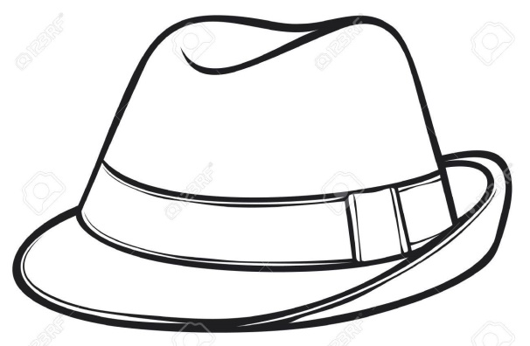

2. Beanie

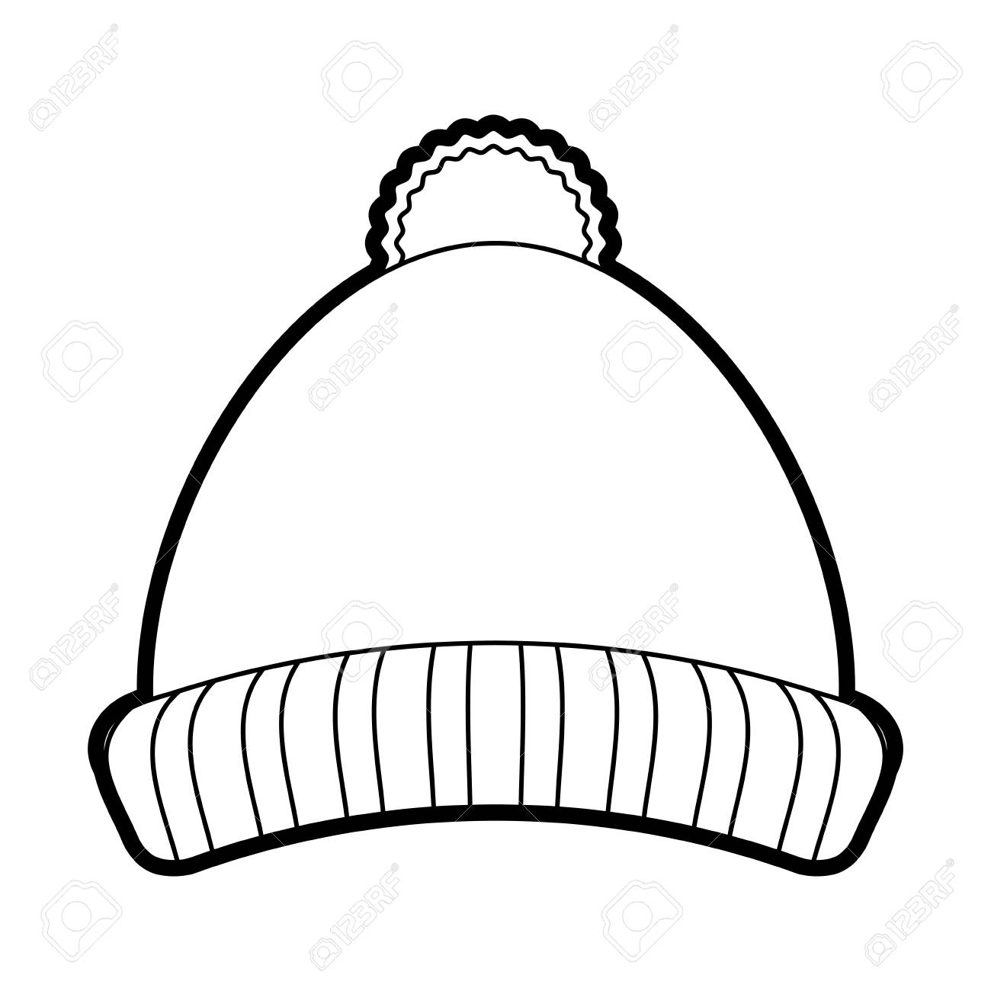
Another hat variant that was initially worn by men but became popular among women later on. This is one type of hat that all of us use, but may not know that it’s called a ‘Beanie’. It is a long and soft hat made of wool and provides protection and coverage in harsh winters. With time, this hat had its makeover too, and as we all know, it is now available in different colors and models. Beanies look cute with any winter outfit, and sometimes girls wear it otherwise too to make up for a bad hair day.

3. Beret

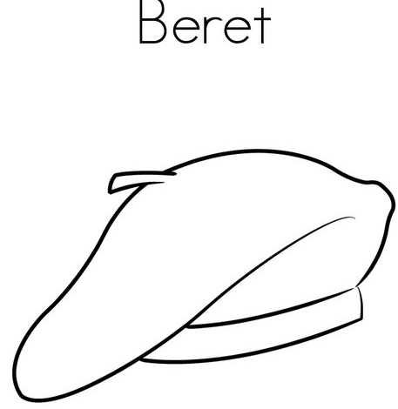
Beret hats originated from France and Spain and were initially used as part of the military uniform before they gained popularity otherwise. These are usually made of wool, acrylic fibers, cotton, etc. They go perfectly with Western dresses and look incredibly stylish. Berets have no rim and are flat hats that just lay flat on your head, with the center of it popping out a little. It can be worn at the center, or on one side if you want to look all European. It goes well with formal one-piece dresses, pencil skirts, and pantsuits.

4. Cowboy
The first thing that comes to your mind when you think about Cowboy hats is a Texan cowboy riding a horse and singing along on a ranch somewhere in Texas or New Mexico. Ranch workers in Southern states first started wearing these hats that had high crowns and big brims. Slowly, women started wearing these as well.

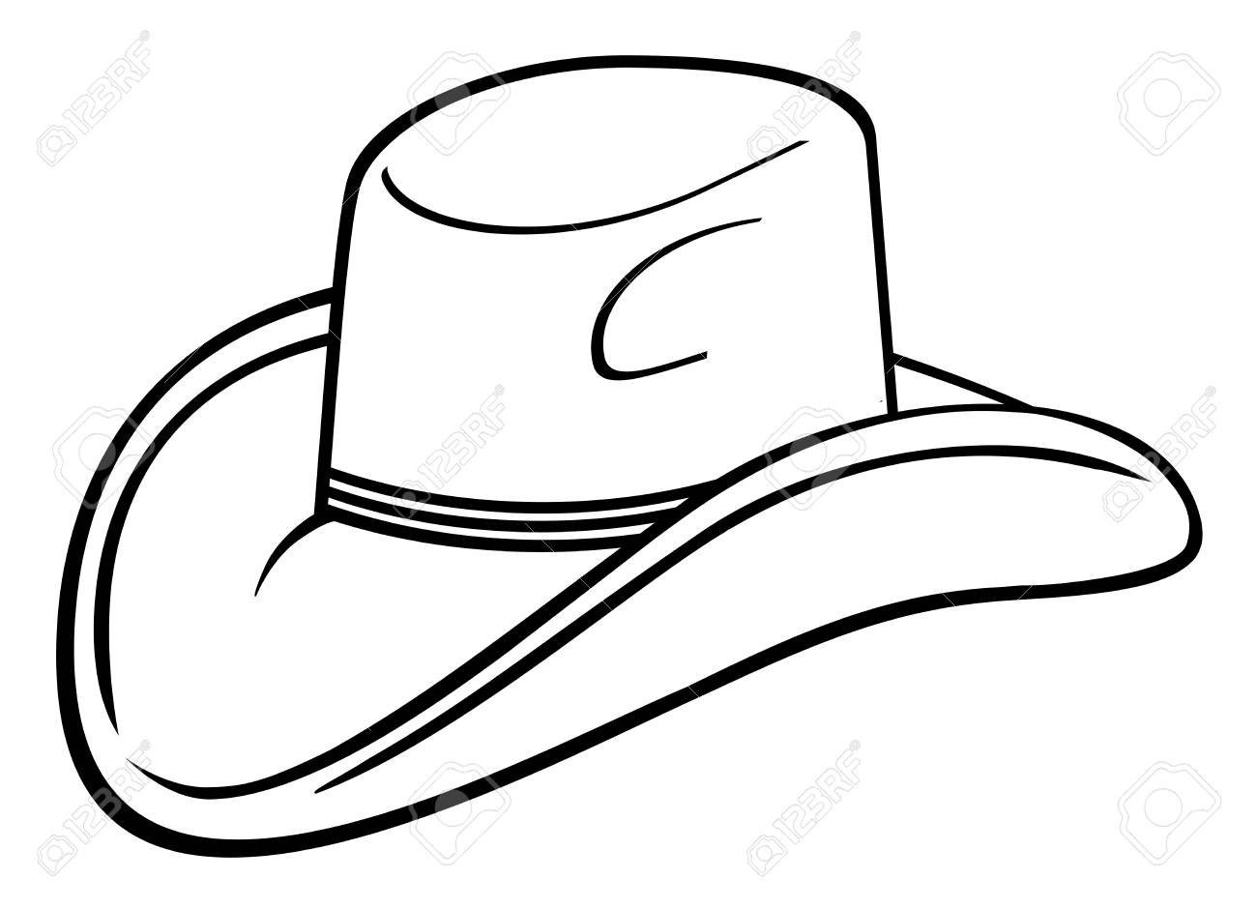

5. Baseball
Baseball caps are the easiest to style and are the most common hats used by both men and women. The baseball cap was specially designed to serve a purpose, and the idea for the basic design was to ensure that the cap sits in place, and extends out to give protection from heat and sun while one is playing sports, etc. These are now available in a million variants and are one of the most sought-after headgears. Wear it to feel sporty instantly.

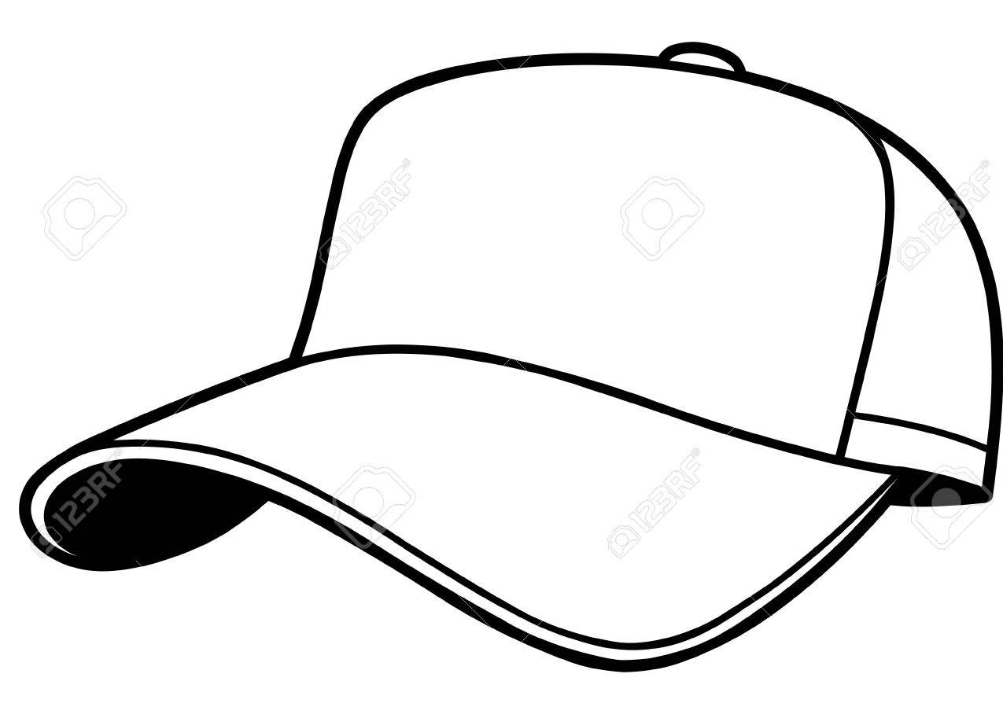

6. Small
Small/mini hats meet in the middle between the fedora and floppy hats. These are a modern addition to the old school definition of caps. These can be used for both formal and informal occasions, depending on the material, make, and how it has been accessorized. Wear it with formal ankle length pants, or skinny jeans and a silk top, and spin it any way you like.

7. Sun Hats

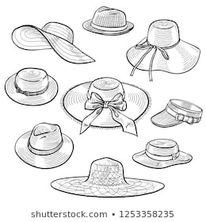
Sun hats were initially called the ‘lifeguard hats’, used by lifeguards who sit at the bay to provide them protection from the glaring sun and the scorching heat. These were usually made of straw or some other kind of plant fiber, and were pretty light. Just like all the other hats, these have gotten a makeover too and have changed with the times. Women seldom go on a beach vacation without wearing one of these. Wear it with bikinis, swimsuits, cover-ups, flowing dresses, and anything you want.

8. Floppy Hat
Floppy hats were a big part of the Bohemian and hippie culture. Women with long hair and cascading curls wore these as an accessory to enhance their look. Just as the name goes, these come with a big and floppy rim that is not so sturdy, but that’s the detailing that makes them look stylish. Wear these with playsuits, floral dresses, jeans or anything casual on a hot summer day, and look effortlessly put together.

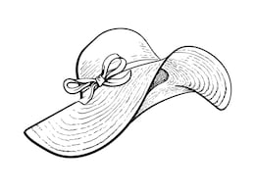

9. Derby Hat
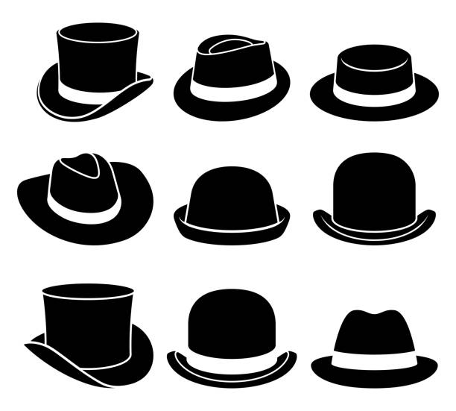
Derby hats are the most iconic hats and are as English as they can get. They trace back to the 1800s when they were called bowler hats. Initially, these hats were about plain and elegant self-designs. They started to get a makeover as English and world fashion evolved. Women going to Polo matches in England wear these hats with formal dresses, and that’s the most famous look. A formal dress, a pearl neckpiece, pumps, and a small hand tote makes up a look that is as perfect as it can get.

10. Cloche Hat
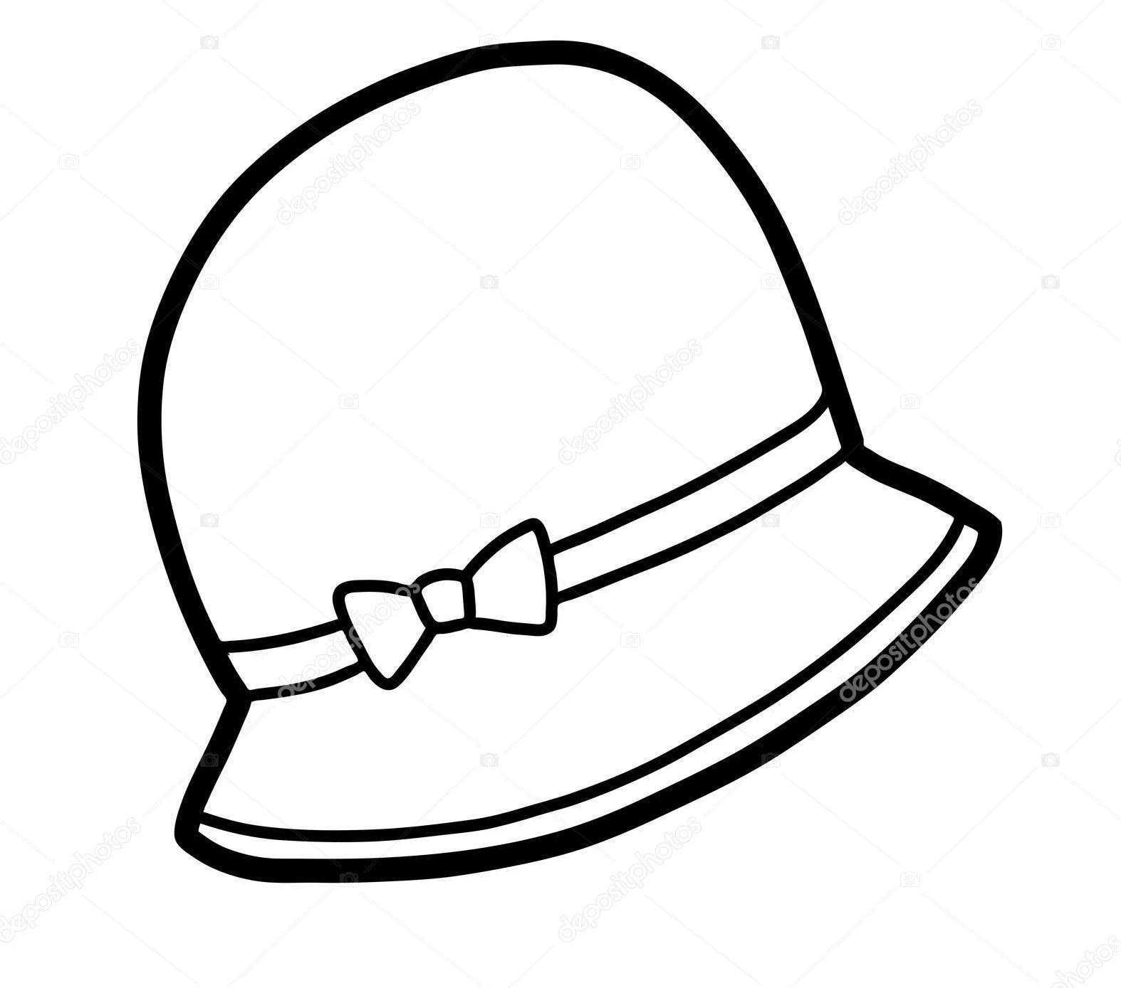
Cloche hats were popular in France in the early 19th century. They are long, narrow, and come with a smaller brim. They are meant to sit low on your head. In the second part of the 19th century, cloche hats got a makeover, and designers started to bring in their element with buttons, embellishments, etc. Wear these with a bodycon dress, or with something more formal.

11. Golf/Flat Cap
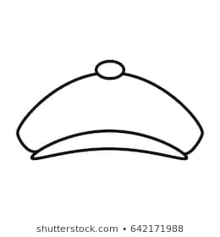
Golf caps are one of the most contemporary styles of hats and are impeccably chic. The golf cap was not really for Golf, but it was more like a promotional event wear that caught on, and has now become a big part of the game.

Tie/Necktie:
The contemporary word “Tie”, a shortened form of “Necktie”, appeared first about 1820. The word derived from the form of this accessory garments, i.e., sometimes that tied around the neck. For some time after this, “Tie” and “Cravat”, an entire term, were used as a men’s neckwear that was worn over a shirt, and cravat use as a rather more high-toned way of referring to a necktie.
Anatomy to Necktie:
Necktie can large in width, sometimes growing to as much as 5² inches, but are more likely to be about 2 3/4 inches to 3 1/2 inches. Lengths vary from 52 to 58 inches. Even longer ties can be obtained by placing special orders with retailers. Traditionally tie fabric is made in silk fiber. However, at present many other fabrics are used.
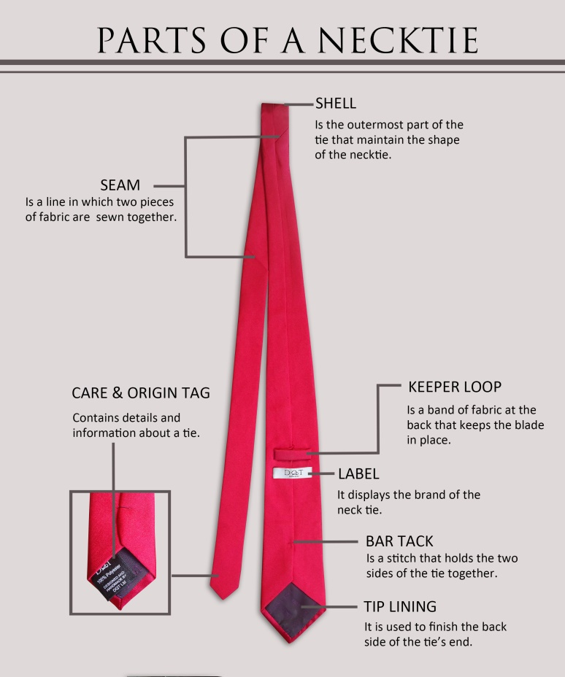
Types of Ties:
1. Apron Necktie:
The wide ends at the front and back of a contemporary necktie.
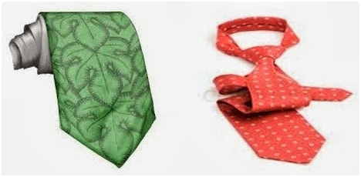
2. Ascot tie:
a. Wide necktie worn looped over and held in place by scarf pin. The ends are cut diagonally.
b. Scarf looped under the chin.
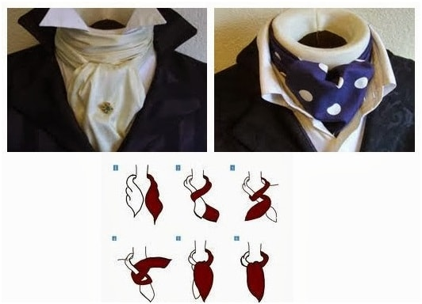
3. Bow tie:
Mans tie, square-cut or with shaped ends, tied in a bow under the chin. Originally introduced in late 19th c. and worn with formal dress for men since then.
4. Bolo /Bola tie:
Western types tie of heavy rounded braid with metal-tipped ends fastening with an ornamental side. Also called Shoelace tie.
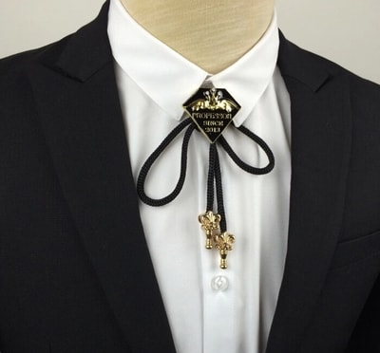
5. Windsor tie:
The Windsor knot is a thick, wide and triangular tie knot. Regular man´s necktie tied in four-in-hand style but large tie knot with suits wide collar shirt. After Duke of Windsor who made it popular in early 1920s.
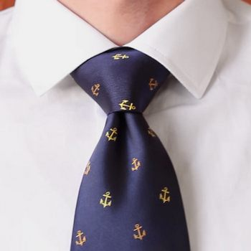
6. Four-in-hand tie:
Long necktie that goes around the neck with one end looping over the other end twice, then being pulled through the loop making a slip knot.
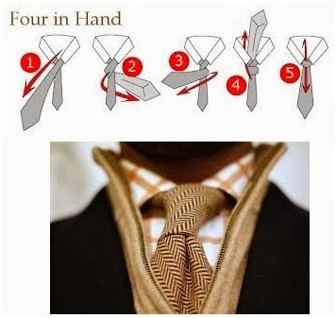
7. Cravat necktie:
Sometimes used as a man’s wide necktie worn with morning coat and pinstriped trouser.
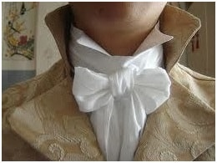
8. Sailor tie:
Large square scarf of black silk folded diagonally and worn under square sailor collar and either tied in sailor knot or pulled through strap on front of a middy blouse, which is a type of blouse copied from those traditionally worn by sailor.
9. String tie:
Necktie, usually not more than one inch wide, often black, worn in a bow with ends hanging down. Also called Bootlace tie, Southern Colonel tie, and in Britain, Sheriff´s tie.
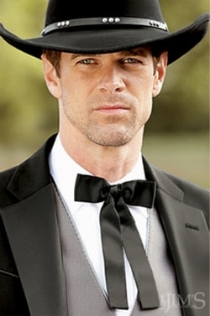
10. 7-fold tie:
Unlined tie made from an outer fabric that is folded over 7 times. As a result no lining is needed, however, due to the cost of such ties, they are now relatively rear.
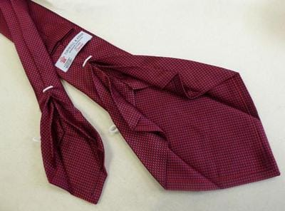
11. Clip-on tie:
Pre-tied knot like a Four-in-hand or a Bow tie that is fastened to the collar band by a metal clip.
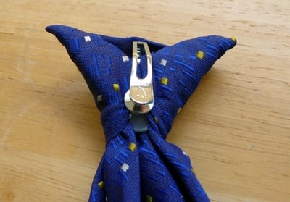
12. Kipper tie:
Necktie 4 or 5² wide with ends like a Bow tie usually of striped or patterned fabric. Introduce from England in late 1960s.
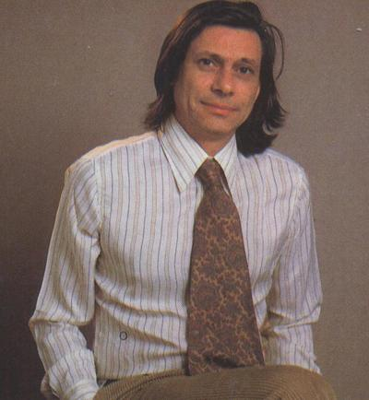
13. Hunting stock tie:
Worn folded over once to fill in neckline of jacket. Used by equestrians when riding in hunt field or show ring. Decorative pins are used to join the two ends of the tie.
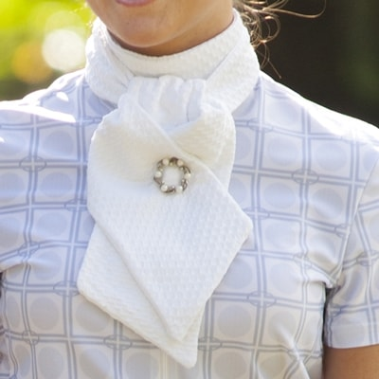
14. Macclesfield tie:
Necktie made from silk fabric of a type produced in Macclesfield, England. Fabrics has small dobby weave patterns.
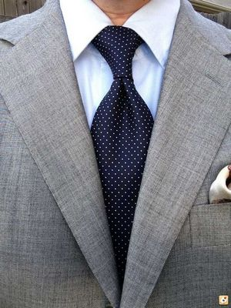
15. Rep/Repp Tie:
Tie made from fabric with closely spaced crosswise ribs. Fabric may be made from a variety of fibers.
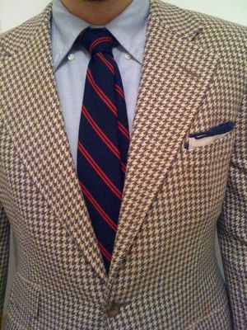
16. Handmade Up Cycle Fashion Neckwear:
This tie is made from different types of fabric, and it is decorated by leather, stone, or button etc. It is closely wrapped around the neck and mainly worn by women. Mainly used by fashion purposes.
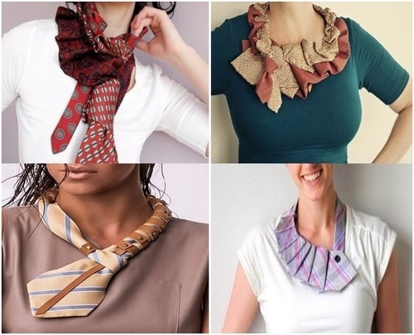
Different uses of necktie:
Now a days necktie used as a recycled finished product. Fashion designer use men’s neckties to produce different types of fashionable items like tie made dress, hand bag, wallet or photo album, tie made accessories like bracelets, head gear, hats, belts etc.

