UNIT – III
Investment and Capital Structure Decisions - Net Income Approach - Net Operating Income Approach - MM Approach; Valuation and Rates of Return; Method of Capital Budgeting.

INTRODUCTION:
Efficient allocation of capital is one of the most important functions of the financial management in modern times. This function involves the firm’s decision to commit its funds in long term assets and other profitable activities. The decision to invest funds in the long term assets of a firm are quite significant and they will influence the firms wealth, determine the size, get the pace and direction of its growth and also affect the business risk.
The capital investment refers to the investment in various fixed assets whose returns would be available only after a year. The investment in fixed assets will be quite heavy and to be made immediately, but the returns will be available after a period of one year. The investment decision of a company is commonly called as the capital budgeting decisions or capital expenditure decisions.
Weston C. Van Horne: “Capital budgeting involves the entire process of planning expenditure whose returns are expected to extend beyond one year”.

Charles T. Horngren: “Capital budgeting is the long term planning for making and financing proposed capital outlays”.

PROCESS OF CAPITAL BUDGETING:
The capital budgeting process involves generation of investment proposals, estimation of cash flows for the proposals, evaluation of cash flows, selection of projects based on acceptance criterion, and finally the continual revaluation of investment after their acceptance. The steps involved in capital budgeting process are as follows:
- Project generation.
- Project Evaluation.
- Project selection.
- Project execution.
- Project Generation: In the project generation, the company has to identify the proposals to be undertaken depending upon its future plans of activity. After identification of the proposals, they can be grouped according to the following categories:
  - Replacement of Equipment: In this case, the existing out-dated equipment and machinery may be replaced by purchasing new and modern equipment.
  - Expansion: The Company can go for increasing additional capacity in the existing product line by purchasing additional equipment.
  - Diversification: The Company can diversify its product lines by way of producing various products and entering into different markets. For this purpose, it has to acquire the fixed assets to enable producing new products.
  - Research and Development: Where the company can go for installation of research and development wing by incurring heavy expenditure, with a few to innovate new methods of production, new products etc.
- Project Evaluation: The process of project evaluation involves two steps:
  - Estimation of benefits and costs: These must be measured in terms of cash flows. Benefits to be received are measured in terms of cash inflows, and costs to be incurred are measured in terms of cash outflows;
  - Selection of an appropriate criterion to judge the desirability of the project.
- Project Selection: There is no standards administrative procedure for approving the investment decisions. The screening and selection procedure would differ from firm to firm. Due to lot of importance of capital budgeting decision, the final approval of the project may generally rest on the top management of the company. However, the proposals are scrutinized at multiple levels. Sometimes top management may delegate authority to approve certain types of investment proposals.
- Project Execution: In the project execution the top management or the project execution committee is responsible for effective utilization of funds allocated for the projects. It must see that the funds are spend in accordance with the appropriation made in the capital budgeting plan. The funds for the purpose of the project execution must be spent only after obtaining the approval of the Finance Controller.

METHODS OF EVALUATING CAPITAL INVESTMENT PROPOSALS

There are a number of appraisal methods recommended for evaluating the capital investment proposals. We shall discuss the most widely accepted methods. These methods can be grouped into the following categories:

  - Traditional Methods.
Traditional methods are grouped into the following:
- Pay –back period method or pay-out methods.
- Improvement of traditional approach to pay-back method.
  - Post pay-back profitability method.
  - Discounted pay-back period
  - Reciprocal pay-back period.
- Average rate of Return (ARR) method or accounting rate of return method.
II. Time Adjusted method or Discounted Cash flow method.
- Net present value method (NPV)
- Internal Rate of Return (IRR)
- Profitability Index method or Benefit-cost Ratio.

I. Traditional Methods:
1. Pay-back period method: Pay-back period is also termed as pay-out period. Pay-out period method is one of the most popular and widely recognized in traditional method of evaluating investment proposals. It is defined as the number of years required to recover the initial investment in full wi6th the help of the stream of annual cash flows generated by the project.

2. Improvement of Traditional Approach to Pay-back period method:
The demerits of the pay-back period method may be eliminated in the following ways;
  - Post pay-back profitability method: One of the limitations of the pay-back period method is that is ignores the post pay-back returns of project. To rectify this limitation, post pay-back period method considers the amount of profits earned after the pay-back period. In this method, pay-back profitability is calculated by annual cash inflows in each year, after the pay-back period.

  - Discounted pay-back method: This method is also designed to overcome the limitations of the pay-back period method. When savings are not leveled, it is better to calculate the pay-back period by taking into consideration the present value of cash inflows. Discounted pay-back method helps to measure the present value of all cash inflows and outflows at an appropriate discount rate. The time period at which the cumulated present value of cash inflows equals the present value of cash outflows is the known as discounted pay-back period.

  - Reciprocal Pay-back period method: This method helps to measure the expected rate of return of income generate by a project. Pay-back reciprocal is exactly equal to the unadjusted rate of return. Unadjusted rate means a rate which has not been adjusted by taking into account the time value of money. It is useful where the cash flows/earnings is relatively consistent and the life of the asset is would be done.

- Average Rate of Return method (ARR) or Accounting Rate of Return Method: Average rate of Return method is also termed as Accounting Rate of Return method or return on investment (ROI). This method focuses on the average net income generated in a project in relation to the projects, average investment outlay. This method involves accounting profits, not cash flows, and is similar to the performance measure of return on capital employed.

II. Discounted Cash Flow Method or Time Adjusted Method:
Discounted cash flow is a method of capital investment appraisal that takes into account both the overall profitability of projects and also the timing of return. Discounted cash flow method helps to measure the cash inflow and outflow of a project as if they occurred at a single point of time so that they can be compared in an appropriate way. This method recognizes that the use of money has a cost, i.e., interest foregone. Under this method, risk can be incorporated into discounted cash flow computations by adjusting the discount rate of cut-off rate.
- Net Present Value (NPV) Method: This is one of the discounted cash flow techniques that explicitly recognize the time value of money NPV method is also known as excess present value or net gain method. In this method all cash inflows and outflows are converted into present value applying an appropriate rate of interest.
- Internal Rate of Return (IRR) Method: Internal Rate of Return Method is also called as Time Adjusted Rate of Return Method. It is defined as the rate which equates the present value of each cash inflows with the present value of cash outflows of an investment. In other words, the internal rate of return IRR is that discount rate at which the NPV of the investment is zero.
- Profitability Index (PI) Method: Profitability Index method is also known as benefit-cost ratio. It gives the present value of future benefits, computed at the required rate of return on the initial investment. In other words, the ratio of the present value of the cash flows to the initial outlays is profitability index or benefit cost ratio.
Consider a fictitious company with below figures.
Earnings before Interest Tax (EBIT) | = | 100,000
Bonds (Debt part) | = | 300,000
Cost of Bonds issued (Debt) | = | 10%
Cost of Equity | = | 14%
Calculating the value of a company Net income approach

EBIT | = | 100,000
Less: Interest cost (10% of 300,000) | = | 30,000
Earnings (since tax is assumed to be absent) | = | 70,000
Shareholders’ Earnings | = | 70,000
Market value of Equity (70,000/14%) | = | 500,000
Market value of Debt | = | 300,000
Total Market value | = | 800,000
Overall cost of capital | = | EBIT/(Total value of firm)
 | = | 100,000/800,000
 | = | 12.5%

Consider a fictitious company with below figures.
Earnings before Interest Tax (EBIT) | = | 100,000
Bonds (Debt part) | = | 300,000
Cost of Bonds issued (Debt) | = | 10%
WACC | = | 12.5%
Calculating the value of the company:
(EBIT) | = | 100,000
WACC | = | 12.5%
Market value of the company | = | EBIT/WACC
 | = | 100,000/12.5%
 | = | 800,000
Total Debt | = | 300,000
Total Equity | = | Total market value – total debt
 | = | 800,000-300,000
 | = | 500,000
Shareholders’ earnings | = | EBIT-interest on debt
 | = | 100,000-10% of 300,000
 | = | 70,000
Cost of equity | = | 70,000/500,000
 | = | 14%

Apple Limited has two project options. The initial investment in both the projects is Rs. 10,00,000.
Project A has even inflow of Rs. 1,00,000 every year.
Project B has uneven cash flows as follows:
Year 1 – Rs. 2,00,000
Year 2 – Rs. 3,00,000
Year 3 – Rs. 4,00,000
Year 4 – Rs. 1,00,000
Now let us apply the payback period method to both the projects.
Project A
If we use the formula, Initial investment / Net annual cash inflows then:
10,00,000/ 1,00,000 = 10 years
Project B
Total inflows = 10,00,000 (2,00,000+ 3,00,000+ 4,00,000+ 1,00,000)
Total outflows = 10,00,000
Project B takes four years to get back the initial investment.
Now, let us modify the cash flows of project B and see how to get the payback period:
Say, cash inflows are –
Year 1 – Rs. 2,00,000
Year 2 – Rs. 3,00,000
Year 3 – Rs. 7,00,000
Year 4 – Rs. 1,50,000
The payback period can be calculated as follows:
Year | Total flow ( in Lakhs) | Cumulative flow
0 | (10,00,000) | (10,00,000)
1 | 2,00,000 | (8,00,000)
2 | 3,00,000 | (5,00,000)
3 | 7,00,000 | 2,00,000
4 | 1,50,000 | 3,50,000

Now to find out the payback period:
Step 1: We must pick the year in which the outflows have become positive. In other words, the year with the last negative outflow has to be selected. So, in this case, it will be year two.
Step 2: Divide the total cumulative flow in the year in which the cash flows became positive by the total flow of the consecutive year.
So that is: 5,00,000/7,00,000 = 0.71
Step 3: Step 1 + Step 2 = The payback period is 2.71 years.
Therefore, between Project A and B, solely on the payback method, Project B (in both the examples) will be selected.
The example stated above is a very simple presentation. In an actual scenario, an investment might not generate returns for the first few years. Gradually over time, it might generate returns. That too will play a major role in determining the payback period.
Accounting Rate of Return – ARR
A project is being considered that has an initial investment of 2,50,000 and it's forecasted to generate revenue for the next five years. Below are the details:
- initial investment: 2,50,000
- expected revenue per year: 70,000
- time frame: 5 years
- Average Rate of Return = Average Income / Average Investment over the life of the project
- ARR calculation: 70,000 (annual revenue) / 2,50,000 (initial cost)
- ARR = .28 or 28% (.28 * 100)

The Bata Co. Ltd., is considering the purchase of a new machine costing Rs. 80,000. Earnings after taxation are expected to be as follows:
Here is the DCF formula:
Where:
CF = Cash Flow in the Period
r = the interest rate or discount rate
n = the period number
The company has a target of return on capital of 10 per cent. On this basis, find the profitability of the machine and state if it is financially preferable.
Solution:
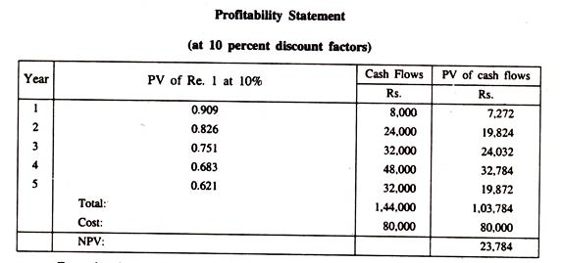
From the above statement it is evident that the new machine would be profitable since the PV of cash inflows is greater than the PV of cash outflows.

UNIT – IV
Working Capital Management - Definition and Objectives - Working Capital Policies - Factors affecting Working Capital requirements - Forecasting Working Capital requirements (problems) - Cash Management - Receivables Management and – Inventory Management - Working Capital Financing - Sources of Working Capital and Implications of various Committee Reports.

WORKING CAPITAL MANAGEMENT
Introduction:
A study of working capital is of major importance for internal and external analysis because of its relationship with the current day-to-day operations of business. Funds collected from different sources are invested in the business for the acquisition of assets. These assets are employed for earning revenue.

The basic problem facing the finance manager of an enterprise is trade-off between conflicting but equally important goals of liquidity and profitability. The greater the liquid resources of the firm, the lesser will be its profitability and vice versa.

Definition:
To maintain flow of revenue from operations, every firm needs a certain amount of current assets. For example, funds required either to pay for expenses or to meet obligations for service received or goods purchased etc. by a firm. These funds are known as working capital.

Shubin (1975) defined working capital as the amount of funds necessary for the cost of operating the enterprise. Working capital in a going concern is a revolving fund; it consist of cash receipts from sales; which are used to cover the cost of operation.

According to Hoagland (1981) working capital is descriptive of that capital which is not fixed. But the more common use of working capital is to consider it as the difference between the book value of the current assets and the current liabilities.

COMPONENTS OF WORKING CAPITAL:
In a narrow sense, the term working capital refers to the net working capital. Net working capital is the excess of current assets over current liabilities. It can be expressed as:

Net working Capital = Current Assets – Current Liabilities

Current assets refer to those assets which in the ordinary course of business can be, or will be, turned into cash within one year without undergoing a diminution in value and without disrupting the operations of the firm. On the other hand, current liabilities are those liabilities which are intended at their inception to be paid in the ordinary course of business, within a year, out of the current assets or earnings of the concern.

The components of current assets and current liabilities are listed here.
Current Assets | Current Liabilities
Sundry Debtors | Sunday Creditors
Bills Receivable | Bills payable.
Cash and Bank Balance | Advance Payments
Short term investments | Short term borrowings
Inventories | Bank Overdraft
Raw materials and components | Dividend payable
Work-in-progress | Accrued or Outstanding Expenses
Finished Goods | Provision for Taxation
Finished goods
Accrued or outstanding Income
Marketable securities
Loan and Advance extend for a short period of time.

DETERMINATION OF WORKING CAPITAL:
The total working capital requirement is determined by a wide variety of factors. It should be, however, noted that these factors affect different enterprises differently. The following is the description of the factors, which generally influence the working capital requirements of the firms.
A. Internal Factors:
1. Nature of Enterprise.
2. Size of Business.
3. Manufacturing cycle.
4. Firm’s credit policy.
5. Access to Money Market.
6. Expansion and growth of business.
7. Profit Management and Dividend policy.
8. Depreciation Policy.
9. Operating Efficiency of firm.
10. Co-ordination Activities of firm.
B. External Factors
1. Business Cycle Fluctuations.
2. Technological Development.
3. Seasonal Fluctuations.
4. Environment Factors.
5. Taxation Policy.

Internal Factors:

- Nature of Enterprise: The working capital requirements of a firm are basically influenced by the nature of its firm. For example, trading and financial firms require a large amount of investment as working capital, but a significantly smaller amount of investment in fixed assets. But in the case of manufacturing concern, they have to invest substantially in working capital and a normal amount in fixed assets. In contrast, public utilities have a very limited need for working capital, while a merchandising department depends generally on inventory and receivable need a large amount of working capital.
- Size of Business: The size of the firm is also an important factor that influences the requirements of working capital. Because a smaller firm needs smaller amount of working capital on the basis of its production activities and vise versa in the opposite case.
- Manufacturing Cycle: Time span required for conversion of raw materials into finished goods is manufacturing cycle. The period in reality extends a little before and after the work-in-progress. This cycle determines the need of working capital.
- Firm’s Credit Policy: The level of working capital is also determined by credit policy which relates to sales and purchases. The credit policy influences the requirement of working capital in two ways (a) Through credit terms granted by the firm to its customers / buyers of goods; (b) Credit than terms available to the firm from is creditors.
- Access to Money Market: working capital requirements of a firm are conditioned by the firm’s access to different sources of money market. Thus, a firm with readily available credit from banks and trade credit facilities at liberal terms will be able to get by with less working capital than a firm without such facilities.
- Expansion and growth of business: It is obvious that, as business expands, it will require more working capital in terms of sales or fixed assets. In the case of growth and expansion, there will be an all round increase in investment.
- Profit Margin and dividend policy: Magnitude of working capital in a firm depends upon its profit margin and dividend policy. As a matter of fact, a high net profit margin reduces the working capital requirements of the firm because it contributes towards working capital pool.
- Depreciation Policy: The depreciation policy influences the levels of working capital by affecting tax liability and retained earnings of the enterprise. Since depreciation is a tax deductible expense item, this will affect the firm’s tax liability and retained earnings and thus strength the firm’s working capital position.
- Operating Efficiency of firm: The operating efficiency of the management is also an important determinant of the level of working capital; management can contribute to a sound working capital position through operating efficiency. Efficiency of operations accelerates the pace of the cash cycle and improves the working capital turnover.
- Coordination activities of firm: Absence of coordination in production and distribution policies in a company results in a high demand for working capital. Where production and distribution activities are coordinated, pressure on working capital will be minimized.

External Factors:
- Business Cycle Fluctuations: This is another factor that determines the need level. Barring exceptional cases, there are variations in the demand for goods / services handled by any organization. Economic boom / recession have their influence on the transactions and consequently on the quantum of working capital required.
- Technological Development: Changes in technologies may lead to improvements in processing raw materials, minimizing wastages, grater productivity and more speed of production. All these improvements may enable the firm to reduce investments in inventory.
- Seasonal Fluctuations: seasonal fluctuations in sales affect the level of variable working capital. Often the demand for products may be of a seasonal nature. Yet, inventories have to get to be purchased during certain seasons only. The size of working capital in one period may, therefore, be bigger than in another.
- Environment factors: Political stability in its wake brings stability in the money market and trade world. Things mostly go smooth. Risk ventures are possible with enhanced need for working capital finance. Similarly, availability of local infrastructural facilities, road, transport, storage, market, etc. influence the business and working capital need as well.
- Taxation Policy: Taxes must be paid out of profits. Tax liability is unavoidable and adequate provision should be made for it in the working capital planning. If the tax liability increases, it will impose an additional strain on working capital. The finance manager must do tax planning to avail the benefits of all sorts of tax concessions and incentives.

MANAGEMENT OF CASH AND MARKETABLE SECURITIES:
Introduction:
Cash plays a vital role in the entire economic life of a business. Cash is the basic component of input required to make payment to its suppliers, and to meet day-to-day operating expenses of any firm. Therefore, it is essential for a business to maintain adequate balance of cash.
Thus, cash management is one of the key areas of working capital management. The basic objective of financial management is to match the inflows and outflows of cash and ensure the liquidity and adequate cash position of a concern during a particular period.

Meaning of Cash:
The term cash has a variety of meanings. In a narrow sense, it includes coins, currency notes, bank draft, and withdrawals by cheques on demand and bank balances in bank accounts. In a broader sense, the term cash refers to as near cash assets. Such cash equivalent assets are marketable securities, time deposit in banks, treasury bills, etc.

Motives for Holding Cash
Jhon Maynard Keynes (1981) identified the following motives for cash held by the firm:
  - Transaction Motive.
  - Precautionary Motive.
  - Speculative Motive.
  - Compensation Motive.
    - Transaction Motive: Transaction motive refers to the holding of cash required by a firm to carry its day-to-day business transactions in the ordinary course of business. The firm is required to maintain purchase of raw materials, wages, operating expenses, interests, taxes, dividends and so on. In other words, any transaction resulting in decrease of the cash position is referred to as cash outflow or cash payments or application of cash or uses of cash.
    - Precautionary Motive: According to this motive, the firm keeps sufficient cash balances to meet unexpected cash needs arising at short notice which may be the result of the following:
- Floods, strikes, droughts and failure of important customers.
- Bills may be presented for payment earlier than expected.
- Unexpected slow down in collection of accounts receivable.
- Cancellation of some orders for goods as the customer is not satisfied.
- Cost of sales increases due to cost of raw materials and labor changes.
    - Speculative Motive: An important reason for holding cash balances is the speculative motive. This refers to maintaining cash balance, the firm to take advantage of investing in profit-making opportunities and which is typically outside the normal course of business.
- The opportunity to make profit arising from fluctuations in commodity prices.
- Purchase of raw materials at a reduced rate on payment of immediate cash, i.e., benefit of cash discount and trade discount.
- A chance to speculate on interest rates, security prices and foreign exchange rates by buying securities when rates are expected to decline.
- Delay purchases of raw materials on the anticipation of decline in prices.
    - Compensation Motive: This motive for holding cash balances is to compensate banks for providing certain service to their clients free of charge. Banks provide variety of services to business firms, such as clearance of cheque, supply of credit information, transfer of funds, etc.

MANAGEMENT OF ACCOUNTS RECEIVABLE

Meaning and Definition:

A trade very often buys and sells goods on credit. Credit is a very powerful instrument to promote sales. In working capital management, sundry debtors are one of the significant and major components. In a business concern, next to inventories and cash, the accounts receivable is considered to be an important aspect of financial planning and control.
The word accounts receivable is otherwise termed as sundry debtors or trade debtors or book debts. Sundry debtors may be defined as “money due from a customer for sale of goods or services in the ordinary course of business”.

COST OF MAINTAINING ACCOUNTS RECEIVABLES

The following specific costs are identified during the extension of credit and maintaining accounts receivables.

Capital Costs:
The increased level of accounts receivable as an investment in current assets results in blocking of the firm’s capital. There is a time lag between the sale of goods and the payments for them. Meanwhile, the firm has to arrange for additional funds either from outside or out of retained profits or share capital to pay employees and suppliers of raw materials, etc., while waiting for payment from its customers. The firm incurs a cost on account of raising additional capital to support credit sales, the capital which alternatively could be earned profitably if employed elsewhere.

Administration Costs:
Another cost comes from an enlarged credit department. This cost is involved in the form of clerical working involved in checking additional accounts serving the added volume of receivables, maintaining accounting records, and cost of conducting investigation to assess the credit worthiness of the customers.

Collection Costs:
Some costs are to be incurred by the firm for collecting the amount from the customers on account of credit sales. Sometimes, additional expenses involves sending frequent follow-up letters, cost of collection of exchange or cost of discounting bills, expenses of stringent action against default customers etc.,

Delinquency costs:
These costs are incurred by the firm when extending credit to the defaulting customers. The delinquency costs include the following.
  - Committing funds to the investments, additional receivables for extended credit period.
  - cost Involved in putting extra effort to recover the overdue from the customers
  - Cost associated with frequent reminders.
  - Cost incurred on account of legal charges.

Default Costs:
This cost comes from the probability of bad debt losses. The cost of bad debts arises when the firm is not able to the due from the defaulting customers.

FORMULATION OF CREDIT POLICIES

Economic conditions, product pricing, product quality and the firm’s credit policies are the chief influences on the level of a firm’s accounts receivable credit policy and can have a significant boosting on the sales. Thus, credit is one of the many factors that stimulate the demand for a firm’s product. The term credit policy refers to a firm’s guidelines for determining quality of trade accounts to be accepted, the length of the credit period, the cash discount, any special term given, such as seasonal dating, the collection programme and policy as to discounting of bills.

The important dimensions of a firm’s credit policies are the following:
- Credit Standard.
- Credit Terms.
  - Cash Discount.
  - Cash Discount period.
  - Credit Period.
- Credit Analysis or Credit Evaluation.
- Credit Standard: The credit standard refers to the minimum quality of credit worthiness of a credit applicant that is acceptable to the firm. In other words, the quality of the trade accounts to be accepted is called as credit standards.
- Credit Terms: The term ‘Credit terms’ refer to the stipulation under which the firm sells on credit to customers. Thus, the size of the accounts receivables is also affected by terms of credit. Four important components of the credit terms are the following:
  - Cash Discount: Cash discount is a powerful device to speed up the payment of receivables. Many firms offer cash discount to debtors, to encourage them to pay their dues early. It helps in reduction of investment in accounts receivables. The term cash discount indicates the rate of discount and the period for which discount has been offered.
  - Cash Discount Period: The cash discount period represents the period of time during which a cash discount can be taken for early payment. Thus, period of discount also influences average collection of receivables.
  - Credit period: The term credit period refers to the period for which the credit is extended to the customers. It is generally stated in terms of net date.
- Credit Analysis (or) Evaluation of Credit: The chief aim of debtor’s management is to ensure minimum or optimum investment in receivable and considerable reduction in bad debt losses. To achieve this, the financial manager should follow clear-cut principles and procedures to evaluate the credit worthiness of the applicants regarding on how much credit can be extended and how long. The evaluation of credit process consists of the following three important steps:
1. Gathering Credit information: Credit Information gathered about the credit applicant.
2. Analysis of Customer’s credit worthiness: Collecting information about the credit worthiness of the client, his requirement for credit.
3. Credit Decision: Making decisions to grant credit facilities.

INVENTORY MANAGEMENT:

Introduction:
Inventory, the firms store current assets as inventory and it comprises of raw materials, work-in- progress, maintenance materials, consumable stores, component parts, tools and packing materials, and finished goods. Each business unit has to maintain a considerable volume of inventory in response to the conditions in which the business operates.
The raw materials inventory contains items that are purchased by the firm from suppliers and are converted into finished goods through the manufacturing process. They are an important input of the final produce. The work-in-progress inventory consists of items currently being used in the production process. They are normally partially or semi-finished goods that are at various stages of production in a multi-stage production process.
Finished goods represent final or completed products that are available for sale. As such a large quantum of fund is necessary to finance the required volume of inventory. As a matter of fact, inventories are very important to the management of an enterprise as they have direct impact on the firm’s profit. The financial managers have the responsibility to ensure that the inventories are properly monitored and effectively controlled.

Meaning and Definition of Inventories
The term inventory is used in day-to-day life as a manpower inventory, equipment inventory, inventory documents, inventory of raw materials, inventory of spare parts, inventory of semi-finished items, inventory of finished goods, inventory of vehicles, etc. the dictionary meaning of the word is stock of goods or items in stock.

TYPES OF INVENTORIES:
The various types of inventories for a manufacturing or trading organization are classified as the following:

Raw Materials and consumable stores:
These materials refer to all commodities or components that are consumed in the process of manufacture. These items form part of the finished products. For example, cotton used in textile mills and timber used in furniture industries. Some materials are indirectly used for conversion from raw materials into finished products.

Work-in-Progress:
Work-in-progress is otherwise known as semi-finished goods or process inventories or convertible inventories. These are processed or semi-finished products manufactured at various stages during the production cycles. In other words, it consists of items that are currently used in the production process. For example, in a bicycle factory, frames, pedals, rims, axles, etc. are semi finished products that are held at various stages of production process.
Finished Goods Inventories:
Finished goods inventories are final or completed products ready to be sent away to the market or consumers. These products have been fabricated or manufactured or assembled from production and in-process inventories.

MEANING AND DEFINITION OF INVENTORY CONTROL:

Inventory control may be defined as “The systematic control over the procurement, storage and usage of materials so as to maintain an even flow of materials and at the same time avoiding excessive investment in inventories”.
According to Jhon L Burbridge, “inventory control is concerned with the control of quantities and / or monetary value of these items at predetermined level or within safe limits”.
Inventory control means control over materials lying in store. Inventory control keep continuous track of inventories. But it is not merely record keeping. Inventory control aims to achieve maximum possible inventory turnover.

INVENTORY CONTROL TECHNIQUES:

Inventory control refers to the regulation of the stock and flow of materials and stores in an efficient, effective and economical manner to meet the needs of manufacturing and trading concerns. To achieve this, the following important inventory control techniques are to be applied.
- Economic Order Quantity.
- Fixation of stock levels
- ABC Analysis.
- VED Analysis, FSN Analysis, Pareto Analysis and Just-in-time inventory system.
- Techniques of Codification.
- Inventory System
- Materials Storage loss.
- Inventory Turnover Ratio.

- Economic Order Quantity (EOQ): Economic Order Quantity (EOQ) is one of the important techniques used to determine the optimum quantity or number of orders to be placed from the suppliers. The main objective of EOQ is to minimize the cost of ordering and cost of carrying materials, and total cost of production. Ordering costs include cost of stationery, salaries to those engaged in receiving and inspecting, general office and administrative expenses of purchases departments. Carrying costs are incurred on stationery, salaries, rent, materials handling cost, interest on capital, insurance cost, risk of obsolescence deterioration and wastage of materials and evaporation.

- Fixation or Determination of Stock Levels: Materials control involves physical control of materials, preservation of stores, minimization of obsolescence and damages through timely disposal and efficient handling. Effective stock control system should ensure the minimization of inventory carrying cost and materials holding cost. Level of stock is an important aspect of inventory control.

- Re-order level.
- Minimum stock level.
- Maximum stock level.
- Danger level
- Average Stock Level.

- ABC Analysis: ABC Analysis is one of the important techniques that are based on grading the items to the importance of materials. This method is popularly known as always better control. This is also termed as proportional value analysis. In inventory control, this technique helps to analyses the distribution of any characteristic by money value to determine its importance. Accordingly, materials are grouped into three categories on the basis of the money value of importance of materials.
A - High Value Materials.
B - Medium Value Materials.
C - Low Value materials.

4. VED Analysis: The term VED refers to vital items, Essential items and Desirable items. This technique is also called as Vital, Essential and Desirable Analysis. This is one of the important tools used in inventory control. VED analysis is used on the basis of items of classification in the nature of ABC analysis. The VED analysis is largely applicable in spare parts. Spare parts are classified as vital, essential and desirable according to their requirements. VED analysis does not consider the utility of the inventory items on the basis of value but on their impact on production.
V - Vital Items.
E - Essential Items.
D - Desirable Items.

FSN Analysis: FSN analysis evaluates the importance of the inventory items on the basis of movement of items in the storehouse. The items are classified as fast moving (F), slow moving (S) and Non-moving (N), FSN classification is done on the basis of consumption pattern of the item under analysis. This analysis is useful to identify the obsolete items. The FSN analysis is also helpful in preventing obsolescence and facilitates timely control.
F - Fast Moving Items.
S - Slow Moving Items.
N - Non-moving Items.

PARETO Analysis: Pareto Analysis is one of the important techniques in inventory management. This is also termed as 80: 20 analyses. The technique Pareto analysis refers to a rule of 80: 20 adopted to ensure the effective management of inventory and debtors.

Just-in-time (JIT) Inventory System: The just-in-time (JIT) inventory control system originally developed by Tajichi Okno in Japan to eliminate the drawbacks of just in case systems. This system implies that the firm should maintain a minimum level of inventory and rely on suppliers to provide parts and components of just-in-time to meet its assembly requirements.

- Classification and Codification of Materials: To ensure effective inventory control, it should be carried out with the classification and codification of materials. Codification is the process of representing each item by a number, the digits of which indicate the group, the sub-group, the type and the size and shape of the items.

- Inventory system: The chief aims of inventory control is as follows:
1. To maintain a balanced inventory.
2. To ensure smooth flow of production.
3. To keep the investment in inventory as low as possible.
Accordingly stock verification is an important aspect to ensure maintains a balanced inventory. The following are the tree of stock verification adopted in different industries:
  - Periodic Inventory system.
  - Perpetual Inventory system
  - Continuous stock taking.

6. Material Storage Losses: The investment in materials constitutes a major portion of current assets, so it is essential to exercise effective stores control. Stores control helps to avoid losses from misappropriation, damage, deterioration, etc. Generally, material storage losses arising during storage may be classified as the following:

1. Normal Loss, 2. Abnormal Loss.

7. Inventory Turnover Ratio: This ratio is also called as stock turnover ratio or stock velocity. Inventory turnover ration may be defined as a ratio that measures the number of items of a firm’s average inventory sold during the year. It establishes the relationship between the cost of goods sold during a given period and the average of the cost of opening and closing stock.

The following information has been provided by a company for the year ended 30.6.2008:

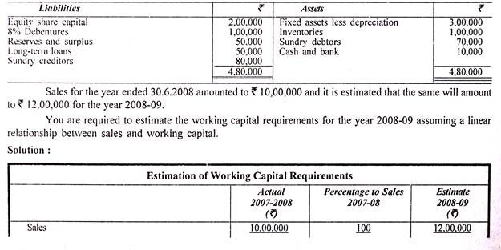

The following are the extracts from the balance sheet of a company as on 30.6.2008. Compute the additional working capital required by the company for the year ending 30.6.2009.
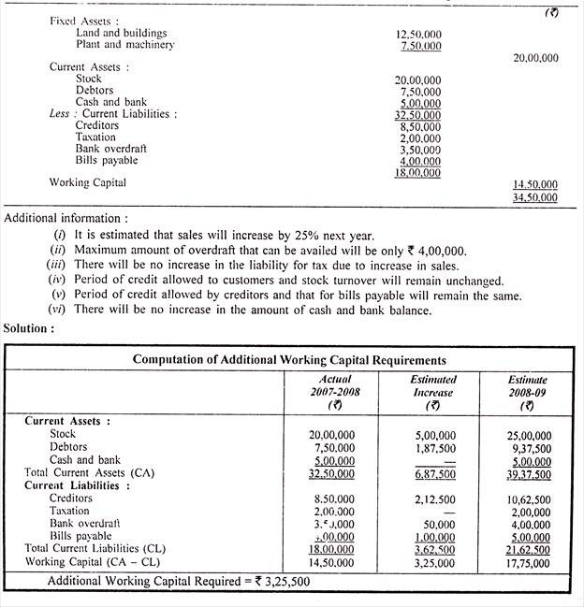
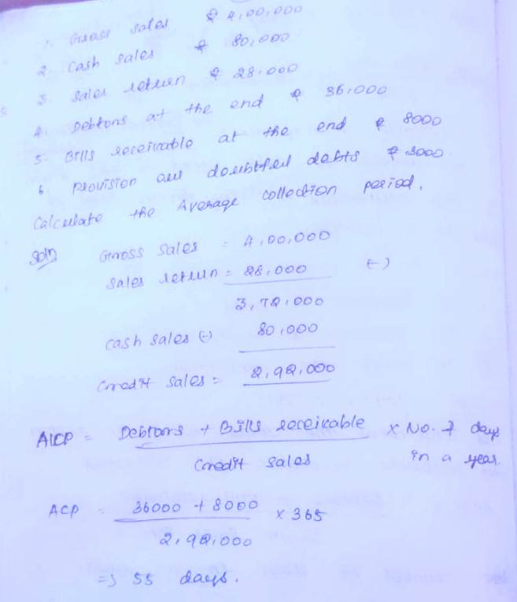
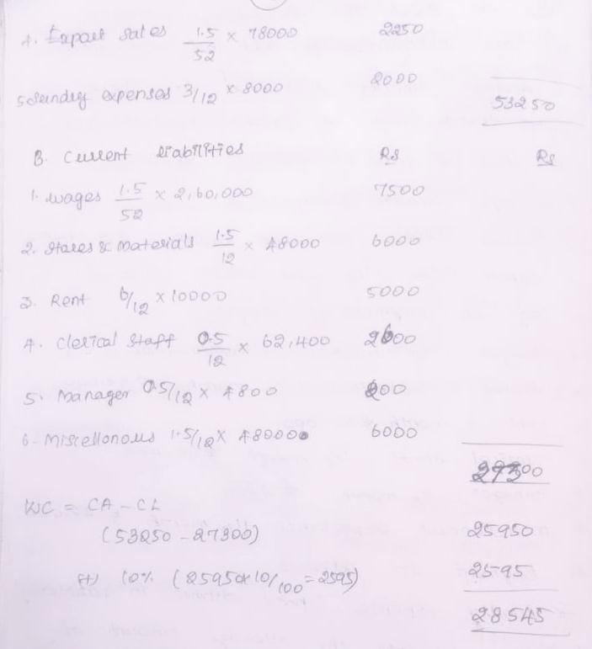
UNIT – V
Internal Financing and Dividend Policy - Types of Divided Policy - Dividend Policy and share valuation - CAPM. Financial Modeling.

INTRODUCTION:
Maximization of profit is one of the chief aims of financial management in any industrial concern. The success or failure of a financial decision by the management should be judged by its impact upon the common stock price. It is observed that the company’s investment and financial decisions can increase the value of the firm.
In this regard, dividend policy is one of the important aspects of financial management to achieve the objective of the concern. Dividend policy implies the broad policy or guidelines that management lays down and follows with respect to sharing of corporate earnings, that is, the amount or percentage of profits to the apportioned shareholders.

Meaning:
The term dividend refers to the portion of the profits of the company that are distributed to the holders of share in the company. This may be paid as a fixed percentage on the share capital contributed by them or at a fixed amount per share.
It is possible that only sufficient profits are available after meeting all the expenses, provision for depreciation and reserves as required under the Companies Act. Dividend should be declared by a company by a resolution passed at the Annual General Meeting.
It is observed that dividend cannot be declared or paid, except out of the profits of the company. In other words, dividend shall be paid only by the profits made during the current year.
The term dividend is applied to a company that is a going concern, means that the portion of the profits of the company that is allocated to the holders of shares in the company.

GENERAL RULES OF RECORDING DIVIDEND:
The following are the important rules/provisions regarding dividend:
- Dividend is declared by a company by a resolution passed at the Annual General Meeting.
- Payment of dividends is in proportion to the amount paid on each share.
- Dividend to be paid only out of profits.
- Mode of payment of dividend is left to the company.
- Dividend is payable only in cash.
- In case of insufficient profit, no dividend can be paid.
- Dividend must be paid only to the registered shareholders.

TYPES OF DIVIDEND:
Dividend can be classified broadly on the basis of types of securities, sources, medium and timing of payments. This may be grouped into the following:
A brief description of different types of dividend can be distributed according to the mode of payments:
1. Cash Dividend.
a) Regular Dividend.
b) Interim Dividend.
2. Stock Dividend.
3. Scrip Dividend.
4. Bond Dividend.
5. Property Dividend.

- Cash Dividend: Cash Dividend is one of the most popular mode of distribution, dividend is payable only in cash. It can also be paid by cheque or warrant to the registered shareholders. This may be (a) Regular Dividend (b) Interim Dividend.

  - Regular Dividend: It is generally paid in cash. It is also called as final dividend and is paid after finalization of accounts. In other words, it is the dividend paid annually by the company.

  - Interim Dividend: It is also known as cash dividend. Interim dividend is an extra dividend declared and paid in between its two annual General Meeting, when companies have enough large earnings during a year and the Board of Directors wish to pay them to the shareholders.
- Stock Dividend (Bonus shares): Stock dividends are paid in the form of issuing shares instead of paying dividend in cash to the registered shareholders. Such shares are also known as bonus shares. It is possible, when the companies do not have good cash position; dividends are paid in the form of shares by capitalization of reserves or surplus during the current year.
- Scrip Dividend: Scrip dividend is used when earnings justify a dividend, but the cash position of the company is temporarily weak. It is in the form of a promissory note, promises to pay the stockholders at a future specified date. The notes are called dividend certificate or scrips. A scrip dividend is a substitute for cash and a temporary medium for stock dividends.
- Bond Dividend: In rare instances, company issues bonds or debentures or notes for a long-term period bearing interest at fixed rate. In other words, as in scrip dividend, dividends are not paid immediately in bond dividends. Instead, the company promises to pay dividends at a future data and to the effect bonds are issued to shareholders in place of cash. The purpose of both the bonds and scrip dividend is alike. i.e., postponement of dividend payment.
- Property Dividend: Property dividend can also be declared and paid in the form of any assets other than cash. Any investment or stock in trade held by the company also can be distributed by the company in the form of property dividend.

But, however, it is important to note that in India, dividend can be paid and distributed only in the form of cash or bonus shares. Other types of dividend are not allowed under the Indian Companies Act, 1956.

FACTORS AFFECTING DIVIDEND POLICY:
The following factors influence the dividend policy
- Stability of earnings
- Liquidity of funds.
- Nature of business
- Financing policy of the concern.
- Dividend policy of competitive concerns.
- Maintaining effective control.
- Need for expansion.
- Cash position.
- Taxation policy.
- Legal requirement.
- Investment opportunities.

  - Stability of earnings: Industrial concerns having stability of earning may formulate a more consistent dividend policy than a firm with fluctuating earnings, because a firm is better able to predict what its future earnings will be.
  - Liquidity of funds: The liquidity of funds is an important factor in dividend decisions. As dividend represent cash outflows, the greater the funds and the liquidity of the firm, the greater is the ability to pay the dividends. The liquidity of a firm is determined by the firm’s investment and financial decisions.
  - Nature of business: Nature of business is the primary factor that influences the determination of dividend policy. Business having more risks but unstable income should prefer equity shares. But firm’s engaged in public utility services for producing the commodity of basic necessity may resort to debentures and preference shares.
  - Financing policy of the company: Dividend policy may be affected and influenced by the financing policy of the company. The company might decide that it will meet its expenses from within the earnings. This will influence the companies decision regarding fixing the payment of lesser or higher dividend to its shareholders. Internal financing policy of the company also decides about the dividend policy of the undertaking.
  - Dividend policy of competitive concerns: This is one of the factors that influence dividend policy of other concerns which are accompanying it in the market. In case other competitive concerns are paying more dividends, then the shareholders will like to invest their money in those, rather than in concerns which are paying less. Thus, every concern will have to decide the dividend policy, taking into consideration the other competitive concern’s dividend policies and programmes.
  - Maintaining Effective Control: The objective of maintaining control over the company by the existing management group or the body of shareholders can be an important variable in influencing the company’s dividend policy. When a company pays more dividends, it cash position is affected. As a result, the company will have to issue new shares to raise funds to finance its investment programmes.
  - Need for expansion: Growth of individual expansion is one of the factors that influence the determination of dividend policy. Many concerns retain the earnings to facilitate planned expansion. Concerns with low credit ratings may not be able to sell their securities to raise finance for the purpose of their expansion of a concern and diversification.
  - Cash Position: Cash position is one of the vital factors to decide the company’s dividend policy. Cash credit limits, working capital needs, capital expenditure investments, and repayment of long-term debt must be considered in the course of cash planning.
  - Taxation Policy: Corporate taxes affects dividend both directly and indirectly. High rate of taxation reduce the earnings of the companies and consequently reduce the residual profit after tax, available for shareholders. In some circumstances, government puts dividend tax on distribution of dividend beyond a certain limit.
  - Legal requirements: In deciding on the dividend, the Board of Directors takes the legal requirements too, in this respect, Section 5 of the Indian Companies Act, 1956, protects the interest of creditors and outsiders.
  - Investment opportunities: This is one of the important factors that influence the concern’s dividend policy. Firms that have substantial investment opportunities generally tend to keep their pay-out ratio rather low to conserve resources for growth. On the other hand, firm’s that have rather limited investment avenues usually pursued a more generous pay-out ratio.

BONUS SHARES:
A company may follow a conservative policy of not distributing all the profits every year and accumulate large reserves over time. If the articles so permit, it may convert a part of these reserves into share capital by issuing fully paid bonus shares to the existing shareholders.
Bonus is something given in a addition to what is usually or strictly due. It comes to shareholders in addition to what they get in the form of dividend. It may also be paid
1. In cash, if the company has surplus cash and has no use for it or,
2. By making partly paid shares as fully paid. Normally bonus is paid to the shareholders in the form of the fully paid shares free of cost. Issue of bonus share results in capitalization of profits and reserves of the company.
Conditions for the issue of Bonus Shares:
- The issue of bonus shares must be authorized by the Articles of the company.
- It must be recommended by a Board resolution and then approved by the shareholders in Annual General Meeting.
- It must be permitted by the Controller of capital issues, regardless of the amount involved.

KINDS OF STOCK DIVIDENDS:
The following kinds of stock dividend can be issued by the company:
- Equity stock to Equity stockholders.
- Preferred Stock to Equity stockholders.
- Equity stock to preferred stockholders.
- Preferred stock to preferred stockholders.

Advantages of issue of Bonus Shares:
The important benefits derived from issue of bonus shares are as follows:
- The stock dividend allows the firms to declare a dividend without using up cash that may be needed for operations expansion.
- Stock dividend helps to increase future profits.
- It helps to boost the credit worthiness of the company.
- Shareholders will receive more cash dividends in future because of additional shares.
- Stock dividend helps to reduce the cost of generating funds.
- It helps to reduce the market price of the shares, rendering the shares more marketable.
- Stock dividend helps the shareholders to retain the proportional ownership in the firm.
- It is an indication to the prospective investors about the financial soundness of the company.
- It creates positive psychological value among the shareholders which leads to encourage further investment in stock.
Disadvantages of Issue of Bonus shares:
- It leads to an increase in the capitalization of the concern without proportionate increase in the earning capacity of the company.
- It leads to an increase in liability in respect of future dividend on the company.
- It excludes the possibility of new investors coming in contract with the company.
- The market value of the existing company goes down.
- Some investors do not like bonus shares due to low market value of the existing shares.

STOCK SPLITS:
A stock split is a method to increase the number of outstanding shares through a proportional reduction in the par value of the shares. A stock split affects only the par value and the number of outstanding shares, the capitalization of the company is not changed at all.
Reasons for Split:
The following reasons are to be taken into account for stock splits:
- Provide broader and more stable market for the stock.
- Increase marketability of new issues, the firm generates funds by use of stock split.
- Merger or acquisition of companies through exchange of stock will often split its stock to make the transactions more attractive.
- Stock split will add to the marketability of shares of the shareholders.

COMPARISON BETWEEN BONUS SHARES AND STOCK SPLIT
S. No. | Bonus Issues | Stock Split
1. | The value of the stock is unchanged. | The par value of stock is reduced.
2. | A part of reserves is capitalized. | There is no capitalization of reserves.
3. | The stockholders proportional ownership remains unchanged. | The stockholder’s proportional ownership remains unchanged.
4. | The book value per share, the earnings per share and the market price per share declines. | The book value per share, it earnings per share, and the market price per share declines.
5. | The market price per share is brought within a more popular trading range. | The market price per share is brought within a more popular trading range.

THEORIES OF DIVIDEND POLICY:
Different theories are developed by many experts regarding dividend decision on the valuation of a firm the theories can be grouped into two heads:

- Relevance Concept of Dividend
- James Walter’s Approach.
- Myron Gordon’s Approach.

- Irrelevance Concept of Dividend.
- Modigliani – Miller’s approach.
Relevance Concept of Dividend:
James Walter’s Approach: James Walter (1966) has developed a relevance concept of dividend model and strongly supports that dividend policies of a firm almost always affect the value of the firm. According to him, the dividend decisions cannot be separated from the investment policy of an enterprise. Thus, the firm can utilize it to maximize the wealth of the equity shareholders.
James Walter suggested that the key relevance proposition is based on the relationship between the return on the firm’s investment or its internal rate of return (r) and its cost of capital or required rate of return (k)
Assumptions: James Walter’s model is based on the following assumptions
- Retained earnings are the only source of entire financing of a firm.
- External sources of funds such as debt or new equity capital are not used.
- Return on firm’s investment (r) and cost of capital (ko) of a firm remain constant.
- Firm’s business risk does not change with additional investment undertaken.
- The firm has an infinite or very long life.

Gordon’s Model:
Myron J. Gordon (1979) suggested a relevance of dividend decision for valuation of a firm. This model is also called as dividend capitalization model. According to this model, dividend policy of a firm affects its value, and is based on the following assumptions.
- The firm is an all equity firm.
- Retained earnings represent the only source of a firm for financing its investment programmes.
- The rate of return (r) on the firm’s investment is constant.
- The cost of capital remains unchanged for all times to come.
- The firm has perpetual life.

Irrelevance Concept of Dividend:
Miller – Modigliani Theory or MM Hypothesis: MM thoughts on irrelevance concept of dividend are most comprehensive and logical. According to them, dividend policy of a firm does not affect the value of a firm. Thus, the dividend payout ratio does not affect the wealth of shareholders.
Assumptions of MM Hypothesis:
- It assumes that capital markets are perfect.
- Investors behave rationally.
- Non-existence of brokerage / commission.
- Availability of free information to all investors.
- No transaction costs and floating costs.
- Investment policy of the firm does not change at any circumstances.

