**SENGAMALA THHAYAAR EDUCATIONAL TRUST WOMEN’S COLLEGE,**

**(Affiliated to Bharathidasan University,Tiruchirapalli)**

**(Accredited with A grade by NAAC)**

**(An ISO 9001:2015 certified Institution)**

**SUNDARAKKOTTAI, MANNARGUDI - 614016.**

**THIRUVARUR Dt, TAMIL NADU, INDIA**

**CLASS: II M.SC BIOCHEMISTRY**

**SUBJECT: CC- IX - ENDOCRINOLOGY**

**CODE: P16BC41**

**SEMESTER: IV**

**Prepared by**

**Dr.G.PRASANNA,**

**Assistant Professor,**

**PG and Research Department of Biochemistry**

**PITUITARY GLAND**

**ANATOMY OF** **PITUITARY GLAND**

The **pituitary gland** weighs ~600 mg and is located within the sella turcica ventral to the diaphragma sella; it consists of anatomically and functionally distinct anterior and posterior lobes. The bony sella is contiguous to vascular and neurologic structures, including the cavernous sinuses, cranial nerves, and optic chiasm. Thus, expanding intrasellar pathologic processes may have significant central mass effects in addition to their endocrinologic impact.

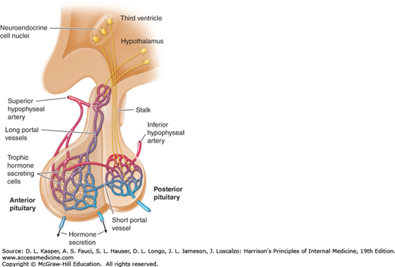

**Figure 1: Diagram of hypothalamic-pituitary vasculature**. **The hypothalamic nuclei produce hormones that traverse the portal system and impinge on anterior pituitary cells to regulate pituitary hormone secretion. Posterior pituitary hormones are derived from direct neural extensions.**

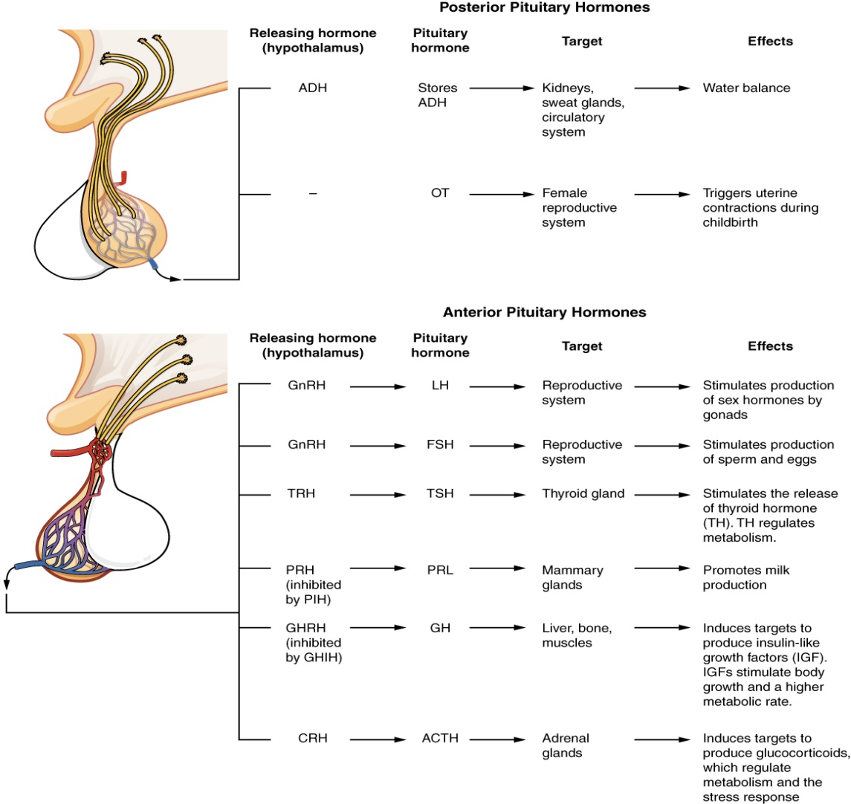

**Figure 2. Major pituitary hormones and their target organs.**

Hypothalamic neural cells synthesize specific releasing and inhibiting hormones that are secreted directly into the portal vessels of the pituitary stalk. Blood supply of the pituitary gland comes from the superior and inferior hypophyseal arteries. The hypothalamic-pituitary portal plexus provides the major blood source for the anterior pituitary, allowing reliable transmission of hypothalamic peptide pulses without significant systemic dilution; consequently, pituitary cells are exposed to releasing or inhibiting factors and in turn release their hormones as discrete pulses into the systemic circulation **(Figure 1& 2)**.

**ANTERIOR PITUITARY GLAND**

The anterior pituitary often is referred to as the “**master gland**” because, together with the **hypothalamus,** it orchestrates the complex regulatory functions of many other endocrine glands. The anterior pituitary gland produces six major hormones:

1. **PROLACTIN (PRL)**
2. **GROWTH HORMONE (GH)**
3. **ADRENOCORTICOTROPIC HORMONE (ACTH)**
4. **LUTEINIZING HORMONE (LH)**
5. **FOLLICLE-STIMULATING HORMONE (FSH)**
6. **THYROID-STIMULATING HORMONE (TSH)**

Pituitary hormones are secreted in a **pulsatile manner**, reflecting stimulation by an array of specific **hypothalamic releasing factors**. Each of these pituitary hormones elicits specific responses in peripheral target tissues. The hormonal products of those peripheral glands, in turn, exert feedback control at the level of the hypothalamus and pituitary to modulate pituitary function. Pituitary tumors cause characteristic hormone excess syndromes. Hormone deficiency may be inherited or acquired. Fortunately, there are efficacious treatments for many pituitary hormone excess and deficiency syndromes. Nonetheless, these diagnoses are often elusive; this emphasizes the importance of recognizing subtle clinical manifestations and performing the correct laboratory diagnostic tests **(Figure 3)**.

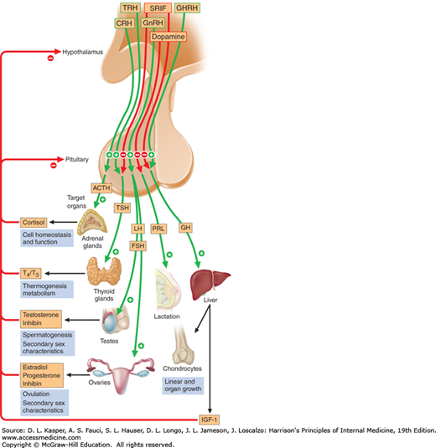

**Figure 3: Diagram of pituitary axes**. **Hypothalamic hormones regulate anterior pituitary trophic hormones that in turn determine target gland secretion. Peripheral hormones feed back to regulate hypothalamic and pituitary hormones.**

## GROWTH HORMONE

The endocrine system regulates the growth of the human body, protein synthesis, and cellular replication. A major hormone involved in this process is **growth hormone (GH)**, also called somatotropin—a protein hormone produced and secreted by the anterior pituitary gland. Its primary function is anabolic; it promotes protein synthesis and tissue building through direct and indirect mechanisms (**Figure 4**). GH levels are controlled by the release of **GHRH** and **GHIH** (also known as **Somatostatin**) from the hypothalamus.

A glucose-sparing effect occurs when GH stimulates lipolysis, or the breakdown of adipose tissue, releasing fatty acids into the blood. As a result, many tissues switch from glucose to fatty acids as their main energy source, which means that less glucose is taken up from the bloodstream.

GH also initiates the diabetogenic effect in which GH stimulates the liver to break down glycogen to glucose, which is then deposited into the blood. The name “**diabetogenic**” is derived from the similarity in elevated blood glucose levels observed between individuals with untreated diabetes mellitus and individuals experiencing GH excess. Blood glucose levels rise as the result of a combination of glucose-sparing and diabetogenic effects.

GH indirectly mediates growth and protein synthesis by triggering the liver and other tissues to produce a group of proteins called **insulin-like growth factors (IGFs)**. These proteins enhance cellular proliferation and inhibit apoptosis, or programmed cell death. IGFs stimulate cells to increase their uptake of amino acids from the blood for protein synthesis. Skeletal muscle and cartilage cells are particularly sensitive to stimulation from IGFs.

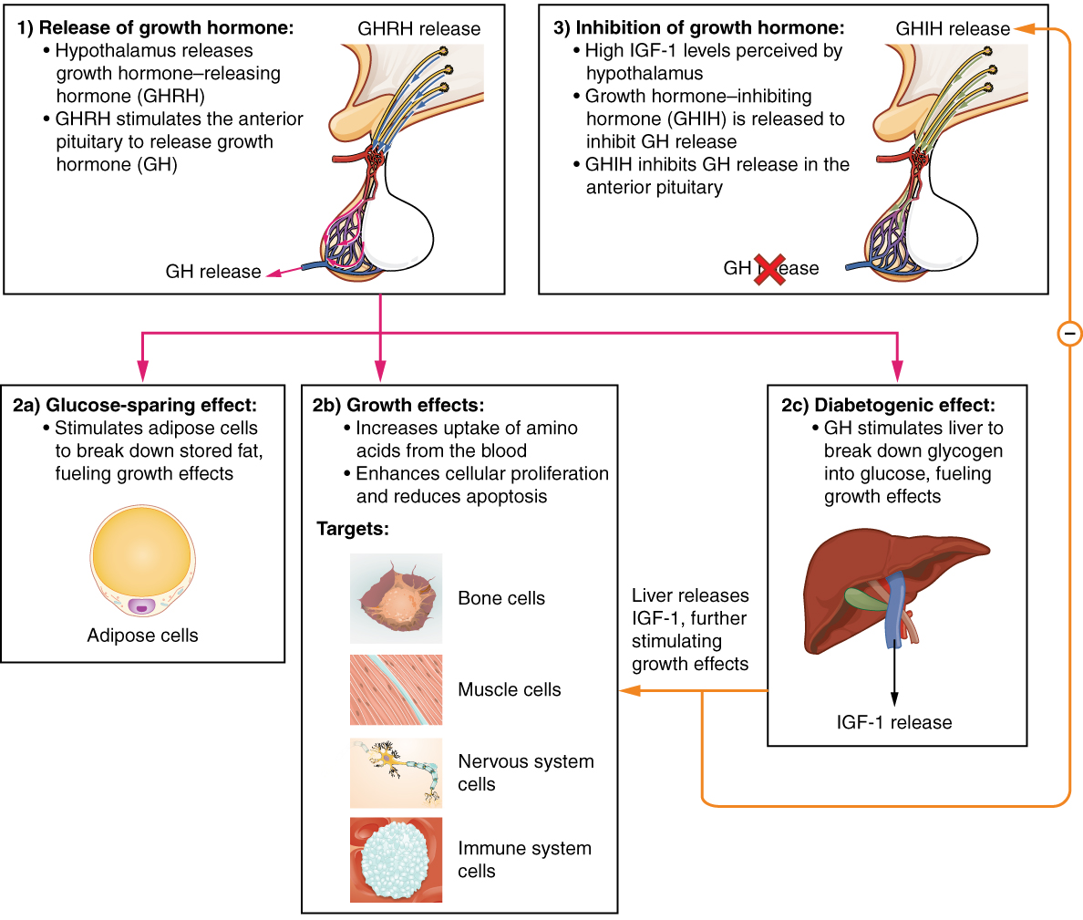

**Figure 4: Hormonal Regulation of Growth. Growth hormone (GH) directly accelerates the rate of protein synthesis in skeletal muscle and bones. Insulin-like growth factor 1 (IGF-1) is activated by growth hormone and indirectly supports the formation of new proteins in muscle cells and bone.**

Dysfunction of the endocrine system’s control of growth can result in several disorders. For example, **gigantism** is a disorder in children that is caused by the secretion of abnormally large amounts of GH, resulting in excessive growth. A similar condition in adults is **acromegaly**, a disorder that results in the growth of bones in the face, hands, and feet in response to excessive levels of GH in individuals who have stopped growing. Abnormally low levels of GH in children can cause growth impairment—a disorder called **pituitary dwarfism** (also known as growth hormone deficiency).

## THYROID-STIMULATING HORMONE

The activity of the thyroid gland is regulated by **thyroid-stimulating hormone (TSH)**, also called thyrotropin. TSH is released from the anterior pituitary in response to **thyrotropin-releasing hormone (TRH)** from the hypothalamus. As discussed shortly, it triggers the secretion of thyroid hormones by the thyroid gland. In a classic negative feedback loop, elevated levels of thyroid hormones in the bloodstream then trigger a drop in production of TRH and subsequently TSH.

## ADRENOCORTICOTROPIC HORMONE

The **adrenocorticotropic hormone (ACTH)**, also called **corticotropin,** stimulates the adrenal cortex (the more superficial “bark” of the adrenal glands) to secrete corticosteroid hormones such as cortisol. ACTH come from a precursor molecule known as **pro-opiomelanotropin (POMC)** which produces several biologically active molecules when cleaved, including **ACTH, melanocyte-stimulating hormone, and the brain opioid peptides known as endorphins.**

The release of ACTH is regulated by the **corticotropin-releasing hormone (CRH)** from the hypothalamus in response to normal physiologic rhythms. A variety of stressors can also influence its release.

## FOLLICLE-STIMULATING HORMONE AND LUTEINIZING HORMONE

The endocrine glands secrete a variety of hormones that control the development and regulation of the reproductive system (these glands include the anterior pituitary, the adrenal cortex, and the gonads—the testes in males and the ovaries in females). Much of the development of the reproductive system occurs during puberty and is marked by the development of sex-specific characteristics in both male and female adolescents. Puberty is initiated by **gonadotropin-releasing hormone (GnRH),** a hormone produced and secreted by the hypothalamus. GnRH stimulates the anterior pituitary to secrete **gonadotropins**—hormones that regulate the function of the gonads. The levels of GnRH are regulated through a negative feedback loop; high levels of reproductive hormones inhibit the release of GnRH. Throughout life, gonadotropins regulate reproductive function and, in the case of women, the onset and cessation of reproductive capacity.

The gonadotropins include two glycoprotein hormones: **follicle-stimulating hormone (FSH)** stimulates the production and maturation of sex cells, or gametes, including ova in women and sperm in men. FSH also promotes follicular growth; these follicles then release estrogens in the female ovaries. **Luteinizing hormone (LH)** triggers ovulation in women, as well as the production of estrogens and progesterone by the ovaries. LH stimulates production of testosterone by the male testes.

## PROLACTIN

As its name implies, **prolactin (PRL)** promotes lactation (milk production) in women. During pregnancy, it contributes to development of the mammary glands, and after birth, it stimulates the mammary glands to produce breast milk. However, the effects of prolactin depend heavily upon the permissive effects of estrogens, progesterone, and other hormones. And as noted earlier, the let-down of milk occurs in response to stimulation from oxytocin. In a non-pregnant woman, prolactin secretion is inhibited by prolactin-inhibiting hormone (PIH), which is actually the neurotransmitter dopamine, and is released from neurons in the hypothalamus. Only during pregnancy do prolactin levels rise in response to **prolactin-releasing hormone (PRH)** from the hypothalamus.

# POSTERIOR PITUITARY GLAND

The posterior pituitary is actually an extension of the neurons of the **paraventricular and supraoptic nuclei** of the hypothalamus. The cell bodies of these regions rest in the hypothalamus, but their axons descend as the hypothalamic–hypophyseal tract within the infundibulum, and end in axon terminals that comprise the posterior pituitary ([**Figure 5**](https://opentextbc.ca/anatomyandphysiology/chapter/17-3-the-pituitary-gland-and-hypothalamus/#fig-ch18_03_02)).

The posterior pituitary gland does not produce hormones, but rather stores and secretes hormones produced by the hypothalamus. The paraventricular nuclei produce the hormone **Oxytocin**, whereas the supraoptic nuclei produce **ADH**. These hormones travel along the axons into storage sites in the axon terminals of the posterior pituitary. In response to signals from the same hypothalamic neurons, the hormones are released from the axon terminals into the bloodstream.

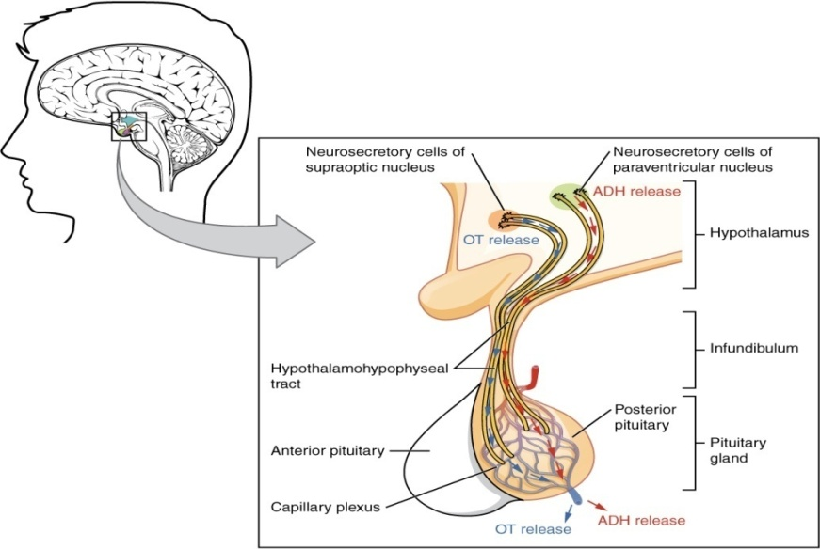

**Figure 5. Posterior Pituitary. Neurosecretory cells in the hypothalamus release oxytocin (OT) or ADH into the posterior lobe of the pituitary gland. These hormones are stored or released into the blood via the capillary plexus.**

## OXYTOCIN

When fetal development is complete, the peptide-derived hormone **oxytocin** (tocia- = “childbirth”) stimulates uterine contractions and dilation of the cervix. Throughout most of pregnancy, oxytocin hormone receptors are not expressed at high levels in the uterus. Toward the end of pregnancy, the synthesis of oxytocin receptors in the uterus increases, and the smooth muscle cells of the uterus become more sensitive to its effects. Oxytocin is continually released throughout childbirth through a positive feedback mechanism. Oxytocin prompts uterine contractions that push the fetal head toward the cervix. In response, cervical stretching stimulates additional oxytocin to be synthesized by the hypothalamus and released from the pituitary. This increases the intensity and effectiveness of uterine contractions and prompts additional dilation of the cervix. The feedback loop continues until birth.

Although the mother’s high blood levels of oxytocin begin to decrease immediately following birth, oxytocin continues to play a role in maternal and newborn health. First, oxytocin is necessary for the milk ejection reflex **(commonly referred to as “let-down”)** in breastfeeding women. As the newborn begins suckling, sensory receptors in the nipples transmit signals to the hypothalamus. In response, oxytocin is secreted and released into the bloodstream. Within seconds, cells in the mother’s milk ducts contract, ejecting milk into the infant’s mouth. Secondly, in both males and females, oxytocin is thought to contribute to parent–newborn bonding, known as attachment. Oxytocin is also thought to be involved in feelings of love and closeness, as well as in the sexual response.

## ANTIDIURETIC HORMONE (ADH)

The solute concentration of the blood, or blood osmolarity, may change in response to the consumption of certain foods and fluids, as well as in response to disease, injury, medications, or other factors. Blood osmolarity is constantly monitored by **osmoreceptors**—specialized cells within the hypothalamus that are particularly sensitive to the concentration of sodium ions and other solutes.

In response to high blood osmolarity, which can occur during dehydration or following a very salty meal, the osmoreceptors signal the posterior pituitary to release **antidiuretic hormone (ADH)**. The target cells of ADH are located in the tubular cells of the kidneys. Its effect is to increase epithelial permeability to water, allowing increased water reabsorption. The more water reabsorbed from the filtrate, the greater the amount of water that is returned to the blood and the less that is excreted in the urine. A greater concentration of water results in a reduced concentration of solutes. ADH is also known as **vasopressin** because, in very high concentrations, it causes constriction of blood vessels, which increases blood pressure by increasing peripheral resistance. The release of ADH is controlled by a negative feedback loop. As blood osmolarity decreases, the hypothalamic osmoreceptors sense the change and prompt a corresponding decrease in the secretion of ADH. As a result, less water is reabsorbed from the urine filtrate.

Interestingly, drugs can affect the secretion of ADH. For example, alcohol consumption inhibits the release of ADH, resulting in increased urine production that can eventually lead to dehydration and a hangover. A disease called **Diabetes Insipidus** is characterized by chronic underproduction of ADH that causes chronic dehydration. Because little ADH is produced and secreted, not enough water is reabsorbed by the kidneys. Although patients feel thirsty, and increase their fluid consumption, this doesn’t effectively decrease the solute concentration in their blood because ADH levels are not high enough to trigger water reabsorption in the kidneys. Electrolyte imbalances can occur in severe cases of diabetes insipidus.