E-CONTENT (BDU)
SENGAMALA THAYAAR EDUCATIONAL TRUST WOMEN’S COLLEGE
SUNDARAKKOTTAI, MANNARGUDI.
(Accredited with ‘A’ Grade by NAAC)

PG & RESEARCH DEPARTMENT OF ECONOMICS
Subject name; MANAGEMENT INFORMATION SYSTEM
Staff name; Dr. R.Malathi
Class : II M.A ECONOMICS
MANAGEMENT INFORMATION SYSTEMS Objective: To help the students understand the uses of Information Technology for Business.
Module I: Foundation Concepts Information system (IS) and technologies – Importance of IS – System concepts – Feedback and control – Components of an IS – IS resources: people, hardware, software, data, network – IS activities: processing, storage, control – Role of IS application – Trends in IS – Types of IS – Managerial challenges – Real world cases.
Module II: Competing with Information Technologies Strategic IT – Strategic links in the supply chain – Competitive strategy concepts – Strategic uses of IT – Value chain and strategic IS – Using IT for strategic advantage – improving business quality – Real world cases.
Module III: Information Technologies Managing data resources – Types of data bases :operational, distributed, external, hypermedia db – data warehouses – data mining – db management software – db interrogation – db maintenance – data resource management – challenges – db structures – hierarchical, network, relational, multidimensional, object oriented – Telecommunication and networks – Trends; industry, technology, business application – Internet applications – Business use of interest Real world cases.
Module IV: Business Applications Functional business systems – Target marketing – IT in business – Marketing systems: interactive marketing, targeted marketing – sales for automation – Manufacturing systems: integrated manufacturing, process control, machine control – Human Resource Systems: HRM and internet, HRM and corporate sector – staffing and training – Real world cases.
Module V: Management Challenges Security and ethical challenges – ethical responsibility of business professionals: business ethics technology ethics, ethical guidelines – computer crime: hacking, cyber theft, unauthorized use at work, software privacy, piracy of intellectual property, viruses and worms – privacy issues – Other challenges: employment, monitoring, working conditions – Health issues. 32 References:
1. James A.O’brien, 2006, Management Information Systems, Tata McGraw Hill Edition, New Delhi
2. Gerald V. Post & David L. Anderson, 1999, Management Information Systems, Tata McGraw Hill Edition, New Delhi
3. C.S.V. Murthy, 2000, Management Information Systems, Himalaya Publication, Mumbai 4. D.P. Goyal 2000, Management Information Systems, Macmillan Delhi

INTRODUCTION;
A management information system (MIS) is a computer system consisting of hardware and software that serves as the backbone of an organization's operations. An MIS gathers data from multiple online systems, analyzes the information, and reports data to aid in management decision-making.

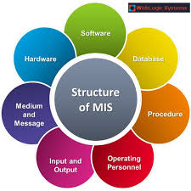

PREPARED BY
Dr. R.Malathi

What is MIS?
MIS is the use of information technology, people, and business processes to record, store and process data to produce information that decision makers can use to make day to day decisions. The full form of MIS is Management Information Systems. The purpose of MIS is to extract data from varied sources and derive insights that drive business growth.
The need for MIS
The following are some of the justifications for having an MIS system
- Decision makers need information to make effective decisions. Management Information Systems (MIS) make this possible.
- MIS systems facilitate communication within and outside the organization – employees within the organization are able to easily access the required information for the day to day operations. Facilitates such as Short Message Service (SMS) & Email make it possible to communicate with customers and suppliers from within the MIS system that an organization is using.
- Record keeping – management information systems record all business transactions of an organization and provide a reference point for the transactions.

Components of MIS
The major components of a typical MIS long-form (Management Information System) are:
- People – people who use the information system
- Data – the data that the information system records
- Business Procedures – procedures put in place on how to record, store and analyze data
- Hardware – these include servers, workstations, networking equipment, printers, etc.
- Software – these are programs used to handle the data. These include programs such as spreadsheet programs, database software, etc.

Types of Information Systems
The type of information system that a user uses depends on their level in an organization. The following diagram shows the three major levels of users in an organization and the type of information system that they use.
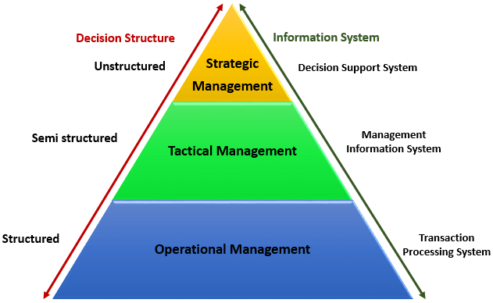
Transaction Processing Systems (TPS)
This type of information system is used to record the day to day transactions of a business. An example of a Transaction Processing System is a Point of Sale (POS) system. A POS system is used to record the daily sales.
Management Information Systems (MIS)
Management Information Systems abbreviated as MIS, are used to guide tactic managers to make semi-structured decisions. The output from the transaction processing system is used as input to the MIS system.
Decision Support Systems (DSS)
Decision support systems are used by top level managers to make semi-structured decisions. The output from the Management Information System is used as input to the decision support system.DSS systems also get data input from external sources such as current market forces, competition, etc.

Manual Information Systems VS Computerized Information Systems (MIS)
Data is the bloodstream of any business entity. Everyone in an organization needs information to make decisions. An information system is an organized way of recording, storing data, and retrieving information.
In this section, we will look at manual information systems vs. computerized information systems.
Manual Information System
A manual information system does not use any computerized devices. The recording, storing and retrieving of data is done manually by the people, who are responsible for the information system.
The following are the major components of a manual information system
- People –people are the recipients of information system
- Business Procedures –these are measures put in place that define the rules for processing data, storing it, analyzing it and producing information
- Data –these are the recorded day to day transactions
- Filing system – this is an organized way of storing information
- Reports –the reports are generated after manually analyzing the data from the filing system and compiling it.
The following diagram illustrates how a typical manual information system works
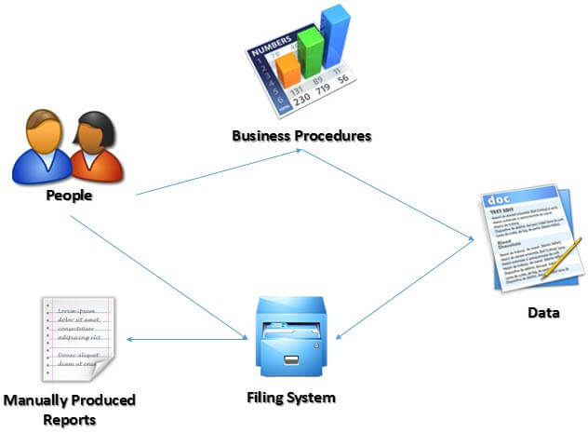

Advantages and Dis-advantages of a manual information system
Advantages:
The following are the advantages of manual information systems
- Cost effective – it is cheaper compared to a computerized system because there is no need to purchase expensive equipment such as servers, workstations, printers, etc.
- Flexible –evolving business requirements can easily be implemented into the business procedures and implemented immediately
Disadvantages:
- Time consuming –all data entries need to be verified before filing, this is a time consuming task when done by humans. Retrieving data from the filing system also takes a considerable amount of time
- Prone to error – the accuracy of the data when verified and validated by human beings is more prone to errors compared to verification and validation done by computerized systems.
- Lack of security – the security of manual systems is implemented by restricting access to the file room. Experience shows unauthorized people can easily gain access to the filing room
- Duplication of data –most departments in an organization need to have access to the same data. In a manual system, it is common to duplicate this data to make it easy to accessible to all authorized users. The challenge comes in when the same data needs to be updated
- Data inconsistency – due to the duplication of data, it is very common to update data in one file and not update the other files. This leads to data inconsistency
- Lack of backups – if the file get lost or mishandled, the chances of recovering the data are almost zero.
Computerized information system
Computerized systems were developed to address the challenges of manual information systems. The major difference between a manual and computerized information system is a computerized system uses a combination of software and hardware to record, store, analyze and retrieve information.

Advantages and Disadvantages of a computerized information system (MIS)
The following are some of the disadvantages of a computerized information system.
Advantages:
The following are the advantages of computerized information systems
- Fast data processing and information retrieval – this is one of the biggest advantages of a computerized information system. It processes data and retrieves information at a faster rate. This leads to improved client/customer service
- Improved data accuracy – easy to implement data validation and verification checks in a computerized system compared to a manual system.
- Improved security – in addition to restricting access to the database server, the computerized information system can implement other security controls such as user’s authentication, biometric authentication systems, access rights control, etc.
- Reduced data duplication – database systems are designed in such a way that minimized duplication of data. This means updating data in one department automatically makes it available to the other departments
- Improved backup systems – with modern day technology, backups can be stored in the cloud which makes it easy to recover the data if something happened to the hardware and software used to store the data
- Easy access to information – most business executives need to travel and still be able to make a decision based on the information. The web and Mobile technologies make accessing data from anywhere possible.
Disadvantages:
- It is expensive to set up and configure – the organization has to buy hardware and the required software to run the information system. In addition to that, business procedures will need to be revised, and the staff will need to be trained on how to use the computerized information system.
- Heavy reliance on technology – if something happens to the hardware or software that makes it stop functioning, then the information cannot be accessed until the required hardware or software has been replaced.
- Risk of fraud – if proper controls and checks are not in place, an intruder can post unauthorized transactions such as an invoice for goods that were never delivered, etc.
Summary
- MIS stands for Management Information System. It is a collection of people, procedures, data, and information technology that aids managers to make informed decisions.
- Computerized information systems are more efficient compared to manual information systems. Manual information systems are cheaper compared to computerized information systems.
- Transaction processing systems (TPS) are by operational staff to record day to day business transactions, and they are used to make structured decisions
- Management Information Systems (MIS) are used by middle-level managers to make semi-structured decisions
- Decision Support Systems are used by top level managers, and they help top level managers to make unstructured decisions.

What Is a Management Information System?
In business, management information systems (or information management systems) are tools used to support processes, operations, intelligence, and IT. MIS tools move data and manage information. They are the core of the information management discipline and are often considered the first systems of the information age.
MIS produce data-driven reports that help businesses make the right decisions at the right time. While MIS overlaps with other business disciplines, there are some differences:
- Enterprise Resource Planning (ERP): This discipline ensures that all departmental systems are integrated. MIS uses those connected systems to access data to create reports.
- IT Management: This department oversees the installation and maintenance of hardware and software that are parts of the MIS. The distinction between the two has always been fuzzy.
- E-commerce: E-commerce activity provides data that the MIS uses. In turn, the MIS reports based on this data affect e-commerce processes.
The concept includes what computers can do in this field, how people process information, and how best to make it accessible and up-to-date. Cummings adds, “The ‘right information in the right place at the right time’ is what we are striving for. This discipline is much more eclectic than straight computer science.”
Besides computer science, there are fields of study that overlap with MIS, both at the theoretical and practical levels:
- Information Systems (IS): In IS, there is a greater emphasis on tools, while MIS places more emphasis on business processes and operations.
- Information Technology (IT): IT is similar to IS, but it focuses solely on computers.
- Informatics: A discipline that combines software engineering, information systems development, and networking.
- Electrical Engineering and Computer Engineering: These fields focus on the development and improvement of hardware and software, respectively. MIS helps determine the practical and theoretical implications of these changes.

Types of MIS Reports
At their core, management information systems exist to store data and create reports that business pros can use to analyze and make decisions. There are three basic kinds of reports:
- Scheduled: Created on a regular basis, these reports use rules the requestor has provided to pull and organize the data. Scheduled reports allow businesses to analyze data over time (e.g. an airline can see the percentage of lost luggage by month), location (e.g. a retail chain can compare sales figures from different stores), or other parameters.
- Ad-hoc: These are one-off reports that a user creates to answer a question. If the reports are useful, you can turn ad-hoc reports into scheduled reports.
- Real-time: This type of MIS report allows someone to monitor changes as they occur. For example, a call center manager may see an unexpected spike in call volume, and find a way to increase productivity or send some of the calls elsewhere.

Definition of Management Information System :
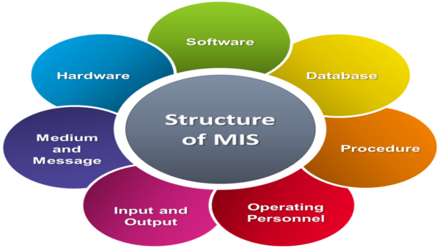

Management Information System, often referred to simply as MIS , is a planned system of collecting , storing , and disseminating data in the form of information needed to carry out the functions of management .
As you notice , it’s composed from three terms : Management , Information and System .
- Management :
Management covers the planning, control, and administration of the operations of a concern.
- Information :
Information means the processed data that helps the management in planning, controlling and operations.
- System :
A system is made up of inputs, processing, output and feedback or control .
Thus Management Information System means a system for processing data in order to give proper information to the management for performing its functions .

Objectives of Management Information System :
The main goals of an MIS are to help executives of an organization make decisions that advance the organization’s strategy and to implement the organizational structure and dynamics of the enterprise for the purpose of managing the organization in a better way for a competitive advantage .
These are some goals of an MIS :
- Capturing Data .
- Processing Data .
- Information Storage .
- Information Retrieval .
- Information Propagation .

Characteristics of Management Information System :
The most important characteristics of an MIS are those that give decision-makers confidence that their actions will have the desired consequences , and among this characteristics we can mention :
- It should be based on a long-term planning .
- It should provide a holistic view of the dynamics and the structure of the organization .
- It should be planned in a top-down way .
- It should be based on need of strategic, operational and tactical information of managers of an entreprise .
- It should be able to make forecasts and estimates, and generate advanced information .
- It should create linkage between all sub-systems within the organization .
- It should have a central database .
Nowadays , with the advanced technology presents in the world , to be a successful manager , you should have a very powerful and effective MIS that presents all the most relevant and useful information for a particular decision.
batch processing
A method of updating a database in which data are collected over some time period and processed together.
data mart
Special subset of a data warehouse that deals with a single area of data and is organized for quick analysis.
data warehouse
An information technology that combines many databases across a whole company into one central database that supports management decision-making.
decision support system (DSS)
A management support system that helps managers make decisions using interactive computer models that describe real-world processes.
executive information system (EIS)

A management support system that is customized for an individual executive; provides specific information for strategic decisions.
expert system
A management support system that gives managers advice similar to what they would get from a human consultant; it uses artificial intelligence to enable computers to reason and learn to solve problems in much the same way humans do.
management support system (MSS)
An information system that uses the internal master database to perform high-level analyses that help managers make better decisions.
online (real-time) processing
A method of updating a database in which data are processed as they become available.
transaction processing system (TPS)
An information system that handles the daily business operations of a firm. The system receives and organizes raw data from internal and external sources for storage in a database using either batch or online processing.
CONCLUSION;
A management information system consists of a transaction processing system, management support systems, and an office automation system. The transaction processing system collects and organizes operational data on the firm’s activities. Management support systems help managers make better decisions. They include an information-reporting system that provides information based on the data collected by the TPS to the managers who need it; decision support systems that use models to assist in answering “what if” types of questions; and expert systems that give managers advice similar to what they would get from a human consultant. Executive information systems are customized to the needs of top management.

