Sengamala Thayaar Educational Trust Women’s College

(Affiliated to Bharathidasan University)
(Accredited with ‘A’ Grade {3.45/4.00} By NAAC) (An ISO 9001: 2015 Certified Institution)
Sundarakkottai, Mannargudi-614 016.
Thiruvarur (Dt.), Tamil Nadu, India.

FOOD MICROBIOLOGY AND SANITATION

DR.S.VISHNUPRIYA

ASSISTANT PROFESSOR
DEPARTMENT OF NUTRITION AND DIETETICS

I M.Sc FOOD SERVICE MANAGEMENT AND DIETETICS

FOOD MICROBIOLOGY AND SANITATION

Beneficial Role of Microorganisms in Food Industry
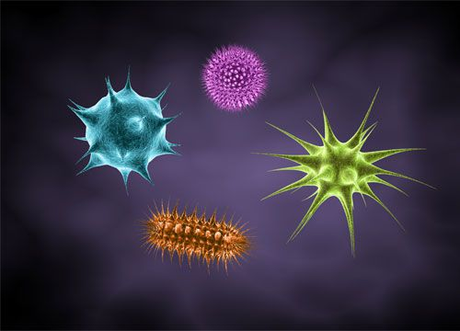Microorganisms
Microorganisms play an important role in food industry. As already discussed in the earlier article Contributions of Microbiology in Food Industry, they are used in production of various food products, and are also responsible for food spoilage thereby causing intoxication and diseases.
Microbial contamination of food products takes places usually on the way from the field to the processing plant, or during processing, storage, transport and distribution or before consumption. The microorganisms that cause food spoilage and also find the maximum exploitation in production of food and food products are mainly bacteria, molds and yeasts.
Bacteria
Bacteria are the largest group of unicellular microorganisms. The shapes of medically important bacteria are classified into-cocci, or spherical cells; bacilli, or cylindrical or rod shaped cells; and spiral or curved forms. The pathogenic or disease causing bacteria are usually gram negative, however, three gram-positive rods are known to cause food intoxications : Clostridium botulinum,C. perfringens,and Bacillus cereus
Some of the other most common bacteria causing food spoilage, infections and disease are Acinetobacter, Aeromonas, Escherichia, Proteus, Alcaligenes, Flavobacterium, Pseudomonas, Arcobacter, Salmonella, Lactococcus, Serratia, Campylobacter, Shigella, Citrobacter, Listeria, Staphylococcus, Micrococcus, Corynebacterium, Vibrio Enterobacter, Paenibacillus, Weissella, Enterococcus, Yersinia
Different strains of bacteria are also used in production of various food and dairy products. Strains of Streptococcus, Lactobacillus Bifidobacterium, Erwiniaetc. are used in the production of fermented food and dairy products. Streptococcus thermophilus and Lactobacillusbulgaricus are used to produce yogurt.
Molds:
Molds are multicellular filamentous fungi whose growth on foods is usually readily recognized by their fuzzy or cottony appearance. They are mainly responsible for food spoilage at room temperature 25- 30oC and low pH, and have minimum moisture requirement. Molds can rapidly grow on grains and corns when these products are stored under moist conditions. Molds require free oxygen for growth and hence grow on the surface of contaminated food.
Molds also find their use in manufacturing of different foods and food products. They are used in ripening of various types of food products as cheese (e.g. Roquefort,Camembert). Molds are also grown as feed and food and are employed to produce ingredients such as enzymes like amylase used in making bread or citric acid used in soft drinks. Molds are major contributors in the ripening of many oriental foods. A species of Bothrytiscinerea, is used in rotting of grape for production of wine. Lactic fermentations using molds results in a unique Finnish fermented milk called viili.
Yeasts:
Yeasts have the ability to ferment sugars to ethanol and carbon-dioxide and hence they are extensively in food industry. The most commonly used yeast, the baker’s yeast is grown industrially. Saccharomyces carlsbergensis is most commonly used in fermentation of most beers. The other yeast strains of importance are
Brettanomyces, Schizosaccharomyce,, Candida, Cryptococcus, Debaryomyces, Zygosaccharomyces, Hanseniaspora, Saccharomyces
Points to remember
- Bacteria, molds and yeast are the most important microorganisms that cause food spoilage and also find the maximum exploitation in production of food and food products.
- Different strains of bacteria and fungus are used for fermentation of dairy products for production of a wide variety of cultured milk products. Both bacteria and fungi are used in these cheese production processes.
- Lactic acid bacteria are used for coagulation of milk that can be processed to yield a wide variety of cheeses, including soft unripened, soft ripened, semisoft, hard, and very hard types.
- Microorganisms such as Lactobacillus and Bifidobacterium are used as in food and health industry.
- Spirulina, a cyanobacterium, also is a popular food source sold in specialty stores.
- Molds are used for rotting of grapes for production of different varieties of wines.
- Mushrooms (Agaricusbisporus) are one of the most important fungi used as a food source.
- Alcoholic beverages as beer are produced by fermentation of cereals and grains using different strains of yeasts.

