SENGAMALA THAYAAR EDUCATIONAL TRUST WOMEN'S COLLEGE,
(Affiliated to Bharathidasan University, Tiruchirappalli)
(Accredited with ‘A’ Grade {CGPA:3.45/4.00} by NAAC)
(An ISO 9001: 2015 Certified Institution)
(Accredited with ‘A’ Grade by NAAC)
Sundarakkottai , Mannargudi - 614 016.

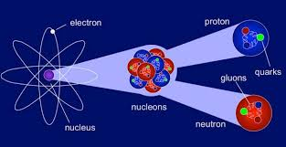

Class : II M.Sc., Physics
Subject: Nuclear and Particle Physics
Subject Code: P16PY41

BY,
Mrs. R.RADHA
ASSISTANT PROFESSOR,
DEPARTMENT OF PHYSICS

CORE COURSE IX
NUCLEAR AND PARTICLE PHYSICS

Unit I Nuclear Properties
Nuclear energy levels - Nuclear angular momentum, parity, isospin – Nuclear magnetic dipole moment – Nuclear electric quadropole moment - Ground state of deuteron – Magnetic dipole moment of deuteron – Proton-neutron scattering at low energies – Scattering length, phase shift – Nature and properties of nuclear forces – Spin dependence – Charge symmetry – Charge independence – Repulsion at short distances – Exchange forces – Meson theory.
Nuclear Energy levels:
Similar to the discrete energy states of the electrons in an atom, the nucleons comprising a nucleus have possible energy states given by Heisenberg principle.
(MeV) I Parity
1.46 2+
1.34 3+
1.18 0+
0.80 2+
0 0+
Level scheme of Pb-206
$H_{n }φ_{n}$ = $E_{n }φ_{n}$
Here Schrodinger wave function $φ_{n}$ depends upon spatial coordinates and also spin and isospin quantum numbers. The ground state possesses latent energy, in the form of potential energy which is normalized to zero. Excitation energies of the higher levels are referred to the zero energy of the ground level. $γ$-rays of discrete values are emitted by the de-excitation of the nucleus to its ground state. The energy level diagram represents excitation energy, nuclear spin I, parity$π$, lifetime $τ$and isospin T.
Nuclear angular momentum:
In 1924, W. Pauli, while explaining hyperfine structure of spectral lines, suggesting that certain atomic nuclei may possess an intrinsic angular momentum as well as a magnetic moment. The nuclear angular momentum can be deduced from the measurement of multiplicity and relative spacing of the spectral lines.
It has been found that the neutron and the proton possess an intrinsic angular momentum, commonly referred to as its spin, of magnitude ½ ℏ just as an electron does. Since nuclei are built up of neurons and protons, each possesses an angular momentum, which consists of both orbital angular momentum due to the motion about the centre of the nucleus and intrinsic spin angular momentum of ½ ℏ per nucleon. The total angular momentum of a particular nuclear state is the resultant of the individual momenta of the constituent nucleons. Corresponding to the total angular momentum quantum number is ℏ${[I\left(I+1\right)]}^{1/2}$. The value of I depends on the type of interaction between the nucleons.
LS- Coupling – In this case the spin orbit interaction is negligible and there is a collective interaction of orbital and intrinsic momenta, i.e.
I=L+S, where L=$\sum_{i}{l_{i}}$ and S=$\sum_{i}{s_{i}}$
For L= 0, 1, 2, 3…., we have levels S, P, D, F…, for each value of L there are (2S+1) possible separated energy levels. The multiplicity (2S+1) is written as a superscript before the letter representing L and the value of I as subscript. Hence for L=1 and S=1/2, we have levels $P_{1/2}^{2}$ and${ P}_{1/2}^{2}$, the spin doublet.
j-j Coupling—in this case the orbital and spin momenta of each individual nucleon are strongly coupled. I is the vector sum of the individual j values. Hence
I=$\sum_{i}{j}$ where $j_{i=}l_{i}$+$s_{i}$
This type of coupling is called strong spin-orbit coupling. If s-nucleon (l=0, j=1/2) couples with p-nucleon (l=1, j=3/2, ½), we have I=0, 1, 1 or 2.
These two coupling schemes are the extreme forms. One can employ intermediate coupling schemes of varying degrees of complexity. The total angular momentum of a nucleus is usually called as nuclear spin. It is an unfortunate terminology for the angular momentum, because spin is generally used for intrinsic angular momentum of elementary particles. Experimentally it is found that all nuclei have relatively low spin in their ground states. The spins of the excited states may differ from the spin of the ground state by integral multiplies of ℏ. The term “spin of the nucleus”, without any specification, always refers to the ground state. It has been found that all even-even nuclei have a spin I=0 in the ground state. Odd-odd nuclei all have integral nuclear spin, other than zero. All odd-even nuclei have half integral nuclear spins lying between ℏ/2 and 9ℏ/2.
The total angular momentum vector I can be oriented in space with respect to a given axis in (2I+1) directions. The component along the axis in any of the states has the magnitude mℏ, where m is the magnetic quantum number, having values from I to –I, as I, (I-1), (I-2)…, - (I-2), - (I-1), -I. thus the largest value of m is I.

Parity:
Parity is a property of the wave function describing a quantum mechanical system and is of great importance in atomic and nuclear physics. Non-quantum theories are always invariant under reflection of coordinates. Invariance under reflection requires that all terms of equation must have the same behavior under reflection. The reflection symmetry principle is equivalent to the statement that the parity of a closed system cannot change. This symmetry property is called the parity and is said to be even (or +) for even functions and odd (or -) for odd functions.
$φ\left(x, y, z, s\right)=φ\left(-x, -y, -z, s\right)$ Even or + parity
$φ\left(x, y, z, s\right)=-φ\left(-x, -y, -z, s\right)$ Odd or – parity
Here the sigh of s remains unchanged under space inversion r to -r. The interchange of the vectors r and –r is equivalent to replacing the spherical coordinates r, $θ$and $∅$by r, $π-θ$ and$π+θ$. As the wave function describing many particles can be written as a product of the particles of the individual particles. Parity is also conserved in nuclear processes as the conservation of charge and of angular momentum. However, since the publication of Lee and Yang experiment, several experiments have demonstrated that parity is not conserved in certain processes, especially in weak interactions. The parity of a nuclear state is often indicated by a superscript + or – on the angular momentum I.
Wave function symmetries depend upon the values of the orbital angular momentum quantum number l. It can be shown that the spatial part of $φ$ does not change sign on reflection of the particle, if l is even and it does not change sign if l is odd. Hence the parity of a motion with an even value of l is even, or +, while odd value of l gives odd, or -, parity. The parity of the particle is the product of the parity of the angular momentum state and intrinsic parity of the particle. From the properties of simple systems it has been found experimentally that the intrinsic parity of the proton, neutron, neutrino, and muon is also even. In contrast, the π meson is found to have odd intrinsic parity. Photon is found to have either value depending upon mode of generation. The parity of photon will depend upon the value of l and also upon whether its origin was electric or magnetic.
E parity=${(-1)}^{l}$ and M parity =$-{(-1)}^{l}$
Isospin:
Neutrons and protons are similar in all aspects except charge. On this basis, Heisenberg suggested these particles as just different manifestations of the same inherent particles, the nucleon. To describe their quantum state, quantum number used was termed the isotopic spin quantum number by Wigner. It is because of the similarity to the spin quantum number s and$m_{s}$, although it is not strictly an angular momentum as spin is. As the neutron and proton have similar masses, hence it was renamed isobaric spin. Now a day it is generally named as isospin or T-spin.
Isospin quantum number is a useful and an important quantum number that is conserved in nuclear transformations. As the states with spin s have multiplicity (2S+1), for s=1/2 we have a doublet ($m_{s}$ = -1/2, +1/2) and for s=1 we have a triplet ($m_{s}=-1, 0, +1)$. In an analogous manner, a nucleon is assigned an isospin of ½ and in an electromagnetic field two charges states with isospin components of 1/2 and -1/2 can be distinguished as the proton and neutron respectively. The isospin is a vector in a three dimensional space, called isospin space, which has no relation to physical space. The component that is measured is said to be${ T}_{3}$, the component of T in the direction of the third axis in isospin space.
Nuclear magnetic dipole moment:
Any charged particle moving in a closed path produces a magnetic field, which at large distances acts as due to magnetic dipole located at the current loop. The protons inside the nucleus are in orbital motion and therefore produce electric currents which produce extra motion nuclear magnetic fields. Each nucleon possesses an intrinsic magnetic moment which is parallel to its spin and is probably caused by the spinning of the nucleon. A spinning positive charge introduces magnetic field whose N-pole direction is parallel to the direction of spin. The magnetic moment is defined as + ve in this case.
If a particle having a charge q and mass m circulates about a force centre with a frequency υ, the equivalent current i = qv. From Kepler’s law of areas area swept dA in time dt by the particle is related with its angular momentum I as
$\frac{dA}{dt}$=$\frac{1}{2}$ I/m= constant
On integration over one period T,
A= ½T I/m
Hence magnetic moment of a ring of current around an area of magnitude A is given by
$μ_{l =}μ_{0}$ iA=$μ_{0}$ (qv)($\frac{1 Tl}{2 m}$) = $\frac{q}{2m} μ_{0}l$
Thus $μ_{l}$ and l are proportional. This relation is also valid in quantum mechanics. However since the particles (electron, proton, and neutron) possess a spin in addition to orbital angular momentum, experimentally it is found that spin is also the source of a magnetic moment. Using q=e and a dimensionless correction factor$g_{s}$, we can write the above equation as
$$μ_{s}=g_{s} \left(\frac{μ_{0}e}{2m}\right)s$$
The factor $g_{s}$ is different for the electron, proton and neutron. Similarly, we introduce a factor $g_{l}$ and have
$$μ_{l}=g_{l} \left(\frac{μ_{0}e}{2m}\right)l$$
The total magnetic dipole moment $μ$ is given as:
$$μ= μ_{s}+μ_{l}= \left(\frac{μ_{0}e}{2m}\right) [g_{s}s+g_{l }l]$$
For the nucleus of mass number A, magnetic dipole moment.
Ground State of Deuteron:
Deuteron is the simplest of two nucleon – bound system. It consists of one proton and one neutron. Therefore deuteron is two body problem .To solve the problem we assume.
- Deuteron is a system of two particles –neutron and proton , of nearly equal masses (each of mass m say) .i.e ., m₁ ₌ m₂ = M
The reduced mass of system
$μ= \frac{m1m2}{m1+ m2}$ = $\frac{MM}{M+M}$ =$\frac{ M}{2}$
- The force between two particles is central and spherically symmetric i.e., it depends on distance between two particles and acts along their line-joining. It is depends on orientation. However this assumption appears to be incorrect because it cannot account for the Quadruple moment of deuteron; but it is taken for the sake of simplicity. Under central force – field the potential energy is expressed as V = V(r).
- The potential function V(r) is independent of time and is square well potential.
The time –independent Schrodinger –equation in Centre of mass system is written as
$∇^{2}Ψ+\frac{2μ}{ℏ^{2}}${E-V(r)}$Ψ=0$
$where μ$ $is the reduced mass$ $μ= \frac{ M}{2}$ , E is the total energy of system.
$$In spherical polar coordinates$$
$∇^{2}Ψ= \frac{1}{r^{2}}\frac{∂}{∂r} \left(r^{2}\frac{∂ψ}{∂r}\right)+\frac{1}{r^{2}\sin{θ}}\frac{∂}{∂θ}\left({\sin{θ}}^{2}\frac{∂ψ}{∂θ}\right)+\frac{1}{r^{2}{\sin{θ}}^{2}}\frac{∂^{2}ψ}{∂ϕ^{2}}$ ……. (1)
Schrodinger equation (1) may be expressed as
$\frac{1}{r^{2}}\frac{∂}{∂r} \left(r^{2}\frac{∂ψ}{∂r}\right)+\frac{1}{r^{2}\sin{θ}}\frac{∂}{∂θ}\left({\sin{θ}}^{2}\frac{∂ψ}{∂θ}\right)+\frac{1}{r^{2}{\sin{θ}}^{2}}\frac{∂^{2}ψ}{∂ϕ^{2}}+\frac{2μ}{ℏ^{2}}${E-V(r)}$Ψ=0$ … (2)
Under the central force assumption, the wave-function $Ψ$may be expressed as
$Ψ=(\frac{μl}{r}$ )Y_{lm} ($θ, ϕ$) ……….. (3)
Where $\frac{μl}{r}$ is the radial function and Y_{lm} ($θ, ϕ$) is spherical harmonic function from (3)

$\frac{∂ϕ}{∂r}=\left[\frac{1}{r}\frac{∂μl}{∂r} - \frac{1}{r^{2}} μl \right]$ Y_{lm} ($θ, ϕ$)
Substituting values of $Ψ ,$ $\frac{∂ψ}{∂r} , \frac{∂ψ}{∂θ} and$ $\frac{∂^{2}ψ}{∂ϕ^{2}}$in equation (2), we get
$\frac{1}{r^{2}}\frac{∂}{∂r}$ $\left\{(\right.\frac{1}{r}\frac{∂μl}{∂r}- μl$ Y_{lm} ($θ, ϕ$))} + $\frac{1}{r^{2}\sin{θ}}$ $\frac{∂}{∂θ}$ { $\sin{θ} (\frac{μl}{r} )$ $\frac{∂Ylm (θ, ϕ) }{∂θ}$ } + $\frac{1}{r^{2}{\sin{θ}}^{2}} \{ \frac{μl}{r}$ $\frac{∂^{2}Ylm (θ, ϕ)}{∂ϕ^{2}}$ }
+ $\frac{2μ}{ℏ^{2}} \{E-V\left(r\right)(\frac{μl}{r} )$ Y_{lm} ($θ, ϕ$) = 0
Dividing by $\frac{μl Ylm (θ, ϕ)}{r^{2}}$ we get
$\frac{r}{μl}$ $\frac{∂}{∂r} \left( r \frac{∂μl}{∂r}- μl \right)$ + $\frac{1}{Ylm \left(θ, ϕ\right)}$ $\frac{∂}{∂θ} \{ \sin{θ} \frac{∂Ylm \left(θ, ϕ\right)}{∂θ}$ } + $\frac{1}{Ylm \left(θ, ϕ\right){\sin{θ}}^{2}}$ $\frac{∂^{2}Ylm }{∂ϕ^{2}}$ + $r^{2}$ $\frac{2μ}{ℏ^{2}} \left\{E-V\left(r\right)\right\}=0$
$\frac{r^{2}}{μl}$ $\frac{∂^{2}μl}{∂r^{2}}$ + $\frac{2μ{ r}^{2}}{ℏ^{2}} \left\{E-V\left(r\right)\right\}$ = - [$\frac{1}{Ylm \left(θ, ϕ\right)}$ $\frac{∂}{∂θ} \{ \sin{θ} \frac{∂Ylm \left(θ, ϕ\right)}{∂θ}$ } + $\frac{1}{Ylm \left(θ, ϕ\right){\sin{θ}}^{2}}$ $\frac{∂^{2}Ylm }{∂ϕ^{2}}$ ] = 0 ……. (3)
In this equation L.H.S is a function of r only; while R.H.S is a function of $θ and ϕ$ only, i.e. this equation is satisfied only if each side is equal to same constant l (l + 1).
$\frac{r^{2}}{μl}$ $\frac{∂^{2}μl}{∂r^{2}}$ + $\frac{2μ{ r}^{2}}{ℏ^{2}} \left\{E-V\left(r\right)\right\}$ = l (l + 1) ………. (4)
And - [$\frac{1}{Ylm \left(θ, ϕ\right)}$ $\frac{∂}{∂θ} \{ \sin{θ} \frac{∂Ylm \left(θ, ϕ\right)}{∂θ}$ } + $\frac{1}{{\sin{θ}}^{2}}$ $\frac{∂^{2}Ylm }{∂ϕ^{2}}$ ] = l (l + 1) ……… (5)
$\frac{∂^{2}μl}{∂r^{2}}$ + $\frac{2μ}{ℏ^{2}} [E-V\left(r\right)- \frac{l (l + 1)ℏ^{2}}{r^{2}}$ ] u_{l} = 0 ……….. (6)
And $\frac{∂}{∂θ}\{ \sin{θ} \frac{∂Ylm \left(θ, ϕ\right)}{∂θ}$ } + $\frac{1}{{\sin{θ}}^{2}}$ $\frac{∂^{2}Ylm }{∂ϕ^{2}}$ ] - l (l + 1) Y_{lm} ($θ, ϕ$) = 0 …………… (7)
The last term $\frac{l (l + 1)}{r^{2}}$ = $ℏ^{2}$appears to a straight in actual potential V (r) and is known as Centrifugal potential , because its derivative with respect to r is equal to classical centrifugal force when angular momentum √ l (l + 1) $ℏ$. The potential function providing the simple solution of Schrodinger’s equation is square well and expressed as V = - V₀ for r ≤ r₀
0 for r > r₀
The Schrodinger equation for I and II regions in l = 0 state may be expressed as
$\frac{d^{2}μ(r)}{dr^{2}}$ + $\frac{2μ}{ℏ^{2}} ($V₀ – E_{B} ) u(r) = 0 r ≤ r₀
$\frac{d^{2}μ(r)}{dr^{2}}$ - $\frac{2μ}{ℏ^{2}}$E_{B} u(r) = 0 r > r₀
Where u_{l} = u (r); dropping the suffix ‘l’
And E = - E_{B} = - 2.225 MeV
Where E_{B} is the binding energy of deuteron.
Substituting √ 2μ ( V₀ - E_{B} ) = k₁ …….. (8b)
And √ $\frac{2μ EB}{ℏ}$ = k₂ …….. (9b)

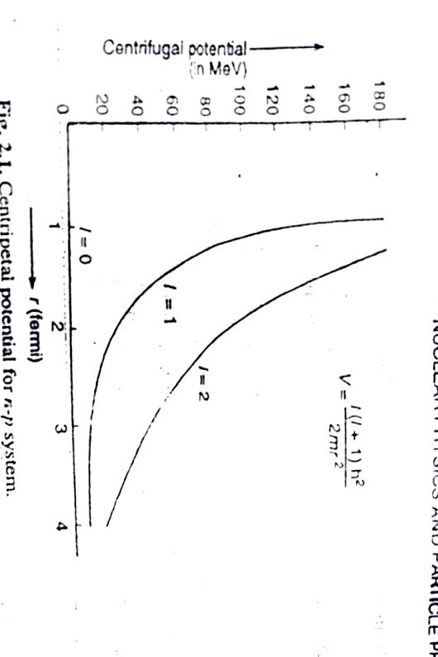
Equations (8a) and (9a) take the form
$\frac{d^{2}μ(r)}{dr^{2}}$ + k₁ u(r) = 0 ; r ≤ r₀ ……. (10)
$\frac{d^{2}μ(r)}{dr^{2}}$ – k₂ u(r) = 0 ; r >r₀ …….. (11)
The general solutions of equations (10) and (11) may be expressed as
u _{I} (r) = A sin k₁r + B cos k₁r ……….. (12)
u_{II} (r) = C $e^{k2 r}$ + D$e^{- k2 r}$ ……… (13)
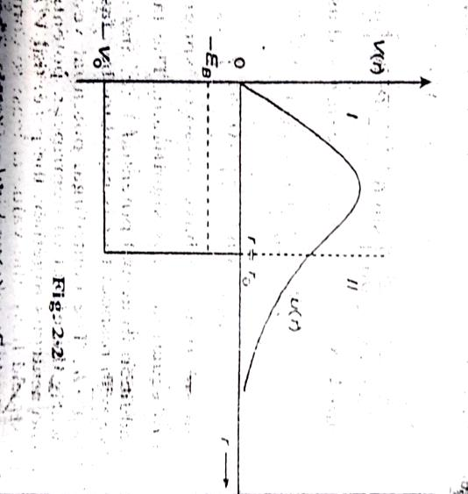
The usual conditions satisfied by wave functions ψ (r) are that ψ (r) = finite at r = 0.The condition
ψ (r ) = 0 requires that u (r ) = r , ψ vanishes at r = 0 and is equal to integral. In view of this equation
u₁ (r ) = 0 at r = 0 implies that B =0. Equation (12) takes form
u _{I} (r) = A sin k₁r .The condition ψ (r ) = 0 at r = ∞ requires that C = 0; so that u_{II} (r ) remains finite, then equation (13) takes the form u_{II} (r) = D$e^{- k2 r}$.
The boundary conditions that u_{I} and u_{II} and their first derivative s with respect to r,
Ψ_{I} = Ψ_{II} = u _{I} = u_{II} at r = r₀ ………. (i)
$\frac{dΨI}{dr}$ = $\frac{dΨII}{dr}$ = $\frac{duI}{dr}$ = $\frac{duII}{dr}$ at r = r₀ ………. (ii)
Condition (i) gives
A sin k₁r₀ = D$e^{- k2 r0}$ ……… (16)
A k₁ cos k₁r₀ = - k₂ D$e^{- k2 r0}$ ……… (17)
Dividing (17) by (16), we get
k₁ cot k₁r₀ = - k₂ ……… (18)
Equation (18) gives implicit relation between binding energy E_{B} of two nucleon system to range of potential r₀ and the depth V₀ . The binding energy E_{B} = 2.225MeV.
Range r₀ fermi ( = 10⁻¹⁵m) | Depth of Potential V₀ MeV
1.0  1.5  2.0  2.5  ∞ | 120  59  36  25  2.83

A number of experiments suggest that the range of nuclear force is 1 fermi = 10⁻¹⁵m.Taking appropriate value of range r₀ = 2 х 10⁻¹⁵m, we get the value of potential depth V₀ = 36 MeV.
Substituting values of k₁ and k₂ in equation (18), we get
Cot k₁ r₀ = - $\frac{k2}{k1}= - √\frac{EB }{V0 - EB }$ ………. (19)

MAGNETIC MOMENT OF DEUTERON: S AND D – STATE PROBABILITIES
The ground state of deuteron is primarily a ³S₁ state with a small admixture of ³D₁; so its wave – function may be expressed as
Ψ = Ψ_{S} + Ψ_{D} ……. (1)
Where Ψ_{S} and Ψ_{D} are S and D- state wave – functions.
If wave – function Ψ is normalized to unity, then we have
$\int{Ψ}$* Ψ dτ =$∫$ (Ψ_{S} + Ψ_{D})* (Ψ_{S} + Ψ_{D}) dτ
$\int{Ψ}$* Ψ dτ = $∫$Ψ_{S}* Ψ_{S} dτ + $∫$Ψ_{D}* Ψ_{D} dτ + $∫$Ψ_{S}* Ψ_{D} dτ +$∫$ Ψ_{D}* Ψ_{S} dτ
The last two terms vanish due to orthogonal properties of Ψ_{S} and Ψ_{D}
$∫$Ψ_{S}* Ψ_{D} dτ = $∫$ Ψ_{D}* Ψ_{S} dτ = 0
$\int{Ψ}$* Ψ dτ = $∫$Ψ_{S}* Ψ_{S} dτ + $∫$Ψ_{D}* Ψ_{D} dτ ……. (2)
The function Ψ_{S} and Ψ_{D} are given by
Ψ_{S} = $\frac{u (r)}{r}$ ¹Y₁₀ and Ψ_{D} = $\frac{V (r)}{r}$ ¹Y₁₂ …….. (3)
Where$u (r$) and$V (r$) are function satisfying radial equation and Y represents spherical Legendre polynomial.
Substituting (3) in (2) and remembering that the integration of angles and spin is equal to unity, we get
$\int{Ψ}$* Ψ dτ = $∫$| u|² dr + $∫$| v|² dr = 1 = P_{S} + P_{D} = 1
Where P_{S} = $∫$| u|² dr and P_{D} = $∫$| v|² dr represents the probabilities of S and D –states respectively.
Expression for Magnetic Dipole Moment
The magnetic moment of deuteron is contributed by magnetic moments of proton and neutron. The magnetic moment of proton is due to both orbital and spin motions; while the neutron is due to spin motion only. The magnetic moment operator of deuteron may be expressed as
μ_{d} = μ_{p} σ_{p} + μ_{n} σ_{n} + L_{p}
Where μ_{p} and μ_{n} are respectively the magnetic moments of proton and deuteron in nucleus; σ_{p} and σ_{n}
are unitary spin operators for proton and neutron respectively and L be the orbital angular momentum of proton. In Centre of mass system, the orbital angular momentum of proton is half of the combined orbital angular momentum L .Equation (1) in C – system may be expressed as
μ_{d} = ½ (μ_{p} + μ_{n} ) ( σ_{p} + σ_{n} ) + ½ (μ_{p} - μ_{n} ) ( σ_{p} - σ_{n} ) + $\frac{L}{2}$
But σ_{p} - σ_{n} = 0 and σ_{p} + σ_{n} = 2 (S_{n} + S_{p} ) = 2S
Where S is total spin angular momentum operator
μ_{d} = ½ (μ_{p} + μ_{n} ) S +$\frac{ 1}{2}$ L
As total nuclear spin I = L + S
μ_{d} = (μ_{p} + μ_{n} ) I – [ (μ_{p} + μ_{n} ) - $\frac{ 1}{2} ]$+ L …… (4)
The observed value of μ is the expression value of μ_{d} in the state I_{Z} = I; we can replace L by L_{Z} so that
L_{Z} = $\frac{L .I}{I2}$ I_{Z} = $\frac{L\left(L+1 \right)+ I\left(I+1 \right)-S\left(S+1 \right)}{2I \left(I+1 \right)}$ I_{Z} …… (5)
For a deuteron S = 1 and I = 1, so that equation (5) gives L_{Z} = $\frac{L\left(L+1 \right)}{4}$ I_{Z}
The expectation value of L (L + 1) in the ground state is
< L (L +1) > = 0 х P_{S} + 6 х P_{D} = 6 P_{D}
Using I_{Z} = 1, we get for expectation value of L_{Z} as < L_{Z} > = 6 P_{D} х ¼ = $\frac{3}{2}$ P_{D}
Magnetic moment of deuteron from equation (4)
μ_{d} = (μ_{p} + μ_{n} ) < I_{Z} > – { (μ_{p} + μ_{n} ) - $\frac{ 1}{2}\} < LZ >$
μ_{d} = (μ_{p} + μ_{n} ) 1 – { (μ_{p} + μ_{n} ) - $\frac{ 1}{2}\} \frac{3}{2}$ P_{D}
This clearly indicates that the magnetic moment of deuteron is not simply the sum of proton and neutron magnetic moments. This is due to the presence of tensor forces. The probability of D –state admixture in the ground state of deuterium is only 4 %. The small value of D –state does not imply that the tensor interactions potential depth is small.
EXPERIMENTAL ARRANGEMENT ON LOW ENERGY n-p SCATTERING:
Neutron – proton scattering experiments below 10MeV reveal that the differential section in the Centre of mass system is practically isotropic (i.e., independent of angle).
The experimental arrangement of Storrs and Frisch is sketched in figure. In experiment the protons accelerated from Van de Graff generator were bombarded on a lithium target. As a result the neutron of energy 1.315MeV is emitted in all directions. The counter ‘1’ called monitor counter determines the length of exposure while counter 2 determines the collimated beam of neutron emitted in the forward direction. A thin scattered of either graphite (C) or polyethylene (CH₂) in the form of a cylinder is placed in front of the slit S, which allows the narrow beam of neutrons to be incident on the scattered. The number of neutron counts in the narrow 2 was counted in the presence and absence of scattered for a given number of counts in the monitor counter 1.
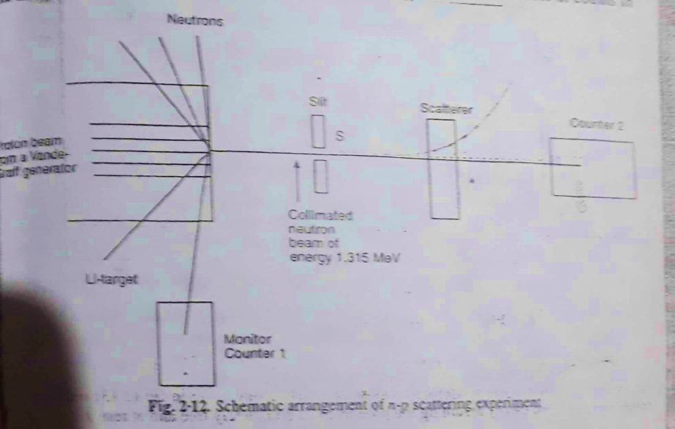

If N and N₀ are the number of counts registered by counter, 2 in the presence and absence of scattered respectively, then the value of scattering cross-section σ_{c} may
For graphite scattered, the direct formula used is
N = N₀ e ^{-nσcx}
Where n is the concentration of nuclei per unit volume in the target and x is the thickness of the target and σ_{c} is cross-section for carbon scattered. For CH₂ scatterer, the sum n_{c} σ_{c} + n_{H} σ_{H} is found from the formula.
N = N₀e^{- ( nc σc} ^{+ n}_{H} ^{σ}_{H} ^{) x}
When n_{c} and σ_{H} are concentration of carbon atoms and hydrogen atoms. By subtracting the contribution from carbon, hydrogen crosss-section may be determined.
The results of experiments are
σ_{c} = ( 2.192 ± 0.020) barns
σ_{H} = (3.675 ± 0.020) barns ( 1 barn = 10 ⁻²⁸ m² )

Similar experiments have been performed by different researchers for different energy ranges using different techniques. The most extensive measurements of n-p scattering cross-section for low energy have been performed by Melkunian and Rainwater et al. For these experiments the neutron source was a pulsed cyclotron at Columbia University. In the device the short bursts of deuterons was made incident on a beryllium target as a result the neutrons are produced by nuclear reaction. The high energy experiments were performed by R.K. Adair. The results of experiments for low and high energy scattering are plotted in fig. Graph shows the increased n-p scattering cross-section below 1eV.
The reason that (i) up to 1eV to protons cannot be regarded as completely free. For this part of energy range the scattered was H₂ gas which has dissociation energy about4.5 eV /molecule. Therefore below this energy scattered is the hydrogen-molecule instead of a free proton.

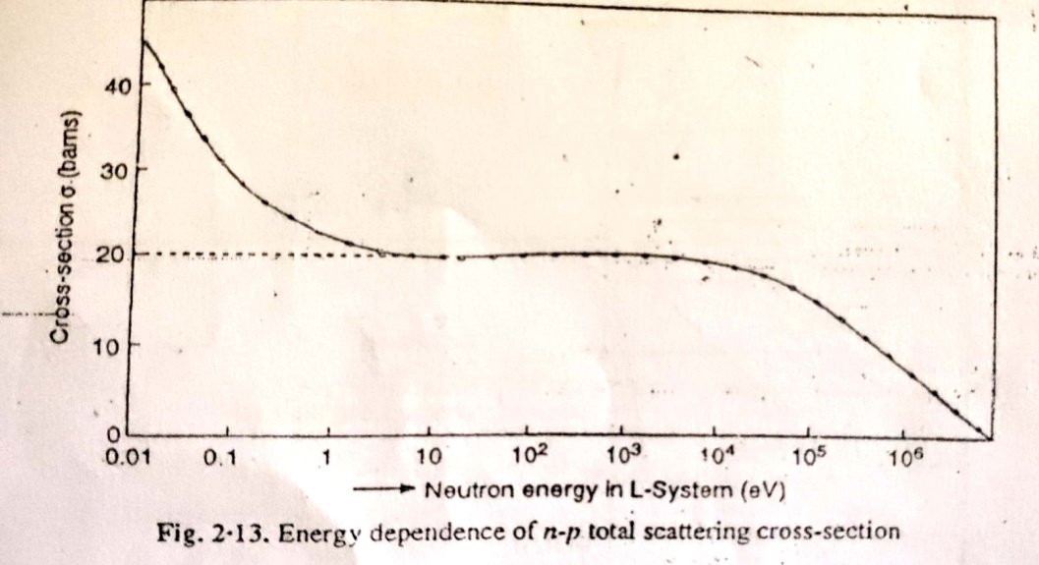
(ii) Neutrons of the order of thermal energy 3/2 kT = 0.025 eV effectively increases the target area and hence the scattering cross-section. The dotted line in fig (2.13) indicates that the result derived from theory assuming the protons to be completely free and at rest.
PARTIAL WAVE ANALYSIS OF n-p SCATTERING:
The Schrodinger wave-equation for two particle system under spherically symmetric central potential V(r) in Centre of mass system of coordinates is
∇²ѱ +$\frac{2μ}{ℏ2}$ [ E – V(r) ] ѱ = 0 $………$(1)
Where µ is the reduced mass, E is the energy and V(r) is scattering potential. In n-p scattering (if M is mass of each nucleon)
$μ= \frac{m1m2}{m1+ m2}$ = $\frac{MM}{M+M}$ =$\frac{ M}{2}$
So that the equation (1) becomes

∇²ѱ + $\frac{M}{ℏ2}$ [E – V(r)] ѱ = 0$……….$(2)
The solution of this equation will contain an incident wave and a scattered wave. A large distance from scattering Centre (where the effect of scattering potential is negligible) the solution will be of the form
Ѱ = e^{ikz} +$\frac{eikr}{r}$ f(θ) $……… (3)$
Where the first term represents a plane wave travelling along z-axis towards the scattering Centre (or origin) and the second term represents the outgoing spherical wave, f(θ) is the amplitude of scattered wave in the direction θ with respect to incident plane wave. The wave number k is given by
k= √$\frac{ME}{ℏ2}$ $……….. \left(4\right)$

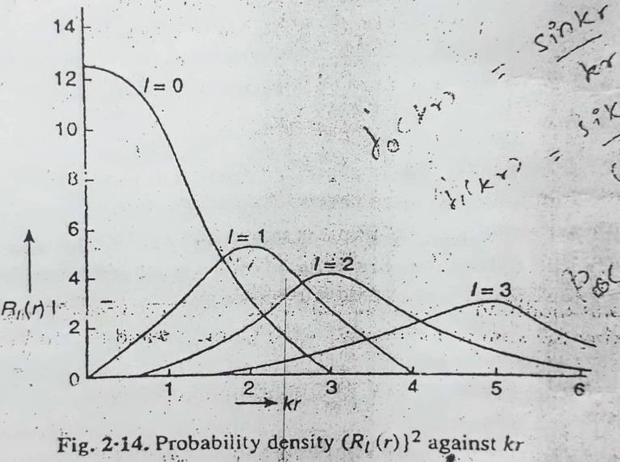
According to Rayleigh’s method of partial waves a plane wave function can be expanded series of spherical harmonics multiplied by a radial wave function.
In spherical coordinates (r, θ, ϕ) we have z = r cosθ; therefore the wave function ѱ_{l} = e^{ikz} = e^{ikrcosθ} – $\sum_{l=0}^{∞}{R}$_{l} (r) P_{l} (cosθ) $……….. (5)$
Each term in the sum of RHS represents a partial wave, the l value signifies the orbital angular momentum of the system. The radial function R_{l}(r) can be expressed in termsof numerical Bessel function j_{l}(kr) as follows:
R_{l} (r) = i^{l} (2l+1) j_{l} (kr) $…… (6)$
The square of radial wave function i.e., |R_{l}(r)|² represents the r-independence of probability for each partial wave and is plotted against kr in fig (2.14) for l=0,1,2,3. For large values of r, j_{l} (kr) has the asymptotic form
j_{l}(kr)$\overset{→}{r→∞}$ $\frac{1}{kr}$ (sin kr –$\frac{lπ}{2}$) for kr$≫$ 1 $……… \left(7\right)$
In equation (5) P_{l} (cosθ) is Legendre polynomial of order l and |P_{l}(cosθ)|² represents the angular dependence of probability density. The total plane wave solution may be expressed as
ѱ_{l} = e^{ikz} = $\sum_{l=0}^{∞}{i}$^{l} (2l+1) j_{l} (kr) P_{l} (cosθ) $…………$(8)
The expression of incident wave function in the form has useful significance. In scattering under central potential, the angular momentum remains constant; so l value does not change and the number of partial waves affecting the process is limited. For energy below 10eV, the value of wave number k= √$\frac{ME}{ℏ2}$= 0.35 Fermi. If we assume the range of nuclear force equal to r₀ = 2 Fermi, then k r₀ = 0.70.Clearly the probability density | R_{l}(r) |² that the distance between two particles at any time less than 2 Fermi is extremely small, except in l = 0 and l=1 partial waves. However for l=1 the probability density is quite small. Hence for energy below 10MeV, it is sufficient to consider the function for l = 0.For this case the solution of equation (2) becomes

Ѱ₀ = R₀(r) P₀(cos θ) $…………..$ (9)
From the equations (6) and (7) for l = 0, we have R₀(r) = $\frac{sinkr}{kr}$ and also P₀ (cos θ) = 1
Therefore ѱ₀ = $\frac{sinkr}{kr}$ = $\frac{eikr - eikr}{2ikr}$
The validity of the solution may be tested by substituting this value into radial equation with l = 0 and V = 0 spherical wave while the term containing an e^{ikr} represents an outgoing spherical wave.
Now we try to modify the function ѱ for n-p scattering under considerations. If we see on the scattering potentials V(r), then the incoming part of wave function at distances but then the range of nuclear forces remains unaffected. However the outgoing part of the wave may be affected. Again outside the range of scattering potential, the amplitude of outside wave remains unchanged. This is equivalent to saying that the number of particles moves away from the scattering Centre remains constant, assuming that no absorption of particles takes place. The only effect of scattering potential is to change the phase of outgoing waves when wave passes the scattering potential. We assume that for l = 0 partial wave, the phase shift is equal to 2$δ$₀; then the equation (10) may be expressed as
Ѱ₀ = e ^{i(kr+ 2δ}₀⁾ e ^{-ikr} –
2ikr
= $\frac{eiδ0}{kr sin (kr + δ0) }$ $…………. (10)$
Now the total modified wave functions in the presence of scattering potential V(r) must obtained by taking the sum of incident wave function e^{ikz} i.e.,
Ѱ = e ^{ikz} + e ^{i(kr +δ}₀⁾ sin δ₀ ……… (11)
kr
Comparing the equation (11) with (3) we find the scattering amplitude
[ f(θ)]_{l=0} = e^{iδ}₀ sin δ₀ ………. (12)
k
Differential scattering cross-section $σ$₀ = |f (θ)| ² = sin² δ₀ ……… (13)
k²
Total scattering cross-section is obtained by integrating (13) over the sphere i.e.,
σ_{(total)l = 0} = $\int_{0}^{π}{\int_{0}^{2π}{σ\left(θ\right)sinθdθ dϕ}}$
= $\int_{0}^{π}{σ\left(θ\right)sinθ dθ.(2π)}$
= $2π\int_{0}^{π}{.}$sin² δ₀ $sinθ dθ$
k²
= $2π$sin² δ₀ [ -cos$θ$ ]
k²
σ_{(total)l = 0} = 4πsin²δ₀ $…….. ($14)
k²
This shows that the scattering cross-section is closely related to the phase-shift experienced by the outgoing wave. This analysis holds for l = 0 wave. In general for all partial waves expression (14) between
σ_{total} = 4π $\sum_{l=0}^{∞}{(2l+1)}$sin²δ_{l ……………..} (15)
k²
Using lambda cross = λ/ 2π = 1/k the partial cross-section corresponding to l-wave is
σ_{l} = 4πλ²(2l+1)sin²δ_{l} $……… .$(16)
and total cross-section σ_{total} = 4πλ²$\sum_{l=0}^{∞}{\left(2l+1\right)}$ sin²δ_{l} $……….$(17)
Scattering Length:
The concept of scattering length was introduced by Fermi and Marshal to explain n- p scattering at low – energies .We have scattering amplitude for l = 0 wave
[ f(θ)]_{l = 0} = f₀ = $\frac{e^{iδ0 }sinδ0}{k}$ ……. (1)l
In the limit of very small neutron – energies E $→0$and so k = $\frac{√ME}{ℏ}$ →0, this implies that δ→0; otherwise f (θ) will become infinite .Thus for low neutron – energies.
f₀ = [ f(θ)]_{l = 0} = $\frac{sinδ0}{k}$ = -a ……. (2)
Where the quantity + a is called the scattering length. If f₀ is in general a complex quantity, the scattering length, to a good approximation, is a real length .The wave function for V₀(r) →0.
Ѱ₀ = $\frac{ e iδ0 sin(kr+δ0)}{kr}$ …… (3)
In the limit k→0, this becomes
Ѱ₀ = $\frac{kr+δ0}{kr}$ …… (4)
u₀(r) = rψ₀ = r + $\frac{δ0}{k0}$ ….. (5)
u₀(r) = r – a
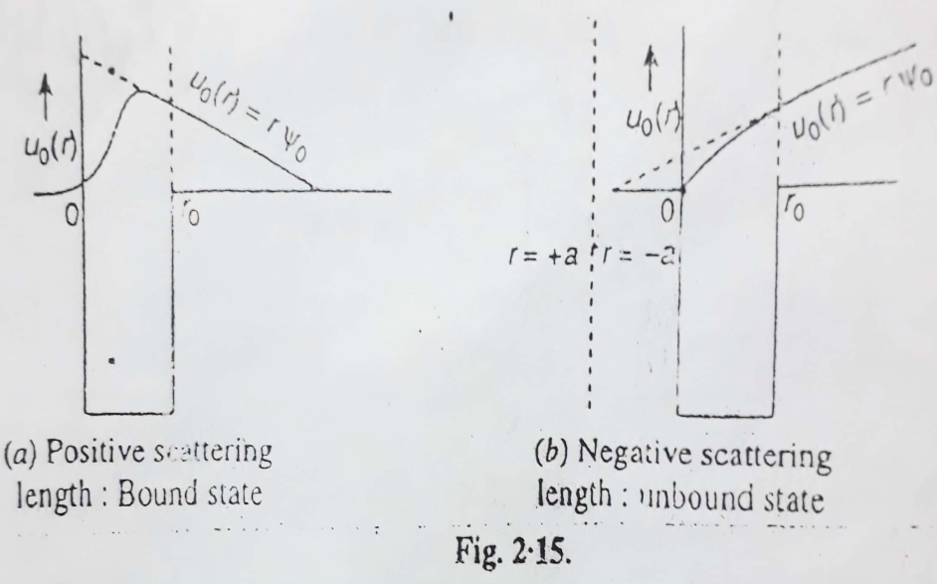
This is the equation of a straight line intercepting r axis at r = a. Plotting u₀ (r₀) = rψ₀ against r, the scattering length may be interpreted physically. The intercept of u₀ (r₀) (= rψ₀) from a point just outside the range of nuclear force gives the scattering length, sometimes also called the Fermi – intercept u₀ (r₀) (= rψ₀) .The positive scattering length occurs when system is bound and negative when system is unbound.
The relation (2) implies that positive phase shift takes place for negative scattering length and vice – versa.
The scattering cross – section for zero - energy neutron will have the value
σ₀ = lim $\left(\frac{4πsin2δ0}{k2}\right)$ = 4$π$ $\left(\frac{δ0}{k}\right)$² = 4$π$a² ……… (6)
Accordingly the scattering length ‘a ‘may be interpreted as the radius of sphere surrounding the scattering Centre. From equation (6) it is obvious that σ₀ determines the magnitude of the scattering length ‘a’ but not its sign.
Determination of Phase Shift δ₀ :
To find the phase – shift δ₀ for lower – energy neutron –proton scattering , we again assume the square – well potential and solve the Schrodinger equation .Inside a well of depth V₀ and radius r₀ (region I) the radial wave – equation for a particles of total energy +E is given by
$\frac{d^{2}u1}{dr^{2}}$ + $\frac{2μ}{ℏ^{2}}$ (E + V₀ ) u₁ = 0 [ for r ≤ r_{o} , V = -V₀ ] ……. (1)
Where u₁ is the function of r only and μ is reduced mass, For neutron – proton system μ = $\frac{M}{2}$
Eqn (1) becomes $\frac{d^{2}u1}{dr^{2}}$ + $\frac{M}{ℏ^{2}}$ (E + V₀ ) u₁ = 0 for r ≤ r_{o} ……. (2)
Outside the well r > r_{o} , V = 0 (region II ), therefore Schrodinger equation is
$\frac{d^{2}uII}{dr^{2}}$ + $\frac{M}{ℏ^{2}}$ E u₁₁ = 0 …….. (3)
Eqn (2) and (3) have solutions
u₁= A sin k₁r ……. (4)
Where k₁ = $\frac{\sqrt{M(E+V0) }}{ℏ^{2}}\frac{ }{ }$ ….. (5)
u₁₁ = B sin (kr + δ₀ ) ……. (6)
Where k = $\frac{\sqrt{ME }}{ℏ}\frac{ }{ }$
The continuity of wave- function and its derivative provides the two boundary conditions at r = r₀.
u₁ = u₁₁ at r = r₀ ……… (i)
$\frac{du1}{dr}$ = $\frac{du11}{dr}$ at r = r₀ …….. (ii)
The boundary condition (i) provides
A sin k₁ r₀ = B sin (kr₀ + δ₀ ) ……… (7)
The boundary condition (ii) provides
k₁ A cos k₁ r₀ = k B sin (k r₀ + δ₀ ) ……. (8)
Dividing equation (7) and (8) we get
k₁ cot k₁ r₀ = k cot (k r₀ + δ₀ ) …….. (9)
This equation gives
δ₀ = cot⁻¹ $(\frac{k1}{k}$ cot k₁ r₀ ) - k r₀ ……. (10)

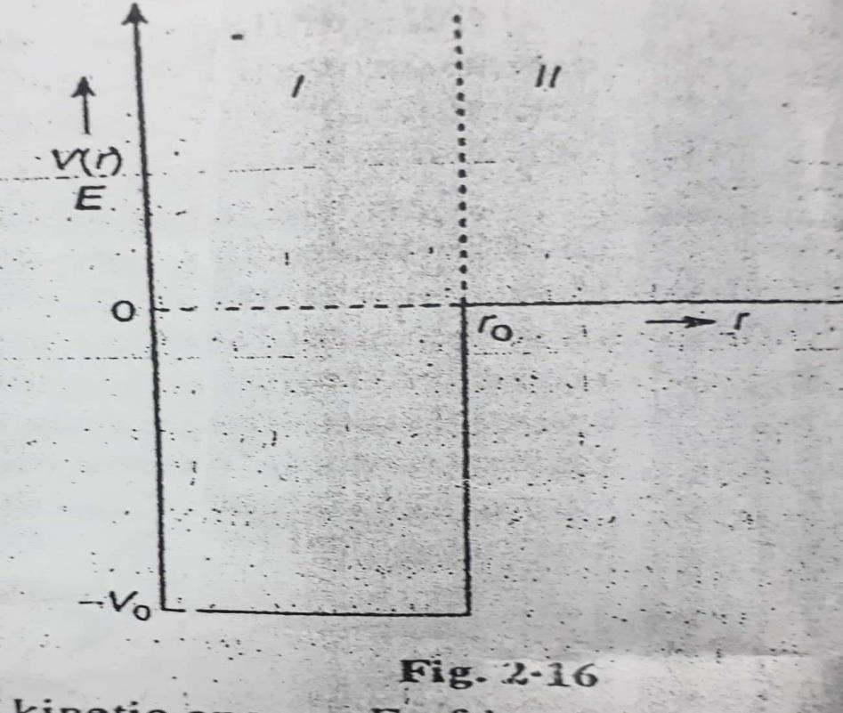
This equation expresses phase shift δ₀ in terms of kinetic energy E of incident particle and depth V₀ of potential well. We compare n – p scattering with the deuteron problem. In deuteron the binding energy E_{B} is small but negative, here if E << V₀.
k cot (k r₀ + δ₀ ) = - α …….. (11)
As r₀ is small, hence we can neglect k₂r₀ in comparison with δ₀ and α = $\frac{\sqrt{MEB }}{ℏ}\frac{ }{ }$
Substituting this in equation (3), we get $\frac{\sqrt{ME }}{ℏ}$ cot δ₀ = - $\frac{\sqrt{MEB }}{ℏ}\frac{ }{ }$
cot δ₀ = - $\frac{\sqrt{EB }}{E}$ …….. (12)
sin² δ₀ = $\frac{1}{1+cot2 δ0 }$ = $\frac{1}{1+\frac{EB}{E}}$ = $\frac{E}{E+EB}$ ……. (13)
σ₀ = $\left(\frac{4π}{k2} sin2δ0\right)$ = $\frac{4π}{k2} \frac{E}{E+EB}$…… (14)
In above expression the magnitude of binding energy $EB$ has been used, so it is appropriate to replace
$EB$ by |$EB| .$
Value of k² = $\frac{ME}{ℏ^{2}}$ , equation (14) takes the form
σ₀ = $\left( \frac{4πℏ^{2}}{M [E+|EB |] } \right)$ …….. (15)
This relationship is in satisfactory agreement with measured n – p scattering cross – section for neutrons whose kinetic energy is large enough so that E > |E_{B} | or E > 2.225 Mev.For neutron energies about 5 to 10Mev.
properties of nuclear forces:
- Gravitational Force: This force is the force of mutual attraction between any two objects in universe by their masses. According to Newton’s law of gravitation, ‘‘the mutual force of attraction between two objects is directly proportional to the product of their masses and inversely proportional the square of distance between them ’’ Accordingly if m₁ and m₂ are masses of two objects at separation r, then gravitational force F_{g} = $\frac{Gm1m2}{r2}$ where universal gravitational constant , its value is 6.67х 10⁻¹¹ newton – metre /kilogram².Thisis a weak force and is observable only if the masses of objects are large . As the size of nucleus is of the order of 10⁻¹⁵ m, i.e, the gravitational force between the nucleons (m₁=m₂ = 1.67х10⁻²⁷ kg)is
F_{g} = $\frac{Gm1m2}{r2}$ = $\frac{6.67 х 10-11 х (1.67х10-27 )2 }{10-15 }$ newton = 1.86 х10⁻³⁴ newton
The interaction energy due to gravitational force.
U_{g} = $\frac{Gm1m2}{r}$ = $\frac{6.67 х 10-11 х (1.67х10-27 )2 }{10-15 }$ newton = - 1.86 х10⁻ ⁴⁹ joule
= - 1.86 х10⁻ ⁴⁹ joule

U_{g} = $\frac{- 1.86 х10- 49 }{1.6 х 10-13}$ MeV = -10⁻³⁶ MeV
This force is capable of explaining large scale phenomena of universe such as force and evolution of stars, motion of planets around sun and motion of bodies falls on earth, i.e the binding energy per nucleon in nucleus is of the order of 8 MeV , while that due to gravitational forces must be of the order of 10⁻³⁶ MeV.
- Electromagnetic Force:
Electromagnetic Force is the force between the charged particles and includes electric force, magnetic force and their interaction. If the charges are at rest the force follows Coulomb’s inverse square law .Accordingly ‘‘the electrostatic force between two charges at infinite separation is proportional to the product of magnitude of charges and inversely proportional to the square of distance between them’’.
If q₁ and q₂ are two charges at rest of separation ‘r’, then electrostatic force.
F_{e} = $\frac{1}{4πϵo}$ $\frac{q1q2}{r2}$
$ϵo$ = Permittivity of free space
= 8.86 х 10⁻¹² C ²/ N- m²
$\frac{1}{ 4πϵo}=9$ х 10⁹ N- m²/ C ²
$Th$is force is repulsive if charges are similar and attractive if the charges are opposite in nature.
For two protons in nucleus
q₁ =q₂ = e = 1.6 х 10⁻¹⁹ c , r = 10⁻¹⁵m
Repulsive force F_{e} = $9$ х 10⁹ $\frac{(1.6х10-19)2}{(10-15)2}$ = 2.30 х10² newton
The interaction energy due to electrostatic force
V_{e} = $\frac{1}{4πϵo}$ $\frac{q1q2}{r}$ $=9$ х 10⁹ х $\frac{(1.6х10-19)2}{(10-15)2}$ = 2.30 х 10⁻¹⁷ joules
V_{e} = $\frac{2.30х10-17}{1.6 х 10-13}$ = 2 х 10⁻⁴ MeV
The electrostatic force, between two protons is nearly 10³⁶ times stronger than the gravitational force between them. The charge in motion produces magnetic interactions like electric and magnetic force in general are inseparable hence the name electromagnetic force ;kike the gravitational force , the electromagnetic force .The moving charges give rise to electric currents and hence they are accompanied by magnetic moment
The magnetic interaction force F_{m} = $\frac{μ0}{4π}$ $\frac{M1M2}{r4}$
Where μ₀ is permeability of free space given by μ₀ = 4π 10⁻⁷ weber /amp – metre
M₁ M₂ are magnetic moments in amp- metre²
For a proton μ_{p} = +2.79275 μ_{N}
= +2.79275 х 5.0505 х10⁻²⁷ ampere metre²
= 1.41 х10⁻²⁶ A-m²
f_{m} = 20 newton
Magnetic interaction energy U_{m} = $\frac{μ0}{4π}$ $\frac{M1M2}{3r3}$ = $\frac{2}{3}$ х10⁻¹⁰joule =0.04 MeV.
Clearly the magnetic force is weaker than electrostatic force.
- Strong Nuclear Force:
This is the force that binds the protons and neutrons in a nucleus. It is evident that some attractive force a nucleus will be unstable because of electrical repulsion between protons .This attractive force cannot be gravitational due to its weak nature as compare to electrostatic force. The three facts about the nuclear force are as given below,
- It is the strongest attractive force in nature, about 100 times stronger than electromagnetic force
- It is charge independent and acts equally between a proton and a proton ,a neutron and a neutron and a proton and a neutron
- It is short - range force .Its range is extremely small of the order of nuclear size, where the distance between two nucleons becomes more than the nucleus diameter this force falls rapidly and vanishes very soon
- It has a saturation character. It means that a nucleon interacts only with its neighbours and not with all other nucleons of nucleus.
- Weak Nuclear Force:
The weak nuclear force appears only in certain nuclear processes such as β- decay nucleus and operates among elementary particles. In β- decay a nucleus emits an electron and a neutral massless particle neutrino .The weak nuclear force is stronger than gravitational force but much weaker than the strong nuclear and electromagnetic forces range of weak nuclear force is small of the order of 10⁻¹⁵ m
- The electromagnetic force is caused by the exchange of photons between the charged particles.
- Strong nuclear force arises from the exchange of mesons.
- Weak nuclear force arises due to exchange of vector bosons (W± and Z).
- Gravitational force arises due to exchange of graviton.
The fundamental forces are tabulated below:
S.No. | Name of force | Relative strengths | Range | Operates among
1 | Gravitational force | 10⁻ ³⁸ | Infinite | All objects in universe
2 | Weak nuclear force | 10⁻ ¹³ | Very short (=10⁻¹⁵ m within nuclear size) | Elementary Particles
3 | Electromagnetic force | 10⁻ ² | Infinite | Charged Particles
4 | Strong nuclear force | 1 | Very short (=10⁻¹⁵ m within nuclear size) | Nucleons
Spin – Dependence of Nuclear Forces:
At low neutron – energies E →0, the scattering cross – section
σ₀ = $\frac{4πℏ^{2}}{M [E+EB ] }$ = $\frac{4πℏ^{2}}{M EB }$ = $\frac{4 х 3.14 х \left( 1.05х 10-34\right)2}{\left(1.67 х 10-27\right)х 2.225 х 1.6 х10-13 }$ = 3.7 х10⁻²⁸ m² = 3.7 barns
This result is quite unsatisfactory because the experimental value of σ₀ is 20.4 barns. Wigner was the first to point out that the single and triplet s – wave interactions are equal .The binding energy E_{B} which dominates E in above calculation applies only to the ground level of deuteron and hence to the triplet interactions between the colliding neutron and proton.
When unpolarised neutrons become incident on randomly oriented protons, the uncorrelated spins may be parallel in some collisions and antiparallel in others. So their spin quantum number S may be unity or zero .The statistical weight for spin S is g_{S} = (2S +1) .For S = 0, the statistical weight is 1 and for S = 1, the statistical weight is 3.
σ₀ = $\frac{3}{4}$ ( ³σ₀ ) + $\frac{1}{4}$ ( ¹σ₀ ) ………. (1)
Where ³σ₀ and ¹σ₀ refer to triplet and singlet collisions. Thus equation (1) holds for triplet collisions, i.e, ³σ₀ = 3.5 barns and ¹σ₀ = 20.4 barns clearly ³σ₀ << ¹σ₀ .In other words the nuclear force are spin –dependent.

Exchange Forces:
- The volume of nucleus is proportional to mass number A.
- The nuclear binding energy is proportional to mass number A, so that the nuclear binding energy per nucleon is constant.
These properties show that the nucleus interacts only with a limited number of nucleons. If each nucleon interacts with all other nucleons in the nucleus, then the total interactions energy will be proportional to the total number of nucleons pairs $\frac{A(A-1)}{2}$ in the nucleus .Clearly for large values of A the binding energy would be proportional A² .
Exchange Forces: The Schrodinger wave equation in centre of mass (C) –system can be written $(-\frac{Ћ^{2}}{2μ}$ $∇^{2}+V)Ψ$ = E$Ψ$ …… (1)
$Where$μ is the reduced mass and $Ψ$ is a function of position and spin coordinates of the two particles .The function $Ψ$ may be expressed as
$Ψ$ = $Ψ$(r₁, r₂ ; σ_{1 ,} σ₂) = φ (r₁, r₂ ) χ (σ_{1 ,} σ₂ )
Where φ (r₁, r₂ ) is a function of position coordinates r₁, r₂ only and χ (σ_{1 ,} σ₂ ) is a function of spin coordinates σ_{1 ,} σ₂ only. φ (r₁, r₂ ) may be written as φ₁₂ and χ (σ_{1 ,} σ₂ ) may be written as χ₁₂
$Ψ$ = φ₁₂ χ₁₂
$Equation$(1) may be expressed as $( \frac{Ћ^{2}}{2μ}$ $∇^{2}+E)$ φ₁₂ χ₁₂ = V φ₁₂ χ₁₂
There are four – types of exchange forces are
- Wigner force (ii) Majorana force
- Bartlett force (iv) Heisenberg force
(i) Wigner force: It is the ordinary force, Wigner exchange operator is unity and does not cause any change in wave – function.
Wigner exchange operator is expressed as V = V(r) P_{w}
Where P_{w} = 1 for all states
Thus the Schrodinger equation will take the form
$( \frac{Ћ^{2}}{2μ}$ $∇^{2}+E)$ φ₁₂ χ₁₂ = V(r) P_{w} φ₁₂ χ₁₂ = ` V(r) φ₁₂ χ₁₂
Wigner or ordinary force is attractive in ³S –state, it must be attractive in all states. This cannot cause saturation.
(ii) Majorana force
In this type of interaction, the space coordinates of the two particles get interchanged while the spin –coordinates remain unchanged.
The potential function is expressed as V =V(r) P_{M ,}where P_{M} is the majorona exchange operator and is defined as P_{M} = φ₂₁ or P_{M} φ(r) = φ(-r)
Schrodinger equation may be expressed as
$( \frac{Ћ^{2}}{2μ}$ $+E)$ φ₁₂ χ₁₂ = V(r) P_{M} φ₁₂ χ₁₂ = (-1)^{L}` V(r) φ₁₂ χ₁₂
$( \frac{Ћ^{2}}{2μ}$ $+E)$ψ = (-1)^{L}` V(r) ψ
This shows that the potential is attractive for even –parity states (e.g., S, D, G etc. ., i.e, 0, 2, 4 etc.) and repulsive for odd –parity states (e.g., P, F etc with L =1 ,3 ,etc.)
- Bartlett Force: In this type of interaction the spin – coordinates of the two particles get interchanged; the spin coordinates are left unchanged.
The potential function is expressed as V = V (r) P_{B}

Where P_{B} is the Bartlett exchange operator and is defined as P_{B} φ₁₂ χ₁₂ = φ₁₂ χ₂₁
Thus the Bartlett operator P_{B} interchanges the spin of the two nucleons. For two particles of spin ½ each, there are three symmetric spin states with S = 1 and one antisymmetric spin state with S= 0.
P_{B} φ₁₂ χ₁₂ = (-1)^{s+1}φ₁₂ χ₁₂
The Schrodinger equation takes the form
$( \frac{Ћ^{2}}{2μ}∇^{2}$ $+E)$ φ₁₂ χ₁₂ = V(r) P_{B} φ₁₂ χ₁₂ = (-1)^{S+1} ` V(r) φ₁₂ χ₁₂
$= +$V(r) φ₁₂ χ₁₂ (for S = 1 triplet)

$= -$V(r) φ₁₂ χ₁₂ (for S =0 singlet)

As ³S force is attractive, so all triplet states (³S, ³P , ³D) are attractive and all singlet states (¹S, ¹P , ¹D ) are repulsive. In n-p scattering experiment at low energies it is found that ¹S force is attractive.
- Heisenberg Forces:
In this type of interaction both the space and the spin coordinates of two nucleons are interchanged. The potential function is expressed as V = V (r) P_{H}
Where P_{H} is the Heisenberg exchange operator and is defined as P_{H} φ₁₂ χ₁₂ = φ₂₁ χ₂₁
Thus the Heisenberg operator P_{H} interchanges both the position and the spin of the two nucleons.
P_{H} φ₁₂ χ₁₂ = (-1)^{L} φ₁₂ (-1)^{s+1}χ₁₂ = (-1)^{L+S+1} φ₁₂ χ₁₂
The Schrodinger equation takes the form
$( \frac{Ћ^{2}}{2μ}∇^{2}$ $+E)$ φ₁₂ χ₁₂ = (-1)^{L+S+1} V (r) φ₁₂ χ₁₂
If (L +S) is even, the sign of V(r) is negative and (L + S) is odd; the sign is positive. This gives a repulsive potential for ³S, ³D , ¹P , ¹F states. Saturation character of nuclear forces requires a mixture of Majorana and Wigner type of potentials .They permit ³S₁ and ³D₁ bound states in deuteron and give positive potential for ³(n p) and ¹(n p) interactions.

֘Yukawa’s model of nuclear force:
In 1935, a Japanese Physicist Yukawa proposed a theory of nuclear force, which is finally referred as Meson –theory of nuclear forces. Yukawa proposed the existence of a new field, now known as Meson field and pointed out that the nuclear forces arise due to continuous exchange of mesons between the nucleons .Yukawa took the theory from quantum field theories of electromagnetic field in which the exchange of photon takes place and gravitational field in which the exchange of graviton is assumed. Both the field particles (photon and graviton) have zero rest mass but the nuclear field has finite rest mass i.e., nuclear force is short –range force .The rest mass M_{π} of the field particle as follows.
When one nucleon exerts a force on the other, a meson is created .The creation of meson takes the conservation of energy by an amount ΔE, corresponding to meson rest mass.
ΔE = m_{π} c² ……… (1)
The time for which meson can exist is determined by the uncertainty relation of wave mechanics is given by
ΔE Δt ̴ $ℏ$ = Δt ̴ $ℏ\frac{Ћ}{ΔE}$ …………. (2)
The maximum distance traversed by meson in this time at maximum possible speed, the speed of light c is
r_{o} = c Δt , Substituting value of Δt from (2)
r_{o} = c $\frac{ℏ}{ΔE}$ = c $\frac{ℏ}{mπ c2 }$ (using (1))
= $\frac{ℏ}{mπ c }$
$mπ= \frac{ℏ}{roc}$ …………. (3)
Assuming range of nuclear force r_{o} = 1.4 F = 1.4 ×10⁻¹⁵m, we get
$mπ=\frac{(1.05×10-34 joule-second )}{\left(1.4 ×10-15 metre\right)×( 3×108\frac{metre}{second})}$ metre
= 0.25 ×10⁻²⁷ kg
In terms of mass of electron m_{e} = 9.1 × 10⁻³¹ kg
$mπ=\frac{0.25 ×10-27}{9.1 × 10-31 }$ m_{e} = 270 m_{e}
After Yukawa’s hypothesis a search for π –mesons was started .In 1945 Powel coworkers discovered π –mesons in cosmic radiation, having mass 273 m_{e} .This is in agreement with theoretical mass of π –mesons ( = 270 m_{e} ) .The π –mesons are of three positive (π⁺), negative (π⁻) and neutral (πº ) , all have intrinsic spin I = 0.
Exchange of Neutral Pion
nº → nº + πº ; p⁺ + πº → p ⁺
Exchange Charged Pion
n₁ $⇋$ p₁⁺ + π ⁻ ; p₂⁺ + π ⁻ $⇋$ n₂
p₁⁺ $⇋$ n₁ + π ⁺ ; n₂ + π ⁺ $⇋$ p₂⁺
In the first case the first nucleon (neutron n₁) emits a negative pion i.e., it absorbed second nucleon (proton p₂ ) .In the exchange process n₁ is converted into proton p₁ another proton p₂ is converted into a neutron n₂ .According to Yukawa the pion exchange among nucleons gives rise to strong attractive force , now called the exchange force. The π – mesons are regarded as the quanta for the meson field. A nucleon is regarded as a source of field quanta and hence of meson – field .A nucleus supposed to be surrounded by virtual photons.
The relativistic relation between energy E and momentum p of a particle of rest mass given by
E² = p² c² + m² c⁴
In Quantum Mechanics the energy operator is E^ = i $\frac{∂}{∂t}$ and momentum operator ^p ,
Substituting values of E and P in operator form, we get
$\left(i ℏ \frac{∂}{∂t}\right)$ . $\left(i ℏ \frac{∂}{∂t}\right)= \left( \frac{ℏ}{i}∇\right)$ . $\left( \frac{ℏ}{i}∇\right)$c² + m² c⁴
- $ℏ$ ²$\frac{∂^{2}}{∂t^{2}}$ = - $ℏ$ ²c² 𝛁² + m² c⁴
$\left(∇2 - \frac{1}{c2} \frac{∂^{2}}{∂t^{2}}-\frac{m^{2}c2}{ℏ^{2}}\right)$ = 0
If φ (r, t) is the pion – wave function, then the wave equation for pion takes the form
$\left(∇2 - \frac{1}{c2} \frac{∂^{2}}{∂t^{2}}-\frac{m^{2}c2}{ℏ^{2}}\right)$ φ (r,t) = 0
This is relativistic Schrodinger equation (also called klein Gordan equation) for a free particle of spin 0. If we set m → 0, then
$\left(∇2 - \frac{1}{c2} \frac{∂^{2}}{∂t^{2}}\right)$ φ (r,t) = 0
This is Maxwell’s equation from which electromagnetic field is derived. This is equation to be derived from the energy equation for particles of rets mass zero.
E² - p² c² = 0
The simplest type of electromagnetic field is the electrostatic field for which$\frac{∂φ}{∂t}$ = 0, so it is given by
∇² φ = 0 (Laplace equation)
Its solution is φ = $\frac{1}{4πε}\frac{e}{r}$ δ
For $π-mesons,$equation may be expressed as
$\left(∇2 - \frac{1}{c2} \frac{∂^{2}}{∂t^{2}}-\frac{m^{2}c2}{ℏ^{2}}\right)$ φ = 0
The time independent part of equation is = $\left(∇2 -\frac{m^{2}c2}{ℏ^{2}}\right)$ φ = 0
If ꞵ = $\frac{m^{2}c}{ℏ^{2}}$ we get
(∇² ⁻ ꞵ² ) φ = 0,
From equation ꞵ = $\frac{mπc}{ℏ}$ = $\frac{1}{r0}$ , i.e., Poisson‘s equation is ∇² φ = - $\frac{ρ}{ε0}$
Therefore, (∇² ⁻ ꞵ² ) φ = $\frac{1}{ε0}$ g δ (r)
Where g is measure of nuclear field and is called the mesonic charge.
δ (r) = 1 at r = 0 ; δ (r) = 0 at r # 0
The solution of equation may be expressed as φ (r) = - λ g $\frac{e^{-βr}}{r}$
Where λ is a constant which depends on system of units.
The meson – potential will be V = g φ (r) = - λ g² $\frac{e^{-βr}}{r}$
This is the required Yukawa potential and is shown graphically in fig (9.4)
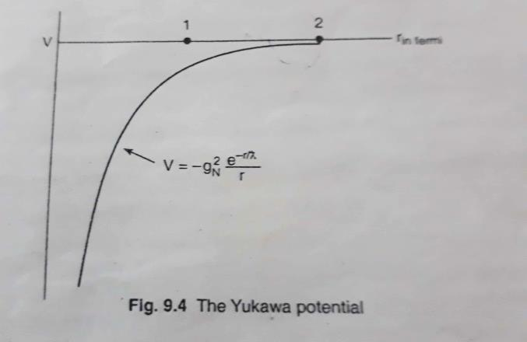
The presence of exponential term indicates that nuclear potential decreases more rapidly than Coulomb potential. For example pion has negative intrinsic parity , therefore it cannot be transferred from a neutron to proton on S –state(l = 0) and still conserve parity .To conserve parity and angular momentum both , the only possible state for the pion is P – state ( l =1).

