ADVANCED PHYSICS

UNIT -IV Wireless Communication Technology-I

Introduction
With this chapter we begin our discussion of several systems that are some- times grouped together as personal communication systems (PCS). Like many technical terms, this one has several meanings. Specifically, it is used for a particular variant of cellular radio which will be described in the next chapter. But more generally, it can be applied to any form of radio communication between individuals.
In this chapter, after some historical introduction, we look at the com- mon North American cellular telephone system, known as the Advanced Mobile Phone Service (AMPS). The network, the cell sites, and the portable and mobile telephones are described.
AMPS is still the most common cellular radio technology in North America, but a digital variation has become increasingly popular. We look at this system in this chapter as well. Newer Personal Communication Systems (PCS), which use cellular techniques but at a different frequency range and with an assortment of digital modulation schemes, are the subject of the next chapter.

Historical Overview
The cellular radiotelephone system has its origins in much earlier systems. There has long been a need for portable and mobile communication. Three early concepts, two of which are still in wide use today, show aspects of what is needed. A brief look at each will show why cellular radio was created.

Citizens’ Band
Radio
This is probably the earliest true personal communication system. Introduced in the United States in the 1960s, citizens’ band (CB) radio enjoyed great popularity in the 1970s, followed by an almost equally steep decline as its limitations became better known.
CB radio was intended to do some of the same things that are envisaged by more recent personal communication systems. The relatively low frequency of 27 MHz made transceivers affordable when CB radio was introduced, and the absence of any test for a license made it easy for anyone to get involved. The transmitter power limit of four watts for full-carrier AM, or twelve watts peak envelope power for SSB, is designed to reduce interference by restricting the communication range to a few kilometers. The fact that most CB operation is between mobile units with low antenna heights and no repeaters also limits the effective range. The restricted range is necessary to limit interference since there are only 40 channels. This should not be a problem since CB radio is intended for local communication.

Improved Mobile
Telephone Service (IMTS)
The familiar cellular radiotelephone system has its origins in much earlier systems that used a few widely spaced repeaters. Wide coverage was obtained by using powerful base-station transmitters with antennas mounted as high as possible. The mobile transceivers likewise used relatively high power, on the order of 30 watts. Very similar systems are still widely used in dispatching systems, such as those for taxicabs and ambulances, for example.
The most common type of mobile telephone, from its introduction in the mid-1960s until the coming of cellular radio in the early 1980s (the first commercial cellular system became operational in Chicago in 1983), was known as the Improved Mobile Telephone Service (IMTS). IMTS is a trunked system; that is, radio channels are assigned by the system to mobile users as needed, rather than having one channel, or pair of channels, permanently associated with each user. Narrowband FM technology is used. Two frequency ranges, at about 150 and 450 MHz were used for IMTS, with an earlier system called MTS operating at around 40 MHz. The three systems combined had only 33 available channels. A few IMTS systems are still in use, mainly in remote locations.
IMTS is capable of assigning channels automatically, by the rather simple means of transmitting a tone from the base station on unoccupied channels. The receiver in the mobile unit scans channels until it detects the tone.
IMTS is capable of full-duplex operation using two channels per tele- phone call. Direct dialing is also possible, so using a mobile phone is almost as simple as using an ordinary telephone at home.
The main problem with IMTS and similar systems is that whatever band- width is made available to a single repeater, is tied up for a radius of perhaps 50 km or even more, depending on the height of the antenna and the power of the transmitter at the base station. Any attempt to reuse frequencies within this radius is likely to result in harmful interference. Simple systems like this also suffer from fading and interference near the edges of their coverage areas. For instance, suppose two similar trunked systems with identical repeaters are located 50 km apart. Then, at a location midway between the two, a receiver would receive equally strong signals from each. Communication would be impossible if both repeaters used the same frequencies.

AMPS Control System
In this section we study in more detail the process by which the AMPS cellular system keeps track of phones and calls. We need to look at the functions of the control channels and also at the control information that is sent over the voice channels.
An effective control system has to do several things. It needs to keep track of mobile phones, knowing which ones are turned on and ready to receive a call and where they are. It needs to keep track of telephone numbers for authentication and billing, and it should have some way to detect and prevent fraudulent use. It must be able to set up calls, both from and to mobile phones and transfer those calls from cell to cell as required. It would be best if all this were transparent to the user, who should only have to dial the phone number or answer the phone, just as with a wireline phone at home. A more advanced system might also be able to send faxes and e-mail, surf the internet, and so forth, but let’s look at the basics first!
First we need to understand the functions of the voice and control channels. You might assume that the voice channels are for talking and the control channels are for control signals, and that is mostly correct. However, there is a problem: cell phones contain only one receiver and one transmitter, so they can’t receive both a voice channel and a control channel at the same time. Therefore, any control messages that have to be sent during a conversation must use the voice channel. Some of this is done using in-channel, out-of-band signaling (consisting of tones above the voice frequency range), and the rest is done with blank-and-burst signaling, during which the voice signal is muted for a short time (100 ms) while data is sent over the voice channel.
Digital signals on the control channel and those sent during blank- and-burst signaling on the voice channel are sent in a relatively simple way. They use FSK with 8 kHz deviation (16 kHz total frequency shift) and a channel bit rate of 10 kb/s. The data is transmitted using Manchester code. In

order to reduce the likelihood of errors, the control channel sends each message five times and also uses Hamming error-correction codes. This increases the robustness of the control system but reduces the actual data throughput to 1200 b/s. There is no encryption in the AMPS system: all the data coding information is publicly available. This is a serious oversight that has been remedied in the newer PCS systems to be described in the next chapter.

Mobile and Base Identification

Each mobile unit has two unique numbers. The mobile identification number (MIN) is stored in the number assignment module (NAM) in the phone. The MIN is simply the 10-digit phone number for the mobile phone (area code plus 7-digit local number), translated according to a simple algorithm into a 34-bit binary number. The NAM has to be programmable, since it may be necessary to assign a different telephone number to the phone, but it is not supposed to be changeable by the user. In most cases, however, it can be changed from the keypad if the user knows the right procedure. (Check the internet—it took the author less than ten minutes to find the procedure for his own cell phone.)
Usually a cell phone is registered on either the A or B system and has one MIN. It can operate on the other system as a roamer, if necessary and if there is an agreement between the two systems to allow it. It is also possible for a phone to have two MINs so that it can be used on both A and B systems with- out roaming. In that case the user of the phone has two phone numbers (and two bills to pay).
The other identification number is an electronic serial number (ESN), which is a unique 32-bit number assigned to the phone at the factory. It is not supposed to be changeable without rendering the phone inoperable, but in practice it is often stored in an EPROM (erasable programmable read-only memory chip) that can be reprogrammed or replaced by persons with the right equipment and knowledge. The combination of the MIN and the ESN enables the system to ensure proper billing and to check for fraudulent use (for instance, if a registered MIN appears with the wrong ESN the system will not allow the call to go through).
The mobile phone also has a number called the station class mark (SCM), which identifies its maximum transmitter power level. There are three power classes corresponding to phones permanently installed in a vehicle, transportable “bag phones,” and handheld phones. The maximum power levels, specified as ERP (effective radiated power with respect to a half-wave dipole) are as follows:
Class I (mobile): +6 dBW (4 W)
Class II (transportable): +2 dBW (1.6 W) Class III (portable): -2 dBW (600 mW)

Mobile transmitter power is controlled by the land station in 4 dB increments, with the lowest power level being 22 dBW (6.3 mW) ERP. The idea is to reduce interference by using as little power as possible. Mobile and trans- portable phones thus have better performance than portable phones only when propagation conditions are bad enough, or cells large enough, that the system needs to increase mobile power past the maximum for a portable phone. Using a portable phone inside a vehicle attenuates the signal considerably, so communication from a portable phone can sometimes be established in marginal areas by simply getting out of a car.
The cellular system has an identifying number called the system identification number (SID). This enables the mobile phone to determine whether it is communicating with its home system or roaming. (Using a “foreign” system usually costs more and the user may disable this ability if desired.) In addition each cell site has a digital color code (DCC). When the mobile detects a change in DCC without a change in frequency, it is an indication that co-channel interference is being received from another base station.

Turning on a Phone

When a cell phone is turned on, it identifies itself to the network. First it scans all the control channels for its designated system (A or B) and finds the strongest. It looks for the SID from the system to determine whether or not it is roaming. If it does not receive this information within three seconds, it tries the next strongest control channel. After receiving the system information, the mobile tunes to the strongest paging channel. Paging channels are control channels that carry information about calls that the system is trying to place to mobiles. If someone is calling the mobile, its number will be transmitted by the paging channel.
The control channel constantly updates the status of its associated reverse control channel (from mobile to system). Only the system transmits on the forward channel, but any mobile can transmit on the reverse channel. The system tells the mobiles when this channel is busy to reduce the chance of a collision, which occurs when two or more mobiles try to use the control channel at the same time. After checking that the reverse channel is free, the newly activated phone transmits its ESN and MIN to the land station so that the system knows the phone is ready for calls and in which cell the phone is located. If the mobile loses the signal and reacquires it or detects that it has moved to a different cell, it identifies itself again. In addition, the system may periodically poll its mobiles to see which are still active.
While turned on but otherwise idle, the mobile phone continues to peri- odically (at least once every 46.3 ms) check the control channel signal from the cell site. It has to verify that a signal is still available, that it is from the same system, and that there are no calls for the mobile phone.

Originating a Call When the user of a mobile phone keys in a phone number and presses Send, the mobile unit transmits an origination message on the reverse control channel (after first checking that this channel is available). This message includes the mobile unit’s MIN and ESN and the number it is calling. The cell site passes the information on to the mobile switching center for processing. Once authorization is complete, the cell site sends a message to the mobile on the forward control channel, telling it which voice channel to use for the call. It also sends the digital color code which identifies the cell site, and a Control Mobile Attenuation Code (CMAC), which sets the power level to be used. This power level can be changed by the land station as needed during the call by means of a control message on the forward voice channel.
Now both stations switch from the control channel to a voice channel, but the audio is still muted on the phone. The cell site sends a control message on the forward voice channel confirming the channel. It then sends a supervisory audio tone (SAT) on the voice channel to the mobile phone. This is a continuous sine wave, with a frequency above the voice band. There are three possible frequencies: 5970, 6000, and 6030 Hz. The mobile relays the tone back to the cell site. Reception of this tone by the cell site confirms that the correct cell site and mobile are connected. The mobile sends a confirmation message on the reverse voice channel. After this handshaking, the call can begin.
During the call the SAT continues (it is filtered out before the audio reaches the speaker in the phone, of course). Reception of the wrong frequency tone by the base station indicates an interfering signal and interruption of the tone indicates that the connection has been lost, perhaps due to severe fading. If the tone is not resumed within five seconds, the call is terminated.
A 10-kHz signaling tone (ST) may also be transmitted on the voice channel during a call. It is used to signal handoffs to another cell and the termination of the call.

Receiving a Call An incoming call is routed by the network to the cell where the mobile last identified itself. (If it has not identified itself to the network, it is assumed to be turned off and a recorded message to that effect is given to the caller.) The land station sends the MIN on the paging channel along with the voice channel number and power level to use. The mobile confirms this message and sends its ESN on the reverse control channel to be matched by the net- work with the MIN. This is to avoid fraudulent use. The base sends its information again on the forward voice channel along with the digital color code information, then the mobile confirms the information on the reverse voice channel. After this handshaking, the supervisory audio tone is transmitted on the voice channel and the conversation can begin.

Handoffs The network monitors the received power from the mobile at adjacent cell sites during a call. When it detects that its strength is greater at an adjacent cell site than at the site with which it is communicating, it orders a handoff from one cell to the next. This always involves a change in channel, since to avoid co-channel interference the same channels are never used in adjacent cells. The order to do this is sent by the first cell site to the mobile on the for- ward voice channel using blank-and-burst signaling. The resulting 100 ms interruption in the conversation is barely perceptible. The voice channel must be used, because during a conversation the mobile is not monitoring any of the control channels. The mobile is given the new channel number, new attenuation code, and new SAT frequency. After confirmation on the reverse voice channel, the mobile switches to the new channel, which connects to the new cell site, and the conversation continues. There will probably be an audible disturbance while this occurs.

Security and Privacy

The AMPS system is not very private. Voices are transmitted using ordinary FM and conversations can be picked up with any FM receiver that will tune to the correct frequency. Base stations often repeat mobile transmissions, so quite often both sides of the conversation can be picked up with one receiver, just as with a cordless phone but from much greater distances (typically a few kilometers). The change in channels as a mobile is handed off does make it hard to follow conversations when the cell phone user is talking from a moving vehicle.
In 1988, in an attempt to increase cell phone privacy, the United States government banned the import or sale of scanners or other receivers that can tune to cellular frequencies. However, these are still legal in many countries (including Canada); there are millions of old scanners around and frequency converters are easy to build. It should therefore be assumed that AMPS voice transmissions are public. The transmission of confidential information, such as credit card numbers for instance, is not advisable with ana- log cell phones.
Stolen cell phones work only until the owner has the service cancelled. (There is a code to lock the phone, but most people don’t bother, or they leave the password at the factory setting, such as “1234.” Generally, they do this because the password is supposed to be changeable only by the dealer, though in fact it can often be done from the keypad if one knows the correct method.) Even if the phone number is changed by a knowledgeable thief, the Electronic Serial Number will give away the fact that the phone is “hot.” However, it is not impossible, at least on some phones, to change the ESN. It

is also possible to acquire valid pairs of MIN and ESN numbers by monitoring the reverse control channels. There is no encryption and the exact specifications for the data fields are publicly available. It is just a matter of acquiring the hardware and software to decode a 10 kb/s FSK data stream— not a very formidable task. Once the numbers are available it is possible to “clone” a cell phone to emulate a valid phone. Calls made on the cloned phone are billed to the unfortunate legitimate subscriber.
Service providers do have some protection. For instance, if the network detects the “same” phone trying to make two calls at once or two calls in quick succession from widely separated locations, it will flag the occurrence and someone will investigate. As the networks become larger and better integrated, this type of fraud becomes a little more difficult.
Another fraud is to use a cloned or stolen phone on another network as a roamer. If the foreign network is not capable of checking the phone’s home network in real time, it may accept the call. This is becoming less likely as networks become better connected with each other. In the meantime, net- works are becoming less trusting (especially in the United States) and less likely to allow roaming without identification.

Cellular Telephone Specifications and Operation
In this section we look at the requirements for the mobile or portable phone itself and consider some examples of phone construction. See Figure 10.4 for a block diagram of a typical analog cell phone. Because the system is full- duplex, the transmitter and receiver must operate simultaneously with a single antenna. A duplexer is used to separate the two signals. The wide 45-MHz frequency separation between transmit and receive frequencies makes this relatively easy. The constant frequency separation also simplifies frequency synthesizer design.
Microprocessor control is necessary to allow the phone to switch channels and power levels by remote control from the base station. The processor and its associated memory are also useful for timing calls, storing passwords to unlock the phone, storing lists of frequently-called numbers, and so on. Some cell phones can enter a sleep state between calls to conserve battery life; they must emerge from this state to check the control channel at least once in each 46.3 ms time period.

Transmitter Power and Frequency
In the previous section we noted that cell phones come in three station classes. This term refers to the maximum power level produced. The actual transmitted power level is adjusted in 4 dB steps by signals from the cell site. The mobile transmitter must transmit at within 3 dB of the correct power

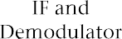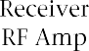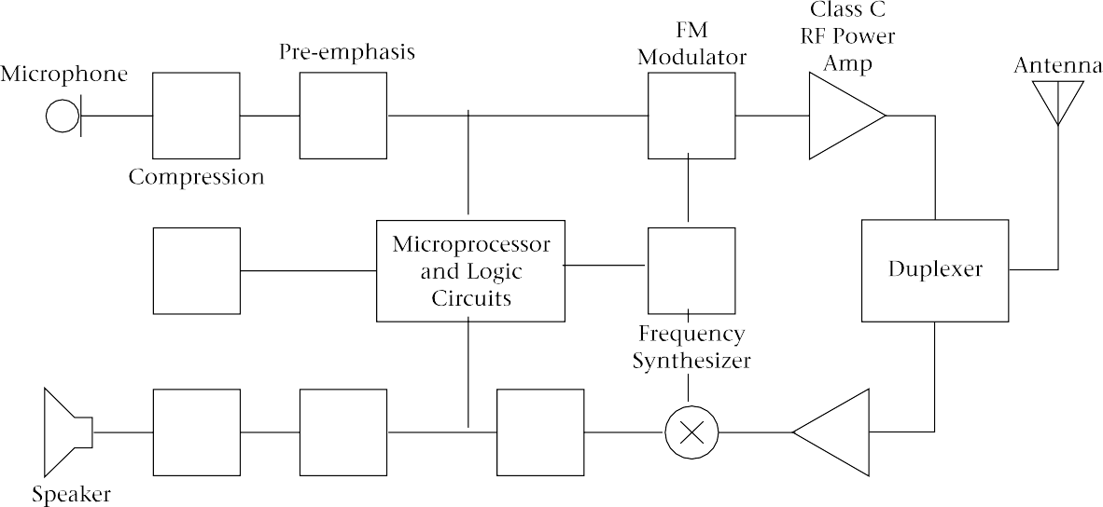

FIGURE 10.4 Block diagram of analog cell phone

level within 2 ms of turning on and must reduce its output to -60 dBm ERP or less within 2 ms of being turned off. The transmitted frequency must be within 1 kHz of the specified channel frequency.
The power levels for mobile, transportable, and portable phones are shown in Table 10.3. The abbreviation MAC refers to the mobile attenuation

TABLE 10.3 Power Levels for Mobile Phones (EIRP in dBW)

MAC | Class I | Class II | Class III
000 | +6 | +2 | -2
001 | +2 | +2 | -2
010 | -2 | -2 | -2
011 | -6 | -6 | -6
100 | -10 | -10 | -10
101 | -14 | -14 | -14
110 | -18 | -18 | -18
111 | -22 | -22 | -22
There is a range of 28 dB between maximum and minimum mobile power levels with a Class I phone.

code, which is transmitted from the base station to adjust the power of the mobile according to propagation conditions. Because FM and FSK are used, there is no need for linearity in the transmitter power amplifier, and Class C operation can be used for greater efficiency.

Transmitter Modulation
As mentioned earlier, voice transmission uses FM with a maximum deviation of 12 kHz each way from the carrier frequency. Data transmission uses FSK with 8-kHz deviation each way.
Companding with a ratio of 2:1 is used in voice transmission. That is, in the transmitter, a 2 dB change in audio level from the microphone causes only a 1 dB change in modulation level. The process is reversed in the receiver. The result is an improvement in signal-to-noise ratio for low-level audio signals.
As with almost all FM systems, pre-emphasis is used in the transmitter and de-emphasis in the receiver. This means, the higher audio signals are given more gain in the transmitter and correspondingly less gain in the receiver. In the cell phone system, all frequencies above 300 Hz are boosted at the transmitter, with a slope of 6 dB per octave. Figure 10.5 shows the pre- emphasis curve with the corresponding de-emphasis curve for the receiver.

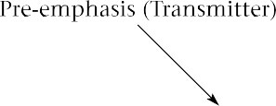
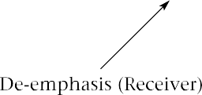
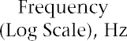
FIGURE 10.5
Cellular radio
pre-emphasis and de-emphasis

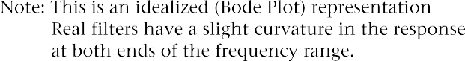

Mobile and Portable Antennas

Since the transmitted power of cellular phones is specified in terms of ERP, the use of more efficient antennas allows transmitter power to be reduced. This is especially important in the case of portable phones, since lower trans- mitter power leads to longer battery life. On the other hand, more efficient antennas tend to be larger.
Most portable cell phones use a quarter-wave monopole antenna. At 800 MHz, the length of this antenna is about 9.5 cm. The options are wider for mobile antennas. Many of these use a quarter-wave and a half-wave section, separated by an impedance-transforming coil. See Figure 10.6 for examples of typical portable and mobile antennas.

FIGURE 10.6
Portable and mobile antennas

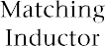

Cell-Site Equipment

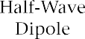
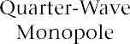
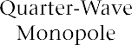
The radio transmitting equipment at the cell site operates at considerably higher power than do the mobile phones, but this power is shared among all the channels that are used at the site. Similarly, there must be receivers for each voice and control channel in use at the site, as well as extra receivers for monitoring the signal strength of mobiles in adjacent cells. Consequently, the cell site equipment is much more complex, bulky, and expensive than the individual cell phones. In addition, as already noted, cell sites often need directional antennas to facilitate the division of each cell into sectors. Transmit and receive antennas may be separate or combined at the cell site. Often two receive antennas and one transmit antenna are used per cell, or

per sector, in a sectorized configuration. This allows for space diversity in the receiver; to counteract the effects of fading, the receiver monitors the signal from both antennas and chooses the stronger signal. The effects of fading are likely to be greater for one antenna than the other at any given moment. Figure 10.7 is a block diagram of the equipment in a typical cellular base station.

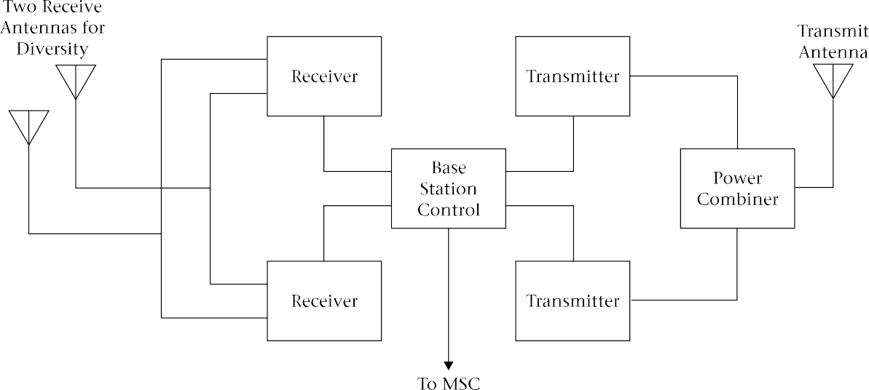
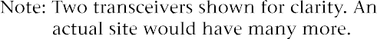

FIGURE 10.7 Cellular radio base station

The combination of the mobile cellular phone and the cell-site radio equipment is known as the air interface. There is much more to cellular tele- phony than radio, however. The network must be organized and administered as a whole. This administration includes keeping track of phone locations, billing, setting up and handing off calls, and so on. The substantial computing resources required to do all this are, at least in part, responsible for the delay in the introduction of cellular telephony for many years after the idea was first proposed.
Figure 10.8 shows a typical cellular telephone system. Each cell has several radio transceivers (one per channel); usually one wideband power amplifier is used to provide the transmit power for all channels in a site (or sector, for sectorized systems). The site’s radio equipment is operated by a base station controller (BSC). The base station controller takes care of

the air interface: assigning channels and power levels, transmitting signaling tones, and so on. The mobile switching centers (MSCs), also called mobile telephone switching offices (MTSOs), route calls along a private copper, fiber optic, or microwave network operated by the cellular service provider.

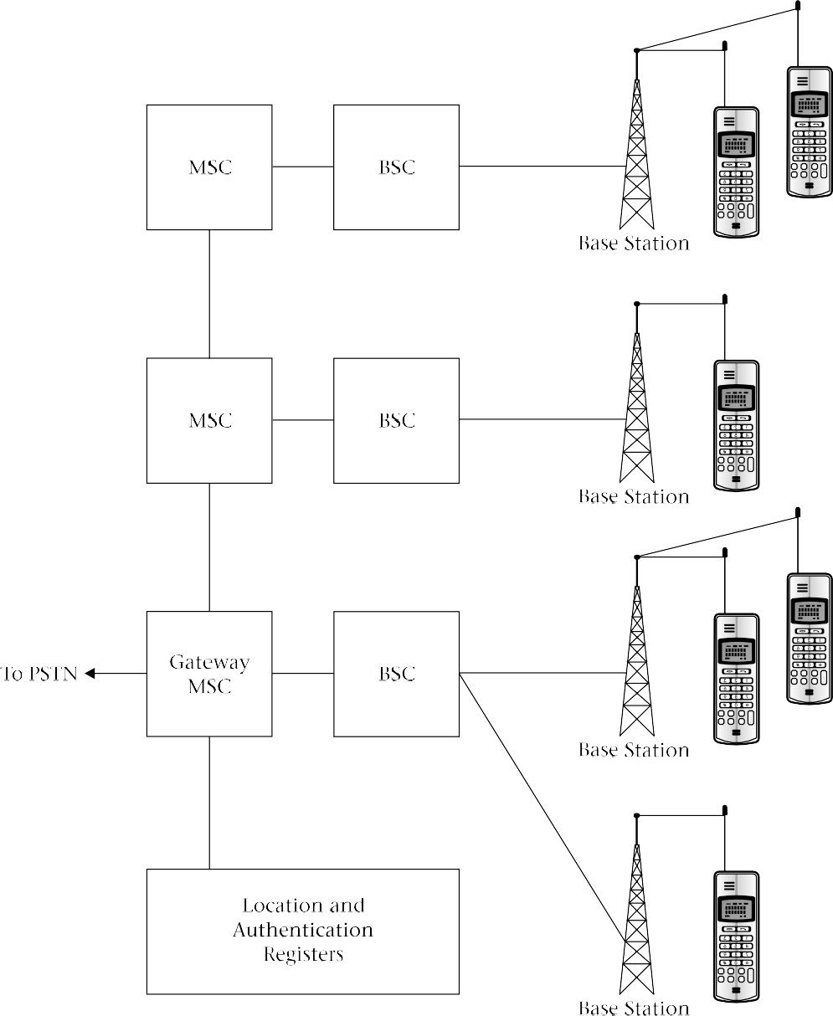
FIGURE 10.8
Cellular radio system

Their action is also required in authorizing calls, billing, initiating handoffs, and so on. Sometimes the BSC and MSC are combined. Associated with the MSCs are data banks where the locations of local and roaming mobiles are stored.
At certain points in the system, the cellular network is connected to the public switched telephone network (PSTN). These gateways allow calls to be made between landline and cellular phones, and between cell phones using different service providers. The cellular system communicates with the PSTN using Signaling System Seven, which was described in Chapter 5.

Traffic and Cell Splitting

The optimum size of a cell depends on the amount of traffic. Ideally, most of the available radio channels should be in use at peak periods, but situations where all channels are in use should be rare. If all channels in a cell are busy, it is impossible for anyone to place a call to or from that cell. The user has to hang up and try again later. This situation is called call blocking and is obviously undesirable. It causes revenue loss, and if it is frequent, unhappy customers may switch to the competing system. (This is always a possibility with the North American AMPS system since there are two competing systems in each area.) Call blocking takes place on the wireline network as well. For instance, long-distance trunks are sometimes unavailable during peak calling periods. This means that customers are used to blocking and will put up with a small percentage, perhaps one or two percent, of calls being blocked.
A more unpleasant situation occurs when a mobile phone moves into a cell that has all its channels busy. The attempt by the system to hand off the call to the new cell is frustrated by the lack of free channels, and the call must be terminated, or dropped. Dropped calls are very inconvenient and sometimes embarrassing, as the effect is the same as if one of the parties had hung up on the other. Call dropping is very rare on the wireline system, so customers are not as tolerant of this problem.
Since call blocking also occurs on the wireline network, which has been in operation for about a century, you might guess that someone has already studied the problem. You’d be correct: A. K. Erlang, a Swedish engineer, studied the problem using statistical analysis early in the twentieth century. He found, not surprisingly, that the more channels there were, the smaller the possibility of blocking for a given amount of traffic. Perhaps less obviously, he found that with more channels, the amount of possible traffic per channel increases for a given blocking probability. This phenomenon is called trunking gain, and it is the reason a two-provider system is theoretically less efficient than one using a single provider.
Trunking gain can perhaps be better understood by looking at an every- day situation: customers lining up to use tellers at a bank. Suppose there are

two tellers and a separate line for each. Further suppose that the lines are as- signed to customers on the basis of the type of accounts they have. Those with checking accounts use the first line, those with savings accounts use the second line.
Now suppose I arrive at the bank. My account is a checking account, but there are several people in line at that window. There is no line at the savings window, but I can’t use that one. I am blocked and decide to try again later. Of course, after several frustrating attempts, I may notice that the competing bank across the street has shorter lines and change service providers. Now my bank changes its policy. There is only one line, and anyone can use the next available teller. The next time I arrive at the bank I have a much lower probability of being blocked. A similar logic applies to many situations: it is always more efficient to combine channels, and the gains are greater with more channels.
Phone traffic is defined in erlangs (E). One erlang is equivalent to one continuous phone conversation. Thus if 1000 customers use the phone ten percent of the time each, they generate 100 E of traffic on average. Mathematically,
T = NP (10.3)
where
T - traffic in erlangs
N -number of customers
P - probability that a given customer is using the phone
We see immediately that traffic analysis does not coordinate channels directly with the number of customers. Real customers may use the phone continuously for an hour, then not at all for the rest of the day. If enough of them use the phone at the same time (afternoon rush hour, for example, is a peak in cell phone usage in cities), the peak traffic will be much greater than the average. Some cell phone owners use the phone continually for business during the working day; others use it mainly for emergencies and generate very little traffic. Also, the usage patterns may vary, in response to changing rates, for instance (lower rates generate more traffic). Evening and weekend use tend to be light for cell phones, just as it is for wireline long distance, and both wireline and cellular providers commonly provide monetary incentives to customers to shift some of their usage to those periods.
The most obvious way to avoid call blocking and call dropping is, of course, to provide more channels. However, the number of channels for the system is fixed, and so is the number per cell once the repeating pattern, usually seven or twelve cells, has been established. In a 12-cell repeating pat- tern, each provider has 395/12  33 voice channel pairs per cell. According to

Erlang’s theory, this number of channels will accommodate about 23 E of traffic for one percent blocking.
The amount of traffic can be increased at the expense of a larger blocking probability. For instance, with 33 channels, a traffic level of 24.6 E can be accommodated with a two percent blocking probability. It might seem at first glance that a 7-cell repeating pattern can allow more traffic, but this is illusory. The cells are each divided into three sectors, using different channels. Therefore, each sector has only 395/21 == 19 duplex voice channels. Using the 7-cell pattern saves money by reducing the number of cell sites needed, not by increasing the number of channels.
Table 10.4 shows traffic levels in erlangs for 19 and 33 channels, with various blocking probabilities. It also shows traffic levels for larger numbers of channels. We’ll use these with digital cell phones shortly.

TABLE 10.4 Cellphone Traffic in Erlangs per Cell or Sector

Blocking Probability
Number of Channels | 1% | 2% | 5%
19 | 11.2 | 12.3 | 14.3
33 | 22.9 | 24.6 | 27.7
55 | 42.4 | 44.9 | 49.5
97 | 81.2 | 85.1 | 92.2

The other way to increase capacity is to increase the number of cells. The number of channels per cell remains the same as before, but since each cell covers a smaller area, with less potential traffic, the probabilities of call blocking and call dropping are reduced. The downside of this, of course, is that the expense of the system increases with the number of cell sites, and more frequent handoffs occur, increasing the system overhead.
This reduction of cell size to increase traffic is called cell-splitting.
Cell-splitting allows the network to begin with large cells throughout, with

the cell size decreasing in high-traffic areas as the traffic increases. Cellular telephone infrastructure is expensive, but it does not all have to be built at once.
Cell-splitting allows spectrum space to be used more efficiently, but it is not particularly cost-effective in terms of equipment. Doubling the number of cells doubles the system capacity with the same bandwidth allocation, but it also doubles the number of cell sites, roughly doubling the system cost.

Microcells, Picocells and Repeaters
Cell-splitting, as described in the preceding paragraphs, can be used to in- crease the capacity of a cellular system. At a certain point diminishing returns set in, however. Cell sites are expensive, and the increase in capacity does not justify the increase in cost for very small cells. Another problem is that real estate costs are highest in the areas where demand is greatest, and the use of small cells means less choice in cell-site location and thus higher costs for access to the sites. Finally, there is increased load on the switching system due to the increase in the number of handoffs with small cells.
In high-demand areas, microcells are often used to help relieve the con- gestion at relatively low cost. A microcell site is a very small unit that can mount on a streetlight pole. The microcell antenna is deliberately mounted lower than the tops of nearby buildings to limit its range. A typical microcell covers about 500 meters of a busy street, but has very little coverage on side streets. See Figure 10.9 for a typical unit.

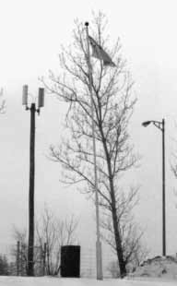
FIGURE 10.9
Microcell site
(Courtesy of Bell Mobility)

Because microcells have such small, narrow patterns, it is difficult to obtain general coverage this way. Consequently the original larger cells (macrocells) are left in place, so that calls can be handed off between micro- cells and conventional cells as required. The microcells must use different frequencies than the overarching conventional cells, of course; this is accomplished by assigning to the microcells some of the channels that were formerly used by the macrocells.
A microcell is often under the control of a conventional cell site, with which it usually communicates by microwave radio. The microcell may itself be divided into several zones. Figure 10.10 illustrates how microcells and conventional cells (sometimes called macrocells) can work together.

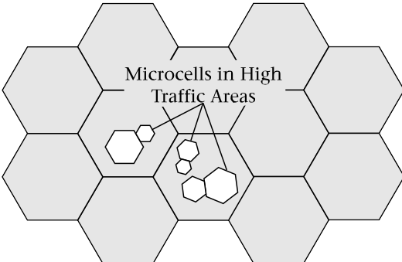
FIGURE 10.10
Overlay of microcells and macrocells

In order to save costs, many microcell sites are not true transceivers but are only amplifiers and frequency translators. Figure 10.11 on page 396 shows the idea. The main cell site up-converts the whole transmitted spectrum to microwave frequencies. The transmitter at the microcell site simply down-converts the block of frequencies to the cellular-radio band and amplifies it. No modulation or channel switching is required at the microcell site. Similarly, the microcell’s receiver consists of a low-noise amplifier that amplifies the entire frequency range in use at that site plus an up-converter to convert the signal to microwave frequencies. All demodulation is handled at the main cell site.
Sometimes cellular radio signals are too weak for reliable use indoors. This is especially true in well-shielded areas like underground concourses. When reliable indoor reception is needed, sometimes very small cells called picocells are used. These are more common with the PCS systems to be described in the next chapter but are sometimes used with AMPS.
Indoor picocells can use the same frequencies as the outdoor cells in the same area if the attenuation of the structure is sufficient. This is the case in underground malls, for instance.

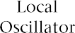
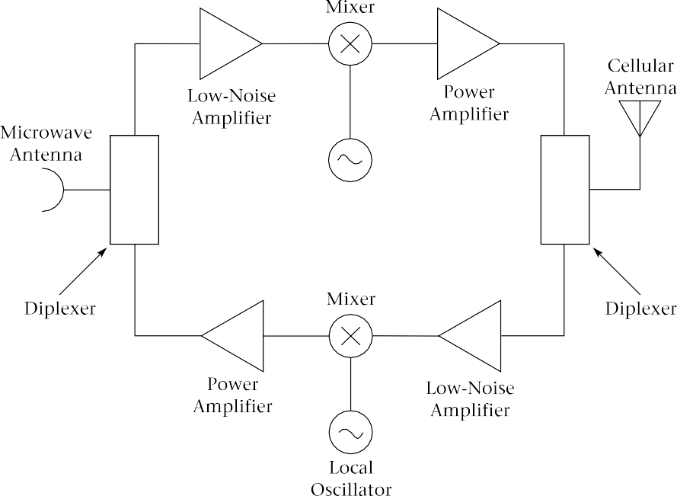
FIGURE 10.11
Microcell block diagram

Sometimes the problem is not excessive traffic, but a “hole” in the system coverage caused by propagation difficulties, such as a tall building or hill that casts a radio shadow. Obviously cell sites should be chosen to minimize these problems, but it is not always possible to eliminate them completely. In that case a repeater can be used, as shown in Figure 10.12. The repeater simply amplifies signals from the cell site and from the mobiles.

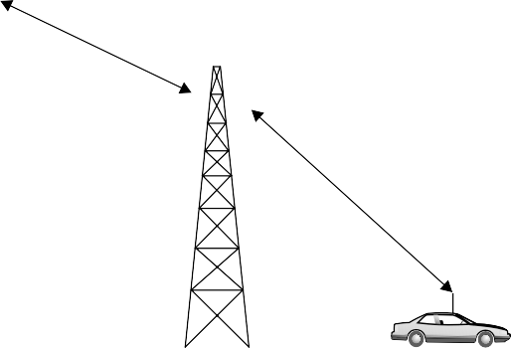
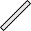
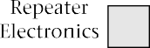
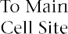
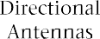
FIGURE 10.12
Cellular repeater

It can be connected to the main site by a microwave link, but often the repeater simply receives and transmits at the same frequencies, avoiding feedback by careful location of directional transmit and receive antennas.

Fax and Data Communication Using Cellular Phones
As can be seen from the foregoing, AMPS is a circuit-switched analog system designed for voice communication, as was the wireline system in its original form. Consequently, the most straightforward way to send data, as with the conventional wireline system, is to use modems at each end of the link. It is also possible to send packet-switched data using AMPS, as will be described shortly.

Cellular Modems The main differences between wireline phone service and analog cellular phones, for modem use, is that cell phone connections tend to be noisier and are subject to interruption during handoffs and fading. These interruptions, though brief in human terms (usually on the order of 100 ms to about 2 s), result in the loss of a considerable amount of data and possibly in a dropped connection. Consequently, the error-correction schemes on modems for cell phone use should be more robust than is necessary for wire- line operation. Of course, this greater robustness results in slower data trans- mission. In addition, the modem must be set up not to require a dial tone before dialing. The dialing connections must be made separately to the phone: the situation is more complex than just plugging in a phone jack, as for a landline modem.
Many (but not all) modem cards for notebook and laptop computers will work with cell phones. Similarly, many, but not all, cell phones can be used with modems. A proprietary cable is required to connect modem to phone. It is also possible to find cell phone cards which plug into a note- book computer and enable it to send data via cellular radio.
Cellular modems are advertised as having speeds of up to 28.8 kb/s but actual speeds are usually 9600 b/s or less. Performance is improved by operating from a stationary vehicle, as this eliminates handoffs and reduces fading.
An error-correcting protocol called MNP10 is usually used with cellular connections. It must be used at both ends of the connection. MNP10 in- corporates some special cellular enhancements. For instance, rather than

trying to connect at the maximum speed and reducing speed if necessary, an MNP10 modem starts at 1200 b/s and gradually increases the speed. Multiple attempts are made to connect, and the packet size starts small and increases provided error rates remain low.
Another protocol, developed by AT&T, is called Enhanced throughput cellular (ETC). It has the advantage of being able to work with a conventional wireline modem at the other end of the connection while retaining at least some of its benefits.
In order to allow communication between cellular modems and conventional wireline modems which may lack these more robust protocols, some cellular providers maintain a modem pool. This allows for conversion be- tween cellular and wireline standards. Generally, the cellular user accesses this service by dialing a special prefix before dialing the telephone number of the landline modem. See Figure 10.13 for the idea.

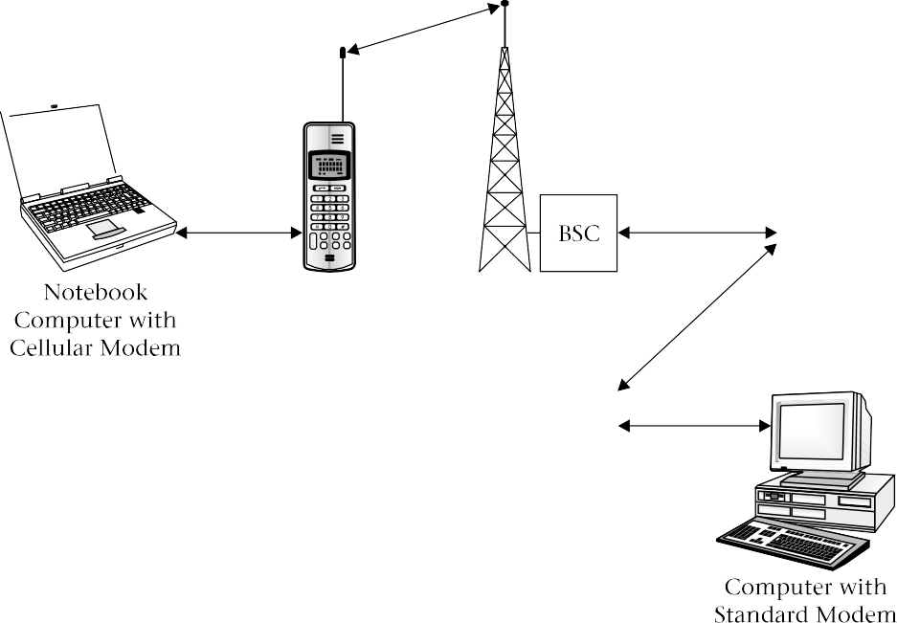
FIGURE 10.13
Data transmission by cellular radio

Facsimile transmission is also possible with cell phones. A fax modem and notebook computer can be used, or a conventional fax machine can be used with a special adapter. The adapter allows the cell phone to simulate a conventional two-wire telephone line with dial tone. Fax performance is much better from a stationary vehicle, since no special protocol is used.

Cellular Digital Packet Data
(CDPD)

The previous section describes how data can be sent over a cellular voice channel in a manner similar to that used with landline telephony. That procedure is relatively simple and requires no prior arrangement with the cellular service provider, but it tends to be expensive, as full airtime costs, plus long-distance costs if applicable, must be paid for the entire time the call is connected.
Another way exists to send data over the AMPS cellular radio system. The Cellular Digital Packet Data (CDPD) system uses packet-switched data and tends to be less expensive than using a cellular modem, especially when data needs to be transmitted in short bursts. On the other hand, a separate ac- count is required, and the cellular system has to be specially configured to use CDPD.
The principle behind CDPD is that at any given moment there are usually some voice channels in an AMPS system that are not in use. The CDPD system monitors the voice channels, using those that are idle to transmit data. When traffic is detected on the voice channel, the data transmissions cease within 40 ms. Since this is less than the setup time for a voice call, the voice customer is not affected. Users, once registered with the CDPD system, can transmit data as required without maintaining a continuous connection and tying up an expensive pair of voice channels.
The bit rate in the RF channel for CDPD is 19.2 kb/s, achieved using Gaussian minimum-shift keying (GMSK), a form of FSK. When overhead is taken into account, the maximum data rate is comparable to that obtained with a 14.4 kb/s modem—slow by current wireline standards, but not too bad for wireless. When the network is busy, the throughput is lower, as packets are stored and forwarded when a channel becomes available.

Digital Cellular Systems
Until recently, digital voice communication used more bandwidth than analog. The conventional wisdom was that digital was preferred where bandwidth was not an issue, because of its flexibility and immunity to the accumulation of noise, but that analog was better when bandwidth was constrained. For instance, you will recall that wireline telephony uses 64 kb/s for each one-way voice channel. In order to transmit this data rate in a 30-kHz channel, an elaborate modulation scheme would be needed. This would not be robust enough for the mobile radio environment with its noise and fading. Consequently, all first-generation cellular radio systems use analog modulation schemes. FM needs more bandwidth than AM and its variants, but it was found that FM’s resistance to noise and interference more than made up for the additional required bandwidth.

Recent advances in data compression and voice coding, as discussed in Chapter 3, have reversed the conventional wisdom about bandwidth. It is now possible to transmit a digitized voice signal in less bandwidth than is re- quired for an analog FM signal. This removes the last big obstacle to digital communication. Digital systems still tend to be more complex than analog, but large-scale integrated circuits have made it possible to build complex systems at low cost and in small packages. In fact, it appears likely that the analog cellular radio system just described will be the last of the great analog communication systems. Soon there will be no reason to use analog except for compatibility with legacy systems and perhaps for very low-cost communication devices.
Analog cellular radio can be seen as the first generation of wireless communication. Digital systems, which we begin to examine here and continue in the next chapter, are the second. The third generation will undoubtedly be digital. Its exact makeup is being debated at this time.

Advantages of Digital Cellular
Radio

The main incentive for converting cellular radio to a digital system was, as suggested earlier, to reduce the bandwidth requirements, allowing more voice channels in a given spectrum allotment. Other reasons also exist. Digital systems have more inherent privacy than analog, being harder to decode with common equipment. They also lend themselves to encryption, if required. Note that analog AMPS already uses digital signaling data. The fact that it is not encrypted is due to oversight: the system designers underestimated the ingenuity of hackers.
Digital communication systems can use error correction to make them less susceptible to noise and signal dropouts. They lend themselves to time- and code-division multiplexing schemes, which can be more flexible than the frequency-division multiplexing used in analog systems. Digital signals are easier to switch: in fact, most of the switching of analog telephone signals, including AMPS cellular telephony, is done digitally after analog- to-digital conversion.
The gradual conversion of the world’s cellular radio systems to digital form has been accomplished differently in various parts of the world. In North America, which is the focus of this book, there existed one analog system with a very large installed base. Most of this infrastructure was not yet fully paid for, so operators were understandably reluctant to replace it. The requirement was for a digital system that would allow as much as possible of the analog equipment to be retained.
There were also millions of analog phones in consumers’ hands. Many of these also were not yet paid for, especially since operators had given many analog phones to customers in exchange for service contracts. Perhaps you

still have one of these (the author does). Making the analog phones obsolete would probably obligate the operators to provide new digital phones to their customers at no charge.
For these reasons, the system that evolved in North America uses the same radio frequencies, power levels, and channel bandwidths as AMPS. Some of the existing analog channels were converted to digital, leaving some analog channels in place in every cell for coexistence with analog equipment. The reduction of bandwidth requirements for digital communication allowed those analog channels that were converted to digital to com- bine three communication channels on one RF channel using TDMA, as described in the following section. The new system is so similar to AMPS that sometimes it is referred to as digital AMPS (D-AMPS).
The situation in Europe was completely different. Almost every country seemed to have a different analog cell phone scheme. Some had more than one! There were even several different frequency bands in use in different countries. The European Community made the radical decision to scrap the entire analog infrastructure and begin again with a common digital system. This system is called GSM (Global System for Mobile). It is not used in the cellular radio bands in North America but it is one of three systems in use for North American PCS, so GSM will be described in the next chapter.
Other countries varied in the type and extent of analog cell phone penetration. The result is a worldwide mixture of incompatible analog and digital formats, which will probably continue at least until the third generation of wireless telephony.

Conversion of AMPS to TDMA

The compatibility requirements outlined in the previous section con- strained the development of a digital cellular radio system for North America. It was decided to combine three digital voice channels into one 30-kHz radio channel using TDMA. This is known as a full-rate TDMA system. The first such system went into operation in 1990. The specifications also encompass a half-rate system with six voice channels in one 30-kHz slot to be implemented at a later date when vocoder technology has improved.
The digital system would seem to be able to carry three times as much traffic as the analog system, but, due to trunking gain, the actual increase for a given level of blocking is greater. In the last two lines of Table 10.4, the traffic for various blocking probabilities is shown for both 7-cell sectorized and 12-cell repeating systems. The numbers of voice channels are calculated on the basis that one analog channel, for backward compatibility, is available in each cell or sector. Note that the traffic capacity is more than tripled.
At first, the AMPS control channels were left alone, and only the voice channels were digitized. This digital specification is known as IS-54B. A later

modification (1991), called IS-136, added high-speed digital control channels for better security and additional features. IS-136 is used both in the 800-MHz cellular radio band and the 1900-MHz PCS band.

TDMA Voice
Channel
Figure 10.14 shows how the RF voice channel is divided in the TDMA system. There are 25 frames per second so each frame is 1/25 s = 40 ms in length. Each frame has 1944 bits so the total bit rate for the RF signal is 1944
- 25 = 48.6 kb/s. Phase-shift keying with four levels( π/4 QPSK) is used, so there are two bits per symbol and the baud rate is 24.3 kbaud. Note that this is a data rate of 48.6/30 = 1.6 b/s per hertz of bandwidth. This is quite conservative, necessarily so because of the radio environment, which is subject to noise, interference, and very deep fading.

FIGURE 10.14
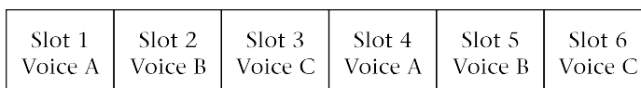
TDMA frame

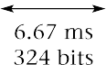

Each frame has six time slots lasting 40 ms/6 = 6.67 ms and containing 1944/6  324 bits each. For full-rate TDMA, each voice signal is assigned to two time slots as shown. Six voice signals, occupying one slot each, can be accommodated with half-rate TDMA. For the full-rate system, speech data corresponding to 40 ms of real time is transmitted in 2 × 6.67 ms = 13.3 ms. As with analog AMPS, the TDMA system uses separate RF channels for trans- mit and receive.
Speech encoding (see Chapter 3) is used to limit the bit rate to approximately 8 kb/s for each speech channel for the full-rate system. The full-rate system allocates two noncontiguous time slots to each voice channel: slots 1 and 4 for the first, 2 and 5 for the second, and 3 and 6 for the third. In addition, the bits corresponding to each 20 ms of speech are divided among two time slots. Interleaving the data bits in this way reduces the effect of burst errors.
Overhead reduces the number of data bits available per time slot to 260. The data rate available for each voice channel is 260 bits/20 ms  13 kb/s. The voice is actually encoded at 7.95 kb/s and the remaining bits are used for error correction. The half-rate system will use 4 kb/s for voice coding.

The frames as just shown are similar for both forward (base to mobile) and reverse (mobile to base) channels, but the composition of the time slots differs. The frames are synchronized for the forward and reverse channels, but the timing is offset so that a frame starts 90 bits (1.85 ms) earlier at the mobile. A mobile transmits during two of the six time slots and receives on a different two slots. The remaining two time slots are idle: the phone may use these to check the signal strength in adjacent cells to assist in initiating a handoff. This technique allows the digital cell phone to have only one transmitter and one receiver, just as for AMPS. In fact the RF situation is a little simpler, since there is no need for the mobile to transmit and receive simultaneously. (Since digital cell phones have to work with the analog AMPS system as well, this unfortunately does not really simplify the design, as a duplexer is still needed for analog operation.)
Each slot contains 324 bits for both forward and reverse channels. The allocation of these bits is different for the forward and reverse links, how- ever. See Figure 10.15 for an illustration of the differences.
In particular, the mobile needs time to turn its transmitter on for each transmit time slot, since to avoid interference it must be off when the mobile is not scheduled to transmit. Six bit periods (123 µs) are allocated to this. The base station transmitter is on all the time, since it uses all six time slots to

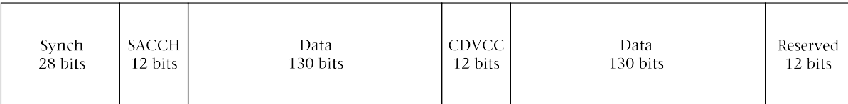

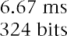
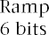
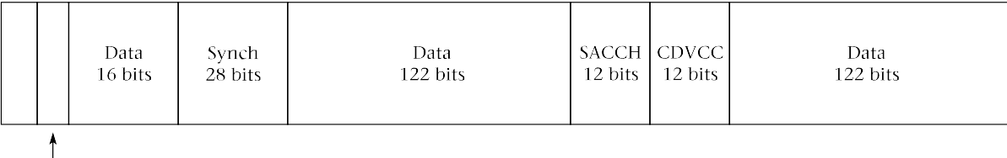
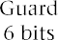

FIGURE 10.15 TDMA voice time slots

transmit to three mobiles on the same RF channel. The mobile also waits for a guard time (another six bits) to pass before transmitting. This is necessary because different amounts of propagation delay could cause mobile trans- missions (on the same RF channel but in different time slots) to overlap when received at the base station.

In addition to voice samples and their associated error correction, the digital traffic channels contain synchronizing, equalizer training, and control information.
The Coded Digital Verification Color Code (CDVCC) provides essentially the same information as the Supervisory Audio Tone (SAT) in AMPS. The Slow Associated Control Channel (SACCH) provides for control signal ex- changes during calls and essentially replaces the blank-and-burst signaling in AMPS, though there are provisions to “steal” voice data bits for additional control information as required. These stolen bits form the Fast-Associated Control Channel (FACCH), which is used for urgent information such as handoff commands. The coded digital locator (CDL) field tells the mobile where to find digital control channels, if available.

TDMA Control
Channels

As mentioned, there are two “flavors” of TDMA cellular radio in use. The earlier specification, called IS-54B, uses the same control channels and formats as AMPS. These are called Analog Control Channels (ACCH) because of their association with the analog system, but as noted earlier, they are actually digital, using FSK and a channel data rate of 10 kb/s.
The IS-136 specification incorporates separate control channels for the digital system. These are called Digital Control Channels (DCCH) to distinguish them from the older type. Digital control channels consist of pairs of slots on the same RF channels that are used for voice. The DCCH can be as- signed to any RF channel; it does not have to be one of the 21 control channels used in the analog system. As with the voice channels, separate forward and reverse channels are needed. Normally there is one DCCH pair per cell, or per sector in a sectorized system. See Figure 10.16.

FIGURE 10.16
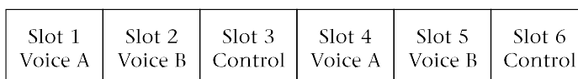
TDMA digital control channel

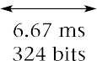

The total bit rate for a DCCH is one-third of the RF channel bit rate, or 44.6/3  14.9 kb/s, compared with 10 kb/s for an ACCH. This extra capacity makes the digital control channels useful for many added features, such as call display and short text messages. As with the analog system, digital control channels are used in setting up calls. They cannot be used during a call, since the single receiver in the mobile unit is otherwise occupied.

Privacy and Security

in Digital Cellular Radio

Privacy is considerably improved in digital cellular radio compared to the analog system. Ordinary analog scanners can make no sense of the digitized voice signal. Even decoding it from digital to analog is not straightforward, due to the need for a vocoder. However, obviously vocoders are present in all digital cell phones, so a modified cell phone could do the job.
There is some encryption of the authorization information in the TDMA system, enough to make cell phone cloning and impersonation difficult. In general the level of security of the TDMA system is considerably better than with AMPS and is probably adequate for general use.

Dual-Mode Systems and
Phones
One of the most important features of the TDMA digital cellular radio system is its backward compatibility with AMPS. Cell-site radio equipment does not need to be replaced, and provided that all cells keep some analog channels, neither do analog cell phones. Cell sites can incorporate digital channels as needed to cope with increased traffic.
Since not all cells are expected to have digital channels in the near future, it is necessary for digital cell phones to work with the analog system as well. While analog-only phones will continue to work throughout the system, digital-only phones would work only in major metropolitan areas. Therefore, all current TDMA digital cell phones are dual-mode: they attempt to make a digital connection first, then if that fails, revert to analog.
One difference in the RF component of TDMA cell phones is the addition of a new power class, Class IV. This is the same as the analog Class III, except for the addition of three new power levels at the bottom of the range. These levels of 26, 30, and 34 dBW ERP allow for better operation with microcells. In addition, lower power levels, coupled with the fact that the transmitter operates only one-third of the time, help to improve battery life in digital mode.

Figure 10.17 is a block diagram for a typical dual-mode TDMA cell phone. Note that a duplexer is required for analog operation. The transmitter power amplifier is linear, because QPSK requires this. Of course, a linear amplifier is also satisfactory for FM and FSK. The fact that the channel band- width and frequencies are the same for analog and digital systems simplifies the RF design. For instance, only one receiver IF filter is needed.
When we look at PCS systems in the next chapter, we’ll see that the TDMA system just described is one of three systems used for PCS. This allows for the possibility of dual-mode, dual-band phones incorporating analog AMPS, as well as both digital cellular and TDMA PCS modes.

Data Communication with Digital Cellular Systems

Paradoxically, connecting data equipment like modems and fax machines to digital cell phones can be more complicated than with the ordinary analog system. Since voice is encoded using a vocoder, it is not satisfactory simply to insert modem tones instead of an analog voice signal. The vocoder is optimized to code voice and will make a mess of any other kind of input. In fact, even DTMF tones from the phone’s keypad have to bypass the vocoder and be transmitted digitally in a time slot of their own.
Circuit-switched data communication can be accomplished with the digital system by inputting the data directly to the voice time slots without using the vocoder. The data rate is limited to 9600 b/s to allow for additional error correction and still fit within the 13 kb/s allocated for voice data. Of course, the system has to be told about this, so that the data can be output properly at the other end.

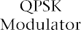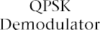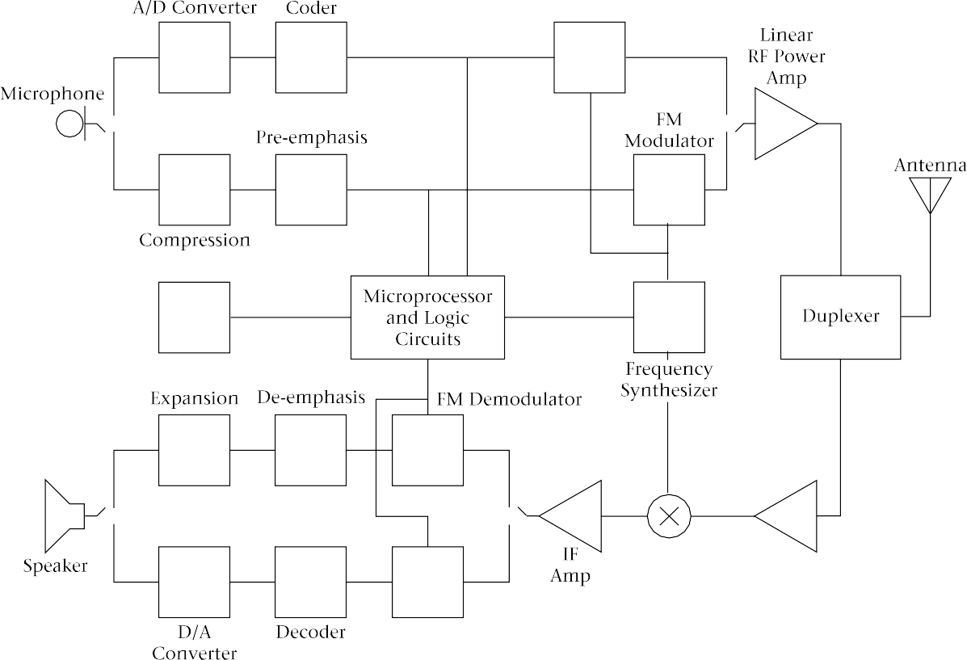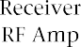

FIGURE 10.17 Block diagram of dual-mode cell phone

In practice, since all 800-MHz digital cell phones and cell sites are also capable of analog operation, the usual way of sending data is to use an analog channel and a cellular modem as previously described. Similarly, packet-switched data can be sent via the analog system using CDPD as al- ready described. Short data messages can be sent using the digital control channel.

Differences Between Cellular Systems and PCS
Though based on the same cellular idea as the first-generation cell phone systems described in Chapter 10, PCS have significant differences which justify the use of a different term. You should realize, however, that many of the differences are transparent, or at least not immediately obvious, to the user. The systems described in this chapter are often called second generation personal communication systems; in other words, the analog cell phone system is really the first generation of PCS. The third generation, now being designed, will feature much wider bandwidth for high-speed data communication and it will be discussed in Chapter 14.

Frequency Range One of the reasons for establishing new PCS was that the cellular frequency bands were becoming crowded, especially in major metropolitan areas. There was no room for expansion in the 800-MHz band, so the new service was established in the 1900-MHz band (1800 MHz in Europe). This has ad- vantages in terms of portable antenna size. A few years ago, electronics for this frequency range would have been prohibitively expensive, but advances in integrated circuit design have reduced the cost penalties.
In North America the broadband PCS band consists of 120 MHz in the 1900-MHz region. The term broadband here is relative. It refers to bandwidth sufficient for voice communication and distinguishes this service from such narrowband services as paging, which will be discussed later in this book. Sometimes the term broadband communication is used to refer to video and high-speed data; that is not the sense in which it is used here.

See Table 11.1 for the PCS band plan. Note that there are six frequency allocations, so up to six licenses can be awarded in any given area. There are three 30-MHz and three 10-MHz allocations. The reverse channel or uplink (mobile to base) is 80 MHz above the forward channel or downlink (base to mobile) frequency. Reverse and forward channel allocations are separated by a 20-MHz band, from 1910 to 1930 MHz, which is allocated for un- licensed services like short-range voice communication. In the United States the frequencies have been assigned by auction; in Canada licenses were allocated after public hearings. Some PCS carriers are established cellular providers with 800-MHz licenses; others are new to the field of wireless communication.

TABLE 11.1 Broadband PCS Band Plan

Allocation | Base Transmit (Forward Channel or Downlink)* | Mobile Transmit (Reverse Channel or Uplink)*
A | 1850–1865 | 1930–1945
B | 1870–1885 | 1950–1965
C | 1895–1910 | 1975–1990
D | 1865–1870 | 1945–1950
E | 1885–1890 | 1965–1970
F | 1890–1895 | 1970–1975
*Frequencies are in MHz

Smaller Cell Size Cellular telephony was originally conceived as a mobile radio system, with phones permanently mounted in vehicles. These phones use efficient external antennas on the roof of the vehicle and have a maximum ERP of 4 W. However, in recent years portable cell phones have outsold mobile phones by a considerable margin. This has implications for the system, as portable phones have lower power and are often in difficult locations—from a propagation point of view—such as inside vehicles and buildings. For these rea- sons, portable AMPS cell phones may not work reliably near the edges of the larger cells. PCS, on the other hand, were designed from the beginning with handheld phones in mind. At first it was thought that most PCS users would be on foot, but it is now quite obvious that subscribers expect to use the phone wherever they are: outdoors, indoors, in an underground shopping mall, or in their cars.

PCS cells are typically smaller than AMPS cells to accommodate more traffic and low-power handheld phones. They must hand off calls very quickly to handle users in moving cars.

All-Digital System Because of technical constraints, all first-generation cellular systems are ana- log, though some progress has been made in converting them to digital technology. In fact, some providers have marketed 800-MHz digital cell phones as “PCS” systems.
Current digital technology is more efficient than analog FM in its use of bandwidth. It also allows lower power consumption in the portable phone and more advanced data communication and calling features. Security and privacy are inherently better with any digital system, since ordinary scanners cannot be used to intercept calls, and digital coding schemes can also incorporate encryption as required.
There is one major problem with North American digital PCS. Whereas first-generation cellular systems in North America all use the same analog technology, there are three incompatible digital systems in North America. This makes roaming more difficult with PCS than with cellular phones. Many providers and phone manufacturers have solved this problem by offering dual-band, dual-mode phones that are capable of both PCS and ana- log cellular operation. The solution is not ideal, because it results in phones that are larger and more expensive than they would otherwise have to be.

Extra Features
Coverage
Rate Structure AMPS systems were designed with POTS (plain old telephone service) in mind. Even features commonly found on wireline phones, such as call display, present problems in AMPS. Digital systems allow a substantial amount of data transmission in their control channels, making all sorts of enhancements possible. In addition to obvious features like call display, digital systems can allow short printed messages, and even e-mail and limited web browsing are possible without additional modems and computers. The features available and the way they are implemented vary with the type of PCS, and we will look further into this later in this chapter.

At least at present, the coverage for any PCS is much less universal than it is for AMPS cell phones. This will undoubtedly change in the future, as the systems acquire more customers and build more infrastructure. In the mean- time PCS users have to pay more attention to local coverage areas than do analog cell phone users.

One of the arguments for PCS is that they should be less expensive than analog cellular radio. The utilization of spectrum space is more efficient, for ex- ample. In practice, rates tend to be set by a combination of market forces. The analog systems have a head start in paying for their infrastructure and have been able to lower prices to match PCS in many cases.

IS-136 (TDMA) PCS
We looked at IS-136, the North American Digital Cellular standard, in Chapter 10. Most people just refer to it as TDMA (time division multiple access) when they are talking about PCS, though GSM is also a TDMA system. The most important difference between the 800-MHz and 1900-MHz versions of TDMA is that there are no analog control channels in the PCS bands. Rather than go over the ground already covered in Chapter 10, in this chapter we will take a closer look at the digital control channel and consider how enhanced services are provided. Much of this material is very similar for the GSM system, described next.

TDMA Digital Control Channel

Recall from Chapter 10 that the digital control channel (DCCH) uses two of the six time slots in a TMDA frame (slots 1 and 4, to be precise). Normally only one DCCH is required per cell or sector. Figure 11.1 shows how the time slot is divided up for both forward and reverse channels.

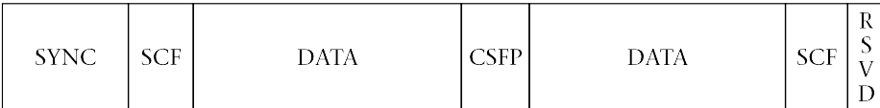
FIGURE 11.1
TDMA digital control channel

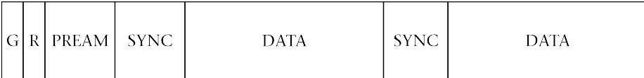

Let us look at the forward channel first. The SYNC (synchronizing) bits have the same function as for the voice channels, allowing the mobile receiver to lock on the beginning of the transmission. The SCF (shared channel feedback) bits perform several functions. They provide acknowledgement of messages from mobiles and inform the mobiles of the status of the reverse control channel. Just as in analog AMPS, the forward channel is under the control of the base station, but many mobiles share a single reverse control channel. By monitoring the status of the reverse channel as reported by the base in the SCF field, the mobiles can reduce the possibility of collisions. These still occur occasionally; however, in that case, the message from the mobile will not be acknowledged by the base, and the mobile will try again after a random delay time.
The CSFP (coded super frame phase) bits identify the location of this time slot in a larger frame that extends over 16 TDMA frames or 32 blocks of control-channel data, representing a time period of 640 ms. Each block is designated as containing broadcast, paging, messaging, or access response information. Each of these types of data can be considered a separate logical channel of data, time-division multiplexed with the other types and with voice as well, since four of every six timeslots on the RF channel that carries the control channel are still used for voice. The number of control-channel blocks assigned to each type of use can be varied within limits. Table 11.2 on page 424 summarizes the logical channels, and a brief description of each is given below.
Two super frames comprise a hyper frame. The hyperframe structure al- lows data to be repeated. This means that a mobile receiver can check the signal strength on other channels, without missing data. It also provides redundancy: if the mobile misses some data because of a burst error, it gets a second chance.
The broadcast channel contains information intended for all mobiles. It is divided into two components. The fast broadcast channel (F-BCCH) is used to transmit system parameters to all the mobiles. These include the structure of the superframe itself, the system identification, and registration and access parameters. All of these must be communicated to the mobile before it can place a call, so all of this information is transmitted at the beginning of each superframe. The extended broadcast channel (E-BCCH) has less critical in- formation, such as lists of the channels used in neighboring cells. This information can be transmitted over the course of several superframes.
The short message service, paging, and access channel (SPACH) is used for control messages to individual telephones and for short paging-type messages to be displayed on the phone. It is not necessary for every phone to monitor all these messages; the phone is told which block to monitor and can go into an idle or sleep mode the rest of the time while it waits for a call. This helps to extend battery life.

The reverse control channel is quite different from the forward channel. There is no broadcast information; there is only one logical channel called the Random Access Channel (RACH). This is used by the mobile to con- tact the base, for registration, authentication, and call setup. Normally the mobile will find out from the broadcast channel whether this channel

TABLE 11.2 Logical Channels in the Data Section of the TDMA Digital Control Channel

Name of Channel |  | Function | Time Slots per Superframe
Broadcast Channel (BCCH) | Fast Broadcast Channel  (F-BCCH) | Urgent information for all mobiles, transmitted once per superframe, at beginning of superframe:  ( Superframe structure ( System identification ( Access parameters  ( Registration parameters | 3–10
 | Extended Broadcast Channel (E-BCCH) | Less urgent information for all mobiles (transmitted over several superframes):  ( Neighbor lists (control channel frequencies in nearby cells)  ( Regulatory configuration (spectrum allocation)  ( Mobile assisted-channel allocation (frequencies mobiles should monitor) | 1–8
Reserved |  | As needed by system | 0–7
Short Message Service, Paging, and Access Channel (SPACH) | Short Message Service Channel (SMSCH) | ( Short message service  ( Remote phone programming | Remaining Slots
 | Paging Channel (PCH) | Paging (ringing mobile phone)
 | Access Response Channel (ARCH) | Control messages to individual phones

is clear; if that information is available, it can transmit at random. If there is no acknowledgement, it probably means a collision has occurred, and the mobile will try again after a short random delay. As with the reverse voice channel, time has to be allocated for ramping up the mobile transmitter power, and guard time is needed to avoid interference between mobiles at different distances from the base. Ramp time is shown as R and guard time as G, in Figure 11.1(b).

11.4 GSM
GSM is the system used in Europe and most of Asia for both cellular and PCS bands. It is not found at 800 MHz in North America, but it is used in the 1900-MHz PCS bands. Note that, even though the same modulation scheme is used, North American PCS phones will not work in Europe because the frequencies allocated to PCS are different—the European bands center around 1800 MHz.
GSM is another TDMA system but the details are different. GSM also has some unique features that make it arguably more sophisticated and versatile than IS-136. It is not compatible with existing IS-136 cell site equipment, but this is not an issue for the new PCS-only providers, as they have no legacy equipment with which to maintain compatibility.

GSM RF Channels and Time Slots

GSM channels are 200 kHz wide (compared with 30 kHz for IS-136 TDMA). The total bit rate for an RF channel is 270.833 kb/s; the modulation is a variant of FSK called GMSK (Gaussian minimum shift keying) using a frequency deviation of 67.708 kHz each way from the carrier frequency. GMSK was described in Chapter 4.
Voice channels are called traffic channels (TCH) in GSM. One RF channel is shared by eight voice transmissions using TDMA. In terms of spectral efficiency, GSM works out to 25 kHz per voice channel, compared to about 30 kHz for AMPS and about 10 kHz for TDMA. This is an approximate comparison as it ignores differences in control-channel overhead.
As in TDMA, the mobile transmitter operates only during its allotted time slot (one-eighth of the time, compared with one-third of the time in TDMA.) Other things being equal, a GSM phone should have longer battery life than a phone using either AMPS or TDMA.
Figure 11.2 on page 426 shows the structure of an RF channel and its division into time slots (called bursts in GSM).
Control information in GSM is on two logical channels called the broadcast channel (BCCH) and the paging channel (PCH). As with TDMA, it is unnecessary

FIGURE 11.2
GSM RF
channel

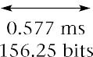

to use a whole RF channel for this. Instead, one of the eight time slots on one RF channel in each cell or sector is designated as a control channel. The broad- cast information is transmitted first, followed by paging information. See Figure 11.3 for an illustration.

FIGURE 11.3
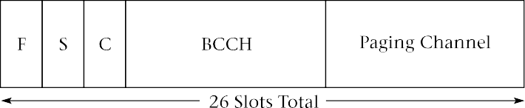
GSM control channel

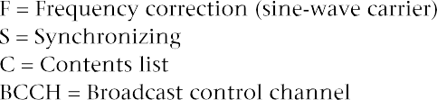

The BCCH and PCH are forward channels only. The corresponding re- verse channel is called the random-access channel (RACH) and is used by the mobiles to communicate with the base. Mobiles transmit on this channel whenever they have information; if a collision occurs, the mobile waits a random time and tries again. Transmissions are shorter than the duration of the slot to prevent interference caused by the propagation delay between mobile and base. The delay problem is avoided on the traffic channels, be- cause the base instructs the mobile to advance or retard the timing of its transmissions to compensate for the changes in propagation delay as it moves about in the cell.
Just as with TDMA, it is also necessary to send control information on the traffic channels. This is because the mobile has only one receiver; it can- not count on receiving the broadcast channel during a call, because both channels may use the same time slot. Also as with TDMA, there are two control channels associated with the traffic channel. The Slow Associated Control Channel (SACCH) uses one of every 26 bursts on the voice channel. It is used

to inform the base of power measurements made by the mobile of signal strength in adjacent cells. The Fast Associated Control Channel (FACCH) “steals” bits from the voice signal and is used for urgent messages from the base, such as handoff instructions.

Voice Transmission
Each voice transmission is coded at 13 kb/s. A linear predictive coder, which models the way sounds are produced in the human throat, mouth, and tongue, is used. Such coding allows the bit rate to be greatly reduced com- pared with straightforward PCM. In the future, it is planned to use more advanced voice coders (vocoders) to allow the bit rate to be reduced to 6.5 kb/s, doubling the capacity of the GSM system. Note the similarity with full- and half-rate TDMA, which code voice at 8 and 4 kb/s, respectively. See Chapter 3 for a discussion of vocoders.
The bits from the vocoder are grouped according to their importance, with the most significant bits getting the most error correction and the least significant bits getting none. Then the data is spread over several frames by interleaving it so that the loss of a frame due to noise or interference will have a less serious effect.
Each voice transmission is allocated one time slot per frame. A frame lasts 4.615 ms so each time slot is approximately 577 s in duration. To allow time for transmitters to turn on and off, the useful portion of the time slot is 542.8 s, which allows time for 147 bits. This gives a raw data rate of
31.8 kb/s per voice channel. The timing for mobile transmissions is critical so that each arrives at the base station in the correct time slot. Since the propagation time varies with the distance of the mobile from the base, the mobile has to advance its timing as it gets farther from the base. It does this by monitoring a timing signal sent from the base on a broadcast channel. Although the time slots used by a mobile for receiving and transmitting have the same number, they are actually separated in time by a period equal to three time slots (uplink lags downlink). This means that the mobile unit, unlike analog systems, does not have to receive and transmit at the same time. When neither receiving nor transmitting on the voice channels, the mobile monitors the broadcast channels of adjacent cell sites and reports their signal strengths to the network to help it determine when to order a handoff. See Figure 11.4 for the structure of a voice channel.

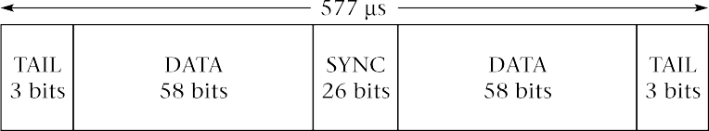
FIGURE 11.4
GSM voice channel

Frequency Hopping in GSM

When multipath fading is a problem, the GSM system allows for frequency hopping, a type of spread-spectrum communication that was discussed in Chapter 4. This can often solve the problem, since multipath fading is highly frequency-dependent. All GSM mobiles are capable of frequency hopping, but only those cells that are located in areas of severe fading are designated as hop- ping cells. The system can hop only among the frequencies that are assigned to the cell, so there will be only a few hopping possibilities (on the order of three frequencies). Thus GSM is not really a true spread-spectrum system, but rather a TDM/FDM system with some spread-spectrum capability added on. This feature is unique to GSM; IS-136 TDMA has nothing like it.

Subscriber ID Module

The subscriber ID module (SIM) is unique to the GSM system. It is a smart card with eight kilobytes of memory that can be plugged into any GSM phone. SIMs come in two sizes: one is the size of a credit card, the other is about postage-stamp size. The SIM contains all subscriber information including telephone number (called the International Mobile Subscriber Identification (IMSI) in GSM), a list of networks and countries where the user is entitled to service, and other user-specified information such as memories and speed dial numbers. The card allows a subscriber to use any GSM phone, anywhere. For instance, since the PCS frequencies are different in Eu- rope and North America, there is no point in a North American traveling in Europe with a PCS phone. If a traveler takes the SIM, however, it will work with any phone rented or purchased in Europe, as long as the subscriber has first contacted his or her North American GSM service provider to arrange for authorization.
The SIM also offers some protection against fraudulent use. A GSM phone is useless without a SIM; if the user removes the card when leaving the phone in a car, for example, the phone cannot be used unless the thief has a valid SIM. Unfortunately, the cards can be stolen too. The SIM can be set up to require the user to enter a personal identification number (PIN) whenever the phone is turned on to provide some security in case the card is lost or stolen.
Once a subscriber has a SIM, buying a new GSM phone is easy. No setup or programming by the dealer is required. Similarly, a user can have a permanently-installed mobile phone and a portable with the same phone number, provided that only one is used at a time. However, the TDMA system also makes purchasing a new phone fairly easy; it allows a phone to be activated and programmed over the air, using the control channel.

GSM Privacy and Security

The GSM SIM just discussed is only a part of the effort that has gone into securing this system. Both the data used in authorizing calls, such as the subscriber’s identifying numbers, and the digitized voice signal itself, are

usually encrypted. (It is possible to weaken or turn off the voice encryption, if a government requires it.) The security in GSM is better than in IS-136 and much better than in analog AMPS.

IS-95 CDMA PCS
This United States-designed system has an air interface that is radically different from either of the others, though its control and messaging structure is quite similar to GSM. CDMA is used to a limited extent on the 800-MHz band, but is much more common in the 1900-MHz PCS band. It uses code-di- vision multiple access by means of direct-sequence spread-spectrum modulation. See Chapter 4 for an introduction to spread-spectrum radio and code-division multiple access (CDMA).

CDMA
Frequency Use

One CDMA RF channel has a bandwidth of 1.25 MHz, using a single carrier modulated by a 1.2288 Mb/s bitstream using QPSK. CDMA allows the use of all frequencies in all cells (not one-seventh or one-twelfth of the frequencies in each cell, as required by other systems). This gives a considerable increase in system capacity. Because of the spread-spectrum system, co-channel interference simply increases the background noise level, and a considerable amount of such interference can be tolerated. As with the other personal communication systems, base and mobile stations transmit on separate channels separated by 80 MHz.
Frequency diversity is inherent in any spread-spectrum system. This is especially beneficial in a mobile environment subject to multipath propagation. The GSM system discussed earlier can use a limited amount of frequency diversity by hopping among several (typically three) discrete channels. The CDMA system, on the other hand, uses the full 1.25-MHz bandwidth for all voice channels on a given RF channel. If a small portion of this spectrum suffers a deep fade due to reflections, the only effect will be a slight increase in the error rate, which should be compensated for by the error correction built into the coding of the voice and control signals.
Space diversity is also built into a spread-spectrum system. Other cellular systems and PCS typically employ two receiving antennas per cell or sector at the base station to provide some space diversity, but they use only one antenna at the mobile location. Multiple receiving antennas are also used with CDMA; but since all frequencies are used in all cells, it is possible to receive the mobile at two or more base stations. Similarly, a mobile can receive signals from more than one base station. Each can make a decision about the strongest signal and can, in fact, combine signals to obtain an even stronger

one. Since there is no need for the mobile to change frequency on handoff, the CDMA system can use a soft handoff, in which a mobile communicates with two or more cells at the same time, rather than having to switch abruptly from one to another. This gives the ultimate in space diversity, with receiving antennas up to several kilometers apart. See Figure 11.5 for a com- parison of soft and hard handoffs.
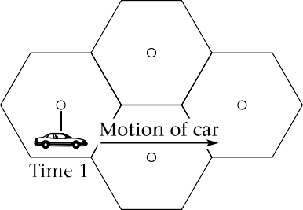
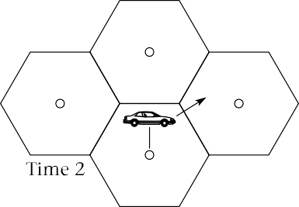
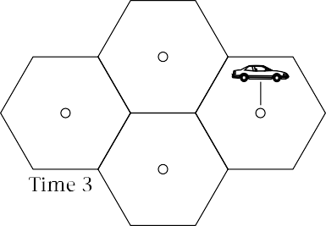

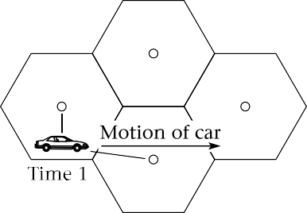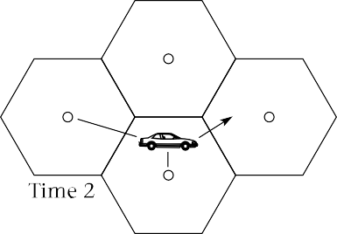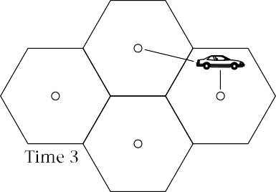

FIGURE 11.5 Hard and soft handoffs

CDMA Channels Each RF channel at a base station supports up to 64 orthogonal CDMA channels, using direct-sequence spread-spectrum, as follows:
(1 pilot channel, which carries the phase reference for the other channels
(1 sync channel, which carries accurate timing information (synchronized to the GPS satellite system) that allows mobiles to decode the other channels

(7 paging channels, equivalent to the control and paging channels in TDMA and GSM
( 55 traffic channels

CDMA thus uses a bandwidth of 1.25 MHz for 55 voice channels, which works out to about 22.7 kHz per channel. This is similar to GSM and, at first glance, not as efficient as TDMA. However, the fact that all channels can be used in all sectors of all cells makes CDMA more efficient in terms of spectrum than any of the other systems. Since CDMA degrades gracefully with increasing traffic, it is difficult to arrive at a definite maximum for its capacity. Proponents of CDMA claim spectrum efficiencies ten to twenty times as great as for GSM; those using other systems dispute this and put the gain nearer two. Once there is a large body of data from all the PCS schemes, it will be easier to get at the truth.
Along with the other personal communication systems discussed in this chapter, the CDMA system also uses FDMA. Each PCS carrier has a spectrum allotment of either 5 MHz or 15 MHz in each direction (refer back to Table 11.1), so a cell site can have more than one RF channel.

Forward Channel The forward and reverse channels are quite different in the CDMA system. Let us look at the forward channel first. We already know that sync, paging, and speech channels are combined on the same physical RF channel using CDMA. We learned in Chapter 4 that the direct-sequence form of CDMA is created by combining each of the baseband signals to be multiplexed with a pseudo-random noise (PN) sequence at a much higher data rate. Each of the signals to be multiplexed should use a different PN sequence. In fact, it can be shown that if the various sequences are mathematically orthogonal, the individual baseband signals can, at least in theory, be recovered exactly without any mutual interference. The math involved in proving this is be- yond the scope of this text, but we should note that the number of possible orthogonal sequences is limited and depends on the length of the sequence. If the PN sequences are not orthogonal, CDMA is still possible, but there will be some mutual interference between the signals. The effect of this will be an increased noise level for all signals; eventually, as the number of non- orthogonal signals increases, the signal-to-noise ratio becomes too low and the bit-error rate too high for proper operation of the system. However, at no time do we hear audible crosstalk, as we do with two analog signals on the same frequency.
From the foregoing it would seem that using orthogonal PN sequences for CDMA is highly desirable, and this is what is done at the base station. A class of PN sequence called a Walsh code is used. The base station uses

64 orthogonal Walsh codes; each repeat after 64 bits. This allows for 64 in- dependent logical channels per RF channel, as mentioned earlier. Walsh code 0 is used for the pilot channel to keep mobile receivers’ phase-aligned with the base station. This is a requirement for coherent demodulation, which is the only way to avoid interference among channels using the same carrier frequency.
In addition to the Walsh codes, two other codes are in use at a CDMA base station: a short code for synchronizing, and a long code, which is used for encryption of both voice and control-system data and is not used for spreading.
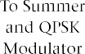
Figure 11.6 shows how the spreading works for one voice signal. The vocoder produces a voice signal with a maximum bit rate of 9.6 kb/s. Error-correction bits are added, and the samples are interleaved over time, just as they are for TDMA and GSM. This process increases the bit rate for one voice channel to 19.2 kb/s. Next the signal is exclusive-Or’s with the long code. This code repeats only after 2⁴²  1 bit and is used for encryption, not spreading. The signal remains at 19.2 kb/s after this process.

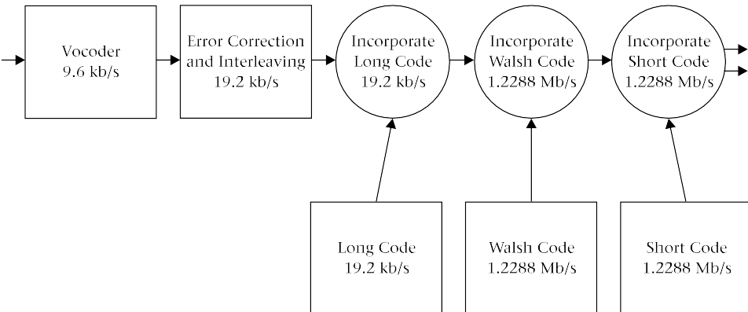
FIGURE 11.6 CDMA forward voice channel

Spreading occurs when the 19.2 kb/s baseband data stream is multi- plied by one of the 64 Walsh codes. Each of the Walsh codes has a bit rate of 1.2288 Mb/s. The multiplication works as follows: when the data bit is zero, the Walsh code bits are transmitted unchanged; when the data bit is one, all Walsh code bits are inverted. The output bit stream is at 1.2288 Mb/s, which is 64 times as great a data rate as for the baseband signal at 19.2 kb/s. There- fore, the transmitted signal bandwidth is 64 times as great as it would be for the original signal, assuming the same modulation scheme for each.

Recall from Chapter 4 that the processing gain can be found as follows:

Gp =
BRF BBB

(11.1)

where

G_{p} = processing gain
B_{RF} = RF (transmitted) bandwidth
B_{BB} = baseband (before spreading) bandwidth
Here,
G = BRF BBB
p
= 1.2288  10⁶
19.2  10³
= 64

In decibels, this is

G_{p} (dB) =10 log 64
= 18.06 dB
If we consider that the error-correction codes are a form of spreading as well, since they increase the data rate, the total spreading becomes
G = BRF BBB
p
= 1.2288 × 10⁶
9.6 × 10³
= 128
= 21.1 dB

A signal-to-noise ratio of about 7 dB is required at the receiver output for a reasonable bit-error rate. This means that the signal-to-noise ratio in the RF channel can be about -14 dB for satisfactory operation; that is, the signal power can be 14 dB less than the noise power. This takes a little getting used to, but is typical of spread-spectrum systems.
The 64 orthogonal channels are transmitted on one RF carrier by summing them, as in Figure 11.7, and using QPSK to modulate them on a single carrier.

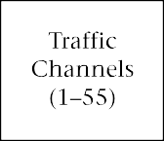
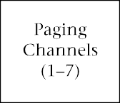
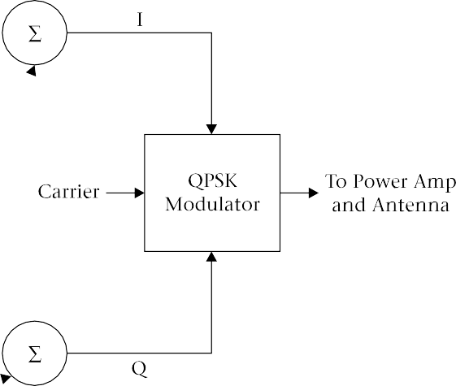
FIGURE 11.7
Multiplexing of CDMA channels

Reverse Channel The mobile units cannot use truly orthogonal channels because they lack a phase-coherent pilot channel. Each mobile would need its own pilot channel, which would use too much bandwidth. Therefore, they use a more robust error-control system. It outputs data at three times the input data rate. Follow Figure 11.8 to see what happens to the signal.
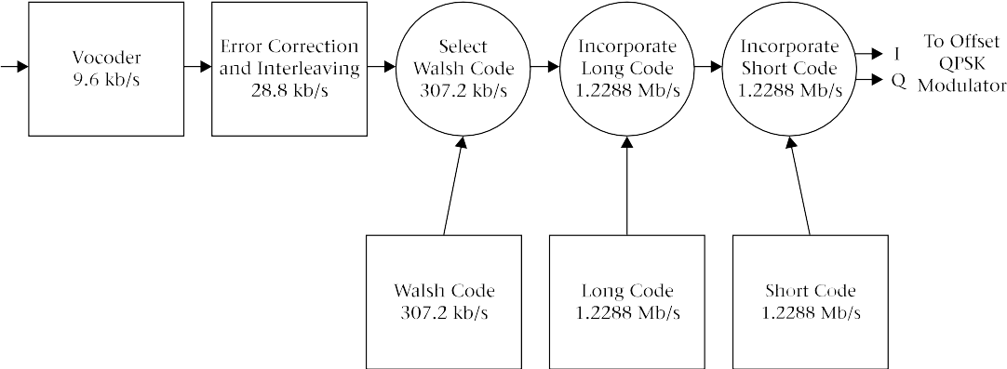

FIGURE 11.8 CDMA reverse voice channel

f₂ = 3 × 9.6 kb/s
= 28.8 kb/s
The 28.8 kb/s signal is combined with one of the 64 Walsh codes and a long code to reach the full data rate of 1.2288 Mb/s. However, the purpose of each of these codes is different on the reverse channel. Here the long code is used to distinguish one mobile from another, as each uses a unique (though not necessarily orthogonal) long code. The Walsh codes are used to help the base station decode the message in the presence of interference. Each block of six information bits (64 different possible combinations) is associated with one of the 64 Walsh codes, and that code, rather than the actual data bits, is transmitted. Since each Walsh code is 64 bits long, this in itself does some spreading of the signal: the bit rate is increased by a factor of 64/6. The Walsh code mapping thus increases the data rate as follows:

f₃ =
28.8 kb/s × 64
6

= 307.2 kb/s
The long code is now multiplied with the data stream to produce a re- verse channel bit rate of 1.2288 Mb/s, the same as for the forward channel. Each mobile transmits at the same rate to produce the spread-spectrum signal received at the base.
The modulation scheme is also slightly different on the reverse and for- ward channels. Both use a form of quadrature phase-shift keying (QPSK). The base station uses conventional QPSK. With this system the transmitter power has to go through zero during certain transitions. See Figure 11.9(a) on page 436.
The mobiles delay the quadrature signal by one-half a bit period to pro- duce offset QPSK, which has the advantage that the transmitter power never goes through zero, though the amplitude does change somewhat. Linear amplifiers are still required in the mobile transmitter, but the linearity requirements are not as strict for offset QPSK as they are for conventional QPSK. See Figure 11.9(b).
Offset QPSK would have no advantage for the base station because a single transmitter is used for all the multiplexed signals. The summing of a large number of signals would result in a signal that still went through the zero- amplitude point at the origin.

Voice Coding CDMA uses a variable rate vocoder. Four different bit rates are possible: 9600, 4800, 2400 and 1200 b/s. The full rate of 9600 b/s is used when the user is talking. During pauses, the bit rate is reduced to 1200 b/s. The other two rates are also in the specifications but are seldom used.

FIGURE 11.9
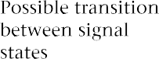
Standard and offset QPSK

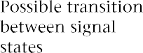

For many years it has been realized that each user typically talks less than fifty percent of the time during a conversation. Theoretically, the band- width allocated to that customer can be reassigned during the pauses while the other person is talking. However, until CDMA PCS came along there were at least two problems with this. The first was that it does not sound natural to have the voice channel go dead when someone stops talking. It sounds as if the phone has been disconnected. The reason is that there is always background noise, even in a quiet room. The CDMA system transmits this noise, but codes it at a lower rate (1200 b/s) because it is not important that it be rendered accurately.
The other problem, with either FDMA or TDMA, was finding a use for the vacated channel or time slot. The slot is usually available for only a few seconds or less, and the amount of time is not known in advance. In CDMA the

reduced amount of information to be sent can be translated directly into reduced interference to other transmissions on the same frequency, which automatically increases the capacity of the system. The way in which this is done is different for the forward and reverse channels.
On the forward channel, data bits are repeated when the coder is running at less than the maximum rate of 9.6 kb/s. For instance, if the coder operates at 1.2 kb/s, as it does during pauses in speech, each block of data is transmitted eight times. Because the error rate at the receiver depends on the energy per received data bit, the power in the transmit channel can be reduced under these circumstances.
The mobile transmitter handles this situation differently. Rather than reduce power, it simply transmits only one-eighth of the time, reducing interference and increasing battery life.

Mobile Power
Control
Controlling the power of the mobile stations is even more important with CDMA than with other schemes. The power received at the base station from all mobiles must be equal, within 1 dB, for the system to work properly. The power level is first set approximately by the mobile, and then tightly con- trolled by the base. When first turned on, the mobile measures the received power from the base, assumes that the losses on the forward and reverse channels are equal, and sets the transmitter power accordingly. This is called open-loop power setting. The mobile usually works with the equation:
P_{T} = -76 dB - P_{R} (11.2)
where
P_{T} = transmitted power in dBm
P_{R} = received power in dBm

The mobile begins by transmitting at the power determined by Equation (11.2) and increases power if it does not receive acknowledgement from the base. This could happen if a substantial amount of the received power at the mobile is actually from adjacent cells. We should also remember, that just as for the other systems, the forward and reverse channels are at different frequencies, so the amount of fading may be different.
Once a call is established, the open-loop power setting is adjusted in 1 dB increments every 1.25 ms by commands from the base station, to keep the received power from all mobiles at the same level. This closed-loop power control is required; for CDMA to work properly, all the received signals must have equal power. Otherwise the system suffers from the near/far effect, in which the weaker signals are lost in the noise created by the stronger ones. Careful power control has the added benefit of reducing battery drain in the portable unit, as the transmitted power is always the minimum required for proper operation of the system.

Rake Receivers and Soft Handoffs
One of the advantages of the CDMA system is that multipath interference can be reduced by combining direct and reflected signals in the receiver. The receivers used are called rake receivers; the reason can be seen in the diagram in Figure 11.10, which somewhat resembles a rake with several teeth for the reception of signals having different amounts of delay.

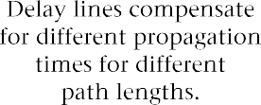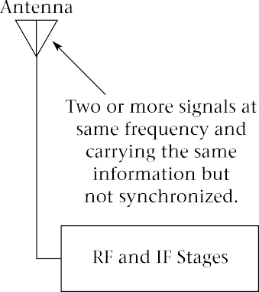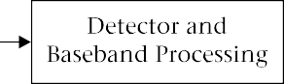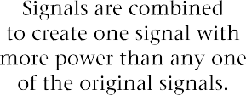

FIGURE 11.10 Rake Receiver

The mobile unit can combine three RF signals, delaying two of them to match the third. One of these signals can be assumed to be the base station in the current cell. The other two may be reflections or neighboring base stations. The base-station receiver can combine four signals: the direct signal from the mobile and three reflections.
In addition, two base stations may receive a signal from the same mobile. The base stations each send their signals to the MSC, which uses the higher-quality signal. Decisions about quality are made on a frame-by-frame basis every 20 ms. It is possible to have two base stations communicating with the same mobile indefinitely in what is referred to as a soft handoff. This avoids the dropping of calls that sometimes occurs when a handoff is unsuccessful in other systems, perhaps because there are no available channels in the new cell. The disadvantage is a considerably increased load on the base stations and the switching network.

CDMA Security CDMA offers excellent security. A casual listener with a scanner will hear only noise on a CDMA channel. In order to decode a call it is not only necessary to have a spread-spectrum receiver, but also to have the correct dispreading code. Since this so-called “long code” is 2⁴² - 1 bits long before it repeats and is newly generated for each call, the chances of eavesdropping are small. Identification is done using private-key encryption, as for GSM.

Comparison of Modulation Schemes
All of the North American PCS have advantages. TDMA is compatible with much existing North American cell-site equipment. GSM has a long history and a large installed base, which tends to lead to lower prices. It also has more advanced features than IS-136. CDMA is the most sophisticated technically, offers the best security, and makes the best use of system bandwidth, at least in theory. All three are in wide use in the United States and Canada. Table 11.3 on page 440 compares the three systems under several headings.

Compatibility Issues: Multi- Mode Phones
From Table 11.3 there appears to be an obvious compatibility problem in PCS. The three systems have only their frequency range in common; none of the systems is compatible with either of the others. Consequently, roaming in the PCS band is possible only among providers that use the same system. At this writing, one or more of these systems is available in most populous areas, but not all areas have all three. Eventually the problem may disappear, as PCS coverage becomes ubiquitous with all three systems, but in the meantime, there is substantially less roaming capability with PCS than

TABLE 11.3 Comparison of North American PCS

Property | IS-136 TDMA | GSM | IS-95 CDMA one
RF Channel Width | 30 kHz | 200 kHz | 1.25 MHz
Voice/Data Channels per RF Channel | 3 | 8 | 64, including 1 sync and 7 control channels
Multiplexing Type | TDMA | TDMA plus limited frequency-hopping | Direct-sequence spread-spectrum
Voice Coding Rate | 8 kb/s full rate 4 kb/s half rate | 13 kb/s full rate  6.5 kb/s half rate | Variable  9600 b/s max.  1200 b/s min.
Bit Rate for RF Channel | 48.6 kb/s | 270.833 kb/s | 1.2288 Mb/s
Control Channel | 2 time slots of 6 in  one 30-kHz RF channel | 1 time slot of 8 in one 200-kHz RF channel | 7 of 64 orthogonal codes in one 1.25-MHz RF channel

with 800-MHz analog AMPS, which still has by far the widest distribution of any system in North America.
There is an obvious, though rather unwieldy, solution to the compatibility problem. This is to manufacture dual-band, dual-mode phones, which work with analog, 800-MHz AMPS as well as with one of the 1900-MHz personal communication systems. Dual-mode phones are currently available for all three of the PCS. Those PCS providers who do not also have an 800-MHz license often form alliances with a cellular provider to allow seam- less roaming with only one monthly bill. Figure 11.11 shows examples of dual-mode phones.

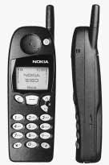
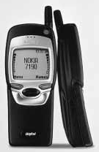
FIGURE 11.11
Dual-mode phones
(Courtesy of Nokia, Inc.)

Data Communication with PCS
When we studied the TDMA cellular system, we observed that data communication can actually be more complex with a digital than with an analog system. This is because vocoders will not work properly with modems, so that the classic technique of connecting a modem to an analog voice channel does not work. We saw that at 800 MHz it is common for a digital phone to revert to analog mode for circuit-switched data communication and to use the CDPD system for packet-switched data.
The above techniques are still possible with a dual-mode PCS phone, but each of the three personal communication systems has developed its own techniques for data communication. This can be expected to become more important as a new generation of “smart phones” incorporating larger dis- plays, (some even including web browsers) and portable computers incorporating RF communication modules are introduced.
At present the most popular use for PCS data seems to be short paging- type messages, followed by electronic mail. Worldwide web access is gaining in importance, but is currently limited by slow connection speeds and the limited graphics capability of PCS phone displays. Let us see how data trans- mission is handled with each of the three PCS.

TDMA Data Communication

The TDMA PCS standard allows for short messages and packet-switched data to be sent on the digital control channels (DCCH) or the digital traffic channels (DTC). Circuit-switched data is possible on the digital traffic channels.
The digital control and traffic channels support two main types of packet-switched data communication. A format called cellular messaging teleservice (CMT) is employed for a short messaging service (SMS). This allows for brief paging-type messages and short e-mail messages (up to 239 characters), which can be read on the phone’s display and entered using the keypad. For longer messages and extended services like web browsing, the Generic UDP Transport Service (GUTS) protocol is used. The acronym- within-an-acronym UDP stands for User Datagram Protocol.
Both of these services require extra equipment in the PCS network to translate between wireline protocols and those used with the radio link. With GUTS, the user connects to a network server that relays messages to and from the internet. The CMT system also requires the servers in the PCS network to assemble messages and interconnect with other services such as the user’s e-mail service. See Figure 11.12 on page 442 for an illustration of packet-switched PCS data.
Circuit-switched data communication is accomplished on the digital traffic channels. The vocoder is bypassed and data is coded and sent directly

FIGURE 11.12
PCS packet- switched data

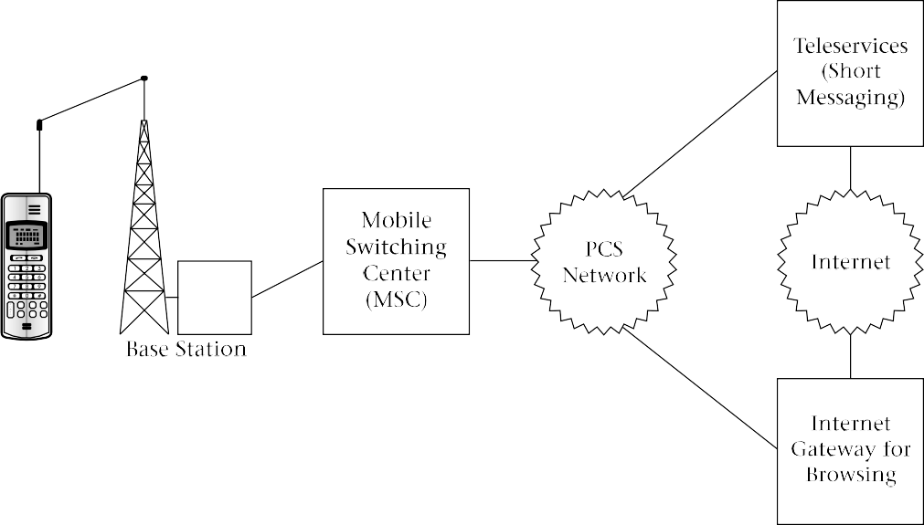

over a traffic channel at up to 9.6 kb/s. It is also possible to combine two or three traffic channels to send data at higher rates. This is done by using four or six of the time slots on a single RF channel, rather than the usual two.
Circuit-switched data is more expensive for the network to carry, as it uses at least one traffic channel full-time. On the other hand, it allows the user more freedom as to the type of data and the network called. For in- stance, a user could dial directly into a company mainframe computer. All that the PCS network has to provide is an interface to convert the protocols used on the air interface to an ordinary wireline modem standard for communication with the PSTN. At the mobile phone, a serial-port interface is typically provided for plugging in a computer. There is no modem in the phone, but it is set up to appear like a standard wireline modem to the computer. Figure 11.13 shows how circuit-switched data works.

GSM Data Communication

The types of data communication possible with GSM are similar to those used with TDMA. Short messages are available (up to 160 characters) using either the control or traffic channels, depending on whether the phone is in use for a voice call at the time. Circuit-switched data (including fax) can be accommodated at up to 9600 b/s using a traffic channel, just as for TDMA. A device especially designed to take advantage of GSM data communication, the Nokia 9000il Communicator, is shown in Figure 11.14.

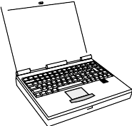
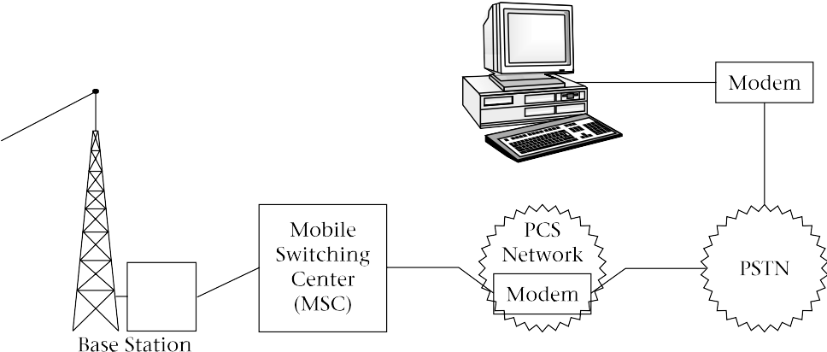
FIGURE 11.13
PCS circuit- switched data

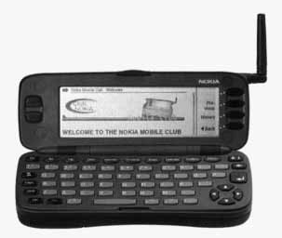
FIGURE 11.14
Nokia communicator
(Courtesy of Nokia, Inc.)

CDMA Data Communication

There are some differences between CDMA and the other two systems in terms of data communication. Like the others, CDMA offers short mes- sages via control channels. Its circuit-switched data capability using a single traffic channel is much greater, though, at 14.4 kb/s.

Wireless Web
Browsing
Any of the PCS schemes just described can be used to access content on the World Wide Web. There are three major problems with all of them however: the data rate is low, even in comparison with ordinary telephone modems; the on-board computing power is low compared with a personal computer; and the handheld devices have very small, low-resolution displays. Many of these displays are not suitable for graphics. A typical web page would take a long time to load and when loaded would be almost, if not completely, unusable.
Third-generation wireless systems, which are described in Chapter 14, will help to solve the first problem, and perhaps make a start on the second. The third is more intractable: large displays and pocket-sized devices are simply not compatible. Therefore, even with third-generation systems, there will be a need for a means to display web pages on the small screens of PCS devices.
Until recently there have been many proprietary standards for displaying web content on wireless devices. Each worked only with a small number of specially created sites. Many of the major wireless manufacturers, including Ericsson, Nokia, and Motorola, have now combined to create a set of de facto standards for creating this content, known as the Wireless Application Protocol (WAP). The idea is to include a small program called a micro browser in the wireless device, with most of the required computing done on net- work servers. These servers have access to specially modified pages on web sites and can also attempt to translate conventional sites so that they can be used by wireless devices. The pages have minimal graphics and condensed text so that they can be used with portable devices.
WAP is compatible with all of the current (second generation) systems and will be compatible with all third-generation systems as well. As more sites begin to provide pages compatible with WAP, the web should become quite accessible to portable wireless devices.

