Dr. Mrs. S. Vairamani M.Sc., M.Ed., M.Phil., Ph.D., (Zoo)., Ph.D.,(Edu).,
Assistant Professor of Zoology
D.G.G.A.for Women, Mayiladuthurai
babavairamani@gmail.com 9486386923
Blastula and blastulation
- 1. Embryology - the science dealing with the embryo and its development
- 2. EMBRYOGENY/EMBRYOGENESIS - the development of the embryo
- 3. EMBRYO - the juvenile stage of an animal while it is contained in the egg (within the egg membranes) or in the maternal body
- 4. Types of eggs based on the amount of yolk they contain:
  - i. MICROLECITHAL (OLIGOLECITHAL) - little yolk present (amphioxus, marsupial and placental mammals)
  - ii. MESOLECITHAL - moderate amounts of yolk present (lamprey, sturgeon, lungfish, and amphibians)
iii.. MACROLECITHAL (POLYLECITHAL) - large amounts of yolk present (hagfish, sharks, rays, teleost fish, reptiles, birds, and monotreme mammals)
5. Types of eggs based on how the yolk is distributed in it:
The pole where the yolk is concentrated is called vegetalpole, the opposite end (with nucleus) is the animal pole.
- Isolecithal (homolecithal) - the yolk is diffused throughout the egg (true for microlecithal eggs) microscopic eggs of mammals, amphioxus
- Telolecithal - the yolk is concentrated towards one side of the egg (true for mesolecithal and macrolecithal eggs) : fishes, reptiles amphibians, birds
- Embryology: Embryogenesis and Organogenesis
- Embryogenesis – development of primary germ layers and their locations Organogenesis – formation of the different organs
Stages of Embryogenesis
Fertilization zygote cleavage

Blastulation Gastrulation Neurulation

organ formation
Blastulation and types of Blastula
Blastula
- During cleavage, a number of cells are prouced to form a big ball of blastomeres. This stage afer cleavage is said to be blastula and the process of blastula formation
is called asBlastualtion
Blastulation:
- The development of blastula is blastulation
- As the cleavage is going on, a central cavity develops among the blastomeres. This cavity is called blastocoel
- It begins to develop from the four cell stage
- It is filled with a gelatinous fluid called blastocoel jelly
- This jelly gradually absorbs water from athe surrounding medium and the cavity increases in its volume
- The embryo in this stage is called Blastula
Blastula
- Cleavage produces an embryonic stage is called Blastula
- It is developed from the Zygote
- It is more or less spherical in shape with a cavity inside called Blastocoel
- It is formed of more than 200 cells
- The cells are arranged in layer around the cavity. This layer of cells is called blastoderm
- The blastoderm is formed of two ypes of cells, namley micromeres and macromeres
- The micromeres are situated at the animal pole and the macromeres are at the vegetal pole
- Hence the blastocoel is eccentric and not central
Types of Blastula
Blastula is of three types. They are
- Coeloblastula
- Discoblastula
- Blastocyst
1. Coeloblastula
As the blastula is a hollow sphere, it is called Coeloblastula
It is spehrical in shape
It has a central blastocoel
The cavity is surrounded by one or more layers of blastomeres
Ex: Frog, amphioxus
2. Discoblastula
It is disc shaped.
The blastocoel is roofed over by one or more layers of blastomeres
EX: Birds, Fishes, Reptiles, etc.,
- Blastocyst
It is in the form of a cyst
Ex: Mammals
&&&&&&&&&&&&&&&&&&&&&&&&&&&&&&&&&&&&&&&&&&&
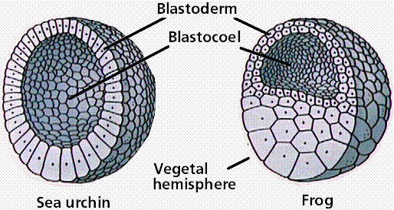

Author

Dr. Mrs. S. Vairamani M.Sc., M.Ed., M.Phil., Ph.D., (Zoo)., Ph.D.,(Edu).,
Assistant Professor of Zoology
D.G.G.A.for Women, Mayiladuthurai
babavairamani@gmail.com 9486386923

