Dr. Mrs. S. Vairamani M.Sc., M.Ed., M.Phil., Ph.D., (Zoo)., Ph.D.,(Edu).,
Assistant Professor of Zoology
D.G.G.A.for Women, Mayiladuthurai
babavairamani@gmail.com 9486386923
Cleavage
Synopsis
- Introduction
- What is cleavage?
- Blastomeres
- Blastula
- Salient features of cleavage
- Planes of cleavage
- Meridional plane
- Vertical plane
- Equatorial plane
- Latitudinal lane
- Patterns of cleavage
- Holoblastic cleavage
- Isolecithal cleavage
- Radialcleavage
- Spiral cleavage
- Biradial cleavage
- Rotational cleavage
- Mesolecithal cleavage
- Radial cleavage
- Meroblastic cleavage
- Telolecithal cleavage
- Bilateral cleavage
- Discoidal cleavage
- Centrolecithal cleavage
i. Superficial cleavage
8. Factors affecting cleavage

Introducation
- 1. Embryology - the science dealing with the embryo and its development
- 2. EMBRYOGENY/EMBRYOGENESIS - the development of the embryo
- 3. EMBRYO - the juvenile stage of an animal while it is contained in the egg (within the egg membranes) or in the maternal body
- 4. Types of eggs based on the amount of yolk they contain:
  - i. MICROLECITHAL (OLIGOLECITHAL) - little yolk present (amphioxus, marsupial and placental mammals)
  - ii. MESOLECITHAL - moderate amounts of yolk present (lamprey, sturgeon, lungfish, and amphibians)
iii.. MACROLECITHAL (POLYLECITHAL) - large amounts of yolk present (hagfish, sharks, rays, teleost fish, reptiles, birds, and monotreme mammals)
5. Types of eggs based on how the yolk is distributed in it:
The pole where the yolk is concentrated is called vegetalpole, the opposite end (with nucleus) is the animal pole.
- Isolecithal (homolecithal) - the yolk is diffused throughout the egg (true for microlecithal eggs) microscopic eggs of mammals, amphioxus
- Telolecithal - the yolk is concentrated towards one side of the egg (true for mesolecithal and macrolecithal eggs) : fishes, reptiles amphibians, birds
- Embryology: Embryogenesis and Organogenesis
- Embryogenesis – development of primary germ layers and their locations Organogenesis – formation of the different organs
Stages of Embryogenesis
Fertilization zygote cleavage Blastulation Gastrulation Neurulation organ formation

- What is cleavage?
- Cleavage is the division of zygote into many smaller cellular units called blastomeres.
- The cleavage starts 60 to 90 minutes after fertilization
- Blastomeres
- Blastomeres are the smaller cellular units caused by cleavage.
- They are of two types.
- Micromeres are smaller in size and Macromeres are larger in size
- Blastula
- Blastula is an embryonic stage develops as a result of cleavage where zygote divides into many smaller cellular units called blastomeres.
- They are of two types.
- Micromeres are smaller in size and Macromeres are larger in size
- A cavity called blastocoel is present among the blastomeres.
- This blastocoel is filled with a fluid called blastocoel jelly
- The blastomeres are arranged in one or more layers around the cavity called blastoderm
- This embryo stage is called blastula
- The development of the blastula is called blastulation
- Salient features of cleavage
- The fertilized egg undergoes mitosis to produce thousands of cells called blastomeres
- Cleavage produces a solid mass of cells called Morula Ex. Mammals
- Cleavage produces a hollow sphere of cells called blastula
- These number of cells helps to construct tissues and ofgans
- During cleavage, the embryo does not grow
- The shape of the embryo also does not change during cleavage
- Amount of DNA also increases during cleavage
- Planes of cleavage
- Cleavage is initiated by forming a groove or constriction called cleavage furrow
- The cleavage furrow divides the egg at different angles or planes
- There are 4 main planes of cleavage
- They are
- Meridional plane
- Vertical plane
- Equatorial plane
- Latitudinal lane
- Meridional plane
If the cleavage furrow bisects both the poles of the egg passing through the polar axis, then the cleavage plane is said to be meridional
- Vertical plane
The cleavage furrow passes from the animal pole to the vegetal pole but not through the median axis of the egg
- Equatorial plane
The equatorial plane bisects the egg at right angles to the median axis and half way between the animal and vegetal poles Ex: sea urchin
- Latitudinal plane
This plane cuts the egg at right angles to the medianaxis but passes either above or below the equator of the egg
- Patterns of cleavage
There are mainly two types of cleavage. They are Holoblastic and Meroblastic cleavage
- A. Holoblastic cleavage(Complete cleavage)
- Here, the entire egg divides completely. It is otherwise called total or complete cleavage
- When the blastomeres ae equal in size then it is called equal cleavage
- When the blastomeres are unequal in size then the cleavage is called unequal cleavage
- Holoblastic cleavage is again divided into 4 types depending upon the symmetry of the cleavage
- Holoblastic cleavage is further divided into
- Radialcleavage
- Here, the blastomeres are arranged radially around the central axis of the egg and the cleavage produces radially symmetrical embryos called radial cleavage
- Spiral cleavage
- It is a holoblastic cleavage where the new blastomeres are slightly displaced giving a spiral shape to the embryo
- In spiral cleavage the blastomees are spirally arranged
- Biradial cleavage
- It is seen in Ctenophora
- The first two cleavage planes are meridional and the third cleavage is vertical
- Rotational cleavage
- Ex: Mammals
- This cleavage is unusual
- First cleavage is meridional
- In the second cleavage the cleavage plane in one of the two blastosmeres is rotated to 90 ⁰with respect to the polar axis
I B.Meroblastic cleavage (Incomplete cleavage)
Here, a portion of the egg divides . Hence it is called partial or incomplete cleavage. Ex: Telolecithal and megalecithal eggs. The meroblastic cleavage is of two types. They are
- Discoidal cleavage
Ex: Fishes, Reptiles and birds
Here the cytoplasm is placed at the animal pole as a disc called blastodisc and this disc only divides. Hence it is called discoidal cleavage
- Superficial cleavage
Ex: Insects
Here the cleavage occurs only in the surface layer of the egg and not upto the central yolk
- Cleavage is further divided into 2 types on the basis of potentiality of the egg blastomere. They are
- Determinate cleavage
Here, the predetermined blastomeres develop into definite organs called Determinate cleavage
This resulting embryo contains different types of predetermined blastomeres.
Such an embryo is called Mosaic embryo and the development is called Mosaic development
The egg producing the mosaic embryo is called mosaic egg

- Indeterminate cleavage
Here, the fate of each part or blastomere is not already determined
The indeterminate cleavage is also called regulative development
Ex: Vertebrates
- Factors affecting cleavage
The rate and nature of cleavage are much affected by factors like Light, Temperature, medium, amount of yolk, cytoplasmic organisations, mitosis, etc.,
- Influence of yolk on cleavage
Yolk influences the cleavage in 2 ways
- It affects the rate of cleavage and
- It determines the pattern of cleavage
- Inflence of organisation of egg cytoplasm on cleavage
- The rate of cleavage and the size of the blastomeres are also determined by the cytoplasm
- Ex: the larger macromeres divide at a faster rate and the smaller blastosmeres at a slower rate
- Influence of mitosis on cleavage
- Nuclear division and
- Cytoplasmic division
Ex: In the early development of chick embryo, cytoplasmic division occurs without involving nuclear division.
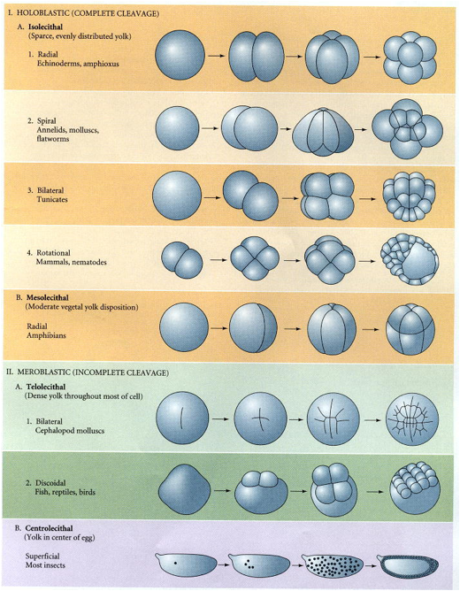

Types of cleavage




