Dr. Mrs. S. Vairamani M.Sc., M.Ed., M.Phil., Ph.D., (Zoo)., Ph.D.,(Edu).,
Assistant Professor of Zoology
D.G.G.A.for Women, Mayiladuthurai
babavairamani@gmail.com 9486386923
Fate map
- Definition
- Construction of Fate map
- Artificial markings
- Natural markings
Definition:
- Topographical surface mapping of the egg or blastula based on the ultimate fate of various areas is called Fate map
- Ex: It is observed that which cell of the blastula develop into various types of tissues and organs.
- So the fate or the final result of each blastomere and each area can be studied.
- As a result, the blastula can be marked into different areas, each developing into a particular organ
Construction of fate map
- Fate map can be constructed in two methods. They are
I . Artificial markings:
The fate map of embryos can be easily studied by marking the blastomeres by various means
The embryos are marked and bserved by using thee types of substances. They are
- Vital stains (W. Vogt in 1925) Ex, Neutral red, Janus green, Nile blue sulphate,etc.;
- Carbon particles (Spratt): He used carbon particles to mark the blastomeres to follow the movements of the marked cells to constructthe fate map
- Radioactive substances :In recent years the fate map has been constructed well by labelling the embryos with radio active substances like C¹⁴, P³², etc.,
- Natural markings
- Naturally certain eggs contain different coloured areas.
- These areas can be observed and followed during development
- Ex: Egg of Frog
- In frog egg, 3 different areas can be seen.
- The animal hemisphere is black and the vegetal hemisphere is yellowish .
- Just below the equator on one side is greyish crescent like area called grey crescent.
- black pigmented area develops into the epidermis and the nervous system
- The grey crescent develops into the mesoderm and the notochord
- The yellowish vegetal hemisphere develops into endoderm of the gut

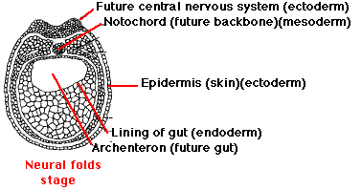
Fate Map

&&&&&&&&&&&&&&&&&&&&&&&&&&&&&&&&&&&&&&

