BIO-INFORMATICS AND COMPUTER APPLICATIONS IN BIOLOGY
SUB. CODE : 16SACBS2

PRESENTED BY
SR.ARPUTHA SAHAYA RANI
DEPT. OF COMPUTER SCIENCE
ARPUTHA COLLEGE OF ARTS AND SCIENCE - VAMBAN

UNIT - I

Computers – Characteristics of Computers – Areas of computer applications- IP-O Cycle. Components of Computers – Memory and control units-Input devices and output devices- Hardware and Software -Operating Systems.

Definition of computer:

- A computer is an electronic device that computes or calculates numbers.
- In other words,
  - A computer is an electronic device with the ability to
i) Accept data supplied by the user.(capturing input data)
ii) Input store and execute instructions.
iii) Perform mathematical and logical operations.
iv) Give results in accordance with users
requirement.(managing output result)

Data
Program
Operations
(or)
Calculations
Result

Element of computer:
i) Hardware:
physical components of computer(input &output,
memory device)
ii)Firmware:
it is a combination of software & hardware.
iii)software:
A set of computer program is called S/W
(can not touch)
iv) Data:
It is a collection of characters and numbers.
v)Live ware(people):
Input given by the people and output is given to them.
vi) Procedure:
it is the activity of manipulating data.

Advantage of computer:
- It can do calculations quickly and accurately.
- It can store large amount of data in small area.
- Accessing speed is very high.
- It can be used in all area.
- It can do repetitive calculations with same accuracy.

Disadvantage of computer:
- It cans no thinking power like human beings.
- The computer is depend on the user who gives the instructions, can not work by itself.
- Regular power supply is major requirement for computer.

Characteristics Computer

The major characteristic of computer which have made them so powerful & useful

- Word length
- Speed
- Storage
- Accuracy
- Versatility
- Automation
- Diligence
- Reduced cost
- Reliability
10. Convenience
1. Word length:
- Word length is the number of bits that a computer can process of a time.
- Computing power of a computer is measures in terms of word length.
- Common word lengths are 8,16,32,64 bits....

2. Speed:
- Computers can calculate at very high speeds.
- A micro computer can execute millions of instructions per second over and over again without any mistake.
- As the power of the computer increases, the speed also increases.

3. Storage:
- Computer have their
  - Main memory
  - Auxiliary memory systems.

- Millions of characters of data are stored in a condensed form in the computer
- It is one of the important characteristics of computers.

4. Accuracy:
- The accuracy of a computer system is very high.
- They either give correct answer or do not answer at all.
- In most cases, the errors are due to the human factor rather than the technological flows.
- So if a wrong input is given, the output also will be wrong.

5. Versatility:
- Computers are very versatile machines.
- Computers can communicate with other computers and can receive & send data in various forms like
-text
-sound
-video
-graphics etc.
- We now live in a connected world and all this is possible because of computer & other related technologies.
- Today, we can send email to people all around the world.

6. Automation:
- The computers execute the program automatically without human intervention.
- Computers can perform repetitive tasks without fatigue.
- The computers do not require time breaks.
- The computer can do millions of repetitive operations automatically.
- The computer performs all necessary operations until the stop instruction is provided.

7. Diligence:
- Human beings suffer from fatigue and lack of concentration. The computers do not have the problem of fatigue.
- The computers can handle million of transactions with the same speed and zeal without fatigue or lattergy.
- The computers can continue to work for days at the same speed due to the repeating activity in functions.
8. Reduced cost:
- The technological improvement in producing electronic components such as semiconductors, processors etc. the cost of the computers are reducing year by year.

9. Reliability:
- Accuracy is the main characteristic of computers and hence they are more reliable.
- The computers have the capability of correcting and modifying the data and instructions automatically after getting required signals.

10. Convenience & flexibility:
- The computers can occupy small space there are packet computers also.
- They can compare statements, take decisions and compute various arithmetical operations.

Applications of computers
(or)
Areas of application

Computers are used every where. the following topics show some of the areas of computer applications.
- Accounting
- Banking
- Medical
- Education
- Designing
- Transport
- Communication
- Engineering
- Entertainment
- Publishing
- Insurance
- Cinema
- Defense
- Meteorology
- Libraries
- Research
- Business
- Space technology
- Telephone
- Law & order

1. Accounting:
- Computers are used to maintain accounts efficiently.
- Computers do inventory management, financial management & cash management very easily.
- Easily take the reports like trail balance, profit and loss account and balance sheet.
2. Banking:
- Nowadays all banks are computerized.
- Customer transactions are maintained by computers.
- Computer controlled Automatic Teller Machines (ATM) are used for cash withdrawals and deposits.
- Computer helps to improve the services of banks.

3. Medical:
- In hospitals, computers are used to maintain patient details, their diseases, and treatments given by the doctors.
- Also, in hospitals, most of the equipments are computer controlled.
- The doctors use these equipments for effective diagnosis.

4. Education:
- Computers can be used in education to teach students.
- It is used to create ‘Virtual class rooms’ and “Virtual University”.
- Students can get most of the details using various websites available in the internet.
5. Designing:
- It is used to draw new designs.
- Engineers draw the blue prints of their proposed buildings.

6. Transport:
- In railways, it is used for reservation and cancellation of tickets in an easy manner.
- By this method people can book their tickets from anywhere in the country.
- Airways and Shipping Corporation use computers in their day-to-day activities.
7. Communication:
- E-mail, voice mail, and video conferencing are possible by using computers.
- Computers control telephone communications also.

8. Engineering:
- Computer-aided manufacturing (CAM) software is used by the engineers to design new products before their manufacture.
9. Entertainment:
- Computers are used to play movies and to play games.
10. Publishing:
- Publishers use computers to prepare and format the contents of books.
11. Insurance:
- Insurance companies use computer to maintain their policyholder details.
12. Cinema:
- Computers are used for adding graphical effects in films.
13. Defense:
- Computer is used to control missiles efficiently.
14. Meteorology:
- In this field computers are used for fishing, shipping, weather forecast, and storm rescue operations.
15. Libraries:
- In library, computers are used to maintain information about books.
- Book issues and receipts are fully controlled by computers.
- Computers are used to calculate the penalty for overdue books automatically.
16. Research:
- Research in physics, chemistry, astronomy, genetic and various areas use computers for analytical purposes.
17. Business:
- Computers have replaces the routine human work in the business field.
18. Space technology:
- Computers are playing important roles in space technology.
- The rapid developments of space technology are mainly due to the developments in the field.
19. Telephone:
- Telephone exchanges were earlier managed manually. Now they have been modified computerized exchanges.
- Hey handle lot of calls quickly and long distance calls handled more efficiently and quickly.
20. Law & Order:
- Record in relation to accidents, vehicle owners, wanted criminals, missing persons, stolen vehicles, fingerprints, criminals history etc.. are maintained by police easy & quick accessibility.

I-P-O Cycle :( Input process output cycle)

- Computer is an electronic device, which converts data in
to information.
- This converting takes place in set sequence of multiple steps

1
2
4
5
3

- Receives data ( or) text
- Process data
- Output result

Receives data:
Input is the collection of data(information) or instructions entered into the computer from input devices. Any types of data (letters,numbers,special characters,images etc) programmers, command and user response (yes,no,cancel etc) are referred as input.
Process data:
Process is the manipulation of data as per given instruction. it is totally inner process of the computer system. It is the coherent (logical) sequence of step undertaken by a program.
Output result:
Output is the result obtained from a computer system following some processing activity. Computer output maybe in a form that people can understand and use, such as words or pictures that are displayed on a screen or pointed or drawer on paper.

Example:

A=5
B=4
C=A+B
C=9

Input Process Output

Components of a computer system

- Input unit
- Output unit
- Central processing unit(UCP)

Input Unit
Arithmetic Logic Unit
Control Unit
Main Memory
CPU
Secondary memory
Output Unit

- Input unit:

- The data and the programs are entered in to the computer through this device.
- When the data and instructions are entered in to the input unit, they are passed to the memory unit of the CPU.
- Some of the input devices are
-keyboard
-mouse
-scanner
-joystick
-trackball, etc.

2. Output unit:
- It accepts the results produced by the computer, which are in coded form and hence cannot be easily understood by user.
- It converts these coded results to human acceptable(readable) form.
- It supplies the converted results to the outside world.
- Some of the output devices are
-monitor
-printer
-plotter, etc...
3. central processing unit:(CPU)
This unit contains the following three subunits,
i) Arithmetic and logic Unit(ALU)
ii) Control Unit (CU)
iii) Memory Unit (MU)

- Arithmetic and logical unit(ALU):
- The processor(CPU) is the "brain" of any computer system.
- Actual data processing occurs in this unit. All arithmetic and logical operations such as

-Addition
-subtraction
-comparison, etc...
are performed here.
It has many subunits. They are
  - Registers:- It is used for temporary storage
  - Program counter:- It is used to store the address of the instruction, that is to be executed.
  - Adders:- It is used to perform arithmetic and logical operations.

II) Control unit:(CU)
- This unit, controls the activities of other units in the computer system.
- It instructs the input device to transfer data and instructions to main memory and then to the ALU.
- The processed results are sent from ALU to storage or monitor by the control unit.
III) Memory unit:
1. Main memory unit
2. Secondary memory unit

1. Main memory unit :
- It holds all data and instructions temporarily
- It is otherwise called primary memory or internal memory.
- There are two types of main memory

->Random Access Memory (RAM)
->Read Only Memory (ROM)

->Random Access Memory(RAM)
- It is a volatile memory.
- So this type of memory looses it contents when the power is turned off.
- It is used for read and write
Two types of RAM:
a)Static RAM(SRAM)-->refreshed required
b) Dynamic RAM(DRAM)-->refreshed not required.

->Read Only Memory (ROM)
- It is nonvolatile memory
- So its contents are not lost when the power is turned off.
- This memory contains the programs, which are used to boot the computer system.
- The other types of ROM are
a)PROM
b)EPROM
c)EEPROM

a)PROM:-
- It stands for
Programmable Read Only memory.

b)EPROM:-
- It stands for
Erasable programmable Read only memory.
- It can be erased and reprogrammed, using ultra violet light.

C) EEPROM:-
- It stands for
Electrically Erasable programmable Read Only memory.
- Using electrical charge (for removed).

Difference between RAM &ROM:
RAM | ROM
1. The contents will be lost when the power goes off | the content is permanent event when the power goes off
2. Accessing speed is large | Accessing speed is short
3. Requires high power | require low power
4. Used in large systems | used is small systems

2. Secondary memory unit:
- It is used to store the data, which are permanent.
- It is otherwise called
-auxiliary memory (or)
-external memory

- There are two types of secondary memory,
a) Sequential memory
b) Random access memory

a)sequential memory:
- It can read and write in sequential manner.
- Example: magnetic tape

b)Random access memory:

- It can read and write randomly
- Example: floppy disk, hard disk & optical disk.

MEMORY AND CONTROL UNITS

- The data fed to the computer are stored in its memory.
Functions of the memory unit:
- All the data to be processed and the instructions required
for processing.(received from input device)
- Intermediate result s of processing
- The results are released to an output device.

1. Memory capacity
2. Memory hierarchy
3. Classification of memory
4. Primary memory
5. Types of primary memory
6. Storage units.

1. Memory capacity:
The capacity of its memory defined in terms of
-kilobytes(KB)
-megabytes(MB)
-gigabytes(GB)

number of bits/bytes | unit
8 bit  1024 byte  1024 KB  1024MB | 1 byte(B)  1 KB  1 MB  1 GB

2. Memory hierarchy:
The hierarchical arrangement of storage in computer architectures is called memory hierarchy.

Registers
Cache
RAM,ROM
Electronic disk
Magnetic disk
Optical disk
Magnetic tape
Increasing cost,speed
Decreasing size
Decreasing cost,speed
Increasing size

- Classsification of memory:
Computer memory
Primary memory
Secondary memory
ROM
RAM
Magnetic memory
Optical memory
PROM
EPROM
EEPROM
SRAM
DRAM
Floppy disk
Hard disk drive
CD

DVD
Pen
drive

4. Primary memory:
- It is otherwise called main memory or internal memory.
- This address does not change
- Each cell can store a fixed number of bits.
- The bits can be either an instruction or a data item.

5. Types of primary memory:
a) RAM
i) Static RAM (SRAM)
ii) Dynamic RAM (DRAM)
b) ROM:
i) PROM
ii)EPROM
iii) EEPROM

a)RAM:
- It is a volatile memory.
- So this type of memory looses it contents when the power is turned off.
- It is used for read and write
- Two types of RAM:
Static RAM (SRAM)
Dynamic RAM (DRAM)

S.NO | SRAM | DRAM
1 | Bit stored in charge form | Bit stored in the voltage
2 | fast operation | slow operation
3 | refreshing required | refreshing not required
4 | high packing density | low packing density
5 | base element capacitor | Base element Flip-flop.

b) ROM:

- It is nonvolatile memory
- So its contents are not lost when the power is turned off.
- This memory contains the programs, which are used to boot the computer system.
- The other types of ROM are
i)PROM
ii)EPROM
iii)EEPROM

a)PROM:-
- It stands for
programmable Read Only memory.

b)EPROM:-
- It stands for
Erasable programmable Read Only memory.
- It can be erased and reprogrammed, using ultra violet light.

C) EEPROM:-
- It stands for
Electrically Erasable programmable Read Only memory.
- Using electrical charge (for removed).

Difference between RAM &ROM:
RAM | ROM
1. The contents will be lost when the power goes off | the content is permanent event when the power goes off
2. Accessing speed is large | Accessing speed is short
3. Requires high power | require low power
4. Used in large systems | used is small systems

5) Storage unit:
i) Floppy disk
ii) Hard disk drive
iii) Compact disk
iv) Digital video disk
v) Pen drive

Two types of Storage:
1.Magnetic Storage
a) Floppy disk
b) Hard disk drive(HDD)
2. Optical storage
a) Compack disk(CD)
b) Digital video disk(DVD)
c) pen drive.

1. Magnetic Storage:

a) Floppy Disk:
  - Portable storage device
  - It is commannly used to move file between different computers
  - It can hold 1.44MB of data and is usually of 3.5 size.
  - Existing information can be erased and new information can be stored(Rewritable)
  - It can be reused any number of times.

Advantage:
  - Power saving
  - Ease of storage
  - Ease of use.

Disadvantage:
  - It is not very reliable.
  - It can be damaged easily.

b) Hard-disk Drive:
  - It is not a single flexible disk, but a stack of metal disks sealed in a box.
  - The hard disk and hard disk drive exist together as a unit and are usually a permanent part of the computer where most of your files are saved.
  - The storage capacity of a hard disk can be several giga bytes raging from 1GB to 40+GB.
  - You can access any information in a fraction of a second.

Advantage:
  - Large storage capacity.
  - Stores and retrieves data much faster than a floppy disk or CD-ROM.
  - Data is not lost when you switch off the computer.
  - Cheap on a cost per mega byte compared to other storage media.
  - Hard disk can be replaced and upgraded as necessary.
  - Can have two hard disk in a machine, one can act as a mirror of the other and create a back up copy.
Disadvantage:
  - Hard disks eventually fail which stops the computer from working.
  - Regular "head" crashes can damage the surface of the disk leading to loss of data in that sector.
  - The disk is fixed inside the computer and can not easily be transferred to another computer.

2. Optical Storage:
a) compact Disk:(CD)
  - This is a recent development in storage device.
  - It has got large storage capacity
  - It can store data up to 800 MB and even more.
  - A special drive is needed to read a CD.
  - Most reliable for long term storage.
  - It is available in three forms
i) CD-ROM
ii) CD-R or WORM
iii) CD-R/W

i) CD-ROM:
  - It has a capacity of 700 MB
  - Its stands for compact Disk- Read Only memory.

ii) CD-R (or) WORM:
  - Data stored on it once, can not be erased.
  - CD-R -->it means Compact Disk Recordable
  - WORM-->it means Write Once Read Many

iii) CD-R/W:
  - It means compact disk Rewritable
  - It is also known as an Erasable Compact Disk.
  - These CDs can be used to write new data and erase the previous one.
Advantage:
1. Storage capacity
2. Portability
3. Durability
4. Low cost of Replication
5. Inexpensive Hardware
6. Availability of Titles
7. Speed.

Disadvantage:
1. cost of subscriptions
2. lack of standards for retrieval software
3. installation

b) Digital video disk(DVD):
  - It is also known as Digital Video Disc. or Digital Versatile Disc.
  - Its main uses are video and data storage.
  - It is similar to a CD but has a larger capacity.
  - Can store about 17 GB of data.
  - Variation of DVD:
i) DVD-ROM: it has data that can only be read and not written.
ii) DVD-R & DVD+R:it can record data only once, and then function as a
DVD- ROM
iii) DVD-RW,DVD+RW &DVD-ROM:it can all record and erase data
multiple times.

Advantage:
  - Superior data storage
  - High density
  - Cost
  - Duplication

Disadvantage:
  - Some DVD players and drives may not be able to read CD-Rs.

(c) pen drive:
  - A pen drives is the latest storage device which works like a floppy.
  - It is a small device with a connector the system's USB port.
  - A USB port is a little rectangular hole that is on the side/back of your computer.
  - It is quickly transfers a file one device to another.
  - The information in the pen drive can be edited deleted and saved.
  - The capacity of a pen drive may vary from 512 MB to 1 GB.

Advantage:
  - Some pen drives are water proof.
  - Personal data or work files from one location to another.
  - Pen drives are much more of abuse than mechanical drives.

Disadvantage:
  - Pen drives are costly
  - Pen drives get damaged or data is corrupted
  - Pen drives is a small size, they are easily misplaced or lost.

INPUT DEVICES

1. Punched card
2. Paper tape
3. Keyboard
4. Mouse
5. Joystick
6. Track ball
7. Touch screen
8. Light pen
9. Floppy disk
10. Mark & character recognition
a) Mark sense recognizer
b) Magnetic ink character recognition (MICR)
c) Optical character recognizer (OCR)
d) Optical mark reader (OMR)
e) Bar code recognition (BCR)
11. Scanner
12. Digital camera
13. Voice input.

1.Punched cards:
- They are simple to operate.
- The punched cards are easy to read and are of less cost.
- They are easily perishable and transfer of data is slow.

2.Paper tape:
- It is continuous strip of paper.
- Data is recorded on paper by punching holes on it.
- Data are processed sequentially.

3.Keyboard:
- It is similar to a typewriter.
- The key is pressed on the keyboard a character will appear on the screen.
- The current position of the screen is indicated by the cursor.
- In the keyboard there are three parts:
  - Main keyboard keys
  - Function keys
  - Numerical keys
4.Mouse:
- Mouse is a pointer device.
- It controls the movement of the cursor & pointer on a display screen.
- It can be used to:
  - Draw lines or pictures on the screen
  - Choose an item from a list(menus)
  - Single click: item selected
  - Double click: item executed on the screen.
5. Joystick:
- It is an input device used for playing video games on personal computers.
- It consists of four micro switches arranged in four directions (east,west,north,south).
- When the joystick is moved in a particular direction, the cursor moves in that direction.
6.Track ball:
- It contains a ball, which can be rotated in any direction
- When the ball moves, the cursor will move on the screen.
7. Touch screen:
- Touch screen is a type of display screen.
- This is sensitive to the user's touch.
- Fingers are used to select the desired command.
- Touch screen are used in laptops &ATM machines.
8.Light pen:
- It is a device used for drawing images on the computer screen.
- It is easies to enter data in to a computer.
- When the pen goes close to the screen, light is emitted by it to create a dot on the screen.
9. Floppy disk:
- It is used to read store data.
- It is a circular piece of thin plastic materials.

10. Mark &character recognition:
a) Magnetic ink character recognition(MICR):
- It stands for Magnetic Ink Character Recognition.
- It can read the characters, which are printed by using a special kind of ink called magnetic ink.
b) Optical character recognizer(OCR):
- It stands for Optical Character Recognition
- It can read characters optically.
- It details the characters, which are printed on a paper.

c) Optical mark reader(OMR):
- It stands for Optical Mark Recognition
- It can sense the presence or absence of a mark created by a pencil.
- It is used to evaluate the answer scripts of aptitude test.
- The major advantage: no special ink is needed.
- In can read up to 2,000 documents per hour.

d) Bar code recognition(BCR):
- It stands for Bar Code Recognition
- It scans bar codes
- They represent a number
- It is useful: supermarket, libraries, hospitals, etc...

11. Scanner:
- It is used to input pictures and images in to your computer.
- It converts images to digital form, so that it fed in to the computer.
12. Digital camera:
- It is used to input images in to computer system directly.
13. Voice input:
- Voice input devices convert a person's speech in to digital form.
- Voice input is the modern mode for communications with the computer.

OUTPUT DEVICE:

Devices that are used to show the output of the computer are called output devices.

Some output devices are:
- Printer
- Plotter
- Monitor
- Sound cards and speakers.

1.Printer :
It is an output device used for making permanent copies.

Classification of printers:
Printer
Impact
Non-Impact
Character/serial printer
Line printer
Character/serial printer

Page printer
1. Dot-matrix
2. Daisy wheel
1. Drum printer
2. Chain printer
3. Wheel printer
1. Inkjet printer
2. Thermal printer
1. Line printer

Impack printer:
These printers use ribbons to create an impression on The paper. it creates The charad by striking the ribbon.

Character serial printer:

1.Dot - matrix printer:
- print one character at a time.
- similar to type writer
- it creates the impression of a character in the form of dots.
- In this type, a head contains 9 pins or 24 pins. these pins are used to make the shape of the character.
- the speed of this printer is 40 to 600 characters per second.
- these printers are fast and cheap but the quality is not high.
2. Daisy wheel printer:
- This printer contains a wheel with 96 characters on its petals.
- it leaves an impressions of a character on paper.
- it speed is 20 to 100 character per second.
- compared to dot matrix printer it can print more quality characters.

Line printer:
- these printers print a line of characters at a time
- they are very fast printers.
- the speed range 300 to 2500 line per minutes.

1)Drum printer:
- Drum printers have a metal drum.
- The drum rotates at a constant speed.
- The numerals and characters are embossed in the rotating metal drums in horizontal rows.
- The rows in A's are printed first, then B's and C's etc .., till the entire line is completed.

2) Chain printer :
- chain printer is like cycle chain that rotates at a regular speed.
- Each link of the chain is embossed with a signal letter , numbers or special character.
- In one signal rotation five lines can be printed.
3) Wheel printer:
- It consists of 132 wheels.
- Each wheel contains 48 characters.
- Printing is done simultaneously
- The wheels are horizontally one over the other and are aligned and positioned properly.
- Around 50 line can be printed in one second.
- Various character set types are available.

Non-Impact printer:
These printers create the characters without striking.
Character/serial printer:
1. Inkjet printer:
- It printers the characters by spraying small drops of ink on the paper by using an array of tiny nozzles.
- Its speed is around 120 characters per second.
- It is an alternative to laser printer while considering the cost.
- It is an ideal printer for drawing pictures,graphics, etc....

2. Thermal printer:
- This type of printer uses thermal effect to produce a particular character.
- In this printer, a special kind of thermal sensitive paper is used.
- This paper is costlier than the ordinary paper.
- The heat produced by the printing head creates the shape of the character on this sensitive paper.
- The speed of these printers is very slow,rangs from 25 CPs to 100CPs.

Page printer:
1. Laser printer:
- The printers generate both graphics as well as text as image outputs.
- The quality of the output is very high.
- This printer uses the techniques of photocopier machine(xerox-machine)
- It can produce multicolored output.
- Its speed ranges from 4 to 20 pages per minute.
- It is used in Desktop publishing.

2. plotter:
it is a graphical output device.

It is classified:

i). Flatbed-plotter:
- It uses a pen to draw graphics on the paper.
- This plotter is also known as 'light pen plotter'
- This plotter can produce multicolored outputs.
- It can create output with 8 to 10 colors.
- The pen is moved in up or down & x and y direction.

ii). Drum-plotter:
- The pen movement is left to right & top to bottom.
- The drum can rotate either clockwise or anticlockwise.
- These plotter are very costly and are not widely used.

3. Monitor:

It is similar to television screen. It is otherwise calls "visual display screen".
The user can identify the current position on the screen by using "cursor”. The standard size of screen consists of 24 lines of 80 columns.

Types of monitors:
1. Monochrome monitor
2. Gray-scale monitor
3. Color monitor

1.Monochrome monitor:
- It can show the characters only in black and white.
2.Gray-scale monitor:
- A gray-scale monitor is aspecial type of monochrome monitor capable of displaying different shades of gray.
3.Color monitor:
- It can show the characters in different colors.
- Color monitors are some time called RGB monitor because they accept three separate signals
-red
-green
-blue.
- The most common type of monitor today is LCD.
- LCD means Liquid Crystal Display.
- It is usually found on laptops.

4.Sound cards and speakers:

- It is used to produce music or speech from programs.
- A speaker part allows to connect speaker to the computer.
- Speakers can be built in to the computer or can be attached separately.

Hardware and software
1. Introduction
2.Define Hardware
3. Types of hardware
i) Internal (or) Processing hardware:
-CPU
-mother board
-RAM
-ROM
ii) Input hardware:
- Keyboard
- Mouse
- Scanner
iii) Output Hardware:
-Monitor
-Printer
-Speaker
iv) Connecting hardware:
-Modem
-LAN Card
v) Storage hardware
- Hard Disk
-Floppy Disk
-CD Rom
4. Software
5. Types of Software
i) System Software
ii) Programming Software
iii) Application Software
iv) Utility Software

1. Introduction:
- A computer is an electronic device that accept Data(input)and, process data arithmetically and logically, produce information(output).
- It is divided in to two main categories
i) Hardware
ii) Software

2. Hardware:
- Hardware is the components that can be seen and touched.
Components of hardware
Input devices
Output devices
Internal (or) processing devices
Connecting devices
Storage Devices

- It includes not only the computer but also the cables, connectors, power supply units, and peripheral devices such as the keyboard, mouse, audio speakers, and printers.

3. Types of hardware:
i) Internal (or) processing hardware:
Internal hardware is also called components. Its includes
      - CPU
      - Motherboard
      - RAM
      - ROM
CPU:
→It is the brains of the computer.
→Most of calculations take place here.
→Two typical components of a CPU are
    - Arithmetic Logic Unit(ALU)
    - Control Unit(CU)
Mother board:
→It is the main circuit board of a micro computers.
→It contains the CPU, memory and all the controllers.
RAM:
→It is the place in a computer.
→It is a validate memory.
→It is used for read & write.
ROM:
→It is non volatile memory.
→So its contents are not lost when the power is turned off.
ii) Input hardware:
- Input hardware consists of external devices by which are give information & instructions to the computer.
- Common input hardware are:
    - Keyboard
    - Mouse
    - Scanner
Keyboard:

→It is similar to a typewriter.
→The key is pressed on the keyboard a character will appear on the screen.
Mouse:
→Mouse is a pointer device.
→It controls the movement of the cursor & pointer on a display screen.
Scanner:
→It is used to input pictures & images in to your computer.

iii) Output hardware
- Output hardware consists of internal & external devices that transfer information from the computers CPU to the user.
- Common output hardware:
    - Monitor
    - Printer
    - Speaker

Monitor:
→It is similar to television screen.
Printer:
→It is an output device.
→It is used to produce music or speech from the programs.
Speaker:
→It is an output part.
→It is used to produce music or speech from the programs.
iv) Connecting Hardware:
- Connecting device allow hardware devices the communicate with each other.
- Common devices:
    - Modem
    - LAN card
Modem:
→Modems connect a personal or portable computer.

LAN card:
A Local Area Network (LAN) card is used to provide wireless Internet access to computer users in home or roaming networks.

v) Storage hardware:

- A computer storage device is any type of hardware that stores data.
- Some common storage devices:
--Hard Disc
--Floppy Disc
--CD Rom

Hard Disc:
→It is magnetic disk
→it can store computer data
Floppy Disc:
→Portable storage device
→It is used to move file between different computers.
→it can be reused any number of times.
CD Rom:
→its stands for Compack Disk Read Only Memory.
→it is a optical storage device

- Software:
- Software means set of instructions or data
- Computers can not do any useful work without instructions from software.

Types of software
System software
Application Software
Programming Software
Utility Software

- Types of Software:
i) System Software:
- System software helps in running the computer hardware and the computer system.
- Main system software are:

→Operating system
→Device drivers
→Operating System:
- An operating system is an interface between user and computer hardware.
- It is control all the computer resources.
- Example: DOS,LINUX,UNIX,Window OS.

→ Device Drivers:

- A device driver is a computer program.
- It allowing higher level computer programs to interact with a hardware device.

ii)Programming Software:
- This is one of the most commonly known and popularly used forms of computer software.
- This software comes in forms of tools.
- It is helping the programmers.
→Text editors
→Compiler
→Interpreters
iii) Application Software:

- Application software is software that has been developed to solve a particular problem useful for working on specific tasks.
→Web browsing
→Word processing
→Spreadsheet
→Database
→Graphics

→web Browsing:
- It allows one to surf the web
- Example: Internet Explorer

→Word processing:
- It allows user to create, edit a document.
- Example:Ms.word.

→Spreadsheet:
- It allows perform calculation.

→Database:
- It allows users to store and retrieve vast amount of data.
- Example: Ms Access etc..

→Graphics:
- It allows users to create visual presentation
- Example: Ms Power point.

iv)Utility Software:
- It is helps in the management of computer hardware and application software.
- It performs a small range of software.
→Disk Defragmenters
→Backup
→Disk partitioned
→ Anti-Virus
→Disk Defragmentors:

- It detects computer files and disjoined fragments and move fragments together to increase efficiency.

→Back up:
- A copy of all information stored on a disk.

→Disk partitioner:
- Treated as an individual drive.

→Anti-Virus:
- These utilities scan computer for viruses

OPERATING SYSTEMS

- Introduction

A computer system can be divided into 4 components:

- the hardware (CPU, memory, input/output devices, etc.),
- the operating system,
- the system programs (word processors, spread sheets, accounting softwares, compilers,…)
- the application programs.

Application Programs

System Programs

Operating
System

Hardware

Figure 1. Hierarchy of computer components

2. Define operating System:

Operating System is a set of programs
Operating System is the link between the hardware and software
It is act as interface between user and computer hardware
It is control all the computer resources.
Example: DOS,LINUX,UNIX,Window OS.

Disk Drive
Mouse
Printer
Application
Monitor
Keyboard
Operating system

3. Goals of operating system:

i) Convenience:
→ Operating System is designed to provide convenience to the user.
→The task can be computed easily
→ The time is limited.
ii) Efficiency:
→For efficient of all the resources of computer system.
→ It shared multi-user systems.
4. Needs for the Operating System:

i)Creates an interface between user and hardware.
ii) Acts as a resource manager.
iii) Sharing hardware among users.
iv) Allowing users to share data among themselves.
v) preventing users from interfering with one another
vi) Scheduling resources among users.
vii) facilitating input/output
viii) recovering from errors
ix) Accounting for resource usage.
x) facilitating parallel operations
xi) Organizing data for secure and rapid access.
xii) Handling network communications.

5. Functions of Operating System:

i) Control the computer resources
-like printer, keyboard, etc..
ii) Executes the application programs such as
- Word, Excel, etc..
iii) Inform user about wrong input or system fault.

iv) Acts as an interface between the hardware and the application software.
v) Maintains priority among users.
vi) Provide multi-access facility.
vii) Process management function
viii) memory management function
ix)Device management function
x) information management function
xi) secondary management function
xii) Network management function
xiii)Protection management function
xiv) Command interpretation function
6. Components of Operating System :

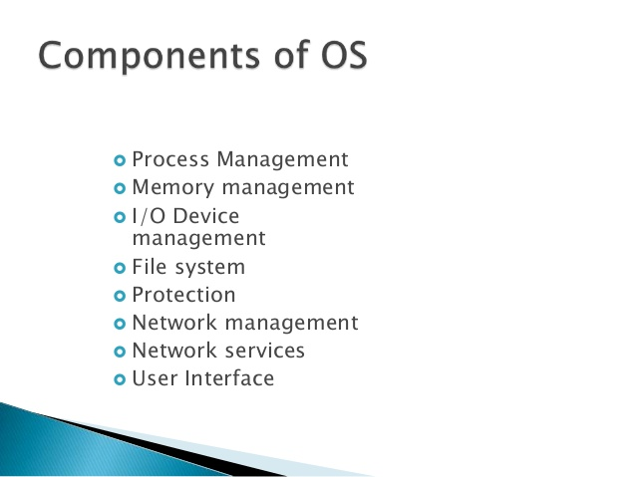
7. Types of Operating System (OR)Classification of OS:
i) Single user operating system
ii) Multi-user operating system
iii) Graphical user interfaces operating system
iv) Multiprocessing operating system
v) Multi-tasking operating system
vi) Multi threading operating system
vii) Serial-processing operating system
viii) Batch-processing operating system
ix) Time sharing operating system
x) Real time operating system
xi) Distributed system

i) Single user operating system:
- It is controls only one user at a time
- This operating system is used in personal computers
- Example: DOS

ii) Multi-user operating system:
- This operating system controls more than one user at a time .
- This OS is used in network environment.
- Some OS permit 100 or 1000 of users programs run simultaneously.
- Example: UNIX &window NT,MVS.

iii) Graphical user interfaces operating system:
- It has the capability of using graphical devices such as mouse.
- Example: windows XP,windows 2000.

iv) Multiprocessing operating system:
- It is also called parallel processing.
- It is support more than one program at the same time.
- It allows several programs run simultaneously.
- Example: UNIX, &windows NT

v) multi-tasking operating system:
- It allows multiple software processes to be run at the same time.
- Example: windows 98,windows 2000 &windows XP.

vi) multi threading operating system:
- It allows different part of a software program to run in parallel.
- Example: windows 98,windows 2000 &windows NT

vii) Serial-processing operating system:
- The programmers interacted directly with the computer between.
- The programs translating sequences of instruction in to binary code.

viii) Batch-processing operating system:
- A batch is a sequence of user jobs.
- A computer operator forms a batch by arranging user jobs in a sequence and inserting special markers to indicate the start and end of the batch.
- The OS achieves this by making an automatic transition from the execution of one job to that of the next job in the batch.
ix) Time sharing operating system:
- Time sharing operating system used to multiprogramming.
- Time sharing OS allows many users to share the computer system simultaneously.
- Every user program is allocated a small period of CPU time known as time slice.

x) Real time operating system:
- A real time system has well defined fixed time constraints.
- Processing must be done within defined constraints otherwise system will fail.
- DOS &UNIX are not real-time because they can take a few seconds to react.

xi) Distributed system:
- Distributed computer system is a collection of computer systems capable of communication via their hardware and software interconnections.

8. Features of operating system:
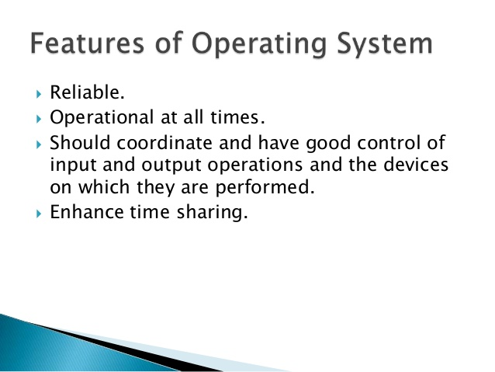

9. Which devices use OS
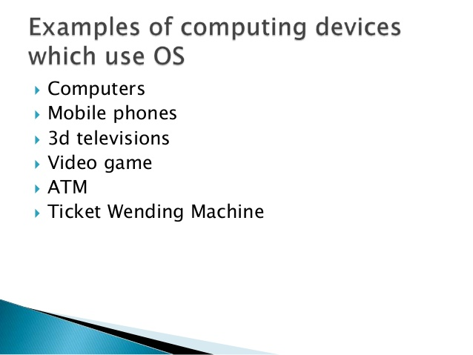
10. Which devices don’t use OS
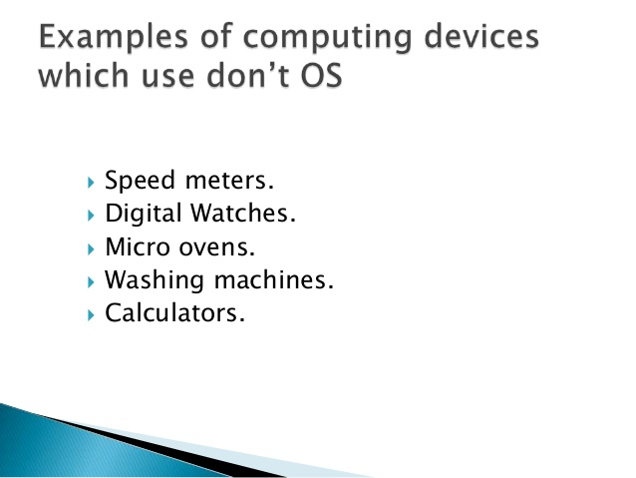

11. Advantages of OS:
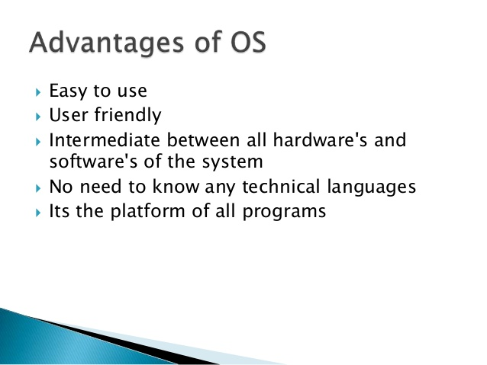
12.Disadvantages of OS:
