FINANCIAL MANAGEMENT
UNIT-5
Receivable management-Objectives-factors influencing size of receivables-credit policy-credit standard-credit term-collection policy-Incremental analysis-inventory management-meaning-types of inventory-purpose of holding inventory-Excess or inadequate inventory-EOQ-Levels of stock;reorder level, minimum and maximum level-technique-ABC,VED,FSN and HML analysis.
Receivable management
Accounts receivable management incorporates is all about ensuring that customers pay their invoices. Good receivables management helps prevent overdue payment or non-payment. It is therefore a quick and effective way to strengthen the company’s financial or liquidity position.

Objectives

- Monitor And Improve Cash Flow

Minimizes Bad Debt Losses

Avoids Invoice Disputes

Improve Customer Satisfaction

Boost Up Sales Volume

Helps In Facing Competition

Factors influencing size of receivables

1. Level of Sales:
The primary factor in determining the volume of debtors/receivables is the level of credit sales. Increase in credit sales means a corresponding increase in debtors, and vice versa. No doubt the level of sales can be used to forecast changes in receivables, i.e., if a firm predicts an increase of 50% in its credit sales for the next period, it will probably experience also an increase of 50% in debtors/receivables.

2. Terms of Trade:
A change in credit policy has a direct impact on debtors. Thus, if credit terms are relaxed, it will lead to increase in the amount of debtors, and vice versa.

3. Credit Policies:
The level of debtors/receivables balance is closely related with the collection policy of the firm. Practically, credit policy determines the amount of risk that a firm is to undertake in its sales activities.

Credit policy

A firm’s credit policy is the set of principles on the basis of which it determines who it will lend money to or gives credit (the ability to pay for goods or services at a later date).

Credit standard
The set of standards that a company or bank uses to determine whether to extend a loan or line of credit to an applicant. Credit standards may include having a certain FICO score, recent good credit history, and a certain income.

Credit term

The terms which indicate when payment is due for sales made on account (or credit). For example, the credit terms might be 2/10, net 30. This means the amount is due in 30 days; however, if the amount is paid in 10 days a discount of 2% will be permitted. Other terms might be net 10 days, due upon receipt, net 60 days, etc.

Collection policy
The steps that a company follows in ensuring timely payment of its account receivable.
Collection policies vary by company. An example of the steps a company can takes involves a
friendly phone call to make sure payment is made on time, followed by a firm phone call when a payment is late, followed by a threatening letter, and finally turning the client over to a
collection agency.
Companies may deviate from their collection policy for longstanding or otherwise trusted
customer.

Incremental analysis
Incremental analysis is a decision-making technique used in business to determine the true cost difference between alternatives. Also called the relevant cost approach, marginal analysis, or differential analysis, incremental analysis disregards any sunk cost or past cost. Incremental analysis is useful for business strategy including the decision to self-produce or outsource a function..

Inventory management
Inventory management refers to the process of ordering, storing, and using a company's inventory. These include the management of raw materials, components, and finished products, as well as warehousing and processing such items.

Types of inventory

1) Raw Materials

2) Work-In-Progress

3) Finished Goods

4) Packing Materials

5) Safety Stock

6) Smoothing Inventory

7) Decoupling

8) Cycle

9) MRO Goods

10) Services

11) Transportation

12) Theoretical

Purpose of holding inventory
- Inventory helps the organization to prevent fluctuations in demand & supply from affecting sales or production. Especially in retail availability is key to making a sale, else the customer may just buy from somewhere else.
- It also can be used as a temporary offset to delay the effect of price increases and thereby improve margins and/or sales.
- Bulk purchases help the organisation to lower their procurement costs and also make efficient use of logistical facilities

Excess or inadequate inventory

Cost

Obsolescence

Quality

Decreased Flexibility

EOQ
EOQ is the acronym for economic order quantity. The economic order quantity is the optimum quantity of an item to be purchased at one time in order to minimize the combined annual costs of ordering and carrying the item in
- 300 per carton
Levels of stock;
Stock level is an important issue that must be considered because it can affect system availability when repair is delayed more than necessary because a component is not in stock and it is necessary to purchase one. In such cases the system is unavailable, and to avoid this the stock policy must be well defined.
In the drill facility system, even though improvement is implemented, other equipment would impact system availability if zero stock was adopted as the stock policy for all equipment because of increased shutdown time that is related with equipment purchase time. Therefore the drill facility system availability will be reduced from 91.87% to 11.93% in the first year. Such an impact occurs because of delays in the purchase process and delivery time difficulty, which would be 6 months.

Reorder level
Reorder level of stock (also known as reorder point or ordering point) in a business is a preset level of stock or inventory at which the business places a new order with its suppliers to obtain the delivery of raw materials or finished goods inventory.
Re-order level = maximum consumption during the period × maximum period required for delivery

Minimum level
The minimum level of stock is a certain predetermined minimum quantity of raw materials or merchandise inventory which should always be available in stock in the normal course of business.
Minimum level = reordering level – (normal usage per period × average delivery time)
Maximum level
The maximum level of stock is the level above which a business does not or cannot hold stock in its premises.
Maximum Level of Stock = Reorder level + Reorder quantity – (Minimum usage × Minimum lead time)

Problem with solution
(a) A manufacturer uses 200 units of a component every month and he buys them entirely from outside supplier. The order placing and receiving cost is Rs.100 and annual carrying cost is Rs.12. From this set of data calculate the Economic Order Quantity.
(b) P. Ltd. uses three types of materials A, B & C for production of X, the final product.
The relevant monthly data for the components are as given below:
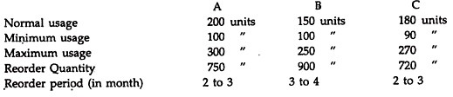
Calculate for each component:
(a) Re-order level
(b) Minimum level
(c) Maximum level
(d) Average stock level
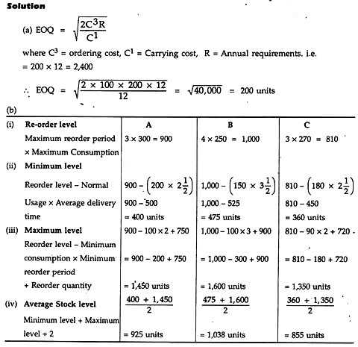

ABC Analysis
It has become an indispensable part of a business and the ABC analysis is widely used for unfinished good, manufactured products, spare parts, components, finished items and assembly items.
This method of management divides the items into three categories A, B and C; where A is the most important item and C the least valuable.

VED Analysis
VED Analysis :- It attempts to classify the items used into three broad categories, namely Vital, Essential, and Desirable. The analysis classifies items on the basis of their criticality for the industry or company.

FSN Analysis
FSN analysis is an inventory management technique. The items are classified according to their rate of consumption. The items are classified broadly into three groups: F – means Fast moving, S – means Slow moving, N – means Non-moving. The FSN analysis is conducted generally on the following basis:
- The last date of receipt of the items or the last date of the issue of items, whichever is later, is taken into account.
- The time period is usually calculated in terms of months or number of days and it pertains to the time elapsed seems the last movement was recorded.

HML analysis
Items are classified into three groups labeled as High – Medium – Low. The HML analysis is very similar to the ABC Analysis, the difference being instead of usage value, the price criterion is used. In their classification, the items used by the company are arranged in descending orders of their unit price. After this, the management of the company uses its discretion and judgment to decide the cut off lines for deciding the three categories.

