UNIT-I
INTRODUCTION TO DATABASE

- Purpose of Database Systems
- Database system
- View of data
- Database Languages
- Relational Databases
- Database Design
- Data Models
- Database Users and Administrators
- Overall Structure
- History of Database Systems

2 marks
- Define Database
DBMS contains information about a particular enterprise
  - Collection of interrelated data
  - Set of programs to access the data
  - An environment that is both convenient and efficient to use
- Define schema
The overall design of the database is called the database schema.
- Analogous to type information of a variable in a program
  - Physical schema: database design at the physical level
  - Logical schema: database design at the logical level
  - Sub schema: A database may also have several schemas at the view level, sometimes called subschemas.
- Define instance
The actual content of the database at a particular point in time Analogous to the value of a variable is called instances.
- Define physical independent
The ability to modify the physical schema without changing the logical schema
  - Applications depend on the logical schema
  - In general, the interfaces between the various levels and components should be well defined so that changes in some parts do not seriously influence others.
- What are the data models
- Relational model
- Entity relationship
- Object based data model
- Semi structured data model
- Define DML
A data manipulation language is a language that enables users to access or manipulate data. Nonprocedural DMLs, which require a user to specify only what data are needed, without specifying exactly how to get those, data are widely used today.

- Define DDL
A data definition language is a language for specifying the database schema and as well as other properties of the data.
- Define database design
Database design mainly involves the design of the database schema. The entity- relationship data model is a widely used data model for database design. It provides convenient graphical representation to view data, relationships and constraints.
- What is storage manager
The storage manager subsystem provides the interface between the low level data stored in the database and the applications programs and queries submitted to the system.
- What is query
A query is the statement requesting the retrival of information the portion of a DML that involves information retrival is called a query language.

- What is transaction management
A transaction is a collection of operations that performs a single logical function in a database application
- Transaction-management component ensures that the database remains in a consistent (correct) state despite system failures.
- Concurrency-control manager controls the interaction among the concurrent transactions, to ensure the consistency of the database
- List out the users of database
- Application programmers
- Sophisticated users language
- Specialized users
- Naïve users
- Who is DBA and expand it
Database administrator is a person who has control central over the system is called DBA.
- What are the role of database
  - Storage structure and access method definition
  - Schema and physical organization modification
  - Granting users authority to access the database
  - Backing up data
  - Monitoring performance and responding to changesDatabase tuning
- What are the running process of database architecture

    - Centralized
    - Client-server
    - Parallel (multiple processors and disks)
    - Distributed

5 marks

- Explain database architecture

The architecture of a database system is greatly influenced by the underlying computer system on which the database system runs. Database systems can be centralized, or client-server, where one server machine executes work on behalf of multiple client machines. Database systems can also be designed to exploit parallel computer architecture. Distributed database span multiple geographically separated machines.

Overall structure in database
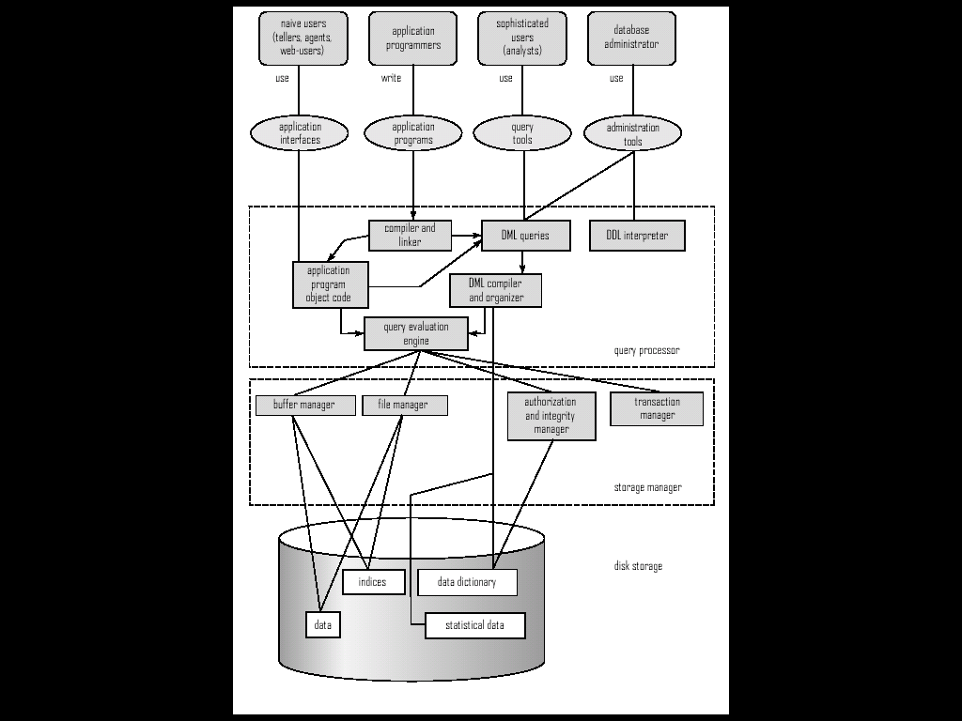

Database application are usually partitioned into two or three parts. In a two-tier architecture, the application resides at the client machine, where it involves database system functionality at the server machine through query languages statement. Application program interface standards like ODBC and JDBC are used for interaction between the client and the server.
In contrast, in a three-tier architecture, the client machine acts as merely front end and does not contain any direct database calls. Instead, the client end communicates with an application server, usually through a forms interface. The application server in turn communicates with a database systems to accept data. The business logic of the application, which says what action to carry out under what conditions, is embedded in the application server, instead of being distributed across multiple clients. Three-tier application are more appropriate for large application, and for application that run on the World Wide Web.

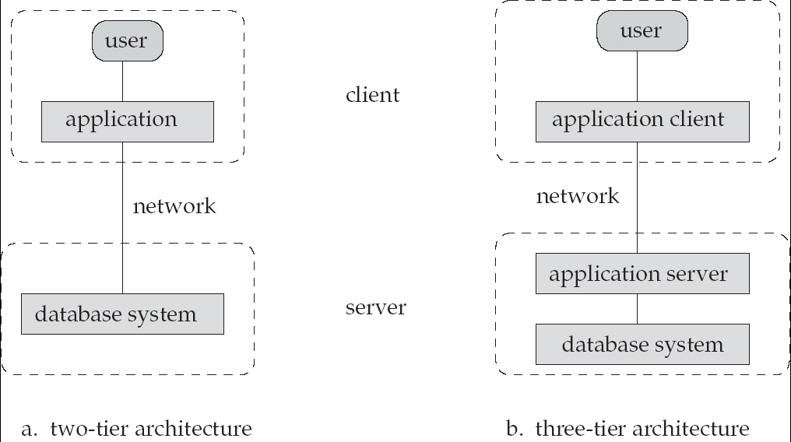

Figure 1.7

- Explain the history of databases

1950s and early 1960s: Magnetic tapes were developed for data storage. Data processing tasks such as payroll were automated, with data stored on tapes processing of data consisted of reading data from one or more tapes and writing data to a new tape. Data could also be input from punched card decks, and output to printers. For example, salary raises were processed by entering the raises on punched cards and reading the punched card deck in synchronization with a tape containing the master salary details.
Data processing programs were forced tom process data in a particular order, by reading and merging data from tapes and card decks.
Late 1960s and 1970s: Widespread use of hard disk in the late 1960s changed the scenario for data processing greatly, since hard disk allowed direct access data. The position of data on disk was immaterial, since any location on disk could be accessed in just ten of milliseconds. Codd later won the prestigious association of the computing machinery during award for this work.
1980s: by the early 1980s relational databases had become competitive with network at and hierarchical databases system even in the area of performance relational databases were so easy to use that they eventually replaced network and hierarchical database programersusin such databases were forced to deal with many low level implementations details.
Early1990s: the SQL languages was designed primarily for decision support application which are query intensive get the main state database in the 1980s was transaction processing applications in which are update intensive. Many database vendors introduced parallel database product in this period database vendors also began to add object relational support to their databases
1990s: the major event of the 1990s was the explosive growth of the world wide web database were developed much more extensively than ever before database systems also had to support web interface to data,
2000s: the first half of the 2000s saw the emerging of XML and the association query language XQuery as a new query new database language although widely used for data exchange as well as storing certain complex data types relational databases still form they core of a vast majority of large scale of database
- Explain introduction to data base and its application?
A data base management system (DBMS) is a collection of interrelated data and a set of programs to access those data. The collection of data usually referred to as the database, contains information relevant to an enterprise. The primary goal of (DBMS) is to provide a way to store and retrieve database information that is both convenient and efficient.
DATA BASE –SYSTEM APPLICATIONS
Databases are widely used .Here are some representative applications:
Enterprise Information:
- SALES: For customer, product, and purchase information.
- ACCOUNTING: For payments, receipts, account balance, assets and other accounting information.
- HUMAN RESOURSES: For information about employees, salaries, payroll taxes, and benefits, and for generation of pay checks.
- MANUFATURING: For management of the supply chain and for tracking production of items in factories inventories of items in warehouse and stores and order for items.
- ONLINE RETAILERS : For sale data noted above plus online order tracking ,generations of recommendation list and maintenance of online product evolutions
BANKING AND FINANCE:
- BANKING: For customer information, accounts, loans and banking transactions.
- CREDIT AND TRANSACTION: For purchases on credit cards and generation of monthly statements.
- FINANCE: For storing information about holdings sales and purchase of financial instruments such as stocks and bonds also for storing real time market data to enable online trading by customers and automated trading by the firm.
- UNIVERSITIES: for student information, course registrations, and grades.
- AIRLINES: for reservations and schedules information, airlines were among the first to use database in a geographically distributed manner.
- TELECOMMUNICATION: for keeping records of all made, generally monthly bills, maintaining balances on prepaid calling cards and storing information about the communication networks.
- Explain database languages?
A database system provides a data-definition language to specify the database schema and a data-manipulation language to express database queries and updates .in practice the data definition and data manipulation languages instead they simply from parts of a single database language ,such as the widely used SQL language.
DATA MANIPULATION LANGUAGE
A data manipulation language (DML) is a language that enables users to access or manipulate data as organised by the appropriate data model. The types of access are:
- Retrieval of information stored in the data base
- Insertion of new information into the data base
- Deletion of information from the database
- Modification of information stored in the data base
A query is a statement requesting the retrieval of information. The portion of a DML that involves information revivals is called query.
DATA –definition language
We specify a data base schema by a set of definitions expressed by a special language called a data –definition language .the DDL is also used to specify additional properties of the data.
- DOMAIN COSTRAINTS: A domain of possible values must be associated with every attribute.
- REFERENTIAL INTEGRITY: There are cases where we wish to ensure that a value that appears in one relation for a given set of attributes also appear in a certain set of attributes in one relation.
- ASSERATION: An assertion is any condition that the database must always satisfy .domain constraints and referential -integrity constraints are special forms of assertions.
- AUTHORIZATION: We may want to differentiate among then users as far as the type of access they are permitted on various data values in the database .these differentiations are expressed in terms of authorization, the most common being read authorization.
- Explain Database users and administrators?
A primary goal of a database system is to retrieve information form and store new information into the database.
DATABASE USER AND USER INTERFACE:
- Native user are unsophisticated user who interact with the system by invoking one of the application programs that have been written previously.
- Application programmers are computer professionals who write application programs .application programmers can choose from many tools to develop user interfaces.
- Sophisticated user interact with the system without writing programs .instead they form their request either using a database query language or by using tools such as data analysis software.
- Specialized user are sophisticated user who write specialized database applications that do not fit into the traditional data processing framework.
DATABASE ADMINISTRATOR:
- Schema definition: the DBA creates the original database schema by executing a set of data definition statements in the DDL.
- Storage structure and access method definition:
- Schema and physical organization modification: the DBA carries out changes to the schema and physical organisation to reflect the changing needs of the organisation or the alter.
- Granting of authorization for data access: by granting different types of authorization the database administrator can regulate which parts of the database various users can access.
- Routine maintenance
- Periodically backing up the database either onto tapes or onto remote server to prevent loss of data in case of disaster
- Ensuring that enough free disk space is available for normal operations
- Monitoring jobs running on the database and ensuring that performance is not degraded by very expensive tasks.

- EXPLAIN VIEW OF DATA?
A database system is a collection of interrelated data and a set of program that allow user to access and modify these data. a major purpose of a databases system is to provide user with an abstract view of the data that is, the system hides certain details of how the data are stored and maintained
- Data abstract for the system to be usable it must retrieve data efficiently the need for efficiently has led designers to use complex data structure to represent data in the database.
- Physical level: The lowest level of abstraction describe how the data are actually stored. The physical level describer complex low-level data structure in detail.
- logical level: the next-higher level of abstraction describer what data are stored in the database and what relationship exist among those data, the logical level thus describer the entire databases in term of small number of relatively simple structure.
- view level: the highest level of abstraction describer only part of the entire databases .even though the logical level user simpler structure completely remain because of the variety of information stored in large database. many users of the database system do not need all this information instead they need to access only part of the database the view level of abstraction exist to simplify their interaction with the system the system may provide many view for the same database.
- instances and schemas: database change over time as information is inserted and deleted the collection of information stored in the database at particular moment is called an instance of the database the overall designing of the database is called the database schema are changed infrequently if at all.
Application program are said to exhibit physical data independence if they do not depend on the physical schema and thus need not be rewritten if the physical schema changes
- data model: underlying the structure of a the data model a collection of conceptual tools for describing data, data relationship, data semantics and consistency constraints a data model provide a way to describer the design of database at the physical, logical, and view levels.
- Relational model: the relation models uses a collection of tables to represent both data and the relationship among those data each table has multiple columns and each column has a unique name tables are also known as relation.
- Entity- relationship: the entity-relationship (E-R) data model uses a collection of basic objects called entities and relationship among these objects an entity is a thing or object in the real world that is distinguishable from other objects.
- Object - oriented programming act-based data model has become the dominant software-development methodology. This led to the development of an object-oriented data model that can be seen as extending the E-R model with notion of encapsulation, method (function) and object identity.
- Semi structure data model: the semi structure data model permits the specification of data where individual data items of the same type may have different sets of attributes or manipulate data

10 MARKS
- Explain the purpose of databases
Database systems arose in response to early methods of computerized management of commercial data .As an example of such methods, typical of the 1960’s, consider part of a university organization that, among other data, keeps information about all instructors, students, departments and course offerings.
    - Add new students, instructors and courses
    - Register students for courses and generate class roasters
    - Assign grades to students, compute grade point averages (GPA), and generate transcripts
New application programs are added to the system as the need arises. For example, suppose that a university decides to create a new major. As a result, the university creates a new department and creates new permanent files to record information about all the instructors in the department, students in the major, course offerings, degree requirements, etc.
This typical file-processing system is supported by a conventional operating system. The system stores permanent records in various files, and it needs different application programs to extract records from, and add records to the appropriate files.
    - Data redundancy and inconsistency: Since different programmers create the files and application programs over a long period, the various files are likely to have different structures and the programs may be written in several programming languages.
    - Difficulty in accessing data: Suppose that one of the university clerks needs to find out the names of all students who live within a particular postal-code area, the clerk asks the data-processing department to generate such a list. Because the designers of the original system did not anticipate this request, there is no application program on hand to meet it. The point here is that conventional file-processing environments do not allow needed data to be retrieved in a convenient and efficient manner. More responsive data-retrieval systems are required for general use.
    - Data isolation: Because data are scattered in various files, and files may be in different formats, writing new application programs to retrieve the appropriate data is difficult.
    - Integrity problems: The data value stored in the database must satisfy certain types of consistency constraints. Suppose the university maintains an account for each department, and records the balance amount in each account. The problem is compounded when constraints involve several data items from different files.
    - Atomicity problems: A computer system, like any other device, is subject to failure. In many applications, it is crucial that, if a failure occurs, the data be restored to the consistent state that existed prior to the failure. That is, the funds transfer must be atomic-it must happen in its entirety or not at all. It is difficulty to ensure atomicity in a conventional file-processing system.
    - Concurrent-access anomalies: For the sake of overall performance of the system and faster response, many systems allow multiple users to update the data simultaneously. Indeed, today, the largest internet retailers may have millions of accesses per day to their data by shoppers. In such an environment, interaction of concurrent updates is possible and may result in inconsistent data.
    - Security problems: Not every user of the database system should be able to access all the data. For example, in a university, payroll personnel need to see only that part of the database that has financial information. They do not need access to information about academic records. But, since application programs are added to the file-processing system in an ad hoc manner enforcing such security constraints is difficult.

2. explain about the Database languages:

A database system provides a data-definition language to specify a data-definition language to specify the database schema and a data-manipulation language to express database queries and updates. In practice, the data-definition and data-manipulation languages are not two separate languages; instead they simply form parts of a single database languages, such as the widely used SQL language.
Data-Manipulation Language:
A data-manipulation language (DML) is a language that enables users to access or manipulate data as organized by the appropriate data model. The types of access are;
      - Retrieval of information stored in the database
      - Insertion of new information into the database
      - Deletion of information from the database
      - Modification of information stored in the database
There are basically two types,
      - Procedural DMLs require a user to specify what data are needed and how to get those data.
      - Declarative or Non-procedural DMLS require a user to specify what data are needed without specifying how to get those data.
A query is a statement requesting the retrieval of information. The portion of a DML that involves information retrieval is called a query language. Although technically incorrect, it is common practice to use the terms query language and data-manipulation language synonymously.
Data-Definition Language:
We specify a database schema by a set of definitions expressed by a special language called a data- definition language (DDL). The DDL is also used to specify additional properties of the data. The data values stored in the database must satisfy certain consistency constraints. For example, suppose the university requires that the account balance of a department must never be negative.
Domain constraint: A domain of possible values must be associated with every attribute (for example, integer types, character types, date/time types).Declaring an attribute to be a particular domain acts as a constraint on the values that it can take. Domain constraints are the most elementary form of integrity constraint. They are tested easily by the system whenever a new data item is entered into the database.
- Referential Integrity: There are cases where we wish to ensure that a value that appears in one relation for a given set of attributes also appears in a certain set of attributes in another relation (referential integrity).when a referential integrity constraint is violated, the normal procedure is to reject the action that caused the violation.
- Assertions: An assertion is any condition that the database must always satisfy. Domain constraints and referential-integrity constraints are special forms of assertions. However, there are many constraints that we cannot express by using only these special forms. For example, “Every department must have at least five courses offered every semester” must be expressed as an assertion. When an assertion is created, the system tests it for validity. If the assertion is valid, then any future modification to the database is allowed only if it does not cause that assertion to be violated.
- Authorization: We may want to differentiate among the users as far as the type of access they are permitted on various data values in the database. These differentiations are expressed in terms of authorization, the most common being;
- Read authorization, which allows reading but not modification of data.
- Insert authorization, which allows insertion of new data but not modification of existing data.
- Update authorization, which allows modification but not deletion of data.
- Delete authorization, which allows deletion of data.
.
We may assign the user all none, or a combination of these types of authorization.

Explain about the Database Design:

Database systems are designed to manage large bodies of information. These large bodies of information do not exist in isolation. They are part of the operation of some enterprise whose end product may be information from the database or may be some device or service for which the database plays only a supporting role.
Design Process:
A high level data model provides the database designer with a conceptual frame work in which to specify the data requirements of the database users, and how the database will be structured to full fill these requirements. The initial phase of database design then, is to characterize fully the data needs of the prospective database users.
The designer chooses a data model, and by applying the concepts of the chosen data model, translates these requirements into a conceptual-design phase provides a detailed overview of the enterprise.
The process of moving from an abstract data model to the implementation of the database proceeds in two final design phases. In the logical design phase, the designer maps the high level conceptual schema onto the implementation data model of the database system that will be used. The designer uses the resulting system specific database schema in the subsequent physical design phase, in which the physical features of the database are specified. These features include the form of file organization and the internal storage structures.
Database Design for a University Organization:
To illustrate `the design process, let us examine how a database for a university could be designed. The initial specification of user requirements may be based on interviews with the database users, and on the designer’s own analysis of the organization. The description that arises from this design phase serves as the basis for specifying the conceptual structure of the database. Here are the major characteristics of the university,
      - The university is organized into departments. Each department is identified by a unique name (dept _name), is located in a particular building, and has a budget.
      - Each department has a list of course it offers. Each course has associated with it a course_ id, title, dept _name and credits and may also have associated prerequisites.
      - Instructors are identified by their unique ID. Each instructor has name, associated department (dept _name), and salary.
      - Students are identified by their unique ID. Each student has a name, an associated major department (dept _name), and tot _cred (total credit hours the student earned thus far).
      - The university maintains a list of classrooms, specifying the name of the building, room _number and room capacity.
      - The university maintains a list of all classes taught. Each section is identified by a course _id, sec _id, year and semester and has associated with it a semester, year, building, room_number and time _slot _id.
      - The department has a list of teaching assignments specifying, for each instructor, the sections the instructor is teaching.
      - The university has a list of all student course registrations, specifying, for each student, the courses and the associated sections that the student has taken (registered for).
The Entity Relationship Model:
The entity relationship (E-R) data model uses a collection of objects, called entities, and relationships among these objects. An entity is a “thing” or “object” in the real world that is distinguishable from other objects. For example, each person is an entity, and bank accounts can be considered as entities.
A relationship is an association among several entities. For example, a member relationship associates an instructor with her department. The set of all entities of the same type and the set of all relationships of the same type are termed an entity set and relationship set respectively.
The overall logical structure (schema) of a database can be expressed graphically by an entity relationship diagram (E_R) diagram. There are several ways in which to draw these diagrams. One of the most popular is to use the unified modelling language (UML).
      - Entity sets are represented by a rectangular box with the entity set name in the header and the attributes listed below it.
      - Relationship sets are represented by a diamond connecting a pair of related entity sets.
Normalization:
Another method for designing a relational database is to use a process commonly known as normalization. The goal is to generate a set of relation schemas that allows us to store information without unnecessary redundancy, yet also allows us to retrieve information easily. The approach is to design schemas that are in an appropriate normal form. To determine whether a relation schema is in one of the desirable normal forms, we need additional information about the real world enterprise that we are modelling with the database. The most common approach is to use functional dependencies.
      - Repetition of information
      - Inability to represent certain information

Explain about Data Storage and Querying:
A database system is partitioned into modules that deal with each of the responsibilities of the overall systems. The functional components of a database system can be broadly divided into the storage manager and the query processor components.
The storage manager is important because databases typically require a large amount of storage space. Corporate databases range in size from hundreds of gigabytes to, for the largest databases, terabytes of data. A gigabyte is approximately 1000 megabytes (actually 1024 ) (1 billion bytes), and a terabyte is 1 million megabytes (1 trillion bytes). Since the main memory of computers cannot store this much information, the information is stored on disks. It is imperative that the database system structure the data so as to minimized the need to move data between disk and main memory.
The query processor is important because it helps the database system to simplify and facilitate access to data.it is the job of the database system to translate updates and queries written in a nonprocedural language at the logical level into an efficient sequence of operations at the physical level.
Storage Manager:
The storage manager is the component of a database system that provides the interface between the low level data stored in the database and the application programs and queries submitted to the system. The storage manager is responsible for the interaction with the file manager. The raw data are stored on the disk using the file system provided by the operating system. The storage manager translates the various DML statements into low level system commands. Thus the storage manager is responsible for storing, retrieving and updating data in the database.
The storage manager components include,
    - Authorization and integrity manager, which tests for the satisfaction of integrity constraints and checks the authority of users for access data.
    - Transaction manager, which ensures that the database remains in a consistent (correct) state despite system failures, and that concurrent transaction executions proceed without conflicting.
    - File manager, which manages the allocation of space on disk storage and the data structures used to represent information store on disk.
    - Buffer manager, which is responsible for fetching data from disk storage into main memory and deciding what data to cache in main memory. The buffer manager is a critical part of the database system, since it enables the database to handle data sizes that are much larger than the size of main memory.
  - The storage manager implements several data structures as part of the physical system implementation,
    - Data files, which store the database itself.
    - Data dictionary, which stores metadata about the structure of the database in particular the schema of the database.
    - Indices, which can provide fast access to data items. Like the index in the textbook, a database index provides pointers to those data items that hold particular value. For example, we could use an index to find the instructor record with a particular ID, or all instructor records with a particular name. Hashing is an alternative to indexing that is faster in some but not all cases.

The query processor:
    - DDL interpreter, which interprets DDL statements and records the definitely in the data dictionary.
    - DML compiler, which translates DML statements in a query language into evaluation plan consisting of low level instructions that the query evaluation engine understands.
    - Query evaluation engine, which executes low level instructions generated by the DML compiler.

completed

