**M.Sc., CHEMISTRY**

**SELECTED TOPICS IN CHEMISTRY**

**UNIT II: Named Reaction and its Applications in Organic Synthesis**

The Staudinger reduction is conducted in two steps. First phosphine imine-forming reaction is conducted involving treatment of the azide with the phosphine. The intermediate, e.g. [triphenylphosphinephenylimide](https://en.wikipedia.org/wiki/Triphenylphosphine_phenylimide), is then subjected to [hydrolysis](https://en.wikipedia.org/wiki/Hydrolysis) to produce a [phosphine oxide](https://en.wikipedia.org/wiki/Phosphine_oxide) and an [amine](https://en.wikipedia.org/wiki/Amine):

R3P=NR' + H2O → R3P=O + R'NH2

The overall conversion is a mild method of [reducing](https://en.wikipedia.org/wiki/Organic_reduction) an azide to an amine. [Triphenylphosphine](https://en.wikipedia.org/wiki/Triphenylphosphine) is commonly used as the [reducing agent](https://en.wikipedia.org/wiki/Reducing_agent), yielding [triphenylphosphine oxide](https://en.wikipedia.org/wiki/Triphenylphosphine_oxide) as the side product in addition to the amine. An example of a Staudinger reduction is the [organic synthesis](https://en.wikipedia.org/wiki/Organic_synthesis) of this pinwheel compound:[[4]](https://en.wikipedia.org/wiki/Staudinger_reaction#cite_note-4)

**Reaction mechanism**

The [reaction mechanism](https://en.wikipedia.org/wiki/Reaction_mechanism) centers around the formation of an [iminophosphorane](https://en.wikipedia.org/wiki/Iminophosphorane) through [nucleophilic addition](https://en.wikipedia.org/wiki/Nucleophilic_addition) of the [phosphine](https://en.wikipedia.org/wiki/Phosphine) at the terminal nitrogen atom of the azide and expulsion of nitrogen. This intermediate is then hydrolyzed in the second step to the [amine](https://en.wikipedia.org/wiki/Amine) and [triphenylphosphine oxide](https://en.wikipedia.org/wiki/Triphenylphosphine_oxide)

[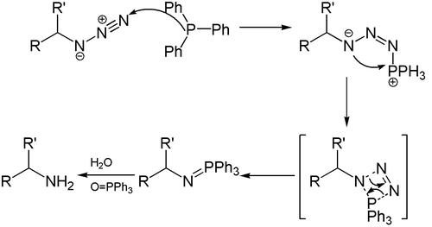](https://en.wikipedia.org/wiki/File:Staudinger-Reaktion.png)

**Staudinger Reduction**

http://www.organic-chemistry.org/namedreactions/staudi14.gif

Azides may be converted to amines by hydrogenation, but another possibility is the Staudinger Reaction, which is a very mild azide reduction. As there are a variety of methods for preparing azides readily, the Staudinger Reaction makes it possible to use -N3 as an -NH2 synthon.

Mechanism of the Staudinger Reaction: [Triphenylphosphine](http://www.organic-chemistry.org/chemicals/reductions/triphenylphosphine.shtm) reacts with the azide to generate a phosphazide, which loses N2 to form an iminophosphorane. Aqueous work up leads to the amine and the very stable phosphine oxide.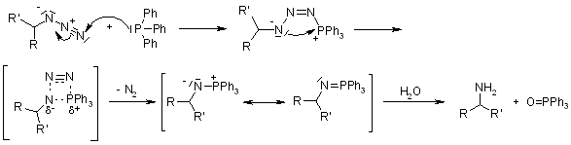

**UGI REACTION**

The Ugi reaction is [exothermic](https://en.wikipedia.org/wiki/Exothermic) and usually complete within minutes of adding the isocyanide. High concentration (0.5M - 2.0M) of reactants give the highest yields. Polar, aprotic [solvents](https://en.wikipedia.org/wiki/Solvent), like [DMF](https://en.wikipedia.org/wiki/Dimethylformamide), work well. However, [methanol](https://en.wikipedia.org/wiki/Methanol) and [ethanol](https://en.wikipedia.org/wiki/Ethanol) have also been used successfully. This uncatalyzed reaction has an inherent high [atom economy](https://en.wikipedia.org/wiki/Atom_economy) as only a molecule of water is lost and [chemical yield](https://en.wikipedia.org/wiki/Chemical_yield) in general are high. Recent research has shown that the Ugi reaction is accelerated in [water](https://en.wikipedia.org/wiki/Water_(molecule)).

**Reaction mechanism:**

In the Ugi reaction, the initial reaction is the formation of an [imine](https://en.wikipedia.org/wiki/Imine) (1) from the amine and the ketone. Subsequent reaction of the imine with the isocyanide and the carboxylic acid gives intermediate 2, which rearranges via an acyl transfer into the bis-amide 3. The exact mechanism of the trimolecular reaction to form intermediate 2 is not known. [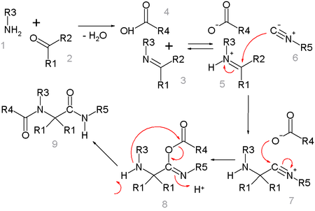](https://en.wikipedia.org/wiki/File:UgiReactionMechanism.png)

[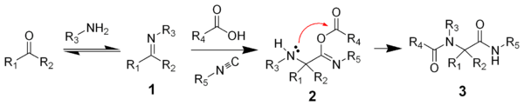](https://en.wikipedia.org/wiki/File:Ugi_Reaction_Mechanism.png)

The reaction can also be performed with a pre-formed imine. This results in an increased yield.

One plausible [reaction mechanism](https://en.wikipedia.org/wiki/Reaction_mechanism) is depicted below:

[Amine](https://en.wikipedia.org/wiki/Amine) 1 and [ketone](https://en.wikipedia.org/wiki/Ketone) 2 form the [imine](https://en.wikipedia.org/wiki/Alkylimino-de-oxo-bisubstitution) 3 with loss of one equivalent of water. Proton exchange with [carboxylic acid](https://en.wikipedia.org/wiki/Carboxylic_acid) 4 activates the [iminium](https://en.wikipedia.org/wiki/Iminium) ion 5 for [nucleophilic addition](https://en.wikipedia.org/wiki/Nucleophilic_addition) of the isocyanide 6 with its terminal carbon atom to [nitrilium](https://en.wikipedia.org/wiki/Nitrilium) ion 7. A second nucleophilic addition takes place at this intermediate with the carboxylic acid anion to 8. The final step is a [Mumm rearrangement](https://en.wikipedia.org/wiki/Mumm_rearrangement) with transfer of the R4 acyl group from oxygen to nitrogen. Note that in the related [Passerini reaction](https://en.wikipedia.org/wiki/Passerini_reaction) (lacking the amine) the isocyanide reacts directly with the carbonyl group but other aspects of the reaction are the same. All reaction steps are [reversible](https://en.wikipedia.org/wiki/Reversible_reaction) except for the Mumm rearrangement, which drives the whole reaction sequence.

**WEINREB–NAHM KETONE SYNTHESIS:**

The Weinreb–Nahm ketone synthesis is a chemical reaction used in [organic chemistry](https://en.wikipedia.org/wiki/Organic_chemistry) to make [carbon–carbon bonds](https://en.wikipedia.org/wiki/Carbon%E2%80%93carbon_bond). It was discovered in 1981 by [Steven M. Weinreb](https://en.wikipedia.org/wiki/Steven_M._Weinreb) and Steven Nahm as a method to synthesize [ketones](https://en.wikipedia.org/wiki/Ketones). The original reaction involved two subsequent [nucleophilic acyl substitutions](https://en.wikipedia.org/wiki/Nucleophilic_acyl_substitution): the conversion of an [acid chloride](https://en.wikipedia.org/wiki/Acid_chloride) with [N,O-Dimethylhydroxylamine](https://en.wikipedia.org/wiki/N,O-Dimethylhydroxylamine), to form a Weinreb–Nahm amide, and subsequent treatment of this species with an [organometallic](https://en.wikipedia.org/wiki/Organometallic) reagent such as a [Grignard reagent](https://en.wikipedia.org/wiki/Grignard_reaction) or [organolithium reagent](https://en.wikipedia.org/wiki/Organolithium_reagent). Nahm and Weinreb also reported the synthesis of [aldehydes](https://en.wikipedia.org/wiki/Aldehyde) by [reduction](https://en.wikipedia.org/wiki/Redox) of the [amide](https://en.wikipedia.org/wiki/Amide) with an excess of [lithium aluminum hydride](https://en.wikipedia.org/wiki/Lithium_aluminium_hydride) (see [amide reduction](https://en.wikipedia.org/wiki/Amide_reduction)).

[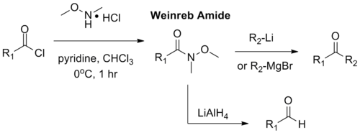](https://en.wikipedia.org/wiki/File:WeinrebAmideIntro.png)

The major advantage of this method over addition of organometallic reagents to more typical acyl compounds is that it avoids the common problem of over-addition. For these latter reactions, two [equivalents](https://en.wikipedia.org/wiki/Equivalent_(chemistry)) of the incoming group add to form an [alcohol](https://en.wikipedia.org/wiki/Alcohol) rather than a ketone or aldehyde. This

[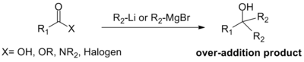](https://en.wikipedia.org/wiki/File:Overaddition.png)

The Weinreb–Nahm amide has since been adopted into regular use by organic chemists as a dependable method for the synthesis of ketones. These [functional groups](https://en.wikipedia.org/wiki/Functional_group) are present in a large number of [natural products](https://en.wikipedia.org/wiki/Natural_product) and can be reliably reacted to form new carbon–carbon bonds or converted into other functional groups. This method has been used in a number of syntheses, including Macrosphelides A and B, Amphidinolide J, and Spirofungins A and B.

einreb and Nahm originally proposed the following [reaction mechanism](https://en.wikipedia.org/wiki/Reaction_mechanism) to explain the selectivity shown in reactions of the Weinreb–Nahm amide. Their suggestion was that the [tetrahedral intermediate](https://en.wikipedia.org/wiki/Tetrahedral_intermediate) (A below) formed as a result of [nucleophilic acyl substitution](https://en.wikipedia.org/wiki/Nucleophilic_acyl_substitution) by the [organometallic](https://en.wikipedia.org/wiki/Organometallic) reagent is stabilized by [chelation](https://en.wikipedia.org/wiki/Chelation) from the [methoxy](https://en.wikipedia.org/wiki/Methoxy) group as shown.This intermediate is stable only at low temperatures, requiring a low-temperature [quench](https://en.wikipedia.org/wiki/Work-up_(chemistry)).

[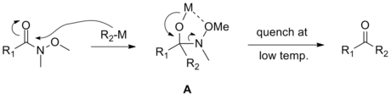](https://en.wikipedia.org/wiki/File:Weinrebmechanism.png)

This chelation is in contrast to the mechanism for formation of the over-addition product wherein collapse of the tetrahedral intermediate allows a second addition. The mechanistic conjecture on the part of Weinreb was immediately accepted by the academic community, but it was not until 2006 that it was confirmed by spectroscopic and kinetic analyses.

**FUKUYAMA COUPLING:**

The Fukuyama coupling is a [coupling reaction](https://en.wikipedia.org/wiki/Coupling_reaction) taking place between a [thioester](https://en.wikipedia.org/wiki/Thioester) and an [organozinc halide](https://en.wikipedia.org/wiki/Organozinc_halide) in the presence of a [palladium](https://en.wikipedia.org/wiki/Palladium)catalyst. The reaction product is a [ketone](https://en.wikipedia.org/wiki/Ketone). This reaction was discovered by [Tohru Fukuyama](https://en.wikipedia.org/wiki/Tohru_Fukuyama) et al. in 1998. Advantages are high chemoselectivity, mild reaction conditions and the use of less-toxic reagents.

[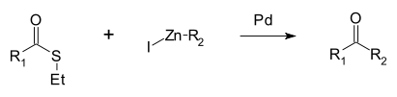](https://en.wikipedia.org/wiki/File:FukuyamaCoupling.svg)

One advantage of this method is that the reaction stops at the ketone and does not proceed to a tertiary alcohol. In addition, the protocol is compatible with [functional groups](https://en.wikipedia.org/wiki/Functional_groups) such as ketones, acetates, sulfides, aromatic bromides, chlorides and aldehydes.

[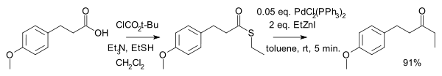](https://en.wikipedia.org/wiki/File:Fukuyama1998.svg)

The reaction (interrupted) has been used in the synthesis of [biotin](https://en.wikipedia.org/wiki/Biotin)

[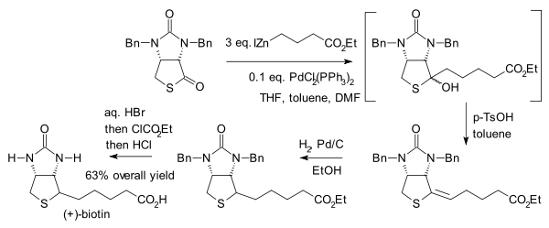](https://en.wikipedia.org/wiki/File:Biotin2000_synthesis.svg)

This reaction was preceded by the conceptually related [Fukuyama reduction](https://en.wikipedia.org/wiki/Fukuyama_reduction).

**HECK REACTION:**

The Heck reaction (also called the Mizoroki-Heck reaction) is the [chemical reaction](https://en.wikipedia.org/wiki/Chemical_reaction) of an unsaturated [halide](https://en.wikipedia.org/wiki/Halide) (or [triflate](https://en.wikipedia.org/wiki/Triflate)) with an [alkene](https://en.wikipedia.org/wiki/Alkene)in the presence of a [base](https://en.wikipedia.org/wiki/Base_(chemistry)) and a [palladium catalyst](https://en.wikipedia.org/wiki/Palladium_catalyst) (or palladium [nanomaterial-based catalyst](https://en.wikipedia.org/wiki/Nanomaterial-based_catalyst)) to form a substituted alkene.[[2]](https://en.wikipedia.org/wiki/Heck_reaction#cite_note-2) It is named after [Tsutomu Mizoroki](https://en.wikipedia.org/w/index.php?title=Tsutomu_Mizoroki&action=edit&redlink=1) and [Richard F. Heck](https://en.wikipedia.org/wiki/Richard_F._Heck). Heck was awarded the 2010 [Nobel Prize in Chemistry](https://en.wikipedia.org/wiki/Nobel_Prize_in_Chemistry), which he shared with [Ei-ichiNegishi](https://en.wikipedia.org/wiki/Ei-ichi_Negishi)and [Akira Suzuki](https://en.wikipedia.org/wiki/Akira_Suzuki_(chemist)), for the discovery and development of this reaction. This reaction was the first example of a carbon-carbon bond-forming reaction that followed a Pd(0)/Pd(II) catalytic cycle, the same catalytic cycle that is seen in other Pd(0)-catalyzed [cross-coupling reactions](https://en.wikipedia.org/wiki/Cross-coupling_reaction). The Heck reaction is of great importance, as it allows one to do substitution reactions on planar sp2-hybridized carbon atoms.

|  |
| --- |
| [The Heck reaction](https://en.wikipedia.org/wiki/File:Heck_Reaction_Scheme.png) |
| The Heck reaction |

The reaction is performed in the presence of an [organopalladium](https://en.wikipedia.org/wiki/Organopalladium) [catalyst](https://en.wikipedia.org/wiki/Catalyst). The halide (Br, Cl) or triflate is an [aryl](https://en.wikipedia.org/wiki/Aryl), [benzyl](https://en.wikipedia.org/wiki/Benzyl), or [vinyl](https://en.wikipedia.org/wiki/Vinyl_group) compound and the alkene contains at least one hydrogen and is often electron-deficient such as [acrylate](https://en.wikipedia.org/wiki/Acrylate) [ester](https://en.wikipedia.org/wiki/Ester) or an [acrylonitrile](https://en.wikipedia.org/wiki/Acrylonitrile).The catalyst can be [tetrakis(triphenylphosphine)palladium(0)](https://en.wikipedia.org/wiki/Tetrakis(triphenylphosphine)palladium(0)), [palladium chloride](https://en.wikipedia.org/wiki/Palladium_chloride) or [palladium(II) acetate](https://en.wikipedia.org/wiki/Palladium(II)_acetate). The [ligand](https://en.wikipedia.org/wiki/Ligand) is [triphenylphosphine](https://en.wikipedia.org/wiki/Triphenylphosphine), [PHOX](https://en.wikipedia.org/wiki/Phosphinooxazolines) or [BINAP](https://en.wikipedia.org/wiki/BINAP). The base is [triethylamine](https://en.wikipedia.org/wiki/Triethylamine), [potassium carbonate](https://en.wikipedia.org/wiki/Potassium_carbonate) or [sodium acetate](https://en.wikipedia.org/wiki/Sodium_acetate).

he [catalytic cycle](https://en.wikipedia.org/wiki/Catalytic_cycle) for the Heck reaction involves a series of transformations around the palladium catalyst. The palladium(0) compound required in this cycle is generally prepared [in situ](https://en.wikipedia.org/wiki/In_situ) from a palladium(II) precursor.

For instance, [palladium(II) acetate](https://en.wikipedia.org/wiki/Palladium(II)_acetate) is reduced by [triphenylphosphine](https://en.wikipedia.org/wiki/Triphenylphosphine) to bis(triphenylphosphine)palladium(0) (1) and triphenylphosphine is oxidized to triphenylphosphine oxide. Step A is an [oxidative addition](https://en.wikipedia.org/wiki/Oxidative_addition) in which palladium inserts itself in the aryl to bromide bond. Palladium then forms a [π complex](https://en.wikipedia.org/wiki/%CE%A0_complex) with the alkene (3) and in step B the alkene inserts itself in the palladium - carbon bond in a [syn addition](https://en.wikipedia.org/wiki/Syn_addition) step. Then follows a [torsional strain](https://en.wikipedia.org/wiki/Strain_(chemistry)#Torsional_strain) relieving rotation to the trans isomer (not shown) and step C is a [beta-hydride elimination](https://en.wikipedia.org/wiki/Beta-hydride_elimination) step with the formation of a new palladium - alkene [π complex](https://en.wikipedia.org/wiki/%CE%A0_complex) (5). This complex is destroyed in the next step. The palladium(0) compound is regenerated by [reductive elimination](https://en.wikipedia.org/wiki/Reductive_elimination) of the palladium(II) compound by [potassium carbonate](https://en.wikipedia.org/wiki/Potassium_carbonate) in the final step, D. In the course of the reaction the carbonate is stoichiometrically consumed and palladium is truly a catalyst and used in catalytic amounts. A similar palladium cycle but with different scenes and actors is observed in the [Wacker process](https://en.wikipedia.org/wiki/Wacker_process).

|  |
| --- |
| [Heck Reaction Mechanism](https://en.wikipedia.org/wiki/File:Heck_Reaction_Mechanism.svg) |

**SONOGASHIRA REACTION:**

The Sonogashira reaction is a [cross-coupling reaction](https://en.wikipedia.org/wiki/Cross-coupling_reaction) used in [organic synthesis](https://en.wikipedia.org/wiki/Organic_synthesis) to form [carbon–carbon bonds](https://en.wikipedia.org/wiki/Carbon%E2%80%93carbon_bond). It employs a [palladium](https://en.wikipedia.org/wiki/Palladium)[catalyst](https://en.wikipedia.org/wiki/Catalyst) to form a carbon–carbon bond between a terminal [alkyne](https://en.wikipedia.org/wiki/Alkyne) and an [aryl](https://en.wikipedia.org/wiki/Aryl) or [vinyl halide](https://en.wikipedia.org/wiki/Vinyl_halide).

{\displaystyle {\begin{matrix}{}\\{\ce {R-\!{\equiv }\!-H}}+{\color {Red}{\ce {R'}}}\!-\!{\ce {X->[{\text{Pd cat., Cu cat.}}][{\text{base, rt}}]R-\!{\equiv }\!}}{\color {Red}{\ce {-R'}}}\end{matrix}}R': Aryl or Vinyl

X: I, Br, Cl or OTf

The Sonogashira cross-coupling reaction has been employed in a wide variety of areas, due to its usefulness in the formation of carbon–carbon bonds. The reaction can be carried out under mild conditions, such as at room temperature, in aqueous media, and with a mild base, which has allowed for the use of the Sonogashira cross-coupling reaction in the synthesis of complex molecules. It applications include pharmaceuticals, natural products, organic materials, and nanomaterials. Specific examples include its use in the synthesis of [tazarotene](https://en.wikipedia.org/wiki/Tazarotene), which is a treatment for [psoriasis](https://en.wikipedia.org/wiki/Psoriasis) and [acne](https://en.wikipedia.org/wiki/Acne), and in the preparation of SIB-1508Y, also known as [Altinicline](https://en.wikipedia.org/wiki/Altinicline), which is a potential treatment for [Parkinson's disease](https://en.wikipedia.org/wiki/Parkinson%27s_disease).

**Mechanism**

The [reaction mechanism](https://en.wikipedia.org/wiki/Reaction_mechanism) is not clearly understood but the textbook mechanism revolves around a palladium cycle and a copper cycle that is less well known.

[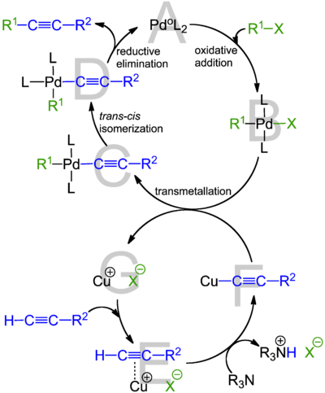](https://en.wikipedia.org/wiki/File:Sonogashira_Mechanism_english_V2.png)

Catalytic cycle for the Sonogashirareaction[[5]](https://en.wikipedia.org/wiki/Sonogashira_coupling#cite_note-Recent_Advances-5)

The palladium cycle

An inactive palladium PdII catalyst is activated by a reduction to the Pd0 compound.

The active palladium catalyst is the 14 electron compound Pd0L2, complex A, which reacts with the [aryl](https://en.wikipedia.org/wiki/Aryl) or [vinyl halide](https://en.wikipedia.org/wiki/Vinyl_halide) in an [oxidative addition](https://en.wikipedia.org/wiki/Oxidative_addition) to produce a PdII intermediate, complex B. This step is believed to be the [rate-limiting step](https://en.wikipedia.org/wiki/Rate-limiting_step) of the reaction.

Complex B reacts in a [transmetallation](https://en.wikipedia.org/wiki/Transmetallation) with the copper [acetylide](https://en.wikipedia.org/wiki/Acetylide), complex F, which is produced in the copper cycle, to give complex C, expelling the copper halide, complex G.

Both organic ligands are trans oriented and convert to cis in a [trans-cis isomerization](https://en.wikipedia.org/wiki/Trans-cis_isomerization) to produce complex D.

In the final step, complex D undergoes [reductive elimination](https://en.wikipedia.org/wiki/Reductive_elimination) to produce the alkyne, with regeneration of the palladium catalyst.

The copper cycle

It is suggested that the presence of base results in the formation of a pi-alkyne complex, complex E, which makes the terminal proton on the alkyne more acidic, leading to the formation of the copper acetylide, compound F.

Compound F continues to react with the palladium intermediate B, with regeneration of the copper halide, G.

Mechanistic studies suggest that these catalytic cycles represent the preferred reaction pathway, however there is debate about the exact identity of some intermediates, which may depend upon reaction conditions. For example, it has been shown that monoligatedPd0(PR3) complexes (B) can be formed when dealing with bulky phosphanes and have been suggested as possible catalytic species in coupling reactions.[[7]](https://en.wikipedia.org/wiki/Sonogashira_coupling#cite_note-Synthesis.2C_Characterization-7) In contrast, some results point to the formation of anionic palladium species, which would be the real catalysts instead of the coordinatively unsaturated Pd0L2. Generally seen in the presence of anions and halides, it is known that Pd0(PPh3)2 does not exist in solution when generated in the presence of halide anions because they coordinate the Pd0 center to form anionic species of the type [L2Pd0Cl]− which can participate in cross-coupling reactions.

**SUZUKI REACTION:**

The Suzuki reaction is an [organic reaction](https://en.wikipedia.org/wiki/Organic_reaction), classified as a [coupling reaction](https://en.wikipedia.org/wiki/Coupling_reaction), where the coupling partners are a [boronic acid](https://en.wikipedia.org/wiki/Boronic_acid) and an [organohalide](https://en.wikipedia.org/wiki/Organohalide) [catalyzed](https://en.wikipedia.org/wiki/Catalyzed) by a [palladium(0) complex](https://en.wikipedia.org/wiki/Palladium). It was first published in 1979 by [Akira Suzuki](https://en.wikipedia.org/wiki/Akira_Suzuki_(chemist)) and he shared the 2010 [Nobel Prize in Chemistry](https://en.wikipedia.org/wiki/Nobel_Prize_in_Chemistry) with [Richard F. Heck](https://en.wikipedia.org/wiki/Richard_F._Heck) and [Ei-ichiNegishi](https://en.wikipedia.org/wiki/Ei-ichi_Negishi) for their effort for discovery and development of palladium-catalyzed cross couplings in organic synthesis. In many publications this reaction also goes by the name Suzuki–Miyaura reaction and is also referred to as the Suzuki coupling. It is widely used to [synthesize](https://en.wikipedia.org/wiki/Organic_synthesis) poly-[olefins](https://en.wikipedia.org/wiki/Olefin), [styrenes](https://en.wikipedia.org/wiki/Styrene), and substituted [biphenyls](https://en.wikipedia.org/wiki/Biphenyl). Several reviews have been published describing advancements and the development of the Suzuki Reaction.[[5]](https://en.wikipedia.org/wiki/Suzuki_reaction#cite_note-5)[[6]](https://en.wikipedia.org/wiki/Suzuki_reaction#cite_note-6)[[7]](https://en.wikipedia.org/wiki/Suzuki_reaction#cite_note-7) The general scheme for the Suzuki reaction is shown below where a carbon-carbon single bond is formed by coupling an [organoboron](https://en.wikipedia.org/wiki/Organoboron) species (R1-BY2) with a [halide](https://en.wikipedia.org/wiki/Halide) (R2-X) using a [palladium](https://en.wikipedia.org/wiki/Palladium) catalyst and a [base](https://en.wikipedia.org/wiki/Base_(chemistry)).

|  |
| --- |
|  |

**Reaction mechanism**

The [mechanism](https://en.wikipedia.org/wiki/Reaction_mechanism) of the Suzuki reaction is best viewed from the perspective of the palladium catalyst. The first step is the [oxidative addition](https://en.wikipedia.org/wiki/Oxidative_addition) of palladium to the [halide](https://en.wikipedia.org/wiki/Halide) 2 to form the [organopalladium](https://en.wikipedia.org/wiki/Organopalladium) species 3. Reaction with base gives [intermediate](https://en.wikipedia.org/wiki/Reaction_intermediate) 4, which via [transmetalation](https://en.wikipedia.org/wiki/Transmetalation)[[8]](https://en.wikipedia.org/wiki/Suzuki_reaction#cite_note-8) with the boron-[ate complex](https://en.wikipedia.org/wiki/Ate_complex) 6 (produced by reaction of the boronic acid 5 with base) forms the [organopalladium](https://en.wikipedia.org/wiki/Organopalladium) species 8. [Reductive elimination](https://en.wikipedia.org/wiki/Reductive_elimination) of the desired product 9 restores the original palladium catalyst 1 which completes the [catalytic cycle](https://en.wikipedia.org/wiki/Catalytic_cycle). The Suzuki coupling takes place in the presence of a base and for a long time the role of the base was never fully understood. The base was first believed to form a trialkyl borate (R3B-OR), in the case of a reaction of an trialkylborane (BR3) and [alkoxide](https://en.wikipedia.org/wiki/Alkoxide) (−OR); this species could be considered as being more [nucleophilic](https://en.wikipedia.org/wiki/Nucleophilic) and then more reactive towards the palladium complex present in the transmetalation step.[[9]](https://en.wikipedia.org/wiki/Suzuki_reaction#cite_note-Duc_-_Kinetics-9)[[10]](https://en.wikipedia.org/wiki/Suzuki_reaction#cite_note-Kinetics_2-10)[[11]](https://en.wikipedia.org/wiki/Suzuki_reaction#cite_note-Kinetics_3-11) Duc and coworkers investigated the role of the base in the reaction mechanism for the Suzuki coupling and they found that the base has three roles: Formation of the palladium complex [ArPd(OR)L2], formation of the trialkyl borate and the acceleration of the reductive elimination step by reaction of the alkoxide with the palladium complex. [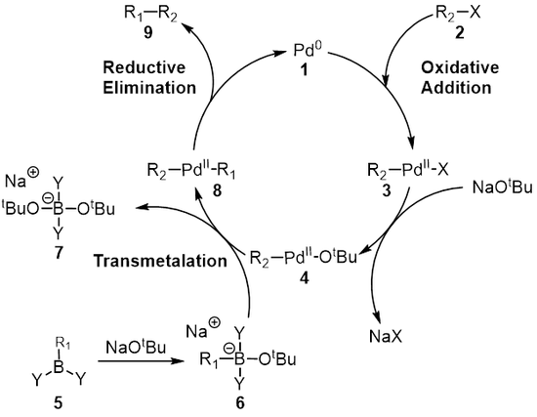](https://en.wikipedia.org/wiki/File:Suzuki_Coupling_Full_Mechanism_2.png)

**BAYLIS-HILLMAN REACTION:**

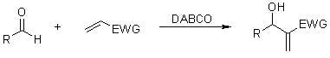

This coupling of an activated alkene derivative with an aldehyde is catalyzed by a tertiary amine (for example: DABCO = 1,4-Diazabicyclo[2.2.2]octane). Phosphines can also be used in this reaction, and enantioselective reactions may be carried out if the amine or phosphine catalyst is asymmetric.

http://www.organic-chemistry.org/namedreactions/Baylis2a.gif

Mechanism of the Baylis-Hillman Reaction

A key step is the addition of the amine catalyst to the activated alkene to form a stabilized nucleophilic anion. This in situ-generated nucleophile then adds to the aldehyde. Subsequent elimination of the catalyst leads to the observed products.

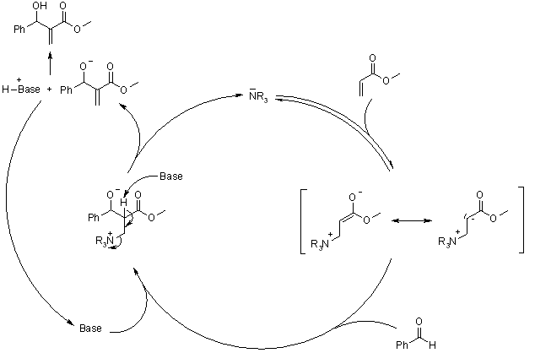

Other activating nitrogen nucleophiles may be suitable too and DMAP and DBU are superior to DABCO in some cases:

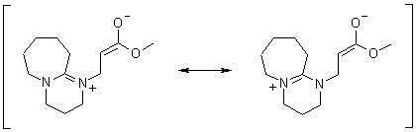product of the addition of DBU and methylacrylate

For aryl aldehydes under polar, nonpolar, and protic conditions, it has been determined that the rate-determining step is second-order in aldehyde and first-order in DABCO and acrylate. On the basis of this reaction rate data, Tyler McQuade recently proposed (*J. Org. Chem.* 2005, *70*, 3980. [DOI](http://dx.doi.org/10.1021/jo050202j)) the following mechanism involving the formation of a hemiacetal intermediate:

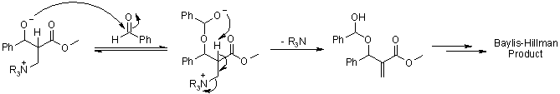

**BIGINELLI REACTION:**

The Biginelli reaction is a [multiple-component](https://en.wikipedia.org/wiki/Multi-component_reaction) [chemical reaction](https://en.wikipedia.org/wiki/Chemical_reaction) that creates 3,4-dihydropyrimidin-2(1*H*)-ones 4 from [ethyl acetoacetate](https://en.wikipedia.org/wiki/Ethyl_acetoacetate)1, an aryl [aldehyde](https://en.wikipedia.org/wiki/Aldehyde) (such as [benzaldehyde](https://en.wikipedia.org/wiki/Benzaldehyde) 2), and [urea](https://en.wikipedia.org/wiki/Urea) 3.[[1]](https://en.wikipedia.org/wiki/Biginelli_reaction#cite_note-1)[[2]](https://en.wikipedia.org/wiki/Biginelli_reaction#cite_note-2)[[3]](https://en.wikipedia.org/wiki/Biginelli_reaction#cite_note-3)[[4]](https://en.wikipedia.org/wiki/Biginelli_reaction#cite_note-4) It is named for the Italian chemist [Pietro Biginelli](https://en.wikipedia.org/wiki/Pietro_Biginelli).[[5]](https://en.wikipedia.org/wiki/Biginelli_reaction#cite_note-Zhu-5)[[6]](https://en.wikipedia.org/wiki/Biginelli_reaction#cite_note-6)

[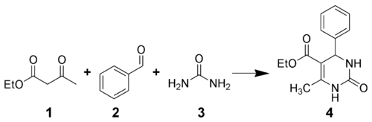](https://en.wikipedia.org/wiki/File:Biginelli_Reaction_Scheme.png)

This reaction was developed by [Pietro Biginelli](https://en.wikipedia.org/wiki/Pietro_Biginelli) in 1891. The reaction can be catalyzed by [Brønsted acids](https://en.wikipedia.org/wiki/Br%C3%B8nsted_acid) and/or by [Lewis acids](https://en.wikipedia.org/wiki/Lewis_acid) such as copper(II) trifluoroacetate hydrate and [boron trifluoride](https://en.wikipedia.org/wiki/Boron_trifluoride).Several [solid-phase](https://en.wikipedia.org/wiki/Solid-phase_synthesis) protocols utilizing different linker combinations have been published.

Dihydropyrimidinones, the products of the Biginelli reaction, are widely used in the [pharmaceutical](https://en.wikipedia.org/wiki/Pharmaceutical) industry as [calcium channel](https://en.wikipedia.org/wiki/Calcium_channel) blockers, [antihypertensive agents](https://en.wikipedia.org/wiki/Antihypertensive), and alpha-1-a-antagonists.

Reaction mechanism

The reaction mechanism of the Biginelli reaction is a series of bimolecular reactions leading to the desired dihydropyrimidinone.

According to a mechanism proposed by Sweet in 1973 the [aldol condensation](https://en.wikipedia.org/wiki/Aldol_condensation) of ethylacetoacetate 1 and the aryl aldehyde is the [rate-limiting step](https://en.wikipedia.org/wiki/Rate-limiting_step) leading to the carbenium ion 2. The nucleophilic addition of urea gives the intermediate 4, which quickly dehydrates to give the desired product 5.

[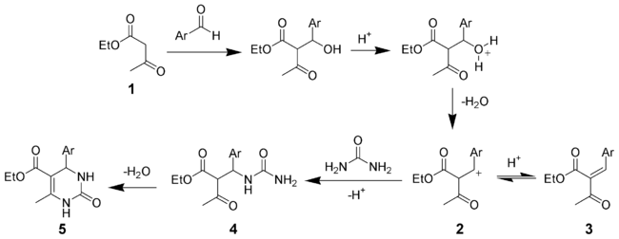](https://en.wikipedia.org/wiki/File:Biginelli_Reaction_Mechanism.png)

This mechanism is superseded by one by Kappe in 1997:

[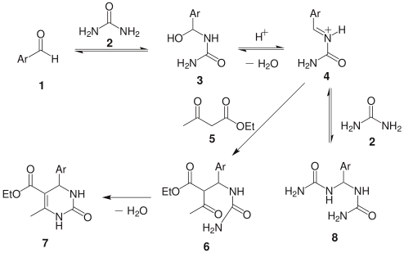](https://en.wikipedia.org/wiki/File:Biginelli_reaction_mechanism.svg)

This scheme begins with rate determining nucleophilic addition by the urea to the aldehyde.The ensuing condensation step is catalyzed by the addition of acid, resulting in the imine nitrogen. The β-ketoester then adds to the imine bond and consequently the ring is closed by the nucleophilic attack by the amine onto the carbonyl group. This final step ensues a second condensation and results in the Biginelli compound.

**COREY–CHAYKOVSKY REACTION:**

The Johnson–Corey–Chaykovsky reaction (sometimes referred to as the Corey–Chaykovsky reaction or CCR) is a [chemical reaction](https://en.wikipedia.org/wiki/Chemical_reaction)used in [organic chemistry](https://en.wikipedia.org/wiki/Organic_chemistry) for the synthesis of [epoxides](https://en.wikipedia.org/wiki/Epoxide), [aziridines](https://en.wikipedia.org/wiki/Aziridine), and [cyclopropanes](https://en.wikipedia.org/wiki/Cyclopropane). It was discovered in 1961 by A. William Johnson and developed significantly by [E. J. Corey](https://en.wikipedia.org/wiki/E._J._Corey) and Michael Chaykovsky. The reaction involves addition of a sulfur [ylide](https://en.wikipedia.org/wiki/Ylide) to a [ketone](https://en.wikipedia.org/wiki/Ketone), [aldehyde](https://en.wikipedia.org/wiki/Aldehyde), [imine](https://en.wikipedia.org/wiki/Imine), or [enone](https://en.wikipedia.org/wiki/Enone) to produce the corresponding 3-membered ring. The reaction is [diastereoselective](https://en.wikipedia.org/wiki/Diastereoselective) favoring *trans* substitution in the product regardless of the initial [stereochemistry](https://en.wikipedia.org/wiki/Stereochemistry). The synthesis of [epoxides](https://en.wikipedia.org/wiki/Epoxide) via this method serves as an important [retrosynthetic](https://en.wikipedia.org/wiki/Retrosynthetic_analysis) alternative to the traditional [epoxidation](https://en.wikipedia.org/wiki/Epoxidation) reactions of [olefins](https://en.wikipedia.org/wiki/Olefin).

The reaction is most often employed for epoxidation via [methylene](https://en.wikipedia.org/wiki/Methylene_(compound)) transfer, and to this end has been used in several notable [total syntheses](https://en.wikipedia.org/wiki/Total_syntheses) (See [Synthesis of epoxides](https://en.wikipedia.org/wiki/Johnson%E2%80%93Corey%E2%80%93Chaykovsky_reaction#Synthesis_of_epoxides) below). Additionally detailed below are the history, mechanism, scope, and enantioselective variants of the reaction.

The [reaction mechanism](https://en.wikipedia.org/wiki/Reaction_mechanism) for the Johnson–Corey–Chaykovsky reaction consists of [nucleophilic addition](https://en.wikipedia.org/wiki/Nucleophilic_addition) of the [ylide](https://en.wikipedia.org/wiki/Ylide) to the [carbonyl](https://en.wikipedia.org/wiki/Carbonyl) or [imine](https://en.wikipedia.org/wiki/Imine) group. A negative charge is transferred to the [heteroatom](https://en.wikipedia.org/wiki/Heteroatom) and because the [sulfonium](https://en.wikipedia.org/wiki/Sulfonium) [cation](https://en.wikipedia.org/wiki/Cation) is a good [leaving group](https://en.wikipedia.org/wiki/Leaving_group) it gets expelled forming the ring. In the related [Wittig reaction](https://en.wikipedia.org/wiki/Wittig_reaction), the formation of the much stronger [phosphorus](https://en.wikipedia.org/wiki/Phosphorus)-[oxygen](https://en.wikipedia.org/wiki/Oxygen) [double bond](https://en.wikipedia.org/wiki/Double_bond) prevents [oxirane](https://en.wikipedia.org/wiki/Oxirane) formation and instead, [olefination](https://en.wikipedia.org/w/index.php?title=Olefination&action=edit&redlink=1) takes place through a 4-membered cyclic intermediate.

[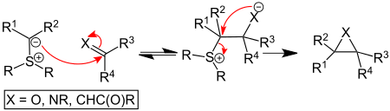](https://en.wikipedia.org/wiki/File:CCR_Mechanism_V.1.svg)

The *trans* [diastereoselectivity](https://en.wikipedia.org/wiki/Diastereoselectivity) observed results from the reversibility of the initial addition, allowing equilibration to the favored *anti* [betaine](https://en.wikipedia.org/wiki/Betaine) over the *syn* betaine. Initial addition of the ylide results in a betaine with adjacent charges; [density functional theory](https://en.wikipedia.org/wiki/Density_functional_theory) calculations have shown that the [rate-limiting step](https://en.wikipedia.org/wiki/Rate-limiting_step) is rotation of the central bond into the conformer necessary for [backside attack](https://en.wikipedia.org/wiki/Nucleophilic_addition) on the sulfonium.[[1]](https://en.wikipedia.org/wiki/Johnson%E2%80%93Corey%E2%80%93Chaykovsky_reaction#cite_note-Aggrawal2003-1)

[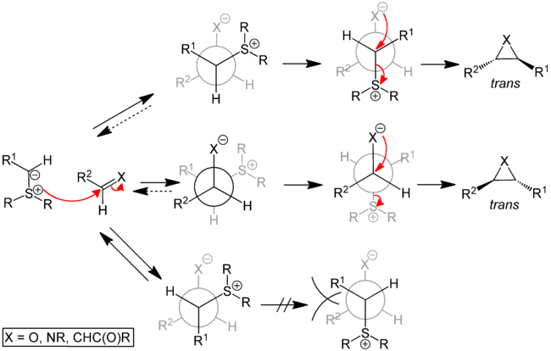](https://en.wikipedia.org/wiki/File:CCR_Mechanism_(Newman)_V2.png)

The degree of reversibility in the initial step (and therefore the diastereoselectivity) depends on four factors, with greater reversibility corresponding to higher selectivity:

**SAKURAI REACTION**

The Sakurai reaction (also known as the Hosomi–Sakurai reaction) is the [chemical reaction](https://en.wikipedia.org/wiki/Chemical_reaction) of [carbon](https://en.wikipedia.org/wiki/Carbon) [electrophiles](https://en.wikipedia.org/wiki/Electrophile) (such as a [ketone](https://en.wikipedia.org/wiki/Ketone)shown here) with [allylic](https://en.wikipedia.org/wiki/Allylic) [silanes](https://en.wikipedia.org/wiki/Silanes) catalyzed by strong [Lewis acids](https://en.wikipedia.org/wiki/Lewis_acid).[[1]](https://en.wikipedia.org/wiki/Sakurai_reaction#cite_note-1)[[2]](https://en.wikipedia.org/wiki/Sakurai_reaction#cite_note-2)[[3]](https://en.wikipedia.org/wiki/Sakurai_reaction#cite_note-3)[[4]](https://en.wikipedia.org/wiki/Sakurai_reaction#cite_note-4)[[5]](https://en.wikipedia.org/wiki/Sakurai_reaction#cite_note-5)[[6]](https://en.wikipedia.org/wiki/Sakurai_reaction#cite_note-6) It is named after the chemists [Akira Hosomi](https://en.wikipedia.org/wiki/Akira_Hosomi) and [Hideki Sakurai](https://en.wikipedia.org/wiki/Hideki_Sakurai).

[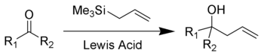](https://en.wikipedia.org/wiki/File:Sakurai_Reaction_Scheme.png)

Lewis acid activation is essential for complete reaction. Strong Lewis acids such as [titanium tetrachloride](https://en.wikipedia.org/wiki/Titanium_tetrachloride), [boron trifluoride](https://en.wikipedia.org/wiki/Boron_trifluoride), [tin tetrachloride](https://en.wikipedia.org/wiki/Tin_tetrachloride), and AlCl(Et)2 are all effective in promoting the Hosomi reaction. The reaction is a type of [electrophilic allyl shift](https://en.wikipedia.org/wiki/Electrophilic_allyl_shift) with formation of an intermediate beta-silyl carbocation. Driving force is the stabilization of said carbocation by the [beta-silicon effect](https://en.wikipedia.org/wiki/Beta-silicon_effect).

**Mechanism**

[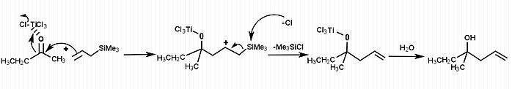](https://en.wikipedia.org/wiki/File:Hosomi_reaction.jpeg)

Figure 1: Hosomi-Sakurai reaction showing allylation of carbonyl ketone

[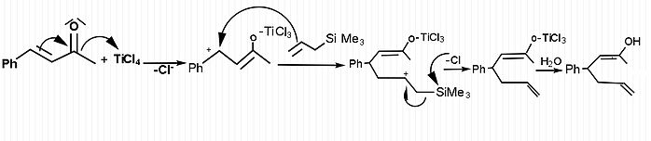](https://en.wikipedia.org/wiki/File:Sohag_chak_2.jpeg)Figure 2: Hosomi-Sakurai reaction showing allylation of allyl ketone

The Hosomi-Sakurai reactions are allylation reactions which involve use of allylsilanes as allylmetal reagents. This section demonstrates examples of allylation of different ketone groups. In figure 1, allylation of a carbonyl ketone (compound containing a ketone group and two different functional groups) has been shown. In the given reaction, the electrophilic compound (carbon with a ketone group) is treated with titanium tetrachloride, a strong Lewis acid and allyltrimethylsilane. According to the general principle, the Lewis acid first activates the electrophilic carbon in presence of allyltrimethylsilane which then undergoes nucleophilic attack from electrons on the allylicsilane.[[7]](https://en.wikipedia.org/wiki/Sakurai_reaction#cite_note-7)[[8]](https://en.wikipedia.org/wiki/Sakurai_reaction#cite_note-8) The silicon plays the key role in stabilizing the carbocation of carbon at the β-position. Hosomi-Sakurai reaction is also applicable for other functional groups such as allyl ketone. In figure 2, the Hosomi- Sakurai reaction has been shown using a cinnamoyl-group containing ketone. This reaction follows the same mechanism as the previous reaction shown here.

**HUNSDIECKER REACTION**

The Hunsdiecker reaction (also called the Borodin reaction after [Alexander Borodin](https://en.wikipedia.org/wiki/Alexander_Borodin)) is the [organic reaction](https://en.wikipedia.org/wiki/Organic_reaction) of [silver](https://en.wikipedia.org/wiki/Silver) salts of [carboxylic acids](https://en.wikipedia.org/wiki/Carboxylic_acid) with [halogens](https://en.wikipedia.org/wiki/Halogen) to give organic [halides](https://en.wikipedia.org/wiki/Halide).[[1]](https://en.wikipedia.org/wiki/Hunsdiecker_reaction#cite_note-1)[[2]](https://en.wikipedia.org/wiki/Hunsdiecker_reaction#cite_note-2)[[3]](https://en.wikipedia.org/wiki/Hunsdiecker_reaction#cite_note-3)[[4]](https://en.wikipedia.org/wiki/Hunsdiecker_reaction#cite_note-4) It is an example of a [halogenation](https://en.wikipedia.org/wiki/Halogenation) reaction. The reaction is named after [Heinz Hunsdiecker](https://en.wikipedia.org/wiki/Heinz_Hunsdiecker) and [CläreHunsdiecker](https://en.wikipedia.org/wiki/Cl%C3%A4re_Hunsdiecker), but was first noted by [Borodin](https://en.wikipedia.org/wiki/Borodin) in 1861 when he prepared [methyl bromide](https://en.wikipedia.org/wiki/Methyl_bromide) from [silver acetate](https://en.wikipedia.org/wiki/Silver_acetate).[[5]](https://en.wikipedia.org/wiki/Hunsdiecker_reaction#cite_note-5)

[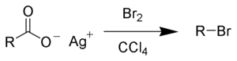](https://en.wikipedia.org/wiki/File:Hunsdiecker_Reaction_Scheme.png)

**REACTION MECHANISM**

The [reaction mechanism](https://en.wikipedia.org/wiki/Reaction_mechanism) of the Hunsdiecker reaction is believed to involve [organic radical](https://en.wikipedia.org/wiki/Radical_(chemistry)) intermediates. The silver salt of the carboxylic acid 1 will quickly react with bromine to form the [acyl hypohalite](https://en.wikipedia.org/w/index.php?title=Acyl_hypohalite&action=edit&redlink=1) intermediate 2. Formation of the [diradical](https://en.wikipedia.org/wiki/Diradical) pair 3 allows for radical decarboxylation to form the diradical pair 4, which will quickly recombine to form the desired organic halide 5. The yield of halide is primary>secondary>tertiary.

[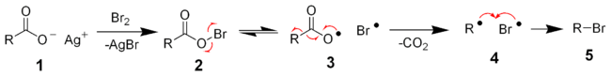](https://en.wikipedia.org/wiki/File:Hunsdiecker_Reaction_Mechanism.png)

**JULIA OLEFINATION:**

The Julia olefination (also known as the Julia–Lythgoe olefination) is the [chemical reaction](https://en.wikipedia.org/wiki/Chemical_reaction) used in [organic chemistry](https://en.wikipedia.org/wiki/Organic_chemistry) of [phenyl](https://en.wikipedia.org/wiki/Phenyl) [sulfones](https://en.wikipedia.org/wiki/Sulfone)(1) with [aldehydes](https://en.wikipedia.org/wiki/Aldehydes) (or [ketones](https://en.wikipedia.org/wiki/Ketone)) to give [alkenes](https://en.wikipedia.org/wiki/Alkene) (3) after alcohol functionalization and reductive elimination using sodium amalgam or [SmI2](https://en.wikipedia.org/wiki/Samarium(II)_iodide). The reaction is named after the French chemist [Marc Julia](https://en.wikipedia.org/wiki/Marc_Julia).

[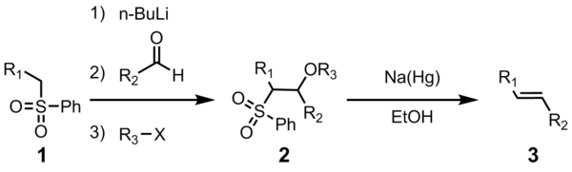](https://en.wikipedia.org/wiki/File:Julia_Olefination_Revised_Scheme.png)

The utility of this connective olefination reaction arises from its versatility, its wide functional group tolerance, and the mild reaction conditions under which the reaction proceeds.

All four steps can be carried out in a single reaction vessel, and use of R3X is optional. However, purification of the sulfone intermediate 2 leads to higher yield and purity. Most often R3 is [acetyl](https://en.wikipedia.org/wiki/Acetyl) or [benzoyl](https://en.wikipedia.org/wiki/Benzoyl), with [acetic anhydride](https://en.wikipedia.org/wiki/Acetic_anhydride) or [benzoyl chloride](https://en.wikipedia.org/wiki/Benzoyl_chloride) used in the preparation of 2

**Reaction mechanism**

The initial steps are straightforward. The phenyl sulfone [anion](https://en.wikipedia.org/wiki/Anion) (2) reacts with an aldehyde to form the [alkoxide](https://en.wikipedia.org/wiki/Alkoxide) (3). The alkoxide is functionalized with R3-X to give the stable intermediate (4). The exact mechanism of the sodium amalgam reduction is unknown but has been shown to proceed through a vinylic radical species (5). Protonation of the vinylic radical gives the desired product [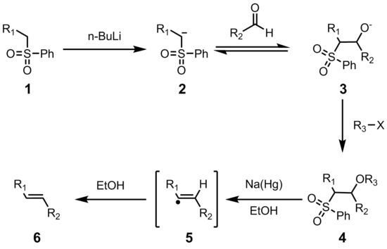](https://en.wikipedia.org/wiki/File:Julia_olefination_mechanism_wiki.png)

The stereochemistry of the alkene (6) is independent of the stereochemistry of the sulfone intermediate 4. It is thought that the radical intermediates are able to equilibrate so that the more thermodynamically stable trans-olefin is produced most often. This transformation highly favors formation of the *E*-alkene.

**MITSUNOBU REACTION:**

The Mitsunobu reaction is an [organic reaction](https://en.wikipedia.org/wiki/Organic_reaction) that converts an alcohol into a variety of functional groups, such as an [ester](https://en.wikipedia.org/wiki/Ester), using [triphenylphosphine](https://en.wikipedia.org/wiki/Triphenylphosphine) and an azodicarboxylate such as [diethyl azodicarboxylate](https://en.wikipedia.org/wiki/Diethyl_azodicarboxylate) (DEAD) or [diisopropylazodicarboxylate](https://en.wikipedia.org/wiki/Diisopropyl_azodicarboxylate) (DIAD) The alcohol undergoes an [inversion](https://en.wikipedia.org/wiki/Walden_inversion) of [stereochemistry](https://en.wikipedia.org/wiki/Stereochemistry). It was discovered by [Oyo Mitsunobu](https://en.wikipedia.org/w/index.php?title=Oyo_Mitsunobu&action=edit&redlink=1) (1934–2003).

[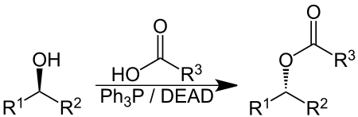](https://en.wikipedia.org/wiki/File:Mitsunobu-Reaction_V.1.svg)

The [reaction mechanism](https://en.wikipedia.org/wiki/Reaction_mechanism) of the Mitsunobu reaction is fairly complex. The identity of intermediates and the roles they play has been the subject of debate.Initially, the triphenyl phosphine (2) makes a nucleophilic attack upon diethyl azodicarboxylate (1) producing a betaine intermediate 3, which deprotonates the carboxylic acid (4) to form the ion pair 5. DEAD itself deprotonates the alcohol (6) forming an alkoxide that can form the key oxyphosphonium ion 8. The ratio and interconversion of intermediates 8–11depend on the carboxylic acid pKa and the solvent polarity.[[7]](https://en.wikipedia.org/wiki/Mitsunobu_reaction#cite_note-7)[[8]](https://en.wikipedia.org/wiki/Mitsunobu_reaction#cite_note-8)[[9]](https://en.wikipedia.org/wiki/Mitsunobu_reaction#cite_note-9) Although several phosphorus intermediates are present, the attack of the carboxylate anion upon intermediate 8 is the only productive pathway forming the desired product 12 and [triphenylphosphine oxide](https://en.wikipedia.org/wiki/Triphenylphosphine_oxide) (13).

[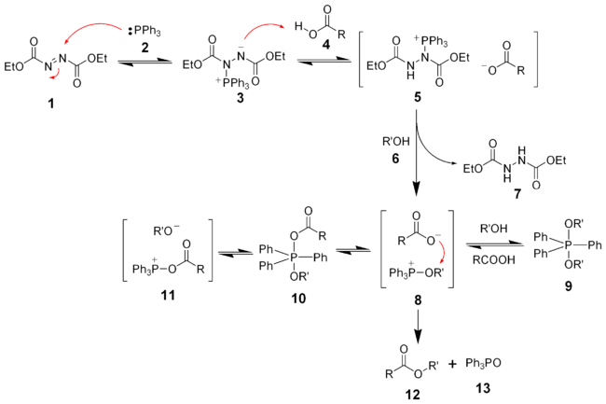](https://en.wikipedia.org/wiki/File:Mitsunobu_Reaction_Mechanism.png)

Hughes *et al.* have found that the formation of the ion pair 5 is very fast. The formation of the oxyphosphonium intermediate 8 is slow and facilitated by the alkoxide. Therefore, the overall rate of reaction is controlled by carboxylate basicity and solvation.[[10]](https://en.wikipedia.org/wiki/Mitsunobu_reaction#cite_note-10)

**PRÉVOST REACTION:**

The Prévost reaction is [chemical reaction](https://en.wikipedia.org/wiki/Chemical_reaction) in which an [alkene](https://en.wikipedia.org/wiki/Alkene) is converted by [iodine](https://en.wikipedia.org/wiki/Iodine) and the [silver](https://en.wikipedia.org/wiki/Silver) [salt](https://en.wikipedia.org/wiki/Salt_(chemistry)) of [benzoic acid](https://en.wikipedia.org/wiki/Benzoic_acid) to a [vicinal](https://en.wikipedia.org/wiki/Vicinal_(chemistry)) [diol](https://en.wikipedia.org/wiki/Diol) with [anti](https://en.wikipedia.org/wiki/Anti_addition) stereochemistry.[[1]](https://en.wikipedia.org/wiki/Pr%C3%A9vost_reaction#cite_note-1)[[2]](https://en.wikipedia.org/wiki/Pr%C3%A9vost_reaction#cite_note-2)[[3]](https://en.wikipedia.org/wiki/Pr%C3%A9vost_reaction#cite_note-3) The reaction was discovered by the French chemist [Charles Prévost](https://en.wikipedia.org/wiki/Charles_Pr%C3%A9vost) (1899–1983).

[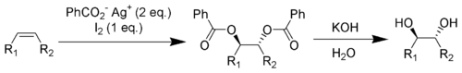](https://en.wikipedia.org/wiki/File:Prevost_Reaction_Scheme.png)

**Reaction mechanism**

The reaction between silver benzoate (1) and iodine is very fast and produces a very reactive iodinium benzoate intermediate (2). The reaction of the iodinium salt (2) with an [alkene](https://en.wikipedia.org/wiki/Alkene)gives another short-lived iodinium salt (3). Nucleophilic substitution ([SN2](https://en.wikipedia.org/wiki/SN2_reaction)) by the benzoate salt gives the ester (4). Another silver ion causes the [neighboring group substitution](https://en.wikipedia.org/wiki/Anchimeric_assistance) of the benzoate ester to give the [oxonium salt](https://en.wikipedia.org/wiki/Oxonium_ion) (5). A second [SN2 substitution](https://en.wikipedia.org/wiki/SN2_reaction) by the benzoate anion gives the desired diester (6).

[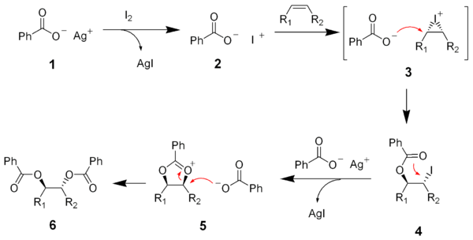](https://en.wikipedia.org/wiki/File:Prevost_Reaction_Mechanism.png)

In the final step [hydrolysis](https://en.wikipedia.org/wiki/Hydrolysis) of the [ester](https://en.wikipedia.org/wiki/Ester) groups gives the anti-diol. This outcome is the opposite of that of the related [Woodward cis-hydroxylation](https://en.wikipedia.org/wiki/Woodward_cis-hydroxylation) which gives [syn addition](https://en.wikipedia.org/wiki/Syn_addition).

**PRINS REACTION:**

The Prins reaction is an [organic reaction](https://en.wikipedia.org/wiki/Organic_reaction) consisting of an [electrophilic addition](https://en.wikipedia.org/wiki/Electrophilic_addition) of an [aldehyde](https://en.wikipedia.org/wiki/Aldehyde) or [ketone](https://en.wikipedia.org/wiki/Ketone) to an [alkene](https://en.wikipedia.org/wiki/Alkene) or [alkyne](https://en.wikipedia.org/wiki/Alkyne) followed by capture of a [nucleophile](https://en.wikipedia.org/wiki/Nucleophile). The outcome of the reaction depends on reaction conditions . With water and a protic acid such as [sulfuric acid](https://en.wikipedia.org/wiki/Sulfuric_acid) as the reaction medium and [formaldehyde](https://en.wikipedia.org/wiki/Formaldehyde)the reaction product is a [1,3-diol](https://en.wikipedia.org/wiki/Diol). When water is absent, the cationic intermediate loses a proton to give an [allylic alcohol](https://en.wikipedia.org/wiki/Allylic_alcohol). With an excess of [formaldehyde](https://en.wikipedia.org/wiki/Formaldehyde) and a low reaction temperature the reaction product is a [dioxane](https://en.wikipedia.org/wiki/Dioxane). When water is replaced by [acetic acid](https://en.wikipedia.org/wiki/Acetic_acid) the corresponding [esters](https://en.wikipedia.org/wiki/Esters) are formed.

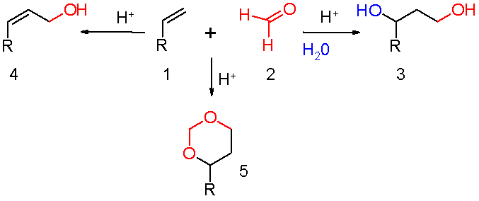

**Reaction mechanism**

The [reaction mechanism](https://en.wikipedia.org/wiki/Reaction_mechanism) for this reaction is depicted in scheme 5. The [carbonyl](https://en.wikipedia.org/wiki/Carbonyl) reactant (2) is [protonated](https://en.wikipedia.org/wiki/Protonation) by a protic acid and for the resulting [oxonium ion](https://en.wikipedia.org/wiki/Oxonium_ion) 3 two [resonance structures](https://en.wikipedia.org/wiki/Resonance_structure) can be drawn. This [electrophile](https://en.wikipedia.org/wiki/Electrophile) engages in an [electrophilic addition](https://en.wikipedia.org/wiki/Electrophilic_addition) with the [alkene](https://en.wikipedia.org/wiki/Alkene) to the [carbocationic](https://en.wikipedia.org/wiki/Carbocation) intermediate 4. Exactly how much positive charge is present on the [secondary carbon](https://en.wikipedia.org/wiki/Secondary_carbon) atom in this intermediate should be determined for each reaction set. Evidence exists for [neighbouring group participation](https://en.wikipedia.org/wiki/Neighbouring_group_participation) of the hydroxyl oxygen or its neighboring carbon atom. When the overall reaction has a high degree of [concertedness](https://en.wikipedia.org/wiki/Concerted_reaction), the charge built-up will be modest.

[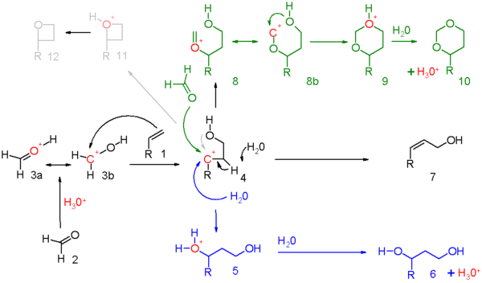](https://en.wikipedia.org/wiki/File:Prins_reaction_mechanism.png)

The three reaction modes open to this oxo-[carbenium](https://en.wikipedia.org/wiki/Carbenium) intermediate are:

in blue: capture of the carbocation by water or any suitable nucleophile through 5 to the 1,3-adduct 6.

in black: proton abstraction in an [elimination reaction](https://en.wikipedia.org/wiki/Elimination_reaction) to unsaturated compound 7. When the alkene carries a methylene group, elimination and addition can be concerted with transfer of an allyl proton to the carbonyl group which in effect is an [ene reaction](https://en.wikipedia.org/wiki/Ene_reaction) in *scheme 6*.

[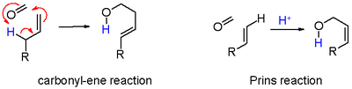](https://en.wikipedia.org/wiki/File:Carbonyl_ene_vs_Prins_reaction.png)

in green: capture of the carbocation by additional carbonyl reactant. In this mode the positive charge is dispersed over oxygen and carbon in the resonance structures 8a and 8b. Ring closure leads through intermediate 9 to the [dioxane](https://en.wikipedia.org/wiki/Dioxane) 10. An example is the conversion of [styrene](https://en.wikipedia.org/wiki/Styrene) to 4-phenyl-m-dioxane.

ingray: only in specific reactions and when the carbocation is very stable the reaction takes a shortcut to the [oxetane](https://en.wikipedia.org/wiki/Oxetane) 12. The photochemical [Paternò–Büchi reaction](https://en.wikipedia.org/wiki/Patern%C3%B2%E2%80%93B%C3%BCchi_reaction) between alkenes and aldehydes to oxetanes is more straightforward.

**SUZUKI REACTION:**

 Suzuki reaction is an [organic reaction](https://en.wikipedia.org/wiki/Organic_reaction), classified as a [coupling reaction](https://en.wikipedia.org/wiki/Coupling_reaction), where the coupling partners are a [boronic acid](https://en.wikipedia.org/wiki/Boronic_acid) and an [organohalide](https://en.wikipedia.org/wiki/Organohalide) [catalyzed](https://en.wikipedia.org/wiki/Catalyzed) by a [palladium(0) complex](https://en.wikipedia.org/wiki/Palladium).[[1]](https://en.wikipedia.org/wiki/Suzuki_reaction#cite_note-1)[[2]](https://en.wikipedia.org/wiki/Suzuki_reaction#cite_note-2)[[3]](https://en.wikipedia.org/wiki/Suzuki_reaction#cite_note-3) It was first published in 1979 by [Akira Suzuki](https://en.wikipedia.org/wiki/Akira_Suzuki_(chemist)) and he shared the 2010 [Nobel Prize in Chemistry](https://en.wikipedia.org/wiki/Nobel_Prize_in_Chemistry) with [Richard F. Heck](https://en.wikipedia.org/wiki/Richard_F._Heck) and [Ei-ichiNegishi](https://en.wikipedia.org/wiki/Ei-ichi_Negishi) for their effort for discovery and development of palladium-catalyzed cross couplings in organic synthesis.[[4]](https://en.wikipedia.org/wiki/Suzuki_reaction#cite_note-4) In many publications this reaction also goes by the name Suzuki–Miyaura reaction and is also referred to as the Suzuki coupling. It is widely used to [synthesize](https://en.wikipedia.org/wiki/Organic_synthesis) poly-[olefins](https://en.wikipedia.org/wiki/Olefin), [styrenes](https://en.wikipedia.org/wiki/Styrene), and substituted [biphenyls](https://en.wikipedia.org/wiki/Biphenyl). Several reviews have been published describing advancements and the development of the Suzuki Reaction.[[5]](https://en.wikipedia.org/wiki/Suzuki_reaction#cite_note-5)[[6]](https://en.wikipedia.org/wiki/Suzuki_reaction#cite_note-6)[[7]](https://en.wikipedia.org/wiki/Suzuki_reaction#cite_note-7) The general scheme for the Suzuki reaction is shown below where a carbon-carbon single bond is formed by coupling an [organoboron](https://en.wikipedia.org/wiki/Organoboron) species (R1-BY2) with a [halide](https://en.wikipedia.org/wiki/Halide) (R2-X) using a [palladium](https://en.wikipedia.org/wiki/Palladium) catalyst and a [base](https://en.wikipedia.org/wiki/Base_(chemistry)).

**Reaction mechanism**

The [mechanism](https://en.wikipedia.org/wiki/Reaction_mechanism) of the Suzuki reaction is best viewed from the perspective of the palladium catalyst. The first step is the [oxidative addition](https://en.wikipedia.org/wiki/Oxidative_addition) of palladium to the [halide](https://en.wikipedia.org/wiki/Halide) 2 to form the [organopalladium](https://en.wikipedia.org/wiki/Organopalladium) species 3. Reaction with base gives [intermediate](https://en.wikipedia.org/wiki/Reaction_intermediate) 4, which via [transmetalation](https://en.wikipedia.org/wiki/Transmetalation)[[8]](https://en.wikipedia.org/wiki/Suzuki_reaction#cite_note-8) with the boron-[ate complex](https://en.wikipedia.org/wiki/Ate_complex) 6 (produced by reaction of the boronic acid 5 with base) forms the [organopalladium](https://en.wikipedia.org/wiki/Organopalladium) species 8. [Reductive elimination](https://en.wikipedia.org/wiki/Reductive_elimination) of the desired product 9 restores the original palladium catalyst 1 which completes the [catalytic cycle](https://en.wikipedia.org/wiki/Catalytic_cycle). The Suzuki coupling takes place in the presence of a base and for a long time the role of the base was never fully understood. The base was first believed to form a trialkyl borate (R3B-OR), in the case of a reaction of an trialkylborane (BR3) and [alkoxide](https://en.wikipedia.org/wiki/Alkoxide) (−OR); this species could be considered as being more [nucleophilic](https://en.wikipedia.org/wiki/Nucleophilic) and then more reactive towards the palladium complex present in the transmetalation step. Duc and coworkers investigated the role of the base in the reaction mechanism for the Suzuki coupling and they found that the base has three roles: Formation of the palladium complex [ArPd(OR)L2], formation of the trialkyl borate and the acceleration of the reductive elimination step by reaction of the alkoxide with the palladium complex.

[](https://en.wikipedia.org/wiki/File:Suzuki_Coupling_Full_Mechanism_2.png)

**Oxidative addition**

In most cases the oxidative Addition is the [rate determining step](https://en.wikipedia.org/wiki/Rate_determining_step) of the catalytic cycle.During this step, the palladium catalyst is [oxidized](https://en.wikipedia.org/wiki/Oxidized) from palladium(0) to palladium(II). The palladium catalyst 1 is coupled with the alkyl halide 2 to yield an organopalladium complex 3. As seen in the diagram below, the [oxidative addition](https://en.wikipedia.org/wiki/Oxidative_addition) step breaks the [carbon](https://en.wikipedia.org/wiki/Carbon)-[halogen](https://en.wikipedia.org/wiki/Halogen)bond where the [palladium](https://en.wikipedia.org/wiki/Palladium) is now bound to both the [halogen](https://en.wikipedia.org/wiki/Halogen) and the R group.

[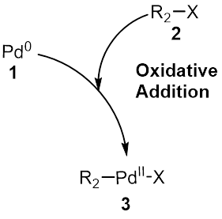](https://en.wikipedia.org/wiki/File:Suzuki_Coupling_Oxidative_Addition.png)

Oxidative addition proceeds with retention of [stereochemistry](https://en.wikipedia.org/wiki/Stereochemistry) with [vinyl halides](https://en.wikipedia.org/wiki/Vinyl_halide), while giving [inversion](https://en.wikipedia.org/wiki/Walden_inversion) of stereochemistry with [allylic](https://en.wikipedia.org/wiki/Allylic) and [benzylic](https://en.wikipedia.org/wiki/Benzylic) halides.The oxidative addition initially forms the [cis](https://en.wikipedia.org/wiki/Cis_isomer)–palladium complex, which rapidly [isomerizes](https://en.wikipedia.org/wiki/Isomerization) to the trans-complex.

[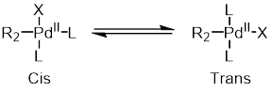](https://en.wikipedia.org/wiki/File:CisTrans_Palladium_Complex.png)

The Suzuki Coupling occurs with retention of configuration on the double bonds for both the organoboron reagent or the halide.[[15]](https://en.wikipedia.org/wiki/Suzuki_reaction#cite_note-Carey_and_Sundberg-15) However, the configuration of that double bond, [cis](https://en.wikipedia.org/wiki/Sterochemistry)or [trans](https://en.wikipedia.org/wiki/Stereochemistry) is determined by the cis-to-trans isomerization of the palladium complex in the oxidative addition step where the trans palladium complex is the predominant form. When the organoboron is attached to a double bond and it is coupled to an alkenyl halide the product is a diene as shown below.

[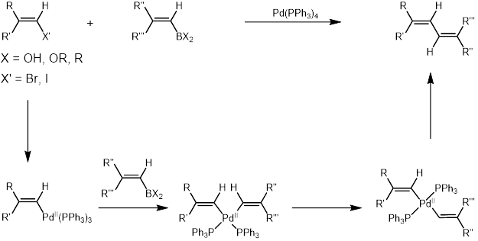](https://en.wikipedia.org/wiki/File:Suzuki_Double_Bond_Three.png)

**TSUJI–TROST REACTION**

The Tsuji–Trost reaction (also called the Trostallylic alkylation or allylic alkylation) is a [palladium](https://en.wikipedia.org/wiki/Palladium)-[catalysed](https://en.wikipedia.org/wiki/Catalysed) [substitution reaction](https://en.wikipedia.org/wiki/Substitution_reaction) involving a substrate that contains a [leaving group](https://en.wikipedia.org/wiki/Leaving_group) in an [allylic](https://en.wikipedia.org/wiki/Allylic) position. The palladium catalyst first coordinates with the allyl group and then undergoes [oxidative addition](https://en.wikipedia.org/wiki/Oxidative_addition), forming the π-allyl complex. This [allyl complex](https://en.wikipedia.org/wiki/Transition_metal_allyl_complex) can then be attacked by a [nucleophile](https://en.wikipedia.org/wiki/Nucleophile), resulting in the substituted product. [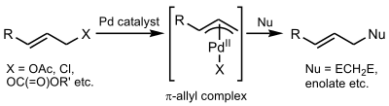](https://en.wikipedia.org/wiki/File:Tsuji-Trost_allylation.svg)

This work was first pioneered by [Jiro Tsuji](https://en.wikipedia.org/w/index.php?title=Jiro_Tsuji&action=edit&redlink=1) in 1965 and, later, adapted by [Barry Trost](https://en.wikipedia.org/wiki/Barry_Trost) in 1973 with the introduction of [phosphine](https://en.wikipedia.org/wiki/Phosphine) ligands.The scope of this reaction has been expanded to many different carbon, nitrogen, and oxygen-based nucleophiles, many different leaving groups, many different phosphorus, nitrogen, and sulfur-based ligands, and many different metals (although palladium is still preferred).The introduction of phosphine ligands led to improved reactivity and numerous asymmetric allylic alkylation strategies. Many of these strategies are driven by the advent of [chiral](https://en.wikipedia.org/wiki/Chiral) [ligands](https://en.wikipedia.org/wiki/Ligands), which are often able to provide high [enantioselectivity](https://en.wikipedia.org/wiki/Enantioselectivity) and high [diastereoselectivity](https://en.wikipedia.org/wiki/Diastereoselectivity) under mild conditions. This modification greatly expands the utility of this reaction for many different synthetic applications. The ability to form carbon-carbon, carbon-nitrogen, and carbon-oxygen bonds under these conditions, makes this reaction very appealing to the fields of both medicinal chemistry and natural product synthesis.

**Mechanism**

Starting with a [zerovalent](https://en.wikipedia.org/wiki/Zerovalent) palladium species and a substrate containing a leaving group in the allylic position, the Tsuji–Trost reaction proceeds through the [catalytic cycle](https://en.wikipedia.org/wiki/Catalytic_cycle) outlined below.

[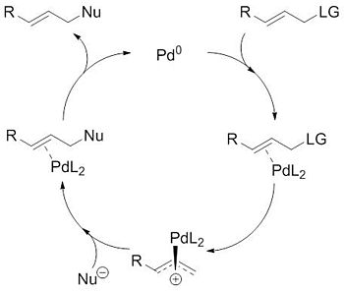](https://en.wikipedia.org/wiki/File:Tsuji-Trost_CC.jpg)

First, the palladium coordinates to the alkene, forming a [η2](https://en.wikipedia.org/wiki/Hapticity) π-allyl-[Pd0](https://en.wikipedia.org/wiki/Oxidation_state) [Π complex](https://en.wikipedia.org/wiki/%CE%A0_complex). The next step is [oxidative addition](https://en.wikipedia.org/wiki/Oxidative_addition) in which the leaving group is expelled with [inversion of configuration](https://en.wikipedia.org/wiki/Inversion_of_configuration) and a [η3](https://en.wikipedia.org/wiki/Hapticity) π-allyl-[PdII](https://en.wikipedia.org/wiki/Oxidation_state) is created (also called ionization). The nucleophile then adds to the allyl group regenerating the η2 π-allyl-Pd0 complex. At the completion of the reaction, the palladium detaches from the alkene and can start again in the [catalytic cycle](https://en.wikipedia.org/wiki/Catalytic_cycle).[[8]](https://en.wikipedia.org/wiki/Tsuji%E2%80%93Trost_reaction#cite_note-8)