**Unit IV- Advanced Features of ASP.NET**

# Security in ASP.NET

The most useful feature available in ASP.NET 3.5 is a suite of seven controls designed to simplify the applications that authenticate users. In Visual Studio 2008, these controls are located in the toolbox under the Login tab.

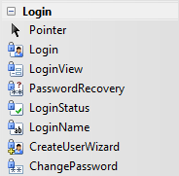

These seven controls are as follows:

1. “[Login](http://www.aspnetbook.com/apps/design_secure_application_login_control.php)”: Allows the user to log in by entering a user name and password.
2. “[CreateUserWizard](http://www.aspnetbook.com/apps/design_secure_application_createuserwizard_control.php)”: Allows the user to create a new user account.
3. “[PasswordRecovery](http://www.aspnetbook.com/apps/design_secure_application_passwordrecovery_control.php)”: Allows the user to retrieve a forgotten password.
4. “[ChangePassword](http://www.aspnetbook.com/apps/design_secure_application_changepassword_control.php)”: Allows the user to change his or her password.
5. “[LoginView](http://www.aspnetbook.com/apps/design_secure_application_loginview_control.php)”: This displays the contents of a template based on the user’s login status.
6. “[LoginStatus](http://www.aspnetbook.com/apps/design_secure_application_loginstatus_control.php)”: If the user is logged in, displays a “Logout” link for the user to log out. If the user isn’t logged in, displays a “Login” link that leads to the application’s login page.
7. “[LoginName](http://www.aspnetbook.com/apps/design_secure_application_loginname_control.php)”: This displays the user’s login name if the user is logged in.

Two aspects of user registration and login security in ASP.NET, and they are:

1. **Authentication** – The process of determining who a user is, and whether the user really is who he or she claims to be.
2. **Authorization –** The process of determining whether a particular user, once authenticated, can access a particular Web site page.

## Three types of authentication

2

1. **Forms-based authentication:**

This method of authentication uses a membership database to store the names and passwords of valid users. In this method, whenever a user attempts to access a restricted or limited access page, ASP.NET automatically redirects the user to a login page, which is normally named “Login.aspx”, which prompts the user to login with a user name and password in order to authenticate that user. The originally requested page is then displayed if the user is valid. This is the most common type of authentication for Web sites that allow public access but require that users create login accounts to access the application.

## Windows-based authentication:

This method of authentication uses the existing Windows accounts to authenticate users. This type of authentication is used mostly for intranet applications, where the users already have valid Windows accounts.

## Passport authentication:

This method of authentication uses Microsoft’s Passport service to authenticate users. When you use Passport authentication, a user must have a valid Passport account to access the application. From these three authentication modes, this one is the least used.

## Login control

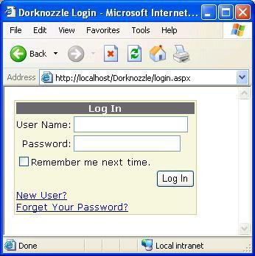ASP.NET 2.0’s new “Login” control provides you with a more convenient way to let the users of your application log in to you application. The “Login” control should be placed in a page called “Login.aspx” unless you changed the default “<authentication>” in the “web.config” file for the login page.

The “Login” control in its simplest form will look like the following:

<asp:Login id="Login1" runat="server" />

If you insert wrong username and password then message will show like this:

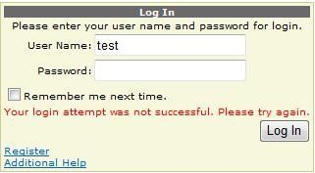

## Note:

 The “Login” control displays text boxes that let the user enter a user name and password.

 If the fields are filled in, the “Login” control uses the membership provider to look up the user name and password in the membership database.

 If the user name and password are valid, the user is logged in and the page requested is displayed else if it is not valid, an error message is displayed and the user will not be logged in to show the requested page.

In ASP.NET, you have the ability to customize your “Login” control by using any of the optional attributes listed below.

|  |  |
| --- | --- |
| **Attribute** | **Description** |
| Id | The “ID” for the Login control. |
| Runat | runat="Server” is needed for all ASP.NET server controls. |
| CreateUserText | The text displayed as a link to the register new user page. |
| CreateUserUrl | The URL to the register new user page. |
| DestinationPageUrl | The URL of the page for successful log in. If you don’t specify this attribute, the page which the user was on before getting to this page is displayed. |

|  |  |
| --- | --- |
| DisplayRememberMe | A checkbox, which is a Boolean, to choose whether the Login Control should automatically let the user save his info by saving a cookie and avoid re-logging in. |
| FailureText | Is the text that will be displayed if the Log in information is not valid. If you do not change this message, a default message“Your login attempt has failed. Please try again” is displayed. |
| InstructionText | A text displayed underneath the title text providing the user with login information. If you do not change this attribute, the default is an empty string. |
| LoginButtonText | The Login button text. |
| Orientation | This specifiex the “Horizontal” or “Vertical” layout of the login control. If you do not change this attribute, the default is “Vertical”. |
| PasswordLabelText | The text for the “Password” field. |
| PasswordRecoveryIconUrl | The URL for the image used as a link to the recover a lost password page. |
| PasswordRecoveryText | The text for the recover a lost password page. |
| PasswordRecoveryUrl | The URL for the recover a lost password page. |
| RememberMeText | Remember Me check box’s text. |
| TitleText | The text for the top of the Login control. |
| UserNameLabelText | The text for the Username label. |

## CreateUserWizard control

ASP.NET “CreateUserWizard” control automates the task of entering the information for a new user and creating a record for the user in the membership database. The “CreateUserWizard” control displays text boxes that let the user enter a user name, a password, an e-mail address, a security question, and the answer to the security question.

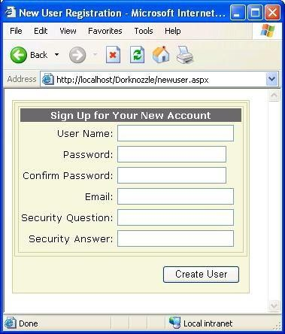

## Note:







If the user clicks the “SignUp” link, the “CreateUserWizard” control attempts to create a new user account with the information entered by the user into the form.

If the account is successfully created, the user is logged in to the new account.

If the account can’t be created, for instance if the account with the same user name already exists, an error message is displayed.

The “CreateUserWizard” control in its simplest form will look like the following:

<asp:CreateUserWizard ID="CreateUserWizard1" runat="server">

<WizardSteps>

<asp:CreateUserWizardStep runat="server">

</asp:CreateUserWizardStep>

<asp:CompleteWizardStep runat="server">

</asp:CompleteWizardStep>

</WizardSteps>

</asp:CreateUserWizard>

In ASP.NET 2.0, you have the ability to customize your “CreateUserWizard” control by using any of the optional attributes listed below.

|  |  |
| --- | --- |
| **Attribute** | **Description** |
| id | The “ID” for the “CreateUserWizard” control |

|  |  |
| --- | --- |
| runat | “runat=“Server” is needed for all ASP.NET server controls. |
| CancelButtonImageUrl | The URL for the image used for the Cancel button. |
| CancelButtonText | The text for the Cancel button. |
| CancelDestinationPageUrl | The URL of the page after the Cancel button is clicked. |
| CompleteStepText | The Complete step text, displayed after a user successfully creates an account. This is only shown after the “LoginCreatedUser” is set to “False”. |
| ContinueButtonImageUrl | The URL for the Continue button image on the Success page. |
| ContinueButtonText | The Continue button text on the Success page. |
| ContinueDestinationPageUrl | The URLof page the user is taken to after clicking the Continue button. |
| ConfirmPasswordLabelText | The text for the “Password Confirmation” label field. |
| CreateUserButtonText | The text for the Create User button. |
| DisableCreatedUser | This is a Boolean check box used to show if the user should be allowed to log in or not. The default, if not specified, is “False”. This can be set to “True” if you want the moderator or administrator to approve their account. |
| DisplayCancelButton | This is a Boolean, whether to display the Cancel button or not, the default, if not specified, is “False”. |
| HeaderText | The text for the header of the “CreateUserWizard” control. |
| InstructionText | The text for the instructions to use the “CreateUserWizard” control. |
| LoginCreatedUser | This is a Boolean to choose if the new user should be automatically logged into the application, the default, if not specified, is “True”. |
| PasswordLabelText | The text for the “Password” label field. |
| QuestionLabelText | The text for the “Security Question” label field. |
| UserNameLabelText | The text for the “Username” label field. |

## Note:













In ASP.NET 2.0, you can apply AutoFormat or the style attributes to customize the appearance of the “CreateUserWizard” control.

The user is always logging to the application after the register is complete, so if you would prefer not to, you can specify it using the LoginCreatedUser="False" attribute.

If you want the user account to be automatically deavticated till the administrator or moderator approve it, you can specify it using DisableCreatedUser="True".

By default, the “CreateUserWizard” control has two steps, the “CreateUserWizardStep” and “CompleteWizardStep” as shown in the code above. You can add steps or even a sidebar with links to each of the steps.

The “CreateUserWizard” control can send a confirmation e-mail to the new user using two methods;

o In the “<MailDefinition>” child element

<MailDefinition From="[name@domain.com](mailto:name@domain.com)" Subject="Subject Line" BodyFileName="BodyFile.txt">

</MailDefinition>

In the “MailDefinition” attributes

<asp:CreateUserWizard runat="server" ID="CreateUserWizard1" MailDefinition-From="[name@domain.com](mailto:name@domain.com)"

MailDefintion-Subject="Subject Line" MailDefinition-BodyFileName="BodyFile.txt" >

</asp:CreateUserWizard>

## Note:

 The body of the e-mail message will be taken from the file "BodyFile.txt" in the “BodyFileName attribute”.

 This “.txt” file can include “<%UserName%>” and “<%Password%>” so you can put the user’s account name and password into the email.

 For the “<MailDefinition>” child element to work, “<MailSettings>" element in the application’s “web.config” file should be changed into:

<system.net>

<mailSettings>

<smtp>

<network host="smtp.yourhostnamehere.com" from="[administrator@MyDomain.com](mailto:administrator@MyDomain.com)" />

</smtp>

</mailSettings>

</system.net>

## Note:

 The “SMTP” settings for the “network host” and the address “from” should be changed to the one you want to use.

## PasswordRecovery control

ASP.NET 2.0’s new “PasswordRecovery” control allows you to easily create a way to retrieve a forgotten password. In this control, the user has to enter their security question and the answer to it. If the values are valid, the password is reset to a random value and that password is emailed to the email address the user provided when registering to the application.

The “PasswordRecovery” control in its simplest form will look like the following:

<asp:PasswordRecovery ID="PasswordRecovery1" runat="server">

</asp:PasswordRecovery>

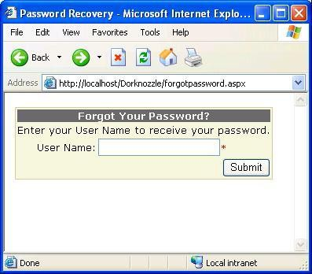

Once users enter valid user names, they must answer their secret questions. In the browser, the page looks like that shown below.

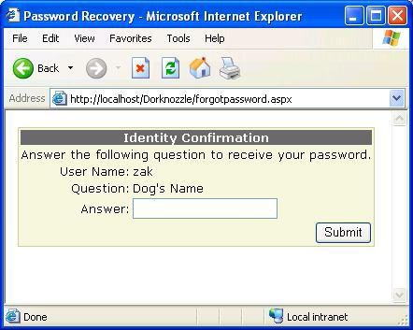

If everything is formatted correctly, the email will be sent and a message will appear to the user similar to this:

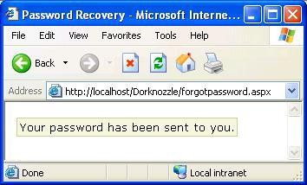

The new password can be sent to the user’s email account. The “PasswordRecovery” control can send a confirmation e-mail to the new user using two methods:

 In the “<MailDefinition>” child element

<asp:PasswordRecovery ID="PasswordRecovery1" runat="server">

<MailDefinition From="[name@domain.com](mailto:name@domain.com)" Subject="Subject Line" BodyFileName="BodyFile.txt">

</MailDefinition>

</asp:PasswordRecovery>

 In the “MailDefinition” attributes

<asp:PasswordRecovery id="PasswordRecovery1" runat="Server" MailDefinition-From="[name@domain.com](mailto:name@domain.com)"

MailDefinition-Subject="Subject Line" MailDefinition-BodyFileName="BodyFile.txt" />

</asp:PasswordRecovery>

## Note:

 The body of the e-mail message will be taken from the file "BodyFile.txt" in the “BodyFileName”attribute.

 This “.txt” file can include “<%UserName%>” and “<%Password%>” so you can put the user’s account name and password into the email.

In ASP.NET 2.0, you have the ability to customize your “PasswordRecovery” control by using any of the optional attributes listed below.

|  |  |
| --- | --- |
| **Attribute** | **Description** |
| id | The “ID” for the “PasswordRecovery” control |
| AnswerLabelText | The text for the “Answer” label field |
| GeneralFailureText | The text fot the “Failure” text field if the password could not be retrieved. |
| QuestionLabelText | The text for the “Secret Question” label. |
| SuccessPageUrl | The URL for theSuccess page if the password has been recovered. |
| SuccessText | The text for the message if the password retrieval is successful, and this is not displayed if the “SuccessPageUrl” is provided. |
| UserNameFailureText | The text for incorrect username. |
| UserNameInstructionText | The text for the instructions for the Username request area. |
| UserNameLabelText | The text for the “Username” label field. |

## ChangePassword control

ASP.NET 2.0’s new “ChangePassword” control gives you the ability to automate the process of a user wanting to change their password. You can configure the new “ChangePassword” control to accepts the username and the password the user wishes to change. You can also configure it such that the user cannot enter his username, but should be logged into the application as a user to change the password.The new “ChangePassword” control also can be configured such that after changing the password, the new password can be e-mailed back to the user.

The “ChangePassword” control in its simplest form will look like the following:

<asp:ChangePassword ID="ChangePassword1" runat="server">

</asp:ChangePassword>

The “ChangePassword” control can send a new password e-mail to the user using the “<MailDefinition>” child element. The following is a sample code of how this will look like:

<asp:ChangePassword id="ChangePassword1" runat="Server" >

<MailDefinition From="[name@domain.com](mailto:name@domain.com)" Subject="Subject Line" BodyFileName=”BodyFile.txt">

</MailDefinition>

</asp:ChangePassword>

## Note:

 The body of the e-mail message will be taken from the file "BodyFile.txt" in the “BodyFileName attribute”.

 This “.txt” file can include “<%UserName%>” and “<%Password%>” so you can put the user’s account name and password into the email.

In ASP.NET 2.0, you have the ability to customize your “ChangePassword” control by using any of the optional attributes listed below.

|  |  |
| --- | --- |
| **Attribute** | **Description** |
| id | The “ID” for the “ChangePassword” control |

|  |  |
| --- | --- |
| runat | runat="Server" is needed for all ASP.NET server controls. |
| CancelButtonImageUrl | The URL for the image used for the Cancel button. |
| CancelButtonText | The text for the Cancel button. |
| CancelDestinationPageUrl | The URL of the page after the Cancel button is clicked. |
| ChangePasswordButtonImageUrl | The URL for the Change Password button image on the Success page. |
| ChangePasswordButtonText | The ChangePassword button text. |
| ChangePasswordTitleText | The text for the “ChangePassword” title area. |
| ConfirmNewPasswordLabelText | The text for the “ConfirmPassword” label field. |
| ContinueButtonImageUrl | The URL for the Continue button image. |
| ContinueButtonText | The Continue button text. |
| ContinueDestinationPageUrl | The URLof page the user is taken to after clicking the Continue button. |
| CreateUserText | The text for the “CreateUser” link. |
| CreateUserUrl | The URL for the CreateUser page. |
| DisplayUserName | This is a Boolean check box, to indicate if you want the user to enter the username when changing the password or the user to be loggied in to the system. If “True”, the “ChangePassword” control can also be used to change the password of an account other than the one to which the user is currently logged in, if “False” they can only change the password of the logged in account. |
| InstructionText | The text for the instructions to use the “ChangePassword” control. |
| NewPasswordLabelText | The text for the “New Password” label field. |
| PasswordHintText | The text diplyed for the instruction for the new password and its requiermetns, like how many character, minimum length, etc… |

|  |  |
| --- | --- |
| PasswordLabelText | The text displayed for the “Current Password” label field. |
| PasswordRecoveryText | The text for the “Password Recovery” page link |
| PasswordRecoveryUrl | The URL for the “Password Recovery” page. |
| SuccessPageUrl | The URL for theSuccess page if the password has been changed. |
| SuccessText | The text for the message if the password change is successful, and this is not displayed if the “SuccessPageUrl” is provided. |
| UserNameLabelText | The text for the “Username” label field. |

Attributes for the “ChangePassword” control

The following is the code for a customized “ChangePassword” control.

<asp:ChangePassword id="ChangePassword1" runat="Server" ChangePasswordTitleText="Change Your Password<br />" PasswordLabelText="Enter your current password:" NewPasswordLabelText="Enter the new password:" ConfirmNewPasswordLabelText="Confirm the new password:">

</asp:ChangePassword>

## Note:

 The “ChangePassword” control requires the user to be logged in to change the password by default. You can change this by specifying the “DiplayeUsername=True” attribute. This will display a “Useraname"textbox, where the user has to enter the valid user name and password to change the password for any user.

 The “ChangePassword” control has two views, and they are:

* The Initial view – this is the Change Password view including the text boxes for the user to enter the new password.
* The Success view – displayed when the password change is successful with a confirmation message. The success view is not displayed if the “SuccessPageUrl” is provided, but instead the page in the URL specified will be shown.

## LoginView control

ASP.NET 2.0’s new “LoginView”control is a template control. This template control can display the contents of its templates according to the login status of the user. This gives you the ability to customize your content of your web application for the needs of different users.

## For example:

The User authentication application should use a “LoginView” control to display a link to the administrator’s page because this page should be only visible to the users with the login status of an “Admin”.

The “LoginView” control does not have any special attributes to customize its appearance or behavior but you can customize the “LoginView” control by using the three types of templates of which each can be coded in as a child element. The three templates are:

1. “Anonymous” template: Displayed if the user isn’t logged in.
2. “LoggedIn” template: Displayed if the user is logged in.
3. “RoleGroup” template: Displayed if the user is logged in and is a member of a particular role group.

The following is a sample code for all the three types of templates of a “LoginView” control.

<asp:LoginView runat="Server" id="LoginView1">

<AnonymousTemplate>

The Anonymous Template is displayed for anonymous users.

</AnonymousTemplate>

<LoggedInTemplate>

The Logged In Template is displayed for users logged in.

</LoggedInTemplate>

<RoleGroups>

<asp:RoleGroup Roles="Admin">

<ContentTemplate>

This Role Groups Template is displayed for admins.

</ContentTemplate>

</asp:RoleGroup>

</RoleGroups>

</asp:LoginView>

## Note:



The “<RoleGroups>” elements can containg more than one “<RoleGroups>”, these elements can be used alongside the “Anonymous” and the “LoggedIn” templates.

## LoginName control

ASP.NET 2.0’s new “LoginName” control is used to display the user’s username which the user logged in to the web application from. If a user is not currently logged into the web application, the “LoginName” control does not display anything.

The “LoginName” control in its simplest form will look like the following:

<asp:LoginName ID="LoginName1" runat="server" />

If you want a custom message such as a welcome message to be displayed in front of the Username, you can do the following:

<asp:LoginName ID="LoginName1" runat="server" FormatString="Welcome, {0}" />

## Note:

The “Welcome” text will be added as a prefix to the Username if the user has logged in, and if no user is logged in nothing is displayed.

## LoginStatus control

ASP.NET 2.0’s new “LoginStatus” control will display a link for the user to log into or log out of the web application depending on whether theuser is logged in or out.

## For example:

 If the user is logged in, a link is displayed to Logout  If the user is not logged in, a link is displayed to Login

The “LoginStatus” control in its simplest form will look like the following:

<asp:LoginStatus ID="LoginStatus1" runat="server" />

In ASP.NET 2.0, you have the ability to customize your “LoginStatus” control by using any of the optional attributes listed below.

|  |  |
| --- | --- |
| **Attribute** | **Description** |
| Id | The “ID” for the “LoginStatus” control |
| runat | runat=“Server” is needed for all ASP.NET server controls. |
| LoginImageUrl | The URL for the “Login” link image. |
| LoginText | The text for the “Login” link. |
| LogoutAction | The action to do after the user logs out. This can be specified to “Redirect” to redirect the user to a page in the “LogoutPageUrl” attribute, or “RedirectToLoginPage” to redirect the user to the login page, or “Refresh” to refresh the current page. |
| LogoutImageUrl | The URL for the “Logout” link. |
| LogoutPageUrl | The URl for the rdirect page after a user logs out if the “LogoutAction” attribute specifies “Redirect”. |
| LogoutText | The text for the “Logout” link. |

Attributes for the “LoginStatus” control

# State Management in ASP.NET

Web pages rarely are stand alone. Web applications almost always need to track users who visits multiple pages, whether to provide personalization, store information about a user or to track usage for reporting purposes.

HTTP (Hyper Text Transfer Protocol) is a stateless protocol. When the client disconnects from the server, the ASP.Net engine discards the page objects. This way each web application can scale up to serve numerous requests simultaneously without running out of server memory.

However, there need to be some technique to store the information between requests and to retrieve it when required. This information i.e., the current value of all the controls and variables for the current user in the current session is called the State.

## Types of State Management

1. Client – Side State Management 2.Server – Side State Management **Client – Side State Management**

Client Side State Management involves storing information either on a Web page or on a Client computer. There are four ways to manage states.

 View State

 Hidden Form Fields  Cookies

 Query String

## View State

In this method, the ViewState property that is inherited from the base Control class is used to automatically save the values of the page and of each control prior to rendering of the page. ViewState is implemented with a hidden form field called the _VIEWSTATE, which is automatically created in every Web Form page. When ASP.Net executes a Web page on a Web Server, the values stored in the ViewState property of the page and controls on it are collected and formatted into a single encoded string. The encoded string is then assigned to the Value attribute of the hidden form field _VIEWSTATE and is sent to the client as a part of the Web page.

## Hidden Form Fields

In ASP.Net we can use the HTML standard hidden fields in a Web Form to store page-specific information. A hidden field does not render in a Web browser. However, we can set the properties of the hidden field. When a page is submitted to the server, the content of the hidden field is sent in the HTTP Form collection along with values of other controls.

## Query String

The Query string is a part of the request that appears after the Question mark (?) character in the URL. A query string provides a simple way to pass information from one page to another.

## Cookies

A cookie, also known as an HTTP cookie, web cookie, or browser cookie, is usually a small piece of data sent from a website and stored in a user's [web browser](http://en.wikipedia.org/wiki/Web_browser) while a user is browsing a website. When the user browses the same website in the future, the data stored in the cookie can be retrieved by the website to notify the website of the user's previous activity.[[1]](http://en.wikipedia.org/wiki/HTTP_cookie#cite_note-0) Cookies were designed to be a reliable mechanism for websites to remember the [state](http://en.wikipedia.org/wiki/Program_state) of the website or activity the user had taken in the past. This can include clicking particular buttons, [logging in,](http://en.wikipedia.org/wiki/Authentication) or a record of which pages were visited by the user even months or years ago.

## Server Side State Management Options Application State

An ASP.Net application is the collection of all web pages, code and other files within a single virtual directory on a web server. When information is stored in application state, it is available to all the users.

To provide for the use of application state, ASP.Net creates an application state object for each application from the HTTPApplicationState class and stores this object in server memory. This object is represented by class file global.asax.

Application State is mostly used to store hit counters and other statistical data, global application data like tax rate, discount rate etc and to keep track of users visiting the site.

Application state data is generally maintained by writing handlers for the events:

* Application_Start
* Application_End
* Application_Error
* Session_Start
* Session_End

## Session State:

When a user connects to an ASP.Net website, a new session object is created. When session state is turned on, a new session state object is created for each new request. This session state object becomes part of the context and it is available through the page.

Session state is generally used for storing application data like inventory or supplier list, or a customer record or shopping cart. It can also keep information about the user and his preference and keep track of pending operations.

Sessions are identified and tracked with a 120-bit SessionID, which is passed from client to server and back as cookie or a modified URL. The SessionID is globally unique and random.

The session state object is created from the HttpSessionState class, which defines a collection of session state items.

# Mobile Application Development in ASP.NET

Mobile application development in ASP.NET is similar to traditional ASP.NET web application development. And it is very easy for ASP.NET developer to develop mobile application. All mobile web pages are inherit from **MobilePage** class which exists in **System.Web.UI.MobileControls** namespace.ASP.NET exposes a **System.Web.Mobile** namespace is for specifically to Web development.

## Creating Mobile Web Page in Application

A Default.aspx is added in your solution and it is traditional ASP.NET page which is inherited from System.Web.UI.Page. But you need to create page which inherit from **MobilePage** class in **System.Web.UI.MobileControls** namespace. In this demonstration, you will use controls from the **System.Web.Mobile** namespace that are specifically designed for devices that cannot display as much information as a desktop browser.

## Creating Mobile Web Page in Application

* 1. Right-click the Default.aspx page in Solution Explorer and choose **Delete**.
  2. Click **OK** in the dialog box.
  3. Right-click the application in Solution Explorer and choose **Add New Item**
  4. Choose **Mobile Web Form** under **Visual Studio installed templates**.

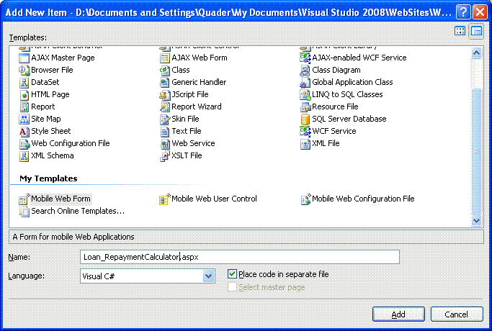

## Test Application

Select **Microsoft Mobile Explorer and p**ress F5 to run the application. Microsoft Mobile Explorer Emulator will appear. Click ASP.NET Development Server icon in the system tray to get application URL name

and its port. It may be different in your system.

In the Microsoft Mobile Explorer Emulator type URL as **http://localhost:1439/LRC/Loan_**

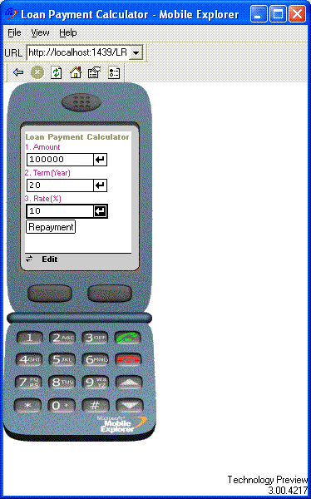

## RepaymentCalculator.aspx

Enter **Amount, Term & Rate**. Click on Repayment button in the screen. You will get result like bellow,

