Business Economics

I .B.Com

II nd Semester

16CACCM1B,

UNIT- I Business Economics – definition - Scope and Nature Art or Science –Concepts – relationship with other disciplines - Micro and Macro Economics relating to business.

Introduction to Business Economics
Business Economics plays an important role in our daily economic life and business practises. Economic theories, economic principles, economic laws, economic equations, and economic concepts are used for decision making. Business Economics is also known as "Managerial Economics". It is also known as "Applied Economics". Business Management means any activity undertaken to earn profit, run by a person and managed with the help of economics. Therefore Managerial Economics is also called Business Economics. In Managerial Economics the concepts, principles and theories in pure economic science are applied to any business activities. Therefore it is also called as Applied Economics.

Definitions of Business Economics or Managerial Economics
- According to E. F. Brigham and J. L. Pappas, "Managerial Economics is the application of Economic theory and methodology to business administration practise."

- According to McNair and Meriam, "Managerial Economics consists of the use of Economic modes of thought to analyse business situations."

- According to M. H. Spencer and L. Siegelman, "Managerial Economics is the integration of economic theory with business practise for the purpose of facilitating decision making and forward planning."

- According to Hauge, "Managerial Economics is concerned with using logic of economics, mathematics & statistics to provide effective ways of thinking about business decision problems."

- According to Joel Dean, "The purpose of Managerial Economics is to show how economic analysis can be used in formulating business policies."

Scope of Business Economics:
As regards the scope of business economics, no uniformity of views exists among various authors. The scope of business economics (micro and macro variety) is a wider one since it “uses the logic of Economics, Mathematics, and Statistics to provide effective ways of thinking about business decision problems.” In view of this saying of Prof. D. C. Hague, we can argue that there are links between managerial economics and management science. In fact, the boundaries between the two subjects are not clear-cut but overlapping.
However, the following aspects are said to generally fall under business economics.
- Forecasting and Demand Analysis.
- Cost Analysis and Production Analysis.
- Pricing Decisions, policies, and practices.
- Profit Management, and.
- Capital Management.
These different aspects are considered to involve in the subject matter of business economics.

Forecasting and Demand Analysis:
A business firm is an economic organization which transforms productive resources into goods to sell in the market. A major part of business decision making depends on accurate estimates of demand. A demand forecast can serve as a guide to management for maintaining and strengthening market position and enlarging profits.
Demands analysis helps identify the various factors influencing the product demand and thus provides guidelines for manipulating demand. Demand analysis and forecasting provided the essential basis for business planning and occupy a strategic place in managerial economics. The main topics covered are; Demand Determinants, Demand Distinctions, and Demand Forecasting.

Cost Analysis and Production Analysis:
A study of economic costs, combined with the data drawn from the firm’s accounting records, can yield significant cost estimates which are useful for management decisions. An element of cost uncertainty exists because all the factors determining costs are not known and controllable.
Discovering economic costs and the ability to measure them are the necessary steps for more effective profit planning, cost control, and sound pricing practices. Production analysis is narrower, in scope than cost analysis.
Production analysis frequently proceeds in physical terms while cost analysis proceeds in monetary terms. The main topics covered under cost and production analysis are; Cost concepts and classification, Cost-output Relationships, Economics and Diseconomies of scale, Production function, and Cost control.

Pricing Decisions, Policies, and Practices:
Pricing is an important area of business economics. In fact, price is the genesis of a firms revenue and as such its success largely depends on how correctly the pricing decisions are taken. The important aspects dealt with under pricing include. Price Determination in Various Market Forms, Pricing Method, Differential Pricing, Product-line Pricing, and Price Forecasting.
Pricing is a very important area of managerial economics. In fact, price is the origin of the revenue of a firm. As such the success of a business firm largely depends on the accuracy of price decisions of that firm.
The important aspects dealt under the area, are as follows:
- Price determination in various market forms.
- Pricing methods, and.
- Differential pricing product-line pricing and price forecasting.

Profit Management:
Business firms are generally organized for the purpose of making profits and in the long run, profits earned are taken as an important measure of the firm’s success. If knowledge about the future were perfect, profit analysis would have been a very easy task.
However, in a world of uncertainty, expectations are not always realized. So, profit planning and measurement constitute a difficult area of business economics. The important aspects covered under this area are; Nature and Measurement of profit, Profit policies and Technique of Profit Planning like Break-Even Analysis.

Capital Management:
Among the various types of business problems, the most complex and troublesome for the business manager are those relating to a firm’s capital investments. Relatively large sums are involved and the problems are so complex that their solution requires considerable time and labor.
Often the decision involving capital management are taken by the top management. Briefly Capital management implies planning and control of capital expenditure. The main topics dealt with are; Cost of capital Rate of Return and Selection of Projects.

Scope of Business Economics
Business Economics covers most of the problems that a manager or establishment faces. Hence, the scope of business economics is wide. Since a firm can face internal/operational as well as external and/or environmental issues, there are different economic theories applicable to them. Microeconomics helps with internal or operational issues whereas macroeconomics is applied to external or environmental issues. In this article, we will look at the scope of business economics under both these heads.

The Scope of Business Economics

I. Microeconomics Applied to Operational Issues
As the name suggests, internal or operational issues are issues that arise within a firm and are within the control of the management. It is within the scope of business economics to analyze this.
Further, a few examples of such issues are choice of business, size of business, product designs, pricing, promotion for sales, technology choice, etc. Most firms can deal with these using the following microeconomics theories:

1. Analyzing Demand and Forecasting
Analyzing demand is all about understanding buyer behavior. It studies the preferences of consumers along with the effects of changes in the determinants of demand. Also, these determinants include the price of the good, consumer’s income, tastes/ preferences, etc.
Forecasting demand is a technique used to predict the future demand for a good and/or service. Further, this prediction is based on the past behavior of factors which affect the demand. This is important for firms as accurate predictions help them produce the required quantities of goods at the right time.
Further, it gives them enough time to arrange various factors of production in advance like raw materials, labor, equipment, etc. Business Economics offers scientific tools which assist in forecasting demand.

2. Production and Cost Analysis
A business economist has the following responsibilities with regards to the production:
- Decide on the optimum size of output based on the objectives of the firm.
- Also, ensure that the firm does not incur any undue costs.
By production analysis, the firm can choose the appropriate technology offering a technically efficient way of producing the output. Cost analysis, on the other hand, enables the firm to identify the behavior of costs when factors like output, time period, and the size of plant change. Further, by using both these analyses, a firm can maximize profits by producing optimum output at the least possible cost.

3. Inventory Management
Firms can use certain rules to reduce costs associated with maintaining inventory in the form of raw materials, work in progress, and finished goods. Further, it is important to understand that the inventory policies affect the profitability of a firm. Hence, economists use methods like the ABC analysis and mathematical models to help the firm in maintaining an optimum stock of inventories.

4. Market Structure and Pricing Policies
Any firm needs to know about the nature and extent of competition in the market. A thorough analysis of the market structure provides this information. Further, with the help of this, firms command a certain ability to determine prices in the market. Also, this information helps firms create strategies for market management under the given competitive conditions.
Price theory, on the other hand, helps the firm in understanding how prices are determined under different kinds of market conditions. Also, it assists the firm in creating pricing policies.

5. Resource Allocation
Business Economics uses advanced tools like linear programming to create the best course of action for an optimal utilization of available resources.

6. Theory of Capital and Investment Decisions
Among other decisions, a firm must carefully evaluate its investment decisions an allocate its capital sensibly. Various theories pertaining to capital and investments offer scientific criteria for choosing investment projects. Further, these theories also help the firm in assessing the efficiency of capital. Business Economics assists the decision-making process when the firm needs to decide between competing uses of funds.

7. Profit Analysis
Profits depend on many factors like changing prices, market conditions, etc. The profit theories help firms in measuring and managing profits under such uncertain conditions. Further, they also help in planning future profits.

8. Risk and Uncertainty Analysis
Most businesses operate under a certain amount of risk and uncertainty. Also, analyzing these risks and uncertainties can help firms in making efficient decisions and formulating plans.

II. Macroeconomics applied to Environmental Issues
External or environmental factors have a measurable impact on the performance of a business. The major macroeconomic factors are:
- Type of economic system
- Stage of the business cycle
- General trends in national income, employment, prices, saving, and investment.
- Government’s economic policies
- Performance of the financial sector and capital market
- Socio-economic organizations
- Social and political environment.
The management of a firm has no control over these factors. Therefore, it is important that the firm fine-tunes its policies to minimize the adverse effects of these factors.

Nature of Business Economics
(i) Business Economics is a Science
What is Science? It is simply a systematic body of knowledge which can establish a relationship between cause and effect. Further, Mathematics, Statistics, and Econometrics are decision sciences.
Business Economics integrates these decision sciences with Economic Theory to arrive at strategies to help businesses achieve their goals. Hence, it follows scientific methods and also tests the validity of the results. This is one aspect of the nature of business economics.
(ii) It is based on Micro Economics
We understand the basic difference between micro and macroeconomics. A business manager is certainly more concerned about achieving the objectives of his own organization. After all, this helps him in ensuring profits and long-term survival of the firm.
Business Economics is more concerned with the decision-making situations of individual establishments. Therefore, it depends on the techniques of Microeconomics.
(iii) It Incorporates Elements of Macro Analysis
Even though all businesses focus on their profitability and survival, a firm cannot operate in a vacuum. The external environment of the economy like income and employment levels in the economy, tax policies, etc., affects the firm. All these external factors are components of macro economy.
Therefore, a business manager has to take all such factors into consideration which may influence his business environment.
(iv) It is an Art
Business Economics is an art as it requires the practical application of rules and principle to achieve set objectives.
(v) Use of Theory of Markets and Private Enterprises
Business Economics primarily uses the theory of markets and private enterprises. It uses the theory of the firm and resource allocation in a private enterprise economy.
(vi) Pragmatic in Approach
Microeconomics is purely theoretical and analyzes economic occurrences under unrealistic assumptions. On the other hand, Business Economics is pragmatic in its approach. It tries to solve the problems which the firms face in the real world.
(vii) Interdisciplinary
Business Economics incorporates tools from many other disciplines like mathematics, statistics, accounting, marketing, etc. Therefore, is in interdisciplinary in nature.
(viii) Normative
Broadly speaking, Economic Theory has evolved along two lines – Positive and Normative.
A positive or pure science analyzes the cause and effect relationship between variables in a scientific manner. However, it does not involve any value judgment. In simpler words, it describes the economic behavior of individuals or society without focusing on the desirability of such behavior.
On the other hand, normative science involves value judgments. It suggests a course of action under the given circumstances.
Usually, Business Economics is normative in nature. It offers suggestions for the application of economic principles while forming policies, making decisions, and planning for the future. However, firms must understand their environment thoroughly to establish decision rules. This requires the study of positive economic theory.
Therefore, we can say that Business Economics combines the essentials of both the theories while keeping more emphasis on the normative economic theory.

Importance of Economics
- Allows know the basics of human needs, production, distribution, reuse and better use of resources.
- It provides the basis for exchange of goods and services between individuals, organizations and even countries.
- Generates systems, techniques and public policies to improve social welfare.
- Help to set target prices of goods and services.
- Adjust political, financial and even social imbalances.
- Provides knowledge and techniques that prevent crises and help them out.
- It uses econometric techniques to predict future economic conditions that could harm or benefit certain situations in acertain place, and how to maximize the benefits and problems mystify.
- As you can see, economics is a science that encompasses us completely.
- To be an expert in this field you can study a university degree in economics, in this course the student will learn how the economy moves and how to generate the best social conditions.

RELATIONSHIP WITH OTHER DISCIPLINES
Economics and Decision Sciences:
Economics is also part of a group of disciplines called decision sciences which includes some branches of statistics, applied mathematics, operational research, and some areas of management and engineering. All of these disciplines deal with how individuals and groups make decisions.
Economists are specifically interested in those decisions relating to production consumption and resource use. As a decision science, economics is closely related to business and management courses.
Economics and Statistics:
One major function of an economist is to conduct research. The job of the company economist is to investigate economic aspects of various decisions Government agencies and private business firms generate a vast array of economic statistics on such matters as income, employment, prices and expenditure patterns. A two-way street exists between statistical data and economic theory.
Statistics can be used to test the consistency of economic theory and measure the responsiveness of economic variables to changes in policy. At the same time, economic theory helps to explain which economic variables are likely to be related and why they are linked. Statistics do not tell their own story.

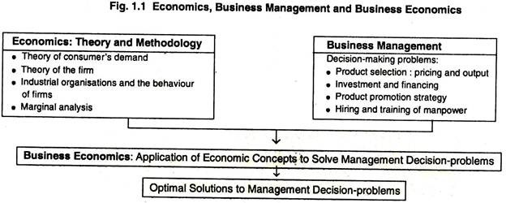

UNIT-II Demand Analysis- Demand Schedule - Law of Demand- Demand curves- Elasticity of Demand- Demand forecasting - Indifference curve analysis- Marginal rate of substitution – Consumer’s equilibrium.

Definition of 'Law Of Demand'
Definition: The law of demand states that other factors being constant (cetris peribus), price and quantity demand of any good and service are inversely related to each other. When the price of a product increases, the demand for the same product will fall.
Description: Law of demand explains consumer choice behavior when the price changes. In the market, assuming other factors affecting demand being constant, when the price of a good rises, it leads to a fall in the demand of that good. This is the natural consumer choice behavior. This happens because a consumer hesitates to spend more for the good with the fear of going out of cash.
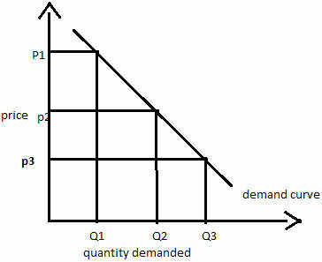
The above diagram shows the demand curve which is downward sloping. Clearly when the price of the commodity increases from price p3 to p2, then its quantity demand comes down from Q3 to Q2 and then to Q3 and vice versa.

Assumptions of Law of Demands
Some of the major assumptions of law of demands are: 1. No change in habits, customs and income of consumers, 2. This law does not apply on necessaries of life, 3. Joint demand, 4. Articles of distinction, 5. Fear of shortage in future, 6. Change in the price of substitutes, 7. Fear of a rise in price in future and 8. Ignorance:
1. No change in habits, customs and income of consumers:
Law of demand tells us that demand goes with a fall in price and goes down with a rise in price. But an increase in price will not bring down the demand if at the same time the income of the buyer has also increased.
2. This law does not apply on necessaries of life:
It is assumed that this law is not applicable in the case of necessaries of life. Because, an increase in the price of flour will not bring down its demand. Likewise a fall in its price will not vary much increase the demand for it.
3. Joint demand:
Goods which have joint demand also falsify the law. Thus, an increase in the demand of cars will lead to more demand for petrol. Whereas the law of demand states that the demand for petrol should increase on it its price falls.
4. Articles of distinction:
Law of demand does not hold goods in case of those goods which confer social distinction. When the price of such goods goes up, their demand shall also increase. For instance, an increase in the price of diamond will raise its demand and a fall in price will lower the demand.
5. Fear of shortage in future:
If there is a fear of shortage of a good in future its demand will increase in present as people would start storing. But according to law of demand its demand should go it when its price falls.
6. Change in the price of substitutes:
This law does not apply in the case of tea and coffee, because these goods are substitutes of each other. When the price of coffee goes up the demand for tea shall increase although there has been no fall in the price of tea.
7. Fear of a rise in price in future:
If consumers think that the price of particular goods will increase in future, they will store it. In other words, the demand of those goods shall increase at the same price. But this law states that demand should go up only if price falls.
8. Ignorance:
It is possible that a consumer may not be aware of the previous price of a good. In this case consumer might start purchasing more of a commodity when its price has actually gone up. A new approach called the ordinal utility approach, developed by Edgeworth, Pareto. Slutsky, Johnson, Hicks and Allen are easier and more helpful in solving the problem of consumer’s demand. The ordinal theory not only requires fewer assumptions but possesses greater predictive power than does its cardinal cousin.
The assumption of cardinally measurable utility has been dispensed with not because utility is not cardinally measurable, but simply because such measurement is not at all required for analyzing consumer’s behavior. The points of distinction between the cardinal and the ordinal measures of utility.
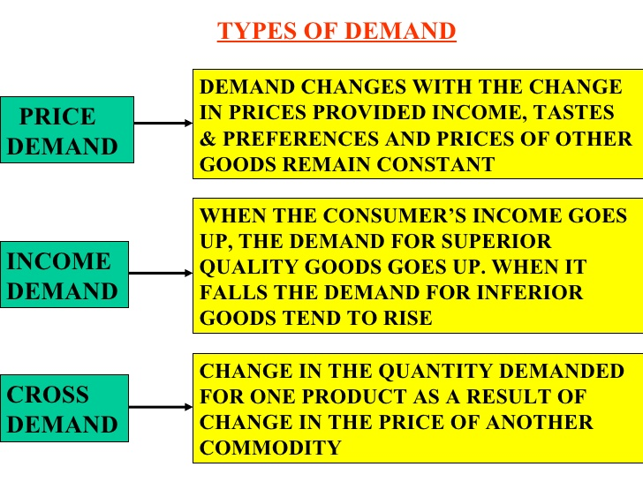

Exceptions to the Law of Demand
Definition: There are certain situations where the law of demand does not apply or becomes ineffective, i.e. with a fall in the price the demand falls and with the rise in price the demand rises are called as the exceptions to the law of demand.

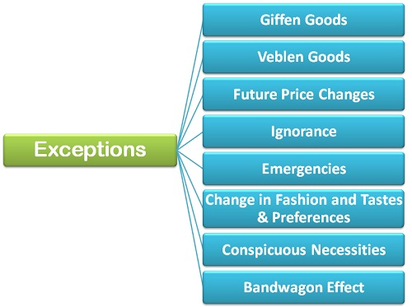
- Giffen Goods: Giffen goods are the inferior goods whose demand increases with the increase in its prices. There are several inferior commodities, much cheaper than the superior substitutes often consumed by the poor households as an essential commodity. Whenever the price of the Giffen goods increases its quantity demanded also increases because, with an increase in the price, and the income remaining the same, the poor people cut the consumption of superior substitute and buy more quantities of Giffen goods to meet their basic needs.
For Example, Suppose the minimum monthly consumption of food grains by a poor household is 20 Kg Bajra (Inferior good) and 10 Kg Rice (superior good). The selling price of Bajra is Rs 5 per kg, and the rice is Rs 10 per kg, and the household spends its total income of Rs 200 on the purchase of these items. Suppose, the price of Bajra rose to Rs 6 per kg then the household will be forced to reduce the consumption of rice by 5 Kg and increase the quantity of Bajra to 25 Kg in order to meet the minimum monthly requirement of food grains of 30 kg.
2.Veblen Goods: Another exception to the law of demand is given by the economist Thorstein Veblen, who proposed the concept of “Conspicuous Consumption.” According to Veblen, there are a certain group of people who measure the utility of the commodity purely by its price, which means, they think that higher priced goods and services derive more utility than the lesser priced commodities.
For example, goods like a diamond, platinum, ruby, etc. are bought by the upper echelons of the society (rich class) for whom the higher the price of these goods, the higher is the prestige value and ultimately the higher is the utility or desirability of them.
3. Expectation of Price Change in Future: When the consumer expects that the price of a commodity is likely to further increase in the future, then he will buy more of it despite its increased price in order to escape himself from the pinch of much higher price in the future.
On the other hand, if the consumer expects the price of the commodity to further fall in the future, then he will likely postpone his purchase despite less price of the commodity in order to avail the benefits of much lower prices in the future.
4. Ignorance: Often people are misconceived as high-priced commodities are better than the low-priced commodities and rest their purchase decision on such a notion. They buy those commodities whose price are relatively higher than the substitutes.
5.Emergencies: During emergencies such as war, natural calamity- flood, drought, earthquake, etc., the law of demand becomes ineffective. In such situations, people often fear the shortage of the essentials and hence demand more goods and services even at higher prices.
6.Change in fashion and Tastes & Preferences: The change in fashion trend and tastes and preferences of the consumers negates the effect of law of demand. The consumer tends to buy those commodities which are very much ‘in’ in the market even at higher prices.
7.Conspicuous Necessities: There are certain commodities which have become essentials of the modern life. These are the goods which consumer buys irrespective of an increase in the price. For example TV, refrigerator, automobiles, washing machines, air conditioners, etc.
8.Bandwagon Effect: This is the most common type of exception to the law of demand wherein the consumer tries to purchase those commodities which are bought by his friends, relatives or neighbors. Here, the person tries to emulate the buying behavior and patterns of the group to which he belongs irrespective of the price of the commodity.
For example, if the majority of group members have smart phones then the consumer will also demand for the smartphone even if the prices are high.
Thus, these are some of the exceptions to the law of demand where the demand curve is upward sloping, i.e. the demand increases with an increase in the price and decreases with the decrease in price.

Reasons for Law of Demand
Definition: The Law of Demand explains the downward slope of the demand curve, which posits that as the price falls the quantity demanded increases and as the price rise, the quantity demanded decreases, other things remaining unchanged.
here are several factors that explain why the demand curve slopes downward or why the law of demand showing an inverse relation between the price and quantity is valid?

Reasons for Law of Demand
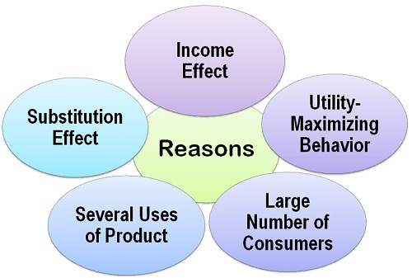
- Substitution Effect: The Substitution effect is seen when the quantity demanded for one commodity changes due to the change in the price of other closely related commodity. Such as, if the price of the commodity decreases while the price of the other is assumed to remain the same, then the latter becomes dearer and the demand for the cheaper commodity increases.
For example, suppose the price of tea decreases while the price of coffee remains unchanged, then the tea will be substituted for coffee and thus the demand for tea increases. This effect of increase in the demand for tea is called as the substitution effect.
- Income Effect: The income effect explains the change in demand due to the change in the real income of the consumer as a result of the change in the price of the given commodity. Such as, with the fall in the price of a commodity, the real income (purchasing power) of the consumer increases since the consumer can now purchase more units of the commodity with the same amount of money income. Thus, the increase in demand due to the increase in the real income is called as the income effect.
For example, Suppose a boy purchases 5 ice-creams for Rs 50, and if the price of ice-cream falls to Rs 8, now he can purchase 6 ice-creams with the same amount of money income or may decide to buy the same quantity and save the rest of the money, as he is required to spend less.
- Utility-Maximizing Behavior: The consumer theory posits that the consumer buys goods and services to maximize his total utility (satisfaction). We know, that the marginal utility decreases with each additional unit of the commodity and thus, this is one of the reasons for the downward slope of the demand curve, which shows that the demand for the normal goods increases with the fall in the prices.
A person exchanges his money income for the purchase of the commodity so as to maximize his satisfaction. He continues to buy the commodity as long as the marginal utility of money (MU_{m}) is less than the marginal utility of the commodity (MU_{x}).
- Large Number of Consumers: The effect on demand due to the change in the number of consumers as a result of a change in the price also causes the demand curve to slope downwards. Such as, if the price of the commodity falls, then many new consumers who were earlier not able to afford the commodity due to its high price, starts purchasing it. And as a result, the demand for the commodity increases.On the other hand, if the price rises, then few rich people can buy it, and many consumers will withdraw themselves from the market. And as a result, the demand for the commodity decreases.
- Varied Uses of the Product: This is one of the important reasons for the law of demand, which explains that the product has several uses and can be utilized for different purposes. When the price of the commodity rises, then the consumer restricts its usage for the most important purpose. On the other hand, if the commodity becomes cheap then it can be utilized for all kinds of purposes, whether important or not.
For example, if the price of coal increases, then it will be more used in the industries where it is an essential raw material, whereas its demand for less important use such as in household (bonfire) gets reduced.

Elasticity of Demand
Definition: The Elasticity of Demand is a measure of change in the quantity demanded in response to the change in the price of the commodity. Simply, the effect of a change of price on the quantity demanded is called as the elasticity of demand.
Importance of Elasticity of Demand
- The concept of demand elasticity helps in understanding the price determination by the monopolist. A monopoly is the market structure wherein there is only one seller whose main objective is to maximize the profits. The price he chooses for his product depends on the elasticity of demand. Such as, if the demand for a commodity is high he can choose the higher price as the consumers will buy the product even when the price rise. But however, if the demand is elastic, he will choose the lower prices.
- The determination of the price depends on demand for and supply of the commodity. But however, the demand is governed by the demand elasticity and the supply too is governed by the elasticity of supply. Therefore, the price of a commodity depends on both the demand and supply elasticity.
- The concept of demand elasticity also helps in understanding other types of prices, such as exchange rates, i.e. a rate at which currency unit of one country is exchanged for the currency unit of another country. Also, the terms of trade, i.e. the rate at which the exports are changed for imports can be easily understood through this concept.
- The concept of elasticity of demand also helps the government in its taxation policies. This helps the government to have a fair idea about the demand elasticity of goods which are being taxed.
- This concept also helps in the determination of wages, such as if the demand for labor is inelastic the union can demand higher wages and conversely if the labor demand is elastic the demand for higher wages could not be raised.
Thus, the concept of elasticity of demand is very important to understand the economic problems and policies. This is very well elucidated through the points explained above.

Determinants of Elasticity of Demand
Definition: The Elasticity of Demand is a measure of sensitiveness of demand to the change in the price of the commodity.

Determinants of Elasticity of Demand
Apart from the price, there are several other factors that influence the elasticity of demand. These are:
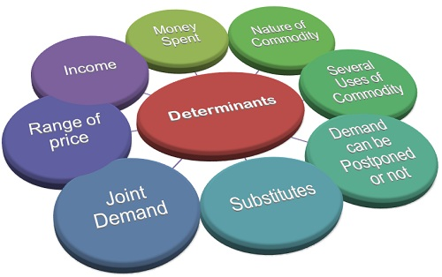
- Consumer Income: The income of the consumer also affects the elasticity of demand. For high-income groups, the demand is said to be less elastic as the rise or fall in the price will not have much effect on the demand for a product. Whereas, in case of the low-income groups, the demand is said to be elastic and rise and fall in the price have a significant effect on the quantity demanded. Such as when the price falls the demand increases and vice-versa.
- Amount of Money Spent: The elasticity of demand for a product is determined by the proportion of income spent by the individual on that product. In case of certain goods, such as matchbox, salt a consumer spends a very small amount of his income, let’s say Rs 2, then even if their prices rise the demand for these products will not be affected to a great extent. Thus, the demand for such products is said to be inelastic.
Whereas foods and clothing are the items where an individual spends a major proportion of his income and therefore, if there is any change in the price of these items, the demand will get affected.
- Nature of Commodity: The elasticity of demand also depends on the nature of the commodity. The product can be categorized as luxury, convenience, necessary goods. The demand for the necessities of life, such as food and clothing is inelastic as their demand cannot be postponed. The demand for the Comfort Goods is neither elastic nor inelastic. As with the rise and fall in their prices, the demand decreases or increases moderately.
Whereas the demand for the luxury goods is said to be highly elastic because even with a slight change in its price the demand changes significantly. But, however, the demand for the prestige goods is said to be inelastic, because people are ready to buy these commodities at any price, such as antiques, gems, stones, etc.
- Several Uses of Commodity: The elasticity of demand also depends on the number of uses of the commodity. Such as, if the commodity is used for a single purpose, then the change in the price will affect the demand for commodity only in that use, and thus the demand for that commodity is said to be inelastic. Whereas, if the product has several uses, such as raw material coal, iron, steel, etc., then the change in their price will affect the demand for these commodities in its many uses. Thus, the demand for such products is said to be elastic.
- Whether the Demand can be Postponed or not: If the demand for a particular product cannot be postponed then, the demand is said to be inelastic. Such as, Wheat is required in daily life and hence its demand cannot be postponed. On the other hand, the items whose demand can be postponed is said to have elastic demand. Such as the demand for the furniture can be postponed until the time its prices fall.
- Existence of Substitutes: The substitutes are the goods which can be used in place of one another. The goods which have close substitutes are said to have elastic demand. Such as, tea and coffee are close substitutes and if the price of tea increases, then people will switch to the coffee and demand for the tea will decrease significantly. Whereas, if there are no close substitutes for a product, then its demand is said to be inelastic. Such as salt and sugar do not have their close substitutes and hence lower is their price elasticity.
- Joint Demand: The elasticity of demand also depends on the complementary goods, the goods which are used jointly. Such as car and petrol, pen and ink, etc. Here the elasticity of demand of secondary (supporting) commodity depends on the elasticity of demand of the major commodity. Such as, if the demand for pen is inelastic, then the demand for the ink will also be less elastic.
- Range of Prices: The price range in which the commodities lie also affects the elasticity of demand. Such as the higher range products are usually bought by the rich people, and they do not care much about the change in the price and hence the demand for such higher range commodities is said to be inelastic.
Also, the lower range commodities have inelastic demand because these are already low priced and can be bought by any sections of the society. But the commodities in middle range prices are said to have an elastic demand because with the fall in the prices the middle class and the lower middle class are induced to buy that commodity and therefore the demand increases. But however, if the prices are increased the consumption reduces and as a result demand falls.
Thus, these are some of the important determinants of elasticity of demand that every firm should understand properly before deciding on the price of their offerings.

Types of Elasticity of Demand
Definition: The Elasticity of Demand measures the percentage change in quantity demanded for a percentage change in the price. Simply, the relative change in demand for a commodity as a result of a relative change in its price is called as the elasticity of demand.

Types of Elasticity of Demand
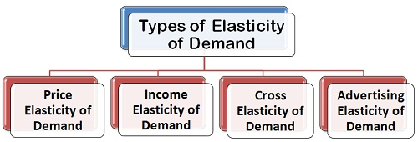
- Price Elasticity of Demand: The price elasticity of demand, commonly known as the elasticity of demand refers to the responsiveness and sensitiveness of demand for a product to the changes in its price. In other words, the price elasticity of demand is equal to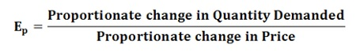Numerically,
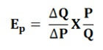Where,
ΔQ = Q₁ –Q₀, ΔP = P₁ – P_{0,} Q₁= New quantity, Q₂= Original quantity, P1 = New price, P0 = Original priceThe following are the main
Types of Price Elasticity of Demand:
  - Perfectly Elastic Demand
  - Perfectly Inelastic Demand
  - Relatively Elastic Demand
  - Relatively Inelastic Demand
  - Unitary Elastic Demand
- Income Elasticity of Demand: The income is the other factor that influences the demand for a product. Hence, the degree of responsiveness of a change in demand for a product due to the change in the income is known as income elasticity of demand. The formula to compute the income elasticity of demand is: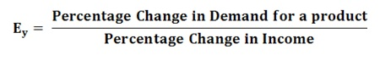For most of the goods, the income elasticity of demand is greater than one indicating that with the change in income the demand will also change and that too in the same direction, i.e. more income means more demand and vice-versa.
- Cross Elasticity of Demand: The cross elasticity of demand refers to the change in quantity demanded for one commodity as a result of the change in the price of another commodity. This type of elasticity usually arises in the case of the interrelated goods such as substitutes and complementary goods. The cross elasticity of demand for goods X and Y can be expressed as: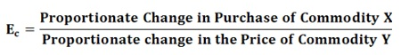The two commodities are said to be complementary, if the price of one commodity falls, then the demand for other increases, on the contrary, if the price of one commodity rises the demand for another commodity decreases. For example, petrol and car are complementary goods.
While the two commodities are said to be substitutes for each other if the price of one commodity falls, the demand for another commodity also decreases, on the other hand, if the price of one commodity rises the demand for the other commodity also increases. For example, tea and coffee are substitute goods.
- Advertising Elasticity of Demand: The responsiveness of the change in demand to the change in advertising or rather promotional expenses, is known as advertising elasticity of demand. In other words, the change in the demand as a result of the change in advertisement and other promotional expenses is called as the advertising elasticity of demand. It can be expressed as: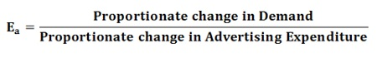
Demand Forecasting
Demand forecasting is a combination of two words; the first one is Demand and another forecasting. Demand means outside requirements of a product or service. In general, forecasting means making an estimation in the present for a future occurring event. Here we are going to discuss demand forecasting and its usefulness. It is a technique for estimation of probable demand for a product or services in the future. It is based on the analysis of past demand for that product or service in the present market condition. Demand forecasting should be done on a scientific basis and facts and events related to forecasting should be considered. Therefore, in simple words, we can say that after gathering information about various aspect of the market and demand based on the past, an attempt may be made to estimate future demand. This concept is called forecasting of demand.
For example, suppose we sold 200, 250, 300 units of product X in the month of January, February, and March respectively. Now we can say that there will be a demand for 250 units approx. of product X in the month of April, if the market condition remains the same.

Usefulness of Demand Forecasting
Demand plays a vital role in the decision making of a business. In competitive market conditions, there is a need to take correct decision and make planning for future events related to business like a sale, production, etc. The effectiveness of a decision taken by business managers depends upon the accuracy of the decision taken by them.
Demand is the most important aspect for business for achieving its objectives. Many decisions of business depend on demand like production, sales, staff requirement, etc. Forecasting is the necessity of business at an international level as well as domestic level. Demand forecasting reduces risk related to business activities and helps it to take efficient decisions. For firms having production at the mass level, the importance of forecasting had increased more. A good forecasting helps a firm in better planning related to business goals.
There is a huge role of forecasting in functional areas of accounting. Good forecast helps in appropriate production planning, process selection, capacity planning, facility layout planning, and inventory management, etc.
Demand forecasting provides reasonable data for the organization’s capital investment and expansion decision. It also provides a way for the formulation of suitable pricing and advertisement strategies.

Following is the significance of Demand Forecasting:
- Fulfilling objectives of the business
- Preparing the budget
- Taking management decision
- Evaluating performance etc.
Moreover, forecasting is not completely full of proof and correct. It thus helps in evaluating various factors which affect demand and enables management staff to know about various forces relevant to the study of demand behavior.

The Scope of Demand Forecasting
The scope of demand forecasting depends upon the operated area of the firm, present as well as what is proposed in the future. Forecasting can be at an international level if the area of operation is international. If the firm supplies its products and services in the local market then forecasting will be at local level.
The scope should be decided considering the time and cost involved in relation to the benefit of the information acquired through the study of demand. Cost of forecasting and benefit flows from such forecasting should be in a balanced manner.

Types of Forecasting
There are two types of forecasting:
- Based on Economy
- Based on the time period

1. Based on Economy
There are three types of forecasting based on the economy:
- Macro-level forecasting: It deals with the general economic environment relating to the economy as measured by the Index of Industrial Production(IIP), national income and general level of employment, etc.
- Industry level forecasting: Industry level forecasting deals with the demand for the industry’s products as a whole. For example demand for cement in India, demand for clothes in India, etc.
- Firm-level forecasting: It means forecasting the demand for a particular firm’s product. For example, demand for Birla cement, demand for Raymond clothes, etc.

2. Based on the Time Period
Forecasting based on time may be short-term forecasting and long-term forecasting
- Short-term forecasting: It covers a short period of time, depending upon the nature of the industry. It is done generally for six months or less than one year. Short-term forecasting is generally useful in tactical decisions.
- Long-term forecasting casting: Long-term forecasts are for a longer period of time say, two to five years or more. It gives information for major strategic decisions of the firm. For example, expansion of plant capacity, opening a new unit of business, etc.

What is an Indifference Curve?
It is a curve that represents all the combinations of goods that give the same satisfaction to the consumer. Since all the combinations give the same amount of satisfaction, the consumer prefers them equally. Hence the name Indifference Curve.
Here is an example to understand the indifference curve better. Peter has 1 unit of food and 12 units of clothing. Now, we ask Peter how many units of clothing is he willing to give up in exchange for an additional unit of food so that his level of satisfaction remains unchanged.
Peter agrees to give up 6 units of clothing for an additional unit of food. Hence, we have two combinations of food and clothing giving equal satisfaction to Peter as follows:
- 1 unit of food and 12 units of clothing
- 2 units of food and 6 units of clothing
By asking him similar questions, we get various combinations as follows:
Combination | Food | Clothing
A | 1 | 12
B | 2 | 6
C | 3 | 4
D | 4 | 3
Graphical Representation:
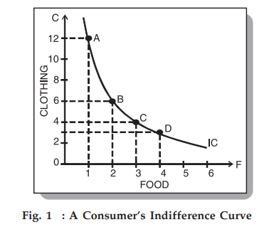
The diagram shows an Indifference curve (IC). Any combination lying on this curve gives the same level of consumer satisfaction. It is also known as Iso-Utility Curve.

Indifference Map
An Indifference Map is a set of Indifference Curves. It depicts the complete picture of a consumer’s preferences. The following diagram showing an indifference map consisting of three curves:
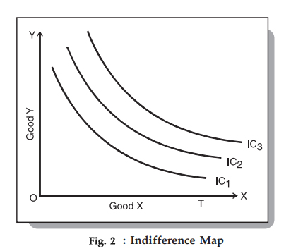
We know that a consumer is indifferent among the combinations lying on the same indifference curve. However, it is important to note that he prefers the combinations on the higher indifference curves to those on the lower ones.
This is because a higher indifference curve implies a higher level of satisfaction. Therefore, all combinations on IC1 offer the same satisfaction, but all combinations on IC2 give greater satisfaction than those on IC1.

Marginal Rate of Substitution
This is the rate at which a consumer is prepared to exchange a good X for Y. If we go back to Peter’s example above, we have the following table:
Combination | Food | Clothing | MRS
A | 1 | 12 | –
B | 2 | 6 | 6
C | 3 | 4 | 2
D | 4 | 3 | 1
In this example, Peter initially gives up 6 units of clothing to get an extra unit of food. Hence, the MRS is 6. Similarly, for subsequent exchanges, the MRS is 2 and 1 respectively. Therefore, MRS of X for Y is the amount of Y whose loss can be compensated by a unit gain of X, keeping the satisfaction the same.
Interestingly, as Peter accumulates more units of food, the MRS starts falling – meaning he is prepared to give up fewer units of clothing for food. There are two reasons for this:
- As Peter gets more units of food, his intensity of desire for additional units of food decreases.
- Most of the goods are imperfect substitutes for one another. If they could substitute one another perfectly, then MRS would remain constant.

Properties of an Indifference Curve or IC
Here are the properties of an indifference curve:

An IC slopes downwards to the right
This slope signifies that when the quantity of one commodity in combination is increased, the amount of the other commodity reduces. This is essential for the level of satisfaction to remain the same on an indifference curve.

An IC is always convex to the origin
From our discussion above, we understand that as Peter substitutes clothing for food, he is willing to part with less and less of clothing. This is the diminishing marginal rate of substitution. The rate gives a convex shape to the indifference curve. However, there are two extreme scenarios:
- Two commodities are perfect substitutes for each other – In this case, the indifference curve is a straight line, where MRS is constant.
- Two goods are perfect complementary goods – An example of such goods would be gasoline and water in a car. In such cases, the IC will be L-shaped and convex to the origin.

Indifference curves never intersect each other
Two ICs will never intersect each other. Also, they need not be parallel to each other either. Look at the following diagram:
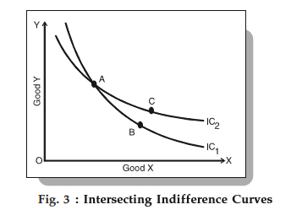
Fig 3 shows tow ICs intersecting each other at point A. Since A and B lie on IC1, the give the same satisfaction level. Similarly, A and C give the same satisfaction level, as they lie on IC2. Therefore, we can imply that B and C offer the same level of satisfaction, which is logically absurd. Hence, no tow ICs can touch or intersect each other.

A higher IC indicates a higher level of satisfaction as compared to a lower IC
A higher IC means that a consumer prefers more goods than not.

An IC does not touch the axis
This is not possible because of our assumption that a consumer considers different combinations of two commodities and wants both of them. If the curve touches either of the axes, then it means that he is satisfied with only one commodity and does not want the other, which is contrary to our assumption.

Budget Line
Since a higher indifference curve represents a higher level of satisfaction, a consumer will try to reach the highest possible IC to maximize his satisfaction. In order to do so, he has to buy more goods and has to work under the following two constraints:
- He has to pay the price for the goods and
- He income is limited, restricting the availability of money for purchasing these goods
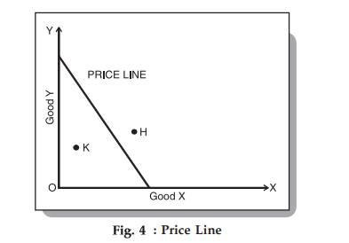
As can be seen above, a budget line shows all possible combinations of two goods that a consumer can buy within the funds available to him at the given prices of the goods. All combinations that are within his reach lie on the budget line.
A point outside the line (point H) represents a combination beyond the financial reach of the consumer. On the other hand, a point inside the line (point K) represents under-spending by the consumer.

Marginal Rate of Substitution
Suppose you and your friend is playing Scrabble. Both of you decided on some new rules for the game. You suggested that if any of you want a new piece of the alphabet you have to do any of the three things.
Either you have to skip a turn or you have to exchange with any other alphabet you have or you have to cut down your earned points. Suppose you want to get a new piece of an alphabet.
You decided to cut your points. How much will you cut down your points to get a new piece of the alphabet?
In the real world and in the business world we come across this type of situation. We have to settle for some commodity instead of others. We have to substitute one service instead of others.
This is the concept of the marginal rate of substitution. Let us get ourselves ready to know them.

Indifference Curve
It is a curve that shows the combination of goods which gives the same level of satisfaction to the consumers so that an individual is indifferent. In other words, the consumer gives equal preference to all such combinations.
It is a graph that gives a consumer equal satisfaction, making the consumer indifferent. An indifference curve shows the combination of services which a consumer can prefer over the other.
For any consumer, utility function (U) is a function of the quantities of goods. Suppose there are two commodities x₁ and x₂. Then
U = f (x₁, x₂) = constant = U₀.
On the indifference curve, the quality consumed of one commodity is compensated by the increase in the quantity consumed of the other commodity.
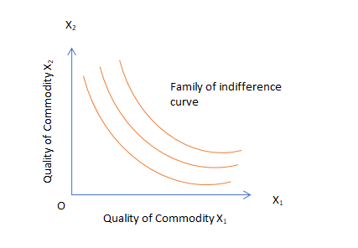

Assumption
- Utility is cardinal.
- Consumer is rational.
- Goods consumed are substitutable.
- Availability of more goods is always better.
- A consumer will have transitivity in his choice. Suppose a consumer prefer item ‘A’ over ‘B’. Also, he chooses item ‘B’ over ‘C’. Then it must prefer item ‘A’ over ‘C’.

Properties of Indifference Curve
- The difference curve has a negative slope.
- Indifferent curves do not intersect.
- They are convex from below, i.e., convex to the origin.
- An indifference curve that lies to the right of another, yields more utility.

Marginal Rate of substitution
It is the rate at which the consumer is willing to give up commodity ‘X’ for one more unit of commodity ‘Y’. He tries to maintain the same level of satisfaction.
In simple words, it is the same as the utility gained for good Y as the utility lost for good X. One can calculate the marginal rate of substitution as
M.R.S. _{Y X} = Δ X / Δ Y, on any point on the indifference curve.

Derivation of Formula Marginal Rate of Substitution
For any consumer, utility function (U) is a function of the quantities of goods. Suppose there are two commodities x₁ and x₂. Then
U = f (x₁, x₂) = constant = U₀.
Taking total differential, we get
d U = ∂ f / ∂ x₁ . d x₁ + ∂ f / ∂ x2 . d x₂ = d U₀ = 0
⇒ f _{x1} d _{x1} + f _{x2} d x₂
⇒ − d x₂ / d x₁ = f _{x1} / f _{x2} = (∂ U / ∂ x₁ ) ÷ (∂ U / ∂ x₂) = MU x₁ / MU x₂
The slope (d x₂ / d x₁) of the tangent at any point on an indifference curve is the rate at which x₁ must be substituted for x₂ or vice versa.
The negative of the slope (− d x₂ / d x₁) is the marginal rate of substitution of x₁ for x₂.
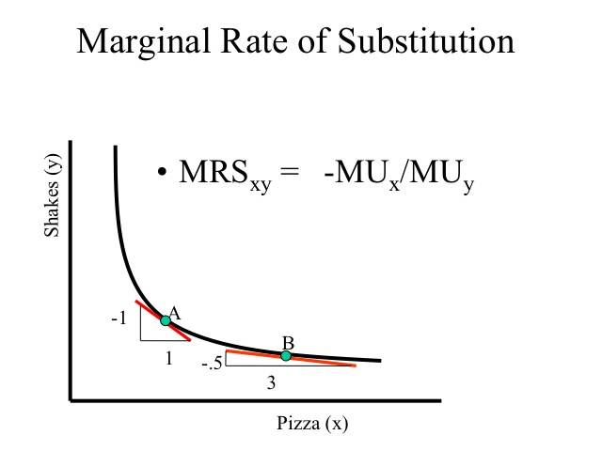
(source – econ 150)

Assumptions
- The consumer is logical and knowledgeable to consume every unit of goods.
- Goods are equal in size and shape.
- No time gap between consumption.
- No change in income, preference, taste, and fashion.
- Utility is cardinal.
- Marginal unit of money is constant.

Limitations
This law doesn’t apply to
- Dissimilar units.
- Unreasonable quantity.
- Unsuitable time period.
- Rare collections like coins, stamps etc.
- Change in taste and fashion of the consumer.
- Abnormal person.
- Changing the income of the consumer.
- Habitual goods.
- Durable and valuable goods.

Types of Marginal Rate of Substitution

Diminishing
The marginal rate of substitution is diminishing. One can obtain it if the consumer is willing to give up less and less unit of good Y for every additional unit of good X.

Constant
The marginal rate of substitution is constant also. One can obtain this if, for one more unit of Y, only one unit of X is given up. It is constant for perfect substitution.

Increasing
Suppose a consumer substitutes a commodity X for the other commodity Y at an increasing rate to maintain the same level of satisfaction. In this case, one can obtain an increasing marginal rate of substitution.

Theory of Consumer Behavior

Consumers Equilibrium
By now, you are clear about indifference curves and the budget line. Let’s look at consumers equilibrium next. A consumer is in equilibrium when he derives maximum satisfaction from the goods and is in no position to rearrange his purchases.

Assumptions
- There is a defined indifference map showing the consumer’s scale of preferences across different combinations of two goods X and Y.
- The consumer has a fixed money income and wants to spend it completely on the goods X and Y.
- The prices of the goods X and Y are fixed for the consumer.
- The goods are homogenous and divisible.
- The consumer acts rationally and maximizes his satisfaction.

Consumers Equilibrium
In order to display the combination of two goods X and Y, that the consumer buys to be in equilibrium, let’s bring his indifference curves and budget line together.
We know that,
- Indifference Map – shows the consumer’s preference scale between various combinations of two goods
- Budget Line – depicts various combinations that he can afford to buy with his money income and prices of both the goods.
In the following figure, we depict an indifference map with 5 indifference curves – IC₁, IC₂, IC₃, IC₄, and IC₅ along with the budget line PL for good X and good Y.
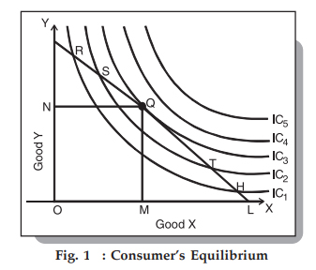
From the figure, we can see that the combinations R, S, Q, T, and H cost the same to the consumer. In order to maximize his level of satisfaction, the consumer will try to reach the highest indifference curve. Since we have assumed a budget constraint, he will be forced to remain on the budget line.

So, which combination will he choose?
Let’s say that he chooses the combination R. From Fig. 1, we can see that R lies on a lower indifference curve – IC₁. He can easily afford the combinations S, Q, or T which lie on the higher ICs. Even if he chooses the combination H, the argument is similar since H lies on the curve IC₁ too.
Next, let’s look at the combination S lying on the curve IC₂. Here again, he can reach a higher level of satisfaction within his budget by choosing the combination Q lying on IC₃ – higher indifference curve level. The argument is similar for the combination T since T lies on the curve IC₂ too.
Therefore, we are left with the combination Q.

What happens if he chooses the combination Q?
This is the best choice since Q lies on his budget line and pts puts him on the highest possible indifference curve, IC₃. While there are higher curves, IC₄ and IC₅, they are beyond his budget. Therefore, he reaches the equilibrium at point Q on curve IC₃.
Notice that at this point, the budget line PL is tangential to the indifference curve IC₃. Also, in this position, the consumer buys OM quantity of X and ON quantity of Y.
Since point Q is the tangent point, the slopes of line PL and curve IC₃ are equal at this point. Further, the slope of the indifference curve shows a marginal rate of substitution of X for Y (MRSxy) equal to MUxMUy. Also, the slope of the price line (PL) indicates the ratio between the prices of X and Y and is equal to PxPy.
Hence, at the equilibrium point Q,
MRSxy = MUxMUy = PxPy
Therefore, we can say that consumers equilibrium is achieved when the price line is tangential to the indifference curve. Or, when the marginal rate of substitution of the goods X and Y is equal to the ratio between the prices of the two goods.

UNIT III Production function-Factors of production - Isoquant analysis -scale of production- economies of large scale production and limitations.
The four factors of production are land, labor, capital, and entrepreneurship.¹﻿ They are the inputs needed for supply. They produce all the goods and services in an economy. That's measured by gross domestic product.

Land as a Factor of Production
Land is short for all the natural resources available to create supply. It includes raw property and anything that comes from the ground. It can be a non-renewable resource. That includes commodities such as oil and gold. It can also be a renewable resource, such as timber. Once man changes it from its original condition, it becomes a capital good. For example, oil is a natural resource, but gasoline is a capital good. Farmland is a natural resource, but a shopping center is a capital good.
The income earned by owners of land and other resources is called rent.
The United States is blessed with an abundance of easily accessible natural resources. These include fertile land and water. Many countries are covered with mountains or desert, making it expensive to use the natural resources. It has miles of coastline, lots of oil, and a moderate climate. That's an advantage over Canada. It has similar natural resources, but they are frozen for most of the year. Global warming is beginning to change that, making Canada one of the winners of climate change.

Labor as a Factor of Production
Labor is the work done by people. The value of the workforce depends on workers' education, skills, and motivation. It also depends on productivity. That measures how much each hour of worker time produces in output.
The reward or income for labor is wages.
The United States has a large, skilled, and mobile labor force that responds quickly to changing business needs. It also benefits from productivity increases due to technological innovations. On the other hand, the U.S. labor force faces increasing competition from other countries. That's one reason why American jobs are being outsourced.
The Bureau of Labor Statistics measures the U.S. labor force. It releases the current U.S. jobs report the first Friday of each month. The report includes the employed and the unemployed. The employed only include people over 16 who worked in the past week. It excludes the active military and any residents of an institution. The unemployed are those who actively looked for a job in the past month. All the other jobless are not members of the labor force.

Capital as a Factor of Production
Capital is short for capital goods. These are man-made objects like machinery, equipment, and chemicals that are used in production. That's what differentiates them from consumer goods. For example, capital goods include industrial and commercial buildings, but not private housing. A commercial aircraft is a capital good, but a private jet is not.
The income earned by owners of capital goods is called interest.
The United States is a technological innovator in creating capital goods, from airplanes to robots. That's why Silicon Valley is a critical comparative advantage in the global market.
The U.S. Bureau of Economic Analysis measures capital goods production with the monthly durable goods orders report. It reports on total capital goods order, shipments, and inventory. It also strips out defense and transportation. Those orders come in large batches. It can hide the real trends. Capital goods production has declined since the Great Recession. Demand for them hasn't returned to the same levels. As a result, companies aren't investing in new equipment. They are buying back stock shares, purchasing new businesses, and looking for opportunities overseas.

Entrepreneurship as a Factor of Production
Entrepreneurship is the drive to develop an idea into a business. An entrepreneur combines the other three factors of production to add to supply. The most successful are innovative risk-takers. nThe income entrepreneurs earn is profits.
The majority of entrepreneurs in the United States own small businesses. That's 5.8 million out of six million companies. They create 65 percent of all new jobs. One reason small businesses do so well is that it's relatively easy to get funded compared to other countries. Others raise money on the stock market by issuing an initial public offering. Shares in these companies are called small-cap stocks.

Iso-Quant Curve: Definitions, Assumptions and Properties
Iso-Quant Curve: Definitions, Assumptions and Properties
The term Iso-quant or Iso-product is composed of two words, Iso = equal, quant = quantity or product = output.
Thus it means equal quantity or equal product. Different factors are needed to produce a good. These factors may be substituted for one another.
A given quantity of output may be produced with different combinations of factors. Iso-quant curves are also known as Equal-product or Iso-product or Production Indifference curves. Since it is an extension of Indifference curve analysis from the theory of consumption to the theory of production.
Thus, an Iso-product or Iso-quant curve is that curve which shows the different combinations of two factors yielding the same total product. Like, indifference curves, Iso- quant curves also slope downward from left to right. The slope of an Iso-quant curve expresses the marginal rate of technical substitution (MRTS).

Definitions:
“The Iso-product curves show the different combinations of two resources with which a firm can produce equal amount of product.” Bilas
“Iso-product curve shows the different input combinations that will produce a given output.” Samuelson
“An Iso-quant curve may be defined as a curve showing the possible combinations of two variable factors that can be used to produce the same total product.” Peterson
“An Iso-quant is a curve showing all possible combinations of inputs physically capable of producing a given level of output.” Ferguson

Assumptions:
The main assumptions of Iso-quant curves are as follows:

1. Two Factors of Production:
Only two factors are used to produce a commodity.

2. Divisible Factor:

Factors of production can be divided into small parts.

3. Constant Technique:
Technique of production is constant or is known before hand.

4. Possibility of Technical Substitution:
The substitution between the two factors is technically possible. That is, production function is of ‘variable proportion’ type rather than fixed proportion.

5. Efficient Combinations:
Under the given technique, factors of production can be used with maximum efficiency.

Iso-Product Schedule:
Let us suppose that there are two factor inputs—labour and capital. An Iso-product schedule shows the different combination of these two inputs that yield the same level of output as shown in table 1.
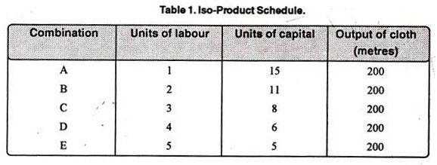
The table 1 shows that the five combinations of labour units and units of capital yield the same level of output, i.e., 200 metres of cloth. Thus, 200 metre cloth can be produced by combining.
(a) 1 units of labour and 15 units of capital
(b) 2 units of labour and 11 units of capital
(c) 3 units of labour and 8 units of capital
(d) 4 units of labour and 6 units of capital
(e) 5 units of labour and 5 units of capital

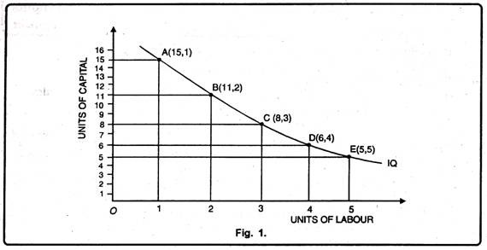

Iso-Product Curve Properties

Properties of Isoquants:

The main properties of the isoquants are similar to those of indifference curves. These properties are now discussed in brief:

(i) An Isoquant Slopes Downward from Left to Right:

This implies that the Isoquant is a negatively sloped curve. This is because when the quantify of factor K (capital) is increased, the quantity of L (labor) must be reduced so as to keep the same level of output.

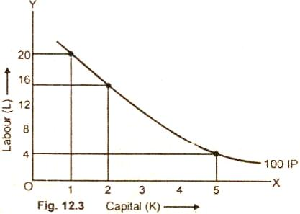

The figure (12.3) depicts that an isoquant IP is negatively sloped curve. This curve shows that as the amount of factor K is increased from one unit to 2 units, the units of factor L are decreased from 20 to 15 only so that output of 100 units remains constant.

(ii) An Isoquant that Lies Above and to the Right of Another Represents a Higher Output Level:

It means a higher isoquant represents higher level of output.

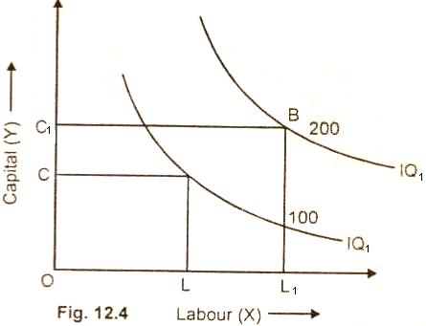

The figure 12.4 represents this property. It shows that greater output can be secured by increasing the quantity combinations of both the factors X and Y. The producer increases the output from 100 units to 200 units by increasing the quantity combination of both the X and Y. The combination of OC of capital and OL of labor yield 100 units of production. The production can be increased to 200 units by increasing the capital from OC to OC₁ and labor from OL to OL₁.

(iii) Isoquants Cannot Cut Each Other:

The two isoquants can not intersect each other.

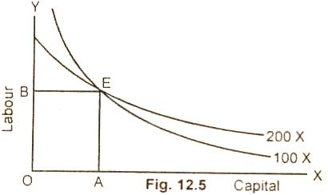

If two isoquant are drawn to intersect each other as is shown in this figure 12.5, then it is a negation of the property that higher Isoquant represents higher level of output to a lower Isoquant. The intersection at point E shows that the same factor combination can produce 100 units as well as 200 units. But this is quite absurd. How can the same level of factor combination produce two different levels of output, when the technique of production remains unchanged. Hence two isoquants cannot intersect each other.

(iv) Isoquants are Convex to the Origin:

This property implies that the marginal significance of one factor in terms of another factor diminishes along an ISO product curve. In other words, the isoquants are convex to the origin due to diminishing marginal rate of substitution.

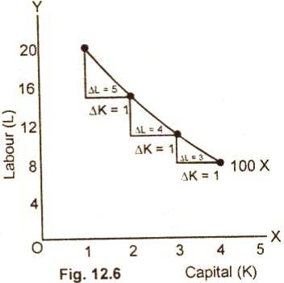

In this figure 12.6 MRS^{KL} diminishes from 5:1 to 4:1 and further to 3:1. This shows that as more and more units of capital (K) are employed to produce 100 units of the product, lesser and lesser units of labor (L) are used. Hence diminishing marginal rate of technical substitution is the reason for the convexity of an isoquant.

(v) Each Isoquant is Oval Shaped:

The iso product curve, is elliptical. This means that the firm produces only those segments of the iso-product curves which are convex to the origin and lie between the ridge lines. This is the economic region
Large scale production and limitations.
The scale of production refers to the amount of factors used, the quantities of products produced, and the techniques of production adopted by a producer. As production increases with the increase in the quantities of land, labour and capital, the scale of production expands.

Economies of Large Scale Production:
Economies of large scale production have been classified by Marshall into Internal Economies and External Economies. Internal economies are internal to a firm when its costs of production are reduced and output increases. They “are open to a single factory or a single firm independently of the action of other firms.
They result from an increase in the scale of output of the firm, and cannot be achieved unless output increases. They are not the result of inventions of any kind, but are due to the use of known methods of production which a small firm does not find worthwhile.” External Economies are external to firms which are available to it when the output of the whole industry increases with the expansion of the industry itself. They are “shared by a number of firms or industries when the scale of production in any industry or group of industries increases. They are not monopolised by a single firm when it grows in size, but are conferred on it when some other firms grow larger.”

(A) Internal Economies — Their Causes and Types:
Causes of Internal Economies:
Internal economies which accrue to a firm when it expands are caused by two factors: (1) indivisibility, and (2) specialisation.
- Indivisibilities:
- Many fixed factors of production are indivisible in the sense that they must he used in a fixed minimum size. Such “factors of production can be most efficiently employed at a fairly large output, but work less efficiently at small outputs because they cannot be divided into smaller units.” Thus as output increases, the indivisible factors which were being used below capacity can be utilised to their full capacity thereby reducing costs. Such indivisibilities arise in the case of labour, machines, marketing, finance and research.
- Labour is not divisible in the sense that if a manager works half the time, he may be paid half the salary. Or, as put by Stonier and Hague, “he cannot be chopped into half, and asked to produce half the current output.” For instance, a college will require the services of a principal regardless of the number of students and lecturers.
- Similar is the case with a factory manager, an engine driver, or a commercial pilot who will carry on his duties up to the maximum operational capacity. A factory manager with the maximum operational capacity of 1000 workers in the factory may be managing the same with 200 workers to start with. But when the factory expands in size and the number of workers increases gradually to 1000, the salary of the manager is spread over this number and thus there is a saving on this count to the management.
- Even if we presume that the salary of the manager also increases with the increase in his duties, it would not be increased in proportion to the increase in his duties because when he was appointed, the salary fixed by the management was in keeping with the maximum size of the factory with 1000 workers.
(2) Specialisation:
Division of labour which leads to specialisation is another cause of internal economies. When a firm expands in size, not only its production increases, but the quantity of raw materials and the number of workers also increase. This necessitates division of labour whereby each worker is assigned one particular job and the splitting up of processes into sub-processes for greater efficiency.
For example, the production process may be split into four departments relating to manufacturing, assembling, packing and marketing under the charge of separate managers who may work under the overall charge of the general manager who will coordinate the activities of the four departments. Thus specialisation will lead to greater productive efficiency and to reduction in costs.

Types of Internal Economies: Internal economies which arise from the expansion of a firm are the following:
(1) Technical Economies: Technical economies are those which arise to a firm from the use of better machines and techniques of production. As a result, production increases and the per unit cost of production falls. Prof. Cairncross divides technical economies into the following five parts:
(i) Economies of Superior Technique: It is only large firms which can afford to pay for costly machines and install them. Such machines are more productive than small machines. The high cost of such machines can be spread over a larger output which they help to produce. Thus the per unit cost of production falls in a large firm which employs costly and superior plant and equipment and thereby enjoys a technical superiority over a small firm.
(ii) Economies of Increased Dimensions: The installation of large machines itself brings many advantages to a firm. The cost of operating large machines is less than that of operating small machines. Even the cost of construction is relatively lower for large machines than for small ones. The manufacture of a double- Decker bus is lower as compared to the manufacture of two ordinary buses. Moreover, a double-decker carries more passengers than an ordinary bus and at the same time requires only a driver and a conductor like the latter. Thus its operating costs are relatively lower.
(iii) Economies of Linked Processes: A large firm is able to reduce its per unit cost of production by linking the various processes of production. For instance, a large sugar manufacturing firm may own its sugarcane farms, manufacture sugar, pack it in bags, transport and distribute sugar through its own transport and distribution departments. Thus by linking the various processes of production and sale, a large firm saves the expenses incurred on intermediaries, thereby reducing unit cost of production.
(iv) Economies of the Use of By-Products: A large firm possesses greater resources than a small firm and is able to utilise its waste material as a by-product. For example, the molasses left over after manufacturing sugar from the sugarcane can be used for producing spirit by installing a plant for the purpose.
(2) Specialisation: Division of labour which leads to specialisation is another cause of internal economies. When a firm expands in size, not only its production increases, but the quantity of raw materials and the number of workers also increase. This necessitates division of labour whereby each worker is assigned one particular job and the splitting up of processes into sub-processes for greater efficiency.
For example, the production process may be split into four departments relating to manufacturing, assembling, packing and marketing under the charge of separate managers who may work under the overall charge of the general manager who will coordinate the activities of the four departments. Thus specialisation will lead to greater productive efficiency and to reduction in costs.

Types of Internal Economies:
Internal economies which arise from the expansion of a firm are the following:
(1) Technical Economies:
Technical economies are those which arise to a firm from the use of better machines and techniques of production. As a result, production increases and the per unit cost of production falls. Prof. Cairncross divides technical economies into the following five parts:
(i) Economies of Superior Technique:
It is only large firms which can afford to pay for costly machines and install them. Such machines are more productive than small machines. The high cost of such machines can be spread over a larger output which they help to produce. Thus the per unit cost of production falls in a large firm which employs costly and superior plant and equipment and thereby enjoys a technical superiority over a small firm.
(ii) Economies of Increased Dimensions:
The installation of large machines itself brings many advantages to a firm. The cost of operating large machines is less than that of operating small machines. Even the cost of construction is relatively lower for large machines than for small ones. The manufacture of a double- Decker bus is lower as compared to the manufacture of two ordinary buses. Moreover, a double-decker carries more passengers than an ordinary bus and at the same time requires only a driver and a conductor like the latter. Thus its operating costs are relatively lower.
(iii) Economies of Linked Processes:
A large firm is able to reduce its per unit cost of production by linking the various processes of production. For instance, a large sugar manufacturing firm may own its sugarcane farms, manufacture sugar, pack it in bags, transport and distribute sugar through its own transport and distribution departments. Thus by linking the various processes of production and sale, a large firm saves the expenses incurred on intermediaries, thereby reducing unit cost of production.
(iv) Economies of the Use of By-Products:
A large firm possesses greater resources than a small firm and is able to utilise its waste material as a by-product. For example, the molasses left over after manufacturing sugar from the sugarcane can be used for producing spirit by installing a plant for the purpose.
(v) Economies of Increased Specialisation:
A large firm is able to reap economies by dividing its production processes into sub-processes thereby leading to greater division of labour and to increased specialisation. This increases the productive efficiency of the firm and reduces the unit cost of production.
(2) Marketing Economies:
A large firm also reaps the economies of buying and selling. It buys its requirements of various inputs in bulk and is, therefore, able to secure them at favourable terms in the form of better quality inputs, prompt delivery, transport concessions, etc. Because of its larger organisation, it produces quality products which are offered for sale in attractive packing by its packing department. It may also have a sales department manned by experts who carry on salesmanship, propaganda and advertisement through the various media efficiently. Thus a large firm is able to reap the economies of marketing through its superior bargaining power and efficient packing and sales organisation.
3) Managerial Economies:
A large firm can afford to put specialists to supervise and manage the various departments. There may be a separate head for manufacturing, assembling, packing, marketing, general administration, etc. This leads to functional specialisation which increases the productive efficiency of the firm. These managerial economies also reduce per unit cost of management because with expansion of the firm, the various departmental managers will manage large output as efficiently as they were managing small output at the same salary.
(4) Financial Economies:
A large firm can procure cheap and timely finance both from the banks and the market because it possesses large assets and good reputation. It can also raise fresh capital by floating shares and debentures in the capital market. It is in this way that a large firm reaps financial economies.
(5) Risk-Bearing Economies:
A large firm is in a better position than a small firm in spreading its risks. It can produce a variety of products, and sell them in different areas. By the diversification, of its products the large firm is able to reduce risks by counter-balancing the loss of one product by the gain from other products. By the diversification of markets, it can counter-balance the fall in demand in one market by the increased demand in other markets. Even if the demand in the other markets for the products of the firm is constant, the loss can be easily borne by it.
A firm undertakes great risk by depending excessively on one source for its supply of power and raw materials. It can avoid risks by having alternative sources of supply in the case of power and different sources for the supply of raw materials. For instance, a large firm can avoid the losses arising from failure of regular power-supply by installing a generator of its own.
(6) Economies of Research:
A large firm possesses-larger resources than a small firm and can establish its own research laboratory and employ trained research workers. When they invent new production techniques or processes, the latter become the property of the firm which utilises them for increasing its output and reducing costs.
(7) Economies of Welfare:
All firms have to provide welfare facilities to their workers. But a large firm, with its large resources, can provide better working conditions in and outside the factory. It may run subsidised canteens, provide creches for the infants of women workers and recreation rooms for the workers within the factory premises. It may also provide cheap houses, educational and medical facilities for the families of workers and recreational clubs outside the factory. Though the expenses on such facilities are very heavy, yet they tend to increase the productive efficiency of the workers which helps in raising production and reducing costs.

(B) External Economies:
External economies benefit all firms within the industry as the size of the industry expands. Such economies accrue to firms when the industry is localised in a particular area, makes inventions and evolves specialisation of production processes. These external economies are discussed below.
(1) Economies of Concentration:
When an industry is concentrated in a particular area, all the member firms reap some common economies. First, skilled labour is available to all the firms. Second, means of transport and communications are considerably improved. The industry may ask the railway authorities for additional facilities for more wagons, loading and unloading, etc. Road transporters may also provide special facilities to the firms. Third, banks, insurance companies and other financial institutions set up their offices in the area and the firms get cheap and timely credit. Fourth, the electricity board supplies adequate power to the firms, often at concessional rates. Lost, subsidiary industries develop to supply the localised industry with tools, equipment and raw materials. All these facilities tend to lower the unit cost of production of all the firms in the industry.
(2) Economies of Information:
An industry is in a better position to set up research laboratories than a large firm because it is able to pool larger resources. It can employ highly paid and more experienced research personnel. The fruits of their research in the form of new inventions are passed on to the firms through a scientific journal. The industry can also set up an information centre which may publish a journal and pass on information regarding the availability of raw materials, modern machines, export potentialities of the products of the industry in various countries of the world and provide other information needed by the firms. All this helps in raising the productive efficiency of the firms and reduction in their cost
(3) Economies of Welfare:
As compared to a large firm, an industry is in a more advantageous position to provide welfare facilities to the workers. It may get land at concessional rates and procure special facilities from the municipal corporation of the area for setting up housing colonies for the workers, public health, and recreational facilities, etc. It may also establish educational institutions, both general and technical, so that a continuous supply of skilled labour is available to the industry. Such facilities increase the efficiency of the workers who help raise the quality and quantity of the products of the industry.
(4) Economies of Specialisation:
The firms in an industry may also reap the economies of specialisation. When an industry expands in size, firms start specialising in different processes and the industry benefits on the whole. For example, in the cotton textile industry some firms may specialise in manufacturing thread, Others in printing, still others in dyeing, some in long cloth, some in dhoties, some in shirting, etc. As a result, the productive efficiency of the firms specialising in different fields increases and the unit cost of production falls.

(C) Relation between Internal and External Economies:
The relation between internal and external economies is only one of degree. For example, firms may be enjoying external economies, but if they combine together, then all external economies become internal for them. Again, an internal economy reaped by a firm becomes external to some other firm if it uses the same. To take an example, if molasses are used by the sugar factory itself for manufacturing spirit, it is an internal economy. But if some other firm buys molasses for manufacturing spirit, it is an external economy to the buying firm.
Often external economies lead to internal economies. As pointed out by Mrs. Robinson, “Economies of large scale industry are likely to have the effect of altering the optimum size of the firm, and the reorganisation of the firm to adapt itself to the new optimum size may lead to further economies”. These have been described by Mr. Robertson as internal-external economies. They are internal economies, because they depend upon the size of the firm and external economies because they depend upon the size of the industry.

Diseconomies of Large Scale Production:
The economies of scale cannot continue indefinitely. A time comes in the life of a firm or an industry when further expansion leads to diseconomies in place of economies. Internal and external diseconomies are, in fact, the limits to large scale production which are discussed below.

(1) Financial Diseconomies:
An entrepreneur needs finance to expand his business. But finance may not be easily available in the required amount at the appropriate time. Lack of finance prevents the firm from expanding in the required direction and retards its production plans thereby increasing costs.

(2) Managerial Diseconomies:
The check to the further expansion of a firm is put due to the failure on the part of the management to supervise and control the business properly. There is a limit beyond which a firm becomes unwieldy and hence unmanageable. Supervision becomes lax. Workers do not work efficiently, wastages arise, decision-making becomes difficult, coordination between workers and management disappears and production costs increase.

(3) Marketing Diseconomies:
The expansion of a firm beyond a certain limit may also involve marketing problems. Raw materials may not be available in sufficient quantities due to their scarcities. The demand for the products of the firm may fall as a result of changes in tastes of the people and the firm may not be in a position to change accordingly in the short period. The market organisation may fail to foresee changes in market conditions whereby the sales might fall.

(4) Technical Diseconomies:
A large scale firm often operates heavy capital equipment which is indivisible. Its aim is to maximise profits which it does by equalising its marginal costs with the price (marginal revenue) of the product. Under perfect competition, it might produce at its minimum average cost in the long run. However, due to the presence of the diseconomies of finance, marketing or management, the firm may fail to operate its plant to its maximum capacity. It may have excess capacity or idle capacity. For example, if the plant can manufacture 2000 units of the commodity per day, the firm may be producing 1500 units per day. Thus the firm operates below its full capacity. As a result, cost per unit increases.

(5) Diseconomies of Risk-Taking:
As the scale of production of a firm expands, risks also increase with it. An error of judgment on the part of the sales manager or the production manager may adversely affect sales or production which may lead to great loss.

(6) External Diseconomies:
If an industry expands as a whole, its growing demand for the various factors of production, like labour, capital, raw materials, etc. may eventually raise their prices. The localisation of industries may lead to shortages of transport, power, labour, raw materials and equipments. All such external diseconomies tend to raise cost per unit.
UNIT-IV Supply-supply schedule-Law of supply-Supply curve-Elasticity of supply. Market structure- Equilibrium of firm and industry- Optimum firm. Meaning and characteristics of perfect, monopoly, duopoly oligopoly and monopolistic markets. Pricing under Perfect & Monopolistic competition

Law of Supply and Demand

The law of supply and demand is a theory that explains the interaction between the sellers of a resource and the buyers for that resource. The theory defines what effect the relationship between the availability of a particular product and the desire (or demand) for that product has on its price. Generally, low supply and high demand increase price and vice versa.
Description: Law of supply depicts the producer behavior at the time of changes in the prices of goods and services. When the price of a good rises, the supplier increases the supply in order to earn a profit because of higher prices.
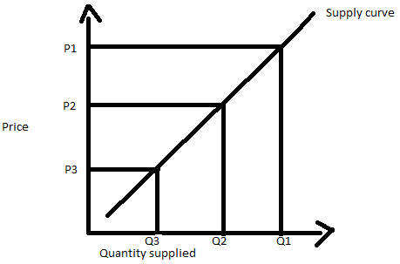
The above diagram shows the supply curve that is upward sloping (positive relation between the price and the quantity supplied). When the price of the good was at P3, suppliers were supplying Q3 quantity. As the price starts rising, the quantity supplied also starts rising.
Law of Supply:
From a study of the supply schedule and supply curve, we can formulate the law of supply thus:
“In a given market, at any time, the quantity of any goods which people are ready to offer for sale generally varies directly with the price.”
‘Varies directly means that as price rises the quantity offered increases, and as it falls, the quantity offered decreases. It should be noted that, in the case of demand, the quantity demanded varies inversely with the price, i.e., as price rises, demand decreases, and vice versa.
The law of supply may be put in another way. “Other things remaining the same, as the price of a commodity rises, its supply is extended, and as the price falls, its supply is contracted.”
When prices are low many individuals and firms do not find it worth-while to sell, for their costs may be high and profits will be low. But, when prices rise, they are in a position to carry on production with profit and sell more. Higher prices mean higher profits. The desire for larger profits carries production to the farthest limit yielding a net profit.

Some Exceptions:
There are some exceptions to the law of supply:
(a) In an auction, goods are sold away whatever the bid. It is possible that the seller is badly in need of money and wants a certain amount of it. As soon as that amount is made up, he will refuse to sell more. The higher the price, the smaller the quantity he will need to sell in order to get the required amount. It is also possible that a person wants to get rid of a quantity of goods as in the case of a person going abroad. In such a case, he will sell away all that he has, whatever the price offered.
(b) When a further heavy fall in price is expected, the sellers may become panicky. They will sell more even if the price falls.
Elasticity of Supply:
Meaning of Elasticity of Supply:
The law of supply says that the supply varies directly with the price. If the price rises, the quantity offered will extend, and as it falls the quantity offered will contract. This attribute of supply, by virtue of which it extends or contracts with a rise or fall in price, is known as the Elasticity of Supply. It refers to the sensitiveness or responsiveness of the supply to changes in price.
Cases of Inelastic Supply:
But supply may not always respond to the changes in price at the same rate If the commodity is perishable, e.g., fresh milk, ripe fruits, fresh vegetables, etc. the supply cannot be withheld and the whole of it must be offered for sale, whatever the price. In this case, as already pointed out, there is no difference between stock and supply. In other words, the supply is inelastic, i.e., it is insensitive to a change in price. The: price may be falling but the commodity will have to be sold away.
In the same manner, if the production of a commodity requires a large fixed «.4pital, say, iron and steel products, cement, aero-planes, motor-cars, etc., the apply cannot be quickly increased when the price rises, or decreased when it falls.
The same is the case with a commodity which takes a long time to be put on the market. For example, you can increase the supply of wheat or cotton only in a year’s time at the next harvest. In this case too, it is difficult to adjust the supply to demand immediately. In such cases, the supply is called inelastic or less elastic.
Elastic Supply:
But if there is a very large stock of commodity already in existence and the commodity can be stocked, or kept back without loss, then the supply put on the market will vary with price. More will be offered when the price is high, and less when it is low. The supply of such a commodity is said to be elastic.
Diagrammatic Representation:
Figure 24.9 represents inelastic supply and Fig. 24.10 elastic supply. Price is measured along OY and quantity offered along OX.
In Fig. 24.9, when the price rises from PM to P’ M ‘ (which is a considerable rise), the quantity offered extends from OM to OM’ only, which is not much. Hence supply is less elastic.
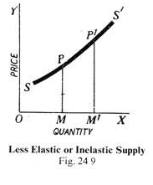
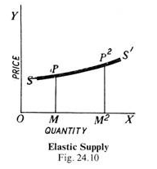
In Fig. 24.10, the-rise from PM to P M is not so large, but the extension of supply from OM to OM ² is quite considerable. Hence the supply is elastic.
Elasticity of Supply and Marginal Costs:
The elasticity of supply is really the measure of the ease with which an industry can be expanded, and it can be judged from the behaviour of the marginal costs. If a slight increase in price is followed by the entry of many new firms having minimum average cost equal to price and the marginal cost does not rise, the supply is said to be perfectly elastic.
In case, however, the increased output can be obtained only by an infinite increase in price and yet no new firm is attracted to the industry, the supply will be inelastic. In between these two extremes, there will be different degrees of elasticity. The degree of elasticity will depend, in a particular case, on the slope of the marginal cost curve and the shape of the average cost curves of the successive firms.
“The relation between price and the quantity supplied is rather like the relation between a whistle and a dog—the louder the whistle the faster comes the dog; raise the price and the quantity supplied increases. If the dog is responsive—in economic terminology elastic—quite a small crescendo in the whistle will send him bouncing along. If the dog is unresponsive or ‘inelastic’, we may have to whistle very loudly before he comes along at all.”
Market Structure
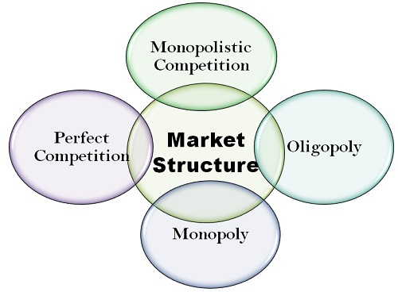

1] Perfect Competiton
In a perfect competition market structure, there are a large number of buyers and sellers. All the sellers of the market are small sellers in competition with each other. There is no one big seller with any significant influence on the market. So all the firms in such a market are price takers.
There are certain assumptions when discussing the perfect competition. This is the reason a perfect competition market is pretty much a theoretical concept. These assumptions are as follows,
- The products on the market are homogeneous, i.e. they are completely identical
- All firms only have the motive of profit maximization
- There is free entry and exit from the market, i.e. there are no barriers
- And there is no concept of consumer preference

2] Monopolistic Competition
This is a more realistic scenario that actually occurs in the real world. In monopolistic competition, there are still a large number of buyers as well as sellers. But they all do not sell homogeneous products. The products are similar but all sellers sell slightly differentiated products.
Now the consumers have the preference of choosing one product over another. The sellers can also charge a marginally higher price since they may enjoy some market power. So the sellers become the price setters to a certain extent.
For example, the market for cereals is a monopolistic competition. The products are all similar but slightly differentiated in terms of taste and flavours. Another such example is toothpaste.

3] Oligopoly
In an oligopoly, there are only a few firms in the market. While there is no clarity about the number of firms, 3-5 dominant firms are considered the norm. So in the case of an oligopoly, the buyers are far greater than the sellers.
The firms in this case either compete with another to collaborate together, They use their market influence to set the prices and in turn maximize their profits. So the consumers become the price takers. In an oligopoly, there are various barriers to entry in the market, and new firms find it difficult to establish themselves.

4] Monopoly
In a monopoly type of market structure, there is only one seller, so a single firm will control the entire market. It can set any price it wishes since it has all the market power. Consumers do not have any alternative and must pay the price set by the seller. Monopolies are extremely undesirable. Here the consumer loose all their power and market forces become irrelevant. However, a pure monopoly is very rare in reality.
Unit V: National Income- concept – Measurement – inequalities of income – Fiscal policy method. Public Finance – Definition – Scope - importance.
National income means the value of goods and services produced by a country during a financial year. Thus, it is the net result of all economic activities of any country during a period of one year and is valued in terms of money. National income is an uncertain term and is often used interchangeably with the national dividend, national output, and national expenditure.

Concept of National Income
The National Income is the total amount of income accruing to a country from economic activities in a years time. It includes payments made to all resources either in the form of wages, interest, rent, and profits.
The progress of a country can be determined by the growth of the national income of the country

National Income Definition
There are two National Income Definition
- Traditional Definition
- Modern Definition



Traditional Definition
National income is an uncertain term which is used interchangeably with national dividend, national output and national expenditure. On this basis, national income has been defined in a number of ways. In common parlance, national income means the total value of goods and services produced annually in a country.
According to Marshall: “The labor and capital of a country acting on its natural resources produce annually a certain net aggregate of commodities, material and immaterial including services of all kinds. This is the true net annual income or revenue of the country or national dividend.”
The definition as laid down by Marshall is being criticized on the following grounds.
Due to the varied category of goods and services, a correct estimation is very difficult.
There is a chance of double counting, hence National Income cannot be estimated correctly.
For example, a product runs in the supply from the producer to distributor to wholesaler to retailer and then to the ultimate consumer. If on every movement commodity is taken into consideration then the value of National Income increases.
Also, one other reason is that there are products which are produced but not marketed.
For example, In an agriculture-oriented country like India, there are commodities which though produced but are kept for self-consumption or exchanged with other commodities. Thus there can be an underestimation of National Income.
Simon Kuznets defines national income as “the net output of commodities and services flowing during the year from the country’s productive system in the hands of the ultimate consumers.”
Following are the Modern National Income definition
- GDP
- GNP

Gross Domestic Product
The total value of goods produced and services rendered within a country during a year is its Gross Domestic Product.
Further, GDP is calculated at market price and is defined as GDP at market prices. Different constituents of GDP are:
- Wages and salaries
- Rent
- Interest
- Undistributed profits
- Mixed-income
- Direct taxes
- Dividend
- Depreciation

Gross National Product
For calculation of GNP, we need to collect and assess the data from all productive activities, such as agricultural produce, wood, minerals, commodities, the contributions to production by transport, communications, insurance companies, professions such (as lawyers, doctors, teachers, etc). at market prices.

It also includes net income arising in a country from abroad. Four main constituents of GNP are:
- Consumer goods and services
- Gross private domestic income
- Goods produced or services rendered
- Income arising from abroad.

GDP and GNP on the basis of Market Price and Factor Cost

a) Market Price
The Actual transacted price including indirect taxes such as GST, Customs duty etc. Such taxes tend to raise the prices of goods and services in the economy.

b) Factor Cost
It Includes the cost of factors of production e.g. interest on capital, wages to labor, rent for land profit to the stakeholders. Thus services provided by service providers and goods sold by the producer is equal to revenue price.
Alternatively,
Revenue Price (or Factor Cost) = Market Price (net of) Net Indirect Taxes
Net Indirect Taxes = Indirect Taxes Net of Subsidies received
Hence,
Factor Cost shall be equal to
(Market Price) LESS (Indirect Taxes ADD Subsidies)

Net Domestic Product
The net output of the country’s economy during a year is its NDP. During the year a country’s capital assets are subject to wear and tear due to its use or can become obsolete.
Hence, we deduct a percentage of such investment from the GDP to arrive at NDP.
So NDP=GDP at factor cost LESS Depreciation.
The Accumulation of all factors of income earned by residents of a country and includes income earned from the county as well as from abroad.
Thus, National Income at Factor Cost shall be equal to
NNP at Market Price LESS (Indirect Taxes ADD Subsidies)

WHAT IS PUBLIC FINANCE?
In simple layman terms, public finance is the study of finance related to government entities. It revolves around the role of government income and expenditure in the economy.
Prof. Dalton in his book Principles of Public Finance states that “Public Finance is concerned with income and expenditure of public authorities and with the adjustment of one to the other”
By this definition, we can understand that public finance deals with income and expenditure of government entity at any level be it central, state or local. However in the modern day context, public finance has a wider scope – it studies the impact of government policies on the economy.
Let’s understand the scope of public finance to understand how public finance impacts the economy.
Every economy goes through periods of booms and depression. It’s the most normal and common business cycles that lead to this scenario. However, these periods cause instability in the economy. The objective of the stabilization function is to eliminate or at least reduce these business fluctuations and its impact on the economy. Policies such as deficit budgeting during the time of depression and surplus budgeting during the time of boom helps achieve the required economic stability.
Nature of Public Finance
Nature of Public finance implies whether it is a science or art or both.

1. Public Finance is a Science: Science is a systematic study of any subject which studies casual relationship between facts. Public finance is a systematically study relating to revenue and expenditure of the government. It also studies the casual relationship between facts relating to revenue and expenditure of the government. Prot.
Plehn has advanced the following arguments in favour of public finance being science:

i. Public finance is not a complete knowledge about human rather it is concerned with definite and limited field of human knowledge.
ii. Public finance is a systematic study of the facts and principles relating to government revenue and expenditure.
iii. Scientific methods are used to study public finance.
iv. Principles of public finance are empirical.

Science is of two types:
a) Positive science and
b) Normative science.
In positive science one knows about factual situation or facts as they are. It describes “what is”. As against it, normative science presents norms or ideals. It describes “what ought to be” or what is right or wrong i.e. value judgement. By the study of public finance one gets factual information about the problems of government’s revenue and expenditure. Public finance is therefore, a positive science. Study of public finance also reveals what should be the quantum of taxes. Which taxes, direct or indirect, should be imposed. On what items more or on what items less of public expenditure be incurred. Public finance is therefore a normative science. Thus, study of public finance offers suggestions regarding revenue and expenditure of the government as also apprises of their factual position.

2. Public Finance is an Art: In the words of J.N. Keynes, ”Art is the application of knowledge for achieving definite objectives.” Fiscal policy which is an important instrument of public finance makes use of the knowledge of the government’s revenue and expenditure to achieve the objectives of full employment, economic equality , economic development and price stability, etc. To achieve the objective of economic equality taxes are levied at progressive rate. Since every tax is likely to be opposed, it becomes essential to plan their timing and volume. The process of levying tax is certainly an art. Budget making is an art in itself. Study of public finance is helpful in solving many practical problems. Public finance is therefore an art also.
In sort, public finance is both science and art. It is a positive science as well as normative science.

Scope of Public Finance (Subject Matter of Public Finance)
The scope of public finance may be summarised as under:
1. Public Revenue
2. Public Expenditure
3. Public Debt
4. Financial Administration
5. Economic Stabilisation

1. Public Revenue: Public revenue concentrates on the methods of raising public revenue, the principles of taxation and its problems. In other words, all kinds of income from taxes and receipts from public deposit are included in public revenue. It also includes the methods of raising funds. It further studies the classification of various resources of public revenue into taxes, fees and assessment etc.

2. Public Expenditure: In this part of public finance we study the principles and problems relating to the expenditure of public funds. This part studies the fundamental principles that govern the flow of Government funds into various streams.

3. Public Debt: In this section of public finance, we study the problem of raising loans. Public authority or any Government can raise income through loans to meet the short-fall in its traditional income. The loan raised by the government in a particular year is the part of receipts of the public authority.

4. Financial Administration: Now comes the problem of organisation and administration of the financial mechanism of the Government. In other words, under financial or fiscal administration, we are concerned with the Government machinery which is responsible for performing various functions of the state.

5. Economic Stabilization: Now –a-day’s economic stabilization and growth are the two aspects of the Government economic policy which got a significant place in the discussion on public finance theory. This part describes the various economic polices and other measures of the government to bring about economic stability in the country.

From the above discussion, we can say that the subject-matter of public finance is not static, but dynamic which is continuously widening with the change in the concept of state and functions of the state. As the economic and social responsibilities of the state are increasing day by day, the methods and techniques of raising public income, public expenditure and public borrowings are also changing. In view of the changed circumstances, it has given more responsibilities in the social and economic field.
Reference
- freepik.com
- https://geteconhelp.com/economics-definition-meaning
- https://www.economicsdiscussion.net/scope/the-scope-of-economics/25093
- https://economictimes.indiatimes.com/definition/law-of-demand
- https://www.toppr.com/guides/business-economics/theory-of-demand/law-of-demand-and-elasticity-of-demand/
- https://www.economicsdiscussion.net/production-function/production-function-meaning-definitions-and-features/6892
- https://www.economicsdiscussion.net/iso-quant-curve/iso-quant-curve-definitions-assumptions-and-properties/6998
- https://sites.google.com/site/economicsbasics/supply-analysis
- https://www.docsity.com/en/demand-and-supply-analysis-3/2198514/
- http://www.yourarticlelibrary.com/notes/national-income-definition-concepts-and-methods-of-measuring-national-income/30801

