ORGANIC CHEMISTRY – II

CHEMISTRY OF CARBOHYDRATES

Ms. D.Karthika
Assistant Professor.
S.T.E.T. WOMEN’S COLLEGE,
MANNARGUDI
CHEMISTRY OF CARBOHYDRATES

- Carbohydrates are the most abundant organic molecules in nature. They have a wide range of functions, including providing a significant fraction of the energy in the diet of most organisms, acting as a storage form of energy in the body, and serving as cell membrane components that mediate some forms of intercellular communication. Carbohydrates also serve as a structural component of many organisms, including the cell walls of bacteria, the exoskeleton of many insects, and the fibrous cellulose of plants.

- The carbohydrates as the name implies are composed of carbon, hydrogen and oxygen with the latter two element in the ratio of 2 to 1 as in water The empiric formula for carbohydrates is (CH2O)n.

- Structurally carbohydrates are polyfunctional compounds. They contain two types of functional groups-hydroxyl and carbonyl. They may be polyhydroxy aldehydes or polyhydroxy ketones.

- Formation of carbohydrates in nature occurs in green plants by a process called photosynthesis, plant contain the green pigment chlorophyll, which catalyses the conversion of carbon dioxide and water into sugar.

Classification and nomenclature of carbohydrates

- The carbohydrates are divided into three major classes depending upon whether or not they undergo hydrolysis and if they do, on the number of products formed.

  - Monosaccharides: The monosaccharides are polyhydroxy aldehydes or polyhydroxy ketones which cannot be decomposed by hydrolysis to give simpler carbohydrates. e.g. Glucose, fructose, Galactose etc.
  - Oligosaccharides: The oligosaccharides (Oligo: few) are carbohydrates which yield a definite number

(2-9) of monosaccharide molecules on hydrolysis.

- Disaccharides - Which yield two monosaccharides molecules on hydrolysis. Which have molecular formula is C12H22O11.e.g. Sucrose, maltose etc

- Trisaccharides - Which yield three monosaccharides molecules on hydrolysis and have molecular formula is C18H32O16.

- Tetrasaccharides - Which yield four monosaccharides molecules on hydrolysis and have molecular

formula is C22H42O21. eg: Stachyose [gal(α1→6)gal(α1→6)glu(α1↔2β)fru]

  - Polysaccharides: The carbohydrates which have higher molecular weight, which yield many monosaccharide molecules on hydrolysis. E.g. Starch, glycogen, Dextrin, Cellulose etc.

- In general monosaccharides and oligosaccharides are crystalline solids, soluble in water and sweet to taste, they are collectively known as sugars, the polysaccharides on the other hand are amorphous, insoluble in water and tasteless, they are called non-sugars.
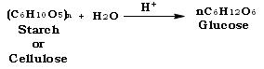

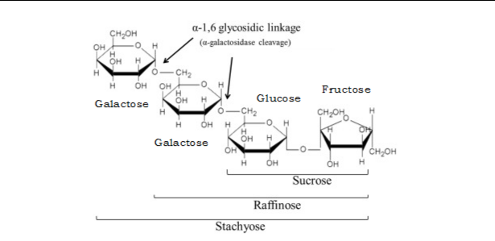

Different between monosaccharaides, oligosaccharides and Polysaccharides

 |  | Character |  | Monosaccharaides |  | Oligosaccharides |  | Polysaccharides
 |  | No. of sugar molecules | 1 |  | 2-9 |  |  | More than 9
 |  | Glycoside bond |  | Absent |  | Present |  | Present
 |  | Molecular Weight |  | Low |  | Moderate |  | High
 |  | Taste |  | Sweet |  | Minimally sweet |  | No taste
 |  | Taste |  | Sweet |  | taste |  | No taste
 |  | Solubility |  | Soluble |  | Soluble |  | Insoluble
 |  | Nature |  | Always reducing sugar |  | May or may not be |  | Always non reducing sugar
 |  | Example |  | Glucose, fructose, |  | Sucrose, Maltose |  | Starch, Glycogen, Dextrin,
 |  | Example |  | Galactose |  | Sucrose, Maltose |  | Cellulose

- Test for carbohydrate:
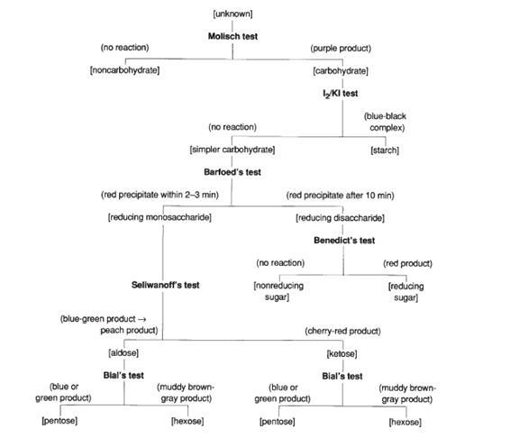

- Classification of Carbohydrates:
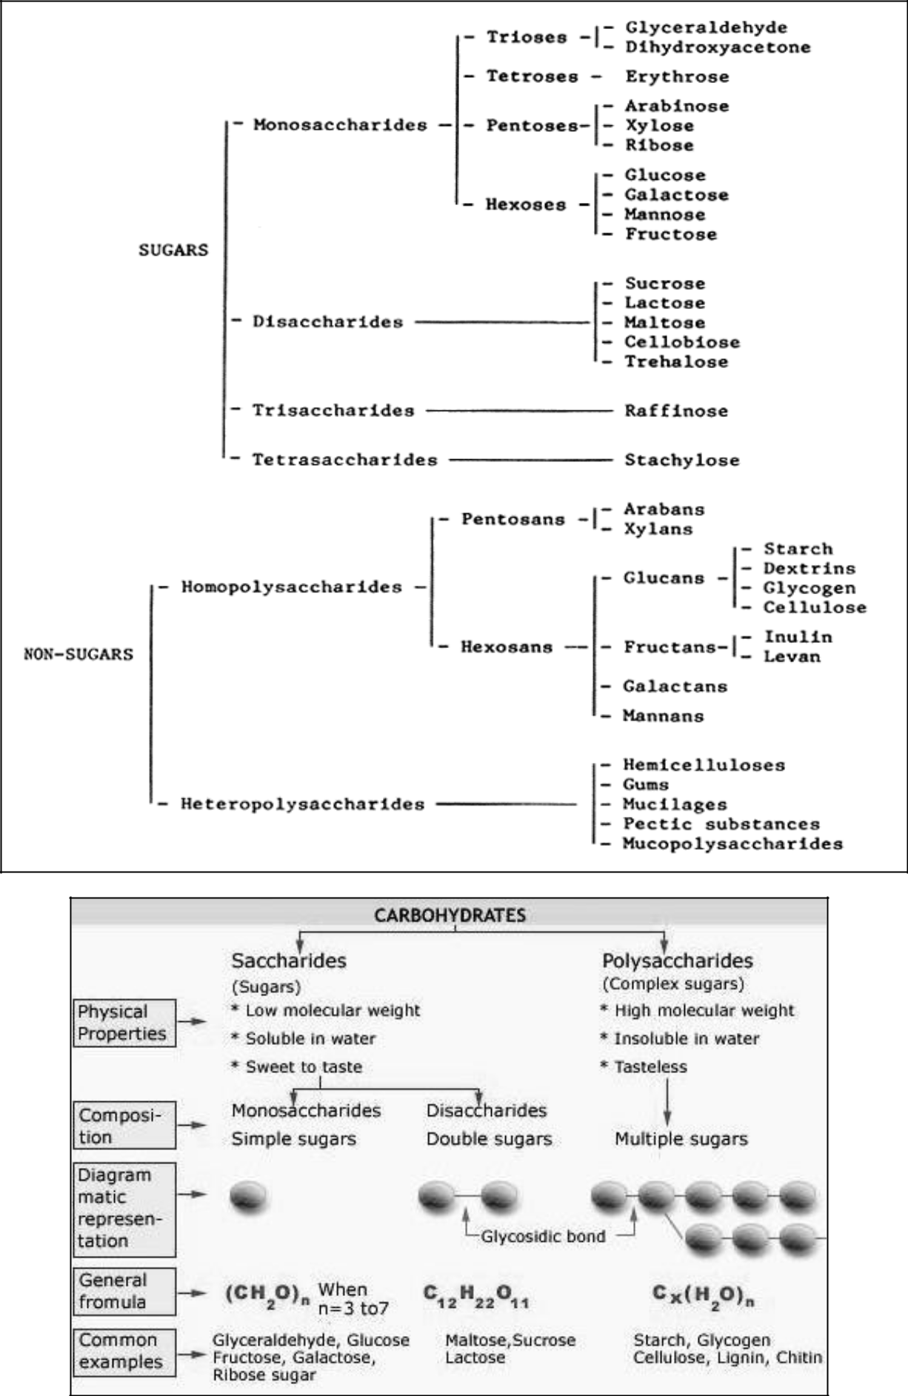

)

- Different between reducing and non-reducing sugar:

Sl. No. | Reducing sugar | Non-reducing sugar
1 | Such sugar bear a free aldehyde (-CHO) or | These sugars do not have such groups
1 | ketonic [RC(=O)R'] group | These sugars do not have such groups
 | Reducing sugars have the capacity to | Non reducing sugars fail to reduce cupric
2 | reduce cupric ions of benedict’s or Fehling | ions of Benedict’s or Fehling solution to
 | solution to cuprous ion | cuprous ion
 | Example: all monosaccharides and
3 | disaccharides (like lactose, Melibiose, | Example: Sucrose, Trehalose
 | Cellobiose, Gentiobiose)
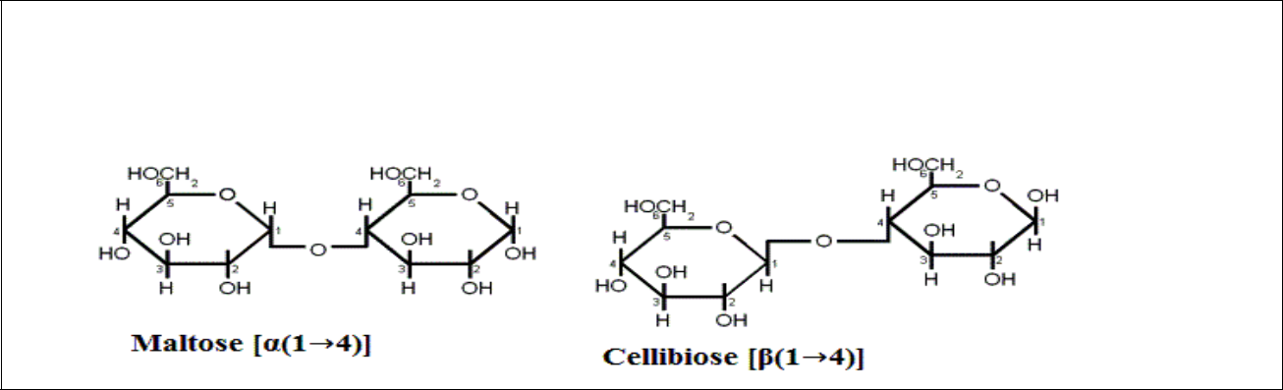

Maltose and Cellobiose

Both maltose and cellobiose are composed of two glucose molecules. But in maltose the glucose molecules are in the α configuration and joined with an α(1→4) link while in cellobiose they are in the β configuration and joined with a β(1→4).
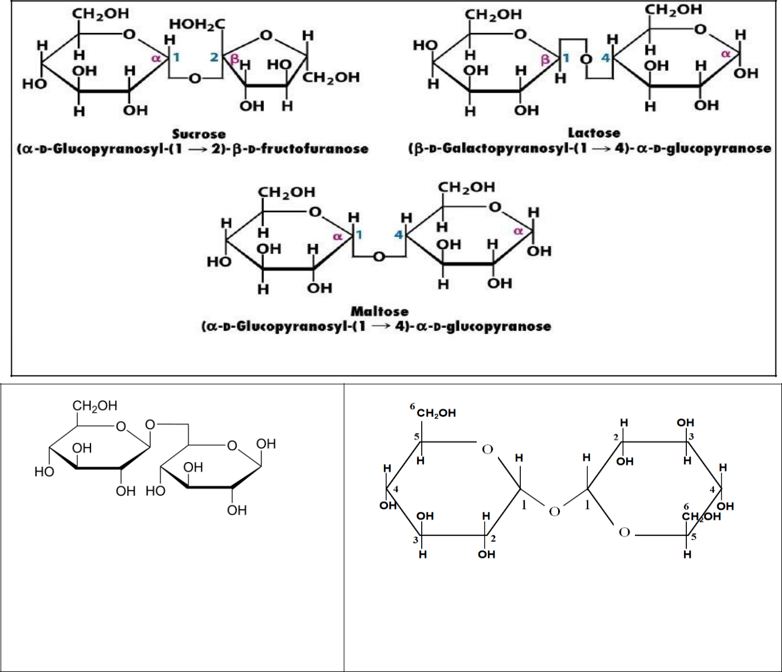

- Pentose Sugar:

  - A pentose is a monosaccharide with five carbon atoms.

  - Pentoses are organized into two groups.

    - Aldopentoses have an aldehyde functional group at position 1.

    - Ketopentoses have a ketone functional group in position 2 or 3.

- Aldopentoses: The aldopentoses have three chiral centers and therefore eight different stereoisomers are possible.
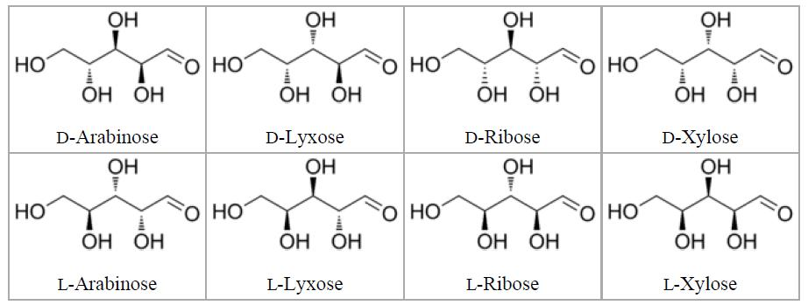

- Ketopentoses: The 2-ketopentoses have two chiral centers, and therefore four different stereoisomers are possible. The 3ketopentoses are rare.
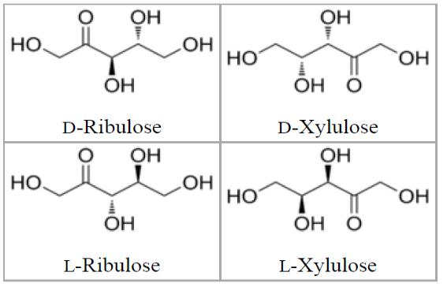

- The carbohydrates may also be classified as either reducing or non reducing sugars. All those carbohydrates which have ability to reduce Fehiling’s solution and Tollen’s reagents are referred to as reducing sugars, while others are non reducing sugars. All monosaccharides and disaccharides other than sucrose are reducing sugars.

- Carbohydrates are also said to be saccharides (Latin: Saccharon - Sugar).

- Note By: Synthetic sweetening agents
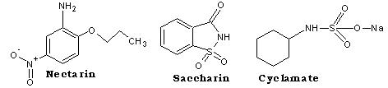

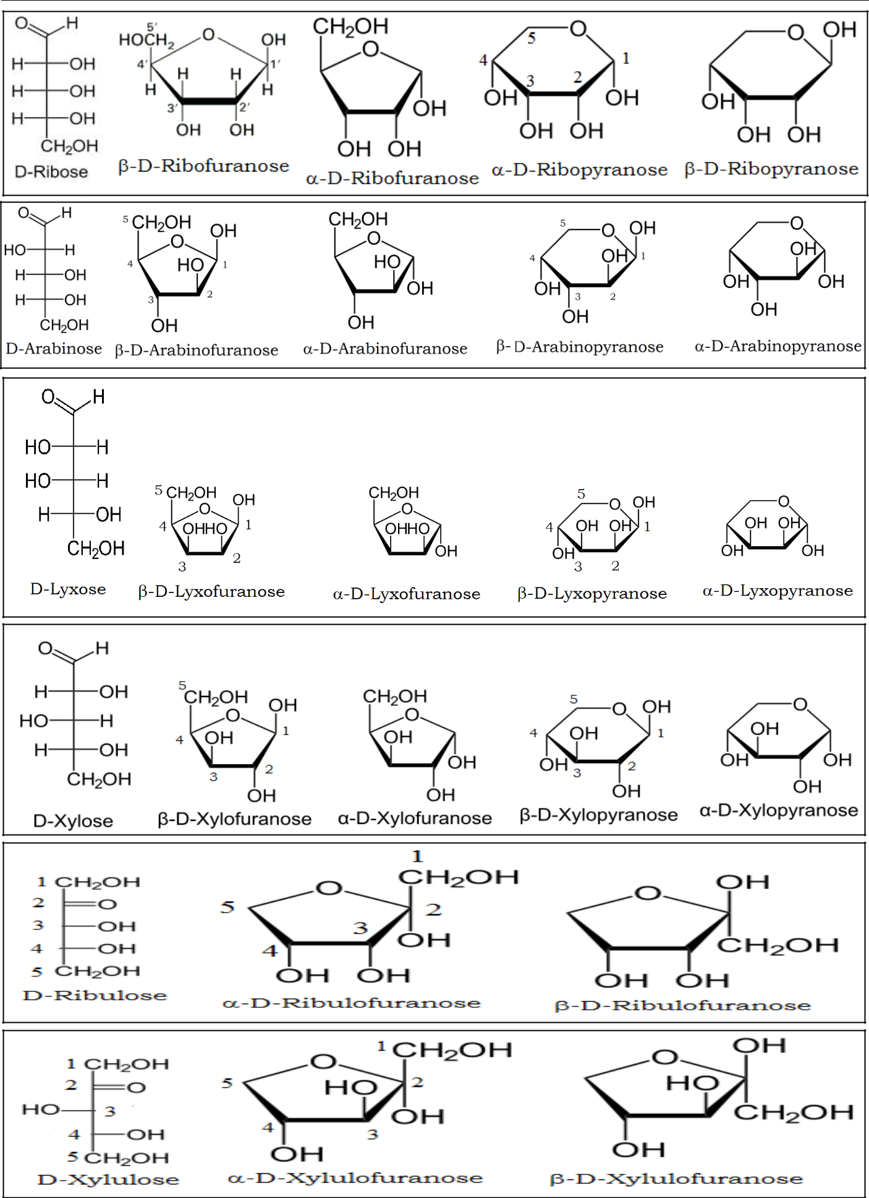

Nomenclature of carbohydrates:

- The monosaccharides are the basis of carbohydrates chemistry since all carbohydrates are either monosaccharides or are converted into monosaccharides on hydrolysis. The monosaccharides are polyhydroxy aldehydes or polyhydroxy ketones. There are therefore two main classes of monosaccharides.

- The Aldoses, which contain an aldehyde group. 2. The Ketoses, which contain a ketone group.

 | O |  |  |  | O
R |  |  | H | R |  |  | R¹
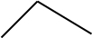
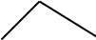

- The aldoses and ketoses are further divided into sub-groups on the basis of the number of carbon atoms in their molecules, as Trioses, Tetroses, Pentoses, Hexoses, etc.

 |  | Aldoses | Ketoses
 | Trioses (C3H6O3) | Glycerose | Dihydroxyacetone
 | Tetroses | Erythrose | Erythrulose
 | (C4H8O4) | Erythrose | Erythrulose
 | Pentoses | Ribose | Ribulose
 | (C5H10O5) | Ribose | Ribulose
 | Hexoses | Glucose | Fructose
 | (C6H12O6) | Glucose | Fructose

- The aldoses and ketoses may be represented by the following general formulas.
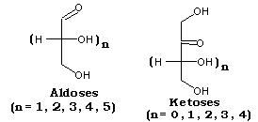

- Glucose and fructose are specific examples of an aldose and ketose.
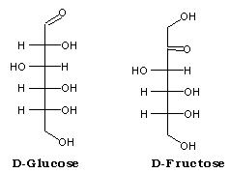

Sugars exhibit various forms of isomerism:

- The maximum number of optical isomers of a sugar is related to the number of asymmetric carbon atoms in the molecules and may be calculated by the following equation,

Maximum Number of Optical Isomers = 2^{n} [n = the asymmetric carbon atoms]

- Glucose, with four asymmetric carbon atoms, can form 16 isomers. The more important types of isomerism found with glucose are as follows.

- D and L isomerism:

- The designation of a sugar isomer as the D form or of its mirror image as the L form.

- The L and D forms of the sugar depends on the orientation of the -H and -OH groups around the carbon atom adjacent to the terminal primary alcohol carbon (carbon 5 in glucose) determines whether the sugar belongs to the D or L series.

- When the -OH group on this carbon is on the right, then sugar is the D-isomer; when it is on the left, then it is the L-isomer.
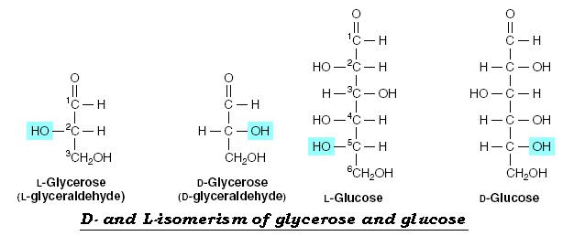

- Most of the monosaccharide occurring in mammals is D sugars, and the enzymes responsible for their metabolism are specific for this configuration. In solution, glucose is dextrorotatory—hence the alternative name dextrose.

- The presence of asymmetric carbon atoms also confers optical activity on the compound. When a beam of plane-polarized light is passed through a solution of an optical isomer, it will be rotated either to the right, dextrorotatory (+); or to the left, levorotatory (-). The direction of rotation is independent of the stereochemistry of the sugar, so it may be designated D (-), D (+), L (-), or L (+). For example, the naturally occurring formof fructose is the D (-) isomer.
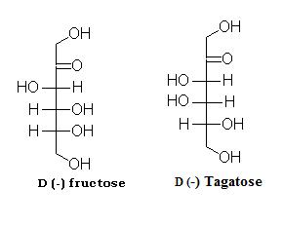

Alpha and beta anomers:

- The anomeric centre of a sugar is a stereocentre created from the intramolecular formation of an acetal (or ketal) of a sugar hydroxyl group and an aldehyde (or ketone) group. The two stereoisomers formed from the two possible stereochemistries at the anomeric centre are called anomers. They are diastereoisomers of one another.

- Cyclic Structures and Anomeric Forms

  - Alcohols react readily with aldehydes to form hemiacetals:
    - This reaction is promoted in the presence of either acid or base

    - One of the subtleties of this reaction involves the stereochemistry of the aldehyde and keto carbon it goes from being achiral to chiral.
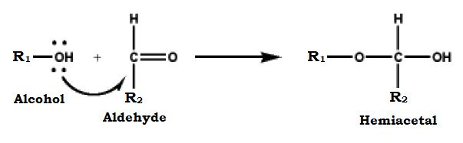

- Similarly alcohols react with ketones to produce hemiketals:
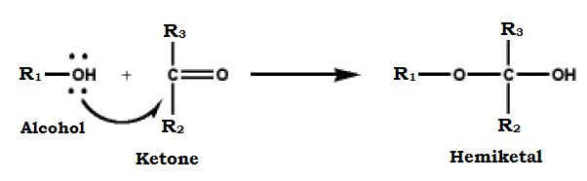

- Since aldoses and ketoses contain alcohol groups, in addition to their aldehyde or ketone groups, they have the potential to react to form cyclic forms.
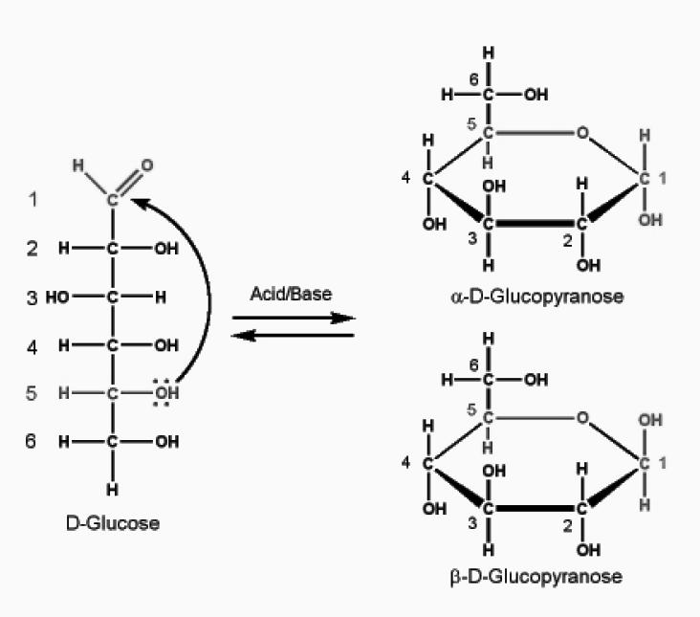

- Cyclization creates an anomeric carbon (the former carbonyl carbon), generating the α and β configurations of the sugar, for example, α-D-glucopyranose and β-D-glucopryanose.

- These two sugars are both glucose but are anomers of each other.

- In the α configuration, the OH on the anomeric C projects to the same side as the ring in a modified Fischer projection formula. In a Haworth projection formula of the α configuration, this OH is trans to the CH2OH group.
- Since the α and β forms are not mirror images, they are referred to as diastereomers.

- Enzymes are able to distinguish between these two structures and use one or the other preferentially.

For example, glycogen is synthesized from α-D-glucopyranose, whereas cellulose is synthesized from β-D-glucopyranose.

- The cyclic α and β anomers of a sugar in solution are in equilibrium with each other and can be spontaneously interconverted which is known as mutarotation.
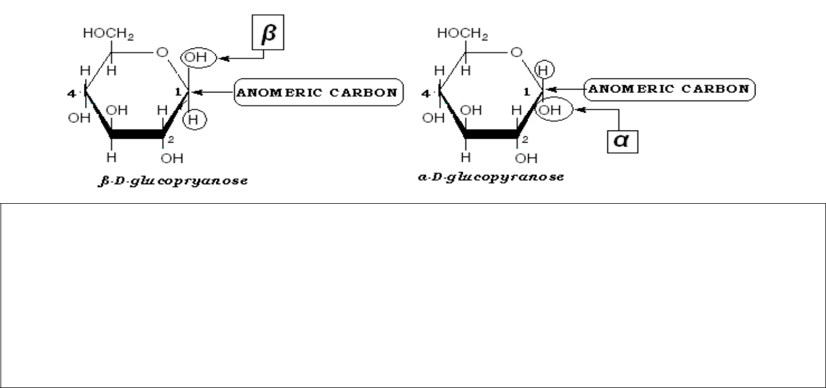

Note By:

Structures of important disaccharides: The α and β refer to the configuration at the anomeric carbon atom (asterisk). When the anomeric carbon of the second residue takes part in the formation of the glycosidic bond, as in sucrose, the residue becomes a glycoside known as a furanoside or pyranoside. As the disaccharide no longer has an anomeric carbon with a free potential aldehyde or ketone group, it no longer exhibits reducing properties, where as the anomeric end of the glucose residue is not involved in the glycosidic linkage it and, therefore, lactose remains a reducing sugar.
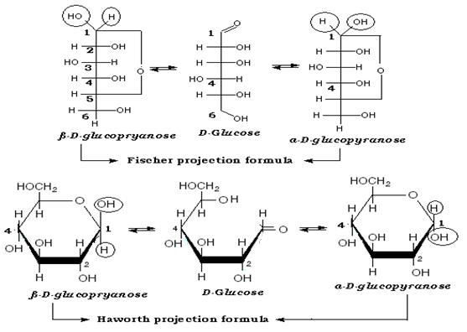

Reducing sugars: If the oxygen on the anomeric carbon of a sugar is not attached to any other structure, that sugar can act as a reducing agent and is termed a reducing sugar. Such sugars can react with chromogenic agents (for example, Benedict's reagent or Fehling's solution) causing the reagent to be reduced and colored, with the anomeric carbon of the sugar becoming oxidized. [Note: Only the state of the oxygen on the anomeric carbon determines if the sugar is reducing or nonreducing—the other hydroxyl groups on the molecule are not involved.
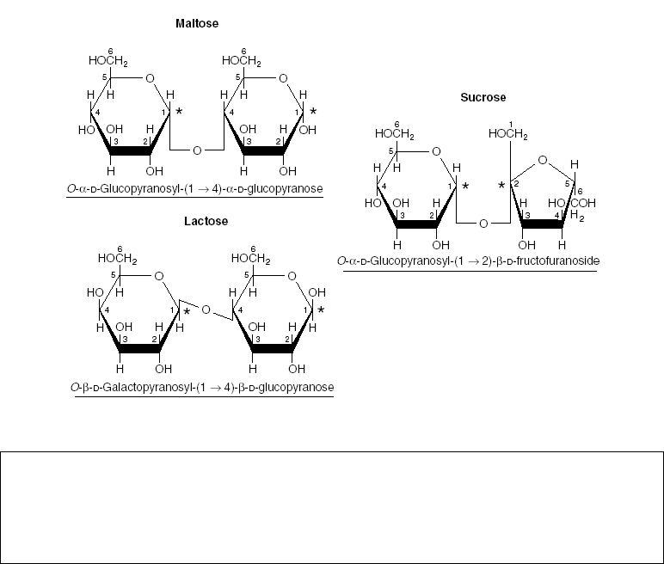

Note By: Glucose is a mixture of α- and β-anomers, primarily the α-anomer. The optical rotation of the α-anomer is +112.2° (c = 10% in water, 20 °C) and the β-anomer is +18.7° (c = 10% in water, 20 °C). When D-glucose is dissolved in water, the optical rotation gradually changes (mutarotates) with time and approaches a final equilibrium value of +52.7° (c = 10%, 20 °C) due to the formation of an equilibrium mixture consisting of approximately one-third α- and two-thirds β-D-glucose.

Pyranose and furanose ring structures:

- The stable ring structures of monosaccharides are similar to the ring structures of either pyran (a six-membered ring) or furan (a five-membered ring). For glucose in solution, more than 99% is in the pyranose form.
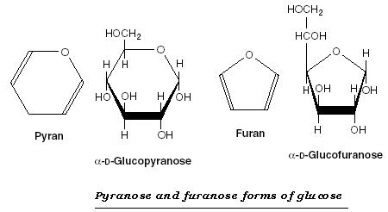

- "Pyranose" is used to refer to the pyran ring structure (6membered ring with 5 carbons and 1 oxygen)

- For five membered rings (four carbons and 1 oxygen) the structure is a furanose ring.

- Cyclization is reversible.

- The resulting chirality of the aldehyde carbon (or keto carbon in ketoses) in the cyclic structure can be either the α- or β-form. This carbon is termed the anomeric carbon, and the α- and β-forms are anomers.

- The ring structure representations are termed "Haworth Projections".

- Cyclic structures can also be represented using Fischer diagrams
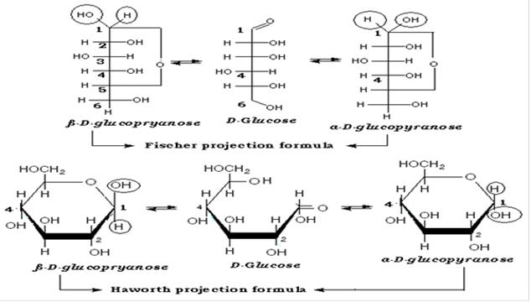

- Alternative ring structures

  - Glucose has a variety of alcohol functional groups, and is able to form alternative hemiacetal ring structures.

  - The 5C-OH can react with the aldehyde forming the above pyranose ring

  - The 4C-OH can react with the aldehyde forming a five membered furanose ring

- Ring geometry

  - The carbon atoms in the ring are sp³ hybrid orbitals, and tetrahedral geometry.

  - The oxygen in the ring is also sp³, and tetrahedral.

  - Thus, the ring structures cannot be planar (that would require trigonal planar geometry, or sp² hybrid orbitals, for the atoms in the ring)

  - The rings actually look like
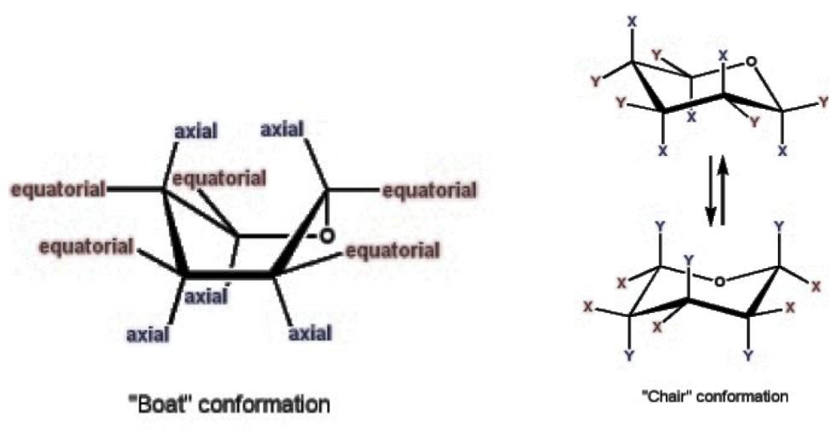

- There is a "boat" and a "chair" structure. There are two different orientations of the functional groups bonded to the ring carbons:

    - If they point in the general plane of the ring, they are said to be in the "equatorial" position

    - If they point in an orientation perpendicular to the general plane of the ring, they are side to be in the "axial" position

    - The chair can have two different conformations. The principle effect of the alternative conformations is to change the axial versus equatorial orientations for the carbon functional groups.

  - Functional groups in the axial position are somewhat crowded together, whereas, the same functional groups in the equatorial position are separated from each other.
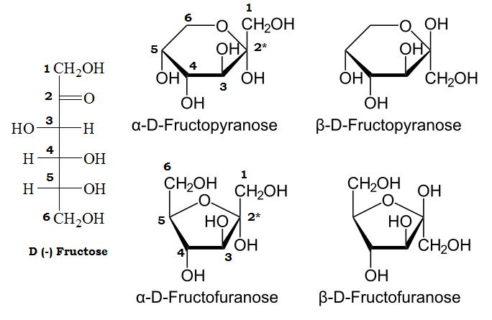

Fischer Projection | Haworth Projection | Configuration | Chair Conformation
Right | Down | α | Axial
Left | Up | β | Equatorial

- Isomers and epimers:

- Compounds that have the same chemical formula but have different structures are called isomers. For example, fructose, glucose, mannose, and galactose are all isomers of each other, having the same chemical formula, C6H12O6.

- Carbohydrate isomers that differ in configuration around only one specific carbon atom are defined as epimers of each other. For example, glucose and galactose are C-4 epimers—their structures differ only in the position of the -OH group at carbon 4. [Note: The carbons in sugars are numbered beginning at the end that contains the carbonyl carbon—that is, the aldehyde or keto group]

- Glucose and mannose are C-2 epimers. However, galactose and mannose are not epimers—they differ in the position of -OH groups at two carbons (2 and 4) and are, therefore, defined only as isomers.
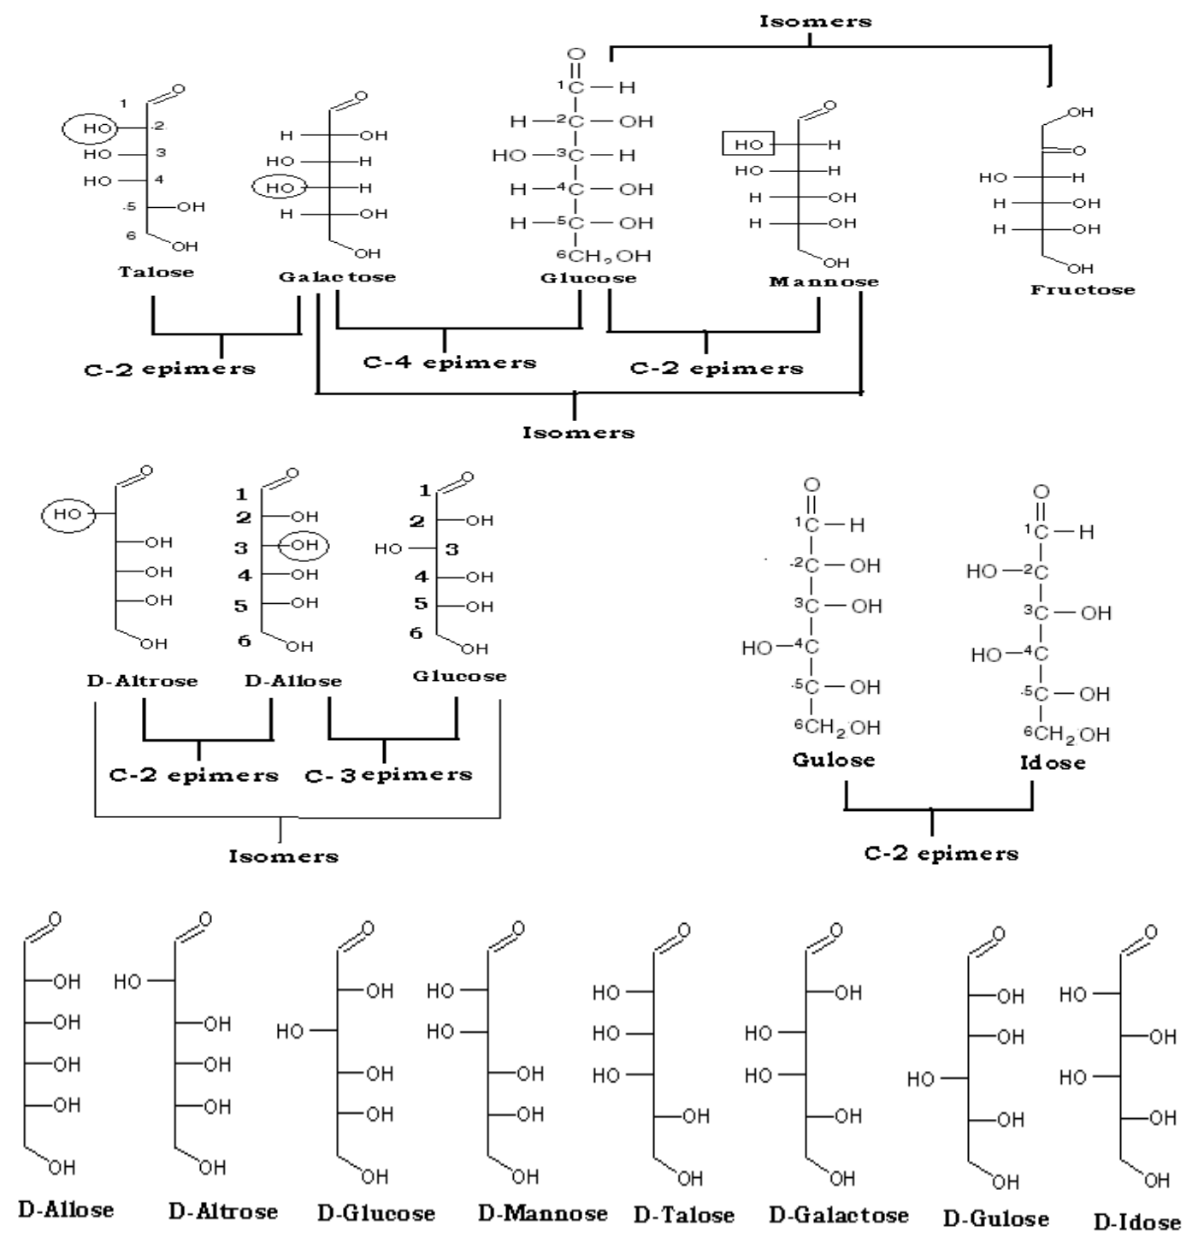

Isomers and Epimer of Fructose
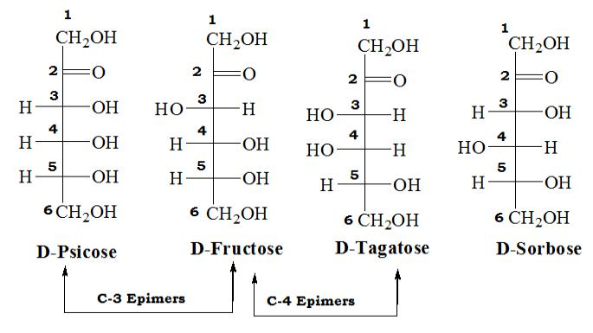

- Enantiomers:

- A special type of isomerism is found in the pairs of structures that are mirror images of each other. These mirror images are called enantiomers and the two members of the pair are designated as a D- and an L-sugar.

- The vast majority of the sugars in humans are D-sugars.

- In the D isomeric form, the OH group on the asymmetric carbon (a carbon linked to four different atoms or groups) farthest from the carbonyl carbon is on the right, while in the L-isomer it is on the left.

- Enzymes known as r a c em as es are able to interconvert D- and L-isomers.
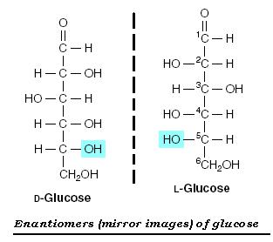

Glycosidic bonds :

- Monosaccharides can be joined to form disaccharides, oligosaccharides and polysaccharides.

- Important disaccharides include lactose (galactose + glucose), sucrose (glucose + fructose) and maltose (glucose + glucose).

- The bonds that link sugars are called glycosidic bonds. These are formed by enzymes known as g l y c o s y l tr an sf e r as e s that use nucleotide sugars such as UDP-glucose as substrates.

- Glycosidic bonds between sugars are named according to the numbers of the connected carbons and

also with regard to the position of the anomeric hydroxyl group of the sugar involved in the bond.

• If this anomeric hydroxyl is in the α configuration, the linkage is an α-bond. If it is in the

β configuration, the linkage is a β-bond.

- Lactose, for example, forming a glycosidic bond between carbon 1 of β-galactose and carbon 4 of glucose. The linkage is, therefore, a β (1→4) glycosidic bond.
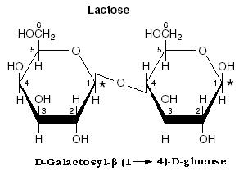

        - Polysaccharides

- Monosaccharides can undergo a series of condensation reactions, adding one unit after another to the chain until very large molecules (polysaccharides) are formed. This is called condensation polymerisation, and the building blocks are called monomers.

- The majority of carbohydrate material in nature occurs in the form of polysaccharides (also known as glycans). Other molecules that contain polysaccharide structures are also referred to as polysaccharides.

    - Homopolysaccharide. A polysaccharide whose monosaccharide units are identical.

    - Heteropolysaccharide. A polysaccharide made up of different monosaccharides

- The most common constituent of polysaccharides is D-Glucose

- Homopolysaccharides composed of glucose are called glucans; Those composed of mannose are called mannans; etc.

- Glycosidic linkages involve only one anomeric carbon (keto or aldehyde) per monosaccharide. However, there are several potential hydroxyl acceptor groups on a given monosaccharide. Thus, polysaccharides can be branched as well as linear.

  - The characterization of polysaccharides includes their length, the type of monosaccharide units, the linkages and branched nature

  - Starch is a glucan that has two polysaccharide forms: one is a linear molecule with α-1-4 linkages called amylose. The other is a branched form of amylose, where the branches have α-1-6 linkages, called amylopectin.
- The properties of a polysaccharide molecule depend on:

      - Its length (though they are usually very long)

      - The extent of any branching (addition of units to the side of the chain rather than one of its ends)

      - Any folding which results in a more compact molecule

      - Whether the chain is 'straight' or 'coiled'

- Starch, Glycogen and Cellulose are all polymers of glucose. They differ in the type of glucose present and the bonds which link thru glucose monomers together, whereas Insulin is the polymer of glucose and fructose

- Starch and Glycogen are made from alpha-glucose. This is an isomer of glucose in which the hydroxyl (-OH) group attached to carbon number 1 is below the plane of the ring. Whereas Cellulose are β-glucose monomer.

- The major form of storage polysaccharide in animals is glycogen (found in the liver and skeletal muscle).

- The most common storage polysaccharide in plants is starch.

- Yeast and bacteria make dextran as a storage polysaccharide. It is composed of α-1-6 linkages of Dglucose, with branched chains (1-2, 1-3 or 1-4 linkages between glucose units). Important component of dental plaque (from bacteria).

)

- Difference between Starch, Glycogen & Cellulose

 | Characters |  |  |  | Starch |  |  | Glycogen |  |  | Cellulose
 |  |  |  |  | α-glucose
 | Monomer |  |  |  | Amylose: (60 to 300 α-glucose Unit) |  |  | α-glucose |  |  | β-glucose
 | Monomer |  |  |  | Amylopectine: (300 to 6000 α- |  |  | (6000 to 30,000 α-glucose Unit) |  |  | (300 to 2500 β-glucose Unit)
 |  |  |  |  | glucose Unit)
 | Type of bond |  |  |  | α(1→4) glycosidic bond (Amylose) + |  |  | α(1→4) and α(1→6) glycosidic
 | between |  |  |  | α(1→4) and α(1→6) glycosidic |  |  | α(1→4) and α(1→6) glycosidic |  |  | β(1→4) glycosidic bond
 | between |  |  |  | α(1→4) and α(1→6) glycosidic |  |  | bonds |  |  | β(1→4) glycosidic bond
 | monomers |  |  |  | bond (Amylopectin) |  |  | bonds
 | Nature of |  |  |  | Amylose is coiled unbranched |  |  | Short many branched chains, some |  |  | Straight, long unbranched
 | Nature of |  |  |  | Amylopectin is long branched |  |  | Short many branched chains, some |  |  | chains form H-bonds, with
 | chain |  |  |  | Amylopectin is long branched |  |  | coiling |  |  | chains form H-bonds, with
 | chain |  |  |  | chains, some coiling |  |  | coiling |  |  | adjacent chains
 | Occurrence |  |  |  | In plants |  |  | In animals and fungi |  |  | In plants
 | Function |  |  |  | Carbohydrate energy store |  |  | Carbohydrate energy store |  |  | Structural
 | General form |  |  |  | Grains |  |  | Small granules |  |  | Fibres
 | Chemical Test |  |  |  | Deep Blue-Violet color |  |  | Reddish brown color |  |  | Negative test
 | or Iodine test |  |  |  | Deep Blue-Violet color |  |  | Reddish brown color |  |  | Negative test
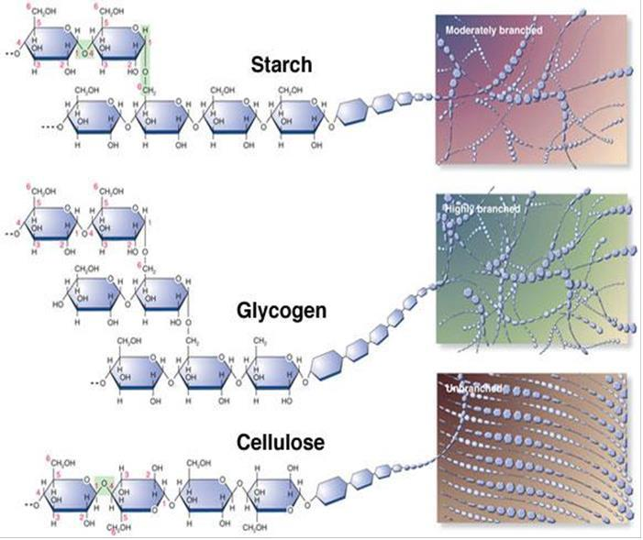

MUTAROTATION IN SUGARS

- Mutarotation is the change in the optical rotation because of the change in the equilibrium between two anomers, when the corresponding stereocenters interconvert. Cyclic sugars show mutarotation as α and β anomeric forms interconvert.

- The optical rotation of the solution depends on the optical rotation of each anomer and their ratio in the solution.

- Mutarotation was discovered by French chemist Sir Dubrunfaut in 1846, when he noticed that the specific rotation of aqueous sugar solution changes with time. [The organic fructose molecule was subsequently discovered by Dubrunfaut in 1847].

- Sugars in the ring form can exist in two states, one where the C-1 hydroxy group is above the plane of the ring (β) and one where it is below (α).

- In aqueous solution there is a constant interchange between the various conformations via the breaking open of the hemi acetal structure and its subsequent reforming.
