Course: B.Sc., (Physics)
Semester: VI
Title of the paper: Theoretical physics
STUDY MATERIAL FOR TWO MARK QUESTIONS
UNIT I
- What are generalized co-ordinates?
The independent co-ordinates sufficient in number to specify unambiguously the system configuration are generalized co-ordinates and are denoted by q₁,q₂,q₃,…q_{k}…,q_{f} where f is the total number of generalized co-ordinates or degrees of freedom.
- Define constraints.
The limitations or geometrical restrictions imposed on the position or motion of a particle or system of particles are known as constraints.
- How constraints are classified?
Constraints are classified as
(i)Holonomic and non- holonomic: If conditions of all the constraints are expressed as equations of the form
Then the constraints are said to be holonomic.
If the constraints are not so expressed, they are called non-holonomic constraints.
(ii)Scleronomic and rheonomic constraints. If the constraints are independent of time, they are called scleronomic. If they contain time explicitly are rheonomic.
- State the principle of virtual work.
A system of particles is in equilibrium only if the total work of the actual or applied forces is zero.
- State D’Alembert’s principle.
D’Alembert’s principle states that the virtual work done by effective force on a dynamical system is zero.
It may be written as
- State Hamilton’s principle.
Hamilton’s principle: The path actually traversed in a conservative holonomic dynamical system from time and is one over which the integral of the Lagrangian between limits and is stationary (i.e., the time integral of the Lagrangian is extremum.

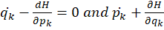 = 0
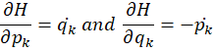
These are the required Hamilton’s equations.
- Give the Lagrange’s equation for a conservative system.
The Lagrange’s equation for a conservative system is
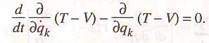
Where L = T – V and L is known as Lagrangian function.
The above equation becomes,
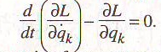
- Write the Lagrange’s equation for a system containing dissipative force.
The Lagrange’s equation for a system containing dissipative force is given by
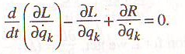
Here, the term 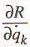 taken into account for the dissipative forces.
Thus, if dissipative forces are acting on the system, we must specify two scalar functions – the Lagrange’s function L and Rayleigh’s dissipation function R – to derive the equations of motions.
UNIT II
- Write Hamilton’s equations.
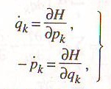
These equations are called Hamilton’s equations or Hamilton’s canonical equationns of motion.
- State the principle of least action.
The principle of least action states that the variation of action along the actual path between given time interval is least i.e.
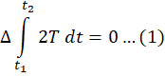
But in system for which Hamiltonian H remains constant,
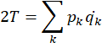
Therefore for such system, the principle of least action may be written as
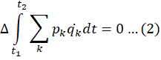
Where Δ represents a new type of variation of the path which allows time as well as position co-ordinates to vary.
- What are cyclic coordinates?
The Langrangian L is written as function of q_{i} and q_{i}. If the Lagrangian of a system does not contain a given coordinate, say q_{k}, then the coordinate is said to be cyclic. Since the coordinates q_{k} is absent in the expression for the Lagragian L, the partial derivative of L with respect to q_{k} will vanish, i.e., 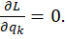
- Define generalized momentum.
The generalized momentum conjugate to the generalized co-ordinates q_{k} is defined as the quantity . It is represent by p_{k}. i.e., 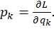
- Define phase space.
A single particle in phase space is specified by six co-ordinates; three position coordinates and three momentum co-ordinates. This six dimensional space is sometimes called the μ space. The phase space is a superposition of μ spaces.
- State conservation theorem for generalized momemtum.
If a given component of the total applied force vanishes, the corresponding component of the linear momentum is conserved.
- State conservation theorem for energy.
If the Lagrangian function does not contain the time explicitly, the total energy of the conservative system is conserved.
UNIT III
- State de Broglie hypothesis.
According to de Broglie, a moving particle, whatever its nature, sometimes acting as a particle and sometimes acting as a wave. He proposed that the wavelength λ associated with any moving particle of momentum p (mass m and velocity v) is given by
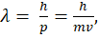 Where h is planck’s constant.
- Define group velocity.
The velocity v_{g} of the wave group is
When ω and k have continuous spreads, the group velocity is given by
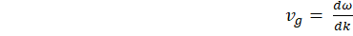
This is the expression for the group velocity, the ratio of change in frequency and change in wave number.
- What is meant by de Broglie waves?
Waves associated with the matter particles are called matter waves or de Broglie waves.
- Write the relation connecting group velocity and phase velocity.
The relation between group velocity and phase velocity is given by
- What is meant by wave velocity?
A wave of angular frequency ω and wave number k, then the de Broglie wave velocity is
- State Heisenberg’s uncertainty principle.
It is impossible to determine precisely and simultaneously the values of both the numbers of a pair of physical variables which describe the motion of an atomic system.
- State the principle of electron microscope.
An electron microscope uses an 'electron beam' to produce the image of the object and magnification is obtained by 'electromagnetic fields'; unlike light or optical microscopes, in which 'light waves' are used to produce the image and magnification is obtained by a system of 'optical lenses'.
UNIT IV
23. State the postulates of wave mechanics.
(i) Each dynamical variable relating to the motion of a particle can be represented by a linear operator.
(ii) A linear eigenvalue equation can be always linked with each operator.
(iii) In general, when a measurement of a dynamical quantity a is made on a particle for which the wave function is , we get different values of a during different trials. This is in conformity with the uncertainty principle. The most probable value of a is given by 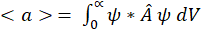
24. what is an operator? Give one example.
An operator tells us what operations to carry out on the quantity that follows it.
The operator 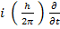 instructs us to take the partial derivative of what comes after it with respect to t and multiply the result by 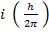.
25. Define eigen value and eigen function.
In general, we can write an eigen value equation as
The differential operator operates on a function , and this yields a constant f times the function. The function is then called an eigen function of the operator , and the corresponding value for f is called the eigen value.
26. Define normalized wave function.
The probability of finding a particle in a volume dx, dy, dz is dx dy dz . further, since the particle is certainly to be found somewhere in space
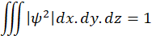
The trial integral extending over all possible values of x, y, z .
A wave function satisfying this relation is called a normalized wave function.
27. Write any two applications of Schrodinger’s wave equation.
- Particle in a box.
- The barrier penetration problem.
28. What are quantum operators for angular momentum and kinetic energy.
For angular momentum of the particle, the operator is 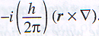
The operator for kinetic energy of a particle is .
29. State Ehrenfest’s theorem
Ehrenfest’s theorem: It states that the schrodinger equation leads to the classical (Newton’s) law of motion on the average.
In other words this theorem states that the average motion of a wave packet agrees with the motion of the corresponding classical particle.
UNIT V
30. What is called a rigid rotator?
Rigid Rotator: The system consisting of two spherical particles attached together, separated by finite fixed distance and capable of rotating about an axis, passing through the centre of mass and normal to the plane containing the two particles, constitutes, a rigid rotator.

