Quran Part 21 Surath Luqman (31)
In the Name of Allah the Most Gracious, the Most Merciful
1. Alif Laam Meem.
2. These are Verses of the Wise Book. (The Holy Qur`an).
3. A guide and mercy for the good doers. ( Muhsinuon).
4. Those who perform prayer ( As- Salath ) and give poor people tax
( Zakath ) and the have faith in the Hereafter with certainly.
5. Such are on guidance from their Lord, and such are the successful.
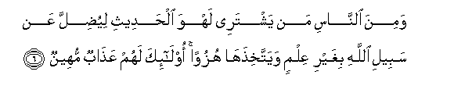
6. And the mankind is he who purchases idle talks (i.e music, singing) to
mislead (men) from the path of Allah without knowledge, and takes it by
way of mockery. For such there will be a humiliating torment (in Hell–fire).
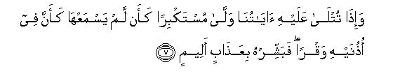
7. And when Our Verses are recited to such a one, he turns away in pride, as
if he heard them not–as if there were deafness in his ear. So announce to
him a painful torment.
8. Verily, those who believe ( in Islamic Monotheism ) and do righteous good
deeds, for them are Gardens of Delight (Paradise ).

9. To abide therein. It is a Promise of Allah in truth. And He is the All- Mighty, the
All- Wise.
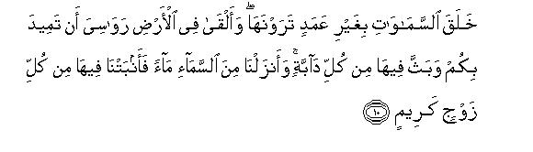
10. He has created the heavens without any pillars that you see, and has set on the
earth firm mountains lest it should shake with you. And He has scattered
therein moving (living) creatures of all kinds. And We send down water (rain)
from the sky, and We cause (plants) of every goodly kind to grow therein.
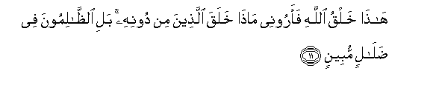
11. This is the creation of Allah. So show me that which those (whom you
worship) besides Him have created. Nay, the (polytheists, wrongdoers and
those who do not believe in the Oneness of Allah) are in plain error.
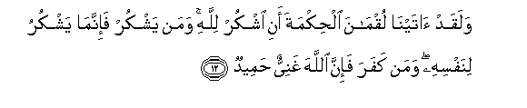
12. And indeed we bestowed upon Luqman Al- Hikmah (wisdom and religious
understanding ) saying: “Give thank to Allah”. And whoever gives thanks, he
gives thanks for his own self. And whoever is unthankful, them verily, Allah is
All- Rich (free of all needs), Worthy of all praise.
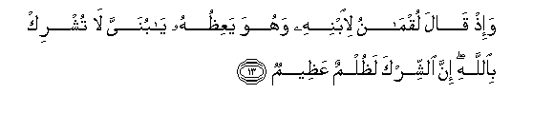
13. And when Luquman said to his son when he was advising him: “O my son!
Join not in worship others with Allah Verily, joining others in workship with
Allah is great Zulm (wrong) indeed.
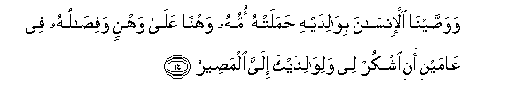
14. And We have enjoined on man (to be dutiful and good ) to his parents. H is
mother bore him in weakness and hardship upon, and his weaning is in two
years–give thanks to Me and to your parents. Unto Me is the final destination.
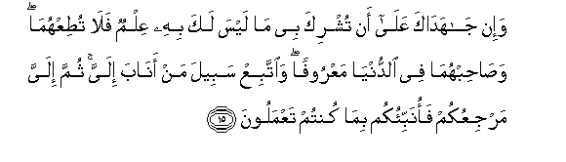
15. But if they (both) strive with you to make you join in worship with Me others
that of which you have no knowledge, then obey them not; but behave with
them in the world kindly, and follow the path of his who turns to Me in
repentance and in obedience. Then to Me will be your return , and I shall tell
you what you used to do.
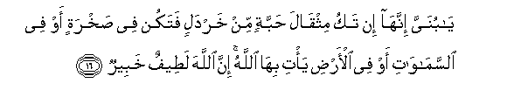
16. “O my son! If it be (anything) equal to weight of a grain of mustard seed, and
though it be in a rock, or in the heavens or in the earth, Allah will bring it
forth. Verily, Allah is subtle (in bringing out that grain), Well- Aware (of its
place).
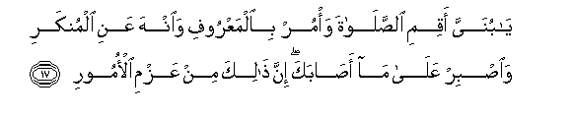
17. “O my son! Perform the Prayer” (Aqim-is-Salath) enjoin (on people) Al-Maruf
(Islamic Monotheism and all that is good) and forbid (people) from Al-
Munkar (i.e disbelieve in the Oneness of Allah, polytheism of all kinds and all
that is evil and bad) and bear with patience whatever befalls you. Verily,
these are some of the important commandments (ordered by Allah with no
exemption).
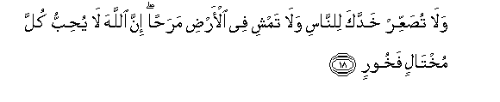
18. “And turn not your face away from men with pride, nor walk in insolence
through the earth”. Verily, Allah likes not any arrogant boaster.
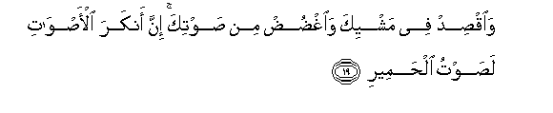
19.”And be moderate (or how no insolence) in your walking, and lower your
voice. Verily, the harshest of all voices is the braying of the asses”.
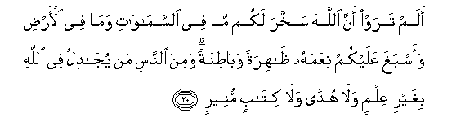
20. See you not (O men) that Allah has subjected for you whatsoever is in the
earth, and has completed and perfected His Graces upon you, (both) apparent
(i.e Islamic Monotheism, and lawful pleasure of this world, including health,
good looks) and hidden [i.e one`s faith in Allah, (of Islamic Monotheism),
knowledge, wisdom, guidance for doing righteous deeds, and also the
pleasure and delights of the Hereafter in Paradise]? Yet of mankind is he who
disputes about Allah without knowledge or guidance or a Book giving
light!.
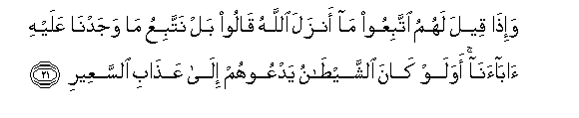
21. And when it is said to them: “Follow that which Allah has sent down” they
say: “Nay, we shall follow that which we found our fathers (followings).”
(would they do so) even if shaitan (Satan) invites them to the torment of the
fire?.
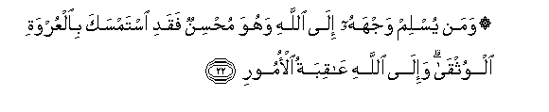
22. And whosoever submits his face (himself) to Allah , while he is a Mushin
show-off or to gain praise or fame and does them in accordance with the
sunnah of Allah`s Messengers Muhammad Sal) then he has grasped the most
trustworthy handhold (La ilaha ill Allah, none has the right to be worshipped
but Allah). And to Allah return all matters for decision.
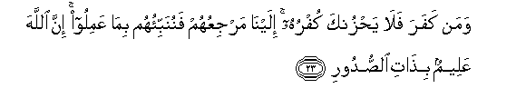
23. And whoever disbelieves, let not his belief grieve you (O Muhammad Sal)
To Us is their return, and We shall inform them what they have done. Verily,
Allah is the All-Knower of what is in the breasts (of men).
24. We let then enjoy for a little while, them in the end we shall oblige them to
(enter) a great torment.
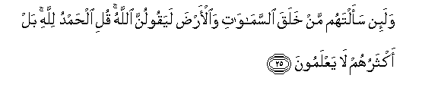
25. And if you (O Muhammad Sal) ask them: “Who has created the heaven and
the earth, “they willl certainly say: “Allah”. Say: “All the praises and thanks be
to Allah!”. But most them know not.
26. To Allah belongs whatsoever is in the heavens and the earth. Verily, Allah ,
He is Al-Ghani (Rich, free of all needs), Worthy of all praise.
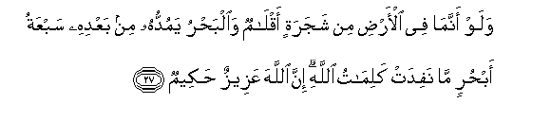
27. And if all the trees on the earth were pens and the sea (were ink wherewith to
write), with seven seas behind it to add to its (supply), yet the Words of Allah
would not be exhausted. Verily, Allah is All-Mighty, All-wise.
28. The creation of you all and the resurrection of you all are only as (the creation
and resurrection of ) a single person. Verily, Allah is All-Hearer, All-Seer.
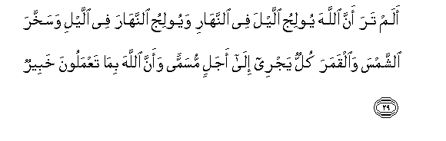

29. See you not (O Muhammad Sal) that Allah merges the night into the day (i.e.
the decrease in the hours of the night are added to the hours of the day), and
merges the day into night. (i.e. the decrease in the hours of a day are added to
the hours of night) and has subjected the sun and the moon, each running its
course for term appointed; and that Allah is All-aware of what you do.
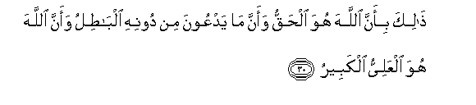
30. That is because Allah, he is the Truth, and that which they invoke besides
Him is Al-Batil (falsehood, Satan and all other false deities); and that Allah,
He is the Most High, the Most Great.
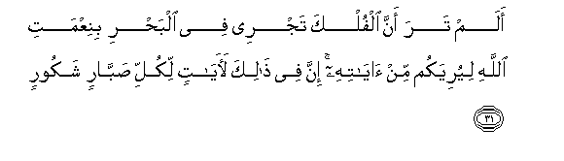
31. See you not that the ships sail through the sea by Allah`s Grace that He
may show you of His Signs? Verily, in this are signs for every patient,
grateful (person ) .
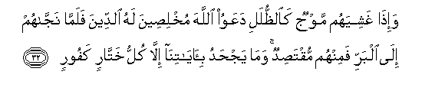
32. And when waves cover them like shades (i.e . like clouds or the
mountains of sea water). They invoke Allah, making their invocations for
Him only. But when He bring them safe to land , there are among them
those that stop in between (Belief and disbelief ). But none denies Our Signs
except every perfidious ingrate.
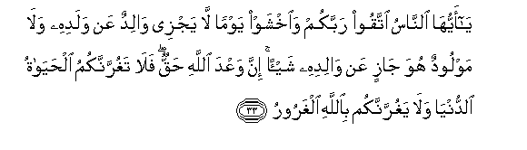
33. O mankind ! Be afraid of your Lord (by keeping your duty to Him and
avoiding all evil), and fear a Day when no father can avail aught for his son,
nor a son avail aught for his father . Verily, the Promise of Allah is true,
let not then this (worldly) present life deceive you, nor let the chief deceiver
(Satan) deceive you about Allah.
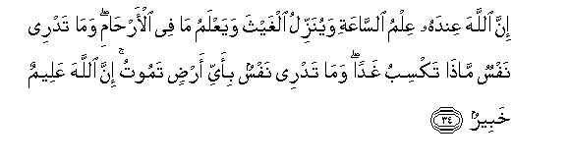
34. Verily, Allah, with Him (Alone) is the knowledge of the Hour, He sends
down the rain, and knows that which is in the wombs. No person knows
what he earn tomorrow, and no person knows in what land he will die .
Verily Allah is All –knower, All –Aware (of things).

Quran Part 26
Surath Hujurat (49) The Dwellings.
In the Name of Allah the Most Gracious, the Most Merciful
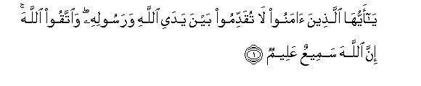
1. O you who believe! Make not (a decision ) in advance before Allah and His
Messenger (Prophet Sal) and fear Allah. Verily Allah is All-hearing, All-
Knowing.
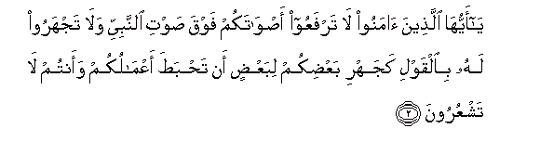
2. O you who believe! Raise not your voices above the voice of the Prophet (Sal)
nor speak aloud to him in talk as you speak aloud to one another, least your
deeds should be rendered fruitless while you perceive not.
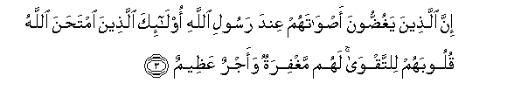
3. Verily, those who lower their voices in the presence of Allah`s Messenger
(Prophet Sal) , they are the ones whose hearts Allah has tested for piety. For
them is forgiveness and a great reward.
4. Verily, those who call you from behind the dwellings, most of them have no
sense.
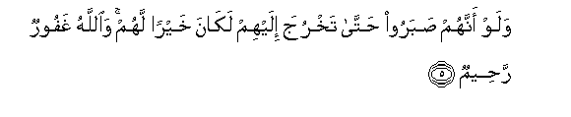
5. And if they had patience till you could come out to them, it would have been
better for them. And Allah is Oft-forgiving, Most Merciful.
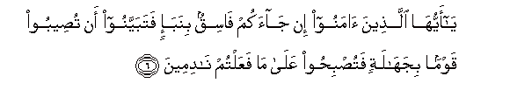
6. O you who believe! If a fasiq (liar-evil person) comes to you with any news,
verify it, lest you should harm people in ignorance, and afterwards you become
regretful for what you have done.
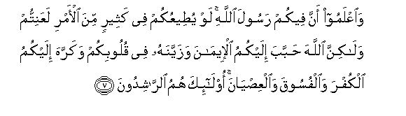
7. And know that among you there is the Messenger of Allah (Prophet Sal). If he
were to obey you (i.e. follow your opinions and desires) in much of the matter,
you would surely be in trouble. But Allah has endeared the Faith to you and
has beautified it in your hearts, and has made disbelief, wickedness and
disobedience (to Allah and His Messenger Prophet Sal) hateful to you . such
are they who are the rightly guided.
8. (This is) a Grace from Allah and His Favour. And Allah is All-knowing, All-
Wise.
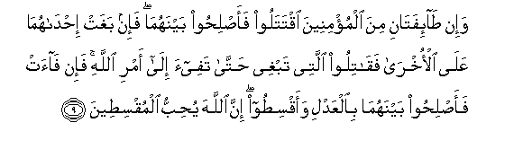

9. And if two parties (or groups) among the believers fall to fighting’s, then make
peace between them both. But if one them outages against the other, (all)
against the one that which outrages till it complies with the Command of
Allah. Then if it complies, then make reconciliation between them justly, and be
equitable. Verily, Allah loves those who are the equitable.
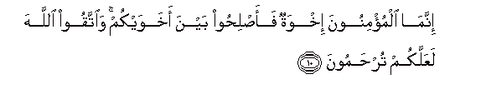
10. The believers are nothing else than brothers ( in Islamic religion). So make
reconciliation between your brothers, and fear Allah, that you may receive
mercy.
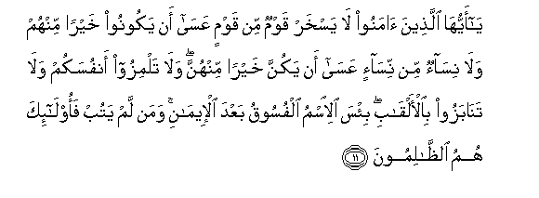
11. O you who believe! Let not a group scoff at another group, it may be that the
latter are better than the former. Nor let (some) women scoff at other women,
it may be that the latter are better than the former. Nor defame on another, nor
insult one another by nicknames. How bad is it to insult one`s brother after
having Faith [i.e to call your Muslim brother (a faithful believer) as : “O
sinner “or “O wicked”]. And whosever foes not repent , then such are indeed
Zalimun (wrong doers).
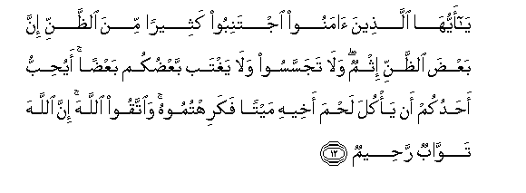
12. O you who believe! Avoid much suspicion; indeed some suspicions are sins.
And spy not, neither backbite one another .Would one of like to eat the flesh
of his dead brother ?you would hate it (so hate backbiting). And fear Allah .
Verily , Allah is the One Who forgives and accepts repentance, Most Merciful.
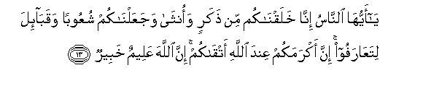
13. O mankind ! We have created you from a male and a female, and made
you into nations and tribes , that you may know one another . Verily , the
most honourable of you with Allah is that (believer) who has At –
Taqwa (i.e. he is one of the Muttaqun ( the pious see V.2:2) . Verily , is All –
Knowing , All – Aware .
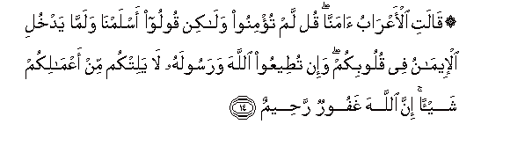
14. The bedouins say: “We believe” . “Say; “You believe not but you only say, We
have surrendered (in Islam ), for Faith has not yet entered your hearts. But
if you obey Allah and His Messenger (Sal), He will not decrease anything in
reward for your deeds. Verily , Allah is Oft –Forgiving , Most Merciful”.
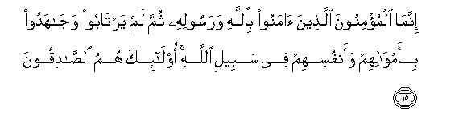
15. Only those are the believers who have believed in Allah and His Messenger,
and afterward doubt not but strive with their wealth and their lives for the
Cause of Allah. Those! They are the truthful.
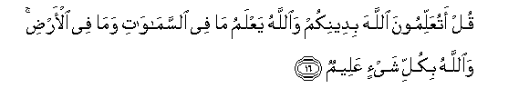
16. Say; “Will you inform Allah of your religion while Allah knows all that is in
the heavens and all that in the earth, and Allah is All –Aware of everything.
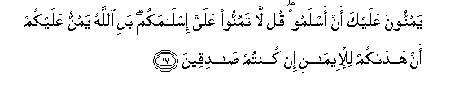

17. They regard as favour to you (O Muhammad Sal ) that they have embraced
Islam Say: “Count not your Islam as a favour to me . Nay , but Allah has
conferred a favour upon you that He has guided you to the faith if indeed
are true.
18. Verily , Allah knows the Unseen of the heavens and the earth. And Allah
is the All – Seer of what you do.

