Subject Code:16SCCAF2
DEPARTMENT OF APPAREL AND FASHION TECHNOLOGY
BASICS OF SEWING
Unit I
Sewing Equipment and Body measurements

Sewing machine- Sewing machine is used to stitch fabric and other material together
Parts of sewing machine-
- spool pin- The main function of spool pin is to hold spool of thread.
- Bobbin binder Spindle- During winding, bobbin in placed here.
- Feed dog- During swing, feed dog pulls the fabric in forward.
- Thread take-up lever- Thread take-up lever moves up and down with the needle.
- Needle clamp- Holds the needle in its actual place.
- Balance wheel- The round wheel located at the upper right of the sewing machine.
- Needle- It is specialized needle for use in sewing machine. Clamped by the sewing machines needle holder.
- Pressure Foot- Pressure foot holds the fabric in its definite place.
- Treadle- Which is operated to produce reciprocating or rotary motion in a machine such as a weaving loom or grinder.
- Drive wheel- The big wheel below the machine that is connected to the treadle.
- Stitch regulator- Regulators the length of the stitches.
- Belt- Connects the balance wheel and the drive wheel.
Care and maintenance
- Oiling keep the parts working smoothly, only a drop of oil once a week.
- Wipe a dust from the exposed parts
- With soft cloth, clean the machine parts
- Scarp material to remove excess oil
- Do not use detergents for cleaning
- Using the lint brush clean feed dog and shuttle
Tools for measuring
- There are many tools to using measuring.
- E.g- Tape, Sewing gauge, Seam Gauge, Transparent ruler, Hem Gauge, Yard Stick
Tools for marking
- Mark the importance point marking a garment, Tracing wheel, tailor chalk
Tools for cutting
- Embroidery Scissors, Trimming Scissors, Pinking Shears, Seam Ripper
Selection of thread and needle
- Heavier fabric require thicker needle, fine fabric require fine needle
- The sewing thread are available in various size

Body Measurement
- It is very important in drafting of pattern
- It helps to produce a garment to fitted to the body
- It helps in reducing fabric or paper waste
- It prevents waste of time and energy,
- Would have been used in pattern alteration or adjusting garments
Eight Head Theory
- The normal body structure is considered 5’4” height.
- The body divided into 8 parts, each parts 8” length
- The observation of body structure becomes easy
- Work shall be easily and speedily executed

Unit II
Seams, Plackets, Fullness and Sleeves
Seams
- One or two layers of fabrics are joined
- Seam is used as functional purpose, E.g Strength, Security, Attaching, Joining
- Sometimes used as decorative purpose
- No missed or uneven stitches
- No damage to the material being sewn
- Comfortable while garment is in use
Types of seams
1. Superimposed Seam
- Mostly used seam for joining fabrics
- It have 50 variations
- Seam can be sewn a variety of m/c. e.g. Lock stitch, overlock
- Mostly used in inside seam like as shirts, pants, children wear
2. Lapped Seam
- Two or more pieces of fabric over lapping each other
- Two sewn ends of the fabric are in opposite direction.
- Mostly two needle chain stitch m/c is used
- This seam used in sewing jeans pants, lunges etc
3.Bound seam
- The bound seam is to finish an edge of garment
- The binder fabric may be different color
- There are 18 variations of bound seam. E.g Underwears, pants, sleeping suits, neckline of t-shirt
4. Flat Seam
- Two pieces of fabric meet precisely at their edges
- Seam thickness is comparatively less.
- Zigzag stitch may be used
- This seam is widely used in undergarments & in knitted items.
Plackets
- A placket is finished opening in front of blouse, polo, shirt
- Fasteners like zippers, buttons, buttonholes, hooks are used in the plackets closed
- It is very easily accessible and conveniently operated
Bound plackets
- These packets can be made on a seam or a slash
- It is usually used in children’s garment
- This placket are not suitable for bulky fabrics or curved seams
Bound or faced
- Usually seen in the back seat of the dresses and left seam of skirt and petticoats
Zipper placket
- Zipper placket usually comes in different sizes and is normally
- It makes it easier to wear the garment
- Appearance wise too zippers give a style to the garment
Shirt plackets
- Centre front of the men’s dresses shirt
- There are the many types of shirt plackets- placket front, French front, fly front
Fullness
Darts
- It is used to shape fabric to fit the body
- They provide fullness to body curved
- Sometime darts are used in decorative purpose
- It is important to the fitting, marking, stitching and pressing darts.
Tucks
- A tuck is a stitched fold of garment
- Tucks are primarily used for decoration
- However, released tucks may be used for shaping fabric to the body

Types of tucks
1. Pin tuck- The small ones (right on the fold of the fabrics)
2. Spaced tucks- Have spaces between the stitching
3. Shell tucks- Stitches by hand or using the sewing machine to blind stitch creating even design
4.Corded tucks- cords are placed in wrong side and tucks are produced
Pleats
- Also used to control fullness in a garment design
- They may be pressed or unpressed, soft or crisp
- Selecting fabric for a pleated design, be sure it has good drape and is resilient
Types of pleats
1.Knife pleat- are flat and are turned to one side, usually right to left on the outside of garment. They are used in kilts, skirts, and on shoulders of bodices.
2. Box- are two straight pleats with folds turned away from each other. Use in skirts, dresses, shirts and jackets
3. Inverted- are two straight pleats with folds turned towards each other. They meet in the centre and are used primarily in skirts
Gathers
- Are visible fullness that is a part of the garment design
- They may be functional or decorative
- It is used in sleeve caps, sleeve cuffs, waistline, yokes, and ruffles
- There are three types- gathers by hand, machine and gathering by using elastic
Frills & Ruffles
- A ruffle is a strip of fabric cut or handled in such a ways as to produce fullness.
- These are used for decoration to a garment
- Also used in hems of skirts and dresses to add length
Sleeve
- The part of an items of clothing that covers the arm
- Sleeve is one of the characteristics of fashion in dress, varying in every country and period
Bell
- A long sleeve fitted from the shoulder to the elbow part and quietly flared from elbow on ward
Raglan
- A sleeve in which the seam extends from the neck to the underarm
Kimono
- shoulder of garment extended over upper arm
Bishopfull sleeve set into normal armhole and gathered into band at wrist
Leg-o-mutton- sleeve with full top gathered or pleated into armhole and tapered to wrist where it looks like a regular sleeve
Puff- short sleeve gathered, either at the armhole or at the cuff bend or both

Unit III
Neck finishes and yokes
Neck finishes:
- It increases the durability of the garment
- Necklines are finished by three ways namely facing, binding and collar
Bias:
- True bias is a diagonal line at 45* to the lengthwise or crosswise grain
- It has the maximum elasticity
Joining bias:
- Place the bias stripes with their right sides facing each other
- The edges of the cut ends should coincide
- Stitch a 0.5 cm seam joining the points where the sides of the two stripes intersect.
- Press the seam open and trim the seam projection

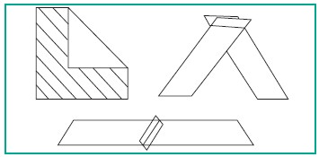

Uses:
- It can be applied as facings and bindings.
- Also used for finishing curved edges such as neckline, sleeveless, armholes and scallops.
Bias facing:
- Facing are used to provide a neat finish to the raw edges in a garment
- Facing may appear on the right side of the garment

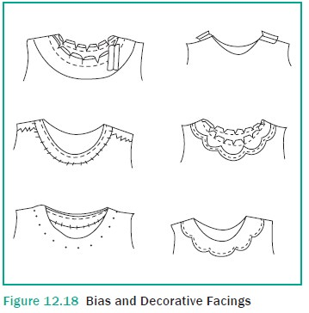

Bias binding:
- It is used to finish and strengthen raw edges
- Add decorative trim to a garment
- It shows both on the right and wrong side of the garment
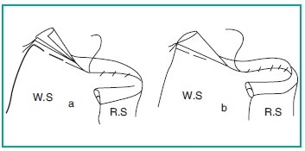

Collars:
- Collar is the part of a dress that closes around your neck securely
- It can be attached to a shirt, coat, blouse, etc.
Parts of collar:
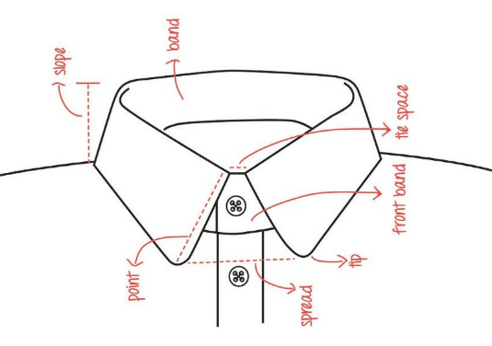

Factors to be considered in designing collar:
- It should be suitable to the garment
- The fabric should be same as the fabric used in the garment
Classification of collar:
- Flat
- Standing
- rolled
Drafting peter pan:
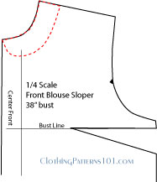
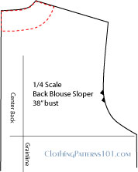

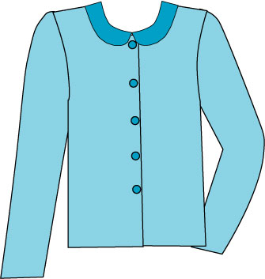
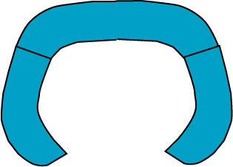

Yokes:
- yoke is a fashioned pattern piece used in garments
- usually fitting around the neck and shoulders or around the hips to provide support for looser parts of the garment

Selection of yoke design:
- Design of the fabric
- Design of the garment
- Purpose and use of the garment
- Sex and age of the wearer
- Figure and personality of the wearer
Creating variety in yoke:
- Variety in shape and size
- Variety in material and grain
- Designing seam line of yoke
- Decoration within the yoke
- Introducing the yoke at different positions
- Designing yokes which release fullness in various forms
Yoke without fullness:

Yoke with fullness:

Attachment of yokes:

Unit-IV
Pockets
A pocket is a bag or envelope which an opening or slot with a closed end that is usually sewn in or over the garment.
Classification:
- Applied pockets
- In-seam pockets
- Set-in pockets – welt, flap and bound or corded pocket
Selection of pocket:
- Pocket design should blend with the fabric design, garment design and its components like collar, sleeve, cuff etc.
Patch:
- It can be lined or unlined and can be made in any shape desired.
- It can be cut in the desired shape and fastened to the outside of the garment.
- It has three layers. First layer is pocket itself, a middle with garment lining and the third layer is a lining matching with garment lining.
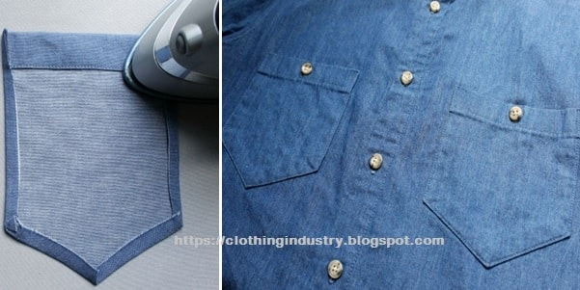

Bound:
- Hidden or secretive pockets
- The edges of the slash have narrow stitched folds or welts along the seams
- Difficult to distinguish from the garment

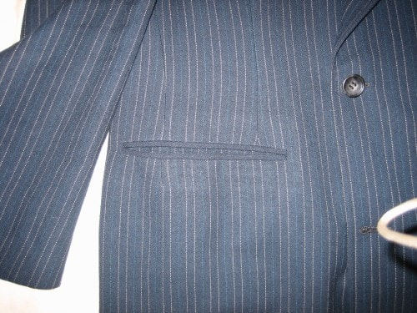

Unit V
Trimmings & Decoration
These are classified based on the raw materials used and the type of work done
Fabric decoration
- Ruffles and frills
- Ric Rac
- Patch work
- Applique
- Belts
- Bows
- Smocking
- Laces
- Scallops
Applied trimming
- Felting
- Satin ribbon work
- Ari & Zardosi
Decorative trimmings
- Sequins
- Mirrors
- Stickers
Decorative fastness
- Bias bindings
- Fabric looks
- Decorative buttons
- Macramé

