Subject Title :Dietetics II
Subject Code : 16SCCND8

UNIT I- HYPERLIPIDEMIA

Hyperlipidemia, refers to elevated levels of fats in the blood. Most people do not usually experience any symptoms, but having hyperlipidemia increases the risk of developing heart disease and increases the risk of stroke and death.
In the United States, about 1 in 3 people have hyperlipidemia.
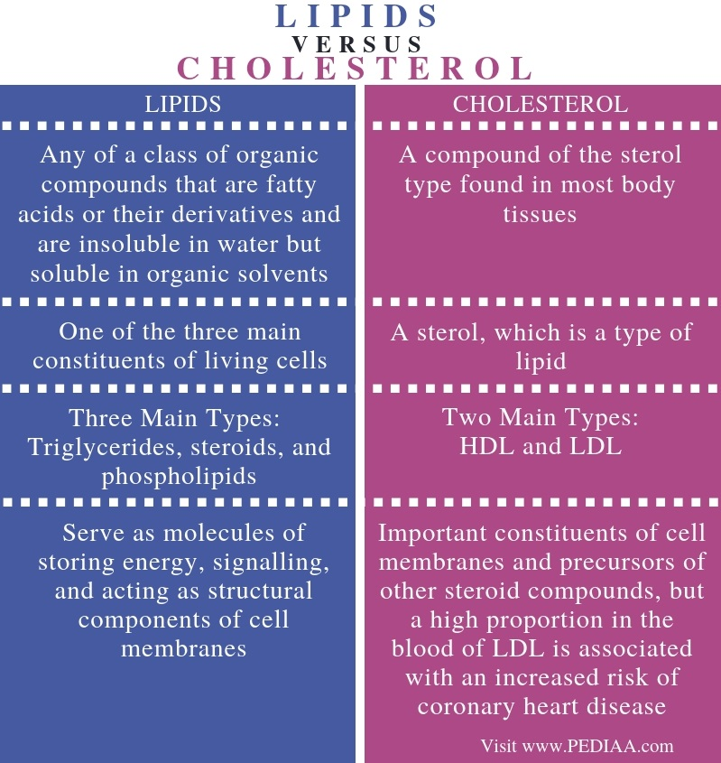
What is hyperlipidemia?
Hyperlipidemia means there is too much cholesterol in the blood.
Cholesterol is a waxy fat molecule that the liver produces. It is essential for healthy cell membranes, brain functioning, hormone production, and vitamin storage.
There are two types of lipoproteins, that transport cholesterol to the cells:
Low-density lipoproteins (LDL), or bad cholesterol,
High-density lipoproteins (HDL), or good cholesterol
LDL has damaging effects on health.
HDL, counteracts the effects of LDL.
HDL is good for health as it carries excess cholesterol back to the liver for excretion. The liver then eliminates cholesterol through bile. LDL that remains in the bloodstream damages health, because it allows excess cholesterol to build up in the blood.
Triglycerides are another type of fat in the blood. They are not a type of cholesterol but have a strong association with heart disease. As such, doctors also measure triglyceride levels in people with hyperlipidemia.
A person can develop hyperlipidemia if they have one or a combination of the following:
- high LDL levels
- low HDL levels
- elevated levels of triglycerides

The following table highlights the ideal cholesterol levels:
Overall cholesterol | Under 200 milligrams per deciliter (mg/dl)
HDL cholesterol | Men: More than 40 mg/dl  Women: More than 50 mg/dl
LDL cholesterol | Otherwise healthy people: Less than 100 mg/dl  People with heart disease or diabetes or poorly controlled risk factors: Less than 70 mg/dl
Triglycerides | Less than 150 mg/dl

Symptoms
Usually, people with hyperlipidemia do not experience any symptoms. However, those with familial, or inherited hyperlipidemia, may develop yellow, fatty growths around the eyes or joints.
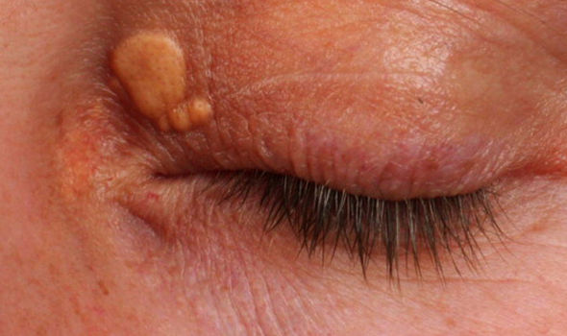
A doctor usually detects hyperlipidemia during a routine blood test or following a cardiovascular event, such as a heart attack or stroke.
An excessive buildup of fat over time can cause atherosclerosis. This is when plaques develop on the walls of the arteries and blood vessels and narrow the openings. This can lead to unstable blood flow through the vessels and can greatly increase the risk of heart disease and stroke.

Prevention
Lifestyle and dietary options are an important way to prevent and treat hyperlipidemia.
Options include eating a “heart-healthy” diet, taking regular exercise, not smoking, and maintaining a healthy body weight.

Principles of Diet
Eating a diet that contains plenty of healthful fats can help prevent hyperlipidemia.
A heart healthy diet includes minimizing the intake of saturated fat, trans fats, and dietary cholesterol, and consuming a variety of whole fruits and vegetables, plenty of fiber, lots of water, and whole grain foods.
People should try to restrict or eliminate fast foods, high carbohydrate foods, and any processed foods or foods that do not offer good nutritional value.
Fish, nuts, and legumes contain “healthful fats” so can provide benefits for people who need to reduce their LDL cholesterol levels. When using oil, choose olive oil, or another oil rich in monounsaturated fats.

Weight
People who are overweight or have obesity are also at greater risk of developing hyperlipidemia and heart disease.
Losing weight can help a person reduce LDL, total cholesterol, and triglyceride levels. It can also boost HDL, which helps to remove the LDL from the blood.

Physical activity
A lack of physical activity is another risk factor for heart disease.
Regular exercise and activity help a person reduce LDL, raise HDL, and encourage weight loss.
The American Heart Association recommend people do 150 minutes of moderately intense physical activity every week.

Not smoking
Smoking triggers many problems that contribute to heart disease.
It promotes atherosclerosis, increases LDL levels, and encourages inflammation and the formation of blood clots.
Quitting smoking will result in higher HDL levels. This may be one reason why the risk of cardiovascular disease (CVD) decreases after a person stops smoking.
A person with hyperlipidemia can reduce the risk of cardiovascular problems later in life by strictly following the diet and treatment

Treatment
Self-management of hyperlipidemia through a balanced diet and regular physical activity may help a person reduce levels of lipid in their blood.
However, genetics also determine cholesterol levels, so a healthful lifestyle may not always be enough to reduce cholesterol. Some individuals might require medications.
Diagnosis
Doctors screen for hyperlipidemia using a lipid profile blood test.
It is usually a fasting test. This means that a person should refrain from eating or drinking anything for 9–12 hours before the test.
A recent guideline update advised that parents can choose for their children to have a cholesterol screening from 2 years of age if they have a family history of high cholesterol or heart disease.
Causes
Having diabetes can be a possible risk factor for hyperlipidemia.
The causes of hyperlipidemia include:
- Genetic factors: A person inherits this type from their parents.
- Poor diet and other factors: Other risk factors include:
- excessive alcohol consumption
- obesity
- taking medications, such as hormones or steroids
- diabetes
- metabolic syndrome
- long term kidney disease
- premature menopause
- an underactive thyroid gland, or hypothyroidism
- pregnancy
- sedentary lifestyle
Familial hyperlipidemia stems from a genetic disorder.
A parent passes down a mutated gene that leads to a missing or malfunctioning LDL receptor. This means that the body cannot clear LDL from the bloodstream, which can result in dangerous levels of LDL in the blood.
Types
There are several types of hyperlipidemia that have different effects on the body. Doctors categorize them by the different types of fat they involve and how each type impacts the body.
Type I: Type I, or hyperlipidemia familial lipoprotein lipase deficiency, typically occurs in childhood and is severe. It is an inherited condition that disrupts the normal breakdown of fats and can lead to abdominal pain, repeated infections of the pancreas, and enlargement of the liver and spleen.
Type II (a and b): Type IIa, or familial hypercholesterolemia, and type IIb, or familial combined hyperlipidemia, both result in high levels of LDL. They can lead to deposits of fat in the skin and around the eyes and can also increase the risk of heart problems.
Type III: Type III, or familial dysbetalipoproteinemia, affects lipoproteins. It occurs when levels of LDL in the blood are too low, but HDL levels remain normal. A typical feature of type III is the occurrence of xanthomas, or flat, yellow-gray plaques on the eyelids and around the eyes or other body parts like legs, neck, etc.
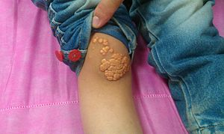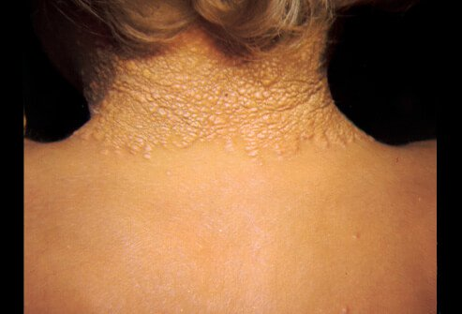
Type III increases the risk of early onset cardiovascular and peripheral artery disease.
Type IV: Type IV, or hypertriglyceridemia, increases levels of triglycerides in the blood rather than cholesterol. This type may also lead to obesity, high blood glucose, and high insulin levels.
A person may not notice type IV hyperlipidemia until early adulthood.
Summary
Hyperlipidemia is a major risk factor for heart disease. It 3refers to excess levels of LDL cholesterol and triglycerides in the blood.
Hypothyroidism, a high fat diet, and being overweight contribute to high cholesterol. However, some types of hyperlipidemia have genetic causes.
Regular physical activity and a diet rich in healthful fats can improve the balance of cholesterol in the blood and help a person prevent related health problems.

